## No. 28/2025 17 July 2025

# Summary of key issues

* In the week ending 16 July 2025, frontal systems brought rainfall totals of up to 50 millimetres to parts of southern Australia. High-pressure systems kept much of the remainder of Australia largely dry.
  + Rainfall was variable across cropping regions, with much of Western Australian and New South Wales regions, as well as isolated parts of Queensland seeing 1-15 millimetres. Much of South Australia and Victoria received 5-50 millimetres, while Queensland remained largely dry.
  + The ongoing lack of rainfall across the Mallee regions of South Australia and Victoria continues to present a downside production risk for winter crops.
* Over the coming eight days, rainfall is expected across much of southern and eastern Australia, while northern and central Australia is likely to remain largely dry.
  + Cropping regions in Victoria, South Australia, and New South Wales are expected to record between 5-50 millimetres of rainfall, with falls of between 15-50 millimetres expected across most cropping regions of Western Australia. If realised, this should provide timely moisture to support the establishment and growth of winter crops across most southern cropping regions.
* Rainfall in June 2025 was variable across the world’s major grain- and oilseed-producing regions, leading to differing crop production outcomes.
  + Global production conditions were generally favourable for major crops including wheat, maize, rice and soybeans.
* Global production conditions have been slightly more favourable to those used to formulate ABARES 2024–25 forecasts of global grain supplies and world prices in the June 2025 Agricultural Commodities Report. As a result, global grain and oilseed production is likely to increase beyond the numbers in the June forecast, due to improvements in global corn and soybean production.
* Water storage levels in the Murray-Darling Basin (MDB) increased by 106 gigalitres (GL) between 10 July 2025 and 17 July 2025. The current volume of water held in storages is 13,389 GL, equivalent to 60% of total storage capacity. Water storage data is sourced from the Bureau of Meteorology (BOM).
* Allocation prices in the Victorian Murray below the Barmah Choke decreased from $318/ML on 10 July 2025 to $305/ML on 17 July 2025. Trade from the Goulburn to the Murray is closed. Trade downstream through the Barmah Choke is closed. Trade from the Murrumbidgee to the Murray is open.

## **Climate**

### Rainfall this week

In the week ending 16 July 2025, **a series of cold fronts and a northwest cloudband** brought rainfall to parts of southern Australia, while high-pressure systems kept much of Australia largely dry.

* Rainfall totals of between 5-100 millimetres were recorded across much of Tasmania, Victoria and isolated parts of northern Queensland.
* Falls of between 5-50 millimetres occurred across much of southwest Western Australia, southern South Australia, and parts of southern New South Wales. In contrast, parts of central Queensland and New South Wales saw between 5-25 millimetres.
* Remaining areas of Australia received little to no rainfall over the period.

Rainfall was highly variable across cropping regions in the week ending 16 July 2025.

* Rainfall totals of between 1-15 millimetres occurred across Western Australia and New South Wales, and isolated regions of northern Queensland broadacre cropping areas receiving up to 25 millimetres. Much of South Australia and Victoria received 5-50 millimetres.
* In contrast, much of central and southern Queensland remained dry, with falls ranging between 0-5 millimetres.
* These conditions have provided some useful follow-up moisture in parts of southern Australia, including western South Australia and parts of eastern Victoria, to support crop establishment and development.
  + However, the ongoing limited volume of rainfall across the Mallee regions of South Australia and Victoria continues to present an increasing downside production risk for winter crops.

#### Rainfall for the week ending 16 July 2025

©Commonwealth of Australia 2025, Australian Bureau of Meteorology Issued: 16/7/2025

Note: The rainfall analyses and associated maps utilise data contained in the Bureau of Meteorology climate database, the Australian Data Archive for Meteorology (ADAM). The analyses are initially produced automatically from real-time data with limited [quality control](http://www.bom.gov.au/climate/headers/qc.shtml). They are intended to provide a general overview of rainfall across Australia as quickly as possible after the observations are received. For further information go to <http://www.bom.gov.au/climate/rainfall/>

### Rainfall forecast for the next eight days

Over the 8 days to 24 July 2025, **cold fronts and cloudbands** are expected to bring rainfall to parts of southern and eastern Australia, with high-pressure systems expected to keep central and northern regions largely dry.

* Southern parts of South Australia and Queensland, much of Victoria and New South Wales are expected to see between 10-50 millimetres, while Tasmania and southern Western Australia is forecast to receive 10-100 millimetres.
* Little rainfall is expected across much of the remainder of the country over this period.

Rainfall is expected across all cropping regions over the coming week.

* Falls of between 5-50 millimetres are forecast across southern Queensland, and much of New South Wales, Victoria and South Australia. In Western Australia, rainfall totals between 15-50 millimetres are expected across most cropping regions.
  + If realised, this should provide timely moisture to support the establishment and growth of winter crops across most southern cropping regions, particularly in the Mallee regions of South Australia and Victoria following relatively dry conditions during late June and early July.
* Meanwhile, falls of between 5-15 millimetres are expected in central Queensland. These expected rainfall totals are likely to provide sufficient moisture to support crop growth and development as crops will also be able to utilise soil moisture reserves.

#### Total forecast rainfall for the period 17 July to 24 July 2025

©Commonwealth of Australia 2025, Australian Bureau of Meteorology Issued 17/7/2025

Note: This rainfall forecast is produced from computer models. As the model outputs are not altered by weather forecasters, it is important to check local forecasts and warnings issued by the Bureau of Meteorology.

### June precipitation percentiles and current production conditions

Crop production is affected by long-term trends in average rainfall and temperature, interannual climate variability, shocks during specific growth stages, and extreme weather events. Some crops are more tolerant than others to certain types of stresses, and at each growth stage, different types of stresses affect crop species in different ways.

Precipitation anomalies and outlooks presented below indicate the current and expected future production conditions for major grain and oilseed producing countries (responsible for over 80% of global crop production). This is an important input to assessing the global grain supply outlook.

Rainfall in June 2025 was variable across the world’s major grain- and oilseed-producing regions:

* In the **southern hemisphere**, precipitation was below average across much of southern Argentina and central Australia. Above average precipitation occurred in parts of Indonesia and southern Brazil. Precipitation was generally average across remaining major southern hemisphere grain- and oilseed-producing regions.
* In the **northern hemisphere**, precipitation was below average across scattered northwestern areas of the United States, southern Canada, parts the Black Sea Region, and southern and eastern regions of the European Union. Precipitation was above average across southern parts of the United States, southern and eastern China, and much of northern India. Precipitation was generally average across remaining major northern hemisphere grain- and oilseed-producing regions.

**Global precipitation percentiles, June 2025**

Note: The world precipitation percentiles indicate a ranking of precipitation for June, with the driest (0th percentile) being 0 on the scale and the wettest (100th percentile) being 1 on the scale. Percentiles are based on precipitation estimates from the NOAA Climate Prediction Center’s [Climate Anomaly Monitoring System Outgoing Precipitation Index](https://iridl.ldeo.columbia.edu/maproom/Global/Precipitation/Percentiles.html) dataset. Precipitation estimates for June 2025 are compared with rainfall recorded for that period during the 1981 to 2010 base period.

Source: International Research Institute for Climate and Society

As of 28 June 2025, global production conditions are generally favourable for wheat, maize, rice and soybeans:

* **Wheat –** In the northern hemisphere, the winter wheat harvest is progressing under generally favourable conditions, albeit with dry conditions in parts of Türkiye and Ukraine.In the southern hemisphere, sowing is underway in Argentina and recent rainfall has supported crop establishment and development in much of Australia.
* **Corn** **–** In the southern hemisphere, the harvest is progressing under mixed conditions. Conditions are generally favourable in the northern hemisphere, albeit with dry conditions in parts of the Russian Federation, Ukraine and the United States.
* **Rice –** Global conditions are broadly favourable for major rice production regions.
* **Soybeans –** Harvest is concluding in the southern hemisphere under generally favourable conditions. In the northern hemisphere, conditions are favourable with the end of the sowing season.

**Crop conditions, AMIS countries, 28 June 2025**

**AMIS** Agricultural Market Information System.

Source: AMIS

The global climate outlook for August 2025 to October 2025 indicates that mixed rainfall conditions are expected for the world’s major grain-producing and oilseed-producing regions. Outlooks and potential production impacts for major grain- and oilseed-producing countries are presented in the following table.

**Rainfall outlook and potential impact on the future state of production conditions, August-October 2025**

|  |  |  |
| --- | --- | --- |
| **Region** | **Rainfall outlook** | **Potential impact on production** |
| **Argentina** | Average rainfall is likely across much of Argentina, with exceptions in some western regions. | A generally favourable rainfall outlook is likely to support the establishment and growth of wheat in Argentina, and allow for the timely planting of cotton, soybeans and corn. |
| **Black Sea Region** | Below average rainfall is expected across much of the Black Sea region, including the Russian Federation and Türkiye. | Anticipated below average rainfall is likely to support the harvesting of major crops including wheat, corn and cotton, and the planting of winter wheat and canola. |
| **Brazil** | Rainfall outcomes across Brazil are expected to be broadly average. | Anticipated rainfall is expected to support wheat production, and the planting of corn and soybeans from September 2025. |
| **Canada** | Generally, below average rainfall is expected in southern and western regions, including British Columbia and Alberta. Average rainfall is more likely in the east. | Below average rainfall is likely to impact the growth of corn, soybean, and sunflower crops, and allow for the harvesting of spring wheat and canola. Average rainfall in isolated areas may benefit the development of crops in these locations. |
| **China** | Above average rainfall is expected throughout much of western China, with below average rainfall expected in scattered eastern areas. | Anticipated rainfall is likely to support the development of major crops over the period but may interrupt harvesting and planting of winter crops. |
| **European Union** | Average rainfall is more likely for much of central European Union between August and October 2025. Below average rainfall is likely in the west. | Average rainfall across much of the European Union is likely to benefit the development of corn, soybeans, and sunflower in the north, as well as planting of winter crops and harvesting of corn, soybeans, and cotton. |
| **South Asia (India)** | Above average rainfall is expected across much of western and central India, with remaining areas forecast to receive average rainfall. | Anticipated rainfall is likely to support the growth of major grains and oilseeds, including corn, rice and sorghum. |
| **Southeast Asia (SEA)** | Above average rainfall is likely across much of Indonesia and Malaysia, with below average rainfall expected in scattered areas of Thailand. | Average to above average rainfall in SEA may support the growth of rice and corn in major growing regions but impair the harvesting of these crops in October. |
| **The United States** | Below average rainfall is likely for much of northern and central United States, with average rainfall more likely across the southeast. | Anticipated rainfall in northern and central areas is likely to impact yield potential of major grains and oilseeds but may support the planting and harvesting of various crops over the period. |

### Water markets – current week

Water storage levels in the Murray-Darling Basin (MDB) increased by 106 gigalitres (GL) between 10 July 2025 and 17 July 2025. The current volume of water held in storages is 13,389 GL, equivalent to 60% of total storage capacity. Water storage data is sourced from the Bureau of Meteorology (BOM)..

#### Water storages in the Murray-Darling Basin, 2013–2025Alt Text: A chart showing water storage in the Murray-Darling Basin. For more information, refer to accompanying text

Allocation prices in the Victorian Murray below the Barmah Choke decreased from $318/ML on 10 July 2025 to $305/ML on 17 July 2025. Trade from the Goulburn to the Murray is closed. Trade downstream through the Barmah Choke is closed. Trade from the Murrumbidgee to the Murray is open.

#### Surface water trade activity, Southern Murray–Darling Basin

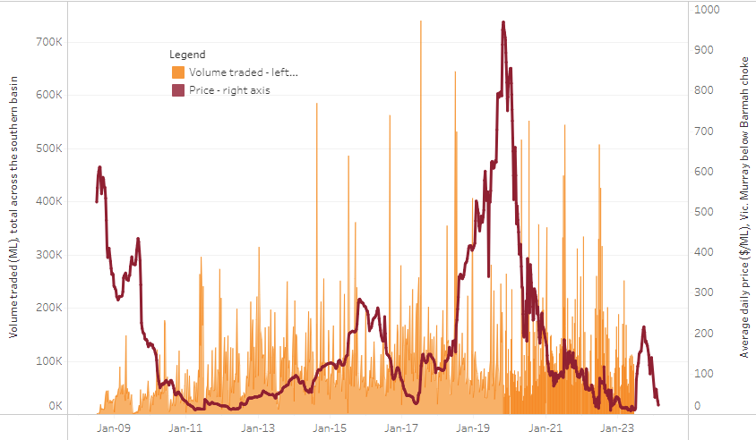

|  |
| --- |
| The trades shown reflect estimated market activity and do not encompass all register trades. The price is shown for the VIC Murray below the Barmah choke. Historical prices (before 1 July 2019) are ABARES estimates after removing outliers from BOM water register data. Prices after 1 July 2019 and prior to the 30 October 2019 reflect recorded transaction prices as sourced from Ruralco. Prices after the 30 October 2019 are sourced from Waterflow. Data for volume traded is sourced from the BOM water register. Only the price data shown is current on 17 October 2024. |

To access the full, interactive, weekly water dashboard, which contains the latest and historical water storage, water market and water allocation information, please visit <https://www.agriculture.gov.au/abares/products/weekly_update/weekly-update-170725>

## **Commodities**

|  |  |  |  |  |  |  |  |  |
| --- | --- | --- | --- | --- | --- | --- | --- | --- |
| **Indicator** | **Week average** | **Unit** | **Latest Price** | **Previous Week** | **Weekly change** | | **Price 12 months ago** | **Annual change** |
| **Selected world indicator prices** |  |  |  |  |  |  | |  |
| AUD/USD Exchange rate | 16-Jul | A$/US$ | 0.65 | 0.65 | 0% | 0.67 | | -2% |
| Wheat – US no. 2 hard red winter wheat, FOB Gulf | 16-Jul | US$/t | 233 | 235 | -1% | 260 | | -10% |
| Corn – US no. 2 yellow corn, FOB Gulf | 16-Jul | US$/t | 192 | 191 | 1% | 177 | | 9% |
| Canola – Rapeseed, Canada, FOB Vancouver | 16-Jul | US$/t | 531 | 536 | -1% | 494 | | 7% |
| Cotton – Cotlook A Index | 16-Jul | USc/lb | 79 | 79 | 0% | 81 | | -3% |
| Sugar – Intercontinental Exchange, nearby futures, no.11 contract | 16-Jul | USc/lb | 16 | 16 | 0% | 19 | | -15% |
| Wool – Eastern Market Indicator | 16-Jul | Ac/kg clean | 1,221 | 1,212 | 1% | 1,093 | | 12% |
| Wool – Western Market Indicator | 09-Jul | Ac/kg clean | 1,355 | 1,352 | 0% | 1,254 | | 8% |
| **Selected Australian grain export prices** |  |  |  |  |  |  | |  |
| Australian Premium White (APW) Wheat, FOB Port Adelaide, SA | 16-Jul | A$/t | 390 | 394 | -1% | 424 | | -8% |
| Australian Standard White (ASW) Wheat, FOB Port Adelaide, SA | 16-Jul | A$/t | 386 | 390 | -1% | 415 | | -7% |
| Feed Barley – FOB Port Adelaide, SA | 16-Jul | A$/t | 374 | 376 | 0% | 367 | | 2% |
| Canola – FOB Kwinana, WA | 16-Jul | A$/t | 804 | 820 | -2% | 757 | | 6% |
| Grain Sorghum – FOB Brisbane, QLD | 16-Jul | A$/t | 426 | 426 | 0% | 411 | | 4% |
| **Selected domestic livestock indicator prices** |  |  |  |  |  |  | |  |
| Beef – Eastern Young Cattle Indicator | 16-Jul | Ac/kg cwt | 734 | 727 | 1% | 631 | | 16% |
| Mutton – Mutton indicator (18–24 kg fat score 2–3), VIC | 16-Jul | Ac/kg cwt | 694 | 685 | 1% | 415 | | 67% |
| Lamb – National Trade Lamb Indicator | 16-Jul | Ac/kg cwt | 1,161 | 1,113 | 4% | 813 | | 43% |
| Pig – Eastern Seaboard (60.1–75 kg), NSW buyer price | 02-Jul | Ac/kg cwt | 452 | 452 | 0% | 409 | | 11% |
| Live cattle – Light steers to Indonesia | 16-Jul | Ac/kg lwt | 345 | 340 | 1% | 300 | | 15% |
| **Global Dairy Trade (GDT) weighted average prices** |  |  |  |  |  |  | |  |
| Dairy – Whole milk powder | 16-Jul | US$/t | 3,928 | 3,859 | 2% | 3,180 | | 24% |
| Dairy – Skim milk powder | 16-Jul | US$/t | 2,785 | 2,718 | 2% | 2,576 | | 8% |
| Dairy – Cheddar cheese | 16-Jul | US$/t | 4,589 | 4,860 | -6% | 4,099 | | 12% |
| Dairy – Anhydrous milk fat | 16-Jul | US$/t | 6,973 | 6,928 | 1% | 6,641 | | 5% |
|  | | | | | | | | |

### Selected world indicator prices

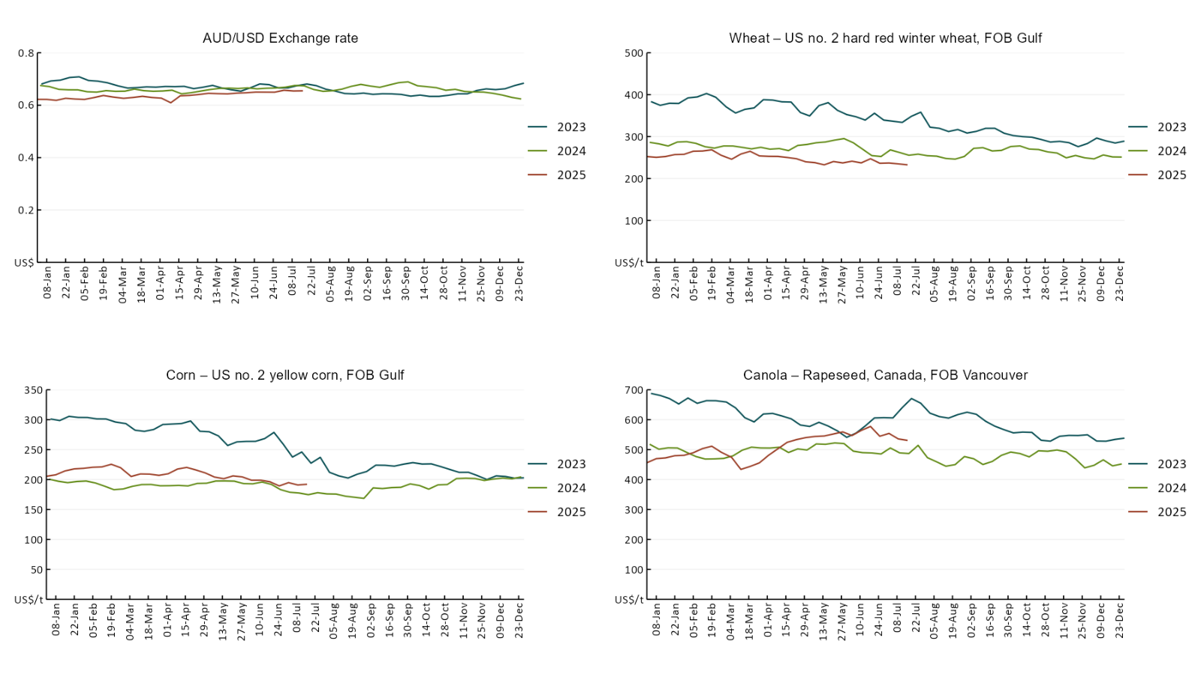

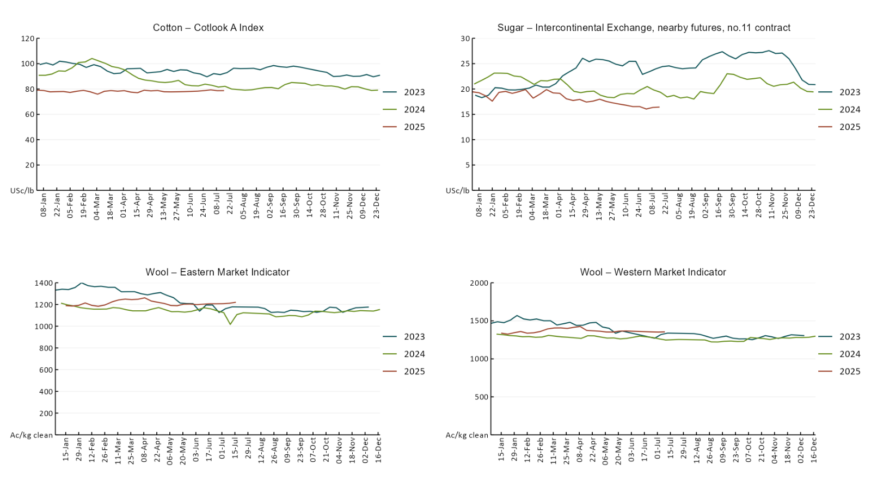

### 3.2 Selected domestic crop indicator prices A line chart of major domestic crop prices. For more information, refer to https://www.agriculture.gov.au/abares/data/weekly-commodity-price-update/world-agricultural-prices

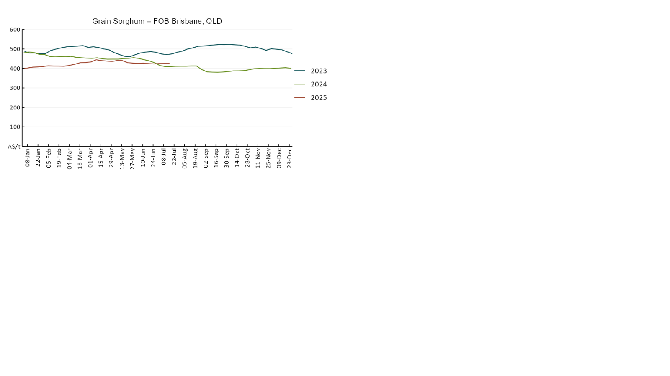

### 3.3 Selected domestic livestock indicator prices

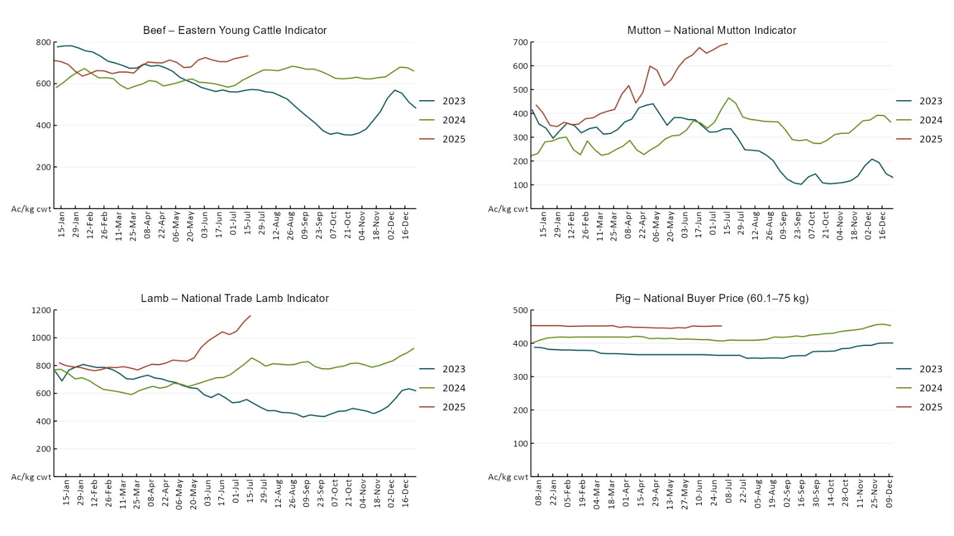

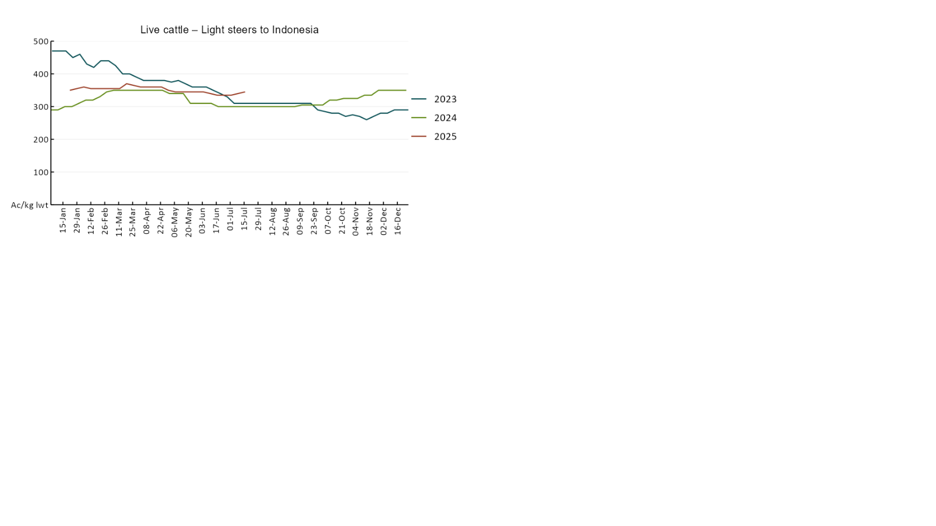

### 3.4 Global Dairy Trade (GDT) weighted average pricesA line chart of Global Dairy Trade prices. For more information, refer to https://www.agriculture.gov.au/abares/data/weekly-commodity-price-update/world-agricultural-prices

### 3.5 Selected fruit and vegetable prices

### A line chart of fruit and vegetable prices. For more information, refer to https://www.agriculture.gov.au/abares/data/weekly-commodity-price-update/world-agricultural-prices

### A line chart of fruit and vegetable prices. For more information, refer to https://www.agriculture.gov.au/abares/data/weekly-commodity-price-update/world-agricultural-prices

### 3.6 Selected domestic fodder indicator prices

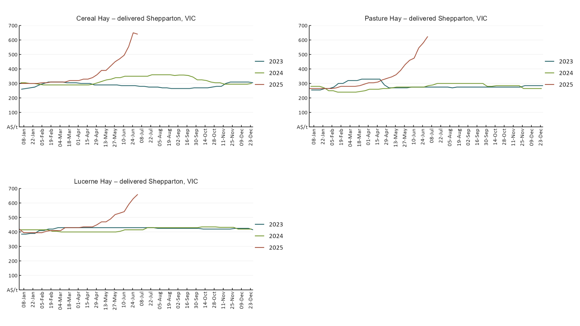

## **4. Data attribution**

### Climate

* Bureau of Meteorology
* Weekly rainfall totals: www.bom.gov.au/climate/maps/rainfall/
* Monthly and last 3-month rainfall percentiles: [www.bom.gov.au/water/landscape/](http://www.bom.gov.au/water/landscape/)
* Temperature anomalies: [www.bom.gov.au/jsp/awap/temp/index.jsp](http://www.bom.gov.au/jsp/awap/temp/index.jsp)
* Rainfall forecast: [www.bom.gov.au/jsp/watl/rainfall/pme.jsp](http://www.bom.gov.au/jsp/watl/rainfall/pme.jsp)
* Seasonal outlook: [www.bom.gov.au/climate/outlooks/#/overview/summary/](http://www.bom.gov.au/climate/outlooks/#/overview/summary/)
* Climate drivers: <http://www.bom.gov.au/climate/enso/>
* Soil moisture: [www.bom.gov.au/water/landscape/](http://www.bom.gov.au/water/landscape/)
* Other
* Pasture growth: [www.longpaddock.qld.gov.au/aussiegrass/](http://www.longpaddock.qld.gov.au/aussiegrass/)
* 3-month global outlooks: [Environment and Climate Change Canada](https://weather.gc.ca/saisons/image_e.html?img=s234pfe1p_cal&bc=prob), [NOAA Climate Prediction Center](https://www.cpc.ncep.noaa.gov/products/predictions/long_range/seasonal.php?lead=2), [EUROBRISA CPTEC/INPE](http://eurobrisa.cptec.inpe.br/), European Centre for Medium-Range Weather Forecasts, [Hydrometcenter of Russia](https://meteoinfo.ru/en/climate/seasonal-forecasts), [National Climate Center Climate System Diagnosis and Prediction Room (NCC)](https://cmdp.ncc-cma.net/pred/cs2gen.php?pred_elem=RAINP#pred_seasonal), [International Research Institute for Climate and Society](https://iri.columbia.edu/our-expertise/climate/forecasts/seasonal-climate-forecasts/)
* Global production: <https://ipad.fas.usda.gov/ogamaps/cropmapsandcalendars.aspx>
* Autumn break: Pook et al., 2009, <https://rmets-onlinelibrary-wiley-com.virtual.anu.edu.au/doi/epdf/10.1002/joc.1833>

### Water

Prices

* Waterflow: <https://www.waterflow.io/>
* Ruralco: <https://www.ruralcowater.com.au/>
* Bureau of Meteorology:
* Allocation trade: <http://www.bom.gov.au/water/dashboards/#/water-markets/mdb/at>
* Storage volumes: <http://www.bom.gov.au/water/dashboards/#/water-storages/summary/drainage>
* Trade constraints:
* Water NSW: <https://www.waternsw.com.au/customer-service/ordering-trading-and-pricing/trading/murrumbidgee>
* Victorian Water Register: <https://www.waterregister.vic.gov.au/TradingRules2019/>

### Commodities

* Fruit and vegetables
* Datafresh: [www.freshstate.com.au](http://www.freshstate.com.au)
* Pigs
* Australian Pork Limited: [www.australianpork.com.au](http://www.australianpork.com.au)
* Dairy
* Global Dairy Trade: [www.globaldairytrade.info/en/product-results/](http://www.globaldairytrade.info/en/product-results/)
* World wheat, canola
* International Grains Council
* World coarse grains
* United States Department of Agriculture
* World cotton
* Cotlook: [www.cotlook.com/](http://www.cotlook.com/)
* World sugar
* New York Stock Exchange - Intercontinental Exchange
* Wool
* Australian Wool Exchange: [www.awex.com.au/](http://www.awex.com.au/)
* Domestic wheat, barley, sorghum, canola and fodder
* Jumbuk Consulting Pty Ltd: http://www.jumbukag.com.au/
* Cattle, beef, mutton, lamb, goat and live export
* Meat and Livestock Australia: [www.mla.com.au/Prices-and-market](http://www.mla.com.au/Prices-and-market)

© Commonwealth of Australia 2025

### Ownership of intellectual property rights

Unless otherwise noted, copyright (and any other intellectual property rights, if any) in this publication is owned by the Commonwealth of Australia (referred to as the Commonwealth).

### Creative Commons licence

All material in this publication is licensed under a [Creative Commons Attribution 4.0 International Licence](https://creativecommons.org/licenses/by/4.0/legalcode) except content supplied by third parties, logos and the Commonwealth Coat of Arms.

Inquiries about the licence and any use of this document should be emailed to [copyright@awe.gov.au](mailto:copyright@awe.gov.au).

https://www.agriculture.gov.au/sites/default/files/images/creative-commons-logo-small.png

### Cataloguing data

This publication (and any material sourced from it) should be attributed as:

ABARES 2025, Weekly Australian Climate, Water and Agricultural Update, Australian Bureau of Agricultural and Resource Economics and Sciences, Canberra, 17 July 2025. CC BY 4.0 DOI: <https://doi.org/10.25814/5f3e04e7d2503>

ISSN **2652-7561**

This publication is available at https://www.agriculture.gov.au/abares/products/weekly_update

Department of Agriculture, Fisheries and Forestry

GPO Box 858 Canberra ACT 2601

Telephone 1800 900 090

Web [agriculture.gov.au/abares](http://awe.gov.au/abares)

### Disclaimer

The Australian Government acting through the Department of Agriculture, Fisheries and Forestry, represented by the Australian Bureau of Agricultural and Resource Economics and Sciences, has exercised due care and skill in preparing and compiling the information and data in this publication. Notwithstanding, the Department of Agriculture, Fisheries and Forestry, ABARES, its employees and advisers disclaim all liability, including liability for negligence and for any loss, damage, injury, expense or cost incurred by any person as a result of accessing, using or relying on any of the information or data in this publication to the maximum extent permitted by law.

### Statement of Professional Independence

The views and analysis presented in ABARES publications, including this one, reflect ABARES professionally independent findings, based on scientific and economic concepts, principles, information and data. These views, analysis and findings may not reflect or be consistent with the views or positions of the Australian Government, or of organisations or groups who have commissioned ABARES reports or analysis. More information on [professional independence](https://www.agriculture.gov.au/abares/about/research-and-analysis#professional-independence) is provided on the ABARES website.

### Acknowledgements

This report was prepared by Holly Beale and Emily Dahl.