## No. 30/2025 31 July 2025

# Summary of key issues

* In the week ending 30 July 2025, cold fronts brought rainfall totals of up to 100 millimetres to parts of southern, central and eastern Australia. High-pressure systems kept much of northern Australia largely dry.
  + Rainfall was recorded across all cropping regions, with Western Australia and Queensland seeing 5-100 millimetres, and South Australia and Victoria seeing 15-100 millimetres. Meanwhile, New South Wales recorded 5-50 millimetres.
  + Widespread rainfall over the past week across South Australia and Victoria has bolstered the yield potential for crops after a late and sporadic start to the season.
  + General rains across much of Western Australia, Queensland and New South Wales have provided useful follow-up moisture in these areas to support crop growth and development and to see some improvement in soil moisture reserves.
* Over the coming eight days, rainfall is expected to be highly variable across cropping regions.
  + Western Australia and northern New South Wales and are forecast to receive between 10-50 millimetres.
  + Meanwhile, parts of southern Queensland, central New South Wales, southern Victoria and western South Australia is forecast to receive between 5-15 millimetres. Remaining cropping regions are expected to remain largely dry.
  + If realised the falls in these areas are likely to provide some useful follow-up moisture to support crop growth and development and continue to build soil moisture reserves.
* The northern rainfall onset for 2025–26 is likely to be earlier than usual for most eastern parts of northern Australia but later than normal for much of the west.
* Water storage levels in the Murray-Darling Basin (MDB) increased by 381 gigalitres (GL) between 24 July 2025 and 31 July 2025. The current volume of water held in storages is 13,920 GL, equivalent to 63% of total storage capacity. This is 22% or 3,956 GL less than the same time last year. Water storage data is sourced from the Bureau of Meteorology (BOM).
* Allocation prices in the Victorian Murray below the Barmah Choke decreased from $286/ML on 24 July 2025 to $266/ML on 31 July 2025. Trade from the Goulburn to the Murray is closed. Trade downstream through the Barmah Choke is closed. Trade from the Murrumbidgee to the Murray is open.

## **Climate**

### Rainfall this week

In the week ending 30 July 2025, **cold fronts and low-pressure systems** brought rainfall to parts of southern, central and eastern Australia, while northern areas of Australia stayed largely dry.

* Rainfall totals of between 10-100 millimetres were recorded across much southern Western Australia and South Australia, as well as Victoria, New South Wales, Tasmania, and much of southern and central Queensland.
* Falls of between 5-50 millimetres occurred across parts of central Australia and northern Queensland.
* Remaining areas of northern Australia received little to no rainfall over the period.

Rainfall was recorded across all cropping regions in the week ending 30 July 2025.

* Rainfall totals of between 15-100 millimetres occurred across Victoria and South Australia.
  + Widespread rainfall in over the past week across South Australia and Victoria has bolstered the yield potential for crops after a late and sporadic start to the season.
  + Some regions had their first falls of more than 30 millimetres in 18 months or more, creating some run-off to help fill dams, and starting to build soil moisture reserves under cereal, pulse, and canola crops, as well as pastures.
* Between 5-100 millimetres fell across Western Australia and Queensland, while New South Wales saw 5-50 millimetres.
  + These conditions have provided useful follow-up moisture in these areas to support crop growth and development and to see some improvement in soil moisture reserves.

#### Rainfall for the week ending 30 July 2025

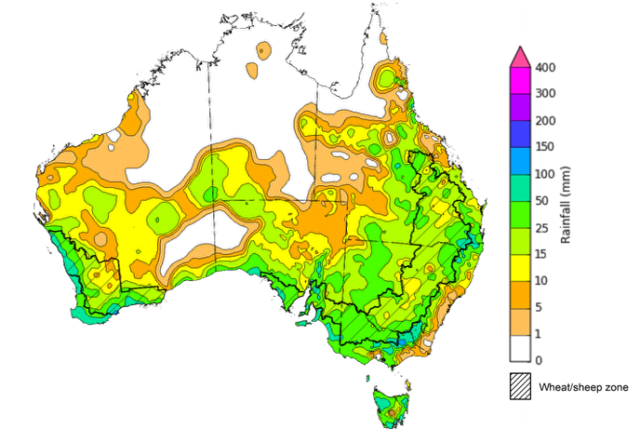

©Commonwealth of Australia 2025, Australian Bureau of Meteorology Issued: 30/7/2025

Note: The rainfall analyses and associated maps utilise data contained in the Bureau of Meteorology climate database, the Australian Data Archive for Meteorology (ADAM). The analyses are initially produced automatically from real-time data with limited [quality control](http://www.bom.gov.au/climate/headers/qc.shtml). They are intended to provide a general overview of rainfall across Australia as quickly as possible after the observations are received. For further information go to <http://www.bom.gov.au/climate/rainfall/>

### Rainfall forecast for the next eight days

Over the 8 days to 7 August 2025, **low pressure systems** are expected to bring rainfall to parts of the east, south and west of the country, while northern and central regions are expected to remain largely dry.

* Rainfall totals of between 5-100 millimetres are expected across much of Western Australia and eastern and northern regions of New South Wales. In Tasmania, 5-50 millimetres of rainfall are forecast.
* Falls of between 5-15 millimetres are forecast for parts of northern and southern Queensland, southern Victoria and the west and south of South Australia.
* Remaining areas are forecast to remain largely dry.

Rainfall is likely to be highly variable across cropping regions over the coming week.

* Falls of between 10-50 millimetres are forecast across Western Australia and northern New South Wales. Parts of southern Queensland, central New South Wales, southern Victoria and western South Australia are forecast to receive between 5-15 millimetres.
  + If realised the falls in these areas are likely to provide some useful follow-up moisture to support crop growth and development and continue to build soil moisture reserves.
* Remaining cropping regions are expected to remain largely dry.

#### Total forecast rainfall for the period 31 July to 7 August 2025

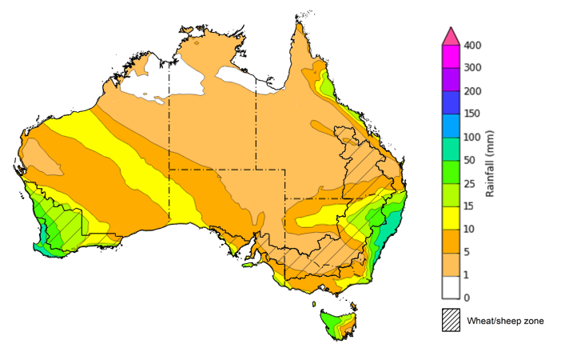

©Commonwealth of Australia 2025, Australian Bureau of Meteorology Issued 31/7/2025

Note: This rainfall forecast is produced from computer models. As the model outputs are not altered by weather forecasters, it is important to check local forecasts and warnings issued by the Bureau of Meteorology.

### 

### Northern rainfall onset

The northern rainfall onset outlook provides an indication of whether the first significant rains after the dry season are likely to be earlier or later than normal. The onset occurs when the total rainfall after 1 September reaches 50 millimetres, which is considered approximately the amount of rainfall required to stimulate plant growth. The northern rainfall onset for the 2025–26 season is likely to be later than usual for most of the western parts of northern Australia, but earlier for much of the east. Much of Western Australia have a 60–75% chance of a later than usual northern rainfall onset. Across Queensland and parts of the east of Northern Territory, the rainfall onset is likely (60–75%) to be earlier than usual. Elsewhere, the northern rainfall onset is likely to be closer to the normal onset date.

**Chance of early Northern Rainfall Onset**

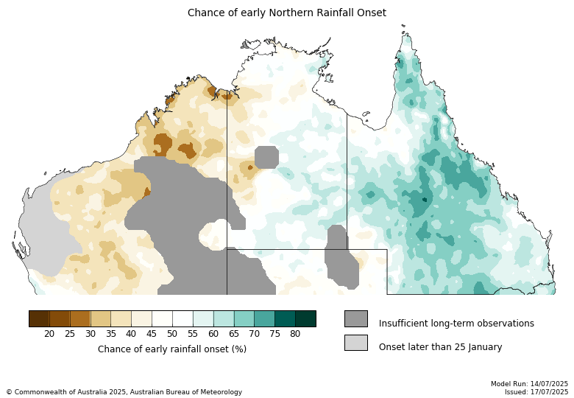

### Water markets – current week

#### Water storage levels in the Murray-Darling Basin (MDB) increased by 381 gigalitres (GL) between 24 July 2025 and 31 July 2025. The current volume of water held in storages is 13,920 GL, equivalent to 63% of total storage capacity. This is 22% or 3,956 GL less than the same time last year. Water storage data is sourced from the Bureau of Meteorology (BOM).

#### Water storages in the Murray-Darling Basin, 2013–2025Alt Text: A chart showing water storage in the Murray-Darling Basin. For more information, refer to accompanying text

Allocation prices in the Victorian Murray below the Barmah Choke decreased from $286/ML on 24 July 2025 to $266/ML on 31 July 2025. Trade from the Goulburn to the Murray is closed. Trade downstream through the Barmah Choke is closed. Trade from the Murrumbidgee to the Murray is open.

#### Surface water trade activity, Southern Murray–Darling Basin

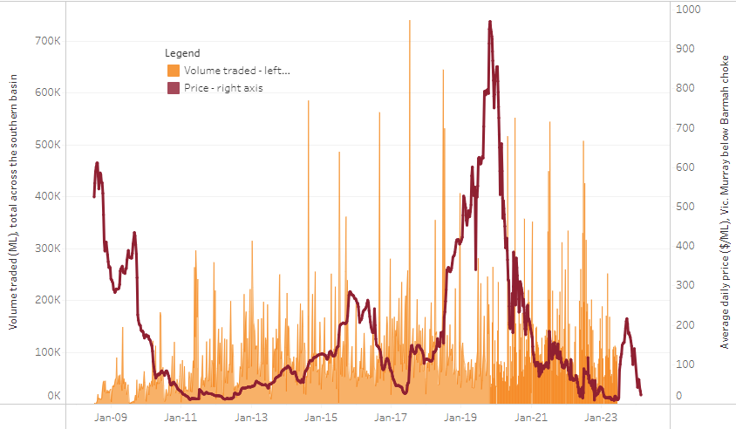

|  |
| --- |
| The trades shown reflect estimated market activity and do not encompass all register trades. The price is shown for the VIC Murray below the Barmah choke. Historical prices (before 1 July 2019) are ABARES estimates after removing outliers from BOM water register data. Prices after 1 July 2019 and prior to the 30 October 2019 reflect recorded transaction prices as sourced from Ruralco. Prices after the 30 October 2019 are sourced from Waterflow. Data for volume traded is sourced from the BOM water register. Only the price data shown is current on 17 October 2024. |

To access the full, interactive, weekly water dashboard, which contains the latest and historical water storage, water market and water allocation information, please visit <https://www.agriculture.gov.au/abares/products/weekly_update/weekly-update-310725>

## **Commodities**

|  |  |  |  |  |  |  |  |  |
| --- | --- | --- | --- | --- | --- | --- | --- | --- |
| **Indicator** | **Week average** | **Unit** | **Latest Price** | **Previous Week** | **Weekly change** | | **Price 12 months ago** | **Annual change** |
| **Selected world indicator prices** |  |  |  |  |  |  | |  |
| AUD/USD Exchange rate | 30-Jul | A$/US$ | 0.65 | 0.66 | 0% | 0.67 | | -2% |
| Wheat – US no. 2 hard red winter wheat, FOB Gulf | 30-Jul | US$/t | 234 | 234 | 0% | 260 | | -10% |
| Corn – US no. 2 yellow corn, FOB Gulf | 30-Jul | US$/t | 189 | 194 | -3% | 177 | | 7% |
| Canola – Rapeseed, Canada, FOB Vancouver | 30-Jul | US$/t | 535 | 540 | -1% | 494 | | 8% |
| Cotton – Cotlook A Index | 30-Jul | USc/lb | 79 | 79 | 0% | 81 | | -3% |
| Sugar – Intercontinental Exchange, nearby futures, no.11 contract | 30-Jul | USc/lb | 17 | 16 | 1% | 19 | | -15% |
| Wool – Eastern Market Indicator | 23-Jul | Ac/kg clean | 1,239 | 1,221 | 1% | 1,093 | | 13% |
| Wool – Western Market Indicator | 23-Jul | Ac/kg clean | 1,373 | 1,355 | 1% | 1,254 | | 9% |
| **Selected Australian grain export prices** |  |  |  |  |  |  | |  |
| Australian Premium White (APW) Wheat, FOB Port Adelaide, SA | 30-Jul | A$/t | 391 | 389 | 1% | 424 | | -8% |
| Australian Standard White (ASW) Wheat, FOB Port Adelaide, SA | 30-Jul | A$/t | 387 | 385 | 1% | 415 | | -7% |
| Feed Barley – FOB Port Adelaide, SA | 30-Jul | A$/t | 369 | 370 | 0% | 367 | | 1% |
| Canola – FOB Kwinana, WA | 30-Jul | A$/t | 813 | 814 | 0% | 757 | | 7% |
| Grain Sorghum – FOB Brisbane, QLD | 30-Jul | A$/t | 427 | 426 | 0% | 411 | | 4% |
| **Selected domestic livestock indicator prices** |  |  |  |  |  |  | |  |
| Beef – Eastern Young Cattle Indicator | 30-Jul | Ac/kg cwt | 786 | 761 | 3% | 631 | | 25% |
| Mutton – Mutton indicator (18–24 kg fat score 2–3), VIC | 30-Jul | Ac/kg cwt | 710 | 693 | 2% | 415 | | 71% |
| Lamb – National Trade Lamb Indicator | 30-Jul | Ac/kg cwt | 1,185 | 1,189 | 0% | 813 | | 46% |
| Pig – Eastern Seaboard (60.1–75 kg), NSW buyer price | 16-Jul | Ac/kg cwt | 452 | 451 | 0% | 409 | | 11% |
| Live cattle – Light steers to Indonesia | 16-Jul | Ac/kg lwt | 345 | 340 | 1% | 300 | | 15% |
| **Global Dairy Trade (GDT) weighted average prices** |  |  |  |  |  |  | |  |
| Dairy – Whole milk powder | 16-Jul | US$/t | 3,928 | 3,859 | 2% | 3,180 | | 24% |
| Dairy – Skim milk powder | 16-Jul | US$/t | 2,785 | 2,718 | 2% | 2,576 | | 8% |
| Dairy – Cheddar cheese | 16-Jul | US$/t | 4,589 | 4,860 | -6% | 4,099 | | 12% |
| Dairy – Anhydrous milk fat | 16-Jul | US$/t | 6,973 | 6,928 | 1% | 6,641 | | 5% |
|  | | | | | | | | |

### Selected world indicator prices

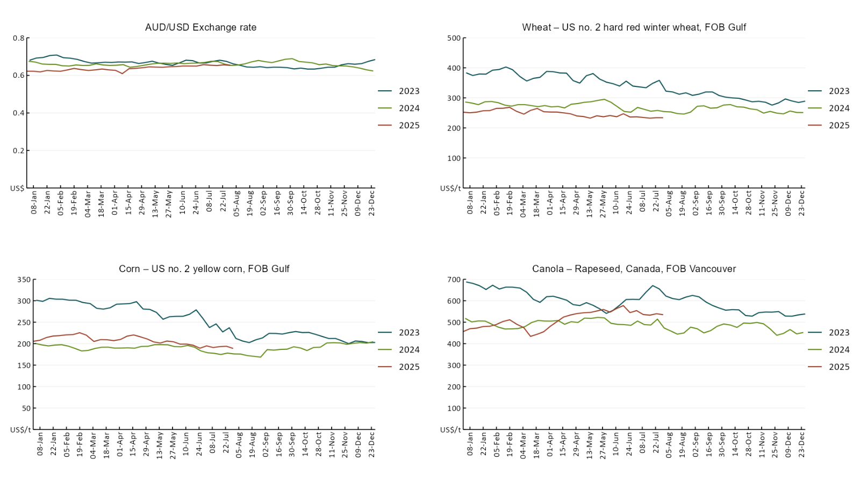

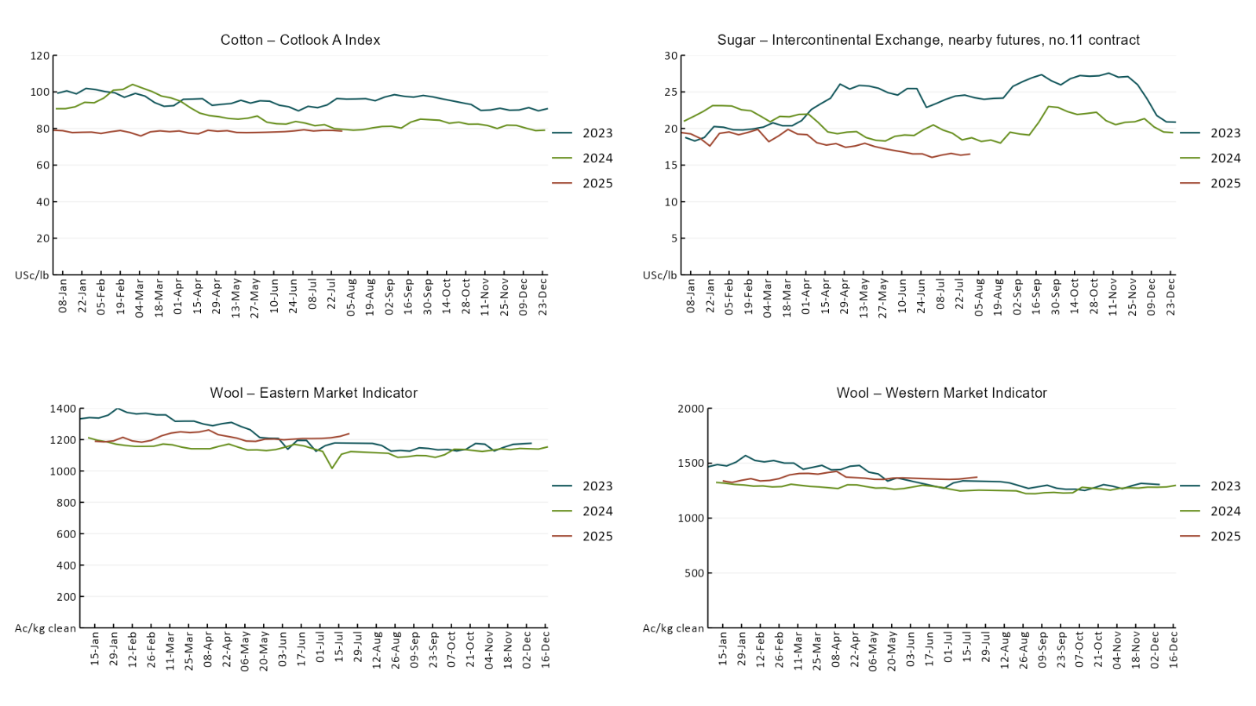

### 3.2 Selected domestic crop indicator prices A line chart of major domestic crop prices. For more information, refer to https://www.agriculture.gov.au/abares/data/weekly-commodity-price-update/world-agricultural-prices

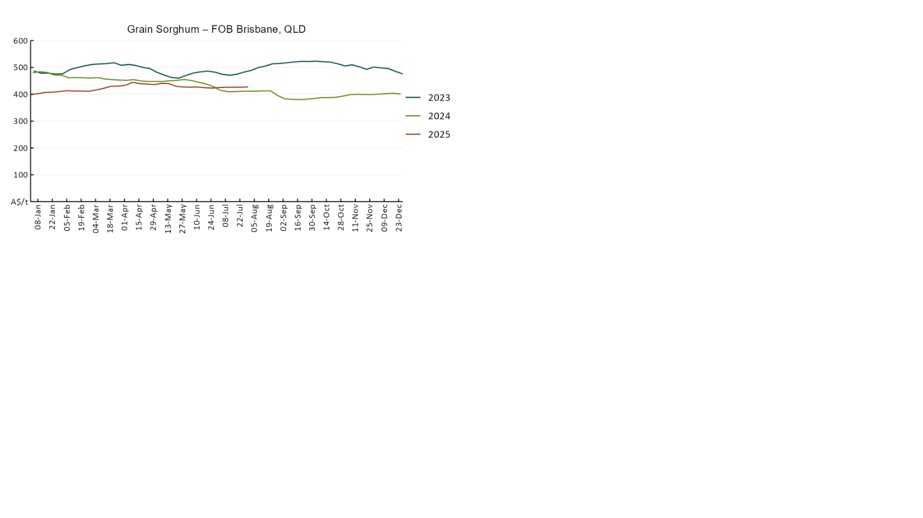

### 3.3 Selected domestic livestock indicator prices

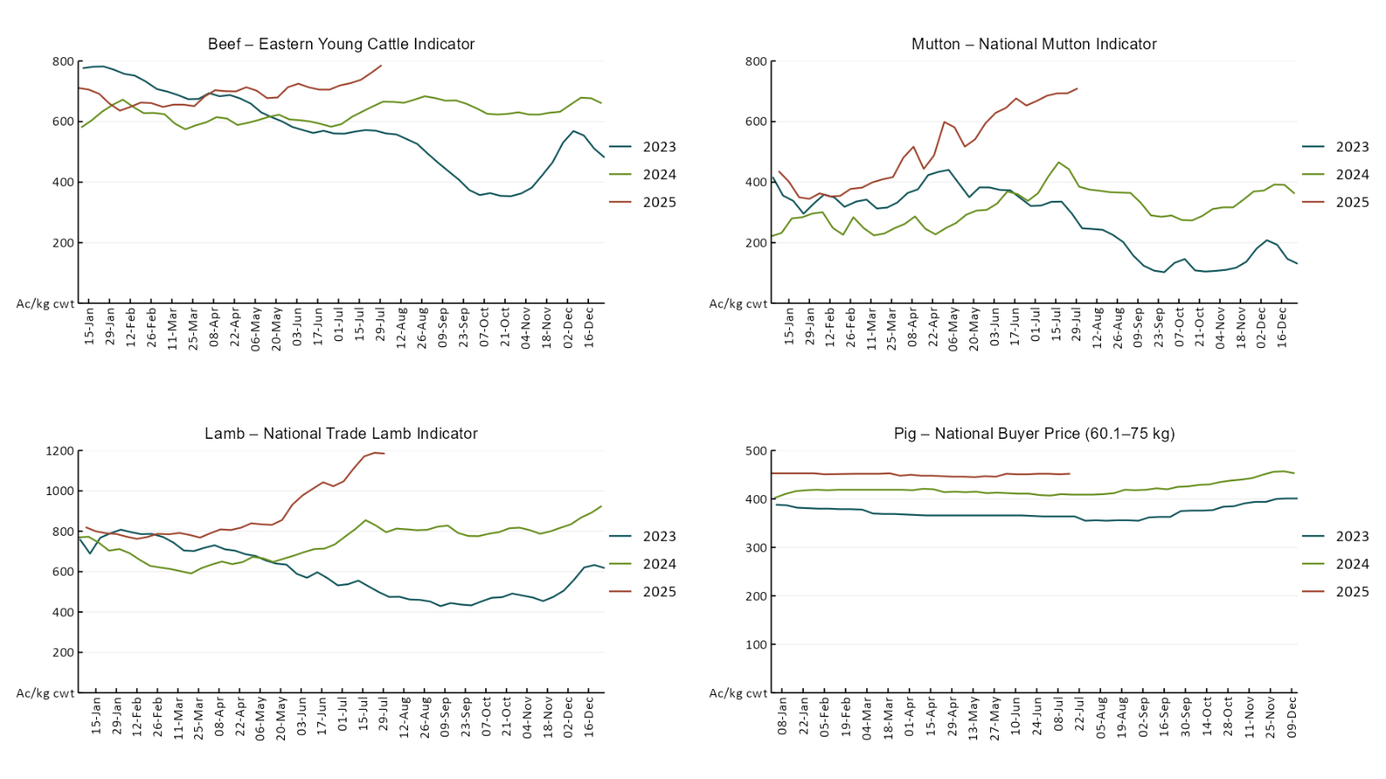

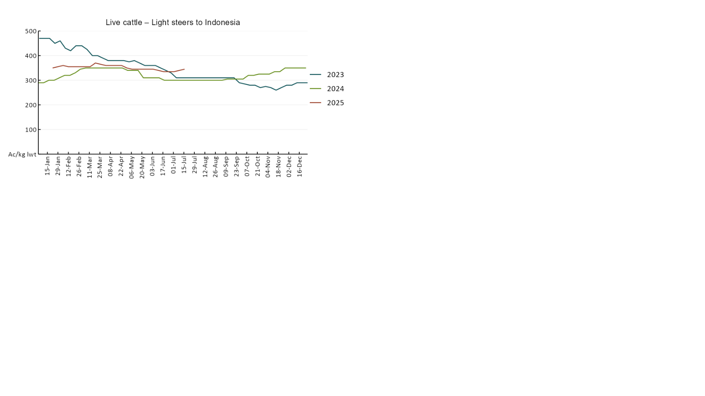

### 3.4 Global Dairy Trade (GDT) weighted average pricesA line chart of Global Dairy Trade prices. For more information, refer to https://www.agriculture.gov.au/abares/data/weekly-commodity-price-update/world-agricultural-prices

### 3.5 Selected fruit and vegetable prices

### A line chart of fruit and vegetable prices. For more information, refer to https://www.agriculture.gov.au/abares/data/weekly-commodity-price-update/world-agricultural-prices

### A line chart of fruit and vegetable prices. For more information, refer to https://www.agriculture.gov.au/abares/data/weekly-commodity-price-update/world-agricultural-prices

### 3.6 Selected domestic fodder indicator prices

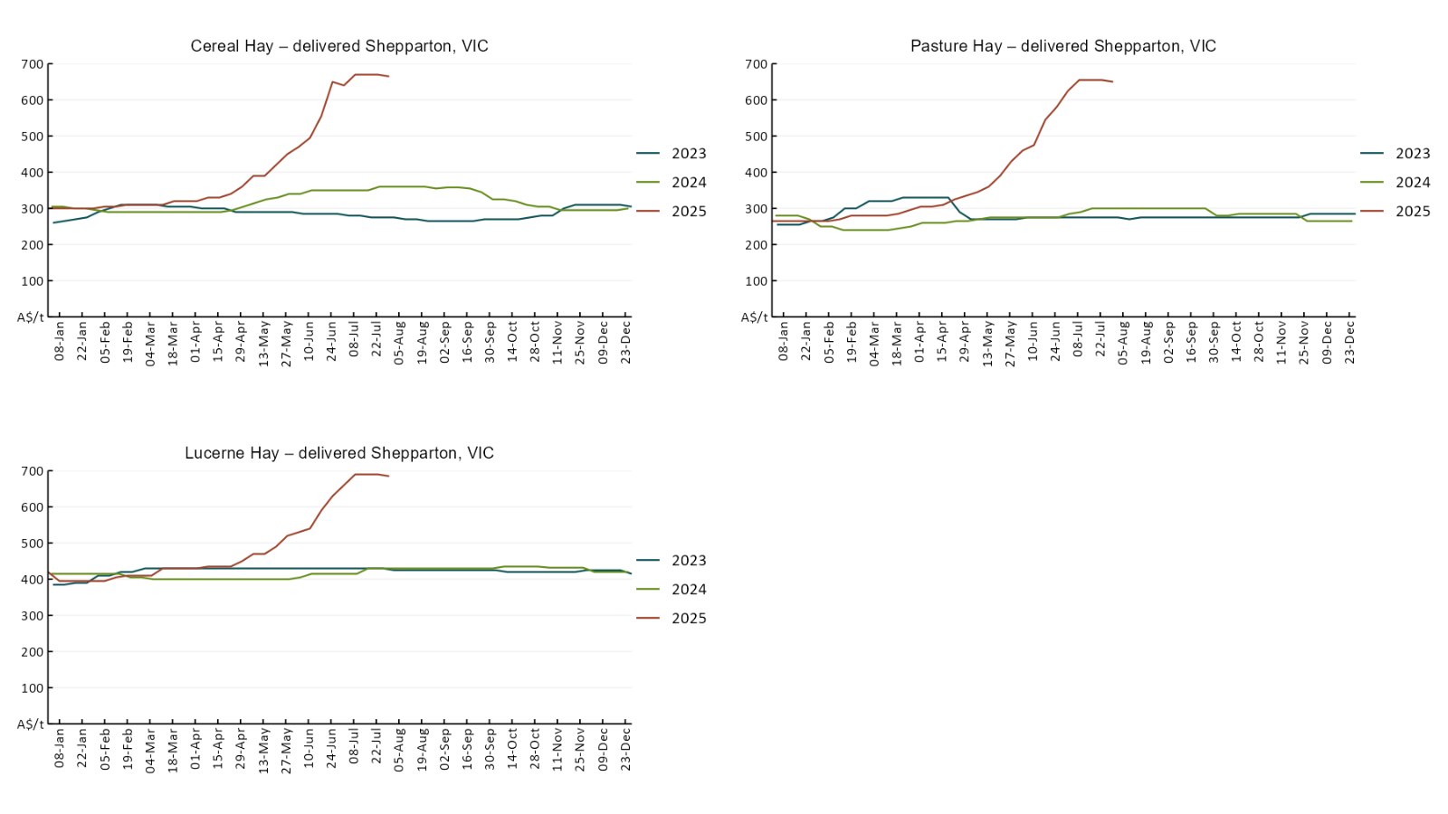

## **4. Data attribution**

### Climate

* Bureau of Meteorology
* Weekly rainfall totals: www.bom.gov.au/climate/maps/rainfall/
* Monthly and last 3-month rainfall percentiles: [www.bom.gov.au/water/landscape/](http://www.bom.gov.au/water/landscape/)
* Temperature anomalies: [www.bom.gov.au/jsp/awap/temp/index.jsp](http://www.bom.gov.au/jsp/awap/temp/index.jsp)
* Rainfall forecast: [www.bom.gov.au/jsp/watl/rainfall/pme.jsp](http://www.bom.gov.au/jsp/watl/rainfall/pme.jsp)
* Seasonal outlook: [www.bom.gov.au/climate/outlooks/#/overview/summary/](http://www.bom.gov.au/climate/outlooks/#/overview/summary/)
* Climate drivers: <http://www.bom.gov.au/climate/enso/>
* Soil moisture: [www.bom.gov.au/water/landscape/](http://www.bom.gov.au/water/landscape/)
* Other
* Pasture growth: [www.longpaddock.qld.gov.au/aussiegrass/](http://www.longpaddock.qld.gov.au/aussiegrass/)
* 3-month global outlooks: [Environment and Climate Change Canada](https://weather.gc.ca/saisons/image_e.html?img=s234pfe1p_cal&bc=prob), [NOAA Climate Prediction Center](https://www.cpc.ncep.noaa.gov/products/predictions/long_range/seasonal.php?lead=2), [EUROBRISA CPTEC/INPE](http://eurobrisa.cptec.inpe.br/), European Centre for Medium-Range Weather Forecasts, [Hydrometcenter of Russia](https://meteoinfo.ru/en/climate/seasonal-forecasts), [National Climate Center Climate System Diagnosis and Prediction Room (NCC)](https://cmdp.ncc-cma.net/pred/cs2gen.php?pred_elem=RAINP#pred_seasonal), [International Research Institute for Climate and Society](https://iri.columbia.edu/our-expertise/climate/forecasts/seasonal-climate-forecasts/)
* Global production: <https://ipad.fas.usda.gov/ogamaps/cropmapsandcalendars.aspx>
* Autumn break: Pook et al., 2009, <https://rmets-onlinelibrary-wiley-com.virtual.anu.edu.au/doi/epdf/10.1002/joc.1833>

### Water

Prices

* Waterflow: <https://www.waterflow.io/>
* Ruralco: <https://www.ruralcowater.com.au/>
* Bureau of Meteorology:
* Allocation trade: <http://www.bom.gov.au/water/dashboards/#/water-markets/mdb/at>
* Storage volumes: <http://www.bom.gov.au/water/dashboards/#/water-storages/summary/drainage>
* Trade constraints:
* Water NSW: <https://www.waternsw.com.au/customer-service/ordering-trading-and-pricing/trading/murrumbidgee>
* Victorian Water Register: <https://www.waterregister.vic.gov.au/TradingRules2019/>

### Commodities

* Fruit and vegetables
* Datafresh: [www.freshstate.com.au](http://www.freshstate.com.au)
* Pigs
* Australian Pork Limited: [www.australianpork.com.au](http://www.australianpork.com.au)
* Dairy
* Global Dairy Trade: [www.globaldairytrade.info/en/product-results/](http://www.globaldairytrade.info/en/product-results/)
* World wheat, canola
* International Grains Council
* World coarse grains
* United States Department of Agriculture
* World cotton
* Cotlook: [www.cotlook.com/](http://www.cotlook.com/)
* World sugar
* New York Stock Exchange - Intercontinental Exchange
* Wool
* Australian Wool Exchange: [www.awex.com.au/](http://www.awex.com.au/)
* Domestic wheat, barley, sorghum, canola and fodder
* Jumbuk Consulting Pty Ltd: http://www.jumbukag.com.au/
* Cattle, beef, mutton, lamb, goat and live export
* Meat and Livestock Australia: [www.mla.com.au/Prices-and-market](http://www.mla.com.au/Prices-and-market)

© Commonwealth of Australia 2025

### Ownership of intellectual property rights

Unless otherwise noted, copyright (and any other intellectual property rights, if any) in this publication is owned by the Commonwealth of Australia (referred to as the Commonwealth).

### Creative Commons licence

All material in this publication is licensed under a [Creative Commons Attribution 4.0 International Licence](https://creativecommons.org/licenses/by/4.0/legalcode) except content supplied by third parties, logos and the Commonwealth Coat of Arms.

Inquiries about the licence and any use of this document should be emailed to [copyright@awe.gov.au](mailto:copyright@awe.gov.au).

https://www.agriculture.gov.au/sites/default/files/images/creative-commons-logo-small.png

### Cataloguing data

This publication (and any material sourced from it) should be attributed as:

ABARES 2025, Weekly Australian Climate, Water and Agricultural Update, Australian Bureau of Agricultural and Resource Economics and Sciences, Canberra, 31 July 2025. CC BY 4.0 DOI: <https://doi.org/10.25814/5f3e04e7d2503>

ISSN **2652-7561**

This publication is available at https://www.agriculture.gov.au/abares/products/weekly_update

Department of Agriculture, Fisheries and Forestry

GPO Box 858 Canberra ACT 2601

Telephone 1800 900 090

Web [agriculture.gov.au/abares](http://awe.gov.au/abares)

### Disclaimer

The Australian Government acting through the Department of Agriculture, Fisheries and Forestry, represented by the Australian Bureau of Agricultural and Resource Economics and Sciences, has exercised due care and skill in preparing and compiling the information and data in this publication. Notwithstanding, the Department of Agriculture, Fisheries and Forestry, ABARES, its employees and advisers disclaim all liability, including liability for negligence and for any loss, damage, injury, expense or cost incurred by any person as a result of accessing, using or relying on any of the information or data in this publication to the maximum extent permitted by law.

### Statement of Professional Independence

The views and analysis presented in ABARES publications, including this one, reflect ABARES professionally independent findings, based on scientific and economic concepts, principles, information and data. These views, analysis and findings may not reflect or be consistent with the views or positions of the Australian Government, or of organisations or groups who have commissioned ABARES reports or analysis. More information on [professional independence](https://www.agriculture.gov.au/abares/about/research-and-analysis#professional-independence) is provided on the ABARES website.

### Acknowledgements

This report was prepared by Holly Beale and Matt Miller.