## No. 31/2025 7 August 2025

# Summary of key issues

* In the week ending 6 August 2025, low-pressure systems brought rainfall totals of up to 200 millimetres to parts of eastern and south-western Australia.
  + In cropping regions, rainfall was mixed. Western Australia and northern New South Wales saw 5-50 millimetres, while South Australia and southern Queensland saw 5-25 millimetres. Remaining areas remained largely dry.
  + A lack of rainfall across parts of southern New South Wales presents a downside production risk with some areas experiencing dry conditions in June and July.
* Over the coming eight days, rainfall is expected to be low across cropping regions in the southeast.
  + Falls of between 10-50 millimetres are forecast across Western Australia and Queensland.
  + Meanwhile, falls of between 5-15 millimetres are expected in northern New South Wales, Victoria and South Australia. In contrast, much of southern New South Wales is expected to remain largely dry.
  + If realised these falls are likely to be sufficient to support the growth and development in most areas and see some ongoing improvement in contribute to a soil moisture reserves in Queensland and South Australia. However, the expected lack of rainfall across southern New South Wales, continues to present a downside production risk for crops and pastures.
* Above average rainfall during July across parts of southern Australia, including South Australia and Victoria, would have provide sufficient rainfall to support development, however continued timely rainfall is required to support yield potential of crops in regions that have seen recent dry conditions include southern New South Wales. Both, upper layer and lower layer soil moisture levels in southern cropping regions have improved compared to June 2025, however lower layer soil moisture remains below average to extremely low in some areas.
* Below average pasture growth for the three months to July 2025 across large areas of Victoria, South Australia, Western Australia, and north-western and southern New South Wales will likely see graziers in these regions actively destocking or remaining reliant on supplemental feed to maintain current stocking rates and production.
* Water storage levels in the Murray-Darling Basin (MDB) increased by 551 gigalitres (GL) between 31 July 2025 and 07 August 2025. The current volume of water held in storages is 14,471 GL, equivalent to 65% of total storage capacity. This is 20% or 3,632 GL less than the same time last year. Water storage data is sourced from the Bureau of Meteorology (BOM).
* Allocation prices in the Victorian Murray below the Barmah Choke increased from $266/ML on 31 July 2025 to $269/ML on 07 August 2025. Trade from the Goulburn to the Murray is closed. Trade downstream through the Barmah Choke is closed. Trade from the Murrumbidgee to the Murray is open.

## **Climate**

### Rainfall this week

In the week ending 6 August 2025, **low-pressure systems** brought rainfall to parts of eastern and south-western Australia, while northern and central areas of Australia stayed largely dry.

* Rainfall totals of between 10-100 millimetres were recorded across much of south-western Western Australia, while western and northern Tasmania saw between 5-50 millimetres.
* In northern and eastern New South Wales, most areas saw between 5-100 millimetres, while some coastal regions saw up to 200 millimetres. This contributed to heavy snowfalls across parts of the Northern Tablelands.
* Falls across the remaining southern regions were highly variable. Parts of South Australia, Victoria, and southern New South Wales recording between 1-10 millimetres of rainfall, with up to 50 millimetres in isolated areas.

Rainfall was highly variable across winter cropping regions in the week ending 6 August 2025.

* Rainfall of between 5-50 millimetres was observed in Western Australia and northern New South Wales. While parts of southern Queensland and western South Australia saw falls of between 5 and 25 millimetres.
  + These falls are likely to see a continuation in the improvement of soil moisture levels in these regions and support the growth and development of winter crops
* In contrast, much of Victoria, southern New South Wales and remaining areas in Queensland and South Australia saw little to no rainfall.
  + Many of these areas have recently seen favourable rainfall during July. However, parts of southern New South Wales saw below average rainfall during June and July. The lack of rainfall across parts of southern New South Wales presents an emerging downside production risk, with adequate and timely rainfall required in the coming weeks to support crop growth and development.

#### Rainfall for the week ending 6 August 2025

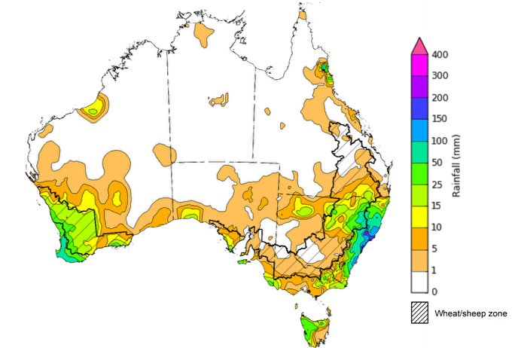

©Commonwealth of Australia 2025, Australian Bureau of Meteorology Issued: 6/8/2025

Note: The rainfall analyses and associated maps utilise data contained in the Bureau of Meteorology climate database, the Australian Data Archive for Meteorology (ADAM). The analyses are initially produced automatically from real-time data with limited [quality control](http://www.bom.gov.au/climate/headers/qc.shtml). They are intended to provide a general overview of rainfall across Australia as quickly as possible after the observations are received. For further information go to <http://www.bom.gov.au/climate/rainfall/>

### Rainfall forecast for the next eight days

Over the 8 days to 14 August 2025, **low pressure systems and a northwest cloudband** are expected to bring rainfall to parts of the east and southwest of the country, while northern and central regions are expected to remain largely dry.

* Rainfall totals of between 5-50 millimetres are expected across much of southern Western Australia, as well as coastal regions of New South Wales, and eastern and central Queensland.
  + Isolated parts of Western Australia are forecast to receive up to 100 millimetres.
* Falls of between 5-25 millimetres are forecast for much of Tasmania. While parts of northern and central New South Wales, Victoria and southern South Australia may see falls of between 5 and 15 millimetres.
* Remaining areas are forecast to remain largely dry.

Rainfall is likely to be low across south-eastern cropping regions over the coming week, with heavier fall expected in the north and west.

* Falls of between 10-50 millimetres are forecast across Western Australia and Queensland. Falls of between 5-15 millimetres are expected in northern New South Wales, Victoria and South Australia.
  + If realised these falls are likely to be sufficient to support the growth and development in most areas and see some ongoing improvement in contribute to a soil moisture reserves in Queensland and South Australia.
* Much of southern New South Wales cropping regions are expected to remain largely dry.
  + This continues to present a downside production risk, following a relatively dry June and July in some areas.

#### Total forecast rainfall for the period 7 August to 14 August 2025

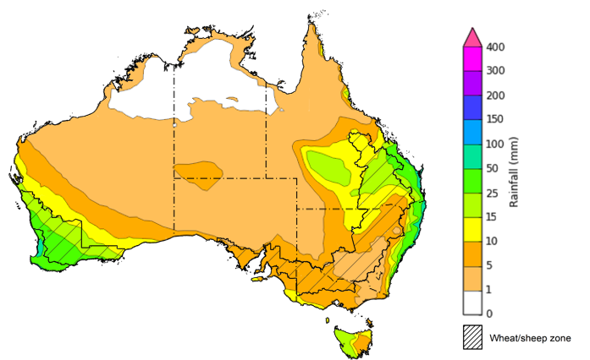

©Commonwealth of Australia 2025, Australian Bureau of Meteorology Issued 7/8/2025

Note: This rainfall forecast is produced from computer models. As the model outputs are not altered by weather forecasters, it is important to check local forecasts and warnings issued by the Bureau of Meteorology.

### 

### Monthly rainfall

Rainfall during July 2025 was generally average to above average, with isolated areas of low rainfall:

* Rainfall was average to extremely high across large areas of southern Australia, southern Western Australia, South Australia, northern and eastern Victoria, western and coastal New South Wales, and parts of the northern tropics.
* Below average rainfall was recorded in isolated areas of Western Australia, southern New South Wales, southern Victoria and Tasmania, and parts of far-northern Queensland and the Northern Territory.
* The remainder of Australia saw generally average July rainfall.

In cropping regions, July rainfall was generally high in the south, and average in the east:

* July rainfall was above average across cropping regions in southern and northern Western Australia, western and central South Australia, Victoria and parts of northern New South Wales and Queensland.
* In southern Queensland and New South Wales, as well as parts of eastern South Australia, and central Western Australia rainfall was broadly average.
  + The average to well above average rainfall conditions recorded across most cropping regions in South Australia, Victoria, northern New South Wales, Western Australia and Queensland are likely to have been sufficient to support the growth and development of crops and pastures. However, below average rainfall during July across parts of south New South Wales continues to present a downside production risk.

**Rainfall percentiles for July 2025**

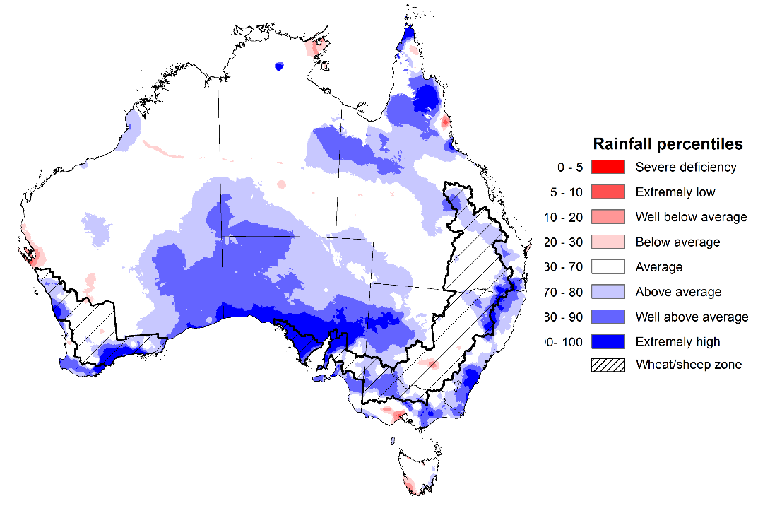

Note: Rainfall for July 2025 is compared with rainfall recorded for that period during the historical record (1900 to present). For further information, go to <http://www.bom.gov.au/climate/austmaps/about-rain-maps.shtml>

Source: Bureau of Meteorology

### Monthly Soil Moisture

In July 2025, modelled **upper layer soil moisture** was generally average to above average, with areas of below soil moisture in scattered central and northern areas.

* Isolated areas of southern Western Australia, central New South Wales, the central Northern Territory and the northern tropics saw very much below average to below average upper layer soil moisture.
* In contrast, much of the southern and eastern Australia, including southwest Western Australia, southern South Australia, Victoria, eastern New South Wales and much of Queensland saw above average to very much above upper layer soil moisture.

At this time of year, upper layer soil moisture is important for the vegetative growth of winter crops across Australian cropping regions. Across some eastern cropping regions, modelled upper layer soil moisture in July was generally **below average to average**. In contrast, most cropping regions in the south saw **average to very much above average** upper layer soil moisture.

* Across parts of New South Wales and southern Queensland, upper layer soil moisture was below average to average.
* In southern Western Australia, South Australia, Victoria and northern Queensland, upper layer soil moisture was average to very much above average.

This represents a substantial improvement in growing conditions in southern cropping regions compared to June 2025, however adequate and timely rainfall throughout the remainder of the growing season will be needed to support ongoing improvements in cropping and pasture growth outcomes.

**Modelled upper layer soil moisture for July 2025**

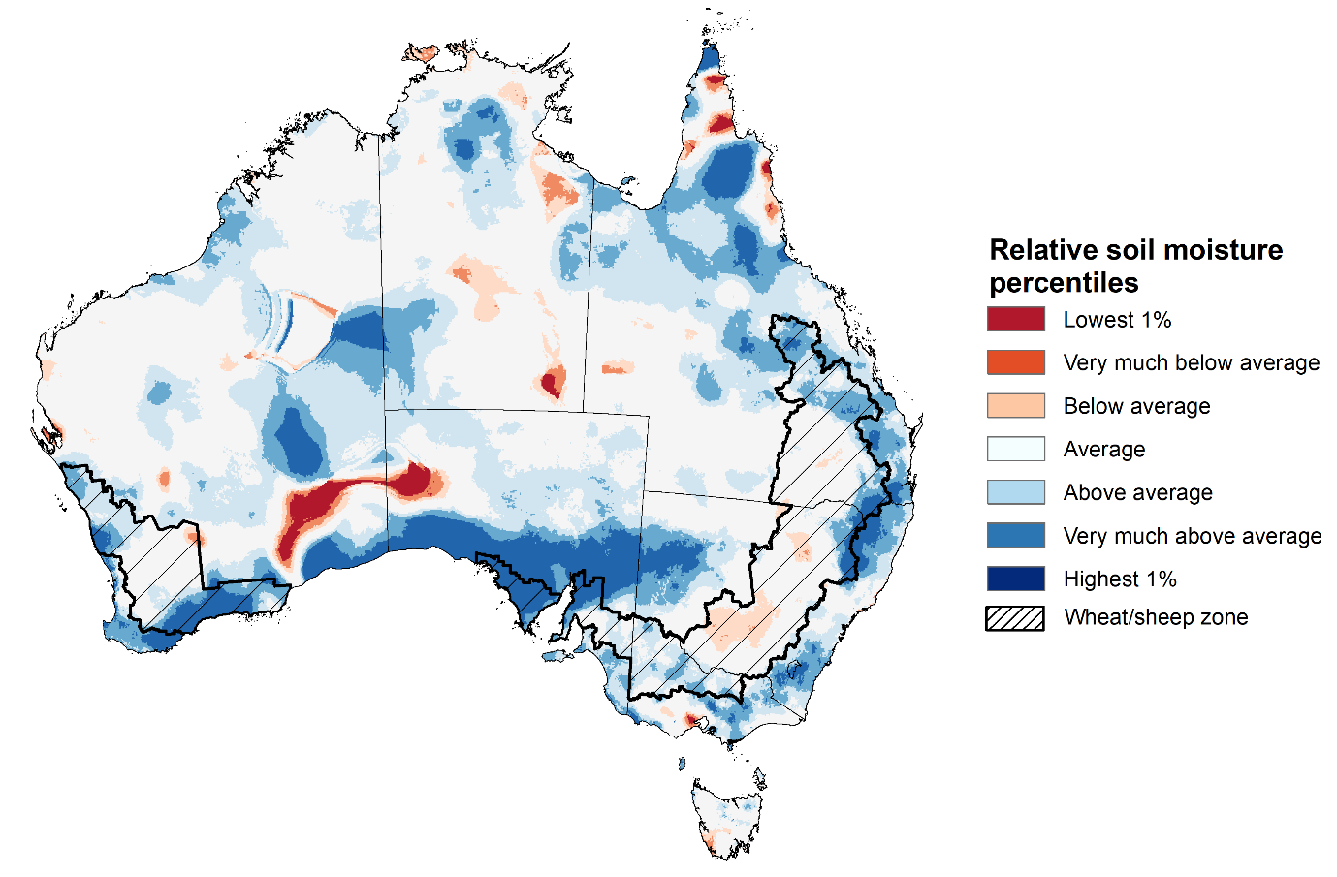

Note: This map shows the levels of modelled upper layer soil moisture (0 to 10 centimetres) during July 2025. This map shows how modelled soil conditions during July 2025 compare with July conditions modelled over the reference period (1911 to 2016). Dark blue areas on the maps were much wetter in July 2025 than during the reference period. The bulk of plant roots occur in the top 20 centimetres of the soil profile. Soil moisture in the upper layer of the soil profile is therefore useful indicator of the availability of water, particularly for germinating seed.

Source: Bureau of Meteorology (<https://awo.bom.gov.au/about/overview>)

Modelled **lower layer soil moisture** in July 2025 was average to very much above average across much of northern and eastern Australia, while extremely low to below average modelled lower layer soil moisture was evident across some southern and western areas.

* Large areas of the Northern Territory, northern Western Australia, Queensland, and eastern New South Wales were modelled as having **very much above average soil moisture.**
* By contrast, parts of south-eastern Australia, including parts of western New South Wales, Victoria, South Australia and Tasmania, as well as western and southern regions of Western Australia were modelled as having **extremely low to below average soil moisture** over the period**.**

Lower layer soil moisture is a larger, deeper store that is slower to respond to seasonal conditions and tends to reflect the accumulated effects of events that have occurred over longer periods. Crop development and pasture growth in areas of above average lower layer soil moisture are typically less reliant on in-season rainfall than in areas with below average lower layer soil moisture.

* Across cropping regions in July 2025, lower layer soil moisture was largely below average to average. Extremely low to below average soil moisture was modelled for parts of eastern South Australia, central Western Australia, western Victoria, as well as parts of southern and northern New South Wales and southern Queensland. In contrast, above average lower layer soil moisture was modelled across parts of western South Australia, parts of northern New South Wales and Queensland, and scattered areas of Western Australia.

Low levels of lower layer soil moisture across some cropping region in south-east Australia and Western Australia present an ongoing downside production risk to the 2025–26 winter crop. These growing regions will require sufficient and timely rainfall throughout the remainder of the growing season to support the growth and development of crops and pastures.

**Modelled lower layer soil moisture for July 2025**

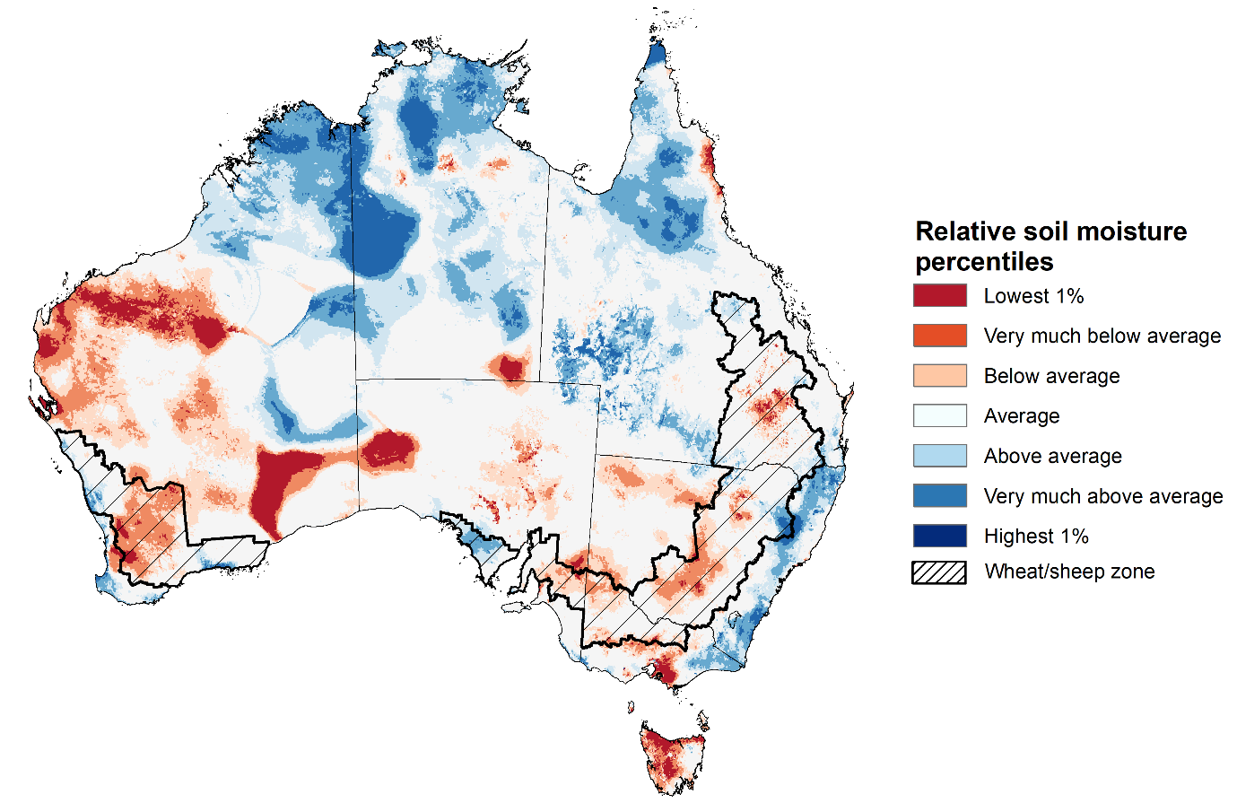

Note: This map shows the levels of modelled lower layer soil moisture (10 to 100 centimetres) during July 2025. This map shows how modelled soil conditions during July 2025 compare with July conditions modelled over the reference period (1911 to 2016). Dark blue areas on the maps were much wetter in July 2025 than during the reference period. The dark red areas were much drier than during the reference period. The bulk of plant roots occur in the top 20 centimetres of the soil profile. The lower layer soil moisture is a larger, deeper store that is slower to respond to rainfall and tends to reflect accumulated rainfall events over longer time periods.

Source: Bureau of Meteorology (<https://awo.bom.gov.au/about/overview>)

### Pasture Growth

Pasture growth for the three months to July 2025 was highly variable across much of country, with northern and parts of eastern Australia experiencing improved pasture growth.

* **Average to extremely high** pasture growth was modelled across large areas of northern and eastern Australia, including Queensland, northern and eastern New South Wales, much of the Northern Territory, southern Victoria, and northern regions of Western Australia.
  + This pasture growth is expected to allow farmers to maintain stock numbers, provide opportunities to build standing dry matter availability and decrease the reliance on fodder to maintain livestock condition over the winter period.
* By contrast, large areas of northern Victoria, South Australia, Western Australia, and north-western and southern New South Wales saw relatively low pasture growth for this time of year.
  + This below average pasture growth will likely see graziers in affected regions actively destocking or continuing to be reliant on supplemental feed to maintain current stocking rates and production.

**Relative pasture growth for 3-months ending July 2025 (1 May to 31 July 2025)**

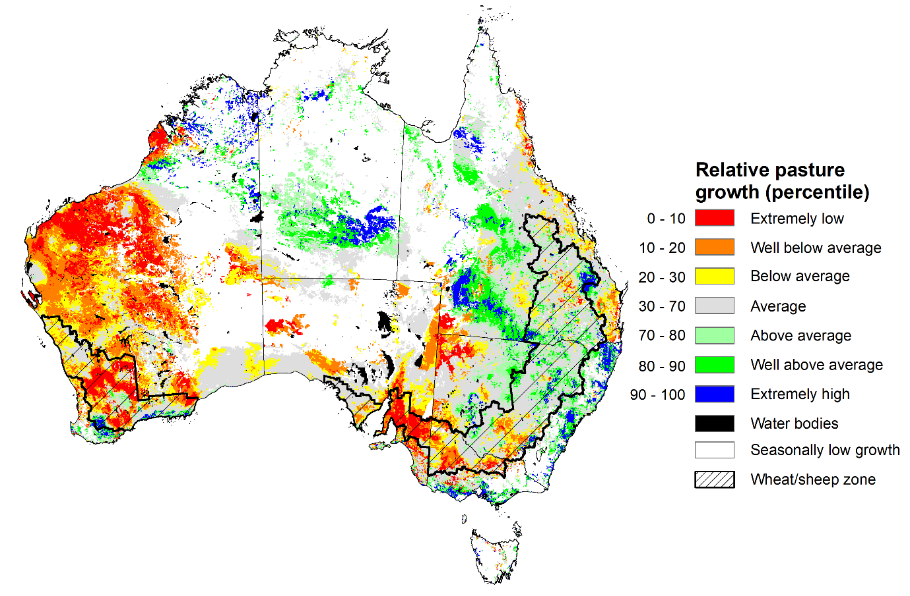

Notes: AussieGRASS pasture growth estimates are relative to the long-term record and shown in percentiles. Percentiles rank data on a scale of zero to 100. This analysis ranks pasture growth for the selected period against average pasture growth for the long-term record (1957 to 2016). Pasture growth is modelled at 5km2 grid cells.  
Source: Department of Environment, Science and Innovation

### Water markets – current week

#### Water storage levels in the Murray-Darling Basin (MDB) increased by 381 gigalitres (GL) between 24 July 2025 and 31 July 2025. The current volume of water held in storages is 13,920 GL, equivalent to 63% of total storage capacity. This is 22% or 3,956 GL less than the same time last year. Water storage data is sourced from the Bureau of Meteorology (BOM).

#### Water storages in the Murray-Darling Basin, 2013–2025Alt Text: A chart showing water storage in the Murray-Darling Basin. For more information, refer to accompanying text

Allocation prices in the Victorian Murray below the Barmah Choke decreased from $286/ML on 24 July 2025 to $266/ML on 31 July 2025. Trade from the Goulburn to the Murray is closed. Trade downstream through the Barmah Choke is closed. Trade from the Murrumbidgee to the Murray is open.

#### Surface water trade activity, Southern Murray–Darling Basin

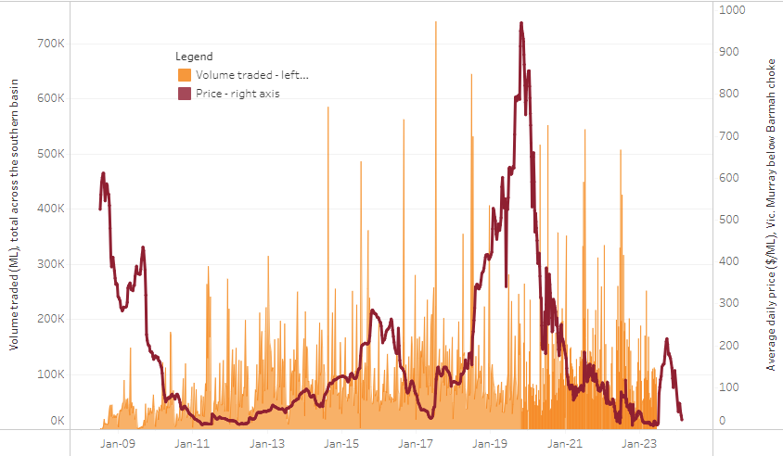

|  |
| --- |
| The trades shown reflect estimated market activity and do not encompass all register trades. The price is shown for the VIC Murray below the Barmah choke. Historical prices (before 1 July 2019) are ABARES estimates after removing outliers from BOM water register data. Prices after 1 July 2019 and prior to the 30 October 2019 reflect recorded transaction prices as sourced from Ruralco. Prices after the 30 October 2019 are sourced from Waterflow. Data for volume traded is sourced from the BOM water register. Only the price data shown is current on 17 October 2024. |

To access the full, interactive, weekly water dashboard, which contains the latest and historical water storage, water market and water allocation information, please visit <https://www.agriculture.gov.au/abares/products/weekly_update/weekly-update-310725>

## **Commodities**

|  |  |  |  |  |  |  |  |  |
| --- | --- | --- | --- | --- | --- | --- | --- | --- |
| **Indicator** | **Week average** | **Unit** | **Latest Price** | **Previous Week** | **Weekly change** | | **Price 12 months ago** | **Annual change** |
| **Selected world indicator prices** |  |  |  |  |  |  | |  |
| AUD/USD Exchange rate | 06-Aug | A$/US$ | 0.65 | 0.65 | 0% | 0.67 | | -3% |
| Wheat – US no. 2 hard red winter wheat, FOB Gulf | 06-Aug | US$/t | 230 | 234 | -2% | 250 | | -8% |
| Corn – US no. 2 yellow corn, FOB Gulf | 06-Aug | US$/t | 184 | 188 | -2% | 172 | | 7% |
| Canola – Rapeseed, Canada, FOB Vancouver | 06-Aug | US$/t | 524 | 534 | -2% | 458 | | 15% |
| Cotton – Cotlook A Index | 06-Aug | USc/lb | 78 | 78 | -1% | 80 | | -3% |
| Sugar – Intercontinental Exchange, nearby futures, no.11 contract | 06-Aug | USc/lb | 16 | 16 | -1% | 19 | | -13% |
| Wool – Eastern Market Indicator | 23-Jul | Ac/kg clean | 1,239 | 1,221 | 1% | 1,100 | | 13% |
| Wool – Western Market Indicator | 23-Jul | Ac/kg clean | 1,373 | 1,355 | 1% | 1,236 | | 11% |
| **Selected Australian grain export prices** |  |  |  |  |  |  | |  |
| Australian Premium White (APW) Wheat, FOB Port Adelaide, SA | 06-Aug | A$/t | 386 | 389 | -1% | 405 | | -5% |
| Australian Standard White (ASW) Wheat, FOB Port Adelaide, SA | 06-Aug | A$/t | 382 | 385 | -1% | 394 | | -3% |
| Feed Barley – FOB Port Adelaide, SA | 06-Aug | A$/t | 367 | 369 | -1% | 358 | | 2% |
| Canola – FOB Kwinana, WA | 06-Aug | A$/t | 813 | 815 | 0% | 725 | | 12% |
| Grain Sorghum – FOB Brisbane, QLD | 06-Aug | A$/t | 430 | 428 | 0% | 408 | | 5% |
| **Selected domestic livestock indicator prices** |  |  |  |  |  |  | |  |
| Beef – Eastern Young Cattle Indicator | 06-Aug | Ac/kg cwt | 834 | 796 | 5% | 671 | | 24% |
| Mutton – Mutton indicator (18–24 kg fat score 2–3), VIC | 06-Aug | Ac/kg cwt | 763 | 720 | 6% | 370 | | 106% |
| Lamb – National Trade Lamb Indicator | 06-Aug | Ac/kg cwt | 1,201 | 1,183 | 2% | 809 | | 49% |
| Pig – Eastern Seaboard (60.1–75 kg), NSW buyer price | 23-Jul | Ac/kg cwt | 452 | 452 | 0% | 415 | | 9% |
| Live cattle – Light steers to Indonesia | 16-Jul | Ac/kg lwt | 345 | 340 | 1% | 300 | | 15% |
| **Global Dairy Trade (GDT) weighted average prices** |  |  |  |  |  |  | |  |
| Dairy – Whole milk powder | 06-Aug | US$/t | 4,012 | 3,928 | 2% | 3,371 | | 19% |
| Dairy – Skim milk powder | 06-Aug | US$/t | 2,805 | 2,785 | 1% | 2,588 | | 8% |
| Dairy – Cheddar cheese | 06-Aug | US$/t | 4,575 | 4,589 | 0% | 4,275 | | 7% |
| Dairy – Anhydrous milk fat | 06-Aug | US$/t | 7,081 | 6,973 | 2% | 7,078 | | 0% |
|  | | | | | | | | |

### Selected world indicator prices

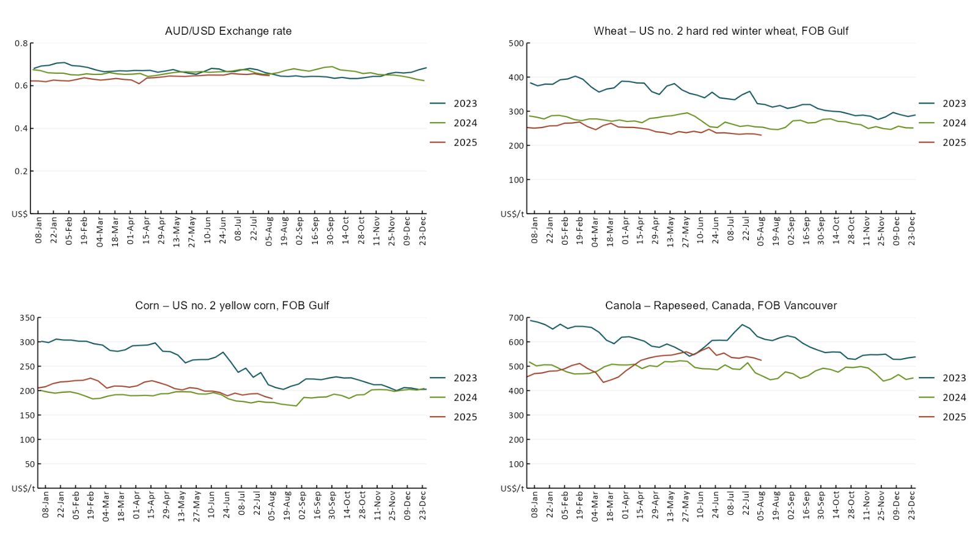

### A line chart of major world indicator prices. For more information, refer to https://www.agriculture.gov.au/abares/data/weekly-commodity-price-update/world-agricultural-prices

### 3.2 Selected domestic crop indicator prices

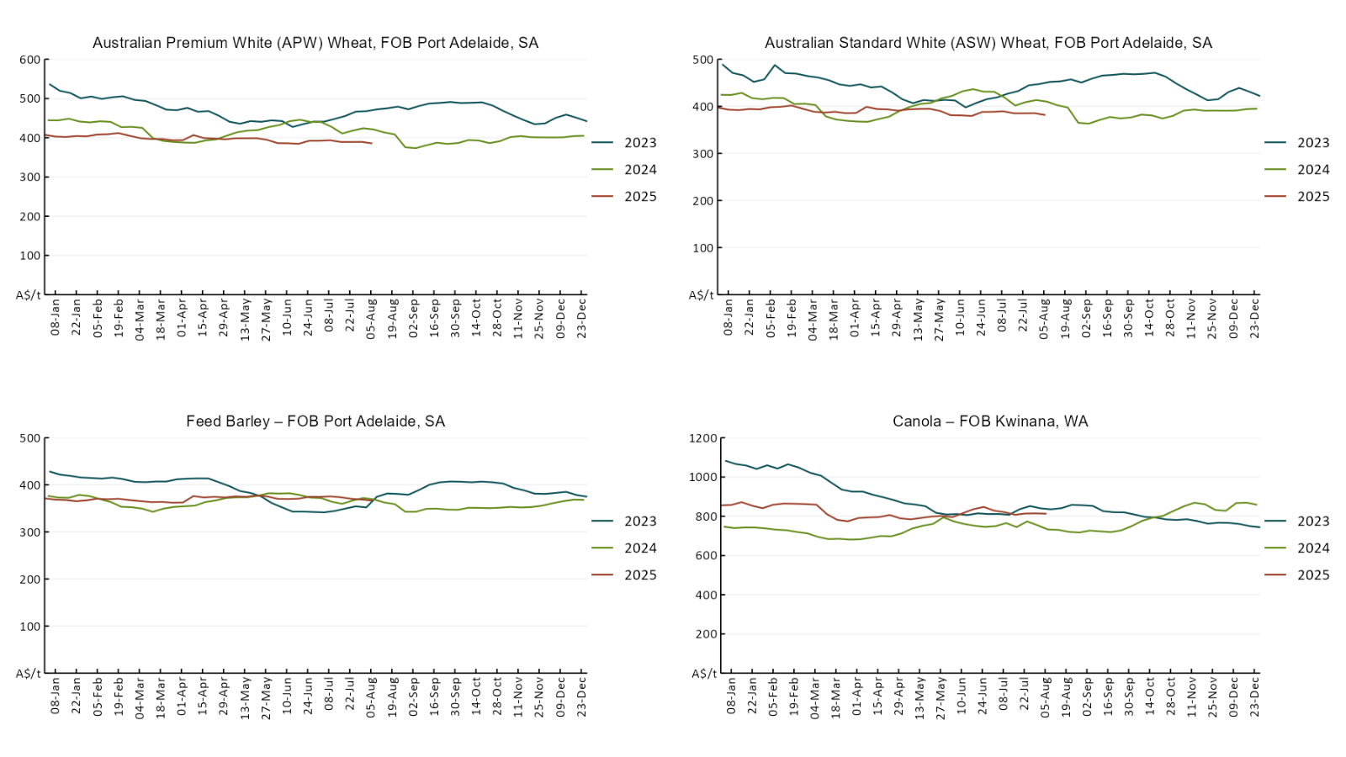

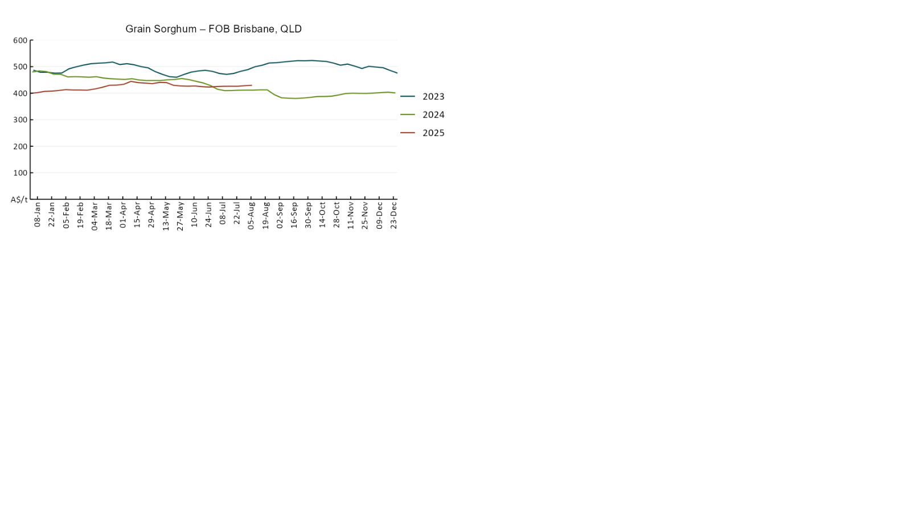

### 3.3 Selected domestic livestock indicator prices

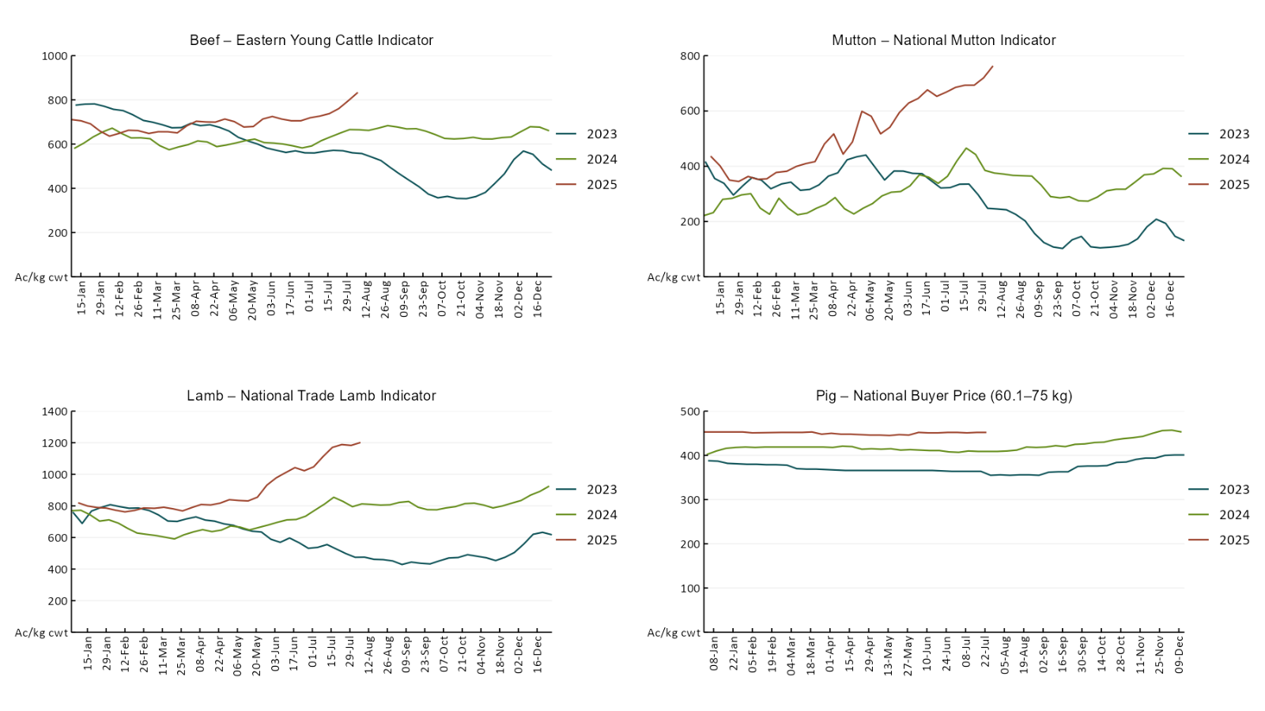

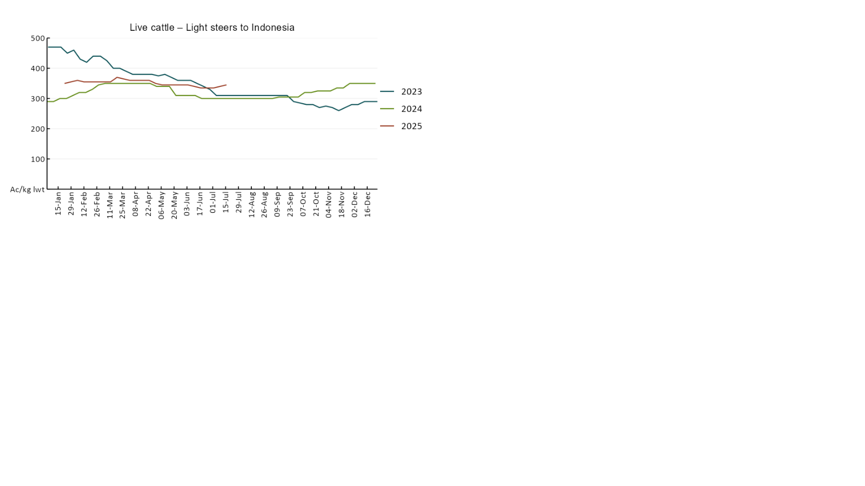

### 3.4 Global Dairy Trade (GDT) weighted average pricesA line chart of Global Dairy Trade prices. For more information, refer to https://www.agriculture.gov.au/abares/data/weekly-commodity-price-update/world-agricultural-prices

### 3.5 Selected fruit and vegetable prices

### A line chart of fruit and vegetable prices. For more information, refer to https://www.agriculture.gov.au/abares/data/weekly-commodity-price-update/world-agricultural-prices

### A line chart of fruit and vegetable prices. For more information, refer to https://www.agriculture.gov.au/abares/data/weekly-commodity-price-update/world-agricultural-prices

### 3.6 Selected domestic fodder indicator prices

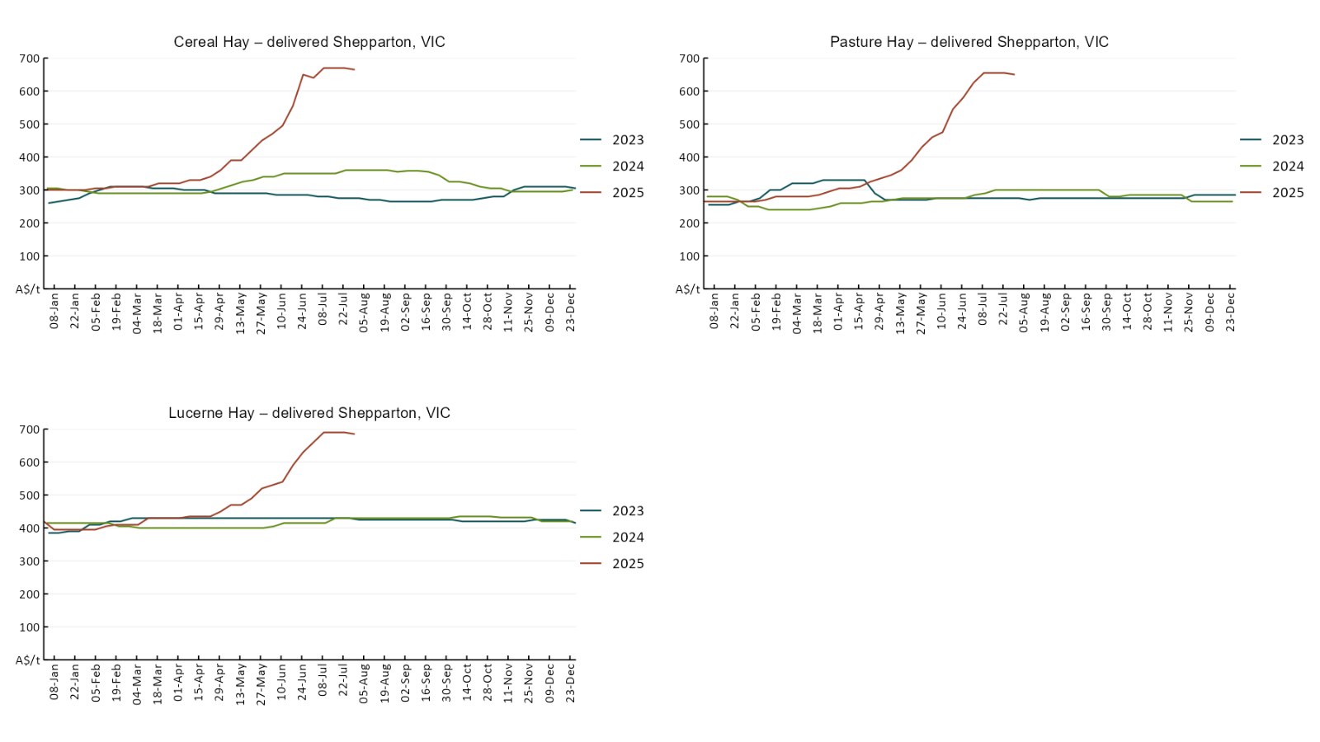

## **4. Data attribution**

### Climate

* Bureau of Meteorology
* Weekly rainfall totals: www.bom.gov.au/climate/maps/rainfall/
* Monthly and last 3-month rainfall percentiles: [www.bom.gov.au/water/landscape/](http://www.bom.gov.au/water/landscape/)
* Temperature anomalies: [www.bom.gov.au/jsp/awap/temp/index.jsp](http://www.bom.gov.au/jsp/awap/temp/index.jsp)
* Rainfall forecast: [www.bom.gov.au/jsp/watl/rainfall/pme.jsp](http://www.bom.gov.au/jsp/watl/rainfall/pme.jsp)
* Seasonal outlook: [www.bom.gov.au/climate/outlooks/#/overview/summary/](http://www.bom.gov.au/climate/outlooks/#/overview/summary/)
* Climate drivers: <http://www.bom.gov.au/climate/enso/>
* Soil moisture: [www.bom.gov.au/water/landscape/](http://www.bom.gov.au/water/landscape/)
* Other
* Pasture growth: [www.longpaddock.qld.gov.au/aussiegrass/](http://www.longpaddock.qld.gov.au/aussiegrass/)
* 3-month global outlooks: [Environment and Climate Change Canada](https://weather.gc.ca/saisons/image_e.html?img=s234pfe1p_cal&bc=prob), [NOAA Climate Prediction Center](https://www.cpc.ncep.noaa.gov/products/predictions/long_range/seasonal.php?lead=2), [EUROBRISA CPTEC/INPE](http://eurobrisa.cptec.inpe.br/), European Centre for Medium-Range Weather Forecasts, [Hydrometcenter of Russia](https://meteoinfo.ru/en/climate/seasonal-forecasts), [National Climate Center Climate System Diagnosis and Prediction Room (NCC)](https://cmdp.ncc-cma.net/pred/cs2gen.php?pred_elem=RAINP#pred_seasonal), [International Research Institute for Climate and Society](https://iri.columbia.edu/our-expertise/climate/forecasts/seasonal-climate-forecasts/)
* Global production: <https://ipad.fas.usda.gov/ogamaps/cropmapsandcalendars.aspx>
* Autumn break: Pook et al., 2009, <https://rmets-onlinelibrary-wiley-com.virtual.anu.edu.au/doi/epdf/10.1002/joc.1833>

### Water

Prices

* Waterflow: <https://www.waterflow.io/>
* Ruralco: <https://www.ruralcowater.com.au/>
* Bureau of Meteorology:
* Allocation trade: <http://www.bom.gov.au/water/dashboards/#/water-markets/mdb/at>
* Storage volumes: <http://www.bom.gov.au/water/dashboards/#/water-storages/summary/drainage>
* Trade constraints:
* Water NSW: <https://www.waternsw.com.au/customer-service/ordering-trading-and-pricing/trading/murrumbidgee>
* Victorian Water Register: <https://www.waterregister.vic.gov.au/TradingRules2019/>

### Commodities

* Fruit and vegetables
* Datafresh: [www.freshstate.com.au](http://www.freshstate.com.au)
* Pigs
* Australian Pork Limited: [www.australianpork.com.au](http://www.australianpork.com.au)
* Dairy
* Global Dairy Trade: [www.globaldairytrade.info/en/product-results/](http://www.globaldairytrade.info/en/product-results/)
* World wheat, canola
* International Grains Council
* World coarse grains
* United States Department of Agriculture
* World cotton
* Cotlook: [www.cotlook.com/](http://www.cotlook.com/)
* World sugar
* New York Stock Exchange - Intercontinental Exchange
* Wool
* Australian Wool Exchange: [www.awex.com.au/](http://www.awex.com.au/)
* Domestic wheat, barley, sorghum, canola and fodder
* Jumbuk Consulting Pty Ltd: http://www.jumbukag.com.au/
* Cattle, beef, mutton, lamb, goat and live export
* Meat and Livestock Australia: [www.mla.com.au/Prices-and-market](http://www.mla.com.au/Prices-and-market)

© Commonwealth of Australia 2025

### Ownership of intellectual property rights

Unless otherwise noted, copyright (and any other intellectual property rights, if any) in this publication is owned by the Commonwealth of Australia (referred to as the Commonwealth).

### Creative Commons licence

All material in this publication is licensed under a [Creative Commons Attribution 4.0 International Licence](https://creativecommons.org/licenses/by/4.0/legalcode) except content supplied by third parties, logos and the Commonwealth Coat of Arms.

Inquiries about the licence and any use of this document should be emailed to [copyright@awe.gov.au](mailto:copyright@awe.gov.au).

https://www.agriculture.gov.au/sites/default/files/images/creative-commons-logo-small.png

### Cataloguing data

This publication (and any material sourced from it) should be attributed as:

ABARES 2025, Weekly Australian Climate, Water and Agricultural Update, Australian Bureau of Agricultural and Resource Economics and Sciences, Canberra, 7 August 2025. CC BY 4.0 DOI: <https://doi.org/10.25814/5f3e04e7d2503>

ISSN **2652-7561**

This publication is available at https://www.agriculture.gov.au/abares/products/weekly_update

Department of Agriculture, Fisheries and Forestry

GPO Box 858 Canberra ACT 2601

Telephone 1800 900 090

Web [agriculture.gov.au/abares](http://awe.gov.au/abares)

### Disclaimer

The Australian Government acting through the Department of Agriculture, Fisheries and Forestry, represented by the Australian Bureau of Agricultural and Resource Economics and Sciences, has exercised due care and skill in preparing and compiling the information and data in this publication. Notwithstanding, the Department of Agriculture, Fisheries and Forestry, ABARES, its employees and advisers disclaim all liability, including liability for negligence and for any loss, damage, injury, expense or cost incurred by any person as a result of accessing, using or relying on any of the information or data in this publication to the maximum extent permitted by law.

### Statement of Professional Independence

The views and analysis presented in ABARES publications, including this one, reflect ABARES professionally independent findings, based on scientific and economic concepts, principles, information and data. These views, analysis and findings may not reflect or be consistent with the views or positions of the Australian Government, or of organisations or groups who have commissioned ABARES reports or analysis. More information on [professional independence](https://www.agriculture.gov.au/abares/about/research-and-analysis#professional-independence) is provided on the ABARES website.

### Acknowledgements

This report was prepared by Holly Beale and Matt Miller.