## No. 32/2025 14 August 2025

# Summary of key issues

* In the week ending 13 August 2025, low-pressure systems and cold fronts brought rainfall to parts of eastern and south-western Australia.
  + In cropping regions, rainfall was mixed. Western Australia and Queensland saw 5 - 50 millimetres, while Victoria saw 5-15 millimetres. Remaining areas stayed largely dry.
  + The lack of rainfall across parts of southern New South Wales is likely to see further declines in soil moisture levels with potential impacts on plant growth rates and yield potentials.
* Over the coming eight days to 21 August 2025, rainfall is expected to be low across cropping regions in the east.
  + Falls of between 10-25 millimetres are forecast across Western Australia.
  + Meanwhile, falls of between 5-15 millimetres are expected in Victoria and South Australia. In contrast, much of New South Wales and Queensland is expected to remain largely dry.
  + If realised these falls are likely to be sufficient to support the growth and development in most areas and see some ongoing improvement in contribute to a soil moisture reserves in Western Australia. However, the expected lack of rainfall across southern New South Wales, continues to present a downside production risk for crops and pastures.
* The national rainfall outlook for September to November 2025 indicates an increased probability of above median rainfall across much of central and eastern Australia. Most western regions are likely to see below average to average rainfall.
  + If realised, the expectation of average to above average September to November 2025 rainfall across most winter cropping regions is likely be sufficient to support the growth and development of winter crops, and the timely planting and establishment of dryland summer crops in eastern Australia.
* Water storage levels in the Murray-Darling Basin (MDB) increased by 177 gigalitres (GL) between 07 August 2025 and 14 August 2025. The current volume of water held in storages is 14,647 GL, equivalent to 66% of total storage capacity. This is 20% or 3,547 GL less than the same time last year. Water storage data is sourced from the Bureau of Meteorology (BOM).
* Allocation prices in the Victorian Murray below the Barmah Choke increased from $269/ML on 07 August 2025 to $287/ML on 14 August 2025. Trade from the Goulburn to the Murray is closed. Trade downstream through the Barmah Choke is closed. Trade from the Murrumbidgee to the Murray is open.

## **Climate**

### Rainfall this week

In the week ending 13 August 2025, **cold fronts and low-pressure systems** brought rainfall to parts of eastern and south-western Australia, while much of the remainder of Australia stayed largely dry.

* Rainfall totals of between 5-50 millimetres were recorded across much of south-western Western Australia, western Tasmania, coastal regions of northern New South Wales and southern Queensland. Lighter fall falls of between 5-15 millimetres were record across much of Victoria, as well as scattered areas in South Australia and northern New South Wales.

Rainfall was highly variable across winter cropping regions in the week ending 13 August 2025.

* Rainfall of between 5-50 millimetres was observed in Western Australia and Queensland, while Victoria saw between 5-15 millimetres.
  + These falls are likely to see a continuation in the improvement of soil moisture levels in these regions and support the growth and development of winter crops
* In contrast, much of South Australia and New South Wales saw between 1-5 millimetres of rainfall.
  + Many of these areas have recently seen favourable rainfall during July. However, parts of southern New South Wales saw below average rainfall during June and July. The lack of rainfall across parts of southern New South Wales is likely to see further declines in soil moisture levels with potential impacts on plant growth rates and yield potentials.

#### Rainfall for the week ending 13 August 2025

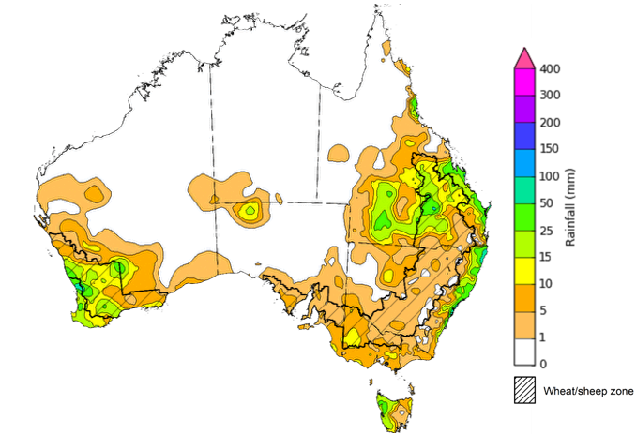

©Commonwealth of Australia 2025, Australian Bureau of Meteorology Issued: 13/8/2025

Note: The rainfall analyses and associated maps utilise data contained in the Bureau of Meteorology climate database, the Australian Data Archive for Meteorology (ADAM). The analyses are initially produced automatically from real-time data with limited [quality control](http://www.bom.gov.au/climate/headers/qc.shtml). They are intended to provide a general overview of rainfall across Australia as quickly as possible after the observations are received. For further information go to <http://www.bom.gov.au/climate/rainfall/>

### Rainfall forecast for the next eight days

Over the 8 days to 21 August 2025, **cold fronts** are expected to bring rainfall to parts of the south and east, while the northern two thirds of Australia are forecast to remain dry.

* Rainfall totals of between 5-50 millimetres are expected across much of southern Western Australia and Tasmania, while south-eastern New South Wales, and southern Victoria and South Australia are expected to see between 5-25 millimetres.
* Remaining areas are forecast to remain largely dry.

Rainfall is likely to be low across eastern cropping regions over the coming week, with heavier fall expected in the west.

* Falls of between 10-25 millimetres are forecast across Western Australia, while Victoria and South Australia are expected to receive between 5-15 millimetres.
  + If realised these falls are likely to be sufficient to support the crop and pasture growth and development in most areas and see some ongoing improvement in contribute to a soil moisture reserves in Western Australia.
* New South Wales and Queensland cropping regions are expected to remain largely dry.
  + This continues to present a downside production risk in some areas, particularly across parts of southern New South Wales following a relatively dry June and July in this region.

#### Total forecast rainfall for the period 14 August to 21 August 2025

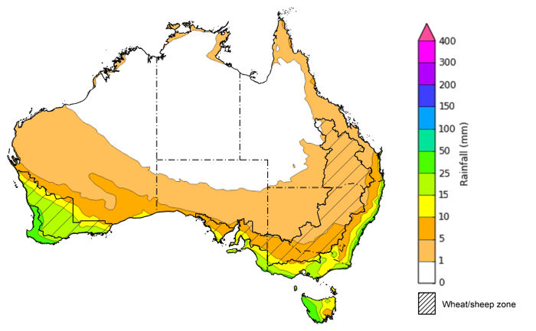

©Commonwealth of Australia 2025, Australian Bureau of Meteorology Issued 14/8/2025

Note: This rainfall forecast is produced from computer models. As the model outputs are not altered by weather forecasters, it is important to check local forecasts and warnings issued by the Bureau of Meteorology.

### 

### National Climate Outlook

The El Niño Southern Oscillation (ENSO) and Indian Ocean Dipole (IOD) climate drivers are currently neutral and having minimal influence on Australian rainfall. The ENSO is likely to remain neutral until January. In contrast, the Southern Annular Mode (SAM) is currently positive, but is likely to return to neutral over the coming fortnight. A positive SAM has contributed to reduced cold front rainfall across parts of south-eastern Australia over recent weeks relative to a neutral SAM expectation.

Meanwhile, the development of a negative IOD event is becoming increasingly likely. During the last 3 weeks the IOD index has been below the negative IOD threshold. The latest IOD index value for the week ending 10 August is −0.84 °C. Sustained index values less than or equal to −0.4 °C for at least 8 weeks are typical of a negative IOD event. All international models, including the Bureau of Meteorology's model, predict a negative phase of the IOD during spring, with a return to neutral in early summer, consistent with the typical IOD life cycle. A negative IOD typically results in above-average spring rainfall over parts of southern Australia.

The most recent **rainfall outlook for September 2025** provided by the Bureau of Meteorology indicates that much of **northern and eastern Australia** is likely to see **above median rainfall,** with parts of **south-western** **Australia** likely to see **below average** falls**.**

* The Bureau of Meteorology’s climate model indicates a 75% chance of September rainfall totals between 5-100 millimetres across much of southern Australia. Despite the increased probabilities of above average rainfall across much of northern Australia, September is a transition month between the northern Australian dry and wet seasons. During this time of year, most of the northern two-thirds of Australia typically receives very low rainfall, with average rainfall less than 5 millimetres for the month of September.
* Across cropping regions, there is a **75% chance** of rainfall totals of between **10-50 millimetres across most southern cropping regions.** If realised, this is expected to provide sufficient moisture to support the growth and development of winter crops across most southern growing regions. In contrast, most Queensland cropping regions are likely to see 5-25 millimetres. These lower expected rainfall totals are unlikely to adversely impact crop growth as crops will be able to utilise soil moisture reserves to support their growth and development.

**Rainfall totals that have a 75% chance of occurring in September 2025**

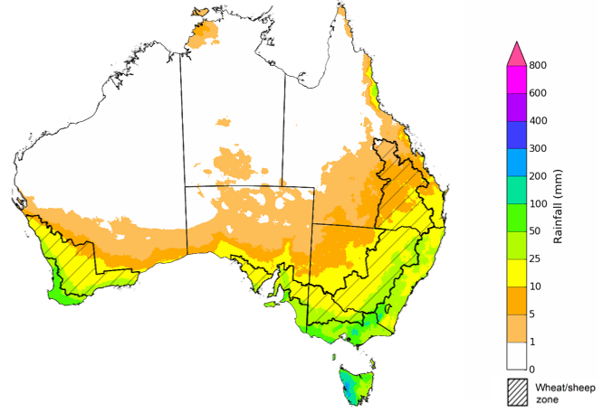

©Commonwealth of Australia 2025, Australian Bureau of Meteorology Issued: 14/8/2025

The **rainfall outlook for September to November 2025** indicates an increased probability of **above median rainfall across much of central and eastern Australia,** including much of Queensland, New South Wales, Victoria, South Australia, and the Northern Territory. In contrast, large areas of Western Australia is showing a slightly increased probability of **below median rainfall**. Much of western Tasmania and remainder of Western Australia have an equal probability of above or below average rainfall.

Across cropping regions, the chance of receiving above median rainfall is above 75% across Queensland and New South Wales, while South Australia and Victoria have a greater than 60% probability of receiving above median rainfall over the period. In Western Australia, the probability of above median rainfall is lower at 35-55%.

**Chance of exceeding the median rainfall September 2025 to November 2025**

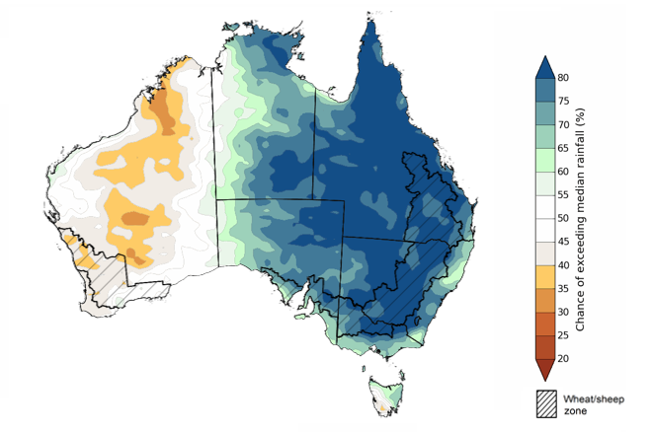

©Commonwealth of Australia 2025, Australian Bureau of Meteorology Issued: 14/8/2025

The **rainfall outlook for September through to November 2025** suggests a 75% chance of receiving rainfall totals of between 50-300 millimetres across much of New South Wales and Victoria. Between 300-600 millimetres are expected across western Tasmania and alpine areas of New South Wales and Victoria. Lower rainfall totals are forecast for northern, central and western regions, with South Australia, Queensland, the Northern Territory, and the southwest and north of Western Australia likely to see 25-200 millimetres of rainfall. Across much of central Western Australia, little to no rainfall is forecast over the period.

In **cropping regions**, there is a **75% chance** of receiving between **100-200 millimetres** acrossQueensland, New South Wales, Victoria and South Australia. In Western Australia, falls of 25-100 millimetres are expected. If realised, these falls are likely be sufficient to support the growth and development of winter crops, and the timely planting and establishment of dryland summer crops in eastern Australia.

**Rainfall totals that have a 75% chance of occurring September 2025 to November 2025**

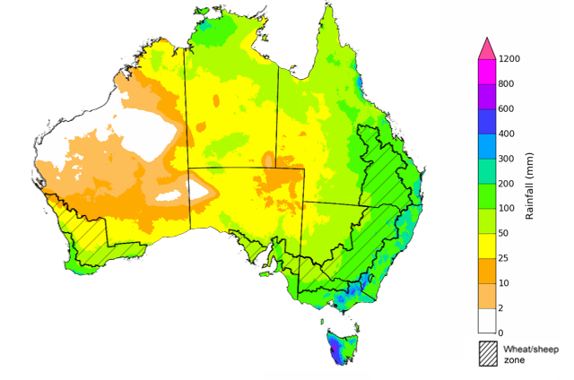

©Commonwealth of Australia 2025, Australian Bureau of Meteorology Issued: 14/8/2025

### Water markets – current week

#### Water storage levels in the Murray-Darling Basin (MDB) increased by 177 gigalitres (GL) between 07 August 2025 and 14 August 2025. The current volume of water held in storages is 14,647 GL, equivalent to 66% of total storage capacity. This is 20% or 3,547 GL less than the same time last year. Water storage data is sourced from the Bureau of Meteorology (BOM).

#### Water storages in the Murray-Darling Basin, 2013–2025Alt Text: A chart showing water storage in the Murray-Darling Basin. For more information, refer to accompanying text

Allocation prices in the Victorian Murray below the Barmah Choke increased from $269/ML on 07 August 2025 to $287/ML on 14 August 2025. Trade from the Goulburn to the Murray is closed. Trade downstream through the Barmah Choke is closed. Trade from the Murrumbidgee to the Murray is open.

#### Surface water trade activity, Southern Murray–Darling Basin

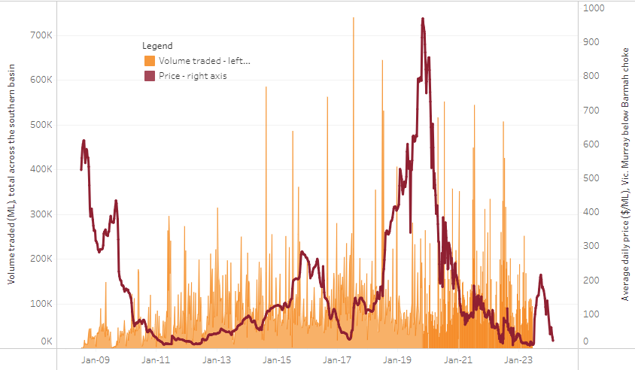

|  |
| --- |
| The trades shown reflect estimated market activity and do not encompass all register trades. The price is shown for the VIC Murray below the Barmah choke. Historical prices (before 1 July 2019) are ABARES estimates after removing outliers from BOM water register data. Prices after 1 July 2019 and prior to the 30 October 2019 reflect recorded transaction prices as sourced from Ruralco. Prices after the 30 October 2019 are sourced from Waterflow. Data for volume traded is sourced from the BOM water register. Only the price data shown is current on 17 October 2024. |

To access the full, interactive, weekly water dashboard, which contains the latest and historical water storage, water market and water allocation information, please visit https://www.agriculture.gov.au/abares/products/weekly_update/weekly-update-140825

## **Commodities**

|  |  |  |  |  |  |  |  |  |
| --- | --- | --- | --- | --- | --- | --- | --- | --- |
| **Indicator** | **Week average** | **Unit** | **Latest Price** | **Previous Week** | **Weekly change** | | **Price 12 months ago** | **Annual change** |
| **Selected world indicator prices** |  |  |  |  |  |  | |  |
| AUD/USD Exchange rate | 13-Aug | A$/US$ | 0.65 | 0.65 | 0% | 0.67 | | -2% |
| Wheat – US no. 2 hard red winter wheat, FOB Gulf | 13-Aug | US$/t | 233 | 232 | 1% | 250 | | -7% |
| Corn – US no. 2 yellow corn, FOB Gulf | 13-Aug | US$/t | 181 | 184 | -2% | 172 | | 5% |
| Canola – Rapeseed, Canada, FOB Vancouver | 13-Aug | US$/t | 509 | 519 | -2% | 458 | | 11% |
| Cotton – Cotlook A Index | 13-Aug | USc/lb | 78.7 | 77.9 | 1% | 80 | | -2% |
| Sugar – Intercontinental Exchange, nearby futures, no.11 contract | 13-Aug | USc/lb | 16.7 | 16.1 | 4% | 19 | | -10% |
| Wool – Eastern Market Indicator | 23-Jul | Ac/kg clean | 1,239 | 1,221 | 1% | 1,100 | | 13% |
| Wool – Western Market Indicator | 23-Jul | Ac/kg clean | 1,373 | 1,355 | 1% | 1,236 | | 11% |
| **Selected Australian grain export prices** |  |  |  |  |  |  | |  |
| Australian Premium White (APW) Wheat, FOB Port Adelaide, SA | 13-Aug | A$/t | 384 | 385 | 0% | 405 | | -5% |
| Australian Standard White (ASW) Wheat, FOB Port Adelaide, SA | 13-Aug | A$/t | 380 | 381 | 0% | 394 | | -3% |
| Feed Barley – FOB Port Adelaide, SA | 13-Aug | A$/t | 366 | 366 | 0% | 358 | | 2% |
| Canola – FOB Kwinana, WA | 13-Aug | A$/t | 805 | 806 | 0% | 725 | | 11% |
| Grain Sorghum – FOB Brisbane, QLD | 13-Aug | A$/t | 425 | 429 | -1% | 408 | | 4% |
| **Selected domestic livestock indicator prices** |  |  |  |  |  |  | |  |
| Beef – Eastern Young Cattle Indicator | 13-Aug | Ac/kg cwt | 854 | 840 | 2% | 671 | | 27% |
| Mutton – Mutton indicator (18–24 kg fat score 2–3), VIC | 13-Aug | Ac/kg cwt | 758 | 765 | -1% | 370 | | 105% |
| Lamb – National Trade Lamb Indicator | 13-Aug | Ac/kg cwt | 1,203 | 1,208 | 0% | 809 | | 49% |
| Pig – Eastern Seaboard (60.1–75 kg), NSW buyer price | 23-Jul | Ac/kg cwt | 452 | 452 | 0% | 415 | | 9% |
| Live cattle – Light steers to Indonesia | 13-Aug | Ac/kg lwt | 350 | 350 | 0% | 300 | | 17% |
| **Global Dairy Trade (GDT) weighted average prices** |  |  |  |  |  |  | |  |
| Dairy – Whole milk powder | 06-Aug | US$/t | 4,012 | 3,928 | 2% | 3,371 | | 19% |
| Dairy – Skim milk powder | 06-Aug | US$/t | 2,805 | 2,785 | 1% | 2,588 | | 8% |
| Dairy – Cheddar cheese | 06-Aug | US$/t | 4,575 | 4,589 | 0% | 4,275 | | 7% |
| Dairy – Anhydrous milk fat | 06-Aug | US$/t | 7,081 | 6,973 | 2% | 7,078 | | 0% |
|  | | | | | | | | |

### Selected world indicator prices

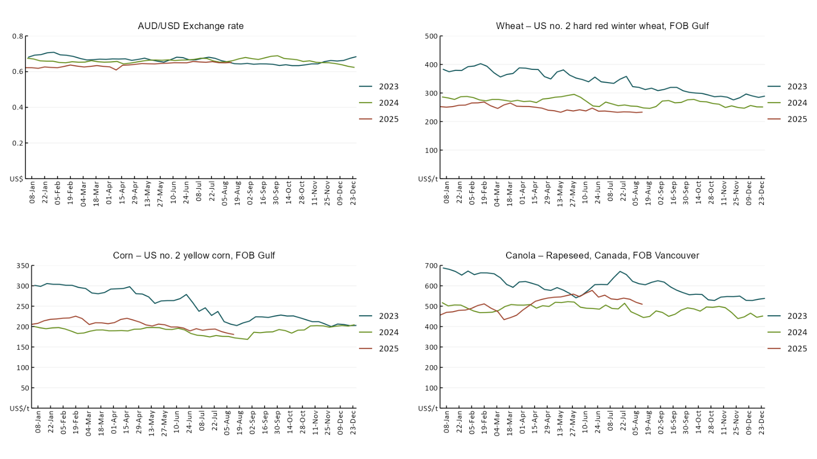

### A line chart of major world indicator prices. For more information, refer to https://www.agriculture.gov.au/abares/data/weekly-commodity-price-update/world-agricultural-prices

### 3.2 Selected domestic crop indicator prices

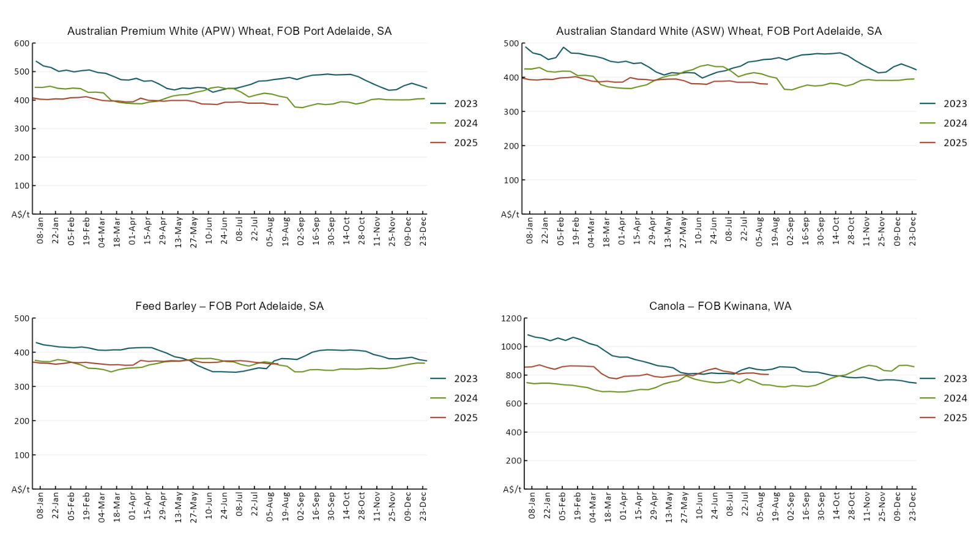

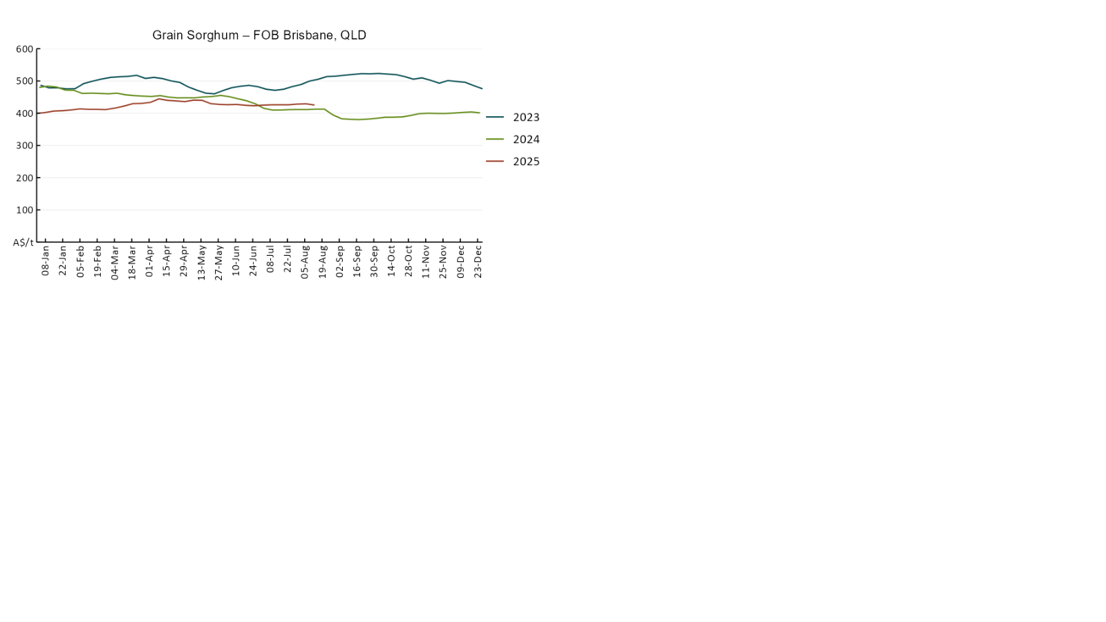

### 3.3 Selected domestic livestock indicator prices

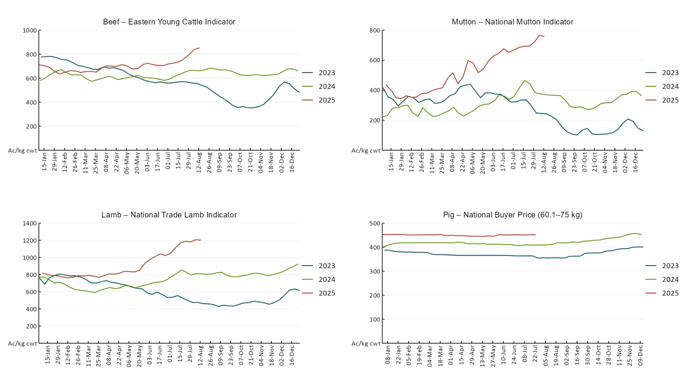

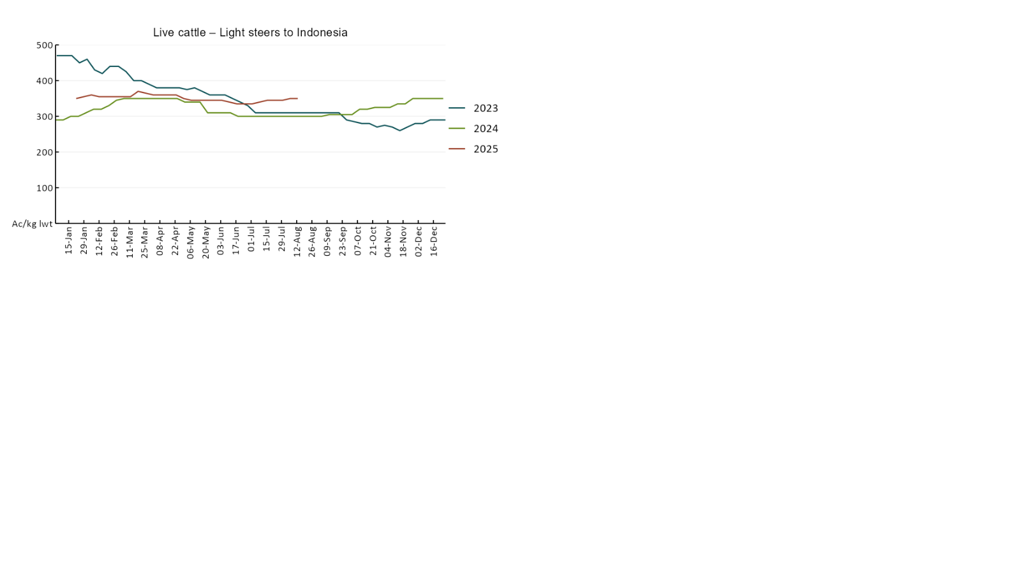

### 3.4 Global Dairy Trade (GDT) weighted average pricesA line chart of Global Dairy Trade prices. For more information, refer to https://www.agriculture.gov.au/abares/data/weekly-commodity-price-update/world-agricultural-prices

### 3.5 Selected fruit and vegetable prices

### A line chart of fruit and vegetable prices. For more information, refer to https://www.agriculture.gov.au/abares/data/weekly-commodity-price-update/world-agricultural-prices

### A line chart of fruit and vegetable prices. For more information, refer to https://www.agriculture.gov.au/abares/data/weekly-commodity-price-update/world-agricultural-prices

### 3.6 Selected domestic fodder indicator prices

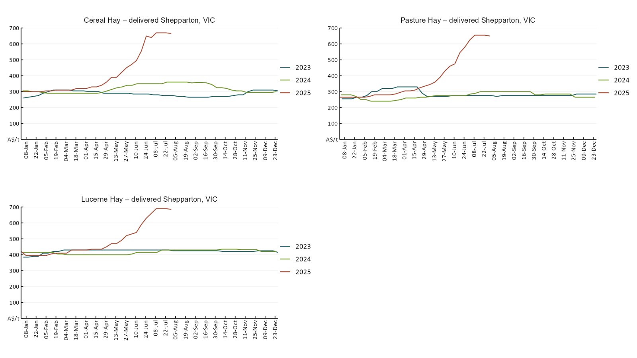

## **4. Data attribution**

### Climate

* Bureau of Meteorology
* Weekly rainfall totals: www.bom.gov.au/climate/maps/rainfall/
* Monthly and last 3-month rainfall percentiles: [www.bom.gov.au/water/landscape/](http://www.bom.gov.au/water/landscape/)
* Temperature anomalies: [www.bom.gov.au/jsp/awap/temp/index.jsp](http://www.bom.gov.au/jsp/awap/temp/index.jsp)
* Rainfall forecast: [www.bom.gov.au/jsp/watl/rainfall/pme.jsp](http://www.bom.gov.au/jsp/watl/rainfall/pme.jsp)
* Seasonal outlook: [www.bom.gov.au/climate/outlooks/#/overview/summary/](http://www.bom.gov.au/climate/outlooks/#/overview/summary/)
* Climate drivers: <http://www.bom.gov.au/climate/enso/>
* Soil moisture: [www.bom.gov.au/water/landscape/](http://www.bom.gov.au/water/landscape/)
* Other
* Pasture growth: [www.longpaddock.qld.gov.au/aussiegrass/](http://www.longpaddock.qld.gov.au/aussiegrass/)
* 3-month global outlooks: [Environment and Climate Change Canada](https://weather.gc.ca/saisons/image_e.html?img=s234pfe1p_cal&bc=prob), [NOAA Climate Prediction Center](https://www.cpc.ncep.noaa.gov/products/predictions/long_range/seasonal.php?lead=2), [EUROBRISA CPTEC/INPE](http://eurobrisa.cptec.inpe.br/), European Centre for Medium-Range Weather Forecasts, [Hydrometcenter of Russia](https://meteoinfo.ru/en/climate/seasonal-forecasts), [National Climate Center Climate System Diagnosis and Prediction Room (NCC)](https://cmdp.ncc-cma.net/pred/cs2gen.php?pred_elem=RAINP#pred_seasonal), [International Research Institute for Climate and Society](https://iri.columbia.edu/our-expertise/climate/forecasts/seasonal-climate-forecasts/)
* Global production: <https://ipad.fas.usda.gov/ogamaps/cropmapsandcalendars.aspx>
* Autumn break: Pook et al., 2009, <https://rmets-onlinelibrary-wiley-com.virtual.anu.edu.au/doi/epdf/10.1002/joc.1833>

### Water

Prices

* Waterflow: <https://www.waterflow.io/>
* Ruralco: <https://www.ruralcowater.com.au/>
* Bureau of Meteorology:
* Allocation trade: <http://www.bom.gov.au/water/dashboards/#/water-markets/mdb/at>
* Storage volumes: <http://www.bom.gov.au/water/dashboards/#/water-storages/summary/drainage>
* Trade constraints:
* Water NSW: <https://www.waternsw.com.au/customer-service/ordering-trading-and-pricing/trading/murrumbidgee>
* Victorian Water Register: <https://www.waterregister.vic.gov.au/TradingRules2019/>

### Commodities

* Fruit and vegetables
* Datafresh: [www.freshstate.com.au](http://www.freshstate.com.au)
* Pigs
* Australian Pork Limited: [www.australianpork.com.au](http://www.australianpork.com.au)
* Dairy
* Global Dairy Trade: [www.globaldairytrade.info/en/product-results/](http://www.globaldairytrade.info/en/product-results/)
* World wheat, canola
* International Grains Council
* World coarse grains
* United States Department of Agriculture
* World cotton
* Cotlook: [www.cotlook.com/](http://www.cotlook.com/)
* World sugar
* New York Stock Exchange - Intercontinental Exchange
* Wool
* Australian Wool Exchange: [www.awex.com.au/](http://www.awex.com.au/)
* Domestic wheat, barley, sorghum, canola and fodder
* Jumbuk Consulting Pty Ltd: http://www.jumbukag.com.au/
* Cattle, beef, mutton, lamb, goat and live export
* Meat and Livestock Australia: [www.mla.com.au/Prices-and-market](http://www.mla.com.au/Prices-and-market)

© Commonwealth of Australia 2025

### Ownership of intellectual property rights

Unless otherwise noted, copyright (and any other intellectual property rights, if any) in this publication is owned by the Commonwealth of Australia (referred to as the Commonwealth).

### Creative Commons licence

All material in this publication is licensed under a [Creative Commons Attribution 4.0 International Licence](https://creativecommons.org/licenses/by/4.0/legalcode) except content supplied by third parties, logos and the Commonwealth Coat of Arms.

Inquiries about the licence and any use of this document should be emailed to [copyright@awe.gov.au](mailto:copyright@awe.gov.au).

https://www.agriculture.gov.au/sites/default/files/images/creative-commons-logo-small.png

### Cataloguing data

This publication (and any material sourced from it) should be attributed as:

ABARES 2025, Weekly Australian Climate, Water and Agricultural Update, Australian Bureau of Agricultural and Resource Economics and Sciences, Canberra, 14 August 2025. CC BY 4.0 DOI: <https://doi.org/10.25814/5f3e04e7d2503>

ISSN **2652-7561**

This publication is available at https://www.agriculture.gov.au/abares/products/weekly_update

Department of Agriculture, Fisheries and Forestry

GPO Box 858 Canberra ACT 2601

Telephone 1800 900 090

Web [agriculture.gov.au/abares](http://awe.gov.au/abares)

### Disclaimer

The Australian Government acting through the Department of Agriculture, Fisheries and Forestry, represented by the Australian Bureau of Agricultural and Resource Economics and Sciences, has exercised due care and skill in preparing and compiling the information and data in this publication. Notwithstanding, the Department of Agriculture, Fisheries and Forestry, ABARES, its employees and advisers disclaim all liability, including liability for negligence and for any loss, damage, injury, expense or cost incurred by any person as a result of accessing, using or relying on any of the information or data in this publication to the maximum extent permitted by law.

### Statement of Professional Independence

The views and analysis presented in ABARES publications, including this one, reflect ABARES professionally independent findings, based on scientific and economic concepts, principles, information and data. These views, analysis and findings may not reflect or be consistent with the views or positions of the Australian Government, or of organisations or groups who have commissioned ABARES reports or analysis. More information on [professional independence](https://www.agriculture.gov.au/abares/about/research-and-analysis#professional-independence) is provided on the ABARES website.

### Acknowledgements

This report was prepared by Holly Beale and Matt Miller.