## No. 33/2025 21 August 2025

# Summary of key issues

* In the week ending 20 August 2025, low-pressure systems and cold fronts brought rainfall to parts of south-eastern and south-western Australia.
  + In cropping regions, rainfall was highly variable. Western Australia saw 5 - 50 millimetres, while southern and central Queensland, western and central South Australia and parts of central and northern New South Wales saw 5-25 millimetres. Remaining areas received little to no rainfall.
  + The lack of rainfall across much of southern New South Wales, Victoria and eastern South Australia is likely to see a draw down in soil moisture levels with potential impacts on plant growth rates and yield potentials. Elsewhere, these falls will continue to support the growth and development of winter crops.
* Over the coming eight days to 28 August 2025, rainfall is expected to be mixed across eastern cropping regions, with heavier falls expected in the west.
  + Falls of between 25-50 millimetres are forecast across Western Australia.
  + Meanwhile, falls of between 5-25 millimetres are expected in in South Australia, Victoria, and across parts of southern and eastern New South Wales and south-eastern Queensland.
  + If realised these falls are likely to be sufficient to support the growth and development in most areas and see some ongoing improvement to a soil moisture reserves in Western Australia and western and central regions of South Australia.
* Rainfall in July 2025 was variable across the world’s major grain- and oilseed-producing regions but generally leading to positive crop production outcomes across both the northern and southern hemispheres.
* Global production conditions were generally favourable for maize, rice and soybeans, but more varied for wheat. Global production conditions have been slightly more favourable to those used to formulate ABARES 2025–26 forecasts of global grain supplies and world prices in the June 2025 Agricultural Commodities Report. As a result, global grain and oilseed production is likely to increase beyond the numbers in the June forecast, particularly due to improvements in global corn and soybean production.
* Water storage levels in the Murray-Darling Basin (MDB) increased by 73 gigalitres (GL) between 14 August 2025 and 21 August 2025. The current volume of water held in storages is 14,720 GL, equivalent to 66% of total storage capacity. This is 20% or 3,595GL less than the same time last year. Water storage data is sourced from the Bureau of Meteorology (BOM).
* Allocation prices in the Victorian Murray below the Barmah Choke decreased from $287/ML on 14 August 2025 to $272/ML on 21 August 2025. Trade from the Goulburn to the Murray is closed. Trade downstream through the Barmah Choke is closed. Trade from the Murrumbidgee to the Murray is open.

## **Climate**

### Rainfall this week

In the week ending 20 August 2025, **cold fronts and low-pressure systems** brought rainfall to parts of south-eastern and south-western Australia, while much of the remainder of Australia stayed largely dry.

* Rainfall totals of between 5-100 millimetres were recorded across south-western Western Australia, while western Tasmania and isolated regions of eastern New South Wales saw 5-50 millimetres.
* Falls of between 5-25 millimetres were record across southern Victoria, as well as southern parts of South Australia, south-eastern Queensland and scattered areas of New South Wales.
* Remaining southern regions, and the northern two thirds of Australia, stayed largely dry

Rainfall was highly variable across winter cropping regions in the week ending 20 August 2025.

* Rainfall of between 5-50 millimetres was observed in Western Australia.
* Southern and central Queensland, western and central South Australia and parts of central and northern New South Wales saw between 5-25 millimetres.
  + These falls are likely to continue to support the growth and development of winter crops.
* In contrast, much of eastern South Australia, Victoria, and southern and central New South Wales saw between 1-5 millimetres of rainfall.
  + The lack of rainfall across parts of the rainfall across much of southern New South Wales, Victoria and eastern South Australia is likely to see further declines in soil moisture levels with potential impacts on plant growth rates and yield potentials.

#### Rainfall for the week ending 20 August 2025

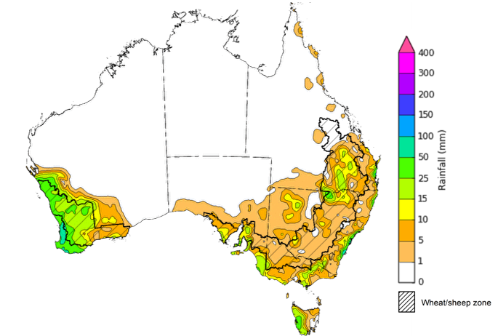

©Commonwealth of Australia 2025, Australian Bureau of Meteorology Issued: 20/8/2025

Note: The rainfall analyses and associated maps utilise data contained in the Bureau of Meteorology climate database, the Australian Data Archive for Meteorology (ADAM). The analyses are initially produced automatically from real-time data with limited [quality control](http://www.bom.gov.au/climate/headers/qc.shtml). They are intended to provide a general overview of rainfall across Australia as quickly as possible after the observations are received. For further information go to <http://www.bom.gov.au/climate/rainfall/>

### Rainfall forecast for the next eight days

Over the 8 days to 28 August 2025, **cold fronts and low-pressure troughs** are expected to bring rainfall to parts of the south and east, while northern and central Australia are forecast to remain dry.

* Rainfall totals of between 5-50 millimetres are expected across much of the southern half of Western Australia, southern South Australia, Victoria, and southeast Queensland.
* Higher falls are expected in Tasmania (15-100 millimetres) and eastern New South Wales (5- 100 millimetres).
* Remaining areas are forecast to remain largely dry.

Rainfall is likely to be mixed across eastern cropping regions over the coming week, with heavier falls expected in the west.

* Falls of between 15-50 millimetres are forecast across Western Australia.
* Meanwhile, falls of between 5-25 millimetres are expected in South Australia, Victoria, and across parts of southern and eastern New South Wales and south-eastern Queensland.
* Remaining areas of New South Wales and Queensland are expected to receive little to no rainfall.
  + If realised these falls are likely to be sufficient to support the crop and pasture growth and development in most areas and see some ongoing improvement to a soil moisture reserves in Western Australia and western and central regions of South Australia.

#### Total forecast rainfall for the period 21 August to 28 August 2025

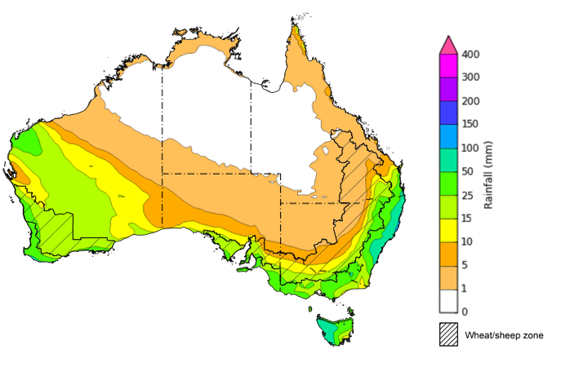

©Commonwealth of Australia 2025, Australian Bureau of Meteorology Issued 21/8/2025

Note: This rainfall forecast is produced from computer models. As the model outputs are not altered by weather forecasters, it is important to check local forecasts and warnings issued by the Bureau of Meteorology.

### 

### July precipitation percentiles and current production conditions

Crop production is affected by long-term trends in average rainfall and temperature, interannual climate variability, shocks during specific growth stages, and extreme weather events. Some crops are more tolerant than others to certain types of stresses, and at each growth stage, different types of stresses affect crop species in different ways.

Precipitation anomalies and outlooks presented below indicate the current and expected future production conditions for major grain and oilseed producing countries (responsible for over 80% of global crop production). This is an important input to assessing the global grain supply outlook.

Rainfall in July 2025 was variable across the world’s major grain- and oilseed-producing regions:

* In the **southern hemisphere**, precipitation was above average across parts of southern Australia, northern New Zealand and central Argentina, as well as much of Indonesia. Below average precipitation occurred in parts of southern Brazil. Precipitation was generally average across remaining major southern hemisphere grain- and oilseed-producing regions.
* In the **northern hemisphere**, precipitation was below average across scattered southern and western areas of the United States, central Canada, parts of the Black Sea Region, and eastern China. Precipitation was above average across central parts of the United States, northern and western China, Thailand, and much of northern India. Precipitation was generally average across remaining major northern hemisphere grain- and oilseed-producing regions.

**Global precipitation percentiles, July 2025**

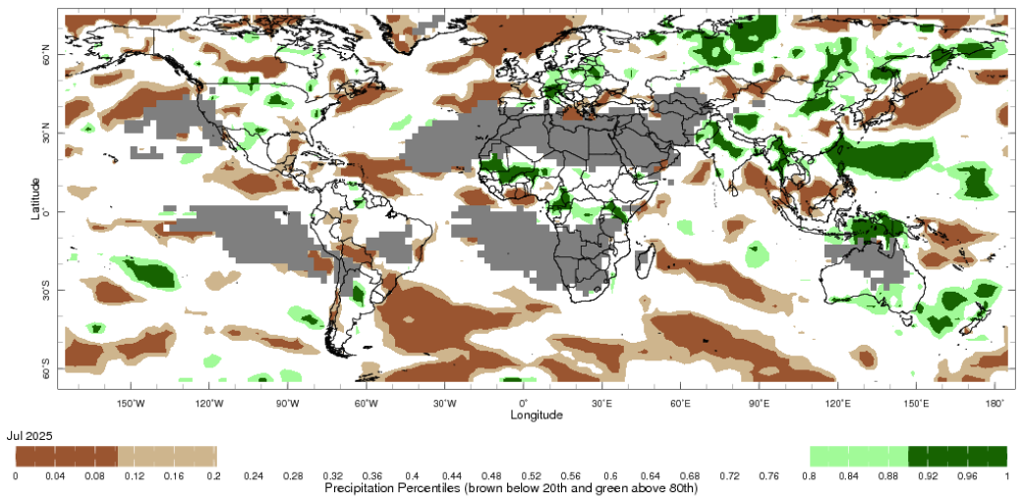

Note: The world precipitation percentiles indicate a ranking of precipitation for July, with the driest (0th percentile) being 0 on the scale and the wettest (100th percentile) being 1 on the scale. Percentiles are based on precipitation estimates from the NOAA Climate Prediction Center’s [Climate Anomaly Monitoring System Outgoing Precipitation Index](https://iridl.ldeo.columbia.edu/maproom/Global/Precipitation/Percentiles.html) dataset. Precipitation estimates for July 2025 are compared with rainfall recorded for that period during the 1981 to 2010 base period.

Source: International Research Institute for Climate and Society

As of 28 July 2025, global production conditions are generally favourable for maize, rice and soybeans, but more varied for wheat:

* **Wheat –** In the **northern hemisphere**, the winter wheat harvest is well underway under varied conditions in parts of Europe, Ukraine, Türkiye, and the US.In the **southern hemisphere**, sowing and crop development is continuing under broadly favourable conditions.
* **Maize** **–** In the **southern hemisphere**, the harvest is progressing under favourable conditions. In the **northern hemisphere,** dry conditions parts of the Russian Federation, Europe, and Ukraine are likely to negatively impact cropping outcomes.
* **Rice –** Global conditions are broadly favourable for major rice production regions.
* **Soybeans –** In the **northern hemisphere**, crops are developing under generally favourable conditions across most major growing regions.

**Crop conditions, AMIS countries, 28 July 2025**

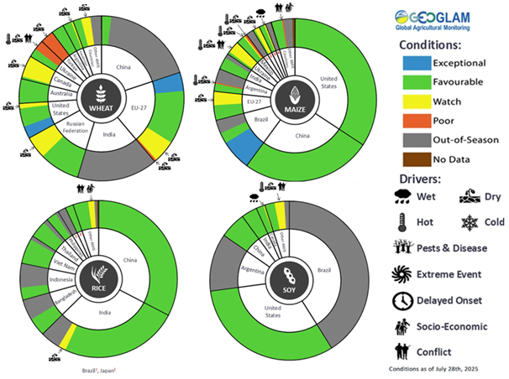

**AMIS** Agricultural Market Information System.

Source: AMIS

The global climate outlook for September 2025 to November 2025 indicates that mixed rainfall conditions are expected for the world’s major grain-producing and oilseed-producing regions. Outlooks and potential production impacts for major grain- and oilseed-producing countries are presented in the following table.

**Rainfall outlook and potential impact on the future state of production conditions, September-November 2025**

|  |  |  |
| --- | --- | --- |
| **Region** | **Rainfall outlook** | **Potential impact on production** |
| **Argentina** | Above average rainfall is likely across much of northern Argentina, with southern regions likely to receive below average rainfall. | A generally favourable rainfall outlook is likely to support the heading and grain fill of wheat and the planting and development corn, soybeans, sunflower, rice, sorghum and millet. |
| **Black Sea Region** | Below average rainfall is expected across Türkiye and parts of the Russian Federation, while Ukraine is likely to see above average falls. | Anticipated below average rainfall in Türkiye and parts of the Russian Federation is likely to support the harvesting of major crops including wheat and cotton. Average rainfall across Kazakhstan and Ukraine is likely to support winter wheat and rapeseed planting in September, and corn and sunflower filling in September and October. |
| **Brazil** | Rainfall outcomes across Brazil are expected to be broadly above average in the northern two thirds of the country, with southern most regions likely to see below average rainfall. | Anticipated above average rainfall across much of Brazil is expected to support the planting and development of corn and soybeans. Below average anticipated rainfall will support an uninterrupted harvest of wheat in southern Brazil. |
| **Canada** | Generally, below average rainfall is expected in western regions, while average rainfall is more likely in the south. | Below average rainfall is likely to impact the growth of corn, soybean, and sunflower crops, but allow for the timely harvesting of wheat, barley and canola. Average rainfall in isolated areas may benefit the development of crops in these locations. |
| **China** | Above average rainfall is expected throughout much of northern and central China, with below average rainfall expected in scattered eastern areas. | Anticipated rainfall is likely to support the development of major crops over the period but may interrupt harvesting of some spring crops and planting of winter crops. |
| **European Union** | Average rainfall is more likely for much of the central European Union, with parts of northern France likely to see above average rainfall. Below average rainfall is likely in Spain and southern France. | Average rainfall across much of the European Union is likely to benefit the development of corn, soybeans, and sunflower in the north, as well as planting of winter crops and harvesting of corn, soybeans, and cotton. |
| **South Asia (India)** | Above average rainfall is expected across much of western and eastern India, with southern areas forecast to receive below average rainfall. | Anticipated rainfall is likely to support the flowering of cotton and the growth of major grains and oilseeds, including corn, rice and sorghum. However, above average rainfall may impair harvesting and planting of winter wheat, canola and sunflower. |
| **Southeast Asia (SEA)** | Above average rainfall is likely across much of Indonesia and Malaysia, with below average rainfall expected in scattered areas of Thailand. | Average to above average rainfall in SEA may support the growth of rice and corn in major growing regions but impair the harvesting of these crops in October. |
| **The United States** | Below average rainfall is likely for much of southern and eastern United States, with average rainfall more likely across the north. | Below average rainfall is likely to adversely affect the filling and maturing of soybeans, sunflower, millet, cotton, rice, corn, sorghum and groundnuts in September leading up to harvest in October and November. Elsewhere, average rainfall is expected to support crop development. |

### Water markets – current week

#### Water storage levels in the Murray-Darling Basin (MDB) increased by 73 gigalitres (GL) between 14 August 2025 and 21 August 2025. The current volume of water held in storages is 14,720 GL, equivalent to 66% of total storage capacity. This is 20% or 3,595GL less than the same time last year. Water storage data is sourced from the Bureau of Meteorology (BOM).

#### Water storages in the Murray-Darling Basin, 2013–2025Alt Text: A chart showing water storage in the Murray-Darling Basin. For more information, refer to accompanying text

Allocation prices in the Victorian Murray below the Barmah Choke decreased from $287/ML on 14 August 2025 to $272/ML on 21 August 2025. Trade from the Goulburn to the Murray is closed. Trade downstream through the Barmah Choke is closed. Trade from the Murrumbidgee to the Murray is open.

#### Surface water trade activity, Southern Murray–Darling Basin

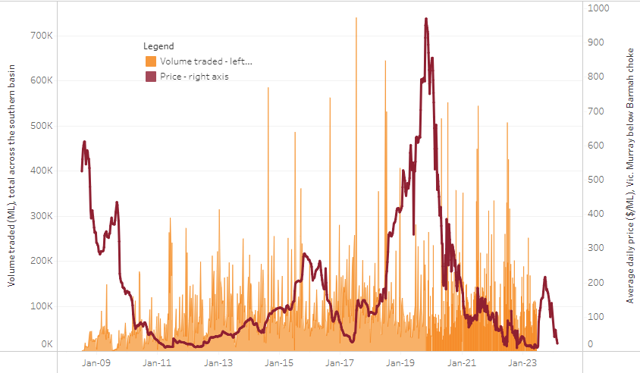

|  |
| --- |
| The trades shown reflect estimated market activity and do not encompass all register trades. The price is shown for the VIC Murray below the Barmah choke. Historical prices (before 1 July 2019) are ABARES estimates after removing outliers from BOM water register data. Prices after 1 July 2019 and prior to the 30 October 2019 reflect recorded transaction prices as sourced from Ruralco. Prices after the 30 October 2019 are sourced from Waterflow. Data for volume traded is sourced from the BOM water register. Only the price data shown is current on 17 October 2024. |

To access the full, interactive, weekly water dashboard, which contains the latest and historical water storage, water market and water allocation information, please visit https://www.agriculture.gov.au/abares/products/weekly_update/weekly-update-140825

## **Commodities**

|  |  |  |  |  |  |  |  |  |
| --- | --- | --- | --- | --- | --- | --- | --- | --- |
| **Indicator** | **Week average** | **Unit** | **Latest Price** | **Previous Week** | **Weekly change** | | **Price 12 months ago** | **Annual change** |
| **Selected world indicator prices** |  |  |  |  |  |  | |  |
| AUD/USD Exchange rate | 20-Aug | A$/US$ | 0.65 | 0.65 | -1% | 0.67 | | -3% |
| Wheat – US no. 2 hard red winter wheat, FOB Gulf | 20-Aug | US$/t | 233 | 232 | 0% | 250 | | -7% |
| Corn – US no. 2 yellow corn, FOB Gulf | 20-Aug | US$/t | 181 | 181 | 0% | 172 | | 6% |
| Canola – Rapeseed, Canada, FOB Vancouver | 20-Aug | US$/t | 504 | 506 | 0% | 458 | | 10% |
| Cotton – Cotlook A Index | 20-Aug | USc/lb | 79.1 | 79.0 | 0% | 80 | | -1% |
| Sugar – Intercontinental Exchange, nearby futures, no.11 contract | 20-Aug | USc/lb | 16.3 | 16.7 | -2% | 19 | | -12% |
| Wool – Eastern Market Indicator | 20-Aug | Ac/kg clean | 1,247 | 1,239 | 1% | 1,100 | | 13% |
| Wool – Western Market Indicator | 20-Aug | Ac/kg clean | 1,396 | 1,373 | 2% | 1,236 | | 13% |
| **Selected Australian grain export prices** |  |  |  |  |  |  | |  |
| Australian Premium White (APW) Wheat, FOB Port Adelaide, SA | 20-Aug | A$/t | 381 | 383 | -1% | 405 | | -6% |
| Australian Standard White (ASW) Wheat, FOB Port Adelaide, SA | 20-Aug | A$/t | 377 | 379 | -1% | 394 | | -4% |
| Feed Barley – FOB Port Adelaide, SA | 20-Aug | A$/t | 363 | 365 | 0% | 358 | | 1% |
| Canola – FOB Kwinana, WA | 20-Aug | A$/t | 807 | 797 | 1% | 725 | | 11% |
| Grain Sorghum – FOB Brisbane, QLD | 20-Aug | A$/t | 415 | 425 | -2% | 408 | | 2% |
| **Selected domestic livestock indicator prices** |  |  |  |  |  |  | |  |
| Beef – Eastern Young Cattle Indicator | 20-Aug | Ac/kg cwt | 860 | 854 | 1% | 671 | | 28% |
| Mutton – Mutton indicator (18–24 kg fat score 2–3), VIC | 20-Aug | Ac/kg cwt | 735 | 753 | -2% | 370 | | 99% |
| Lamb – National Trade Lamb Indicator | 20-Aug | Ac/kg cwt | 1,153 | 1,192 | -3% | 809 | | 42% |
| Pig – Eastern Seaboard (60.1–75 kg), NSW buyer price | 06-Aug | Ac/kg cwt | 453 | 452 | 0% | 415 | | 9% |
| Live cattle – Light steers to Indonesia | 13-Aug | Ac/kg lwt | 350 | 350 | 0% | 300 | | 17% |
| **Global Dairy Trade (GDT) weighted average prices** |  |  |  |  |  |  | |  |
| Dairy – Whole milk powder | 20-Aug | US$/t | 4,036 | 4,012 | 1% | 3,371 | | 20% |
| Dairy – Skim milk powder | 20-Aug | US$/t | 2,756 | 2,805 | -2% | 2,588 | | 7% |
| Dairy – Cheddar cheese | 20-Aug | US$/t | 4,548 | 4,575 | -1% | 4,275 | | 6% |
| Dairy – Anhydrous milk fat | 20-Aug | US$/t | 7,078 | 7,081 | 0% | 7,078 | | 0% |
|  | | | | | | | | |

### Selected world indicator prices

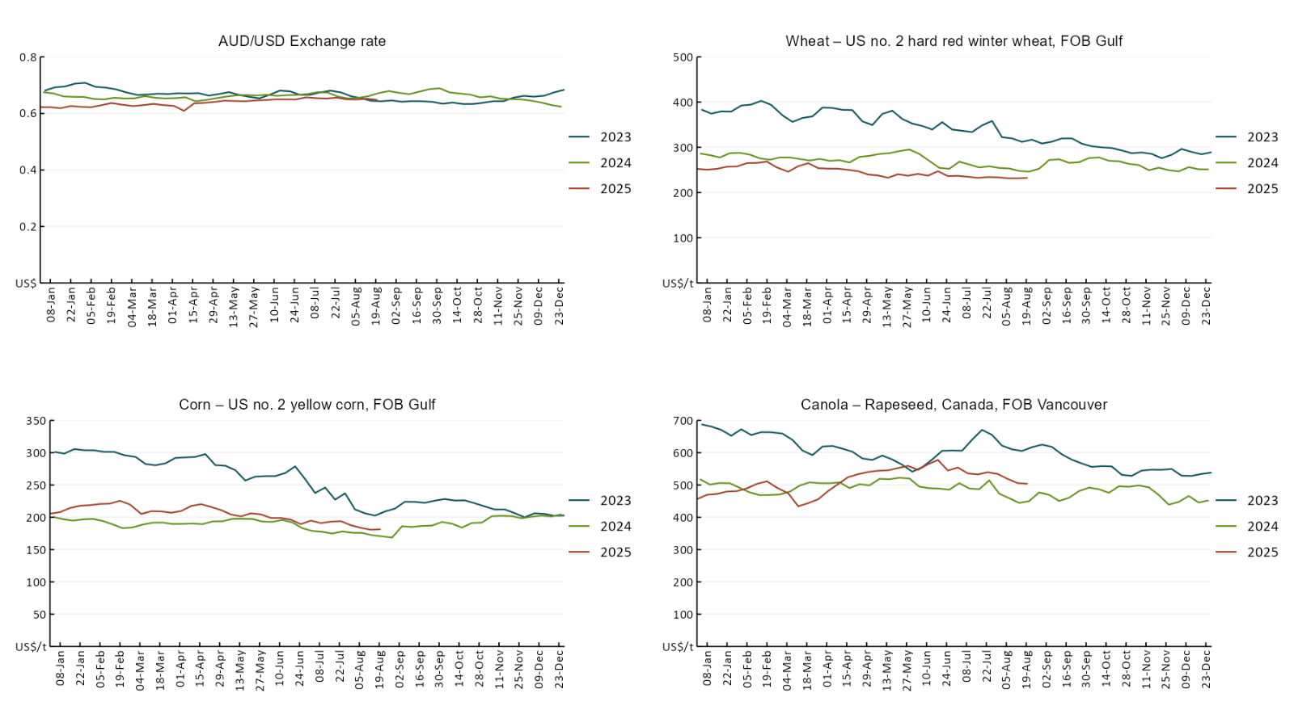

### A line chart of major world indicator prices. For more information, refer to https://www.agriculture.gov.au/abares/data/weekly-commodity-price-update/world-agricultural-prices

### 3.2 Selected domestic crop indicator prices

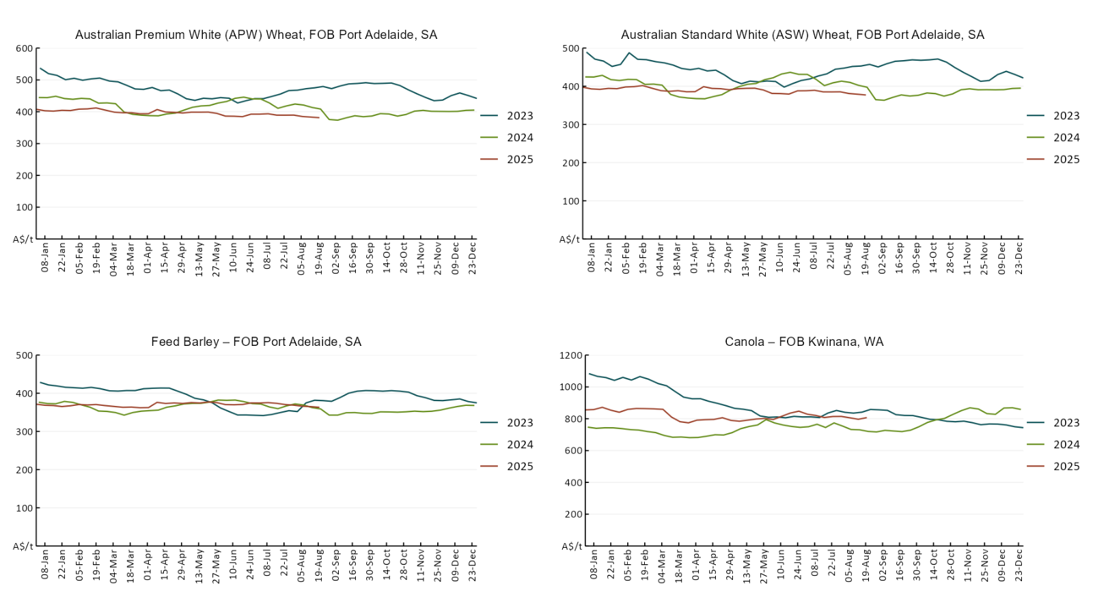

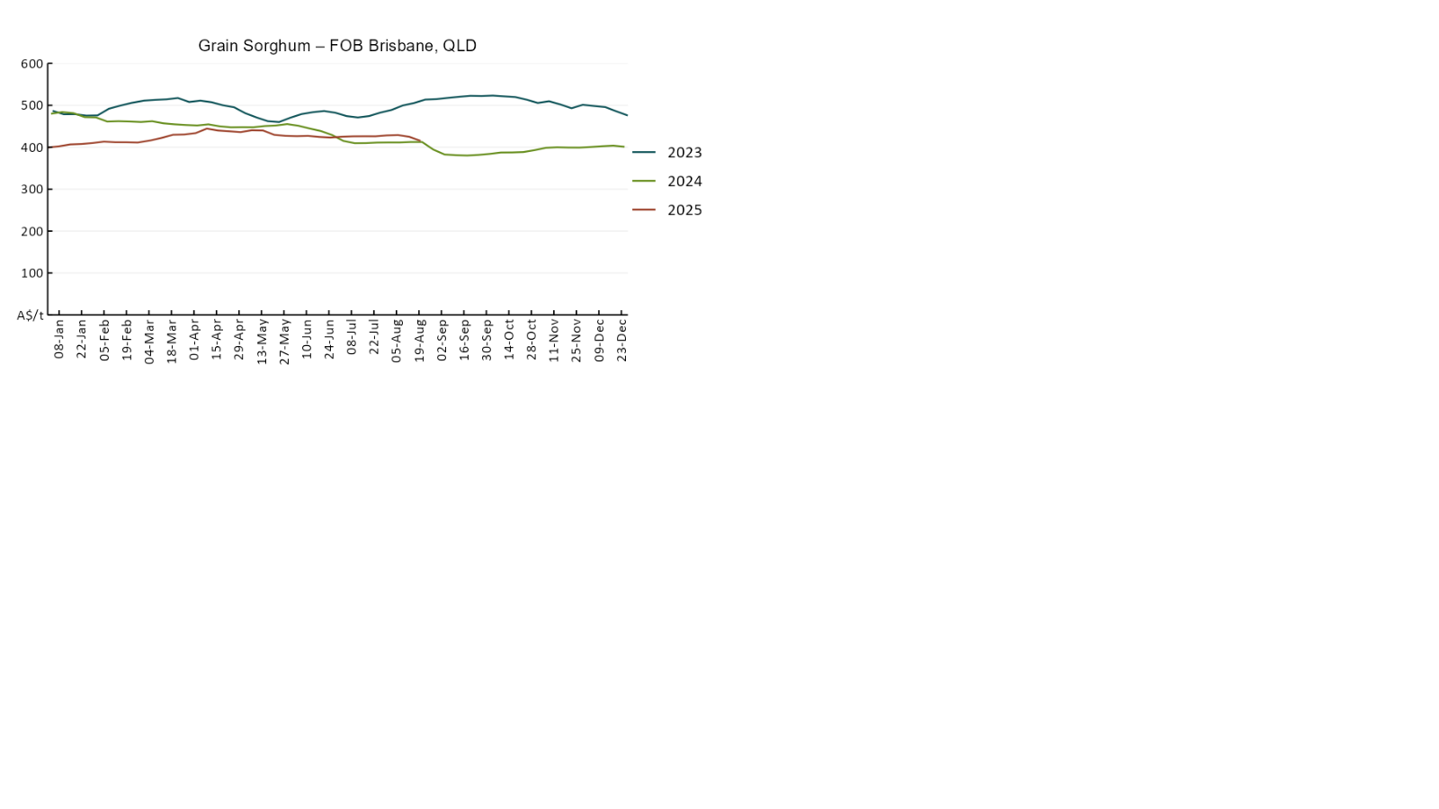

### 3.3 Selected domestic livestock indicator prices

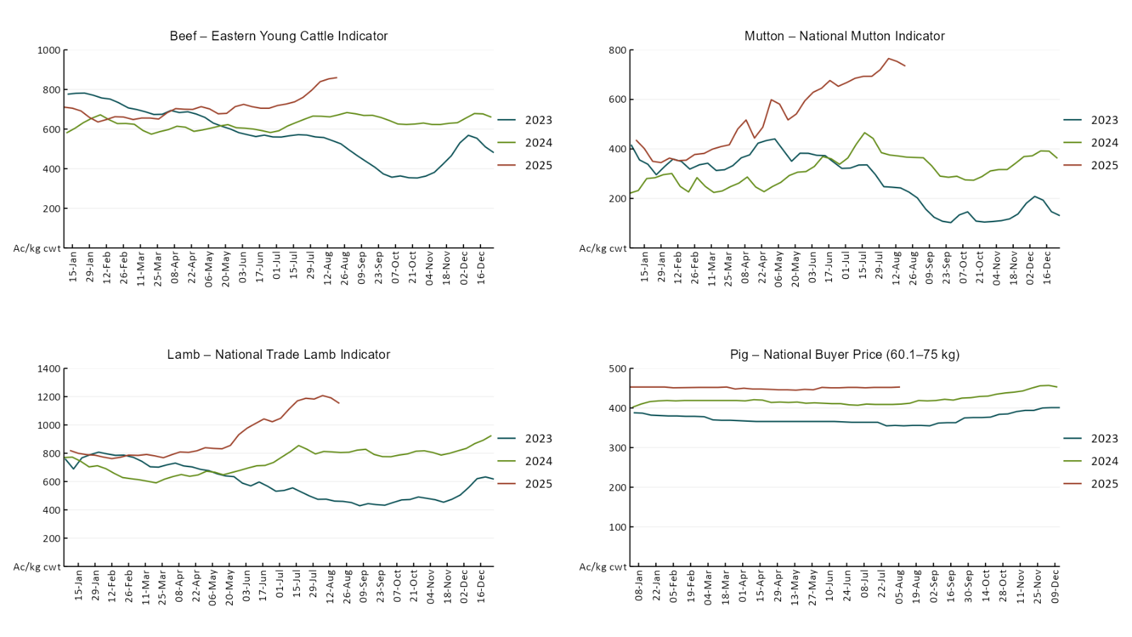

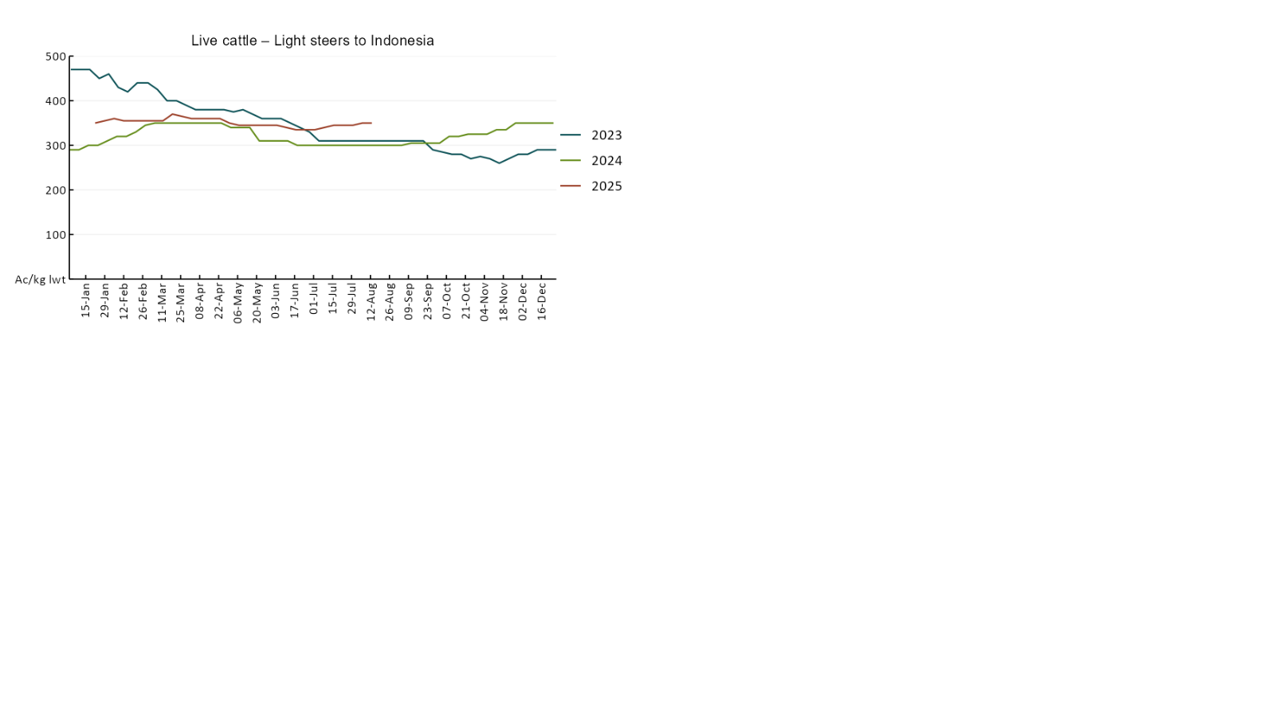

### 3.4 Global Dairy Trade (GDT) weighted average pricesA line chart of Global Dairy Trade prices. For more information, refer to https://www.agriculture.gov.au/abares/data/weekly-commodity-price-update/world-agricultural-prices

### 3.5 Selected fruit and vegetable prices

### A line chart of fruit and vegetable prices. For more information, refer to https://www.agriculture.gov.au/abares/data/weekly-commodity-price-update/world-agricultural-prices

### A line chart of fruit and vegetable prices. For more information, refer to https://www.agriculture.gov.au/abares/data/weekly-commodity-price-update/world-agricultural-prices

### 3.6 Selected domestic fodder indicator prices

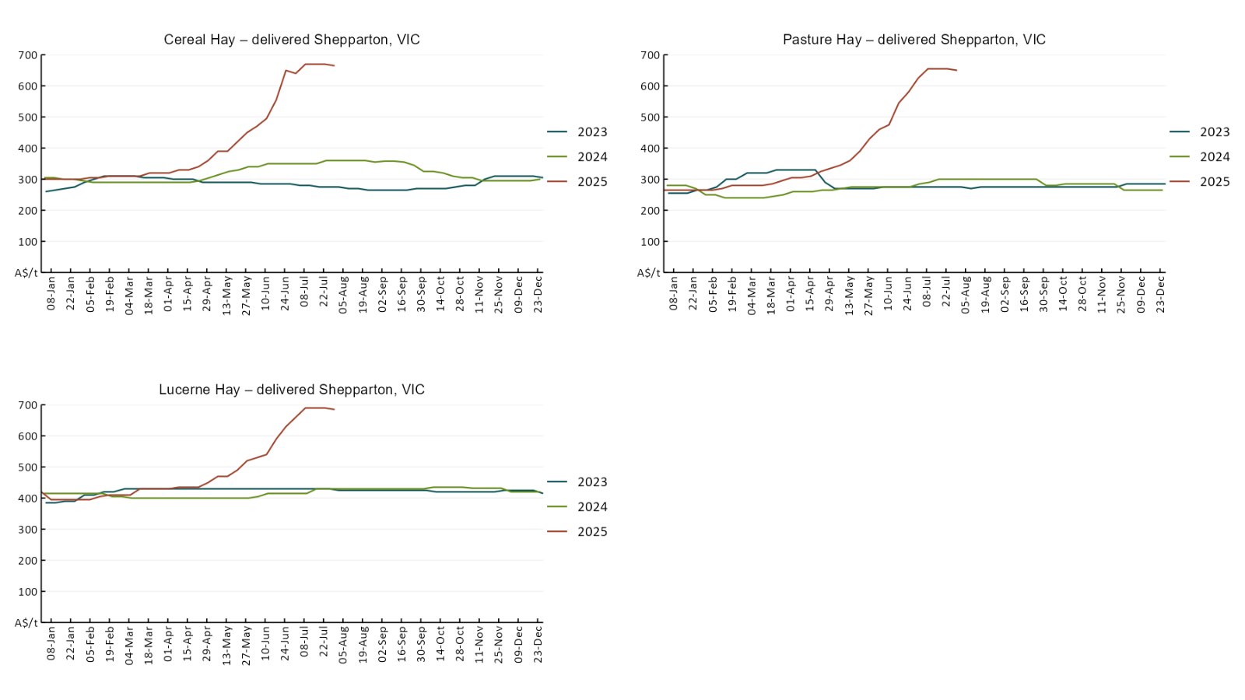

## **4. Data attribution**

### Climate

* Bureau of Meteorology
* Weekly rainfall totals: www.bom.gov.au/climate/maps/rainfall/
* Monthly and last 3-month rainfall percentiles: [www.bom.gov.au/water/landscape/](http://www.bom.gov.au/water/landscape/)
* Temperature anomalies: [www.bom.gov.au/jsp/awap/temp/index.jsp](http://www.bom.gov.au/jsp/awap/temp/index.jsp)
* Rainfall forecast: [www.bom.gov.au/jsp/watl/rainfall/pme.jsp](http://www.bom.gov.au/jsp/watl/rainfall/pme.jsp)
* Seasonal outlook: [www.bom.gov.au/climate/outlooks/#/overview/summary/](http://www.bom.gov.au/climate/outlooks/#/overview/summary/)
* Climate drivers: <http://www.bom.gov.au/climate/enso/>
* Soil moisture: [www.bom.gov.au/water/landscape/](http://www.bom.gov.au/water/landscape/)
* Other
* Pasture growth: [www.longpaddock.qld.gov.au/aussiegrass/](http://www.longpaddock.qld.gov.au/aussiegrass/)
* 3-month global outlooks: [Environment and Climate Change Canada](https://weather.gc.ca/saisons/image_e.html?img=s234pfe1p_cal&bc=prob), [NOAA Climate Prediction Center](https://www.cpc.ncep.noaa.gov/products/predictions/long_range/seasonal.php?lead=2), [EUROBRISA CPTEC/INPE](http://eurobrisa.cptec.inpe.br/), European Centre for Medium-Range Weather Forecasts, [Hydrometcenter of Russia](https://meteoinfo.ru/en/climate/seasonal-forecasts), [National Climate Center Climate System Diagnosis and Prediction Room (NCC)](https://cmdp.ncc-cma.net/pred/cs2gen.php?pred_elem=RAINP#pred_seasonal), [International Research Institute for Climate and Society](https://iri.columbia.edu/our-expertise/climate/forecasts/seasonal-climate-forecasts/)
* Global production: <https://ipad.fas.usda.gov/ogamaps/cropmapsandcalendars.aspx>
* Autumn break: Pook et al., 2009, <https://rmets-onlinelibrary-wiley-com.virtual.anu.edu.au/doi/epdf/10.1002/joc.1833>

### Water

Prices

* Waterflow: <https://www.waterflow.io/>
* Ruralco: <https://www.ruralcowater.com.au/>
* Bureau of Meteorology:
* Allocation trade: <http://www.bom.gov.au/water/dashboards/#/water-markets/mdb/at>
* Storage volumes: <http://www.bom.gov.au/water/dashboards/#/water-storages/summary/drainage>
* Trade constraints:
* Water NSW: <https://www.waternsw.com.au/customer-service/ordering-trading-and-pricing/trading/murrumbidgee>
* Victorian Water Register: <https://www.waterregister.vic.gov.au/TradingRules2019/>

### Commodities

* Fruit and vegetables
* Datafresh: [www.freshstate.com.au](http://www.freshstate.com.au)
* Pigs
* Australian Pork Limited: [www.australianpork.com.au](http://www.australianpork.com.au)
* Dairy
* Global Dairy Trade: [www.globaldairytrade.info/en/product-results/](http://www.globaldairytrade.info/en/product-results/)
* World wheat, canola
* International Grains Council
* World coarse grains
* United States Department of Agriculture
* World cotton
* Cotlook: [www.cotlook.com/](http://www.cotlook.com/)
* World sugar
* New York Stock Exchange - Intercontinental Exchange
* Wool
* Australian Wool Exchange: [www.awex.com.au/](http://www.awex.com.au/)
* Domestic wheat, barley, sorghum, canola and fodder
* Jumbuk Consulting Pty Ltd: http://www.jumbukag.com.au/
* Cattle, beef, mutton, lamb, goat and live export
* Meat and Livestock Australia: [www.mla.com.au/Prices-and-market](http://www.mla.com.au/Prices-and-market)

© Commonwealth of Australia 2025

### Ownership of intellectual property rights

Unless otherwise noted, copyright (and any other intellectual property rights, if any) in this publication is owned by the Commonwealth of Australia (referred to as the Commonwealth).

### Creative Commons licence

All material in this publication is licensed under a [Creative Commons Attribution 4.0 International Licence](https://creativecommons.org/licenses/by/4.0/legalcode) except content supplied by third parties, logos and the Commonwealth Coat of Arms.

Inquiries about the licence and any use of this document should be emailed to [copyright@awe.gov.au](mailto:copyright@awe.gov.au).

https://www.agriculture.gov.au/sites/default/files/images/creative-commons-logo-small.png

### Cataloguing data

This publication (and any material sourced from it) should be attributed as:

ABARES 2025, Weekly Australian Climate, Water and Agricultural Update, Australian Bureau of Agricultural and Resource Economics and Sciences, Canberra, 21 August 2025. CC BY 4.0 DOI: <https://doi.org/10.25814/5f3e04e7d2503>

ISSN **2652-7561**

This publication is available at https://www.agriculture.gov.au/abares/products/weekly_update

Department of Agriculture, Fisheries and Forestry

GPO Box 858 Canberra ACT 2601

Telephone 1800 900 090

Web [agriculture.gov.au/abares](http://awe.gov.au/abares)

### Disclaimer

The Australian Government acting through the Department of Agriculture, Fisheries and Forestry, represented by the Australian Bureau of Agricultural and Resource Economics and Sciences, has exercised due care and skill in preparing and compiling the information and data in this publication. Notwithstanding, the Department of Agriculture, Fisheries and Forestry, ABARES, its employees and advisers disclaim all liability, including liability for negligence and for any loss, damage, injury, expense or cost incurred by any person as a result of accessing, using or relying on any of the information or data in this publication to the maximum extent permitted by law.

### Statement of Professional Independence

The views and analysis presented in ABARES publications, including this one, reflect ABARES professionally independent findings, based on scientific and economic concepts, principles, information and data. These views, analysis and findings may not reflect or be consistent with the views or positions of the Australian Government, or of organisations or groups who have commissioned ABARES reports or analysis. More information on [professional independence](https://www.agriculture.gov.au/abares/about/research-and-analysis#professional-independence) is provided on the ABARES website.

### Acknowledgements

This report was prepared by Holly Beale and Matt Miller.