## No. 35/2025 4 September 2025

# Summary of key issues

* In the week ending 3 September 2025, cold fronts brought rainfall to parts of south-eastern Australia.
* Rainfall was highly variable across winter cropping regions in the week ending 3 September 2025.
  + Rainfall totals of between 5-25 millimetres were observed across much of South Australia and Victoria, as well as far south-eastern areas of New South Wales. Meanwhile, some central cropping regions in Queensland, and parts of Western Australia recorded 5- 15 millimetres.
  + Low rainfall totals coupled with warming winter temperatures across much of southern New South Wales are likely to see further declines in soil moisture levels with potential impacts on plant growth rates and yield potentials.
* Over the coming eight days to 11 September 2025, moderate rainfall totals are expected across most cropping regions, with exceptions in Queensland.
  + Falls of between 10-50 millimetres are forecast across Western Australia, New South Wales and Victoria, with falls of between 5-25 millimetres expected in South Australia and parts of southern Queensland. Remaining areas are expected to receive little to no rainfall.
* Low rainfall totals during August across southern New South Wales, is likely to have effected growth and development of winter crops and pastures in this regions. Continued timely rainfall is required to support yield potential of crops in regions that have seen recent dry conditions. While areas of below average pasture growth for the three months to August 2025 are still evident across parts of Victoria, South Australia, Western Australia, southern New South Wales and southern Queensland, relative pasture growth rates have improved across some southern production regions compared to the 3-month period ending July 2025.
* Water storage levels in the Murray-Darling Basin (MDB) increased by 278 gigalitres (GL) between 28 August 2025 and 04 September 2025. The current volume of water held in storages is 15,139 GL, equivalent to 68% of total storage capacity. This is -18% or -3,284 GL less than the same time last year. Water storage data is sourced from the Bureau of Meteorology (BOM).
* Allocation prices in the Victorian Murray below the Barmah Choke increased from $262/ML on 28 August 2025 to $278/ML on 04 September 2025. Trade from the Goulburn to the Murray is closed. Trade downstream through the Barmah Choke is closed. Trade from the Murrumbidgee to the Murray is closed.

## **Climate**

### Rainfall this week

In the week ending 3 September 2025,cold frontsbrought rainfall to parts of south-eastern and south-western Australia, while much of the remainder of Australia stayed largely dry.

* Rainfall totals of between 5-100 millimetres were recorded across southern South Australia, much of Victoria, and south-eastern New South Wales.
* In Tasmania, falls of between 10-150 millimetres were observed, with higher falls in western regions.
* Meanwhile, parts of south-eastern Queensland saw 5-25 millimetres, while falls of between 5- 15 millimetres were recorded across parts of south-western Western Australia.
* In contrast, remaining areas of Australia stayed largely dry over the period.

Rainfall was highly variable across winter cropping regions in the week ending 3 September 2025.

* Rainfall total of between 5-25 millimetres were observed across much of South Australia and Victoria, as well as far south-eastern areas of New South Wales.
* Falls of between 5-15 millimetres were recorded in some central cropping regions in Queensland, and parts of Western Australia. Remaining areas received little to no rainfall.
  + Low rainfall totals coupled with warming temperatures across much of southern New South Wales are likely to see further declines in soil moisture levels with potential impacts on plant growth rates and yield potentials.

#### Rainfall for the week ending 3 September 2025

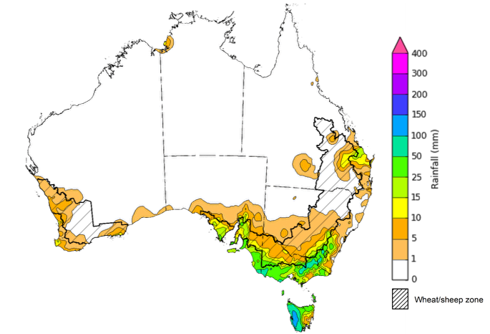

©Commonwealth of Australia 2025, Australian Bureau of Meteorology Issued: 3/9/2025

Note: The rainfall analyses and associated maps utilise data contained in the Bureau of Meteorology climate database, the Australian Data Archive for Meteorology (ADAM). The analyses are initially produced automatically from real-time data with limited [quality control](http://www.bom.gov.au/climate/headers/qc.shtml). They are intended to provide a general overview of rainfall across Australia as quickly as possible after the observations are received. For further information go to <http://www.bom.gov.au/climate/rainfall/>

### Rainfall forecast for the next eight days

Over the 8 days to 11 September 2025, cold fronts and low-pressure systems are expected to bring rainfall to large areas of the southern Australia, while central and northern regions of Australia are forecast to remain dry.

* Rainfall totals of between 10-100 millimetres are expected across much of Victoria and New South Wales. Heavier falls of between 25-150 millimetres are expected across Tasmania.
* Falls of between 5-50 millimetres are forecast for much of southern South Australia and the south of Western Australia.
* In contrast, remaining areas are forecast to remain largely dry.

Moderate rainfall totals are likely across most cropping regions this week, with exceptions in Queensland.

* Falls of between 10-50 millimetres are forecast across Western Australia, New South Wales and Victoria, with falls of between 5-25 millimetres expected in South Australia and parts of southern Queensland.
  + If realised these falls are likely to be sufficient to support the crop and pasture growth and development and see some ongoing improvement to soil moisture reserves in most areas.
* Most northern and central cropping regions in Queensland are expected to receive little to no rainfall.

#### Total forecast rainfall for the period 4 September to 11 September 2025

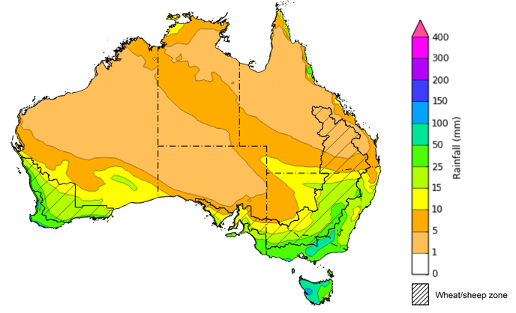

©Commonwealth of Australia 2025, Australian Bureau of Meteorology Issued 4/9/2025

Note: This rainfall forecast is produced from computer models. As the model outputs are not altered by weather forecasters, it is important to check local forecasts and warnings issued by the Bureau of Meteorology.

### 

### Monthly rainfall

Rainfall during August 2025 was generally average to above average, with areas of low rainfall across the southeast and in central Australia:

* Rainfall was above average to extremely high across large areas of Western Australia and eastern and northern New South Wales, as well as part of southern Queensland and the far-north Northern Territory.
* Below average rainfall was recorded across much of Tasmania and southern New South Wales, as well as part of Victoria, southern South Australia, Cape York peninsula and central Australia.
* The remainder of Australia saw generally average August rainfall.

In cropping regions, August rainfall was generally high in the west and northeast, and below average to average in the southeast:

* August rainfall was average to extremely high across cropping regions in Queensland, northern New South Wales, and much of Western Australia.
  + The average to extremely high rainfall recorded in these regions are likely to have provided a boost to soil moisture levels and supported strong yield potentials and the growth and development of crops and pastures.
* Most South Australian and Victorian cropping regions saw below average to average rainfall.
  + This should have been sufficient to support the growth and development of crops and pastures, particularly as this follows above average rainfall during July.
* However, much of southern New South Wales recorded well below average to below average August rainfall.
  + These low rainfall totals have only been sufficient to support below average yield expectations for winter crops and pastures, and seen a drawdown of stored soil moisture levels to minimal levels and continues to present a downside production risk for the remainder of the season.

**Rainfall percentiles for August 2025**

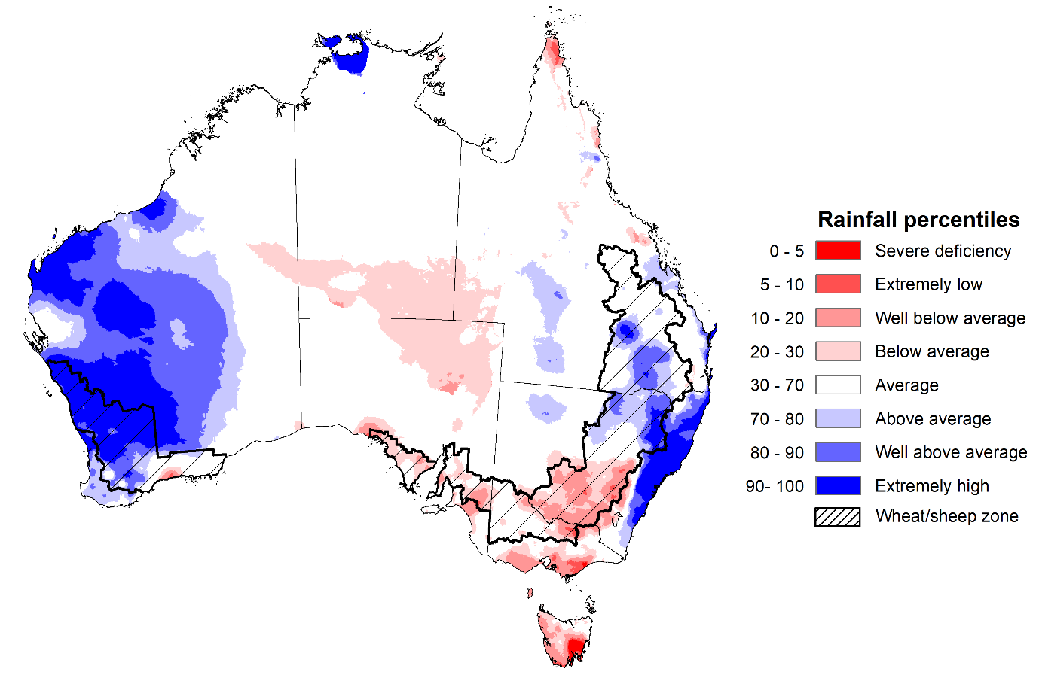

Note: Rainfall for August 2025 is compared with rainfall recorded for that period during the historical record (1900 to present). For further information, go to <http://www.bom.gov.au/climate/austmaps/about-rain-maps.shtml>

Source: Bureau of Meteorology

### Monthly Soil Moisture

In August 2025, modelled **upper layer soil moisture** was generally average to above average, with areas of below soil moisture in the southeast and scattered central and northern areas.

* Much of Tasmania, southern parts of Victoria and New South Wales, and scattered areas of South Australia, as well as isolated parts of Western Australia and the northern tropics, were modelled as having below average to very low soil moisture.
* In contrast, much of western and eastern Australia, including Western Australia, eastern and northern New South Wales and large area of Queensland and the Northern Territory saw above average to very much above upper layer soil moisture.

At this time of year, upper layer soil moisture is less critical for well-established winter crops. However, upper layer soil moisture will be critical for supporting the germination and establishment of summer crops in the coming months.

Across some south-eastern cropping regions, modelled upper layer soil moisture in August was generally **below average to average**. In contrast, most in the south-western and north-eastern cropping regions saw **average to very much above average** upper layer soil moisture.

* Across Queensland, northern New South Wales and Western Australia, upper layer soil moisture was average to very much above average.
* In South Australia, Victoria, and southern New South Wales, upper layer soil moisture was average to below average.

This represents a substantial improvement in growing conditions across most cropping regions, except for southern New South Wales, compared to July 2025. Adequate and timely rainfall throughout the remainder of the growing season will be needed particularly across most south-eastern cropping regions to support ongoing improvements in cropping and pasture growth outcomes.

**Modelled upper layer soil moisture for August 2025**

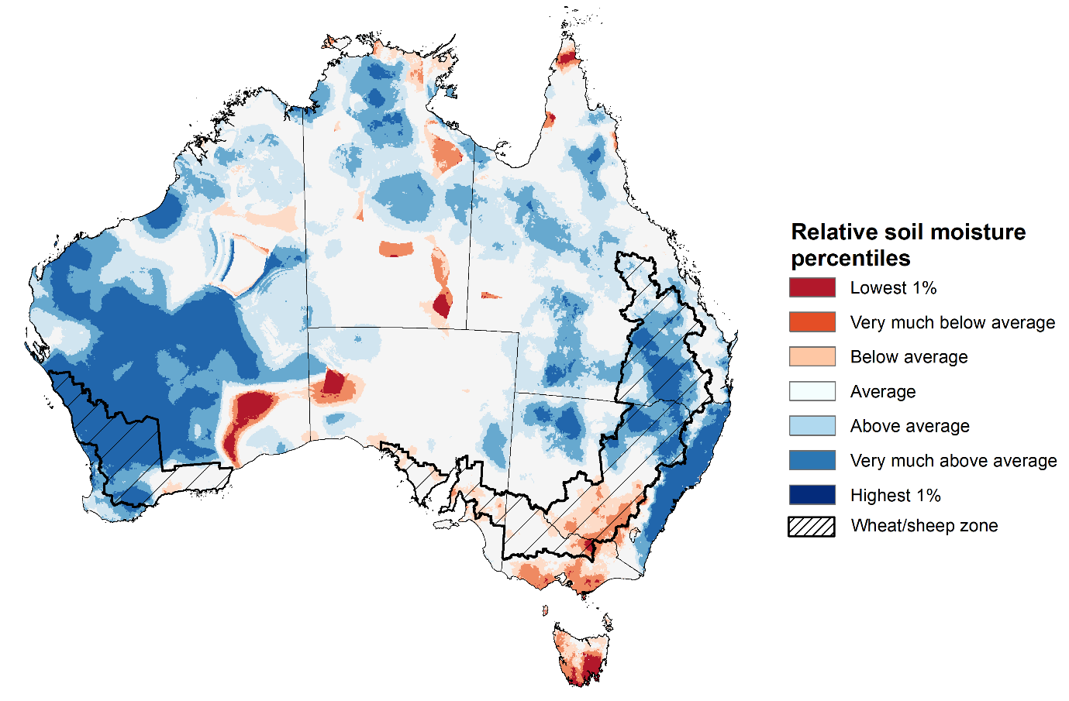

Note: This map shows the levels of modelled upper layer soil moisture (0 to 10 centimetres) during August 2025. This map shows how modelled soil conditions during August 2025 compare with August conditions modelled over the reference period (1911 to 2016). Dark blue areas on the maps were much wetter in August 2025 than during the reference period. The bulk of plant roots occur in the top 20 centimetres of the soil profile. Soil moisture in the upper layer of the soil profile is therefore useful indicator of the availability of water, particularly for germinating seed.

Source: Bureau of Meteorology (<https://awo.bom.gov.au/about/overview>)

Modelled **lower layer soil moisture** in August 2025 was average to very much above average across much of Australia, while extremely low to below average modelled lower layer soil moisture was evident across some southern and eastern areas.

* Large areas of the Northern Territory, Western Australia, Queensland, South Australia, and eastern New South Wales were modelled as having **very much above average soil moisture.**
* By contrast, parts of south-eastern Australia, including parts of southern New South Wales and Victoria, and Tasmania, as well as western and southern regions of Western Australia were modelled as having **extremely low to below average soil moisture** over the period**.**

Lower layer soil moisture is a larger, deeper store that is slower to respond to seasonal conditions and tends to reflect the accumulated effects of events that have occurred over longer periods. Crop development and pasture growth in areas of above average lower layer soil moisture are typically less reliant on in-season rainfall than in areas with below average lower layer soil moisture.

Across cropping regions in August 2025, lower layer soil moisture was largely average to above average. Extremely low to below average soil moisture was modelled for large areas of southern New South Wales. In contrast, above average lower layer soil moisture was modelled across parts of western South Australia, parts of northern New South Wales and Queensland, and scattered areas of Western Australia. Remaining cropping regions were modelled to have generally average lower layer soil moisture levels for this time of year.

* Low levels of lower layer soil moisture across some cropping region in south-east Australia present an ongoing downside production risk to the 2025–26 winter crop. These growing regions will require sufficient and timely rainfall throughout the remainder of the growing season to support the growth and development of crops and pastures.

**Modelled lower layer soil moisture for August 2025**

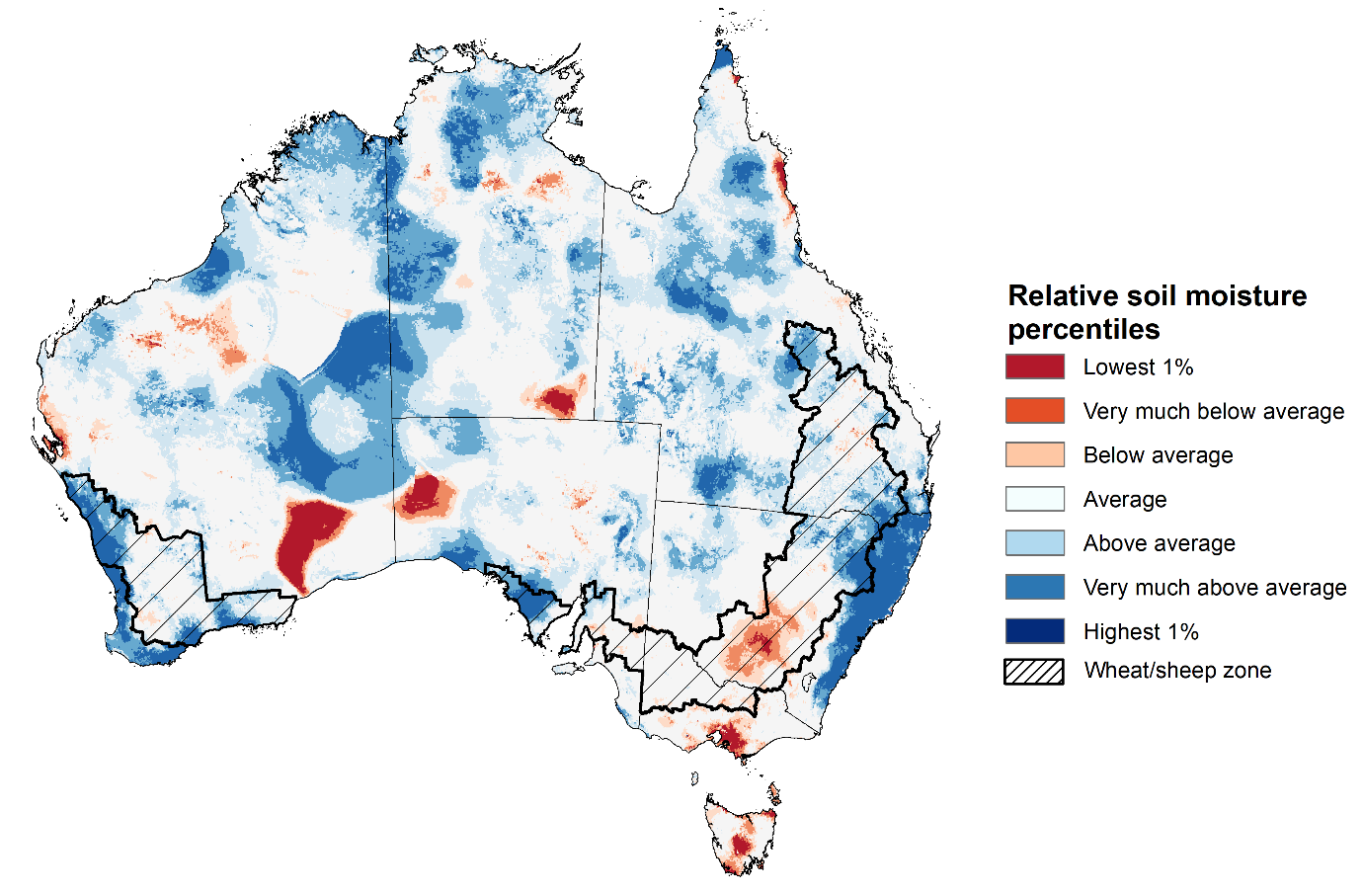

Note: This map shows the levels of modelled lower layer soil moisture (10 to 100 centimetres) during August 2025. This map shows how modelled soil conditions during August 2025 compare with August conditions modelled over the reference period (1911 to 2016). Dark blue areas on the maps were much wetter in August 2025 than during the reference period. The dark red areas were much drier than during the reference period. The bulk of plant roots occur in the top 20 centimetres of the soil profile. The lower layer soil moisture is a larger, deeper store that is slower to respond to rainfall and tends to reflect accumulated rainfall events over longer time periods.

Source: Bureau of Meteorology (<https://awo.bom.gov.au/about/overview>)

### Pasture Growth

Pasture growth for the three months to August 2025 was variable across much of country, with parts of southern and eastern Australia experiencing improved pasture growth.

* **Average to extremely high** pasture growth was modelled across large areas of southern and eastern Australia, including Queensland, northern and eastern New South Wales, southern Victoria, and western and southern regions of South Australia.
  + This pasture growth is expected to allow farmers to rebuild livestock numbers, provide opportunities to build standing dry matter availability and decrease the reliance on fodder to maintain livestock condition over the winter period.
* By contrast, large areas of the Mallee region, southern Western Australia, southern Queensland, central New South Wales saw relatively low pasture growth for this time of year, but with some improvement evident in some southern production regions compared to the 3-month period ending July 2025.
  + This below average pasture growth will likely see some graziers in affected regions continuing to be reliant on supplemental feed to maintain current stocking rates and production.

**Relative pasture growth for 3-months ending July 2025 (1 June to 31 August 2025)**

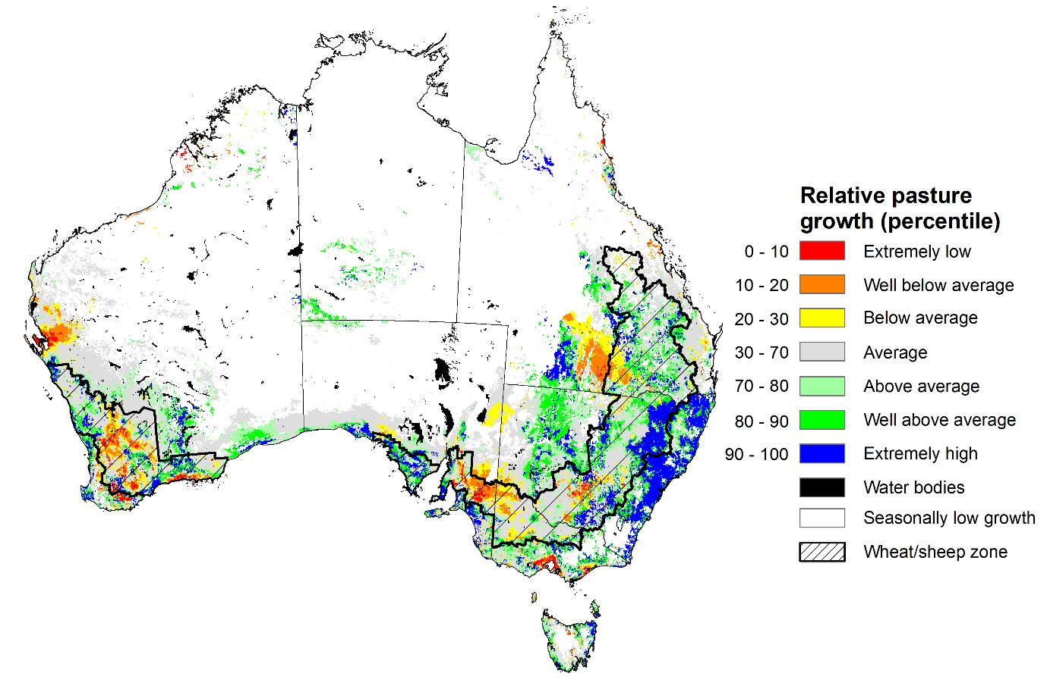

Notes: AussieGRASS pasture growth estimates are relative to the long-term record and shown in percentiles. Percentiles rank data on a scale of zero to 100. This analysis ranks pasture growth for the selected period against average pasture growth for the long-term record (1957 to 2016). Pasture growth is modelled at 5km2 grid cells.  
Source: Department of Environment, Science and Innovation

### Water markets – current week

#### Water storage levels in the Murray-Darling Basin (MDB) increased by 278 gigalitres (GL) between 28 August 2025 and 04 September 2025. The current volume of water held in storages is 15,139 GL, equivalent to 68% of total storage capacity. This is -18% or -3,284 GL less than the same time last year. Water storage data is sourced from the Bureau of Meteorology (BOM).

#### Water storages in the Murray-Darling Basin, 2013–2025Alt Text: A chart showing water storage in the Murray-Darling Basin. For more information, refer to accompanying text

Allocation prices in the Victorian Murray below the Barmah Choke increased from $262/ML on 28 August 2025 to $278/ML on 04 September 2025. Trade from the Goulburn to the Murray is closed. Trade downstream through the Barmah Choke is closed. Trade from the Murrumbidgee to the Murray is closed.

#### Surface water trade activity, Southern Murray–Darling Basin

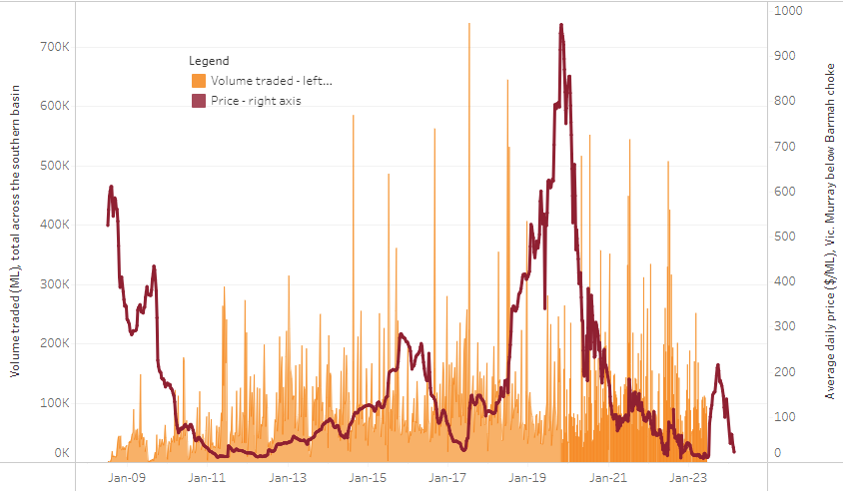

|  |
| --- |
| The trades shown reflect estimated market activity and do not encompass all register trades. The price is shown for the VIC Murray below the Barmah choke. Historical prices (before 1 July 2019) are ABARES estimates after removing outliers from BOM water register data. Prices after 1 July 2019 and prior to the 30 October 2019 reflect recorded transaction prices as sourced from Ruralco. Prices after the 30 October 2019 are sourced from Waterflow. Data for volume traded is sourced from the BOM water register. Only the price data shown is current on 17 October 2024. |

To access the full, interactive, weekly water dashboard, which contains the latest and historical water storage, water market and water allocation information, please visit https://www.agriculture.gov.au/abares/products/weekly_update/weekly-update-140825

## **Commodities**

|  |  |  |  |  |  |  |  |  |
| --- | --- | --- | --- | --- | --- | --- | --- | --- |
| **Indicator** | **Week average** | **Unit** | **Latest Price** | **Previous Week** | **Weekly change** | | **Price 12 months ago** | **Annual change** |
| **Selected world indicator prices** |  |  |  |  |  |  | |  |
| AUD/USD Exchange rate | 03-Sep | A$/US$ | 0.65 | 0.65 | 0% | 0.68 | | -3% |
| Wheat – US no. 2 hard red winter wheat, FOB Gulf | 03-Sep | US$/t | 229 | 229 | 0% | 270 | | -15% |
| Corn – US no. 2 yellow corn, FOB Gulf | 03-Sep | US$/t | 192 | 185 | 4% | 186 | | 3% |
| Canola – Rapeseed, Canada, FOB Vancouver | 03-Sep | US$/t | 510 | 509 | 0% | 465 | | 10% |
| Cotton – Cotlook A Index | 03-Sep | USc/lb | 77.8 | 78.5 | -1% | 83 | | -6% |
| Sugar – Intercontinental Exchange, nearby futures, no.11 contract | 03-Sep | USc/lb | 16.9 | 16.7 | 1% | 21 | | -18% |
| Wool – Eastern Market Indicator | 27-Aug | Ac/kg clean | 1,261 | 1,247 | 1% | 1,094 | | 15% |
| Wool – Western Market Indicator | 27-Aug | Ac/kg clean | 1,402 | 1,396 | 0% | 1,229 | | 14% |
| **Selected Australian grain export prices** |  |  |  |  |  |  | |  |
| Australian Premium White (APW) Wheat, FOB Port Adelaide, SA | 03-Sep | A$/t | 383 | 385 | -1% | 382 | | 0% |
| Australian Standard White (ASW) Wheat, FOB Port Adelaide, SA | 03-Sep | A$/t | 378 | 381 | -1% | 372 | | 2% |
| Feed Barley – FOB Port Adelaide, SA | 03-Sep | A$/t | 362 | 366 | -1% | 347 | | 4% |
| Canola – FOB Kwinana, WA | 03-Sep | A$/t | 805 | 818 | -2% | 724 | | 11% |
| Grain Sorghum – FOB Brisbane, QLD | 03-Sep | A$/t | 420 | 415 | 1% | 381 | | 10% |
| **Selected domestic livestock indicator prices** |  |  |  |  |  |  | |  |
| Beef – Eastern Young Cattle Indicator | 03-Sep | Ac/kg cwt | 893 | 885 | 1% | 669 | | 34% |
| Mutton – Mutton indicator (18–24 kg fat score 2–3), VIC | 03-Sep | Ac/kg cwt | 708 | 710 | 0% | 318 | | 123% |
| Lamb – National Trade Lamb Indicator | 03-Sep | Ac/kg cwt | 1,168 | 1,133 | 3% | 805 | | 45% |
| Pig – Eastern Seaboard (60.1–75 kg), NSW buyer price | 13-Aug | Ac/kg cwt | 461 | 453 | 2% | 422 | | 9% |
| Live cattle – Light steers to Indonesia | 27-Aug | Ac/kg lwt | 350 | 350 | 0% | 304 | | 15% |
| **Global Dairy Trade (GDT) weighted average prices** |  |  |  |  |  |  | |  |
| Dairy – Whole milk powder | 03-Sep | US$/t | 3,809 | 4,036 | -6% | 3,422 | | 11% |
| Dairy – Skim milk powder | 03-Sep | US$/t | 2,620 | 2,756 | -5% | 2,781 | | -6% |
| Dairy – Cheddar cheese | 03-Sep | US$/t | 4,709 | 4,548 | 4% | 4,383 | | 7% |
| Dairy – Anhydrous milk fat | 03-Sep | US$/t | 6,917 | 7,078 | -2% | 7,266 | | -5% |
|  | | | | | | | | |

### Selected world indicator prices

### 3.2 Selected domestic crop indicator prices

### 3.3 Selected domestic livestock indicator prices

### 3.5 Selected fruit and vegetable prices

### 3.6 Selected domestic fodder indicator prices

## **4. Data attribution**

### Climate

* Bureau of Meteorology
* Weekly rainfall totals: www.bom.gov.au/climate/maps/rainfall/
* Monthly and last 3-month rainfall percentiles: [www.bom.gov.au/water/landscape/](http://www.bom.gov.au/water/landscape/)
* Temperature anomalies: [www.bom.gov.au/jsp/awap/temp/index.jsp](http://www.bom.gov.au/jsp/awap/temp/index.jsp)
* Rainfall forecast: [www.bom.gov.au/jsp/watl/rainfall/pme.jsp](http://www.bom.gov.au/jsp/watl/rainfall/pme.jsp)
* Seasonal outlook: [www.bom.gov.au/climate/outlooks/#/overview/summary/](http://www.bom.gov.au/climate/outlooks/#/overview/summary/)
* Climate drivers: <http://www.bom.gov.au/climate/enso/>
* Soil moisture: [www.bom.gov.au/water/landscape/](http://www.bom.gov.au/water/landscape/)
* Other
* Pasture growth: [www.longpaddock.qld.gov.au/aussiegrass/](http://www.longpaddock.qld.gov.au/aussiegrass/)
* 3-month global outlooks: [Environment and Climate Change Canada](https://weather.gc.ca/saisons/image_e.html?img=s234pfe1p_cal&bc=prob), [NOAA Climate Prediction Center](https://www.cpc.ncep.noaa.gov/products/predictions/long_range/seasonal.php?lead=2), [EUROBRISA CPTEC/INPE](http://eurobrisa.cptec.inpe.br/), European Centre for Medium-Range Weather Forecasts, [Hydrometcenter of Russia](https://meteoinfo.ru/en/climate/seasonal-forecasts), [National Climate Center Climate System Diagnosis and Prediction Room (NCC)](https://cmdp.ncc-cma.net/pred/cs2gen.php?pred_elem=RAINP#pred_seasonal), [International Research Institute for Climate and Society](https://iri.columbia.edu/our-expertise/climate/forecasts/seasonal-climate-forecasts/)
* Global production: <https://ipad.fas.usda.gov/ogamaps/cropmapsandcalendars.aspx>
* Autumn break: Pook et al., 2009, <https://rmets-onlinelibrary-wiley-com.virtual.anu.edu.au/doi/epdf/10.1002/joc.1833>

### Water

Prices

* Waterflow: <https://www.waterflow.io/>
* Ruralco: <https://www.ruralcowater.com.au/>
* Bureau of Meteorology:
* Allocation trade: <http://www.bom.gov.au/water/dashboards/#/water-markets/mdb/at>
* Storage volumes: <http://www.bom.gov.au/water/dashboards/#/water-storages/summary/drainage>
* Trade constraints:
* Water NSW: <https://www.waternsw.com.au/customer-service/ordering-trading-and-pricing/trading/murrumbidgee>
* Victorian Water Register: <https://www.waterregister.vic.gov.au/TradingRules2019/>

### Commodities

* Fruit and vegetables
* Datafresh: [www.freshstate.com.au](http://www.freshstate.com.au)
* Pigs
* Australian Pork Limited: [www.australianpork.com.au](http://www.australianpork.com.au)
* Dairy
* Global Dairy Trade: [www.globaldairytrade.info/en/product-results/](http://www.globaldairytrade.info/en/product-results/)
* World wheat, canola
* International Grains Council
* World coarse grains
* United States Department of Agriculture
* World cotton
* Cotlook: [www.cotlook.com/](http://www.cotlook.com/)
* World sugar
* New York Stock Exchange - Intercontinental Exchange
* Wool
* Australian Wool Exchange: [www.awex.com.au/](http://www.awex.com.au/)
* Domestic wheat, barley, sorghum, canola and fodder
* Jumbuk Consulting Pty Ltd: http://www.jumbukag.com.au/
* Cattle, beef, mutton, lamb, goat and live export
* Meat and Livestock Australia: [www.mla.com.au/Prices-and-market](http://www.mla.com.au/Prices-and-market)

© Commonwealth of Australia 2025

### Ownership of intellectual property rights

Unless otherwise noted, copyright (and any other intellectual property rights, if any) in this publication is owned by the Commonwealth of Australia (referred to as the Commonwealth).

### Creative Commons licence

All material in this publication is licensed under a [Creative Commons Attribution 4.0 International Licence](https://creativecommons.org/licenses/by/4.0/legalcode) except content supplied by third parties, logos and the Commonwealth Coat of Arms.

Inquiries about the licence and any use of this document should be emailed to [copyright@awe.gov.au](mailto:copyright@awe.gov.au).

https://www.agriculture.gov.au/sites/default/files/images/creative-commons-logo-small.png

### Cataloguing data

This publication (and any material sourced from it) should be attributed as:

ABARES 2025, Weekly Australian Climate, Water and Agricultural Update, Australian Bureau of Agricultural and Resource Economics and Sciences, Canberra, 4 September 2025. CC BY 4.0 DOI: <https://doi.org/10.25814/5f3e04e7d2503>

ISSN **2652-7561**

This publication is available at https://www.agriculture.gov.au/abares/products/weekly_update

Department of Agriculture, Fisheries and Forestry

GPO Box 858 Canberra ACT 2601

Telephone 1800 900 090

Web [agriculture.gov.au/abares](http://awe.gov.au/abares)

### Disclaimer

The Australian Government acting through the Department of Agriculture, Fisheries and Forestry, represented by the Australian Bureau of Agricultural and Resource Economics and Sciences, has exercised due care and skill in preparing and compiling the information and data in this publication. Notwithstanding, the Department of Agriculture, Fisheries and Forestry, ABARES, its employees and advisers disclaim all liability, including liability for negligence and for any loss, damage, injury, expense or cost incurred by any person as a result of accessing, using or relying on any of the information or data in this publication to the maximum extent permitted by law.

### Statement of Professional Independence

The views and analysis presented in ABARES publications, including this one, reflect ABARES professionally independent findings, based on scientific and economic concepts, principles, information and data. These views, analysis and findings may not reflect or be consistent with the views or positions of the Australian Government, or of organisations or groups who have commissioned ABARES reports or analysis. More information on [professional independence](https://www.agriculture.gov.au/abares/about/research-and-analysis#professional-independence) is provided on the ABARES website.

### Acknowledgements

This report was prepared by Holly Beale and Matt Miller.