## No. 36/2025 11 September 2025

# Summary of key issues

* In the week ending 10 September 2025, cold fronts and a northwest cloudband brought rainfall to parts of central and southern Australia.
  + Rainfall was highly variable across winter cropping regions in the week ending 10 September 2025.
  + Rainfall totals of between 5-25 millimetres were observed across much of Victoria, with southern areas of New South Wales seeing 5-15 millimetres.
  + Higher falls of up to 50 millimetres were observed in parts of Western Australia, South Australia and northern New South Wales.
* Over the coming eight days to 18 September 2025, rainfall is expected across most cropping regions, with exceptions in northern Queensland.
  + Falls of between 10-50 millimetres are forecast across New South Wales, and Victoria, with falls of between 5-25 millimetres expected in Western Australia, South Australia and parts of southern Queensland. Remaining areas are expected to receive little to no rainfall.
  + If realised these falls are likely to be sufficient to support the crop and pasture growth and development and see some ongoing improvement to soil moisture reserves in most areas.
* The national rainfall outlook for October to December 2025 indicates an increased probability of above median rainfall across Australia. Part of northern Western Australia and western Tasmania are more likely to see below median rainfall, while remaining areas have an equal probability of above or below average rainfall
  + If realised, the expectation of average to above average October to December 2025 rainfall across much of Australia is likely be sufficient to support the development of winter crops, as well as supporting spring and early summer pasture growth and the timely planting and establishment of dryland summer crops in eastern Australia.
* Water storage levels in the Murray-Darling Basin (MDB) increased by 190 gigalitres (GL) between 04 September 2025 and 11 September 2025. The current volume of water held in storages is 15,329 GL, equivalent to 69% of total storage capacity. This is -16% or -2,949 GL less than the same time last year. Water storage data is sourced from the Bureau of Meteorology (BOM).
* Allocation rices in the Victorian Murray below the Barmah Choke increased from $262/ML on 04 September 2025 to $278/ML on 11 September 2025. Trade from the Goulburn to the Murray is closed. Trade downstream through the Barmah Choke is closed. Trade from the Murrumbidgee to the Murray is closed.

## **Climate**

### Rainfall this week

In the week ending 10 September 2025, **cold fronts and a northwest cloudband** brought rainfall to parts of central and southern Australia, while much of the north of Australia stayed largely dry.

* Rainfall totals of between 5-100 millimetres were recorded across much of northern and central New South Wales, while southwest Western Australia and western Tasmania saw higher falls of between 10-150 millimetres.
* Meanwhile parts of eastern South Australia, southwest Queensland, and the south of the Northern Territory and much of Victoria saw falls of between 5-50 millimetres.
* Remaining areas of Australia stayed largely dry over the period.

Rainfall was highly variable across winter cropping regions in the week ending 10 September 2025.

* Rainfall totals of between 5-25 millimetres were observed across much of Victoria, with southern areas of New South Wales seeing 5-15 millimetres.
* Western Australia and South Australia saw falls of 15-50 and 5-50 millimetres respectively over the period. In northern New South Wales, rainfall was between 5-50 millimetres with up to 100 millimetres in isolated areas.
* Queensland received little to no rainfall.

#### Rainfall for the week ending 10 September 2025

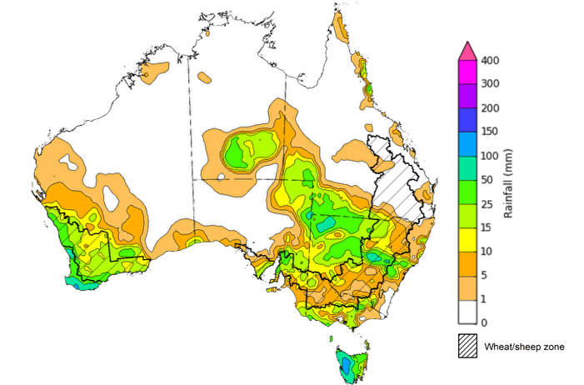

©Commonwealth of Australia 2025, Australian Bureau of Meteorology Issued: 10/9/2025

Note: The rainfall analyses and associated maps utilise data contained in the Bureau of Meteorology climate database, the Australian Data Archive for Meteorology (ADAM). The analyses are initially produced automatically from real-time data with limited [quality control](http://www.bom.gov.au/climate/headers/qc.shtml). They are intended to provide a general overview of rainfall across Australia as quickly as possible after the observations are received. For further information go to <http://www.bom.gov.au/climate/rainfall/>

### Rainfall forecast for the next eight days

Over the 8 days to 18 September 2025, **cold fronts and low-pressure systems** are expected to bring rainfall to large areas of the southern Australia, while central and northern regions of Australia are forecast to remain largely dry.

* Rainfall totals of between 5-100 millimetres are expected across much of New South Wales and Tasmania, with isolated areas in western Tasmania likely to see higher falls.
* Falls of between 5-50 millimetres are forecast for much of southern South Australia, southern Western Australia, Victoria, and northern Queensland.
* Remaining areas are forecast to remain largely dry.

Moderate rainfall totals are likely across most cropping regions this week, with exceptions in northern Queensland.

* Falls of between 10-50 millimetres are forecast across New South Wales, with falls of between 5- 25 millimetres expected in Western Australia, South Australia, Victoria and parts of southern Queensland.
  + If realised these falls are likely to be sufficient to support the crop and pasture growth and development and see some ongoing improvement to soil moisture reserves in most areas.
* Most northern and central cropping regions in Queensland are expected to receive little to no rainfall. These low expected rainfall totals are unlikely to adversely impact crop production outcomes as crops will be able to utilise soil moisture reserves to support their growth and development.

#### Total forecast rainfall for the period 11 September to 18 September 2025

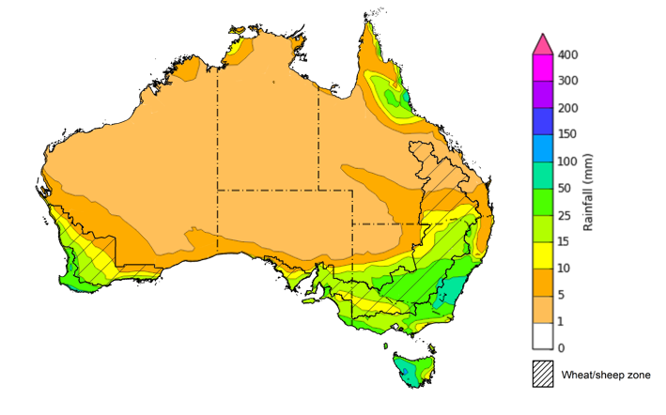

©Commonwealth of Australia 2025, Australian Bureau of Meteorology Issued 11/9/2025

Note: This rainfall forecast is produced from computer models. As the model outputs are not altered by weather forecasters, it is important to check local forecasts and warnings issued by the Bureau of Meteorology.

### 

### National Climate Outlook

The El Niño Southern Oscillation (ENSO) and the Southern Annular Mode (SAM) are currently neutral and having minimal influence on Australian rainfall. The ENSO is likely to remain neutral until January. However, the Indian Ocean Dipole (IOD) Index has been negative for 7 consecutive weeks and is likely to remain negative for the upcoming week, classifying this as a negative IOD event. A negative IOD typically results in above-average spring rainfall over parts of southern Australia.

The most recent **rainfall outlook for October 2025** provided by the Bureau of Meteorology indicates that much of **Australia** is likely to see **above median rainfall,** with parts of **Western** **Australia** and **south-eastern Australia** the likely to see closer to **average** falls**.**

* The Bureau of Meteorology’s climate model indicates a 75% chance of October rainfall totals between 5-50 millimetres across much of eastern Australia and parts of south-western Western Australia and the tropical north. Despite the increased probabilities of above average rainfall across much of the remainder of northern Australia, October is a transition month between the northern Australian dry and wet seasons. During this time of year, most of the northern two-thirds of Australia typically receives very low rainfall, but typically sees higher rainfall totals than September.
* Across cropping regions, there is a **75% chance** of rainfall totals of between **10-50 millimetres across eastern cropping regions,** including Queensland and New South Wales**.** Much of **South Australia and Victoria** are likely to see 10-25 millimetres, while **Western Australian** cropping regions are likely to see 5-25 millimetres.If realised, this is expected to provide sufficient moisture to support the development of winter crops across most growing regions and support the timely planting and establishment of summer crops across Queensland and northern New South Wales.

**Rainfall totals that have a 75% chance of occurring in October 2025**

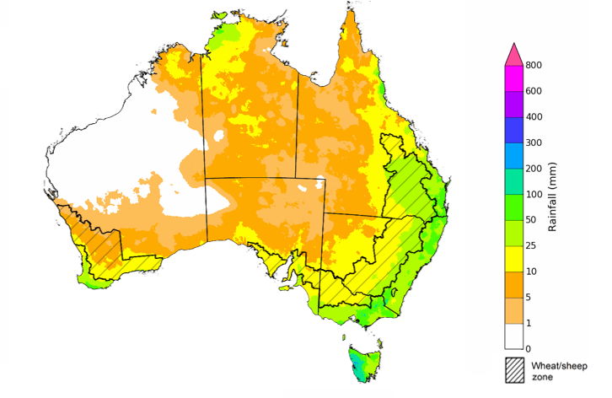

©Commonwealth of Australia 2025, Australian Bureau of Meteorology Issued: 11/9/2025

The **rainfall outlook for October to December 2025** indicates an increased probability of **above median rainfall across much of Australia,** including much of Queensland, New South Wales, Victoria, South Australia, eastern Tasmania, southern Western Australia, and the Northern Territory. Part of northern Western Australia and western Tasmania are more likely to see below median rainfall, while remaining areas have an equal probability of above or below average rainfall

Across cropping regions, the chance of receiving above median rainfall is 65-80% across Queensland, New South Wales, South Australia and Victoria. In Western Australia, the probability of above median rainfall is lower at 45-65%.

**Chance of exceeding the median rainfall October 2025 to December 2025**

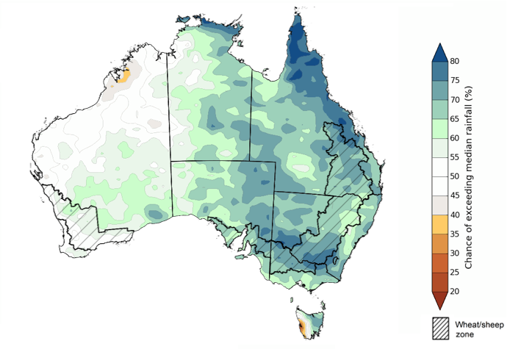

©Commonwealth of Australia 2025, Australian Bureau of Meteorology Issued: 11/9/2025

The **rainfall outlook for October through to December 2025** suggests a 75% chance of receiving rainfall totals of between 25-400 millimetres across much of eastern and northern Australia, including Queensland, New South Wales, Victoria, the Northern Territory and northern Western Australia. Between 400-600 millimetres are expected across western Tasmania and alpine areas of New South Wales and Victoria, as well as parts of the northern tropics. Lower rainfall totals are forecast for central and western regions, with South Australia and southern Westernisis Australia likely to see 25- 100 millimetres of rainfall.

In **cropping regions**, there is a **75% chance** of receiving between **100-200 millimetres** across **much of Queensland and New South Wales**. In **Western Australia**, falls of **10-100 millimetres** are expected, with **Victoria** **and much of South Australia** likely to see **50-100 millimetres**. If realised, these falls are likely be sufficient to support the development of winter crops, and the timely planting and establishment of dryland summer crops in eastern Australia.

**Rainfall totals that have a 75% chance of occurring October 2025 to December 2025**

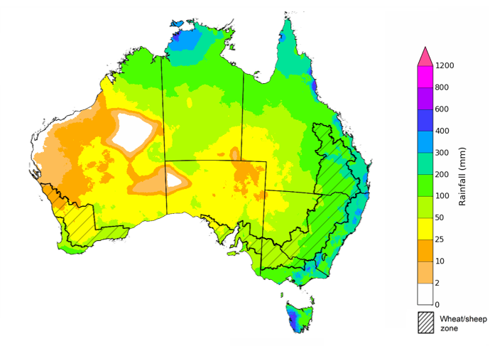

©Commonwealth of Australia 2025, Australian Bureau of Meteorology Issued: 11/9/2025

### Water markets – current week

#### Water storage levels in the Murray-Darling Basin (MDB) increased by 190 gigalitres (GL) between 04 September 2025 and 11 September 2025. The current volume of water held in storages is 15,329 GL, equivalent to 69% of total storage capacity. This is -16% or -2,949 GL less than the same time last year. Water storage data is sourced from the Bureau of Meteorology (BOM).

#### Water storages in the Murray-Darling Basin, 2013–2025A chart showing water storage in the Murray-Darling Basin. For more information, refer to accompanying text

Allocation prices in the Victorian Murray below the Barmah Choke increased from $262/ML on 04 September 2025 to $278/ML on 11 September 2025. Trade from the Goulburn to the Murray is closed. Trade downstream through the Barmah Choke is closed. Trade from the Murrumbidgee to the Murray is closed.

#### Surface water trade activity, Southern Murray–Darling Basin

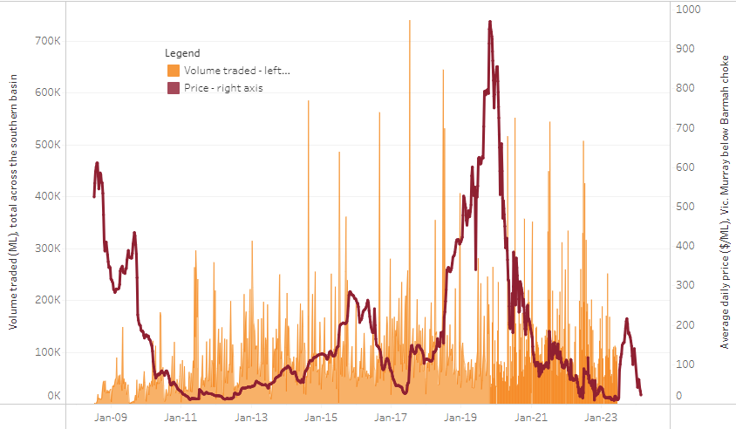

|  |
| --- |
| The trades shown reflect estimated market activity and do not encompass all register trades. The price is shown for the VIC Murray below the Barmah choke. Historical prices (before 1 July 2019) are ABARES estimates after removing outliers from BOM water register data. Prices after 1 July 2019 and prior to the 30 October 2019 reflect recorded transaction prices as sourced from Ruralco. Prices after the 30 October 2019 are sourced from Waterflow. Data for volume traded is sourced from the BOM water register. Only the price data shown is current on 17 October 2024. |

To access the full, interactive, weekly water dashboard, which contains the latest and historical water storage, water market and water allocation information, please visit <https://www.agriculture.gov.au/abares/products/weekly_update/weekly-update-110925>

https://www.agriculture.gov.au/abares/products/weekly_update/weekly-update-140825

## **Commodities**

|  |  |  |  |  |  |  |  |  |
| --- | --- | --- | --- | --- | --- | --- | --- | --- |
| **Indicator** | **Week average** | **Unit** | **Latest Price** | **Previous Week** | **Weekly change** | | **Price 12 months ago** | **Annual change** |
| **Selected world indicator prices** |  |  |  |  |  |  | |  |
| AUD/USD Exchange rate | 10-Sep | A$/US$ | 0.66 | 0.65 | 1% | 0.68 | | -2% |
| Wheat – US no. 2 hard red winter wheat, FOB Gulf | 10-Sep | US$/t | 237 | 229 | 3% | 270 | | -12% |
| Corn – US no. 2 yellow corn, FOB Gulf | 10-Sep | US$/t | 194 | 192 | 1% | 186 | | 4% |
| Canola – Rapeseed, Canada, FOB Vancouver | 10-Sep | US$/t | 477 | 502 | -5% | 465 | | 2% |
| Cotton – Cotlook A Index | 10-Sep | USc/lb | 77.6 | 77.7 | 0% | 83 | | -6% |
| Sugar – Intercontinental Exchange, nearby futures, no.11 contract | 10-Sep | USc/lb | 16.4 | 16.6 | -1% | 21 | | -20% |
| Wool – Eastern Market Indicator | 03-Sep | Ac/kg clean | 1,291 | 1,261 | 2% | 1,094 | | 18% |
| Wool – Western Market Indicator | 27-Aug | Ac/kg clean | 1,402 | 1,396 | 0% | 1,229 | | 14% |
| **Selected Australian grain export prices** |  |  |  |  |  |  | |  |
| Australian Premium White (APW) Wheat, FOB Port Adelaide, SA | 10-Sep | A$/t | 372 | 380 | -2% | 382 | | -2% |
| Australian Standard White (ASW) Wheat, FOB Port Adelaide, SA | 10-Sep | A$/t | 367 | 375 | -2% | 372 | | -1% |
| Feed Barley – FOB Port Adelaide, SA | 10-Sep | A$/t | 355 | 359 | -1% | 347 | | 2% |
| Canola – FOB Kwinana, WA | 10-Sep | A$/t | 789 | 803 | -2% | 724 | | 9% |
| Grain Sorghum – FOB Brisbane, QLD | 10-Sep | A$/t | 414 | 419 | -1% | 381 | | 9% |
| **Selected domestic livestock indicator prices** |  |  |  |  |  |  | |  |
| Beef – Eastern Young Cattle Indicator | 10-Sep | Ac/kg cwt | 899 | 894 | 1% | 669 | | 34% |
| Mutton – Mutton indicator (18–24 kg fat score 2–3), VIC | 10-Sep | Ac/kg cwt | 719 | 709 | 1% | 318 | | 126% |
| Lamb – National Trade Lamb Indicator | 10-Sep | Ac/kg cwt | 1,176 | 1,174 | 0% | 805 | | 46% |
| Pig – Eastern Seaboard (60.1–75 kg), NSW buyer price | 27-Aug | Ac/kg cwt | 461 | 461 | 0% | 422 | | 9% |
| Live cattle – Light steers to Indonesia | 27-Aug | Ac/kg lwt | 350 | 350 | 0% | 304 | | 15% |
| **Global Dairy Trade (GDT) weighted average prices** |  |  |  |  |  |  | |  |
| Dairy – Whole milk powder | 03-Sep | US$/t | 3,809 | 4,036 | -6% | 3,422 | | 11% |
| Dairy – Skim milk powder | 03-Sep | US$/t | 2,620 | 2,756 | -5% | 2,781 | | -6% |
| Dairy – Cheddar cheese | 03-Sep | US$/t | 4,709 | 4,548 | 4% | 4,383 | | 7% |
| Dairy – Anhydrous milk fat | 03-Sep | US$/t | 6,917 | 7,078 | -2% | 7,266 | | -5% |
|  | | | | | | | | |

### Selected world indicator prices

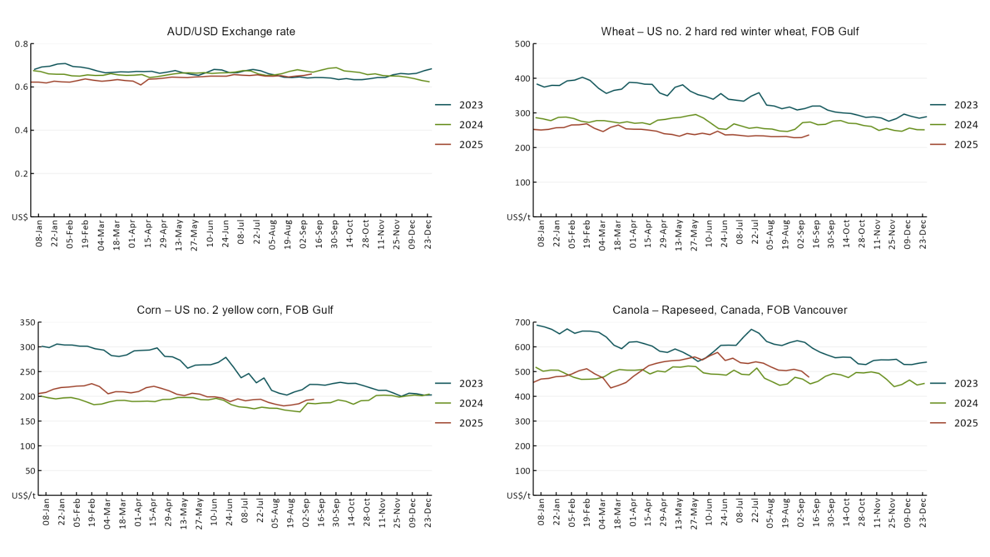

### A line chart of major world indicator prices. For more information, refer to https://www.agriculture.gov.au/abares/data/weekly-commodity-price-update/world-agricultural-prices

### 3.2 Selected domestic crop indicator prices

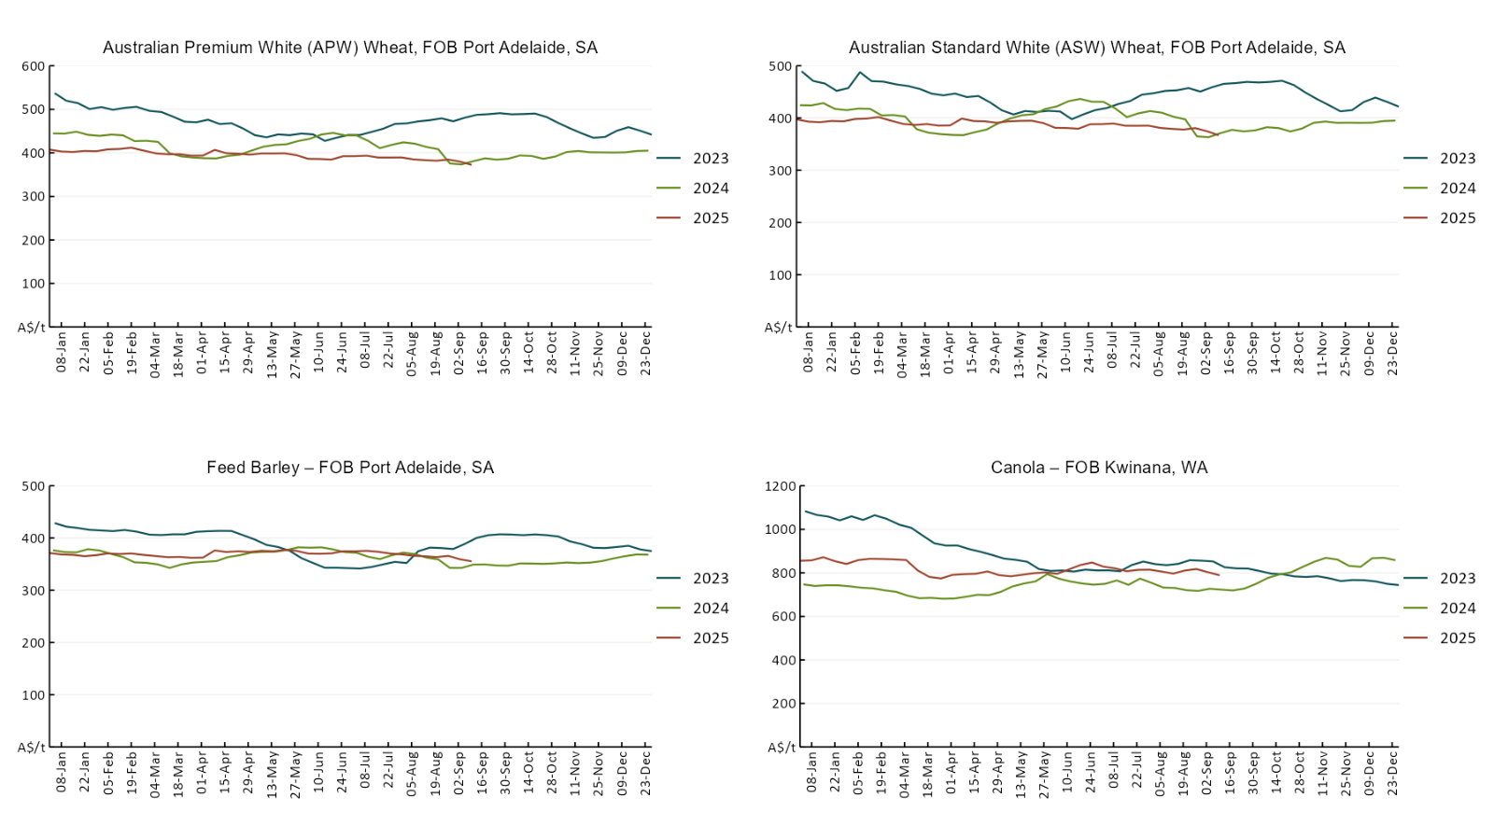

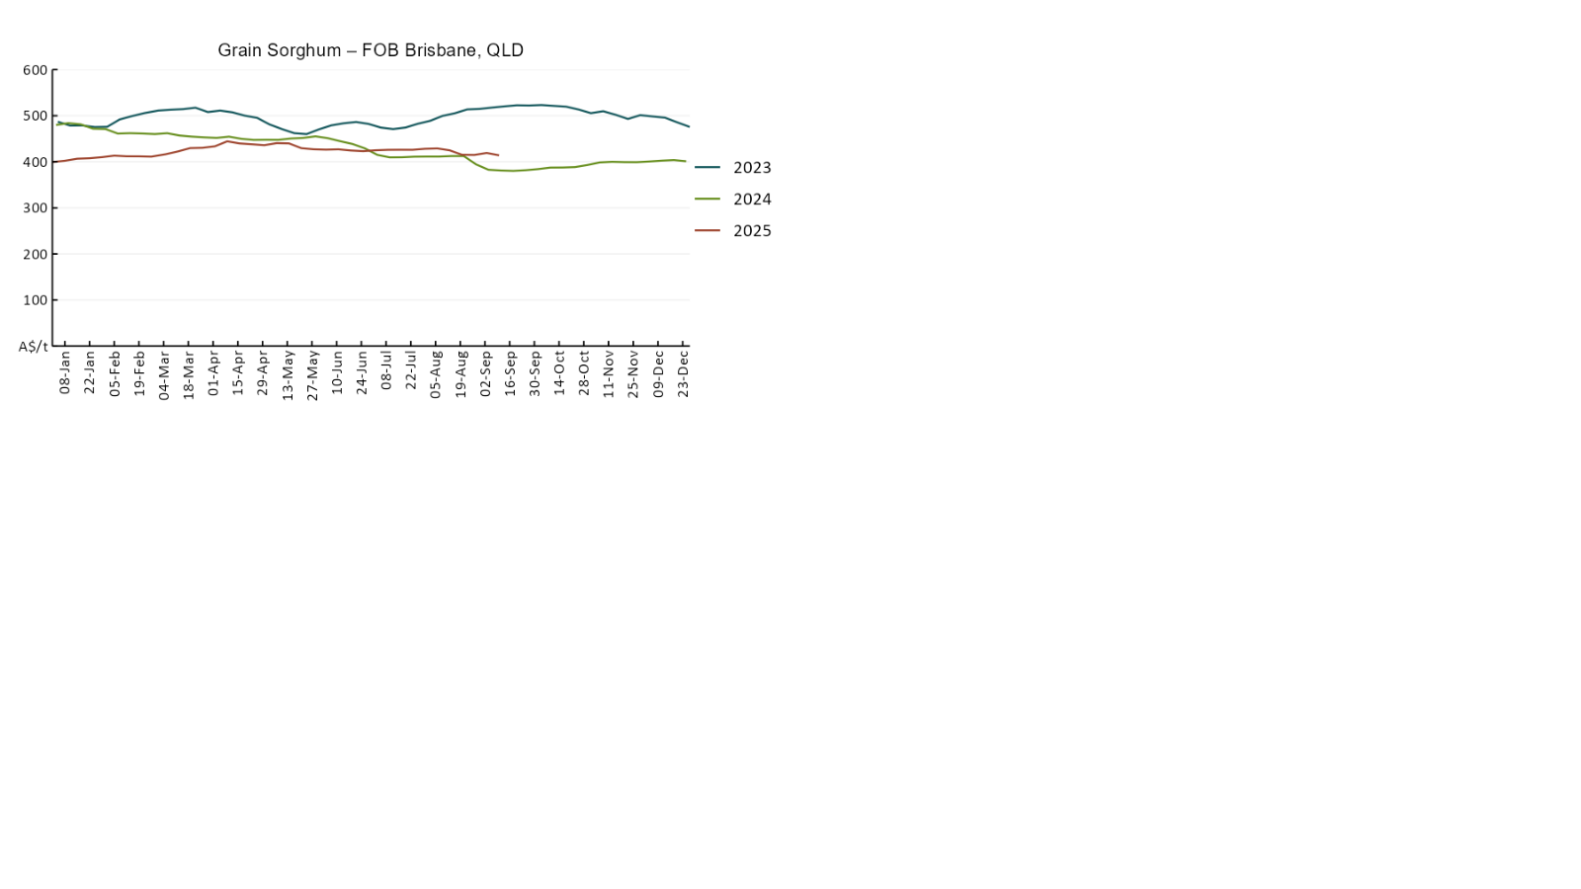

### 3.3 Selected domestic livestock indicator prices

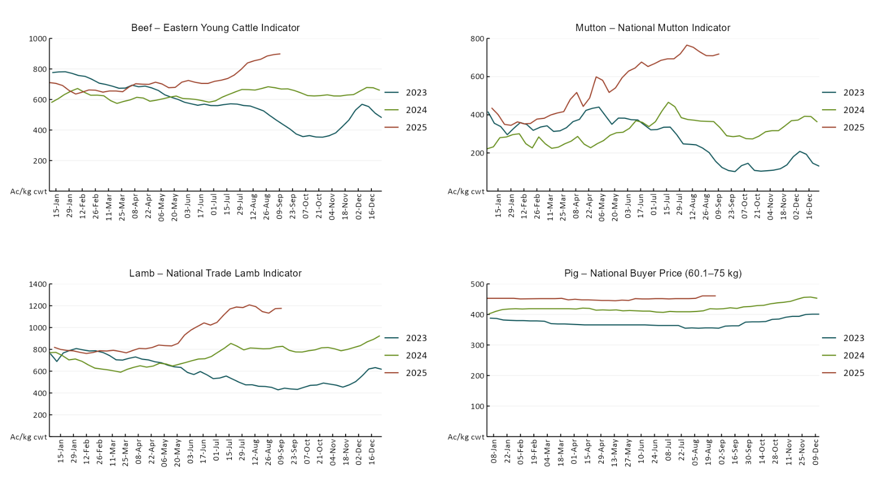

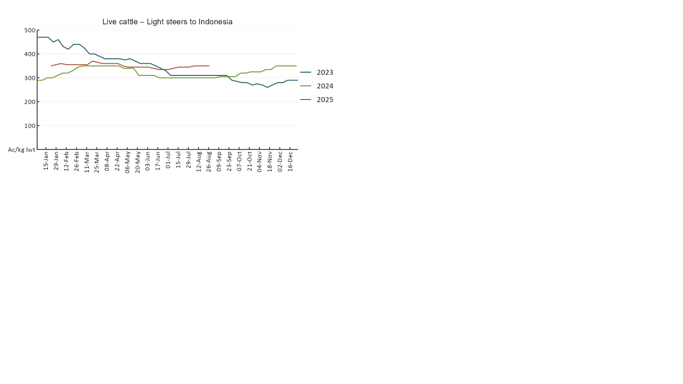

### 3.4 Global Dairy Trade (GDT) weighted average pricesA line chart of Global Dairy Trade prices. For more information, refer to https://www.agriculture.gov.au/abares/data/weekly-commodity-price-update/world-agricultural-prices

### 3.5 Selected fruit and vegetable prices

### A line chart of fruit and vegetable prices. For more information, refer to https://www.agriculture.gov.au/abares/data/weekly-commodity-price-update/world-agricultural-prices

### A line chart of fruit and vegetable prices. For more information, refer to https://www.agriculture.gov.au/abares/data/weekly-commodity-price-update/world-agricultural-prices

### 3.6 Selected domestic fodder indicator prices

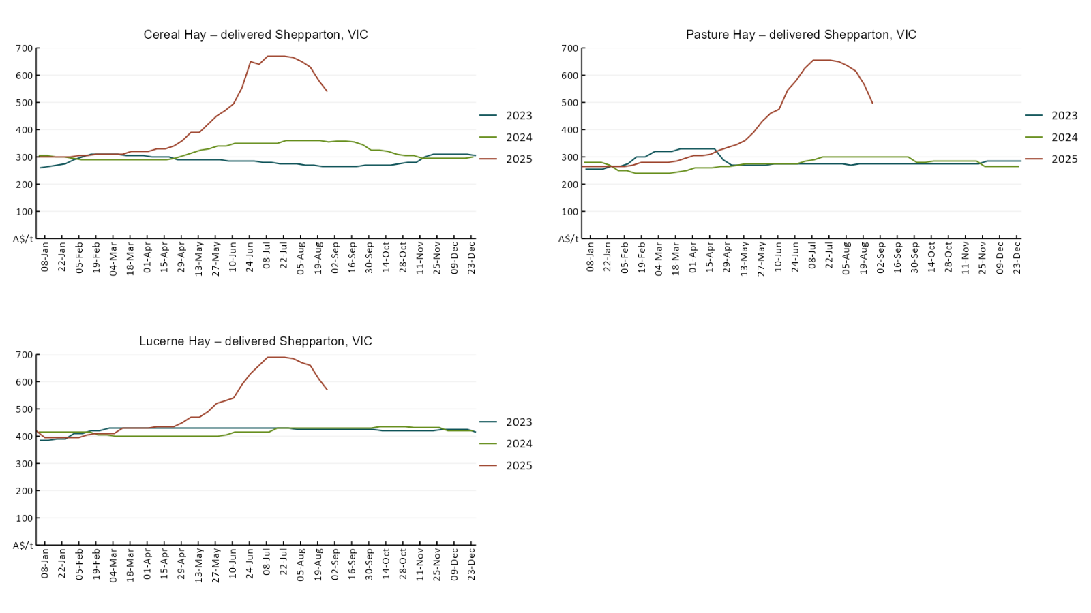

## **4. Data attribution**

### Climate

* Bureau of Meteorology
* Weekly rainfall totals: www.bom.gov.au/climate/maps/rainfall/
* Monthly and last 3-month rainfall percentiles: [www.bom.gov.au/water/landscape/](http://www.bom.gov.au/water/landscape/)
* Temperature anomalies: [www.bom.gov.au/jsp/awap/temp/index.jsp](http://www.bom.gov.au/jsp/awap/temp/index.jsp)
* Rainfall forecast: [www.bom.gov.au/jsp/watl/rainfall/pme.jsp](http://www.bom.gov.au/jsp/watl/rainfall/pme.jsp)
* Seasonal outlook: [www.bom.gov.au/climate/outlooks/#/overview/summary/](http://www.bom.gov.au/climate/outlooks/#/overview/summary/)
* Climate drivers: <http://www.bom.gov.au/climate/enso/>
* Soil moisture: [www.bom.gov.au/water/landscape/](http://www.bom.gov.au/water/landscape/)
* Other
* Pasture growth: [www.longpaddock.qld.gov.au/aussiegrass/](http://www.longpaddock.qld.gov.au/aussiegrass/)
* 3-month global outlooks: [Environment and Climate Change Canada](https://weather.gc.ca/saisons/image_e.html?img=s234pfe1p_cal&bc=prob), [NOAA Climate Prediction Center](https://www.cpc.ncep.noaa.gov/products/predictions/long_range/seasonal.php?lead=2), [EUROBRISA CPTEC/INPE](http://eurobrisa.cptec.inpe.br/), European Centre for Medium-Range Weather Forecasts, [Hydrometcenter of Russia](https://meteoinfo.ru/en/climate/seasonal-forecasts), [National Climate Center Climate System Diagnosis and Prediction Room (NCC)](https://cmdp.ncc-cma.net/pred/cs2gen.php?pred_elem=RAINP#pred_seasonal), [International Research Institute for Climate and Society](https://iri.columbia.edu/our-expertise/climate/forecasts/seasonal-climate-forecasts/)
* Global production: <https://ipad.fas.usda.gov/ogamaps/cropmapsandcalendars.aspx>
* Autumn break: Pook et al., 2009, <https://rmets-onlinelibrary-wiley-com.virtual.anu.edu.au/doi/epdf/10.1002/joc.1833>

### Water

Prices

* Waterflow: <https://www.waterflow.io/>
* Ruralco: <https://www.ruralcowater.com.au/>
* Bureau of Meteorology:
* Allocation trade: <http://www.bom.gov.au/water/dashboards/#/water-markets/mdb/at>
* Storage volumes: <http://www.bom.gov.au/water/dashboards/#/water-storages/summary/drainage>
* Trade constraints:
* Water NSW: <https://www.waternsw.com.au/customer-service/ordering-trading-and-pricing/trading/murrumbidgee>
* Victorian Water Register: <https://www.waterregister.vic.gov.au/TradingRules2019/>

### Commodities

* Fruit and vegetables
* Datafresh: [www.freshstate.com.au](http://www.freshstate.com.au)
* Pigs
* Australian Pork Limited: [www.australianpork.com.au](http://www.australianpork.com.au)
* Dairy
* Global Dairy Trade: [www.globaldairytrade.info/en/product-results/](http://www.globaldairytrade.info/en/product-results/)
* World wheat, canola
* International Grains Council
* World coarse grains
* United States Department of Agriculture
* World cotton
* Cotlook: [www.cotlook.com/](http://www.cotlook.com/)
* World sugar
* New York Stock Exchange - Intercontinental Exchange
* Wool
* Australian Wool Exchange: [www.awex.com.au/](http://www.awex.com.au/)
* Domestic wheat, barley, sorghum, canola and fodder
* Jumbuk Consulting Pty Ltd: http://www.jumbukag.com.au/
* Cattle, beef, mutton, lamb, goat and live export
* Meat and Livestock Australia: [www.mla.com.au/Prices-and-market](http://www.mla.com.au/Prices-and-market)

© Commonwealth of Australia 2025

### Ownership of intellectual property rights

Unless otherwise noted, copyright (and any other intellectual property rights, if any) in this publication is owned by the Commonwealth of Australia (referred to as the Commonwealth).

### Creative Commons licence

All material in this publication is licensed under a [Creative Commons Attribution 4.0 International Licence](https://creativecommons.org/licenses/by/4.0/legalcode) except content supplied by third parties, logos and the Commonwealth Coat of Arms.

Inquiries about the licence and any use of this document should be emailed to [copyright@awe.gov.au](mailto:copyright@awe.gov.au).

https://www.agriculture.gov.au/sites/default/files/images/creative-commons-logo-small.png

### Cataloguing data

This publication (and any material sourced from it) should be attributed as:

ABARES 2025, Weekly Australian Climate, Water and Agricultural Update, Australian Bureau of Agricultural and Resource Economics and Sciences, Canberra, 11 September 2025. CC BY 4.0 DOI: <https://doi.org/10.25814/5f3e04e7d2503>

ISSN **2652-7561**

This publication is available at https://www.agriculture.gov.au/abares/products/weekly_update

Department of Agriculture, Fisheries and Forestry

GPO Box 858 Canberra ACT 2601

Telephone 1800 900 090

Web [agriculture.gov.au/abares](http://awe.gov.au/abares)

### Disclaimer

The Australian Government acting through the Department of Agriculture, Fisheries and Forestry, represented by the Australian Bureau of Agricultural and Resource Economics and Sciences, has exercised due care and skill in preparing and compiling the information and data in this publication. Notwithstanding, the Department of Agriculture, Fisheries and Forestry, ABARES, its employees and advisers disclaim all liability, including liability for negligence and for any loss, damage, injury, expense or cost incurred by any person as a result of accessing, using or relying on any of the information or data in this publication to the maximum extent permitted by law.

### Statement of Professional Independence

The views and analysis presented in ABARES publications, including this one, reflect ABARES professionally independent findings, based on scientific and economic concepts, principles, information and data. These views, analysis and findings may not reflect or be consistent with the views or positions of the Australian Government, or of organisations or groups who have commissioned ABARES reports or analysis. More information on [professional independence](https://www.agriculture.gov.au/abares/about/research-and-analysis#professional-independence) is provided on the ABARES website.

### Acknowledgements

This report was prepared by Holly Beale and Matt Miller.