## No. 37/2025 18 September 2025

# Summary of key issues

* In the week ending 17 September 2025, cold fronts and low-pressure systems brought rainfall to parts of northern and southern Australia.
  + Rainfall was highly variable across winter cropping regions in the week ending 17 September 2025.
  + As forecast last week, rainfall totals of between 10-50 millimetres were observed across much of southern New South Wales. These falls are likely to be sufficient to arrest declines in soil moisture levels and winter crop yields, and provided a boost to pasture growth across most southern growing regions in New South Wales.
  + Lower rainfall totals of between 1-15 millimetres were recorded in most remaining cropping regions except for much of Queensland which received little to no rainfall.
* Over the coming eight days to 25 September 2025, rainfall is expected across most eastern cropping regions.
  + Falls of between 5-25 millimetres are forecast across New South Wales, Queensland and southern Victoria. If realised, these falls are likely to be sufficient to support the crop and pasture growth and development.
  + Meanwhile most cropping regions of Western Australia, South Australia, and northern Victoria are forecast to receive little to no rainfall. Crops and pastures in these regions are likely to draw on stored soil moisture reserves to support their growth.
* Globally, variable rainfall during August 2025 has led to mixed crop production prospects across the world’s major grain- and oilseed-producing regions but on balance have led to generally positive crop production outcomes across both the northern and southern hemisphere.
* Global production conditions were generally favourable for rice and soybeans, but more varied for wheat and maize. Global production conditions have been slightly more favourable to those used to formulate ABARES 2025–26 forecasts of global grain supplies and world prices in the September 2025 Agricultural Commodities Report. As a result, global grain and oilseed production is likely to increase beyond the numbers in the September forecast, particularly due to improvements in global wheat production.
* Water storage levels in the Murray-Darling Basin (MDB) increased by 252 gigalitres (GL) between 11 September 2025 and 18 September 2025. The current volume of water held in storages is 15,581 GL, equivalent to 70% of total storage capacity. This is -14% or -2,560 GL less than the same time last year. Water storage data is sourced from the Bureau of Meteorology (BOM).
* Allocation prices in the Victorian Murray below the Barmah Choke increased from $278/ML on 11 September 2025 to $294/ML on 18 September 2025. Trade from the Goulburn to the Murray is closed. Trade downstream through the Barmah Choke is closed. Trade from the Murrumbidgee to the Murray is open.

## **Climate**

### Rainfall this week

In the week ending 17 September 2025, **cold fronts and low-pressure systems** brought rainfall to much of the far south-west and parts of northern Western Australia, much of Tasmania, Victoria, southern and eastern New South Wales, and southern South Australia, parts of northeast Queensland and the north-western of the Northern Territory, while much of remainder of Australia stayed largely dry.

Rainfall was highly variable across winter cropping regions in the week ending 17 September 2025.

* As forecast last week, rainfall totals of between 10-50 millimetres were observed across much of southern New South Wales.
  + These falls are likely to be sufficient to arrest declines in soil moisture levels and winter crop yields, and provided a boost to pasture growth across most southern growing regions in New South Wales.
* Lower rainfall totals of between 5-25 millimetres were recorded in southern Western Australia and eastern Victoria, while South Australia, northern Western Australia, western Victoria, northern New South Wales and parts of southern Queensland saw 1-15 millimetres.
* Much of Queensland received little to no rainfall.

#### Rainfall for the week ending 17 September 2025

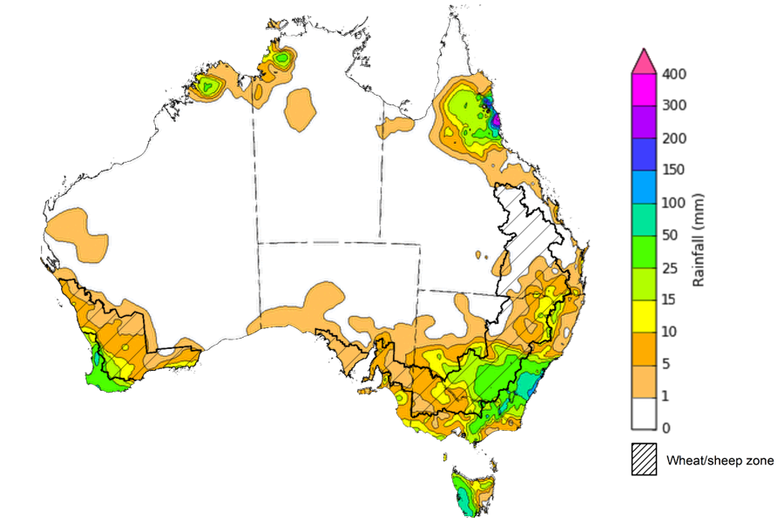

©Commonwealth of Australia 2025, Australian Bureau of Meteorology Issued: 17/9/2025

Note: The rainfall analyses and associated maps utilise data contained in the Bureau of Meteorology climate database, the Australian Data Archive for Meteorology (ADAM). The analyses are initially produced automatically from real-time data with limited [quality control](http://www.bom.gov.au/climate/headers/qc.shtml). They are intended to provide a general overview of rainfall across Australia as quickly as possible after the observations are received. For further information go to <http://www.bom.gov.au/climate/rainfall/>

### Rainfall forecast for the next eight days

Over the 8 days to 25 September 2025, **low-pressure systems** are expected to bring rainfall to large areas of the eastern Australia, while central and western regions of Australia are forecast to remain largely dry.

Rainfall is expected across most eastern cropping regions this week, while western regions are likely to be largely dry.

* Falls of between 5-25 millimetres are forecast across New South Wales and Queensland. In Victoria, up to 15 millimetres is expected in the south.
  + If realised these falls are likely to be sufficient to support the crop and pasture growth and development and see some ongoing improvement to soil moisture reserves in most areas.
* Much of Western Australia, South Australia, and northern Victoria are expected to receive little to no rainfall.
  + These low expected rainfall totals are unlikely to adversely impact crop production outcomes in these areas as crops are likely to draw on stored soil moisture reserves to support their growth.

#### Total forecast rainfall for the period 18 September to 25 September 2025

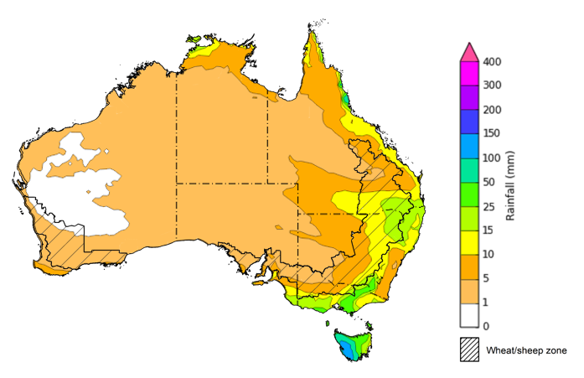

©Commonwealth of Australia 2025, Australian Bureau of Meteorology Issued 18/9/2025

Note: This rainfall forecast is produced from computer models. As the model outputs are not altered by weather forecasters, it is important to check local forecasts and warnings issued by the Bureau of Meteorology.

### 

### August precipitation percentiles and current production conditions

Crop production is affected by long-term trends in average rainfall and temperature, interannual climate variability, shocks during specific growth stages, and extreme weather events. Some crops are more tolerant than others to certain types of stresses, and at each growth stage, different types of stresses affect crop species in different ways.

Precipitation anomalies and outlooks presented below indicate the current and expected future production conditions for major grain and oilseed producing countries (responsible for over 80% of global crop production). This is an important input to assessing the global grain supply outlook.

Rainfall in August 2025 was variable across the world’s major grain- and oilseed-producing regions:

* In the **southern hemisphere**, precipitation was above average across northern Argentina, parts of Australia, as well as much of Southeast Asia. Below average precipitation occurred in parts of central Brazil and southern Argentina. Precipitation was generally average across remaining major southern hemisphere grain- and oilseed-producing regions.
* In the **northern hemisphere**, precipitation was below average across scattered eastern areas of the United States, parts of central and western Europe, and eastern China. Precipitation was above average across parts of the northern United States, northern and western China, the west of the Russian Federation, central Canada, and much of southern India. Precipitation was generally average across remaining major northern hemisphere grain- and oilseed-producing regions.

**Global precipitation percentiles, August 2025**

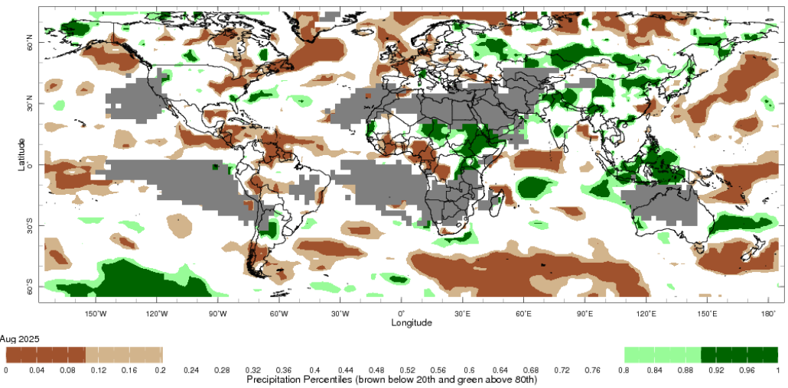

Note: The world precipitation percentiles indicate a ranking of precipitation for August, with the driest (0th percentile) being 0 on the scale and the wettest (100th percentile) being 1 on the scale. Percentiles are based on precipitation estimates from the NOAA Climate Prediction Center’s [Climate Anomaly Monitoring System Outgoing Precipitation Index](https://iridl.ldeo.columbia.edu/maproom/Global/Precipitation/Percentiles.html) dataset. Precipitation estimates for August 2025 are compared with rainfall recorded for that period during the 1981 to 2010 base period.

Source: International Research Institute for Climate and Society

As of 28 August 2025, global production conditions are generally favourable for rice and soybeans, but more varied for corn and wheat:

* **Wheat –** In the **northern hemisphere**, the winter wheat harvest is concluding under mixed conditions. Crop yields were generally favourable across most growing region, but below average yield were recorded across southern regions of the Russian Federation, southern and eastern regions of Ukraine due to severe drought and the ongoing war and Nebraska and South Dakota in the US. The development and harvest of spring wheat is progressing under generally favourable conditions.In the **southern hemisphere**, crop development is continuing under broadly favourable conditions.
* **Maize** **–** In the **southern hemisphere**, the harvest is ending in Brazil under exceptional conditions. In the **northern hemisphere,** dry conditions across parts of south-eastern Europe, Mexico, the south of the Russian Federation and Ukraine and are likely to negatively impact cropping outcomes. Crowing conditions have been generally favourable elsewhere.
* **Rice –** Global conditions are broadly favourable for major rice production regions.
* **Soybeans –** In the **northern hemisphere**, crops are developing under generally favourable conditions across most major growing regions, with exceptions in parts of Europe, Ukraine and the Russian Federation.

**Crop conditions, AMIS countries, 28 August 2025**

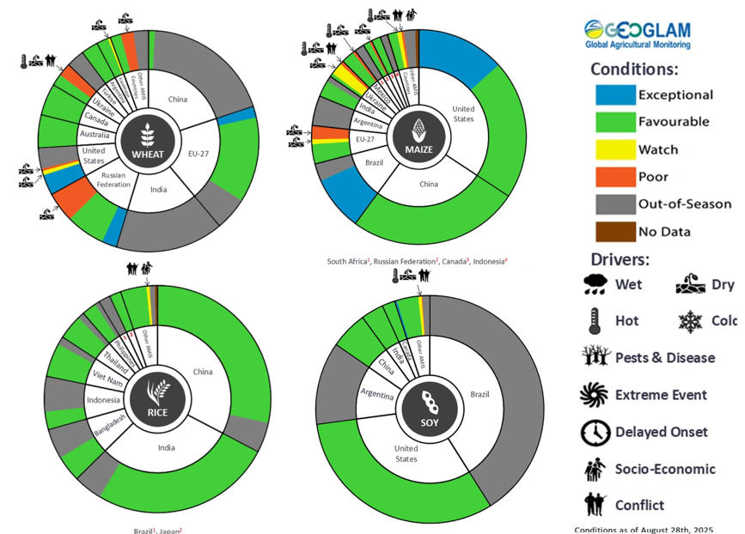

**AMIS** Agricultural Market Information System.

Source: AMIS

The global climate outlook for October 2025 to December 2025 indicates that mixed rainfall conditions are expected for the world’s major grain-producing and oilseed-producing regions. Outlooks and potential production impacts for major grain- and oilseed-producing countries are presented in the following table.

**Rainfall outlook and potential impact on the future state of production conditions, October-December 2025**

|  |  |  |
| --- | --- | --- |
| **Region** | **Rainfall outlook** | **Potential impact on production** |
| **Argentina** | Below average rainfall is likely across parts of eastern and western Argentina. | Below average rainfall in eastern and western areas is likely to adversely affect the heading and grain development of wheat and the planting and establishment of cotton and late-planted corn in October. These conditions may also adversely impact early corn silking, and the flowering of cotton and late corn in November and December. More favourable production conditions are expected across the remainder of the country. |
| **Black Sea Region** | Below average rainfall is expected across Türkiye and parts of the south of the Russian Federation, while Ukraine is likely to see average falls. | Generally average rainfall across most regions is likely to support boll development and grain filling for cotton, corn and sunflower, as well as the development of winter wheat and canola in October. In November and December winter wheat and canola will enter dormancy, and generally average rainfall is likely to provide sufficient snowpack to prevent winterkill. |
| **Brazil** | Rainfall outcomes across Brazil are expected to be below average in the south of the country, with central and northern regions likely to see average to above average rainfall. | Below average rainfall in parts of southern Brazil would allow for uninterrupted harvesting of wheat in October and November. However, below average rainfall is likely to adversely affect flowering of corn and soybeans in December and may affect the planting and growth of soybeans and first crop corn in southern Brazil. |
| **Canada** | Rainfall across Canada is expected to average to above average. | Average rainfall may favour harvesting and reduce grain quality concerns for canola, corn, soybean, spring wheat and sunflower in October and November. Average rainfall is also likely to provide sufficient snowpack to prevent winterkill of winter wheat in December. |
| **China** | Below average rainfall is expected throughout much of eastern and western China, with scattered central regions are likely to see above average falls. | Anticipated rainfall is likely to support the harvesting of major crops over the period but may reduce the level of snowpack during crop dormancy. |
| **European Union** | Average rainfall is more likely for much of the central European Union, with parts of western Europe including Spain and parts of France likely to see below average rainfall. | Average rainfall across much of the European Union is likely to benefit the harvesting of corn, soybean, sunflower, sorghum and cotton, as well as the planting of winter crops. |
| **South Asia (India)** | Above average rainfall is expected across much of the southern two thirds of India, while average rainfall is expected in the north. | Anticipated rainfall is likely to support the development of cotton, but could interfere with the harvesting and planting of crops, especially cotton in the south. |
| **Southeast Asia (SEA)** | Above average rainfall is likely across much of SEA. | Average to above average rainfall in SEA may support the growth of rice and corn in major growing regions but impair the harvesting of these crops in October. |
| **The United States** | Below average rainfall is likely for much of southern and eastern United States, with average rainfall more likely across the north. | Below average rainfall is likely to support the harvest of major grains and oilseeds, but could contribute to lower snowpack over the December dormancy period for winter wheat. |

### Water markets – current week

#### Water storage levels in the Murray-Darling Basin (MDB) increased by 252 gigalitres (GL) between 11 September 2025 and 18 September 2025. The current volume of water held in storages is 15,581 GL, equivalent to 70% of total storage capacity. This is -14% or -2,560 GL less than the same time last year. Water storage data is sourced from the Bureau of Meteorology (BOM).

#### Water storages in the Murray-Darling Basin, 2013–2025A chart showing water storage in the Murray-Darling Basin. For more information, refer to accompanying text

Allocation prices in the Victorian Murray below the Barmah Choke increased from $278/ML on 11 September 2025 to $294/ML on 18 September 2025. Trade from the Goulburn to the Murray is closed. Trade downstream through the Barmah Choke is closed. Trade from the Murrumbidgee to the Murray is open.

#### Surface water trade activity, Southern Murray–Darling Basin

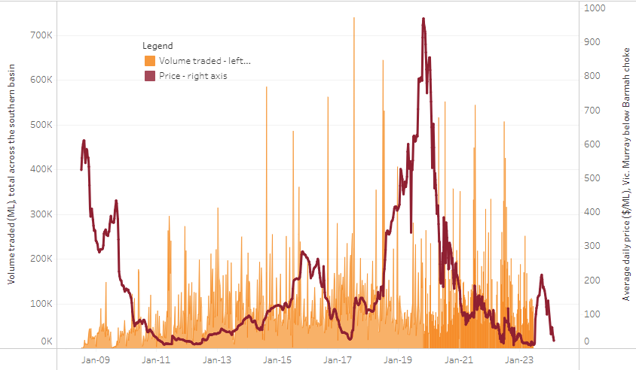

|  |
| --- |
| The trades shown reflect estimated market activity and do not encompass all register trades. The price is shown for the VIC Murray below the Barmah choke. Historical prices (before 1 July 2019) are ABARES estimates after removing outliers from BOM water register data. Prices after 1 July 2019 and prior to the 30 October 2019 reflect recorded transaction prices as sourced from Ruralco. Prices after the 30 October 2019 are sourced from Waterflow. Data for volume traded is sourced from the BOM water register. Only the price data shown is current on 17 October 2024. |

To access the full, interactive, weekly water dashboard, which contains the latest and historical water storage, water market and water allocation information, please visit <https://www.agriculture.gov.au/abares/products/weekly_update/weekly-update-180925>

https://www.agriculture.gov.au/abares/products/weekly_update/weekly-update-140825

## **Commodities**

|  |  |  |  |  |  |  |  |  |
| --- | --- | --- | --- | --- | --- | --- | --- | --- |
| **Indicator** | **Week average** | **Unit** | **Latest Price** | **Previous Week** | **Weekly change** | | **Price 12 months ago** | **Annual change** |
| **Selected world indicator prices** |  |  |  |  |  |  | |  |
| AUD/USD Exchange rate | 17-Sep | A$/US$ | 0.67 | 0.66 | 1% | 0.68 | | -1% |
| Wheat – US no. 2 hard red winter wheat, FOB Gulf | 17-Sep | US$/t | 238 | 236 | 1% | 270 | | -12% |
| Corn – US no. 2 yellow corn, FOB Gulf | 17-Sep | US$/t | 199 | 196 | 2% | 186 | | 7% |
| Canola – Rapeseed, Canada, FOB Vancouver | 17-Sep | US$/t | 485 | 481 | 1% | 465 | | 4% |
| Cotton – Cotlook A Index | 17-Sep | USc/lb | 78.4 | 77.8 | 1% | 83 | | -5% |
| Sugar – Intercontinental Exchange, nearby futures, no.11 contract | 17-Sep | USc/lb | 16.6 | 16.5 | 1% | 21 | | -19% |
| Wool – Eastern Market Indicator | 10-Sep | Ac/kg clean | 1,319 | 1,291 | 2% | 1,094 | | 21% |
| Wool – Western Market Indicator | 27-Aug | Ac/kg clean | 1,402 | 1,396 | 0% | 1,229 | | 14% |
| **Selected Australian grain export prices** |  |  |  |  |  |  | |  |
| Australian Premium White (APW) Wheat, FOB Port Adelaide, SA | 17-Sep | A$/t | 365 | 371 | -1% | 382 | | -4% |
| Australian Standard White (ASW) Wheat, FOB Port Adelaide, SA | 17-Sep | A$/t | 361 | 366 | -1% | 372 | | -3% |
| Feed Barley – FOB Port Adelaide, SA | 17-Sep | A$/t | 351 | 354 | -1% | 347 | | 1% |
| Canola – FOB Kwinana, WA | 17-Sep | A$/t | 783 | 789 | -1% | 724 | | 8% |
| Grain Sorghum – FOB Brisbane, QLD | 17-Sep | A$/t | 406 | 412 | -2% | 381 | | 6% |
| **Selected domestic livestock indicator prices** |  |  |  |  |  |  | |  |
| Beef – Eastern Young Cattle Indicator | 17-Sep | Ac/kg cwt | 894 | 899 | -1% | 669 | | 34% |
| Mutton – Mutton indicator (18–24 kg fat score 2–3), VIC | 17-Sep | Ac/kg cwt | 755 | 727 | 4% | 318 | | 138% |
| Lamb – National Trade Lamb Indicator | 17-Sep | Ac/kg cwt | 1,178 | 1,171 | 1% | 805 | | 46% |
| Pig – Eastern Seaboard (60.1–75 kg), NSW buyer price | 03-Sep | Ac/kg cwt | 461 | 461 | 0% | 422 | | 9% |
| Live cattle – Light steers to Indonesia | 27-Aug | Ac/kg lwt | 350 | 350 | 0% | 304 | | 15% |
| **Global Dairy Trade (GDT) weighted average prices** |  |  |  |  |  |  | |  |
| Dairy – Whole milk powder | 17-Sep | US$/t | 3,790 | 3,809 | 0% | 3,422 | | 11% |
| Dairy – Skim milk powder | 17-Sep | US$/t | 2,615 | 2,620 | 0% | 2,781 | | -6% |
| Dairy – Cheddar cheese | 17-Sep | US$/t | 4,814 | 4,709 | 2% | 4,383 | | 10% |
| Dairy – Anhydrous milk fat | 17-Sep | US$/t | 6,802 | 6,917 | -2% | 7,266 | | -6% |
|  | | | | | | | | |

### Selected world indicator prices

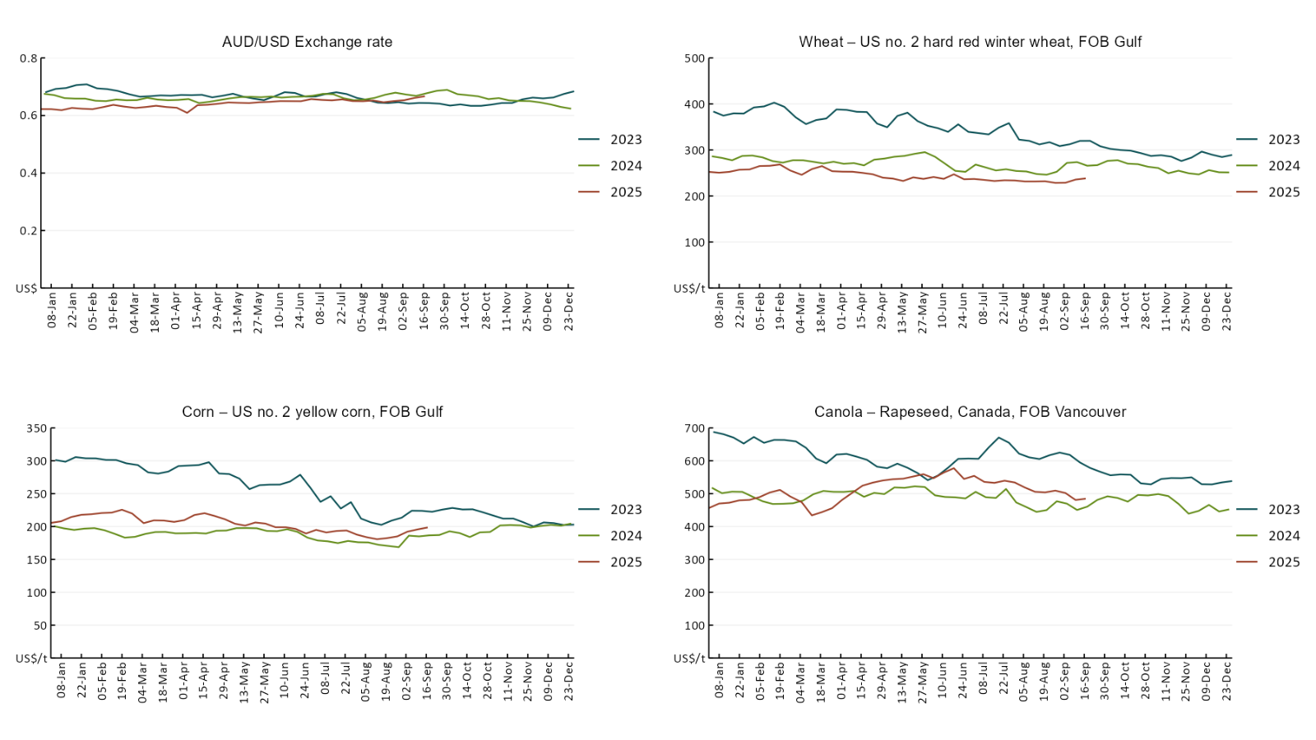

### A line chart of major world indicator prices. For more information, refer to https://www.agriculture.gov.au/abares/data/weekly-commodity-price-update/world-agricultural-prices

### 3.2 Selected domestic crop indicator prices

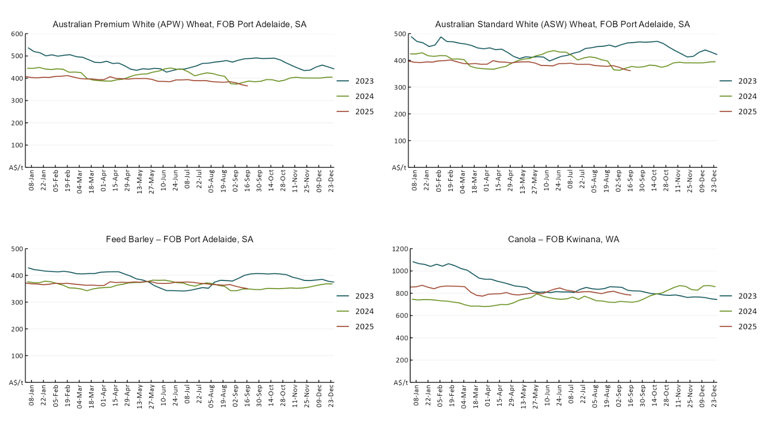

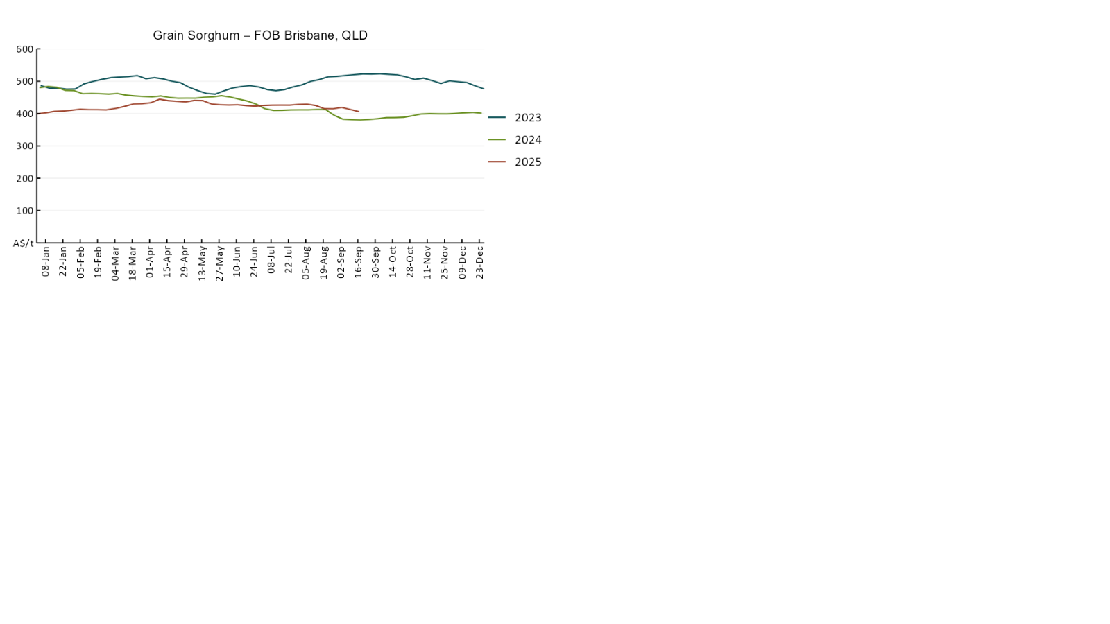

### 3.3 Selected domestic livestock indicator prices

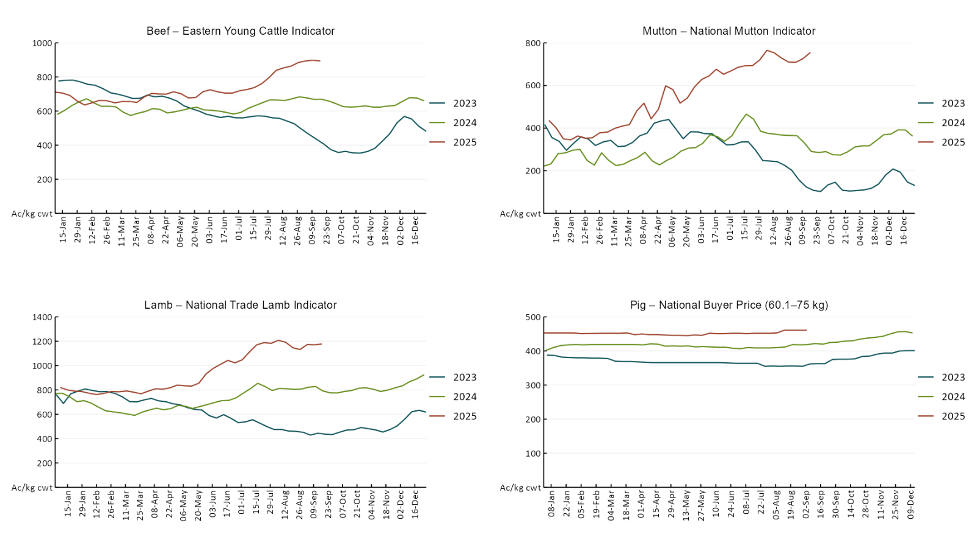

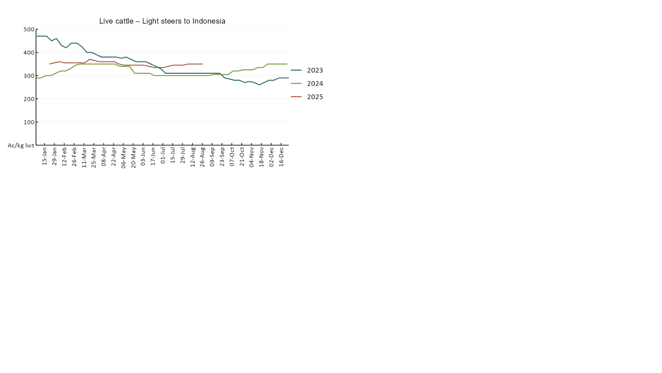

### 3.4 Global Dairy Trade (GDT) weighted average pricesA line chart of Global Dairy Trade prices. For more information, refer to https://www.agriculture.gov.au/abares/data/weekly-commodity-price-update/world-agricultural-prices

### 3.5 Selected fruit and vegetable prices

### A line chart of fruit and vegetable prices. For more information, refer to https://www.agriculture.gov.au/abares/data/weekly-commodity-price-update/world-agricultural-prices

### A line chart of fruit and vegetable prices. For more information, refer to https://www.agriculture.gov.au/abares/data/weekly-commodity-price-update/world-agricultural-prices

### 3.6 Selected domestic fodder indicator prices

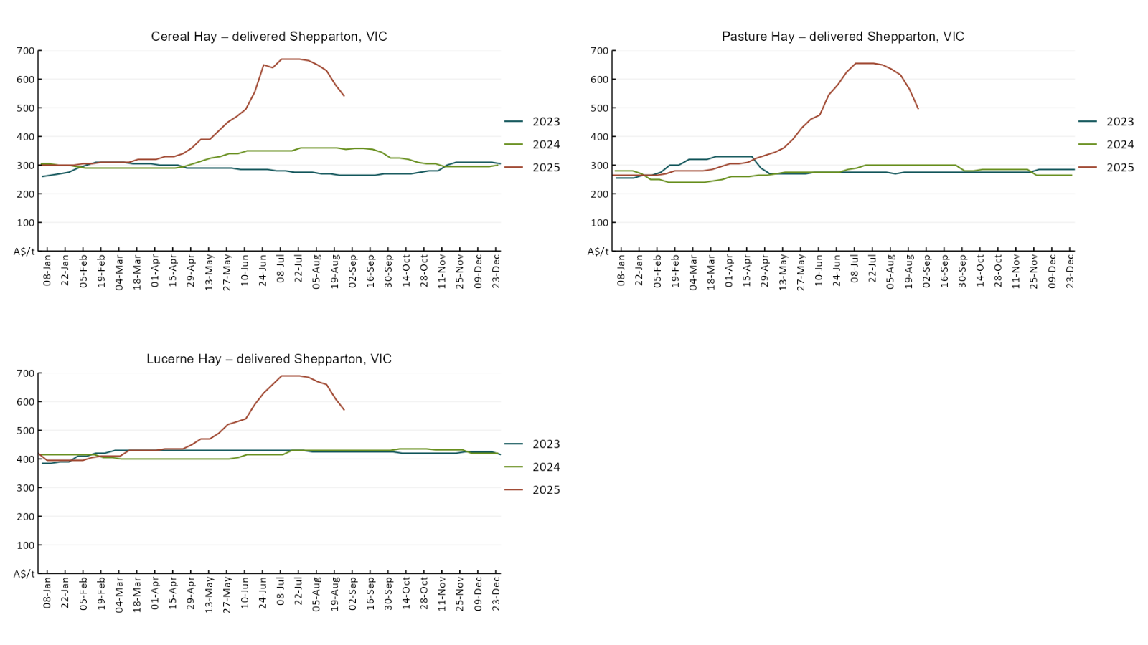

## **4. Data attribution**

### Climate

* Bureau of Meteorology
* Weekly rainfall totals: www.bom.gov.au/climate/maps/rainfall/
* Monthly and last 3-month rainfall percentiles: [www.bom.gov.au/water/landscape/](http://www.bom.gov.au/water/landscape/)
* Temperature anomalies: [www.bom.gov.au/jsp/awap/temp/index.jsp](http://www.bom.gov.au/jsp/awap/temp/index.jsp)
* Rainfall forecast: [www.bom.gov.au/jsp/watl/rainfall/pme.jsp](http://www.bom.gov.au/jsp/watl/rainfall/pme.jsp)
* Seasonal outlook: [www.bom.gov.au/climate/outlooks/#/overview/summary/](http://www.bom.gov.au/climate/outlooks/#/overview/summary/)
* Climate drivers: <http://www.bom.gov.au/climate/enso/>
* Soil moisture: [www.bom.gov.au/water/landscape/](http://www.bom.gov.au/water/landscape/)
* Other
* Pasture growth: [www.longpaddock.qld.gov.au/aussiegrass/](http://www.longpaddock.qld.gov.au/aussiegrass/)
* 3-month global outlooks: [Environment and Climate Change Canada](https://weather.gc.ca/saisons/image_e.html?img=s234pfe1p_cal&bc=prob), [NOAA Climate Prediction Center](https://www.cpc.ncep.noaa.gov/products/predictions/long_range/seasonal.php?lead=2), [EUROBRISA CPTEC/INPE](http://eurobrisa.cptec.inpe.br/), European Centre for Medium-Range Weather Forecasts, [Hydrometcenter of Russia](https://meteoinfo.ru/en/climate/seasonal-forecasts), [National Climate Center Climate System Diagnosis and Prediction Room (NCC)](https://cmdp.ncc-cma.net/pred/cs2gen.php?pred_elem=RAINP#pred_seasonal), [International Research Institute for Climate and Society](https://iri.columbia.edu/our-expertise/climate/forecasts/seasonal-climate-forecasts/)
* Global production: <https://ipad.fas.usda.gov/ogamaps/cropmapsandcalendars.aspx>
* Autumn break: Pook et al., 2009, <https://rmets-onlinelibrary-wiley-com.virtual.anu.edu.au/doi/epdf/10.1002/joc.1833>

### Water

Prices

* Waterflow: <https://www.waterflow.io/>
* Ruralco: <https://www.ruralcowater.com.au/>
* Bureau of Meteorology:
* Allocation trade: <http://www.bom.gov.au/water/dashboards/#/water-markets/mdb/at>
* Storage volumes: <http://www.bom.gov.au/water/dashboards/#/water-storages/summary/drainage>
* Trade constraints:
* Water NSW: <https://www.waternsw.com.au/customer-service/ordering-trading-and-pricing/trading/murrumbidgee>
* Victorian Water Register: <https://www.waterregister.vic.gov.au/TradingRules2019/>

### Commodities

* Fruit and vegetables
* Datafresh: [www.freshstate.com.au](http://www.freshstate.com.au)
* Pigs
* Australian Pork Limited: [www.australianpork.com.au](http://www.australianpork.com.au)
* Dairy
* Global Dairy Trade: [www.globaldairytrade.info/en/product-results/](http://www.globaldairytrade.info/en/product-results/)
* World wheat, canola
* International Grains Council
* World coarse grains
* United States Department of Agriculture
* World cotton
* Cotlook: [www.cotlook.com/](http://www.cotlook.com/)
* World sugar
* New York Stock Exchange - Intercontinental Exchange
* Wool
* Australian Wool Exchange: [www.awex.com.au/](http://www.awex.com.au/)
* Domestic wheat, barley, sorghum, canola and fodder
* Jumbuk Consulting Pty Ltd: http://www.jumbukag.com.au/
* Cattle, beef, mutton, lamb, goat and live export
* Meat and Livestock Australia: [www.mla.com.au/Prices-and-market](http://www.mla.com.au/Prices-and-market)

© Commonwealth of Australia 2025

### Ownership of intellectual property rights

Unless otherwise noted, copyright (and any other intellectual property rights, if any) in this publication is owned by the Commonwealth of Australia (referred to as the Commonwealth).

### Creative Commons licence

All material in this publication is licensed under a [Creative Commons Attribution 4.0 International Licence](https://creativecommons.org/licenses/by/4.0/legalcode) except content supplied by third parties, logos and the Commonwealth Coat of Arms.

Inquiries about the licence and any use of this document should be emailed to [copyright@awe.gov.au](mailto:copyright@awe.gov.au).

https://www.agriculture.gov.au/sites/default/files/images/creative-commons-logo-small.png

### Cataloguing data

This publication (and any material sourced from it) should be attributed as:

ABARES 2025, Weekly Australian Climate, Water and Agricultural Update, Australian Bureau of Agricultural and Resource Economics and Sciences, Canberra, 18 September 2025. CC BY 4.0 DOI: <https://doi.org/10.25814/5f3e04e7d2503>

ISSN **2652-7561**

This publication is available at https://www.agriculture.gov.au/abares/products/weekly_update

Department of Agriculture, Fisheries and Forestry

GPO Box 858 Canberra ACT 2601

Telephone 1800 900 090

Web [agriculture.gov.au/abares](http://awe.gov.au/abares)

### Disclaimer

The Australian Government acting through the Department of Agriculture, Fisheries and Forestry, represented by the Australian Bureau of Agricultural and Resource Economics and Sciences, has exercised due care and skill in preparing and compiling the information and data in this publication. Notwithstanding, the Department of Agriculture, Fisheries and Forestry, ABARES, its employees and advisers disclaim all liability, including liability for negligence and for any loss, damage, injury, expense or cost incurred by any person as a result of accessing, using or relying on any of the information or data in this publication to the maximum extent permitted by law.

### Statement of Professional Independence

The views and analysis presented in ABARES publications, including this one, reflect ABARES professionally independent findings, based on scientific and economic concepts, principles, information and data. These views, analysis and findings may not reflect or be consistent with the views or positions of the Australian Government, or of organisations or groups who have commissioned ABARES reports or analysis. More information on [professional independence](https://www.agriculture.gov.au/abares/about/research-and-analysis#professional-independence) is provided on the ABARES website.

### Acknowledgements

This report was prepared by Holly Beale and Matt Miller.