## No. 38/2025 25 September 2025

# Summary of key issues

* In the week ending 24 September 2025, cold fronts brought rainfall to parts of northern and eastern Australia.
  + Rainfall was low across most winter cropping regions in the week ending 24 September 2025.
  + Most regions in Western Australia, South Australia, Victoria, and southern New South Wales recorded rainfall totals of 0-5 millimetres over the period. In regions that have experienced consecutive weeks of low rainfall, this is likely to have contributed to adverse yield outcomes for crops.
  + Higher rainfall totals of between 5-25 millimetres were recorded in Queensland, northern New South Wales, with isolated areas seeing up to 50 millimetres.
* Over the coming eight days to 2 October 2025, limited rainfall is expected across most cropping regions.
  + Falls of between 5-15 millimetres are forecast across cropping regions in Victoria and southern New South Wales, while southeastern South Australia is likely to see 5-10 millimetres. If realised, these falls are likely to support crop and pasture growth and development.
  + Meanwhile most cropping regions of Western Australia, western South Australia, northern New South Wales, and Queensland are forecast to receive little rainfall. Crops and pastures in these regions will likely draw on stored soil moisture to support growth.
* The national rainfall outlook for October to December 2025 indicates an increased probability of above median rainfall across much of eastern Australia. While parts of western Tasmania are more likely to see below median rainfall, remaining areas have an equal probability of above or below average rainfall
  + If realised, the expectation of average to above average October to December 2025 rainfall across much of Australia would support the finishing of winter crops, as well as supporting spring and early summer pasture growth and the timely planting and establishment of dryland summer crops in eastern Australia.
* Water storage levels in the Murray-Darling Basin (MDB) increased by 63 gigalitres (GL) between 18 September 2025 and 25 September 2025. The current volume of water held in storages is 15,645 GL, equivalent to 70% of total storage capacity. This is -13% or -2,283 GL less than the same time last year. Water storage data is sourced from the Bureau of Meteorology (BOM).
* Allocation prices in the Victorian Murray below the Barmah Choke decreased from $294/ML on 18 September 2025 to $279/ML on 25 September 2025. Trade from the Goulburn to the Murray is closed. Trade downstream through the Barmah Choke is closed. Trade from the Murrumbidgee to the Murray is closed.

## **Climate**

### Rainfall this week

In the week ending 24 September 2025, **cold fronts** brought rainfall to much of eastern and northern Australia, including the Northern Territory, Queensland, much of northeast New South Wales, southern parts of Victoria, and western Tasmania, while much of the remainder of Australia stayed largely dry.

Rainfall was generally low across winter cropping regions in the south for the week ending 24 September 2025.

* Most cropping regions in Western Australia, South Australia, Victoria, and southern New South Wales recorded rainfall totals of 0-5 millimetres over the period.
  + In regions that have experienced consecutive weeks of low rainfall, this is likely to have contributed to adverse yield outcomes for crops as they approach the end of the crop development period.
* Higher rainfall totals of between 5-25 millimetres were recorded in Queensland and northern New South Wales, with isolated areas seeing up to 50 millimetres.

#### Rainfall for the week ending 24 September 2025

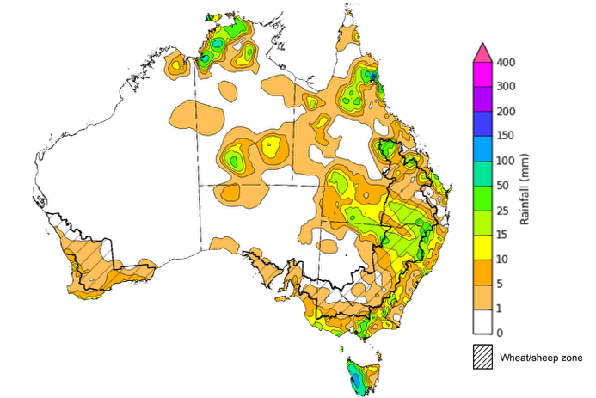

©Commonwealth of Australia 2025, Australian Bureau of Meteorology Issued: 24/9/2025

Note: The rainfall analyses and associated maps utilise data contained in the Bureau of Meteorology climate database, the Australian Data Archive for Meteorology (ADAM). The analyses are initially produced automatically from real-time data with limited [quality control](http://www.bom.gov.au/climate/headers/qc.shtml). They are intended to provide a general overview of rainfall across Australia as quickly as possible after the observations are received. For further information go to <http://www.bom.gov.au/climate/rainfall/>

### Rainfall forecast for the next eight days

Over the 8 days to 2nd October 2025, **cold fronts** are expected to bring rainfall to isolated areas of the south of Australia, while central and northern Australia is forecast to remain largely dry.

Rainfall is expected across some southern cropping regions this week, while western and eastern regions are likely to be largely dry.

* Falls of between 5-15 millimetres are forecast in cropping regions across Victoria and southern New South Wales, while South Australia is forecast to receive 5-10 millimetres.
  + If realised these falls are likely to support crop and pasture growth and development.
* Western Australia, northern New South Wales, and Queensland are forecast to see little to no rainfall over the period.
  + These low expected rainfall totals are unlikely to adversely impact crop production outcomes in these areas as crops are likely to draw on stored soil moisture reserves to support growth, and may allow for uninterrupted harvest of early winter crops and planting of early summer crops in northern regions.

#### Total forecast rainfall for the period 25 September to 2 October 2025

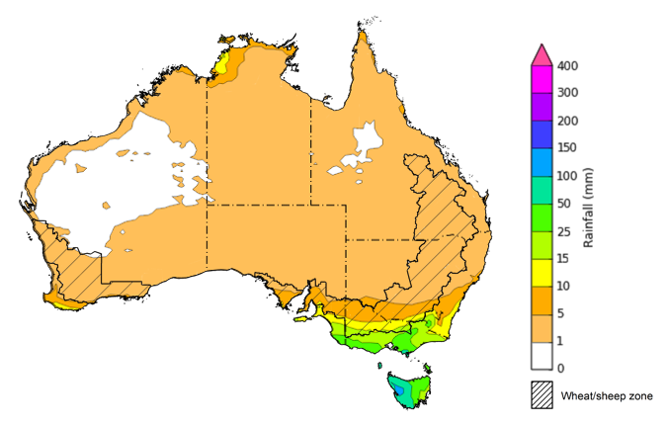

©Commonwealth of Australia 2025, Australian Bureau of Meteorology Issued 25/9/2025

Note: This rainfall forecast is produced from computer models. As the model outputs are not altered by weather forecasters, it is important to check local forecasts and warnings issued by the Bureau of Meteorology.

### 

### National Climate Outlook

The El Niño Southern Oscillation (ENSO) is currently neutral and having minimal influence on Australian rainfall. However, the Indian Ocean Dipole (IOD) Index has been negative for 8 weeks, classifying this as a negative IOD event. A negative IOD typically results in above-average spring rainfall over parts of southern Australia. The Southern Annular Mode (SAM) index is also currently negative, but is likely to return to neutral over the coming fortnight.

The most recent **rainfall outlook for October 2025** provided by the Bureau of Meteorology indicates that much of **eastern Australia** is likely to see **above median rainfall,** with parts of **Tasmania** are likely to see below averagefalls**.**

* The Bureau of Meteorology’s climate model indicates a 75% chance of October rainfall totals between 5-50 millimetres across much of eastern Australia and parts of south-western Western Australia. Despite the increased probabilities of above average rainfall across much of the remainder of northern Australia, October is a transition month between the northern Australian dry and wet seasons. During this time of year, most of the northern two-thirds of Australia aside from coastal regions typically receives very low rainfall.
* Across cropping regions, there is a **75% chance** of rainfall totals of between **10-50 millimetres across eastern cropping regions,** including Queensland and New South Wales**.** Much of **South Australia and Victoria** are likely to see 10-25 millimetres, while **Western Australian** cropping regions are likely to see 5-25 millimetres.If realised, this is expected to provide sufficient moisture to support the finishing of winter crops across most growing regions and support the timely planting and establishment of summer crops across Queensland and northern New South Wales.

**Rainfall totals that have a 75% chance of occurring in October 2025**

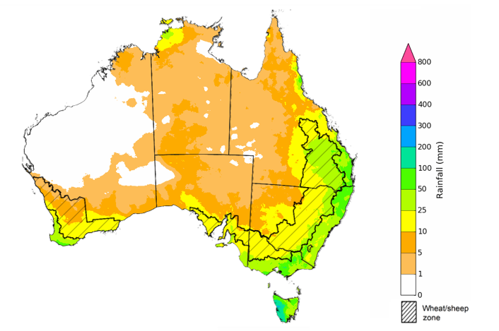

©Commonwealth of Australia 2025, Australian Bureau of Meteorology Issued: 25/9/2025

The **rainfall outlook for October to December 2025** indicates an increased probability of **above median rainfall across much of the eastern two thirds of Australia,** including in Queensland, New South Wales, Victoria, South Australia, eastern Tasmania, southern Western Australia, and the Northern Territory. Parts of western Tasmania are more likely to see below median rainfall, while remaining areas have an equal probability of above or below average rainfall

Across cropping regions, the chance of receiving above median rainfall is 60-70% across Queensland, southern New South Wales, South Australia and Victoria. In Western Australia and northern New South Wales, the probability of above median rainfall is lower at 45-65%.

**Chance of exceeding the median rainfall October 2025 to December 2025**

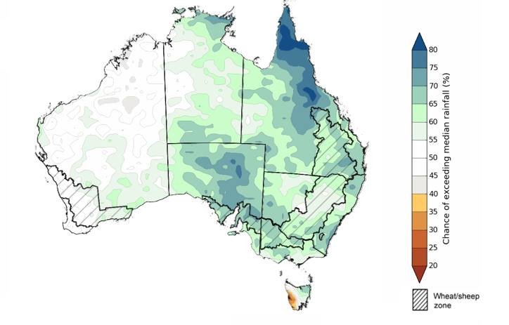

©Commonwealth of Australia 2025, Australian Bureau of Meteorology Issued: 25/9/2025

The **rainfall outlook for October through to December 2025** suggests a 75% chance of receiving rainfall totals of between 50-400 millimetres across much of eastern and northern Australia, including Queensland, New South Wales, Victoria, the Northern Territory and northern Western Australia. Between 400-600 millimetres are expected across western Tasmania and alpine areas of New South Wales and Victoria, as well as parts of the northern tropics. Lower rainfall totals are forecast for central and western regions, with South Australia and southern Westernisis Australia likely to see 25- 100 millimetres of rainfall.

In **cropping regions**, there is a **75% chance** of receiving between **50-200 millimetres** across **much of Queensland and New South Wales**. In **Western Australia**, falls of **10-100 millimetres** are expected, with **Victoria** **and much of South Australia** likely to see **50-100 millimetres**. If realised, these falls are likely be sufficient to support the finishing of winter crops, and the timely planting and establishment of dryland summer crops in eastern Australia.

**Rainfall totals that have a 75% chance of occurring October 2025 to December 2025**

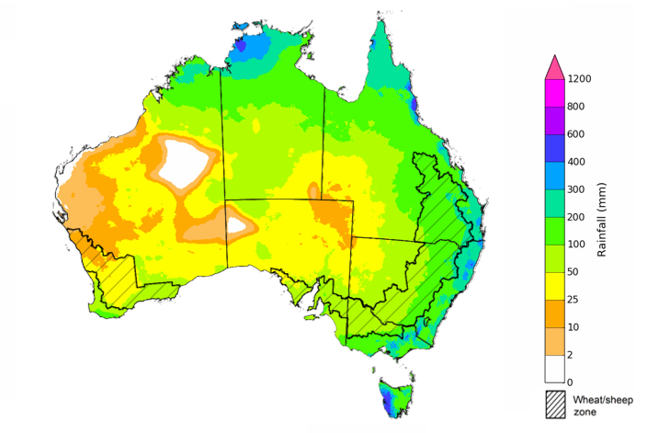

©Commonwealth of Australia 2025, Australian Bureau of Meteorology Issued: 25/9/2025

### Water markets – current week

#### Water storage levels in the Murray-Darling Basin (MDB) increased by 63 gigalitres (GL) between 18 September 2025 and 25 September 2025. The current volume of water held in storages is 15,645 GL, equivalent to 70% of total storage capacity. This is -13% or -2,283 GL less than the same time last year. Water storage data is sourced from the Bureau of Meteorology (BOM).

#### Water storages in the Murray-Darling Basin, 2013–2025A chart showing water storage in the Murray-Darling Basin. For more information, refer to accompanying text

Allocation prices in the Victorian Murray below the Barmah Choke decreased from $294/ML on 18 September 2025 to $279/ML on 25 September 2025. Trade from the Goulburn to the Murray is closed. Trade downstream through the Barmah Choke is closed. Trade from the Murrumbidgee to the Murray is closed.

#### Surface water trade activity, Southern Murray–Darling Basin

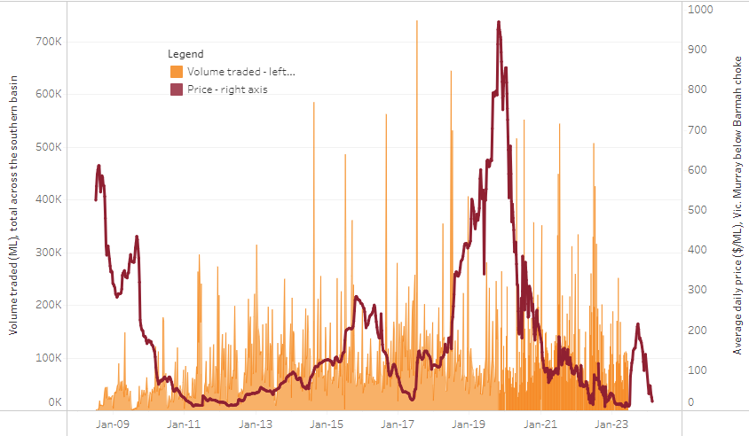

|  |
| --- |
| The trades shown reflect estimated market activity and do not encompass all register trades. The price is shown for the VIC Murray below the Barmah choke. Historical prices (before 1 July 2019) are ABARES estimates after removing outliers from BOM water register data. Prices after 1 July 2019 and prior to the 30 October 2019 reflect recorded transaction prices as sourced from Ruralco. Prices after the 30 October 2019 are sourced from Waterflow. Data for volume traded is sourced from the BOM water register. Only the price data shown is current on 17 October 2024. |

To access the full, interactive, weekly water dashboard, which contains the latest and historical water storage, water market and water allocation information, please visit <https://www.agriculture.gov.au/abares/products/weekly_update/weekly-update-180925>

https://www.agriculture.gov.au/abares/products/weekly_update/weekly-update-140825

## **Commodities**

|  |  |  |  |  |  |  |  |  |
| --- | --- | --- | --- | --- | --- | --- | --- | --- |
| **Indicator** | **Week average** | **Unit** | **Latest Price** | **Previous Week** | **Weekly change** | | **Price 12 months ago** | **Annual change** |
| **Selected world indicator prices** |  |  |  |  |  |  | |  |
| AUD/USD Exchange rate | 24-Sep | A$/US$ | 0.66 | 0.66 | -1% | 0.68 | | -2% |
| Wheat – US no. 2 hard red winter wheat, FOB Gulf | 24-Sep | US$/t | 234 | 237 | -1% | 270 | | -13% |
| Corn – US no. 2 yellow corn, FOB Gulf | 24-Sep | US$/t | 198 | 198 | 0% | 186 | | 6% |
| Canola – Rapeseed, Canada, FOB Vancouver | 24-Sep | US$/t | 470 | 479 | -2% | 465 | | 1% |
| Cotton – Cotlook A Index | 24-Sep | USc/lb | 78.0 | 78.5 | -1% | 82.5 | | -6% |
| Sugar – Intercontinental Exchange, nearby futures, no.11 contract | 24-Sep | USc/lb | 16.0 | 16.4 | -2% | 20.6 | | -22% |
| Wool – Eastern Market Indicator | 17-Sep | Ac/kg clean | 1,344 | 1,319 | 2% | 1,094 | | 23% |
| Wool – Western Market Indicator | 27-Aug | Ac/kg clean | 1,402 | 1,396 | 0% | 1,229 | | 14% |
| **Selected Australian grain export prices** |  |  |  |  |  |  | |  |
| Australian Premium White (APW) Wheat, FOB Port Adelaide, SA | 24-Sep | A$/t | 368 | 367 | 0% | 382 | | -4% |
| Australian Standard White (ASW) Wheat, FOB Port Adelaide, SA | 24-Sep | A$/t | 364 | 363 | 0% | 372 | | -2% |
| Feed Barley – FOB Port Adelaide, SA | 24-Sep | A$/t | 351 | 351 | 0% | 347 | | 1% |
| Canola – FOB Kwinana, WA | 24-Sep | A$/t | 781 | 784 | 0% | 724 | | 8% |
| Grain Sorghum – FOB Brisbane, QLD | 24-Sep | A$/t | 404 | 406 | 0% | 381 | | 6% |
| **Selected domestic livestock indicator prices** |  |  |  |  |  |  | |  |
| Beef – Eastern Young Cattle Indicator | 24-Sep | Ac/kg cwt | 896 | 895 | 0% | 669 | | 34% |
| Mutton – Mutton indicator (18–24 kg fat score 2–3), VIC | 24-Sep | Ac/kg cwt | 768 | 758 | 1% | 318 | | 142% |
| Lamb – National Trade Lamb Indicator | 24-Sep | Ac/kg cwt | 1,184 | 1,182 | 0% | 805 | | 47% |
| Pig – Eastern Seaboard (60.1–75 kg), NSW buyer price | 10-Sep | Ac/kg cwt | 462 | 461 | 0% | 422 | | 10% |
| Live cattle – Light steers to Indonesia | 27-Aug | Ac/kg lwt | 350 | 350 | 0% | 304 | | 15% |
| **Global Dairy Trade (GDT) weighted average prices** |  |  |  |  |  |  | |  |
| Dairy – Whole milk powder | 17-Sep | US$/t | 3,790 | 3,809 | 0% | 3,422 | | 11% |
| Dairy – Skim milk powder | 17-Sep | US$/t | 2,615 | 2,620 | 0% | 2,781 | | -6% |
| Dairy – Cheddar cheese | 17-Sep | US$/t | 4,814 | 4,709 | 2% | 4,383 | | 10% |
| Dairy – Anhydrous milk fat | 17-Sep | US$/t | 6,802 | 6,917 | -2% | 7,266 | | -6% |
|  | | | | | | | | |

### Selected world indicator prices

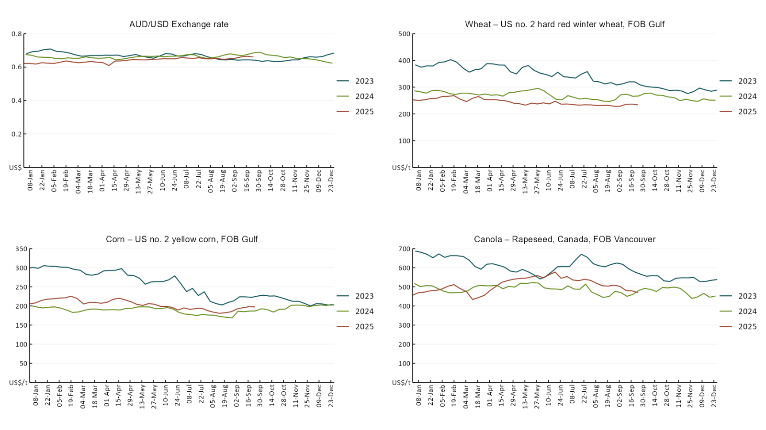

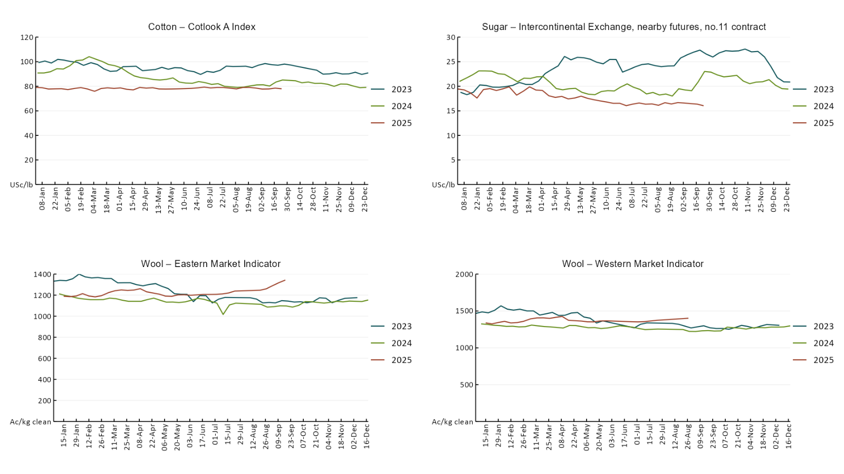

### 3.2 Selected domestic crop indicator prices

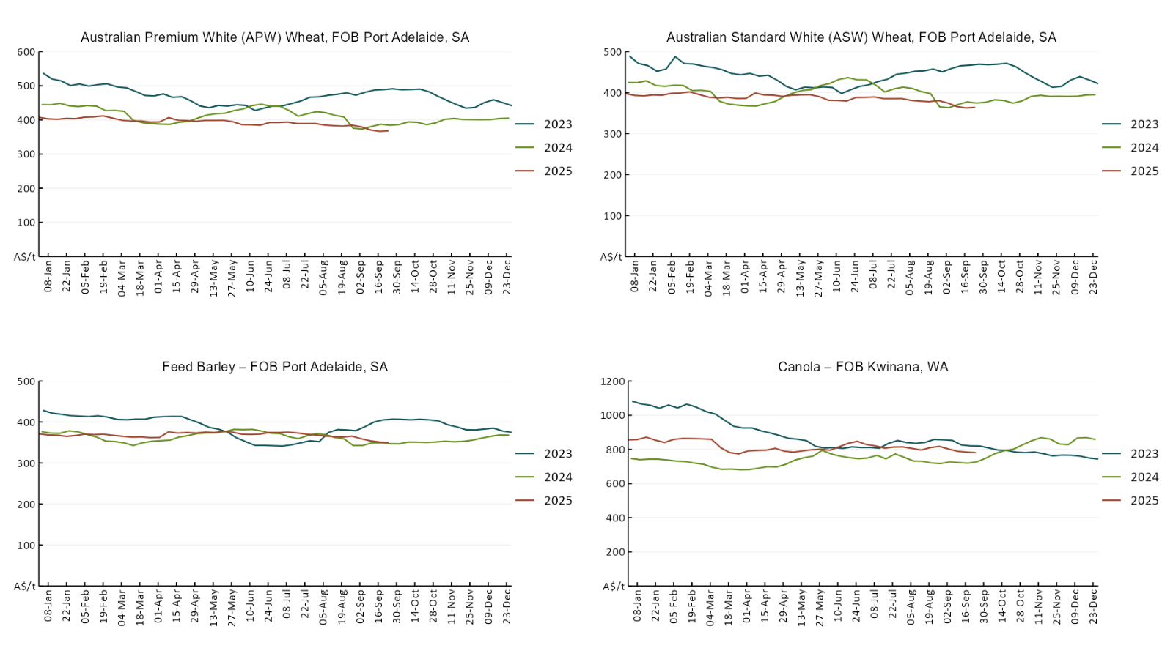

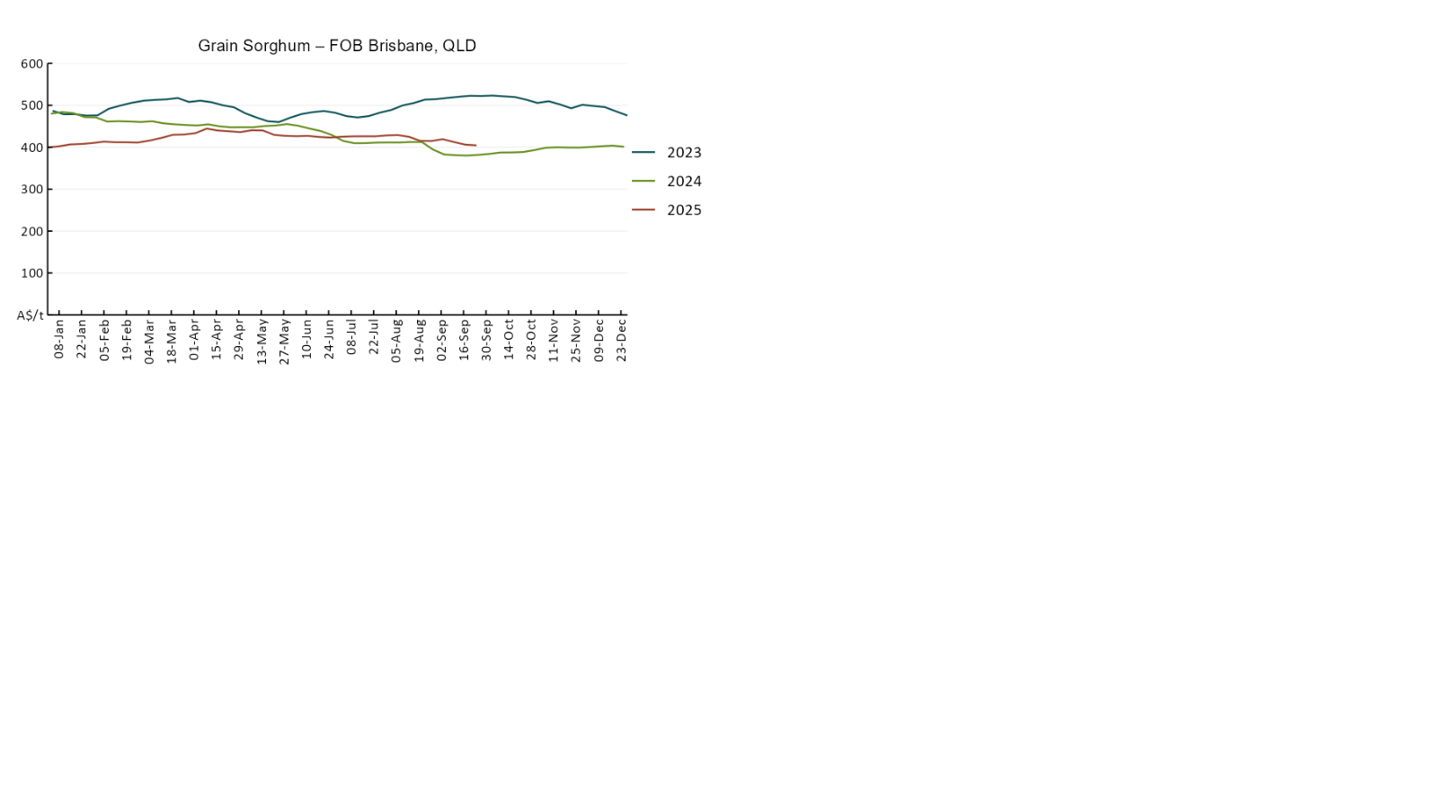

### 3.3 Selected domestic livestock indicator prices

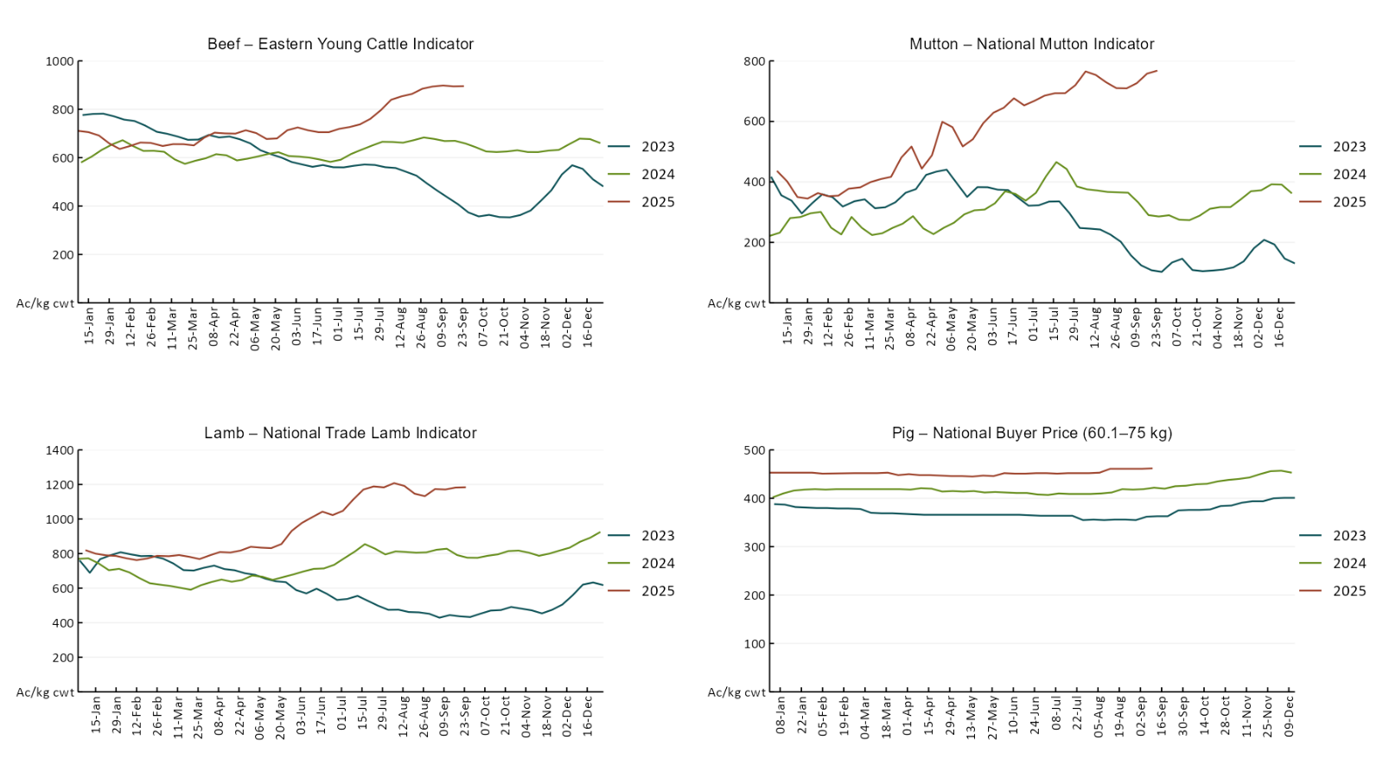

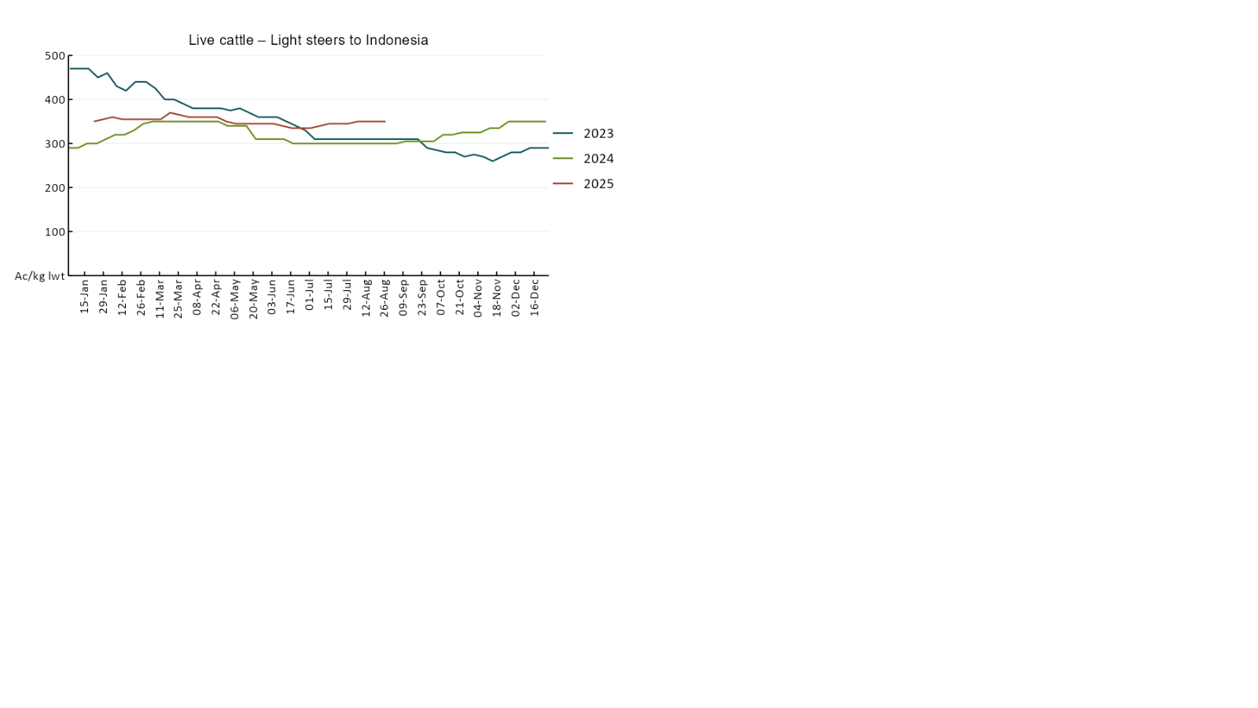

### 3.4 Global Dairy Trade (GDT) weighted average pricesA line chart of Global Dairy Trade prices. For more information, refer to https://www.agriculture.gov.au/abares/data/weekly-commodity-price-update/world-agricultural-prices

### 3.5 Selected fruit and vegetable prices

### A line chart of fruit and vegetable prices. For more information, refer to https://www.agriculture.gov.au/abares/data/weekly-commodity-price-update/world-agricultural-prices

### A line chart of fruit and vegetable prices. For more information, refer to https://www.agriculture.gov.au/abares/data/weekly-commodity-price-update/world-agricultural-prices

### 3.6 Selected domestic fodder indicator prices

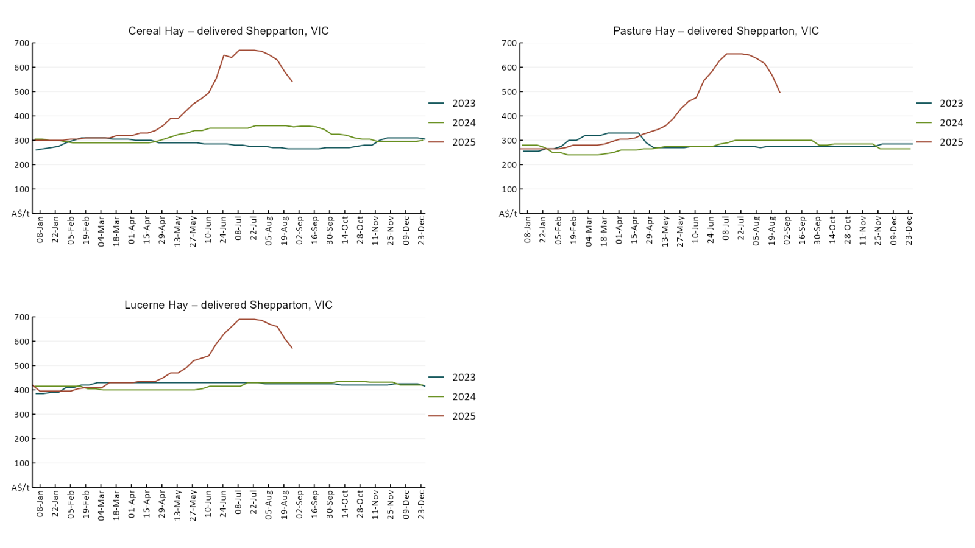

## **4. Data attribution**

### Climate

* Bureau of Meteorology
* Weekly rainfall totals: www.bom.gov.au/climate/maps/rainfall/
* Monthly and last 3-month rainfall percentiles: [www.bom.gov.au/water/landscape/](http://www.bom.gov.au/water/landscape/)
* Temperature anomalies: [www.bom.gov.au/jsp/awap/temp/index.jsp](http://www.bom.gov.au/jsp/awap/temp/index.jsp)
* Rainfall forecast: [www.bom.gov.au/jsp/watl/rainfall/pme.jsp](http://www.bom.gov.au/jsp/watl/rainfall/pme.jsp)
* Seasonal outlook: [www.bom.gov.au/climate/outlooks/#/overview/summary/](http://www.bom.gov.au/climate/outlooks/#/overview/summary/)
* Climate drivers: <http://www.bom.gov.au/climate/enso/>
* Soil moisture: [www.bom.gov.au/water/landscape/](http://www.bom.gov.au/water/landscape/)
* Other
* Pasture growth: [www.longpaddock.qld.gov.au/aussiegrass/](http://www.longpaddock.qld.gov.au/aussiegrass/)
* 3-month global outlooks: [Environment and Climate Change Canada](https://weather.gc.ca/saisons/image_e.html?img=s234pfe1p_cal&bc=prob), [NOAA Climate Prediction Center](https://www.cpc.ncep.noaa.gov/products/predictions/long_range/seasonal.php?lead=2), [EUROBRISA CPTEC/INPE](http://eurobrisa.cptec.inpe.br/), European Centre for Medium-Range Weather Forecasts, [Hydrometcenter of Russia](https://meteoinfo.ru/en/climate/seasonal-forecasts), [National Climate Center Climate System Diagnosis and Prediction Room (NCC)](https://cmdp.ncc-cma.net/pred/cs2gen.php?pred_elem=RAINP#pred_seasonal), [International Research Institute for Climate and Society](https://iri.columbia.edu/our-expertise/climate/forecasts/seasonal-climate-forecasts/)
* Global production: <https://ipad.fas.usda.gov/ogamaps/cropmapsandcalendars.aspx>
* Autumn break: Pook et al., 2009, <https://rmets-onlinelibrary-wiley-com.virtual.anu.edu.au/doi/epdf/10.1002/joc.1833>

### Water

Prices

* Waterflow: <https://www.waterflow.io/>
* Ruralco: <https://www.ruralcowater.com.au/>
* Bureau of Meteorology:
* Allocation trade: <http://www.bom.gov.au/water/dashboards/#/water-markets/mdb/at>
* Storage volumes: <http://www.bom.gov.au/water/dashboards/#/water-storages/summary/drainage>
* Trade constraints:
* Water NSW: <https://www.waternsw.com.au/customer-service/ordering-trading-and-pricing/trading/murrumbidgee>
* Victorian Water Register: <https://www.waterregister.vic.gov.au/TradingRules2019/>

### Commodities

* Fruit and vegetables
* Datafresh: [www.freshstate.com.au](http://www.freshstate.com.au)
* Pigs
* Australian Pork Limited: [www.australianpork.com.au](http://www.australianpork.com.au)
* Dairy
* Global Dairy Trade: [www.globaldairytrade.info/en/product-results/](http://www.globaldairytrade.info/en/product-results/)
* World wheat, canola
* International Grains Council
* World coarse grains
* United States Department of Agriculture
* World cotton
* Cotlook: [www.cotlook.com/](http://www.cotlook.com/)
* World sugar
* New York Stock Exchange - Intercontinental Exchange
* Wool
* Australian Wool Exchange: [www.awex.com.au/](http://www.awex.com.au/)
* Domestic wheat, barley, sorghum, canola and fodder
* Jumbuk Consulting Pty Ltd: http://www.jumbukag.com.au/
* Cattle, beef, mutton, lamb, goat and live export
* Meat and Livestock Australia: [www.mla.com.au/Prices-and-market](http://www.mla.com.au/Prices-and-market)

© Commonwealth of Australia 2025

### Ownership of intellectual property rights

Unless otherwise noted, copyright (and any other intellectual property rights, if any) in this publication is owned by the Commonwealth of Australia (referred to as the Commonwealth).

### Creative Commons licence

All material in this publication is licensed under a [Creative Commons Attribution 4.0 International Licence](https://creativecommons.org/licenses/by/4.0/legalcode) except content supplied by third parties, logos and the Commonwealth Coat of Arms.

Inquiries about the licence and any use of this document should be emailed to [copyright@awe.gov.au](mailto:copyright@awe.gov.au).

https://www.agriculture.gov.au/sites/default/files/images/creative-commons-logo-small.png

### Cataloguing data

This publication (and any material sourced from it) should be attributed as:

ABARES 2025, Weekly Australian Climate, Water and Agricultural Update, Australian Bureau of Agricultural and Resource Economics and Sciences, Canberra,258 September 2025. CC BY 4.0 DOI: <https://doi.org/10.25814/5f3e04e7d2503>

ISSN **2652-7561**

This publication is available at https://www.agriculture.gov.au/abares/products/weekly_update

Department of Agriculture, Fisheries and Forestry

GPO Box 858 Canberra ACT 2601

Telephone 1800 900 090

Web [agriculture.gov.au/abares](http://awe.gov.au/abares)

### Disclaimer

The Australian Government acting through the Department of Agriculture, Fisheries and Forestry, represented by the Australian Bureau of Agricultural and Resource Economics and Sciences, has exercised due care and skill in preparing and compiling the information and data in this publication. Notwithstanding, the Department of Agriculture, Fisheries and Forestry, ABARES, its employees and advisers disclaim all liability, including liability for negligence and for any loss, damage, injury, expense or cost incurred by any person as a result of accessing, using or relying on any of the information or data in this publication to the maximum extent permitted by law.

### Statement of Professional Independence

The views and analysis presented in ABARES publications, including this one, reflect ABARES professionally independent findings, based on scientific and economic concepts, principles, information and data. These views, analysis and findings may not reflect or be consistent with the views or positions of the Australian Government, or of organisations or groups who have commissioned ABARES reports or analysis. More information on [professional independence](https://www.agriculture.gov.au/abares/about/research-and-analysis#professional-independence) is provided on the ABARES website.

### Acknowledgements

This report was prepared by Holly Beale and Matt Miller.