## No. 40/2025 9 October 2025

# Summary of key issues

* In the week ending 8 October 2025, cold fronts and a northwest cloudband brought rainfall to parts of southern Australia.
  + Rainfall was low across most eastern cropping regions. Cropping regions in South Australia and parts of southern Western Australia and Victoria recorded 1- 10 millimetres. North-western cropping regions in Western Australia observed 1-25 millimetres of rainfall over the period.
  + These low rainfall totals in southern and eastern regions have resulted in a drawdown of soil moisture to support the growth and development of crops and pasture. In regions that have low soil moisture reserves, these low rainfall totals are likely to contribute to declining yield outcomes for winter crops as they approach the end of the crop development period.
* Over the coming eight days to 16 October 2025, some rainfall is expected across most eastern cropping regions. Victoria, South Australia, southern New South Wales and Western Australia are forecast to receive little to no rainfall over the period.
  + Low expected rainfall totals across Western Australia are unlikely to adversely impact crop production outcomes. However, ongoing dry conditions across parts of South Australia, Victoria and southern New South Wales presents an increased downside production risk for winter crops and pastures which are in their critical final yield determining growth stages.
* The national rainfall outlook for November 2025 to January 2026 indicates an increased probability of above median rainfall across much of Australia.
  + If realised, above median rainfall would support late spring and summer pasture growth across eastern and northern Australia. Additionally, these expected above average falls are likely to be sufficient to support above yield expectation for summer crops.
* Improving pasture growth for the three months to September 2025 across large areas of Victoria, South Australia, Western Australia, and north-western and southern New South Wales will likely see graziers to increase stocking rates and production.
* Water storage levels in the Murray-Darling Basin (MDB) decreased by 116 gigalitres (GL) between 02 October 2025 and 09 October 2025. The current volume of water held in storages is 15,471 GL, equivalent to 70% of total storage capacity. This is -11% or -1,989 GL less than the same time last year. Water storage data is sourced from the Bureau of Meteorology.
* Allocation prices in the Victorian Murray below the Barmah Choke increased from $300/ML on 02 October 2025 to $319/ML on 09 October 2025. Trade from the Goulburn to the Murray is closed. Trade downstream through the Barmah Choke is closed. Trade from the Murrumbidgee to the Murray is open.

## **Climate**

### Rainfall this week

In the week ending 8 October 2025, cold fronts and a northwest cloudband brought rainfall to parts of southern Australia, including much of Tasmania and southern parts of Victoria, South Australia, New South Wales and Western Australia, while the northern two thirds of Australia stayed largely dry.

Rainfall was generally low across winter cropping regions for the week ending 8 October 2025.

* Most cropping regions in New South Wales, Queensland, and northern Victoria recorded little to no rainfall over the period.
* South Australia and parts of southern Western Australia and Victoria recorded 1 -10 millimetres. North-western cropping regions in Western Australia observed 1-25 millimetres of rainfall over the period.
  + These low rainfall totals in southern and eastern regions have resulted in a drawdown of soil moisture to support the growth and development of crops and pasture. In regions that have low soil moisture reserves, these low rainfall totals are likely to contribute to declining yield outcomes for winter crops as they approach the end of the crop development period.

#### Rainfall for the week ending 8 October 2025

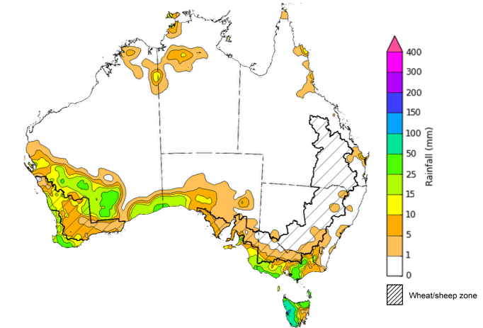

©Commonwealth of Australia 2025, Australian Bureau of Meteorology Issued: 8/10/2025

Note: The rainfall analyses and associated maps utilise data contained in the Bureau of Meteorology climate database, the Australian Data Archive for Meteorology (ADAM). The analyses are initially produced automatically from real-time data with limited [quality control](http://www.bom.gov.au/climate/headers/qc.shtml). They are intended to provide a general overview of rainfall across Australia as quickly as possible after the observations are received. For further information go to <http://www.bom.gov.au/climate/rainfall/>

### Rainfall forecast for the next eight days

Over the 8 days to 16 October 2025, low-pressure systems are expected to bring rainfall to large areas of northern, central and eastern Australia, while much of the southwest of Australia is forecast to see very limited rainfall.

Some rainfall is expected across eastern cropping regions this week, while southern regions are likely to see very limited rainfall.

* Falls of between 10-50 millimetres are forecast in cropping regions across most of Queensland, while most of New South Wales is forecast to receive 5- 25 millimetres.
  + If realised these falls are likely to be sufficient to support crop and pasture growth and development in most areas.
* Victoria, South Australia, southern New South Wales and Western Australia are forecast to receive little to no rainfall over the period.
  + These low expected rainfall totals across Western Australia are unlikely to adversely impact crop production outcomes following average to above average rainfall in previous months. However, ongoing dry conditions across parts of South Australia, Victoria and southern New South Wales presents an increased downside production risk for winter crops and pastures which are in their critical final yield determining growth stages, partially given the rapid decline in soil moisture levels in recent weeks.

#### Total forecast rainfall for the period 9 October to 16 October 2025

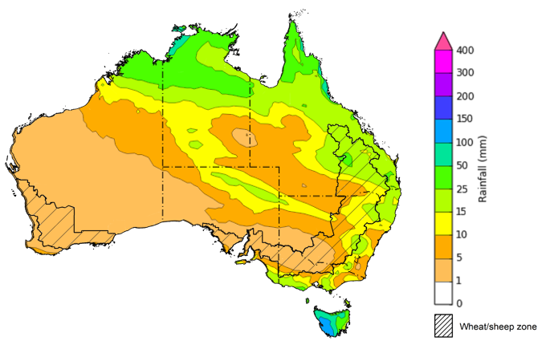

©Commonwealth of Australia 2025, Australian Bureau of Meteorology Issued 9/10/2025

Note: This rainfall forecast is produced from computer models. As the model outputs are not altered by weather forecasters, it is important to check local forecasts and warnings issued by the Bureau of Meteorology.

### 

### Pasture Growth

During the northern Australia dry season (May to September), pasture growth typically declines significantly due to the reduction in water availability, with livestock relying on pasture grown throughout the previous wet season. Across southern Australia, July to September pasture growth influences the number of livestock than can be supported without supplementary feeding over winter and the level of reliance on hay and grain during this period. Pasture availability during this period influences the growth and branding and marking rates of lambs and calves, livestock turnoff and the production of meat, milk, and wool.

Pasture growth for the three months to September 2025 was variable across much of country, with parts of southern and eastern Australia experiencing robust pasture growth.

* **Average to extremely high** pasture growth was modelled across large areas of southern and eastern Australia, including parts of Queensland, central and eastern New South Wales, southern Victoria, southern regions of South Australia, and parts of southwestern Western Australia.
  + This pasture growth is expected to have allow farmers to rebuild livestock numbers, provide opportunities to build standing dry matter availability and decrease the reliance on fodder to maintain livestock condition over the winter and early spring period.
* By contrast, large areas of the Mallee region, southern Western Australia, and southern and eastern Queensland saw relatively low pasture growth for this time of year.
  + This below average pasture growth will likely see some graziers in affected regions continuing to be reliant on supplemental feed to maintain current stocking rates and production.

**Relative pasture growth for 3-months ending September 2025 (1 July to 31 September 2025)**

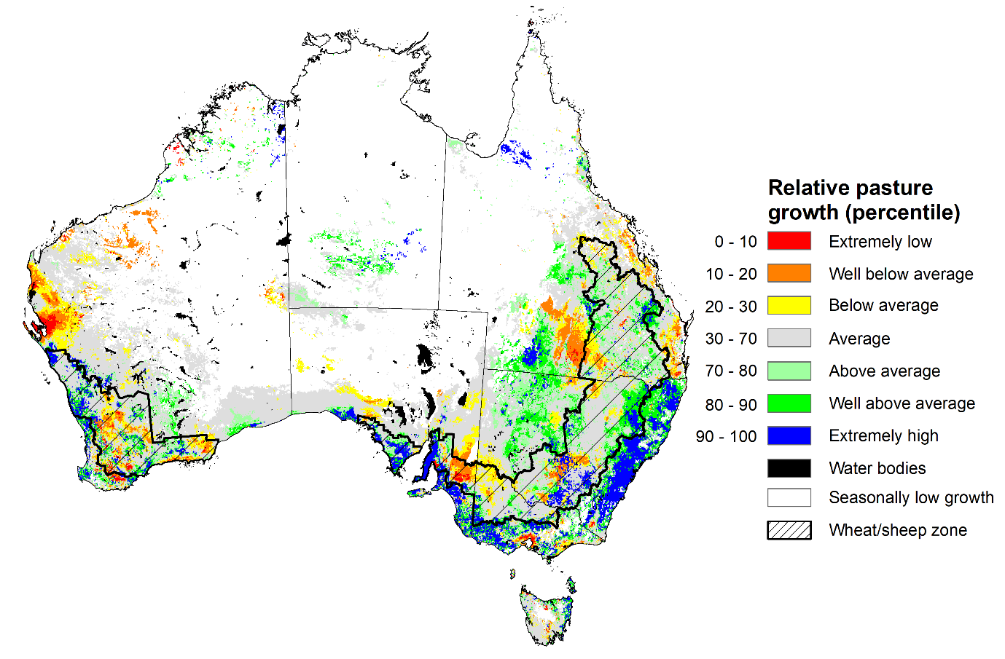

Notes: AussieGRASS pasture growth estimates are relative to the long-term record and shown in percentiles. Percentiles rank data on a scale of zero to 100. This analysis ranks pasture growth for the selected period against average pasture growth for the long-term record (1957 to 2016). Pasture growth is modelled at 5km2 grid cells.  
Source: Department of Environment, Science and Innovation

### National Climate Outlook

The El Niño Southern Oscillation (ENSO) is currently neutral and having minimal influence on Australian rainfall. However, the Indian Ocean Dipole (IOD) Index and Southern Annular Mode (SAM) are currently under negative conditions. A negative IOD typically results in above-average spring rainfall over parts of southern Australia.

The most recent **rainfall outlook for November 2025** provided by the Bureau of Meteorology indicates that much of **eastern and central Australia** is likely to see **above median rainfall,** with much of **Western** **Australia** and Tasmania more likely to see closer to **average** falls**.**

* The Bureau of Meteorology’s climate model indicates a 75% chance of November rainfall totals between 10-100 millimetres across much of eastern and northern Australia, with higher rainfall totals of up to 200 millimetres expected in the north of the Northern Territory and alpine regions of New South Wales and Victoria. Most southern and central regions are likely to see falls of between 1-25 millimetres, including southern Western Australia and South Australia.
* Across cropping regions, there is a 75% chance of rainfall totals of between 10-50 millimetres across eastern cropping regions, including Queensland and New South Wales. Much of South Australia and Victoria are likely to see 10-25 millimetres, while Western Australian cropping regions are likely to see 1-25 millimetres.
  + If realised, these relatively low expected rainfall totals across much of south-eastern Australia represent a downside production risk for both winter crop production and pasture growth, particularly given the lack of rainfall in recent weeks and declining soil moisture levels across large areas. However, if forecast rainfall totals are realised across much of northern New South Wales and Queensland, these falls are likely to be sufficient to support above average yield prospects for winter and summer crops and average or better levels of pasture production.

**Rainfall totals that have a 75% chance of occurring in November 2025**

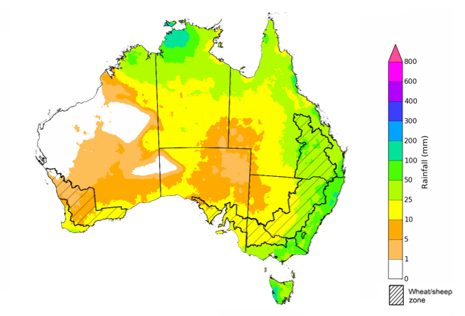

©Commonwealth of Australia 2025, Australian Bureau of Meteorology Issued: 2/10/2025

The **rainfall outlook for November 2025 to January 2026** indicates an increased probability of **above median rainfall across much of Australia,** including much of Queensland, New South Wales, Victoria, South Australia, eastern Tasmania, and south of Western Australia. Part of far southwest of Western Australia and western Tasmania are more likely to see below median rainfall, while remaining areas have an equal probability of above or below average rainfall

Across cropping regions, the chance of receiving above median rainfall is 55-80% across Queensland and New South Wales, while South Australia and Victoria has a 60-75% chance. In Western Australia, the probability of above median rainfall is lower at 55-65%. If above median rainfall is realised, this rainfall is likely to support the build-up of soil moisture levels in eastern regions for the summer cropping period and contribute to improving soil moisture in south-eastern regions.

**Chance of exceeding the median rainfall November 2025 to January 2026**

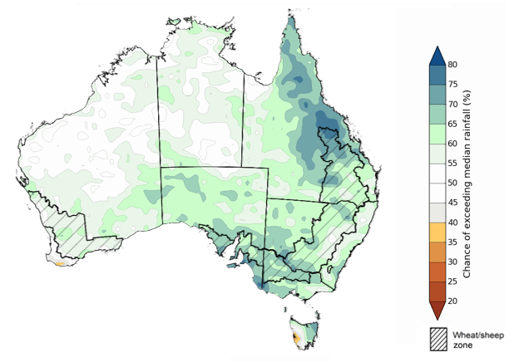

©Commonwealth of Australia 2025, Australian Bureau of Meteorology Issued: 2/10/2025

The **rainfall outlook for November 2025 to January 2026** suggests a 75% chance of receiving rainfall totals of between 50-400 millimetres across much of eastern and northern Australia. Between 400-800 millimetres are expected across scattered east coast regions as well as parts of the northern tropics. Lower rainfall totals are forecast for south-western and central regions, with South Australia and southern Westernisis Australia likely to see 10- 100 millimetres.

In **cropping regions**, there is a **75% chance** of receiving between**100-300 millimetres** across **much of Queensland and northern New South Wales**. **Southern New South Wales** likely to see **50- 200 millimetres.** In **Western Australia**, falls of **10-100 millimetres** are expected, with **Victoria** and **South Australia** is likely to see **25-100 millimetres**.

Given the winter crops harvest will be well underway across several regions, November through to January rainfall will have little influence on winter crop production prospects, other than its influence on harvest progress. Meanwhile, if the forecast November through to January rainfall totals are realised, they are likely to be sufficient to support late spring and summer pasture growth across eastern and northern Australia. Additionally, these expected falls are likely to be sufficient to support above yield expectation for summer crops.

**Rainfall totals that have a 75% chance of occurring November 2025 to January 2026**

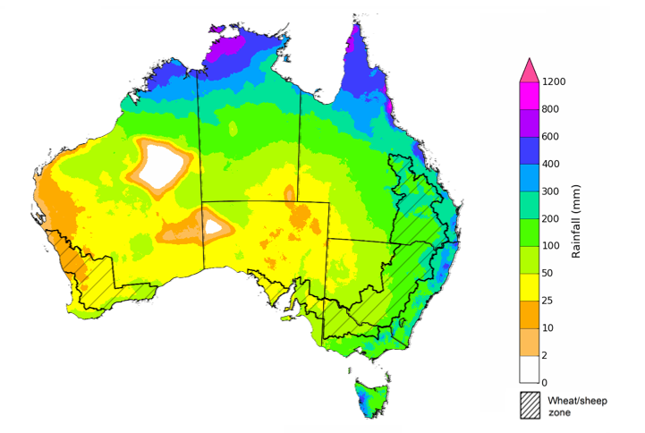

©Commonwealth of Australia 2025, Australian Bureau of Meteorology Issued: 2/10/2025

### Water markets – current week

#### Water storage levels in the Murray-Darling Basin (MDB) decreased by 116 gigalitres (GL) between 02 October 2025 and 09 October 2025. The current volume of water held in storages is 15,471 GL, equivalent to 70% of total storage capacity. This is -11% or -1,989 GL less than the same time last year. Water storage data is sourced from the Bureau of Meteorology (BOM).

#### Water storages in the Murray-Darling Basin, 2013–2025

Allocation prices in the Victorian Murray below the Barmah Choke increased from $300/ML on 02 October 2025 to $319/ML on 09 October 2025. Trade from the Goulburn to the Murray is closed. Trade downstream through the Barmah Choke is closed. Trade from the Murrumbidgee to the Murray is open.

#### Water market prices, Southern Murray–Darling Basin

|  |  |
| --- | --- |
| Region | $/ML |
| NSW Murray Above | 246 |
| NSW Murrumbidgee | 265 |
| Vic Greater Goulburn | 288 |
| Vic Murray Below | 319 |

Note: The water allocation prices shown are volume weighted average prices based on the last 10 trades. Price data is sourced from Waterflow and current as at 02 October 2025.

To access the full, interactive, weekly water dashboard, which contains the latest and historical water storage, water market and water allocation information, please visit <https://www.agriculture.gov.au/abares/products/weekly_update/weekly-update-091025>

https://www.agriculture.gov.au/abares/products/weekly_update/weekly-update-140825

## **Commodities**

|  |  |  |  |  |  |  |  |  |
| --- | --- | --- | --- | --- | --- | --- | --- | --- |
| **Indicator** | **Week average** | **Unit** | **Latest Price** | **Previous Week** | **Weekly change** | | **Price 12 months ago** | **Annual change** |
| **Selected world indicator prices** |  |  |  |  |  |  | |  |
| AUD/USD Exchange rate | 8-Oct | A$/US$ | 0.66 | 0.66 | 0% | 0.67 | | -2% |
| Wheat – US no. 2 hard red winter wheat, FOB Gulf | 8-Oct | US$/t | 229 | 230 | 0% | 271 | | -16% |
| Corn – US no. 2 yellow corn, FOB Gulf | 8-Oct | US$/t | 198 | 197 | 0% | 190 | | 4% |
| Canola – Rapeseed, Canada, FOB Vancouver | 8-Oct | US$/t | 468 | 465 | 1% | 489 | | -4% |
| Cotton – Cotlook A Index | 8-Oct | USc/lb | 76.5 | 77.0 | -1% | 83.6 | | -9% |
| Sugar – Intercontinental Exchange, nearby futures, no.11 contract | 8-Oct | USc/lb | 16.7 | 16.4 | 2% | 22.3 | | -25% |
| Wool – Eastern Market Indicator | 1-Oct | Ac/kg clean | 1,565 | 1,453 | 8% | 1,127 | | 39% |
| Wool – Western Market Indicator | 24-Sep | Ac/kg clean | 1,577 | 1,480 | 7% | 1,261 | | 25% |
| **Selected Australian grain export prices** |  |  |  |  |  |  | |  |
| Australian Premium White (APW) Wheat, FOB Port Adelaide, SA | 8-Oct | A$/t | 374 | 373 | 0% | 390 | | -4% |
| Australian Standard White (ASW) Wheat, FOB Port Adelaide, SA | 8-Oct | A$/t | 370 | 369 | 0% | 379 | | -2% |
| Feed Barley – FOB Port Adelaide, SA | 8-Oct | A$/t | 349 | 349 | 0% | 350 | | 0% |
| Canola – FOB Kwinana, WA | 8-Oct | A$/t | 799 | 783 | 2% | 790 | | 1% |
| Grain Sorghum – FOB Brisbane, QLD | 8-Oct | A$/t | 406 | 404 | 0% | 388 | | 5% |
| **Selected domestic livestock indicator prices** |  |  |  |  |  |  | |  |
| Beef – Eastern Young Cattle Indicator | 8-Oct | Ac/kg cwt | 857 | 881 | -3% | 630 | | 36% |
| Mutton – Mutton indicator (18–24 kg fat score 2–3), VIC | 8-Oct | Ac/kg cwt | 803 | 789 | 2% | 288 | | 179% |
| Lamb – National Trade Lamb Indicator | 8-Oct | Ac/kg cwt | 1,155 | 1,153 | 0% | 798 | | 45% |
| Pig – Eastern Seaboard (60.1–75 kg), NSW buyer price | 10-Sep | Ac/kg cwt | 462 | 461 | 0% | 432 | | 7% |
| Live cattle – Light steers to Indonesia | 27-Aug | Ac/kg lwt | 350 | 350 | 0% | 319 | | 10% |
| **Global Dairy Trade (GDT) weighted average prices** |  |  |  |  |  |  | |  |
| Dairy – Whole milk powder | 8-Oct | US$/t | 3,696 | 3,790 | -2% | 3,556 | | 4% |
| Dairy – Skim milk powder | 8-Oct | US$/t | 2,599 | 2,615 | -1% | 2,770 | | -6% |
| Dairy – Cheddar cheese | 8-Oct | US$/t | 4,858 | 4,814 | 1% | 4,654 | | 4% |
| Dairy – Anhydrous milk fat | 8-Oct | US$/t | 6,916 | 6,802 | 2% | 7,221 | | -4% |
|  | | | | | | | | |

### Selected world indicator prices

### 3.2 Selected domestic crop indicator prices

### 3.3 Selected domestic livestock indicator prices

### 3.5 Selected fruit and vegetable prices

### 3.6 Selected domestic fodder indicator prices

## **4. Data attribution**

### Climate

* Bureau of Meteorology
* Weekly rainfall totals: www.bom.gov.au/climate/maps/rainfall/
* Monthly and last 3-month rainfall percentiles: [www.bom.gov.au/water/landscape/](http://www.bom.gov.au/water/landscape/)
* Temperature anomalies: [www.bom.gov.au/jsp/awap/temp/index.jsp](http://www.bom.gov.au/jsp/awap/temp/index.jsp)
* Rainfall forecast: [www.bom.gov.au/jsp/watl/rainfall/pme.jsp](http://www.bom.gov.au/jsp/watl/rainfall/pme.jsp)
* Seasonal outlook: [www.bom.gov.au/climate/outlooks/#/overview/summary/](http://www.bom.gov.au/climate/outlooks/#/overview/summary/)
* Climate drivers: <http://www.bom.gov.au/climate/enso/>
* Soil moisture: [www.bom.gov.au/water/landscape/](http://www.bom.gov.au/water/landscape/)
* Other
* Pasture growth: [www.longpaddock.qld.gov.au/aussiegrass/](http://www.longpaddock.qld.gov.au/aussiegrass/)
* 3-month global outlooks: [Environment and Climate Change Canada](https://weather.gc.ca/saisons/image_e.html?img=s234pfe1p_cal&bc=prob), [NOAA Climate Prediction Center](https://www.cpc.ncep.noaa.gov/products/predictions/long_range/seasonal.php?lead=2), [EUROBRISA CPTEC/INPE](http://eurobrisa.cptec.inpe.br/), European Centre for Medium-Range Weather Forecasts, [Hydrometcenter of Russia](https://meteoinfo.ru/en/climate/seasonal-forecasts), [National Climate Center Climate System Diagnosis and Prediction Room (NCC)](https://cmdp.ncc-cma.net/pred/cs2gen.php?pred_elem=RAINP#pred_seasonal), [International Research Institute for Climate and Society](https://iri.columbia.edu/our-expertise/climate/forecasts/seasonal-climate-forecasts/)
* Global production: <https://ipad.fas.usda.gov/ogamaps/cropmapsandcalendars.aspx>
* Autumn break: Pook et al., 2009, <https://rmets-onlinelibrary-wiley-com.virtual.anu.edu.au/doi/epdf/10.1002/joc.1833>

### Water

Prices

* Waterflow: <https://www.waterflow.io/>
* Ruralco: <https://www.ruralcowater.com.au/>
* Bureau of Meteorology:
* Allocation trade: <http://www.bom.gov.au/water/dashboards/#/water-markets/mdb/at>
* Storage volumes: <http://www.bom.gov.au/water/dashboards/#/water-storages/summary/drainage>
* Trade constraints:
* Water NSW: <https://www.waternsw.com.au/customer-service/ordering-trading-and-pricing/trading/murrumbidgee>
* Victorian Water Register: <https://www.waterregister.vic.gov.au/TradingRules2019/>

### Commodities

* Fruit and vegetables
* Datafresh: [www.freshstate.com.au](http://www.freshstate.com.au)
* Pigs
* Australian Pork Limited: [www.australianpork.com.au](http://www.australianpork.com.au)
* Dairy
* Global Dairy Trade: [www.globaldairytrade.info/en/product-results/](http://www.globaldairytrade.info/en/product-results/)
* World wheat, canola
* International Grains Council
* World coarse grains
* United States Department of Agriculture
* World cotton
* Cotlook: [www.cotlook.com/](http://www.cotlook.com/)
* World sugar
* New York Stock Exchange - Intercontinental Exchange
* Wool
* Australian Wool Exchange: [www.awex.com.au/](http://www.awex.com.au/)
* Domestic wheat, barley, sorghum, canola and fodder
* Jumbuk Consulting Pty Ltd: http://www.jumbukag.com.au/
* Cattle, beef, mutton, lamb, goat and live export
* Meat and Livestock Australia: [www.mla.com.au/Prices-and-market](http://www.mla.com.au/Prices-and-market)

© Commonwealth of Australia 2025

### Ownership of intellectual property rights

Unless otherwise noted, copyright (and any other intellectual property rights, if any) in this publication is owned by the Commonwealth of Australia (referred to as the Commonwealth).

### Creative Commons licence

All material in this publication is licensed under a [Creative Commons Attribution 4.0 International Licence](https://creativecommons.org/licenses/by/4.0/legalcode) except content supplied by third parties, logos and the Commonwealth Coat of Arms.

Inquiries about the licence and any use of this document should be emailed to [copyright@awe.gov.au](mailto:copyright@awe.gov.au).

https://www.agriculture.gov.au/sites/default/files/images/creative-commons-logo-small.png

### Cataloguing data

This publication (and any material sourced from it) should be attributed as:

ABARES 2025, Weekly Australian Climate, Water and Agricultural Update, Australian Bureau of Agricultural and Resource Economics and Sciences, Canberra, 9 October 2025. CC BY 4.0 DOI: <https://doi.org/10.25814/5f3e04e7d2503>

ISSN **2652-7561**

This publication is available at https://www.agriculture.gov.au/abares/products/weekly_update

Department of Agriculture, Fisheries and Forestry

GPO Box 858 Canberra ACT 2601

Telephone 1800 900 090

Web [agriculture.gov.au/abares](http://awe.gov.au/abares)

### Disclaimer

The Australian Government acting through the Department of Agriculture, Fisheries and Forestry, represented by the Australian Bureau of Agricultural and Resource Economics and Sciences, has exercised due care and skill in preparing and compiling the information and data in this publication. Notwithstanding, the Department of Agriculture, Fisheries and Forestry, ABARES, its employees and advisers disclaim all liability, including liability for negligence and for any loss, damage, injury, expense or cost incurred by any person as a result of accessing, using or relying on any of the information or data in this publication to the maximum extent permitted by law.

### Statement of Professional Independence

The views and analysis presented in ABARES publications, including this one, reflect ABARES professionally independent findings, based on scientific and economic concepts, principles, information and data. These views, analysis and findings may not reflect or be consistent with the views or positions of the Australian Government, or of organisations or groups who have commissioned ABARES reports or analysis. More information on [professional independence](https://www.agriculture.gov.au/abares/about/research-and-analysis#professional-independence) is provided on the ABARES website.

### Acknowledgements

This report was prepared by Holly Beale and Matt Miller.