## No. 41/2025 16 October 2025

# Summary of key issues

* In the week ending 15 October 2025, cold fronts and low-pressure troughs brought rainfall to parts of northern and southern Australia.
  + Rainfall was generally low across southern cropping regions, while parts of Queensland saw up to 50 millimetres.
  + Ongoing dry conditions across South Australia, Victoria and southern New South Wales presents an increased downside production risk for pastures and winter crops which are in their final yield-determining growth stages. As dry conditions continue some growers will be making decisions about whether to cut crops for hay.
  + Falls across Queensland may have resulted in some winter crop harvesting delays but would have provided a timely boost in soil moisture for the planting and establishment of summer crops. Rainfall across central regions of New South Wales is likely to have provided a boost in soil moisture levels, benefiting winter crops and pastures.
* Over the coming eight days to 23 October 2025, some rainfall is expected across most southern cropping regions. However, cropping regions in northern Western Australia and northern Queensland are forecast to receive little to no rainfall over the period.
  + If realised, falls in southern cropping regions would provide some much-needed moisture for crop and pasture growth but may be too late to prevent declines in expected crop yields in some areas.
* Globally, rainfall during September 2025 has improved crop production prospects, albeit with significant variability across major grain and oilseed-producing regions
* Global production conditions were generally favourable for maize, rice and soybeans, but more variable for wheat. According to the most recent crop estimate numbers released by the USDA in September 2025, global production conditions have been slightly more favourable to those used to formulate ABARES 2025–26 forecasts of global grain supplies and world prices in the September 2025 Agricultural Commodities Report. As a result, global grain and oilseed production is likely to increase beyond the numbers in the September forecast.

## **Climate**

### Rainfall this week

In the week ending 15 October 2025, low-pressure troughs brought rainfall to northern Australia, including much of Queensland, the Northern Territory, and parts of northern Western Australia. In the south, cold fronts brought rainfall to Tasmania and parts of Victoria and New South Wales.

Rainfall was generally low across winter cropping regions for the week ending 15 October 2025.

* Most cropping regions in Western Australia, South Australia, Victoria, northern Queensland, and southern New South Wales recorded little to no rainfall over the period.
  + Little to no rainfall in Western Australia is unlikely to adversely impact crop production outcomes following average to above average rainfall in previous months.
  + Ongoing dry conditions across South Australia, Victoria and southern New South Wales presents an increased downside production risk for pastures and winter crops which are in their final yield-determining growth stages. As dry conditions continue some growers will be making decisions about whether to cut cereal and canola crops for hay instead of harvesting. Some wheat and barley crops are already being cut for hay in Victoria’s Wimmera district.
* Cropping regions in northern and central New South Wales recorded 1 -25 millimetres, while southern and central cropping regions in Queensland observed 1-50 millimetres of rainfall over the period.
  + The rainfall recorded across southern and central cropping regions of Queensland is likely to have resulted in some winter crop harvest delays but would have provided a timely boost in soil moisture for the planting and establishment of summer crops. The falls across central regions of New South Wales is likely to have arrested some of the recent decline in soil moisture levels, benefiting winter crops and pastures which are in their critical final yield determining growth stages.

#### Rainfall for the week ending 15 October 2025

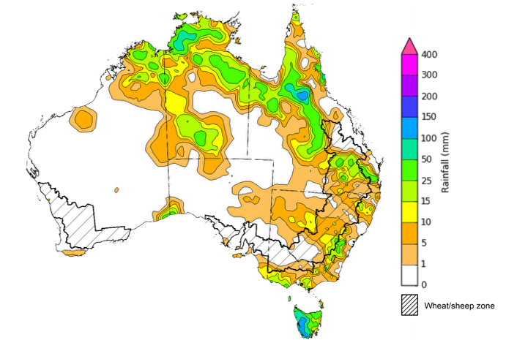

©Commonwealth of Australia 2025, Australian Bureau of Meteorology Issued: 15/10/2025

Note: The rainfall analyses and associated maps utilise data contained in the Bureau of Meteorology climate database, the Australian Data Archive for Meteorology (ADAM). The analyses are initially produced automatically from real-time data with limited [quality control](http://www.bom.gov.au/climate/headers/qc.shtml). They are intended to provide a general overview of rainfall across Australia as quickly as possible after the observations are received. For further information go to <http://www.bom.gov.au/climate/rainfall/>

### Rainfall forecast for the next eight days

Over the 8 days to 23 October 2025, cold fronts and low-pressure systems are expected to bring rainfall to various coastal areas of southern and northwestern Australia, while much of central and northeast Australia is forecast to see very limited rainfall.

Some rainfall is expected across southern cropping regions this week, while those in Queensland and northern parts of Western Australia are likely to see very limited rainfall.

* Falls of between 5-50 millimetres are forecast in cropping regions in New South Wales, with Victoria and southern Western Australia forecast to see 5-15 millimetres in most areas, and South Australia expected to see 10-25 millimetres.
  + If realised these falls are likely to supply some much need moisture for crop and pasture growth, but may arrived too late to prevent declines in expected crop yields in some areas.
* Northern cropping areas of Queensland and Western Australia are forecast to receive little to no rainfall over the period.

#### Total forecast rainfall for the period 16 October to 23 October 2025

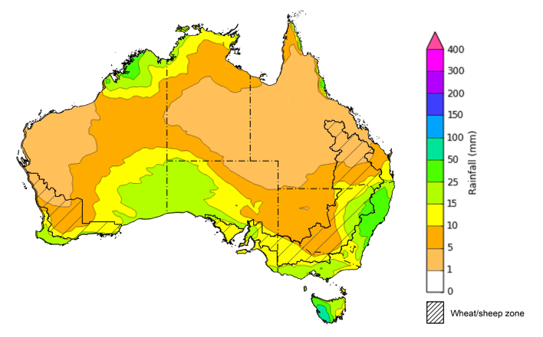

©Commonwealth of Australia 2025, Australian Bureau of Meteorology Issued 16/10/2025

Note: This rainfall forecast is produced from computer models. As the model outputs are not altered by weather forecasters, it is important to check local forecasts and warnings issued by the Bureau of Meteorology.

### 

### September precipitation percentiles and current production conditions

Crop production is affected by long-term trends in average rainfall and temperature, interannual climate variability, shocks during specific growth stages, and extreme weather events. Some crops are more tolerant than others to certain types of stresses, and at each growth stage, different types of stresses affect crop species in different ways.

Precipitation anomalies and outlooks presented below indicate the current and expected future production conditions for major grain and oilseed producing countries (responsible for over 80% of global crop production). This is an important input to assessing the global grain supply outlook.

Precipitation (rainfall) in September 2025 was variable across the world’s major grain- and oilseed-producing regions:

* In the **southern hemisphere**, precipitation was above average across northern and central Argentina, and much of Southeast Asia, including Thailand, Malaysia and Indonesia. Below average precipitation occurred in much of central Brazil. Precipitation was generally average across the remaining major southern hemisphere grain- and oilseed-producing regions.
* In the **northern hemisphere**, precipitation was below average across scattered eastern areas of the United States, parts of southeastern Europe, and western areas of the Russian Federation. Precipitation was above average across parts of the southwest United States, central and northern Europe, east of the Black Sea Region, western and central China, and parts of western India. Precipitation was generally average across remaining major northern hemisphere grain- and oilseed-producing regions.

**Global precipitation percentiles, September 2025**

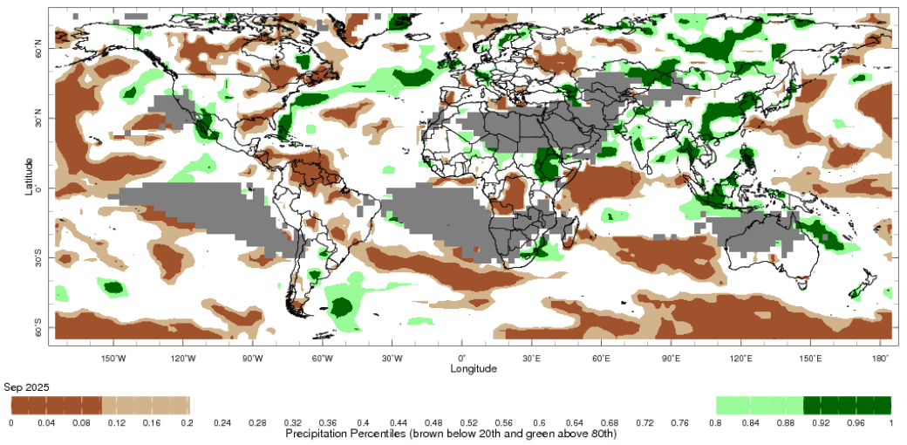

Note: The world precipitation percentiles indicate a ranking of precipitation for September, with the driest (0th percentile) being 0 on the scale and the wettest (100th percentile) being 1 on the scale. Percentiles are based on precipitation estimates from the NOAA Climate Prediction Center’s [Climate Anomaly Monitoring System Outgoing Precipitation Index](https://iridl.ldeo.columbia.edu/maproom/Global/Precipitation/Percentiles.html) dataset. Precipitation estimates for September are compared with rainfall recorded for that period during the 1981 to 2010 base period.

Source: International Research Institute for Climate and Society

As of 28 September 2025, global production conditions were generally favourable for maize, rice, and soybeans, but more variable for wheat:

* **Wheat –** In the **northern hemisphere**, the spring wheat harvest is concluding under largely favourable conditions. Seasonal conditions have supported above average yields in parts of the US and the Russian Federation. Sowing of winter wheat for harvest in 2026–27 is underway amid dry conditions across parts of the US, Ukraine and the Russian Federation, but remains broadly positive.In the **southern hemisphere**, crop development is continuing under broadly favourable conditions.
* **Maize** **–** In the **southern hemisphere**, the harvest is ending in Brazil under exceptional conditions while sowing for spring crops is beginning. In the **northern hemisphere**, harvesting is ongoing under favourable conditions in the United States, Canada, China, India and much of the European Union. However, drought and repeated heatwaves in south-eastern Europe have led to yield losses in Bulgaria, Hungary, and Romania, as well as in southern and eastern regions of Ukraine and the south the Russian Federation.
* **Rice –** Global conditions are broadly favourable for major rice production regions.
* **Soybeans –** In the **northern hemisphere**, crop harvest is ongoing with generally favourable conditions across most major growing regions. However, drought conditions in south-eastern Europe, southern regions of Ukraine and the south of the Russian Federation have led to yield losses. In the **southern hemisphere**, sowing is beginning in Brazil.

**Crop conditions, AMIS countries, 28 September 2025**

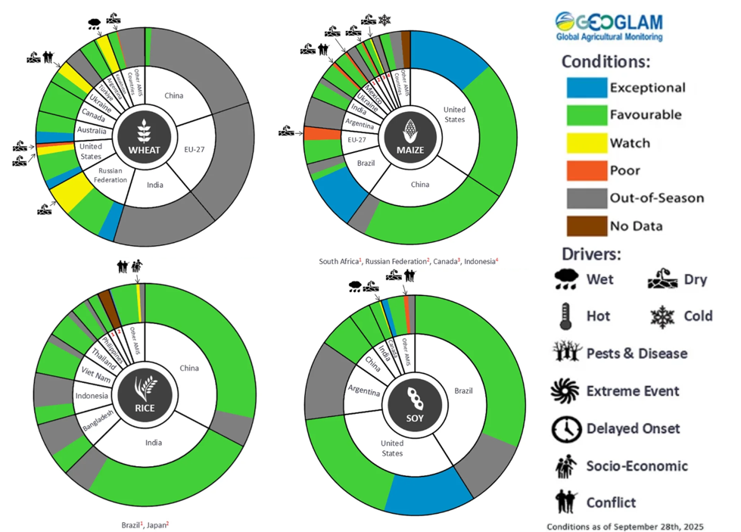

**AMIS** Agricultural Market Information System.

Source: AMIS

The global climate outlook for November 2025 to January 2026 indicates that mixed rainfall conditions are expected for the world’s major grain-producing and oilseed-producing regions. Outlooks and potential production impacts for major grain- and oilseed-producing countries are presented in the following table.

**Rainfall outlook and potential impact on the future state of production conditions, November-January 2025**

|  |  |  |
| --- | --- | --- |
| **Region** | **Rainfall outlook** | **Potential impact on production** |
| **Argentina** | Below average rainfall is likely across parts of northern and central Argentina. | Below average rainfall is likely to adversely affect the silking, flowering and grain filling of corn, as well as the flowering of cotton, ground nuts, soybeans and sunflowers. |
| **Black Sea Region** | Below average rainfall is expected across Türkiye and parts of the south of the Russian Federation, while Ukraine is likely to see above average falls. | In November and December winter wheat and canola will enter dormancy, and above average rainfall in Ukraine is likely to provide sufficient snowpack to prevent winterkill. Below average rainfall in remaining regions may adversely affect crop outcomes. |
| **Brazil** | Rainfall outcomes across Brazil are expected to be below average in the south of the country, with central and northern regions likely to see average to above average rainfall. | Above average rainfall in parts of northern Brazil is likely to support crop development over the coming months. Meanwhile, below average rainfall in southern areas is likely to impact flowering of corn, cotton, groundnuts and soybeans, as well as the grain filling of corn in January. |
| **Canada** | Rainfall across Canada is expected to be average to above average in central regions, with isolated areas of below average rainfall. | Average rainfall may favour harvesting and reduce grain quality concerns for canola, corn, soybean, spring wheat and sunflower. Average rainfall is also likely to provide sufficient snowpack to prevent winterkill of winter wheat in December. |
| **China** | Below average rainfall is expected throughout much of eastern and western China, with scattered central regions are likely to see above average falls. | Anticipated rainfall is likely to support the harvesting of major crops over the period but may reduce the level of snowpack during crop dormancy. |
| **European Union** | Average rainfall is more likely for much of the central European Union, with parts of western Europe including Spain likely to see below average rainfall. | Average rainfall across much of the European Union is likely to support the harvesting of corn, soybean, sunflower, sorghum and cotton, as well as the planting of winter crops for harvest in 2026–27. |
| **South Asia (India)** | Below average rainfall is expected across much of eastern India, while above average rainfall is expected in the south. | Anticipated rainfall is likely to support the harvesting and planting of crops in many areas, but could adversely affect cotton in the south. |
| **Southeast Asia (SEA)** | Above average rainfall is likely across much of SEA. | Above average rainfall in SEA is likely to benefit the growth and development of dry-season rice throughout November to January. |
| **The United States** | Below average rainfall is likely for much of southern and eastern United States, with average rainfall more likely across the north. | Below average rainfall across southern areas of the US is likely to support harvesting corn, sorghum and soybean crops in November. Average rainfall conditions expected across the northern US is likely to provide sufficient snow cover through December and January to protect winter wheat and canola through dormancy. |

https://www.agriculture.gov.au/abares/products/weekly_update/weekly-update-140825

## **Commodities**

|  |  |  |  |  |  |  |  |  |
| --- | --- | --- | --- | --- | --- | --- | --- | --- |
| **Indicator** | **Week average** | **Unit** | **Latest Price** | **Previous Week** | **Weekly change** | | **Price 12 months ago** | **Annual change** |
| **Selected world indicator prices** |  |  |  |  |  |  | |  |
| AUD/USD Exchange rate | 15-Oct | A$/US$ | 0.65 | 0.66 | -1% | 0.67 | | -3% |
| Wheat – US no. 2 hard red winter wheat, FOB Gulf | 15-Oct | US$/t | 226 | 228 | -1% | 271 | | -17% |
| Corn – US no. 2 yellow corn, FOB Gulf | 15-Oct | US$/t | 194 | 197 | -1% | 190 | | 2% |
| Canola – Rapeseed, Canada, FOB Vancouver | 15-Oct | US$/t | 462 | 468 | -1% | 489 | | -5% |
| Cotton – Cotlook A Index | 15-Oct | USc/lb | 75.0 | 76.4 | -2% | 83.6 | | -10% |
| Sugar – Intercontinental Exchange, nearby futures, no.11 contract | 15-Oct | USc/lb | 15.7 | 16.4 | -4% | 22.3 | | -29% |
| Wool – Eastern Market Indicator | 8-Oct | Ac/kg clean | 1,517 | 1,565 | -3% | 1,127 | | 35% |
| Wool – Western Market Indicator | 24-Sep | Ac/kg clean | 1,577 | 1,480 | 7% | 1,261 | | 25% |
| **Selected Australian grain export prices** |  |  |  |  |  |  | |  |
| Australian Premium White (APW) Wheat, FOB Port Adelaide, SA | 15-Oct | A$/t | 373 | 373 | 0% | 390 | | -4% |
| Australian Standard White (ASW) Wheat, FOB Port Adelaide, SA | 15-Oct | A$/t | 369 | 369 | 0% | 379 | | -3% |
| Feed Barley – FOB Port Adelaide, SA | 15-Oct | A$/t | 348 | 348 | 0% | 350 | | -1% |
| Canola – FOB Kwinana, WA | 15-Oct | A$/t | 791 | 797 | -1% | 790 | | 0% |
| Grain Sorghum – FOB Brisbane, QLD | 15-Oct | A$/t | 405 | 405 | 0% | 388 | | 4% |
| **Selected domestic livestock indicator prices** |  |  |  |  |  |  | |  |
| Beef – Eastern Young Cattle Indicator | 15-Oct | Ac/kg cwt | 839 | 850 | -1% | 630 | | 33% |
| Mutton – Mutton indicator (18–24 kg fat score 2–3), VIC | 15-Oct | Ac/kg cwt | 741 | 796 | -7% | 288 | | 158% |
| Lamb – National Trade Lamb Indicator | 15-Oct | Ac/kg cwt | 1,114 | 1,149 | -3% | 798 | | 40% |
| Pig – Eastern Seaboard (60.1–75 kg), NSW buyer price | 1-Oct | Ac/kg cwt | 461 | 461 | 0% | 432 | | 7% |
| Live cattle – Light steers to Indonesia | 15-Oct | Ac/kg lwt | 450 | 430 | 5% | 319 | | 41% |
| **Global Dairy Trade (GDT) weighted average prices** |  |  |  |  |  |  | |  |
| Dairy – Whole milk powder | 8-Oct | US$/t | 3,696 | 3,790 | -2% | 3,556 | | 4% |
| Dairy – Skim milk powder | 8-Oct | US$/t | 2,599 | 2,615 | -1% | 2,770 | | -6% |
| Dairy – Cheddar cheese | 8-Oct | US$/t | 4,858 | 4,814 | 1% | 4,654 | | 4% |
| Dairy – Anhydrous milk fat | 8-Oct | US$/t | 6,916 | 6,802 | 2% | 7,221 | | -4% |
|  | | | | | | | | |

### Selected world indicator prices

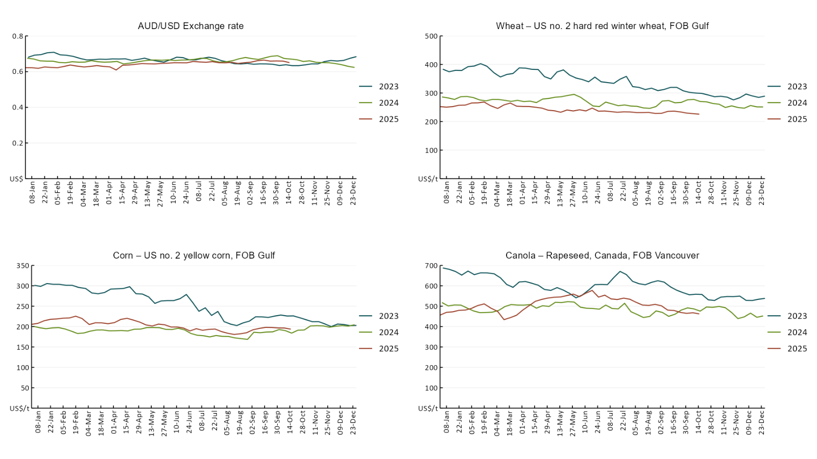

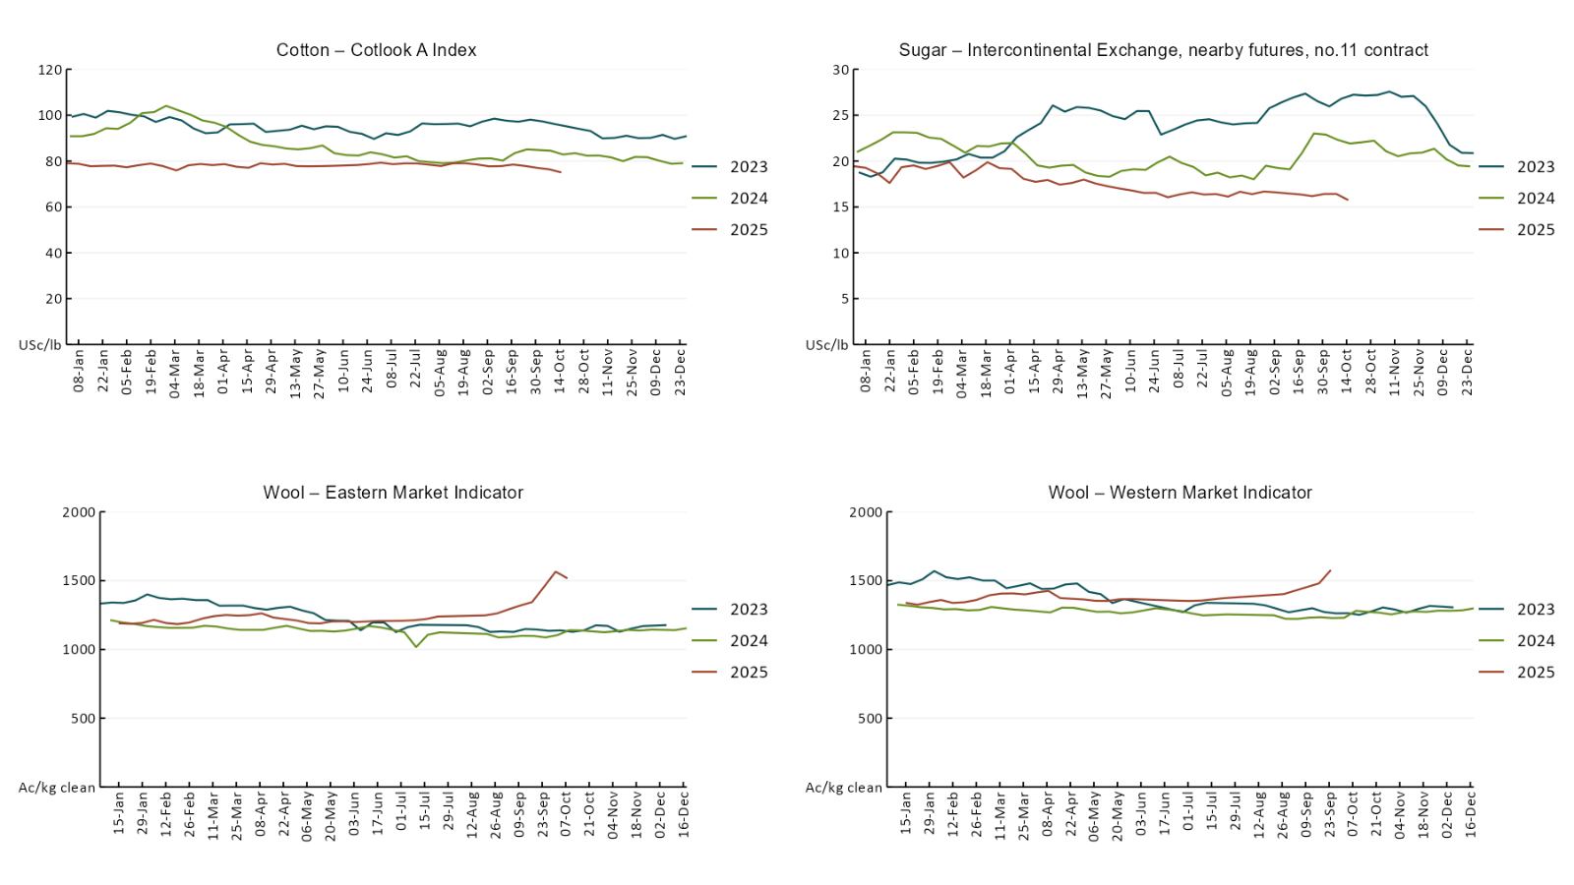

### 3.2 Selected domestic crop indicator prices

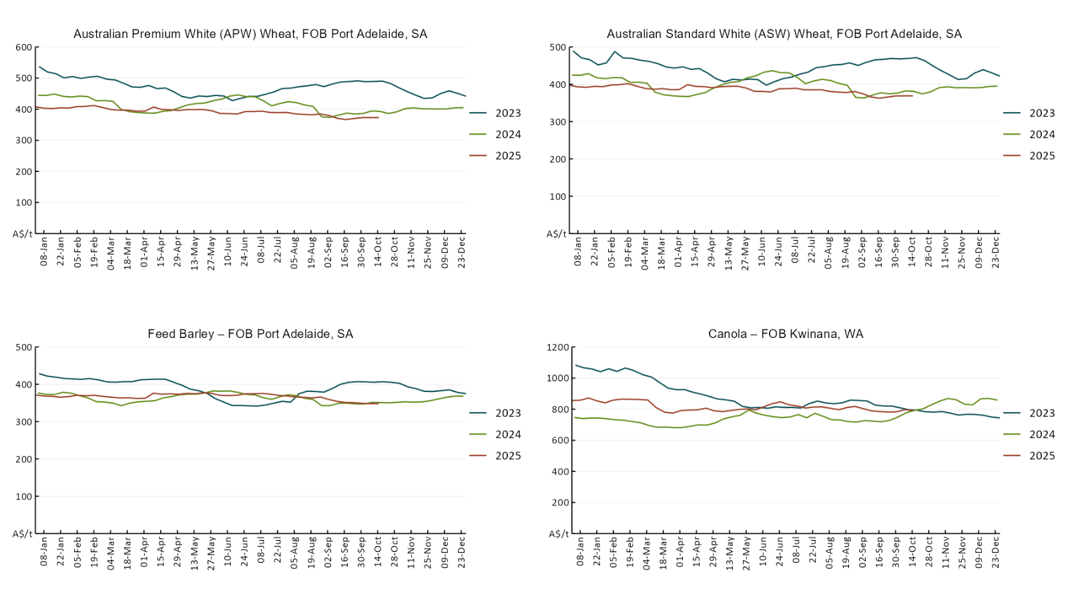

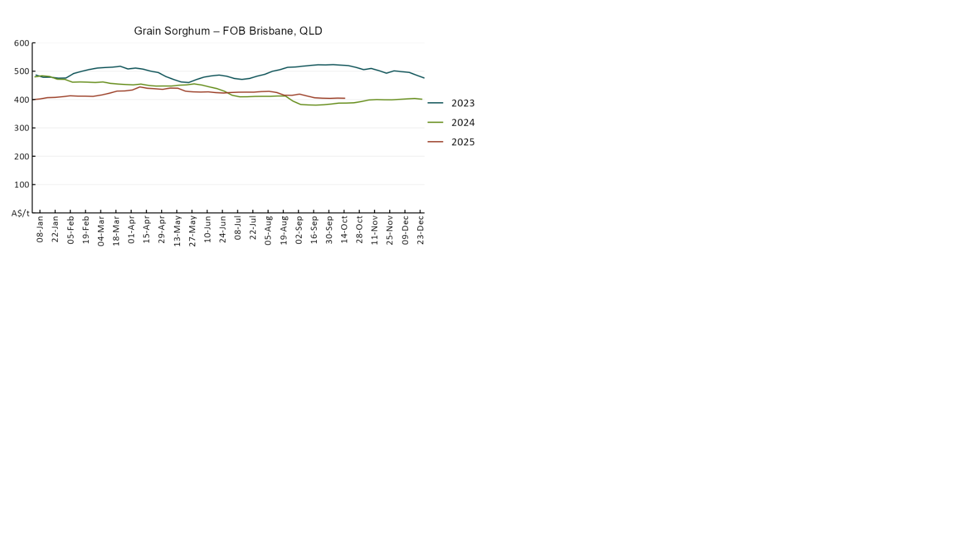

### 3.3 Selected domestic livestock indicator prices

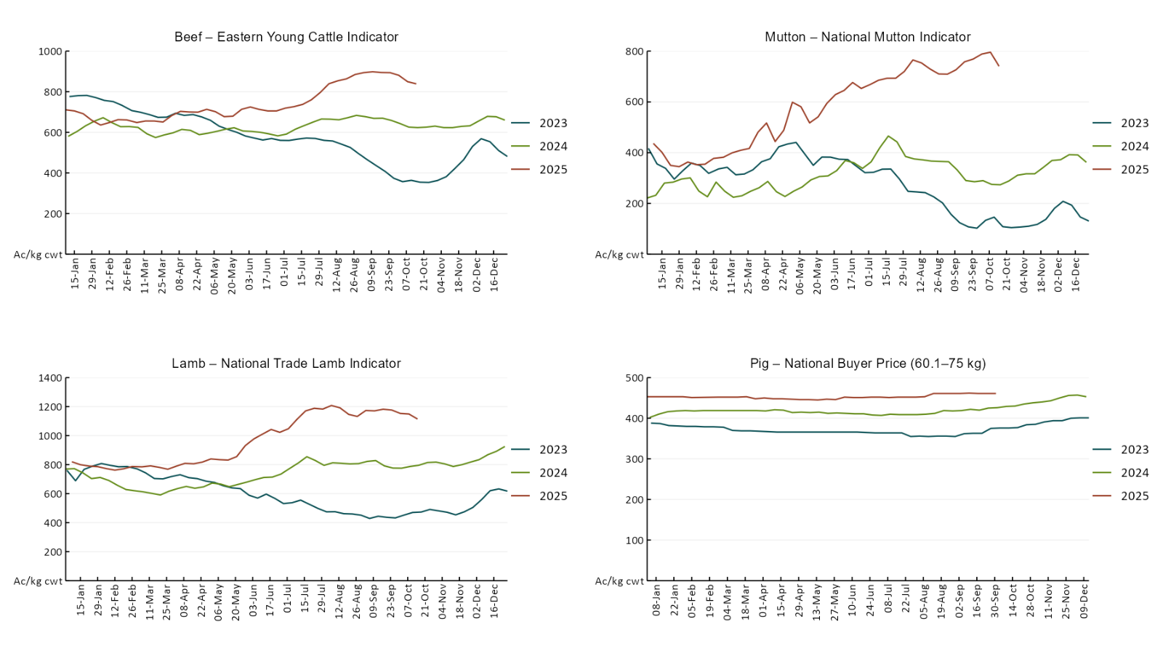

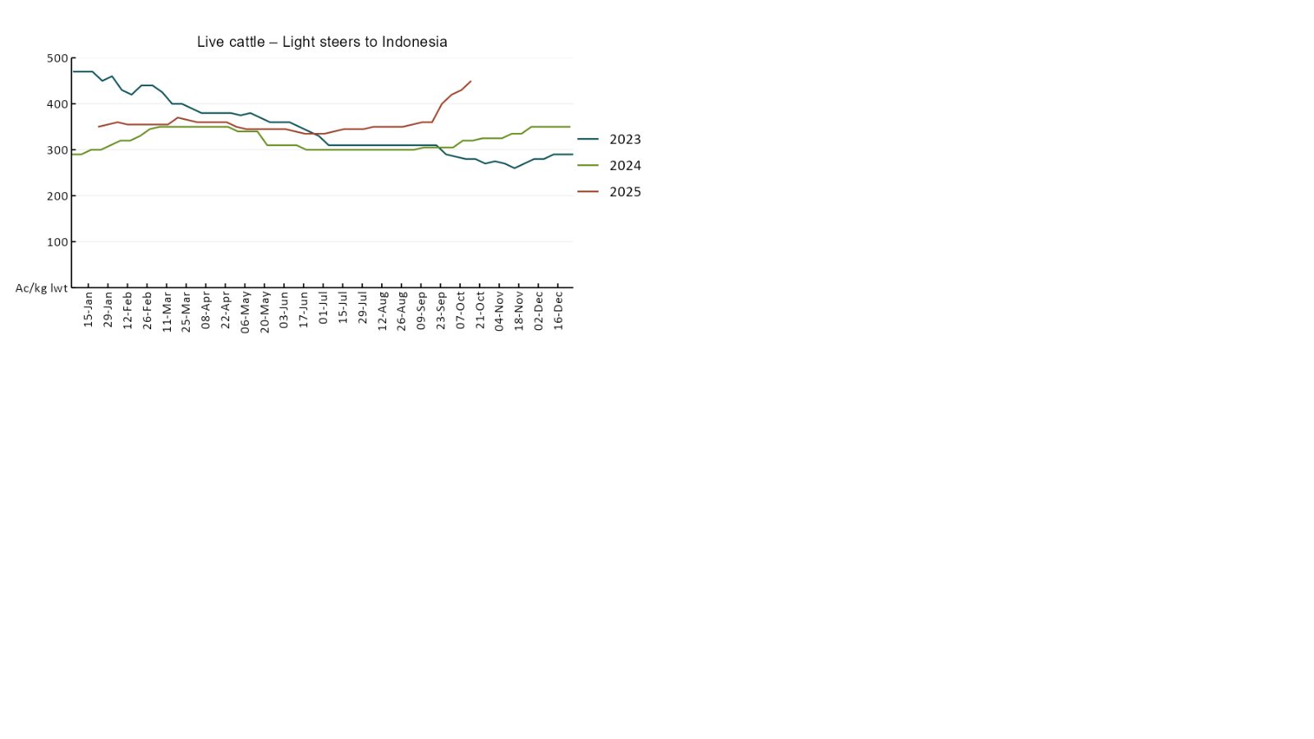

### 3.4 Global Dairy Trade (GDT) weighted average pricesA line chart of Global Dairy Trade prices. For more information, refer to https://www.agriculture.gov.au/abares/data/weekly-commodity-price-update/world-agricultural-prices

### 3.5 Selected fruit and vegetable prices

### A line chart of fruit and vegetable prices. For more information, refer to https://www.agriculture.gov.au/abares/data/weekly-commodity-price-update/world-agricultural-prices

### A line chart of fruit and vegetable prices. For more information, refer to https://www.agriculture.gov.au/abares/data/weekly-commodity-price-update/world-agricultural-prices

### 3.6 Selected domestic fodder indicator prices

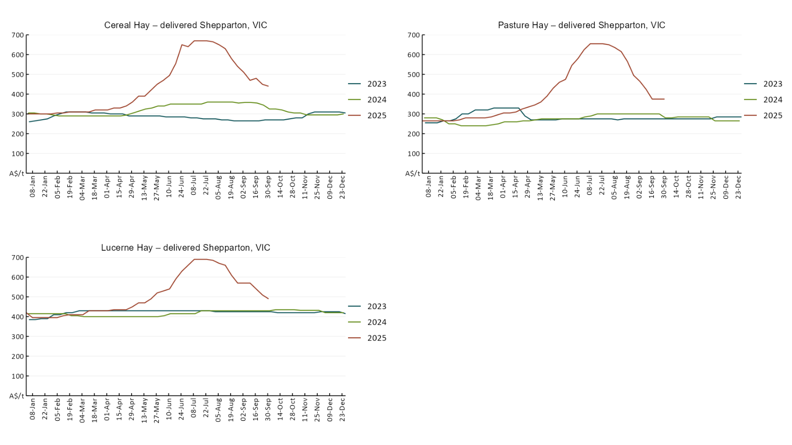

## **4. Data attribution**

### Climate

* Bureau of Meteorology
* Weekly rainfall totals: www.bom.gov.au/climate/maps/rainfall/
* Monthly and last 3-month rainfall percentiles: [www.bom.gov.au/water/landscape/](http://www.bom.gov.au/water/landscape/)
* Temperature anomalies: [www.bom.gov.au/jsp/awap/temp/index.jsp](http://www.bom.gov.au/jsp/awap/temp/index.jsp)
* Rainfall forecast: [www.bom.gov.au/jsp/watl/rainfall/pme.jsp](http://www.bom.gov.au/jsp/watl/rainfall/pme.jsp)
* Seasonal outlook: [www.bom.gov.au/climate/outlooks/#/overview/summary/](http://www.bom.gov.au/climate/outlooks/#/overview/summary/)
* Climate drivers: <http://www.bom.gov.au/climate/enso/>
* Soil moisture: [www.bom.gov.au/water/landscape/](http://www.bom.gov.au/water/landscape/)
* Other
* Pasture growth: [www.longpaddock.qld.gov.au/aussiegrass/](http://www.longpaddock.qld.gov.au/aussiegrass/)
* 3-month global outlooks: [Environment and Climate Change Canada](https://weather.gc.ca/saisons/image_e.html?img=s234pfe1p_cal&bc=prob), [NOAA Climate Prediction Center](https://www.cpc.ncep.noaa.gov/products/predictions/long_range/seasonal.php?lead=2), [EUROBRISA CPTEC/INPE](http://eurobrisa.cptec.inpe.br/), European Centre for Medium-Range Weather Forecasts, [Hydrometcenter of Russia](https://meteoinfo.ru/en/climate/seasonal-forecasts), [National Climate Center Climate System Diagnosis and Prediction Room (NCC)](https://cmdp.ncc-cma.net/pred/cs2gen.php?pred_elem=RAINP#pred_seasonal), [International Research Institute for Climate and Society](https://iri.columbia.edu/our-expertise/climate/forecasts/seasonal-climate-forecasts/)
* Global production: <https://ipad.fas.usda.gov/ogamaps/cropmapsandcalendars.aspx>
* Autumn break: Pook et al., 2009, <https://rmets-onlinelibrary-wiley-com.virtual.anu.edu.au/doi/epdf/10.1002/joc.1833>

### Water

Prices

* Waterflow: <https://www.waterflow.io/>
* Ruralco: <https://www.ruralcowater.com.au/>
* Bureau of Meteorology:
* Allocation trade: <http://www.bom.gov.au/water/dashboards/#/water-markets/mdb/at>
* Storage volumes: <http://www.bom.gov.au/water/dashboards/#/water-storages/summary/drainage>
* Trade constraints:
* Water NSW: <https://www.waternsw.com.au/customer-service/ordering-trading-and-pricing/trading/murrumbidgee>
* Victorian Water Register: <https://www.waterregister.vic.gov.au/TradingRules2019/>

### Commodities

* Fruit and vegetables
* Datafresh: [www.freshstate.com.au](http://www.freshstate.com.au)
* Pigs
* Australian Pork Limited: [www.australianpork.com.au](http://www.australianpork.com.au)
* Dairy
* Global Dairy Trade: [www.globaldairytrade.info/en/product-results/](http://www.globaldairytrade.info/en/product-results/)
* World wheat, canola
* International Grains Council
* World coarse grains
* United States Department of Agriculture
* World cotton
* Cotlook: [www.cotlook.com/](http://www.cotlook.com/)
* World sugar
* New York Stock Exchange - Intercontinental Exchange
* Wool
* Australian Wool Exchange: [www.awex.com.au/](http://www.awex.com.au/)
* Domestic wheat, barley, sorghum, canola and fodder
* Jumbuk Consulting Pty Ltd: http://www.jumbukag.com.au/
* Cattle, beef, mutton, lamb, goat and live export
* Meat and Livestock Australia: [www.mla.com.au/Prices-and-market](http://www.mla.com.au/Prices-and-market)

© Commonwealth of Australia 2025

### Ownership of intellectual property rights

Unless otherwise noted, copyright (and any other intellectual property rights, if any) in this publication is owned by the Commonwealth of Australia (referred to as the Commonwealth).

### Creative Commons licence

All material in this publication is licensed under a [Creative Commons Attribution 4.0 International Licence](https://creativecommons.org/licenses/by/4.0/legalcode) except content supplied by third parties, logos and the Commonwealth Coat of Arms.

Inquiries about the licence and any use of this document should be emailed to [copyright@awe.gov.au](mailto:copyright@awe.gov.au).

https://www.agriculture.gov.au/sites/default/files/images/creative-commons-logo-small.png

### Cataloguing data

This publication (and any material sourced from it) should be attributed as:

ABARES 2025, Weekly Australian Climate, Water and Agricultural Update, Australian Bureau of Agricultural and Resource Economics and Sciences, Canberra, 16 October 2025. CC BY 4.0 DOI: <https://doi.org/10.25814/5f3e04e7d2503>

ISSN **2652-7561**

This publication is available at https://www.agriculture.gov.au/abares/products/weekly_update

Department of Agriculture, Fisheries and Forestry

GPO Box 858 Canberra ACT 2601

Telephone 1800 900 090

Web [agriculture.gov.au/abares](http://awe.gov.au/abares)

### Disclaimer

The Australian Government acting through the Department of Agriculture, Fisheries and Forestry, represented by the Australian Bureau of Agricultural and Resource Economics and Sciences, has exercised due care and skill in preparing and compiling the information and data in this publication. Notwithstanding, the Department of Agriculture, Fisheries and Forestry, ABARES, its employees and advisers disclaim all liability, including liability for negligence and for any loss, damage, injury, expense or cost incurred by any person as a result of accessing, using or relying on any of the information or data in this publication to the maximum extent permitted by law.

### Statement of Professional Independence

The views and analysis presented in ABARES publications, including this one, reflect ABARES professionally independent findings, based on scientific and economic concepts, principles, information and data. These views, analysis and findings may not reflect or be consistent with the views or positions of the Australian Government, or of organisations or groups who have commissioned ABARES reports or analysis. More information on [professional independence](https://www.agriculture.gov.au/abares/about/research-and-analysis#professional-independence) is provided on the ABARES website.

### Acknowledgements

This report was prepared by Holly Beale and Matt Miller.