## No. 42/2025 23 October 2025

# Summary of key issues

* In the week ending 22 October 2025, cold fronts and low-pressure troughs brought rainfall to parts of northern, eastern and southern Australia.
  + Rainfall was highly variable across winter cropping regions, while parts of Queensland, northern New South Wales, Victoria and South Australia saw up to 50 millimetres.
  + Ongoing dry conditions across northern Victoria and southern New South Wales continue to present an increased downside production risk for pastures and winter crops which are in their final yield-determining growth stages.
  + Falls across Queensland and northern New South Wales may have resulted in some winter crop harvesting delays but would have provided a timely boost in soil moisture for the planting and establishment of summer crops. Rainfall across South Australia and western Victoria is likely to have provided a boost in soil moisture levels, benefiting some winter crops and pastures.
* Over the coming eight days to 30 October 2025, some rainfall is expected across most cropping regions. However, cropping regions in south-western Queensland, north-western New South Wales and much of Western Australia are forecast to receive little to no rainfall over the period.
  + If realised, falls in southern cropping regions would provide some much-needed moisture for crop and pasture growth but may be too late to prevent declines in expected crop yields in some areas.
* The national rainfall outlook for November 2025 to January 2026 indicates an increased probability of above median rainfall across much of eastern Australia.
  + If realised, above median rainfall would support late spring and summer pasture growth across eastern Australia. Additionally, these expected above average falls are likely to be sufficient to support above average yield expectations for summer crops.
* Water storage levels in the Murray-Darling Basin (MDB) decreased by 158 gigalitres (GL) between 16 October 2025 and 23 October 2025. The current volume of water held in storages is 15,104 GL, equivalent to 68% of total storage capacity. This is 12% or 2,062 GL less than the same time last year. Water storage data is sourced from the Bureau of Meteorology.
* Allocation prices in the Victorian Murray below the Barmah Choke decreased from $319/ML on 16 October 2025 to $316/ML on 23 October 2025. Trade from the Goulburn to the Murray is closed. Trade downstream through the Barmah Choke is closed. Trade from the Murrumbidgee to the Murray is open.

## **Climate**

### Rainfall this week

In the week ending 22 October 2025, low-pressure troughs brought rainfall to northern Australia, including parts of southern Queensland, scattered areas of the Northern Territory, and parts of northern Western Australia. In the south, cold fronts brought rainfall to Tasmania and parts of New South Wales, Victoria, South Australia and the far southwest of Western Australia.

Rainfall was highly variable across winter cropping regions for the week ending 22 October 2025.

* Most cropping regions in Western Australia, northern and eastern Queensland, southern New South Wales and northern Victoria recorded little to no rainfall over the period.
  + Little to no rainfall in Western Australia is unlikely to adversely impact crop production outcomes following average to above average rainfall in previous months.
  + Ongoing dry conditions across northern Victoria and southern New South Wales continue to present an increased downside production risk for pastures and winter crops which are in their final yield-determining growth stages.
* Cropping regions in South Australia, western Victoria and western Queensland recorded 5- 25 millimetres, while northern New South Wales cropping regions observed 1- 15 millimetres of rainfall over the period.
  + The rainfall recorded across cropping regions in western Queensland and northern New South Wales is likely to have resulted in some winter crop harvest delays but would have provided a timely boost in soil moisture for the planting and establishment of summer crops. The falls across cropping regions of South Australia and western Victoria are likely to have arrested some of the recent decline in soil moisture levels and benefitted some winter crops and pastures which are in their critical final yield determining growth stages.

#### Rainfall for the week ending 22 October 2025

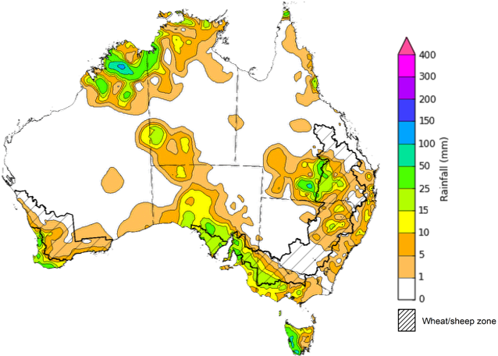

©Commonwealth of Australia 2025, Australian Bureau of Meteorology Issued: 22/10/2025

Note: The rainfall analyses and associated maps utilise data contained in the Bureau of Meteorology climate database, the Australian Data Archive for Meteorology (ADAM). The analyses are initially produced automatically from real-time data with limited [quality control](http://www.bom.gov.au/climate/headers/qc.shtml). They are intended to provide a general overview of rainfall across Australia as quickly as possible after the observations are received. For further information go to <http://www.bom.gov.au/climate/rainfall/>

### Rainfall forecast for the next eight days

Over the 8 days to 30 October 2025, frontal systems and a low-pressure trough are expected to bring rainfall to large areas of south-eastern and north-eastern Australia, while much of Western Australia and inland areas of New South Wales, Queensland and the Northern Territory are forecast to see very limited rainfall.

Some rainfall is expected across most cropping regions this week, while those in south-western Queensland, north-western New South Wales and much of Western Australia are likely to see very limited rainfall.

* Falls of between 5-50 millimetres are forecast in most cropping regions in New South Wales and Queensland, with Victorian and South Australian cropping regions forecast to see 10- 25 millimetres, while southern Westen Australian regions are expected to see 5- 15 millimetres.
  + If realised these falls are likely to supply some much-needed moisture for crop and pasture growth, but may arrive too late to prevent declines in expected winter crop yields in some areas of Victoria, South Australia and southern New South Wales.

#### Total forecast rainfall for the period 23 October to 30 October 2025

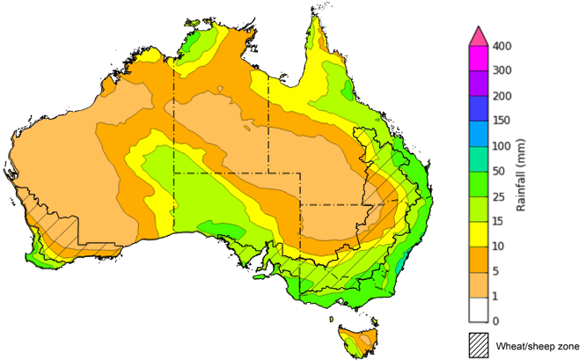

©Commonwealth of Australia 2025, Australian Bureau of Meteorology Issued 23/10/2025

Note: This rainfall forecast is produced from computer models. As the model outputs are not altered by weather forecasters, it is important to check local forecasts and warnings issued by the Bureau of Meteorology.

### National Climate Outlook

The El Niño Southern Oscillation (ENSO) and Southern Annular Mode (SAM) are currently neutral and having minimal influence on Australian rainfall. However, the Indian Ocean Dipole (IOD) Index is currently under negative conditions. A negative IOD typically results in above-average spring rainfall over parts of southern Australia.

The most recent **rainfall outlook for November 2025** provided by the Bureau of Meteorology indicates that much of **eastern and central Australia** is likely to see **above median rainfall,** with much of **Western** **Australia** and Tasmania more likely to see closer to **average** falls**.**

* The Bureau of Meteorology’s climate model indicates a 75% chance of November rainfall totals between 10-100 millimetres across much of eastern and northern Australia, with higher rainfall totals of up to 200 millimetres expected in the north of the Northern Territory and alpine regions of New South Wales and Victoria. Most western and central regions are likely to see falls of between 1-25 millimetres, including southern Western Australia and South Australia.
* Across cropping regions, there is a 75% chance of rainfall totals of between 10-100 millimetres across eastern cropping regions, including Queensland and New South Wales. Much of South Australia and Victoria are likely to see 10-25 millimetres, while Western Australian cropping regions are likely to see 1-25 millimetres.
  + If realised, these relatively low expected rainfall totals across much of south-eastern Australia represent a downside production risk for both winter crop production and pasture growth, particularly given the lack of rainfall in recent weeks and declining soil moisture levels across large areas. However, if forecast rainfall totals are realised across much of northern New South Wales and Queensland, these falls are likely to be sufficient to support above average yield prospects for summer crops and average or better levels of pasture production.

**Rainfall totals that have a 75% chance of occurring in November 2025**

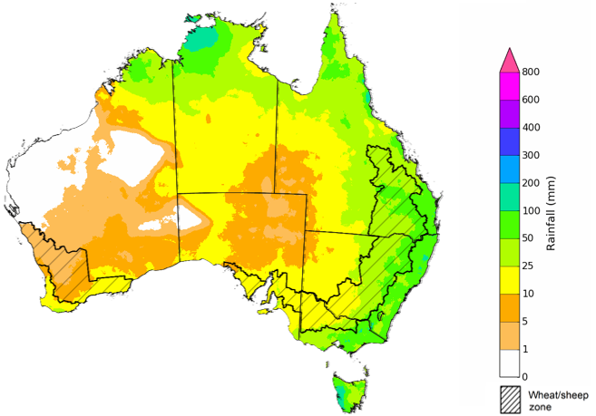

©Commonwealth of Australia 2025, Australian Bureau of Meteorology Issued:23/10/2025

The **rainfall outlook for November 2025 to January 2026** indicates an increased probability of **above median rainfall across large areas of eastern Australia,** including much of Queensland, New South Wales and Victoria. Large areas of Western Australia and western Tasmania are more likely to see below median rainfall, while remaining areas have an equal probability of above or below average rainfall

Across cropping regions, the chance of receiving above median rainfall is 55-70% across Queensland and New South Wales, while Victoria has a 50-70% chance and South Australia has a 45-55% chance. In Western Australia, the probability of above median rainfall is lower at 35-55%. If above median rainfall is realised across eastern Australia, this rainfall is likely to support soil moisture levels in eastern regions for late spring and summer crop and pasture growth.

**Chance of exceeding the median rainfall November 2025 to January 2026**

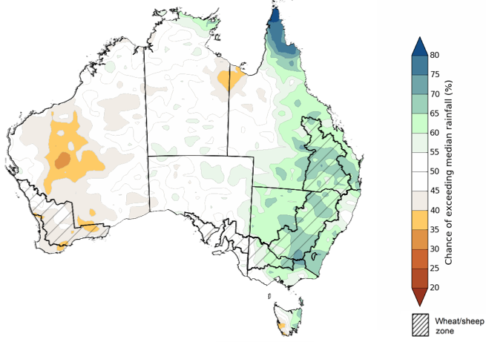

©Commonwealth of Australia 2025, Australian Bureau of Meteorology Issued: 23/10/2025

The **rainfall outlook for November 2025 to January 2026** suggests a 75% chance of receiving rainfall totals of between 50-400 millimetres across much of eastern and northern Australia. Between 400-800 millimetres are expected across scattered east coast regions as well as parts of the northern tropics. Lower rainfall totals are forecast for south-western and central regions, with South Australia and southern Western Australia likely to see 10- 100 millimetres.

In **cropping regions**, there is a **75% chance** of receiving between**100-300 millimetres** across **much of Queensland and northern New South Wales**. **Southern New South Wales** is likely to see **50- 200 millimetres.** In **Western Australia**, falls of **10-50 millimetres** are expected, with **Victoria** and **South Australia** likely to see **25-100 millimetres**.

Given the winter crop harvest will be well underway across several regions, November through to January rainfall will have little influence on winter crop production prospects, other than its influence on harvest progress. Meanwhile, if the forecast November through to January rainfall totals are realised, they are likely to be sufficient to support late spring and summer pasture growth across eastern and northern Australia. Additionally, these expected falls are likely to be sufficient to support above average yield expectations for summer crops.

**Rainfall totals that have a 75% chance of occurring November 2025 to January 2026**

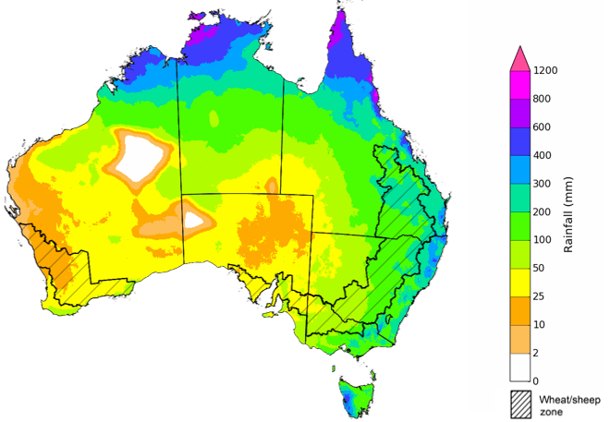

©Commonwealth of Australia 2025, Australian Bureau of Meteorology Issued: 23/10/2025

### Water markets – current week

#### Water storage levels in the Murray-Darling Basin (MDB) decreased by 158 gigalitres (GL) between 16 October 2025 and 23 October 2025. The current volume of water held in storages is 15,104 GL, equivalent to 68% of total storage capacity. This is 12% or 2,062 GL less than the same time last year. Water storage data is sourced from the Bureau of Meteorology.

#### Water storages in the Murray-Darling Basin, 2013–2025

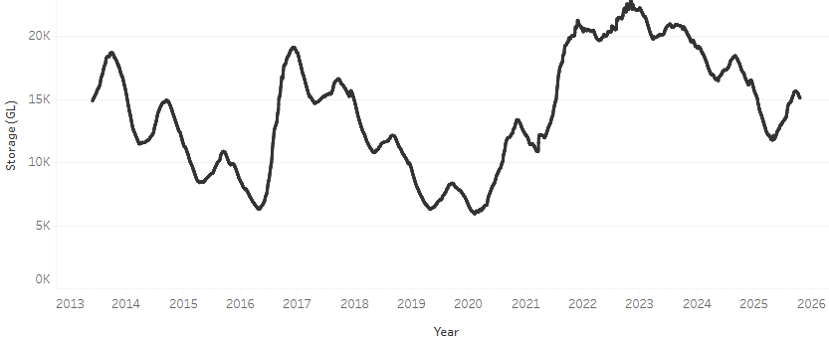

Allocation prices in the Victorian Murray below the Barmah Choke decreased from $319/ML on 16 October 2025 to $316/ML on 23 October 2025. Trade from the Goulburn to the Murray is closed. Trade downstream through the Barmah Choke is closed. Trade from the Murrumbidgee to the Murray is open.

#### Water market prices, Southern Murray–Darling Basin

|  |  |
| --- | --- |
| Region | $/ML |
| NSW Murray Above | 264 |
| NSW Murrumbidgee | 292 |
| Vic Greater Goulburn | 303 |
| Vic Murray Below | 316 |

Note: The water allocation prices shown are volume weighted average prices based on the last 10 trades. Price data is sourced from Waterflow and current as at 02 October 2025.

To access the full, interactive, weekly water dashboard, which contains the latest and historical water storage, water market and water allocation information, please visit <https://www.agriculture.gov.au/abares/products/weekly_update/weekly-update-231025>

## **Commodities**

|  |  |  |  |  |  |  |  |  |
| --- | --- | --- | --- | --- | --- | --- | --- | --- |
| **Indicator** | **Week average** | **Unit** | **Latest Price** | **Previous Week** | **Weekly change** | | **Price 12 months ago** | **Annual change** |
| **Selected world indicator prices** |  |  |  |  |  |  | |  |
| AUD/USD Exchange rate | 22-Oct | A$/US$ | 0.65 | 0.65 | 0% | 0.67 | | -3% |
| Wheat – US no. 2 hard red winter wheat, FOB Gulf | 22-Oct | US$/t | 227 | 227 | 0% | 271 | | -16% |
| Corn – US no. 2 yellow corn, FOB Gulf | 22-Oct | US$/t | 197 | 195 | 1% | 190 | | 4% |
| Canola – Rapeseed, Canada, FOB Vancouver | 22-Oct | US$/t | 475 | 470 | 1% | 489 | | -3% |
| Cotton – Cotlook A Index | 22-Oct | USc/lb | 75.7 | 75.1 | 1% | 83.6 | | -9% |
| Sugar – Intercontinental Exchange, nearby futures, no.11 contract | 22-Oct | USc/lb | 15.5 | 15.7 | -1% | 22.3 | | -30% |
| Wool – Eastern Market Indicator | 15-Oct | Ac/kg clean | 1,456 | 1,517 | -4% | 1,127 | | 29% |
| Wool – Western Market Indicator | 15-Oct | Ac/kg clean | 1,588 | 1,656 | -4% | 1,261 | | 26% |
| **Selected Australian grain export prices** |  |  |  |  |  |  | |  |
| Australian Premium White (APW) Wheat, FOB Port Adelaide, SA | 22-Oct | A$/t | 371 | 374 | -1% | 390 | | -5% |
| Australian Standard White (ASW) Wheat, FOB Port Adelaide, SA | 22-Oct | A$/t | 367 | 370 | -1% | 379 | | -3% |
| Feed Barley – FOB Port Adelaide, SA | 22-Oct | A$/t | 350 | 349 | 0% | 350 | | 0% |
| Canola – FOB Kwinana, WA | 22-Oct | A$/t | 788 | 793 | -1% | 790 | | 0% |
| Grain Sorghum – FOB Brisbane, QLD | 22-Oct | A$/t | 405 | 405 | 0% | 388 | | 4% |
| **Selected domestic livestock indicator prices** |  |  |  |  |  |  | |  |
| Beef – Eastern Young Cattle Indicator | 22-Oct | Ac/kg cwt | 833 | 839 | -1% | 630 | | 32% |
| Mutton – Mutton indicator (18–24 kg fat score 2–3), VIC | 22-Oct | Ac/kg cwt | 682 | 725 | -6% | 288 | | 137% |
| Lamb – National Trade Lamb Indicator | 22-Oct | Ac/kg cwt | 1,066 | 1,100 | -3% | 798 | | 34% |
| Pig – Eastern Seaboard (60.1–75 kg), NSW buyer price | 8-Oct | Ac/kg cwt | 461 | 461 | 0% | 432 | | 7% |
| Live cattle – Light steers to Indonesia | 15-Oct | Ac/kg lwt | 450 | 430 | 5% | 319 | | 41% |
| **Global Dairy Trade (GDT) weighted average prices** |  |  |  |  |  |  | |  |
| Dairy – Whole milk powder | 22-Oct | US$/t | 3,610 | 3,696 | -2% | 3,556 | | 2% |
| Dairy – Skim milk powder | 22-Oct | US$/t | 2,559 | 2,599 | -2% | 2,770 | | -8% |
| Dairy – Cheddar cheese | 22-Oct | US$/t | 4,758 | 4,858 | -2% | 4,654 | | 2% |
| Dairy – Anhydrous milk fat | 22-Oct | US$/t | 7,038 | 6,916 | 2% | 7,221 | | -3% |
|  | | | | | | | | |

### Selected world indicator prices

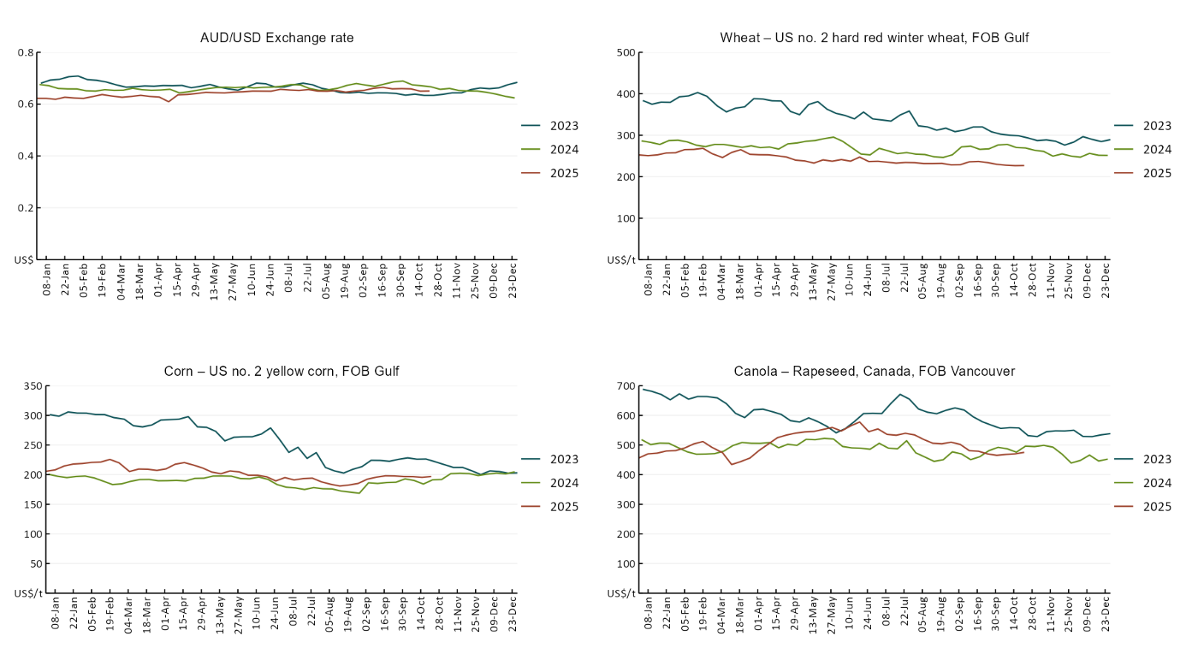

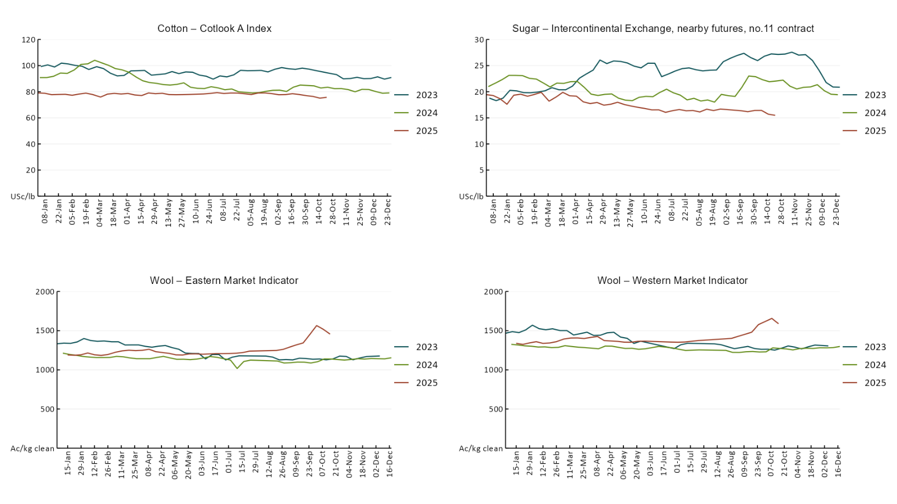

### 3.2 Selected domestic crop indicator prices

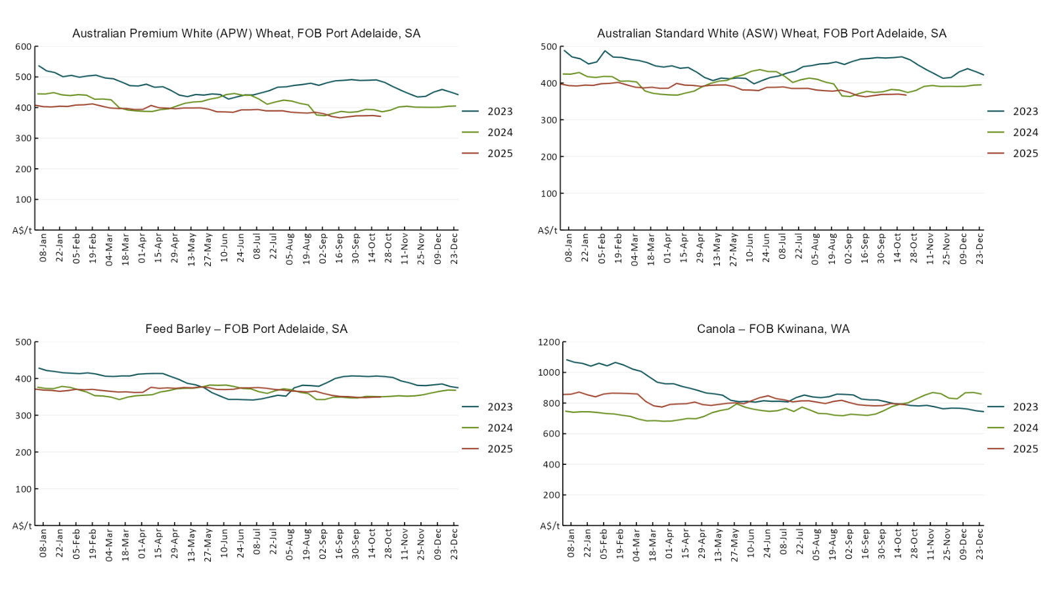

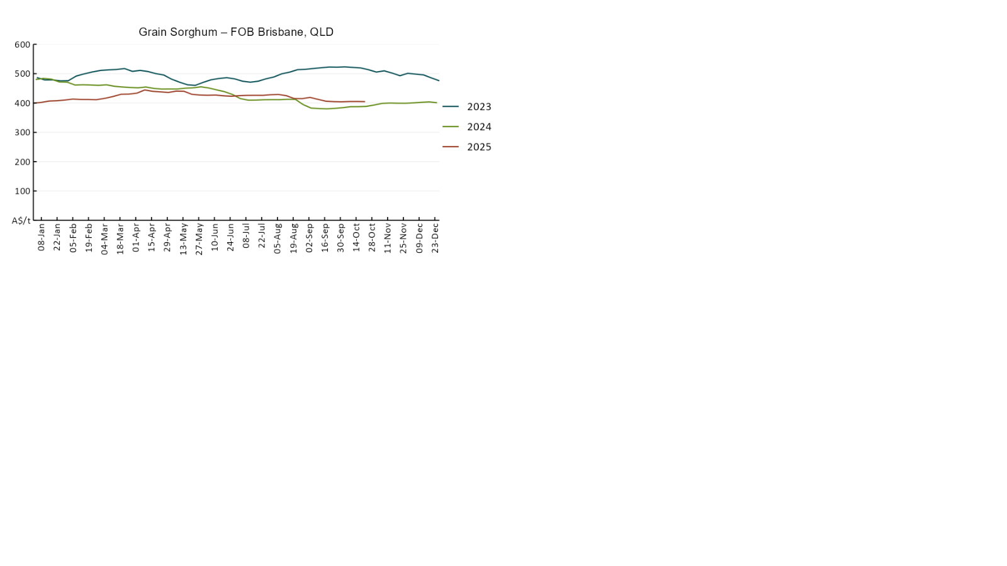

### 3.3 Selected domestic livestock indicator prices

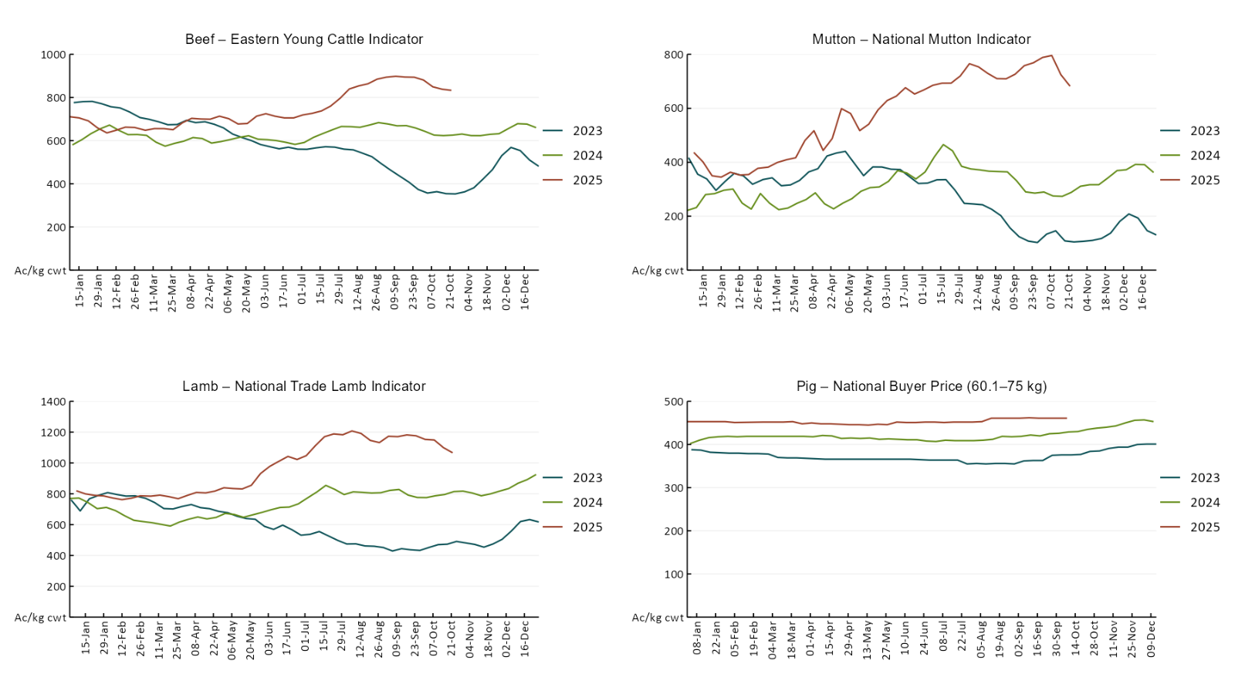

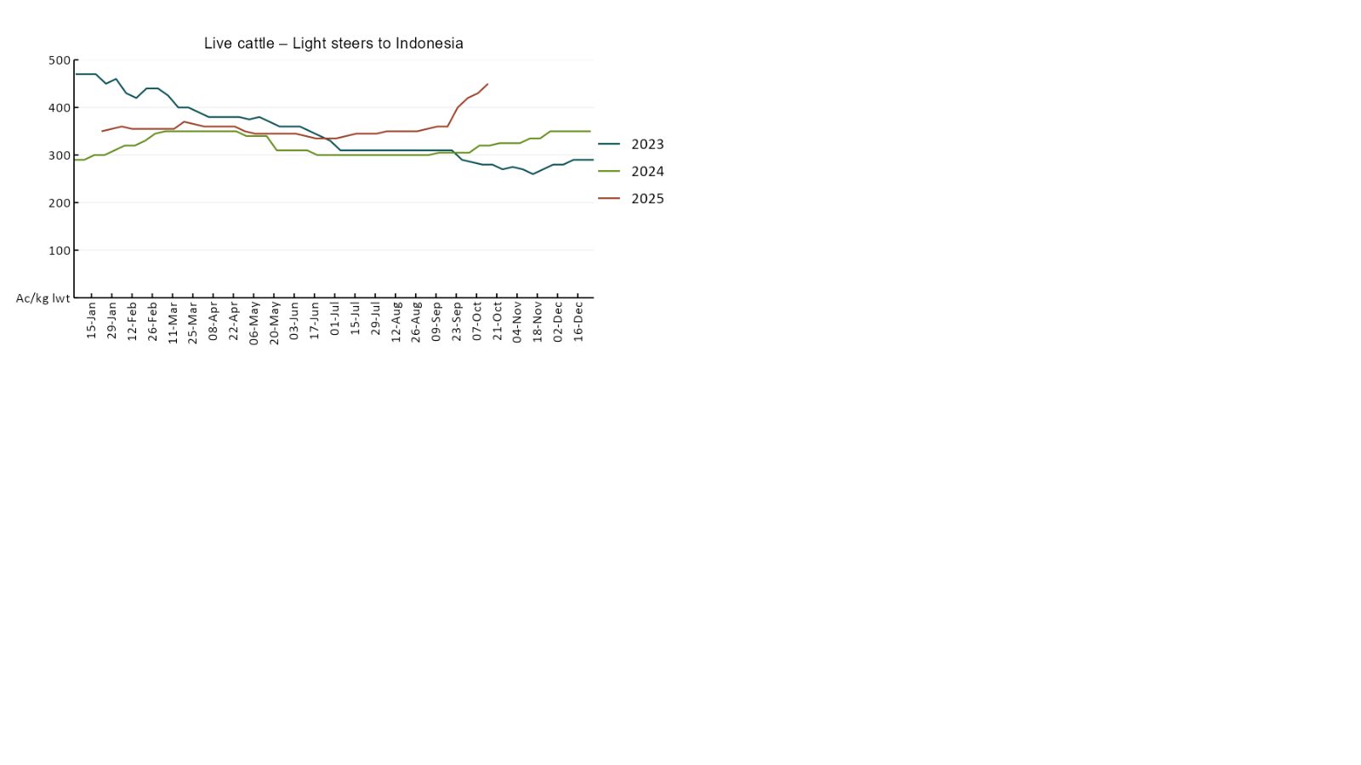

### 3.4 Global Dairy Trade (GDT) weighted average pricesSee the World agricultural prices page for chart descriptions - https://www.agriculture.gov.au/abares/data/weekly-commodity-price-update/world-agricultural-prices.

### 3.5 Selected fruit and vegetable prices

### See the Australian Horticulture prices page for chart descriptions - https://www.agriculture.gov.au/abares/data/weekly-commodity-price-update/australian-horticulture-prices.

### See the Australian Horticulture prices page for chart descriptions - https://www.agriculture.gov.au/abares/data/weekly-commodity-price-update/australian-horticulture-prices.

### 3.6 Selected domestic fodder indicator prices

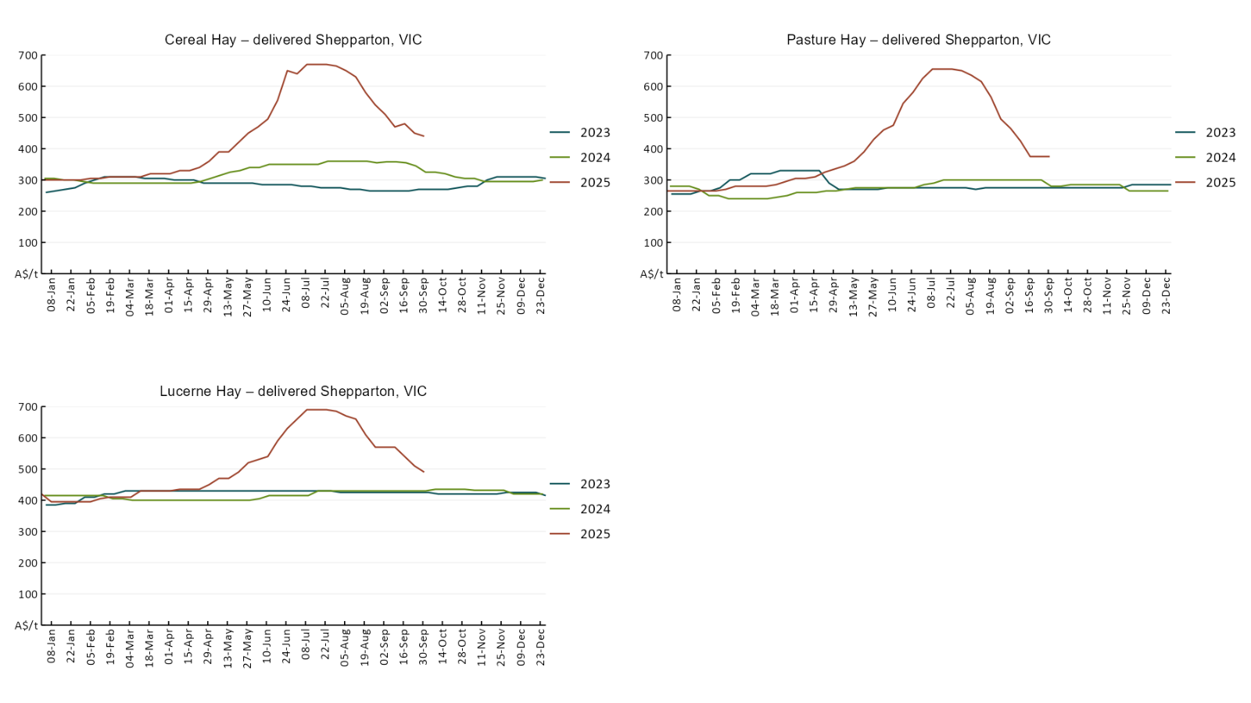

## **4. Data attribution**

### Climate

* Bureau of Meteorology
* Weekly rainfall totals: www.bom.gov.au/climate/maps/rainfall/
* Monthly and last 3-month rainfall percentiles: [www.bom.gov.au/water/landscape/](http://www.bom.gov.au/water/landscape/)
* Temperature anomalies: [www.bom.gov.au/jsp/awap/temp/index.jsp](http://www.bom.gov.au/jsp/awap/temp/index.jsp)
* Rainfall forecast: [www.bom.gov.au/jsp/watl/rainfall/pme.jsp](http://www.bom.gov.au/jsp/watl/rainfall/pme.jsp)
* Seasonal outlook: [www.bom.gov.au/climate/outlooks/#/overview/summary/](http://www.bom.gov.au/climate/outlooks/#/overview/summary/)
* Climate drivers: <http://www.bom.gov.au/climate/enso/>
* Soil moisture: [www.bom.gov.au/water/landscape/](http://www.bom.gov.au/water/landscape/)
* Other
* Pasture growth: [www.longpaddock.qld.gov.au/aussiegrass/](http://www.longpaddock.qld.gov.au/aussiegrass/)
* 3-month global outlooks: [Environment and Climate Change Canada](https://weather.gc.ca/saisons/image_e.html?img=s234pfe1p_cal&bc=prob), [NOAA Climate Prediction Center](https://www.cpc.ncep.noaa.gov/products/predictions/long_range/seasonal.php?lead=2), [EUROBRISA CPTEC/INPE](http://eurobrisa.cptec.inpe.br/), European Centre for Medium-Range Weather Forecasts, [Hydrometcenter of Russia](https://meteoinfo.ru/en/climate/seasonal-forecasts), [National Climate Center Climate System Diagnosis and Prediction Room (NCC)](https://cmdp.ncc-cma.net/pred/cs2gen.php?pred_elem=RAINP#pred_seasonal), [International Research Institute for Climate and Society](https://iri.columbia.edu/our-expertise/climate/forecasts/seasonal-climate-forecasts/)
* Global production: <https://ipad.fas.usda.gov/ogamaps/cropmapsandcalendars.aspx>
* Autumn break: Pook et al., 2009, <https://rmets-onlinelibrary-wiley-com.virtual.anu.edu.au/doi/epdf/10.1002/joc.1833>

### Water

Prices

* Waterflow: <https://www.waterflow.io/>
* Ruralco: <https://www.ruralcowater.com.au/>
* Bureau of Meteorology:
* Allocation trade: <http://www.bom.gov.au/water/dashboards/#/water-markets/mdb/at>
* Storage volumes: <http://www.bom.gov.au/water/dashboards/#/water-storages/summary/drainage>
* Trade constraints:
* Water NSW: <https://www.waternsw.com.au/customer-service/ordering-trading-and-pricing/trading/murrumbidgee>
* Victorian Water Register: <https://www.waterregister.vic.gov.au/TradingRules2019/>

### Commodities

* Fruit and vegetables
* Datafresh: [www.freshstate.com.au](http://www.freshstate.com.au)
* Pigs
* Australian Pork Limited: [www.australianpork.com.au](http://www.australianpork.com.au)
* Dairy
* Global Dairy Trade: [www.globaldairytrade.info/en/product-results/](http://www.globaldairytrade.info/en/product-results/)
* World wheat, canola
* International Grains Council
* World coarse grains
* United States Department of Agriculture
* World cotton
* Cotlook: [www.cotlook.com/](http://www.cotlook.com/)
* World sugar
* New York Stock Exchange - Intercontinental Exchange
* Wool
* Australian Wool Exchange: [www.awex.com.au/](http://www.awex.com.au/)
* Domestic wheat, barley, sorghum, canola and fodder
* Jumbuk Consulting Pty Ltd: http://www.jumbukag.com.au/
* Cattle, beef, mutton, lamb, goat and live export
* Meat and Livestock Australia: [www.mla.com.au/Prices-and-market](http://www.mla.com.au/Prices-and-market)

© Commonwealth of Australia 2025

### Ownership of intellectual property rights

Unless otherwise noted, copyright (and any other intellectual property rights, if any) in this publication is owned by the Commonwealth of Australia (referred to as the Commonwealth).

### Creative Commons licence

All material in this publication is licensed under a [Creative Commons Attribution 4.0 International Licence](https://creativecommons.org/licenses/by/4.0/legalcode) except content supplied by third parties, logos and the Commonwealth Coat of Arms.

Inquiries about the licence and any use of this document should be emailed to [copyright@awe.gov.au](mailto:copyright@awe.gov.au).

Creative commons licence logo

### Cataloguing data

This publication (and any material sourced from it) should be attributed as:

ABARES 2025, Weekly Australian Climate, Water and Agricultural Update, Australian Bureau of Agricultural and Resource Economics and Sciences, Canberra, 23 October 2025. CC BY 4.0 DOI: <https://doi.org/10.25814/5f3e04e7d2503>

ISSN **2652-7561**

This publication is available at https://www.agriculture.gov.au/abares/products/weekly_update

Department of Agriculture, Fisheries and Forestry

GPO Box 858 Canberra ACT 2601

Telephone 1800 900 090

Web [agriculture.gov.au/abares](http://awe.gov.au/abares)

### Disclaimer

The Australian Government acting through the Department of Agriculture, Fisheries and Forestry, represented by the Australian Bureau of Agricultural and Resource Economics and Sciences, has exercised due care and skill in preparing and compiling the information and data in this publication. Notwithstanding, the Department of Agriculture, Fisheries and Forestry, ABARES, its employees and advisers disclaim all liability, including liability for negligence and for any loss, damage, injury, expense or cost incurred by any person as a result of accessing, using or relying on any of the information or data in this publication to the maximum extent permitted by law.

### Statement of Professional Independence

The views and analysis presented in ABARES publications, including this one, reflect ABARES professionally independent findings, based on scientific and economic concepts, principles, information and data. These views, analysis and findings may not reflect or be consistent with the views or positions of the Australian Government, or of organisations or groups who have commissioned ABARES reports or analysis. More information on [professional independence](https://www.agriculture.gov.au/abares/about/research-and-analysis#professional-independence) is provided on the ABARES website.

### Acknowledgements

This report was prepared by Matt Miller.