
No. 43/2025 30 October 2025

Summary of key issues
- In the week ending 29 October 2025, cold fronts and low-pressure troughs brought rainfall to parts of eastern and central Australia.
  - Rainfall was highly variable across cropping regions. Little to no rainfall was recorded across cropping regions of Western Australia, much of South Australia, northern Victoria, and parts of south-western New South Wales and Queensland, while parts of eastern Queensland, northern New South Wales, and southern Victoria saw up to 50 millimetres.
    - Ongoing dry conditions across parts of northern Victoria and South Australia as well as across parts of southern New South Wales continue to present an increased downside production risk for pastures and winter crops which are in their final yield-determining growth stages.
    - Rainfall across Queensland and northern New South Wales is benefitted soil moisture levels and the planting, establishment and growth of summer crops, but is likely to have disrupted the harvest of winter crops.
- Over the coming eight days to 6 November 2025, some rainfall is expected across most cropping regions.
  - If realised, falls in southern cropping regions would provide some much-needed moisture for crop and pasture growth but may be too late to prevent declines in expected crop yields in some areas of Victoria, South Australia and southern New South Wales.
- The northern rainfall onset (the start of the wet season) for 2025–26 has arrived in some central and northern areas of the Northern Territory, Queensland, and Western Australia. However, the northern rainfall onset has not yet occurred across much of Australia’s tropical north outside of these areas.
- Water storage levels in the Murray-Darling Basin (MDB) decreased by 96 gigalitres (GL) between 23 October 2025 and 30 October 2025. The current volume of water held in storages is 14,900 GL, equivalent to 67% of total storage capacity. This is 12% or 2,089 GL less than the same time last year. Water storage data is sourced from the Bureau of Meteorology.
- Allocation prices in the Victorian Murray below the Barmah Choke increased from $316/ML on 23 October 2025 to $318/ML on 30 October 2025.

Climate

Rainfall this week
In the week ending 29 October 2025, low-pressure troughs brought rainfall to eastern and central Australia, including large areas of the Northern Territory, Queensland, South Australia, and eastern New South Wales. Further south, cold fronts brought rainfall to much of Tasmania and Victoria.
Rainfall was highly variable across cropping regions for the week ending 29 October 2025.
- In the east, Queensland recorded 5-50 millimetres of rainfall in most areas, with parts of the north seeing up to 100 millimetres. Northern and south-eastern New South Wales and southern Victoria saw 10-50 millimetres.
  - Rainfall across Queensland and northern New South Wales is expected to benefit soil moisture levels and the planting, establishment and growth of summer crops, but is likely to have disrupted the harvest of winter crops. Where rainfall was recorded across south-eastern Australia it is likely to support production outcomes for winter crops in late development stages.
- Cropping regions in Western Australia, much of South Australia, northern Victoria, and parts of south-western New South Wales and Queensland saw little to no rainfall over the period.
  - Little to no rainfall in Western Australia is unlikely to adversely impact crop production outcomes, with robust soil moisture supported by recent average to above average rainfall.
  - Ongoing dry conditions across parts of northern Victoria and South Australia as well as across parts of southern New South Wales continue to present an increased downside production risk for pastures and winter crops which are in their final yield-determining growth stages.

Rainfall for the week ending 29 October 2025
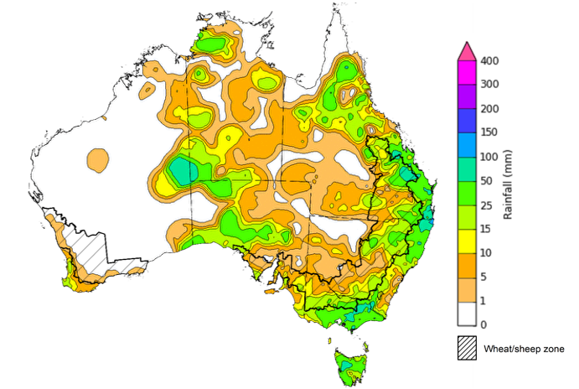
©Commonwealth of Australia 2025, Australian Bureau of Meteorology Issued: 29/10/2025
Note: The rainfall analyses and associated maps utilise data contained in the Bureau of Meteorology climate database, the Australian Data Archive for Meteorology (ADAM). The analyses are initially produced automatically from real-time data with limited quality control. They are intended to provide a general overview of rainfall across Australia as quickly as possible after the observations are received. For further information go to http://www.bom.gov.au/climate/rainfall/

Rainfall forecast for the next eight days
Over the 8 days to 6 November 2025, frontal systems and a low-pressure trough are expected to bring rainfall to large areas of northern, eastern and southern Australia, while much of Western Australia and inland areas of Queensland, South Australia and the Northern Territory are forecast to see very limited rainfall.
Some rainfall is expected across most cropping regions this week, while those in western Queensland, north-western New South Wales and northern Western Australia are likely to see limited rainfall.
- Falls of between 25-50 millimetres are forecast in most cropping regions in Victoria. In southern and eastern New South Wales and eastern Queensland 10- 50 millimetres are expected. While southern and central Westen Australian and South Australian cropping regions are expected to see 10- 25 millimetres.
  - If realised these falls are likely to supply some much-needed moisture for crop and pasture growth, but may arrive too late to prevent declines in expected winter crop yields in some areas of Victoria, South Australia and southern New South Wales.

Total forecast rainfall for the period 30 October to 6 November 2025
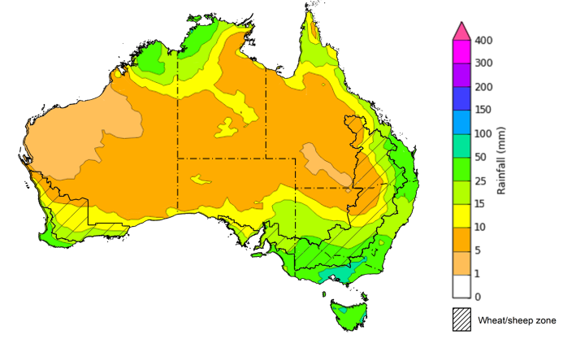
©Commonwealth of Australia 2025, Australian Bureau of Meteorology Issued 30/10/2025
Note: This rainfall forecast is produced from computer models. As the model outputs are not altered by weather forecasters, it is important to check local forecasts and warnings issued by the Bureau of Meteorology.

Northern Rainfall Onset
The northern rainfall onset outlook provides an indication of whether the first significant rains after the dry season are likely to be earlier or later than normal. The onset (i.e. start of the wet season) occurs when the total rainfall after 1 September reaches 50 millimetres, which is considered approximately the amount of rainfall required to stimulate plant growth. The northern rainfall onset for the 2025–26 season has commenced early in parts of the northern tropics, as well as isolated parts of central Australia.
Number of days earlier or later than the long-term average onset date
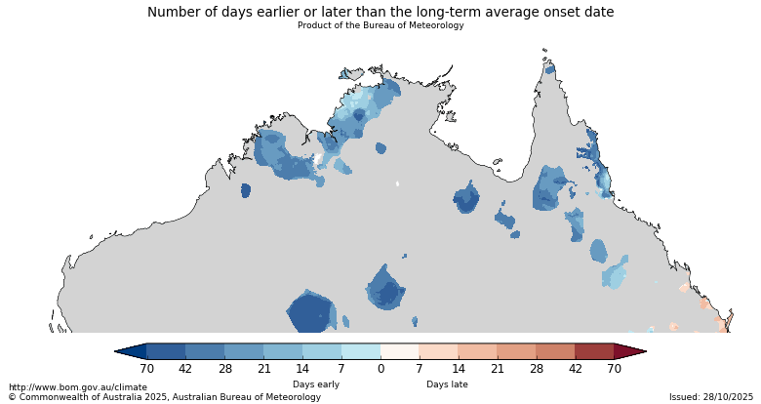
The northern rainfall onset has arrived early for some parts of Western Australia, the Northern Territory and northern Queensland, where the onset is usually in November or December. In contrast, the date of onset in south-eastern Queensland this season is likely to be later than the historical median.

Northern rainfall onset - All years median onset
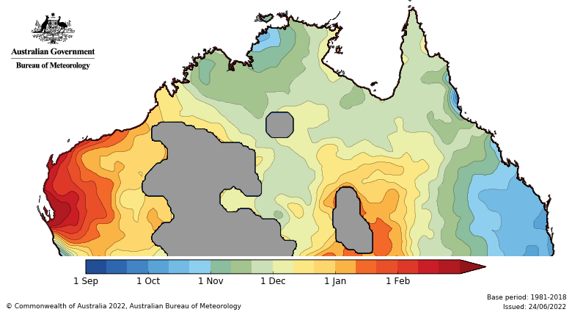

Water markets – current week

Water storage levels in the Murray-Darling Basin (MDB) decreased by 96 gigalitres (GL) between 23 October 2025 and 30 October 2025. The current volume of water held in storages is 14,900 GL, equivalent to 67% of total storage capacity. This is 12% or 2,089 GL less than the same time last year. Water storage data is sourced from the Bureau of Meteorology.

Water storages in the Murray-Darling Basin, 2013–2025
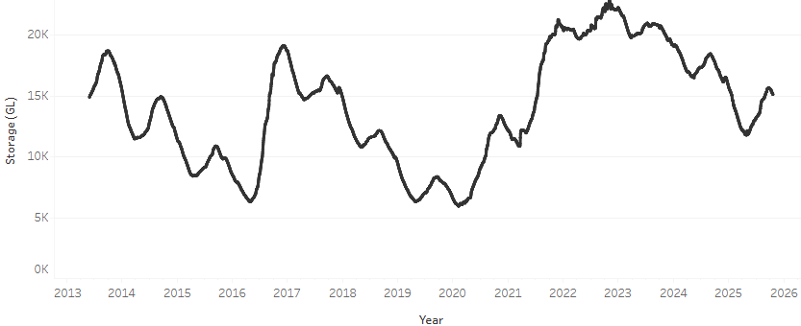
Allocation prices in the Victorian Murray below the Barmah Choke increased from $316/ML on 23 October 2025 to $318/ML on 30 October 2025. Trade from the Goulburn to the Murray is closed. Trade downstream through the Barmah Choke is closed. Trade from the Murrumbidgee to the Murray is closed.

Water market prices, Southern Murray–Darling Basin

Region | $/ML
NSW Murray Above | 255
NSW Murrumbidgee | 279
Vic Greater Goulburn | 298
Vic Murray Below | 318

Note: The water allocation prices shown are volume weighted average prices based on the last 10 trades. Price data is sourced from Waterflow and current as at 30 October 2025.
To access the full, interactive, weekly water dashboard, which contains the latest and historical water storage, water market and water allocation information, please visit https://www.agriculture.gov.au/abares/products/weekly_update/weekly-update-231025

Commodities
Indicator | Week average | Unit | Latest Price | Previous Week | Weekly change |  | Price 12 months ago | Annual change
Selected world indicator prices
AUD/USD Exchange rate | 29-Oct | A$/US$ | 0.66 | 0.65 | 1% | 0.67 |  | -2%
Wheat – US no. 2 hard red winter wheat, FOB Gulf | 29-Oct | US$/t | 240 | 229 | 5% | 271 |  | -12%
Corn – US no. 2 yellow corn, FOB Gulf | 29-Oct | US$/t | 202 | 198 | 2% | 190 |  | 6%
Canola – Rapeseed, Canada, FOB Vancouver | 29-Oct | US$/t | 485 | 476 | 2% | 489 |  | -1%
Cotton – Cotlook A Index | 29-Oct | USc/lb | 76.0 | 75.6 | 1% | 83.6 |  | -9%
Sugar – Intercontinental Exchange, nearby futures, no.11 contract | 29-Oct | USc/lb | 14.4 | 15.3 | -6% | 22.3 |  | -35%
Wool – Eastern Market Indicator | 22-Oct | Ac/kg clean | 1,427 | 1,456 | -2% | 1,127 |  | 27%
Wool – Western Market Indicator | 15-Oct | Ac/kg clean | 1,588 | 1,656 | -4% | 1,261 |  | 26%
Selected Australian grain export prices
Australian Premium White (APW) Wheat, FOB Port Adelaide, SA | 29-Oct | A$/t | 369 | 370 | 0% | 390 |  | -5%
Australian Standard White (ASW) Wheat, FOB Port Adelaide, SA | 29-Oct | A$/t | 365 | 366 | 0% | 379 |  | -4%
Feed Barley – FOB Port Adelaide, SA | 29-Oct | A$/t | 353 | 351 | 0% | 350 |  | 1%
Canola – FOB Kwinana, WA | 29-Oct | A$/t | 795 | 790 | 1% | 790 |  | 1%
Grain Sorghum – FOB Brisbane, QLD | 29-Oct | A$/t | 404 | 405 | 0% | 388 |  | 4%
Selected domestic livestock indicator prices
Beef – Eastern Young Cattle Indicator | 29-Oct | Ac/kg cwt | 827 | 831 | -1% | 630 |  | 31%
Mutton – Mutton indicator (18–24 kg fat score 2–3), VIC | 29-Oct | Ac/kg cwt | 690 | 682 | 1% | 288 |  | 140%
Lamb – National Trade Lamb Indicator | 29-Oct | Ac/kg cwt | 1,065 | 1,066 | 0% | 798 |  | 33%
Pig – Eastern Seaboard (60.1–75 kg), NSW buyer price | 15-Oct | Ac/kg cwt | 462 | 461 | 0% | 432 |  | 7%
Live cattle – Light steers to Indonesia | 15-Oct | Ac/kg lwt | 450 | 430 | 5% | 319 |  | 41%
Global Dairy Trade (GDT) weighted average prices
Dairy – Whole milk powder | 22-Oct | US$/t | 3,610 | 3,696 | -2% | 3,556 |  | 2%
Dairy – Skim milk powder | 22-Oct | US$/t | 2,559 | 2,599 | -2% | 2,770 |  | -8%
Dairy – Cheddar cheese | 22-Oct | US$/t | 4,758 | 4,858 | -2% | 4,654 |  | 2%
Dairy – Anhydrous milk fat | 22-Oct | US$/t | 7,038 | 6,916 | 2% | 7,221 |  | -3%

Selected world indicator prices
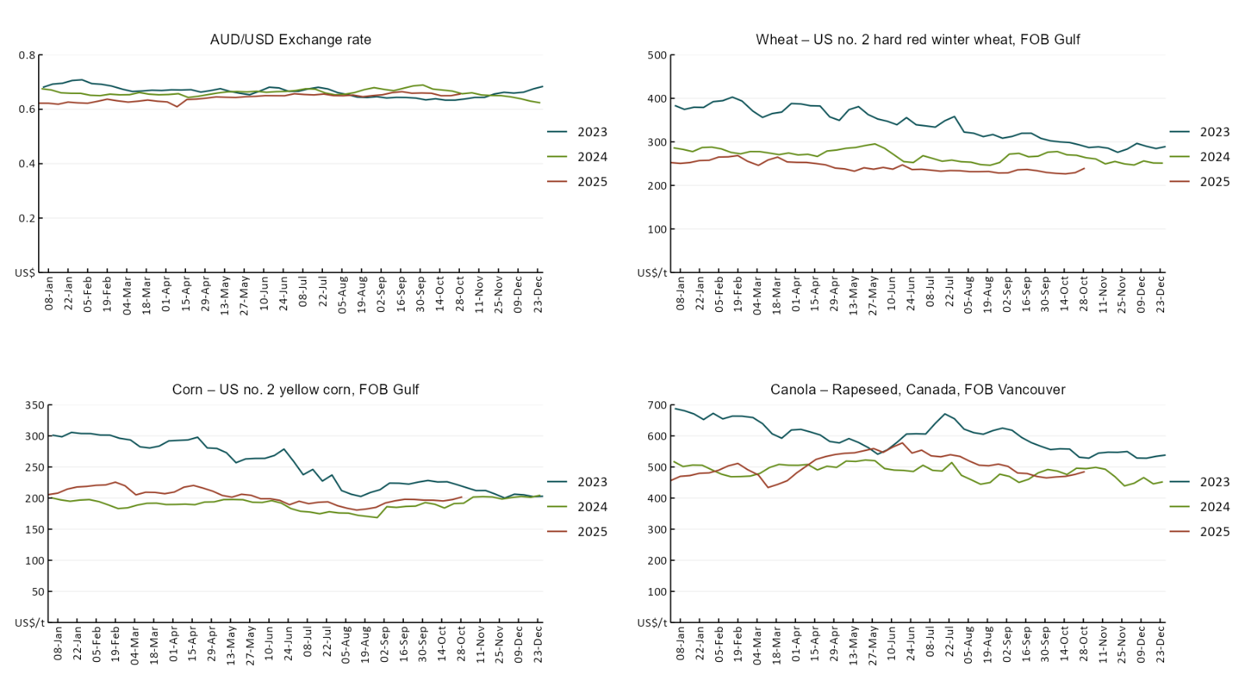

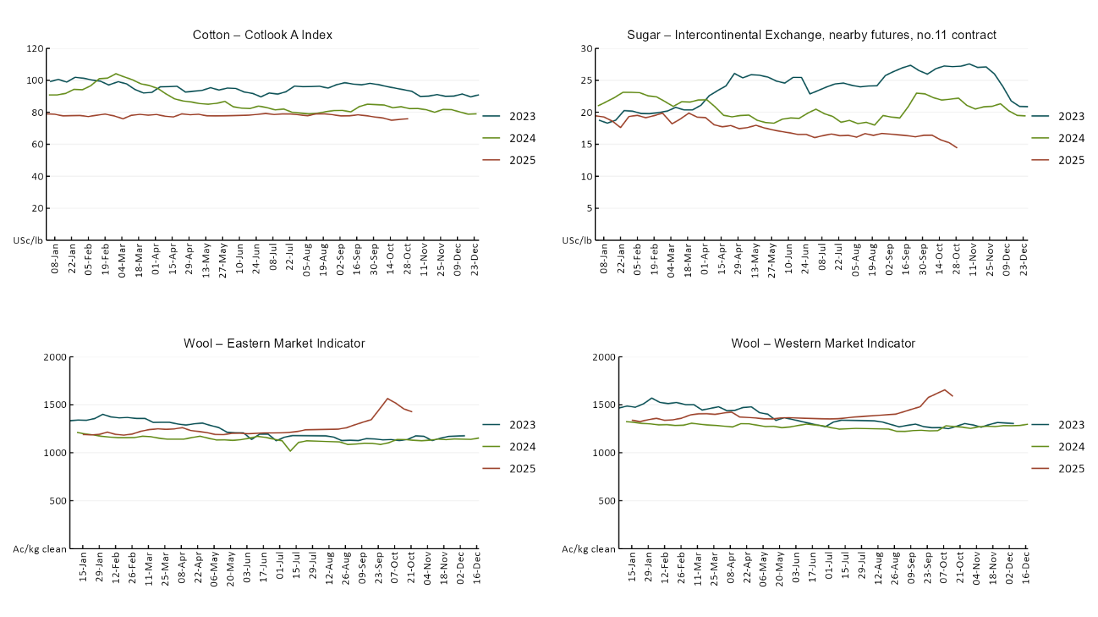

3.2 Selected domestic crop indicator prices
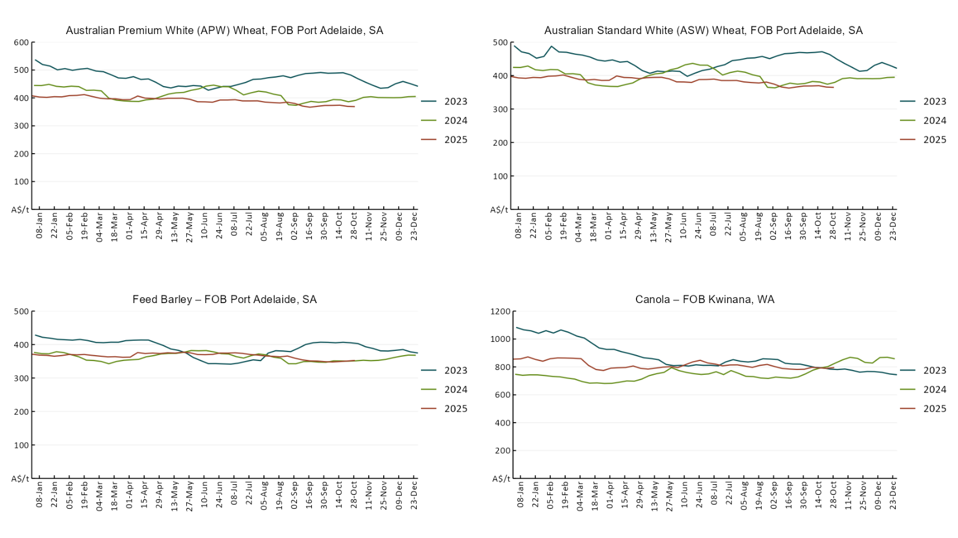
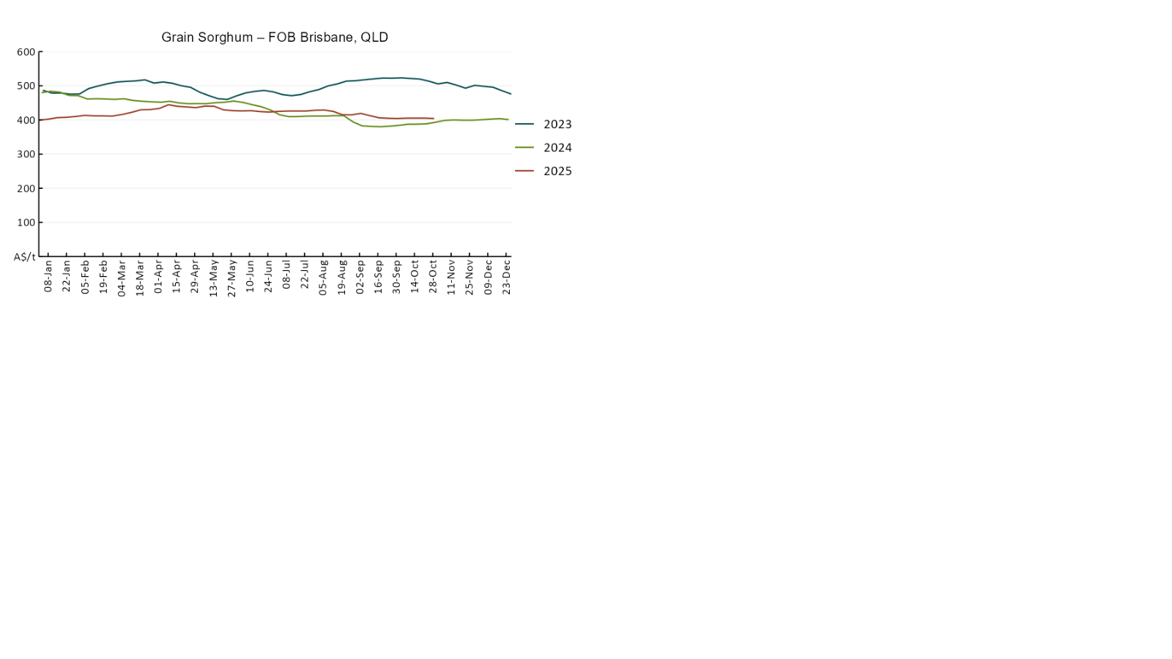

3.3 Selected domestic livestock indicator prices
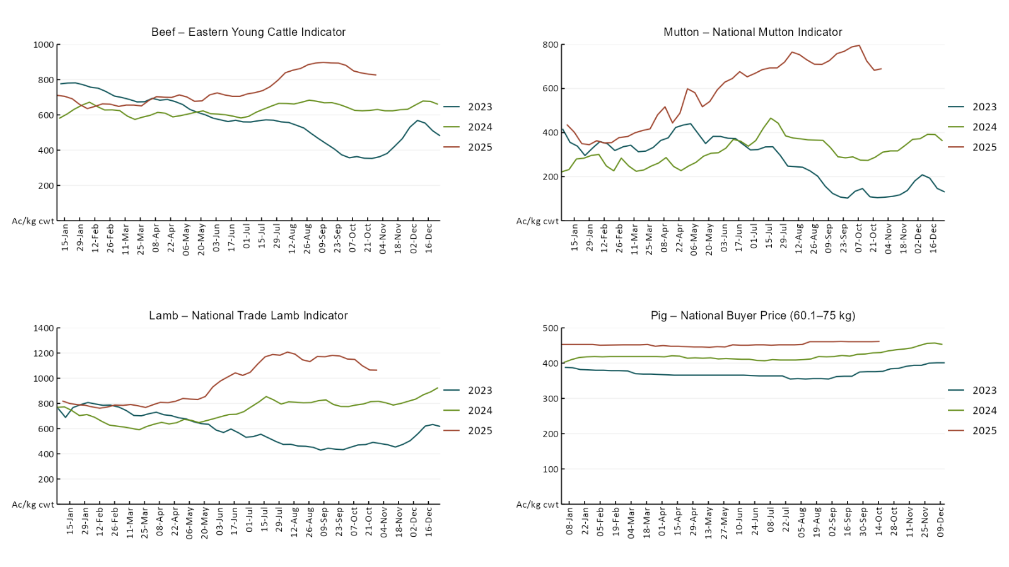
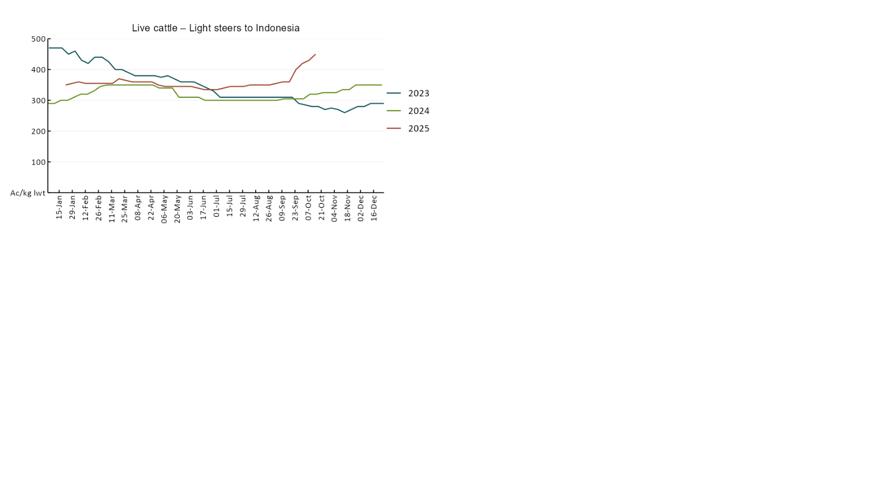

3.4 Global Dairy Trade (GDT) weighted average prices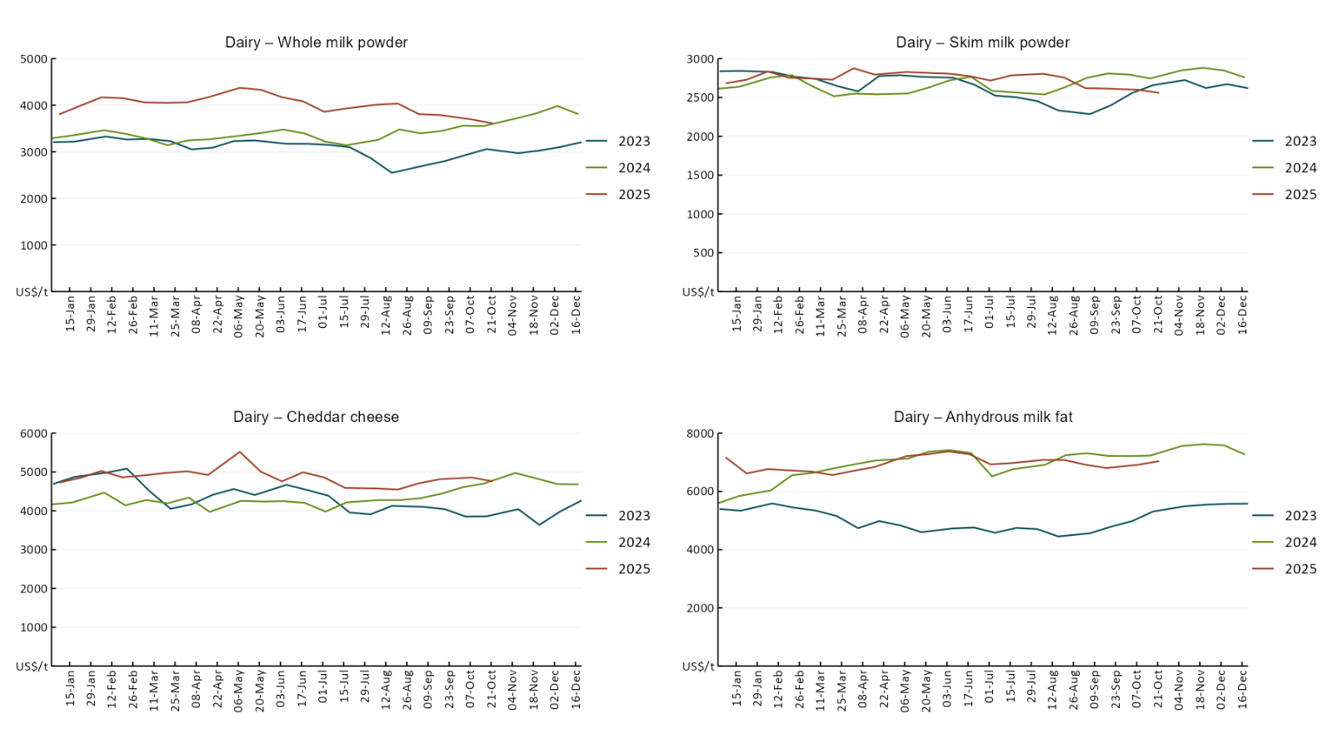

3.5 Selected fruit and vegetable prices

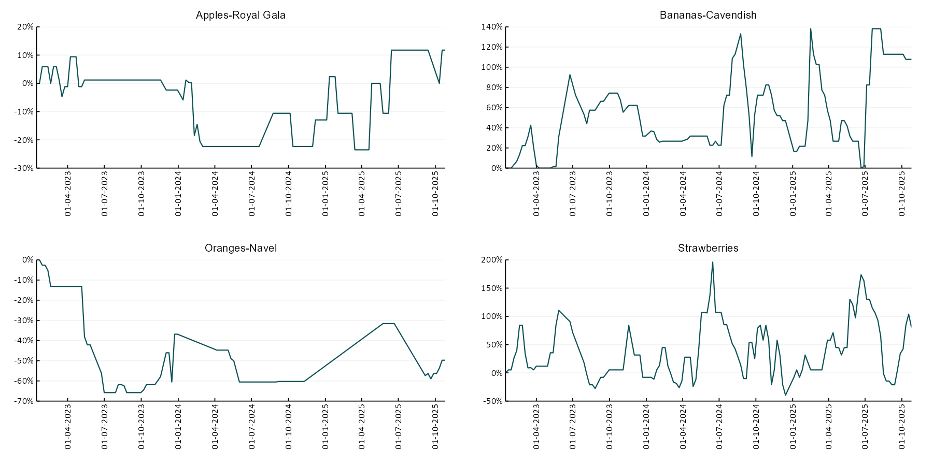

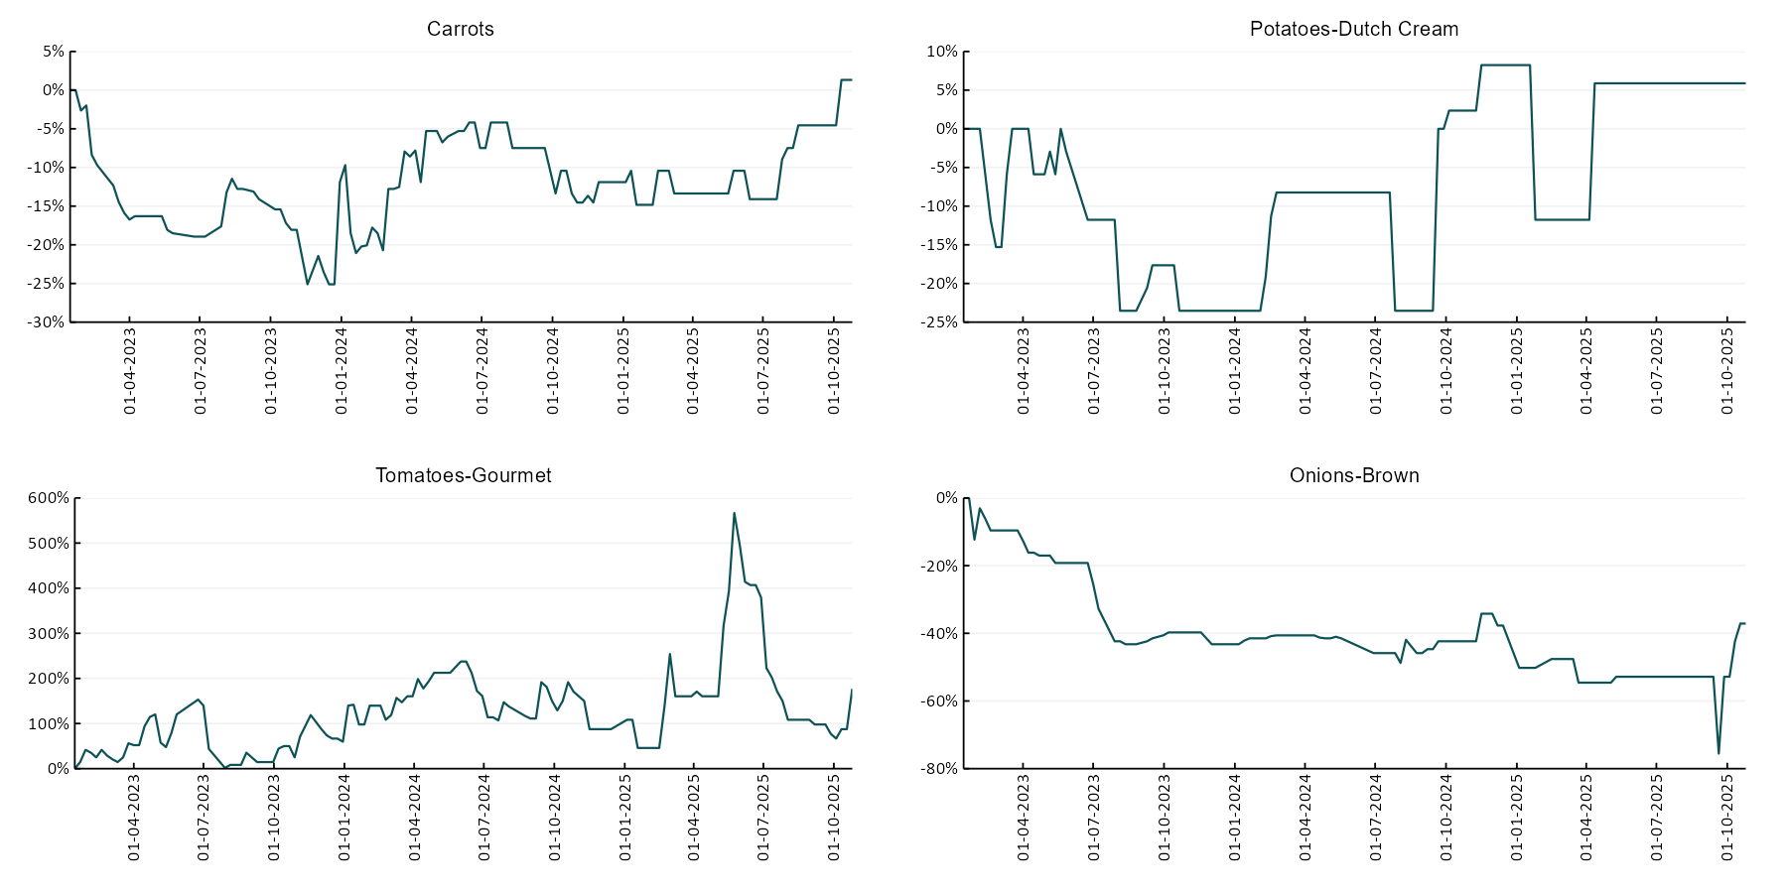

3.6 Selected domestic fodder indicator prices
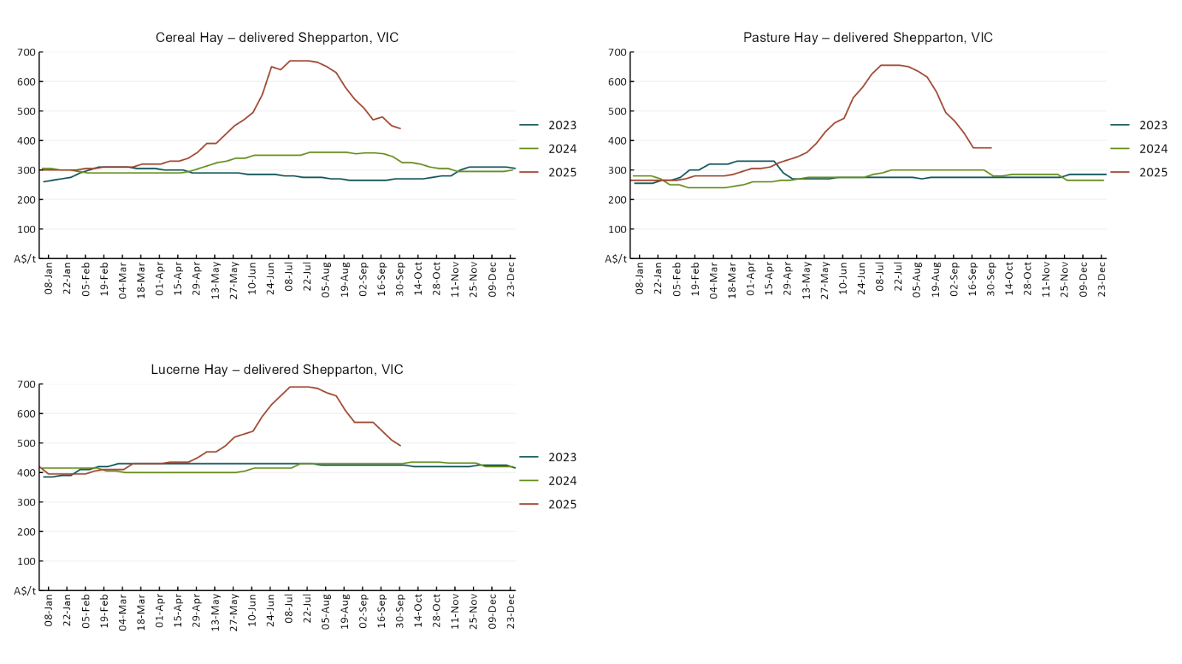

4. Data attribution

Climate
Bureau of Meteorology
- Weekly rainfall totals: www.bom.gov.au/climate/maps/rainfall/
- Monthly and last 3-month rainfall percentiles: https://www.bom.gov.au/climate/ahead/outlooks/#moreMaps
- Rainfall forecast: www.bom.gov.au/jsp/watl/rainfall/pme.jsp
- Seasonal outlook: www.bom.gov.au/climate/outlooks/#/overview/summary/
- Climate drivers: http://www.bom.gov.au/climate/enso/
- Soil moisture: https://awo.bom.gov.au/products/historical/soilMoisture-rootZone/

Other
- Pasture growth: www.longpaddock.qld.gov.au/aussiegrass/
- 3-month global outlooks: Environment and Climate Change Canada, NOAA Climate Prediction Center, EUROBRISA CPTEC/INPE, European Centre for Medium-Range Weather Forecasts, Hydrometcenter of Russia, National Climate Center Climate System Diagnosis and Prediction Room (NCC), International Research Institute for Climate and Society
- Global production: https://ipad.fas.usda.gov/ogamaps/cropmapsandcalendars.aspx
- Autumn break: Pook et al., 2009, https://rmets-onlinelibrary-wiley-com.virtual.anu.edu.au/doi/epdf/10.1002/joc.1833

Water
Prices
- Waterflow: https://www.waterflow.io/
- Ruralco: https://www.ruralcowater.com.au/
- Bureau of Meteorology:
- Allocation trade: http://www.bom.gov.au/water/dashboards/#/water-markets/mdb/at
- Storage volumes: http://www.bom.gov.au/water/dashboards/#/water-storages/summary/drainage

Trade constraints:
- Water NSW: https://www.waternsw.com.au/customer-service/ordering-trading-and-pricing/trading/murrumbidgee
- Victorian Water Register: https://www.waterregister.vic.gov.au/TradingRules2019/

Commodities
Fruit and vegetables
- Datafresh: www.freshstate.com.au

Pigs
- Australian Pork Limited: www.australianpork.com.au

Dairy
- Global Dairy Trade: www.globaldairytrade.info/en/product-results/

World wheat, canola
- International Grains Council
- https://www.igc.int/en/default.aspx
- United States Department of Agriculture

World cotton
- Cotlook: www.cotlook.com/

World sugar
- New York Stock Exchange - Intercontinental Exchange

Wool
- Australian Wool Exchange: www.awex.com.au/

Domestic wheat, barley, sorghum, canola and fodder
- Jumbuk Consulting Pty Ltd: Jumbuk AG | Agriculture Consulting

Cattle, beef, mutton, lamb, goat and live export
- Meat and Livestock Australia: https://www.mla.com.au/prices-markets/

© Commonwealth of Australia 2025

Ownership of intellectual property rights
Unless otherwise noted, copyright (and any other intellectual property rights, if any) in this publication is owned by the Commonwealth of Australia (referred to as the Commonwealth).

Creative Commons licence
All material in this publication is licensed under a Creative Commons Attribution 4.0 International Licence except content supplied by third parties, logos and the Commonwealth Coat of Arms.
Inquiries about the licence and any use of this document should be emailed to copyright@awe.gov.au.


Cataloguing data
This publication (and any material sourced from it) should be attributed as:
ABARES 2025, Weekly Australian Climate, Water and Agricultural Update, Australian Bureau of Agricultural and Resource Economics and Sciences, Canberra, 30 October 2025. CC BY 4.0 DOI: https://doi.org/10.25814/5f3e04e7d2503
ISSN 2652-7561
This publication is available at https://www.agriculture.gov.au/abares/products/weekly_update
Department of Agriculture, Fisheries and Forestry
GPO Box 858 Canberra ACT 2601
Telephone 1800 900 090
Web agriculture.gov.au/abares

Disclaimer
The Australian Government acting through the Department of Agriculture, Fisheries and Forestry, represented by the Australian Bureau of Agricultural and Resource Economics and Sciences, has exercised due care and skill in preparing and compiling the information and data in this publication. Notwithstanding, the Department of Agriculture, Fisheries and Forestry, ABARES, its employees and advisers disclaim all liability, including liability for negligence and for any loss, damage, injury, expense or cost incurred by any person as a result of accessing, using or relying on any of the information or data in this publication to the maximum extent permitted by law.

Statement of Professional Independence
The views and analysis presented in ABARES publications, including this one, reflect ABARES professionally independent findings, based on scientific and economic concepts, principles, information and data. These views, analysis and findings may not reflect or be consistent with the views or positions of the Australian Government, or of organisations or groups who have commissioned ABARES reports or analysis. More information on professional independence is provided on the ABARES website.

Acknowledgements
This report was prepared by Holly Beale and Matt Miller.

