
No. 43/2025 6 November 2025

Summary of key issues
- In the week ending 5 November 2025, low-pressure systems brought rainfall to parts of eastern Australia.
  - In the east, eastern and central Queensland recorded 5-50 millimetres of rainfall, while much of Victoria, South Australia and eastern and southern New South Wales saw 5- 25 millimetres.
    - Rainfall across Queensland and northern New South Wales is expected to benefit soil moisture levels and the planting, establishment and growth of summer crops, but is likely to have disrupted the harvest of winter crops. Where rainfall was recorded across south-eastern Australia it is likely to support production outcomes for winter crops in late development stages.
  - Cropping regions in Western Australia, the Mallee regions of South Australia and Victoria, and parts of south-western New South Wales and Queensland saw little to no rainfall over the period.
    - Little to no rainfall in Western Australia is unlikely to adversely impact crop production outcomes, with draw down of soil moisture supporting production.
    - Ongoing dry conditions across parts of northern Victoria and South Australia continue to present an increased downside production risk for pastures and winter crops which are in their final yield-determining growth stages.
- Over the coming eight days to 13 November 2025, limited rainfall is expected across most cropping regions.
  - If realised, falls in southern cropping regions would provide some much-needed moisture for crop and pasture growth. In northern cropping regions of Queensland these falls are expected to benefit soil moisture levels and the planting, establishment and growth of summer crops.
- Improved pasture growth for the three months to October 2025 across large areas of Victoria, South Australia, Western Australia, and north-western and southern New South Wales will likely provide opportunities for some graziers to increase stocking rates and production.
- Water storage levels in the Murray-Darling Basin (MDB) decreased by 113 gigalitres (GL) between 30 October 2025 and 6 November 2025. The current volume of water held in storages is 14,787 GL, equivalent to 66% of total storage capacity. This is 11 percentage points or 1,890 GL less than the same time last year. Water storage data is sourced from the Bureau of Meteorology (BOM).
- Allocation prices in the Victorian Murray below the Barmah Choke decreased from $318/ML on 30 October 2025 to $308/ML on 06 November 2025.

Climate

Rainfall this week
In the week ending 5 November 2025, low-pressure troughs brought rainfall and storms to eastern Australia, including large areas of Queensland and New South Wales, as well as central regions of the Northern Territory. Further south, cold fronts brought rainfall to much of Tasmania, Victoria, and parts of southern South Australia and Western Australia.
Rainfall was highly variable across cropping regions for the week ending 5 November 2025.
- In the east, eastern and central Queensland recorded 5-50 millimetres of rainfall, while much of Victoria, South Australia and eastern and southern New South Wales saw 2-25 millimetres.
  - Rainfall across Queensland and northern New South Wales is expected to benefit soil moisture levels and the planting, establishment and growth of summer crops, but is likely to have disrupted the harvest of winter crops. Where rainfall was recorded across south-eastern Australia it is likely to support production outcomes for winter crops in late development stages.
- Cropping regions in Western Australia, the Mallee regions of South Australia and Victoria, and parts of south-western New South Wales and Queensland saw little to no rainfall over the period.
  - Little to no rainfall in Western Australia is unlikely to adversely impact crop production outcomes, with draw down of soil moisture supporting production.
  - Ongoing dry conditions across parts of northern Victoria and South Australia continue to present an increased downside production risk for pastures and winter crops which are in their final yield-determining growth stages.

Rainfall for the week ending 5 November 2025
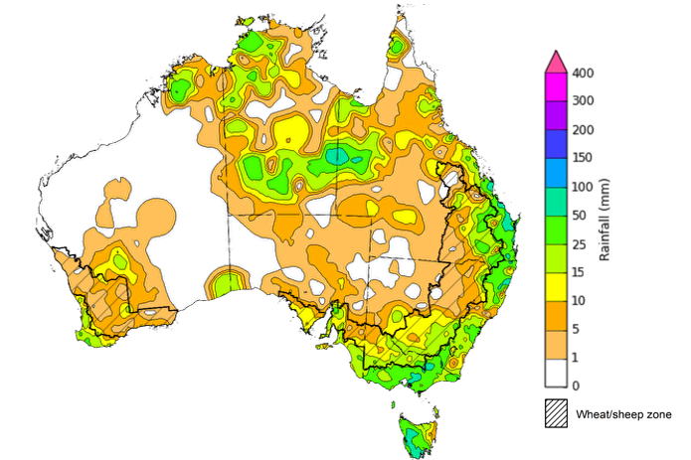
©Commonwealth of Australia 2025, Australian Bureau of Meteorology Issued: 5/11/2025
Note: The rainfall analyses and associated maps utilise data contained in the Bureau of Meteorology climate database, the Australian Data Archive for Meteorology (ADAM). The analyses are initially produced automatically from real-time data with limited quality control. They are intended to provide a general overview of rainfall across Australia as quickly as possible after the observations are received. For further information go to http://www.bom.gov.au/climate/rainfall/

Rainfall forecast for the next eight days
Over the 8 days to 13 November 2025, low-pressure systems are expected to bring rainfall to large areas of northern and eastern Australia, while much of the west of Western Australia and inland areas of Queensland, South Australia and New South Wales are forecast to see very limited rainfall.
Limited rainfall is expected across most southern cropping regions this week, while those in northern Queensland are likely to see higher rainfall totals.
- Falls of between 1-15 millimetres are forecast in most cropping regions in eastern New South Wales, South Australia, Western Australia, Victoria, and southern Queensland.
  - If realised these falls are likely to supply some much-needed moisture for crop and pasture growth.
- In northern Queensland, falls of 15-50 millimetres are expected.
  - If realised these falls are expected to benefit soil moisture levels and the planting, establishment and growth of summer crops.

Total forecast rainfall for the period 6 November to 13 November 2025
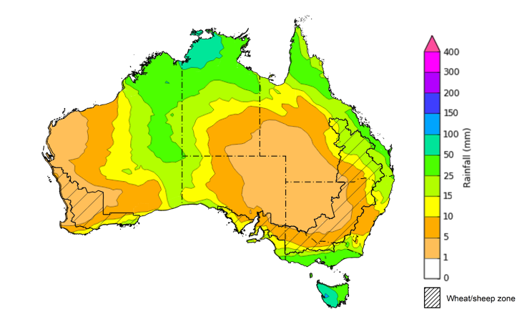
©Commonwealth of Australia 2025, Australian Bureau of Meteorology Issued 6/11/2025
Note: This rainfall forecast is produced from computer models. As the model outputs are not altered by weather forecasters, it is important to check local forecasts and warnings issued by the Bureau of Meteorology.

Monthly rainfall
Rainfall during October 2025 was mixed across Australia:
- Rainfall was average to extremely high across the northern tropics, Tasmania, western areas of the Northern Territory and South Australia, and large parts of Western Australia.
- Below average rainfall was recorded across most of New South Wales and southern Western Australia, extending into parts of Queensland and Victoria including east Gippsland and the northern Mallee.
In cropping regions, October rainfall was generally average to below average:
- October rainfall was average to above average across most cropping regions in South Australia and Victoria.
- For cropping regions in southern Western Australia, parts of northern Victoria, southern New South Wales and southeast Queensland, rainfall was below average.
  - The below average conditions observed in winter cropping areas over the period are likely to have presented a downside production risk over critical growth and yield determination stages of many winter cereals and oilseeds.
- Remaining cropping regions saw average rainfall.
Rainfall percentiles for October 2025
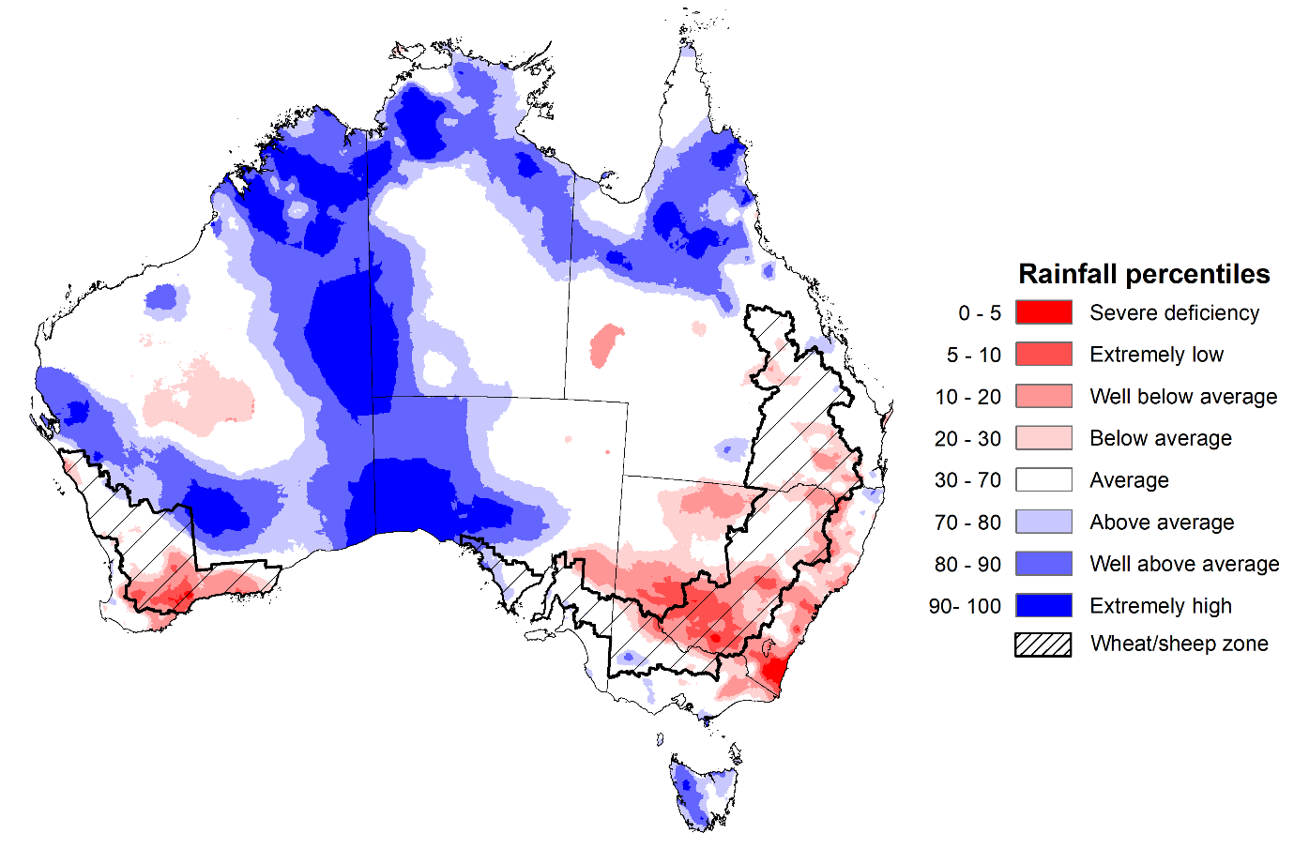

Note: Rainfall for October 2025 is compared with rainfall recorded for that period during the historical record (1900 to present). For further information, go to http://www.bom.gov.au/climate/austmaps/about-rain-maps.shtml
Source: Bureau of Meteorology

Monthly Soil Moisture
In October 2025, modelled upper layer soil moisture was generally average to above average in the north, with areas of below average soil moisture in scattered eastern and southern areas.
- Large areas of New South Wales, southern Queensland, northern Victoria, and central and southern Western Australia saw very much below average to below average upper layer soil moisture.
- In contrast, much of northern and central Australia, including the northern tropics, western South Australia, Tasmania, and parts of southern Victoria and eastern Western Australia saw above average to very much above upper layer soil moisture.
At this time of year, upper layer soil moisture is less critical for well-established winter crops. However, upper layer soil moisture will be critical for supporting the germination and establishment of summer crops in the coming months. Across most eastern cropping regions, modelled upper layer soil moisture in October was generally below average to average.

Modelled upper layer soil moisture for October 2025
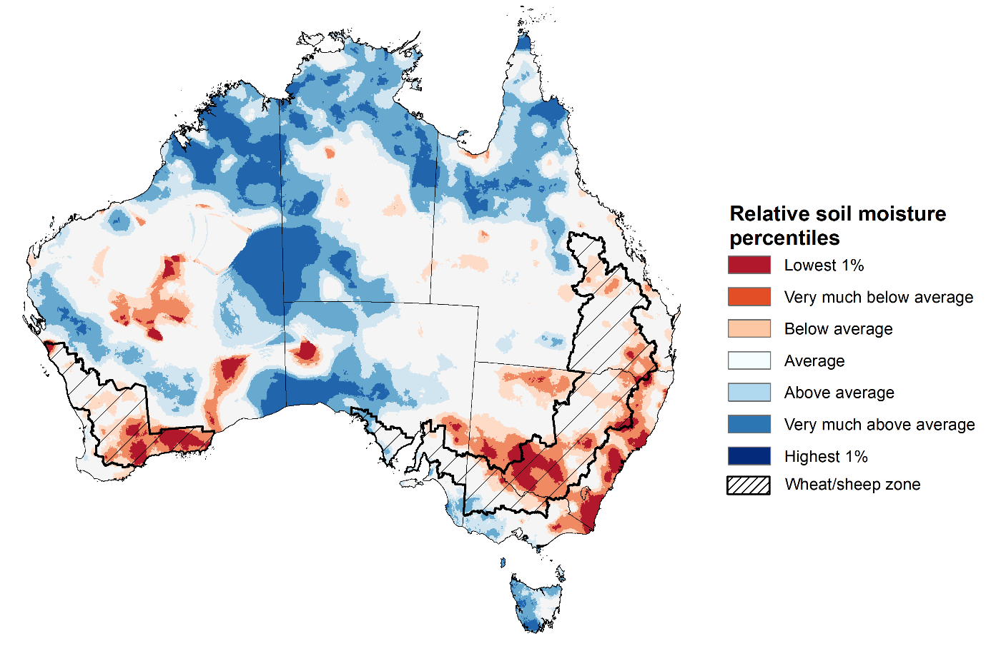

Note: This map shows the levels of modelled upper layer soil moisture (0 to 10 centimetres) during October 2025. This map shows how modelled soil conditions during October 2025 compare with October conditions modelled over the reference period (1911 to 2016). Dark blue areas on the maps were much wetter in July 2025 than during the reference period. The bulk of plant roots occur in the top 20 centimetres of the soil profile. Soil moisture in the upper layer of the soil profile is therefore useful indicator of the availability of water, particularly for germinating seed.
Source: Bureau of Meteorology (https://awo.bom.gov.au/about/overview)
Modelled lower layer soil moisture in October 2025 was average to very much above average across much of northern and western Australia, while extremely low to below average modelled lower layer soil moisture was evident across some southern and eastern areas.
Lower layer soil moisture is a larger, deeper store that is slower to respond to seasonal conditions and tends to reflect the accumulated effects of events that have occurred over longer periods. Crop development and pasture growth in areas of above average lower layer soil moisture are typically less reliant on in-season rainfall than in areas with below average lower layer soil moisture.
Across cropping regions in October 2025, lower layer soil moisture was largely below average to average. Low levels of lower layer soil moisture across some cropping region in south-eastern Australia present an ongoing downside production risk to the 2025–26 winter crop. Cropping regions in south-eastern Australia with extremely low levels of stored soil moisture will require sufficient and timely rainfall to arrest declining levels of crop yields and pasture growth.
Modelled lower layer soil moisture for October 2025
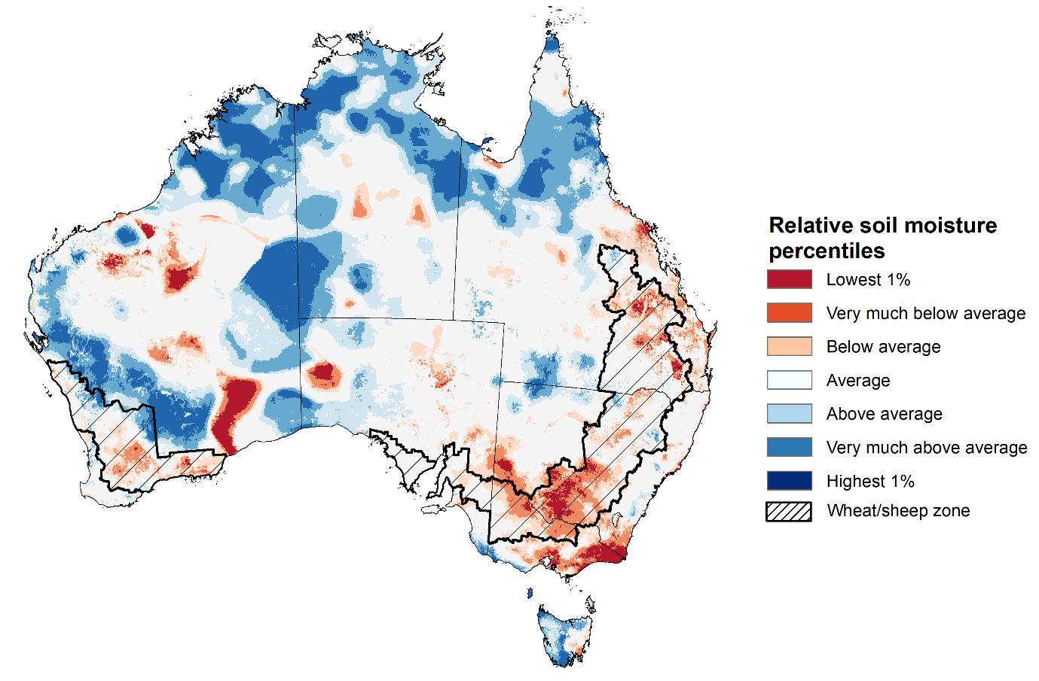
Note: This map shows the levels of modelled lower layer soil moisture (10 to 100 centimetres) during October 2025. This map shows how modelled soil conditions during October 2025 compare with October conditions modelled over the reference period (1911 to 2016). Dark blue areas on the maps were much wetter in July 2025 than during the reference period. The dark red areas were much drier than during the reference period. The bulk of plant roots occur in the top 20 centimetres of the soil profile. The lower layer soil moisture is a larger, deeper store that is slower to respond to rainfall and tends to reflect accumulated rainfall events over longer time periods.
Source: Bureau of Meteorology (https://awo.bom.gov.au/about/overview)

Pasture Growth
Pasture growth during the August to October period is typically low across large areas of central and northern Australia as it is firmly in the dry season. Across southern Australia, August to October pasture growth provides the spring flush which typically allows producers to cease winter supplementary feeding with grain and hay. It also influences the growth, branding and marking rates of lambs and calves, and the production of meat, milk, and wool over this peak production period.
Pasture growth for the three months to October 2025 was variable across much of country, with parts of southern and eastern Australia experiencing robust pasture growth.
- Average to extremely high pasture growth was modelled across large areas of southern and eastern Australia, including parts of Queensland, northern and eastern New South Wales, southern Victoria, southern regions of South Australia, and much of south-western Western Australia.
  - This pasture growth is expected to have allowed some farmers to rebuild livestock numbers, provide opportunities to build standing dry matter availability and decrease the reliance on fodder to maintain livestock condition over the winter and early spring period.
- By contrast, large areas of the Mallee regions in South Australia and Victoria, scattered areas of southern Western Australia, and parts of southern and eastern Queensland and southern New South Wales saw relatively low pasture growth for this time of year.
  - This below average pasture growth will likely see some graziers in affected regions continuing to be reliant on supplemental feed to maintain current stocking rates and production.
Relative pasture growth for 3-months ending October 2025 (1 August to 31 October 2025)
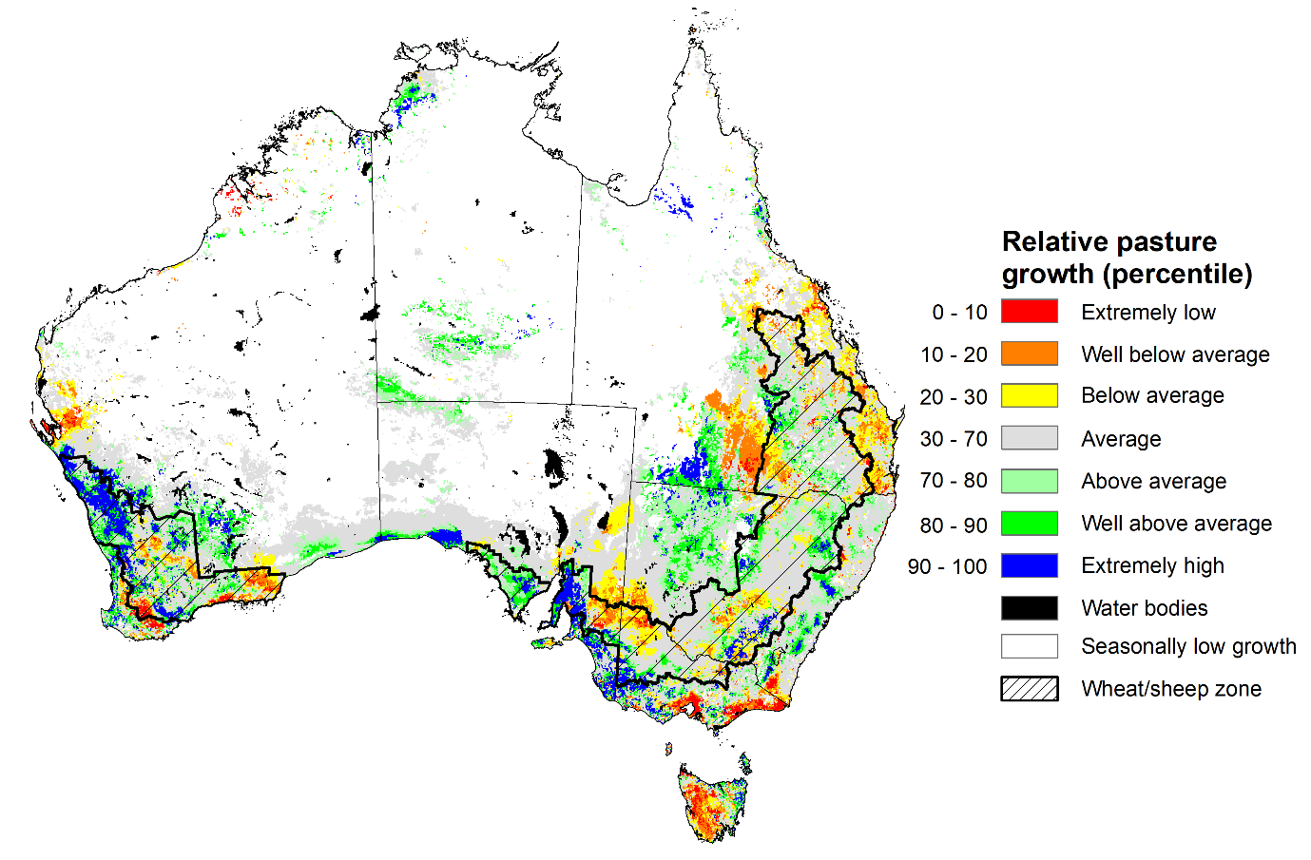

Notes: AussieGRASS pasture growth estimates are relative to the long-term record and shown in percentiles. Percentiles rank data on a scale of zero to 100. This analysis ranks pasture growth for the selected period against average pasture growth for the long-term record (1957 to 2016). Pasture growth is modelled at 5km2 grid cells.
Source: Department of Environment, Science and Innovation

Water markets – current week

Water storage levels in the Murray-Darling Basin (MDB) decreased by 113 gigalitres (GL) between 30 October 2025 and 6 November 2025. The current volume of water held in storages is 14,787 GL, equivalent to 66% of total storage capacity. This is 11% or 1,890 GL less than the same time last year. Water storage data is sourced from the Bureau of Meteorology (BOM).

Water storages in the Murray-Darling Basin, 2013–2025
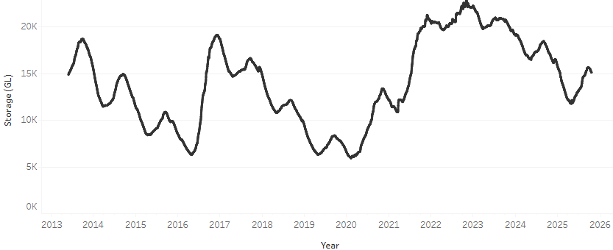
Allocation prices in the Victorian Murray below the Barmah Choke decreased from $318/ML on 30 October 2025 to $308/ML on 6 November 2025. Trade from the Goulburn to the Murray is closed. Trade downstream through the Barmah Choke is closed. Trade from the Murrumbidgee to the Murray is closed.

Water market prices, Southern Murray–Darling Basin

Region | $/ML
NSW Murray Above | 260
NSW Murrumbidgee | 282
Vic Greater Goulburn | 274
Vic Murray Below | 308

Note: The water allocation prices shown are volume weighted average prices based on the last 10 trades. Price data is sourced from Waterflow and current as at 30 October 2025.
To access the full, interactive, weekly water dashboard, which contains the latest and historical water storage, water market and water allocation information, please visit https://www.agriculture.gov.au/abares/products/weekly_update/weekly-update-61125

Commodities
Indicator | Week average | Unit | Latest Price | Previous Week | Weekly change |  | Price 12 months ago | Annual change
Selected world indicator prices
AUD/USD Exchange rate | 5-Nov | A$/US$ | 0.65 | 0.66 | -1% | 0.65 |  | 0%
Wheat – US no. 2 hard red winter wheat, FOB Gulf | 5-Nov | US$/t | 248 | 240 | 3% | 254 |  | -2%
Corn – US no. 2 yellow corn, FOB Gulf | 5-Nov | US$/t | 204 | 202 | 1% | 201 |  | 1%
Canola – Rapeseed, Canada, FOB Vancouver | 5-Nov | US$/t | 487 | 488 | 0% | 475 |  | 3%
Cotton – Cotlook A Index | 5-Nov | USc/lb | 76.8 | 76.4 | 1% | 81.4 |  | -6%
Sugar – Intercontinental Exchange, nearby futures, no.11 contract | 5-Nov | USc/lb | 14.4 | 14.4 | 0% | 20.8 |  | -31%
Wool – Eastern Market Indicator | 29-Oct | Ac/kg clean | 1,413 | 1,427 | -1% | 1,139 |  | 24%
Wool – Western Market Indicator | 15-Oct | Ac/kg clean | 1,588 | 1,656 | -4% | 1,276 |  | 25%
Selected Australian grain export prices
Australian Premium White (APW) Wheat, FOB Port Adelaide, SA | 5-Nov | A$/t | 374 | 369 | 1% | 402 |  | -7%
Australian Standard White (ASW) Wheat, FOB Port Adelaide, SA | 5-Nov | A$/t | 370 | 365 | 1% | 392 |  | -6%
Feed Barley – FOB Port Adelaide, SA | 5-Nov | A$/t | 351 | 352 | 0% | 353 |  | -1%
Canola – FOB Kwinana, WA | 5-Nov | A$/t | 821 | 805 | 2% | 853 |  | -4%
Grain Sorghum – FOB Brisbane, QLD | 5-Nov | A$/t | 402 | 404 | -1% | 399 |  | 1%
Selected domestic livestock indicator prices
Beef – Eastern Young Cattle Indicator | 5-Nov | Ac/kg cwt | 853 | 832 | 3% | 627 |  | 36%
Mutton – Mutton indicator (18–24 kg fat score 2–3), VIC | 5-Nov | Ac/kg cwt | 744 | 702 | 6% | 336 |  | 121%
Lamb – National Trade Lamb Indicator | 5-Nov | Ac/kg cwt | 1,111 | 1,072 | 4% | 803 |  | 38%
Pig – Eastern Seaboard (60.1–75 kg), NSW buyer price | 22-Oct | Ac/kg cwt | 461 | 462 | 0% | 447 |  | 3%
Live cattle – Light steers to Indonesia | 5-Nov | Ac/kg lwt | 445 | 450 | -1% | 336 |  | 32%
Global Dairy Trade (GDT) weighted average prices
Dairy – Whole milk powder | 5-Nov | US$/t | 3,503 | 3,610 | -3% | 3,770 |  | -7%
Dairy – Skim milk powder | 5-Nov | US$/t | 2,559 | 2,559 | 0% | 2,866 |  | -11%
Dairy – Cheddar cheese | 5-Nov | US$/t | 4,449 | 4,758 | -6% | 4,904 |  | -9%
Dairy – Anhydrous milk fat | 5-Nov | US$/t | 6,887 | 7,038 | -2% | 7,590 |  | -9%

Selected world indicator prices
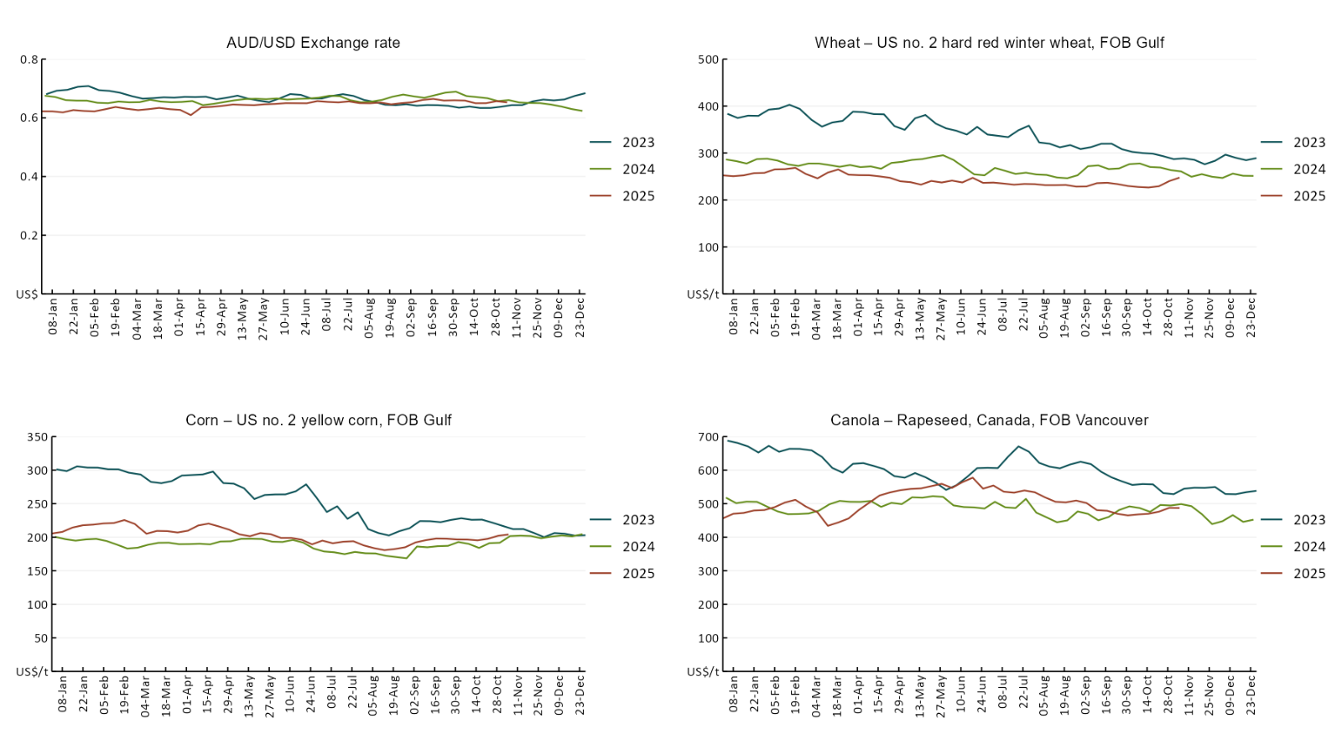

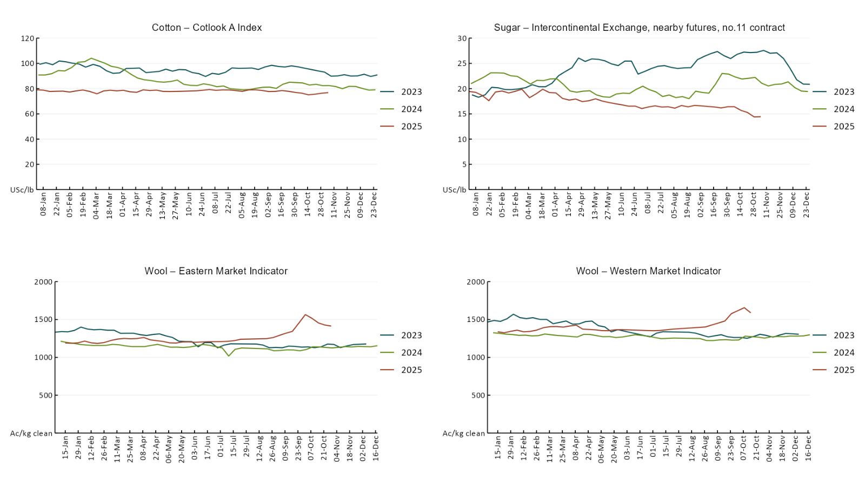

3.2 Selected domestic crop indicator prices
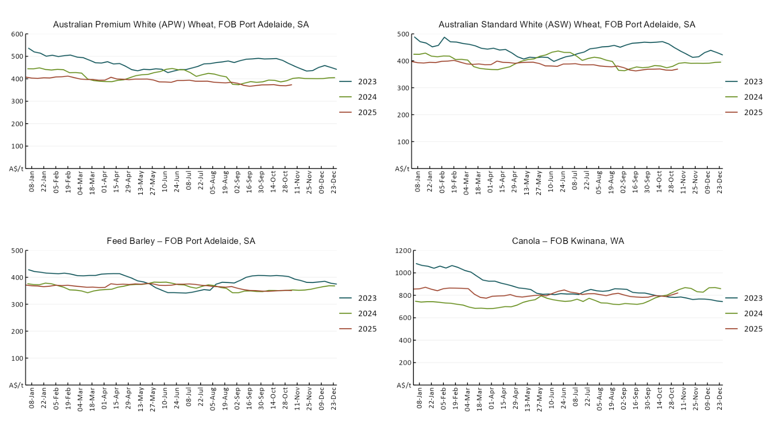
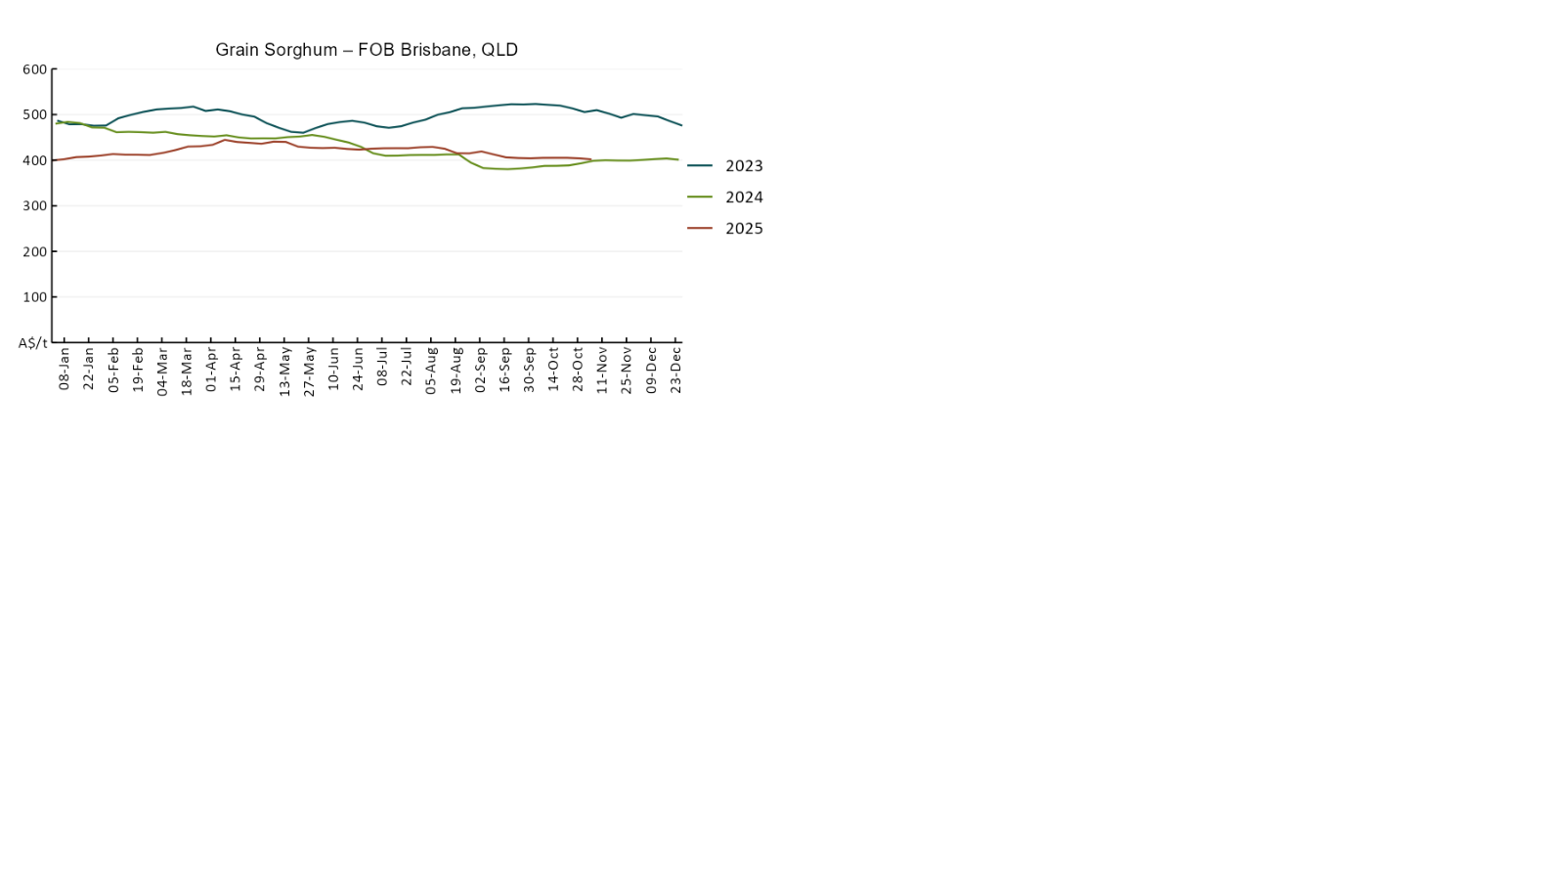

3.3 Selected domestic livestock indicator prices
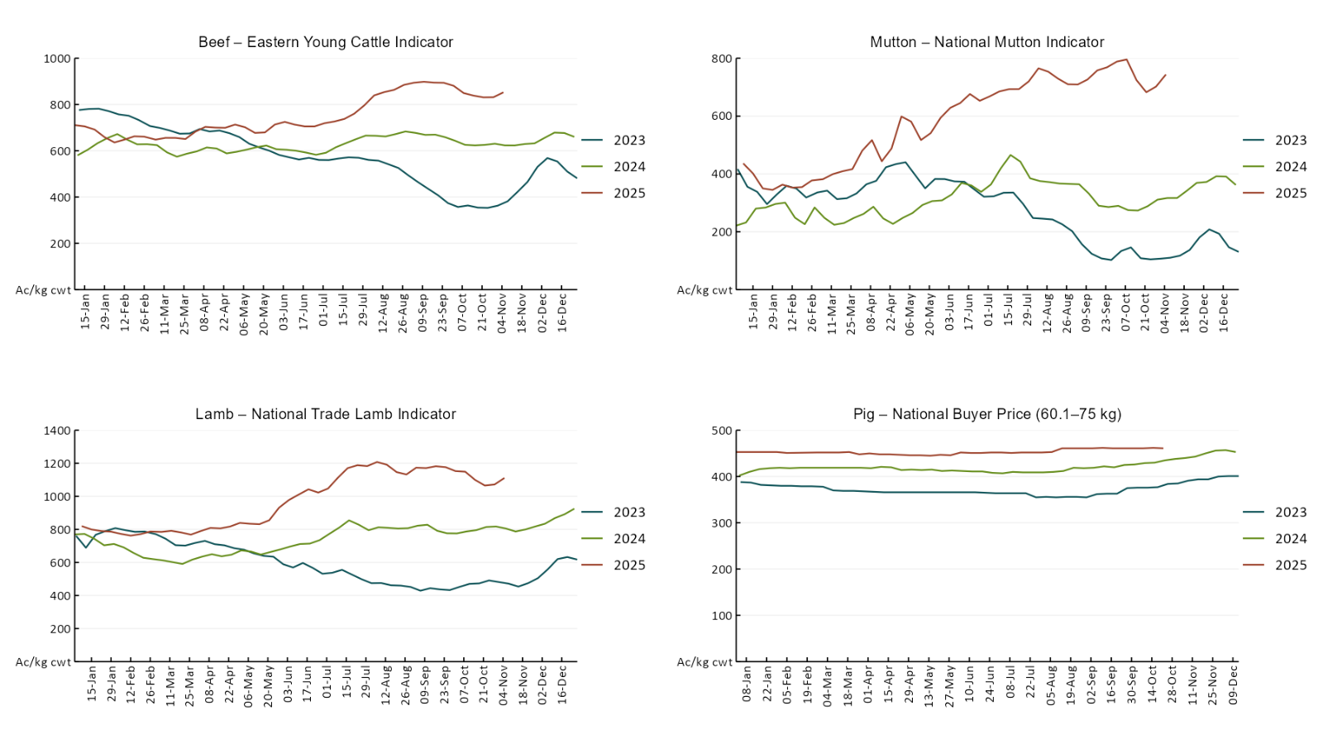
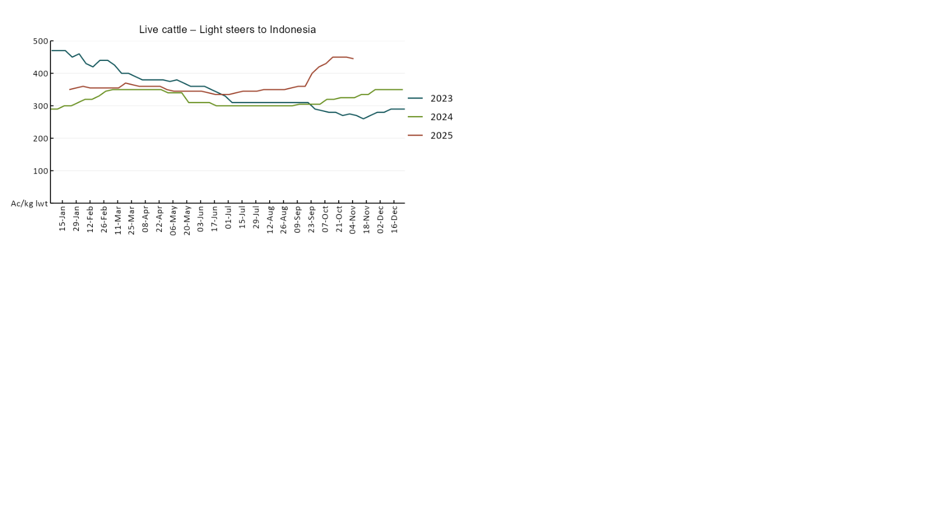

3.4 Global Dairy Trade (GDT) weighted average prices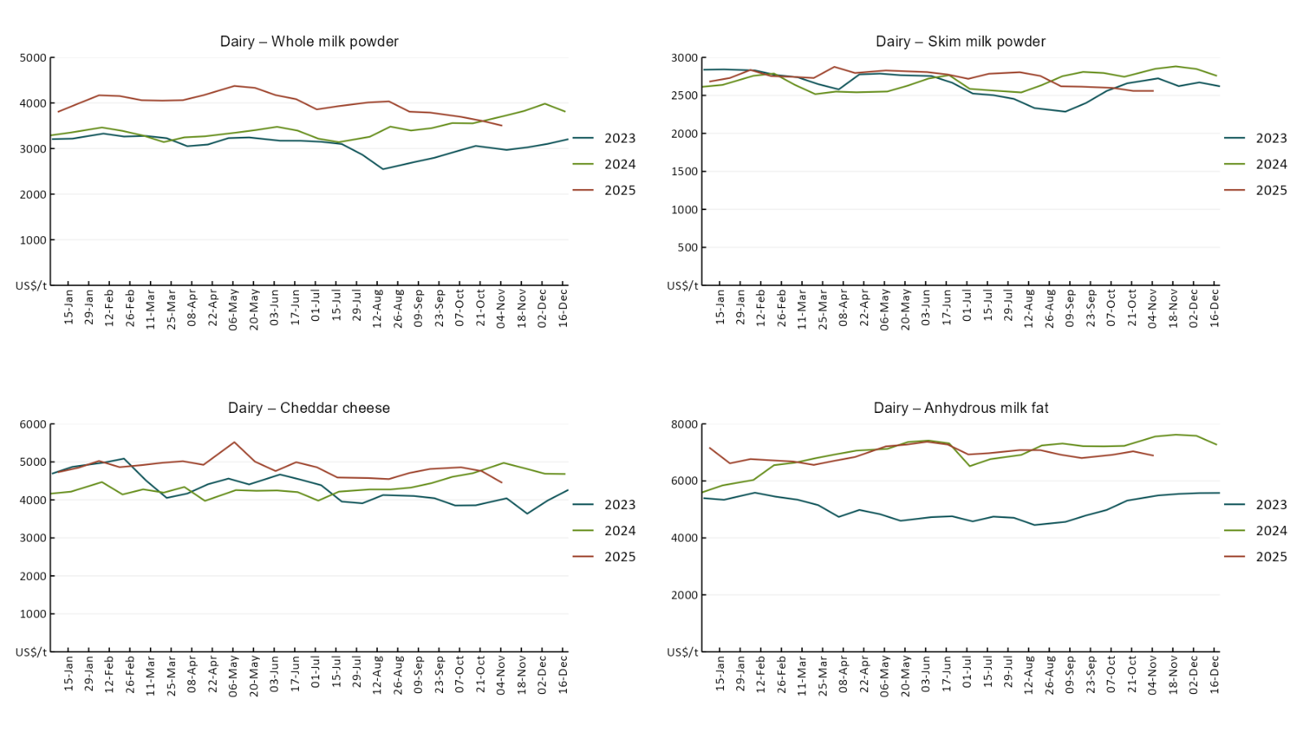

3.5 Selected fruit and vegetable prices

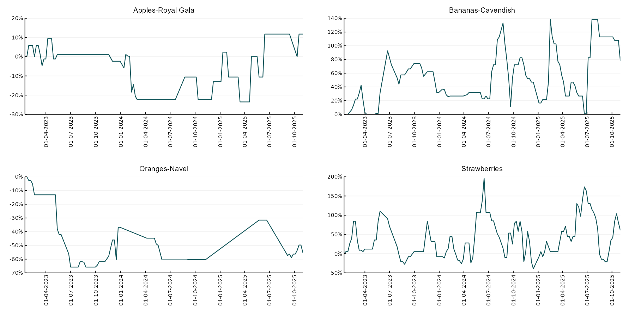

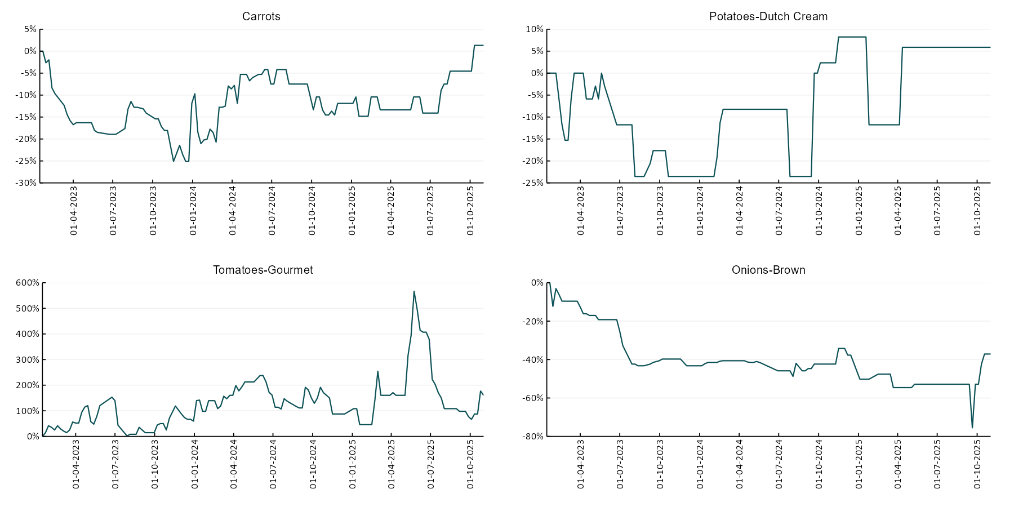

3.6 Selected domestic fodder indicator prices
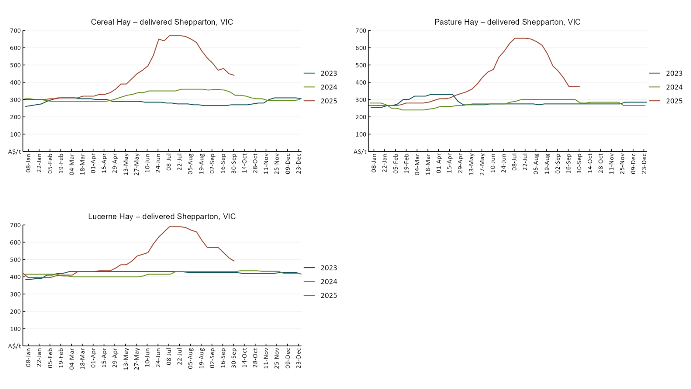

4. Data attribution

Climate
Bureau of Meteorology
- Weekly rainfall totals: www.bom.gov.au/climate/maps/rainfall/
- Monthly and last 3-month rainfall percentiles: https://www.bom.gov.au/climate/ahead/outlooks/#moreMaps
- Rainfall forecast: www.bom.gov.au/jsp/watl/rainfall/pme.jsp
- Seasonal outlook: www.bom.gov.au/climate/outlooks/#/overview/summary/
- Climate drivers: http://www.bom.gov.au/climate/enso/
- Soil moisture: https://awo.bom.gov.au/products/historical/soilMoisture-rootZone/

Other
- Pasture growth: www.longpaddock.qld.gov.au/aussiegrass/
- 3-month global outlooks: Environment and Climate Change Canada, NOAA Climate Prediction Center, EUROBRISA CPTEC/INPE, European Centre for Medium-Range Weather Forecasts, Hydrometcenter of Russia, National Climate Center Climate System Diagnosis and Prediction Room (NCC), International Research Institute for Climate and Society
- Global production: https://ipad.fas.usda.gov/ogamaps/cropmapsandcalendars.aspx
- Autumn break: Pook et al., 2009, https://rmets-onlinelibrary-wiley-com.virtual.anu.edu.au/doi/epdf/10.1002/joc.1833

Water
Prices
- Waterflow: https://www.waterflow.io/
- Ruralco: https://www.ruralcowater.com.au/
- Bureau of Meteorology:
- Allocation trade: http://www.bom.gov.au/water/dashboards/#/water-markets/mdb/at
- Storage volumes: http://www.bom.gov.au/water/dashboards/#/water-storages/summary/drainage

Trade constraints:
- Water NSW: https://www.waternsw.com.au/customer-service/ordering-trading-and-pricing/trading/murrumbidgee
- Victorian Water Register: https://www.waterregister.vic.gov.au/TradingRules2019/

Commodities
Fruit and vegetables
- Datafresh: www.freshstate.com.au

Pigs
- Australian Pork Limited: www.australianpork.com.au

Dairy
- Global Dairy Trade: www.globaldairytrade.info/en/product-results/

World wheat, canola
- International Grains Council
- https://www.igc.int/en/default.aspx
- United States Department of Agriculture

World cotton
- Cotlook: www.cotlook.com/

World sugar
- New York Stock Exchange - Intercontinental Exchange

Wool
- Australian Wool Exchange: www.awex.com.au/

Domestic wheat, barley, sorghum, canola and fodder
- Jumbuk Consulting Pty Ltd: Jumbuk AG | Agriculture Consulting

Cattle, beef, mutton, lamb, goat and live export
- Meat and Livestock Australia: https://www.mla.com.au/prices-markets/

© Commonwealth of Australia 2025

Ownership of intellectual property rights
Unless otherwise noted, copyright (and any other intellectual property rights, if any) in this publication is owned by the Commonwealth of Australia (referred to as the Commonwealth).

Creative Commons licence
All material in this publication is licensed under a Creative Commons Attribution 4.0 International Licence except content supplied by third parties, logos and the Commonwealth Coat of Arms.
Inquiries about the licence and any use of this document should be emailed to copyright@awe.gov.au.


Cataloguing data
This publication (and any material sourced from it) should be attributed as:
ABARES 2025, Weekly Australian Climate, Water and Agricultural Update, Australian Bureau of Agricultural and Resource Economics and Sciences, Canberra, 6 November 2025. CC BY 4.0 DOI: https://doi.org/10.25814/5f3e04e7d2503
ISSN 2652-7561
This publication is available at https://www.agriculture.gov.au/abares/products/weekly_update
Department of Agriculture, Fisheries and Forestry
GPO Box 858 Canberra ACT 2601
Telephone 1800 900 090
Web agriculture.gov.au/abares

Disclaimer
The Australian Government acting through the Department of Agriculture, Fisheries and Forestry, represented by the Australian Bureau of Agricultural and Resource Economics and Sciences, has exercised due care and skill in preparing and compiling the information and data in this publication. Notwithstanding, the Department of Agriculture, Fisheries and Forestry, ABARES, its employees and advisers disclaim all liability, including liability for negligence and for any loss, damage, injury, expense or cost incurred by any person as a result of accessing, using or relying on any of the information or data in this publication to the maximum extent permitted by law.

Statement of Professional Independence
The views and analysis presented in ABARES publications, including this one, reflect ABARES professionally independent findings, based on scientific and economic concepts, principles, information and data. These views, analysis and findings may not reflect or be consistent with the views or positions of the Australian Government, or of organisations or groups who have commissioned ABARES reports or analysis. More information on professional independence is provided on the ABARES website.

Acknowledgements
This report was prepared by Holly Beale and Matt Miller.

