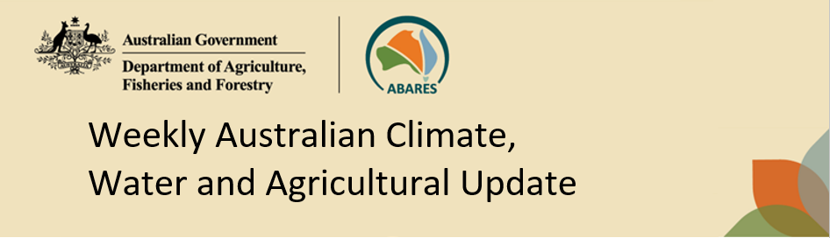
No. 45/2025 13 November 2025

Summary of key issues
- In the week ending 12 November 2025, rainfall was recorded across scattered areas of Australia.
  - Across cropping regions, rainfall outcomes were mixed.
    - For those cropping regions that recorded rainfall this week, it is likely to support production outcomes for winter crops in late development stages but may have continued to disrupt winter crop harvest activities where crops are ready for harvest.
    - Ongoing dry conditions across northern Victoria, South Australia and southern New South Wales continue to present an increased downside production risk for pastures and winter crops.
- Over the coming eight days to 20 November 2025, limited rainfall is expected across most southern cropping regions, while cropping regions in Queensland and northern New South Wales are likely to see higher rainfall totals.
  - At this late stage of the winter growing season, the light falls forecast for many southern growing regions will be of little benefit to crop and pasture production.
  - If realised the heavier falls forecast in north-eastern cropping regions are expected to disrupt ongoing harvest of winter crops and planting of summer crops in affected regions. However, across summer cropping regions these falls will likely provide a substantial boost to soil moisture levels and support the germination and growth of crops already in the ground.
- The national rainfall outlook for December 2025 to February 2026 indicates an increased probability of above median rainfall across much of eastern Australia.
  - If realised, above median rainfall would support summer pasture growth across eastern Australia. Additionally, these expected above average falls are likely to be sufficient to support above average yield expectations for summer crops.
- Water storage levels in the Murray-Darling Basin (MDB) decreased by 98 gigalitres (GL) between 6 November 2025 and 13 November 2025. The current volume of water held in storages is 14,689 GL, equivalent to 66% of total storage capacity. This is 11 percentage points or 1,821 GL less than the same time last year. Water storage data is sourced from the Bureau of Meteorology.
- Allocation prices in the Victorian Murray below the Barmah Choke decreased from $308/ML on 6 November 2025 to $298/ML on 13 November 2025.

Climate

Rainfall this week
In the week ending 12 November 2025, low-pressure troughs brought rainfall and storms to northern Australia, including large areas of northern Western Australia and the Northern Territory. Further south, cold fronts brought rainfall to much of Tasmania, Victoria, and parts of southern Western Australia.
Across cropping regions, rainfall outcomes were highly variable for the week ending 12 November 2025.
- Scattered areas of Queensland, northern New South Wales, and Western Australia saw falls of between 5-25 millimetres, likely disrupting remaining harvesting in affected areas.
- Cropping regions in Victoria, South Australia, and remaining areas of New South Wales, Queensland and Western Australia received little to no rainfall during the past week.
  - Little to no rainfall across large areas of southern Australia would have provided for an uninterrupted harvest of winter crops and hay where harvest has commenced. In southern areas which did not receive rainfall last week, another dry week may likely see further declines in grain yields in later sown crops and farmers will be continuing to make decisions on whether to cut these crops for hay or turn them over for livestock grazing as grain yield and relative returns for grain compared to hay continue to decline.

Rainfall for the week ending 12 November 2025
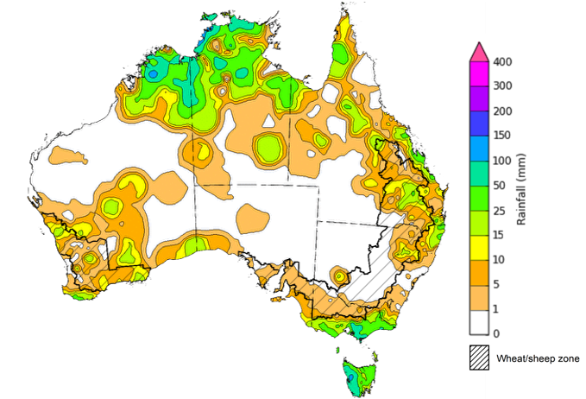
©Commonwealth of Australia 2025, Australian Bureau of Meteorology Issued: 12/11/2025
Note: The rainfall analyses and associated maps utilise data contained in the Bureau of Meteorology climate database, the Australian Data Archive for Meteorology (ADAM). The analyses are initially produced automatically from real-time data with limited quality control. They are intended to provide a general overview of rainfall across Australia as quickly as possible after the observations are received. For further information go to http://www.bom.gov.au/climate/rainfall/

Rainfall forecast for the next eight days
Over the 8 days to 20 November 2025, low-pressure systems are expected to bring rainfall to large areas of northern and eastern Australia, while high-pressure systems are expected to keep much of Western Australia, South Australia, and western New South Wales dry.
Limited rainfall is expected across most southern cropping regions this week, while those in Queensland and northern New South Wales are likely to see higher rainfall totals.
- Falls of between 1-10 millimetres are forecast in most cropping regions in western and southern New South Wales, Western Australia, northern Victoria and eastern South Australia.
  - At this late stage of the winter growing season, these light falls will be of little benefit to crop and pasture production
- Falls of between 10-25 millimetres are forecast for some cropping regions in southern Victoria and central and western South Australia
  - If realised these falls may supply some much-needed moisture for crop in their final grain fill stages in far southern cropping areas and may provide some useful late spring pasture growth.
- In Queensland and north-eastern areas of New South Wales, falls of 10-100 millimetres are expected.
  - If realised these falls are expected to disrupt ongoing harvest of winter crops and planting of summer crops in affected regions. However, across summer cropping regions in northern New South Wales and Queensland these falls will likely provide a substantial boost to soil moisture levels and support the germination and growth of crops already in the ground.

Total forecast rainfall for the period 13 November to 20 November 2025
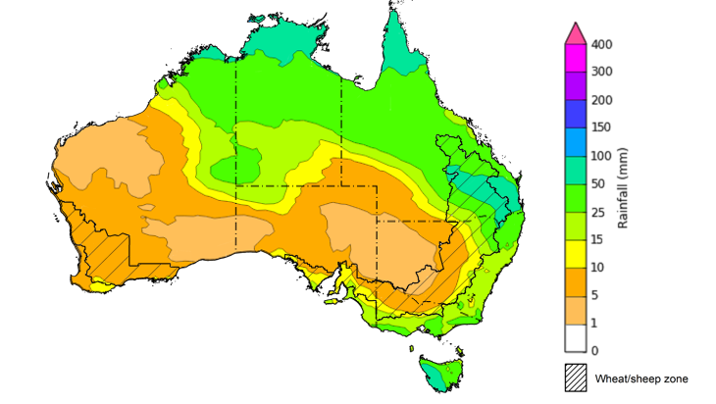
©Commonwealth of Australia 2025, Australian Bureau of Meteorology Issued 13/11/2025
Note: This rainfall forecast is produced from computer models. As the model outputs are not altered by weather forecasters, it is important to check local forecasts and warnings issued by the Bureau of Meteorology.

National Climate Outlook
The El Niño Southern Oscillation (ENSO) and Southern Annular Mode (SAM) are currently neutral and having minimal influence on Australian rainfall. However, the Indian Ocean Dipole (IOD) Index is currently under negative conditions. A negative IOD typically results in above-average spring rainfall over parts of southern Australia.
The most recent rainfall outlook for December 2025 provided by the Bureau of Meteorology indicates that large areas of eastern Australia are more likely to see above median rainfall, with much of Western Australia, the Northern Territory, and western Tasmania more likely to see below average falls.
- The Bureau of Meteorology’s climate model indicates a 75% chance of December rainfall totals between 10-100 millimetres across much of eastern and northern Australia, with higher rainfall totals of up to 200 millimetres expected in the Northern Tropics and parts of north-eastern New South Wales. Much of southern Western Australia, much of South Australia and western areas of New South Wales and Queensland are likely to see little to no rainfall.
- Across cropping regions, there is a 75% chance of receiving rainfall totals of between 25- 100 millimetres across much of Queensland and New South Wales. Meanwhile much of Victoria and south-western New South Wales are likely to see 10-25 millimetres of rainfall, with South Australia and Western Australia is likely to see 0-10 millimetres.
  - If realised, these relatively low expected rainfall totals across much of southern Australia continue to represent a significant downside risk for pasture growth over summer, particularly given the lack of rainfall in recent weeks and declining soil moisture levels across large areas. However, if forecast rainfall totals are realised across much of New South Wales and Queensland, these falls are likely to be sufficient to support above average yield prospects for summer crops and average or better levels of pasture production.

Rainfall totals that have a 75% chance of occurring in December 2025
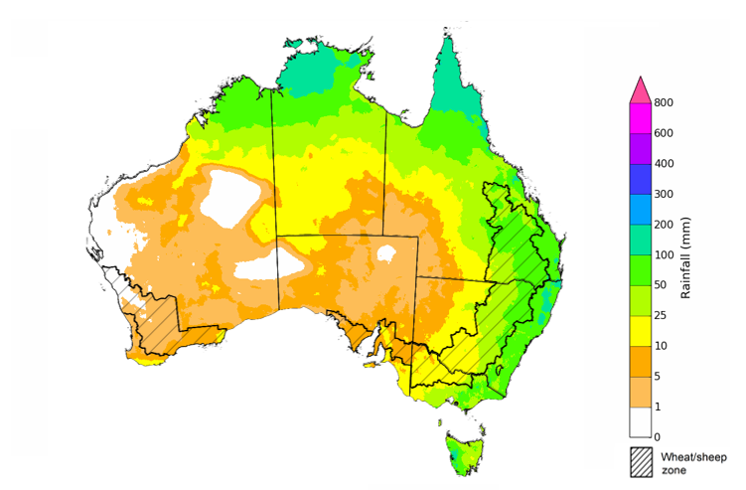
©Commonwealth of Australia 2025, Australian Bureau of Meteorology Issued:6/11/2025
The rainfall outlook for December 2025 to February 2026 indicates an increased probability of above median rainfall across large areas of eastern Australia, including much of eastern Queensland, New South Wales and isolated parts of Victoria. Large areas of Western Australia, the Northern Territory, and western Tasmania are more likely to see below median rainfall, while remaining areas have an equal probability of above or below average rainfall
Across cropping regions, the chance of receiving above median rainfall is 55-65% across Queensland, New South Wales, Victoria, and South Australia. In Western Australia, the probability of above median rainfall is lower at 35-55%. If above median rainfall is realised across eastern Australia, this rainfall is likely to support soil moisture levels in eastern regions for summer crop and pasture growth.
Chance of exceeding the median rainfall December 2025 to February 2026
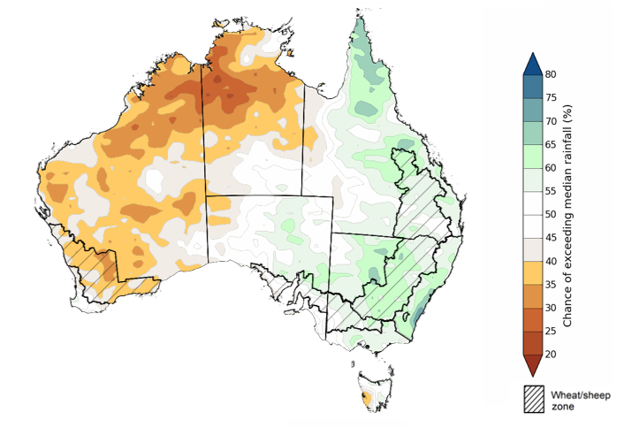
©Commonwealth of Australia 2025, Australian Bureau of Meteorology Issued: 6/11/2025
The rainfall outlook for December 2025 to February 2026 suggests a 75% chance of receiving rainfall totals of between 50-400 millimetres across much of eastern and northern Australia. Between 400-1200 millimetres are expected across scattered east coast regions as well as large areas of the northern tropics. Lower rainfall totals are forecast for south-western and central regions, with South Australia and southern Western Australia likely to see 10- 100 millimetres.
In cropping regions, there is a 75% chance of receiving between 100-200 millimetres across much of Queensland and northern New South Wales. Southern New South Wales is likely to see 50-100 millimetres. In Western Australia and South Australia, falls of 10-50 millimetres are expected, with Victoria likely to see 25-100 millimetres.
Given the winter crop harvest will be well underway across several regions, December through to February rainfall will have little influence on winter crop production prospects, other than its influence on harvest progress and quality. Meanwhile, if the forecast December through to February rainfall totals are realised, they are likely to be sufficient to support December to February pasture growth across eastern and northern Australia. Additionally, these expected falls are likely to be sufficient to support above average yield expectations for summer crops.
Rainfall totals that have a 75% chance of occurring December 2025 to February 2026
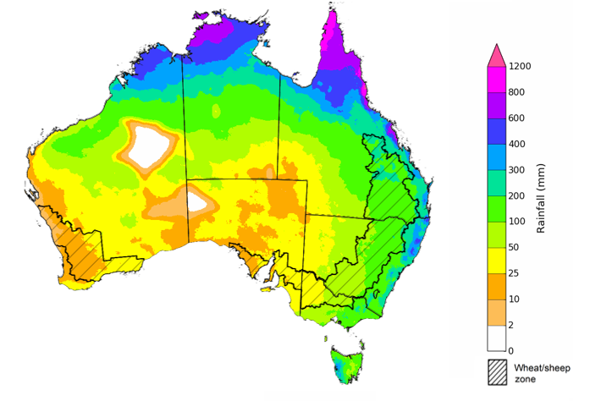
©Commonwealth of Australia 2025, Australian Bureau of Meteorology Issued: 6/11/2025

Water markets – current week

Water storage levels in the Murray-Darling Basin (MDB) decreased by 98 gigalitres (GL) between 6 November 2025 and 13 November 2025. The current volume of water held in storages is 14,689 GL, equivalent to 66% of total storage capacity. This is 11 percentage points or 1,821 GL less than the same time last year. Water storage data is sourced from the Bureau of Meteorology.

Water storages in the Murray-Darling Basin, 2013–2025
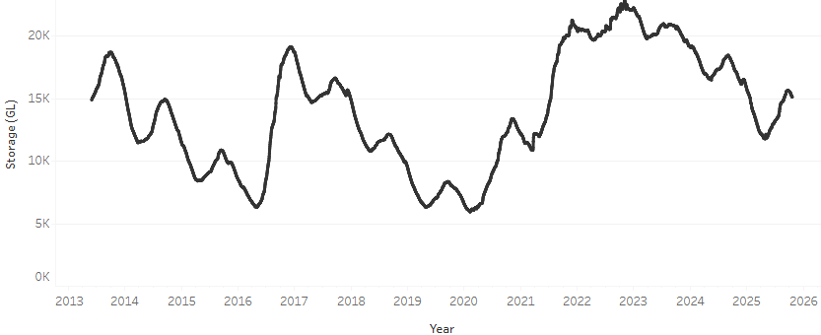
Allocation prices in the Victorian Murray below the Barmah Choke decreased from $308/ML on 6 November 2025 to $298/ML on 13 November 2025. Trade from the Goulburn to the Murray is closed. Trade downstream through the Barmah Choke is closed. Trade from the Murrumbidgee to the Murray is closed.

Water market prices, Southern Murray–Darling Basin

Region | $/ML
NSW Murray Above | 254
NSW Murrumbidgee | 279
Vic Greater Goulburn | 283
Vic Murray Below | 298

Note: The water allocation prices shown are volume weighted average prices based on the last 10 trades. Price data is sourced from Waterflow and current as at 30 October 2025.
To access the full, interactive, weekly water dashboard, which contains the latest and historical water storage, water market and water allocation information, please visit https://www.agriculture.gov.au/abares/products/weekly_update/weekly-update-131125

Commodities
Indicator | Week average | Unit | Latest Price | Previous Week | Weekly change |  | Price 12 months ago | Annual change
Selected world indicator prices
AUD/USD Exchange rate | 12-Nov | A$/US$ | 0.65 | 0.65 | 0% | 0.65 |  | 0%
Wheat – US no. 2 hard red winter wheat, FOB Gulf | 12-Nov | US$/t | 248 | 246 | 1% | 254 |  | -2%
Corn – US no. 2 yellow corn, FOB Gulf | 12-Nov | US$/t | 204 | 203 | 0% | 201 |  | 2%
Canola – Rapeseed, Canada, FOB Vancouver | 12-Nov | US$/t | 490 | 484 | 1% | 475 |  | 3%
Cotton – Cotlook A Index | 12-Nov | USc/lb | 75.5 | 76.6 | -1% | 81.4 |  | -7%
Sugar – Intercontinental Exchange, nearby futures, no.11 contract | 12-Nov | USc/lb | 14.2 | 14.3 | 0% | 20.8 |  | -32%
Wool – Eastern Market Indicator | 12-Nov | Ac/kg clean | 1,458 | 1,419 | 3% | 1,139 |  | 28%
Wool – Western Market Indicator | 12-Nov | Ac/kg clean | 1,585 | 1,588 | 0% | 1,276 |  | 24%
Selected Australian grain export prices
Australian Premium White (APW) Wheat, FOB Port Adelaide, SA | 12-Nov | A$/t | 373 | 374 | 0% | 402 |  | -7%
Australian Standard White (ASW) Wheat, FOB Port Adelaide, SA | 12-Nov | A$/t | 369 | 370 | 0% | 392 |  | -6%
Feed Barley – FOB Port Adelaide, SA | 12-Nov | A$/t | 347 | 350 | -1% | 353 |  | -2%
Canola – FOB Kwinana, WA | 12-Nov | A$/t | 811 | 820 | -1% | 853 |  | -5%
Grain Sorghum – FOB Brisbane, QLD | 12-Nov | A$/t | 404 | 401 | 1% | 399 |  | 1%
Selected domestic livestock indicator prices
Beef – Eastern Young Cattle Indicator | 12-Nov | Ac/kg cwt | 875 | 856 | 2% | 627 |  | 40%
Mutton – Mutton indicator (18–24 kg fat score 2–3), VIC | 12-Nov | Ac/kg cwt | 730 | 741 | -2% | 336 |  | 117%
Lamb – National Trade Lamb Indicator | 12-Nov | Ac/kg cwt | 1,140 | 1,119 | 2% | 803 |  | 42%
Pig – Eastern Seaboard (60.1–75 kg), NSW buyer price | 29-Oct | Ac/kg cwt | 461 | 461 | 0% | 447 |  | 3%
Live cattle – Light steers to Indonesia | 12-Nov | Ac/kg lwt | 450 | 445 | 1% | 336 |  | 34%
Global Dairy Trade (GDT) weighted average prices
Dairy – Whole milk powder | 5-Nov | US$/t | 3,503 | 3,610 | -3% | 3,770 |  | -7%
Dairy – Skim milk powder | 5-Nov | US$/t | 2,559 | 2,559 | 0% | 2,866 |  | -11%
Dairy – Cheddar cheese | 5-Nov | US$/t | 4,449 | 4,758 | -6% | 4,904 |  | -9%
Dairy – Anhydrous milk fat | 5-Nov | US$/t | 6,887 | 7,038 | -2% | 7,590 |  | -9%

Selected world indicator prices
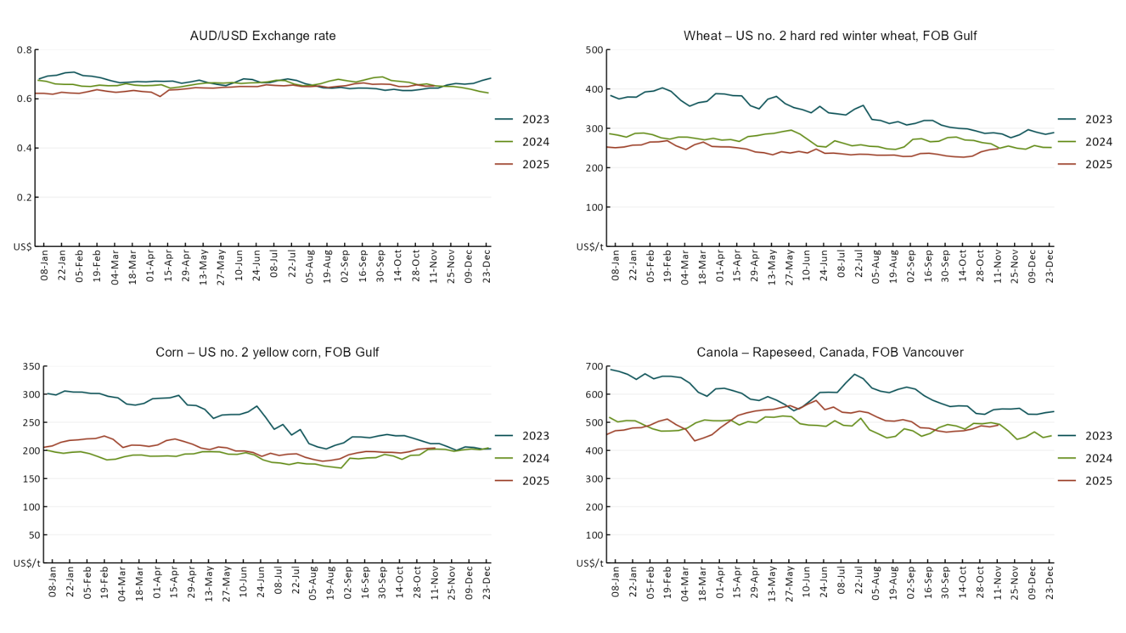

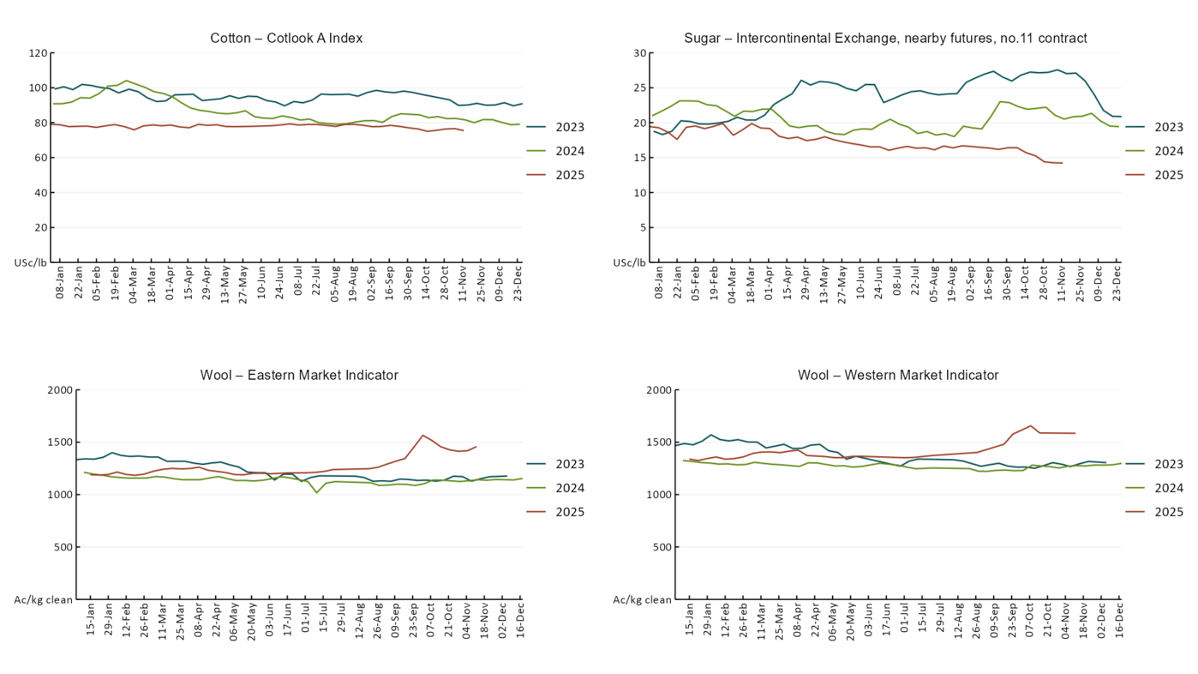

3.2 Selected domestic crop indicator prices
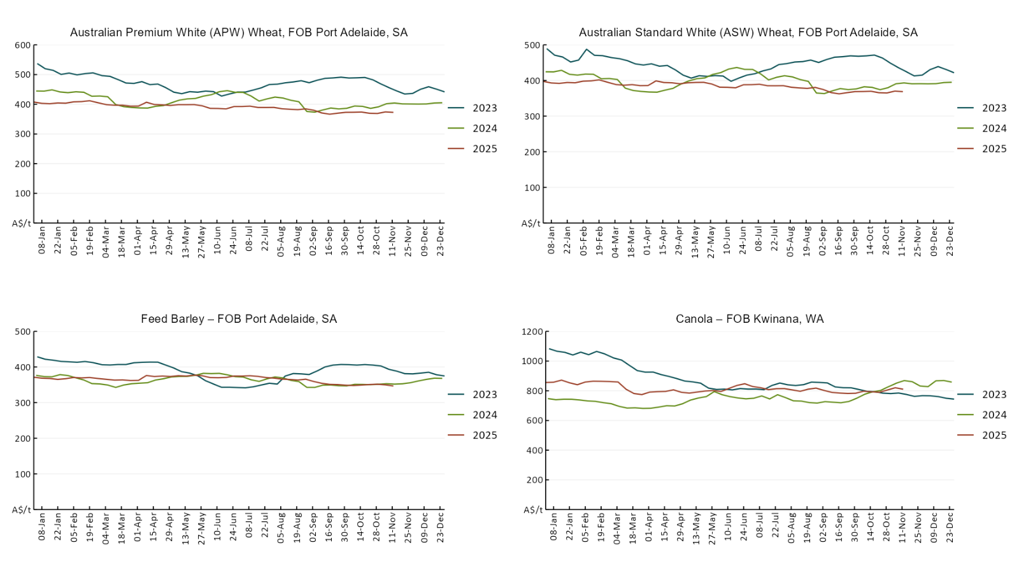
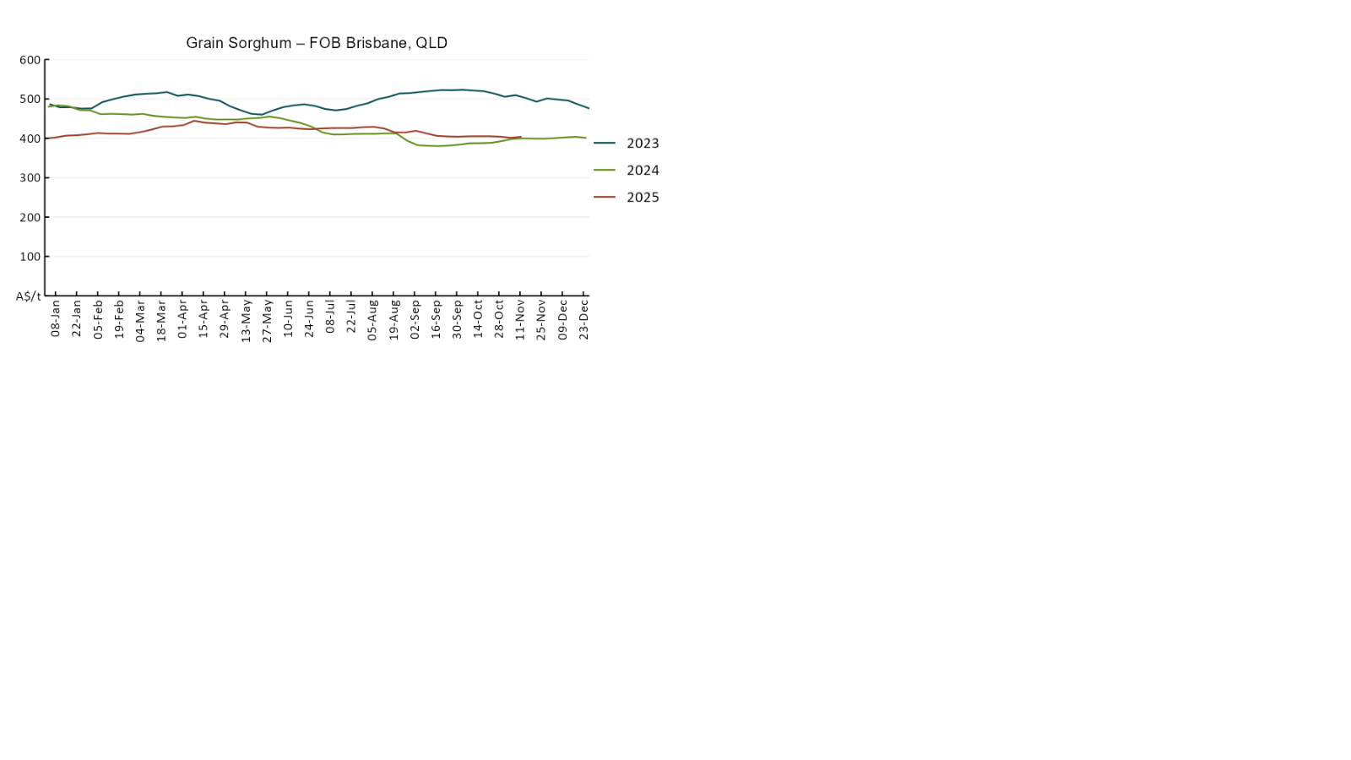

3.3 Selected domestic livestock indicator prices
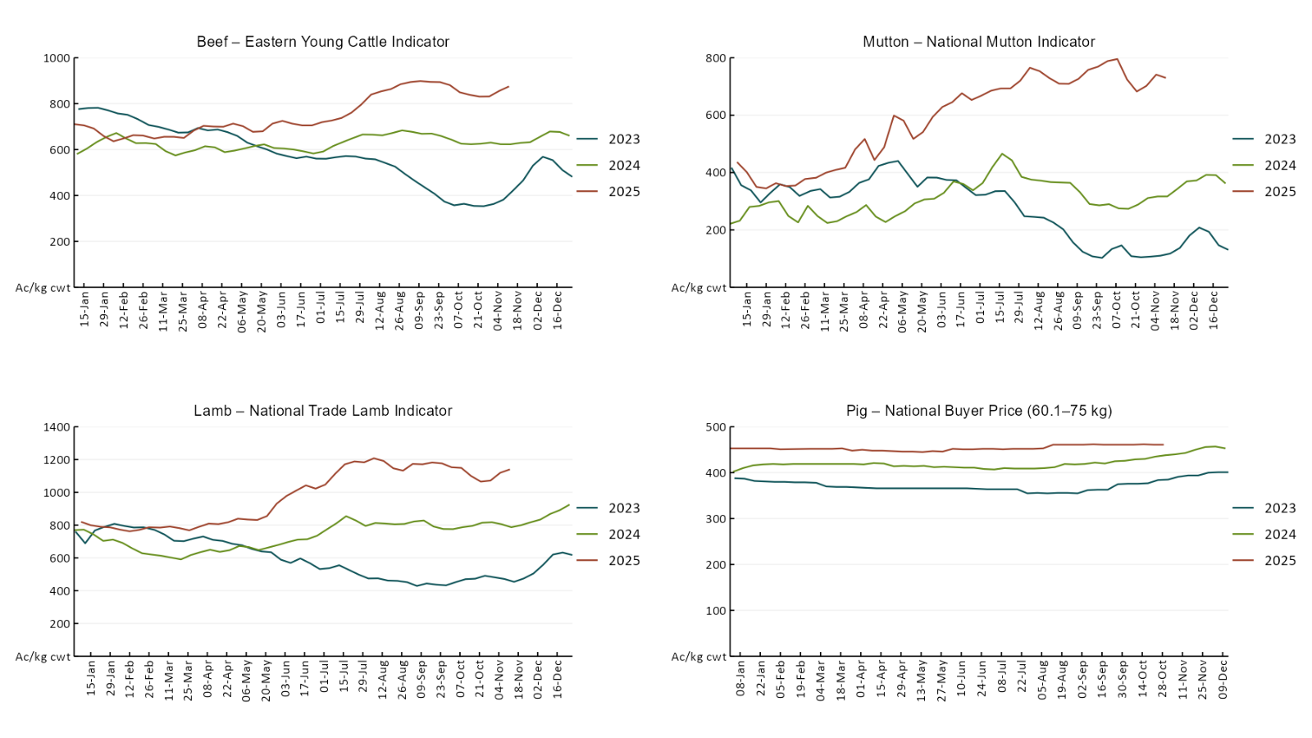
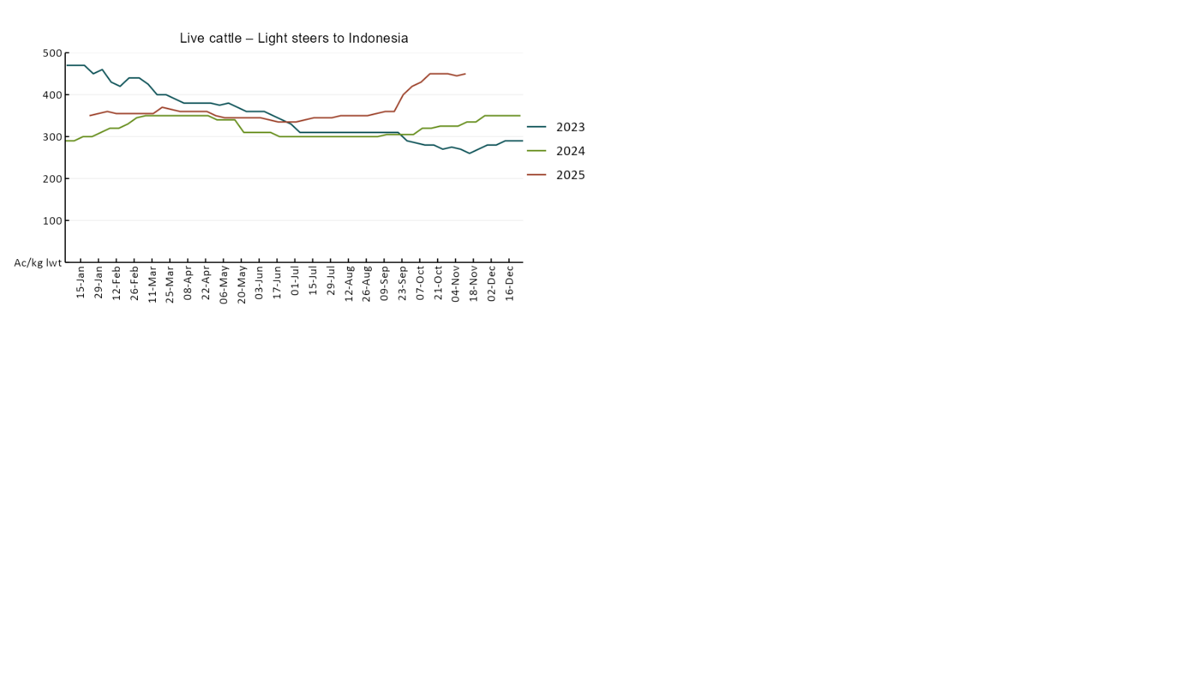

3.4 Global Dairy Trade (GDT) weighted average prices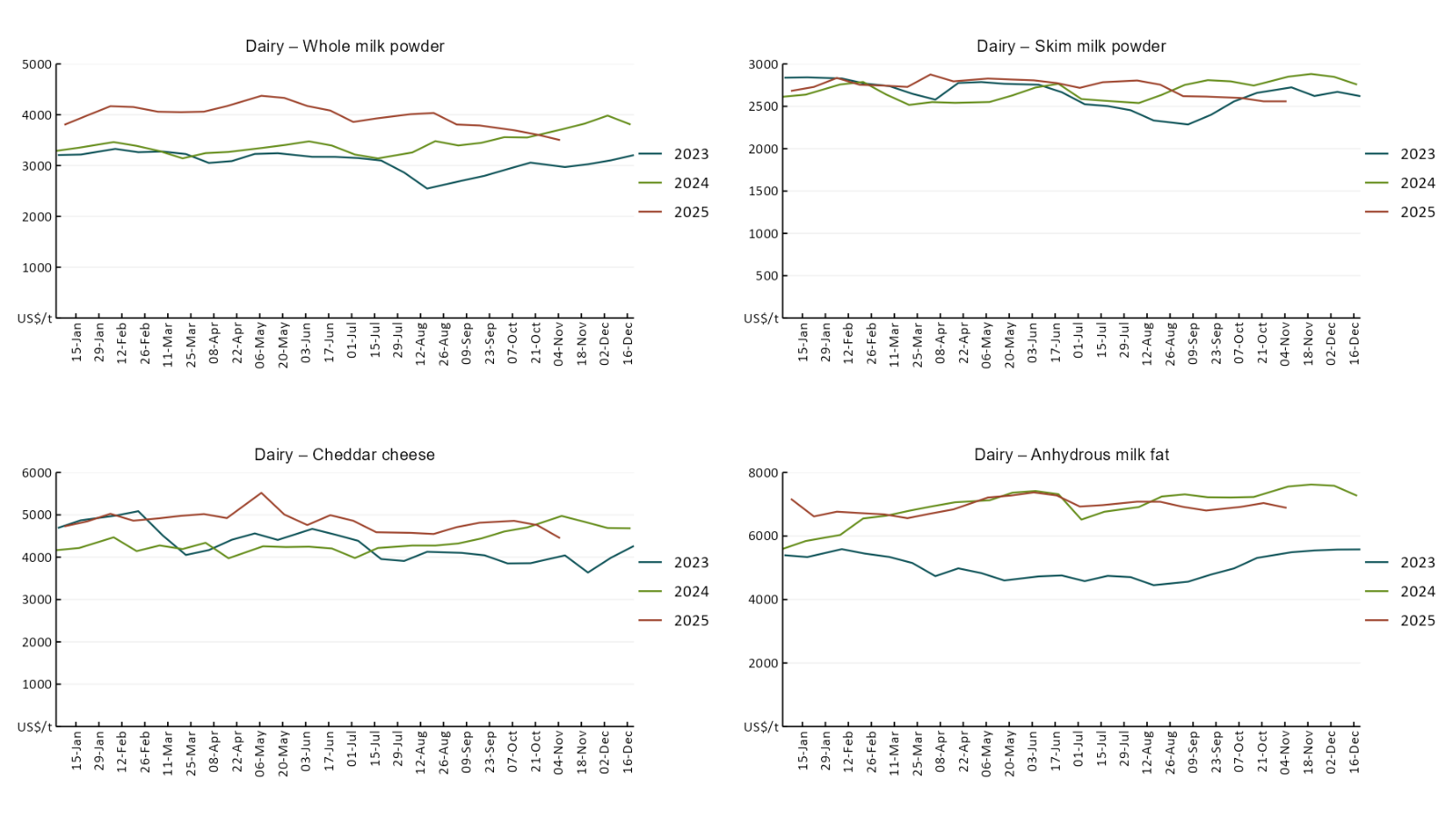

3.5 Selected fruit and vegetable prices

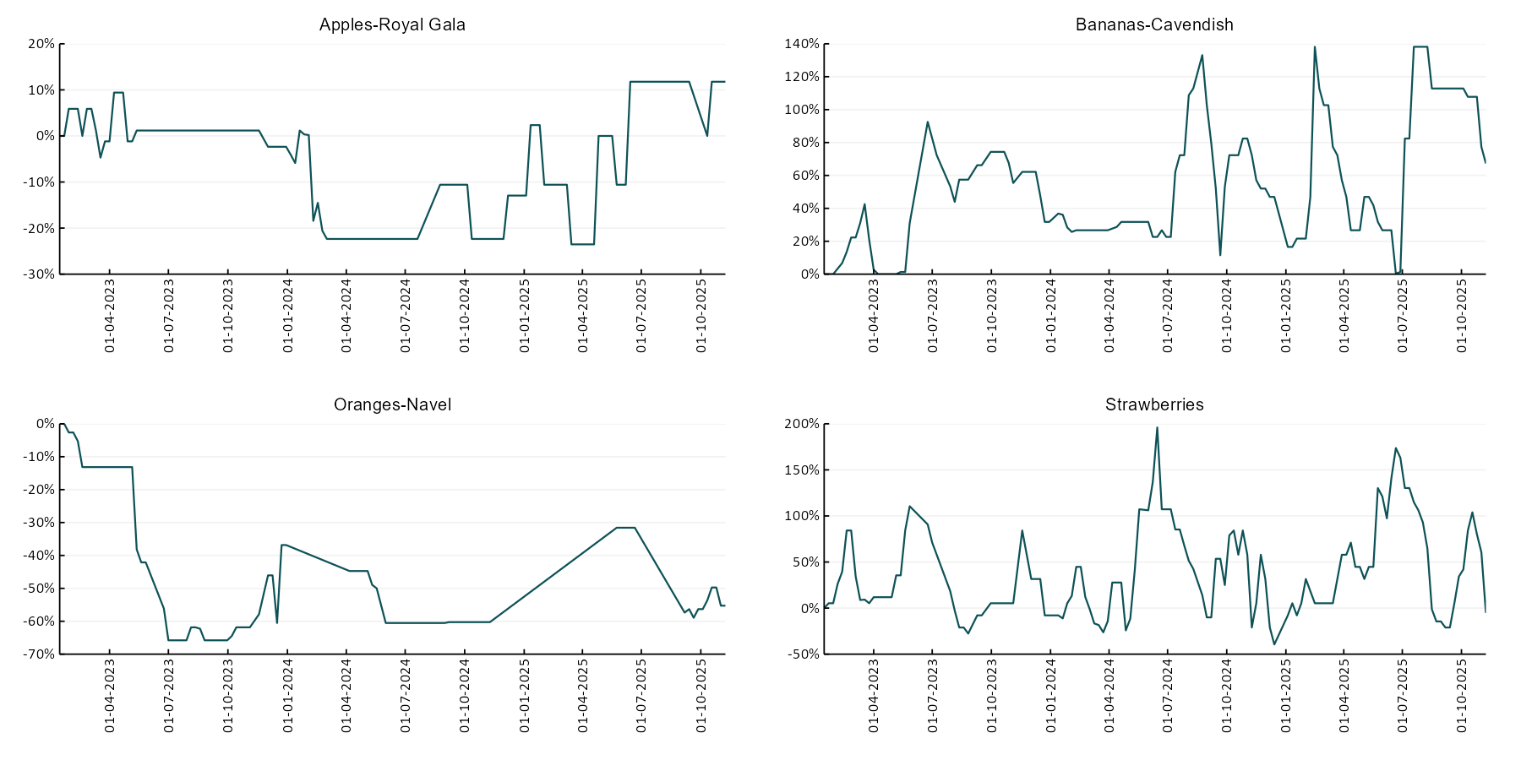

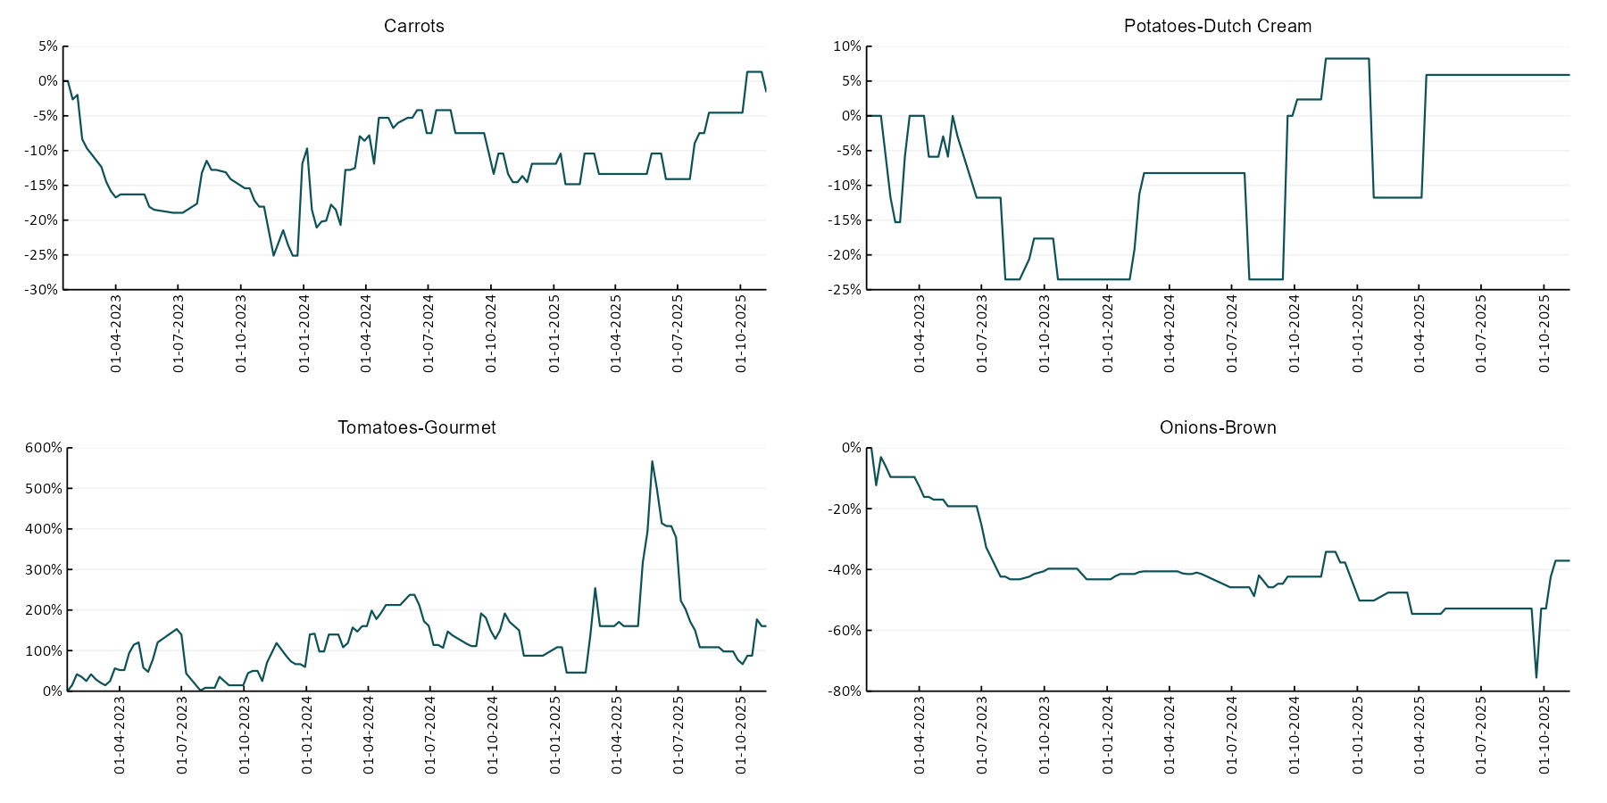

3.6 Selected domestic fodder indicator prices
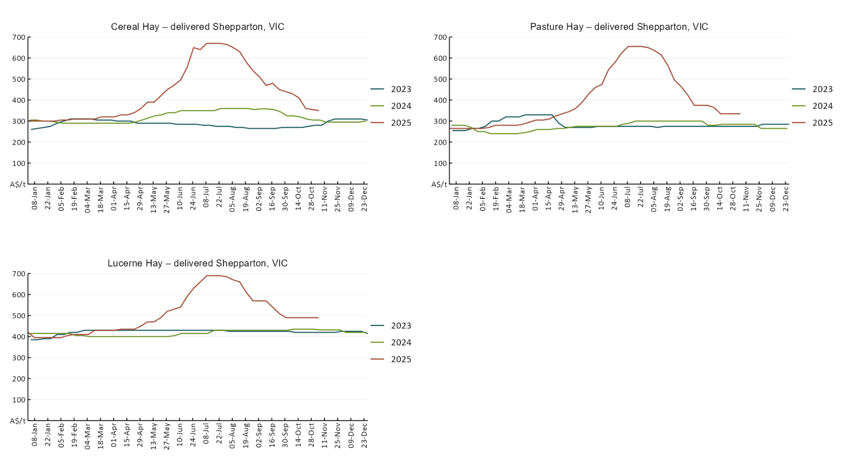

4. Data attribution

Climate
Bureau of Meteorology
- Weekly rainfall totals: www.bom.gov.au/climate/maps/rainfall/
- Monthly and last 3-month rainfall percentiles: https://www.bom.gov.au/climate/ahead/outlooks/#moreMaps
- Rainfall forecast: www.bom.gov.au/jsp/watl/rainfall/pme.jsp
- Seasonal outlook: www.bom.gov.au/climate/outlooks/#/overview/summary/
- Climate drivers: http://www.bom.gov.au/climate/enso/
- Soil moisture: https://awo.bom.gov.au/products/historical/soilMoisture-rootZone/

Other
- Pasture growth: www.longpaddock.qld.gov.au/aussiegrass/
- 3-month global outlooks: Environment and Climate Change Canada, NOAA Climate Prediction Center, EUROBRISA CPTEC/INPE, European Centre for Medium-Range Weather Forecasts, Hydrometcenter of Russia, National Climate Center Climate System Diagnosis and Prediction Room (NCC), International Research Institute for Climate and Society
- Global production: https://ipad.fas.usda.gov/ogamaps/cropmapsandcalendars.aspx
- Autumn break: Pook et al., 2009, https://rmets-onlinelibrary-wiley-com.virtual.anu.edu.au/doi/epdf/10.1002/joc.1833

Water
Prices
- Waterflow: https://www.waterflow.io/
- Ruralco: https://www.ruralcowater.com.au/
- Bureau of Meteorology:
- Allocation trade: http://www.bom.gov.au/water/dashboards/#/water-markets/mdb/at
- Storage volumes: http://www.bom.gov.au/water/dashboards/#/water-storages/summary/drainage

Trade constraints:
- Water NSW: https://www.waternsw.com.au/customer-service/ordering-trading-and-pricing/trading/murrumbidgee
- Victorian Water Register: https://www.waterregister.vic.gov.au/TradingRules2019/

Commodities
Fruit and vegetables
- Datafresh: www.freshstate.com.au

Pigs
- Australian Pork Limited: www.australianpork.com.au

Dairy
- Global Dairy Trade: www.globaldairytrade.info/en/product-results/

World wheat, canola
- International Grains Council
- https://www.igc.int/en/default.aspx
- United States Department of Agriculture

World cotton
- Cotlook: www.cotlook.com/

World sugar
- New York Stock Exchange - Intercontinental Exchange

Wool
- Australian Wool Exchange: www.awex.com.au/

Domestic wheat, barley, sorghum, canola and fodder
- Jumbuk Consulting Pty Ltd: Jumbuk AG | Agriculture Consulting

Cattle, beef, mutton, lamb, goat and live export
- Meat and Livestock Australia: https://www.mla.com.au/prices-markets/

© Commonwealth of Australia 2025

Ownership of intellectual property rights
Unless otherwise noted, copyright (and any other intellectual property rights, if any) in this publication is owned by the Commonwealth of Australia (referred to as the Commonwealth).

Creative Commons licence
All material in this publication is licensed under a Creative Commons Attribution 4.0 International Licence except content supplied by third parties, logos and the Commonwealth Coat of Arms.
Inquiries about the licence and any use of this document should be emailed to copyright@awe.gov.au.


Cataloguing data
This publication (and any material sourced from it) should be attributed as:
ABARES 2025, Weekly Australian Climate, Water and Agricultural Update, Australian Bureau of Agricultural and Resource Economics and Sciences, Canberra, 13 November 2025. CC BY 4.0 DOI: https://doi.org/10.25814/5f3e04e7d2503
ISSN 2652-7561
This publication is available at https://www.agriculture.gov.au/abares/products/weekly_update
Department of Agriculture, Fisheries and Forestry
GPO Box 858 Canberra ACT 2601
Telephone 1800 900 090
Web agriculture.gov.au/abares

Disclaimer
The Australian Government acting through the Department of Agriculture, Fisheries and Forestry, represented by the Australian Bureau of Agricultural and Resource Economics and Sciences, has exercised due care and skill in preparing and compiling the information and data in this publication. Notwithstanding, the Department of Agriculture, Fisheries and Forestry, ABARES, its employees and advisers disclaim all liability, including liability for negligence and for any loss, damage, injury, expense or cost incurred by any person as a result of accessing, using or relying on any of the information or data in this publication to the maximum extent permitted by law.

Statement of Professional Independence
The views and analysis presented in ABARES publications, including this one, reflect ABARES professionally independent findings, based on scientific and economic concepts, principles, information and data. These views, analysis and findings may not reflect or be consistent with the views or positions of the Australian Government, or of organisations or groups who have commissioned ABARES reports or analysis. More information on professional independence is provided on the ABARES website.

Acknowledgements
This report was prepared by Holly Beale and Matt Miller.

