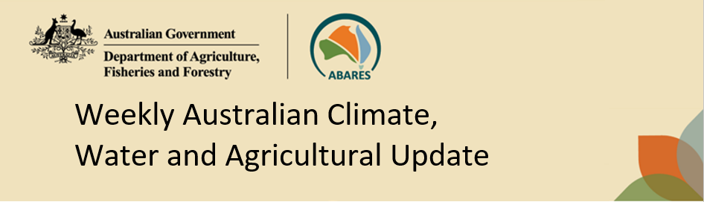
No. 46/2025 20 November 2025

Summary of key issues
- In the week ending 19 November 2025, rainfall was recorded across parts of northern, western and eastern Australia, while central areas remained comparably dry.
  - Across cropping regions, rainfall outcomes were low in southern areas with heavy fall recorded in the northeast.
    - For northern cropping regions these falls have likely boosted soil moisture levels and will support the growth of summer crops already in the ground and encourage further planting, but have likely disrupted harvest of winter crops in these areas.
    - Ongoing dry conditions across northern Victoria, South Australia and southern New South Wales continue to present an increased downside production risk for pastures and winter crops.
- Over the coming eight days to 27 November 2025, limited rainfall is expected across most southeastern cropping regions, while cropping regions in Queensland, southern Western Australia, and northern New South Wales are likely to see higher rainfall totals.
  - At this late stage of the winter growing season, the light falls forecast for many southern growing regions are unlikely to boost production, but may alleviate some of the increased downside production risk that has emerged in recent weeks due to dry conditions.
  - If realised the heavier falls forecast in north-eastern cropping regions are expected to cause some delays to the ongoing harvest of winter crops and planting of summer crops in affected regions. However, across summer cropping regions these falls will likely provide a substantial boost to soil moisture levels and support the germination and growth of crops already in the ground.
- Global production conditions were generally favourable for rice and soybeans, but more variable for maize and wheat. According to the most recent crop estimate numbers released by the USDA in November 2025, global production conditions have been slightly more favourable to those used to formulate ABARES 2025–26 forecasts of global grain supplies and world prices in the September 2025 Agricultural Commodities Report. As a result, global grain and oilseed production is likely to increase beyond the numbers in the September forecast.
- Water storage levels in the Murray-Darling Basin (MDB) decreased by 122 gigalitres (GL) between 13 November 2025 and 19 November 2025. The current volume of water held in storages is 14,567 GL, equivalent to 65% of total storage capacity. This is 11% or 1,754 GL less than the same time last year. Water storage data is sourced from the Bureau of Meteorology.
- Allocation prices in the Victorian Murray below the Barmah Choke increased from $298/ML on 13 November 2025 to $304/ML on 20 November 2025. Trade from the Goulburn to the Murray is closed. Trade downstream through the Barmah Choke is closed. Trade from the Murrumbidgee to the Murray is closed.

Climate

Rainfall this week
In the week ending 19 November 2025, low-pressure systems brought rainfall to northern, western and eastern Australia, including large areas of the northern tropics. Further south, cold fronts brought rainfall to much of Tasmania and southern Victoria.
Across cropping regions, rainfall totals were low across most southern regions, with heavy falls recorded across the northeast for the week ending 19 November 2025.
- Queensland cropping regions saw falls of between 5-100 millimetres, with higher rainfall totals in central and northern areas. In northern New South Wales, up to 50 millimetres was recorded.
  - These falls have boosted soil moisture levels and likely support the growth of summer crops already in the ground and encourage further planting, but have likely disrupted harvest in winter crops.
- Cropping regions in Victoria, South Australia, southern Western Australia, and southern and central New South Wales, received little to no rainfall during the past week. In northern cropping regions of Western Australia, falls of 5-15 millimetres occurred.
  - Little to no rainfall across large areas of southern Australia would have provided for an uninterrupted harvest of winter crops and hay where harvest has commenced. In southern areas which did not receive rainfall last week, another dry week may likely see further declines in grain yields in later sown crops.

Rainfall for the week ending 19 November 2025
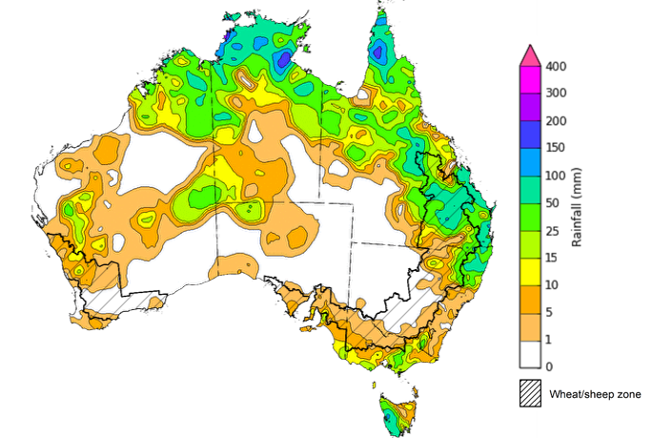

©Commonwealth of Australia 2025, Australian Bureau of Meteorology Issued: 19/11/2025
Note: The rainfall analyses and associated maps utilise data contained in the Bureau of Meteorology climate database, the Australian Data Archive for Meteorology (ADAM). The analyses are initially produced automatically from real-time data with limited quality control. They are intended to provide a general overview of rainfall across Australia as quickly as possible after the observations are received. For further information go to http://www.bom.gov.au/climate/rainfall/

Rainfall forecast for the next eight days
Over the 8 days to 27 November 2025, low-pressure systems and tropical cyclone Fina are expected to bring rainfall to northern and eastern Australia, while a cold front is expected bring rainfall to much of the south coast.
Limited rainfall is expected across most southern cropping regions this week, while those in Queensland and northern New South Wales are likely to see higher rainfall totals.
- Falls of between 5-15 millimetres are forecast in most southeastern cropping regions including eastern South Australia, Victoria, and southern New South Wales.
  - At this late stage of the winter growing season, the light falls forecast for many southern growing regions are unlikely to boost crop and pasture production, but may alleviate some of the increased downside production risk that has emerged in recent weeks due to dry conditions.
- Western Australia is forecast to see 1-5 millimetres in the north, while southern regions see 15- 50 millimetres.
- Falls of between 10-25 millimetres are forecast for cropping regions in Queensland and western South Australia, with northern and eastern parts of New South Wales is expected to see 25- 50 millimetres.
  - If realised these falls are expected to cause some delays to the ongoing harvest of winter crops and planting of summer crops in affected regions. However, across summer cropping regions in northern New South Wales and Queensland these falls will likely provide a substantial boost to soil moisture levels and support the germination and growth of crops already in the ground.

Total forecast rainfall for the period 20 November to 27 November 2025
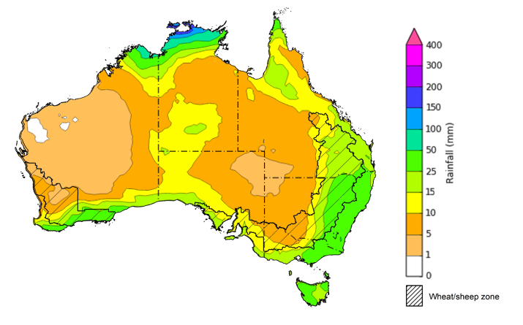
©Commonwealth of Australia 2025, Australian Bureau of Meteorology Issued 20/11/2025
Note: This rainfall forecast is produced from computer models. As the model outputs are not altered by weather forecasters, it is important to check local forecasts and warnings issued by the Bureau of Meteorology.

October precipitation percentiles and current production conditions
Crop production is affected by long-term trends in average rainfall and temperature, interannual climate variability, shocks during specific growth stages, and extreme weather events. Some crops are more tolerant than others to certain types of stresses, and at each growth stage, different types of stresses affect crop species in different ways.
Precipitation anomalies and outlooks presented below indicate the current and expected future production conditions for major grain and oilseed producing countries (responsible for over 80% of global crop production). This is an important input to assessing the global grain supply outlook.
Precipitation in October 2025 was variable across the world’s major grain- and oilseed-producing regions:
- In the southern hemisphere, precipitation was above average across much of Southeast Asia, including Malaysia and Indonesia, as well as isolated parts of Australia. Below average precipitation occurred in much of central Brazil and southern Argentina. Precipitation was generally average across the remaining major southern hemisphere grain- and oilseed-producing regions.
- In the northern hemisphere, precipitation was below average across much of Kazakhstan and parts of western Europe. Precipitation was above average across parts of the western United States, southern regions of the Russian Federation, Ukraine, parts of southern Europe, northern India, and central China. Precipitation was generally average across remaining major northern hemisphere grain- and oilseed-producing regions.

Global precipitation percentiles, October 2025

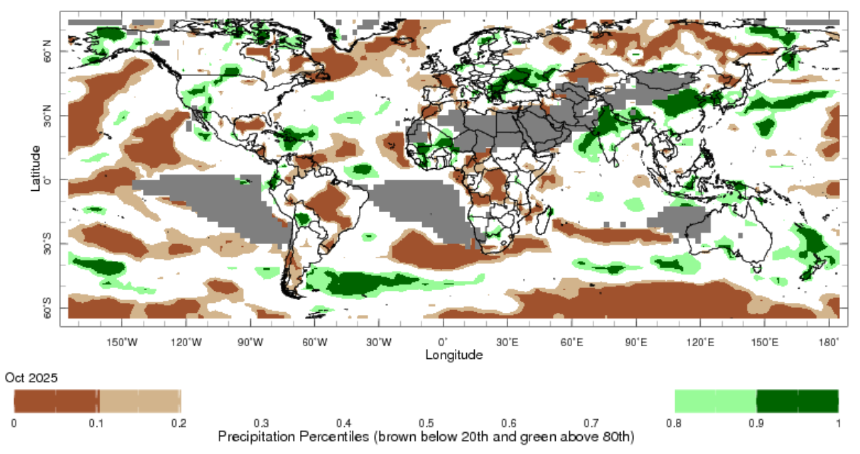

Note: The world precipitation percentiles indicate a ranking of precipitation for October, with the driest (0th percentile) being 0 on the scale and the wettest (100th percentile) being 1 on the scale. Percentiles are based on precipitation estimates from the NOAA Climate Prediction Center’s Climate Anomaly Monitoring System Outgoing Precipitation Index dataset. Precipitation estimates for October are compared with rainfall recorded for that period during the 1981 to 2010 base period.
Source: International Research Institute for Climate and Society
As of 28 October 2025, global production conditions were generally favourable for rice and soybeans, but more variable for maize and wheat:
- Wheat – In the northern hemisphere, sowing of winter wheat for harvest in 2026–27 is progressing in most areas however there are some areas of concern in China, the EU, the Russian Federation and Ukraine, with heavy rainfall delaying planting. In the southern hemisphere, crop harvest is continuing under largely favourable conditions.
- Maize – In the southern hemisphere, favourable conditions are supporting increased plantings in Brazil and Argentina. In the northern hemisphere, harvesting is ongoing under generally favourable conditions India, Indonesia, Canada, the United States, and much of the European Union. However, drought and repeated heatwaves in south-eastern Europe, eastern regions of Ukraine and parts of the Russian Federation have led to yield losses in these areas. Meanwhile, heavy rainfall and flooding has delayed harvest progress and lead to some production losses in China, as well as negatively impacting the spring-summer crop in Mexico.
- Rice – Global conditions are broadly favourable for major rice production regions, with exceptions in Vietnam where tropical storms in late September caused damage to summer-autumn rice.
- Soybeans – In the northern hemisphere, crop harvest is ongoing with generally favourable conditions across most major growing regions. In the southern hemisphere, sowing is beginning in Brazil.
Crop conditions, AMIS countries, 28 October 2025
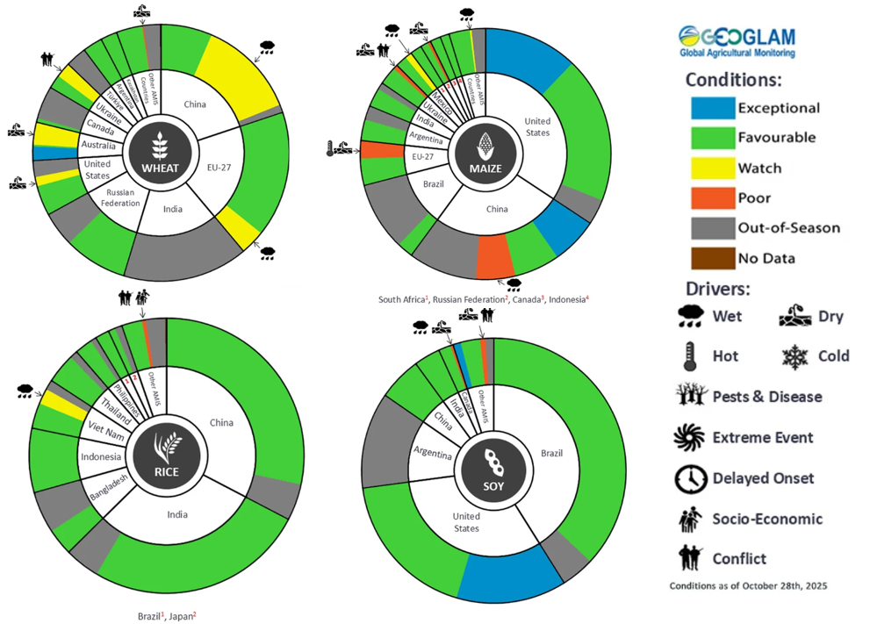
AMIS Agricultural Market Information System.
Source: AMIS

The global climate outlook for December 2025 to February 2026 indicates that mixed rainfall conditions are expected for the world’s major grain-producing and oilseed-producing regions. Outlooks and potential production impacts for major grain- and oilseed-producing countries are presented in the following table.
Rainfall outlook and potential impact on the future state of production conditions, December 2025-February 2026
Region | Rainfall outlook | Potential impact on production
Argentina | Below average rainfall is likely across parts of central Argentina. | Below average rainfall may adversely affect the flowering and silking of many major grains and oilseeds, including corn, rice, soybeans and cotton.
Black Sea Region | Below average rainfall is expected across Türkiye, western Ukraine and parts of the south of the Russian Federation. | Over the coming months winter wheat and canola will enter dormancy, and average rainfall in much of the Black Sea region is likely to provide sufficient snowpack to prevent winterkill. Below average rainfall in remaining regions may adversely affect crop outcomes.
Brazil | Rainfall outcomes across Brazil are expected to be below average in southern and central regions. | Below average rainfall in parts of southern and central Brazil may impair crop development stages over the coming months, including the critical flowering period for soybeans, corn, and cotton, as well as grain heading for key grains such as rice and sorghum.
Canada | Rainfall across Canada is expected to be average to above average in southern regions. | Average rainfall is likely to provide sufficient snowpack to prevent winterkill of winter wheat in December through to February.
China | Below average rainfall is expected across parts of eastern and western China, with average falls expected elsewhere. | Anticipated rainfall is likely to reduce the level of snowpack during crop dormancy in some areas and increase the risk of winterkill.
European Union | Average rainfall is more likely for much of the central European Union, with parts of western Europe including Spain likely to see above average rainfall. | Average rainfall across much of the European Union is likely to support the dormancy of winter wheat and canola.
South Asia (India) | Below average rainfall is expected across much of northern India, while above average rainfall is expected in central regions. | Anticipated rainfall is likely to support the harvesting and planting of crops in many areas, but could adversely affect the heading of wheat and canola in northern regions.
Southeast Asia (SEA) | Below average rainfall is likely across much of SEA, including Thailand and Indonesia. | Below average rainfall in SEA is may negatively affect the growth of dry season crops.
The United States | Below average rainfall is likely for much of southern United States, with above average rainfall more likely across the north. | Above average rainfall conditions expected across the northern US is likely to provide sufficient snow cover through December and January to protect winter wheat and canola through dormancy. Below average rainfall may negatively impact cropping outcomes in the south.

Water markets – current week

Water storage levels in the Murray-Darling Basin (MDB) decreased by 122 gigalitres (GL) between 13 November 2025 and 19 November 2025. The current volume of water held in storages is 14,567 GL, equivalent to 65% of total storage capacity. This is 11% or 1,754 GL less than the same time last year. Water storage data is sourced from the Bureau of Meteorology (BOM).

Water storages in the Murray-Darling Basin, 2013–2025
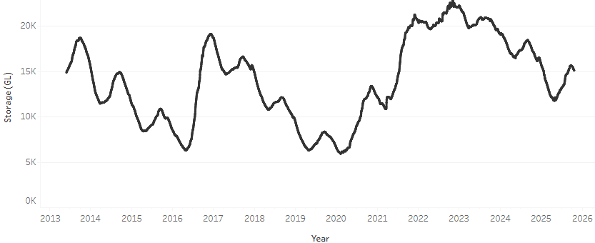
Allocation prices in the Victorian Murray below the Barmah Choke increased from $298/ML on 13 November 2025 to $304/ML on 20 November 2025. Trade from the Goulburn to the Murray is closed. Trade downstream through the Barmah Choke is closed. Trade from the Murrumbidgee to the Murray is closed.

Water market prices, Southern Murray–Darling Basin

Region | $/ML
NSW Murray Above | 242
NSW Murrumbidgee | 285
Vic Greater Goulburn | 289
Vic Murray Below | 304

Note: The water allocation prices shown are volume weighted average prices based on the last 10 trades. Price data is sourced from Waterflow and current as at 30 October 2025.
To access the full, interactive, weekly water dashboard, which contains the latest and historical water storage, water market and water allocation information, please visit https://www.agriculture.gov.au/abares/products/weekly_update/weekly-update-131125

Commodities
Indicator | Week average | Unit | Latest Price | Previous Week | Weekly change |  | Price 12 months ago | Annual change
Selected world indicator prices
AUD/USD Exchange rate | 19-Nov | A$/US$ | 0.65 | 0.65 | -1% | 0.65 |  | -1%
Wheat – US no. 2 hard red winter wheat, FOB Gulf | 19-Nov | US$/t | 249 | 247 | 1% | 254 |  | -2%
Corn – US no. 2 yellow corn, FOB Gulf | 19-Nov | US$/t | 202 | 204 | -1% | 201 |  | 0%
Canola – Rapeseed, Canada, FOB Vancouver | 19-Nov | US$/t | 494 | 491 | 1% | 475 |  | 4%
Cotton – Cotlook A Index | 19-Nov | USc/lb | 74.5 | 75.2 | -1% | 81.4 |  | -9%
Sugar – Intercontinental Exchange, nearby futures, no.11 contract | 19-Nov | USc/lb | 14.8 | 14.5 | 2% | 20.8 |  | -29%
Wool – Eastern Market Indicator | 19-Nov | Ac/kg clean | 1,514 | 1,458 | 4% | 1,139 |  | 33%
Wool – Western Market Indicator | 19-Nov | Ac/kg clean | 1,661 | 1,585 | 5% | 1,276 |  | 30%
Selected Australian grain export prices
Australian Premium White (APW) Wheat, FOB Port Adelaide, SA | 19-Nov | A$/t | 375 | 373 | 0% | 402 |  | -7%
Australian Standard White (ASW) Wheat, FOB Port Adelaide, SA | 19-Nov | A$/t | 372 | 369 | 1% | 392 |  | -5%
Feed Barley – FOB Port Adelaide, SA | 19-Nov | A$/t | 350 | 348 | 1% | 353 |  | -1%
Canola – FOB Kwinana, WA | 19-Nov | A$/t | 830 | 812 | 2% | 853 |  | -3%
Grain Sorghum – FOB Brisbane, QLD | 19-Nov | A$/t | 407 | 403 | 1% | 399 |  | 2%
Selected domestic livestock indicator prices
Beef – Eastern Young Cattle Indicator | 19-Nov | Ac/kg cwt | 901 | 882 | 2% | 627 |  | 44%
Mutton – Mutton indicator (18–24 kg fat score 2–3), VIC | 19-Nov | Ac/kg cwt | 740 | 731 | 1% | 336 |  | 120%
Lamb – National Trade Lamb Indicator | 19-Nov | Ac/kg cwt | 1,150 | 1,143 | 1% | 803 |  | 43%
Pig – Eastern Seaboard (60.1–75 kg), NSW buyer price | 5-Nov | Ac/kg cwt | 461 | 461 | 0% | 447 |  | 3%
Live cattle – Light steers to Indonesia | 12-Nov | Ac/kg lwt | 450 | 445 | 1% | 336 |  | 34%
Global Dairy Trade (GDT) weighted average prices
Dairy – Whole milk powder | 19-Nov | US$/t | 3,452 | 3,503 | -1% | 3,770 |  | -8%
Dairy – Skim milk powder | 19-Nov | US$/t | 2,542 | 2,559 | -1% | 2,866 |  | -11%
Dairy – Cheddar cheese | 19-Nov | US$/t | 4,328 | 4,449 | -3% | 4,904 |  | -12%
Dairy – Anhydrous milk fat | 19-Nov | US$/t | 6,543 | 6,887 | -5% | 7,590 |  | -14%

Selected world indicator prices
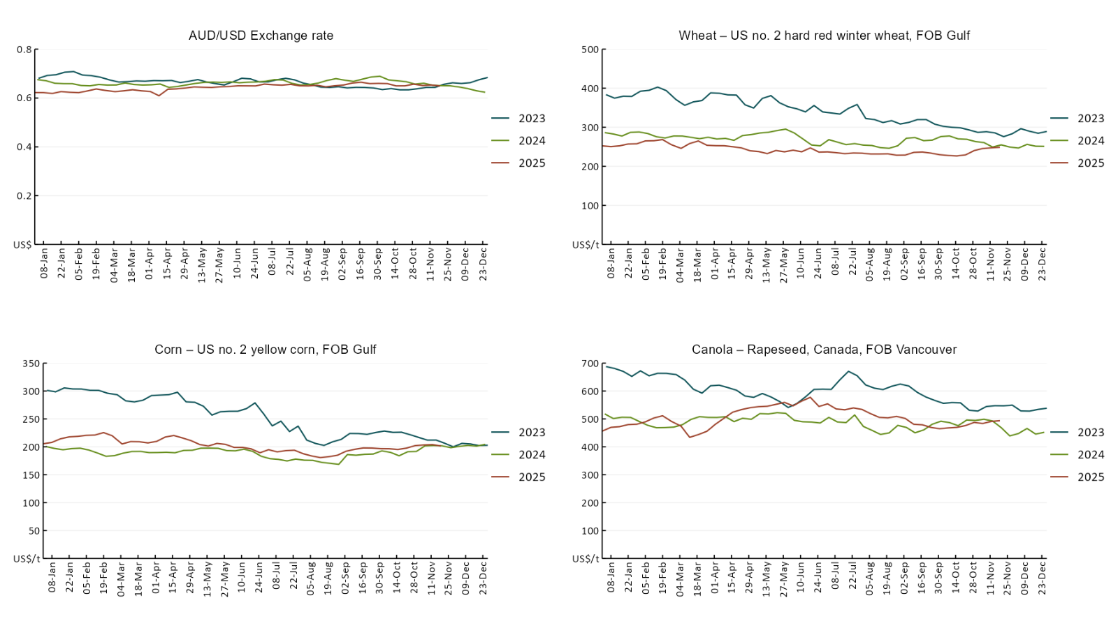

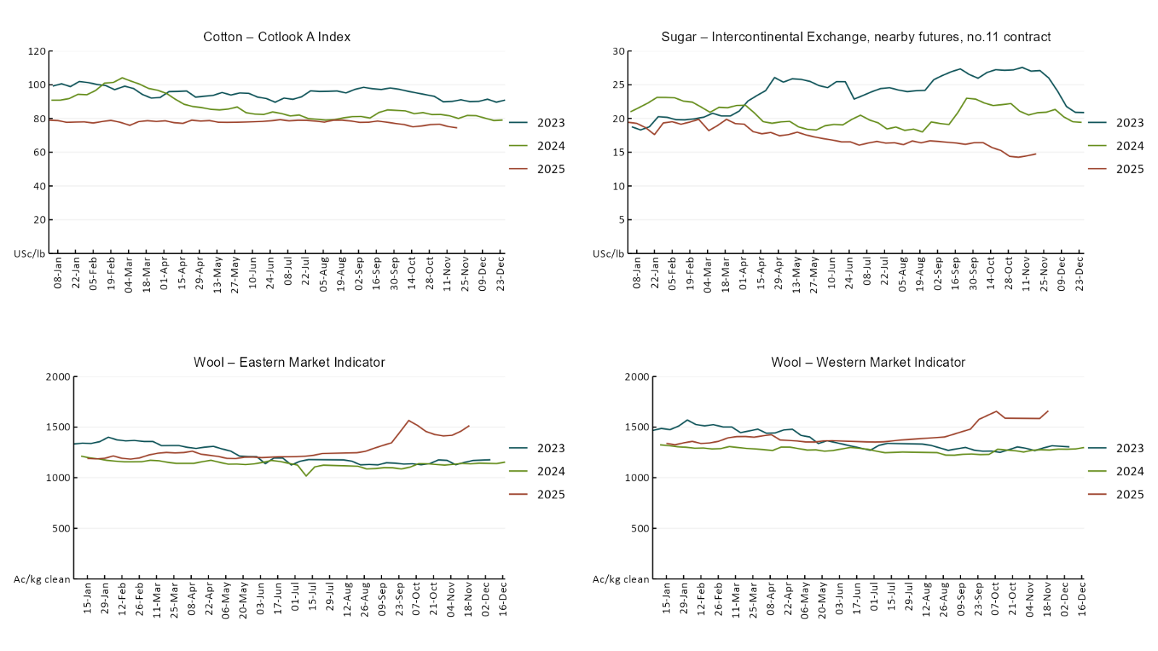

3.2 Selected domestic crop indicator prices
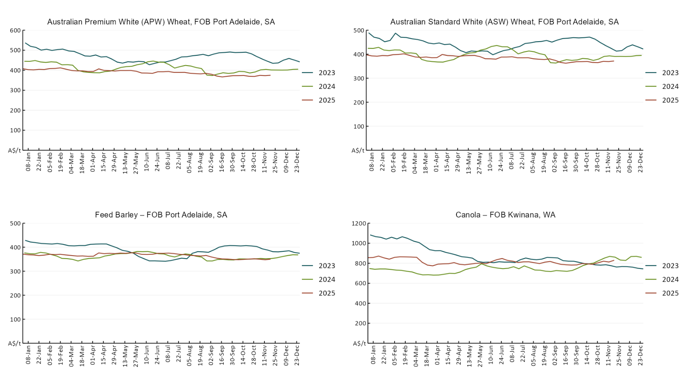
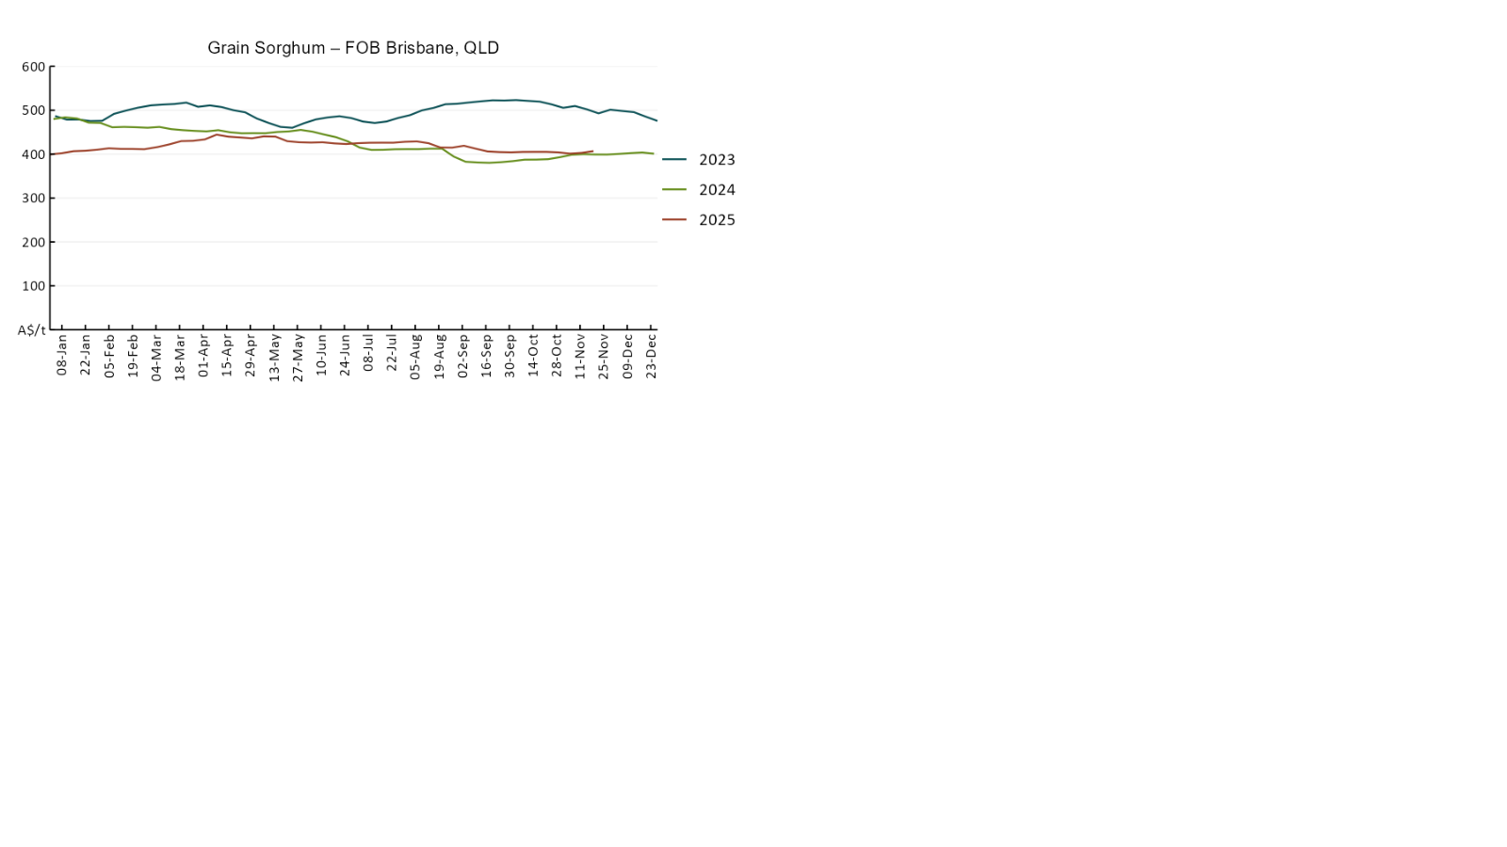

3.3 Selected domestic livestock indicator prices
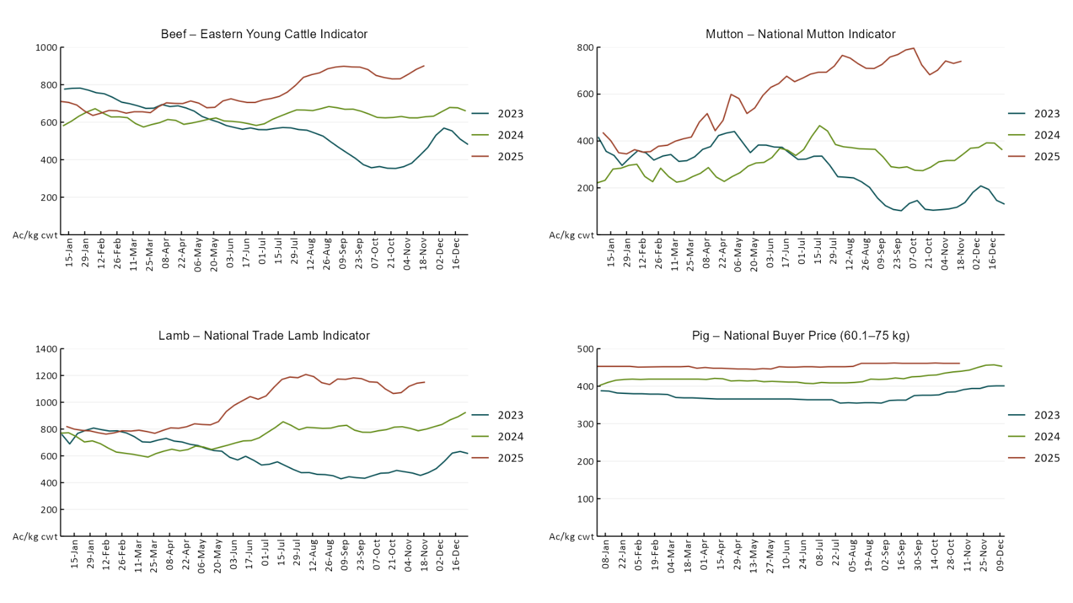
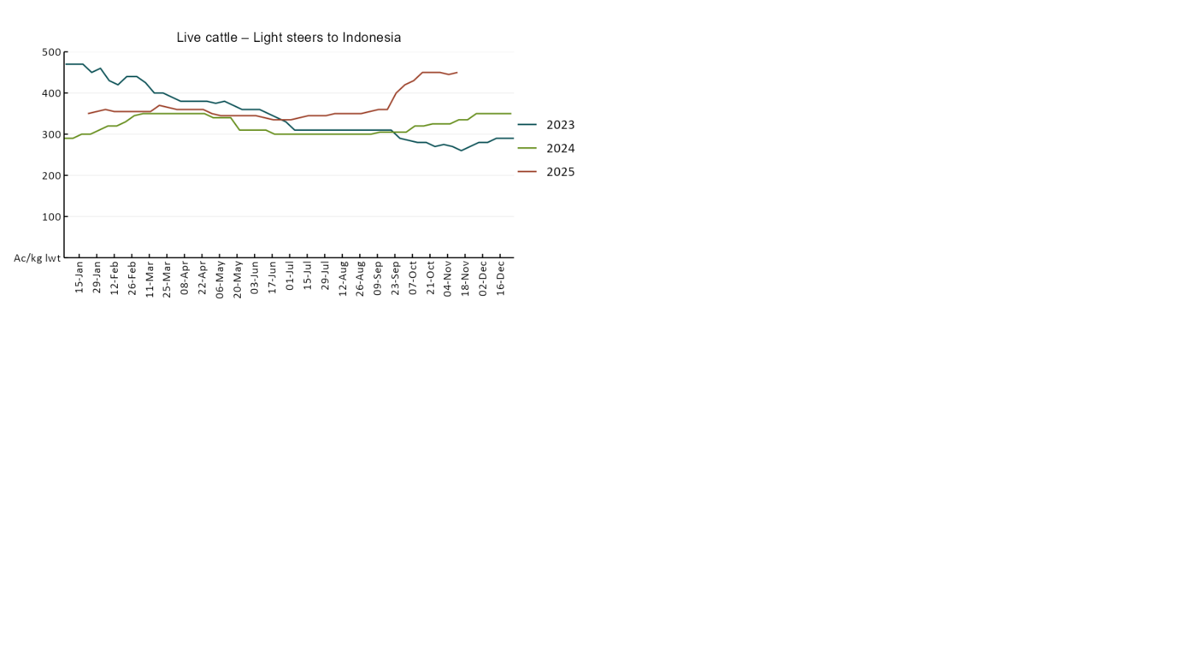

3.4 Global Dairy Trade (GDT) weighted average prices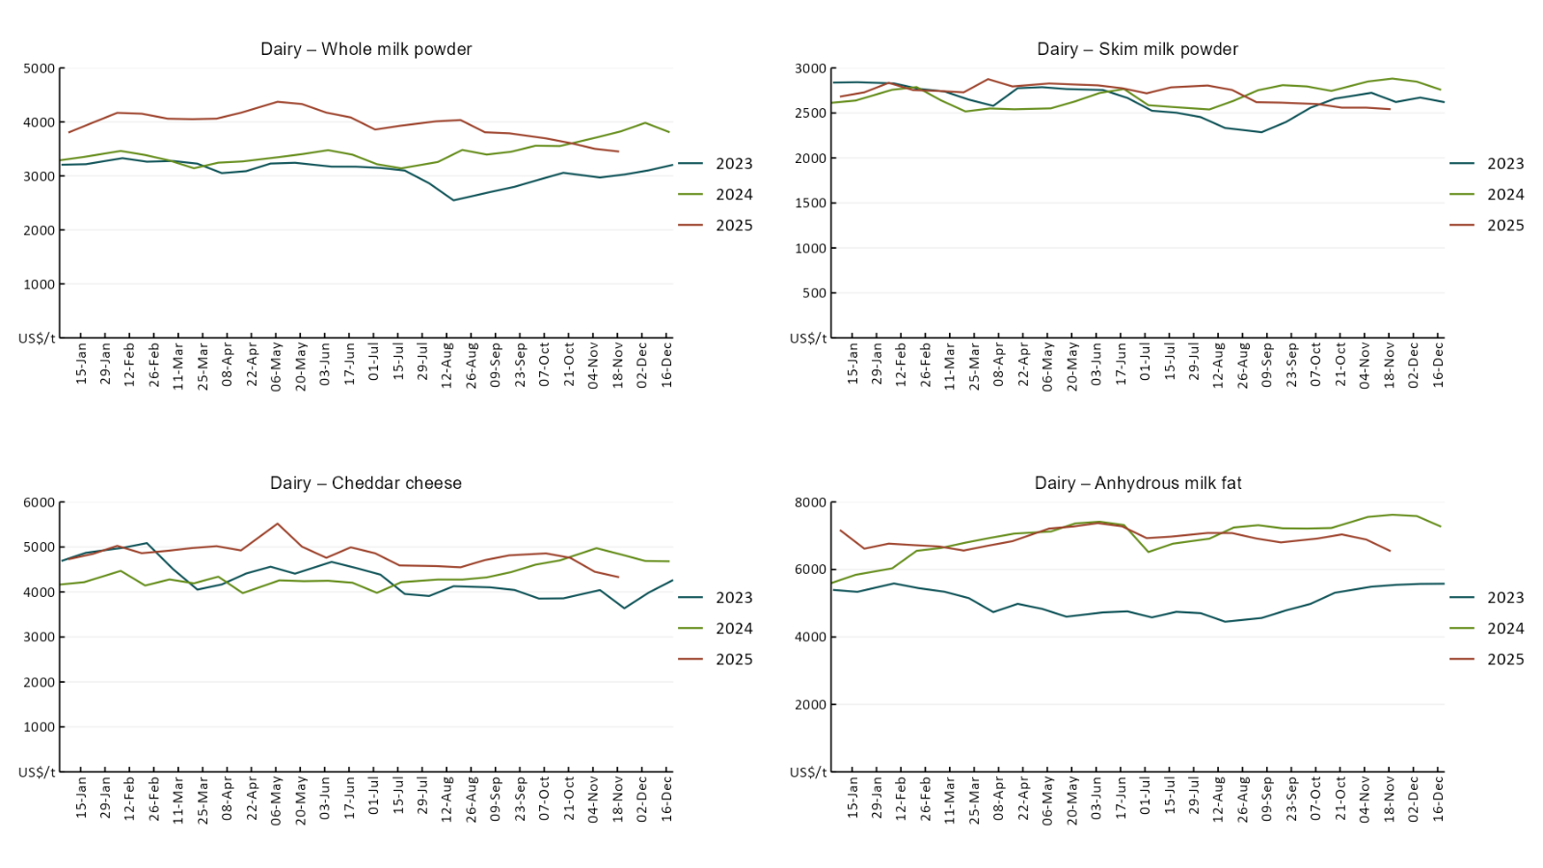

3.5 Selected fruit and vegetable prices

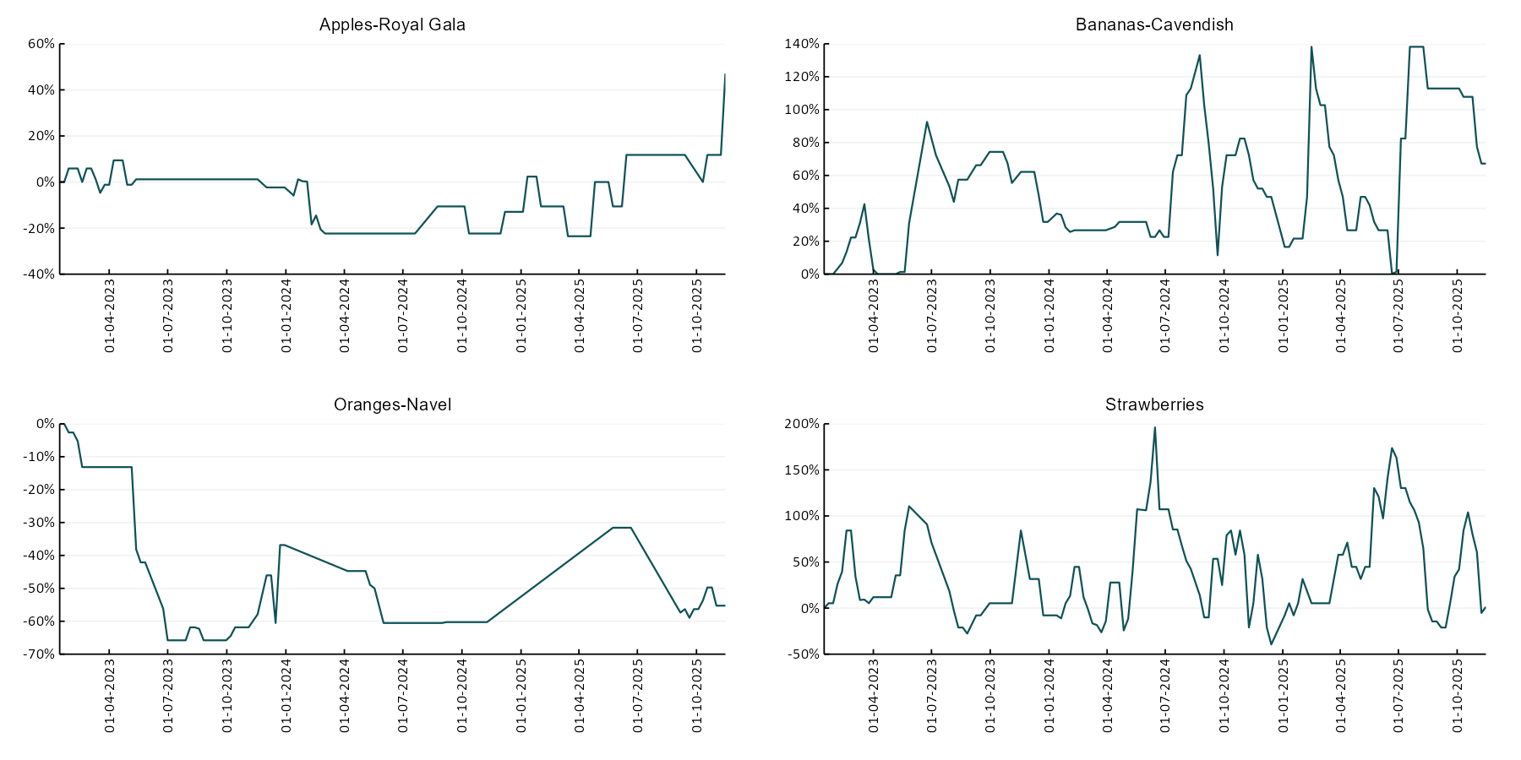

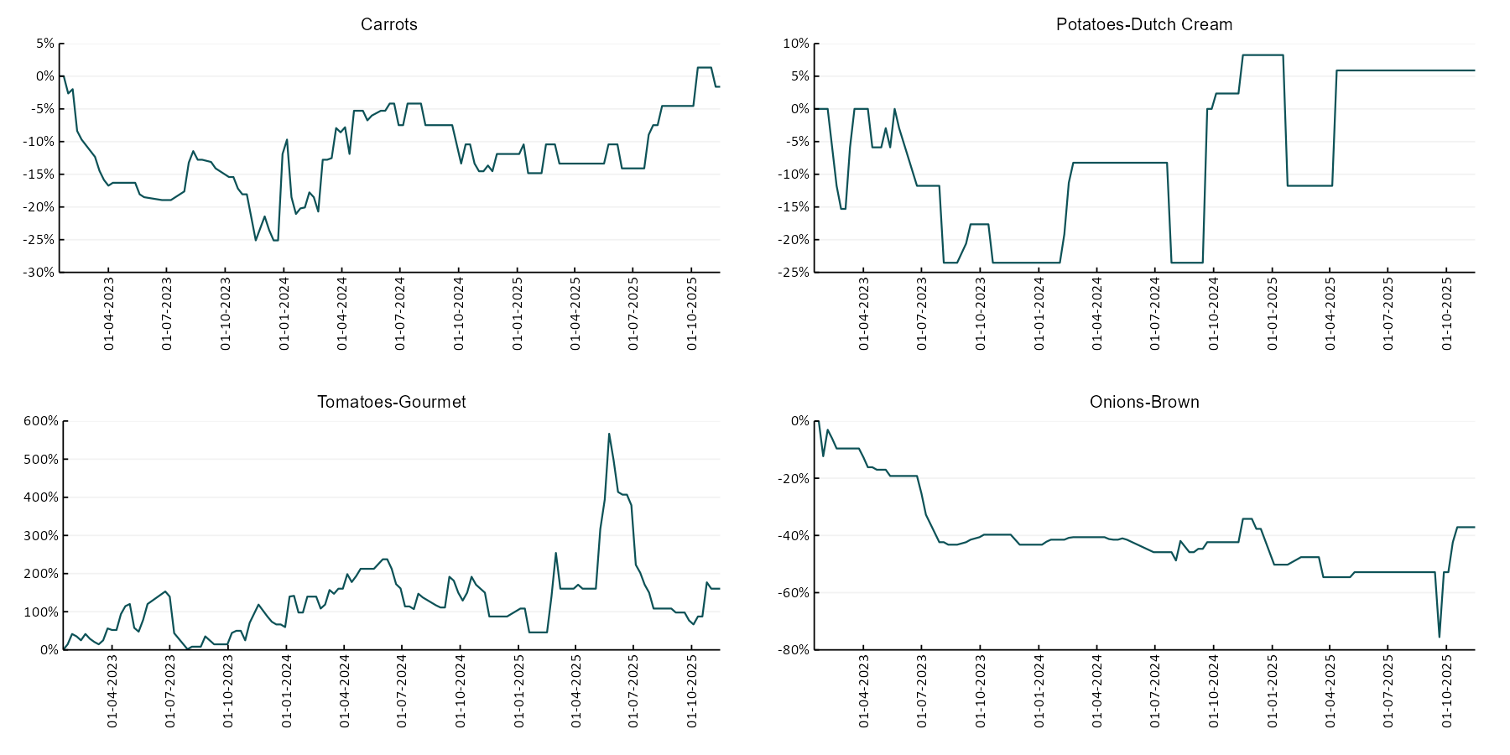

3.6 Selected domestic fodder indicator prices
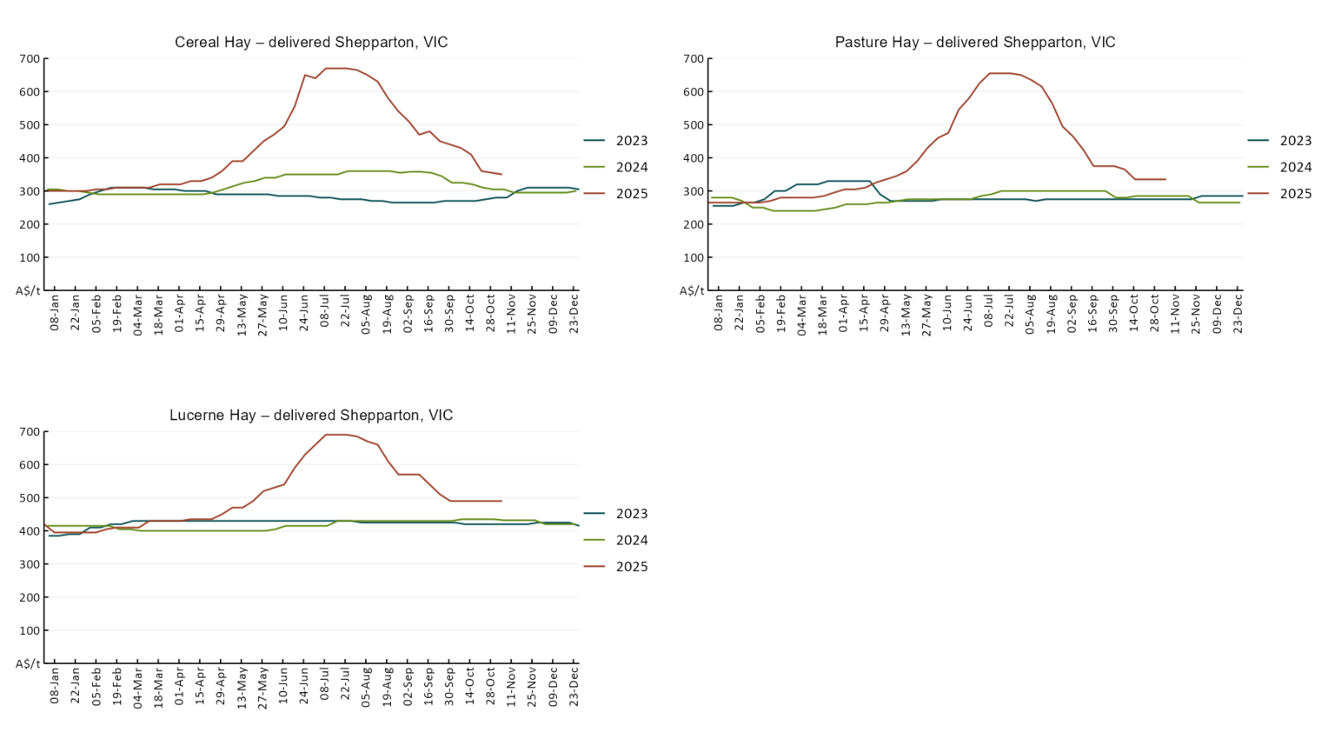

4. Data attribution

Climate
Bureau of Meteorology
- Weekly rainfall totals: www.bom.gov.au/climate/maps/rainfall/
- Monthly and last 3-month rainfall percentiles: https://www.bom.gov.au/climate/ahead/outlooks/#moreMaps
- Rainfall forecast: www.bom.gov.au/jsp/watl/rainfall/pme.jsp
- Seasonal outlook: www.bom.gov.au/climate/outlooks/#/overview/summary/
- Climate drivers: http://www.bom.gov.au/climate/enso/
- Soil moisture: https://awo.bom.gov.au/products/historical/soilMoisture-rootZone/

Other
- Pasture growth: www.longpaddock.qld.gov.au/aussiegrass/
- 3-month global outlooks: Environment and Climate Change Canada, NOAA Climate Prediction Center, EUROBRISA CPTEC/INPE, European Centre for Medium-Range Weather Forecasts, Hydrometcenter of Russia, National Climate Center Climate System Diagnosis and Prediction Room (NCC), International Research Institute for Climate and Society
- Global production: https://ipad.fas.usda.gov/ogamaps/cropmapsandcalendars.aspx
- Autumn break: Pook et al., 2009, https://rmets-onlinelibrary-wiley-com.virtual.anu.edu.au/doi/epdf/10.1002/joc.1833

Water
Prices
- Waterflow: https://www.waterflow.io/
- Ruralco: https://www.ruralcowater.com.au/
- Bureau of Meteorology:
- Allocation trade: http://www.bom.gov.au/water/dashboards/#/water-markets/mdb/at
- Storage volumes: http://www.bom.gov.au/water/dashboards/#/water-storages/summary/drainage

Trade constraints:
- Water NSW: https://www.waternsw.com.au/customer-service/ordering-trading-and-pricing/trading/murrumbidgee
- Victorian Water Register: https://www.waterregister.vic.gov.au/TradingRules2019/

Commodities
Fruit and vegetables
- Datafresh: www.freshstate.com.au

Pigs
- Australian Pork Limited: www.australianpork.com.au

Dairy
- Global Dairy Trade: www.globaldairytrade.info/en/product-results/

World wheat, canola
- International Grains Council
- https://www.igc.int/en/default.aspx
- United States Department of Agriculture

World cotton
- Cotlook: www.cotlook.com/

World sugar
- New York Stock Exchange - Intercontinental Exchange

Wool
- Australian Wool Exchange: www.awex.com.au/

Domestic wheat, barley, sorghum, canola and fodder
- Jumbuk Consulting Pty Ltd: Jumbuk AG | Agriculture Consulting

Cattle, beef, mutton, lamb, goat and live export
- Meat and Livestock Australia: https://www.mla.com.au/prices-markets/

© Commonwealth of Australia 2025

Ownership of intellectual property rights
Unless otherwise noted, copyright (and any other intellectual property rights, if any) in this publication is owned by the Commonwealth of Australia (referred to as the Commonwealth).

Creative Commons licence
All material in this publication is licensed under a Creative Commons Attribution 4.0 International Licence except content supplied by third parties, logos and the Commonwealth Coat of Arms.
Inquiries about the licence and any use of this document should be emailed to copyright@awe.gov.au.


Cataloguing data
This publication (and any material sourced from it) should be attributed as:
ABARES 2025, Weekly Australian Climate, Water and Agricultural Update, Australian Bureau of Agricultural and Resource Economics and Sciences, Canberra, 20 November 2025. CC BY 4.0 DOI: https://doi.org/10.25814/5f3e04e7d2503
ISSN 2652-7561
This publication is available at https://www.agriculture.gov.au/abares/products/weekly_update
Department of Agriculture, Fisheries and Forestry
GPO Box 858 Canberra ACT 2601
Telephone 1800 900 090
Web agriculture.gov.au/abares

Disclaimer
The Australian Government acting through the Department of Agriculture, Fisheries and Forestry, represented by the Australian Bureau of Agricultural and Resource Economics and Sciences, has exercised due care and skill in preparing and compiling the information and data in this publication. Notwithstanding, the Department of Agriculture, Fisheries and Forestry, ABARES, its employees and advisers disclaim all liability, including liability for negligence and for any loss, damage, injury, expense or cost incurred by any person as a result of accessing, using or relying on any of the information or data in this publication to the maximum extent permitted by law.

Statement of Professional Independence
The views and analysis presented in ABARES publications, including this one, reflect ABARES professionally independent findings, based on scientific and economic concepts, principles, information and data. These views, analysis and findings may not reflect or be consistent with the views or positions of the Australian Government, or of organisations or groups who have commissioned ABARES reports or analysis. More information on professional independence is provided on the ABARES website.

Acknowledgements
This report was prepared by Holly Beale and Matt Miller.

