
No. 47/2025 27 November 2025

Summary of key issues
- In the week ending 26 November 2025, rainfall was recorded across parts of northern, southern and eastern Australia, while central areas remained comparably dry.
  - Across cropping regions, rainfall totals were low across most south-eastern regions, with heavy falls recorded across the northeast and parts of the southwest.
    - For north-eastern cropping regions these falls have likely boosted soil moisture levels and will support the growth of summer crops already in the ground and encourage further planting, but have likely disrupted harvest of winter crops in these areas.
    - In the eastern Western Australian cropping region, rainfall this week has likely disrupted the harvest of winter crops, but is unlikely to impact crop quality as this stage.
- Over the coming eight days to 4 December 2025, limited rainfall is expected across Western Australia, with higher totals in the southeast and north.
  - At this late stage of the winter growing season, the falls forecast for many south-eastern growing regions are unlikely to boost production, but may alleviate some of the increased downside production risk that has emerged in recent weeks due to dry conditions.
- The national rainfall outlook for December 2025 to February 2026 indicates a decreased probability of above median rainfall across large areas of western and eastern Australia.
  - If realised, this increased chance of below median rainfall across parts of eastern Australia is unlikely to adversely affect summer crop and pasture production due to the average to well above average November rainfall experienced in most regions, which has boosted soil moisture levels.
- Water storage levels in the Murray-Darling Basin (MDB) decreased by 89 gigalitres (GL) between 20 November 2025 and 27 November 2025. The current volume of water held in storages is 14,397 GL, equivalent to 65% of total storage capacity. This is 11% or 1,751 GL less than the same time last year. Water storage data is sourced from the Bureau of Meteorology.
- Allocation prices in the Victorian Murray below the Barmah Choke increased from $304/ML on 20 November 2025 to $311/ML on 27 November 2025. Trade from the Goulburn to the Murray is closed. Trade downstream through the Barmah Choke is closed. Trade from the Murrumbidgee to the Murray is closed.

Climate

Rainfall this week
In the week ending 26 November 2025, low-pressure systems and Cyclone Fina brought rainfall to parts of northern and eastern Australia. Meanwhile, cold fronts brought rainfall to large areas of southern Australia.
Across cropping regions, rainfall totals were low across most south-eastern regions, with heavy falls recorded across the northeast and parts of the southwest for the week ending 26 November 2025.
- Queensland and north-eastern New South Wales cropping regions saw falls of between 5- 100 millimetres. Meanwhile, cropping regions across the east of Western Australia and south-eastern New South Wales, recorded falls of between 5-50 millimetres were recorded.
  - Across Queensland and northern New South Wales these falls have likely boosted soil moisture levels and supported the growth of summer crops already in the ground and encourage further planting, but have likely disrupted the harvest of winter crops.
  - In eastern Western Australian cropping region rainfall this week have likely disrupted the harvest of winter crops, but have unlikely impacted crop quality as this stage.
- Cropping regions in Victoria, South Australia, and west Western Australia saw falls of 5- 15 millimetres.
  - Little to no rainfall across large areas of southern Australia would have provided for an uninterrupted harvest of winter crops and hay where harvest has commenced.

Rainfall for the week ending 26 November 2025
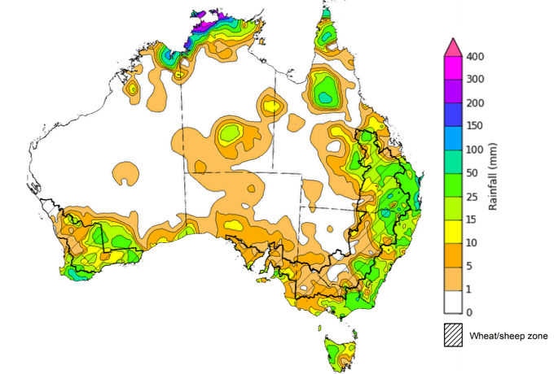

©Commonwealth of Australia 2025, Australian Bureau of Meteorology Issued: 26/11/2025
Note: The rainfall analyses and associated maps utilise data contained in the Bureau of Meteorology climate database, the Australian Data Archive for Meteorology (ADAM). The analyses are initially produced automatically from real-time data with limited quality control. They are intended to provide a general overview of rainfall across Australia as quickly as possible after the observations are received. For further information go to http://www.bom.gov.au/climate/rainfall/

Rainfall forecast for the next eight days
Over the 8 days to 4 December 2025, low-pressure systems are expected to bring rainfall to northern Australia, while a cold front is expected bring rainfall to much of the southeast.
Limited rainfall is expected across western cropping regions this week, while those in south-eastern and northern Australia are likely to see higher rainfall totals.
- Falls of between 10-50 millimetres are forecast for northern and central Queensland cropping regions. In Victoria, South Australia and southern New South Wales falls of between 10-25 millimetres are expected.
  - At this late stage of the winter growing season, the falls forecast for many southern growing regions are unlikely to boost crop and pasture production, but may alleviate some of the increased downside production risk that has emerged in recent weeks due to dry conditions.
  - If realised these falls are expected to cause some delays to the ongoing harvest of winter crops and planting of summer crops in affected regions.
- Western Australia, northern New South Wales, and south-western Queensland are forecast to receive little to no rainfall
  - This is likely to support the ongoing harvest of winter crops, but may contribute to soil moisture drawdown in summer cropping regions.

Total forecast rainfall for the period 27 November to 4 December 2025
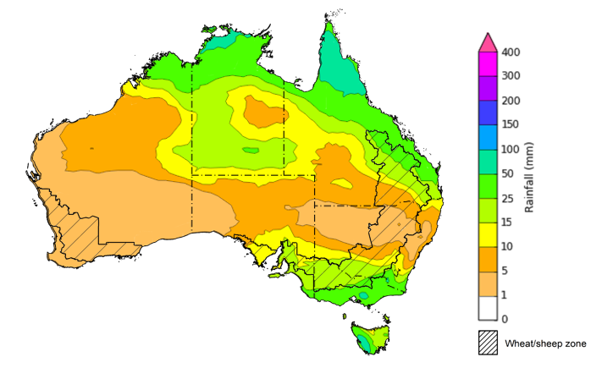
©Commonwealth of Australia 2025, Australian Bureau of Meteorology Issued 27/11/2025
Note: This rainfall forecast is produced from computer models. As the model outputs are not altered by weather forecasters, it is important to check local forecasts and warnings issued by the Bureau of Meteorology.

National Climate Outlook
The El Niño Southern Oscillation (ENSO) and Southern Annular Mode (SAM) are currently neutral and having minimal influence on Australian rainfall. However, the Indian Ocean Dipole (IOD) Index is currently under negative conditions. A negative IOD typically results in above-average spring rainfall over parts of southern Australia.
The most recent rainfall outlook for December 2025 provided by the Bureau of Meteorology indicates that most of Australia is more likely to see below median rainfall, with much of eastern Queensland, south-west Western Australia and Tasmania more likely to see average falls.
- The Bureau of Meteorology’s climate model indicates a 75% chance of December rainfall totals between 10-100 millimetres across much of eastern and northern Australia, with higher rainfall totals of up to 200 millimetres expected in the Northern Tropics.Much of southern Western Australia, South Australia and western areas of New South Wales and Queensland are likely to see little to no rainfall.
- Across cropping regions, there is a 75% chance of receiving rainfall totals of between 25- 50 millimetres across much of Queensland and north-eastern New South Wales. Meanwhile remaining areas in New South Wales, Victoria, and eastern Western Australia is likely to see 5-25 millimetres. Remaining cropping regions are forecast to see little to no rainfall.
  - If forecast rainfall totals are realised across much of New South Wales and Queensland, these falls are likely to be sufficient to support above average yield prospects for summer crops and average or better levels of pasture production.

Rainfall totals that have a 75% chance of occurring in December 2025
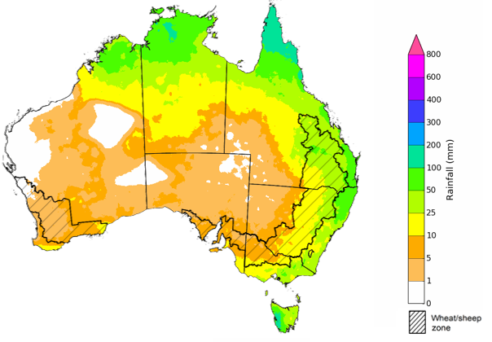
©Commonwealth of Australia 2025, Australian Bureau of Meteorology Issued:26/11/2025
The rainfall outlook for December 2025 to February 2026 indicates an increased probability of below median rainfall across large areas of western and eastern Australia, including much of Western Australia, western regions of the Northern Territory and South Australia, and central Queensland and northern New South Wales. Parts of northern Queensland have a higher probability of above median rainfall, while remaining areas have an equal chance of above or below median rainfall.
Across cropping regions, the chance of receiving above median rainfall is 30-50% across New South Wales and Western Australia, while Queensland has a 35-50% chance. In South Australia and Victoria, the chance of receiving median rainfall is 40-55%. The increased chance of below median rainfall across parts of eastern Australia is unlikely to adversely affect summer crop and pasture production due to the average to well above average November rainfall experienced in most regions, which has boosted soil moisture levels.
Chance of exceeding the median rainfall December 2025 to February 2026
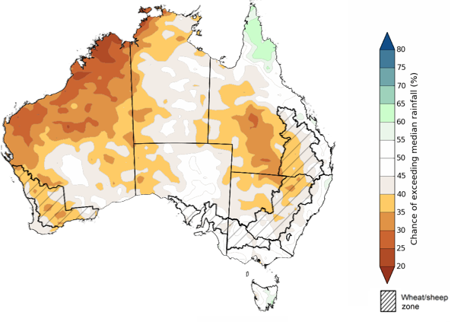
©Commonwealth of Australia 2025, Australian Bureau of Meteorology Issued: 26/11/2025
The rainfall outlook for December 2025 to February 2026 suggests a 75% chance of receiving rainfall totals of between 50-400 millimetres across much of eastern and northern Australia. Between 400-1200 millimetres are expected across scattered east coast regions as well as large areas of the northern tropics. Lower rainfall totals are forecast for south-western and central regions, with South Australia and southern Western Australia likely to see 10- 50 millimetres.
In cropping regions, there is a 75% chance of receiving between 100-200 millimetres across much of Queensland and northern New South Wales. Southern New South Wales is likely to see 50-100 millimetres. In Western Australia and South Australia, falls of 10-50 millimetres are expected, with Victoria likely to see 25-100 millimetres.
Given the winter crop harvest will be well underway across most regions, December through to February rainfall will have little influence on winter crop production prospects, other than its influence on harvest progress and quality. Meanwhile, if the forecast December through to February rainfall totals are realised, they are likely to be sufficient to support December to February pasture growth across eastern and northern Australia. Additionally, these expected falls are likely to be sufficient to support above average yield expectations for summer crops.
Rainfall totals that have a 75% chance of occurring December 2025 to February 2026
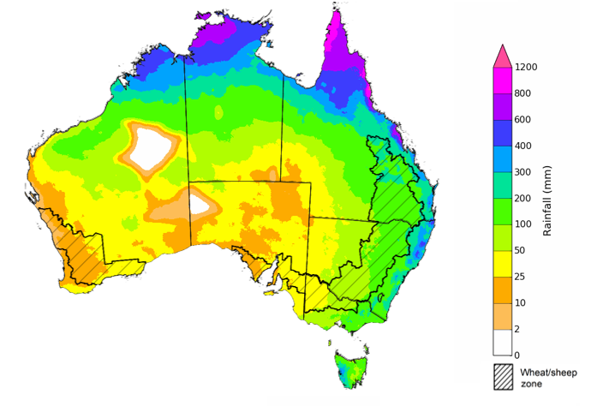
©Commonwealth of Australia 2025, Australian Bureau of Meteorology Issued: 26/11/2025

Water markets – current week

Water storage levels in the Murray-Darling Basin (MDB) decreased by 89 gigalitres (GL) between 20 November 2025 and 27 November 2025. The current volume of water held in storages is 14,397 GL, equivalent to 65% of total storage capacity. This is 11% or 1,751 GL less than the same time last year. Water storage data is sourced from the Bureau of Meteorology (BOM).

Water storages in the Murray-Darling Basin, 2013–2025
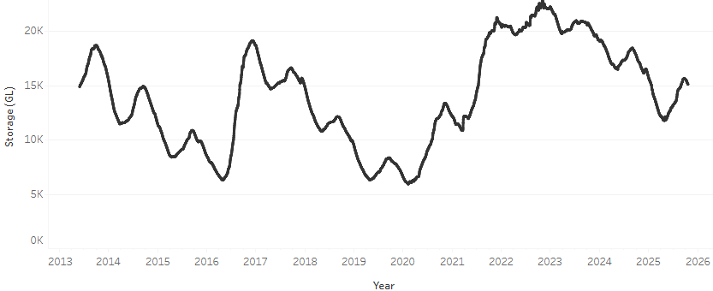
Allocation prices in the Victorian Murray below the Barmah Choke increased from $304/ML on 20 November 2025 to $311/ML on 27 November 2025. Trade from the Goulburn to the Murray is closed. Trade downstream through the Barmah Choke is closed. Trade from the Murrumbidgee to the Murray is closed.

Water market prices, Southern Murray–Darling Basin

Region | $/ML
NSW Murray Above | 250
NSW Murrumbidgee | 300
Vic Greater Goulburn | 288
Vic Murray Below | 311

Note: The water allocation prices shown are volume weighted average prices based on the last 10 trades. Price data is sourced from Waterflow and current as at 30 October 2025.
To access the full, interactive, weekly water dashboard, which contains the latest and historical water storage, water market and water allocation information, please visit https://www.agriculture.gov.au/abares/products/weekly_update/weekly-update-131125

Commodities
Indicator | Week average | Unit | Latest Price | Previous Week | Weekly change |  | Price 12 months ago | Annual change
Selected world indicator prices
AUD/USD Exchange rate | 26-Nov | A$/US$ | 0.65 | 0.65 | 0% | 0.65 |  | -1%
Wheat – US no. 2 hard red winter wheat, FOB Gulf | 26-Nov | US$/t | 243 | 245 | -1% | 254 |  | -4%
Corn – US no. 2 yellow corn, FOB Gulf | 26-Nov | US$/t | 198 | 200 | -1% | 201 |  | -1%
Canola – Rapeseed, Canada, FOB Vancouver | 26-Nov | US$/t | 484 | 489 | -1% | 475 |  | 2%
Cotton – Cotlook A Index | 26-Nov | USc/lb | 74.3 | 74.3 | 0% | 81.4 |  | -9%
Sugar – Intercontinental Exchange, nearby futures, no.11 contract | 26-Nov | USc/lb | 14.9 | 14.7 | 1% | 20.8 |  | -29%
Wool – Eastern Market Indicator | 26-Nov | Ac/kg clean | 1,504 | 1,514 | -1% | 1,139 |  | 32%
Wool – Western Market Indicator | 26-Nov | Ac/kg clean | 1,665 | 1,661 | 0% | 1,276 |  | 31%
Selected Australian grain export prices
Australian Premium White (APW) Wheat, FOB Port Adelaide, SA | 26-Nov | A$/t | 371 | 375 | -1% | 402 |  | -8%
Australian Standard White (ASW) Wheat, FOB Port Adelaide, SA | 26-Nov | A$/t | 368 | 372 | -1% | 392 |  | -6%
Feed Barley – FOB Port Adelaide, SA | 26-Nov | A$/t | 345 | 350 | -1% | 353 |  | -2%
Canola – FOB Kwinana, WA | 26-Nov | A$/t | 814 | 830 | -2% | 853 |  | -5%
Grain Sorghum – FOB Brisbane, QLD | 26-Nov | A$/t | 407 | 406 | 0% | 399 |  | 2%
Selected domestic livestock indicator prices
Beef – Eastern Young Cattle Indicator | 26-Nov | Ac/kg cwt | 905 | 903 | 0% | 627 |  | 44%
Mutton – Mutton indicator (18–24 kg fat score 2–3), VIC | 26-Nov | Ac/kg cwt | 749 | 743 | 1% | 336 |  | 123%
Lamb – National Trade Lamb Indicator | 26-Nov | Ac/kg cwt | 1,127 | 1,147 | -2% | 803 |  | 40%
Pig – Eastern Seaboard (60.1–75 kg), NSW buyer price | 12-Nov | Ac/kg cwt | 461 | 461 | 0% | 447 |  | 3%
Live cattle – Light steers to Indonesia | 26-Nov | Ac/kg lwt | 450 | 450 | 0% | 336 |  | 34%
Global Dairy Trade (GDT) weighted average prices
Dairy – Whole milk powder | 19-Nov | US$/t | 3,452 | 3,503 | -1% | 3,770 |  | -8%
Dairy – Skim milk powder | 19-Nov | US$/t | 2,542 | 2,559 | -1% | 2,866 |  | -11%
Dairy – Cheddar cheese | 19-Nov | US$/t | 4,328 | 4,449 | -3% | 4,904 |  | -12%
Dairy – Anhydrous milk fat | 19-Nov | US$/t | 6,543 | 6,887 | -5% | 7,590 |  | -14%

Selected world indicator prices
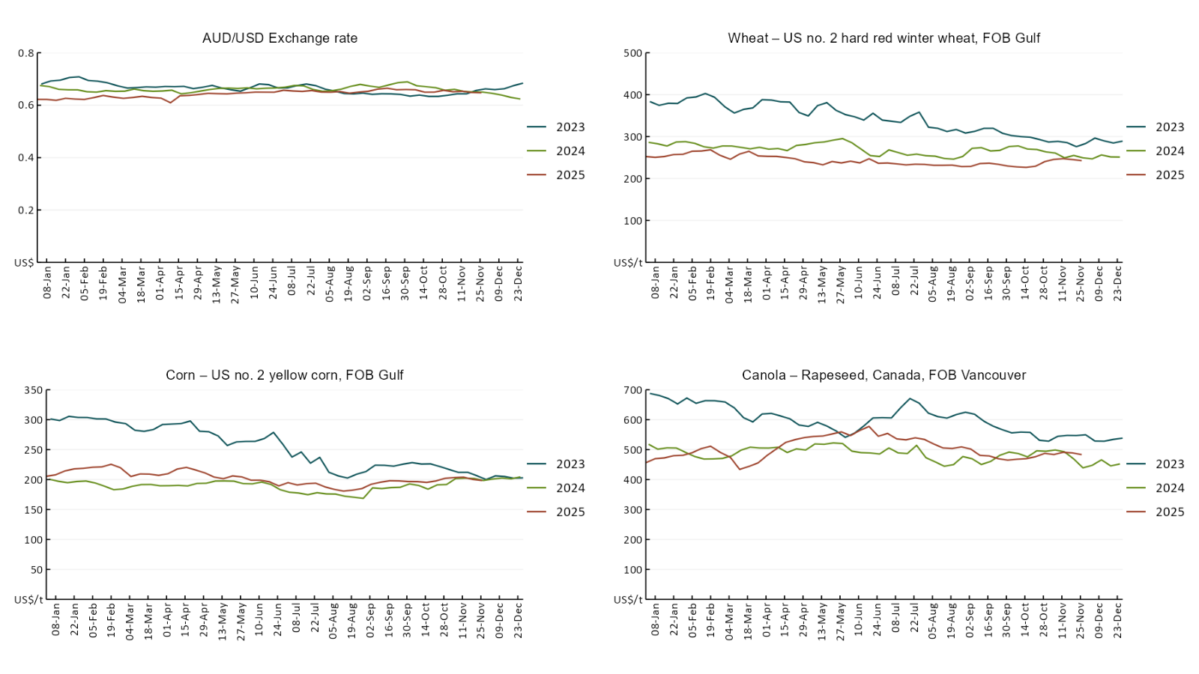

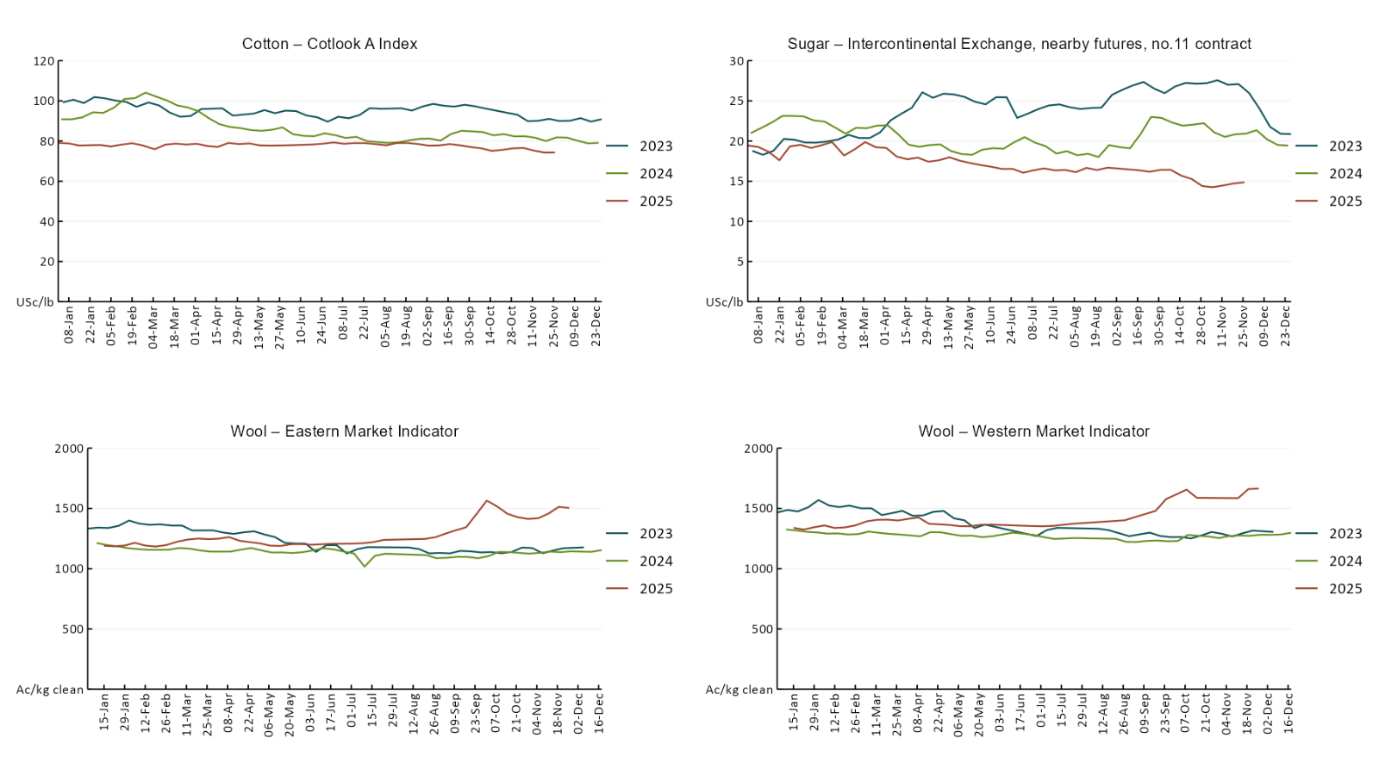

3.2 Selected domestic crop indicator prices
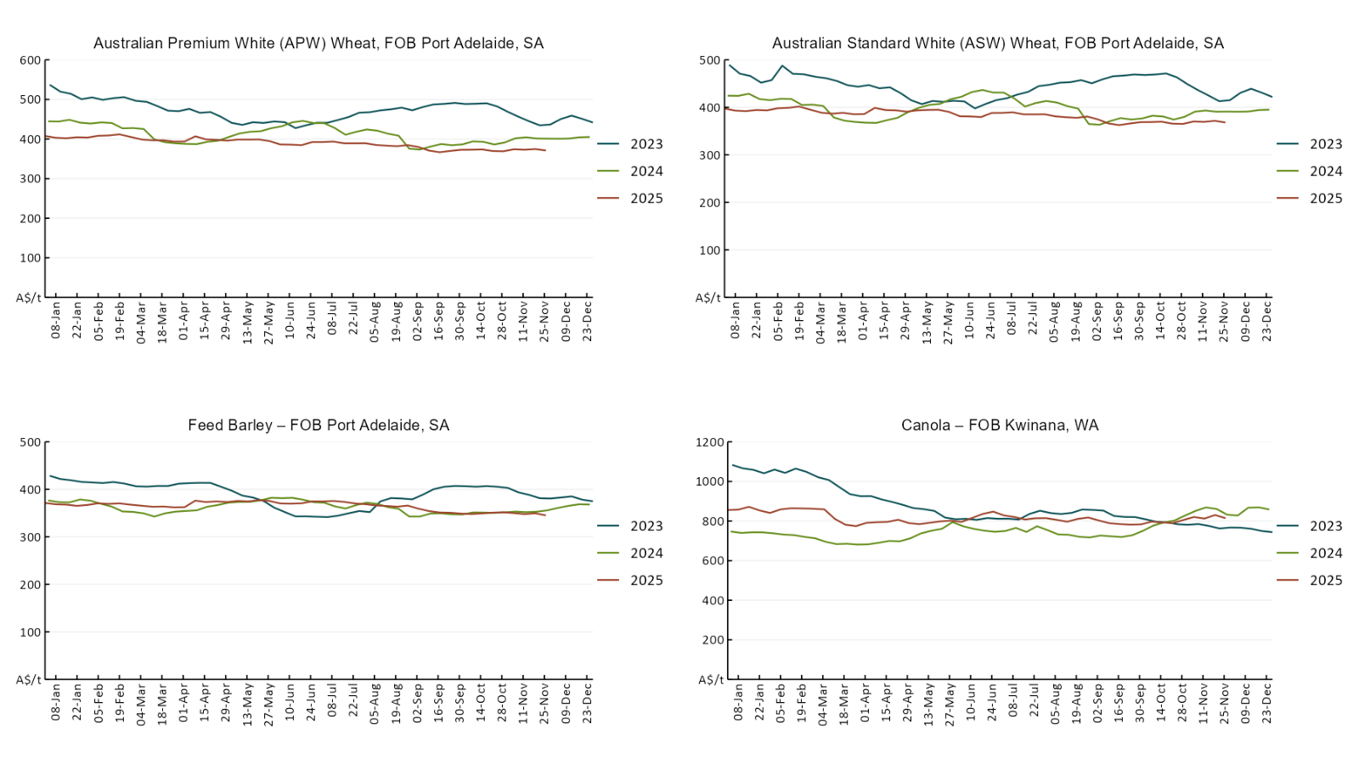
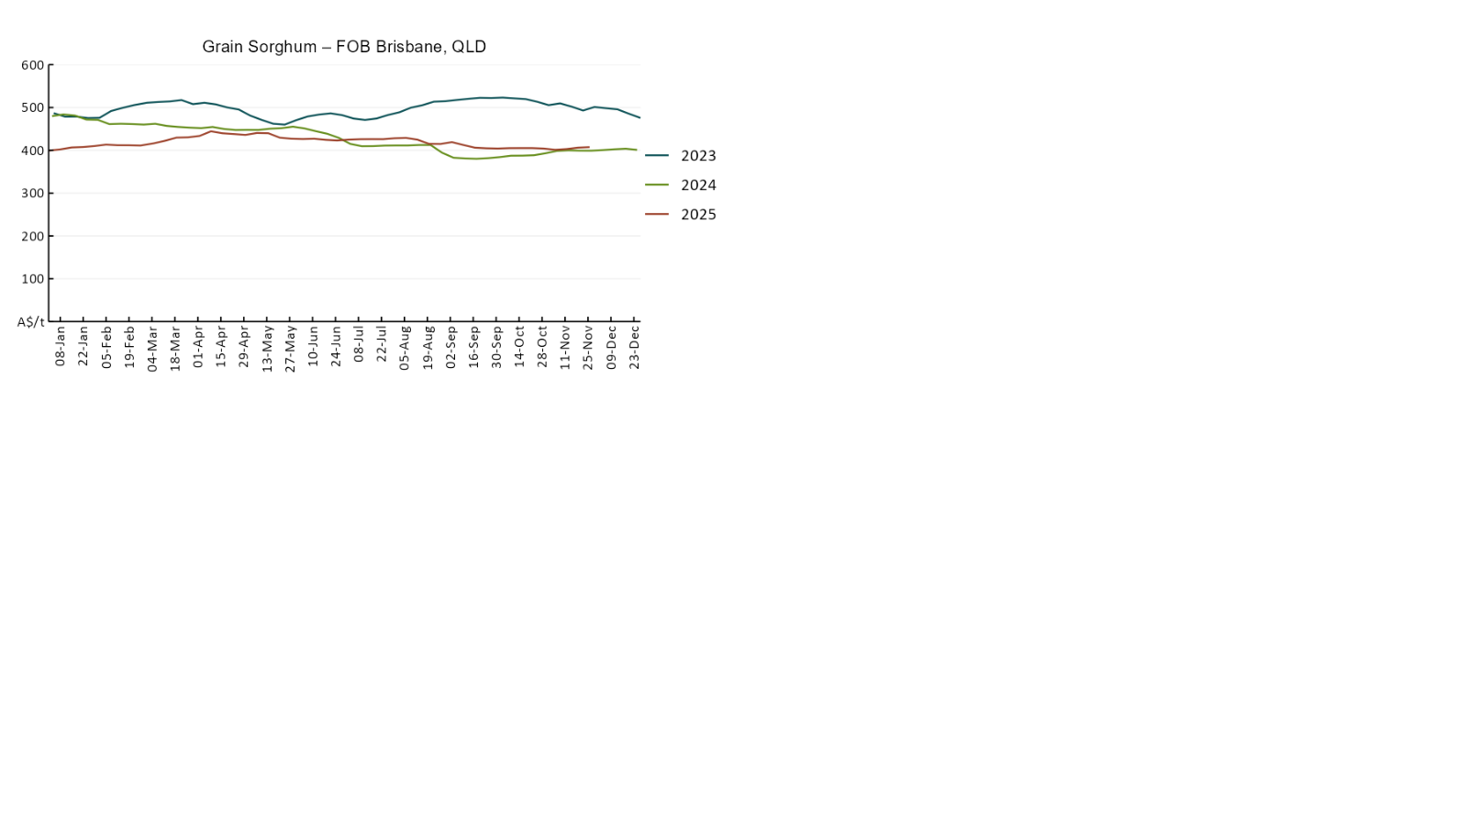

3.3 Selected domestic livestock indicator prices
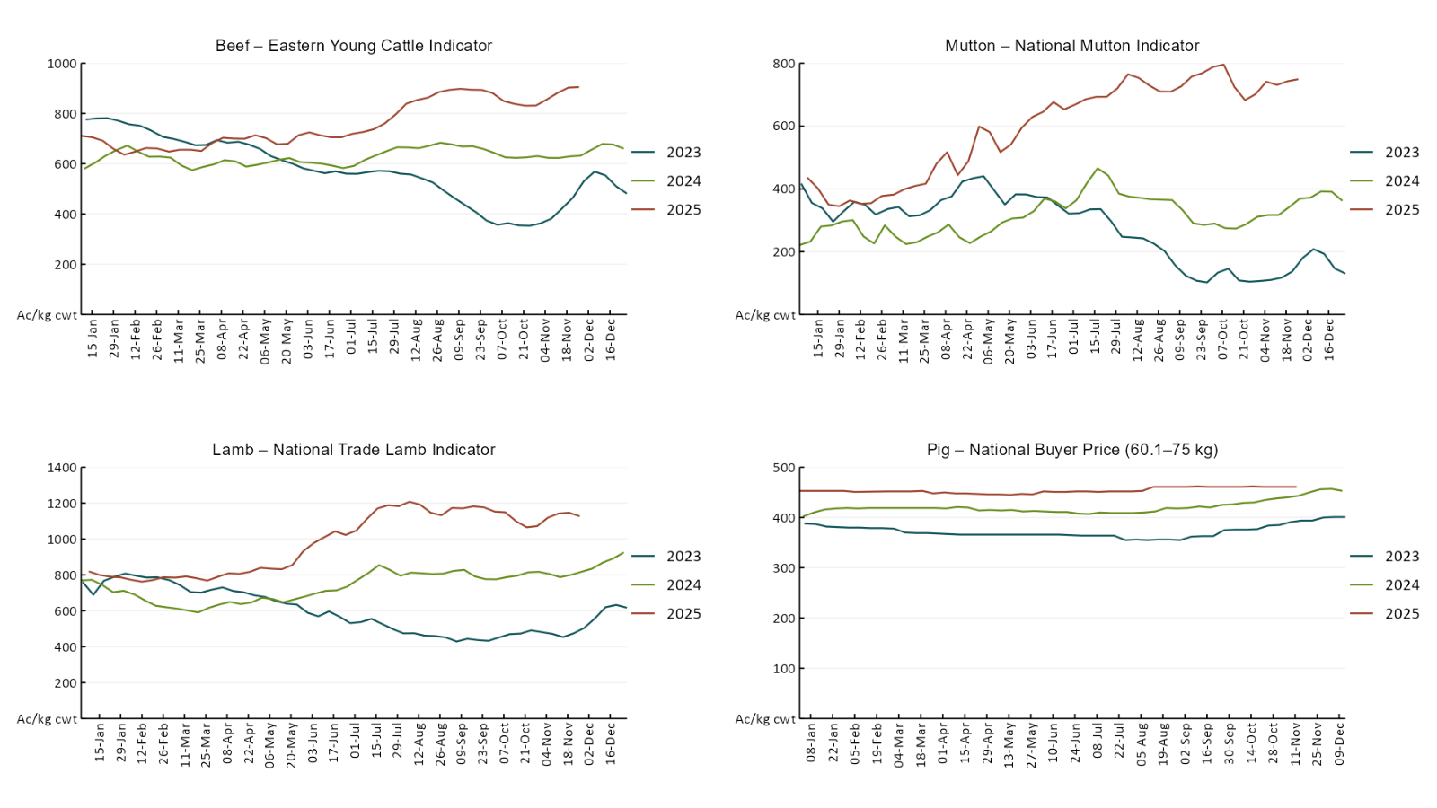
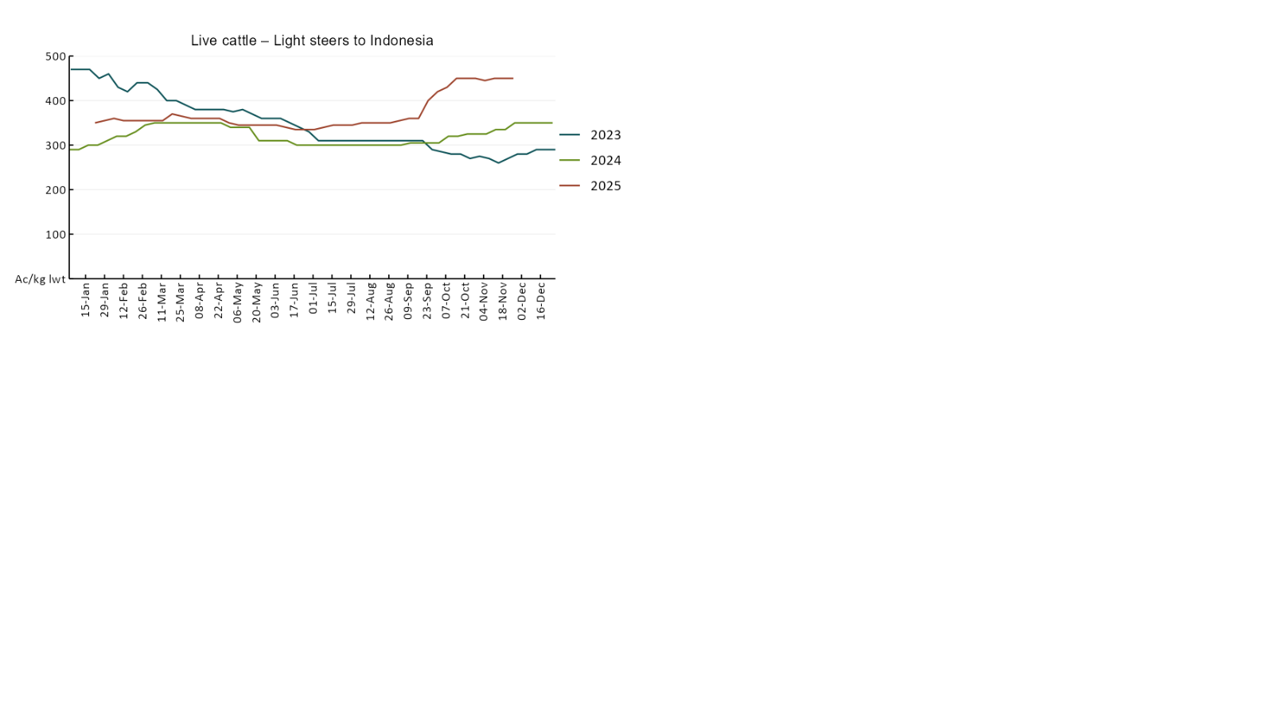

3.4 Global Dairy Trade (GDT) weighted average prices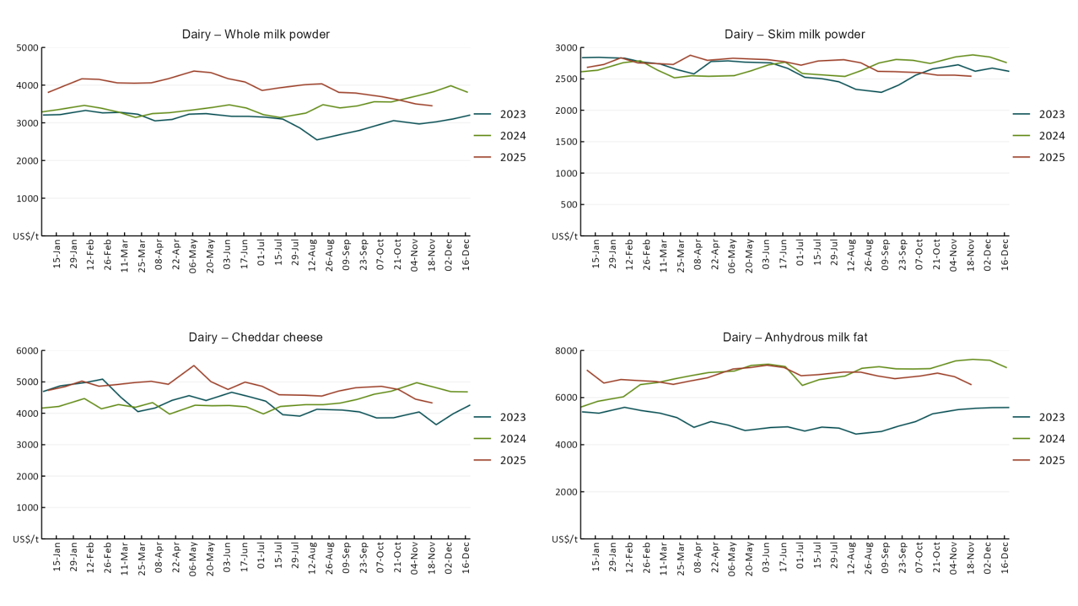

3.5 Selected fruit and vegetable prices

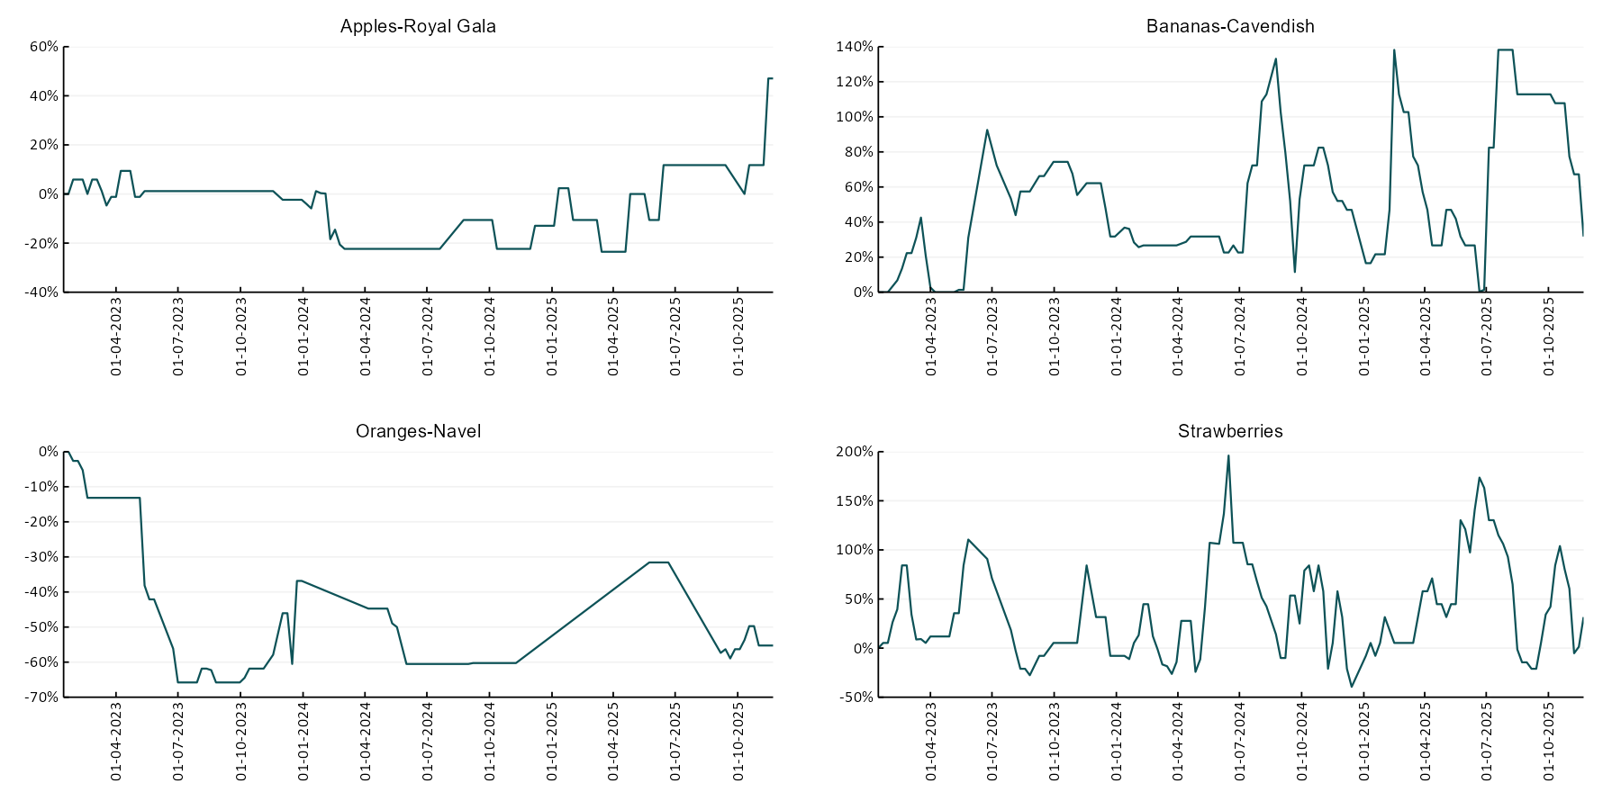

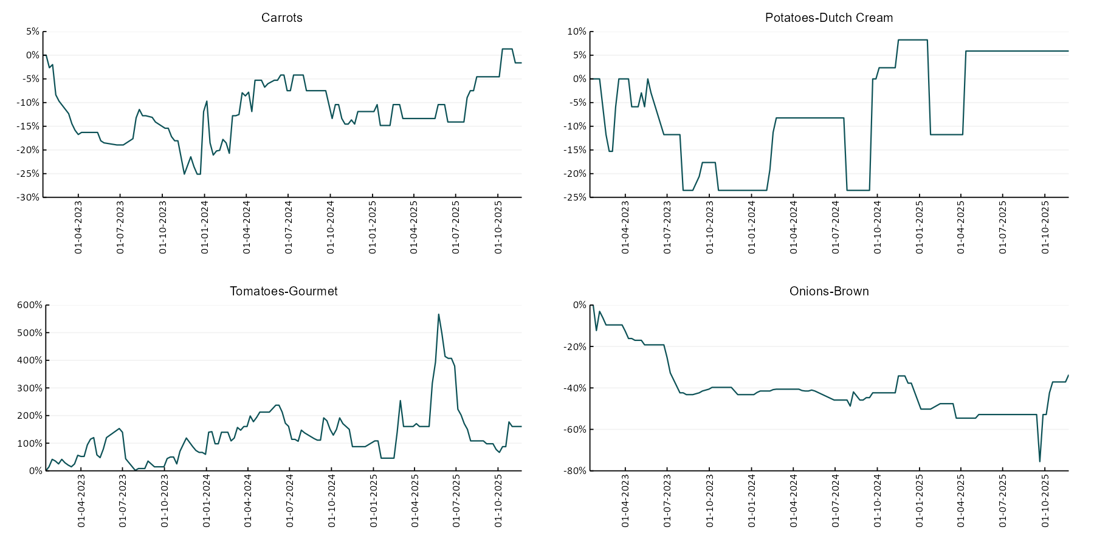

3.6 Selected domestic fodder indicator prices
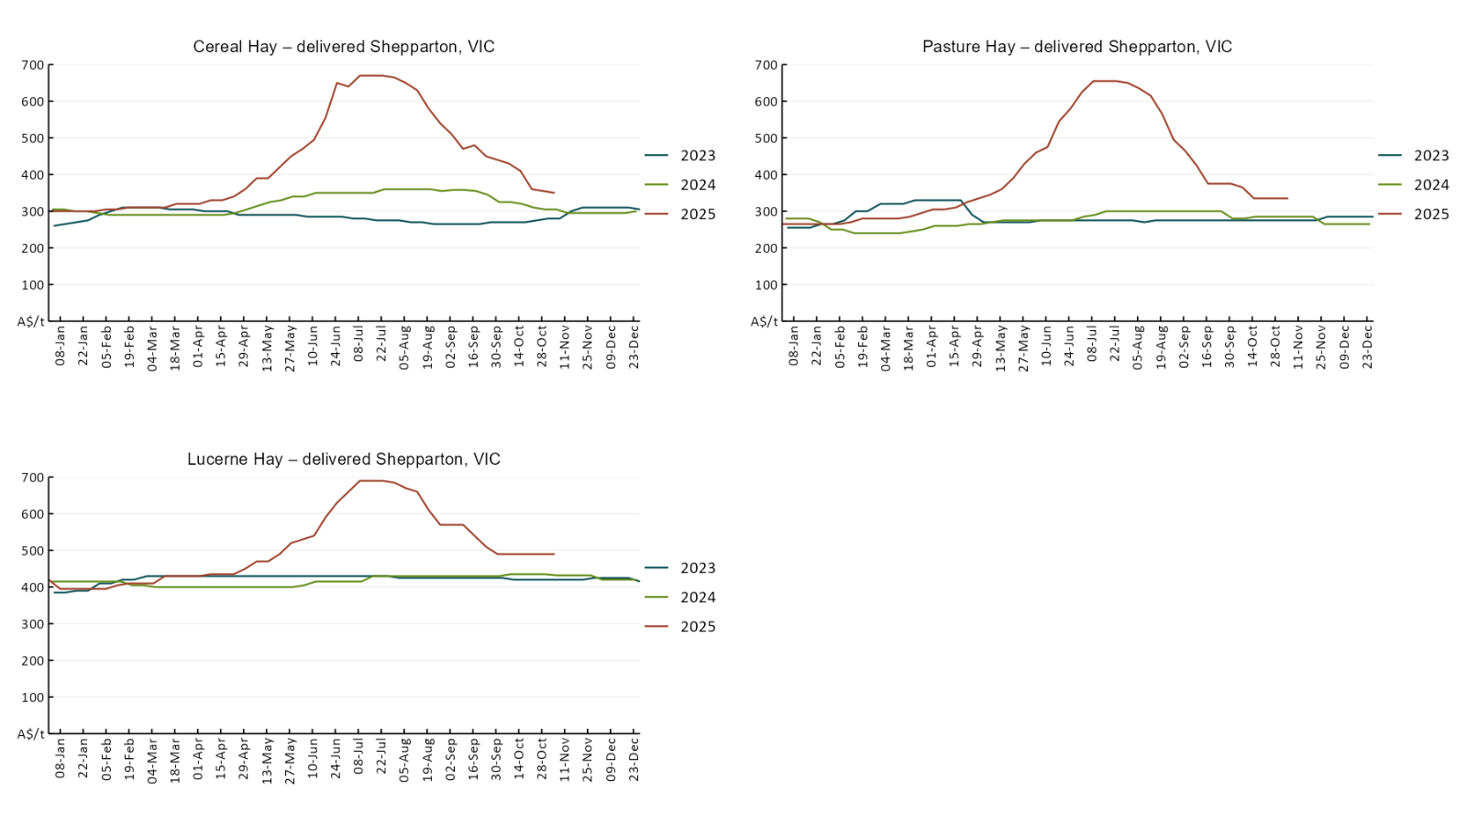

4. Data attribution

Climate
Bureau of Meteorology
- Weekly rainfall totals: www.bom.gov.au/climate/maps/rainfall/
- Monthly and last 3-month rainfall percentiles: https://www.bom.gov.au/climate/ahead/outlooks/#moreMaps
- Rainfall forecast: www.bom.gov.au/jsp/watl/rainfall/pme.jsp
- Seasonal outlook: www.bom.gov.au/climate/outlooks/#/overview/summary/
- Climate drivers: http://www.bom.gov.au/climate/enso/
- Soil moisture: https://awo.bom.gov.au/products/historical/soilMoisture-rootZone/

Other
- Pasture growth: www.longpaddock.qld.gov.au/aussiegrass/
- 3-month global outlooks: Environment and Climate Change Canada, NOAA Climate Prediction Center, EUROBRISA CPTEC/INPE, European Centre for Medium-Range Weather Forecasts, Hydrometcenter of Russia, National Climate Center Climate System Diagnosis and Prediction Room (NCC), International Research Institute for Climate and Society
- Global production: https://ipad.fas.usda.gov/ogamaps/cropmapsandcalendars.aspx
- Autumn break: Pook et al., 2009, https://rmets-onlinelibrary-wiley-com.virtual.anu.edu.au/doi/epdf/10.1002/joc.1833

Water
Prices
- Waterflow: https://www.waterflow.io/
- Ruralco: https://www.ruralcowater.com.au/
- Bureau of Meteorology:
- Allocation trade: http://www.bom.gov.au/water/dashboards/#/water-markets/mdb/at
- Storage volumes: http://www.bom.gov.au/water/dashboards/#/water-storages/summary/drainage

Trade constraints:
- Water NSW: https://www.waternsw.com.au/customer-service/ordering-trading-and-pricing/trading/murrumbidgee
- Victorian Water Register: https://www.waterregister.vic.gov.au/TradingRules2019/

Commodities
Fruit and vegetables
- Datafresh: www.freshstate.com.au

Pigs
- Australian Pork Limited: www.australianpork.com.au

Dairy
- Global Dairy Trade: www.globaldairytrade.info/en/product-results/

World wheat, canola
- International Grains Council
- https://www.igc.int/en/default.aspx
- United States Department of Agriculture

World cotton
- Cotlook: www.cotlook.com/

World sugar
- New York Stock Exchange - Intercontinental Exchange

Wool
- Australian Wool Exchange: www.awex.com.au/

Domestic wheat, barley, sorghum, canola and fodder
- Jumbuk Consulting Pty Ltd: Jumbuk AG | Agriculture Consulting

Cattle, beef, mutton, lamb, goat and live export
- Meat and Livestock Australia: https://www.mla.com.au/prices-markets/

© Commonwealth of Australia 2025

Ownership of intellectual property rights
Unless otherwise noted, copyright (and any other intellectual property rights, if any) in this publication is owned by the Commonwealth of Australia (referred to as the Commonwealth).

Creative Commons licence
All material in this publication is licensed under a Creative Commons Attribution 4.0 International Licence except content supplied by third parties, logos and the Commonwealth Coat of Arms.
Inquiries about the licence and any use of this document should be emailed to copyright@awe.gov.au.


Cataloguing data
This publication (and any material sourced from it) should be attributed as:
ABARES 2025, Weekly Australian Climate, Water and Agricultural Update, Australian Bureau of Agricultural and Resource Economics and Sciences, Canberra, 20 November 2025. CC BY 4.0 DOI: https://doi.org/10.25814/5f3e04e7d2503
ISSN 2652-7561
This publication is available at https://www.agriculture.gov.au/abares/products/weekly_update
Department of Agriculture, Fisheries and Forestry
GPO Box 858 Canberra ACT 2601
Telephone 1800 900 090
Web agriculture.gov.au/abares

Disclaimer
The Australian Government acting through the Department of Agriculture, Fisheries and Forestry, represented by the Australian Bureau of Agricultural and Resource Economics and Sciences, has exercised due care and skill in preparing and compiling the information and data in this publication. Notwithstanding, the Department of Agriculture, Fisheries and Forestry, ABARES, its employees and advisers disclaim all liability, including liability for negligence and for any loss, damage, injury, expense or cost incurred by any person as a result of accessing, using or relying on any of the information or data in this publication to the maximum extent permitted by law.

Statement of Professional Independence
The views and analysis presented in ABARES publications, including this one, reflect ABARES professionally independent findings, based on scientific and economic concepts, principles, information and data. These views, analysis and findings may not reflect or be consistent with the views or positions of the Australian Government, or of organisations or groups who have commissioned ABARES reports or analysis. More information on professional independence is provided on the ABARES website.

Acknowledgements
This report was prepared by Holly Beale and Matt Miller.

