
No. 48/2025 4 December 2025

Summary of key issues
- In the week ending 3 December 2025, rainfall was recorded across parts of northern, southern and central Australia, while south-western areas remained comparably dry.
  - Across cropping regions, rainfall totals were highly variable with the heaviest falls recorded across the parts of the northeast and southeast.
    - In southern cropping regions, rainfall this week have likely disrupted the harvest of winter crops but has unlikely impacted crop quality as this stage. Little to no rainfall across large areas of northern New South Wales, south-western Queensland and Western Australia would have provided for an uninterrupted harvest of winter crops.
- Over the coming eight days to 11 December 2025, limited rainfall is expected across most cropping regions, with exceptions in parts of the east.
  - In northern New South Wales and Queensland, these falls will likely support soil moisture levels in summer cropping regions but may result in some harvest delays for winter crops in northern New South Wales.
  - The relatively dry conditions expected across much southern cropping regions are likely to support harvest activities following a slow start due to cool wet conditions during much of November.
- Nationally, November rainfall was average to well above average across much of the country, with large areas of New South Wales and southwest Queensland seeing below average rainfall. This average to well above average rainfall has benefited both upper- and lower-layer soil moister levels across much of the country. However, low levels of lower layer soil moisture across some cropping regions particularly in central and southern New South Wales present an ongoing downside production for late sown winter crops and pasture growth.
- Improved pasture growth for the three months to November 2025 across large areas of Victoria, South Australia, Western Australia, and north-western and southern New South Wales will likely provide opportunities for some graziers to increase stocking rates and production.
- Water storage levels in the Murray-Darling Basin (MDB) decreased by 129 gigalitres (GL) between 27 November 2025 and 4 December 2025. The current volume of water held in storages is 14,246 GL, equivalent to 64% of total storage capacity. This is 12% or 1,995 GL less than the same time last year. Water storage data is sourced from the Bureau of Meteorology.
- Allocation prices in the Victorian Murray below the Barmah Choke increased from $311/ML on 27 November 2025 to $357/ML on 4 December 2025. Trade from the Goulburn to the Murray is closed. Trade downstream through the Barmah Choke is closed. Trade from the Murrumbidgee to the Murray is closed.

Climate

Rainfall this week
In the week ending 3 December 2025, low-pressure systems brought rainfall to parts of northern and eastern Australia. Meanwhile, cold fronts brought rainfall to large areas of southern Australia.
Across cropping regions, rainfall totals were highly variable with the heaviest falls recorded across the parts of the northeast and southeast for the week ending 3 December 2025.
- South Australia and Victoria cropping regions saw falls of between 5-50 millimetres of rainfall, with higher rainfall totals in southern regions of Victoria. Additionally, eastern regions of Queensland recorded falls of between 5-50 millimetres, with up to 100 millimetres in isolated areas.
  - Across those areas of Queensland which recorded rainfall this week, these falls have likely boosted soil moisture levels and supported the growth of summer crops already in the ground and encourage further planting but have likely disrupted the wrap up of the winter crop harvest.
  - In southern cropping regions, rainfall this week has likely disrupted the harvest of winter crops but has unlikely impacted crop quality as this stage.
- Cropping regions in New South Wales saw falls of 0-25 millimetres, while cropping regions in Western Australia and western Queensland recorded little to no rainfall.
  - Little to no rainfall across large areas of northern New South Wales, south-western Queensland and Western Australia would have provided for an uninterrupted harvest of winter crops.

Rainfall for the week ending 3 December 2025
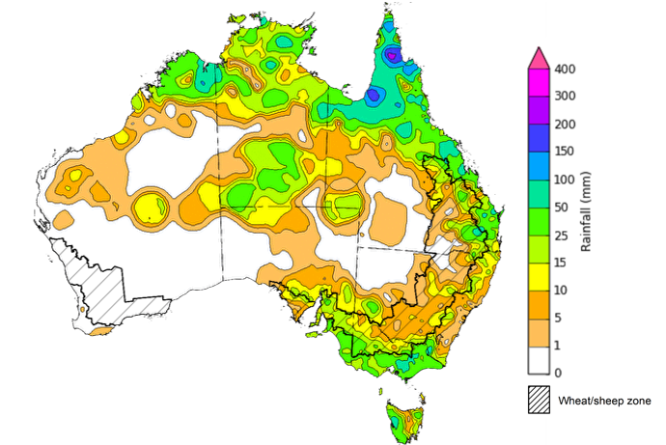

©Commonwealth of Australia 2025, Australian Bureau of Meteorology Issued: 3/12/2025
Note: The rainfall analyses and associated maps utilise data contained in the Bureau of Meteorology climate database, the Australian Data Archive for Meteorology (ADAM). The analyses are initially produced automatically from real-time data with limited quality control. They are intended to provide a general overview of rainfall across Australia as quickly as possible after the observations are received. For further information go to http://www.bom.gov.au/climate/rainfall/

Rainfall forecast for the next eight days
Over the 8 days to 11 December 2025, low-pressure systems are expected to bring rainfall to parts of northern and eastern Australia, while a cold front is expected bring rainfall to isolated areas in the south. Much of Australia is expected to remain largely dry.
Limited rainfall is expected across cropping regions this week, with exceptions in eastern areas of southern Queensland and northern New South Wales.
- Falls of between 5-25 millimetres are forecast for cropping regions in northern New South Wales and Queensland.
  - This is likely to support soil moisture storage in summer cropping regions, but may result in some harvest delays for winter crops in northern New South Wales.
- Remaining cropping regions, including southern New South Wales, Victoria, South Australia, and Western Australia are forecast to receive little to no rainfall.
  - These relatively dry conditions across much southern cropping regions are likely to support harvest activities following a slow start due to cool wet conditions during much of November.

Total forecast rainfall for the period 4 December to 11 December 2025
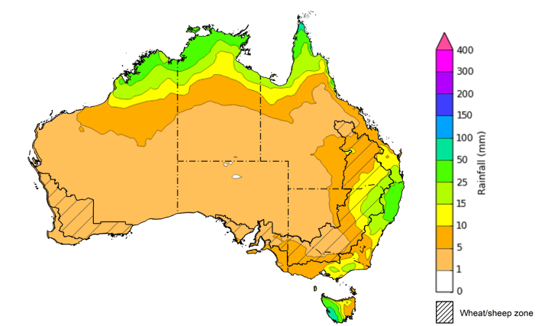
©Commonwealth of Australia 2025, Australian Bureau of Meteorology Issued 4/12/2025
Note: This rainfall forecast is produced from computer models. As the model outputs are not altered by weather forecasters, it is important to check local forecasts and warnings issued by the Bureau of Meteorology.

Monthly rainfall
Rainfall during November 2025 was mixed across Australia:
- Rainfall was average to extremely high across most states and territories, with the exception of large areas of New South Wales and southwest Queensland which recorded extremely low to below average rainfall.
In cropping regions, November rainfall was generally average to well above average:
- November rainfall was average to extremely high across most cropping regions in South Australia, Queensland and Western Australia.
- Cropping regions in central and southern New South Wales and south-western Queensland, recorded was below average rainfall.
  - The below average conditions observed in these areas has likely hampered late spring pasture growth and led to a drawdown of soil moisture reserves to support the growth of summer crops
- Remaining cropping regions saw average rainfall.
Rainfall percentiles for November 2025
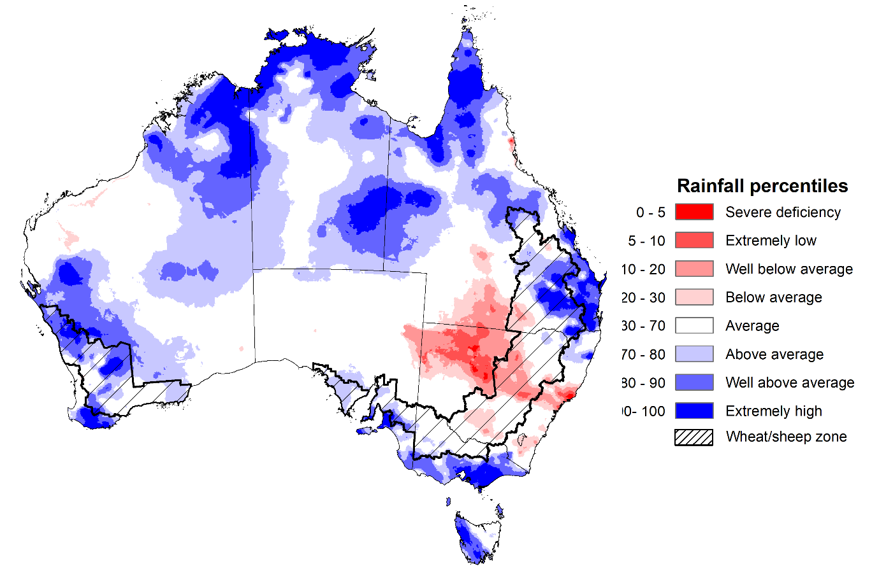

Note: Rainfall for November 2025 is compared with rainfall recorded for that period during the historical record (1900 to present). For further information, go to http://www.bom.gov.au/climate/austmaps/about-rain-maps.shtml
Source: Bureau of Meteorology

Monthly Soil Moisture
In November 2025, modelled upper layer soil moisture was generally average to above average in the north and south, with areas of below average soil moisture in scattered eastern and western areas.
- Large areas of north-western New South Wales, south-western Queensland, and western and central Western Australia saw very much below average to below average upper layer soil moisture.
- In contrast, much of northern and southern Australia, including the northern tropics, eastern Queensland, southern South Australia, Tasmania, southern Victoria and south-western Western Australia saw above average to very much above upper layer soil moisture.
At this time of year, upper layer soil moisture is important at the beginning of the summer cropping season and for pasture growth across northern Australia since plant germination and establishment utilise this moisture. It is also an important indicator of the ability to access paddocks for winter crop harvesting and summer crop planting activities..
Across most cropping regions, modelled upper layer soil moisture in November was generally average to very much above average. However much of New South Wales and parts of south-western Queensland were modelled to have below average to average upper layer soil moisture levels for this time of year.
Modelled upper layer soil moisture for November 2025
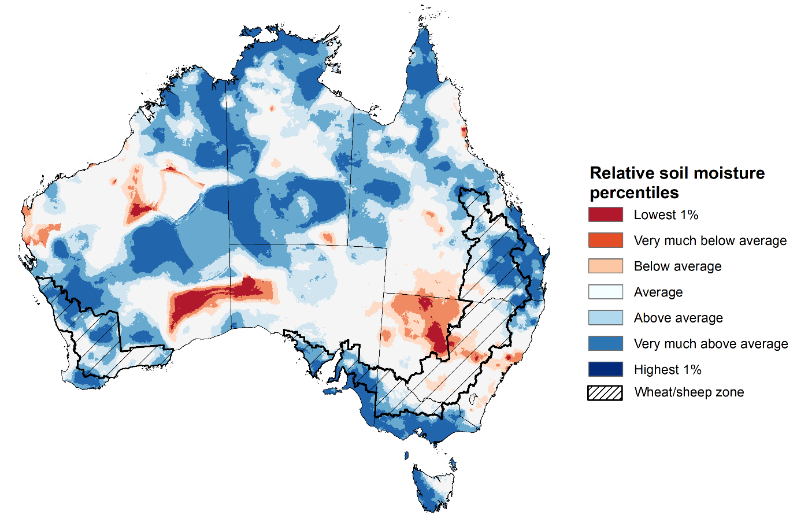

Note: This map shows the levels of modelled upper layer soil moisture (0 to 10 centimetres) during November 2025. This map shows how modelled soil conditions during November 2025 compare with November conditions modelled over the reference period (1911 to 2016). Dark blue areas on the maps were much wetter in November 2025 than during the reference period. The bulk of plant roots occur in the top 20 centimetres of the soil profile. Soil moisture in the upper layer of the soil profile is therefore useful indicator of the availability of water, particularly for germinating seed.
Source: Bureau of Meteorology (https://awo.bom.gov.au/about/overview)
Modelled lower layer soil moisture in November 2025 was average to very much above average across much of northern, central and western Australia, while extremely low to below average modelled lower layer soil moisture was evident across some southern and eastern areas.
Lower layer soil moisture is a larger, deeper store that is slower to respond to seasonal conditions and tends to reflect the accumulated effects of events that have occurred over longer periods. Crop development and pasture growth in areas of above average lower layer soil moisture are typically less reliant on in-season rainfall than in areas with below average lower layer soil moisture.
November 2025 modelled lower layer soil moisture was average to above average across most southern and north-eastern cropping regions. This represents an improvement in deep moisture stores from October in much of South Australia, Victoria, Queensland and parts of Western Australia. This additional moisture has likely arrested any further declines in yield potentials and pasture growth in southern areas. Low levels of lower layer soil moisture across some cropping regions in eastern Australia, including much of central and southern New South Wales present an ongoing downside production for late sown winter crops and pasture growth.
Modelled lower layer soil moisture for November 2025
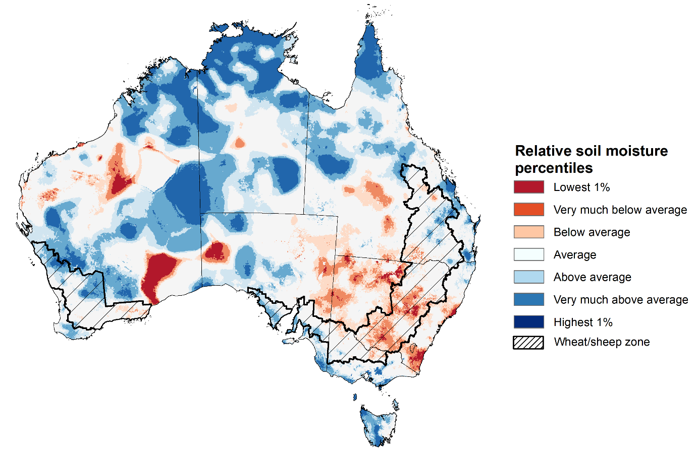

Note: This map shows the levels of modelled lower layer soil moisture (10 to 100 centimetres) during November 2025. This map shows how modelled soil conditions during November 2025 compare with November conditions modelled over the reference period (1911 to 2016). Dark blue areas on the maps were much wetter in July 2025 than during the reference period. The dark red areas were much drier than during the reference period. The bulk of plant roots occur in the top 20 centimetres of the soil profile. The lower layer soil moisture is a larger, deeper store that is slower to respond to rainfall and tends to reflect accumulated rainfall events over longer time periods.
Source: Bureau of Meteorology (https://awo.bom.gov.au/about/overview)

Pasture Growth
Pasture growth during the September to November period is typically low across large areas of central and western Australia as exits the dry season. Across southern Australia, September and November is the peak pasture growth period which typically provides a bulk of feed and allows for fodder conservation to maintain production through the low pasture growth months of summer. It also influences the growth, branding and marking rates of lambs and calves, and the production of meat, milk, and wool over this peak production period.
Pasture growth for the three months to November 2025 was variable across much of country, with parts of southern and northern Australia experiencing robust pasture growth.
- Average to extremely high relative pasture growth was modelled across large areas of southern and northern Australia, including parts of the northern tropics, southern Victoria, southern regions of South Australia, and much of south-western Western Australia.
  - This pasture growth is expected to have allowed some farmers to rebuild livestock numbers, provide opportunities to build standing dry matter availability and replenish fodder supplies during late spring and early summer..
- In contrast, large areas of the southeast, including parts of central Queensland, eastern New South Wales and South Australia, northern Victoria, and western Tasmania saw relatively low pasture growth for this time of year. Isolated areas in the west, including southern Western Australia, also saw below average pasture growth.
  - This below average pasture growth has likely led to a decline in pasture availability and graziers in regions where below average pasture growth was recorded will be more reliant on supplemental feed to maintain current stocking rates and production.
Relative pasture growth for 3-months ending November 2025 (1 September to 30 November 2025)
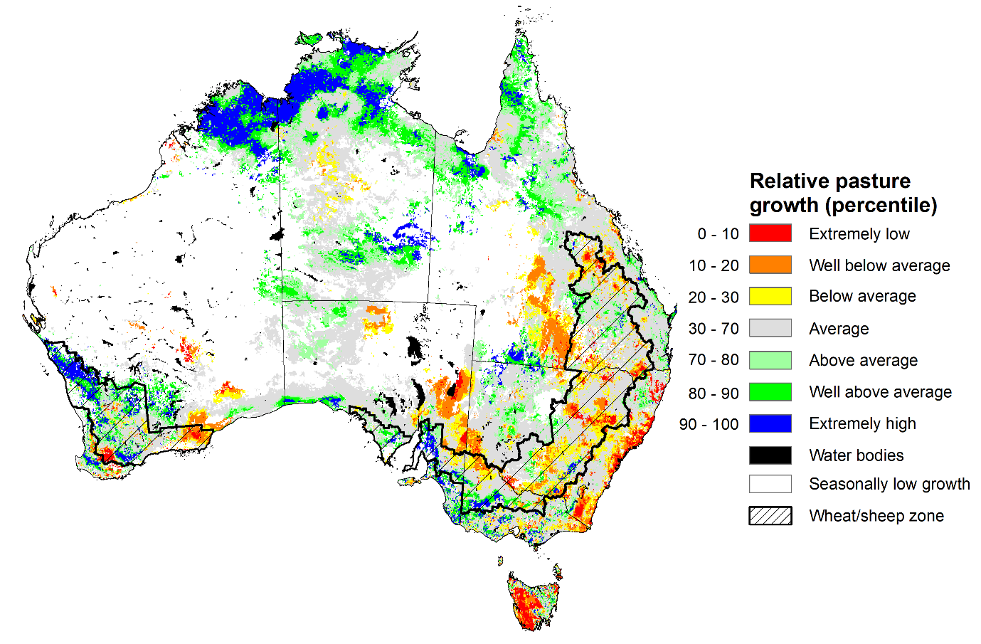
Notes: AussieGRASS pasture growth estimates are relative to the long-term record and shown in percentiles. Percentiles rank data on a scale of zero to 100. This analysis ranks pasture growth for the selected period against average pasture growth for the long-term record (1957 to 2016). Pasture growth is modelled at 5km2 grid cells.
Source: Department of Environment, Science and Innovation

Water markets – current week
Water storage levels in the Murray-Darling Basin (MDB) decreased by 129 gigalitres (GL) between 27 November 2025 and 4 December 2025. The current volume of water held in storages is 14,246 GL, equivalent to 64% of total storage capacity. This is 12% or 1,995 GL less than the same time last year. Water storage data is sourced from the Bureau of Meteorology.

Water storages in the Murray-Darling Basin, 2013–2025
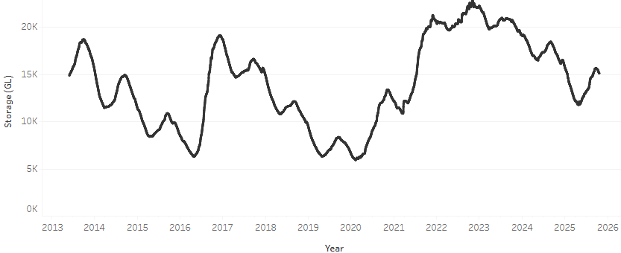
Allocation prices in the Victorian Murray below the Barmah Choke increased from $311/ML on 27 November 2025 to $357/ML on 4 December 2025. Trade from the Goulburn to the Murray is closed. Trade downstream through the Barmah Choke is closed. Trade from the Murrumbidgee to the Murray is closed.

Water market prices, Southern Murray–Darling Basin

Region | $/ML
NSW Murray Above | 295
NSW Murrumbidgee | 321
Vic Greater Goulburn | 300
Vic Murray Below | 357

Note: The water allocation prices shown are volume weighted average prices based on the last 10 trades. Price data is sourced from Waterflow and current as at 4 December 2025.
To access the full, interactive, weekly water dashboard, which contains the latest and historical water storage, water market and water allocation information, please visit https://www.agriculture.gov.au/abares/products/weekly_update/weekly-update-041225

Commodities
Indicator | Week average | Unit | Latest Price | Previous Week | Weekly change |  | Price 12 months ago | Annual change
Selected world indicator prices
AUD/USD Exchange rate | 3-Dec | A$/US$ | 0.66 | 0.65 | 1% | 0.63 |  | 3%
Wheat – US no. 2 hard red winter wheat, FOB Gulf | 3-Dec | US$/t | 246 | 244 | 1% | 252 |  | -2%
Corn – US no. 2 yellow corn, FOB Gulf | 3-Dec | US$/t | 205 | 198 | 3% | 202 |  | 1%
Canola – Rapeseed, Canada, FOB Vancouver | 3-Dec | US$/t | 488 | 488 | 0% | 453 |  | 8%
Cotton – Cotlook A Index | 3-Dec | USc/lb | 74.9 | 74.6 | 0% | 79.9 |  | -6%
Sugar – Intercontinental Exchange, nearby futures, no.11 contract | 3-Dec | USc/lb | 14.9 | 15.0 | -1% | 20.1 |  | -26%
Wool – Eastern Market Indicator | 26-Nov | Ac/kg clean | 1,504 | 1,514 | -1% | 1,145 |  | 31%
Wool – Western Market Indicator | 26-Nov | Ac/kg clean | 1,665 | 1,661 | 0% | 1,288 |  | 29%
Selected Australian grain export prices
Australian Premium White (APW) Wheat, FOB Port Adelaide, SA | 3-Dec | A$/t | 371 | 370 | 0% | 403 |  | -8%
Australian Standard White (ASW) Wheat, FOB Port Adelaide, SA | 3-Dec | A$/t | 368 | 367 | 0% | 393 |  | -6%
Feed Barley – FOB Port Adelaide, SA | 3-Dec | A$/t | 348 | 345 | 1% | 366 |  | -5%
Canola – FOB Kwinana, WA | 3-Dec | A$/t | 807 | 815 | -1% | 856 |  | -6%
Grain Sorghum – FOB Brisbane, QLD | 3-Dec | A$/t | 410 | 408 | 1% | 402 |  | 2%
Selected domestic livestock indicator prices
Beef – Eastern Young Cattle Indicator | 3-Dec | Ac/kg cwt | 885 | 902 | -2% | 668 |  | 33%
Mutton – Mutton indicator (18–24 kg fat score 2–3), VIC | 3-Dec | Ac/kg cwt | 757 | 750 | 1% | 379 |  | 100%
Lamb – National Trade Lamb Indicator | 3-Dec | Ac/kg cwt | 1,086 | 1,118 | -3% | 880 |  | 23%
Pig – Eastern Seaboard (60.1–75 kg), NSW buyer price | 12-Nov | Ac/kg cwt | 461 | 461 | 0% | 455 |  | 1%
Live cattle – Light steers to Indonesia | 26-Nov | Ac/kg lwt | 450 | 450 | 0% | 350 |  | 29%
Global Dairy Trade (GDT) weighted average prices
Dairy – Whole milk powder | 3-Dec | US$/t | 3,364 | 3,452 | -3% | 3,897 |  | -14%
Dairy – Skim milk powder | 3-Dec | US$/t | 2,498 | 2,542 | -2% | 2,803 |  | -11%
Dairy – Cheddar cheese | 3-Dec | US$/t | 4,639 | 4,328 | 7% | 4,686 |  | -1%
Dairy – Anhydrous milk fat | 3-Dec | US$/t | 5,902 | 6,543 | -10% | 7,425 |  | -21%

Selected world indicator prices

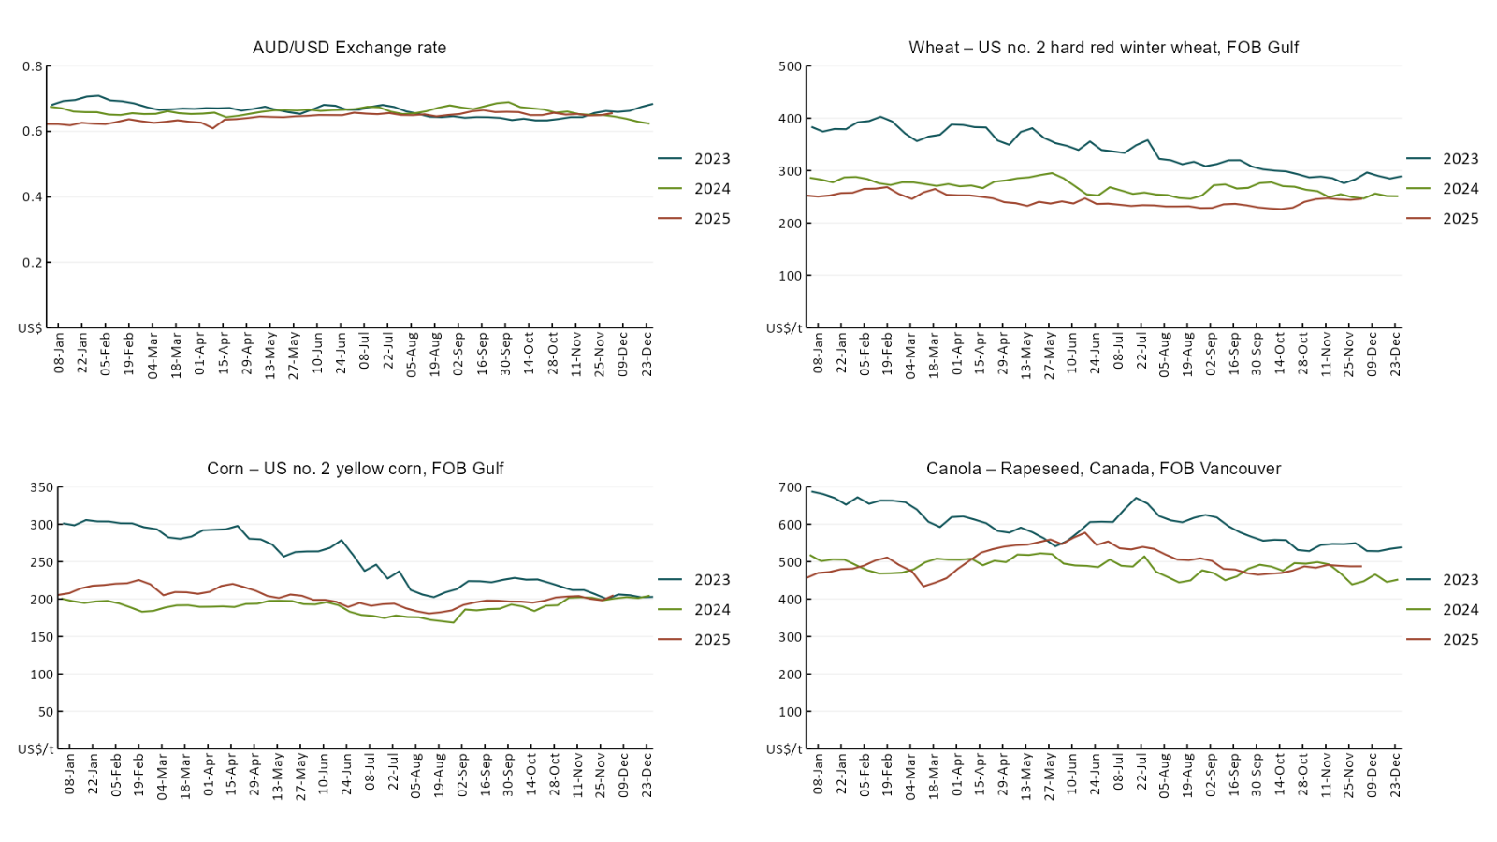
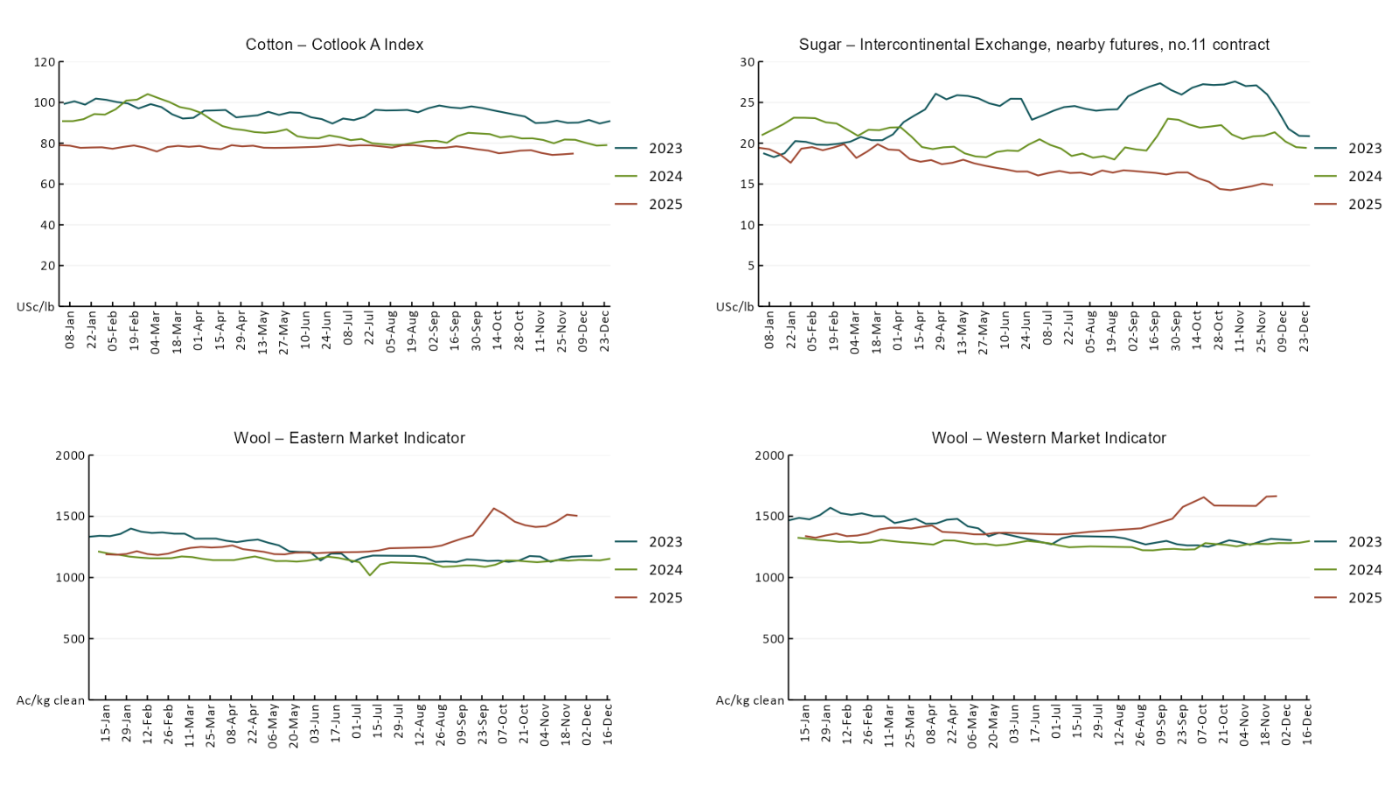

3.2 Selected domestic crop indicator prices
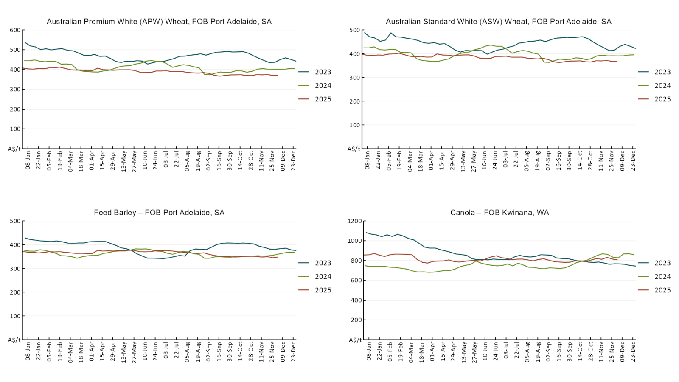
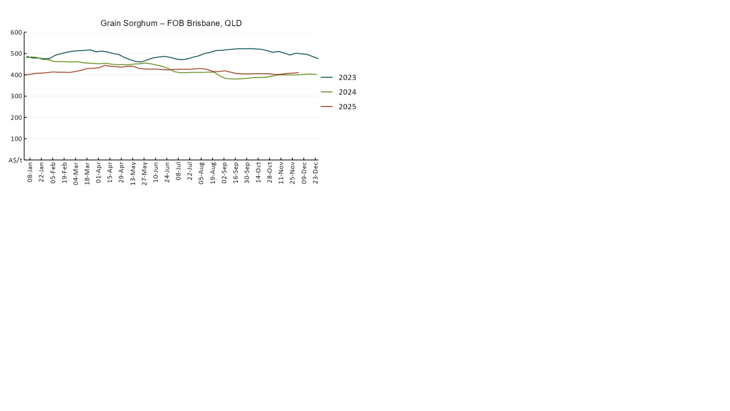

3.3 Selected domestic livestock indicator prices
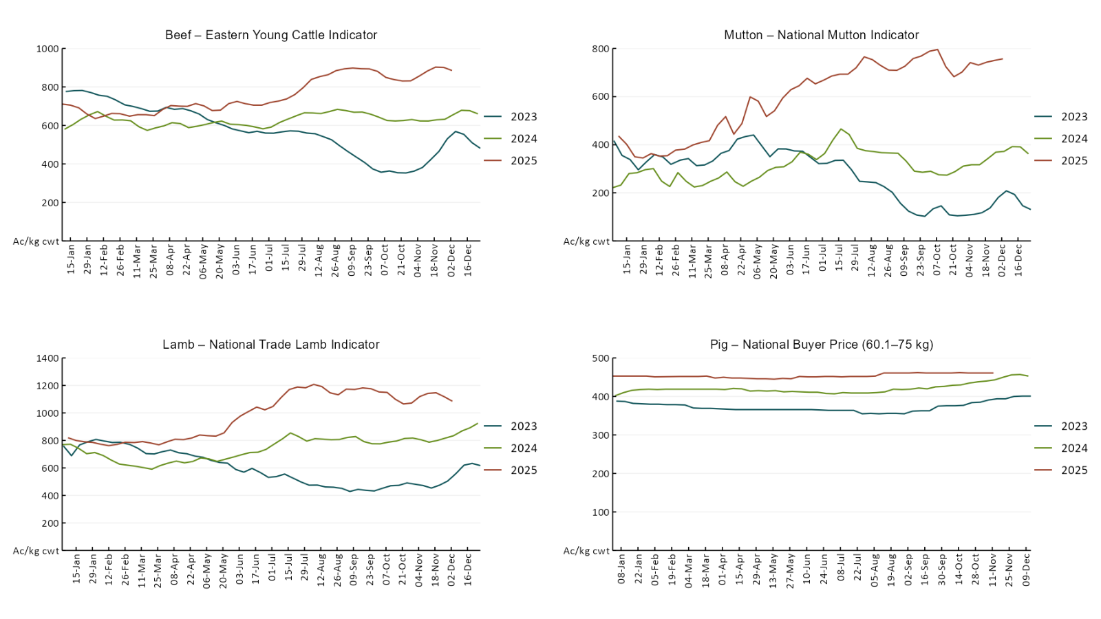
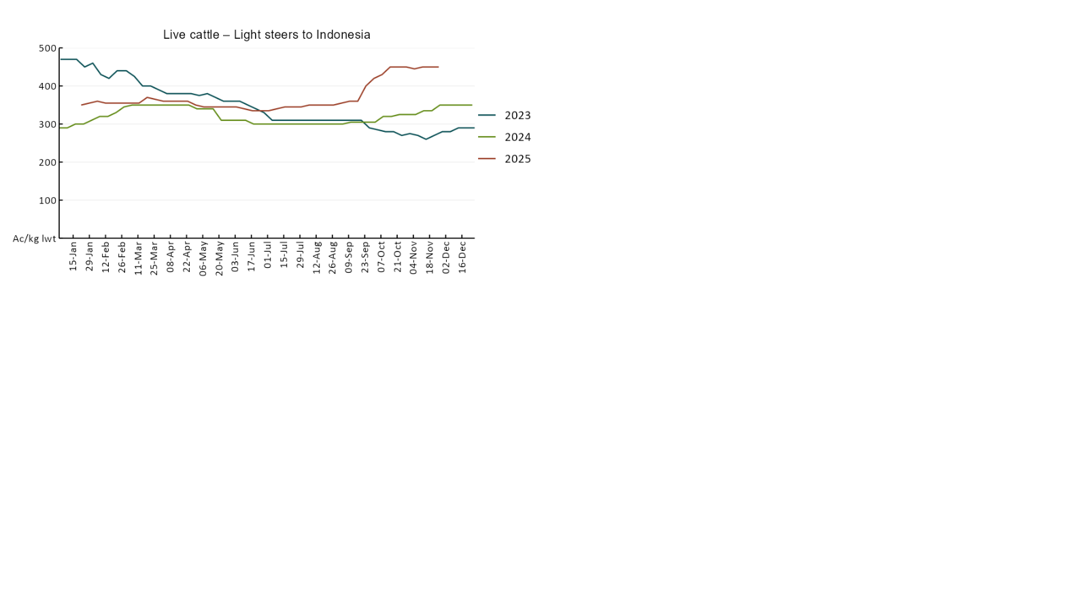

3.4 Global Dairy Trade (GDT) weighted average prices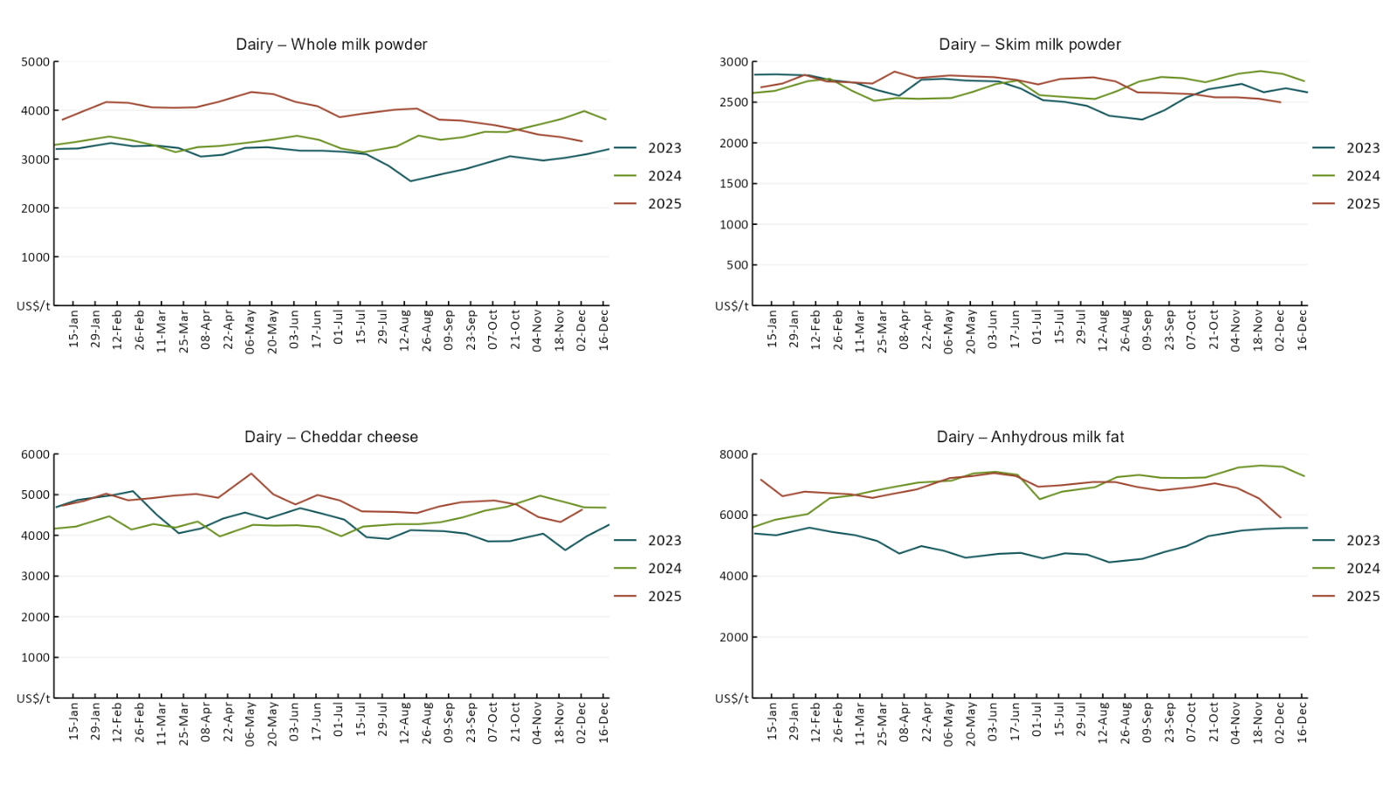

3.5 Selected fruit and vegetable prices

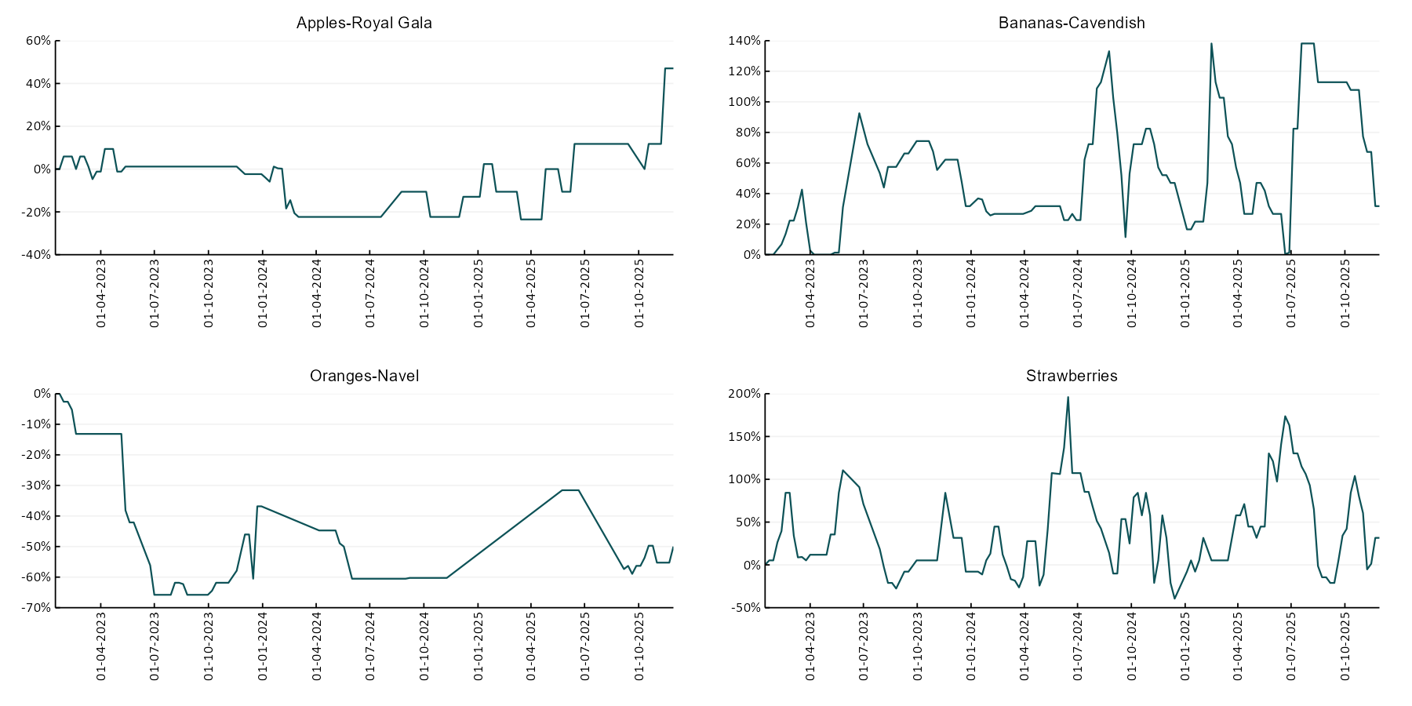

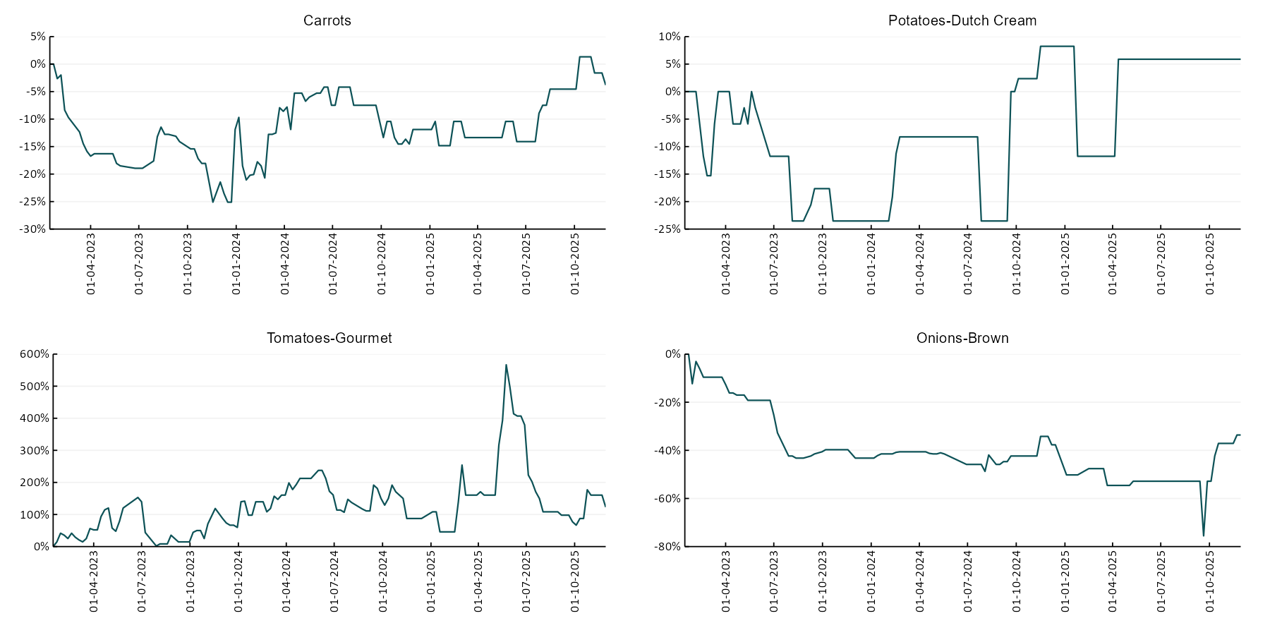

3.6 Selected domestic fodder indicator prices
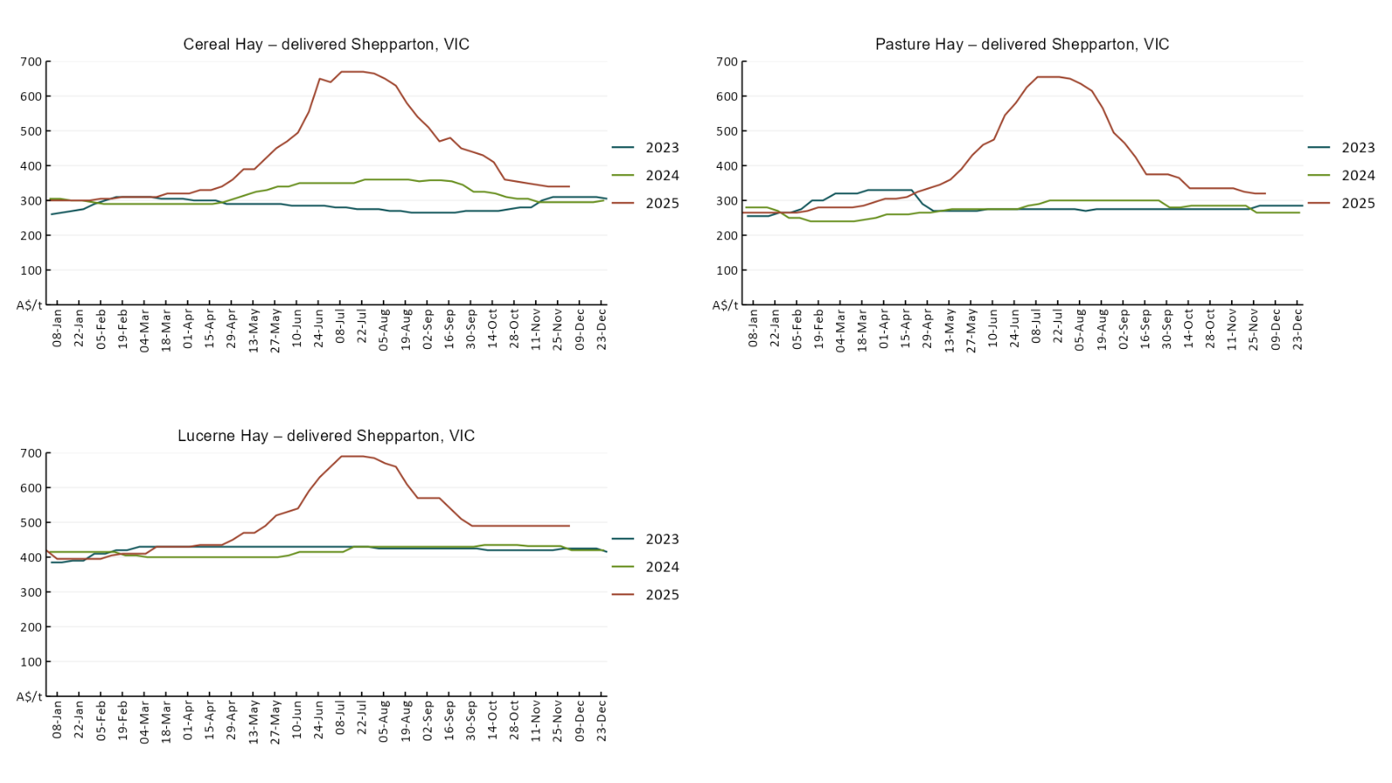

4. Data attribution

Climate
Bureau of Meteorology
- Weekly rainfall totals: www.bom.gov.au/climate/maps/rainfall/
- Monthly and last 3-month rainfall percentiles: https://www.bom.gov.au/climate/ahead/outlooks/#moreMaps
- Rainfall forecast: www.bom.gov.au/jsp/watl/rainfall/pme.jsp
- Seasonal outlook: www.bom.gov.au/climate/outlooks/#/overview/summary/
- Climate drivers: http://www.bom.gov.au/climate/enso/
- Soil moisture: https://awo.bom.gov.au/products/historical/soilMoisture-rootZone/

Other
- Pasture growth: www.longpaddock.qld.gov.au/aussiegrass/
- 3-month global outlooks: Environment and Climate Change Canada, NOAA Climate Prediction Center, EUROBRISA CPTEC/INPE, European Centre for Medium-Range Weather Forecasts, Hydrometcenter of Russia, National Climate Center Climate System Diagnosis and Prediction Room (NCC), International Research Institute for Climate and Society
- Global production: https://ipad.fas.usda.gov/ogamaps/cropmapsandcalendars.aspx
- Autumn break: Pook et al., 2009, https://rmets-onlinelibrary-wiley-com.virtual.anu.edu.au/doi/epdf/10.1002/joc.1833

Water
Prices
- Waterflow: https://www.waterflow.io/
- Ruralco: https://www.ruralcowater.com.au/
- Bureau of Meteorology:
- Allocation trade: http://www.bom.gov.au/water/dashboards/#/water-markets/mdb/at
- Storage volumes: http://www.bom.gov.au/water/dashboards/#/water-storages/summary/drainage

Trade constraints:
- Water NSW: https://www.waternsw.com.au/customer-service/ordering-trading-and-pricing/trading/murrumbidgee
- Victorian Water Register: https://www.waterregister.vic.gov.au/TradingRules2019/

Commodities
Fruit and vegetables
- Datafresh: www.freshstate.com.au

Pigs
- Australian Pork Limited: www.australianpork.com.au

Dairy
- Global Dairy Trade: www.globaldairytrade.info/en/product-results/

World wheat, canola
- International Grains Council
- https://www.igc.int/en/default.aspx
- United States Department of Agriculture

World cotton
- Cotlook: www.cotlook.com/

World sugar
- New York Stock Exchange - Intercontinental Exchange

Wool
- Australian Wool Exchange: www.awex.com.au/

Domestic wheat, barley, sorghum, canola and fodder
- Jumbuk Consulting Pty Ltd: Jumbuk AG | Agriculture Consulting

Cattle, beef, mutton, lamb, goat and live export
- Meat and Livestock Australia: https://www.mla.com.au/prices-markets/

© Commonwealth of Australia 2025

Ownership of intellectual property rights
Unless otherwise noted, copyright (and any other intellectual property rights, if any) in this publication is owned by the Commonwealth of Australia (referred to as the Commonwealth).

Creative Commons licence
All material in this publication is licensed under a Creative Commons Attribution 4.0 International Licence except content supplied by third parties, logos and the Commonwealth Coat of Arms.
Inquiries about the licence and any use of this document should be emailed to copyright@awe.gov.au.


Cataloguing data
This publication (and any material sourced from it) should be attributed as:
ABARES 2025, Weekly Australian Climate, Water and Agricultural Update, Australian Bureau of Agricultural and Resource Economics and Sciences, Canberra, 4 December 2025. CC BY 4.0 DOI: https://doi.org/10.25814/5f3e04e7d2503
ISSN 2652-7561
This publication is available at https://www.agriculture.gov.au/abares/products/weekly_update
Department of Agriculture, Fisheries and Forestry
GPO Box 858 Canberra ACT 2601
Telephone 1800 900 090
Web agriculture.gov.au/abares

Disclaimer
The Australian Government acting through the Department of Agriculture, Fisheries and Forestry, represented by the Australian Bureau of Agricultural and Resource Economics and Sciences, has exercised due care and skill in preparing and compiling the information and data in this publication. Notwithstanding, the Department of Agriculture, Fisheries and Forestry, ABARES, its employees and advisers disclaim all liability, including liability for negligence and for any loss, damage, injury, expense or cost incurred by any person as a result of accessing, using or relying on any of the information or data in this publication to the maximum extent permitted by law.

Statement of Professional Independence
The views and analysis presented in ABARES publications, including this one, reflect ABARES professionally independent findings, based on scientific and economic concepts, principles, information and data. These views, analysis and findings may not reflect or be consistent with the views or positions of the Australian Government, or of organisations or groups who have commissioned ABARES reports or analysis. More information on professional independence is provided on the ABARES website.

Acknowledgements
This report was prepared by Holly Beale and Matt Miller.

