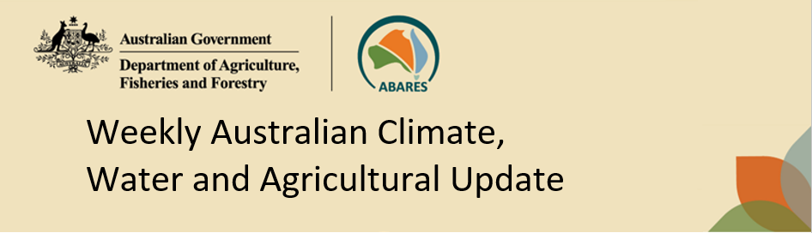
No. 49/2025 11 December 2025

Summary of key issues
- In the week ending 10 December 2025, rainfall was recorded across northern, eastern, and isolated southern regions of Australia, while central and western areas remained comparably dry.
  - Across cropping regions, little to no rainfall was recorded, with exceptions in the northeast.
    - Most cropping regions in New South Wales, Queensland, South Australia, Victoria and Western Australia saw falls of between 0-5 millimetres. Scattered areas of north-eastern New South Wales and south-eastern Queensland recorded falls of between 5-15 millimetres.
- Over the coming eight days to 18 December 2025, limited rainfall is expected across most southern cropping regions, with higher rainfall totals expected in the east.
  - The expected heavier falls across northern New South Wales and Queensland are likely to support soil moisture storage in summer cropping regions, but the lighter falls across southern New South Wales, eastern Victoria and Western Australia may result in some harvest delays for winter crops.
  - The relatively dry expected conditions across most southern cropping regions are likely to support harvest activities following a slow start due to cool wet conditions during much of November.
- The national rainfall outlook for January to March 2026 indicates an increased probability of below median rainfall across areas of north-western and parts of south-eastern Australia, while some northern and eastern areas are more likely to see above median rainfall.
  - If realised, the increased chance of below median rainfall across parts of south-eastern Australia is likely to benefit late harvest activity of winter crops. Close to average forecast rainfall for much of northern and eastern Australia is expected to support summer crop and pasture production.
- Water storage levels in the Murray-Darling Basin (MDB) decreased by 186 gigalitres (GL) between 4 December 2025 and 11 December 2025. The current volume of water held in storages is 14,072 GL, equivalent to 63% of total storage capacity. This is 15% or 2,420 GL less than the same time last year. Water storage data is sourced from the Bureau of Meteorology.
- Allocation prices in the Victorian Murray below the Barmah Choke increased from $357/ML on 4 December 2025 to $364/ML on 11 December 2025. Trade from the Goulburn to the Murray is closed. Trade downstream through the Barmah Choke is closed. Trade from the Murrumbidgee to the Murray is closed.

Climate

Rainfall this week
In the week ending 10 December 2025, a low-pressure trough brought showers and thunderstorms to parts of northern and eastern Australia. Meanwhile, cold fronts brought rainfall to parts of southern Australia.
Across cropping regions, little to no rainfall was recorded across most cropping regions except parts of the northeast for the week ending 10 December 2025.
- Most cropping regions in New South Wales, Queensland, South Australia, Victoria and Western Australia saw falls of between 0-5 millimetres. Scattered areas of north-eastern New South Wales and south-eastern Queensland recorded falls of between 5-15 millimetres.
  - Little to no rainfall across most areas of would have provided for an uninterrupted harvest of winter crops and allowed field access for crop management and further planting of summer crops across northern New South Wales and Queensland
  - Across those areas of Queensland and New South Wales which recorded rainfall this week, these falls have likely provided some benefit to soil moisture levels and supported the growth of summer crops already in the ground and could encourage further planting.

Rainfall for the week ending 10 December 2025
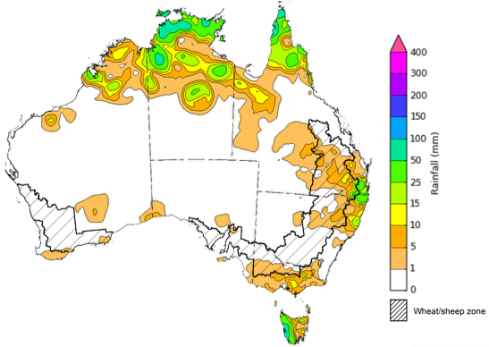

©Commonwealth of Australia 2025, Australian Bureau of Meteorology Issued: 10/12/2025
Note: The rainfall analyses and associated maps utilise data contained in the Bureau of Meteorology climate database, the Australian Data Archive for Meteorology (ADAM). The analyses are initially produced automatically from real-time data with limited quality control. They are intended to provide a general overview of rainfall across Australia as quickly as possible after the observations are received. For further information go to http://www.bom.gov.au/climate/rainfall/

Rainfall forecast for the next eight days
Over the 8 days to 18 December 2025, low-pressure troughs and onshore flow are expected to bring rainfall to much of northern and eastern Australia, while a cold front is expected bring rainfall to isolated areas in the south. Much of central Australia is expected to remain largely dry.
Limited rainfall is expected across south-eastern cropping regions this week, with much of Queensland and New South Wales expected to receive heavier falls.
- Falls of between 15-50 millimetres are forecast for most cropping regions in New South Wales and Queensland. Cropping regions across south-western New South Wales, eastern Victoria and Western Australia are expected to receive falls of between 5-15 millimetres.
  - These expected heavier falls across northern New South Wales and Queensland are likely to support soil moisture storage in summer cropping regions, but the lighter falls across southern New South Wales, eastern Victoria and Western Australia may result in some harvest delays for winter crops.
- Remaining cropping regions, including western Victoria and South Australia are forecast to receive little to no rainfall.
  - These relatively dry conditions across much southern cropping regions are likely to support harvest activities following a slow start due to cool wet conditions during much of November.

Total forecast rainfall for the period 11 December to 18 December 2025
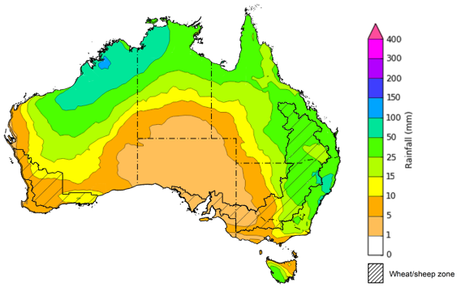
©Commonwealth of Australia 2025, Australian Bureau of Meteorology Issued 11/12/2025
Note: This rainfall forecast is produced from computer models. As the model outputs are not altered by weather forecasters, it is important to check local forecasts and warnings issued by the Bureau of Meteorology.

National Climate Outlook
The Bureau of Meteorology has indicated that a La Niña event is underway in the Pacific Ocean. Observations in the tropical Pacific Ocean have been consistent with La Niña conditions since early October. The Bureau's model currently predicts that tropical Pacific Ocean temperatures are likely to remain at La Niña levels until early 2026 before returning to neutral, supporting higher rainfall outcomes in the north and east. This timing aligns with most international models assessed. The negative Indian Ocean Dipole (IOD) event has been weakening steadily since early November and is near its end, likely reducing the incidence of rainfall events in southern Australia. The Bureau's model predicts a return to a neutral IOD during December, which is consistent with most international models.
The most recent rainfall outlook for January 2026 provided by the Bureau of Meteorology indicates that most of Australia is more likely to see below median to median rainfall, with parts of north-eastern Northern Territory and northern Queensland more likely to see above median falls.
- The Bureau of Meteorology’s climate model indicates a 75% chance of January rainfall totals between 10-200 millimetres across much of eastern and northern Australia, with higher rainfall totals of up to 300 millimetres expected in the Northern Tropics. Much of southern Western Australia, South Australia, north-western Victoria and western areas of New South Wales and Queensland are likely to see little to no rainfall.
- Across cropping regions, there is a 75% chance of receiving rainfall totals of between 25- 50 millimetres across much of Queensland and north-eastern New South Wales. Meanwhile remaining areas in New South Wales and eastern Victoria is likely to see 5- 10 millimetres. Remaining cropping regions are forecast to see little to no rainfall.
  - If forecast rainfall totals are realised across much of New South Wales and Queensland, these falls are likely to be sufficient to support above average yield prospects for summer crops and average or better levels of pasture production.

Rainfall totals that have a 75% chance of occurring in January 2026
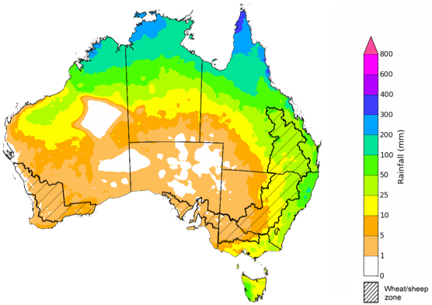
©Commonwealth of Australia 2025, Australian Bureau of Meteorology Issued: 11/12/2025
The rainfall outlook for January 2026 to March 2026 indicates no strong tendency towards above or below median rainfall across much of Australia. However, there is an increased probability of below median rainfall across parts of north-western and south-eastern Australia, including Tasmania, and parts of northern Western Australia, some western and northern regions of the Northern Territory and southern South Australia and Victoria. Meanwhile, parts of eastern and northern Queensland and parts of eastern New South Wales have a higher probability of above median rainfall.
Across cropping regions, the chance of receiving above median rainfall is 45-65% across New South Wales and Queensland. In South Australia, Victoria and Western Australia, the chance of receiving median rainfall is lower at 35- 50%. The increased chance of below median rainfall across much of southern Australia is likely to support late harvest activity of winter crops. Close to average forecast rainfall for much of northern and eastern Australia is expected to support summer crop and pasture production.
Chance of exceeding the median rainfall January 2026 to March 2026
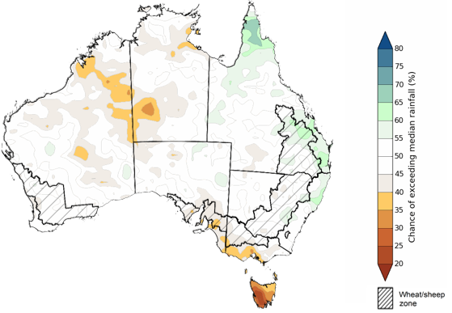
©Commonwealth of Australia 2025, Australian Bureau of Meteorology Issued: 11/12/2025
The rainfall outlook for January 2026 to March 2026 suggests a 75% chance of receiving rainfall totals of between 50-400 millimetres across much of eastern and northern Australia. Between 400-1200 millimetres are expected across scattered east coast regions as well as large areas of the northern tropics. Lower rainfall totals are forecast for south-western and central regions, with South Australia, southern Western Australia, western New South Wales and Victoria, and south-western Queensland and southern Northern Territory likely to see 10- 50 millimetres.
In cropping regions, there is a 75% chance of receiving between 100-200 millimetres across much of Queensland and north-eastern New South Wales. The remainder of New South Wales is likely to see 25-100 millimetres. In South Australia, falls of 10-25 millimetres are expected, with Western Australia and Victoria likely to see 10-50 millimetres.
Given the winter crop harvest will be nearing completion across most regions, January through to March rainfall will have little influence on winter crop production prospects, other than its influence on harvest progress and quality. Meanwhile, if the forecast January through to March rainfall totals are realised, they are likely to be sufficient to support summer pasture growth across eastern and northern Australia. Additionally, these expected falls are likely to be sufficient to support above average yield expectations for summer crops.
Rainfall totals that have a 75% chance of occurring January 2026 to March 2026
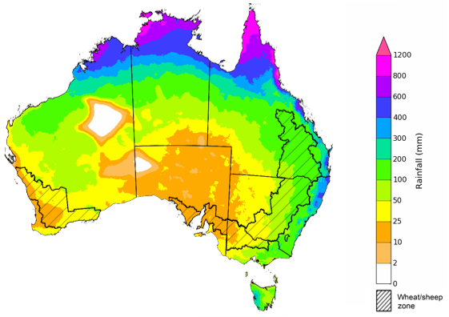
©Commonwealth of Australia 2025, Australian Bureau of Meteorology Issued: 11/12/2025

Water markets – current week
Water storage levels in the Murray-Darling Basin (MDB) decreased by 186 gigalitres (GL) between 4 December 2025 and 11 December 2025. The current volume of water held in storages is 14,072 GL, equivalent to 63% of total storage capacity. This is 15% or 2,420 GL less than the same time last year. Water storage data is sourced from the Bureau of Meteorology.

Water storages in the Murray-Darling Basin, 2013–2025
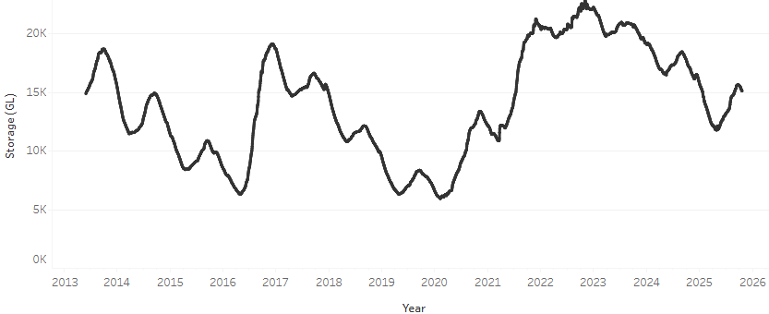
Allocation prices in the Victorian Murray below the Barmah Choke increased from $357/ML on 4 December 2025 to $364/ML on 11 December 2025. Trade from the Goulburn to the Murray is closed. Trade downstream through the Barmah Choke is closed. Trade from the Murrumbidgee to the Murray is closed.

Water market prices, Southern Murray–Darling Basin

Region | $/ML
NSW Murray Above | 309
NSW Murrumbidgee | 360
Vic Greater Goulburn | 336
Vic Murray Below | 363

Note: The water allocation prices shown are volume weighted average prices based on the last 10 trades. Price data is sourced from Waterflow and current as at 11 December 2025.
To access the full, interactive, weekly water dashboard, which contains the latest and historical water storage, water market and water allocation information, please visit https://www.agriculture.gov.au/abares/products/weekly_update/weekly-update-111225

Commodities
Indicator | Week average | Unit | Latest Price | Previous Week | Weekly change |  | Price 12 months ago | Annual change
Selected world indicator prices
AUD/USD Exchange rate | 10-Dec | A$/US$ | 0.66 | 0.66 | 1% | 0.63 |  | 5%
Wheat – US no. 2 hard red winter wheat, FOB Gulf | 10-Dec | US$/t | 243 | 247 | -1% | 252 |  | -3%
Corn – US no. 2 yellow corn, FOB Gulf | 10-Dec | US$/t | 207 | 206 | 1% | 202 |  | 2%
Canola – Rapeseed, Canada, FOB Vancouver | 10-Dec | US$/t | 468 | 480 | -2% | 453 |  | 3%
Cotton – Cotlook A Index | 10-Dec | USc/lb | 73.9 | 74.7 | -1% | 79.9 |  | -8%
Sugar – Intercontinental Exchange, nearby futures, no.11 contract | 10-Dec | USc/lb | 14.7 | 14.9 | -1% | 20.1 |  | -27%
Wool – Eastern Market Indicator | 10-Dec | Ac/kg clean | 1,542 | 1,521 | 1% | 1,145 |  | 35%
Wool – Western Market Indicator | 10-Dec | Ac/kg clean | 1,712 | 1,665 | 3% | 1,288 |  | 33%
Selected Australian grain export prices
Australian Premium White (APW) Wheat, FOB Port Adelaide, SA | 10-Dec | A$/t | 367 | 370 | -1% | 403 |  | -9%
Australian Standard White (ASW) Wheat, FOB Port Adelaide, SA | 10-Dec | A$/t | 365 | 367 | -1% | 393 |  | -7%
Feed Barley – FOB Port Adelaide, SA | 10-Dec | A$/t | 348 | 348 | 0% | 366 |  | -5%
Canola – FOB Kwinana, WA | 10-Dec | A$/t | 792 | 806 | -2% | 856 |  | -7%
Grain Sorghum – FOB Brisbane, QLD | 10-Dec | A$/t | 416 | 411 | 1% | 402 |  | 3%
Selected domestic livestock indicator prices
Beef – Eastern Young Cattle Indicator | 10-Dec | Ac/kg cwt | 868 | 882 | -2% | 668 |  | 30%
Mutton – Mutton indicator (18–24 kg fat score 2–3), VIC | 10-Dec | Ac/kg cwt | 764 | 760 | 1% | 379 |  | 101%
Lamb – National Trade Lamb Indicator | 10-Dec | Ac/kg cwt | 1,074 | 1,083 | -1% | 880 |  | 22%
Pig – Eastern Seaboard (60.1–75 kg), NSW buyer price | 26-Nov | Ac/kg cwt | 468 | 467 | 0% | 455 |  | 3%
Live cattle – Light steers to Indonesia | 10-Dec | Ac/kg lwt | 455 | 450 | 1% | 350 |  | 30%
Global Dairy Trade (GDT) weighted average prices
Dairy – Whole milk powder | 3-Dec | US$/t | 3,364 | 3,452 | -3% | 3,897 |  | -14%
Dairy – Skim milk powder | 3-Dec | US$/t | 2,498 | 2,542 | -2% | 2,803 |  | -11%
Dairy – Cheddar cheese | 3-Dec | US$/t | 4,639 | 4,328 | 7% | 4,686 |  | -1%
Dairy – Anhydrous milk fat | 3-Dec | US$/t | 5,902 | 6,543 | -10% | 7,425 |  | -21%

Selected world indicator prices

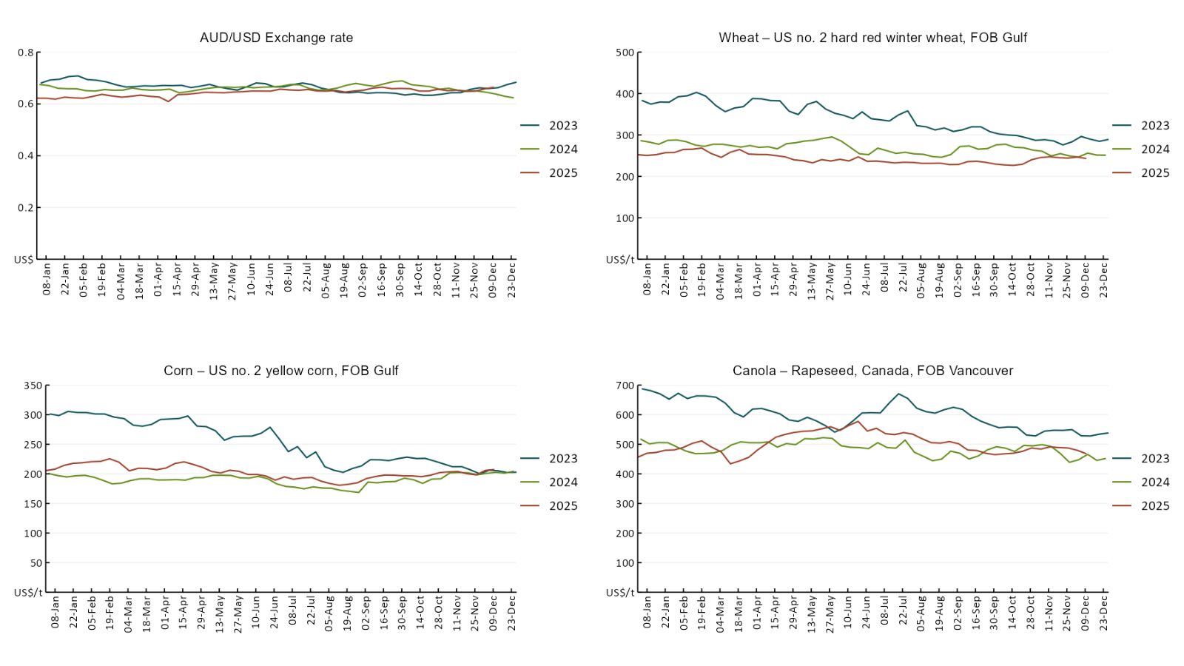
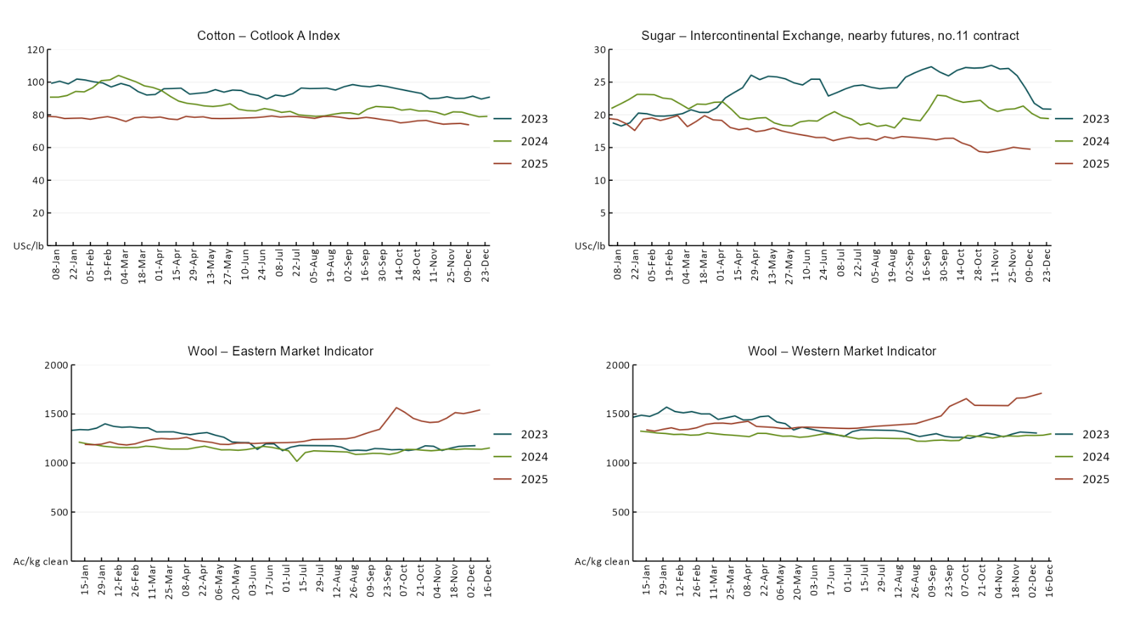

3.2 Selected domestic crop indicator prices
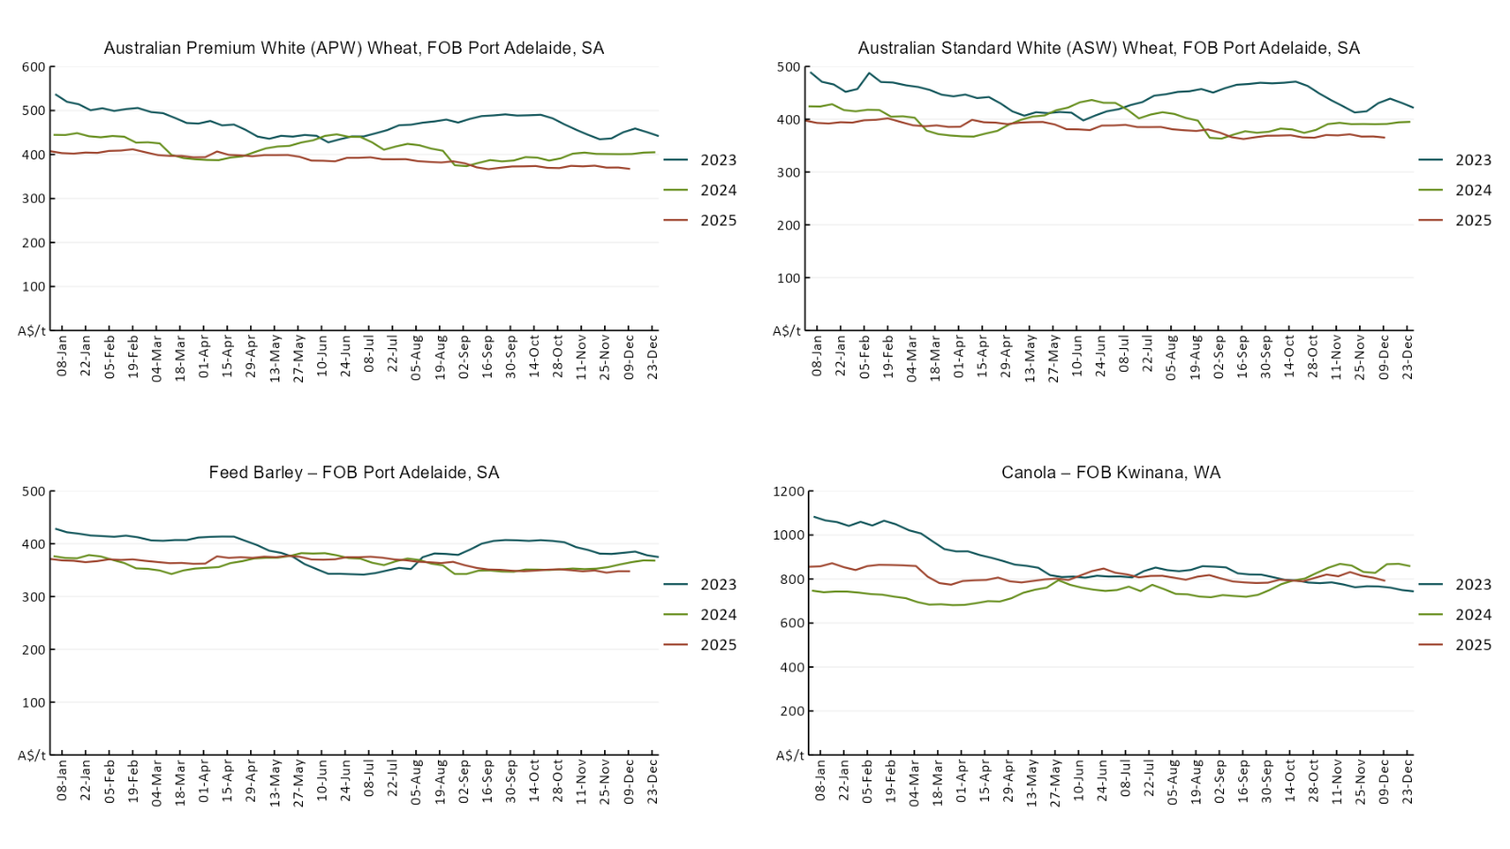
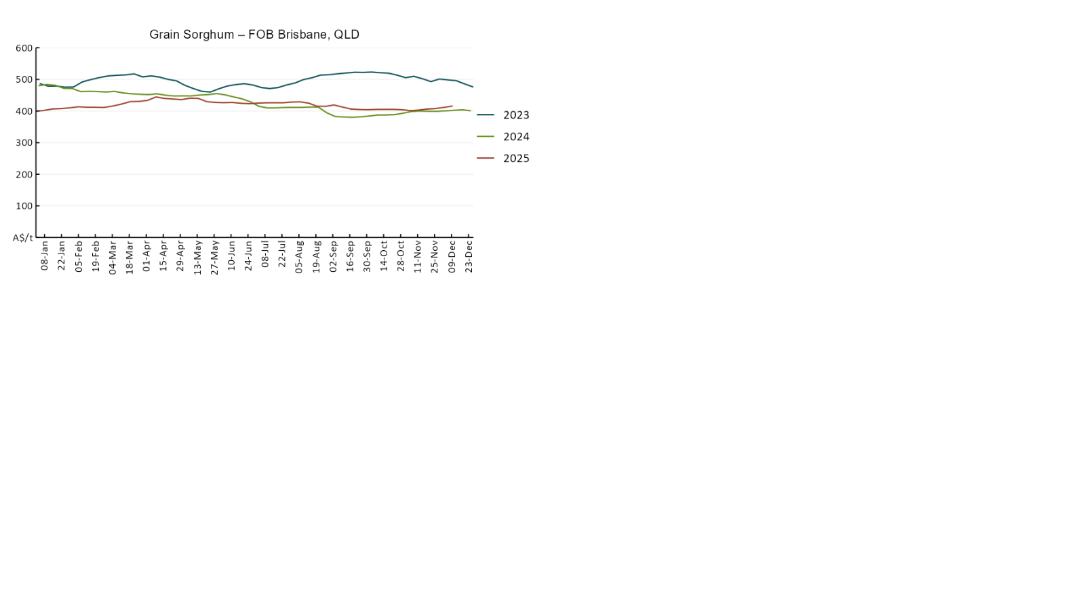

3.3 Selected domestic livestock indicator prices
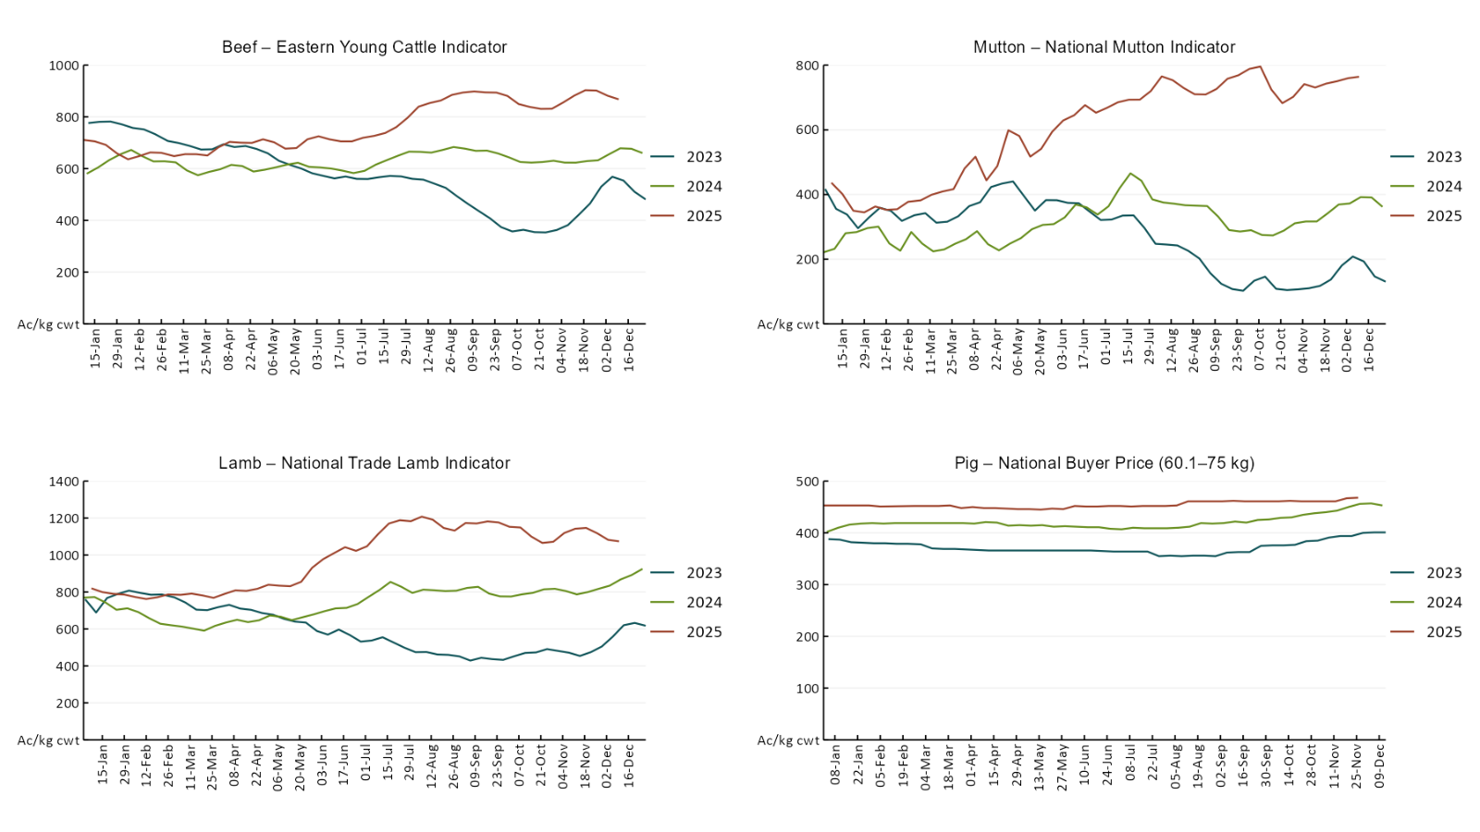
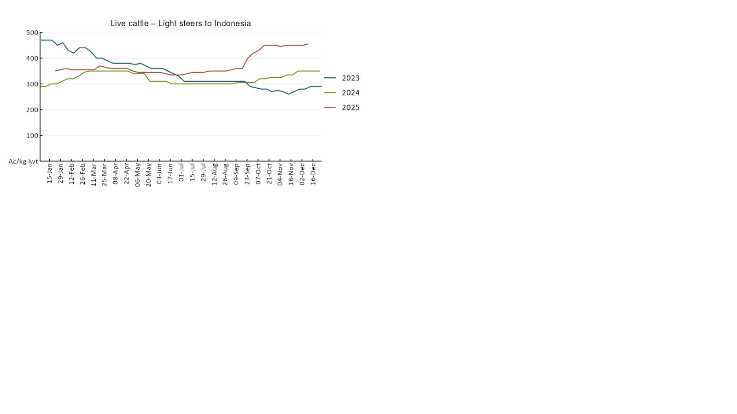

3.4 Global Dairy Trade (GDT) weighted average prices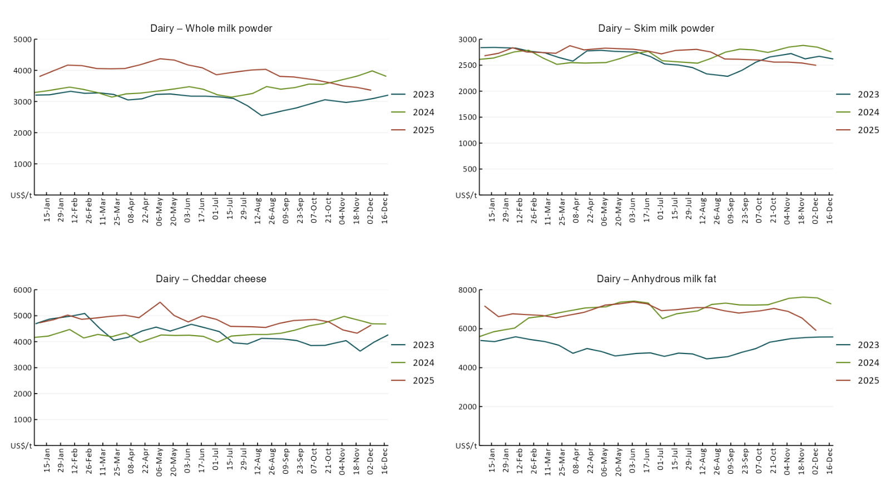

3.5 Selected fruit and vegetable prices

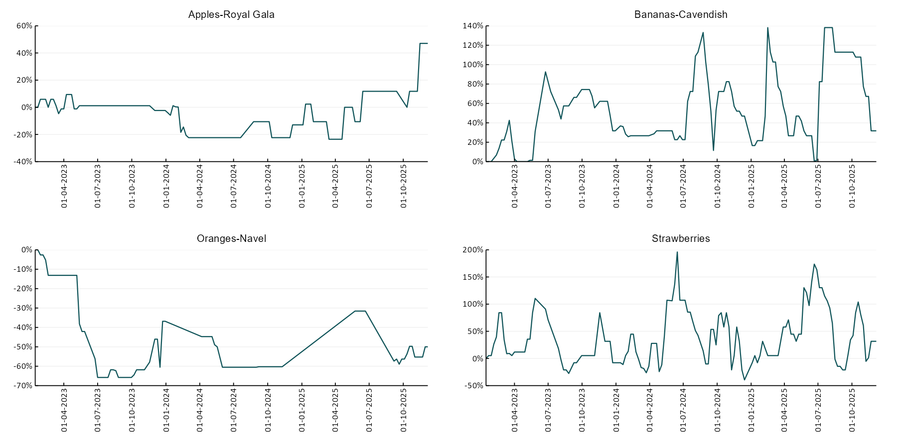

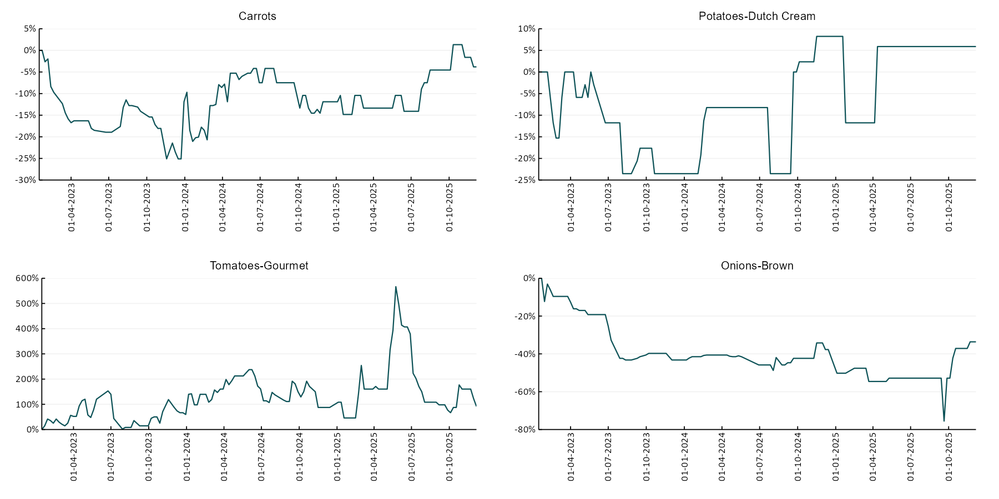

3.6 Selected domestic fodder indicator prices
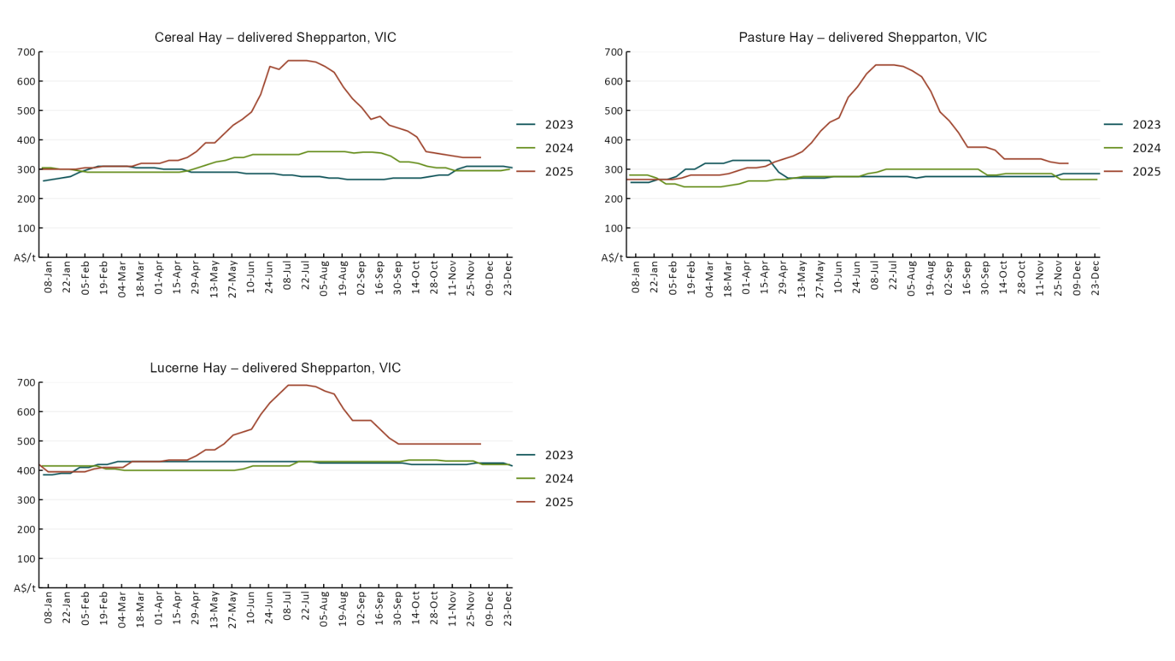

4. Data attribution

Climate
Bureau of Meteorology
- Weekly rainfall totals: www.bom.gov.au/climate/maps/rainfall/
- Monthly and last 3-month rainfall percentiles: https://www.bom.gov.au/climate/ahead/outlooks/#moreMaps
- Rainfall forecast: www.bom.gov.au/jsp/watl/rainfall/pme.jsp
- Seasonal outlook: www.bom.gov.au/climate/outlooks/#/overview/summary/
- Climate drivers: http://www.bom.gov.au/climate/enso/
- Soil moisture: https://awo.bom.gov.au/products/historical/soilMoisture-rootZone/

Other
- Pasture growth: www.longpaddock.qld.gov.au/aussiegrass/
- 3-month global outlooks: Environment and Climate Change Canada, NOAA Climate Prediction Center, EUROBRISA CPTEC/INPE, European Centre for Medium-Range Weather Forecasts, Hydrometcenter of Russia, National Climate Center Climate System Diagnosis and Prediction Room (NCC), International Research Institute for Climate and Society
- Global production: https://ipad.fas.usda.gov/ogamaps/cropmapsandcalendars.aspx
- Autumn break: Pook et al., 2009, https://rmets-onlinelibrary-wiley-com.virtual.anu.edu.au/doi/epdf/10.1002/joc.1833

Water
Prices
- Waterflow: https://www.waterflow.io/
- Ruralco: https://www.ruralcowater.com.au/
- Bureau of Meteorology:
- Allocation trade: http://www.bom.gov.au/water/dashboards/#/water-markets/mdb/at
- Storage volumes: http://www.bom.gov.au/water/dashboards/#/water-storages/summary/drainage

Trade constraints:
- Water NSW: https://www.waternsw.com.au/customer-service/ordering-trading-and-pricing/trading/murrumbidgee
- Victorian Water Register: https://www.waterregister.vic.gov.au/TradingRules2019/

Commodities
Fruit and vegetables
- Datafresh: www.freshstate.com.au

Pigs
- Australian Pork Limited: www.australianpork.com.au

Dairy
- Global Dairy Trade: www.globaldairytrade.info/en/product-results/

World wheat, canola
- International Grains Council
- https://www.igc.int/en/default.aspx
- United States Department of Agriculture

World cotton
- Cotlook: www.cotlook.com/

World sugar
- New York Stock Exchange - Intercontinental Exchange

Wool
- Australian Wool Exchange: www.awex.com.au/

Domestic wheat, barley, sorghum, canola and fodder
- Jumbuk Consulting Pty Ltd: Jumbuk AG | Agriculture Consulting

Cattle, beef, mutton, lamb, goat and live export
- Meat and Livestock Australia: https://www.mla.com.au/prices-markets/

© Commonwealth of Australia 2025

Ownership of intellectual property rights
Unless otherwise noted, copyright (and any other intellectual property rights, if any) in this publication is owned by the Commonwealth of Australia (referred to as the Commonwealth).

Creative Commons licence
All material in this publication is licensed under a Creative Commons Attribution 4.0 International Licence except content supplied by third parties, logos and the Commonwealth Coat of Arms.
Inquiries about the licence and any use of this document should be emailed to copyright@awe.gov.au.


Cataloguing data
This publication (and any material sourced from it) should be attributed as:
ABARES 2025, Weekly Australian Climate, Water and Agricultural Update, Australian Bureau of Agricultural and Resource Economics and Sciences, Canberra, 11 December 2025. CC BY 4.0 DOI: https://doi.org/10.25814/5f3e04e7d2503
ISSN 2652-7561
This publication is available at https://www.agriculture.gov.au/abares/products/weekly_update
Department of Agriculture, Fisheries and Forestry
GPO Box 858 Canberra ACT 2601
Telephone 1800 900 090
Web agriculture.gov.au/abares

Disclaimer
The Australian Government acting through the Department of Agriculture, Fisheries and Forestry, represented by the Australian Bureau of Agricultural and Resource Economics and Sciences, has exercised due care and skill in preparing and compiling the information and data in this publication. Notwithstanding, the Department of Agriculture, Fisheries and Forestry, ABARES, its employees and advisers disclaim all liability, including liability for negligence and for any loss, damage, injury, expense or cost incurred by any person as a result of accessing, using or relying on any of the information or data in this publication to the maximum extent permitted by law.

Statement of Professional Independence
The views and analysis presented in ABARES publications, including this one, reflect ABARES professionally independent findings, based on scientific and economic concepts, principles, information and data. These views, analysis and findings may not reflect or be consistent with the views or positions of the Australian Government, or of organisations or groups who have commissioned ABARES reports or analysis. More information on professional independence is provided on the ABARES website.

Acknowledgements
This report was prepared by Holly Beale and Matt Miller.

