

No. 50/2025 18 December 2025
Season’s Greetings and all the best for the new year. This is the last weekly Climate Update for 2025. The next Update will be published on 15 January 2026

Summary of key issues
- In the week ending 17 December 2025, rainfall was recorded across northern, eastern, and western regions of Australia, while central and some southern areas remained comparably dry.
  - Across cropping regions, rainfall was high in the east, and comparatively dry in the south.
    - Across those areas of Queensland and New South Wales which recorded rainfall this week, these falls have likely provided some benefit to soil moisture levels and supported the growth of summer crops already in the ground and could encourage further planting.
- Over the coming eight days to 25 December 2025, limited rainfall is expected across most southern cropping regions, with higher rainfall totals expected in the east.
  - The expected heavier falls across northern New South Wales and Queensland are likely to support soil moisture storage in summer cropping regions.
  - The relatively dry expected conditions across most southern cropping regions are likely to support harvest activities.
- Global production conditions in November were generally favourable for maize, rice, and soybeans, but more varied for wheat. According to the most recent crop estimate numbers released by the USDA, global production conditions have been slightly more favourable to those used to formulate ABARES 2025–26 forecasts of global grain supplies and world prices in the December 2025 Agricultural Commodities Report. As a result, global grain and oilseed production is likely to increase beyond the numbers in the December forecast.
- According to the Australian Agricultural Drought Indicators December 2025 estimates, broadacre farm profits for 2025–26 at a national level are forecast to be Very Much Above Average (88th percentile) compared to the past 33 years. These projections are consistent with the broader farm performance forecasts for 2025–26 outlined in the December 2025 Agricultural Commodities report.
- Water storage levels in the Murray-Darling Basin (MDB) decreased by 174 gigalitres (GL) between 11 December 2025 and 18 December 2025. The current volume of water held in storages is 13,788 GL, equivalent to 62% of total storage capacity. This is 16% or 2,650 GL less than the same time last year. Water storage data is sourced from the Bureau of Meteorology.
- Allocation prices in the Victorian Murray below the Barmah Choke increased from $364/ML on 11 December 2025 to $379/ML on 11 December 2025. Trade from the Goulburn to the Murray is closed. Trade downstream through the Barmah Choke is closed. Trade from the Murrumbidgee to the Murray is closed.

Climate

Rainfall this week
In the week ending 17 December 2025, a low-pressure trough brought showers and thunderstorms to parts of northern, western and eastern Australia. Central and some southern regions remained largely dry.
Across cropping regions, rainfall was high in the east, and comparatively dry in south.
- Much of Queensland and New South Wales saw 5-50 millimetres of rainfall, with scattered areas seeing up to 100 millimetres. In Western Australia, falls of up to 25 millimetres were recorded in the northwest.
  - Across those areas of Queensland and New South Wales which recorded rainfall this week, these falls have likely provided some benefit to soil moisture levels and supported the growth of summer crops already in the ground and could encourage further planting.
- Little to no rainfall was recorded across much of Victoria, South Australia, and southern Western Australia.
  - Three consecutive weeks of little to no rainfall across these cropping regions would have continued to support the harvesting of winter crops.

Rainfall for the week ending 17 December 2025
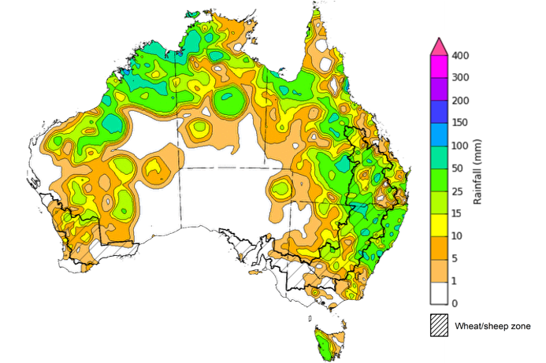

©Commonwealth of Australia 2025, Australian Bureau of Meteorology Issued: 17/12/2025
Note: The rainfall analyses and associated maps utilise data contained in the Bureau of Meteorology climate database, the Australian Data Archive for Meteorology (ADAM). The analyses are initially produced automatically from real-time data with limited quality control. They are intended to provide a general overview of rainfall across Australia as quickly as possible after the observations are received. For further information go to http://www.bom.gov.au/climate/rainfall/

Rainfall forecast for the next eight days
Over the 8 days to 25 December 2025, monsoon conditions are forecast to bring heavy rainfall to northern Australia, and low pressure systems are expected to bring rainfall to much of eastern Australia. Much of southwest Australia is expected to remain largely dry.
Limited rainfall is expected across western and central cropping regions this week, with eastern regions expected to receive heavier falls.
- Falls of between 15-50 millimetres are forecast for most cropping regions in Queensland and southern New South Wales, while northern New South Wales and Victoria are expected to see 10- 25 millimetres.
  - These expected heavier falls across New South Wales and Queensland are likely to support soil moisture storage in summer cropping regions, but the falls across southern cropping regions may result in some harvest delays for winter crops.
- Remaining cropping regions, including Western Australia and South Australia, are forecast to receive little to no rainfall.
  - These relatively dry conditions are likely to support harvest activities following a slow start due to cool wet conditions during much of November.

Total forecast rainfall for the period 18 December to 25 December 2025
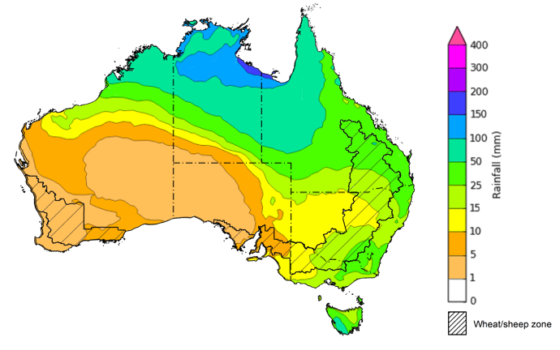
©Commonwealth of Australia 2025, Australian Bureau of Meteorology Issued 18/12/2025
Note: This rainfall forecast is produced from computer models. As the model outputs are not altered by weather forecasters, it is important to check local forecasts and warnings issued by the Bureau of Meteorology.

November precipitation percentiles and current production conditions
Crop production is affected by long-term trends in average rainfall and temperature, interannual climate variability, shocks during specific growth stages, and extreme weather events. Some crops are more tolerant than others to certain types of stresses, and at each growth stage, different types of stresses affect crop species in different ways.
Precipitation anomalies and outlooks presented below indicate the current and expected future production conditions for major grain and oilseed producing countries (responsible for over 80% of global crop production). This is an important input to assessing the global grain supply outlook.
Precipitation in November 2025 was variable across the world’s major grain- and oilseed-producing regions:
- In the southern hemisphere, precipitation was above average across much of southern Africa and Southeast Asia, including Malaysia and Indonesia, as well as isolated parts of Australia. Below average precipitation occurred in much of central Brazil and parts of southern and northern Argentina. Precipitation was generally average across the remaining major southern hemisphere grain- and oilseed-producing regions.
- In the northern hemisphere, precipitation was below average across much of southern Kazakhstan, the far south of the Russian Federation, and parts of western Europe, south-eastern and north-eastern United States and eastern Canada. Precipitation was above average across parts of the south-western United States, much of the Russian Federation, and parts of southern Europe and southern China. Precipitation was generally average across remaining major northern hemisphere grain- and oilseed-producing regions.

Global precipitation percentiles, November 2025

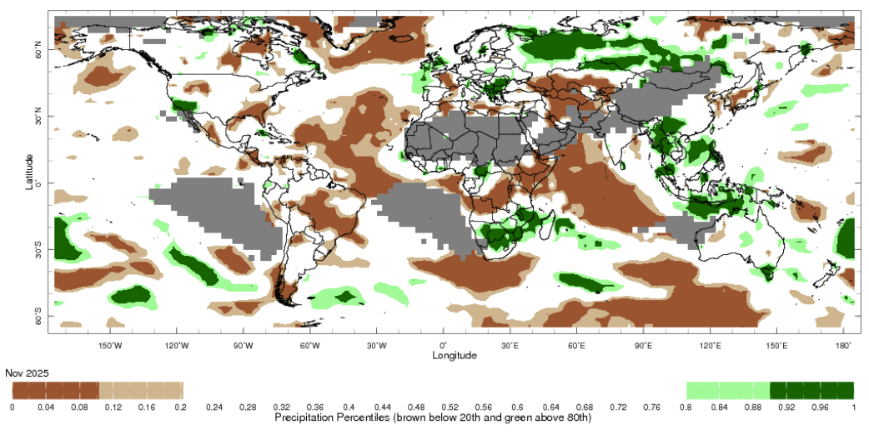

Note: The world precipitation percentiles indicate a ranking of precipitation for November, with the driest (0th percentile) being 0 on the scale and the wettest (100th percentile) being 1 on the scale. Percentiles are based on precipitation estimates from the NOAA Climate Prediction Center’s Climate Anomaly Monitoring System Outgoing Precipitation Index dataset. Precipitation estimates for November are compared with rainfall recorded for that period during the 1981 to 2010 base period.
Source: International Research Institute for Climate and Society
As of 28 November 2025, global production conditions were generally favourable for wheat, maize, rice and soybeans:
- Wheat – In the northern hemisphere, sowing is progressing or nearing completion in most areas under broadly favourable conditions, however, dryness in the United States and Türkiye, the ongoing conflict in Ukraine and excessive moisture in northern China continues to weigh on production outcomes. In the southern hemisphere, crop harvest is continuing under largely favourable conditions.
- Maize – In the southern hemisphere, favourable conditions are supporting increased plantings in South Africa as well as Brazil and Argentina, despite some dryness during November. In the northern hemisphere, harvesting is ongoing under generally favourable conditions in the United States, Canada, and Mexico while poor conditions are evident across parts of Ukraine due to prolonged drought and war in the southern and eastern regions. In India sowing of the Rabi crop is beginning under favourable conditions.
- Rice – Global conditions are broadly favourable for major rice production regions, with exceptions in parts of Southeast Asia, including the Philippines and parts of Thailand which are experiencing poor conditions due to widespread flooding caused by several typhoons.
- Soybeans – In the northern hemisphere, crop harvest is nearing completion with generally favourable conditions across most major growing regions. In the southern hemisphere, sowing is progressing with generally favourable crop expectations, despite some climate variability during November.
Crop conditions, AMIS countries, 28 November 2025
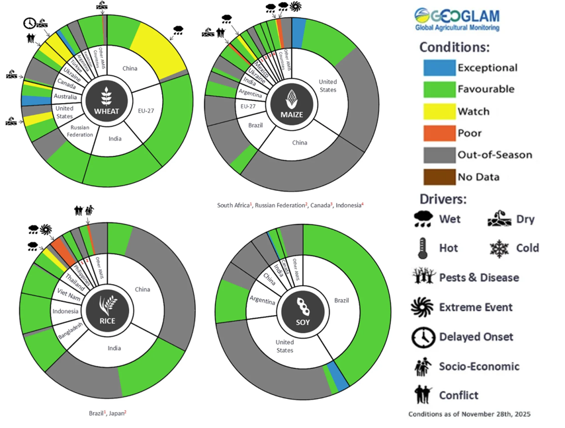
AMIS Agricultural Market Information System.
Source: AMIS

The global climate outlook for January 2026 to March 2026 indicates that mixed rainfall conditions are expected for the world’s major grain-producing and oilseed-producing regions. Outlooks and potential production impacts for major grain- and oilseed-producing countries are presented in the following table.
Rainfall outlook and potential impact on the future state of production conditions, January 2026 - March 2026
Region | Rainfall outlook | Potential impact on production
Argentina | Below average rainfall is likely across parts of north-eastern and central Argentina, with above average rainfall more likely in the far south and northwest. | Ample soil moisture reserves are likely to support the flowering and silking of many major grains and oilseeds, including corn, sorghum, rice, soybeans and cotton, despite below average expected rainfall over the January 2026 - March 2026 period.
Black Sea Region | Above average rainfall is expected across western Ukraine and parts of the south of the Russian Federation. | Over the coming months winter wheat and canola will enter dormancy, and above average rainfall in much of the Black Sea region is likely to provide sufficient snowpack to prevent winterkill.
Brazil | Rainfall outcomes across Brazil are expected to be above average in the north. In the south, below average rainfall is more likely. | Above average expected rainfall in the north will support crop production. However, below average expected rainfall in parts of southern Brazil may impair crop development stages over the coming months, including the critical flowering period for soybeans, corn, and cotton, as well as grain heading for key grains such as rice and sorghum.
Canada | Rainfall across Canada is expected to be average to above average in southern regions. | Average rainfall is likely to provide sufficient snowpack to prevent winterkill of winter wheat in December through to February.
China | Below average rainfall is expected across parts of eastern and northern China, with average falls expected elsewhere. | Anticipated rainfall is likely to reduce the level of snowpack during crop dormancy in some areas and increase the risk of winterkill.
European Union | Average rainfall is more likely for much of the European Union, with parts of Germany, northern Italy, and eastern Europe likely to see above average falls. | Average rainfall across much of the European Union is likely to support the dormancy of winter wheat and canola.
South Asia (India) | Below average rainfall is expected across much of northern India, while above average rainfall is expected in central regions. | Anticipated rainfall is likely to support the harvesting and planting of crops in many areas, but below average rainfall could adversely affect the heading of wheat and canola in northern regions.
Southeast Asia (SEA) | Above average to average rainfall is likely across much of Southeast Asia. | Above average rainfall in SEA is likely to support the growth of dry season crops.
The United States | Below average rainfall is likely for much of southern United States, with above average rainfall more likely across the north and east. | Above average to average rainfall conditions expected across the northern US is likely to provide sufficient snow cover through January and March to protect winter wheat and canola through dormancy. Below average rainfall may negatively impact cropping outcomes in the south.

Climate and price impacts on broadacre farm profits
The Australian Agricultural Drought Indicators (AADI) project combines climate and economic modelling to produce monthly forecasts of broadacre farm profits. The AADI profit (climate and prices) indicator brings together forecast seasonal conditions (using Bureau of Meteorology climate data) and commodity prices (drawn from the quarterly ABARES Agricultural Commodities). This indicator provides the most accurate representation of forecast farm profits, presented as percentiles relative to the last 33 years (which provide a long-term historical benchmark). For more information, see Australian Agricultural Drought Indicators.
Australian broadacre farm business profits are forecast to be well above average across much of Australia in 2025–26, tracking at the 88th percentile of the last 33 years. This positive outlook extends across Queensland, the northern tropics, west Western Australia, eastern and western New South Wales and the southern regions of Victoria.
Broadacre farm business profit indicator, 2025–26
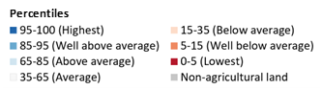
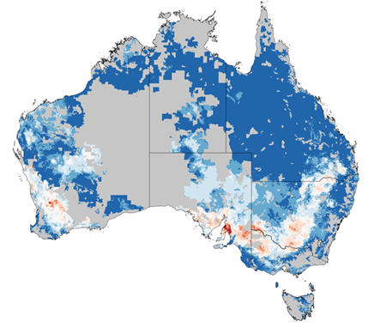

Note: The percentile ranges cover the forecast profitability of broadacre farms in 2025–26 based on forecast climate conditions and prices and current farm characteristics. They are calculated compared to simulated farm performance over the past 33 years, based on historical climate conditions and prices.

Source: ABARES farmpredict; AADI
This result is primarily driven by high commodity prices (particularly for livestock), which are compensating for “average” climate conditions. When isolating climate conditions, the AADI profit (climate only) indicator is tracking at the 44th percentile. The significant gap between the two indicators highlights a decoupling of production and profit: while the physical environment is providing only average support, robust commodity prices - particularly in the beef and sheep sectors - are sustaining profitability well above the long-term average across the majority of Australia.
The interplay between climate and price drivers is also creating distinct regional outcomes:
- The strongest forecasts are concentrated in the Northern Territory and Queensland, both tracking at the 98th percentile. Here, favourable conditions are aligning with strong market prices to lead to historically high farm profits.
- In southern cropping regions, specifically South Australia, northern Victoria. southern New South Wales, and parts of Western Australia, climatic conditions are tighter. However, the strength of commodity prices is acting as a buffer. Even in South Australia, where the outlook is lowest nationwide, the Profit (Climate and Prices) indicator for the state remains at the 64th percentile ("Average"), significantly outperforming the underlying climate conditions.
These projections are consistent with the broader farm performance forecasts for 2025–26 outlined in the December quarter ABARES Agricultural Commodities report.
Conditions as of December 2025 are expected to be broadly above average:
- Nationally, profit (climate and price) for Australian broadacre farms in 2025–26 is forecast to be Very Much Above Average (88th percentile of the last 33 years) but may range from the 87th to the 89th percentile of the last 33 years.
- The national 12-month average profit (climate and price) for Australian broadacre farms is Very Much Above Average (87th percentile). The national 24-month average profit (climate and price) for Australian broadacre farms is Average (54th percentile).
- Profit (climate and price) is forecast to be lowest in South Australia (Average at 64th percentile), and second lowest in Western Australia (Above Average at 75th percentile).
- Profit (climate and price) is forecast to be highest in Northern Territory (Highest at 98th percentile), and second highest in Queensland (Highest at 98th percentile).

Australian Agricultural and Grazing Industries Survey (AAGIS) Wheat-sheep and High rainfall regions profit (climate and price) forecast – Lowest performing 5 regions
AAGIS Wheat-sheep and High rainfall regions^ | FY25* | FY26* | Area Very Much Below Average in 2026 (%)**
SA: Murray Lands and Yorke Peninsula | 6 | 24 | 21
VIC: Mallee | 41 | 39 | 4
SA: Eyre Peninsula | 9 | 41 | 3
NSW: Riverina | 56 | 62 | 1
VIC: Wimmera | 25 | 63 | 6
Note: ^Displaying AAGIS Wheat-sheep and High rainfall regions sorted by lowest values in "FY26 *Percentile values for specified financial year. **Percentage of area in region where conditions are Very Much Below Average (less than 15th percentile).

Water markets – current week
Water storage levels in the Murray-Darling Basin (MDB) decreased by 174 gigalitres (GL) between 11 December 2025 and 18 December 2025. The current volume of water held in storages is 13,788 GL, equivalent to 62% of total storage capacity. This is 16% or 2,650 GL less than the same time last year. Water storage data is sourced from the Bureau of Meteorology.

Water storages in the Murray-Darling Basin, 2013–2025
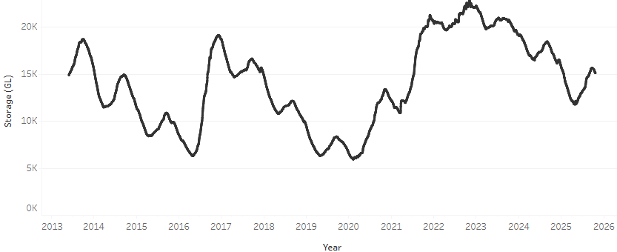
Allocation prices in the Victorian Murray below the Barmah Choke increased from $364/ML on 11 December 2025 to $379/ML on 11 December 2025. Trade from the Goulburn to the Murray is closed. Trade downstream through the Barmah Choke is closed. Trade from the Murrumbidgee to the Murray is closed.

Water market prices, Southern Murray–Darling Basin

Region | $/ML
NSW Murray Above | 315
NSW Murrumbidgee | 365
Vic Greater Goulburn | 359
Vic Murray Below | 379

Note: The water allocation prices shown are volume weighted average prices based on the last 10 trades. Price data is sourced from Waterflow and current as at 11 December 2025.
To access the full, interactive, weekly water dashboard, which contains the latest and historical water storage, water market and water allocation information, please visit https://www.agriculture.gov.au/abares/products/weekly_update/weekly-update-181225

Commodities
Indicator | Week average | Unit | Latest Price | Previous Week | Weekly change |  | Price 12 months ago | Annual change
Selected world indicator prices
AUD/USD Exchange rate | 17-Dec | A$/US$ | 0.66 | 0.66 | 0% | 0.63 |  | 5%
Wheat – US no. 2 hard red winter wheat, FOB Gulf | 17-Dec | US$/t | 238 | 242 | -2% | 252 |  | -5%
Corn – US no. 2 yellow corn, FOB Gulf | 17-Dec | US$/t | 204 | 207 | -1% | 202 |  | 1%
Canola – Rapeseed, Canada, FOB Vancouver | 17-Dec | US$/t | 462 | 468 | -1% | 453 |  | 2%
Cotton – Cotlook A Index | 17-Dec | USc/lb | 73.9 | 74.0 | 0% | 79.9 |  | -8%
Sugar – Intercontinental Exchange, nearby futures, no.11 contract | 17-Dec | USc/lb | 14.9 | 14.9 | 0% | 20.1 |  | -26%
Wool – Eastern Market Indicator | 17-Dec | Ac/kg clean | 1,541 | 1,542 | 0% | 1,145 |  | 35%
Wool – Western Market Indicator | 17-Dec | Ac/kg clean | 1,715 | 1,712 | 0% | 1,288 |  | 33%
Selected Australian grain export prices
Australian Premium White (APW) Wheat, FOB Port Adelaide, SA | 17-Dec | A$/t | 362 | 366 | -1% | 403 |  | -10%
Australian Standard White (ASW) Wheat, FOB Port Adelaide, SA | 17-Dec | A$/t | 360 | 364 | -1% | 393 |  | -8%
Feed Barley – FOB Port Adelaide, SA | 17-Dec | A$/t | 348 | 348 | 0% | 366 |  | -5%
Canola – FOB Kwinana, WA | 17-Dec | A$/t | 793 | 792 | 0% | 856 |  | -7%
Grain Sorghum – FOB Brisbane, QLD | 17-Dec | A$/t | 421 | 417 | 1% | 402 |  | 5%
Selected domestic livestock indicator prices
Beef – Eastern Young Cattle Indicator | 17-Dec | Ac/kg cwt | 860 | 866 | -1% | 668 |  | 29%
Mutton – Mutton indicator (18–24 kg fat score 2–3), VIC | 17-Dec | Ac/kg cwt | 713 | 756 | -6% | 379 |  | 88%
Lamb – National Trade Lamb Indicator | 17-Dec | Ac/kg cwt | 1,067 | 1,073 | -1% | 880 |  | 21%
Pig – Eastern Seaboard (60.1–75 kg), NSW buyer price | 3-Dec | Ac/kg cwt | 468 | 468 | 0% | 455 |  | 3%
Live cattle – Light steers to Indonesia | 10-Dec | Ac/kg lwt | 455 | 450 | 1% | 350 |  | 30%
Global Dairy Trade (GDT) weighted average prices
Dairy – Whole milk powder | 17-Dec | US$/t | 3,161 | 3,364 | -6% | 3,897 |  | -19%
Dairy – Skim milk powder | 17-Dec | US$/t | 2,431 | 2,498 | -3% | 2,803 |  | -13%
Dairy – Cheddar cheese | 17-Dec | US$/t | 4,646 | 4,639 | 0% | 4,686 |  | -1%
Dairy – Anhydrous milk fat | 17-Dec | US$/t | 5,602 | 5,902 | -5% | 7,425 |  | -25%

Selected world indicator prices

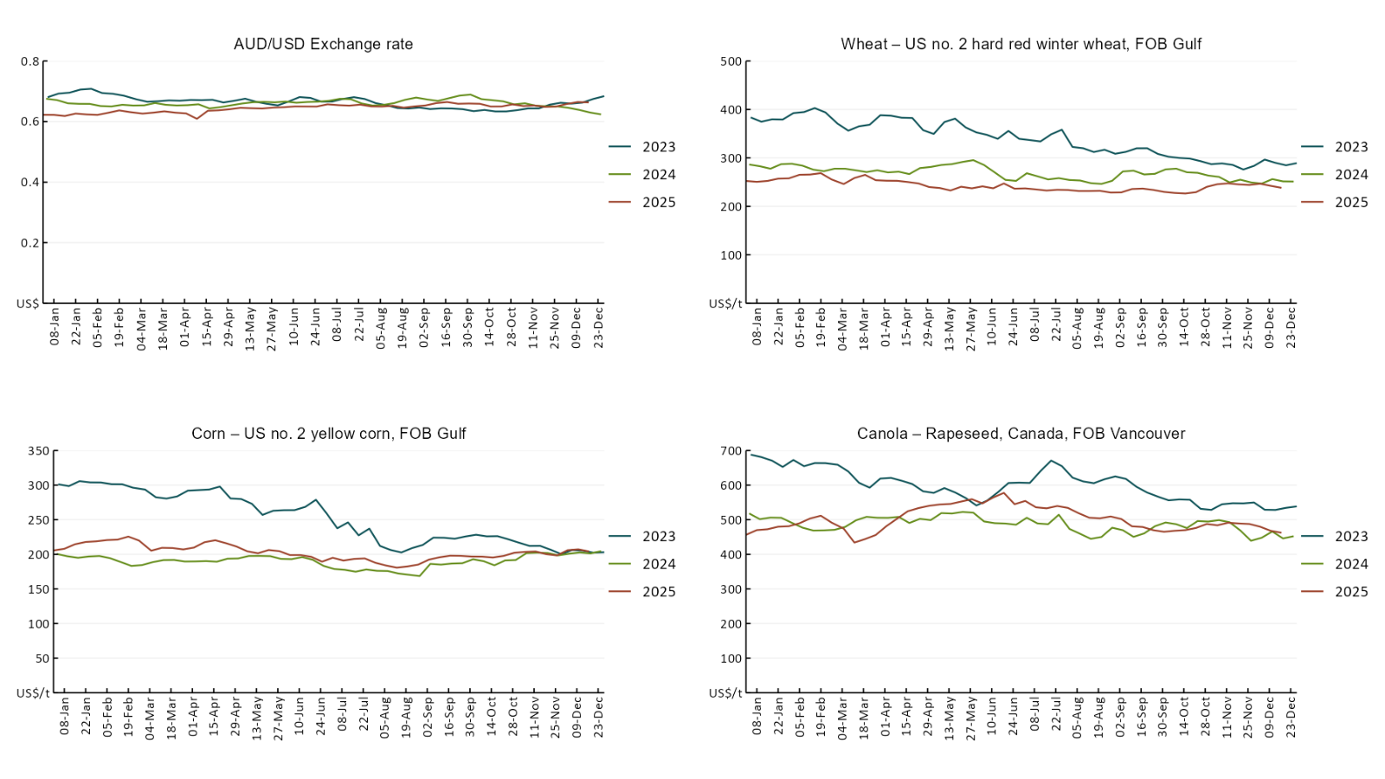
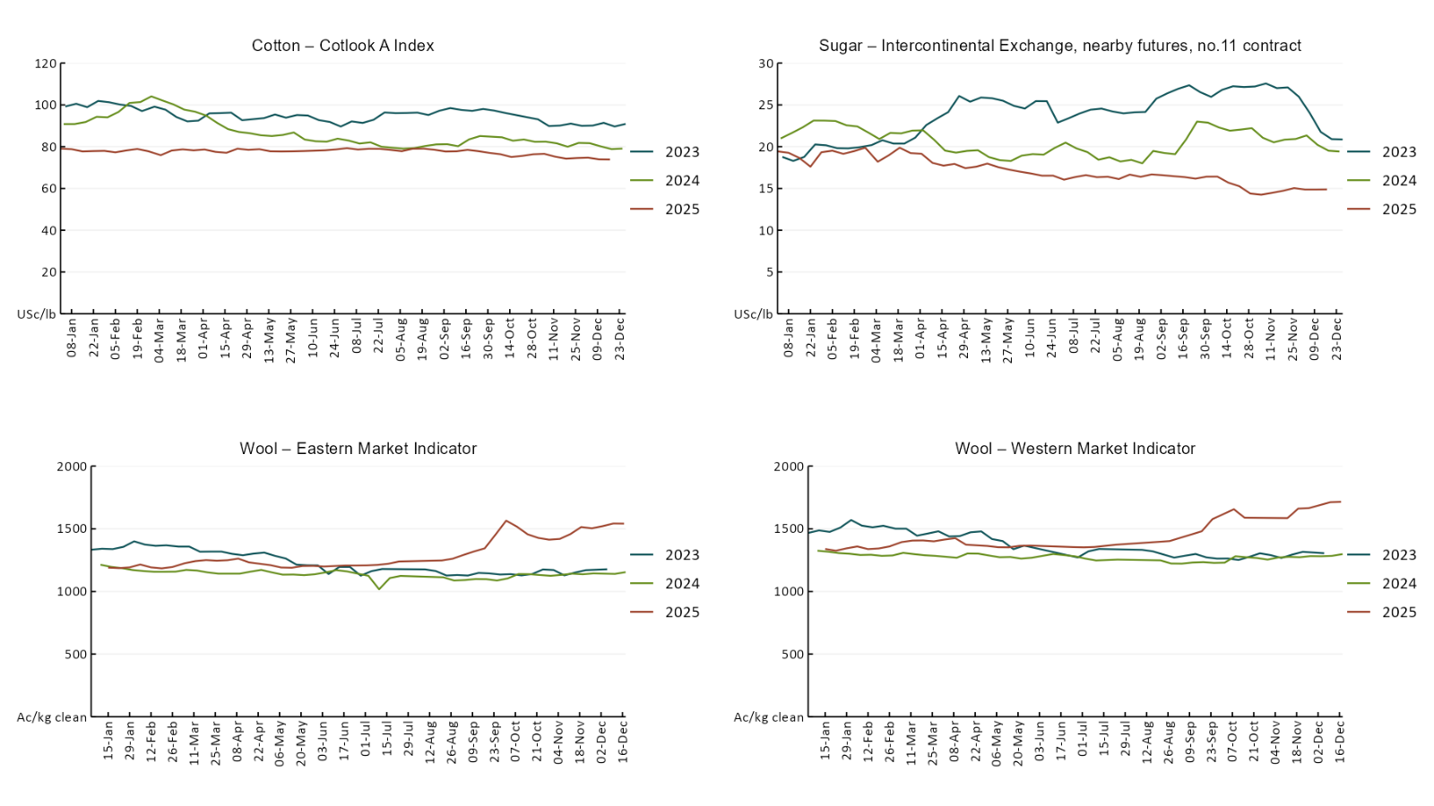

3.2 Selected domestic crop indicator prices
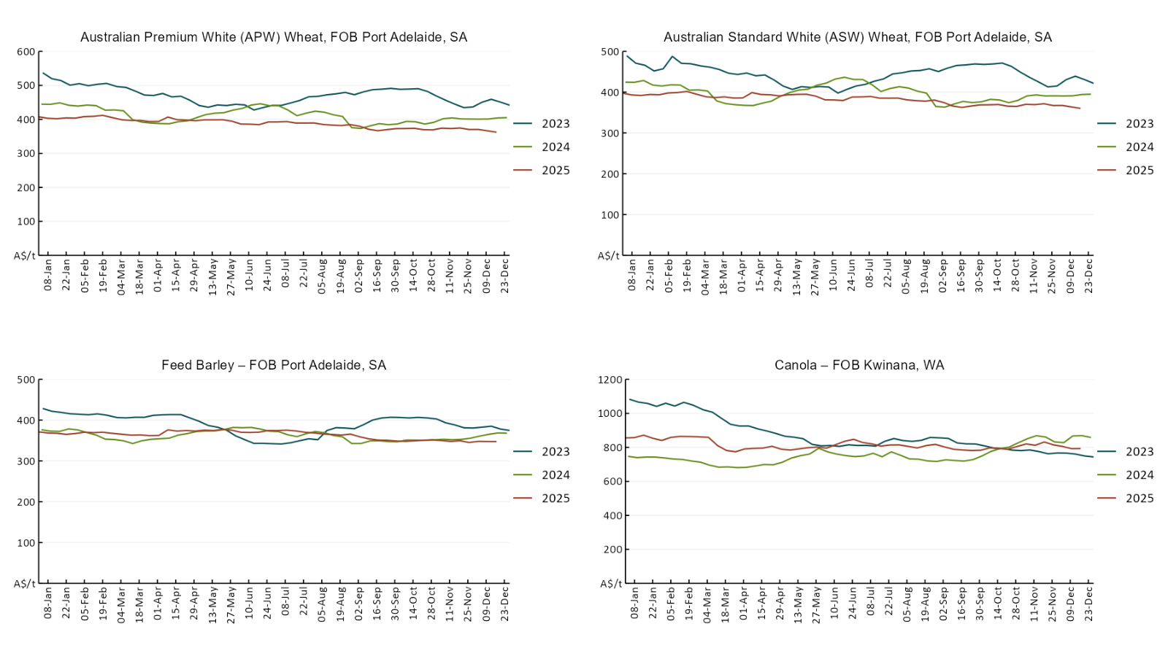
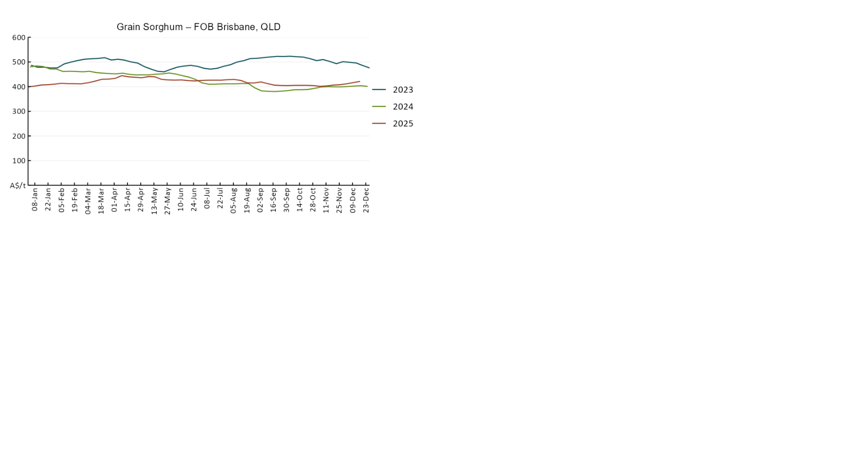

3.3 Selected domestic livestock indicator prices
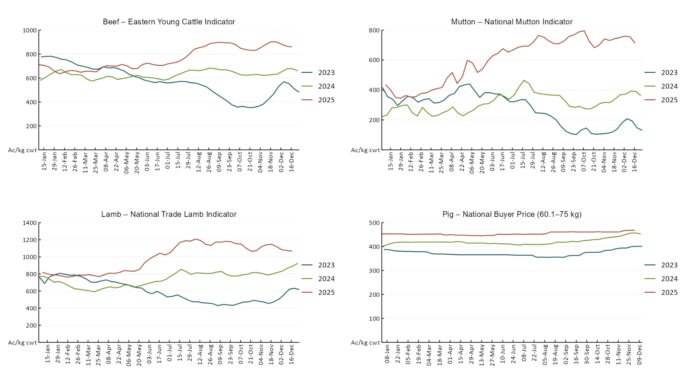
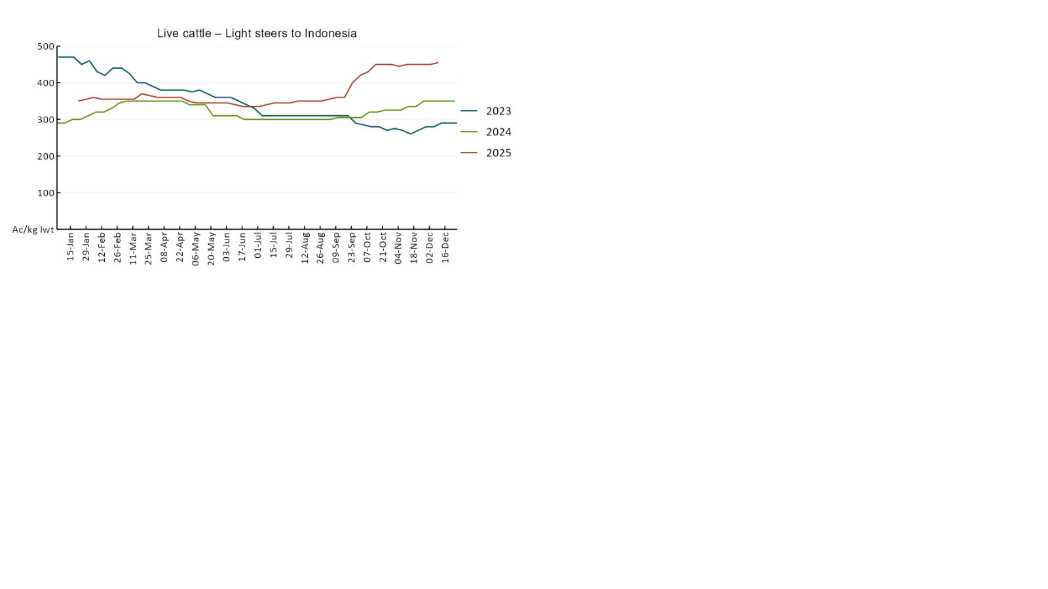

3.4 Global Dairy Trade (GDT) weighted average prices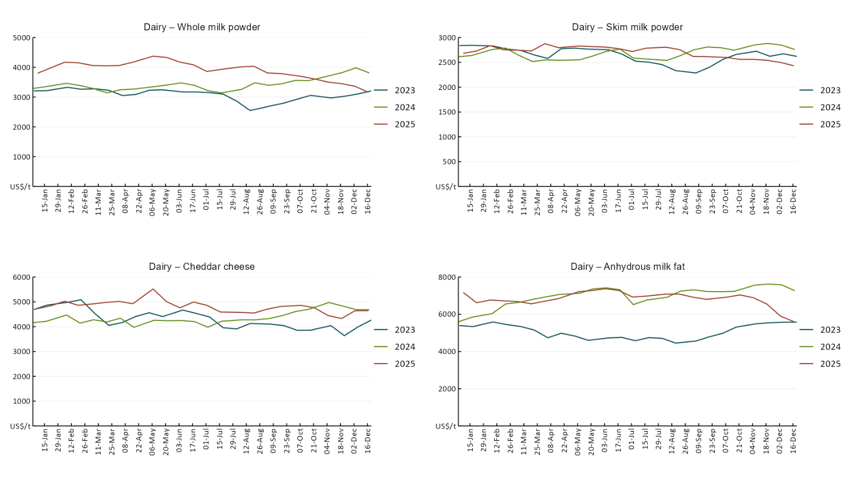

3.5 Selected fruit and vegetable prices

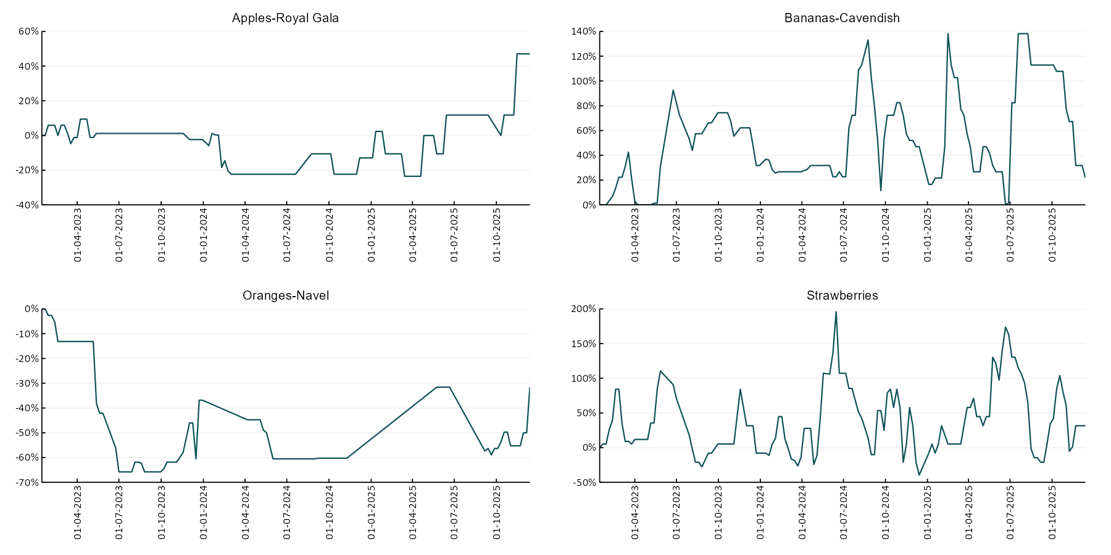

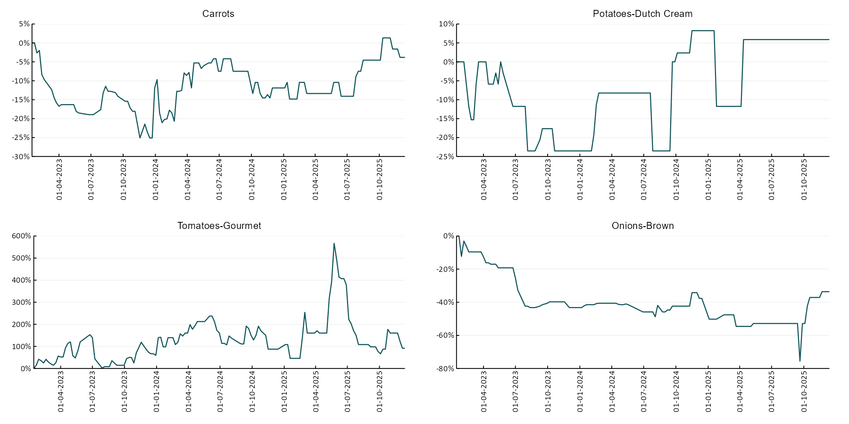

3.6 Selected domestic fodder indicator prices
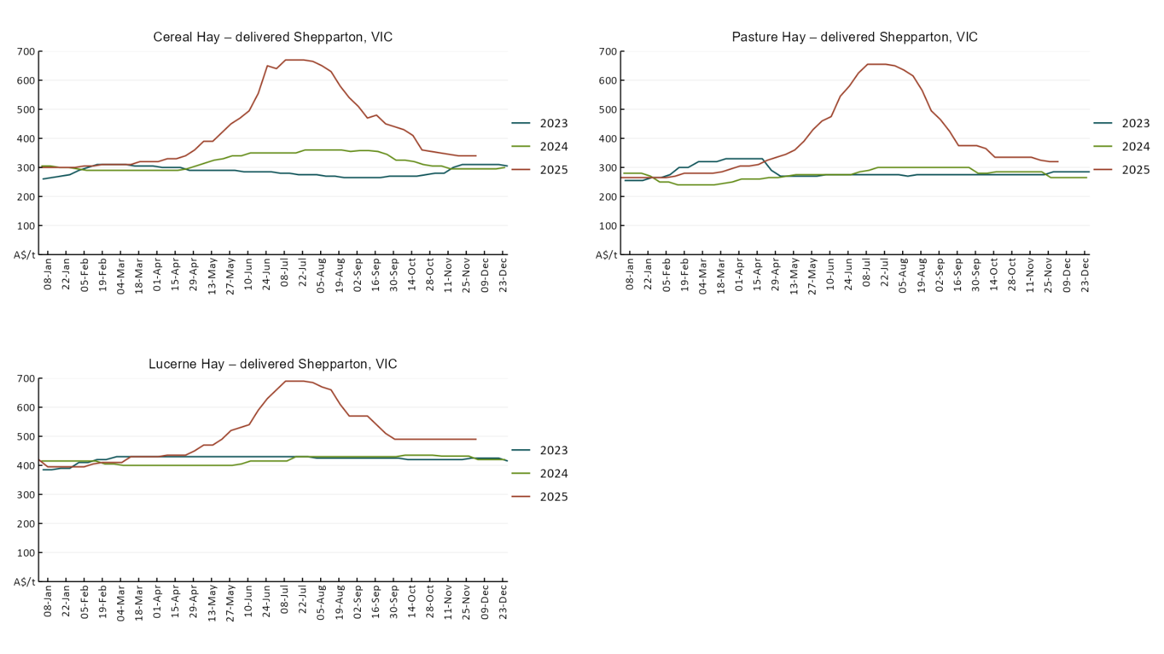

4. Data attribution

Climate
Bureau of Meteorology
- Weekly rainfall totals: www.bom.gov.au/climate/maps/rainfall/
- Monthly and last 3-month rainfall percentiles: https://www.bom.gov.au/climate/ahead/outlooks/#moreMaps
- Rainfall forecast: www.bom.gov.au/jsp/watl/rainfall/pme.jsp
- Seasonal outlook: www.bom.gov.au/climate/outlooks/#/overview/summary/
- Climate drivers: http://www.bom.gov.au/climate/enso/
- Soil moisture: https://awo.bom.gov.au/products/historical/soilMoisture-rootZone/

Other
- Pasture growth: www.longpaddock.qld.gov.au/aussiegrass/
- 3-month global outlooks: Environment and Climate Change Canada, NOAA Climate Prediction Center, EUROBRISA CPTEC/INPE, European Centre for Medium-Range Weather Forecasts, Hydrometcenter of Russia, National Climate Center Climate System Diagnosis and Prediction Room (NCC), International Research Institute for Climate and Society
- Global production: https://ipad.fas.usda.gov/ogamaps/cropmapsandcalendars.aspx
- Autumn break: Pook et al., 2009, https://rmets-onlinelibrary-wiley-com.virtual.anu.edu.au/doi/epdf/10.1002/joc.1833

Water
Prices
- Waterflow: https://www.waterflow.io/
- Ruralco: https://www.ruralcowater.com.au/
- Bureau of Meteorology:
- Allocation trade: http://www.bom.gov.au/water/dashboards/#/water-markets/mdb/at
- Storage volumes: http://www.bom.gov.au/water/dashboards/#/water-storages/summary/drainage

Trade constraints:
- Water NSW: https://www.waternsw.com.au/customer-service/ordering-trading-and-pricing/trading/murrumbidgee
- Victorian Water Register: https://www.waterregister.vic.gov.au/TradingRules2019/

Commodities
Fruit and vegetables
- Datafresh: www.freshstate.com.au

Pigs
- Australian Pork Limited: www.australianpork.com.au

Dairy
- Global Dairy Trade: www.globaldairytrade.info/en/product-results/

World wheat, canola
- International Grains Council
- https://www.igc.int/en/default.aspx
- United States Department of Agriculture

World cotton
- Cotlook: www.cotlook.com/

World sugar
- New York Stock Exchange - Intercontinental Exchange

Wool
- Australian Wool Exchange: www.awex.com.au/

Domestic wheat, barley, sorghum, canola and fodder
- Jumbuk Consulting Pty Ltd: Jumbuk AG | Agriculture Consulting

Cattle, beef, mutton, lamb, goat and live export
- Meat and Livestock Australia: https://www.mla.com.au/prices-markets/

Australian Agricultural Drought Indicators
About Australian Agricultural Drought Indicators
The Australian Agricultural Drought Indicators (AADI) links weather and agricultural data with a range of scientific and economic models to measure and forecast the effects of climate variability and drought on agricultural outcomes.
On AADI, projected broadacre farm profits are presented as percentile outcomes relative to simulated historical outcomes using the groupings:
Highest | 95-100th percentile
Very much above average | 85-95th percentile
Above average | 65-85th percentile
Average | 35-65th percentile
Below average | 15-35th percentile
Very much below average | 5-15th percentile
Lowest 5% | 0-5th percentile

There are two AADI farm profit indicators:
- The AADI farm profit climate and price indicator shows the effect of climate and prices on broadacre farm business profits of current farms compared to the last 33 years.
- The AADI farm profit climate only indicator isolates the effect of climate on profits by holding prices fixed.

© Commonwealth of Australia 2025

Ownership of intellectual property rights
Unless otherwise noted, copyright (and any other intellectual property rights, if any) in this publication is owned by the Commonwealth of Australia (referred to as the Commonwealth).

Creative Commons licence
All material in this publication is licensed under a Creative Commons Attribution 4.0 International Licence except content supplied by third parties, logos and the Commonwealth Coat of Arms.
Inquiries about the licence and any use of this document should be emailed to copyright@awe.gov.au.


Cataloguing data
This publication (and any material sourced from it) should be attributed as:
ABARES 2025, Weekly Australian Climate, Water and Agricultural Update, Australian Bureau of Agricultural and Resource Economics and Sciences, Canberra, 18 December 2025. CC BY 4.0 DOI: https://doi.org/10.25814/5f3e04e7d2503
ISSN 2652-7561
This publication is available at https://www.agriculture.gov.au/abares/products/weekly_update
Department of Agriculture, Fisheries and Forestry
GPO Box 858 Canberra ACT 2601
Telephone 1800 900 090
Web agriculture.gov.au/abares

Disclaimer
The Australian Government acting through the Department of Agriculture, Fisheries and Forestry, represented by the Australian Bureau of Agricultural and Resource Economics and Sciences, has exercised due care and skill in preparing and compiling the information and data in this publication. Notwithstanding, the Department of Agriculture, Fisheries and Forestry, ABARES, its employees and advisers disclaim all liability, including liability for negligence and for any loss, damage, injury, expense or cost incurred by any person as a result of accessing, using or relying on any of the information or data in this publication to the maximum extent permitted by law.

Statement of Professional Independence
The views and analysis presented in ABARES publications, including this one, reflect ABARES professionally independent findings, based on scientific and economic concepts, principles, information and data. These views, analysis and findings may not reflect or be consistent with the views or positions of the Australian Government, or of organisations or groups who have commissioned ABARES reports or analysis. More information on professional independence is provided on the ABARES website.

Acknowledgements
This report was prepared by Holly Beale and Matt Miller.

