
No. 1/2026 15 January 2026

Summary of key issues
- In the week ending 15 January 2026, rainfall was recorded across northern and eastern regions of Australia, while central and some southern areas remained comparably dry.
  - Ex-Tropical cyclone Koji brought widespread rainfall and thunderstorms across much of eastern Queensland, causing widespread flooding and led to damage to farm infrastructure and resulted in some crop and livestock losses. Continued rainfall across the Gulf region of north Queensland is likely to have exacerbated flooding impacts and delayed recovery efforts.
  - Across cropping regions rainfall in Queensland and northern New South Wales has likely provided some benefit to soil moisture levels and the growth of summer crop.
- Over the 8-days to 22 January 2026, rainfall is forecast for the north and east of the country.
  - Continued heavy falls are forecast across major flood warning areas of northern Queensland. If realised these falls are likely to further exacerbate flooding, continue to slow recovery efforts and may lead to increased livestock losses due to a lack of feed and exposure to disease and illness.
  - The expected heavier falls across northern New South Wales and Queensland are likely to further support soil moisture storage in summer cropping regions.
- Nationally, December rainfall was mixed, with average to well above average rainfall in the north and west, and below average rainfall in the south This average to well above average rainfall has benefited both upper- and lower-layer soil moister levels across parts of the country. However, low levels of lower layer soil moisture across some cropping regions particularly in southern regions presents an ongoing downside production for pasture growth.
- The national rainfall outlook for February to April 2026 indicates an increased probability of below median rainfall across areas of north-western and parts of south-eastern Australia, while parts of southern Queensland are more likely to see above median rainfall.
  - If realised, close to average forecast rainfall for much of northern and eastern Australia is expected to support summer crop and pasture production.
- Water storage levels in the Murray-Darling Basin (MDB) decreased by 254 gigalitres (GL) between 8 January 2026 and 14 January 2026. The current volume of water held in storages is 12,742 GL, equivalent to 57% of total storage capacity. This is 17% or 2,545 GL less than the same time last year. Water storage data is sourced from the Bureau of Meteorology (BOM).
- Allocation prices in the Victorian Murray below the Barmah Choke increased from $379/ML on 11 December 2026 to $436/ML on 15 January 2026. Trade from the Goulburn to the Murray is closed. Trade downstream through the Barmah Choke is closed. Trade from the Murrumbidgee to the Murray is open.

Climate

Rainfall this week
In the week ending 14 January 2026, ex-tropical cyclone (TC) Koji brought heavy rainfall to large areas of north-eastern Australia, while low pressure systems brought rainfall to the Northern Tropics and parts of the southeast. Central and southern areas remained largely dry.
- Tropical cyclone Koji weakened from a Category 2 system off the coast and crossed the north Queensland coast on 11 January as a Category 1 system before rapidly weakening. The system brought widespread rainfall and thunderstorms across much of eastern Queensland, causing minor to major flooding to already saturated coastal areas, and led to damage to farm infrastructure and resulted in some crop and livestock losses.
- Continued rainfall across the Gulf region of north Queensland is likely to have exacerbated flooding impacts and delayed recovery efforts.
Across cropping regions, rainfall was generally low, with exceptions in northern Queensland:
- Northern Queensland cropping regions saw falls of up to 300 millimetres . In New South Wales, between 5-15 millimetres of rainfall was recorded in eastern areas.
  - Heavy rainfall in northern cropping regions have led to some crop losses.
  - In other regions, rainfall is expected to support soil moisture storage for summer cropping and pasture growth.
- Little to no rainfall was recorded across much of southern Queensland, New South Wales, Victoria, South Australia and Western Australia.

Rainfall for the week ending 14 January 2026
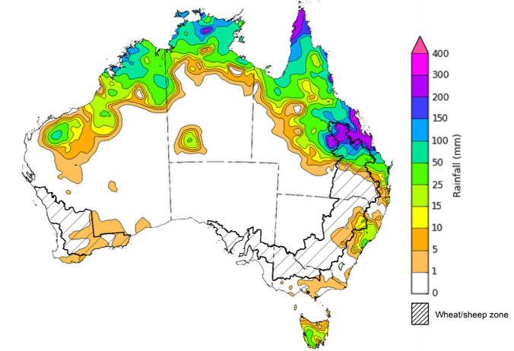
©Commonwealth of Australia 2026, Australian Bureau of Meteorology Issued: 14/1/2026
Note: The rainfall analyses and associated maps utilise data contained in the Bureau of Meteorology climate database, the Australian Data Archive for Meteorology (ADAM). The analyses are initially produced automatically from real-time data with limited quality control. They are intended to provide a general overview of rainfall across Australia as quickly as possible after the observations are received. For further information go to http://www.bom.gov.au/climate/rainfall/

Rainfall forecast for the next eight days
Over the 8 days to 22 January 2026, low-pressure troughs are expected to bring considerable rainfall to much of the north and east of Australia, while the rest of the country is forecast to remain largely dry.
- Forecast falls of between 50-150 millimetres are expected across major flood warning areas of northern Queensland. If realised these falls are likely to further exacerbate flooding, continue to slow recovery efforts and may lead to increased livestock losses due to a lack of feed and exposure to disease and illness.
Limited rainfall is expected across southern and western cropping regions this week, with eastern regions expected to receive heavier falls.
- Falls of between 50-100 millimetres are forecast for most cropping regions in northern Queensland, while central and southern Queensland are expected to see falls of 15- 50 millimetres. In New South Wales, falls of 5-50 millimetres are forecast, with higher rainfall totals more likely in eastern and northern areas.
  - These expected heavier falls across New South Wales and Queensland are likely to support soil moisture storage in summer cropping regions and improve pasture growth.
- Remaining cropping regions, including Western Australia, Victoria and South Australia, are forecast to receive little to no rainfall.

Total forecast rainfall for the period 15 January to 22 January 2026
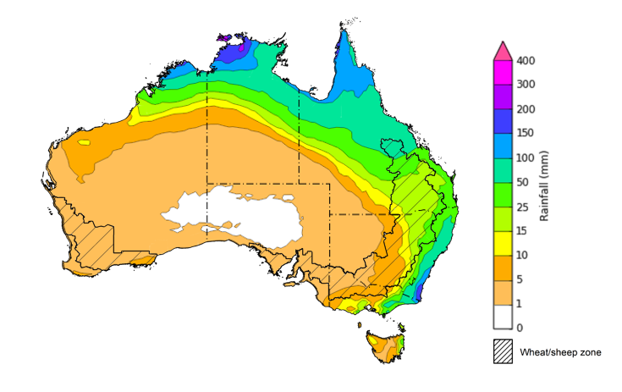
©Commonwealth of Australia 2025, Australian Bureau of Meteorology Issued 15/1/2026
Note: This rainfall forecast is produced from computer models. As the model outputs are not altered by weather forecasters, it is important to check local forecasts and warnings issued by the Bureau of Meteorology.

Monthly rainfall
Rainfall during December 2025 was mixed across Australia:
- Rainfall was average to extremely high in the north and parts of the west, including much of northern Queensland and the Northern Territory, as well as parts of northern Western Australia. Scattered areas of eastern central Australia, and west parts of Western Australia, saw well above average rainfall.
  - A monsoonal trough brought the highest on record December rainfall to the Gulf region of northern Queensland leading to major flooding. The latest data from the Queensland Department of Primary Industries estimates 54,000 livestock are dead or missing across the state, with the number expected to grow further as heavy rainfall continues and recovery efforts commence.
- Average to severely deficient rainfall was recorded in parts of the south, including southern Western Australia and large parts of central Australia. Rainfall in eastern regions of New South Wales and Queensland was average to extremely low.
In cropping regions, December rainfall was generally average to extremely low:
- December rainfall was average to extremely low in much of South Australia, southern Western Australia, and eastern parts of Queensland and northern New South Wales.
  - The below average to average conditions observed across many areas has allowed for a largely uninterrupted finish to the winter crop harvest.
  - Above average rainfall was observed in isolated areas of northern Western Australia and southern New South Wales.
Rainfall percentiles for December 2025
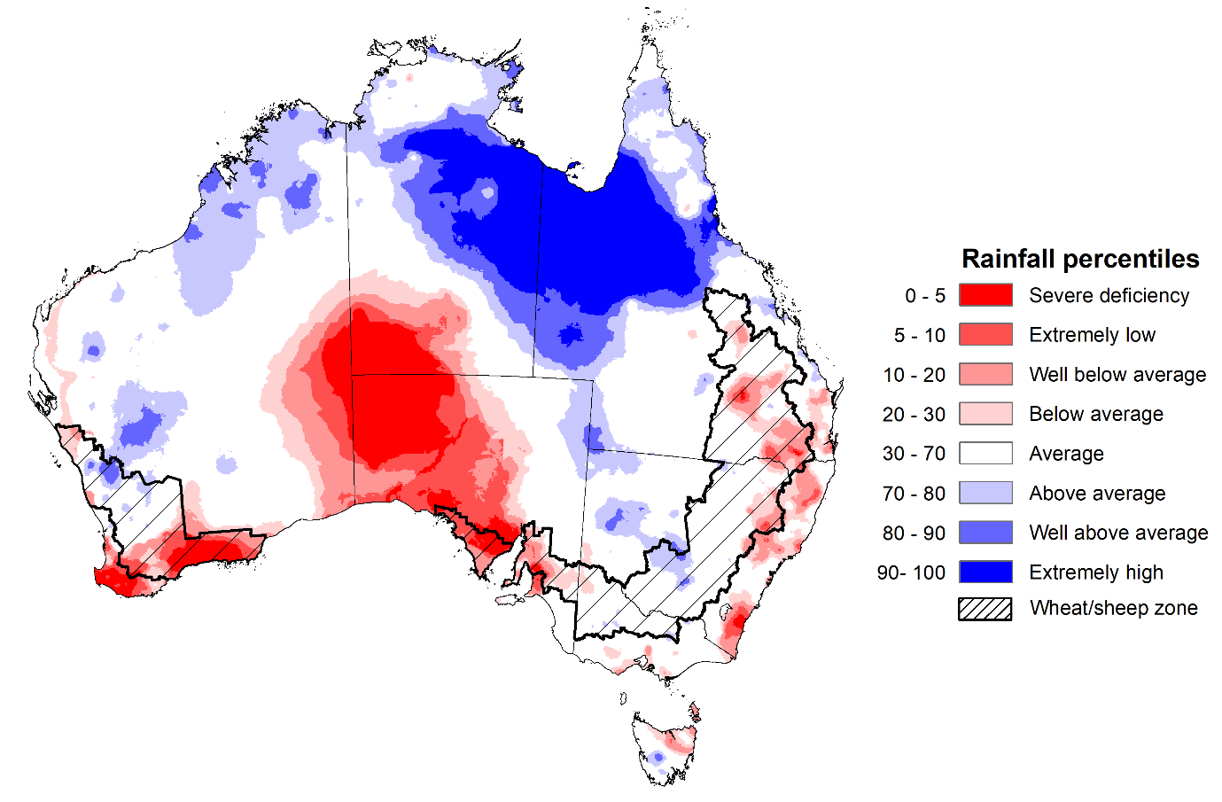
Note: Rainfall for December 2025 is compared with rainfall recorded for that period during the historical record (1900 to present). For further information, go to http://www.bom.gov.au/climate/austmaps/about-rain-maps.shtml
Source: Bureau of Meteorology

Monthly Soil Moisture
In December 2025, modelled upper layer soil moisture was generally average to above average in the north and west, with areas of below average soil moisture in southern and eastern regions.
- Large areas of southern Western Australia and South Australia, central Australia, eastern and coastal regions of southern Queensland and New South Wales, and northern Tasmania saw very much below average to below average upper layer soil moisture.
- In contrast, much of northern and western Australia, including the northern tropics, western Queensland, central New South Wales, and western and central Western Australia saw above average to very much above upper layer soil moisture.
At this time of year, upper layer soil moisture is important at the beginning of the summer cropping season and for pasture growth across northern Australia since plant germination and establishment utilise this moisture. It is also an important indicator of the ability to access paddocks for winter crop harvesting and summer crop planting activities.
Across most cropping regions, modelled upper layer soil moisture in December was generally average to very much below average, with exceptions in southern New South Wales, Victoria, and parts of northern Western Australia.
Modelled upper layer soil moisture for December 2025
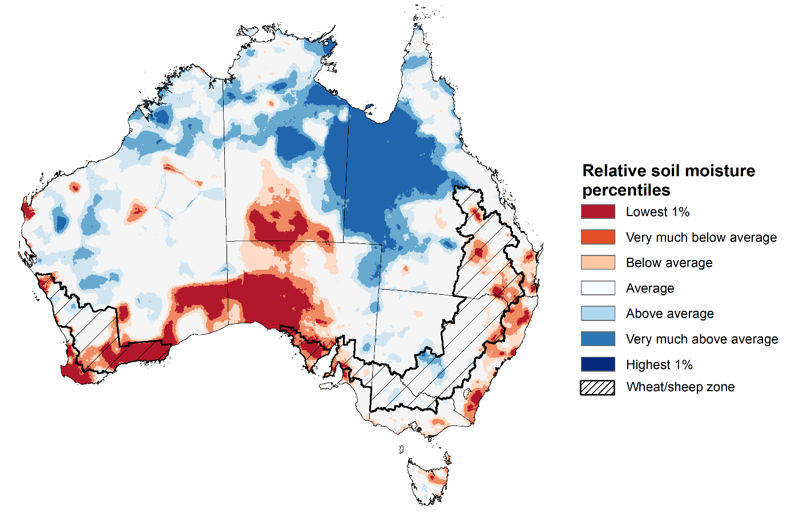
Note: This map shows the levels of modelled upper layer soil moisture (0 to 10 centimetres) during December 2025. This map shows how modelled soil conditions during December 2025 compare with December conditions modelled over the reference period (1911 to 2016). Dark blue areas on the maps were much wetter in December 2025 than during the reference period. The bulk of plant roots occur in the top 20 centimetres of the soil profile. Soil moisture in the upper layer of the soil profile is therefore useful indicator of the availability of water, particularly for germinating seed.
Source: Bureau of Meteorology (https://awo.bom.gov.au/about/overview)
Modelled lower layer soil moisture in December 2025 was average to very much above average across much of northern, southern and western Australia, while extremely low to below average modelled lower layer soil moisture was evident across some southern and eastern areas.
Lower layer soil moisture is a larger, deeper store that is slower to respond to seasonal conditions and tends to reflect the accumulated effects of events that have occurred over longer periods. Crop development and pasture growth in areas of above average lower layer soil moisture are typically less reliant on in-season rainfall than in areas with below average lower layer soil moisture.
December 2025 modelled lower layer soil moisture was average to very much below average across cropping regions in the east, including Queensland and New South Wales, as well as parts of southern Western Australia. Declining levels of lower layer soil moisture across some summer cropping regions in eastern Australia indicates a drawdown of soil moisture stores following below average rainfall to support above average levels of summer crop production.
Generally, average soil moisture levels were modelled across most southern and north-eastern cropping regions. This represents an improvement in deep moisture stores from October in much of South Australia, Victoria, Queensland and parts of Western Australia.
Modelled lower layer soil moisture for December 2025
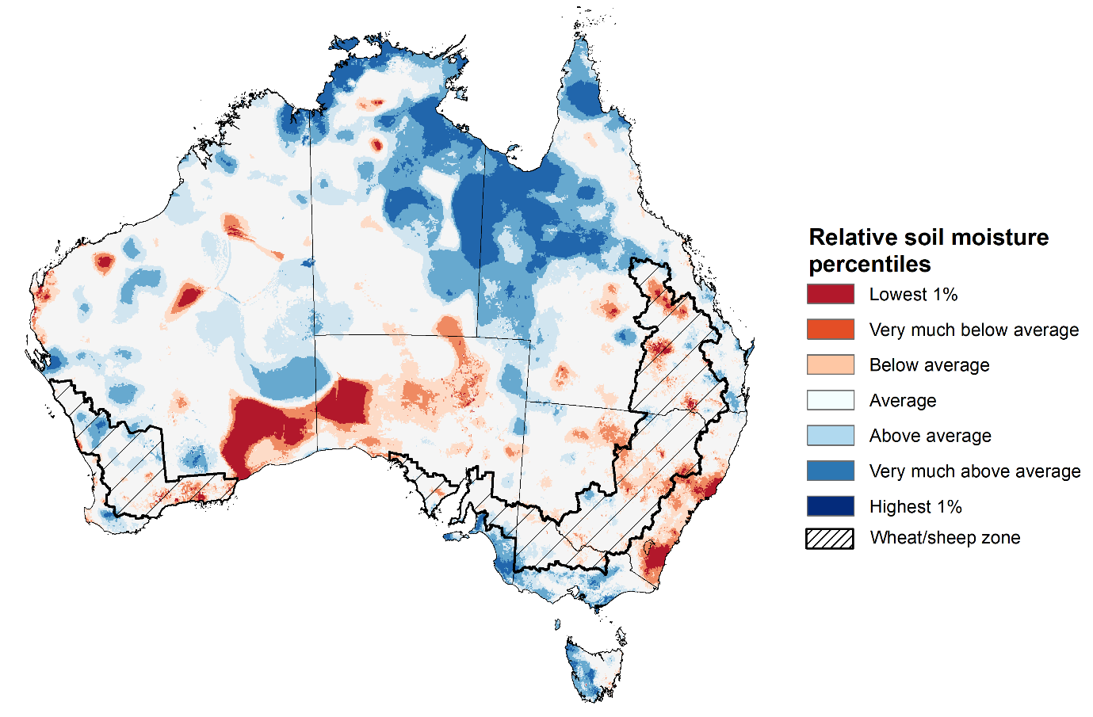
Note: This map shows the levels of modelled lower layer soil moisture (10 to 100 centimetres) during December 2025. This map shows how modelled soil conditions during December 2025 compare with December conditions modelled over the reference period (1911 to 2016). Dark blue areas on the maps were much wetter in December 2025 than during the reference period. The dark red areas were much drier than during the reference period. The bulk of plant roots occur in the top 20 centimetres of the soil profile. The lower layer soil moisture is a larger, deeper store that is slower to respond to rainfall and tends to reflect accumulated rainfall events over longer time periods.
Source: Bureau of Meteorology (https://awo.bom.gov.au/about/overview)

Pasture Growth
Pasture growth during the October to December period is typically low across large areas of central and western Australia as it exits the dry season. Across southern Australia, October and December is the peak pasture growth period which typically provides a bulk of feed and allows for fodder conservation to maintain production through the low pasture growth months of summer. It also influences the growth, branding and marking rates of lambs and calves, and the production of meat, milk, and wool over this peak production period.
Pasture growth for the three months to December 2025 was variable across much of country, with much of northern Australia seeing robust pasture growth but below average growth was evident across large areas of eastern Australia.
- Average to extremely high relative pasture growth was modelled across large areas of southern and northern Australia, including parts of the northern tropics, southern Victoria, southern regions of South Australia, and much of south-western Western Australia.
  - This pasture growth is expected to have allowed some farmers to rebuild livestock numbers, provide opportunities to build standing dry matter availability and replenish fodder supplies during late spring and early summer.
- In contrast, large areas of the eastern Australia, including parts of central Queensland, eastern New South Wales and South Australia, northern Victoria, and western Tasmania saw relatively low pasture growth for this time of year. Isolated areas in the west, including southern Western Australia, also saw below average pasture growth.
  - This below average pasture growth has likely led to a decline in pasture availability and graziers in regions where below average pasture growth was recorded will be more reliant on supplemental feed to maintain current stocking rates and production.
Relative pasture growth for 3-months ending December 2025 (1 October to 31 December 2025)
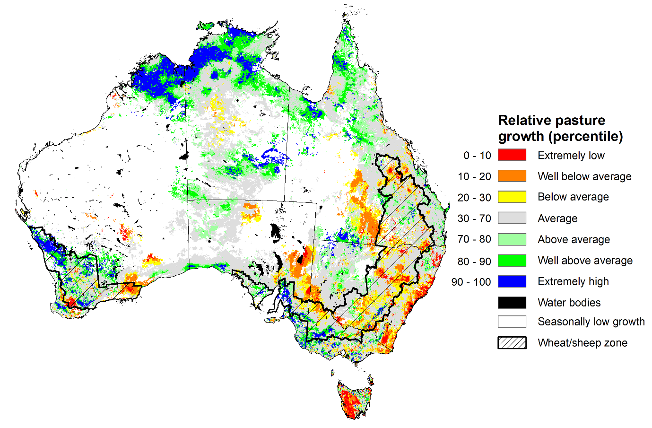
Notes: AussieGRASS pasture growth estimates are relative to the long-term record and shown in percentiles. Percentiles rank data on a scale of zero to 100. This analysis ranks pasture growth for the selected period against average pasture growth for the long-term record (1957 to 2016). Pasture growth is modelled at 5km2 grid cells.
Source: Department of Environment, Science and Innovation

National Climate Outlook
The Bureau of Meteorology has indicated that a La Niña event is continuing in the Pacific Ocean. Observations in the tropical Pacific Ocean have been consistent with La Niña conditions since early October. The Bureau's model currently predicts that tropical Pacific Ocean temperatures are likely to remain at La Niña levels until early 2026 before returning to neutral, supporting higher rainfall outcomes in the north and east of the country. This timing aligns with most international models assessed. The negative Southern Annular Mode (SAM) event is currently neutral and is forecast to remain neutral until autumn. Similar, the Indian Ocean Dipole (IOD) event is currently neutral, and is likely to remain neutral over the coming week
The most recent rainfall outlook for February 2026 provided by the Bureau of Meteorology indicates that most of Australia is more likely to see below median to median rainfall, with parts of southern Queensland more likely to see above median falls.
- The Bureau of Meteorology’s climate model indicates a 75% chance of February rainfall totals between 10-200 millimetres across much of eastern and northern Australia, with higher rainfall totals of up to 300 millimetres expected in the Northern Tropics. Much of southern Western Australia, South Australia, and western areas of New South Wales, Victoria and Queensland are likely to see little to no rainfall which is typical for this time of year.
- Across cropping regions, there is a 75% chance of receiving rainfall totals of between 25- 50 millimetres across much of Queensland and north-eastern New South Wales. Meanwhile remaining areas in southern New South Wales, eastern Victoria, South Australia, and Western Australia are likely to see 5- 10 millimetres.
  - If forecast rainfall totals are realised across much of New South Wales and Queensland, these falls are likely to be sufficient to support above average yield prospects for summer crops and average or better levels of pasture production.

Rainfall totals that have a 75% chance of occurring in February 2026
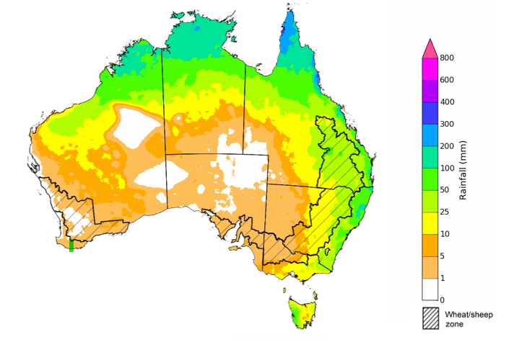
©Commonwealth of Australia 2025, Australian Bureau of Meteorology Issued: 15/1/2026
The rainfall outlook for February 2026 to April 2026 indicates no strong tendency towards above or below median rainfall across much of Australia. However, there is an increased probability of below median rainfall across parts of north-western and southern Australia, including Tasmania, Victoria, and parts of northern and southern Western Australia, some western and northern regions of the Northern Territory and southern South Australia and Victoria. Meanwhile, parts of southern Queensland and eastern New South Wales have a higher probability of above median rainfall.
Across cropping regions, the chance of receiving above median rainfall is 45-65% across New South Wales and Queensland. In Victoria and Western Australia, the chance of receiving median rainfall is lower at 40- 50%, while South Australia has a 35-45% chance. Close to average forecast rainfall for much of northern and eastern Australia is expected to support summer crop and pasture production.
Chance of exceeding the median rainfall February 2026 to April 2026
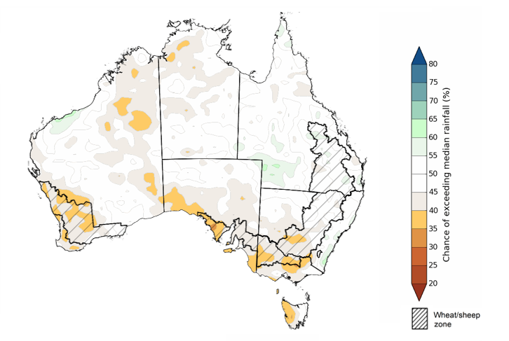
©Commonwealth of Australia 2025, Australian Bureau of Meteorology Issued: 15/1/2026
The rainfall outlook for February 2026 to April 2026 suggests a 75% chance of receiving rainfall totals of between 50-400 millimetres across much of eastern and northern Australia, as well as parts of central Western Australia. Higher falls of up to 1200 millimetres are expected across scattered east coast regions as well as large areas of the northern tropics. Lower rainfall totals are forecast for south-western and central regions, with South Australia, southern Western Australia, western New South Wales and Victoria, and south-western Queensland and southern Northern Territory likely to see 10- 100 millimetres.
In cropping regions, there is a 75% chance of receiving between 100-200 millimetres across much of Queensland and north-eastern New South Wales. The remaining cropping regions of southern New South Wales, Victoria, South Australia, and Western Australia is likely to see 25-100 millimetres.
If these forecast February through April rainfall totals are realised, they are likely to be sufficient to support summer pasture growth across eastern and northern Australia. Additionally, these expected falls are likely to be sufficient to support above average yield expectations for summer crops.
Rainfall totals that have a 75% chance of occurring February 2026 to April 2026
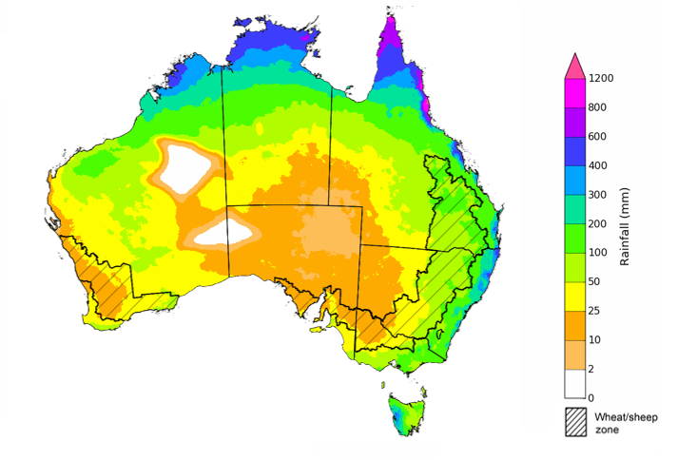
©Commonwealth of Australia 2025, Australian Bureau of Meteorology Issued: 15/1/2026

Water markets – current week
Water storage levels in the Murray-Darling Basin (MDB) decreased by 254 gigalitres (GL) between 8 January 2026 and 14 January 2026. The current volume of water held in storages is 12,742 GL, equivalent to 57% of total storage capacity. This is 17% or 2,545 GL less than the same time last year. Water storage data is sourced from the Bureau of Meteorology (BOM).

Water storages in the Murray-Darling Basin, 2013–2025
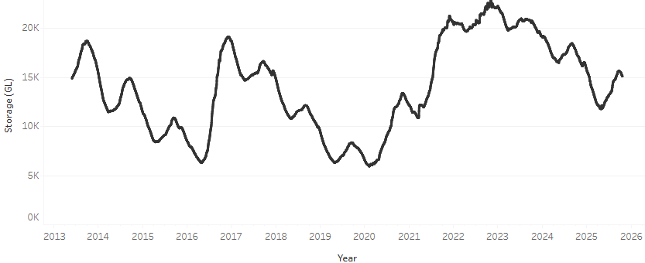
Allocation prices in the Victorian Murray below the Barmah Choke increased from $379/ML on 11 December 2026 to $436/ML on 15 January 2026. Trade from the Goulburn to the Murray is closed. Trade downstream through the Barmah Choke is closed. Trade from the Murrumbidgee to the Murray is open.

Water market prices, Southern Murray–Darling Basin

Region | $/ML
NSW Murray Above | 315
NSW Murrumbidgee | 365
Vic Greater Goulburn | 359
Vic Murray Below | 379

Note: The water allocation prices shown are volume weighted average prices based on the last 10 trades. Price data is sourced from Waterflow and current as at 11 December 2025.
To access the full, interactive, weekly water dashboard, which contains the latest and historical water storage, water market and water allocation information, please visit https://www.agriculture.gov.au/abares/products/weekly_update/weekly-update-150126

Commodities
Indicator | Week average | Unit | Latest Price | Previous Week | Weekly change |  | Price 12 months ago | Annual change
Selected world indicator prices
AUD/USD Exchange rate | 14-Jan | A$/US$ | 0.67 | 0.67 | 0% | 0.62 |  | 8%
Wheat – US no. 2 hard red winter wheat, FOB Gulf | 14-Jan | US$/t | 249 | 244 | 2% | 254 |  | -2%
Corn – US no. 2 yellow corn, FOB Gulf | 14-Jan | US$/t | 199 | 207 | -4% | 213 |  | -7%
Canola – Rapeseed, Canada, FOB Vancouver | 14-Jan | US$/t | 478 | 473 | 1% | 472 |  | 1%
Cotton – Cotlook A Index | 14-Jan | USc/lb | 74.8 | 74.6 | 0% | 78.3 |  | -4%
Sugar – Intercontinental Exchange, nearby futures, no.11 contract | 14-Jan | USc/lb | 14.9 | 14.7 | 1% | 18.9 |  | -21%
Wool – Eastern Market Indicator | 14-Jan | Ac/kg clean | 1,648 | 1,541 | 7% | 1,189 |  | 39%
Wool – Western Market Indicator | 14-Jan | Ac/kg clean | 1,846 | 1,715 | 8% | 1,336 |  | 38%
Selected Australian grain export prices
Australian Premium White (APW) Wheat, FOB Port Adelaide, SA | 14-Jan | A$/t | 351 | 357 | -2% | 404 |  | -13%
Australian Standard White (ASW) Wheat, FOB Port Adelaide, SA | 14-Jan | A$/t | 348 | 355 | -2% | 394 |  | -12%
Feed Barley – FOB Port Adelaide, SA | 14-Jan | A$/t | 337 | 344 | -2% | 368 |  | -9%
Canola – FOB Kwinana, WA | 14-Jan | A$/t | 770 | 766 | 1% | 856 |  | -10%
Grain Sorghum – FOB Brisbane, QLD | 14-Jan | A$/t | 430 | 426 | 1% | 405 |  | 6%
Selected domestic livestock indicator prices
Beef – Eastern Young Cattle Indicator | 14-Jan | Ac/kg cwt | 860 | 845 | 2% | 692 |  | 24%
Mutton – Mutton indicator (18–24 kg fat score 2–3), VIC | 14-Jan | Ac/kg cwt | 756 | 753 | 0% | 383 |  | 97%
Lamb – National Trade Lamb Indicator | 14-Jan | Ac/kg cwt | 1,065 | 1,076 | -1% | 799 |  | 33%
Pig – Eastern Seaboard (60.1–75 kg), NSW buyer price | 7-Jan | Ac/kg cwt | 468 | 468 | 0% | 453 |  | 3%
Live cattle – Light steers to Indonesia | 10-Dec | Ac/kg lwt | 455 | 450 | 1% | 353 |  | 29%
Global Dairy Trade (GDT) weighted average prices
Dairy – Whole milk powder | 7-Jan | US$/t | 3,407 | 3,161 | 8% | 3,896 |  | -13%
Dairy – Skim milk powder | 7-Jan | US$/t | 2,564 | 2,431 | 5% | 2,706 |  | -5%
Dairy – Cheddar cheese | 7-Jan | US$/t | 4,665 | 4,646 | 0% | 4,787 |  | -3%
Dairy – Anhydrous milk fat | 7-Jan | US$/t | 6,011 | 5,602 | 7% | 6,893 |  | -13%

Selected world indicator prices

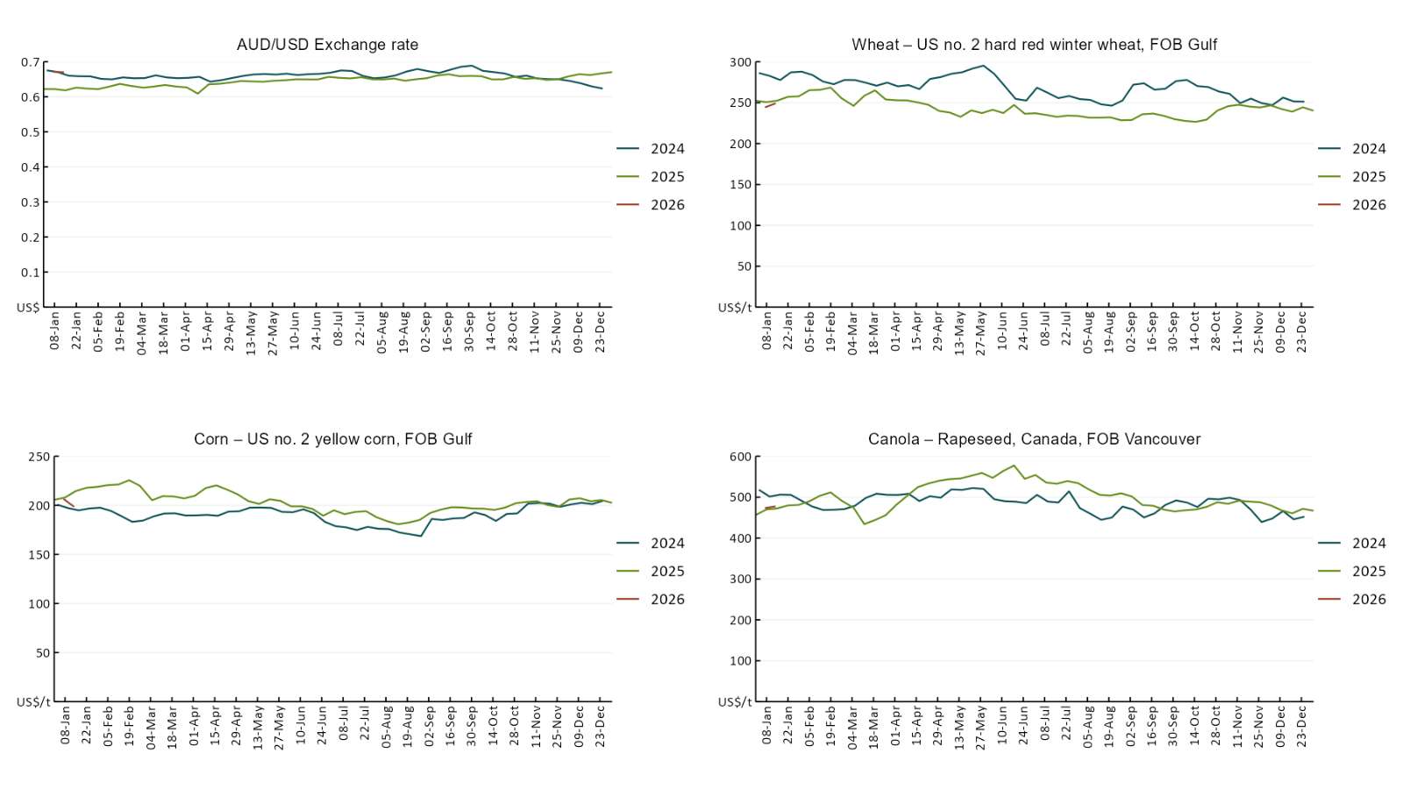
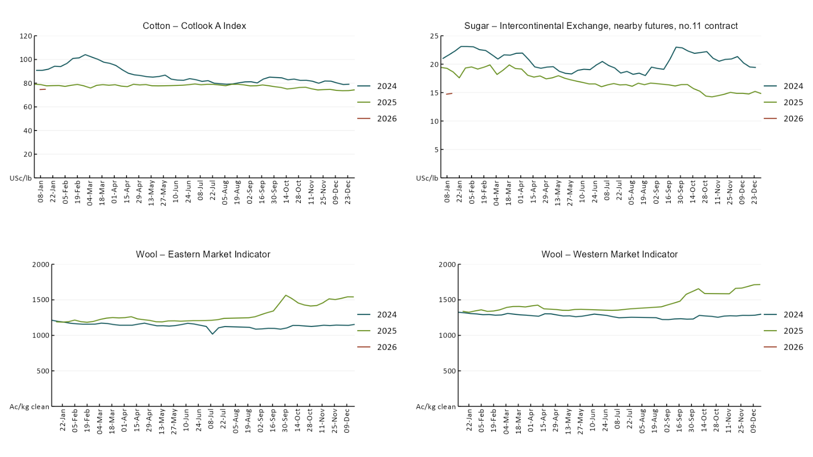

3.2 Selected domestic crop indicator prices
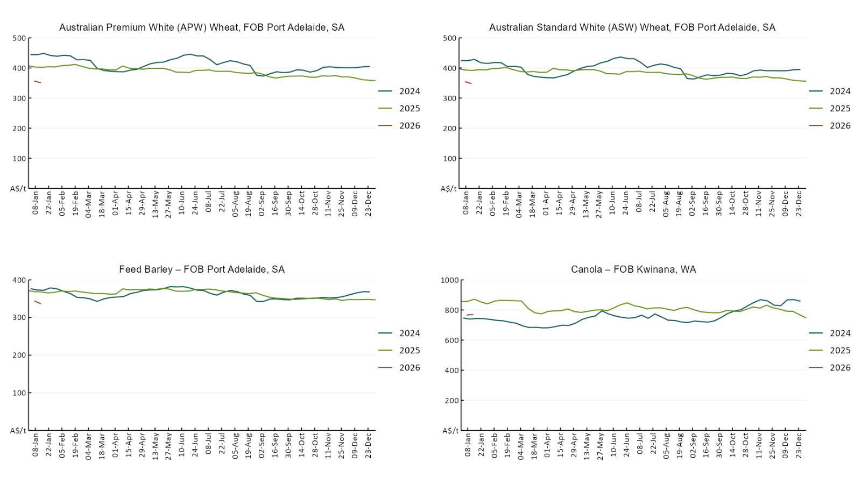
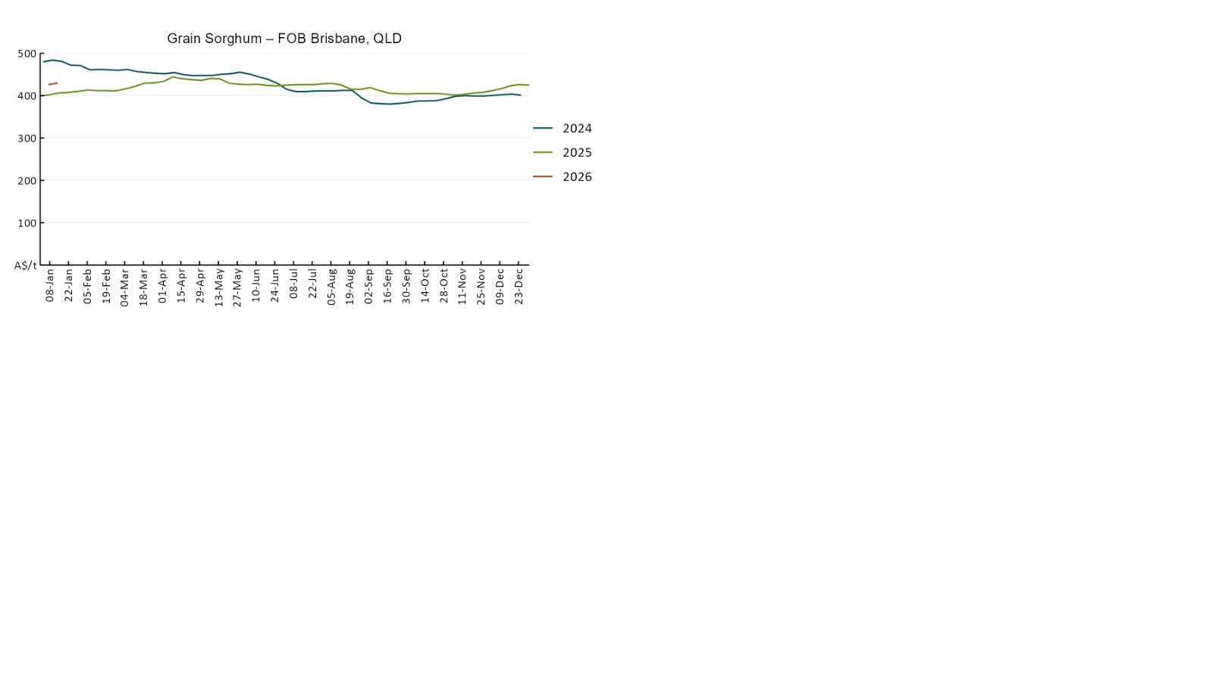

3.3 Selected domestic livestock indicator prices
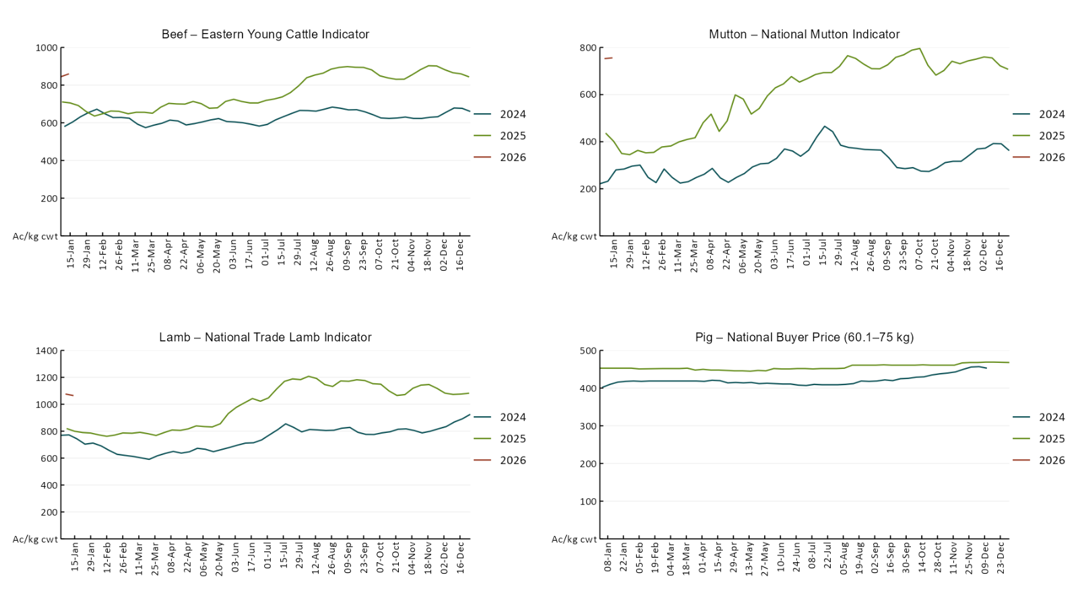
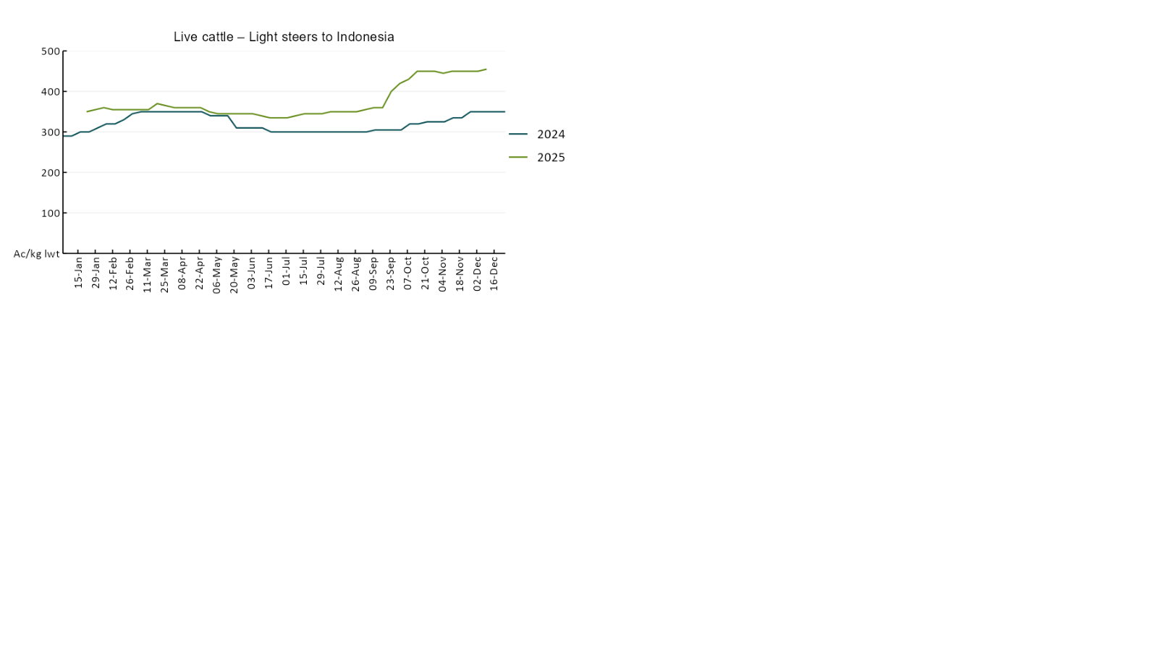

3.4 Global Dairy Trade (GDT) weighted average prices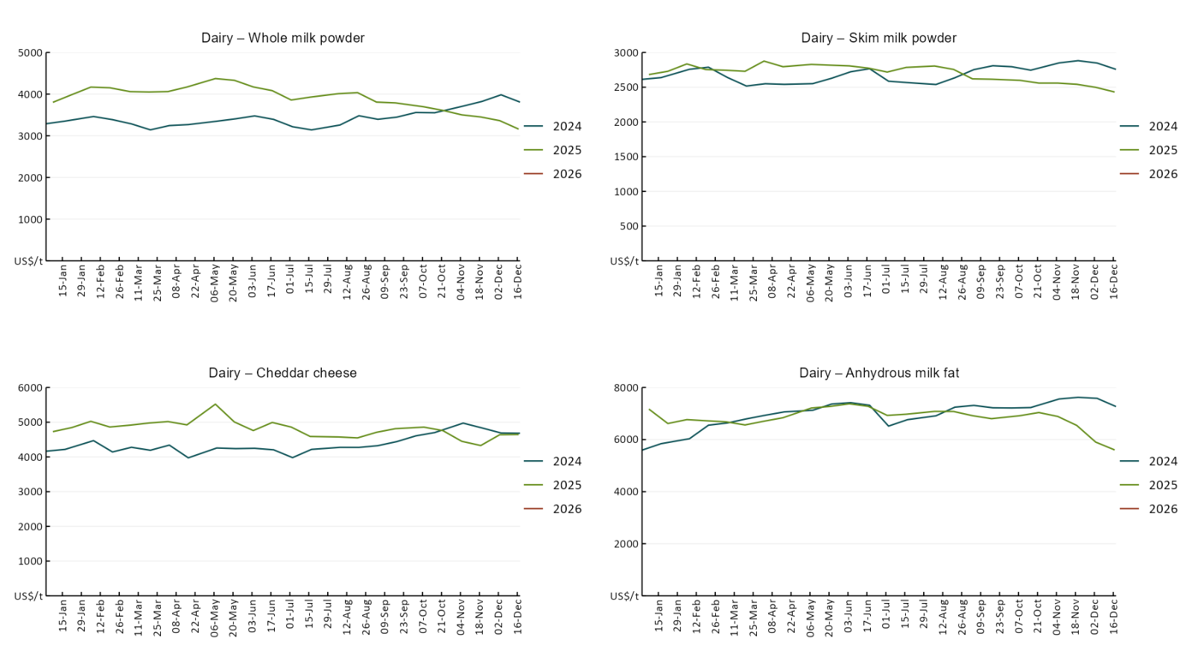

3.5 Selected fruit and vegetable prices

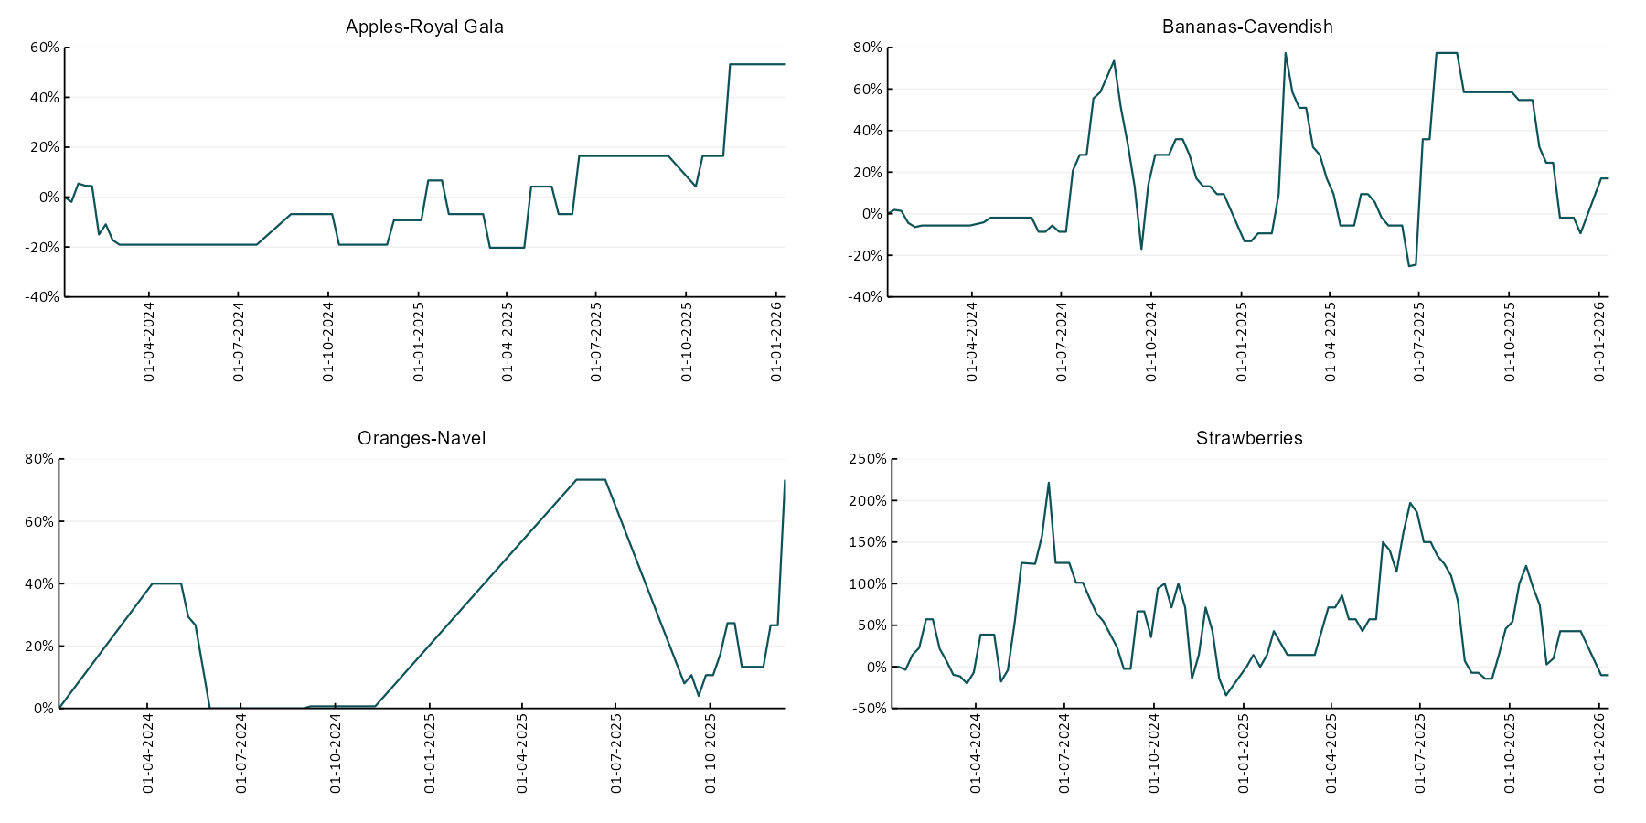

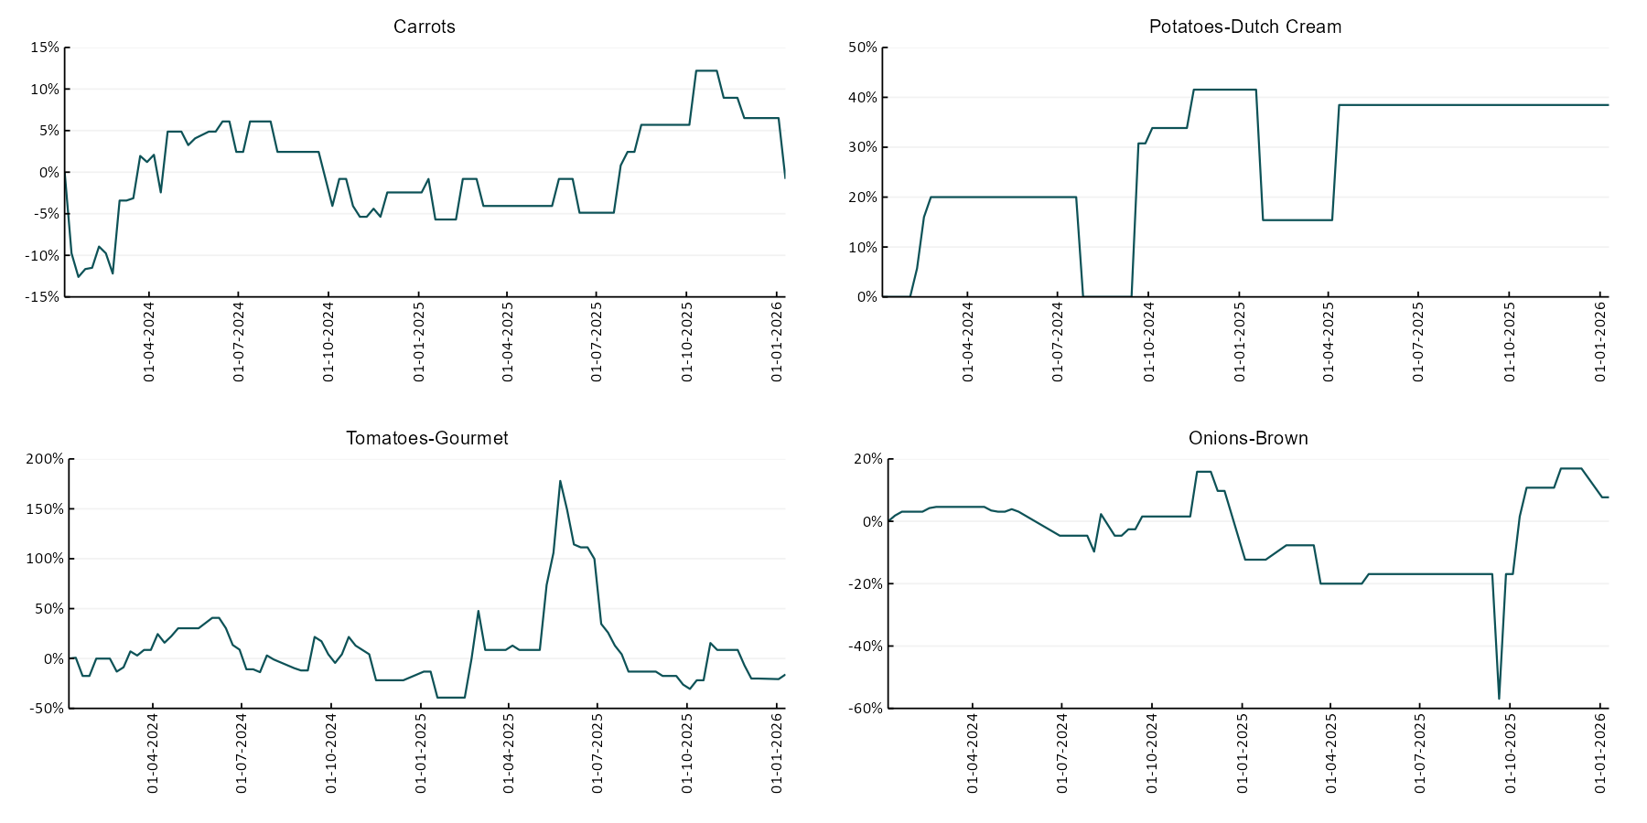

3.6 Selected domestic fodder indicator prices
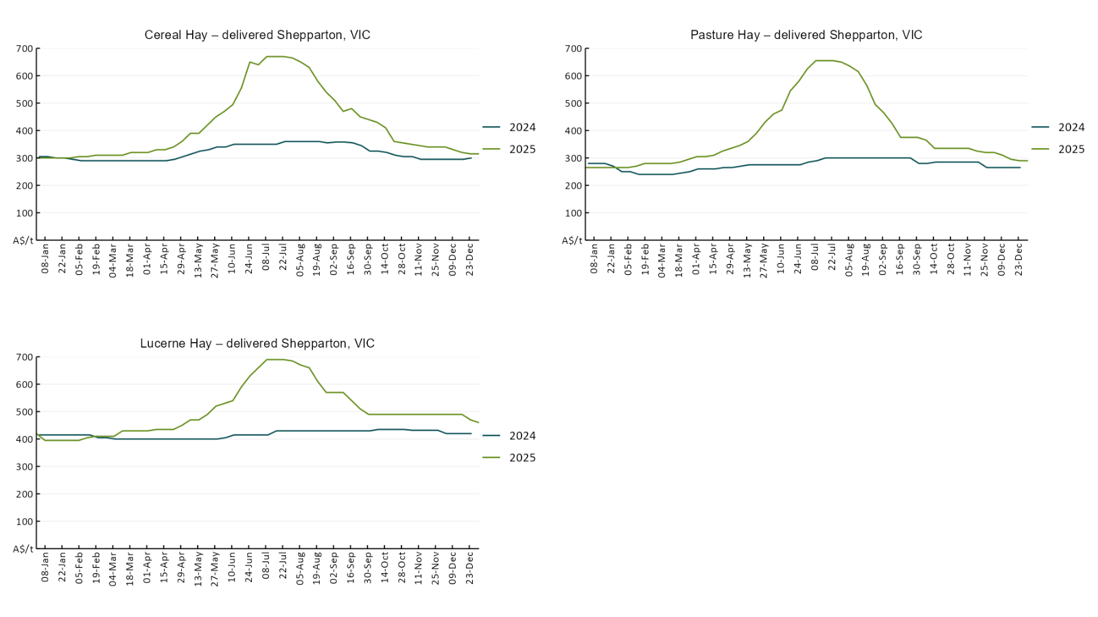

4. Data attribution

Climate
Bureau of Meteorology
- Weekly rainfall totals: www.bom.gov.au/climate/maps/rainfall/
- Monthly and last 3-month rainfall percentiles: https://www.bom.gov.au/climate/ahead/outlooks/#moreMaps
- Rainfall forecast: www.bom.gov.au/jsp/watl/rainfall/pme.jsp
- Seasonal outlook: www.bom.gov.au/climate/outlooks/#/overview/summary/
- Climate drivers: http://www.bom.gov.au/climate/enso/
- Soil moisture: https://awo.bom.gov.au/products/historical/soilMoisture-rootZone/

Other
- Pasture growth: www.longpaddock.qld.gov.au/aussiegrass/
- 3-month global outlooks: Environment and Climate Change Canada, NOAA Climate Prediction Center, EUROBRISA CPTEC/INPE, European Centre for Medium-Range Weather Forecasts, Hydrometcenter of Russia, National Climate Center Climate System Diagnosis and Prediction Room (NCC), International Research Institute for Climate and Society
- Global production: https://ipad.fas.usda.gov/ogamaps/cropmapsandcalendars.aspx
- Autumn break: Pook et al., 2009, https://rmets-onlinelibrary-wiley-com.virtual.anu.edu.au/doi/epdf/10.1002/joc.1833

Water
Prices
- Waterflow: https://www.waterflow.io/
- Ruralco: https://www.ruralcowater.com.au/
- Bureau of Meteorology:
- Allocation trade: http://www.bom.gov.au/water/dashboards/#/water-markets/mdb/at
- Storage volumes: http://www.bom.gov.au/water/dashboards/#/water-storages/summary/drainage

Trade constraints:
- Water NSW: https://www.waternsw.com.au/customer-service/ordering-trading-and-pricing/trading/murrumbidgee
- Victorian Water Register: https://www.waterregister.vic.gov.au/TradingRules2019/

Commodities
Fruit and vegetables
- Datafresh: www.freshstate.com.au

Pigs
- Australian Pork Limited: www.australianpork.com.au

Dairy
- Global Dairy Trade: www.globaldairytrade.info/en/product-results/

World wheat, canola
- International Grains Council
- https://www.igc.int/en/default.aspx
- United States Department of Agriculture

World cotton
- Cotlook: www.cotlook.com/

World sugar
- New York Stock Exchange - Intercontinental Exchange

Wool
- Australian Wool Exchange: www.awex.com.au/

Domestic wheat, barley, sorghum, canola and fodder
- Jumbuk Consulting Pty Ltd: Jumbuk AG | Agriculture Consulting

Cattle, beef, mutton, lamb, goat and live export
- Meat and Livestock Australia: https://www.mla.com.au/prices-markets/

Australian Agricultural Drought Indicators
About Australian Agricultural Drought Indicators
The Australian Agricultural Drought Indicators (AADI) links weather and agricultural data with a range of scientific and economic models to measure and forecast the effects of climate variability and drought on agricultural outcomes.
On AADI, projected broadacre farm profits are presented as percentile outcomes relative to simulated historical outcomes using the groupings:
Highest | 95-100th percentile
Very much above average | 85-95th percentile
Above average | 65-85th percentile
Average | 35-65th percentile
Below average | 15-35th percentile
Very much below average | 5-15th percentile
Lowest 5% | 0-5th percentile

There are two AADI farm profit indicators:
- The AADI farm profit climate and price indicator shows the effect of climate and prices on broadacre farm business profits of current farms compared to the last 33 years.
- The AADI farm profit climate only indicator isolates the effect of climate on profits by holding prices fixed.

© Commonwealth of Australia 2026

Ownership of intellectual property rights
Unless otherwise noted, copyright (and any other intellectual property rights, if any) in this publication is owned by the Commonwealth of Australia (referred to as the Commonwealth).

Creative Commons licence
All material in this publication is licensed under a Creative Commons Attribution 4.0 International Licence except content supplied by third parties, logos and the Commonwealth Coat of Arms.
Inquiries about the licence and any use of this document should be emailed to copyright@awe.gov.au.


Cataloguing data
This publication (and any material sourced from it) should be attributed as:
ABARES 2026, Weekly Australian Climate, Water and Agricultural Update, Australian Bureau of Agricultural and Resource Economics and Sciences, Canberra, 15 January 2026. CC BY 4.0 DOI: https://doi.org/10.25814/5f3e04e7d2503
ISSN 2652-7561
This publication is available at https://www.agriculture.gov.au/abares/products/weekly_update
Department of Agriculture, Fisheries and Forestry
GPO Box 858 Canberra ACT 2601
Telephone 1800 900 090
Web agriculture.gov.au/abares

Disclaimer
The Australian Government acting through the Department of Agriculture, Fisheries and Forestry, represented by the Australian Bureau of Agricultural and Resource Economics and Sciences, has exercised due care and skill in preparing and compiling the information and data in this publication. Notwithstanding, the Department of Agriculture, Fisheries and Forestry, ABARES, its employees and advisers disclaim all liability, including liability for negligence and for any loss, damage, injury, expense or cost incurred by any person as a result of accessing, using or relying on any of the information or data in this publication to the maximum extent permitted by law.

Statement of Professional Independence
The views and analysis presented in ABARES publications, including this one, reflect ABARES professionally independent findings, based on scientific and economic concepts, principles, information and data. These views, analysis and findings may not reflect or be consistent with the views or positions of the Australian Government, or of organisations or groups who have commissioned ABARES reports or analysis. More information on professional independence is provided on the ABARES website.

Acknowledgements
This report was prepared by Holly Beale and Matt Miller.

