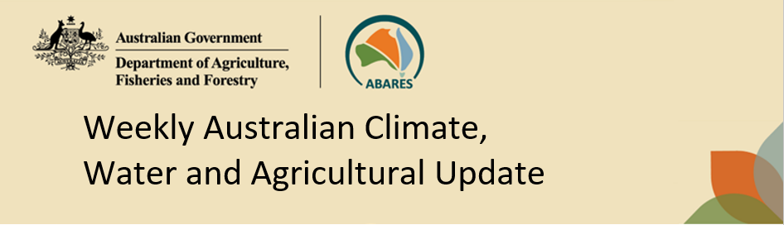
No. 2/2026 22 January 2026

Summary of key issues
- In the week ending 21 January 2026, rainfall was recorded across northern and eastern regions of Australia, while central and some southern areas remained comparably dry.
  - The remnants of Ex-Tropical cyclone Koji continued to influence rainfall outcomes in eastern regions, with rainfall totals of 100-300 millimetres in coastal New South Wales and the Northern Tropics.
  - Across cropping regions rainfall in Queensland and northern New South Wales has likely provided some benefit to soil moisture levels and the growth of summer crop.
- Over the 8-days to 29 January 2026, rainfall is forecast for the north and west of the country.
  - Continued heavy falls are forecast across major flood warning areas of northern Queensland. If realised these falls are likely to further exacerbate flooding, continue to slow recovery efforts and may lead to increased livestock losses due to a lack of feed and exposure to disease and illness.
  - The expected falls in Queensland are likely to further support soil moisture in summer cropping regions.
- Water storage levels in the Murray-Darling Basin (MDB) remained unchanged between 15 January 2026 and 22 January 2026. The current volume of water held in storages is 12,694 GL, equivalent to 57% of total storage capacity. This is 16% or 2,328 GL less than the same time last year. Water storage data is sourced from the Bureau of Meteorology.
- Allocation prices in the Victorian Murray below the Barmah Choke decreased from $436/ML on 15 January 2026 to $413/ML on 22 January 2026. Trade from the Goulburn to the Murray is closed. Trade downstream through the Barmah Choke is closed. Trade from the Murrumbidgee to the Murray is open.

Climate

Rainfall this week
In the week ending 21 January 2026, coastal throughs brought heavy rainfall to large areas of eastern Australia, while low pressure systems brought continued rainfall to the Northern Tropics. Large areas of central, western, and southern areas remained largely dry.
- The remnants of Ex Tropical cyclone (TC) Koji continued to influence rainfall patterns in the east, with resultant coastal troughs bringing rainfall totals of 100-300 millimetres in parts of coastal New South Wales and the Northern Tropics.
- Continued rainfall across the Gulf region of north Queensland is likely to have exacerbated flooding impacts and delayed recovery efforts.
Across cropping regions, rainfall was generally low, with exceptions in the east:
- Northern Queensland cropping regions saw falls of up to 300 millimetres. Southern Queensland and northern New South Wales saw rainfall between 10-50 millimetres.
  - Heavy rainfall in northern cropping regions has led to some localised crop losses but is largely expected to benefit crop and pasture production across the broader region.
  - In other regions, rainfall is expected to support soil moisture storage for summer cropping and pasture growth.
- In cropping regions in southern New South Wales and eastern Victoria, lower rainfall totals ranging between 0- 15 millimetres were observed.
- Little to no rainfall was recorded across much of western Victoria, South Australia and Western Australia cropping regions.

Rainfall for the week ending 21 January 2026
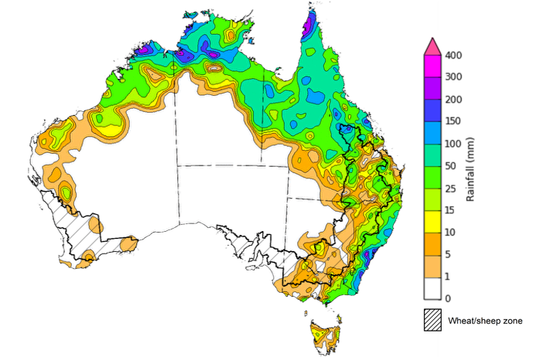
©Commonwealth of Australia 2026, Australian Bureau of Meteorology Issued: 21/1/2026
Note: The rainfall analyses and associated maps utilise data contained in the Bureau of Meteorology climate database, the Australian Data Archive for Meteorology (ADAM). The analyses are initially produced automatically from real-time data with limited quality control. They are intended to provide a general overview of rainfall across Australia as quickly as possible after the observations are received. For further information go to http://www.bom.gov.au/climate/rainfall/

Rainfall forecast for the next eight days
Over the 8 days to 29 January 2026, tropical lows are expected to bring considerable rainfall to much of the north of Australia, while south-eastern and far western regions of the country are forecast to remain largely dry.
- Forecast falls of between 50-150 millimetres are expected across major flood warning areas of northern Queensland. If realised these falls are likely to further exacerbate flooding, continue to slow recovery efforts and may lead to increased livestock losses due to a lack of feed and exposure to disease and illness.
Limited rainfall is expected across cropping regions this week, with exceptions in parts of Queensland.
- Falls of between 10-25 millimetres are forecast for most northern Queensland cropping regions , while central and southern Queensland are expected to see falls of 5-15 millimetres.
  - These expected heavier falls across Queensland are likely to support soil moisture in summer cropping regions and improve pasture growth.
- Remaining cropping regions are forecast to receive little to no rainfall.

Total forecast rainfall for the period 22 January to 29 January 2026
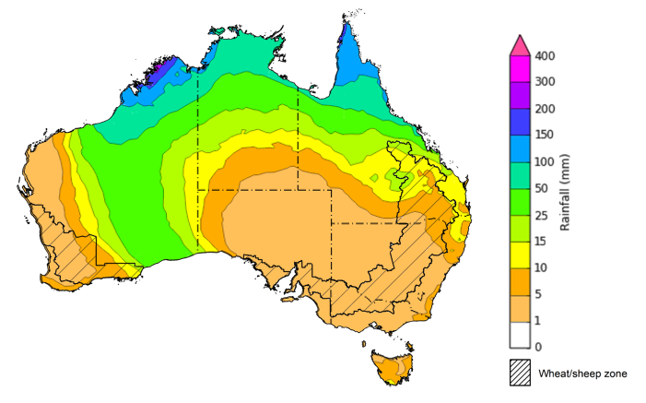
©Commonwealth of Australia 2026, Australian Bureau of Meteorology Issued 22/1/2026
Note: This rainfall forecast is produced from computer models. As the model outputs are not altered by weather forecasters, it is important to check local forecasts and warnings issued by the Bureau of Meteorology.

December precipitation percentiles and current production conditions
Crop production is affected by long-term trends in average rainfall and temperature, interannual climate variability, shocks during specific growth stages, and extreme weather events. Some crops are more tolerant than others to certain types of stresses, and at each growth stage, different types of stresses affect crop species in different ways.
Precipitation anomalies and outlooks presented below indicate the current and expected future production conditions for major grain and oilseed producing countries (responsible for over 80% of global crop production). This is an important input to assessing the global grain supply outlook.
Precipitation in December 2025 was variable across the world’s major grain- and oilseed-producing regions:
- In the southern hemisphere, precipitation was above average across much of southern Africa, and Southeast Asia including Malaysia and parts of Indonesia. Below average precipitation occurred in parts of southern and western Brazil, eastern Argentina and southern Australia. Precipitation was generally average across the remaining major southern hemisphere grain- and oilseed-producing regions.
- In the northern hemisphere, precipitation was below average in much of the European Union and the western Black Sea region, the southern United States, and isolated parts of western China. Precipitation was above average across parts of the northwestern United States, much of the Russian Federation, much of Canada, and central Asia. Precipitation was generally average across remaining major northern hemisphere grain- and oilseed-producing regions.

Global precipitation percentiles, December 2025

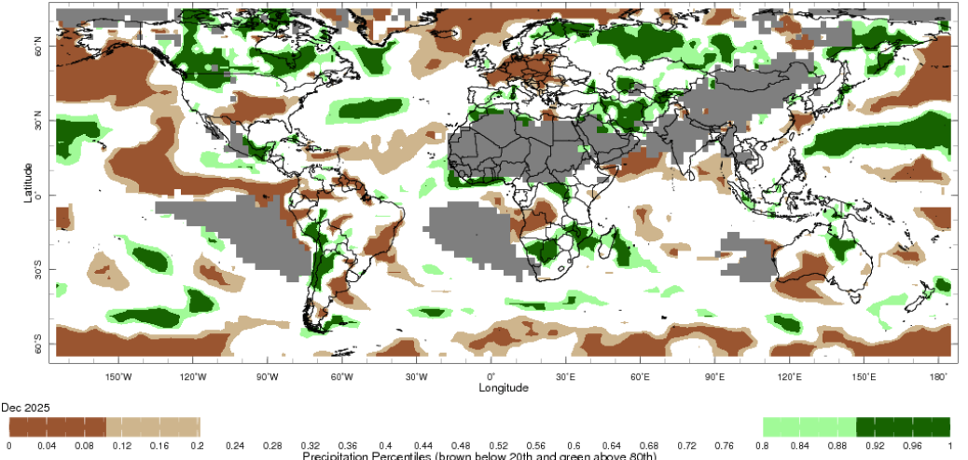

Note: The world precipitation percentiles indicate a ranking of precipitation for December, with the driest (0th percentile) being 0 on the scale and the wettest (100th percentile) being 1 on the scale. Percentiles are based on precipitation estimates from the NOAA Climate Prediction Center’s Climate Anomaly Monitoring System Outgoing Precipitation Index dataset. Precipitation estimates for December are compared with rainfall recorded for that period during the 1981 to 2010 base period.
Source: International Research Institute for Climate and Society

The global climate outlook for February 2026 to April 2026 indicates that mixed rainfall conditions are expected for the world’s major grain-producing and oilseed-producing regions. Outlooks and potential production impacts for major grain- and oilseed-producing countries are presented in the following table.
Precipitation outlook and potential impact on the future state of production conditions, February 2026 - April 2026
Region | Precipitation outlook | Potential impact on production
Argentina | Below average rainfall is likely across parts of eastern Argentina. | Below average rainfall in cropping regions in the east is likely to impact flowering of soybeans, rice, sorghum, and millet crops over February.
Black Sea Region | Close to average precipitation is expected for much of the Black Sea Region, with exceptions insolated parts of the Russian Federation. | Winter wheat and canola continue to remain in dormancy, and average precipitation in much of the Black Sea region is likely to provide sufficient snowpack to prevent winterkill.
Brazil | Rainfall outcomes across Brazil are expected to be below average in some southern and northern regions. | Below average expected rainfall in parts of Brazil may impair crop development stages over the coming months, including the critical flowering period for soybeans, corn, and cotton, as well as grain heading for key grains such as rice and sorghum.
Canada | Precipitation across much of Canada is expected to be average to above average, with some central areas more likely to see below average rainfall. | Generally average to above average precipitation is likely to provide sufficient snowpack to prevent winterkill in Canada’s limited winter wheat areas from February to March. The precipitation outlook is favourable for spring snowmelt and boosting soil moisture for spring planting and establishment.
China | Below average precipitation is expected across parts of eastern and northern China, with average falls expected elsewhere. | Anticipated below average precipitation in some areas is likely to reduce the level of snowpack during crop dormancy and increase the risk of winterkill.
European Union | Average precipitation is more likely for much of the European Union, with parts of northern Europe, including Denmark and the Netherlands to see above average falls. | Average precipitation across much of the European Union is likely to support the dormancy of winter wheat and canola.
South Asia | Average rainfall is expected across much of India, with isolated areas of below average rainfall in the west and east. | Anticipated rainfall is likely to support the growth of crops in many areas, but below average rainfall could adversely affect the heading of wheat and canola in some regions.
Southeast Asia | Below average to average rainfall is likely across much of Southeast Asia. | Below average rainfall may facilitate the harvest of corn, rice, and soybean in many areas, but impede the establishment of crops elsewhere.
The United States | Below average precipitation is likely for much of southern United States, with above average precipitation more likely across the north and east. | Above average precipitation conditions expected across the northern US are likely to provide sufficient snow cover from February to protect winter wheat and canola through dormancy. However, below average precipitation across southern US presents a downside production risk for winter wheat.

Water markets – current week
Water storage levels in the Murray-Darling Basin (MDB) remained unchanged between 15 January 2026 and 22 January 2026. The current volume of water held in storages is 12,694 GL, equivalent to 57% of total storage capacity. This is -6% or 2,328 GL less than the same time last year. Water storage data is sourced from the Bureau of Meteorology (BOM).

Water storages in the Murray-Darling Basin, 2013–2026
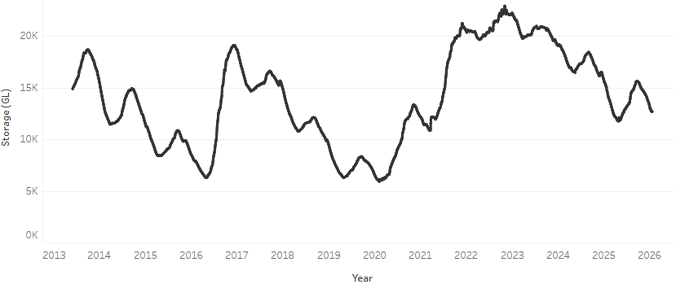

Allocation prices in the Victorian Murray below the Barmah Choke decreased from $436/ML on 15 January 2026 to $413/ML on 22 January 2026. Trade from the Goulburn to the Murray is closed. Trade downstream through the Barmah Choke is closed. Trade from the Murrumbidgee to the Murray is open.

Water market prices, Southern Murray–Darling Basin

Region | $/ML
NSW Murray Above | 422
NSW Murrumbidgee | 347
Vic Greater Goulburn | 421
Vic Murray Below | 413

Note: The water allocation prices shown are volume weighted average prices based on the last 10 trades. Price data is sourced from Waterflow and current as at 22 January 2026.
To access the full, interactive, weekly water dashboard, which contains the latest and historical water storage, water market and water allocation information, please visit https://www.agriculture.gov.au/abares/products/weekly_update/weekly-update-260122

Commodities
Indicator | Week average | Unit | Latest Price | Previous Week | Weekly change |  | Price 12 months ago | Annual change
Selected world indicator prices
AUD/USD Exchange rate | 21-Jan | A$/US$ | 0.67 | 0.67 | 0% | 0.62 |  | 8%
Wheat – US no. 2 hard red winter wheat, FOB Gulf | 21-Jan | US$/t | 250 | 249 | 0% | 254 |  | -2%
Corn – US no. 2 yellow corn, FOB Gulf | 21-Jan | US$/t | 200 | 199 | 1% | 213 |  | -6%
Canola – Rapeseed, Canada, FOB Vancouver | 21-Jan | US$/t | 490 | 480 | 2% | 472 |  | 4%
Cotton – Cotlook A Index | 21-Jan | USc/lb | 74.8 | 74.9 | 0% | 78.3 |  | -4%
Sugar – Intercontinental Exchange, nearby futures, no.11 contract | 21-Jan | USc/lb | 14.8 | 14.8 | 0% | 18.9 |  | -21%
Wool – Eastern Market Indicator | 21-Jan | Ac/kg clean | 1,689 | 1,648 | 2% | 1,189 |  | 42%
Wool – Western Market Indicator | 21-Jan | Ac/kg clean | 1,878 | 1,846 | 2% | 1,336 |  | 41%
Selected Australian grain export prices
Australian Premium White (APW) Wheat, FOB Port Adelaide, SA | 21-Jan | A$/t | 350 | 350 | 0% | 404 |  | -13%
Australian Standard White (ASW) Wheat, FOB Port Adelaide, SA | 21-Jan | A$/t | 346 | 348 | -1% | 394 |  | -12%
Feed Barley – FOB Port Adelaide, SA | 21-Jan | A$/t | 337 | 337 | 0% | 368 |  | -8%
Canola – FOB Kwinana, WA | 21-Jan | A$/t | 769 | 772 | 0% | 856 |  | -10%
Grain Sorghum – FOB Brisbane, QLD | 21-Jan | A$/t | 436 | 431 | 1% | 405 |  | 8%
Selected domestic livestock indicator prices
Beef – Eastern Young Cattle Indicator | 21-Jan | Ac/kg cwt | 866 | 862 | 0% | 692 |  | 25%
Mutton – Mutton indicator (18–24 kg fat score 2–3), VIC | 21-Jan | Ac/kg cwt | 754 | 755 | 0% | 383 |  | 97%
Lamb – National Trade Lamb Indicator | 21-Jan | Ac/kg cwt | 1,062 | 1,062 | 0% | 799 |  | 33%
Pig – Eastern Seaboard (60.1–75 kg), NSW buyer price | 7-Jan | Ac/kg cwt | 468 | 468 | 0% | 453 |  | 3%
Live cattle – Light steers to Indonesia | 10-Dec | Ac/kg lwt | 455 | 450 | 1% | 353 |  | 29%
Global Dairy Trade (GDT) weighted average prices
Dairy – Whole milk powder | 21-Jan | US$/t | 3,449 | 3,407 | 1% | 3,896 |  | -11%
Dairy – Skim milk powder | 21-Jan | US$/t | 2,615 | 2,564 | 2% | 2,706 |  | -3%
Dairy – Cheddar cheese | 21-Jan | US$/t | 4,594 | 4,665 | -2% | 4,787 |  | -4%
Dairy – Anhydrous milk fat | 21-Jan | US$/t | 6,191 | 6,011 | 3% | 6,893 |  | -10%

Selected world indicator prices

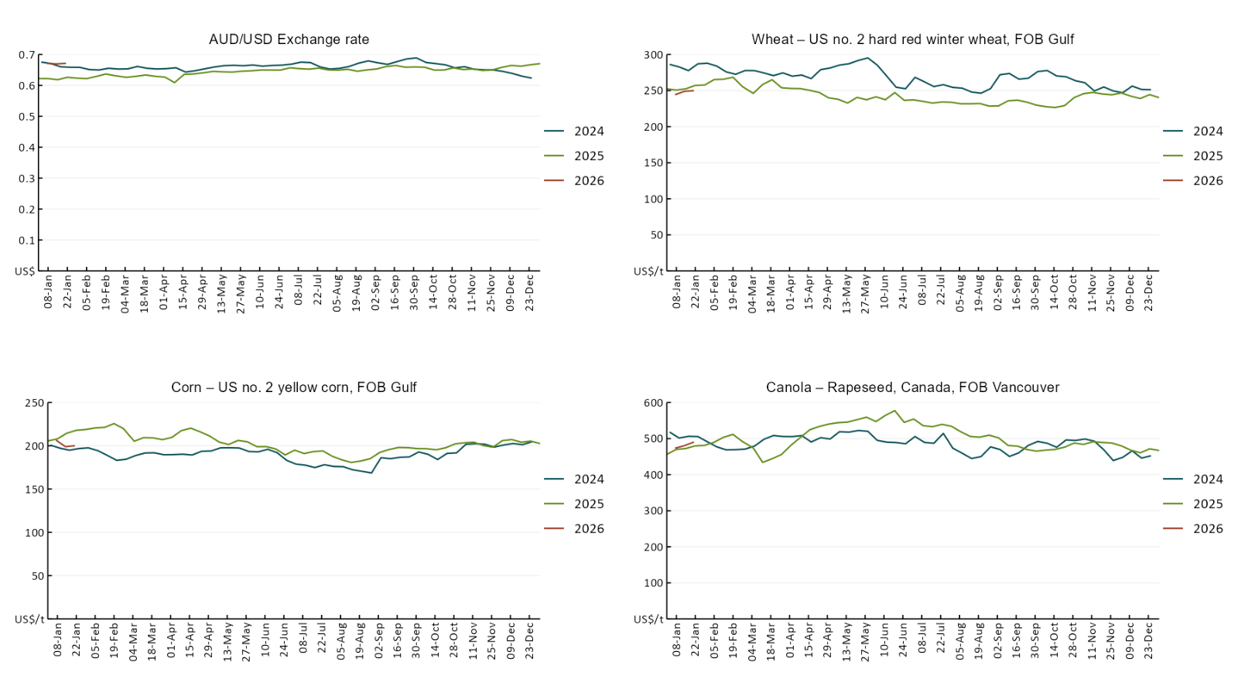
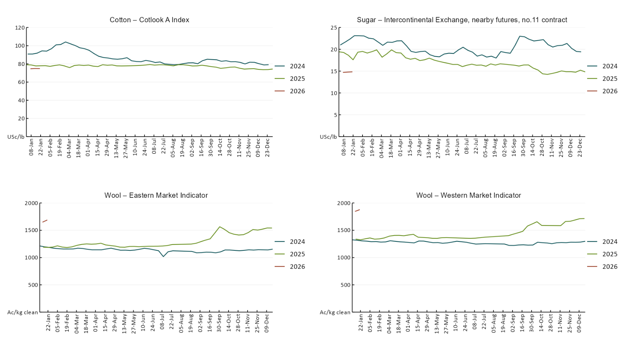

3.2 Selected domestic crop indicator prices
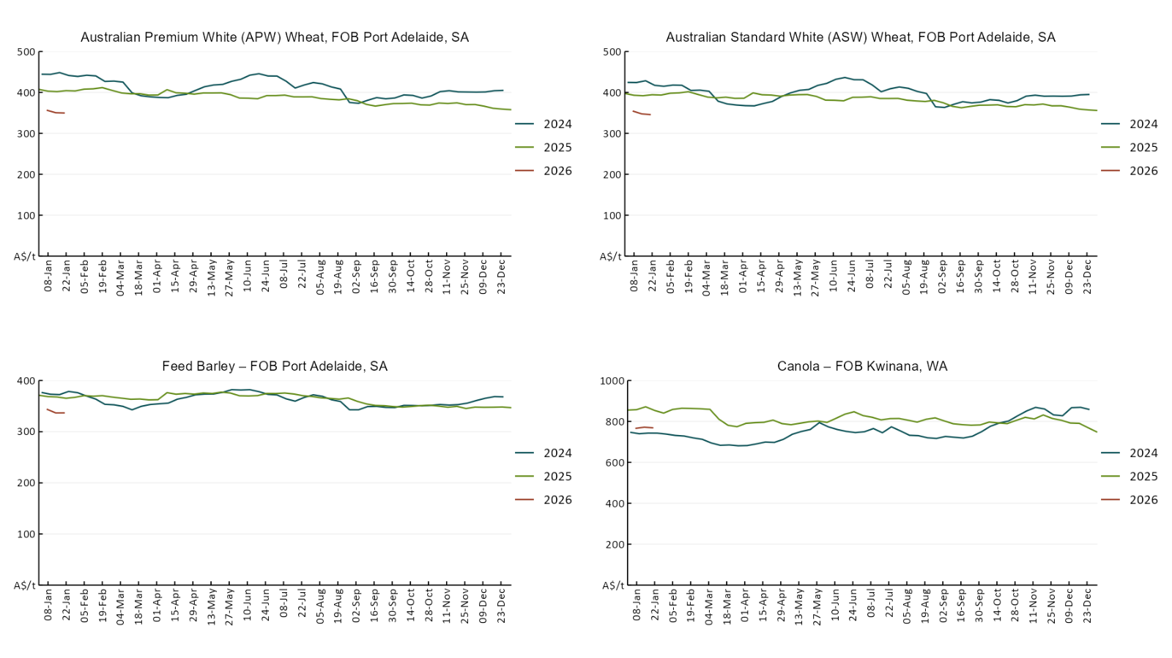
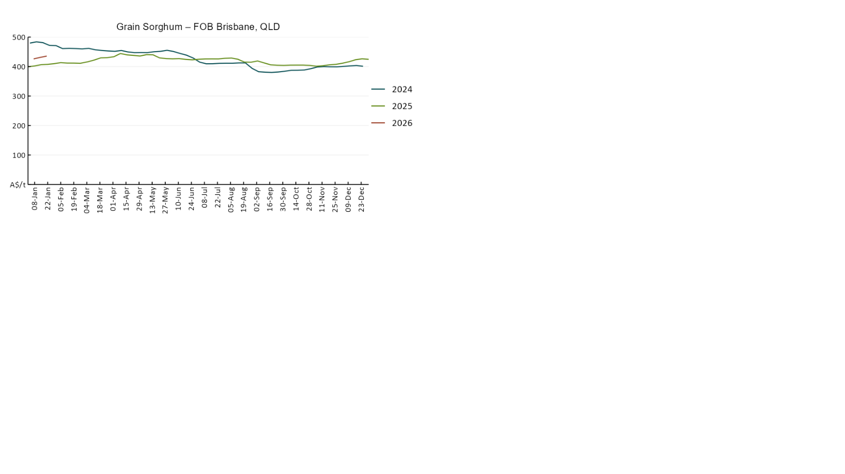

3.3 Selected domestic livestock indicator prices
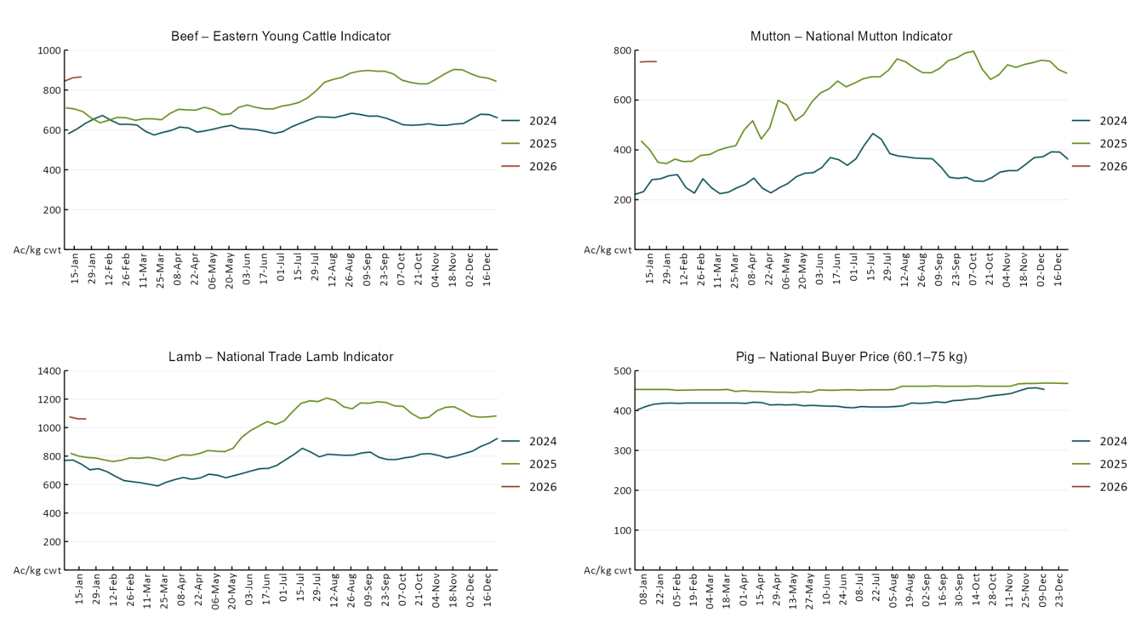
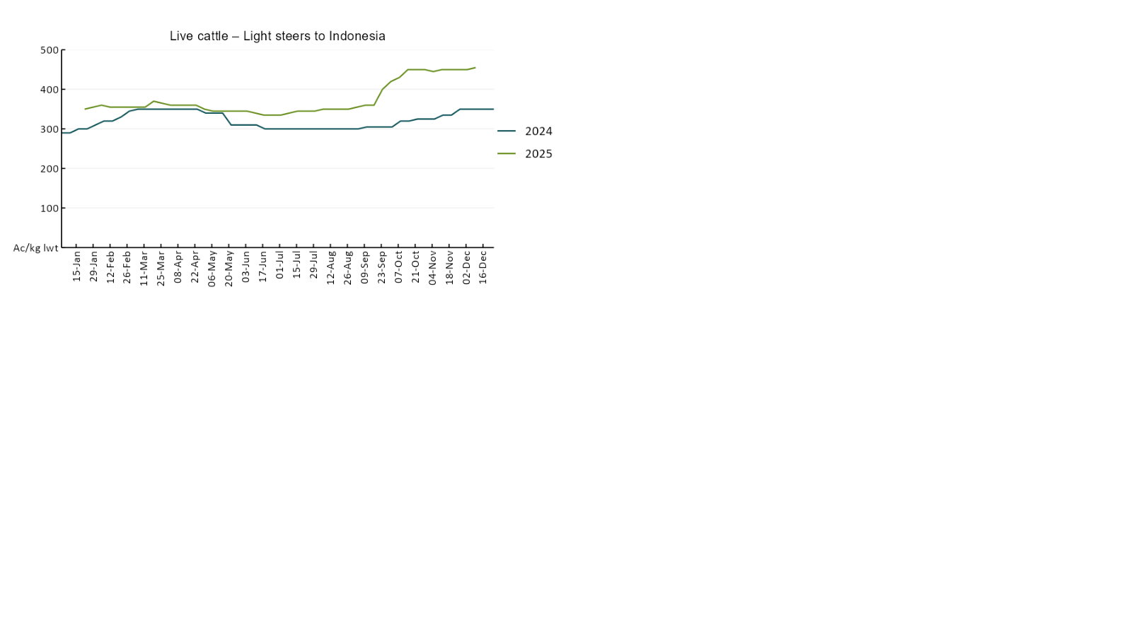

3.4 Global Dairy Trade (GDT) weighted average prices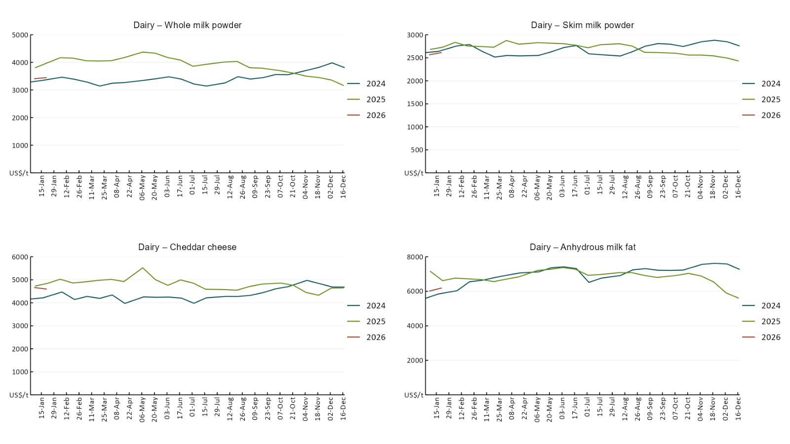

3.5 Selected fruit and vegetable prices

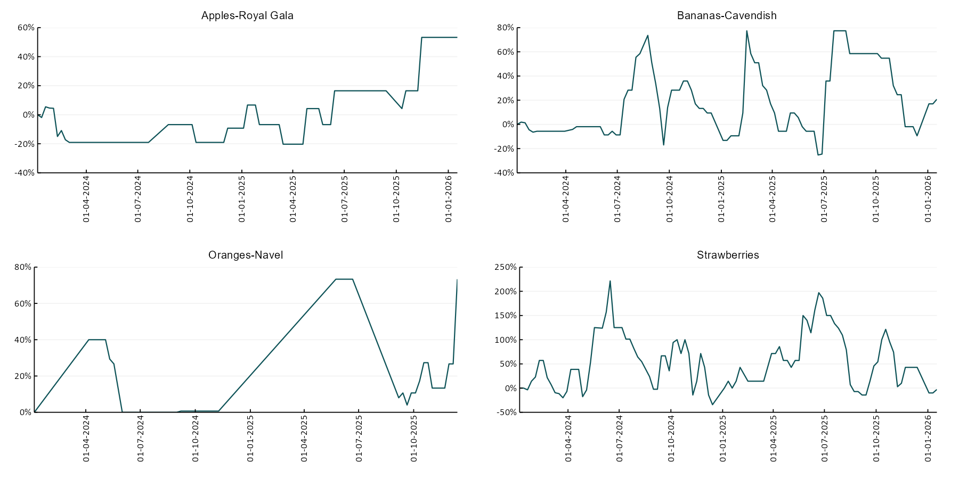

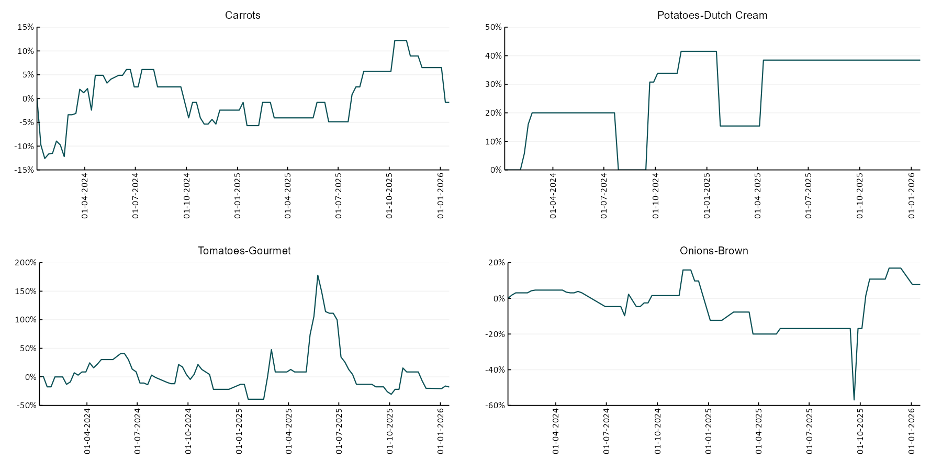

3.6 Selected domestic fodder indicator prices
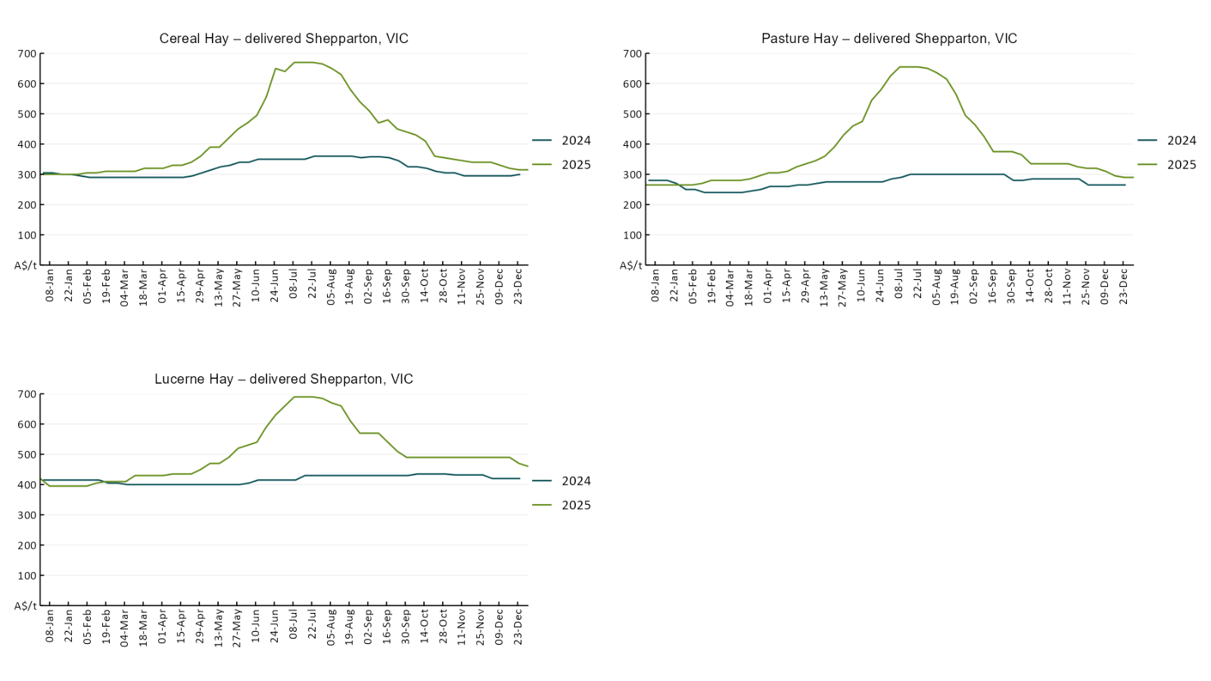

4. Data attribution

Climate
Bureau of Meteorology
- Weekly rainfall totals: www.bom.gov.au/climate/maps/rainfall/
- Monthly and last 3-month rainfall percentiles: https://www.bom.gov.au/climate/ahead/outlooks/#moreMaps
- Rainfall forecast: www.bom.gov.au/jsp/watl/rainfall/pme.jsp
- Seasonal outlook: www.bom.gov.au/climate/outlooks/#/overview/summary/
- Climate drivers: http://www.bom.gov.au/climate/enso/
- Soil moisture: https://awo.bom.gov.au/products/historical/soilMoisture-rootZone/

Other
- Pasture growth: www.longpaddock.qld.gov.au/aussiegrass/
- 3-month global outlooks: Environment and Climate Change Canada, NOAA Climate Prediction Center, EUROBRISA CPTEC/INPE, European Centre for Medium-Range Weather Forecasts, Hydrometcenter of Russia, National Climate Center Climate System Diagnosis and Prediction Room (NCC), International Research Institute for Climate and Society
- Global production: https://ipad.fas.usda.gov/ogamaps/cropmapsandcalendars.aspx
- Autumn break: Pook et al., 2009, https://rmets-onlinelibrary-wiley-com.virtual.anu.edu.au/doi/epdf/10.1002/joc.1833

Water
Prices
- Waterflow: https://www.waterflow.io/
- Ruralco: https://www.ruralcowater.com.au/
- Bureau of Meteorology:
- Allocation trade: http://www.bom.gov.au/water/dashboards/#/water-markets/mdb/at
- Storage volumes: http://www.bom.gov.au/water/dashboards/#/water-storages/summary/drainage

Trade constraints:
- Water NSW: https://www.waternsw.com.au/customer-service/ordering-trading-and-pricing/trading/murrumbidgee
- Victorian Water Register: https://www.waterregister.vic.gov.au/TradingRules2019/

Commodities
Fruit and vegetables
- Datafresh: www.freshstate.com.au

Pigs
- Australian Pork Limited: www.australianpork.com.au

Dairy
- Global Dairy Trade: www.globaldairytrade.info/en/product-results/

World wheat, canola
- International Grains Council
- https://www.igc.int/en/default.aspx
- United States Department of Agriculture

World cotton
- Cotlook: www.cotlook.com/

World sugar
- New York Stock Exchange - Intercontinental Exchange

Wool
- Australian Wool Exchange: www.awex.com.au/

Domestic wheat, barley, sorghum, canola and fodder
- Jumbuk Consulting Pty Ltd: Jumbuk AG | Agriculture Consulting

Cattle, beef, mutton, lamb, goat and live export
- Meat and Livestock Australia: https://www.mla.com.au/prices-markets/

Australian Agricultural Drought Indicators
About Australian Agricultural Drought Indicators
The Australian Agricultural Drought Indicators (AADI) links weather and agricultural data with a range of scientific and economic models to measure and forecast the effects of climate variability and drought on agricultural outcomes.
On AADI, projected broadacre farm profits are presented as percentile outcomes relative to simulated historical outcomes using the groupings:
Highest | 95-100th percentile
Very much above average | 85-95th percentile
Above average | 65-85th percentile
Average | 35-65th percentile
Below average | 15-35th percentile
Very much below average | 5-15th percentile
Lowest 5% | 0-5th percentile

There are two AADI farm profit indicators:
- The AADI farm profit climate and price indicator shows the effect of climate and prices on broadacre farm business profits of current farms compared to the last 33 years.
- The AADI farm profit climate only indicator isolates the effect of climate on profits by holding prices fixed.

© Commonwealth of Australia 2026

Ownership of intellectual property rights
Unless otherwise noted, copyright (and any other intellectual property rights, if any) in this publication is owned by the Commonwealth of Australia (referred to as the Commonwealth).

Creative Commons licence
All material in this publication is licensed under a Creative Commons Attribution 4.0 International Licence except content supplied by third parties, logos and the Commonwealth Coat of Arms.
Inquiries about the licence and any use of this document should be emailed to copyright@awe.gov.au.


Cataloguing data
This publication (and any material sourced from it) should be attributed as:
ABARES 2026, Weekly Australian Climate, Water and Agricultural Update, Australian Bureau of Agricultural and Resource Economics and Sciences, Canberra, 22 January 2026. CC BY 4.0 DOI: https://doi.org/10.25814/5f3e04e7d2503
ISSN 2652-7561
This publication is available at https://www.agriculture.gov.au/abares/products/weekly_update
Department of Agriculture, Fisheries and Forestry
GPO Box 858 Canberra ACT 2601
Telephone 1800 900 090
Web agriculture.gov.au/abares

Disclaimer
The Australian Government acting through the Department of Agriculture, Fisheries and Forestry, represented by the Australian Bureau of Agricultural and Resource Economics and Sciences, has exercised due care and skill in preparing and compiling the information and data in this publication. Notwithstanding, the Department of Agriculture, Fisheries and Forestry, ABARES, its employees and advisers disclaim all liability, including liability for negligence and for any loss, damage, injury, expense or cost incurred by any person as a result of accessing, using or relying on any of the information or data in this publication to the maximum extent permitted by law.

Statement of Professional Independence
The views and analysis presented in ABARES publications, including this one, reflect ABARES professionally independent findings, based on scientific and economic concepts, principles, information and data. These views, analysis and findings may not reflect or be consistent with the views or positions of the Australian Government, or of organisations or groups who have commissioned ABARES reports or analysis. More information on professional independence is provided on the ABARES website.

Acknowledgements
This report was prepared by Holly Beale and Matt Miller.

