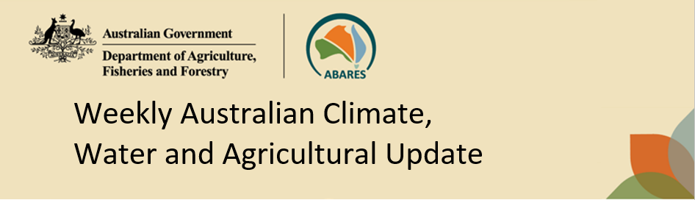
No. 3/2026 29 January 2026

Summary of key issues
- In the week ending 28 January 2026, rainfall was recorded across northern regions of Australia, while central and most southern areas remained comparably dry.
  - Tropical Cyclone Luana and a tropical low, brought widespread falls of between 50 and 300 millimetres to the north of Western Australia and Queensland.
    - Continued rainfall across the Gulf region of north Queensland is likely to have exacerbated flooding impacts and delayed recovery efforts.
    - Elsewhere, these falls are expected to support soil moisture storage and benefit crop and pasture production across the broader region.
- Over the 8-days to 5 February 2026, rainfall is forecast for the north and east of the country.
  - Continued heavy falls are forecast across major flood warning areas of northern Queensland. If realised these falls are likely to further exacerbate flooding and continue to slow recovery efforts. Outside of flood affected regions these substantial falls across northern Australia are likely to support soil moisture levels, replenish water supplies and sustain high pasture availability and growth.
  - The expected falls in Queensland are likely to further support summer cropping regions.
- The national rainfall outlook for February to April 2026 indicates an increased probability of below median rainfall across areas of northern, central and parts of south-eastern Australia, while parts of southern Queensland and north-eastern New South Wales are more likely to see above median rainfall.
  - If realised, close to average forecast rainfall for areas of eastern Australia is expected to support summer crop and pasture production.
- Water storage levels in the Murray-Darling Basin (MDB) remained unchanged between 22 January 2026 and 29 January 2026. The current volume of water held in storages is 12,695 GL, equivalent to 57% of total storage capacity. This is 9% or 2,005 GL less than the same time last year. Water storage data is sourced from the Bureau of Meteorology.
- Allocation prices in the Victorian Murray below the Barmah Choke decreased from $413/ML on 22 January 2026 to $440/ML on 29 January 2026. Trade from the Goulburn to the Murray is closed. Trade downstream through the Barmah Choke is closed. Trade from the Murrumbidgee to the Murray is open.

Climate

Rainfall this week
In the week ending 28 January 2026, Tropical Cyclone Luana and an active monsoonal trough to the north of Australia brought heavy rainfall to large areas of northern Australia, as well as central regions of Western Australia and Queensland. Large areas of central, western, and southern areas remained largely dry.
- Tropical Cyclone Luana made landfall as a Category 2 system on the afternoon of 24 January near Beagle Bay, on the northern Dampier coast of Western Australia, bring some destructive winds and widespread falls of between 50 and 300 millimetres.
- Throughout the week, a monsoon trough was active just north of Australia and a tropical low, enhancing rainfall across the tropical north and generating thunderstorms. Continued rainfall across the Gulf region of north Queensland is likely to have exacerbated flooding impacts and delayed recovery efforts.
Across cropping regions, rainfall was generally low, with exceptions in the northeast:
- Northern Queensland cropping regions saw falls of up to 50 millimetres, while southern Queensland regions saw lighter falls of between 1-15 millimetres.
  - These falls are expected to support soil moisture storage and benefit crop and pasture production across the broader region.
- Little to no rainfall was recorded across New South Wales, Victorian, South Australian and Western Australian cropping regions.

Rainfall for the week ending 28 January 2026
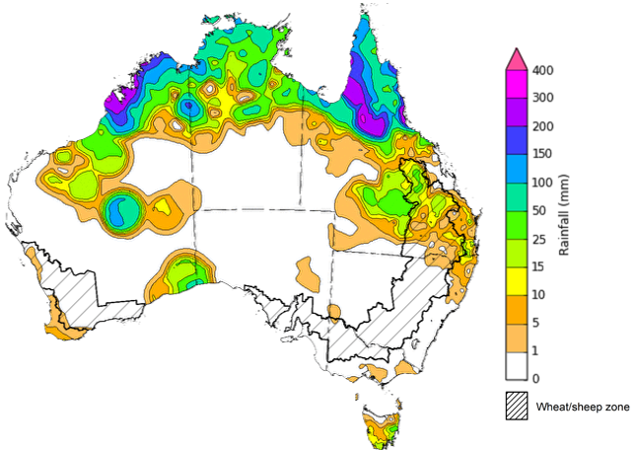
©Commonwealth of Australia 2026, Australian Bureau of Meteorology Issued: 28/1/2026
Note: The rainfall analyses and associated maps utilise data contained in the Bureau of Meteorology climate database, the Australian Data Archive for Meteorology (ADAM). The analyses are initially produced automatically from real-time data with limited quality control. They are intended to provide a general overview of rainfall across Australia as quickly as possible after the observations are received. For further information go to http://www.bom.gov.au/climate/rainfall/

Rainfall forecast for the next eight days
Over the 8 days to 5 February 2026, low pressure systems are expected to bring considerable rainfall to much of the north and east of Australia, while central and south-western regions of the country are forecast to remain largely dry.
- Forecast falls of between 25-150 millimetres are expected across major flood warning areas of northern Queensland. If realised these falls are likely to continue to slow recovery efforts and may lead to increased livestock losses due to a lack of feed and exposure to disease and illness.
- Outside of flood affected regions these substantial falls across northern Australia are likely to support soil moisture levels, replenish water supplies and sustain high pasture availability and growth.
Limited rainfall is expected across southern cropping regions this week, with substantial rainfall expected in the east.
- Falls of between 10-25 millimetres are forecast for cropping regions Queensland and eastern Victoria, while New South Wales regions are expected to see falls of 10-50 millimetres.
  - These expected heavier falls across Queensland and New South Wales are likely to support soil moisture in summer cropping regions and improve pasture growth.
- Remaining cropping regions are forecast to receive little to no rainfall.

Total forecast rainfall for the period 29 January to 5 February 2026
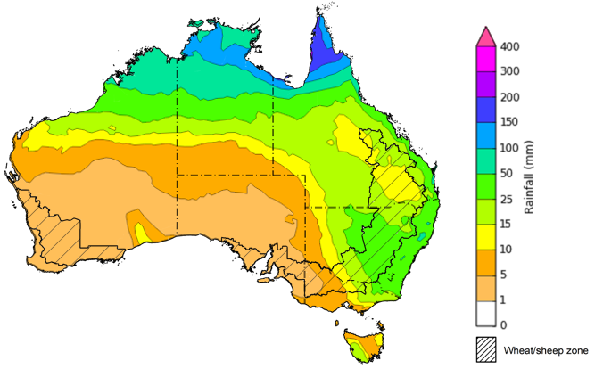
©Commonwealth of Australia 2026, Australian Bureau of Meteorology Issued 29/1/2026
Note: This rainfall forecast is produced from computer models. As the model outputs are not altered by weather forecasters, it is important to check local forecasts and warnings issued by the Bureau of Meteorology.

National Climate Outlook
The Bureau of Meteorology has indicated that a La Niña event is continuing in the Pacific Ocean. The Bureau's model currently predicts that tropical Pacific Ocean temperatures are likely to remain at La Niña levels before returning to neutral levels in late summer. This timing aligns with most international models assessed. The Southern Annular Mode (SAM) event is currently neutral and is forecast to remain neutral over the coming weeks. Similar, the Indian Ocean Dipole (IOD) event is currently neutral, and is likely to remain neutral over the coming week
The most recent rainfall outlook for February 2026 provided by the Bureau of Meteorology indicates highly variable rainfall tendencies across much of Australia. Below median rainfall is expected across large areas of northern Australia, extending through parts of central into south-eastern Australia, with parts of southern Queensland, northern New Soth Wales and much of Western Australia more likely to see above median falls.
- The Bureau of Meteorology’s climate model indicates a 75% chance of February rainfall totals between 10-200 millimetres across much of eastern and northern Australia, with higher rainfall totals of up to 300 millimetres expected in the Northern Tropics. Much of South Australia, and western areas of New South Wales, Victoria and Queensland are likely to see little to no rainfall which is typical for this time of year.
- Across cropping regions, there is a 75% chance of receiving rainfall totals of between 25- 50 millimetres across much of Queensland and north-eastern New South Wales. Meanwhile remaining areas in southern New South Wales, eastern Victoria and Western Australia are likely to see 5- 25 millimetres.
  - If forecast rainfall totals are realised across much of New South Wales and Queensland, these falls are likely to be sufficient to support above average yield prospects for summer crops and average or better levels of pasture production.

Rainfall totals that have a 75% chance of occurring in February 2026
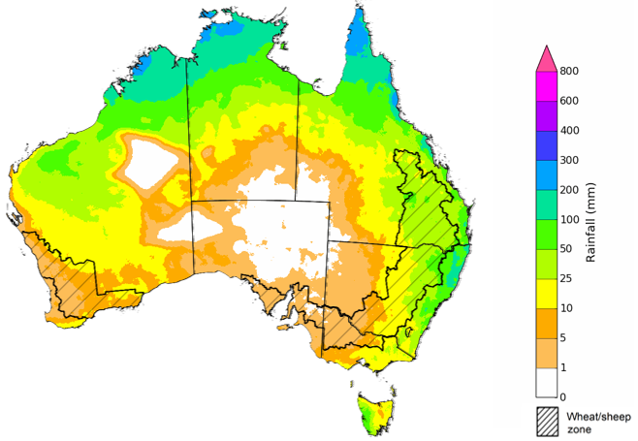
©Commonwealth of Australia 2025, Australian Bureau of Meteorology Issued: 29/1/2026
The rainfall outlook for February 2026 to April 2026 indicates no strong tendencies toward above or below median rainfall across much of Australia. There is an increased probability of below median rainfall across large areas of northern Australia, extending through parts of central into south-eastern Australia, including Tasmania, Victoria, eastern South Australia, western New South Wales, north-western Queensland, and much of the Northern Territory. Meanwhile, parts of south-eastern Queensland, eastern New South Wales and parts of Western Australia have a higher probability of above median rainfall.
Across cropping regions, the chance of receiving above median rainfall is 45-70% across New South Wales and Queensland, and 45-55% in Western Australia. In Victoria, the chance of receiving median rainfall is lower at 30- 40%, while South Australia has a 30-55% chance. Close to average or better forecast rainfall for parts eastern Australia is expected to support summer crop and pasture production. The increased chance of below average forecast rainfall in parts of northern Australia is likely to easy recent flooding and allow for a shift to recovery and rebuilding flowing heavily localised livestock and infrastructure losses and damage.
Chance of exceeding the median rainfall February 2026 to April 2026
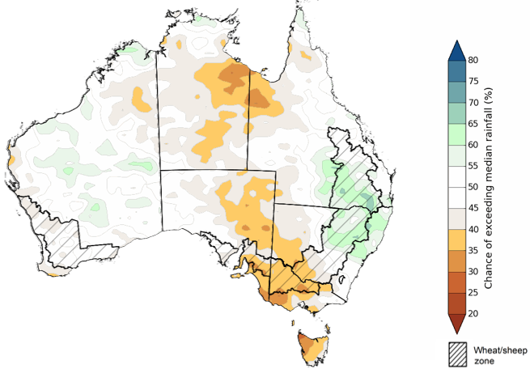
©Commonwealth of Australia 2025, Australian Bureau of Meteorology Issued: 29/1/2026
The rainfall outlook for February 2026 to April 2026 suggests a 75% chance of receiving rainfall totals of between 50-400 millimetres across much of eastern and northern Australia, as well as parts of central Western Australia. Higher falls of over 800 millimetres are expected across scattered east coast regions as well as large areas of the northern tropics. Lower rainfall totals are forecast for south-western and central regions, with South Australia, southern Western Australia, western New South Wales and Victoria, and south-western Queensland and southern Northern Territory likely to see 10- 100 millimetres.
In cropping regions, there is a 75% chance of receiving between 100-200 millimetres across much of Queensland and north-eastern New South Wales. The remaining cropping regions of New South Wales and Queensland as well as much of the cropping regions in Western Australia and southern Victoria are likely to see 25- 100 millimetres. South Australian and northern Victorian cropping regions are likely to see less than 25 millimetres over the next three months.
If these forecast February through April rainfall totals are realised, they are likely to be sufficient to support summer pasture growth across eastern and northern Australia. Additionally, these expected falls are likely to be sufficient to support above average yield expectations for summer crops.
Rainfall totals that have a 75% chance of occurring February 2026 to April 2026
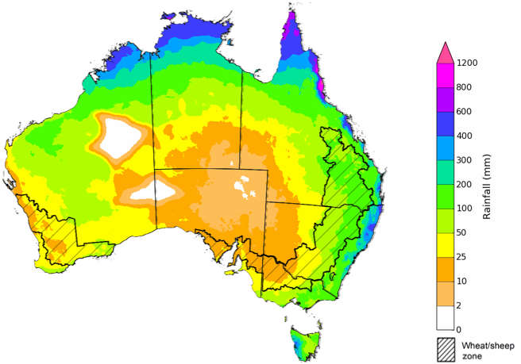
©Commonwealth of Australia 2025, Australian Bureau of Meteorology Issued: 29/1/2026

Water markets – current week
Water storage levels in the Murray-Darling Basin (MDB) remained unchanged between 22 January 2026 and 29 January 2026. The current volume of water held in storages is 12,695 GL, equivalent to 57% of total storage capacity. This is 9% or 2,005 GL less than the same time last year. Water storage data is sourced from the Bureau of Meteorology.

Water storages in the Murray-Darling Basin, 2013–2026
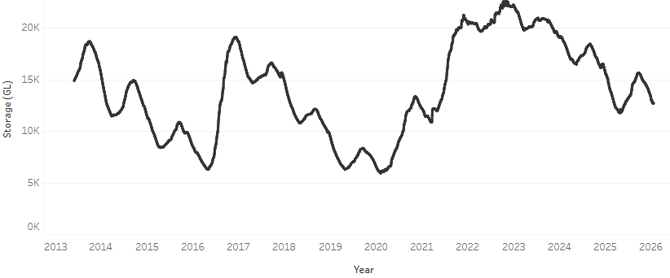
Allocation prices in the Victorian Murray below the Barmah Choke increased from $413/ML on 22 January 2026 to $440/ML on 29 January 2026. Trade from the Goulburn to the Murray is closed. Trade downstream through the Barmah Choke is closed. Trade from the Murrumbidgee to the Murray is open.

Water market prices, Southern Murray–Darling Basin

Region | $/ML
NSW Murray Above | 345
NSW Murrumbidgee | 430
Vic Greater Goulburn | 400
Vic Murray Below | 440

Note: The water allocation prices shown are volume weighted average prices based on the last 10 trades. Price data is sourced from Waterflow and current as at 22 January 2026.
To access the full, interactive, weekly water dashboard, which contains the latest and historical water storage, water market and water allocation information, please visit https://www.agriculture.gov.au/abares/products/weekly_update/weekly-update-260122

Commodities
Indicator | Week average | Unit | Latest Price | Previous Week | Weekly change |  | Price 12 months ago | Annual change
Selected world indicator prices
AUD/USD Exchange rate | 28-Jan | A$/US$ | 0.70 | 0.68 | 3% | 0.62 |  | 12%
Wheat – US no. 2 hard red winter wheat, FOB Gulf | 28-Jan | US$/t | 254 | 251 | 1% | 254 |  | 0%
Corn – US no. 2 yellow corn, FOB Gulf | 28-Jan | US$/t | 207 | 202 | 2% | 213 |  | -3%
Canola – Rapeseed, Canada, FOB Vancouver | 28-Jan | US$/t | 508 | 496 | 2% | 472 |  | 8%
Cotton – Cotlook A Index | 28-Jan | USc/lb | 73.8 | 74.6 | -1% | 78.3 |  | -6%
Sugar – Intercontinental Exchange, nearby futures, no.11 contract | 28-Jan | USc/lb | 14.8 | 14.8 | 0% | 18.9 |  | -21%
Wool – Eastern Market Indicator | 21-Jan | Ac/kg clean | 1,689 | 1,648 | 2% | 1,189 |  | 42%
Wool – Western Market Indicator | 21-Jan | Ac/kg clean | 1,878 | 1,846 | 2% | 1,336 |  | 41%
Selected Australian grain export prices
Australian Premium White (APW) Wheat, FOB Port Adelaide, SA | 28-Jan | A$/t | 348 | 350 | -1% | 404 |  | -14%
Australian Standard White (ASW) Wheat, FOB Port Adelaide, SA | 28-Jan | A$/t | 344 | 346 | -1% | 394 |  | -13%
Feed Barley – FOB Port Adelaide, SA | 28-Jan | A$/t | 335 | 336 | 0% | 368 |  | -9%
Canola – FOB Kwinana, WA | 28-Jan | A$/t | 783 | 766 | 2% | 856 |  | -9%
Grain Sorghum – FOB Brisbane, QLD | 28-Jan | A$/t | 425 | 433 | -2% | 405 |  | 5%
Selected domestic livestock indicator prices
Beef – Eastern Young Cattle Indicator | 28-Jan | Ac/kg cwt | 854 | 865 | -1% | 692 |  | 23%
Mutton – Mutton indicator (18–24 kg fat score 2–3), VIC | 28-Jan | Ac/kg cwt | 745 | 752 | -1% | 383 |  | 94%
Lamb – National Trade Lamb Indicator | 28-Jan | Ac/kg cwt | 1,094 | 1,068 | 2% | 799 |  | 37%
Pig – Eastern Seaboard (60.1–75 kg), NSW buyer price | 14-Jan | Ac/kg cwt | 468 | 468 | 0% | 453 |  | 3%
Live cattle – Light steers to Indonesia | 28-Jan | Ac/kg lwt | 480 | 470 | 2% | 353 |  | 36%
Global Dairy Trade (GDT) weighted average prices
Dairy – Whole milk powder | 21-Jan | US$/t | 3,449 | 3,407 | 1% | 3,896 |  | -11%
Dairy – Skim milk powder | 21-Jan | US$/t | 2,615 | 2,564 | 2% | 2,706 |  | -3%
Dairy – Cheddar cheese | 21-Jan | US$/t | 4,594 | 4,665 | -2% | 4,787 |  | -4%
Dairy – Anhydrous milk fat | 21-Jan | US$/t | 6,191 | 6,011 | 3% | 6,893 |  | -10%

Selected world indicator prices
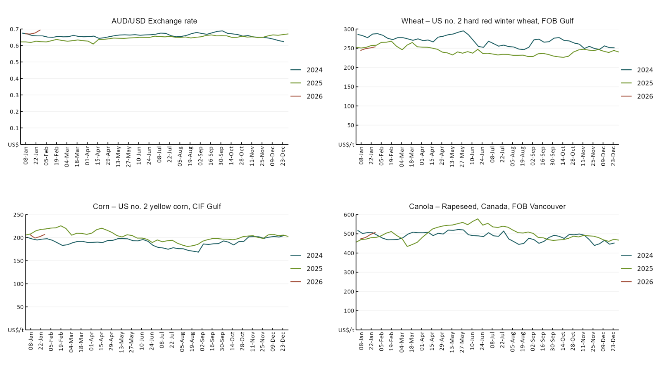

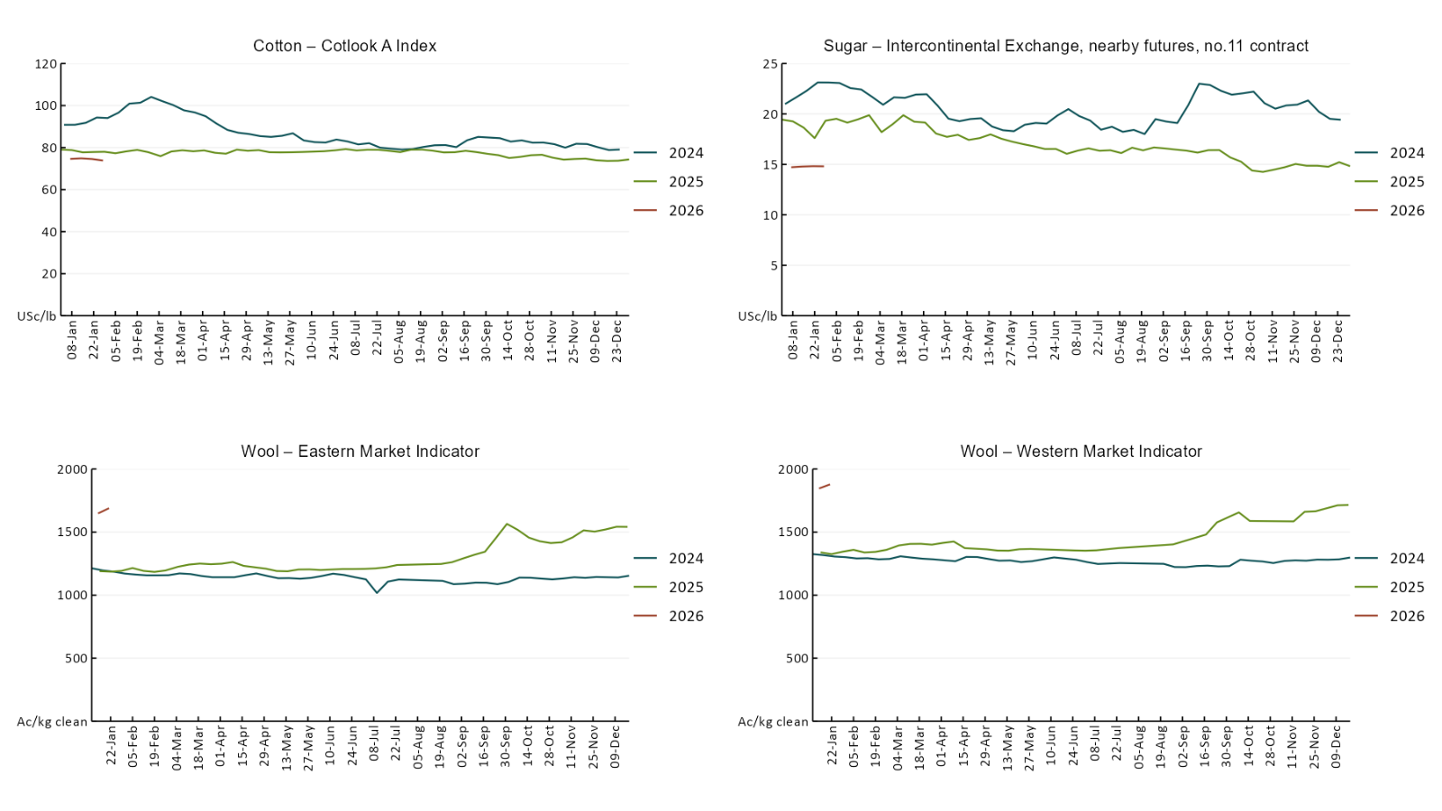

3.2 Selected domestic crop indicator prices
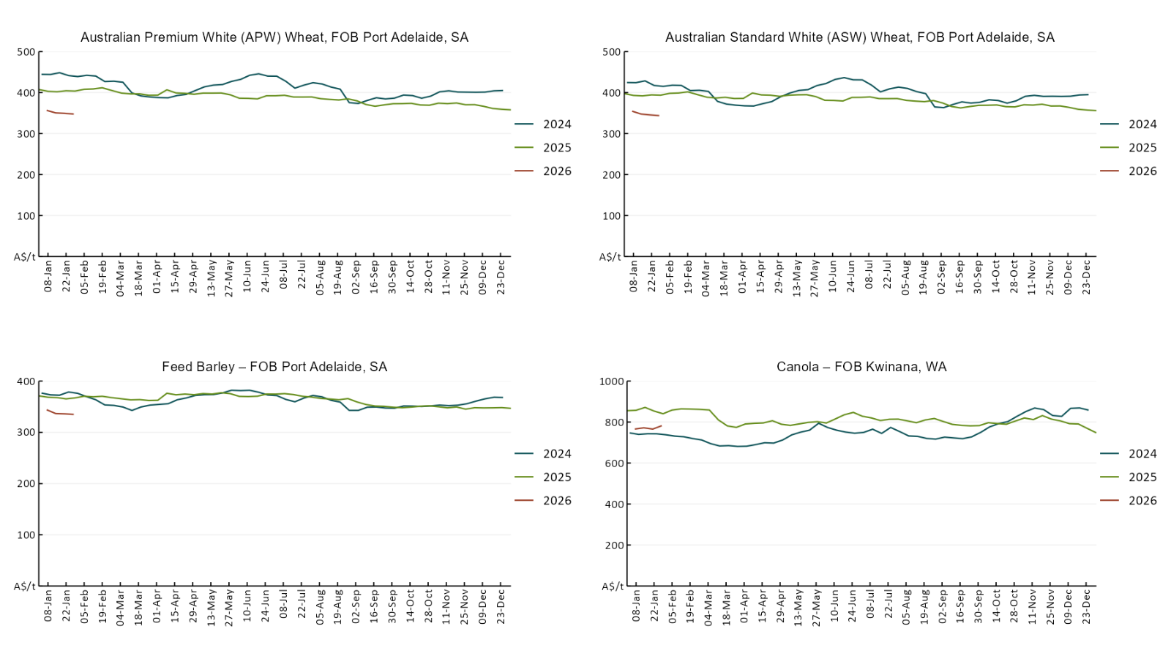

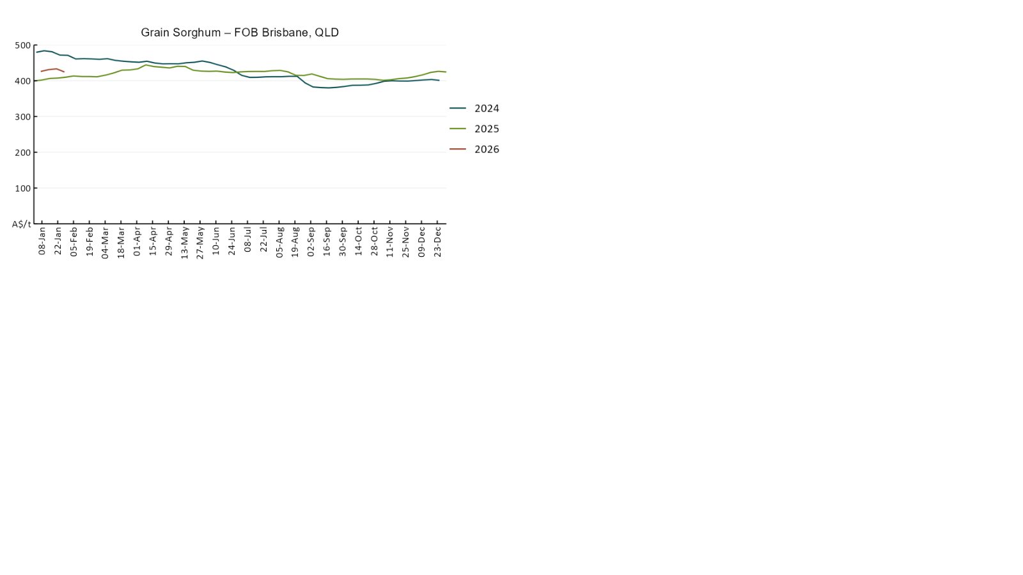

3.3 Selected domestic livestock indicator prices
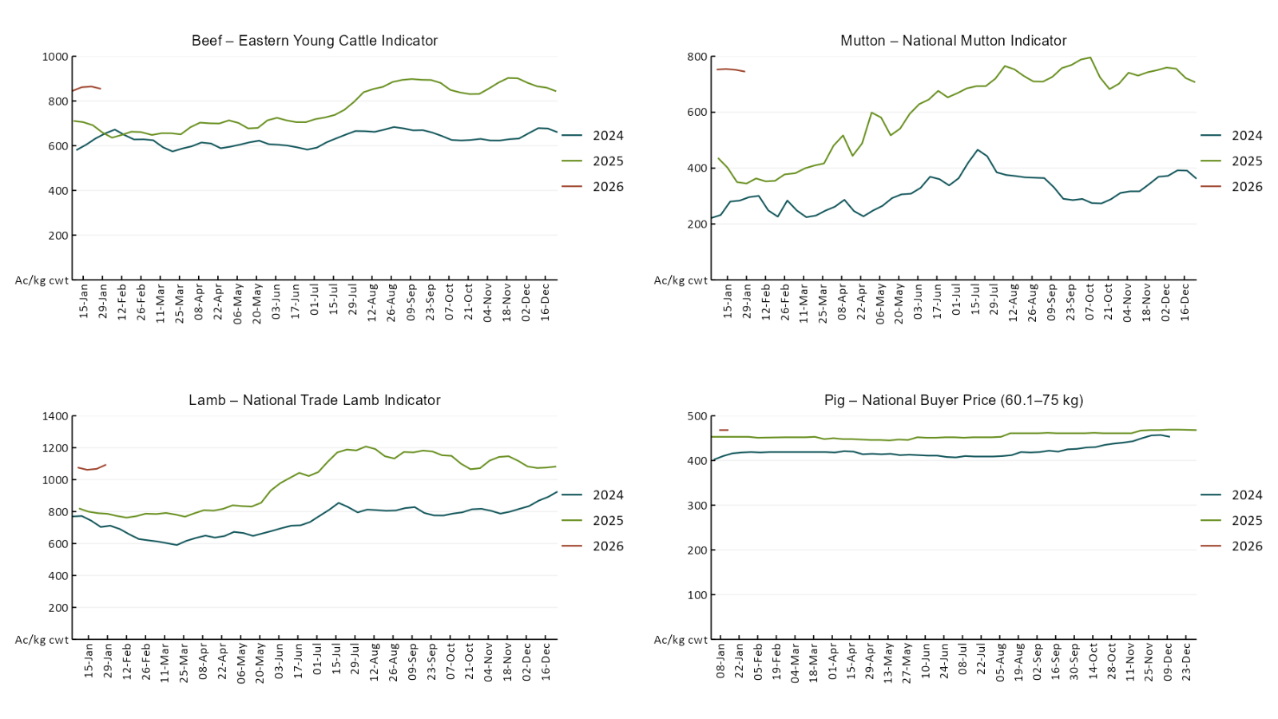
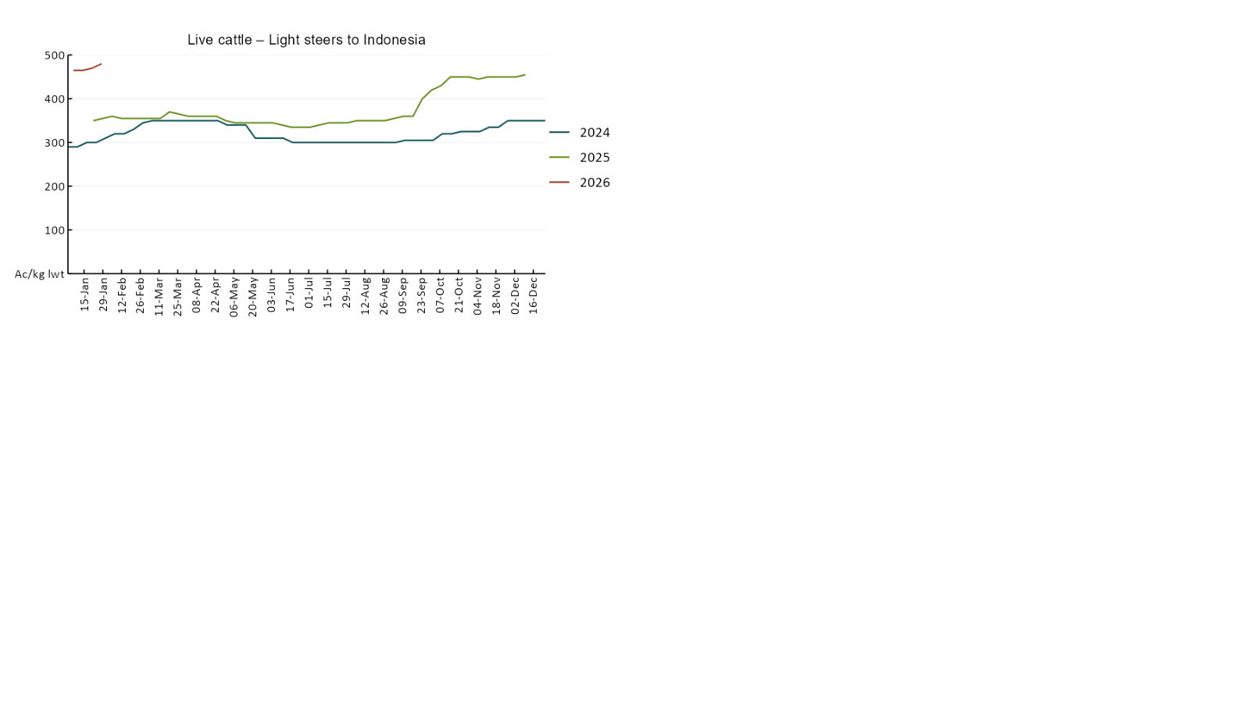

3.4 Global Dairy Trade (GDT) weighted average prices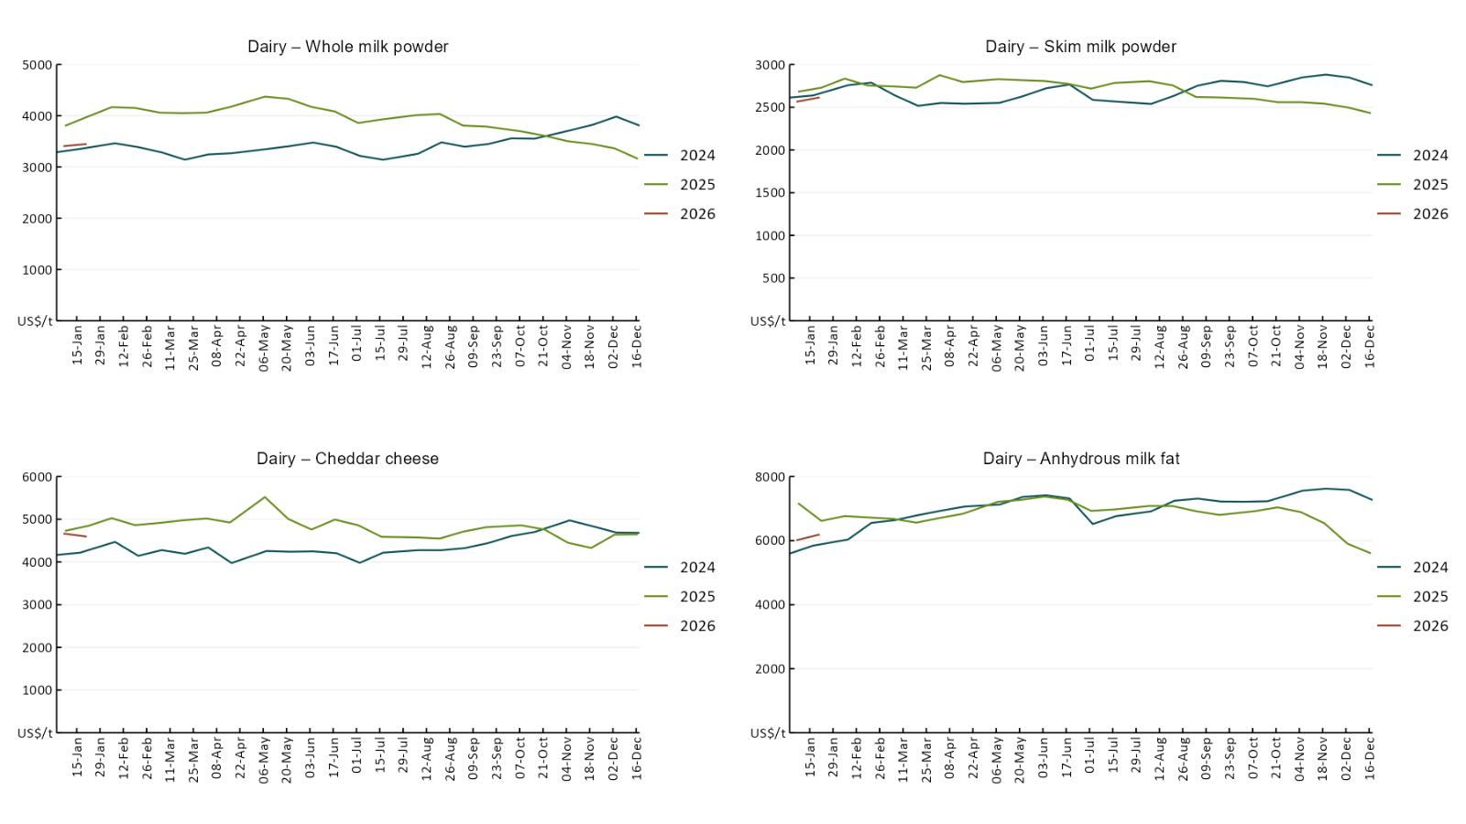

3.5 Selected fruit and vegetable prices
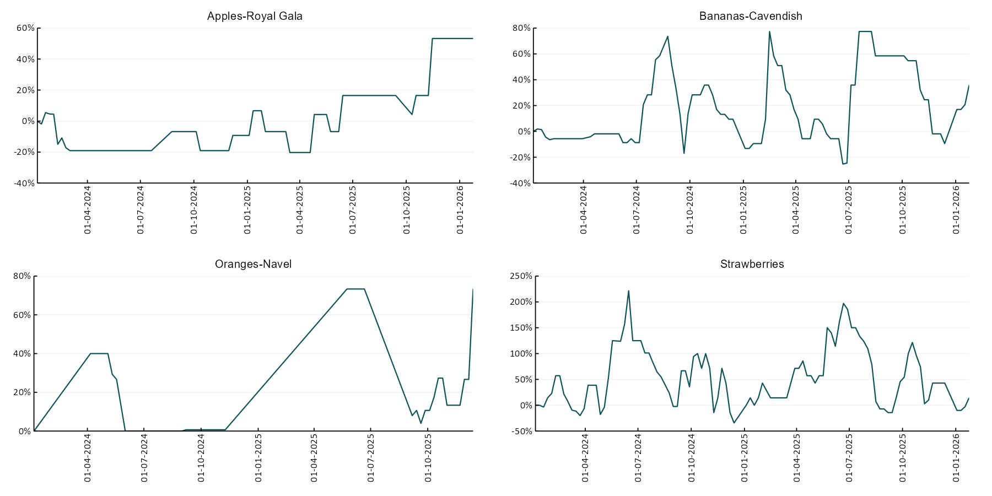
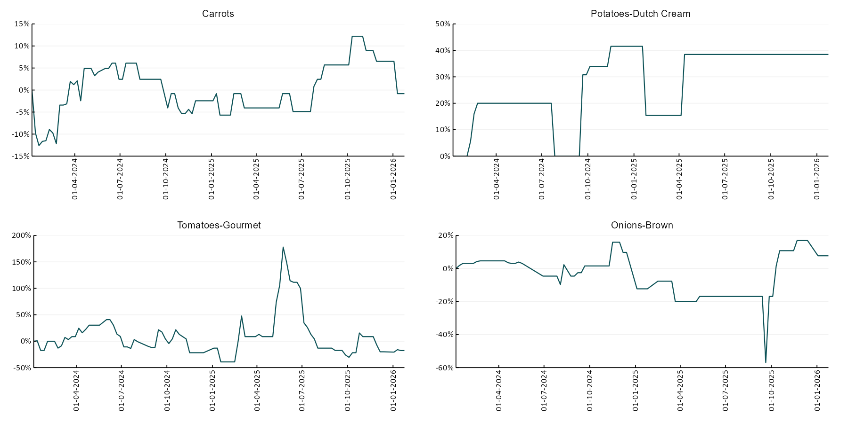

3.6 Selected domestic fodder indicator prices
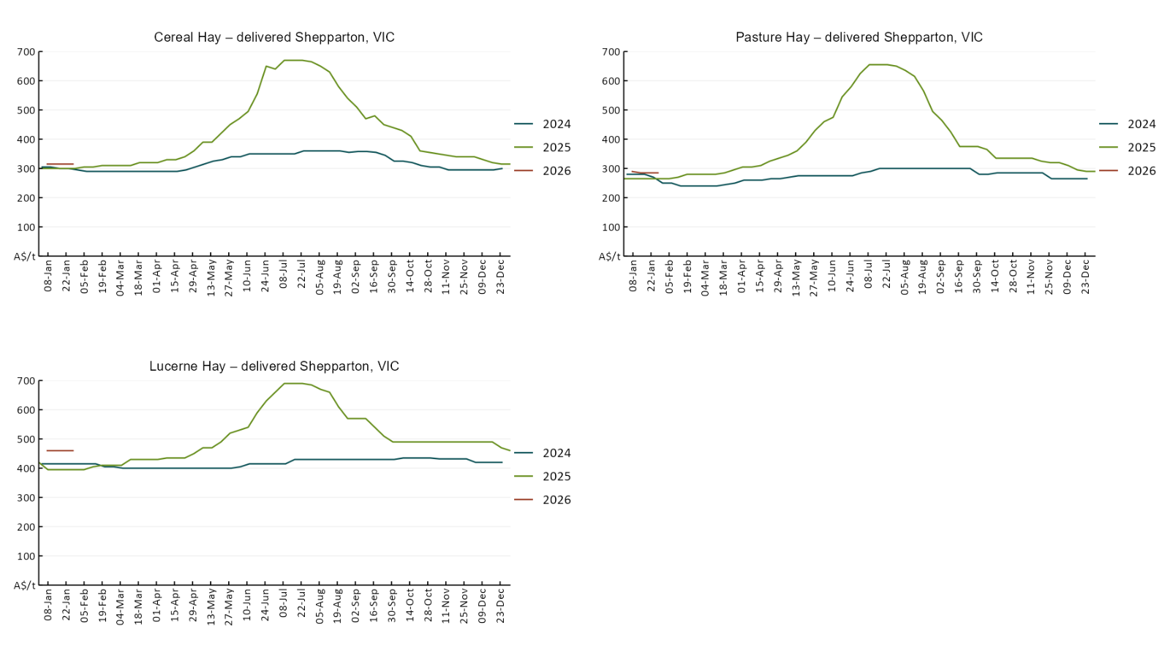

4. Data attribution

Climate
Bureau of Meteorology
- Weekly rainfall totals: www.bom.gov.au/climate/maps/rainfall/
- Monthly and last 3-month rainfall percentiles: https://www.bom.gov.au/climate/ahead/outlooks/#moreMaps
- Rainfall forecast: www.bom.gov.au/jsp/watl/rainfall/pme.jsp
- Seasonal outlook: www.bom.gov.au/climate/outlooks/#/overview/summary/
- Climate drivers: http://www.bom.gov.au/climate/enso/
- Soil moisture: https://awo.bom.gov.au/products/historical/soilMoisture-rootZone/

Other
- Pasture growth: www.longpaddock.qld.gov.au/aussiegrass/
- 3-month global outlooks: Environment and Climate Change Canada, NOAA Climate Prediction Center, EUROBRISA CPTEC/INPE, European Centre for Medium-Range Weather Forecasts, Hydrometcenter of Russia, National Climate Center Climate System Diagnosis and Prediction Room (NCC), International Research Institute for Climate and Society
- Global production: https://ipad.fas.usda.gov/ogamaps/cropmapsandcalendars.aspx
- Autumn break: Pook et al., 2009, https://rmets-onlinelibrary-wiley-com.virtual.anu.edu.au/doi/epdf/10.1002/joc.1833

Water
Prices
- Waterflow: https://www.waterflow.io/
- Ruralco: https://www.ruralcowater.com.au/
- Bureau of Meteorology:
- Allocation trade: http://www.bom.gov.au/water/dashboards/#/water-markets/mdb/at
- Storage volumes: http://www.bom.gov.au/water/dashboards/#/water-storages/summary/drainage

Trade constraints:
- Water NSW: https://www.waternsw.com.au/customer-service/ordering-trading-and-pricing/trading/murrumbidgee
- Victorian Water Register: https://www.waterregister.vic.gov.au/TradingRules2019/

Commodities
Fruit and vegetables
- Datafresh: www.freshstate.com.au

Pigs
- Australian Pork Limited: www.australianpork.com.au

Dairy
- Global Dairy Trade: www.globaldairytrade.info/en/product-results/

World wheat, canola
- International Grains Council
- https://www.igc.int/en/default.aspx
- United States Department of Agriculture

World cotton
- Cotlook: www.cotlook.com/

World sugar
- New York Stock Exchange - Intercontinental Exchange

Wool
- Australian Wool Exchange: www.awex.com.au/

Domestic wheat, barley, sorghum, canola and fodder
- Jumbuk Consulting Pty Ltd: Jumbuk AG | Agriculture Consulting

Cattle, beef, mutton, lamb, goat and live export
- Meat and Livestock Australia: https://www.mla.com.au/prices-markets/

Australian Agricultural Drought Indicators
About Australian Agricultural Drought Indicators
The Australian Agricultural Drought Indicators (AADI) links weather and agricultural data with a range of scientific and economic models to measure and forecast the effects of climate variability and drought on agricultural outcomes.
On AADI, projected broadacre farm profits are presented as percentile outcomes relative to simulated historical outcomes using the groupings:
Highest | 95-100th percentile
Very much above average | 85-95th percentile
Above average | 65-85th percentile
Average | 35-65th percentile
Below average | 15-35th percentile
Very much below average | 5-15th percentile
Lowest 5% | 0-5th percentile

There are two AADI farm profit indicators:
- The AADI farm profit climate and price indicator shows the effect of climate and prices on broadacre farm business profits of current farms compared to the last 33 years.
- The AADI farm profit climate only indicator isolates the effect of climate on profits by holding prices fixed.

© Commonwealth of Australia 2026

Ownership of intellectual property rights
Unless otherwise noted, copyright (and any other intellectual property rights, if any) in this publication is owned by the Commonwealth of Australia (referred to as the Commonwealth).

Creative Commons licence
All material in this publication is licensed under a Creative Commons Attribution 4.0 International Licence except content supplied by third parties, logos and the Commonwealth Coat of Arms.
Inquiries about the licence and any use of this document should be emailed to copyright@awe.gov.au.


Cataloguing data
This publication (and any material sourced from it) should be attributed as:
ABARES 2026, Weekly Australian Climate, Water and Agricultural Update, Australian Bureau of Agricultural and Resource Economics and Sciences, Canberra, 29 January 2026. CC BY 4.0 DOI: https://doi.org/10.25814/5f3e04e7d2503
ISSN 2652-7561
This publication is available at https://www.agriculture.gov.au/abares/products/weekly_update
Department of Agriculture, Fisheries and Forestry
GPO Box 858 Canberra ACT 2601
Telephone 1800 900 090
Web agriculture.gov.au/abares

Disclaimer
The Australian Government acting through the Department of Agriculture, Fisheries and Forestry, represented by the Australian Bureau of Agricultural and Resource Economics and Sciences, has exercised due care and skill in preparing and compiling the information and data in this publication. Notwithstanding, the Department of Agriculture, Fisheries and Forestry, ABARES, its employees and advisers disclaim all liability, including liability for negligence and for any loss, damage, injury, expense or cost incurred by any person as a result of accessing, using or relying on any of the information or data in this publication to the maximum extent permitted by law.

Statement of Professional Independence
The views and analysis presented in ABARES publications, including this one, reflect ABARES professionally independent findings, based on scientific and economic concepts, principles, information and data. These views, analysis and findings may not reflect or be consistent with the views or positions of the Australian Government, or of organisations or groups who have commissioned ABARES reports or analysis. More information on professional independence is provided on the ABARES website.

Acknowledgements
This report was prepared by Matthew Miller.

