
No. 4/2026 5 February 2026

Summary of key issues
- In the week ending 4 February 2026, rainfall was recorded across northern regions of Australia, while central and most southern areas remained comparably dry.
  - Active wet season troughs and a tropical low, brought widespread falls of between 25 and 150 millimetres to the tropical north of Australia, while falls in excess of 150 millimetres were recorded across the north of the Northern Territory.
    - Continued rainfall across northern Queensland may have exacerbated flooding impacts and disrupted recovery efforts. Meanwhile rainfall across Queensland cropping regions is expected to support soil moisture storage and benefit crop and pasture production.
    - Widespread heavy rainfall across the north of the Northern Territory has led to issuing of flood warning across numerous river catchments. These falls are likely to provide significant longer-term benefits to pasture production.
- Over the 8-days to 12 February 2026, rainfall is forecast for the north, centre and east.
  - If realised continued heavy forecast rainfall across flood warning areas of northern Australia may exacerbate flooding and continue to slow recovery efforts. Outside of flood affected regions these substantial forecast falls are likely to support soil moisture levels, replenish water supplies and boost pasture availability and benefit the growth of summer crops.
- Rainfall was highly variable across Australia during January 2026, with well below average rainfall across much of central and south-eastern Australia. In contrast, parts of the north, west and far southeast saw well above average rainfall.
- Pasture growth for the three months to January 2026 has been mixed across Australia. Above average rainfall totals resulted in average to extremely high pasture growth across large parts of northern Australia. Below average to extremely low pasture growth was recorded across parts of eastern and central Australia.
- Soil moisture models indicate low soil moisture levels in much of central and southern Australia, with above average soil moisture modelled in northern Queensland, the north of the Northern Territory, and parts of eastern Western Australia.
- Water storage levels in the Murray-Darling Basin (MDB) decreased by 308 gigalitres (GL) between 29 January 2026 and 5 February 2026. The current volume of water held in storages is 11,454 GL, equivalent to 52% of total storage capacity. This is 19% or 2,708 GL less than the same time last year. Water storage data is sourced from the Bureau of Meteorology.
- Allocation prices in the Victorian Murray below the Barmah Choke decreased from $440/ML on 29 January 2026 to $426/ML on 5 February 2026. Trade from the Goulburn to the Murray is closed. Trade downstream through the Barmah Choke is closed. Trade from the Murrumbidgee to the Murray is open.

Climate

Rainfall this week
In the week ending 4 February 2026, active wet season troughs and a tropical low brought heavy rainfall to large areas of northern Australia. Large areas of central, western, and southern areas remained largely dry.
- Throughout the week, troughs and a tropical low have enhanced rainfall across the tropical north and generating thunderstorms. Continued rainfall across northern Queensland may have exacerbated flooding impacts and disrupted recovery efforts.
- Across the north of the Northern Territory widespread weekly rainfall totals in excess of 200 millimetres has led to issuing of flood warning across numerous river catchments. At this early stage there have been no reports of agricultural losses, with these falls likely to provide significant longer-term benefits to pasture production.
Across cropping regions, rainfall was generally low, with exceptions in the northeast:
- Northern Queensland cropping regions saw falls of up to 50 millimetres, while eastern Queensland regions saw lighter falls of between 1-25 millimetres.
  - These falls are expected to support soil moisture storage and benefit crop and pasture production across the broader region.
- Little to no rainfall was recorded across New South Wales, Victorian, South Australian and Western Australian cropping regions.

Rainfall for the week ending 4 February 2026
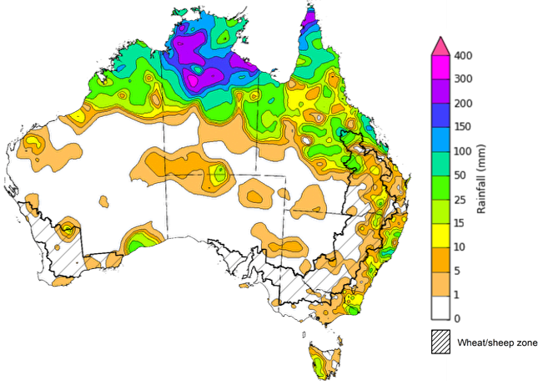
©Commonwealth of Australia 2026, Australian Bureau of Meteorology Issued: 4/2/2026
Note: The rainfall analyses and associated maps utilise data contained in the Bureau of Meteorology climate database, the Australian Data Archive for Meteorology (ADAM). The analyses are initially produced automatically from real-time data with limited quality control. They are intended to provide a general overview of rainfall across Australia as quickly as possible after the observations are received. For further information go to http://www.bom.gov.au/climate/rainfall/

Rainfall forecast for the next eight days
Over the 8 days to 12 February 2026, low pressure systems are expected to bring considerable rainfall to much of the north, centre and east of Australia, while south-western regions of the country are forecast to remain largely dry.
- Forecast falls of between 25-150 millimetres are expected across flood warning areas of northern Australia. If realised these falls are likely to continue to slow recovery efforts.
- Outside of flood affected regions, if realised these substantial falls across northern, central and eastern Australia are likely to support soil moisture levels, replenish water supplies and boost pasture availability and benefit the growth of summer crops.
Limited rainfall is expected across southern cropping regions this week, with substantial rainfall expected in the east.
- Falls of between 15-50 millimetres are forecast for cropping regions Queensland, New South Wales and eastern Victoria.
  - These expected heavier falls across Queensland and New South Wales are likely to support soil moisture in summer cropping regions and improve pasture growth.
- Remaining cropping regions are forecast to receive little to no rainfall.

Total forecast rainfall for the period 5 February to 12 February 2026
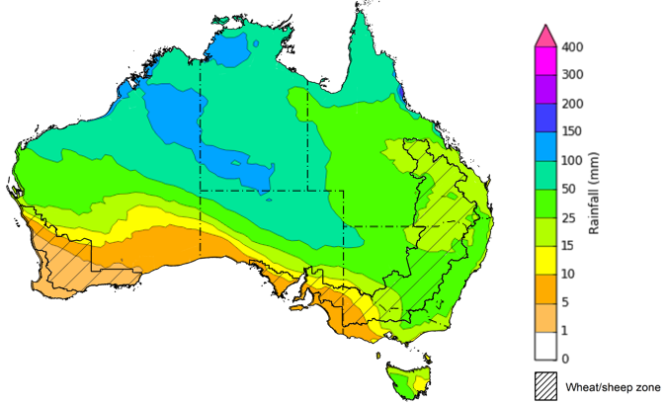
©Commonwealth of Australia 2026, Australian Bureau of Meteorology Issued 5/2/2026
Note: This rainfall forecast is produced from computer models. As the model outputs are not altered by weather forecasters, it is important to check local forecasts and warnings issued by the Bureau of Meteorology.

Monthly rainfall
Rainfall during January 2026 was highly variable across Australia:
- Rainfall was average to extremely high in the north and parts of the west, including much of northern Queensland and the Northern Territory, as well as much of eastern Western Australia. Coastal areas of south-eastern New South Wales also saw above average rainfall.
  - Tropical cyclone Koji crossed the north Queensland coast on 11 January as a Category 1 system before rapidly weakening. The system brought widespread rainfall and thunderstorms across much of eastern Queensland, causing minor to major flooding to already saturated coastal areas, and led to damage to farm infrastructure and resulted in some crop and livestock losses.
  - This rain is likely to have mixed impact on production, with some farmers reporting beneficial rainfall for certain grain and dryland crops following Koji’s rain — particularly in the central Queensland cropping region, where extended dry conditions preceded the event.
- Average to severely deficient rainfall was recorded in large areas of the south, including western Western Australia, parts of southern Queensland and the Northern Territory, as well as much of New South Wales, South Australia, Victoria and Tasmania.
In cropping regions, January rainfall was generally average to extremely low:
- January rainfall was below average to extremely low in much of New South Wales, Victoria South Australia, Western Australia, and southern parts of Queensland.
  - The below average conditions observed across many areas has allowed for a largely uninterrupted finish to the winter crop harvest.
  - Above average rainfall was observed in isolated areas of northern Queensland, benefiting summer crops and pastures.
Rainfall percentiles for January 2026
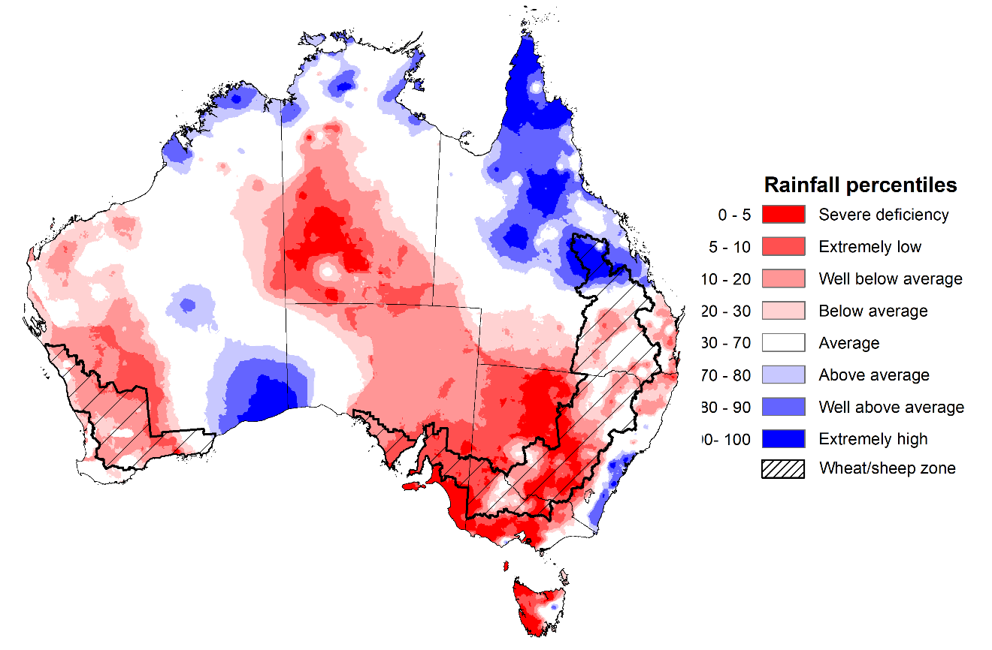
Note: Rainfall for January 2026 is compared with rainfall recorded for that period during the historical record (1900 to present). For further information, go to http://www.bom.gov.au/climate/austmaps/about-rain-maps.shtml
Source: Bureau of Meteorology

Monthly Soil Moisture
In January 2026, modelled upper layer soil moisture was generally average to above average in the north and parts of the west of the country, with large areas of extremely low soil moisture in south-western, central and south-eastern regions.
- Large areas of southern Western Australia and South Australia, central Australia, eastern and coastal regions of southern Queensland, central and western New South Wales, much of Victoria and western Tasmania saw very much below average to below average upper layer soil moisture.
- In contrast, much of northern and western Australia, including the northern tropics, central Queensland and eastern Western Australia saw average to very much above upper layer soil moisture.
At this time of year, upper layer soil moisture is important for late planted summer crops in northern New South Wales and Queensland and for pasture growth across northern Australia since plant germination and establishment utilise this moisture. It is also an important indicator of the ability to access paddocks for summer crop planting activities.
Across most cropping regions, modelled upper layer soil moisture in January was generally below average to extremely low, with exceptions in Queensland which is modelled as having generally average to very much above average upper layer soil moisture, benefiting summer crops and pastures.
Modelled upper layer soil moisture for January 2026
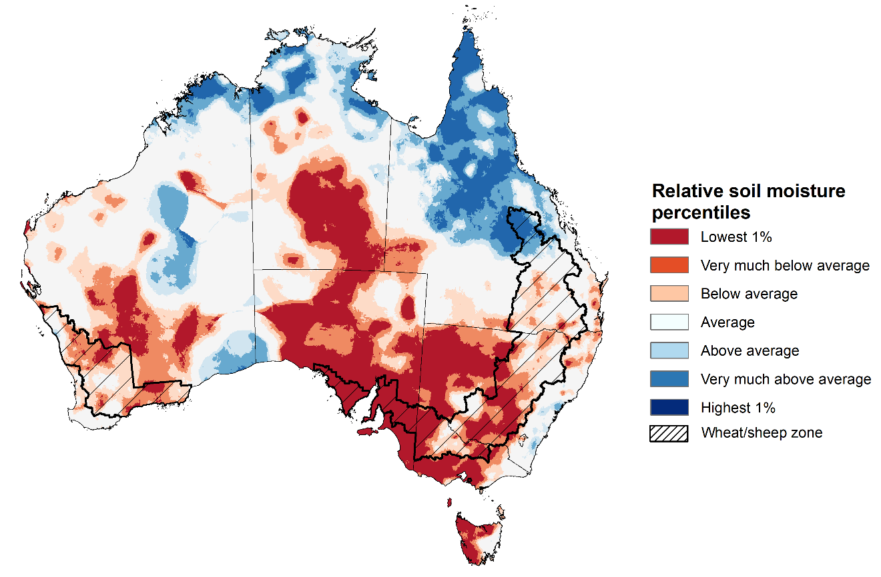
Note: This map shows the levels of modelled upper layer soil moisture (0 to 10 centimetres) during January 2025. This map shows how modelled soil conditions during December 2025 compare with January conditions modelled over the reference period (1911 to 2016). Dark blue areas on the maps were much wetter in December 2025 than during the reference period. The bulk of plant roots occur in the top 20 centimetres of the soil profile. Soil moisture in the upper layer of the soil profile is therefore useful indicator of the availability of water, particularly for germinating seed.
Source: Bureau of Meteorology (https://awo.bom.gov.au/about/overview)
Modelled lower layer soil moisture in January 2026 was average to very much above average across much of northern Australia and scattered parts of southern Australia, while extremely low to below average modelled lower layer soil moisture was evident across some western, central and eastern areas. This represents a considerable decline from December 2025, where much of Australia was modelled as having average to above average soil moisture.
- Much of the south of the Northern Territory, South Australia, southern Queensland and New South Wales, northern Victoria and western Western Australia were modelled as having very much below average to average soil moisture. By contrast, much of northern Queensland, the north of Western Australia and the Northern Territory recorded above average to very much above average soil moisture over the period.
At this time of year increased levels of lower layer soil moisture will be important to support summer crops and pasture growth during a peak growth period.
Across cropping regions, modelled lower layer soil moisture was generally below average to average with areas of extremely low soil moisture modelled in the south.
- Most northern cropping regions in Queensland were modelled as having average to very much above average soil moisture. In contrast, remaining cropping regions were modelled as having extremely low to average soil moisture for this time of year.
In areas with average to above average lower layer soil moisture, this is likely to provide a reserve of plant-available water for summer crops later in the growing season. Agricultural regions across southern Australia with extremely low levels of stored soil moisture will require sufficient and timely rainfall over the remainder of summer to arrest declining levels of pasture availability and provide a boost to soil moisture reserves ahead of planting of the 2026–27 winter crop.
Modelled lower layer soil moisture for January 2026
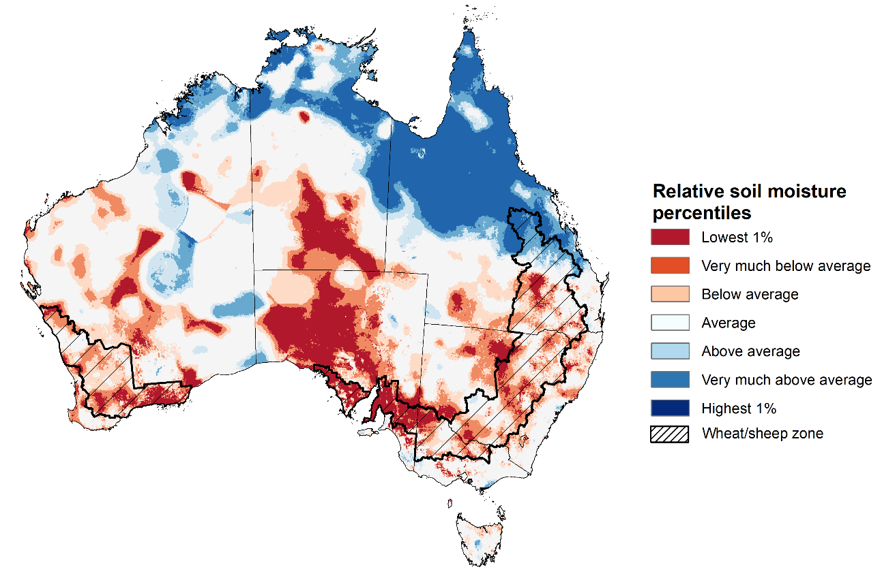
Note: This map shows the levels of modelled lower layer soil moisture (10 to 100 centimetres) during January 2026. This map shows how modelled soil conditions during January 2026compare with January conditions modelled over the reference period (1911 to 2016). Dark blue areas on the maps were much wetter in January 2026 than during the reference period. The dark red areas were much drier than during the reference period. The bulk of plant roots occur in the top 20 centimetres of the soil profile. The lower layer soil moisture is a larger, deeper store that is slower to respond to rainfall and tends to reflect accumulated rainfall events over longer time periods.
Source: Bureau of Meteorology (https://awo.bom.gov.au/about/overview)

Pasture Growth
Pasture growth during the November to January period is the peak pasture growth period for northern Australia which typically provides a bulk of feed to maintain production through the low pasture growth months of the northern dry season. Across southern Australia, November to January pasture growth is typically low reflecting lower rainfall totals, high temperature and high evapotranspiration rates at this time of year. Pasture availability during this period influences the growth and branding and marking rates of lambs and calves, livestock turnoff and the production of meat, milk, and wool.
Pasture growth for the three months to January 2026 was variable across much of country, with much of northern Australia seeing robust pasture growth but below average growth was evident across large areas of eastern and central Australia.
- Average to extremely high relative pasture growth was modelled across large areas of northern Australia and parts of south-eastern Australia, including parts of the northern tropics, southern Victoria and western Tasmania.
  - This pasture growth is expected to have allowed some farmers to rebuild livestock numbers, provide opportunities to build standing dry matter availability and replenish fodder supplies during late spring and early summer period.
- In contrast, large areas of the eastern Australia, including parts of southern Queensland, large areas of New South Wales and South Australia, and the southwest of the Northern Territory saw relatively low pasture growth for this time of year.
  - This below average pasture growth has likely led to a decline in pasture availability and graziers in regions where below average pasture growth was recorded will be more reliant on supplemental feed to maintain current stocking rates and production.
Relative pasture growth for 3-months ending January 2026 (1 November to 31 January 2026)
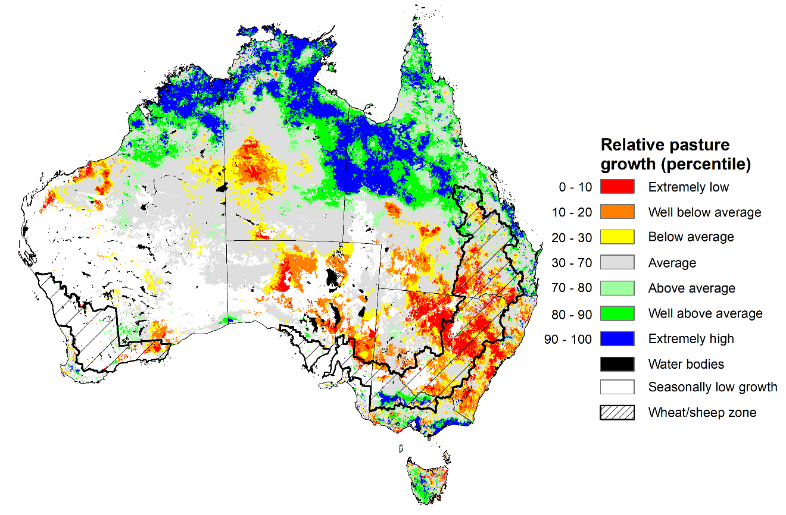
Notes: AussieGRASS pasture growth estimates are relative to the long-term record and shown in percentiles. Percentiles rank data on a scale of zero to 100. This analysis ranks pasture growth for the selected period against average pasture growth for the long-term record (1957 to 2016). Pasture growth is modelled at 5km2 grid cells.
Source: Department of Environment, Science and Innovation

Water markets – current week
Water storage levels in the Murray-Darling Basin (MDB) decreased by 308 gigalitres (GL) between 29 January 2026 and 5 February 2026. The current volume of water held in storages is 11,454 GL, equivalent to 52% of total storage capacity. This is 19% or 2,708 GL less than the same time last year. Water storage data is sourced from the Bureau of Meteorology.

Water storages in the Murray-Darling Basin, 2013–2026
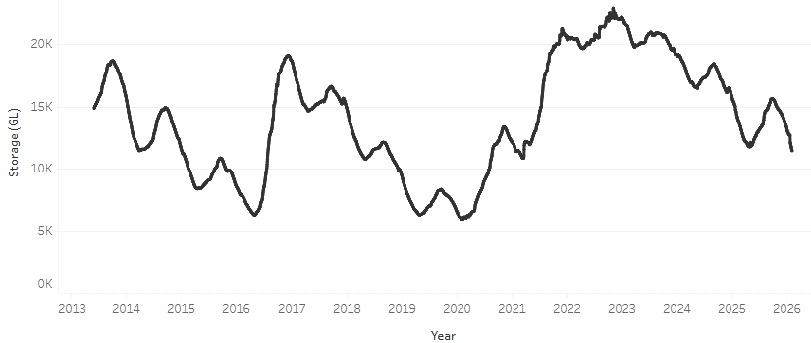
Allocation prices in the Victorian Murray below the Barmah Choke decreased from $440/ML on 29 January 2026 to $426/ML on 5 February 2026. Trade from the Goulburn to the Murray is closed. Trade downstream through the Barmah Choke is closed. Trade from the Murrumbidgee to the Murray is open.

Water market prices, Southern Murray–Darling Basin

Region | $/ML
NSW Murray Above | 343
NSW Murrumbidgee | 430
Vic Greater Goulburn | 397
Vic Murray Below | 426

Note: The water allocation prices shown are volume weighted average prices based on the last 10 trades. Price data is sourced from Waterflow and current as at 22 January 2026.
To access the full, interactive, weekly water dashboard, which contains the latest and historical water storage, water market and water allocation information, please visit https://www.agriculture.gov.au/abares/products/weekly_update/weekly-update-260205

Commodities
Indicator | Week average | Unit | Latest Price | Previous Week | Weekly change |  | Price 12 months ago | Annual change
Selected world indicator prices
AUD/USD Exchange rate | 4-Feb | A$/US$ | 0.70 | 0.70 | 0% | 0.63 |  | 11%
Wheat – US no. 2 hard red winter wheat, FOB Gulf | 4-Feb | US$/t | 257 | 258 | 0% | 264 |  | -2%
Corn – US no. 2 yellow corn, FOB Gulf | 4-Feb | US$/t | 211 | 208 | 1% | 222 |  | -5%
Canola – Rapeseed, Canada, FOB Vancouver | 4-Feb | US$/t | 507 | 511 | -1% | 499 |  | 2%
Cotton – Cotlook A Index | 4-Feb | USc/lb | 73.4 | 73.9 | -1% | 78.1 |  | -6%
Sugar – Intercontinental Exchange, nearby futures, no.11 contract | 4-Feb | USc/lb | 14.0 | 14.5 | -4% | 19.5 |  | -28%
Wool – Eastern Market Indicator | 4-Feb | Ac/kg clean | 1,677 | 1,665 | 1% | 1,197 |  | 40%
Wool – Western Market Indicator | 4-Feb | Ac/kg clean | 1,878 | 1,859 | 1% | 1,350 |  | 39%
Selected Australian grain export prices
Australian Premium White (APW) Wheat, FOB Port Adelaide, SA | 4-Feb | A$/t | 346 | 346 | 0% | 409 |  | -15%
Australian Standard White (ASW) Wheat, FOB Port Adelaide, SA | 4-Feb | A$/t | 342 | 342 | 0% | 399 |  | -14%
Feed Barley – FOB Port Adelaide, SA | 4-Feb | A$/t | 334 | 334 | 0% | 370 |  | -10%
Canola – FOB Kwinana, WA | 4-Feb | A$/t | 776 | 781 | -1% | 862 |  | -10%
Grain Sorghum – FOB Brisbane, QLD | 4-Feb | A$/t | 427 | 422 | 1% | 412 |  | 4%
Selected domestic livestock indicator prices
Beef – Eastern Young Cattle Indicator | 4-Feb | Ac/kg cwt | 842 | 850 | -1% | 652 |  | 29%
Mutton – Mutton indicator (18–24 kg fat score 2–3), VIC | 4-Feb | Ac/kg cwt | 760 | 752 | 1% | 362 |  | 110%
Lamb – National Trade Lamb Indicator | 4-Feb | Ac/kg cwt | 1,130 | 1,106 | 2% | 773 |  | 46%
Pig – Eastern Seaboard (60.1–75 kg), NSW buyer price | 21-Jan | Ac/kg cwt | 468 | 468 | 0% | 452 |  | 4%
Live cattle – Light steers to Indonesia | 4-Feb | Ac/kg lwt | 480 | 480 | 0% | 356 |  | 35%
Global Dairy Trade (GDT) weighted average prices
Dairy – Whole milk powder | 4-Feb | US$/t | 3,614 | 3,449 | 5% | 4,161 |  | -13%
Dairy – Skim milk powder | 4-Feb | US$/t | 2,874 | 2,615 | 10% | 2,795 |  | 3%
Dairy – Cheddar cheese | 4-Feb | US$/t | 4,772 | 4,594 | 4% | 4,944 |  | -3%
Dairy – Anhydrous milk fat | 4-Feb | US$/t | 6,524 | 6,191 | 5% | 6,745 |  | -3%

Selected world indicator prices
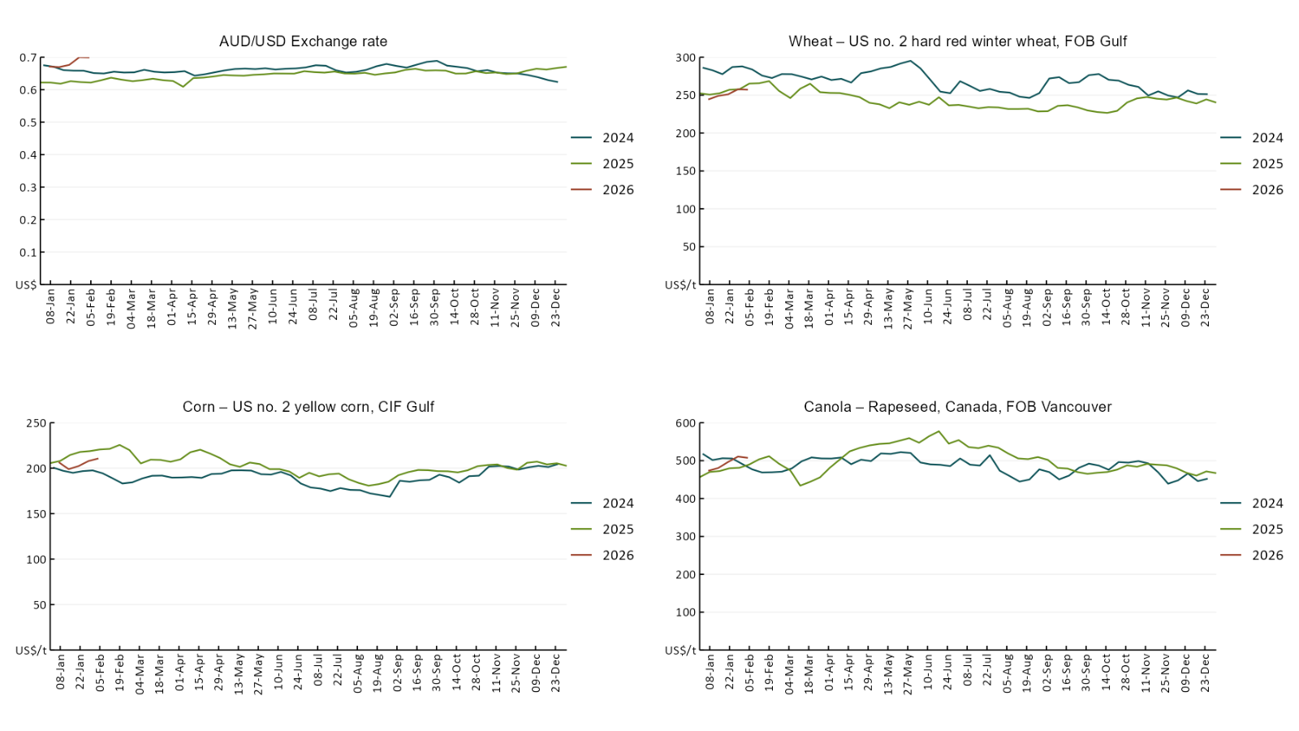

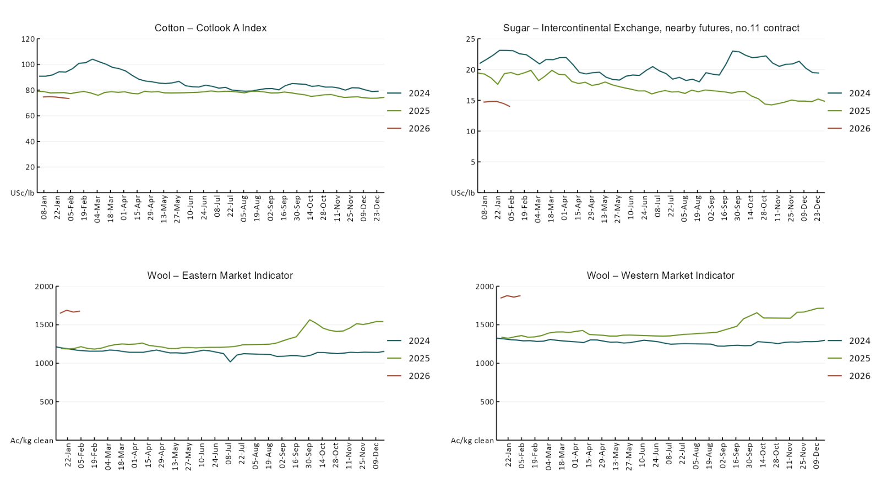

3.2 Selected domestic crop indicator prices
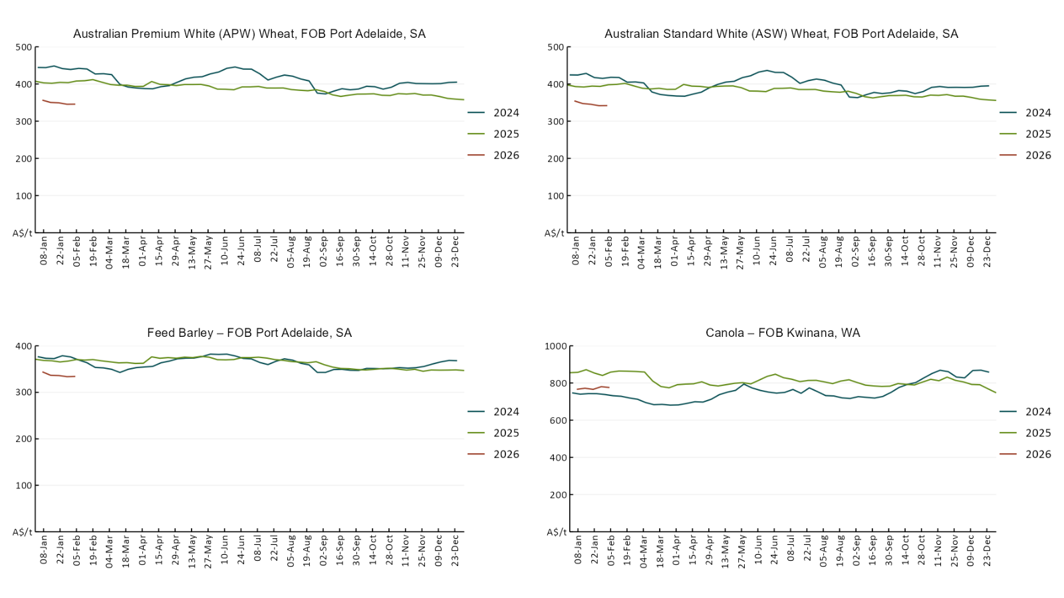

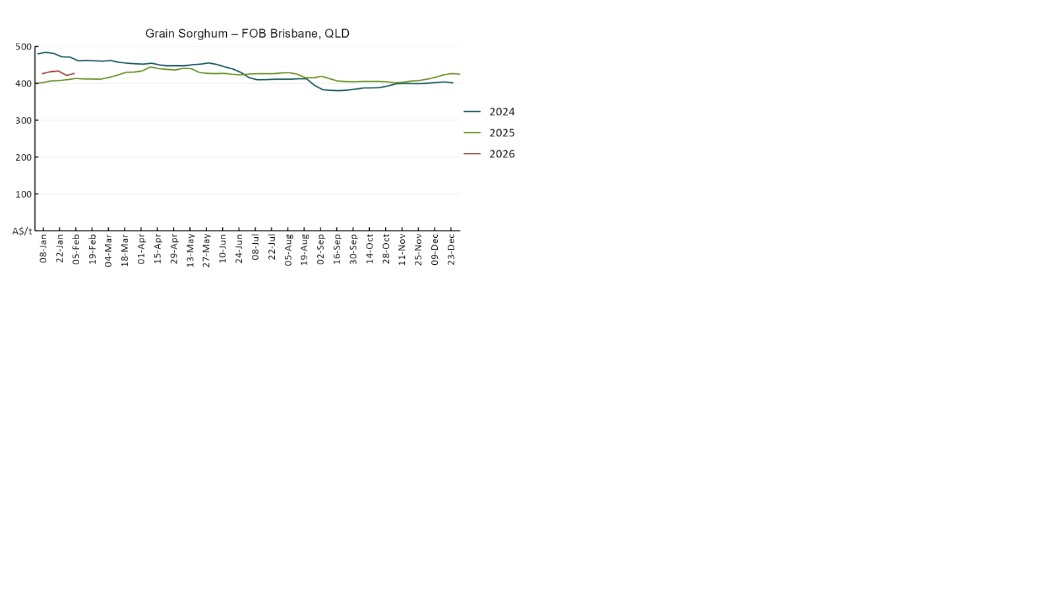

3.3 Selected domestic livestock indicator prices
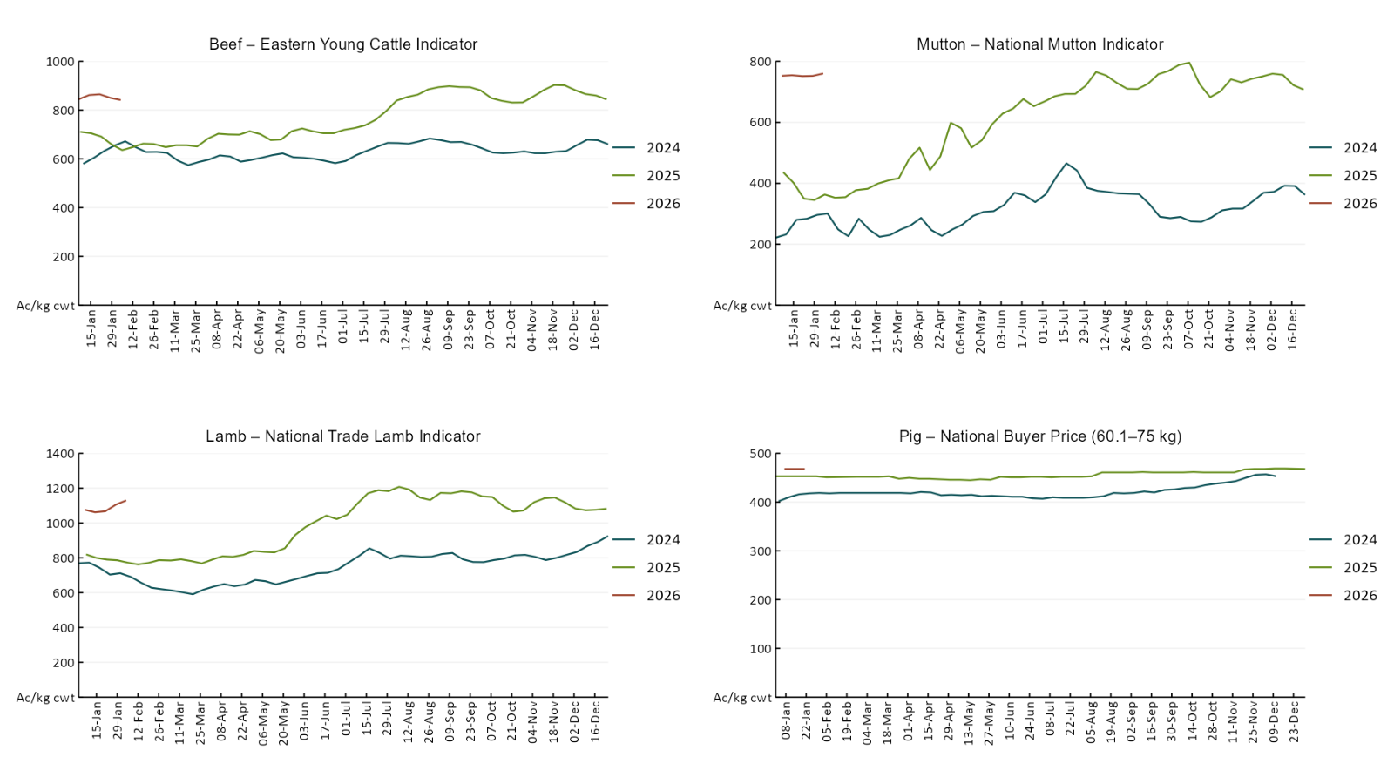
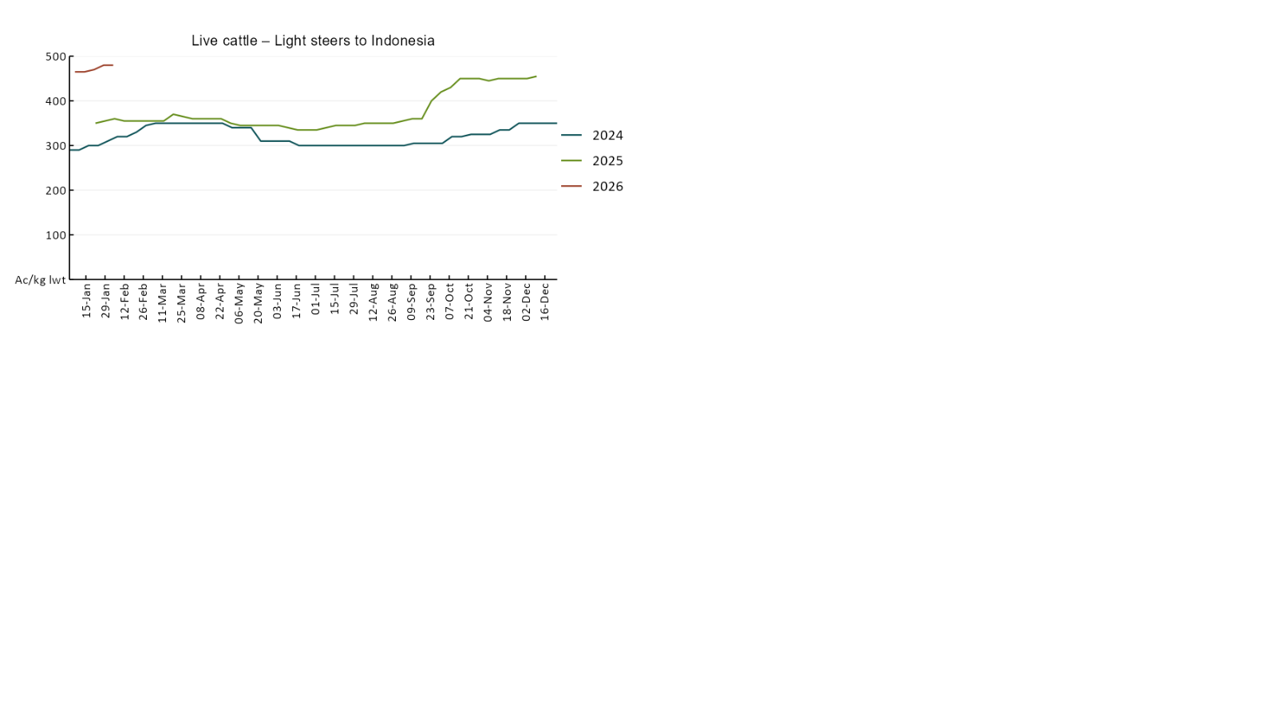

3.4 Global Dairy Trade (GDT) weighted average prices
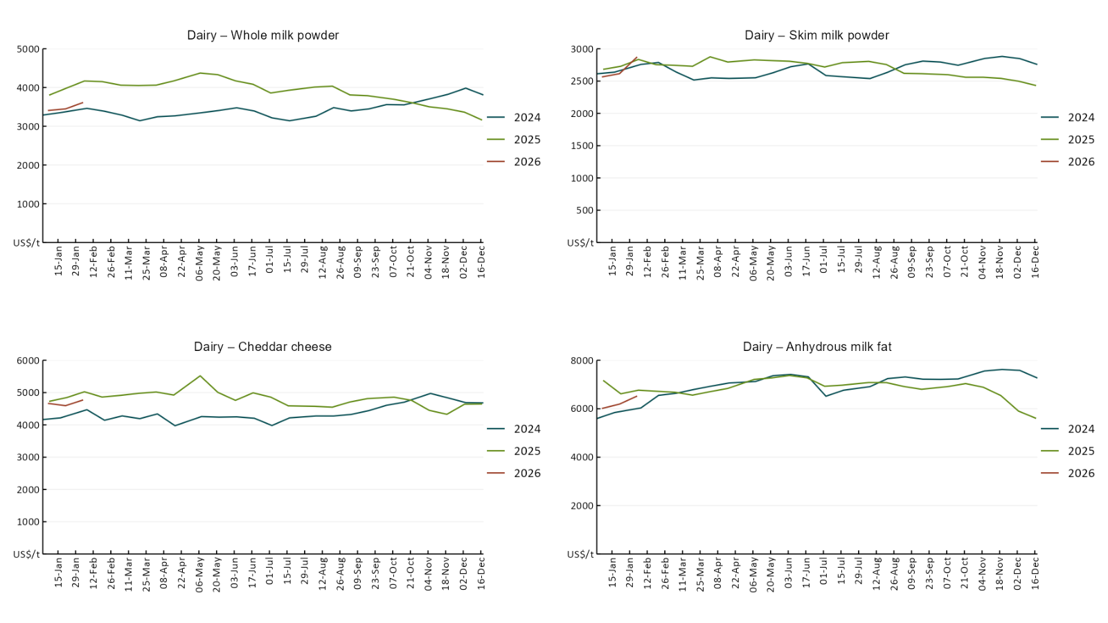

3.5 Selected fruit and vegetable prices
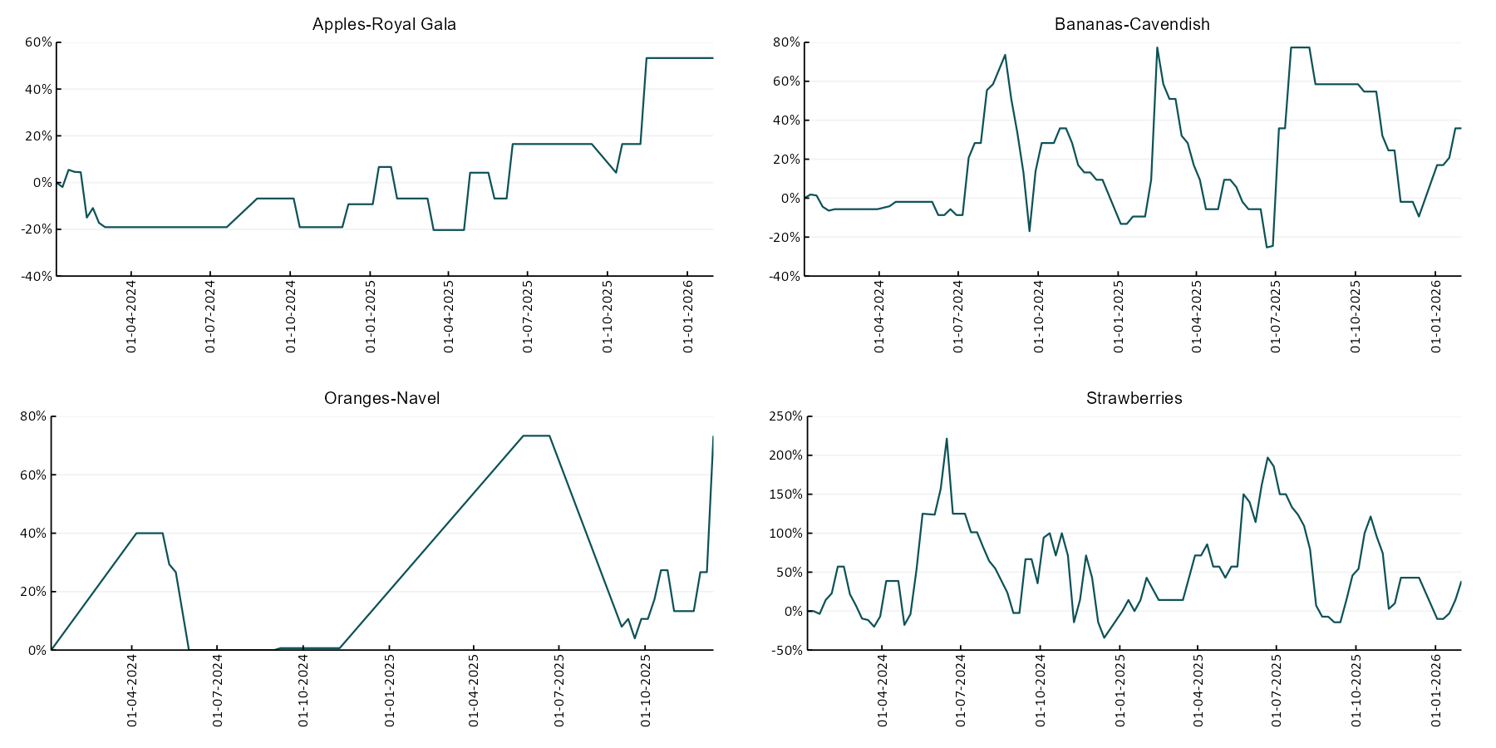
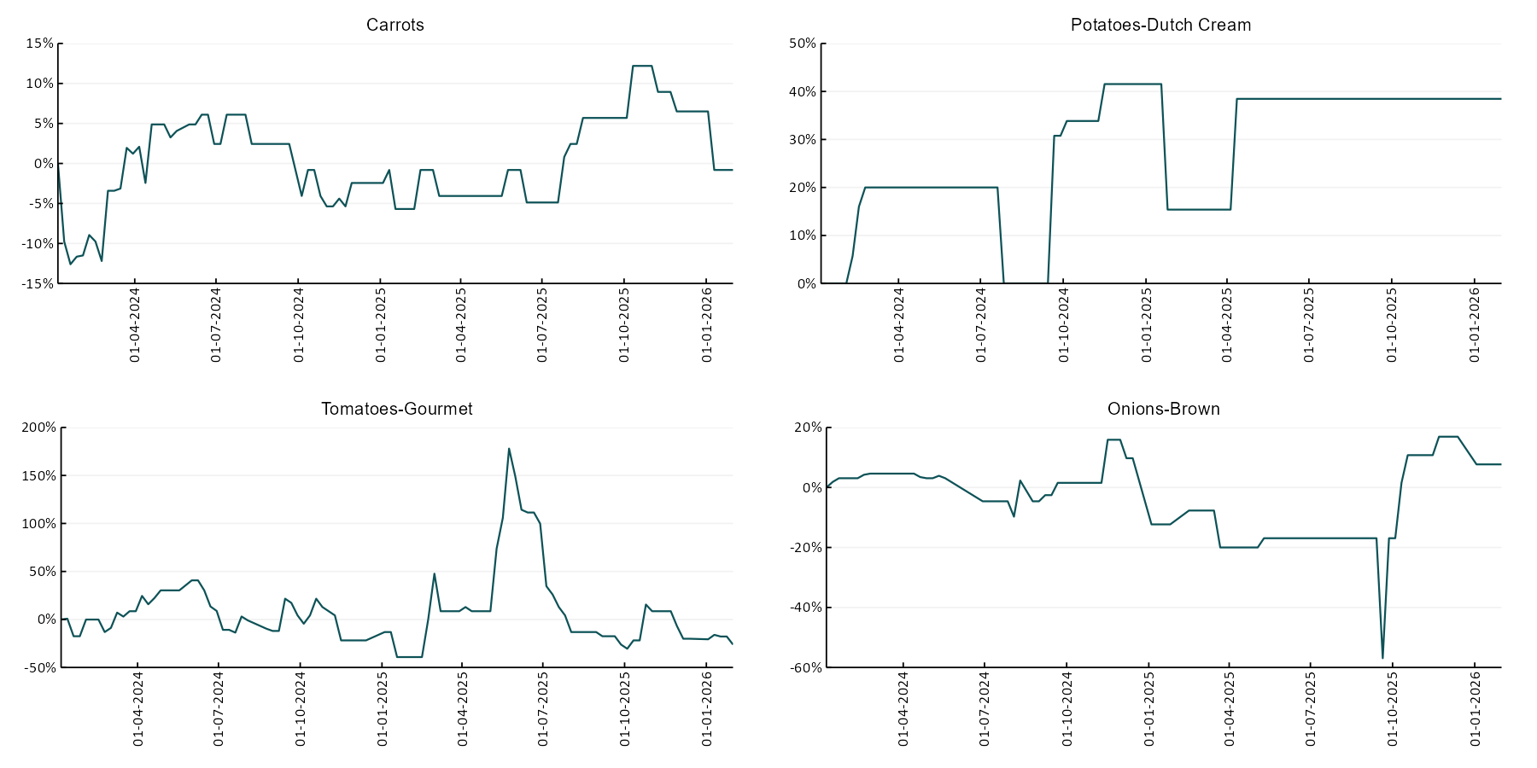

3.6 Selected domestic fodder indicator prices
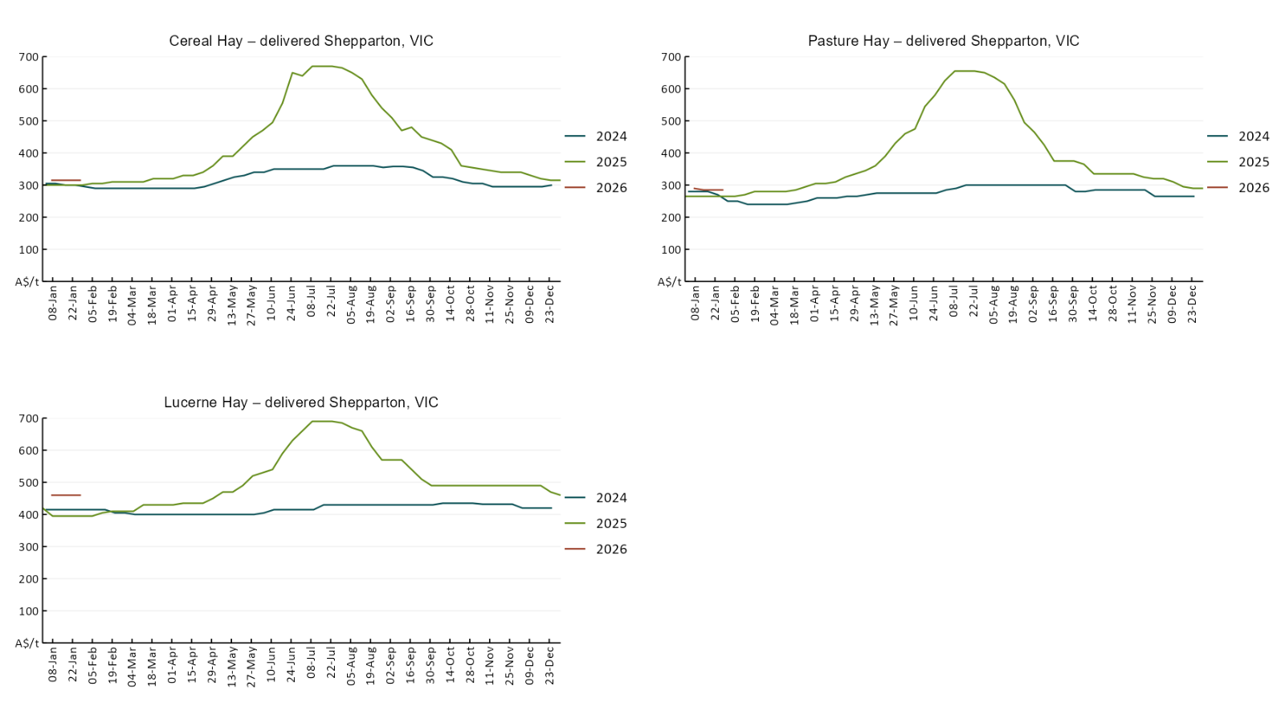

4. Data attribution

Climate
Bureau of Meteorology
- Weekly rainfall totals: www.bom.gov.au/climate/maps/rainfall/
- Monthly and last 3-month rainfall percentiles: https://www.bom.gov.au/climate/ahead/outlooks/#moreMaps
- Rainfall forecast: www.bom.gov.au/jsp/watl/rainfall/pme.jsp
- Seasonal outlook: www.bom.gov.au/climate/outlooks/#/overview/summary/
- Climate drivers: http://www.bom.gov.au/climate/enso/
- Soil moisture: https://awo.bom.gov.au/products/historical/soilMoisture-rootZone/

Other
- Pasture growth: www.longpaddock.qld.gov.au/aussiegrass/
- 3-month global outlooks: Environment and Climate Change Canada, NOAA Climate Prediction Center, EUROBRISA CPTEC/INPE, European Centre for Medium-Range Weather Forecasts, Hydrometcenter of Russia, National Climate Center Climate System Diagnosis and Prediction Room (NCC), International Research Institute for Climate and Society
- Global production: https://ipad.fas.usda.gov/ogamaps/cropmapsandcalendars.aspx
- Autumn break: Pook et al., 2009, https://rmets-onlinelibrary-wiley-com.virtual.anu.edu.au/doi/epdf/10.1002/joc.1833

Water
Prices
- Waterflow: https://www.waterflow.io/
- Ruralco: https://www.ruralcowater.com.au/
- Bureau of Meteorology:
- Allocation trade: http://www.bom.gov.au/water/dashboards/#/water-markets/mdb/at
- Storage volumes: http://www.bom.gov.au/water/dashboards/#/water-storages/summary/drainage

Trade constraints:
- Water NSW: https://www.waternsw.com.au/customer-service/ordering-trading-and-pricing/trading/murrumbidgee
- Victorian Water Register: https://www.waterregister.vic.gov.au/TradingRules2019/

Commodities
Fruit and vegetables
- Datafresh: www.freshstate.com.au

Pigs
- Australian Pork Limited: www.australianpork.com.au

Dairy
- Global Dairy Trade: www.globaldairytrade.info/en/product-results/

World wheat, canola
- International Grains Council
- https://www.igc.int/en/default.aspx
- United States Department of Agriculture

World cotton
- Cotlook: www.cotlook.com/

World sugar
- New York Stock Exchange - Intercontinental Exchange

Wool
- Australian Wool Exchange: www.awex.com.au/

Domestic wheat, barley, sorghum, canola and fodder
- Jumbuk Consulting Pty Ltd: Jumbuk AG | Agriculture Consulting

Cattle, beef, mutton, lamb, goat and live export
- Meat and Livestock Australia: https://www.mla.com.au/prices-markets/

Australian Agricultural Drought Indicators
About Australian Agricultural Drought Indicators
The Australian Agricultural Drought Indicators (AADI) links weather and agricultural data with a range of scientific and economic models to measure and forecast the effects of climate variability and drought on agricultural outcomes.
On AADI, projected broadacre farm profits are presented as percentile outcomes relative to simulated historical outcomes using the groupings:
Highest | 95-100th percentile
Very much above average | 85-95th percentile
Above average | 65-85th percentile
Average | 35-65th percentile
Below average | 15-35th percentile
Very much below average | 5-15th percentile
Lowest 5% | 0-5th percentile

There are two AADI farm profit indicators:
- The AADI farm profit climate and price indicator shows the effect of climate and prices on broadacre farm business profits of current farms compared to the last 33 years.
- The AADI farm profit climate only indicator isolates the effect of climate on profits by holding prices fixed.

© Commonwealth of Australia 2026

Ownership of intellectual property rights
Unless otherwise noted, copyright (and any other intellectual property rights, if any) in this publication is owned by the Commonwealth of Australia (referred to as the Commonwealth).

Creative Commons licence
All material in this publication is licensed under a Creative Commons Attribution 4.0 International Licence except content supplied by third parties, logos and the Commonwealth Coat of Arms.
Inquiries about the licence and any use of this document should be emailed to copyright@awe.gov.au.


Cataloguing data
This publication (and any material sourced from it) should be attributed as:
ABARES 2026, Weekly Australian Climate, Water and Agricultural Update, Australian Bureau of Agricultural and Resource Economics and Sciences, Canberra, 5 February 2026. CC BY 4.0 DOI: https://doi.org/10.25814/5f3e04e7d2503
ISSN 2652-7561
This publication is available at https://www.agriculture.gov.au/abares/products/weekly_update
Department of Agriculture, Fisheries and Forestry
GPO Box 858 Canberra ACT 2601
Telephone 1800 900 090
Web agriculture.gov.au/abares

Disclaimer
The Australian Government acting through the Department of Agriculture, Fisheries and Forestry, represented by the Australian Bureau of Agricultural and Resource Economics and Sciences, has exercised due care and skill in preparing and compiling the information and data in this publication. Notwithstanding, the Department of Agriculture, Fisheries and Forestry, ABARES, its employees and advisers disclaim all liability, including liability for negligence and for any loss, damage, injury, expense or cost incurred by any person as a result of accessing, using or relying on any of the information or data in this publication to the maximum extent permitted by law.

Statement of Professional Independence
The views and analysis presented in ABARES publications, including this one, reflect ABARES professionally independent findings, based on scientific and economic concepts, principles, information and data. These views, analysis and findings may not reflect or be consistent with the views or positions of the Australian Government, or of organisations or groups who have commissioned ABARES reports or analysis. More information on professional independence is provided on the ABARES website.

Acknowledgements
This report was prepared by Matthew Miller.

