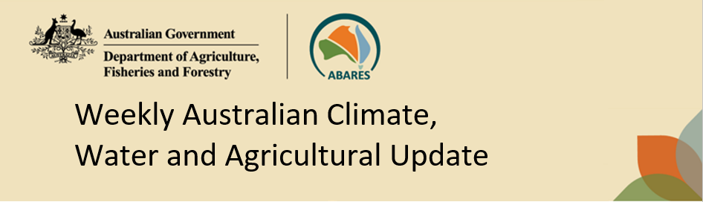
No. 5/2026 12 February 2026

Summary of key issues
- In the week ending 11 February 2026, weather systems including Tropical Cyclone Mitchell brought rainfall to much of Australia.
  - Tropical Cyclone Mitchell hugged the Western Australian north-western coastline for several days between 6-9 February before making landfall as a tropical low system in the early hours of 10 February near Shark Bay, bringing some destructive winds and widespread falls of between 50 and 150 millimetres.
  - Across northern and central Australia widespread weekly rainfall totals in excess of 50 millimetres has led to issuing of flood warning across numerous river catchments. At this stage there have been no reports of agricultural losses, with these falls likely to provide significant longer-term benefits to pasture production.
  - Large areas of western and central New South Wales saw falls of between 15-100 millimetres.
- Over the 8-days to 19 February 2026, rainfall is forecast for much of the north and east of Australia.
  - High rainfall totals of 50-150 millimetres are forecast for Queensland, with northern New South Wales expected to 10-100 millimetres.
  - These expected heavier falls across Queensland and northern New South Wales are likely to support soil moisture in summer cropping regions and improve pasture growth.
- The national rainfall outlook for March to May 2026 indicates an increased probability of below median rainfall across much of southern and central Australia.
  - Despite these expected below average falls, rainfall totals across northern Australia are likely to be sufficient to support summer pasture growth and summer crop yield prospects, particularly given recent heavy rainfall and boosted soil moisture levels.
  - In contrast, these expected well below average falls for much of southern and central Australia represents an increased downside production risk for the upcoming 2026–27 winter cropping season and autumn pasture growth.
- Water levels in the Murray-Darling Basin (MDB) decreased by 175 gigalitres (GL) between 5 February 2026 and 12 February 2026. The current volume of water held in storages is 11,171 GL, equivalent to 50% of total storage capacity. This is 20% or 2744 GL less than the same time last year. Water storage data is sourced from the Bureau of Meteorology.
- Allocation prices in the Victorian Murray below the Barmah Choke increased from $426/ML on 5 February to $466/ML on 12 February 2026. Trade from the Goulburn to the Murray is closed. Trade downstream through the Barmah Choke is closed. Trade from the Murrumbidgee to the Murray is open.

Climate

Rainfall this week
In the week ending 11 February 2026, Tropical cyclone Mitchell, cold fronts and a northwest cloudband brought heavy rainfall to much of Australia, including northern, central, and western Australia. Parts of the south and the east remained largely dry.
- Tropical Cyclone Mitchell hugged the Western Australian north-western coastline for several days between 6-9 February before making landfall as a tropical low system in the early hours of 10 February near Shark Bay, bringing some destructive winds and widespread falls of between 50 and 150 millimetres.
- Across northern and central Australia widespread weekly rainfall totals in excess of 50 millimetres has led to issuing of flood warning across numerous river catchments. At this stage there have been no reports of agricultural losses, with these falls likely to provide significant longer-term benefits to pasture production.
- Large areas of western and central New South Wales saw falls of between 15-100 millimetres.
Across cropping regions, rainfall was low in some southern areas, while high in the west and southeast:
- New South Wales saw falls of between 5-100 millimetres, with rainfall totals being lower in the northern and southern margins. In contrast, Queensland saw little to no rainfall over the period.
  - These falls are expected to support soil moisture storage and benefit summer crop and pasture production across New South Wales.
- In Western Australia, falls of 5-100 millimetres were observed.
  - These falls are expected to support soil moisture storage ahead of the 2026–27 winter cropping season.
- Little to no rainfall was recorded across Victoria and South Australian cropping regions.

Rainfall for the week ending 11 February 2026
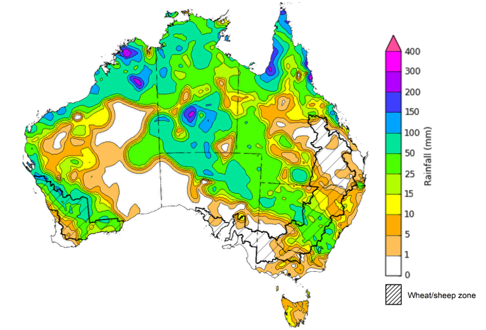
©Commonwealth of Australia 2026, Australian Bureau of Meteorology Issued: 11/2/2026
Note: The rainfall analyses and associated maps utilise data contained in the Bureau of Meteorology climate database, the Australian Data Archive for Meteorology (ADAM). The analyses are initially produced automatically from real-time data with limited quality control. They are intended to provide a general overview of rainfall across Australia as quickly as possible after the observations are received. For further information go to http://www.bom.gov.au/climate/rainfall/

Rainfall forecast for the next eight days
Over the 8 days to 19 February 2026, low pressure systems are expected to bring considerable rainfall to much of the north and east of Australia, while south-western regions of the country are forecast to remain largely dry.
- Forecast falls of between 25-150 millimetres are expected across flood warning areas of northern Australia. If realised these falls are likely to continue to slow recovery efforts.
- Outside of flood affected regions, if realised these substantial falls across northern and eastern Australia are likely to support soil moisture levels, replenish water supplies and boost pasture availability and benefit the growth of summer crops.
Limited rainfall is expected across southern cropping regions this week, with substantial rainfall expected in the northeast.
- High rainfall totals of 50-150 millimetres are forecast for Queensland, with northern New South Wales expected to 10-100 millimetres.
  - These expected heavier falls across Queensland and northern New South Wales are likely to support soil moisture in summer cropping regions and improve pasture growth.
- Remaining cropping regions are forecast to receive little to no rainfall.

Total forecast rainfall for the period 12 February to 19 February 2026
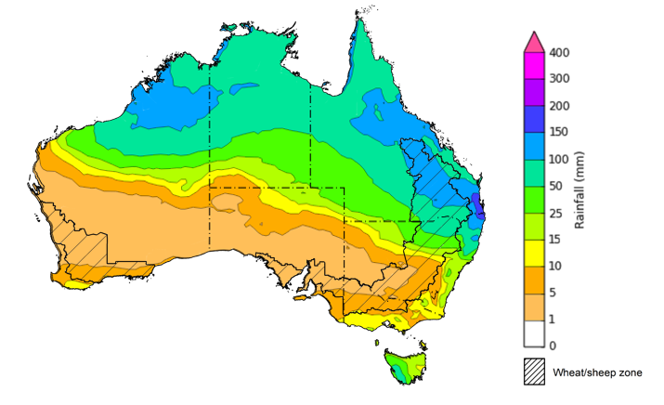
©Commonwealth of Australia 2026, Australian Bureau of Meteorology Issued 12/2/2026
Note: This rainfall forecast is produced from computer models. As the model outputs are not altered by weather forecasters, it is important to check local forecasts and warnings issued by the Bureau of Meteorology.

National Climate Outlook
The Bureau of Meteorology has indicated that the 2025–26 La Niña continues to weaken, with sea surface temperatures in the central tropical Pacific now close to the neutral ENSO range and atmospheric indicators also show a general easing of the La Niña pattern. These recent changes in the tropical Pacific are consistent with model forecasts, which for some months have indicated a general easing of La Niña during the latter part of the 2025–26 summer. All models, including the Bureau's, indicate a continued warming in the tropical Pacific with a neutral ENSO state favoured through to at least late autumn. Some models suggest the possibility of El Niño development from June. The negative Southern Annular Mode (SAM) event is currently neutral and is forecast to remain neutral until autumn. Similar, the Indian Ocean Dipole (IOD) event is currently neutral, and is likely to remain neutral until autumn 2026.
The most recent rainfall outlook for March 2026 provided by the Bureau of Meteorology indicates that most of Australia is more likely to see below median to median rainfall, with parts of northern Australia more likely to see above median falls.
- The Bureau of Meteorology’s climate model indicates a 75% chance of March rainfall totals between 10-200 millimetres across parts of eastern and northern Australia, with higher rainfall totals of up to 300 millimetres expected in the Northern Tropics. Much of southern Western Australia, South Australia, and western areas of New South Wales, northern Victoria and south-western Queensland are likely to see little to no rainfall which is typical for this time of year.
- Across cropping regions, there is a 75% chance of receiving rainfall totals of between 5- 25 millimetres across Queensland and eastern New South Wales. Meanwhile western New South Wales, Victoria, South Australia, and Western Australia are likely to see 1- 10 millimetres.
  - If forecast rainfall totals are realised across much of New South Wales and Queensland, these falls are likely to be sufficient to support above average yield prospects for summer crops and average or better levels of pasture production, particularly given the recent boost in soil moisture levels.

Rainfall totals that have a 75% chance of occurring in March 2026
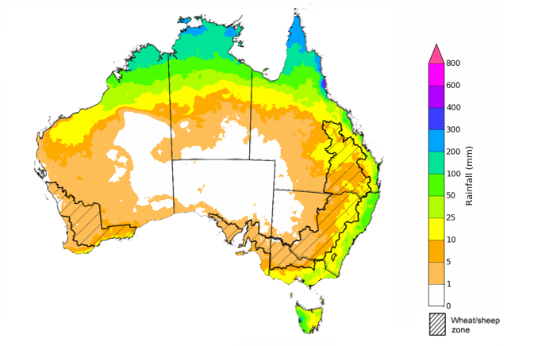
©Commonwealth of Australia 2025, Australian Bureau of Meteorology Issued: 12/2/2026
The rainfall outlook for March 2026 to May 2026 indicates a strong tendency towards below median rainfall across much of southern and central Australia. However, there is an increased probability of above median rainfall in parts of the northern tropics, with remaining areas of northern Australia showing no strong tendency towards above or below median rainfall.
Across cropping regions, the chance of receiving above median rainfall are low with most cropping regions showing a 20-40% chance of receiving above median rainfall.
Chance of exceeding the median rainfall March 2026 to May 2026
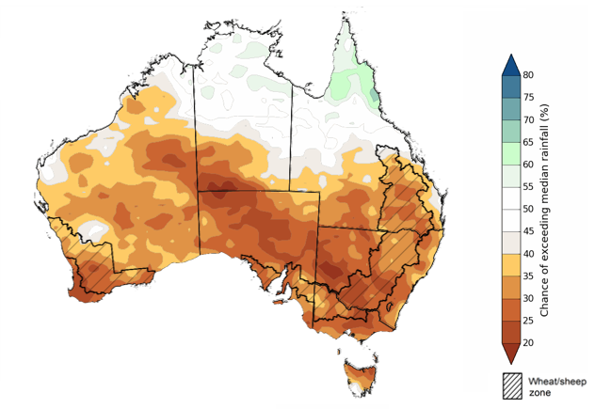
©Commonwealth of Australia 2025, Australian Bureau of Meteorology Issued: 15/1/2026
The rainfall outlook for March 2026 to May 2026 suggests a 75% chance of receiving rainfall totals of between 50-300 millimetres across parts of eastern, southern and northern Australia. Higher falls of up to 600 millimetres are expected across scattered northeast coastal regions and parts of western Tasmania, with higher rainfall totals in isolated areas of the northern tropics. Lower rainfall totals are forecast for central regions, with much of South Australia, central Western Australia, western New South Wales, northern Victoria, and south-western Queensland and southern Northern Territory likely to see 5-50 millimetres.
In cropping regions, there is a 75% chance of receiving between 25-100 millimetres across much of Queensland, northern New South Wales and Western Australia. The remaining cropping regions of southern New South Wales, Victoria, and South Australia are likely to see 10-50 millimetres.
If these forecast March through May rainfall totals are realised, they are likely to be sufficient to support summer pasture growth and summer crop yield prospects across northern Australia, particularly given recent heavy rainfall and boosted soil moisture levels. In contrast, these expected well below average falls for much of southern and central Australia represents an increased downside production risk for the upcoming 2026–27 winter cropping season and autumn pasture growth.
Rainfall totals that have a 75% chance of occurring March 2026 to May 2026
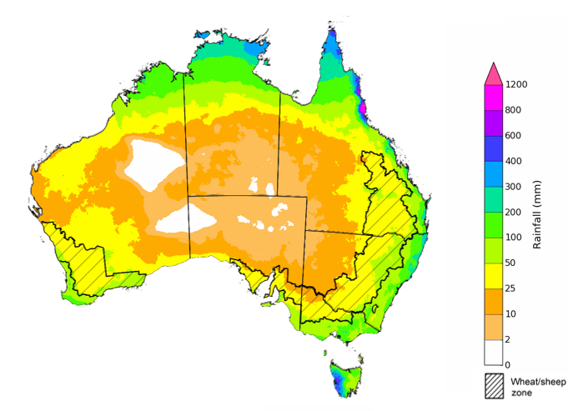
©Commonwealth of Australia 2025, Australian Bureau of Meteorology Issued: 12/2/2026

Water markets – current week
Water levels in the Murray-Darling Basin (MDB) decreased by 175 gigalitres (GL) between 5 February 2026 and 12 February 2026. The current volume of water held in storages is 11,171 GL, equivalent to 50% of total storage capacity. This is 20% or 2744 GL less than the same time last year. Water storage data is sourced from the Bureau of Meteorology.

Water storages in the Murray-Darling Basin, 2013–2026
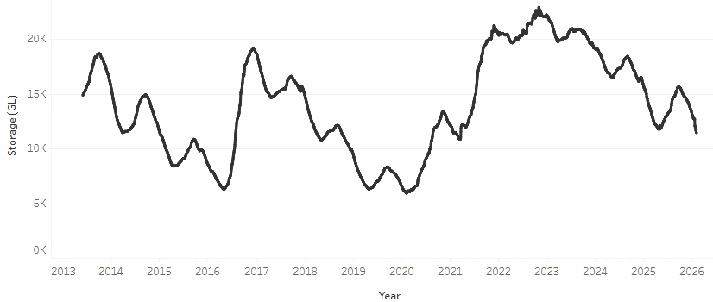
Allocation prices in the Victorian Murray below the Barmah Choke increased from $426/ML on 5 February to $466/ML on 12 February 2026. Trade from the Goulburn to the Murray is closed. Trade downstream through the Barmah Choke is closed. Trade from the Murrumbidgee to the Murray is open.

Water market prices, Southern Murray–Darling Basin

Region | $/ML
NSW Murray Above | 338
NSW Murrumbidgee | 471
Vic Greater Goulburn | 383
Vic Murray Below | 466

Note: The water allocation prices shown are volume weighted average prices based on the last 10 trades. Price data is sourced from Waterflow and current as at 22 January 2026.
To access the full, interactive, weekly water dashboard, which contains the latest and historical water storage, water market and water allocation information, please visit https://www.agriculture.gov.au/abares/products/weekly_update/weekly-update-260212

Commodities
Indicator | Week average | Unit | Latest Price | Previous Week | Weekly change |  | Price 12 months ago | Annual change
Selected world indicator prices
AUD/USD Exchange rate | 11-Feb | A$/US$ | 0.71 | 0.70 | 1% | 0.63 |  | 12%
Wheat – US no. 2 hard red winter wheat, FOB Gulf | 11-Feb | US$/t | 255 | 257 | -1% | 264 |  | -3%
Corn – US no. 2 yellow corn, FOB Gulf | 11-Feb | US$/t | 212 | 212 | 0% | 222 |  | -5%
Canola – Rapeseed, Canada, FOB Vancouver | 11-Feb | US$/t | 526 | 513 | 2% | 499 |  | 5%
Cotton – Cotlook A Index | 11-Feb | USc/lb | 73.1 | 73.3 | 0% | 78.1 |  | -6%
Sugar – Intercontinental Exchange, nearby futures, no.11 contract | 11-Feb | USc/lb | 13.9 | 13.9 | 0% | 19.5 |  | -29%
Wool – Eastern Market Indicator | 11-Feb | Ac/kg clean | 1,693 | 1,677 | 1% | 1,197 |  | 41%
Wool – Western Market Indicator | 11-Feb | Ac/kg clean | 1,894 | 1,878 | 1% | 1,350 |  | 40%
Selected Australian grain export prices
Australian Premium White (APW) Wheat, FOB Port Adelaide, SA | 11-Feb | A$/t | 343 | 346 | -1% | 409 |  | -16%
Australian Standard White (ASW) Wheat, FOB Port Adelaide, SA | 11-Feb | A$/t | 339 | 342 | -1% | 399 |  | -15%
Feed Barley – FOB Port Adelaide, SA | 11-Feb | A$/t | 335 | 335 | 0% | 370 |  | -9%
Canola – FOB Kwinana, WA | 11-Feb | A$/t | 772 | 776 | 0% | 862 |  | -10%
Grain Sorghum – FOB Brisbane, QLD | 11-Feb | A$/t | 426 | 428 | -1% | 412 |  | 3%
Selected domestic livestock indicator prices
Beef – Eastern Young Cattle Indicator | 11-Feb | Ac/kg cwt | 847 | 842 | 1% | 652 |  | 30%
Mutton – Mutton indicator (18–24 kg fat score 2–3), VIC | 11-Feb | Ac/kg cwt | 757 | 759 | 0% | 362 |  | 109%
Lamb – National Trade Lamb Indicator | 11-Feb | Ac/kg cwt | 1,110 | 1,122 | -1% | 773 |  | 43%
Pig – Eastern Seaboard (60.1–75 kg), NSW buyer price | 28-Jan | Ac/kg cwt | 469 | 468 | 0% | 452 |  | 4%
Live cattle – Light steers to Indonesia | 11-Feb | Ac/kg lwt | 480 | 480 | 0% | 356 |  | 35%
Global Dairy Trade (GDT) weighted average prices
Dairy – Whole milk powder | 4-Feb | US$/t | 3,614 | 3,449 | 5% | 4,161 |  | -13%
Dairy – Skim milk powder | 4-Feb | US$/t | 2,874 | 2,615 | 10% | 2,795 |  | 3%
Dairy – Cheddar cheese | 4-Feb | US$/t | 4,772 | 4,594 | 4% | 4,944 |  | -3%
Dairy – Anhydrous milk fat | 4-Feb | US$/t | 6,524 | 6,191 | 5% | 6,745 |  | -3%

Selected world indicator prices
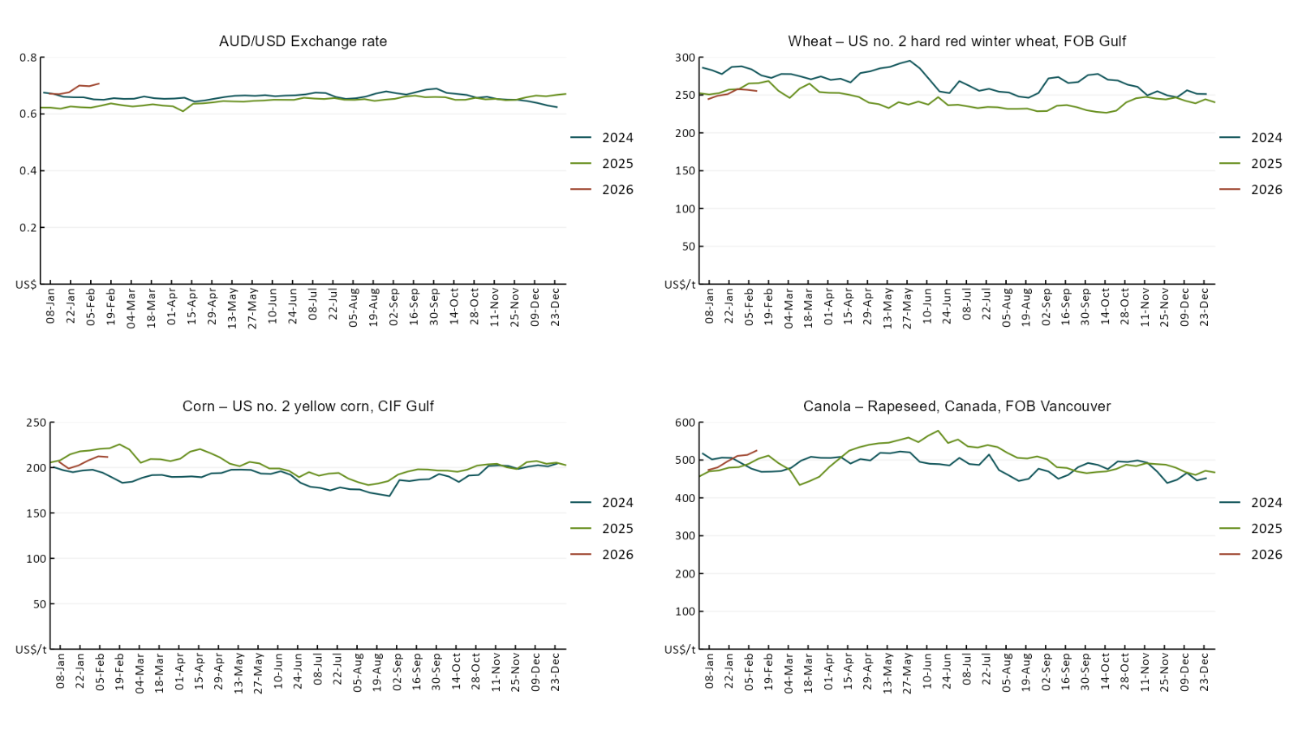

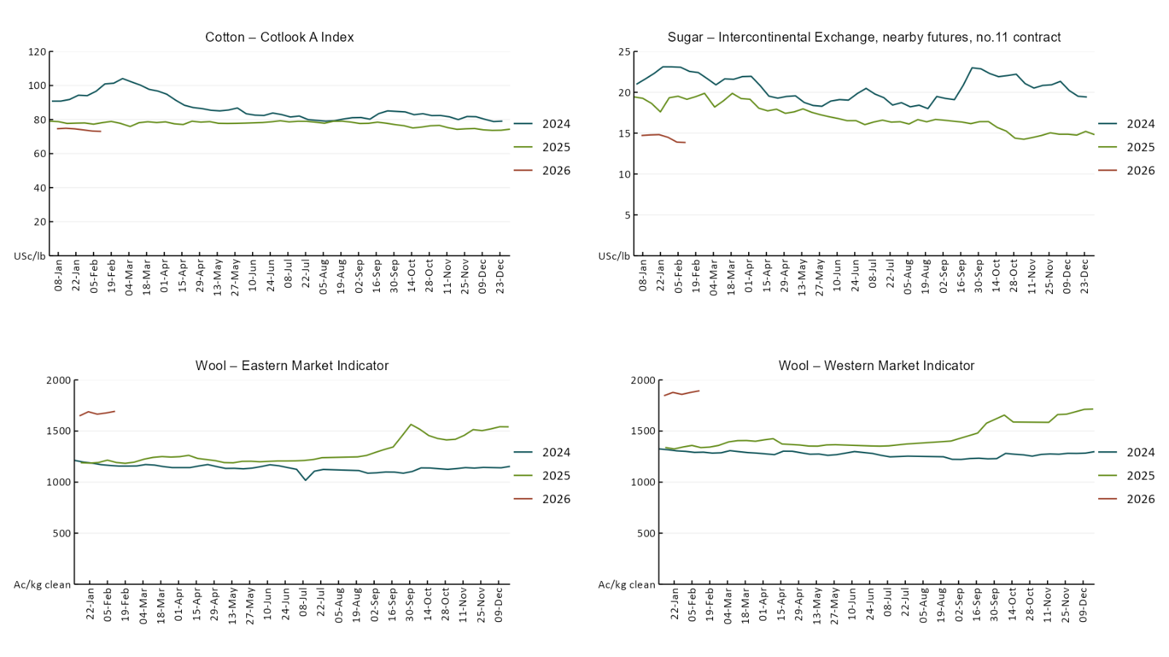

3.2 Selected domestic crop indicator prices
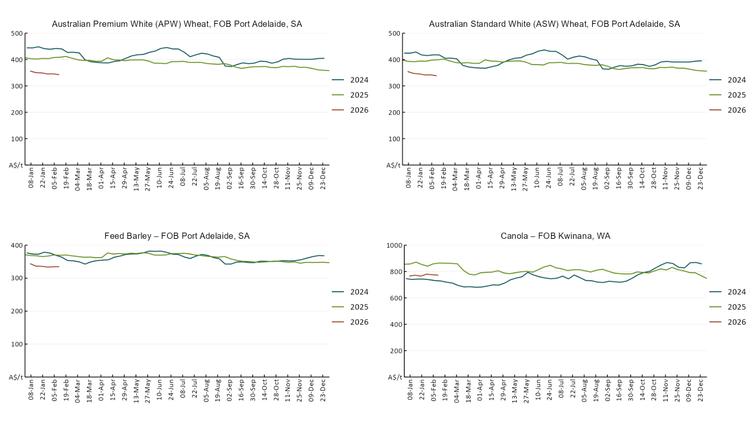

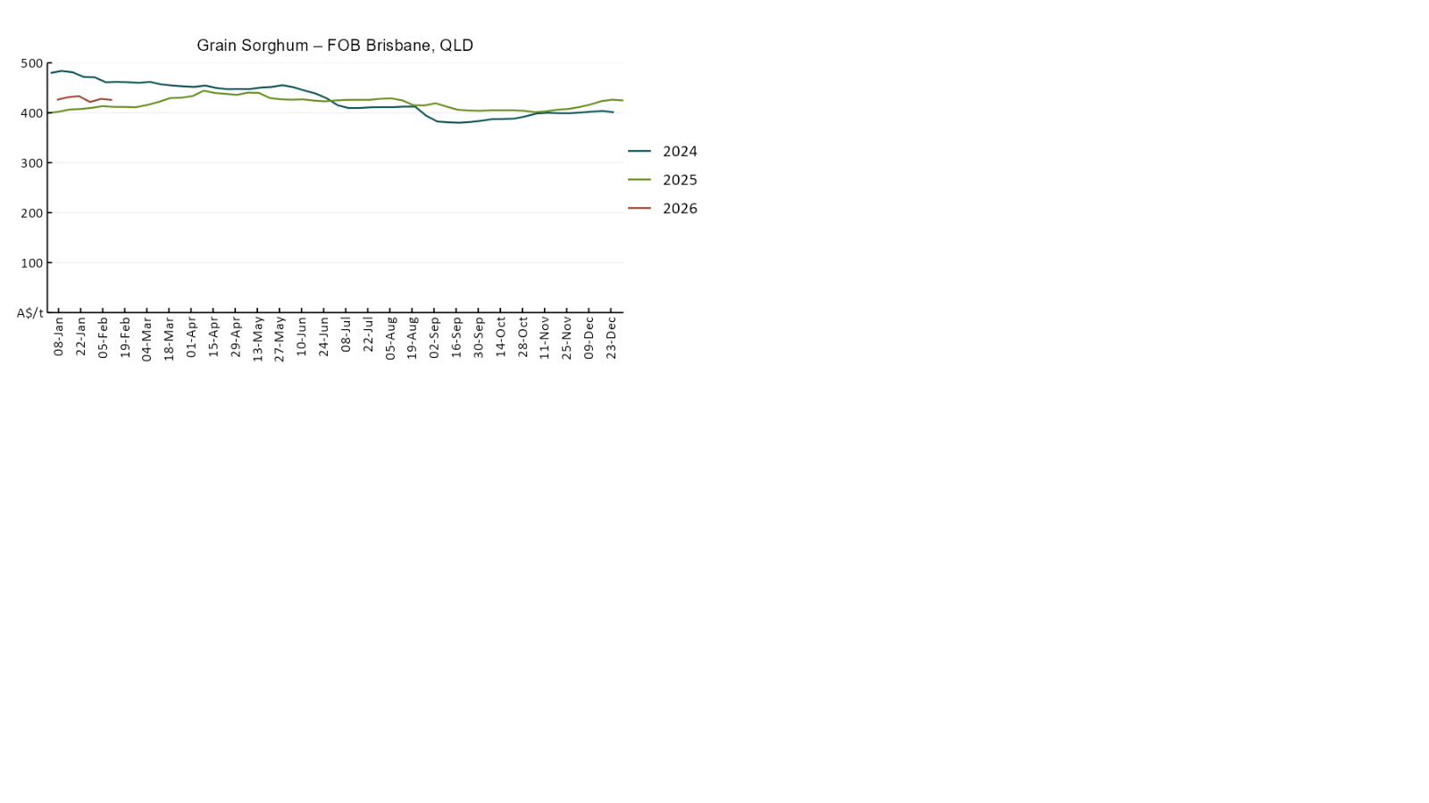

3.3 Selected domestic livestock indicator prices
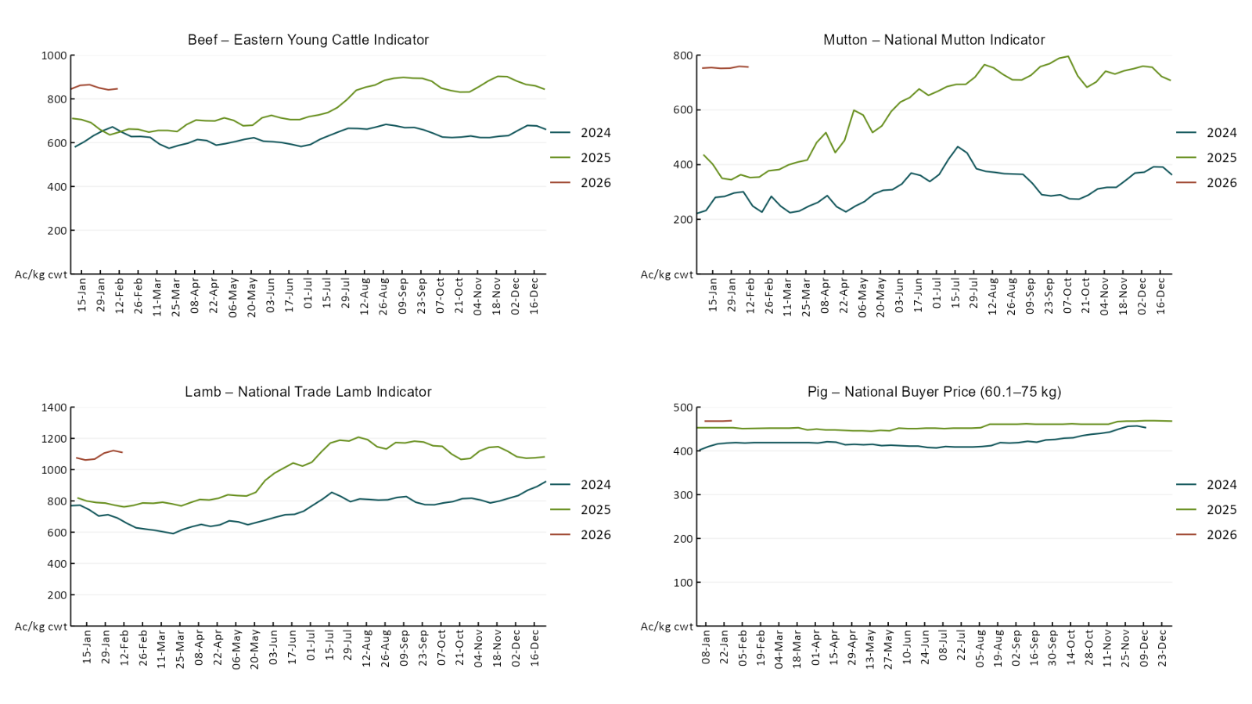
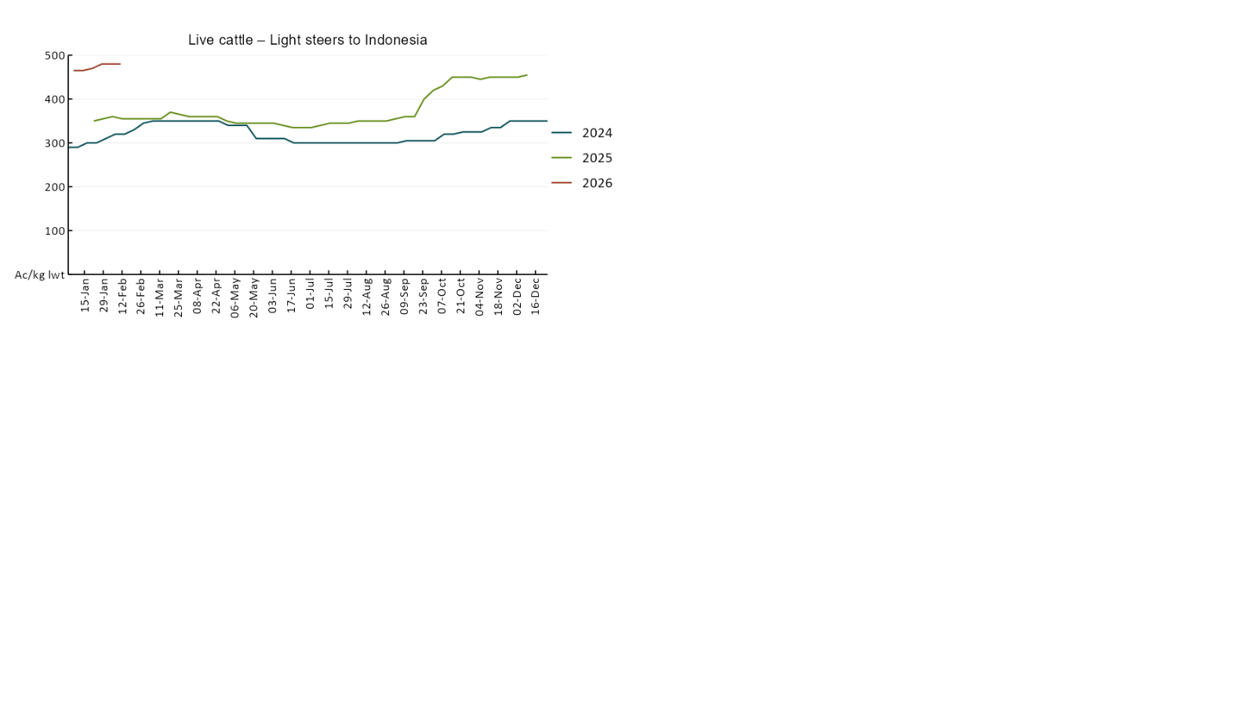

3.4 Global Dairy Trade (GDT) weighted average prices
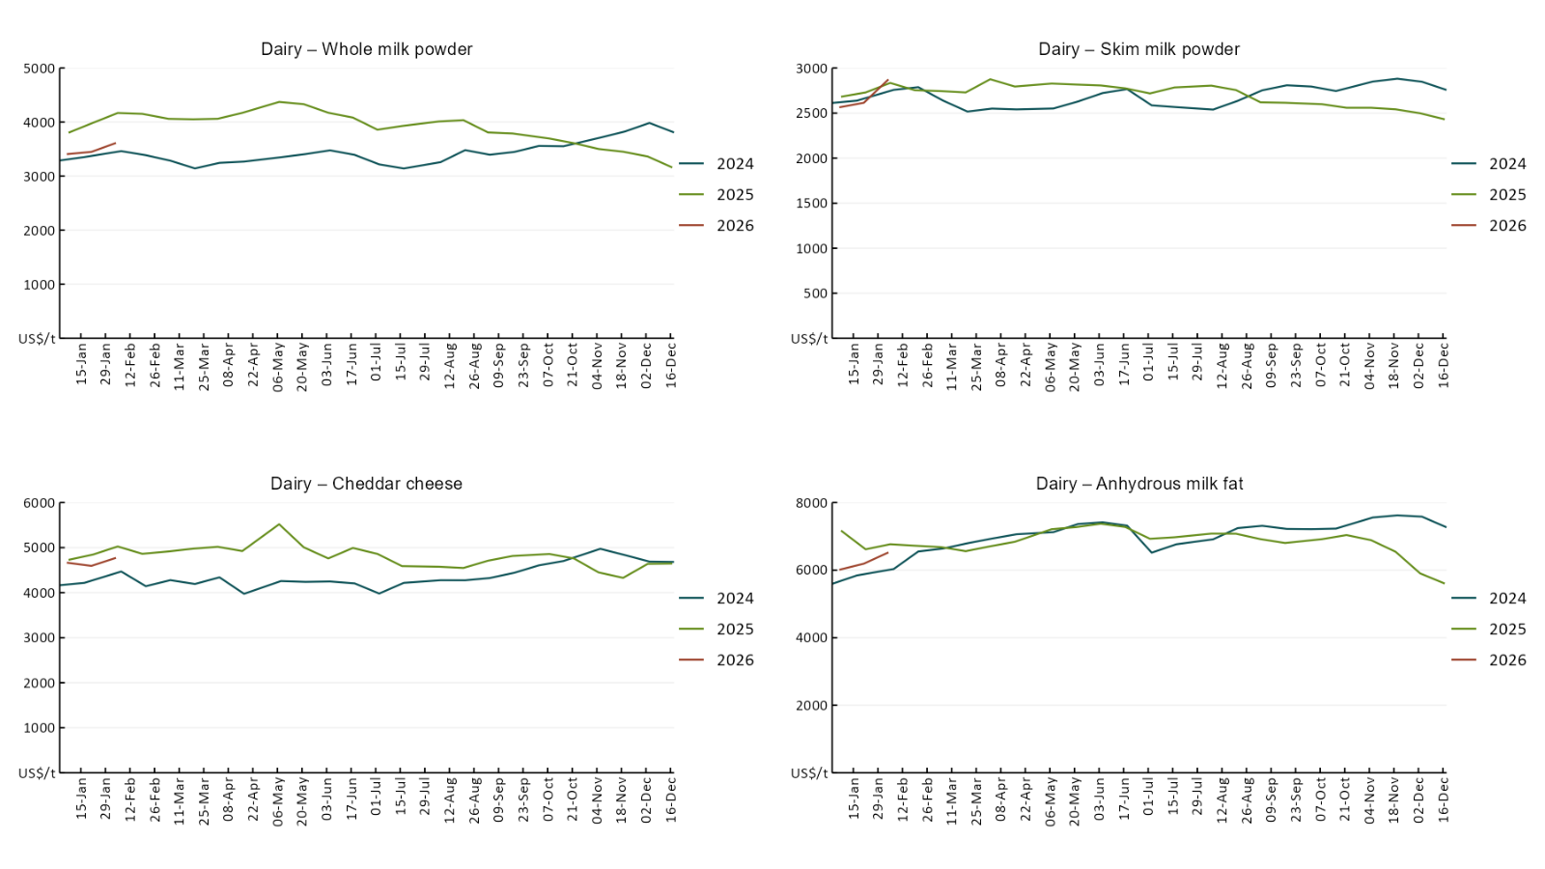

3.5 Selected fruit and vegetable prices
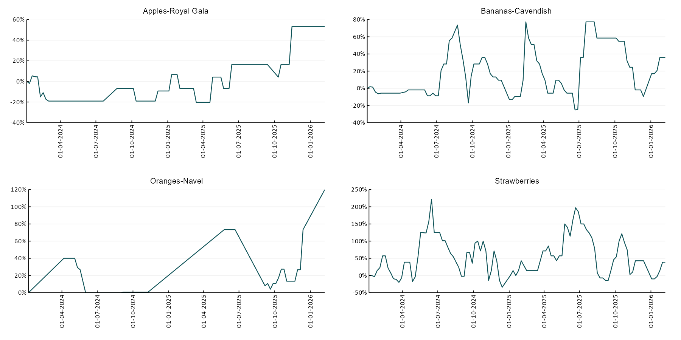
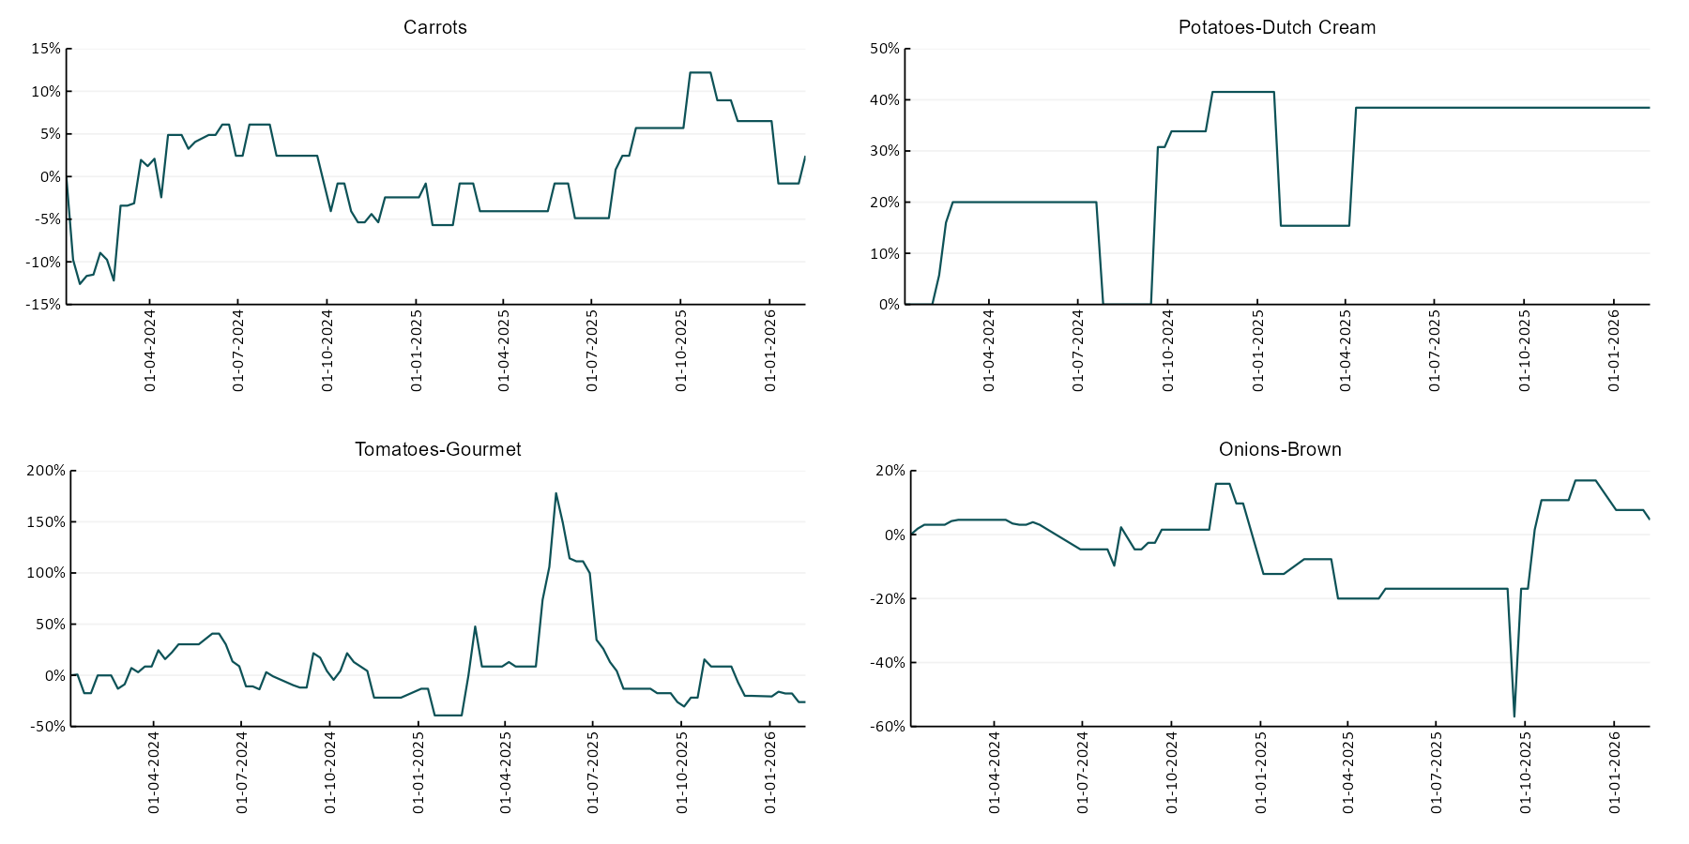

3.6 Selected domestic fodder indicator prices
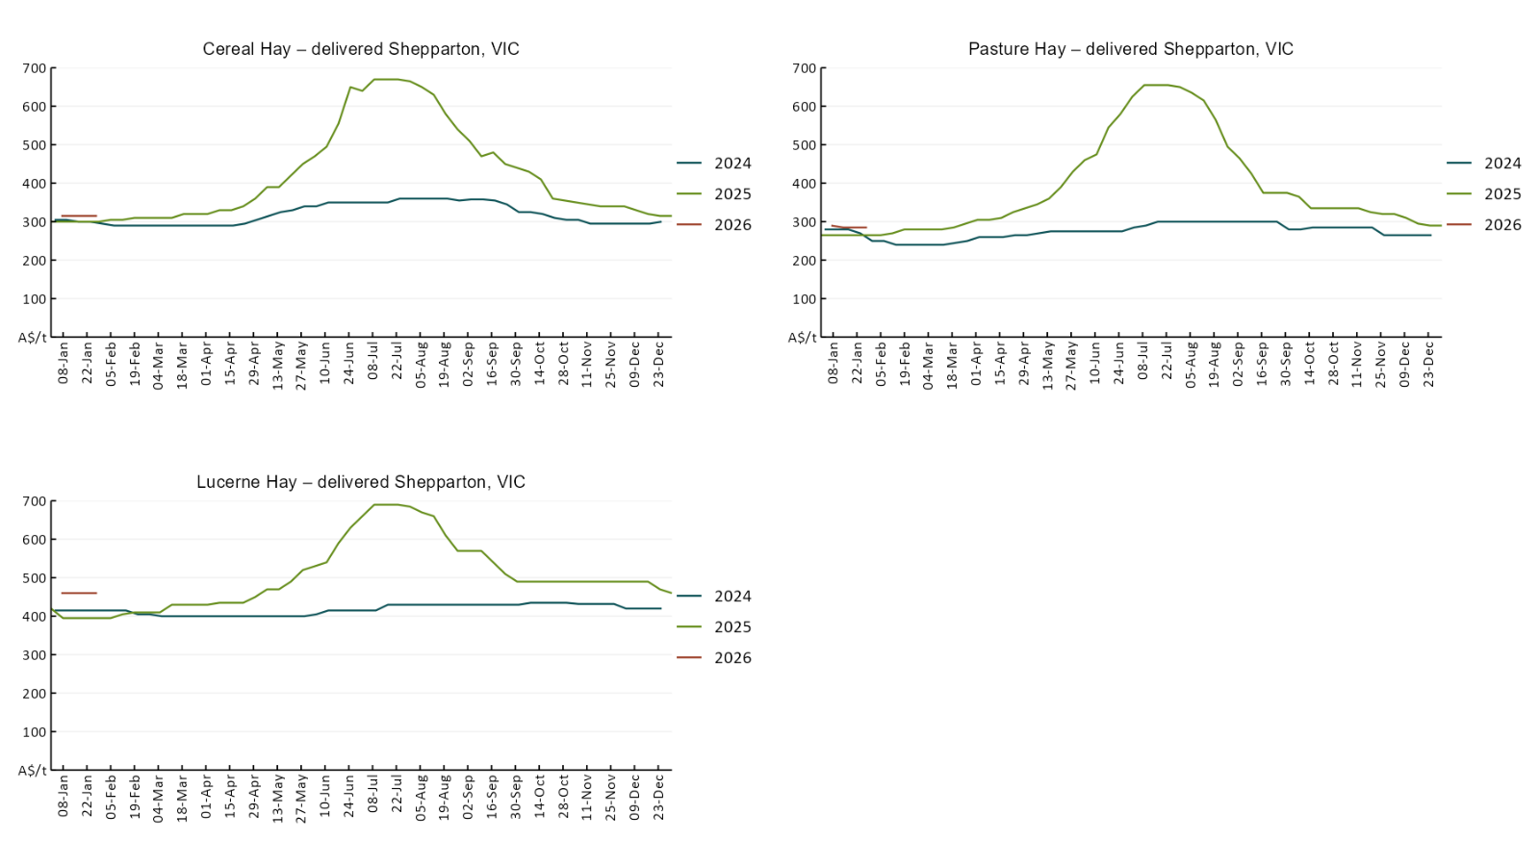

4. Data attribution

Climate
Bureau of Meteorology
- Weekly rainfall totals: www.bom.gov.au/climate/maps/rainfall/
- Monthly and last 3-month rainfall percentiles: https://www.bom.gov.au/climate/ahead/outlooks/#moreMaps
- Rainfall forecast: www.bom.gov.au/jsp/watl/rainfall/pme.jsp
- Seasonal outlook: www.bom.gov.au/climate/outlooks/#/overview/summary/
- Climate drivers: http://www.bom.gov.au/climate/enso/
- Soil moisture: https://awo.bom.gov.au/products/historical/soilMoisture-rootZone/

Other
- Pasture growth: www.longpaddock.qld.gov.au/aussiegrass/
- 3-month global outlooks: Environment and Climate Change Canada, NOAA Climate Prediction Center, EUROBRISA CPTEC/INPE, European Centre for Medium-Range Weather Forecasts, Hydrometcenter of Russia, National Climate Center Climate System Diagnosis and Prediction Room (NCC), International Research Institute for Climate and Society
- Global production: https://ipad.fas.usda.gov/ogamaps/cropmapsandcalendars.aspx
- Autumn break: Pook et al., 2009, https://rmets-onlinelibrary-wiley-com.virtual.anu.edu.au/doi/epdf/10.1002/joc.1833

Water
Prices
- Waterflow: https://www.waterflow.io/
- Ruralco: https://www.ruralcowater.com.au/
- Bureau of Meteorology:
- Allocation trade: http://www.bom.gov.au/water/dashboards/#/water-markets/mdb/at
- Storage volumes: http://www.bom.gov.au/water/dashboards/#/water-storages/summary/drainage

Trade constraints:
- Water NSW: https://www.waternsw.com.au/customer-service/ordering-trading-and-pricing/trading/murrumbidgee
- Victorian Water Register: https://www.waterregister.vic.gov.au/TradingRules2019/

Commodities
Fruit and vegetables
- Datafresh: www.freshstate.com.au

Pigs
- Australian Pork Limited: www.australianpork.com.au

Dairy
- Global Dairy Trade: www.globaldairytrade.info/en/product-results/

World wheat, canola
- International Grains Council
- https://www.igc.int/en/default.aspx
- United States Department of Agriculture

World cotton
- Cotlook: www.cotlook.com/

World sugar
- New York Stock Exchange - Intercontinental Exchange

Wool
- Australian Wool Exchange: www.awex.com.au/

Domestic wheat, barley, sorghum, canola and fodder
- Jumbuk Consulting Pty Ltd: Jumbuk AG | Agriculture Consulting

Cattle, beef, mutton, lamb, goat and live export
- Meat and Livestock Australia: https://www.mla.com.au/prices-markets/

Australian Agricultural Drought Indicators
About Australian Agricultural Drought Indicators
The Australian Agricultural Drought Indicators (AADI) links weather and agricultural data with a range of scientific and economic models to measure and forecast the effects of climate variability and drought on agricultural outcomes.
On AADI, projected broadacre farm profits are presented as percentile outcomes relative to simulated historical outcomes using the groupings:
Highest | 95-100th percentile
Very much above average | 85-95th percentile
Above average | 65-85th percentile
Average | 35-65th percentile
Below average | 15-35th percentile
Very much below average | 5-15th percentile
Lowest 5% | 0-5th percentile

There are two AADI farm profit indicators:
- The AADI farm profit climate and price indicator shows the effect of climate and prices on broadacre farm business profits of current farms compared to the last 33 years.
- The AADI farm profit climate only indicator isolates the effect of climate on profits by holding prices fixed.

© Commonwealth of Australia 2026

Ownership of intellectual property rights
Unless otherwise noted, copyright (and any other intellectual property rights, if any) in this publication is owned by the Commonwealth of Australia (referred to as the Commonwealth).

Creative Commons licence
All material in this publication is licensed under a Creative Commons Attribution 4.0 International Licence except content supplied by third parties, logos and the Commonwealth Coat of Arms.
Inquiries about the licence and any use of this document should be emailed to copyright@awe.gov.au.


Cataloguing data
This publication (and any material sourced from it) should be attributed as:
ABARES 2026, Weekly Australian Climate, Water and Agricultural Update, Australian Bureau of Agricultural and Resource Economics and Sciences, Canberra, 12 February 2026. CC BY 4.0 DOI: https://doi.org/10.25814/5f3e04e7d2503
ISSN 2652-7561
This publication is available at https://www.agriculture.gov.au/abares/products/weekly_update
Department of Agriculture, Fisheries and Forestry
GPO Box 858 Canberra ACT 2601
Telephone 1800 900 090
Web agriculture.gov.au/abares

Disclaimer
The Australian Government acting through the Department of Agriculture, Fisheries and Forestry, represented by the Australian Bureau of Agricultural and Resource Economics and Sciences, has exercised due care and skill in preparing and compiling the information and data in this publication. Notwithstanding, the Department of Agriculture, Fisheries and Forestry, ABARES, its employees and advisers disclaim all liability, including liability for negligence and for any loss, damage, injury, expense or cost incurred by any person as a result of accessing, using or relying on any of the information or data in this publication to the maximum extent permitted by law.

Statement of Professional Independence
The views and analysis presented in ABARES publications, including this one, reflect ABARES professionally independent findings, based on scientific and economic concepts, principles, information and data. These views, analysis and findings may not reflect or be consistent with the views or positions of the Australian Government, or of organisations or groups who have commissioned ABARES reports or analysis. More information on professional independence is provided on the ABARES website.

Acknowledgements
This report was prepared by Holly Beale and Matthew Miller.

