
No. 6/2026 19 February 2026

Summary of key issues
- In the week ending 18 February 2026, low-pressure systems brought heavy rainfall to much of northern Australia
  - Much of northern Australia, including the northern tropics, central and southeast Queensland and the southern Northern Territory saw falls of 50 millimetres or greater. This has led to the issuing of numerous new flood warning across several river catchments. At this stage there have been no significant reports of agricultural losses, with these falls likely to provide significant longer-term benefits to pasture production.
  - Across cropping regions, rainfall was low in most southern areas, while high in the northeast. Queensland saw falls of between 25-200 millimetres, with isolated areas northern New South Wales recording 5-50 millimetres.
- Over the 8-days to 26 February 2026, rainfall is forecast for much of the north, centre and southeast of Australia.
  - Rainfall totals across cropping regions over the coming week are forecast to be higher in the southeast, with South Australia, Victoria, and southern New South Wales are forecast to see 25- 50 millimetres of rainfall over the period. These falls are likely to contribute to a build-up of soil moisture following a relative dry summer to date and benefit the growth of summer active pastures.
- Global production conditions in January were generally favourable for maize, rice and soybeans, but more variable for wheat. According to the most recent crop estimate numbers released by the USDA, global production conditions have been slightly more favourable to those used to formulate ABARES 2025–26 forecasts of global grain supplies and world prices in the December 2025 Agricultural Commodities Report. As a result, global grain and oilseed production is likely to increase beyond the numbers in the December forecast.
- According to the Australian Agricultural Drought Indicators February 2026 estimates, broadacre farm profits for 2025–26 at a national level are forecast to be Very Much Above Average (89th percentile) compared to the past 33 years. These projections are broadly consistent with farm profit forecasts for 2025–26 outlined in the December 2025 Agricultural Commodities report.
- Water storage levels in the Murray-Darling Basin (MDB) decreased by 216 gigalitres (GL) between 12 February 2026 and 19 February 2026. The current volume of water held in storages is 10,884 GL, equivalent to 49% of total storage capacity. This is 20% or 2,777 GL less than the same time last year. Water storage data is sourced from the Bureau of Meteorology.
- Allocation prices in the Victorian Murray below the Barmah Choke increased from $466/ML on 12 February 2026 to $541/ML on 19 February 2026. Trade from the Goulburn to the Murray is closed. Trade downstream through the Barmah Choke is closed. Trade from the Murrumbidgee to the Murray is open

Climate

Rainfall this week
In the week ending 18 February 2026, low-pressure systems brought heavy rainfall to much of northern Australia, while cold fronts brough rainfall to parts of the south. Western areas remained largely dry.
- Much of northern Australia, including the northern tropics, southeast Queensland and the southern Northern Territory saw falls of 50 millimetres or greater. This has led to the issuing of numerous new flood warning across several river catchments in Queensland and the Northern Territory. At this stage there have been no significant reports of agricultural losses, with these falls likely to provide significant longer-term benefits to pasture production.
- In the south, fall of between 5-25 millimetres were recorded in eastern and northern New South Wales, much of southern Victoria, and isolated parts of South Australia and southern Western Australia.
Across cropping regions, rainfall was low in most southern areas, while high in the northeast:
- Queensland saw falls of between 25-100 millimetres, with isolated areas seeing up to 200 millimetres. Meanwhile, northern New South Wales and isolated areas of central Western Australia recording 5-50 millimetres. Little to no rainfall was recorded across much of Western Australia’s cropping regions.
  - These falls are expected to support soil moisture storage and benefit summer crop and pasture production across northern cropping areas.
- In Victoria and South Australia, falls of 5-15 millimetres were observed.

Rainfall for the week ending 18 February 2026
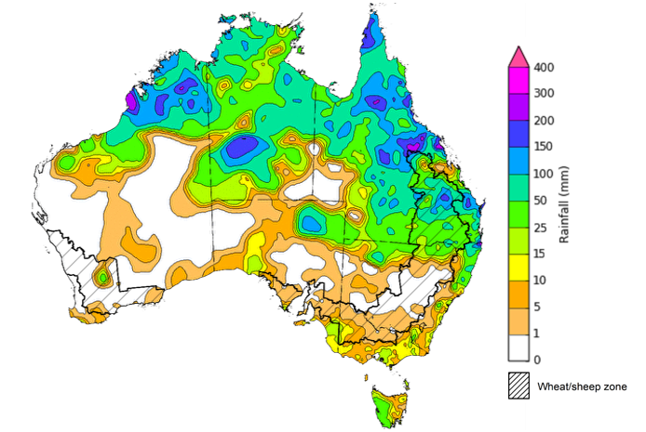
©Commonwealth of Australia 2026, Australian Bureau of Meteorology Issued: 18/2/2026
Note: The rainfall analyses and associated maps utilise data contained in the Bureau of Meteorology climate database, the Australian Data Archive for Meteorology (ADAM). The analyses are initially produced automatically from real-time data with limited quality control. They are intended to provide a general overview of rainfall across Australia as quickly as possible after the observations are received. For further information go to http://www.bom.gov.au/climate/rainfall/

Rainfall forecast for the next eight days
Over the 8 days to 26 February 2025, low-pressure systems are expected to bring rainfall to northern, central, and southeastern Australia:
- Falls of between 25-150 millimetres are forecast for large parts of northern Australia, with the parts of the Northern Territory and northern Queensland likely to see up to 200 millimetres. Much of South Australia is also forecast to receive falls of between 25-150 millimetres.
  - Across the northeast of the Australia these expected heavy fall coincided with numerous new flood warning areas and if realised these falls are likely to exacerbate exiting flooding and slow recovery efforts.
  - Outside of flood affected regions, if realised these substantial falls across northern and eastern Australia are likely to support soil moisture levels, replenish water supplies and boost pasture availability and benefit the growth of summer crops.
- Between 5-25 millimetres are forecast for southeast Queensland and northern New South Wales, as well as southwest Western Australia. In contrast, much of southern New South Wales, Victoria, and Tasmania is forecast to see 15-50 millimetres.
Rainfall totals across cropping regions over the coming week are forecast to be high in the south, with exceptions in Western Australia:
- Low rainfall totals (1-10 millimetres) are forecast for Western Australia, northern New South Wales and much of Queensland, however, isolated areas in northern Queensland are expected to see up to 100 millimetres.
  - In northern New South Wales and much of Queensland these conditions are likely to contribute to a drawdown of soil moisture to support the growth of later sown summer crops, but will allow of an uninterrupted harvest of earlier sown summer crops.
- South Australia, Victoria, and southern New South Wales are forecast to see 25-50 millimetres of rainfall over the period.
  - These falls are likely to contribute to a build-up of soil moisture following are relative dry summer to date and benefit the growth of summer active pastures.

Total forecast rainfall for the period 19 February to 26 February 2026
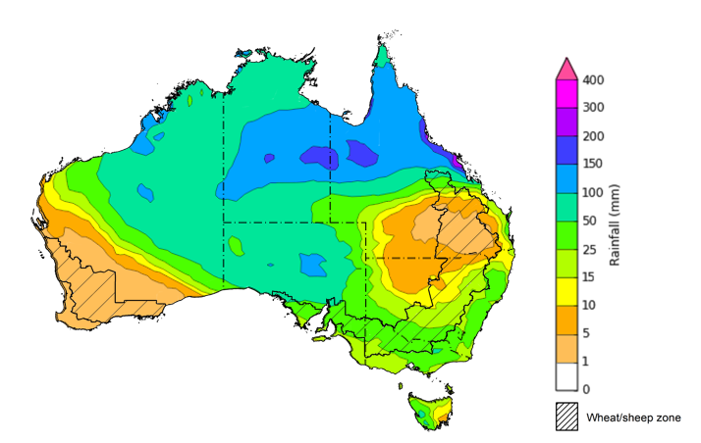
©Commonwealth of Australia 2026, Australian Bureau of Meteorology Issued 19/2/2026
Note: This rainfall forecast is produced from computer models. As the model outputs are not altered by weather forecasters, it is important to check local forecasts and warnings issued by the Bureau of Meteorology.

January precipitation percentiles and current production conditions
Crop production is affected by long-term trends in average rainfall and temperature, interannual climate variability, shocks during specific growth stages, and extreme weather events. Some crops are more tolerant than others to certain types of stresses, and at each growth stage, different types of stresses affect crop species in different ways.
Precipitation anomalies and outlooks presented below indicate the current and expected future production conditions for major grain and oilseed producing countries (responsible for over 80% of global crop production). This is an important input to assessing the global grain supply outlook.
Precipitation in January 2026 was variable across the world’s major grain- and oilseed-producing regions:
- In the northern hemisphere, precipitation was above average in much of central Europe, with exceptions in the north and south, Ukraine the west of the Russian Federation. Below average precipitation occurred across large areas of the northern and eastern United States, and southern China. Precipitation was generally average across the remaining major northern hemisphere grain- and oilseed-producing regions.
- In the southern hemisphere, precipitation was below average across much of Argentina and South Africa, parts of central Brazil and southern and western Australia. Precipitation was above average across parts of northern New Zealand and northern Australia. Precipitation was generally average across the remaining major southern hemisphere grain- and oilseed-producing regions.

Global precipitation percentiles, January 2026

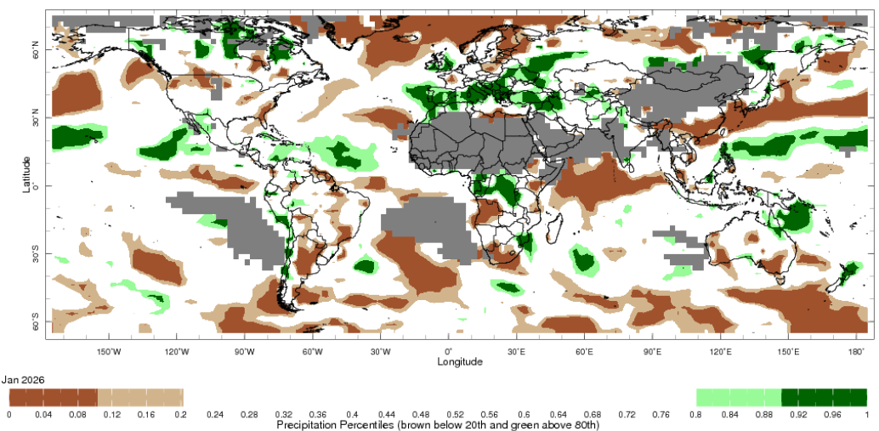

Note: The world precipitation percentiles indicate a ranking of precipitation for November, with the driest (0th percentile) being 0 on the scale and the wettest (100th percentile) being 1 on the scale. Percentiles are based on precipitation estimates from the NOAA Climate Prediction Center’s Climate Anomaly Monitoring System Outgoing Precipitation Index dataset. Precipitation estimates for November are compared with rainfall recorded for that period during the 1981 to 2010 base period.
Source: International Research Institute for Climate and Society
As of 28 January 2026, global production conditions were generally favourable for maize, rice and soybeans, but more variable for wheat:
- Wheat – In the northern hemisphere, crops for harvest in 2026-27 are in winter dormancy, with isolated areas in North America and Europe at risk of winterkill due to a lack of snow cover and recent freeze events.
- Maize – In the southern hemisphere, favourable conditions are supporting cropping in South Africa as well as Brazil and much of Argentina, however there are some areas of production concerns in Argentina due to recent hot and dry conditions. In the northern hemisphere, harvesting has largely concluded. In India development of the Rabi crop is continuing under favourable conditions.
- Rice – Global conditions are broadly favourable for major rice production regions, with exceptions in parts of Southeast Asia, including the Philippines and parts of Thailand which are experiencing poor conditions due to high rainfall.
- Soybeans – In the southern hemisphere, conditions have been supporting the beginning of the harvest in Brazil, while sowing concludes in Argentina with some western regions seeing low rainfall.
Crop conditions, AMIS countries, 28 January 2026
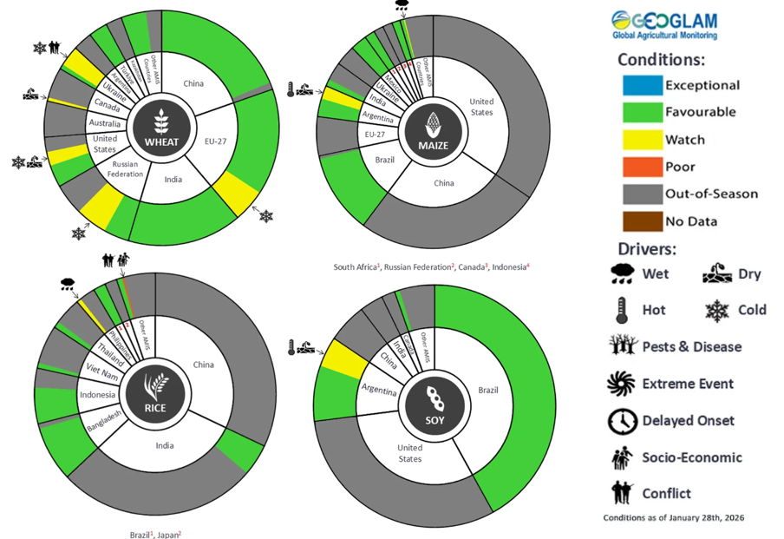
AMIS Agricultural Market Information System.
Source: AMIS

The global climate outlook for March 2026 to May 2026 indicates that mixed rainfall conditions are expected for the world’s major grain-producing and oilseed-producing regions. Outlooks and potential production impacts for major grain- and oilseed-producing countries are presented in the following table.
Rainfall outlook and potential impact on the future state of production conditions, March 2026 - May 2026
Region | Rainfall outlook | Potential impact on production
Argentina | Below average rainfall is likely across parts of northern and southern Argentina, with above average rainfall more likely in central areas. | Below average rainfall is likely to reduce the yield potential of major crops, including sorghum, rice, millet, soybeans, and corn which are undergoing grain filling and maturing.
Black Sea Region | Above average rainfall is expected across western Ukraine and parts of the south of the Russian Federation. | Above average rainfall is likely to support the heading and grain development of wheat and canola in Ukraine, Türkiye, and the Russian Federation.
Brazil | Rainfall outcomes across Brazil are expected to be broadly below average, with exceptions in the southeast. | Below average expected rainfall in parts of southern Brazil may impair the flowering of cotton, and the silking of corn.
Canada | Precipitation across Canada is expected to be mixed, with broadly average conditions and areas of both below and above average precipitation in southern regions. | Average precipitation is likely to provide sufficient snowpack to prevent winterkill of winter wheat in December through to February.
China | Below average rainfall is expected across parts of eastern and northern China, with average falls expected elsewhere. | Drier than average conditions in eastern and northern regions may impact the heading of canola, wheat, and rice.
European Union | Average precipitation is more likely for much of the European Union, with isolated eastern areas and parts of the United Kingdom to see below average falls. | Average precipitation across much of the European Union is likely to support the heading of wheat in March and April.
South Asia (India) | Below average rainfall is expected across parts of western India, while above average rainfall is expected in northern and eastern regions. | Anticipated rainfall is likely to support the harvesting and maturation of wheat and canola.
Southeast Asia (SEA) | Below average rainfall is likely across much of Southeast Asia. | Below average rainfall in SEA is likely to support the planting of crops, but impede development outcomes.
The United States | Below average rainfall is likely for much of south-western and central United States, with above average rainfall more likely across the east. | Below average to average rainfall conditions expected across southern US is likely to reduce soil moisture before the heading of winter wheat, but support planting of corn and soybeans in May.

Climate and price impacts on broadacre farm profits
The Australian Agricultural Drought Indicators (AADI) project combines climate and economic modelling to produce monthly forecasts of broadacre farm profits. The AADI profit (climate and prices) indicator brings together forecast seasonal conditions (using Bureau of Meteorology climate data) and commodity prices (drawn from the quarterly ABARES Agricultural Commodities). This indicator provides the most accurate representation of forecast farm profits, presented as percentiles relative to the last 33 years (which provide a long-term historical benchmark). For more information, see Australian Agricultural Drought Indicators.
Australian broadacre farm business profits are forecast to be well above average across much of Australia in 2025–26, tracking at the 89th percentile of the last 33 years. This positive outlook extends across Queensland, the northern tropics, west Western Australia, eastern and western New South Wales and the southern regions of Victoria.
Broadacre farm business profit indicator, 2025–26
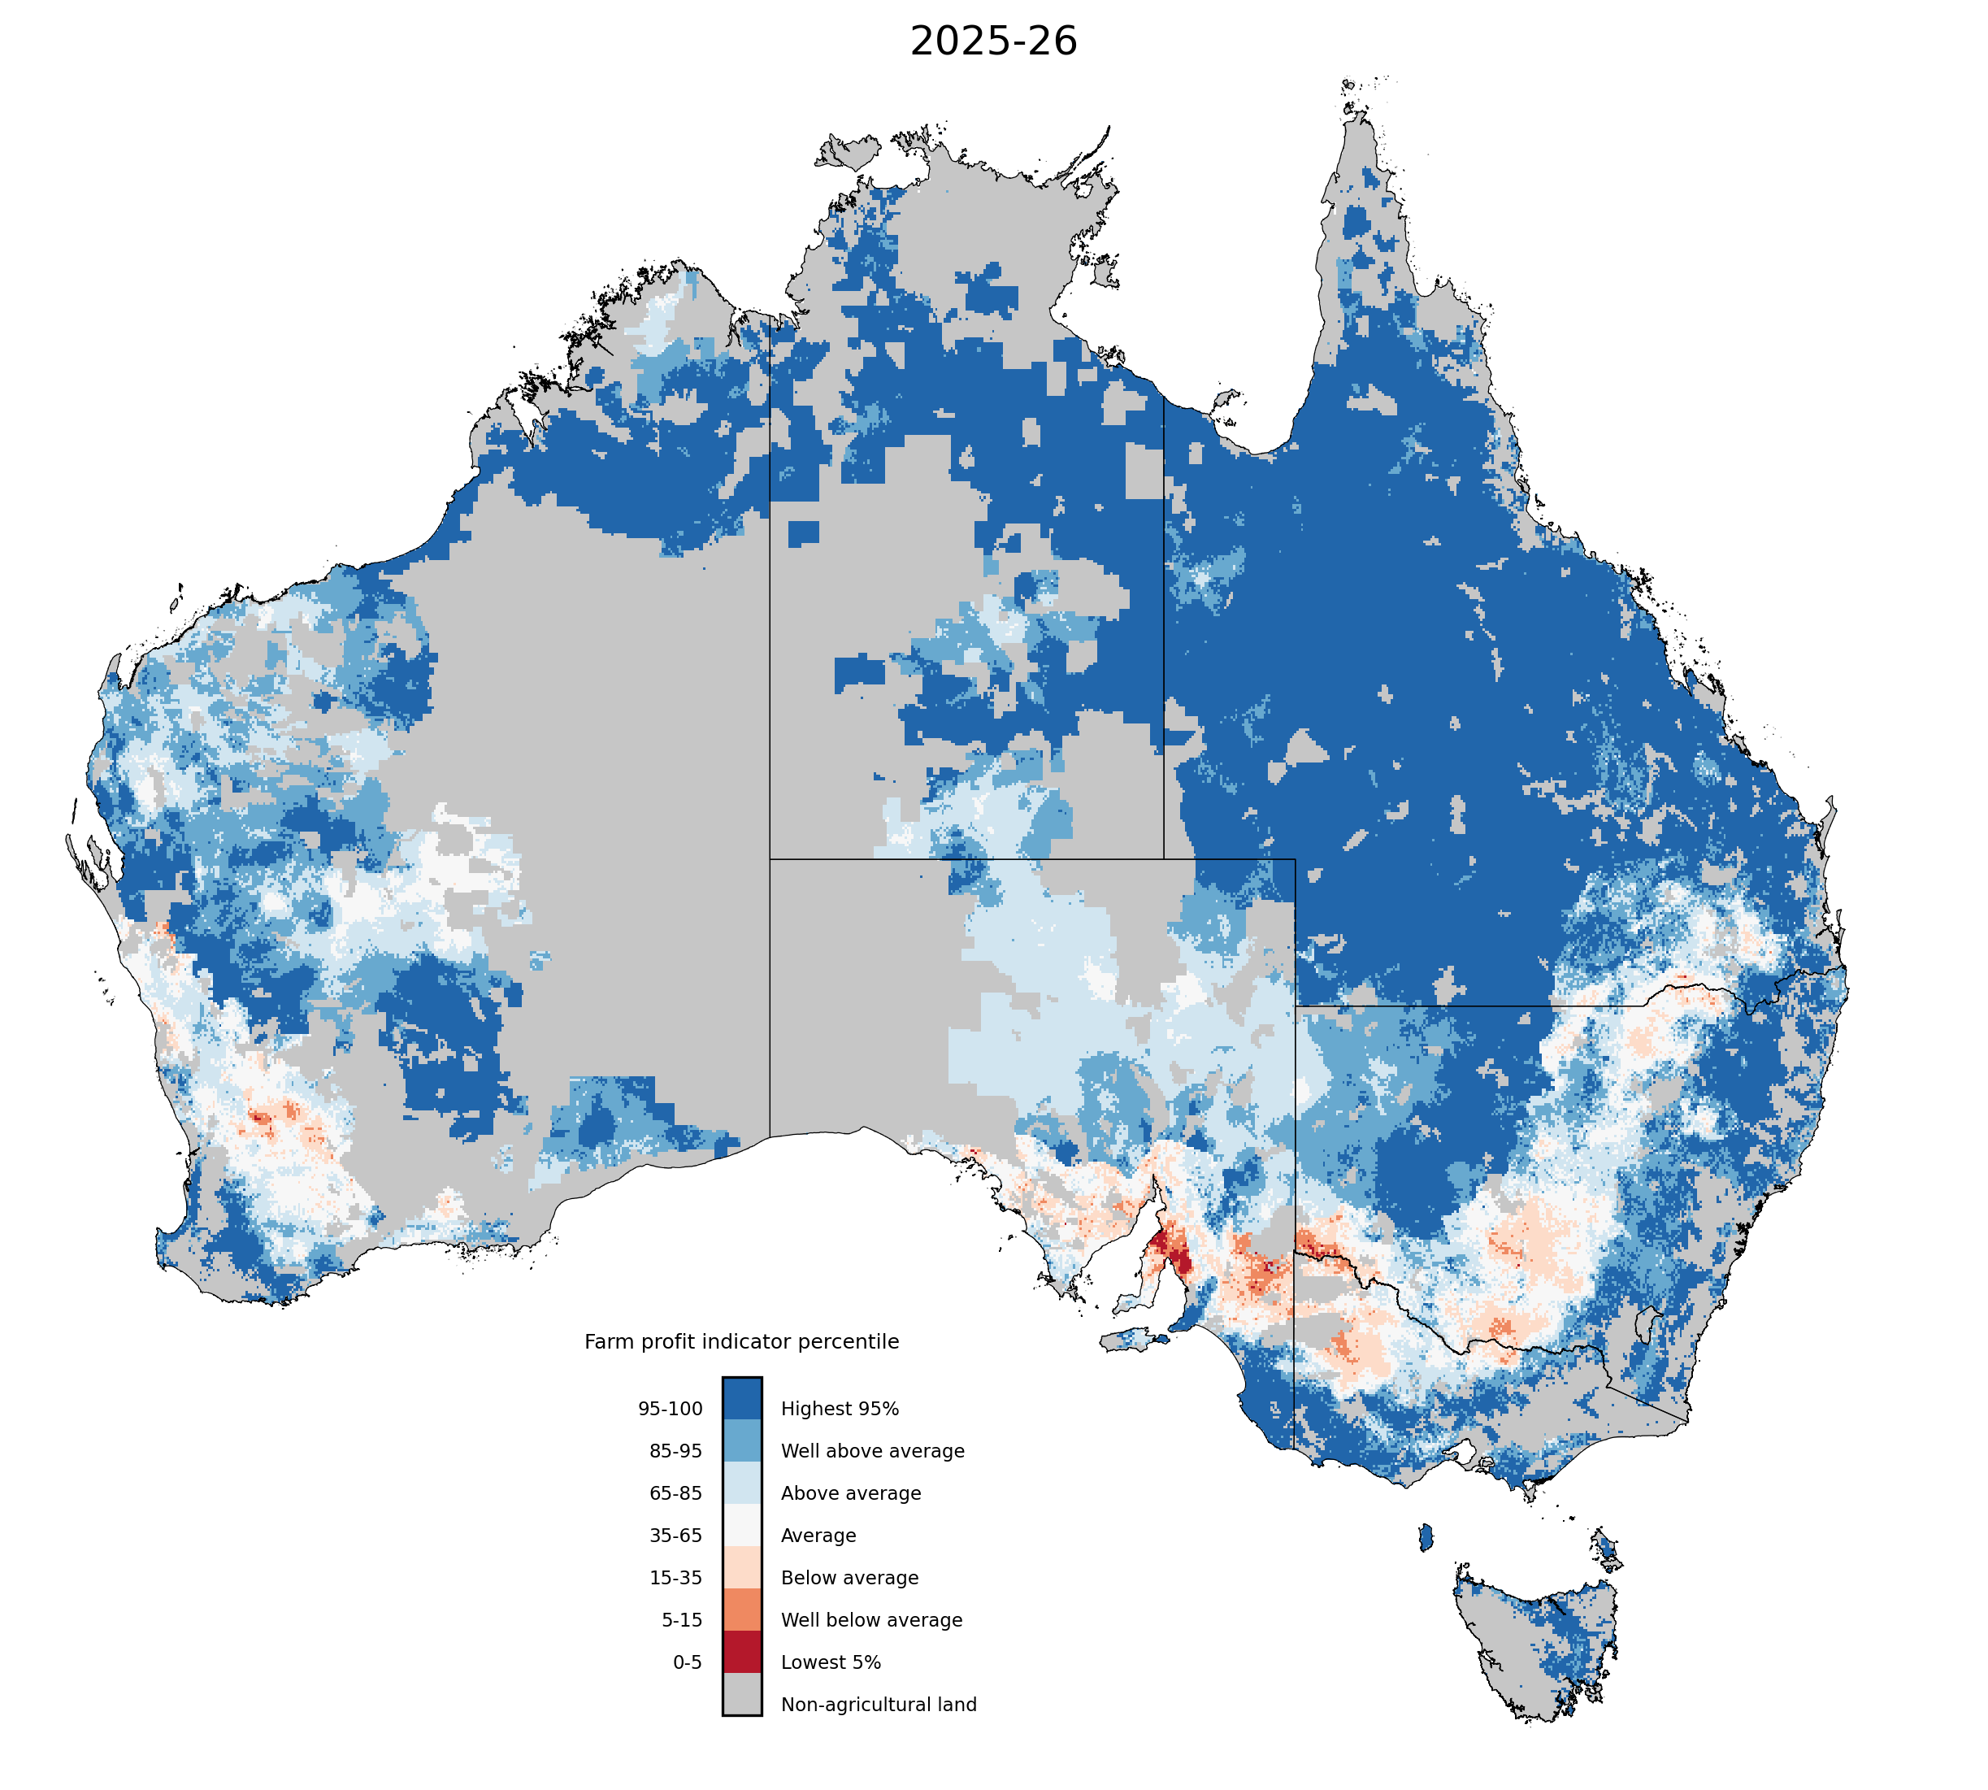

Note: The percentile ranges cover the forecast profitability of broadacre farms in 2025–26 based on forecast climate conditions and prices and current farm characteristics. They are calculated compared to simulated farm performance over the past 33 years, based on historical climate conditions and prices.

Source: ABARES farmpredict; AADI
The interplay between climate and price drivers is also creating distinct regional outcomes:
- The strongest forecast broadacre farm business profits are concentrated in the Northern Territory and Queensland, both tracking at the 98th percentile. Here, favourable conditions are aligning with strong market prices to lead to historically high farm business profits.
- In southern cropping regions, specifically South Australia, western Victoria. southern New South Wales, and parts of Western Australia, less favourable climatic conditions have constrained production outcomes. However, the strength of commodity prices are acting to somewhat buffer lower production. For example, in South Australia, where the forecast broadacre farm business profits are the lowest nationwide, the Profit (Climate and Prices) indicator for the state remains at the 64th percentile ("Average"), significantly outperforming the underlying poor climatic conditions.
These projections are consistent with the broader farm performance forecasts for 2025–26 outlined in the December quarter ABARES Agricultural Commodities report.
Conditions as of February 2026 are expected to be broadly above average, with significant regionally variability:
- Profit (climate and price impacts) is forecast to be lowest in South Australia (above average at 67th percentile), and second lowest in Western Australia (above average at 78th percentile).
- Profit (climate and price) is forecast to be highest in Northern Territory (highest at 98th percentile), and second highest in Queensland (highest at 98th percentile).

Australian Agricultural and Grazing Industries Survey (AAGIS) Wheat-sheep and High rainfall regions profit (climate and price) forecast – Lowest performing 5 regions 2025–26
AAGIS Wheat-sheep and High rainfall regions^ | Regional profit forecast 2024–25* (percentile ranking) | Regional profit forecast 2025–26* (percentile ranking) | Percentage of region experiencing Very Much Below Average profits in 2025–26 (%)**
SA: Murray Lands and Yorke Peninsula | 1 | 13 | 43
NSW: Riverina | 53 | 20 | 16
SA: South East | 6 | 35 | 14
SA: Eyre Peninsula | 12 | 32 | 8
VIC: Southern and Eastern Victoria | 16 | 48 | 5
Note: ^Displaying AAGIS Wheat-sheep and High rainfall regions sorted by lowest values in "FY26 *Percentile values for specified financial year. **Percentage of area in region where conditions are Very Much Below Average (less than 15th percentile).

Water markets – current week
Water storage levels in the Murray-Darling Basin (MDB) decreased by 216 gigalitres (GL) between 12 February 2026 and 19 February 2026. The current volume of water held in storages is 10,884 GL, equivalent to 49% of total storage capacity. This is 20% or 2,777 GL less than the same time last year. Water storage data is sourced from the Bureau of Meteorology.

Water storages in the Murray-Darling Basin, 2013–2026
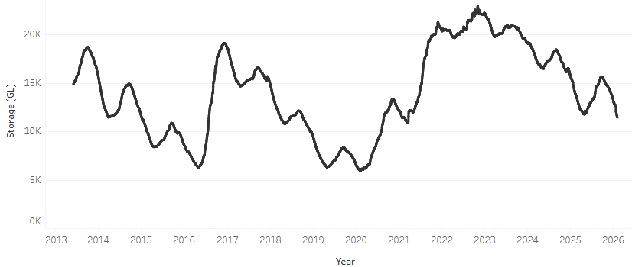
Allocation prices in the Victorian Murray below the Barmah Choke increased from $466/ML on 12 February 2026 to $541/ML on 19 February 2026. Trade from the Goulburn to the Murray is closed. Trade downstream through the Barmah Choke is closed. Trade from the Murrumbidgee to the Murray is open.

Water market prices, Southern Murray–Darling Basin

Region | $/ML
NSW Murray Above | 338
NSW Murrumbidgee | 471
Vic Greater Goulburn | 383
Vic Murray Below | 541

Note: The water allocation prices shown are volume weighted average prices based on the last 10 trades. Price data is sourced from Waterflow and current as at 22 January 2026.
To access the full, interactive, weekly water dashboard, which contains the latest and historical water storage, water market and water allocation information, please visit https://www.agriculture.gov.au/abares/products/weekly_update/weekly-update-260219

Commodities
Indicator | Week average | Unit | Latest Price | Previous Week | Weekly change |  | Price 12 months ago | Annual change
Selected world indicator prices
AUD/USD Exchange rate | 18-Feb | A$/US$ | 0.71 | 0.71 | 0% | 0.63 |  | 12%
Wheat – US no. 2 hard red winter wheat, FOB Gulf | 18-Feb | US$/t | 252 | 257 | -2% | 264 |  | -4%
Corn – US no. 2 yellow corn, FOB Gulf | 18-Feb | US$/t | 208 | 211 | -1% | 222 |  | -6%
Canola – Rapeseed, Canada, FOB Vancouver | 18-Feb | US$/t | 518 | 524 | -1% | 499 |  | 4%
Cotton – Cotlook A Index | 18-Feb | USc/lb | 73.8 | 73.3 | 1% | 78.1 |  | -6%
Sugar – Intercontinental Exchange, nearby futures, no.11 contract | 18-Feb | USc/lb | 13.5 | 13.6 | -1% | 19.5 |  | -31%
Wool – Eastern Market Indicator | 11-Feb | Ac/kg clean | 1,693 | 1,677 | 1% | 1,197 |  | 41%
Wool – Western Market Indicator | 11-Feb | Ac/kg clean | 1,894 | 1,878 | 1% | 1,350 |  | 40%
Selected Australian grain export prices
Australian Premium White (APW) Wheat, FOB Port Adelaide, SA | 18-Feb | A$/t | 345 | 343 | 1% | 409 |  | -15%
Australian Standard White (ASW) Wheat, FOB Port Adelaide, SA | 18-Feb | A$/t | 341 | 339 | 1% | 399 |  | -14%
Feed Barley – FOB Port Adelaide, SA | 18-Feb | A$/t | 341 | 337 | 1% | 370 |  | -8%
Canola – FOB Kwinana, WA | 18-Feb | A$/t | 755 | 767 | -2% | 862 |  | -12%
Grain Sorghum – FOB Brisbane, QLD | 18-Feb | A$/t | 426 | 425 | 0% | 412 |  | 3%
Selected domestic livestock indicator prices
Beef – Eastern Young Cattle Indicator | 18-Feb | Ac/kg cwt | 854 | 849 | 1% | 652 |  | 31%
Mutton – Mutton indicator (18–24 kg fat score 2–3), VIC | 18-Feb | Ac/kg cwt | 770 | 757 | 2% | 362 |  | 113%
Lamb – National Trade Lamb Indicator | 18-Feb | Ac/kg cwt | 1,098 | 1,109 | -1% | 773 |  | 42%
Pig – Eastern Seaboard (60.1–75 kg), NSW buyer price | 28-Jan | Ac/kg cwt | 469 | 468 | 0% | 452 |  | 4%
Live cattle – Light steers to Indonesia | 18-Feb | Ac/kg lwt | 480 | 480 | 0% | 356 |  | 35%
Global Dairy Trade (GDT) weighted average prices
Dairy – Whole milk powder | 18-Feb | US$/t | 3,706 | 3,614 | 3% | 4,161 |  | -11%
Dairy – Skim milk powder | 18-Feb | US$/t | 2,973 | 2,874 | 3% | 2,795 |  | 6%
Dairy – Cheddar cheese | 18-Feb | US$/t | 4,736 | 4,772 | -1% | 4,944 |  | -4%
Dairy – Anhydrous milk fat | 18-Feb | US$/t | 6,751 | 6,524 | 3% | 6,745 |  | 0%

Selected world indicator prices
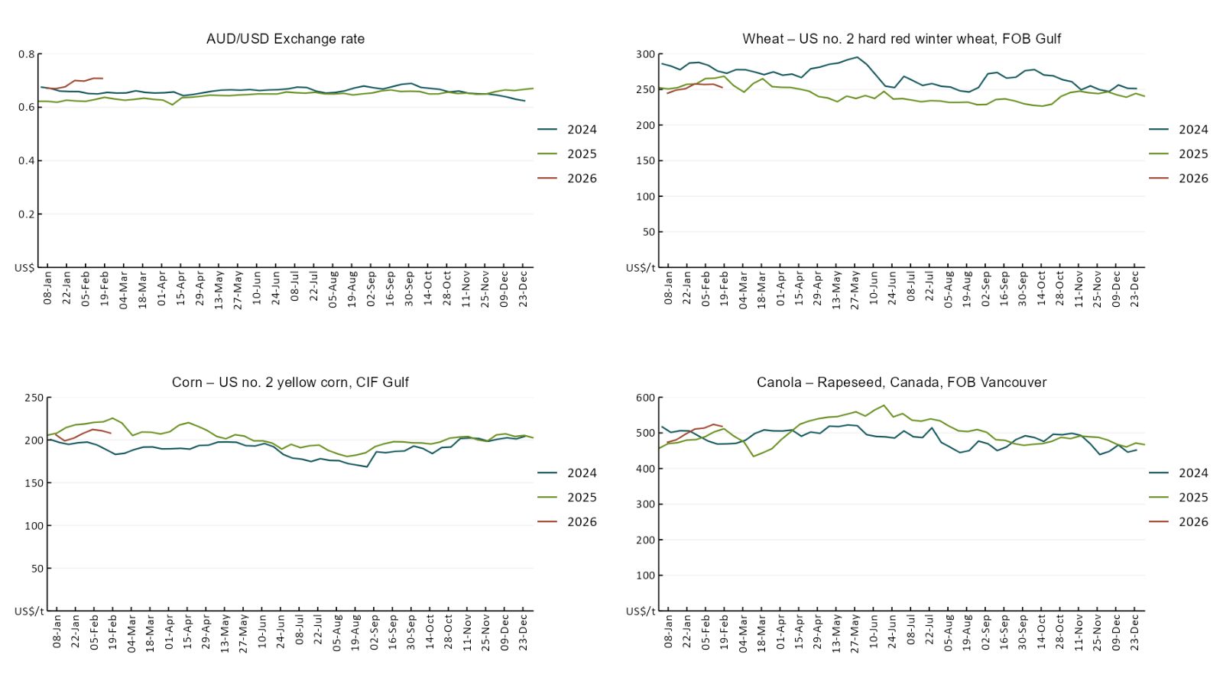

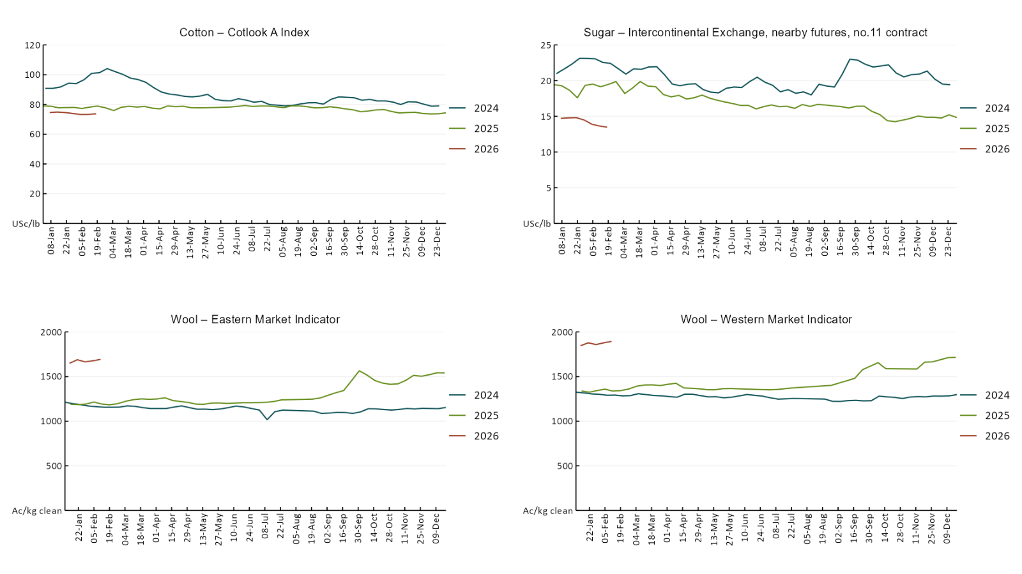

3.2 Selected domestic crop indicator prices
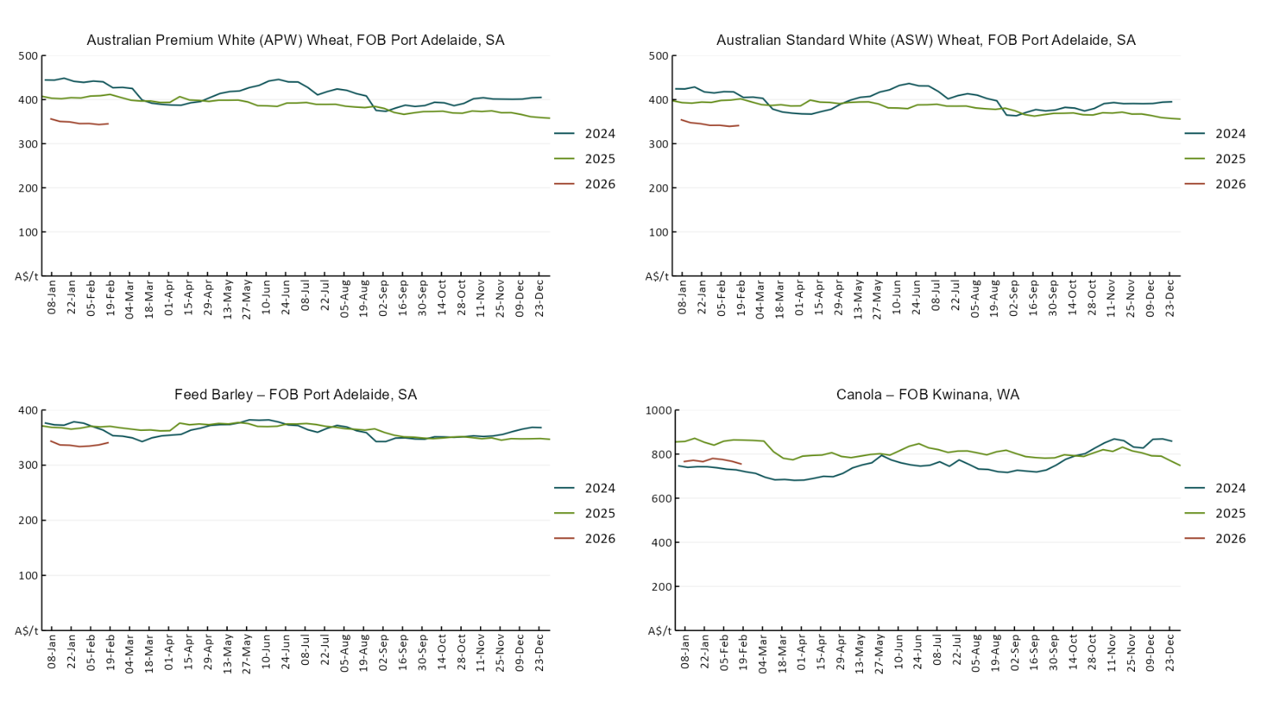

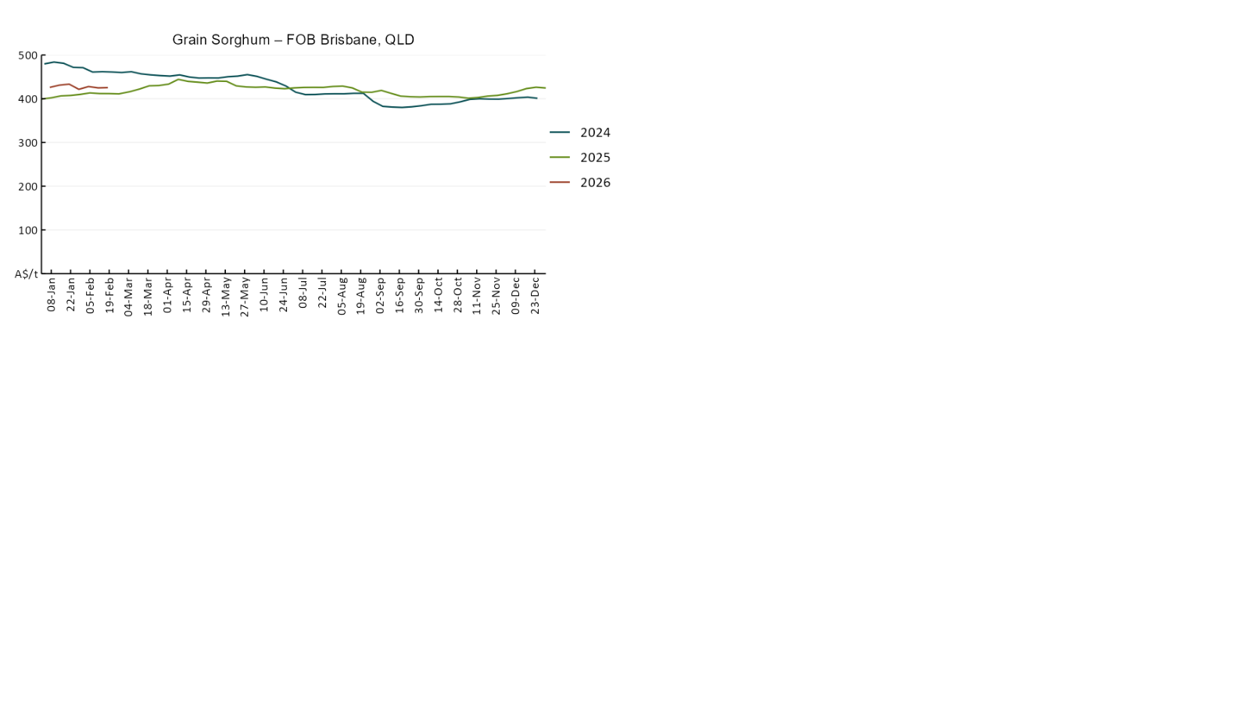

3.3 Selected domestic livestock indicator prices
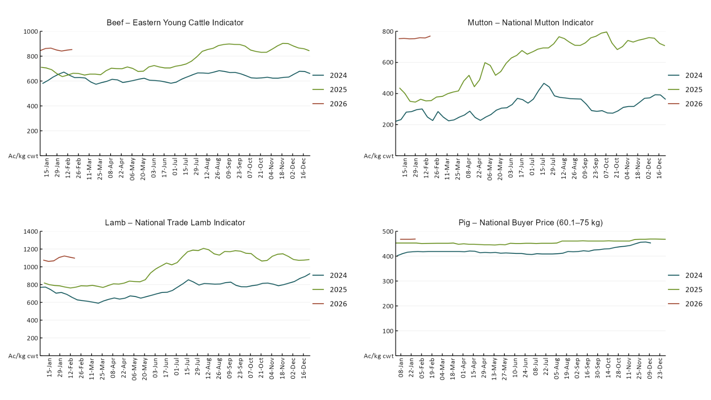
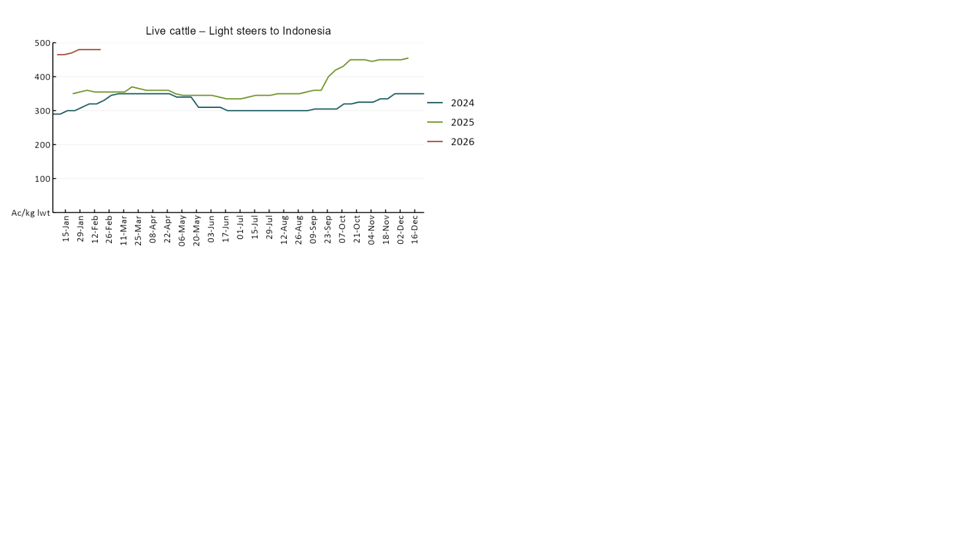

3.4 Global Dairy Trade (GDT) weighted average prices
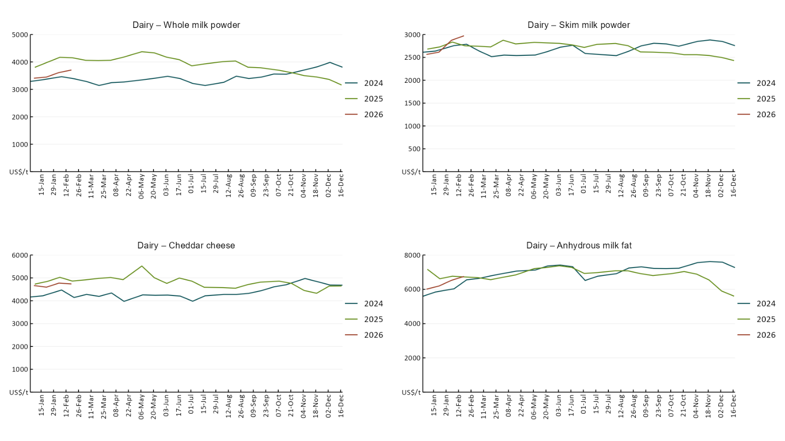

3.5 Selected fruit and vegetable prices
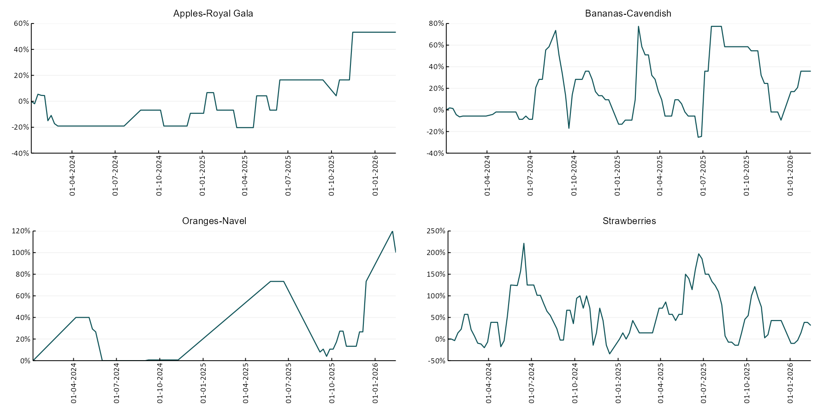
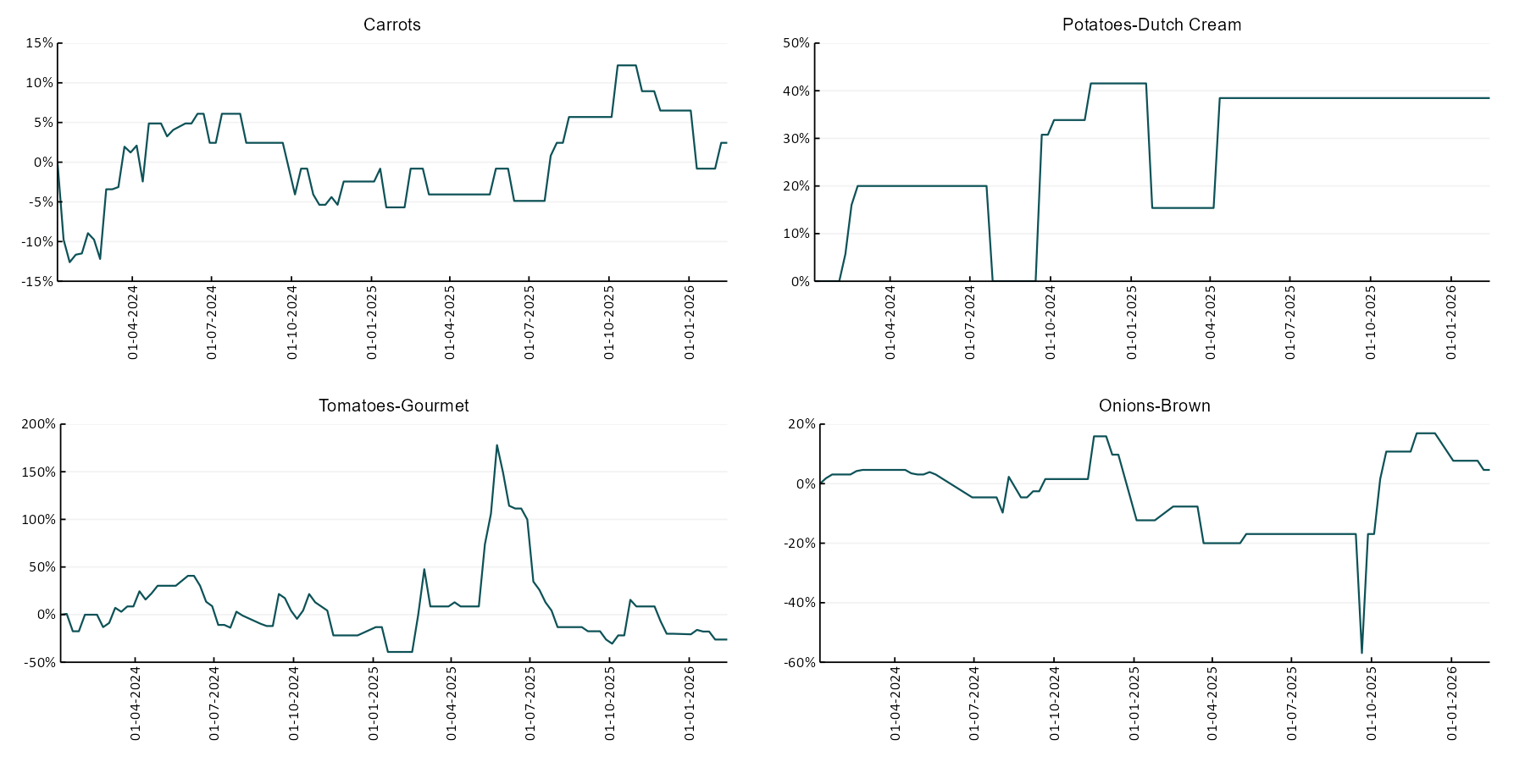

3.6 Selected domestic fodder indicator prices
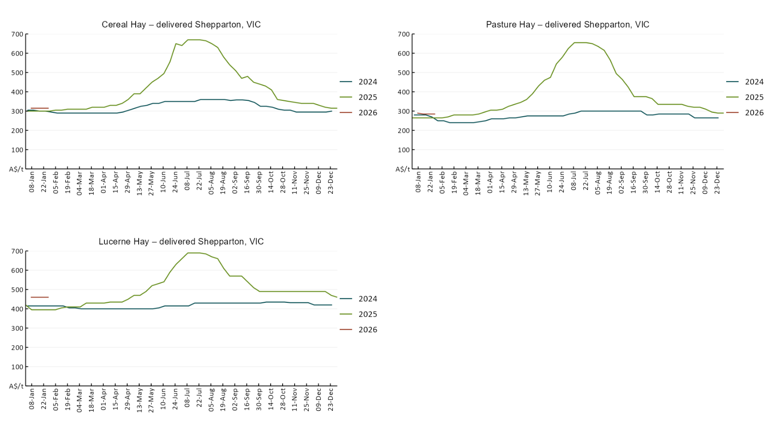

4. Data attribution

Climate
Bureau of Meteorology
- Weekly rainfall totals: www.bom.gov.au/climate/maps/rainfall/
- Monthly and last 3-month rainfall percentiles: https://www.bom.gov.au/climate/ahead/outlooks/#moreMaps
- Rainfall forecast: www.bom.gov.au/jsp/watl/rainfall/pme.jsp
- Seasonal outlook: www.bom.gov.au/climate/outlooks/#/overview/summary/
- Climate drivers: http://www.bom.gov.au/climate/enso/
- Soil moisture: https://awo.bom.gov.au/products/historical/soilMoisture-rootZone/

Other
- Pasture growth: www.longpaddock.qld.gov.au/aussiegrass/
- 3-month global outlooks: Environment and Climate Change Canada, NOAA Climate Prediction Center, EUROBRISA CPTEC/INPE, European Centre for Medium-Range Weather Forecasts, Hydrometcenter of Russia, National Climate Center Climate System Diagnosis and Prediction Room (NCC), International Research Institute for Climate and Society
- Global production: https://ipad.fas.usda.gov/ogamaps/cropmapsandcalendars.aspx
- Autumn break: Pook et al., 2009, https://rmets-onlinelibrary-wiley-com.virtual.anu.edu.au/doi/epdf/10.1002/joc.1833

Water
Prices
- Waterflow: https://www.waterflow.io/
- Ruralco: https://www.ruralcowater.com.au/
- Bureau of Meteorology:
- Allocation trade: http://www.bom.gov.au/water/dashboards/#/water-markets/mdb/at
- Storage volumes: http://www.bom.gov.au/water/dashboards/#/water-storages/summary/drainage

Trade constraints:
- Water NSW: https://www.waternsw.com.au/customer-service/ordering-trading-and-pricing/trading/murrumbidgee
- Victorian Water Register: https://www.waterregister.vic.gov.au/TradingRules2019/

Commodities
Fruit and vegetables
- Datafresh: www.freshstate.com.au

Pigs
- Australian Pork Limited: www.australianpork.com.au

Dairy
- Global Dairy Trade: www.globaldairytrade.info/en/product-results/

World wheat, canola
- International Grains Council
- https://www.igc.int/en/default.aspx
- United States Department of Agriculture

World cotton
- Cotlook: www.cotlook.com/

World sugar
- New York Stock Exchange - Intercontinental Exchange

Wool
- Australian Wool Exchange: www.awex.com.au/

Domestic wheat, barley, sorghum, canola and fodder
- Jumbuk Consulting Pty Ltd: Jumbuk AG | Agriculture Consulting

Cattle, beef, mutton, lamb, goat and live export
- Meat and Livestock Australia: https://www.mla.com.au/prices-markets/

Australian Agricultural Drought Indicators
About Australian Agricultural Drought Indicators
The Australian Agricultural Drought Indicators (AADI) links weather and agricultural data with a range of scientific and economic models to measure and forecast the effects of climate variability and drought on agricultural outcomes.
On AADI, projected broadacre farm profits are presented as percentile outcomes relative to simulated historical outcomes using the groupings:
Highest | 95-100th percentile
Very much above average | 85-95th percentile
Above average | 65-85th percentile
Average | 35-65th percentile
Below average | 15-35th percentile
Very much below average | 5-15th percentile
Lowest 5% | 0-5th percentile

There are two AADI farm profit indicators:
- The AADI farm profit climate and price indicator shows the effect of climate and prices on broadacre farm business profits of current farms compared to the last 33 years.
- The AADI farm profit climate only indicator isolates the effect of climate on profits by holding prices fixed.

© Commonwealth of Australia 2026

Ownership of intellectual property rights
Unless otherwise noted, copyright (and any other intellectual property rights, if any) in this publication is owned by the Commonwealth of Australia (referred to as the Commonwealth).

Creative Commons licence
All material in this publication is licensed under a Creative Commons Attribution 4.0 International Licence except content supplied by third parties, logos and the Commonwealth Coat of Arms.
Inquiries about the licence and any use of this document should be emailed to copyright@awe.gov.au.


Cataloguing data
This publication (and any material sourced from it) should be attributed as:
ABARES 2026, Weekly Australian Climate, Water and Agricultural Update, Australian Bureau of Agricultural and Resource Economics and Sciences, Canberra, 12 February 2026. CC BY 4.0 DOI: https://doi.org/10.25814/5f3e04e7d2503
ISSN 2652-7561
This publication is available at https://www.agriculture.gov.au/abares/products/weekly_update
Department of Agriculture, Fisheries and Forestry
GPO Box 858 Canberra ACT 2601
Telephone 1800 900 090
Web agriculture.gov.au/abares

Disclaimer
The Australian Government acting through the Department of Agriculture, Fisheries and Forestry, represented by the Australian Bureau of Agricultural and Resource Economics and Sciences, has exercised due care and skill in preparing and compiling the information and data in this publication. Notwithstanding, the Department of Agriculture, Fisheries and Forestry, ABARES, its employees and advisers disclaim all liability, including liability for negligence and for any loss, damage, injury, expense or cost incurred by any person as a result of accessing, using or relying on any of the information or data in this publication to the maximum extent permitted by law.

Statement of Professional Independence
The views and analysis presented in ABARES publications, including this one, reflect ABARES professionally independent findings, based on scientific and economic concepts, principles, information and data. These views, analysis and findings may not reflect or be consistent with the views or positions of the Australian Government, or of organisations or groups who have commissioned ABARES reports or analysis. More information on professional independence is provided on the ABARES website.

Acknowledgements
This report was prepared by Holly Beale and Matthew Miller.

