
No. 8/2026 5 March 2026

Summary of key issues
- In the week ending 4 March 2026, low-pressure systems and tropical lows brought heavy rainfall to much of northern and central Australia
  - Severe weather and flood warnings remain in place throughout parts of the Northern Territory and Queensland, as well as South Australia and New South Wales. Flash flooding particularly in South Australia is set to result in major disruptions to supply chains, with freight operators warning of major delays across regional Australia after severe weather washed out key rail links, cutting off one of the nation’s most important east–west supply routes for weeks.
- Over the 8-days to 12 March 2026, rainfall is forecast for much of the north and southeast of Australia.
  - Low rainfall totals (1-10 millimetres) are forecast for cropping regions in Western Australia and South Australia, while Victoria is forecast to receive 5-15 millimetres.
  - Higher falls are forecast for much of New South Wales (10-50 millimetres) and Queensland (15- 150 millimetres), with falls higher in northern regions.
- Rainfall was highly variable across Australia during February 2026, with well above average rainfall across much of central and northern Australia. In contrast, parts of the east and west saw below average rainfall.
- Pasture growth for the three months to February 2026 has been mixed across Australia. Above average rainfall totals resulted in average to extremely high pasture growth across large parts of northern Australia. Below average to extremely low pasture growth was recorded across parts of eastern and western Australia.
- Soil moisture models indicate low soil moisture levels parts of eastern and southern Australia, with above average soil moisture modelled in the northern tropics and central Australia.
- Water storage levels in the Murray-Darling Basin (MDB) decreased by 44 gigalitres (GL) between 26 February 2026 and 5 March 2026. The current volume of water held in storages is 10,650 GL, equivalent to 48% of total storage capacity. This is 19% or 2,428 GL lower than the same time last year. Water storage data is sourced from the Bureau of Meteorology.
- Allocation prices in the Victorian Murray below the Barmah Choke decreased from $454/ML on 26 February 2026 to $445/ML on 5 March 2026. Trade from the Goulburn to the Murray is closed. Trade downstream through the Barmah Choke is closed. Trade from the Murrumbidgee to the Murray is open.

Climate

Rainfall this week
In the week ending 4 March 2026, low-pressure systems and tropical lows brought heavy rainfall to much of northern and central Australia, while cold fronts brought rainfall to parts of the southeast. Western areas and parts of the east remained largely dry.
- Many northern and some isolated inland regions continued to observe high rainfall totals, with much of the Northern Tropics, the south of the Northern Territory and western Queensland seeing falls of 25-200 millimetre, with some locations seeing falls of up to 400 millimetres. In the south, fall of between 15-150 millimetres were recorded across much of South Australia and Victoria and western and southern New South Wales, with some locations seeing falls in excess of 150 millimetres.
  - Severe weather and flood warnings remain in place throughout parts of the Northern Territory and Queensland, as well as South Australia and New South Wales. Flash flooding particularly in South Australia is set to result in major disruptions to supply chains, with freight operators warning of major delays across regional Australia after severe weather washed out key rail links, cutting off one of the nation’s most important east–west supply routes for weeks.
- Much of southern Western Australia, northern New South Wales and southeast Queensland remained largely dry.
Across cropping regions, rainfall was mixed, with some southern areas seeing considerable falls:
- Much of Victoria and South Australia saw falls of between 50-150 millimetres. In southern New South Wales, between 15-100 millimetres were observed.
  - These falls are expected to support soil moisture storage and benefit pasture production across south-eastern cropping areas.
- In Western Australia, much of Queensland and remaining areas in New South Wales little to no rainfall was observed.

Rainfall for the week ending 4 March 2026
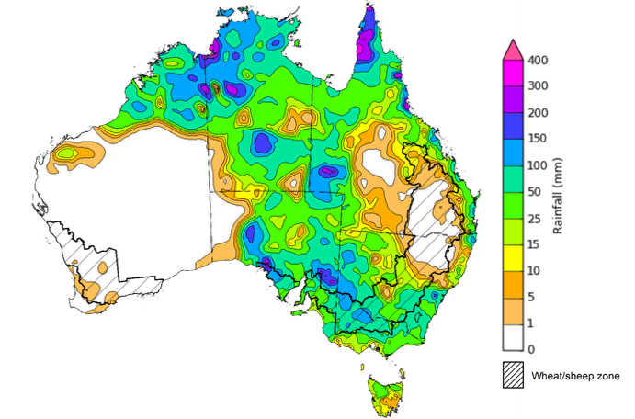
©Commonwealth of Australia 2026, Australian Bureau of Meteorology Issued: 4/3/2026
Note: The rainfall analyses and associated maps utilise data contained in the Bureau of Meteorology climate database, the Australian Data Archive for Meteorology (ADAM). The analyses are initially produced automatically from real-time data with limited quality control. They are intended to provide a general overview of rainfall across Australia as quickly as possible after the observations are received. For further information go to http://www.bom.gov.au/climate/rainfall/

Rainfall forecast for the next eight days
Over the 8 days to 12 March 2026, low-pressure systems and tropical lows are expected to bring rainfall to northern and south-eastern Australia:
- Falls of between 15-200 millimetres are forecast for large parts of northern Australia, with the parts of the Northern Territory and northern Queensland likely to see up to 300 millimetres.
  - If realised, these substantial falls across northern Australia are likely to support soil moisture levels, replenish water supplies and boost pasture availability.
  - However, heavy falls coincided with numerous current flood warning areas could continue to exacerbate exiting flooding and slow recovery efforts.
- Southern Queensland and north-eastern New South Wales are forecast to see falls of 15- 100 millimetres, while south-eastern areas of New South Wales and Tasmania are anticipated to see 10-50 millimetres. Victoria is forecast to record 10-25 millimetres over the period.
- In southern Western Australia and South Australia, little to no rainfall is expected
Rainfall totals across cropping regions over the coming week are forecast to be high in the east, and low in the west:
- Low rainfall totals (1-10 millimetres) are forecast for Western Australia and South Australia, while Victoria is forecast to receive 5-15 millimetres.
- Higher falls are forecast for much of New South Wales (10-50 millimetres) and Queensland (15- 150 millimetres), with falls higher in northern regions.
  - These falls are likely to contribute to a build-up of soil moisture ahead of the planting of 2026–27 winter crops and benefit the growth of pastures and late sown summer crops.

Total forecast rainfall for the period 5 March to 12 March 2026
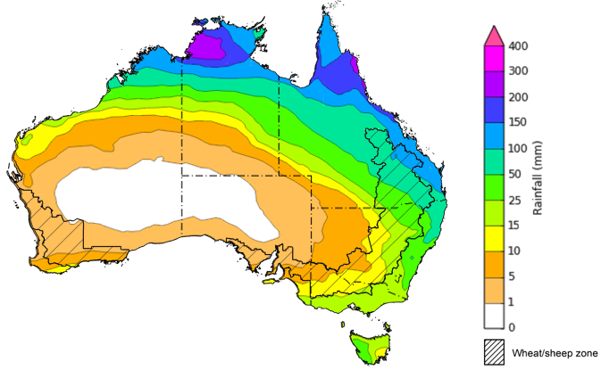
©Commonwealth of Australia 2026, Australian Bureau of Meteorology Issued 5/3/2026
Note: This rainfall forecast is produced from computer models. As the model outputs are not altered by weather forecasters, it is important to check local forecasts and warnings issued by the Bureau of Meteorology.

Monthly rainfall
- Rainfall during February 2026 was generally above average across Australia.
  - Numerous low pressure systems brought highest on record February rainfall totals to parts of central Australia contributed to widespread flooding across the Northern Territory, Queensland and South Australia, as well as parts of western New South Wales and Victoria.
  - This rain is likely to have varied impacts on agricultural production. At this stage there have been some additional reports of agricultural losses, such as table grapes in the Mildura region of Victoria. While this heavy rainfall and renewed flooding is likely to slow recovery efforts in previously flooded areas and lead to some short-term hardship for some producers, these falls are likely to provide significant longer-term benefits to pasture production.
- Below average to severely deficient rainfall was recorded in some isolated western and eastern areas, including the northwest and far southwest of Western Australia, parts of south-eastern Queensland and north-eastern New South Wales, and northern Tasmania.
In cropping regions, February rainfall was generally average to extremely high, with some below average falls in the east:
- February rainfall was below average to extremely low in parts of northern New South Wales, and broadly average across most remaining areas in the east regions. Southern cropping regions, including Victoria, South Australia, and much of Western Australia, saw average to extremely high rainfall for the period.
  - This above average rainfall outcome is likely to have supported pasture growth and soil moisture storage ahead of the winter cropping season.
Rainfall percentiles for February 2026
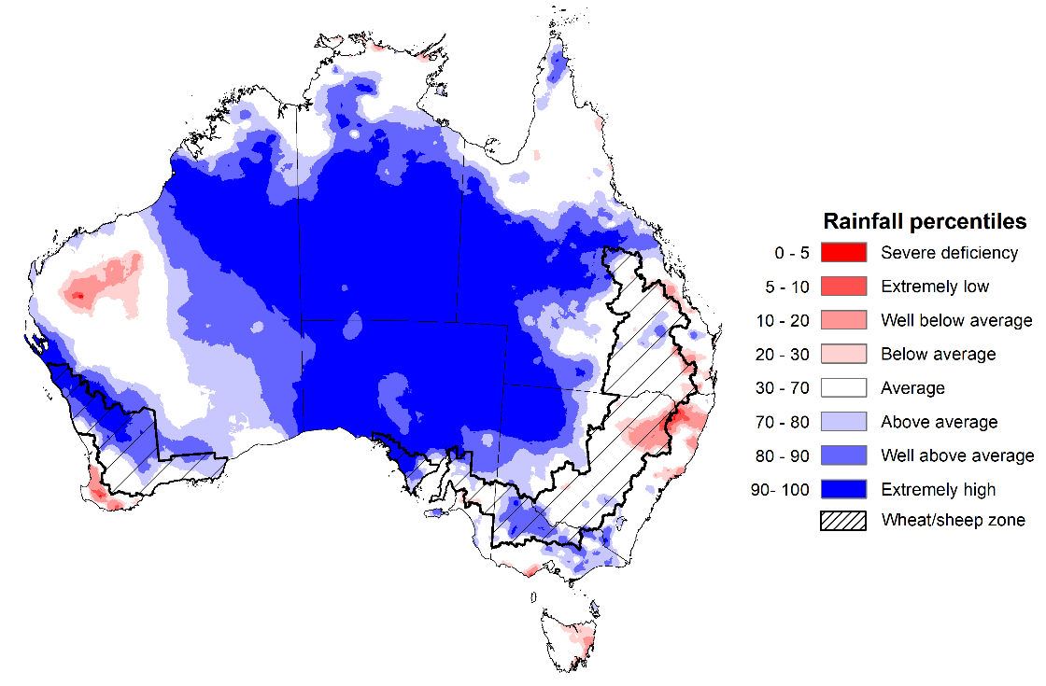
\
Note: Rainfall for February 2026 is compared with rainfall recorded for that period during the historical record (1900 to present). For further information, go to http://www.bom.gov.au/climate/austmaps/about-rain-maps.shtml
Source: Bureau of Meteorology

Monthly Soil Moisture
In February 2026, modelled upper layer soil moisture was generally average to above average in the northern, central, and southern parts of the country, with scattered areas of extremely low soil moisture in eastern and western regions.
- Parts of south-eastern Queensland, north-eastern New South Wales, central and southern Western Australia, and eastern Tasmania saw very much below average to below average upper layer soil moisture.
- In contrast, much of central and northern Australia, including the northern tropics, South Australia, Victoria and remaining areas in Queensland, New South Wales, and Western Australia saw average to very much above upper layer soil moisture.
At this time of year, upper layer soil moisture is important for late planted summer crops in northern New South Wales and Queensland and for pasture growth across northern Australia since plant growth utilises this moisture. It is also an important indicator of the ability to access paddocks for summer crop harvest activities.
Across cropping regions, modelled upper layer soil moisture in February for north-eastern cropping regions was generally average to below average, while southern cropping regions saw average to very much above average upper layer soil moisture.
Modelled upper layer soil moisture for February 2026
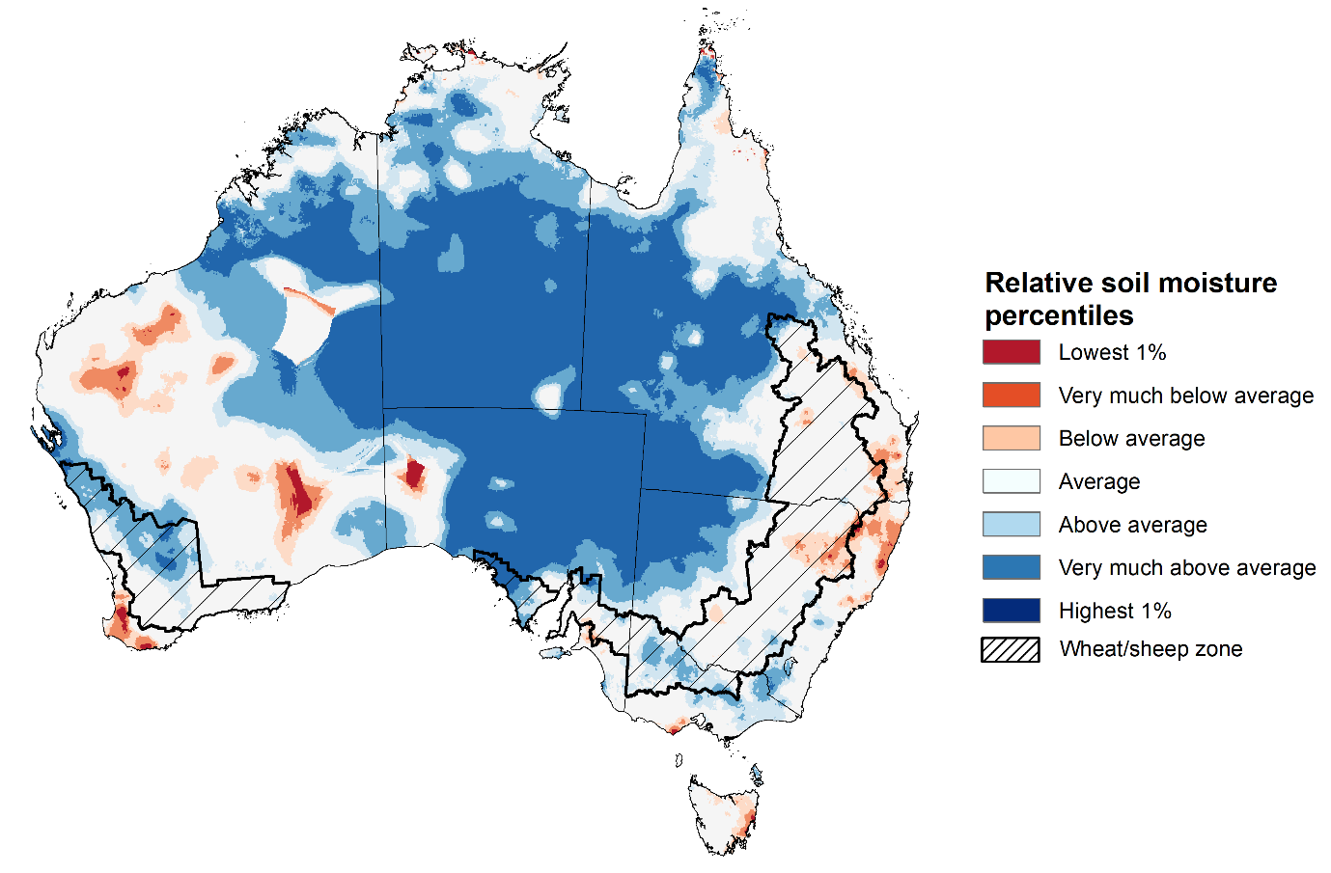

Note: This map shows the levels of modelled upper layer soil moisture (0 to 10 centimetres) during February 2026 This map shows how modelled soil conditions during February 2026 compare with February conditions modelled over the reference period (1911 to 2016). Dark blue areas on the maps were much wetter in February 2026 than during the reference period. The bulk of plant roots occur in the top 20 centimetres of the soil profile. Soil moisture in the upper layer of the soil profile is therefore useful indicator of the availability of water, particularly for germinating seed.
Source: Bureau of Meteorology (https://awo.bom.gov.au/about/overview)
Modelled lower layer soil moisture in February 2026 was average to very much above average across much of Australia, while extremely low to below average modelled lower layer soil moisture was evident across some eastern and southern areas. This represents an improvement from January 2026.
- Much of south-eastern Queensland, north-eastern New South Wales, southern Victoria, , Tasmania, central Western Australia, and parts of southern South Australia were modelled as having very much below average to below average soil moisture. By contrast, much of the northern tropics, northern South Australia, western Queensland and New South Wales, and southern Western Australia were modelled as having above average to very much above average soil moisture over the period.
At this time of year increased levels of lower layer soil moisture will be important to support summer crops and pasture growth during a peak growth period.
Most northern cropping regions in Queensland and New South Wales, as well as Victoria and South Australia, were modelled as having average to very much below average soil moisture. In contrast, Western Australia recorded average to very much above average soil moisture for this time of year.
In areas with average to above average lower layer soil moisture, this is likely to provide a reserve of plant-available water for summer crops later in the growing season. Agricultural regions across southern Australia have seen a significant improvement in soil moisture levels since the end of January 2026. This is likely to assist in arresting declining levels of pasture availability and provide a boost to soil moisture reserves ahead of planting of the 2026–27 winter crop.
Modelled lower layer soil moisture for February 2026
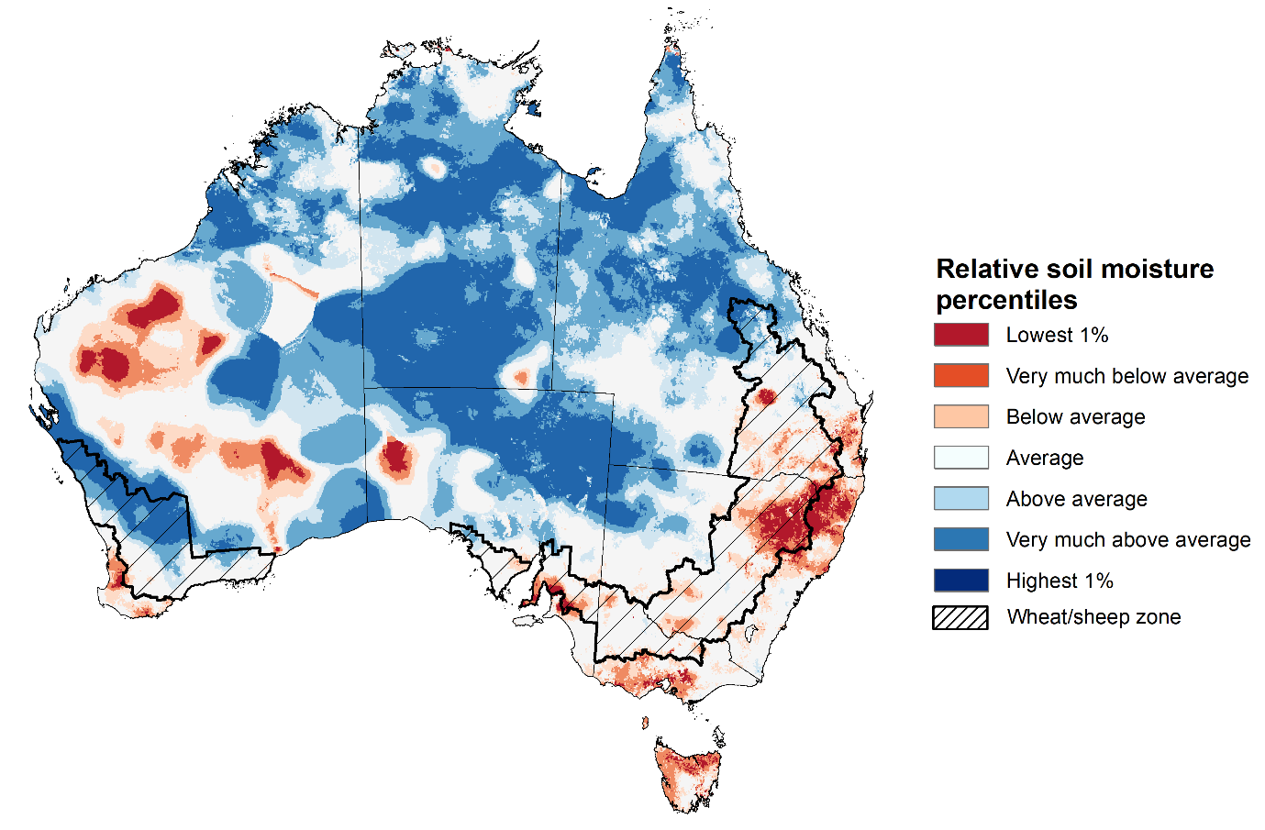
Note:. This map shows how modelled soil conditions during February 2026 compare with February conditions modelled over the reference period (1911 to 2016). Dark blue areas on the maps were much wetter in February 2026 than during the reference period. The dark red areas were much drier than during the reference period. The bulk of plant roots occur in the top 20 centimetres of the soil profile. The lower layer soil moisture is a larger, deeper store that is slower to respond to rainfall and tends to reflect accumulated rainfall events over longer time periods.
Source: Bureau of Meteorology (https://awo.bom.gov.au/about/overview)

Pasture Growth
The December to February period is the peak pasture growth period for northern Australia which typically provides the bulk of feed to maintain production through the low pasture growth months of the northern dry season. Across southern Australia, December to February pasture growth is typically low reflecting lower rainfall totals, high temperature and high evapotranspiration rates at this time of year. Pasture availability during this period influences the growth and branding and marking rates of lambs and calves, livestock turnoff and the production of meat, milk, and wool.
Pasture growth for the three months to February 2026 was variable across much of country, with much of northern and central Australia seeing robust pasture growth but below average growth was evident across large areas of eastern and western Australia.
- Average to extremely high relative pasture growth was modelled across large areas of northern and central Australia, as well as isolated south-eastern regions, including parts of the northern tropics, northern South Australia, the southern Northern Territory, western New South Wales and western Tasmania.
  - This pasture growth is expected to have allowed some farmers to rebuild livestock numbers, provide opportunities to build standing dry matter availability and replenish fodder supplies during late spring and early summer period.
- In contrast, large areas of the eastern Australia, including parts of southern Queensland, large areas of New South Wales and Victoria, and the northwest of Western Australia saw relatively low pasture growth for this time of year.
  - This below average pasture growth has likely led to a decline in pasture availability and graziers in regions where below average pasture growth was recorded will be more reliant on supplemental feed to maintain current stocking rates and production.
Relative pasture growth for 3-months ending February 2026 (1 December to 28 February 2026)
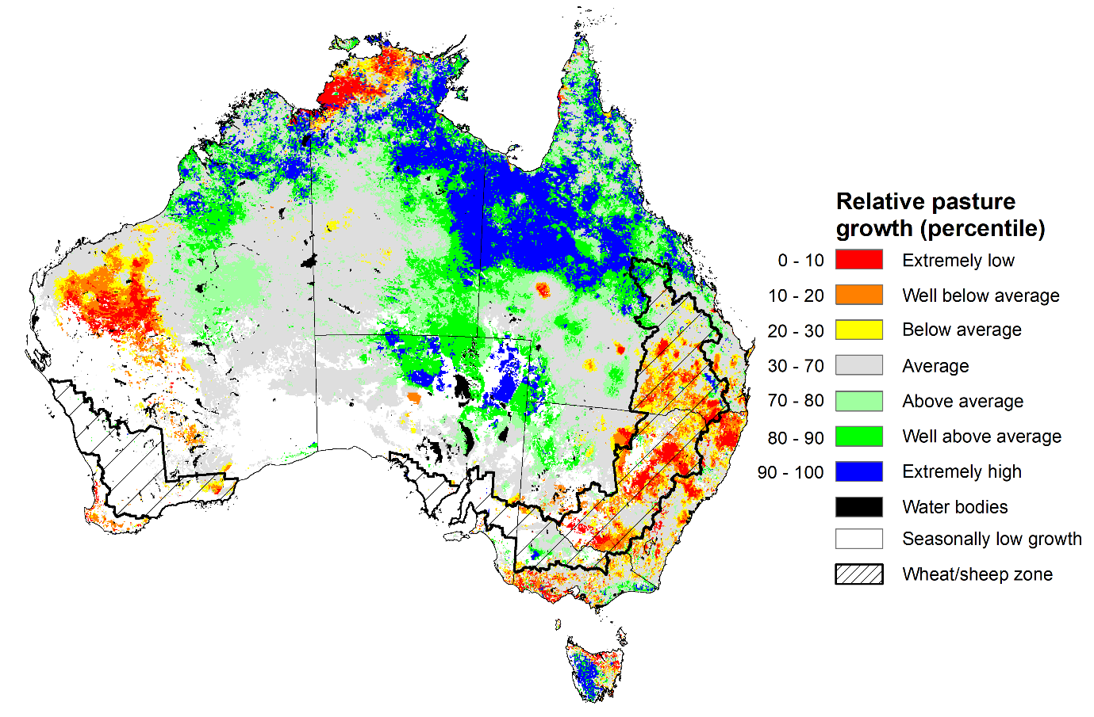
Notes: AussieGRASS pasture growth estimates are relative to the long-term record and shown in percentiles. Percentiles rank data on a scale of zero to 100. This analysis ranks pasture growth for the selected period against average pasture growth for the long-term record (1957 to 2016). Pasture growth is modelled at 5km2 grid cells.
Source: Department of Environment, Science and Innovation

Water markets – current week
Water storage levels in the Murray-Darling Basin (MDB) decreased by 44 gigalitres (GL) between 26 February 2026 and 5 March 2026. The current volume of water held in storages is 10,650 GL, equivalent to 48% of total storage capacity. This is 19% or 2,428 GL lower than the same time last year. Water storage data is sourced from the Bureau of Meteorology (BOM).

Water storages in the Murray-Darling Basin, 2013–2026
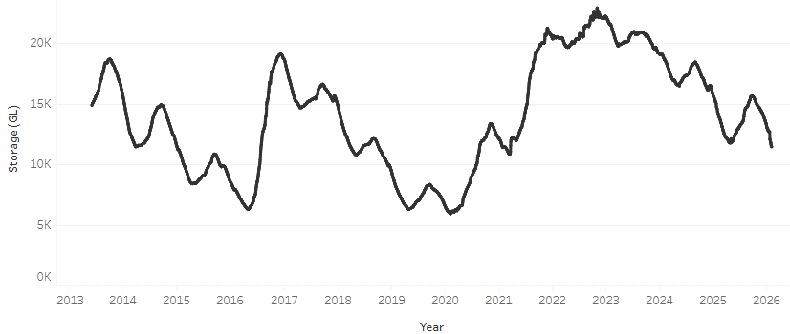
Allocation prices in the Victorian Murray below the Barmah Choke decreased from $454/ML on 26 February 2026 to $445/ML on 5 March 2026. Trade from the Goulburn to the Murray is closed. Trade downstream through the Barmah Choke is closed. Trade from the Murrumbidgee to the Murray is open.

Water market prices, Southern Murray–Darling Basin

Region | $/ML
NSW Murray Above | 332
NSW Murrumbidgee | 427
Vic Greater Goulburn | 373
Vic Murray Below | 445

Note: The water allocation prices shown are volume weighted average prices based on the last 10 trades. Price data is sourced from Waterflow and current as at 22 January 2026.
To access the full, interactive, weekly water dashboard, which contains the latest and historical water storage, water market and water allocation information, please visit https://www.agriculture.gov.au/abares/products/weekly_update/weekly-update-260305

Commodities
Indicator | Week average | Unit | Latest Price | Previous Week | Weekly change |  | Price 12 months ago | Annual change
Selected world indicator prices
AUD/USD Exchange rate | 4-Mar | A$/US$ | 0.71 | 0.71 | 0% | 0.63 |  | 12%
Wheat – US no. 2 hard red winter wheat, FOB Gulf | 4-Mar | US$/t | 263 | 259 | 2% | 256 |  | 3%
Corn – US no. 2 yellow corn, FOB Gulf | 4-Mar | US$/t | 211 | 211 | 0% | 208 |  | 2%
Canola – Rapeseed, Canada, FOB Vancouver | 4-Mar | US$/t | 540 | 531 | 2% | 452 |  | 19%
Cotton – Cotlook A Index | 4-Mar | USc/lb | 75.1 | 75.9 | -1% | 77.8 |  | -3%
Sugar – Intercontinental Exchange, nearby futures, no.11 contract | 4-Mar | USc/lb | 13.9 | 14.0 | 0% | 19.1 |  | -27%
Wool – Eastern Market Indicator | 4-Mar | Ac/kg clean | 1,767 | 1,716 | 3% | 1,241 |  | 42%
Wool – Western Market Indicator | 4-Mar | Ac/kg clean | 1,994 | 1,917 | 4% | 1,402 |  | 42%
Selected Australian grain export prices
Australian Premium White (APW) Wheat, FOB Port Adelaide, SA | 4-Mar | A$/t | 361 | 361 | 0% | 396 |  | -9%
Australian Standard White (ASW) Wheat, FOB Port Adelaide, SA | 4-Mar | A$/t | 358 | 357 | 0% | 387 |  | -8%
Feed Barley – FOB Port Adelaide, SA | 4-Mar | A$/t | 352 | 350 | 1% | 364 |  | -3%
Canola – FOB Kwinana, WA | 4-Mar | A$/t | 742 | 741 | 0% | 806 |  | -8%
Grain Sorghum – FOB Brisbane, QLD | 4-Mar | A$/t | 435 | 429 | 2% | 425 |  | 3%
Selected domestic livestock indicator prices
Beef – Eastern Young Cattle Indicator | 4-Mar | Ac/kg cwt | 867 | 858 | 1% | 653 |  | 33%
Mutton – Mutton indicator (18–24 kg fat score 2–3), VIC | 4-Mar | Ac/kg cwt | 789 | 785 | 0% | 402 |  | 96%
Lamb – National Trade Lamb Indicator | 4-Mar | Ac/kg cwt | 1,119 | 1,100 | 2% | 782 |  | 43%
Pig – Eastern Seaboard (60.1–75 kg), NSW buyer price | 11-Feb | Ac/kg cwt | 469 | 469 | 0% | 451 |  | 4%
Live cattle – Light steers to Indonesia | 25-Feb | Ac/kg lwt | 480 | 480 | 0% | 361 |  | 33%
Global Dairy Trade (GDT) weighted average prices
Dairy – Whole milk powder | 4-Mar | US$/t | 3,863 | 3,706 | 4% | 4,057 |  | -5%
Dairy – Skim milk powder | 4-Mar | US$/t | 3,243 | 2,973 | 9% | 2,737 |  | 19%
Dairy – Cheddar cheese | 4-Mar | US$/t | 4,920 | 4,736 | 4% | 4,946 |  | -1%
Dairy – Anhydrous milk fat | 4-Mar | US$/t | 7,147 | 6,751 | 6% | 6,621 |  | 8%

Selected world indicator prices
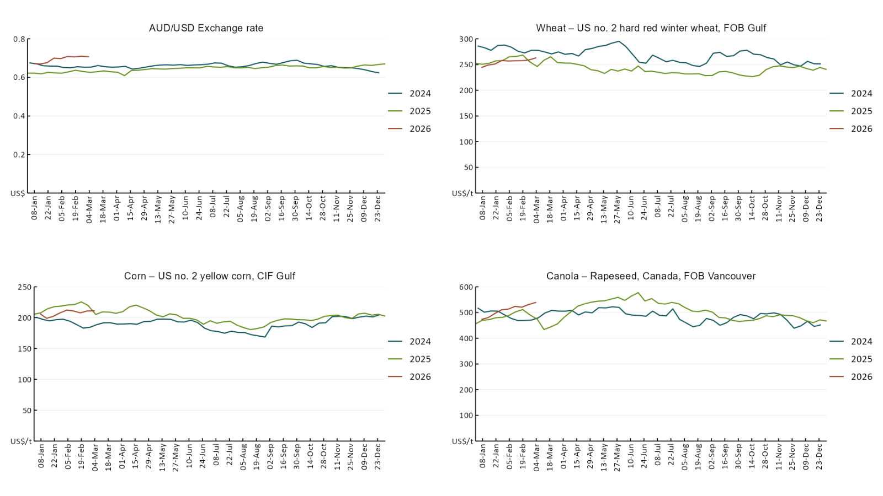

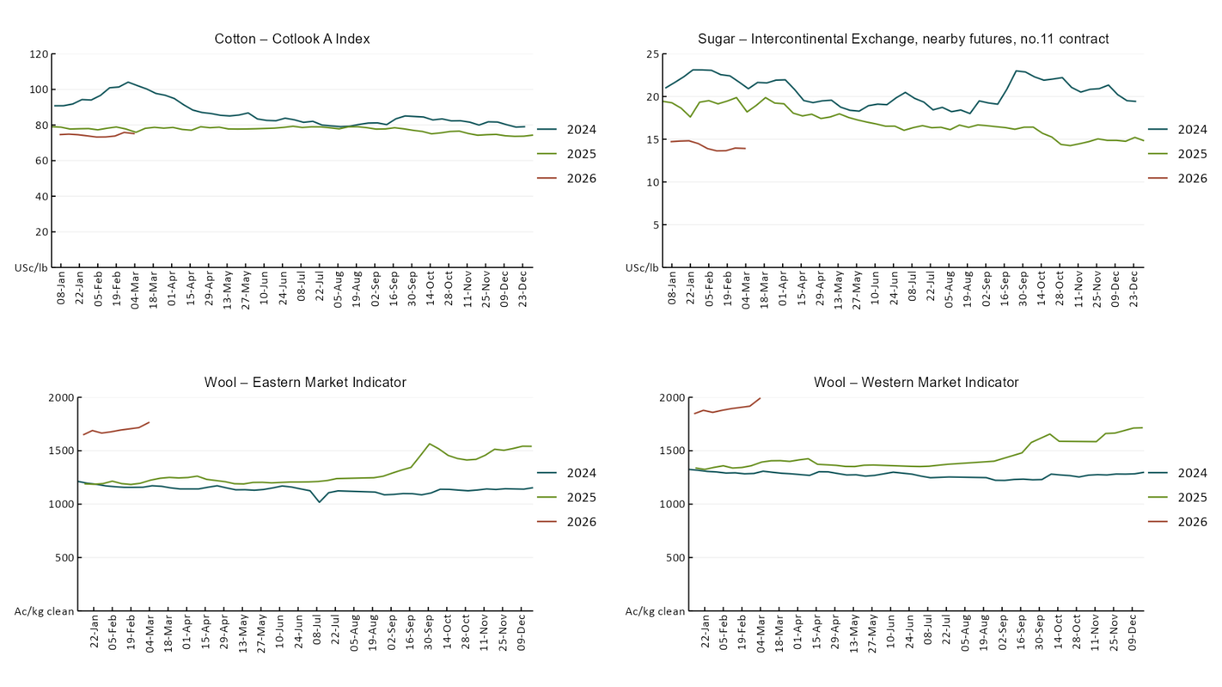

3.2 Selected domestic crop indicator prices
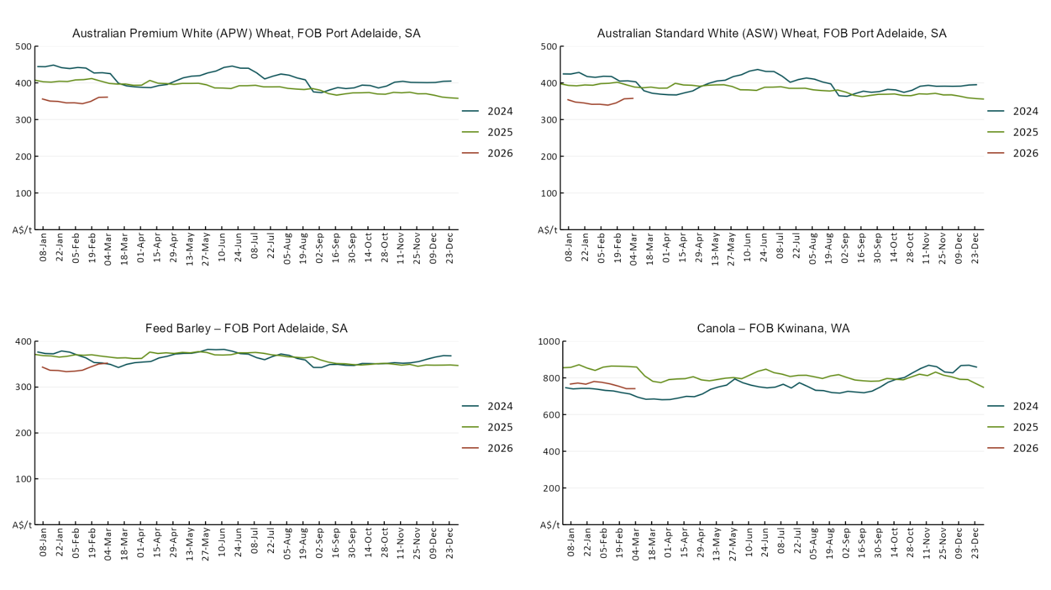

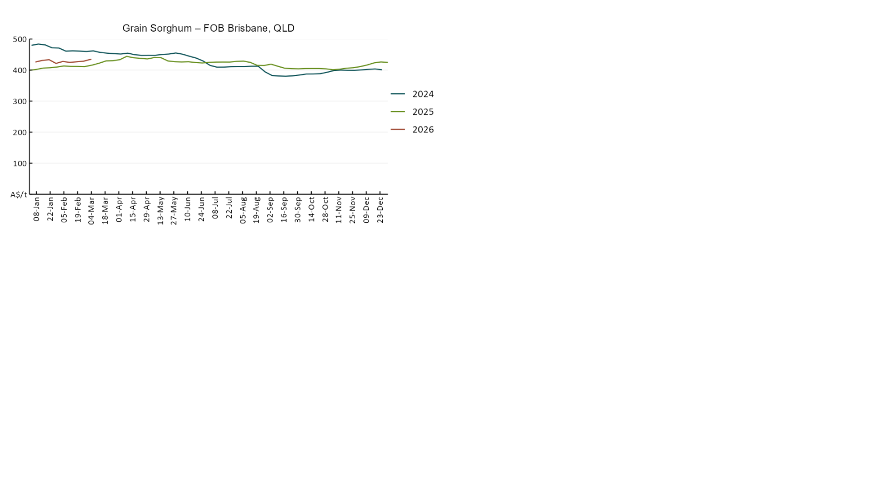

3.3 Selected domestic livestock indicator prices
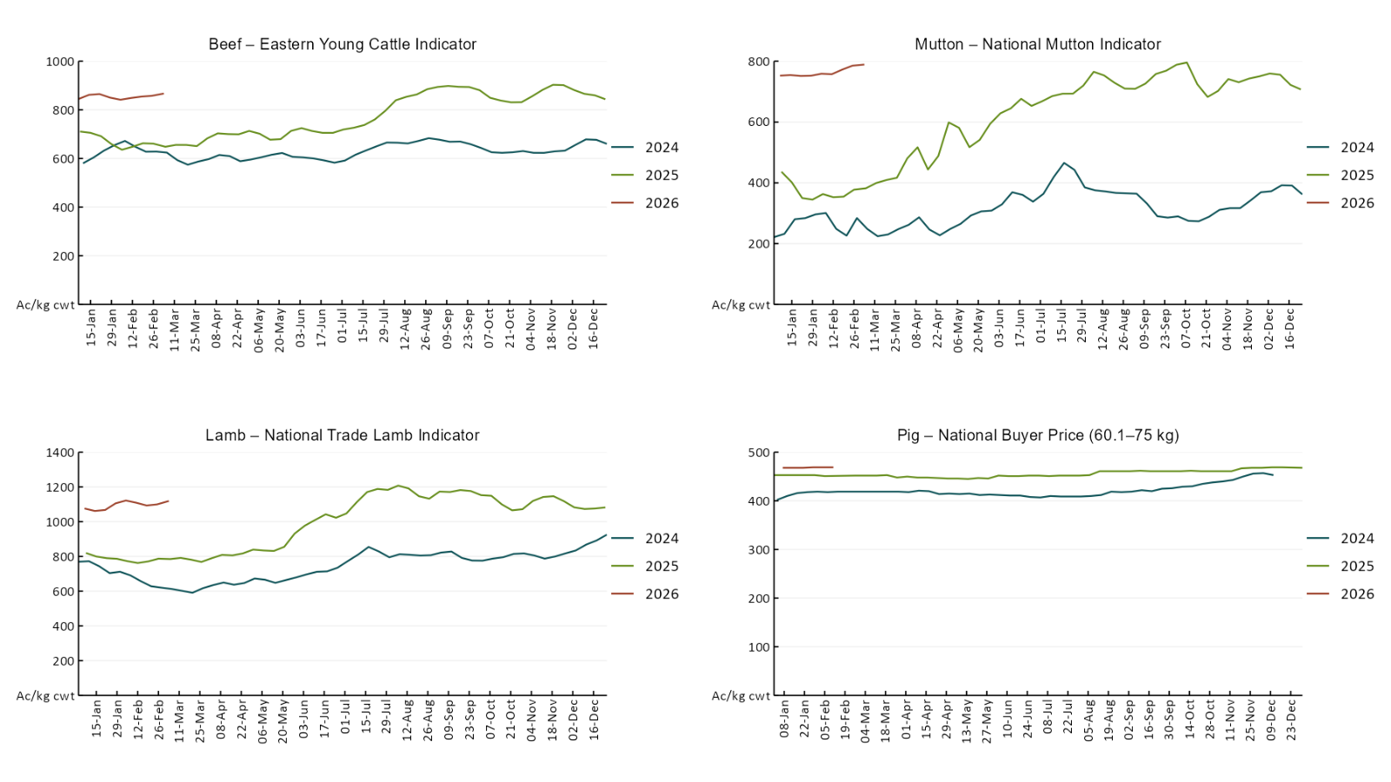
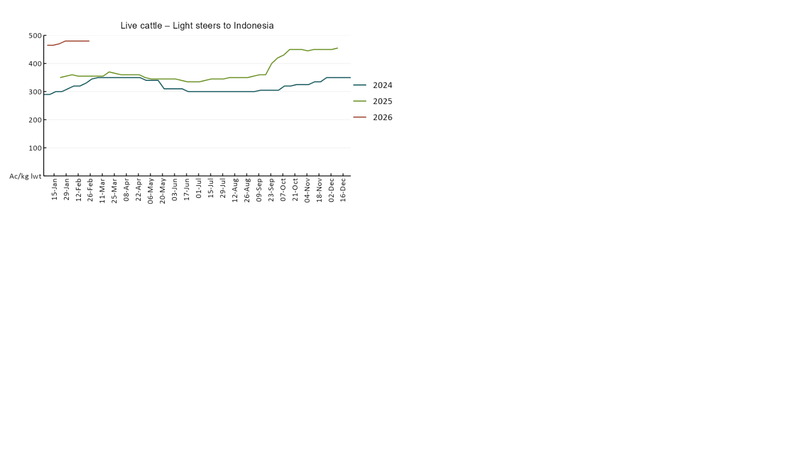

3.4 Global Dairy Trade (GDT) weighted average prices
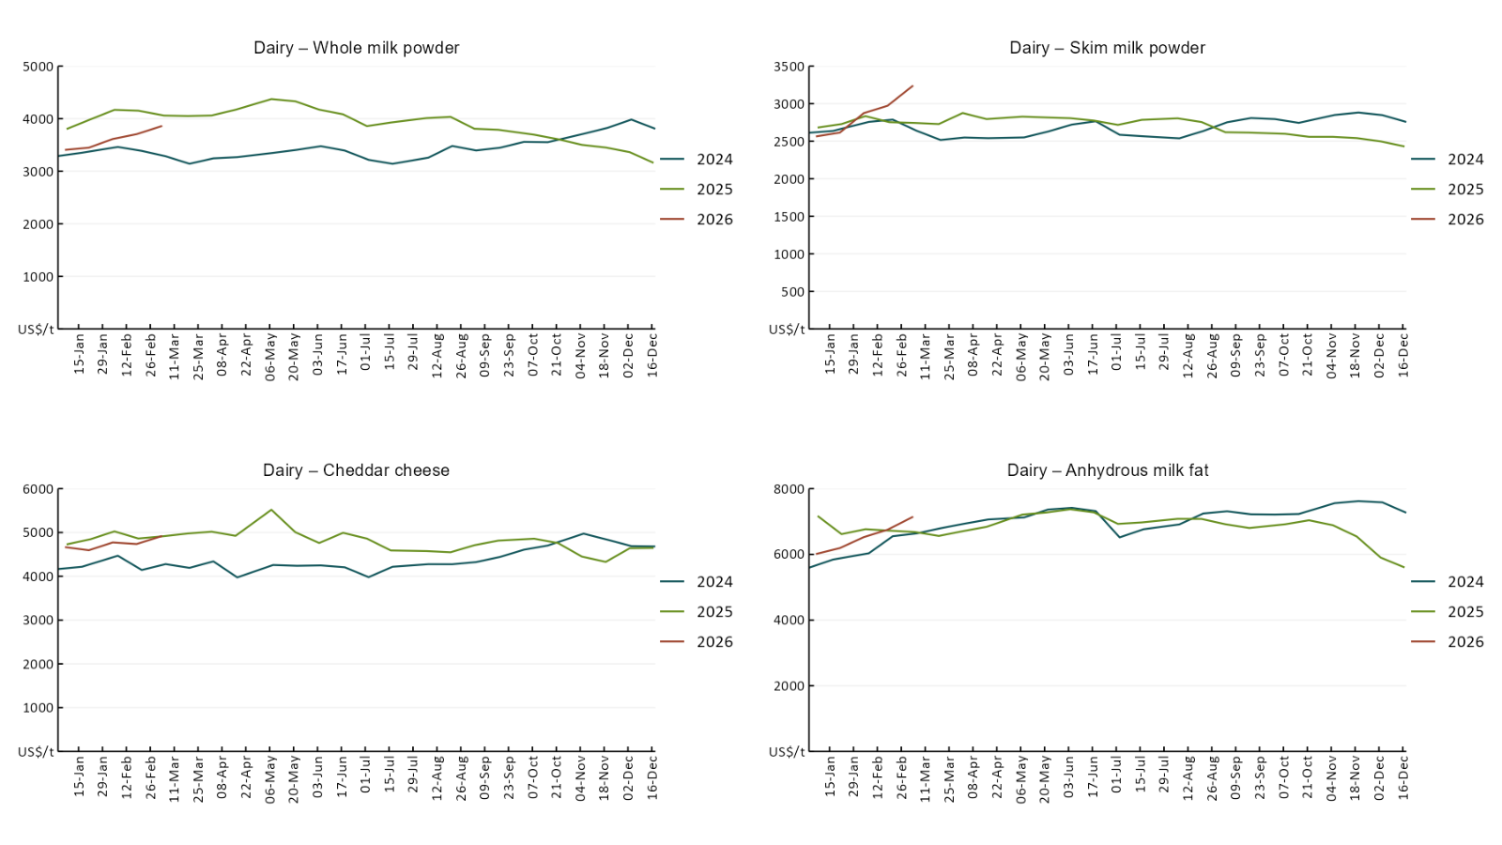

3.5 Selected fruit and vegetable prices
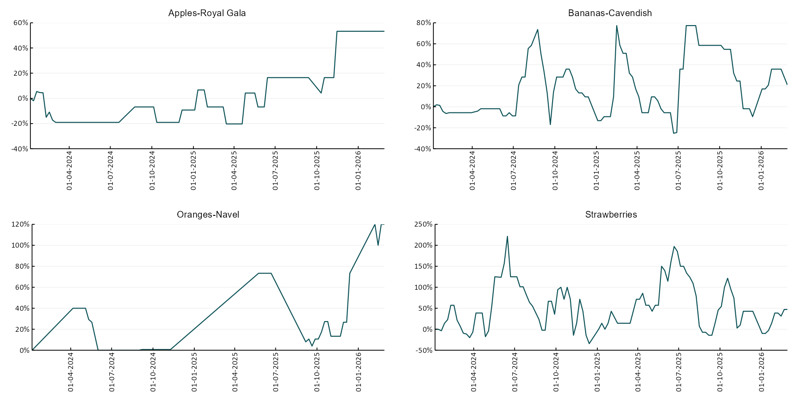
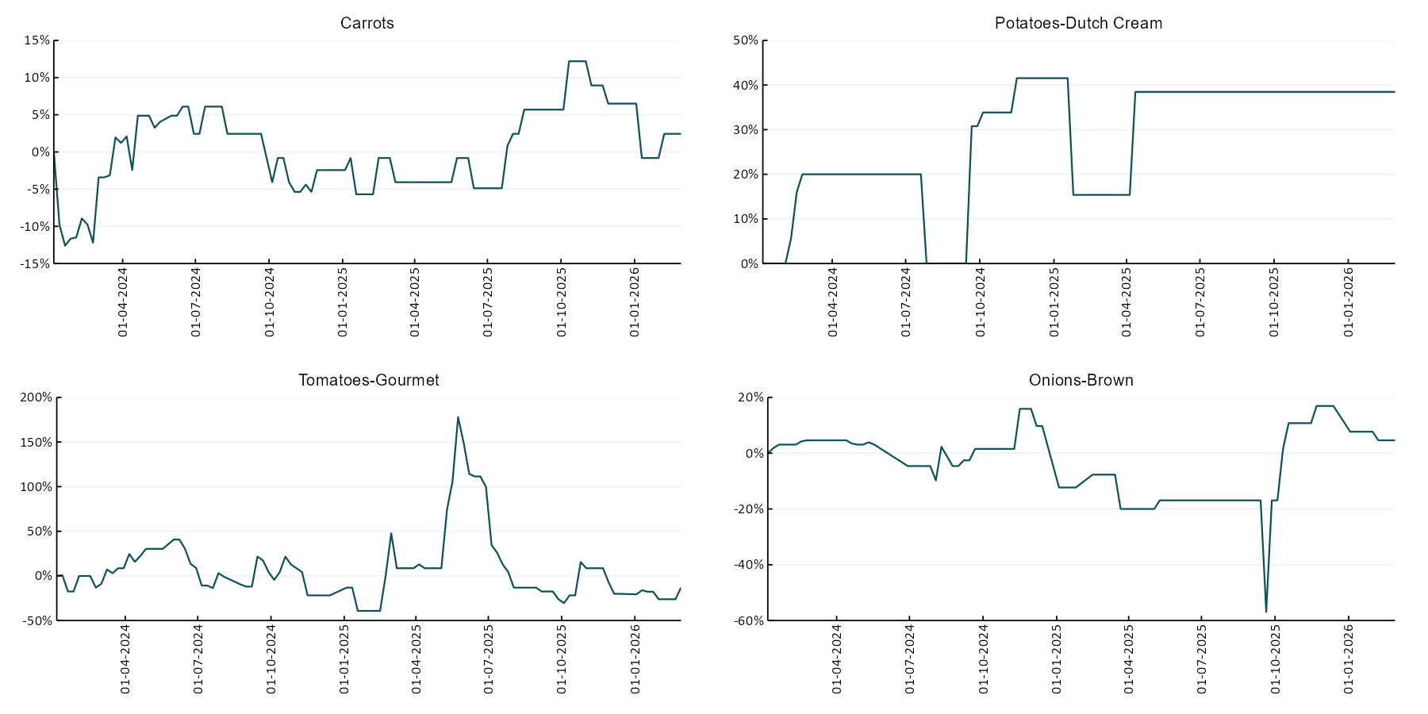

3.6 Selected domestic fodder indicator prices
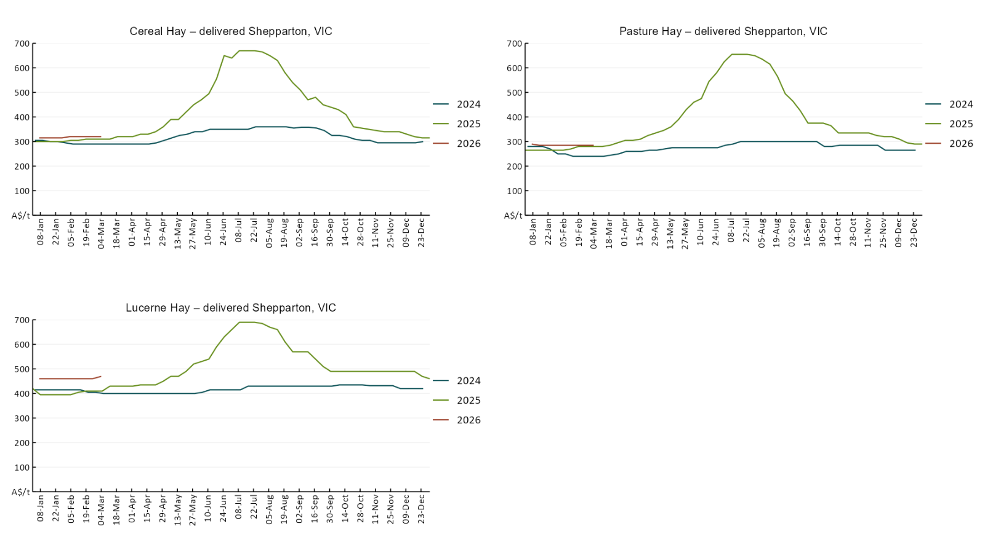

4. Data attribution

Climate
Bureau of Meteorology
- Weekly rainfall totals: www.bom.gov.au/climate/maps/rainfall/
- Monthly and last 3-month rainfall percentiles: https://www.bom.gov.au/climate/ahead/outlooks/#moreMaps
- Rainfall forecast: www.bom.gov.au/jsp/watl/rainfall/pme.jsp
- Seasonal outlook: www.bom.gov.au/climate/outlooks/#/overview/summary/
- Climate drivers: http://www.bom.gov.au/climate/enso/
- Soil moisture: https://awo.bom.gov.au/products/historical/soilMoisture-rootZone/

Other
- Pasture growth: www.longpaddock.qld.gov.au/aussiegrass/
- 3-month global outlooks: Environment and Climate Change Canada, NOAA Climate Prediction Center, EUROBRISA CPTEC/INPE, European Centre for Medium-Range Weather Forecasts, Hydrometcenter of Russia, National Climate Center Climate System Diagnosis and Prediction Room (NCC), International Research Institute for Climate and Society
- Global production: https://ipad.fas.usda.gov/ogamaps/cropmapsandcalendars.aspx
- Autumn break: Pook et al., 2009, https://rmets-onlinelibrary-wiley-com.virtual.anu.edu.au/doi/epdf/10.1002/joc.1833

Water
Prices
- Waterflow: https://www.waterflow.io/
- Ruralco: https://www.ruralcowater.com.au/
- Bureau of Meteorology:
- Allocation trade: http://www.bom.gov.au/water/dashboards/#/water-markets/mdb/at
- Storage volumes: http://www.bom.gov.au/water/dashboards/#/water-storages/summary/drainage

Trade constraints:
- Water NSW: https://www.waternsw.com.au/customer-service/ordering-trading-and-pricing/trading/murrumbidgee
- Victorian Water Register: https://www.waterregister.vic.gov.au/TradingRules2019/

Commodities
Fruit and vegetables
- Datafresh: www.freshstate.com.au

Pigs
- Australian Pork Limited: www.australianpork.com.au

Dairy
- Global Dairy Trade: www.globaldairytrade.info/en/product-results/

World wheat, canola
- International Grains Council
- https://www.igc.int/en/default.aspx
- United States Department of Agriculture

World cotton
- Cotlook: www.cotlook.com/

World sugar
- New York Stock Exchange - Intercontinental Exchange

Wool
- Australian Wool Exchange: www.awex.com.au/

Domestic wheat, barley, sorghum, canola and fodder
- Jumbuk Consulting Pty Ltd: Jumbuk AG | Agriculture Consulting

Cattle, beef, mutton, lamb, goat and live export
- Meat and Livestock Australia: https://www.mla.com.au/prices-markets/

Australian Agricultural Drought Indicators
About Australian Agricultural Drought Indicators
The Australian Agricultural Drought Indicators (AADI) links weather and agricultural data with a range of scientific and economic models to measure and forecast the effects of climate variability and drought on agricultural outcomes.
On AADI, projected broadacre farm profits are presented as percentile outcomes relative to simulated historical outcomes using the groupings:
Highest | 95-100th percentile
Very much above average | 85-95th percentile
Above average | 65-85th percentile
Average | 35-65th percentile
Below average | 15-35th percentile
Very much below average | 5-15th percentile
Lowest 5% | 0-5th percentile

There are two AADI farm profit indicators:
- The AADI farm profit climate and price indicator shows the effect of climate and prices on broadacre farm business profits of current farms compared to the last 33 years.
- The AADI farm profit climate only indicator isolates the effect of climate on profits by holding prices fixed.

© Commonwealth of Australia 2026

Ownership of intellectual property rights
Unless otherwise noted, copyright (and any other intellectual property rights, if any) in this publication is owned by the Commonwealth of Australia (referred to as the Commonwealth).

Creative Commons licence
All material in this publication is licensed under a Creative Commons Attribution 4.0 International Licence except content supplied by third parties, logos and the Commonwealth Coat of Arms.
Inquiries about the licence and any use of this document should be emailed to copyright@awe.gov.au.


Cataloguing data
This publication (and any material sourced from it) should be attributed as:
ABARES 2026, Weekly Australian Climate, Water and Agricultural Update, Australian Bureau of Agricultural and Resource Economics and Sciences, Canberra, 26 February 2026. CC BY 4.0 DOI: https://doi.org/10.25814/5f3e04e7d2503
ISSN 2652-7561
This publication is available at https://www.agriculture.gov.au/abares/products/weekly_update
Department of Agriculture, Fisheries and Forestry
GPO Box 858 Canberra ACT 2601
Telephone 1800 900 090
Web agriculture.gov.au/abares

Disclaimer
The Australian Government acting through the Department of Agriculture, Fisheries and Forestry, represented by the Australian Bureau of Agricultural and Resource Economics and Sciences, has exercised due care and skill in preparing and compiling the information and data in this publication. Notwithstanding, the Department of Agriculture, Fisheries and Forestry, ABARES, its employees and advisers disclaim all liability, including liability for negligence and for any loss, damage, injury, expense or cost incurred by any person as a result of accessing, using or relying on any of the information or data in this publication to the maximum extent permitted by law.

Statement of Professional Independence
The views and analysis presented in ABARES publications, including this one, reflect ABARES professionally independent findings, based on scientific and economic concepts, principles, information and data. These views, analysis and findings may not reflect or be consistent with the views or positions of the Australian Government, or of organisations or groups who have commissioned ABARES reports or analysis. More information on professional independence is provided on the ABARES website.

Acknowledgements
This report was prepared by Holly Beale and Matthew Miller.

