
No. 10/2026 19 March 2026

Summary of key issues
- In the week ending 18 March 2026, low-pressure systems and tropical lows brought heavy rainfall to of the far north and eastern Australia.
  - Severe weather and flood warnings remain in place throughout parts of the Northern Territory, Queensland and New South Wales. Flash flooding is set to see major disruptions to supply chains persisting, with extensive road closures across Queensland and western New South Wales.
  - Across cropping regions falls of between 5-50 millimetres were recorded across South Australia, with eastern Western Australia and Victoria observing 5-25 millimetres. These falls are expected to support autumn pasture growth and boost soil moisture levels in the led up to winter crop planting.
- Over the 8-days to 26 March 2026, Tropical Cyclone (TC) Narelle is expected to bring heavy rainfall and destructive winds the far north of Australia, with rainfall also forecast for large areas of south-eastern Australia.
  - Across northern Australia falls of between 25-200 millimetres are forecast, with some areas likely to see up to 400 millimetres. These heavy falls are likely to exacerbate exiting flooding, extend supply chain disruptions and slow recovery efforts.
  - Across cropping regions rainfall of between 5-25 millimetres are expected to be restricted to parts of the south-east and eastern Western Australia. These falls are likely to contribute to a build-up of soil moisture ahead of the planting of 2026–27 winter crops and benefit the growth of pastures.
- Global production conditions in February were generally favourable for maize, rice and soybeans, but more variable for wheat. According to the most recent crop estimate numbers released by the USDA, global production conditions have been slightly more favourable to those used to formulate ABARES 2025–26 forecasts of global grain supplies and world prices in the March 2026 Agricultural Commodities Report. As a result, global grain and oilseed production is likely to increase beyond the numbers in the March forecast.
- Water storage levels in the Murray-Darling Basin (MDB) decreased by 39 gigalitres (GL) between 12 March 2026 and 19 March 2026. The current volume of water held in storages is 10,550 GL, equivalent to 47% of total storage capacity. This is 15% or 1,859 GL less than the same time last year. Water storage data is sourced from the Bureau of Meteorology.
- Allocation prices in the Victorian Murray below the Barmah Choke decreased from $489/ML on 12 March 2026 to $463/ML on 19 March 2026. Trade from the Goulburn to the Murray is closed. Trade downstream through the Barmah Choke is closed. Trade from the Murrumbidgee to the Murray is open.

Climate

Rainfall this week
In the week ending 18 March 2026, low-pressure troughs and south easterlies brought heavy rainfall to the northern, southern, and central Australia, while some eastern and western areas remained largely dry.
- Many northern regions continue to experience high rainfall totals, with falls of 50-200 millimetres across much of the northern tropics, and isolated areas seeing falls of up to 300 millimetres. Similarly, much of northern South Australia saw falls of 50-200 millimetres
  - Severe weather and flood warnings remain in place throughout much of Queensland, and parts of the Northern Territory, South Australia and New South Wales. Disruptions to supply chains are expected to persist, including road closures and damage to railway infrastructure.
- Southern and eastern coastal regions, including southern Western Australia, South Australia, Victoria, Tasmania, and far-east New South Wales and Queensland saw 5-50 millimetres of rainfall over the period.
- Much of the remainder of Western Australia, Queensland, and New South Wales remained largely dry.
Across cropping regions, rainfall was mixed, with limited rainfall in the far west and eastern regions:
- Most cropping regions of Queensland, New South Wales and of west of Western Australia saw little to no rainfall.
  - These mainly dry conditions across Queensland and northern New South Wales are expected to support the harvest of late summer crops.
- Eastern Western Australia and South Australia saw 5-50 millimetres of rainfall, while Victoria observed 5-25 millimetres.
  - These falls are expected to support autumn pasture growth and boost soil moisture levels in the led up to winter crop planting.

Rainfall for the week ending 18 March 2026
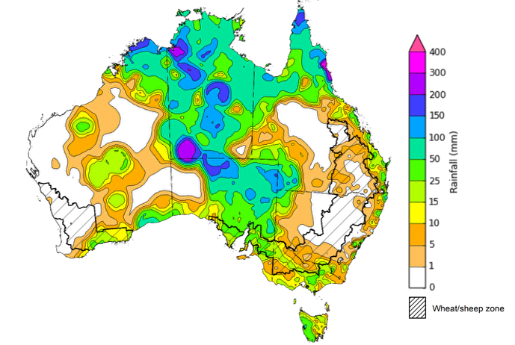
©Commonwealth of Australia 2026, Australian Bureau of Meteorology Issued: 18/3/2026
Note: The rainfall analyses and associated maps utilise data contained in the Bureau of Meteorology climate database, the Australian Data Archive for Meteorology (ADAM). The analyses are initially produced automatically from real-time data with limited quality control. They are intended to provide a general overview of rainfall across Australia as quickly as possible after the observations are received. For further information go to http://www.bom.gov.au/climate/rainfall/

Rainfall forecast for the next eight days
Over the 8 days to 26 March 2026, Tropical Cyclone (TC) Narelle is expected to bring heavy rainfall and destructive winds the far north of Australia:
- Falls of between 25-200 millimetres are forecast for large parts of tropical northern Australia, with parts of northern Queensland and the Northern Territory likely to see up to 400 millimetres.
  - These falls and extreme winds are likely to exacerbate exiting flooding, extend supply chain disruptions and slow recovery efforts.
- The far southeast of Queensland and much of eastern New South Wales are forecast to see falls of 10- 50 millimetres, with north-eastern areas of New South Wales to see up to 100 millimetres. Much of eastern Victoria and Tasmania is likely to see 25-50 millimetres of rainfall over the period.
- Remaining central and southern areas are likely to see little to no rainfall.
Rainfall totals across cropping regions over the coming week are forecast to be low, with exceptions in parts of the east and west:
- Low rainfall totals (5-15 millimetres) are forecast for southern Queensland, eastern Western Australia, and much of Victoria, while South Australia is like to see 1-10 millimetres.
- Higher falls are forecast for much of eastern New South Wales, and parts of eastern Victoria (10-25 millimetres).
  - These falls are likely to contribute to a build-up of soil moisture ahead of the planting of 2026–27 winter crops and benefit the growth of pastures.

Total forecast rainfall for the period 19 March to 26 March 2026
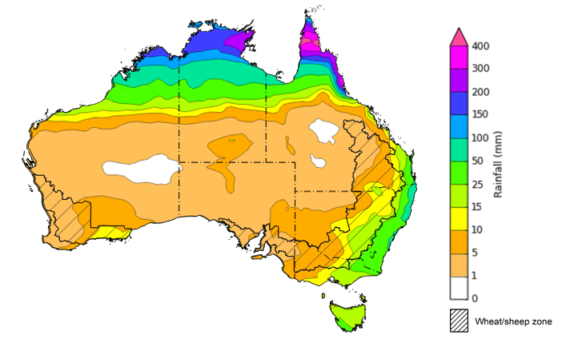
©Commonwealth of Australia 2026, Australian Bureau of Meteorology Issued 19/3/2026
Note: This rainfall forecast is produced from computer models. As the model outputs are not altered by weather forecasters, it is important to check local forecasts and warnings issued by the Bureau of Meteorology.

February precipitation percentiles and current production conditions
Crop production is affected by long-term trends in average rainfall and temperature, interannual climate variability, shocks during specific growth stages, and extreme weather events. Some crops are more tolerant than others to certain types of stresses, and at each growth stage, different types of stresses affect crop species in different ways.
Precipitation anomalies and outlooks presented below indicate the current and expected future production conditions for major grain and oilseed producing countries (responsible for over 80% of global crop production). This is an important input to assessing the global grain supply outlook.
Precipitation in February 2026 was variable across the world’s major grain- and oilseed-producing regions:
- In the northern hemisphere, precipitation was above average in much of central and western Europe - with exceptions in northern regions – and the Black Sea Region. Below average precipitation occurred across large areas of the eastern United States, northern Europe, and parts of northern India. Precipitation was generally average across the remaining major northern hemisphere grain- and oilseed-producing regions.
- In the southern hemisphere, precipitation was below average across much northern and southern Brazil, eastern Argentina, and isolated parts of Australia. Precipitation was above average across parts of southern New Zealand, South Africa, and central Australia. Precipitation was generally average across the remaining major southern hemisphere grain- and oilseed-producing regions.

Global precipitation percentiles, February 2026

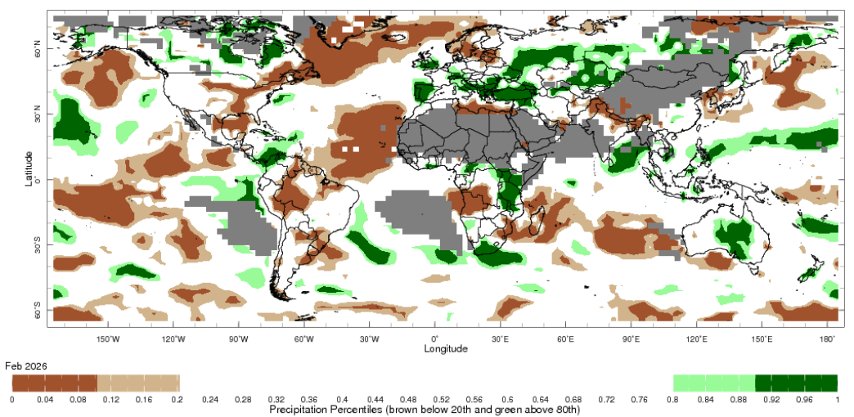

Note: The world precipitation percentiles indicate a ranking of precipitation for February, with the driest (0th percentile) being 0 on the scale and the wettest (100th percentile) being 1 on the scale. Percentiles are based on precipitation estimates from the NOAA Climate Prediction Center’s Climate Anomaly Monitoring System Outgoing Precipitation Index dataset. Precipitation estimates for February are compared with rainfall recorded for that period during the 1981 to 2010 base period.
Source: International Research Institute for Climate and Society
As of 28 February 2026, global production conditions were generally favourable for maize, rice and soybeans, but more variable for wheat:
- Wheat – In the northern hemisphere, crops for harvest in 2026–27 are in winter dormancy, with isolated areas in North America, Ukraine and Europe at risk of winterkill with lower than typical temperatures and dry conditions.
- Maize – In the southern hemisphere, conditions have been largely favourable for the harvest across much of South America, however there are some areas of production concerns in Argentina due to recent hot and dry conditions. In Indonesia, harvesting of early sown crops is progressing. In India development of the Rabi crop is continuing under favourable conditions.
- Rice – Global conditions remain broadly favourable for major rice production regions.
- Soybeans – The harvest in Brazil is continuing under favourable conditions, while weather conditions in Argentina are supporting crop development.

Crop conditions, AMIS countries, 28 February 2026
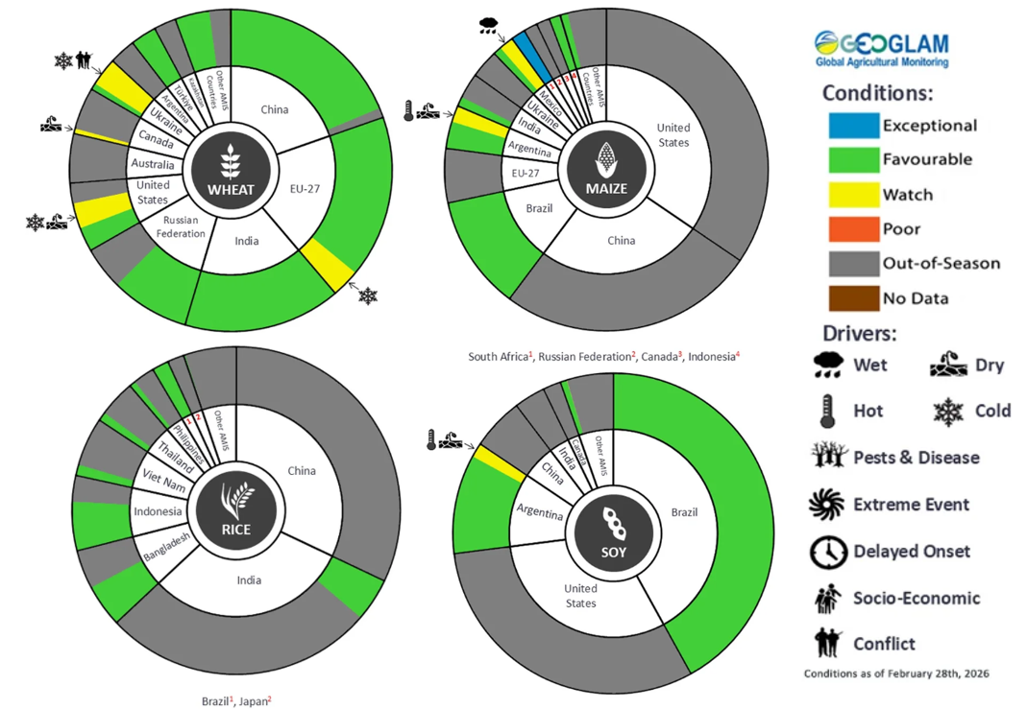
AMIS Agricultural Market Information System.
Source: AMIS

The global climate outlook for April 2026 to June 2026 indicates that mixed rainfall conditions are expected for the world’s major grain-producing and oilseed-producing regions. Outlooks and potential production impacts for major grain- and oilseed-producing countries are presented in the following table.
Rainfall outlook and potential impact on the future state of production conditions, April 2026 - June 2026
Region | Rainfall outlook | Potential impact on production
Argentina | Above average rainfall is likely across much of Argentina, including northern, central, and southern areas. | Above average rainfall is likely to be sufficient to support the development of sorghum, rice, millet, and the planting of wheat in May 2026.
Black Sea Region | Above average rainfall is expected across parts of northern and southern Ukraine, as well as the southeast of the Russian Federation. | Above average rainfall is likely to support the heading and grain development of wheat and canola in Ukraine, Türkiye, and the Russian Federation.
Brazil | Rainfall outcomes across Brazil are expected to be broadly above average in central and western regions, with exceptions in the far south which is expected to see below average falls. | Above average rainfall across western and central western Brazil is likely to support the development of cotton and corn, and the harvesting of soybeans. Below average rainfall in the south is likely to hinder the development and harvesting of rice, sorghum, millet, sunflower, soybeans, cotton, nuts and corn, and the planting of wheat in May 2024.
Canada | Precipitation across Canada is expected to be mixed, with broadly average conditions and areas of both below and above average precipitation in southern regions. | Average precipitation is likely to support winter wheat development as it leaves dormancy, and facilitate the planting of spring wheat, canola, corn and soybeans over the coming months.
China | Average rainfall is expected across of China, with scattered areas of above average rainfall in inland regions. | Average to above average rainfall across much China is likely to support the development of winter wheat and canola and the planting and development of early rice, single rice, cotton and spring wheat.
European Union | Average precipitation is more likely for much of the European Union, with parts of Germany, Poland and isolated areas of southern Europe to see below average falls. | Average precipitation across much of the European Union is likely to support the heading of wheat in April, and the flowering of cotton and corn.
South Asia (India) | Below average rainfall is expected across parts of southern India, while above average rainfall is expected in isolated northern areas. | Anticipated rainfall is likely to support the harvesting of wheat and canola, as well as the planting of spring crops.
Southeast Asia (SEA) | Below average rainfall is likely across much of Southeast Asia. | Below average rainfall in SEA is likely to support the planting of crops, but impede development outcomes.
The United States | Below average to average rainfall is likely for much of the United States. | Below average to average rainfall conditions expected across southern US is likely to reduce soil moisture before the heading of winter wheat, but support planting of corn and soybeans in May.

Water markets – current week
Water storage levels in the Murray-Darling Basin (MDB) decreased by 39 gigalitres (GL) between 12 March 2026 and 19 March 2026. The current volume of water held in storages is 10,550 GL, equivalent to 47% of total storage capacity. This is 15% or 1,859 GL less than the same time last year. Water storage data is sourced from the Bureau of Meteorology (BOM).

Water storages in the Murray-Darling Basin, 2013–2026
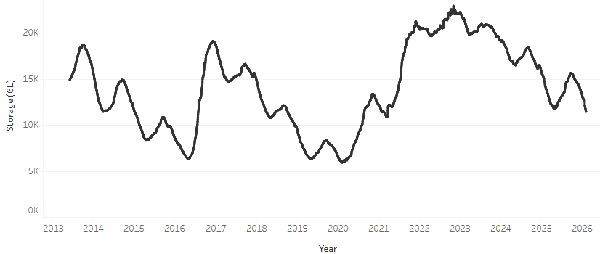
Allocation prices in the Victorian Murray below the Barmah Choke decreased from $489/ML on 12 March 2026 to $463/ML on 19 March 2026. Trade from the Goulburn to the Murray is closed. Trade downstream through the Barmah Choke is closed. Trade from the Murrumbidgee to the Murray is open.

Water market prices, Southern Murray–Darling Basin

Region | $/ML
NSW Murray Above | 330
NSW Murrumbidgee | 490
Vic Greater Goulburn | 393
Vic Murray Below | 463

Note: The water allocation prices shown are volume weighted average prices based on the last 10 trades. Price data is sourced from Waterflow and current as at 22 January 2026.
To access the full, interactive, weekly water dashboard, which contains the latest and historical water storage, water market and water allocation information, please visit https://www.agriculture.gov.au/abares/products/weekly_update/weekly-update-260319

Commodities
Indicator | Week average | Unit | Latest Price | Previous Week | Weekly change |  | Price 12 months ago | Annual change
Selected world indicator prices
AUD/USD Exchange rate | 18-Mar | A$/US$ | 0.71 | 0.71 | 0% | 0.63 |  | 12%
Wheat – US no. 2 hard red winter wheat, FOB Gulf | 18-Mar | US$/t | 276 | 278 | -1% | 256 |  | 8%
Corn – US no. 2 yellow corn, FOB Gulf | 18-Mar | US$/t | 211 | 213 | -1% | 208 |  | 1%
Canola – Rapeseed, Canada, FOB Vancouver | 18-Mar | US$/t | 540 | 559 | -3% | 452 |  | 19%
Cotton – Cotlook A Index | 18-Mar | USc/lb | 78.2 | 75.4 | 4% | 77.8 |  | 1%
Sugar – Intercontinental Exchange, nearby futures, no.11 contract | 18-Mar | USc/lb | 14.3 | 14.4 | -1% | 19.1 |  | -25%
Wool – Eastern Market Indicator | 18-Mar | Ac/kg clean | 1,751 | 1,783 | -2% | 1,241 |  | 41%
Wool – Western Market Indicator | 18-Mar | Ac/kg clean | 1,922 | 1,991 | -3% | 1,402 |  | 37%
Selected Australian grain export prices
Australian Premium White (APW) Wheat, FOB Port Adelaide, SA | 18-Mar | A$/t | 368 | 367 | 0% | 396 |  | -7%
Australian Standard White (ASW) Wheat, FOB Port Adelaide, SA | 18-Mar | A$/t | 365 | 364 | 0% | 387 |  | -6%
Feed Barley – FOB Port Adelaide, SA | 18-Mar | A$/t | 355 | 352 | 1% | 364 |  | -2%
Canola – FOB Kwinana, WA | 18-Mar | A$/t | 749 | 749 | 0% | 806 |  | -7%
Grain Sorghum – FOB Brisbane, QLD | 18-Mar | A$/t | 442 | 443 | 0% | 425 |  | 4%
Selected domestic livestock indicator prices
Beef – Eastern Young Cattle Indicator | 18-Mar | Ac/kg cwt | 889 | 888 | 0% | 653 |  | 36%
Mutton – Mutton indicator (18–24 kg fat score 2–3), VIC | 18-Mar | Ac/kg cwt | 798 | 799 | 0% | 402 |  | 99%
Lamb – National Trade Lamb Indicator | 18-Mar | Ac/kg cwt | 1,160 | 1,153 | 1% | 782 |  | 48%
Pig – Eastern Seaboard (60.1–75 kg), NSW buyer price | 25-Feb | Ac/kg cwt | 468 | 469 | 0% | 451 |  | 4%
Live cattle – Light steers to Indonesia | 25-Feb | Ac/kg lwt | 480 | 480 | 0% | 361 |  | 33%
Global Dairy Trade (GDT) weighted average prices
Dairy – Whole milk powder | 18-Mar | US$/t | 3,709 | 3,863 | -4% | 4,057 |  | -9%
Dairy – Skim milk powder | 18-Mar | US$/t | 3,409 | 3,243 | 5% | 2,737 |  | 25%
Dairy – Cheddar cheese | 18-Mar | US$/t | 4,925 | 4,920 | 0% | 4,946 |  | 0%
Dairy – Anhydrous milk fat | 18-Mar | US$/t | 7,602 | 7,147 | 6% | 6,621 |  | 15%

Selected world indicator prices
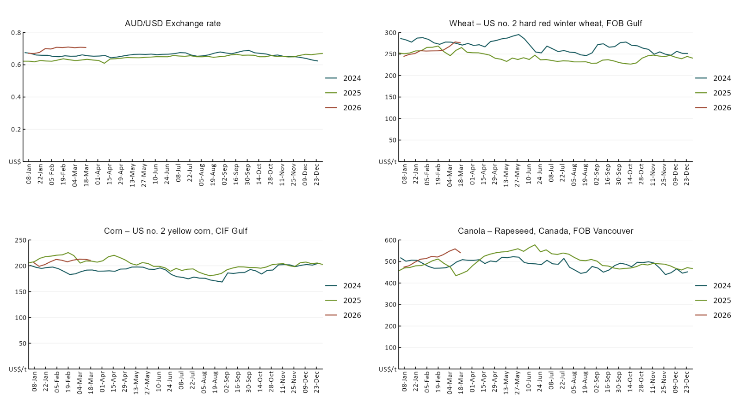

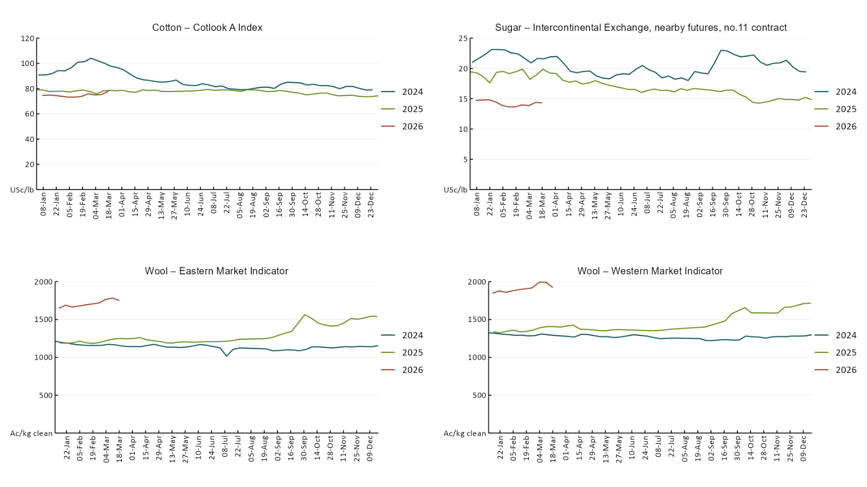

3.2 Selected domestic crop indicator prices
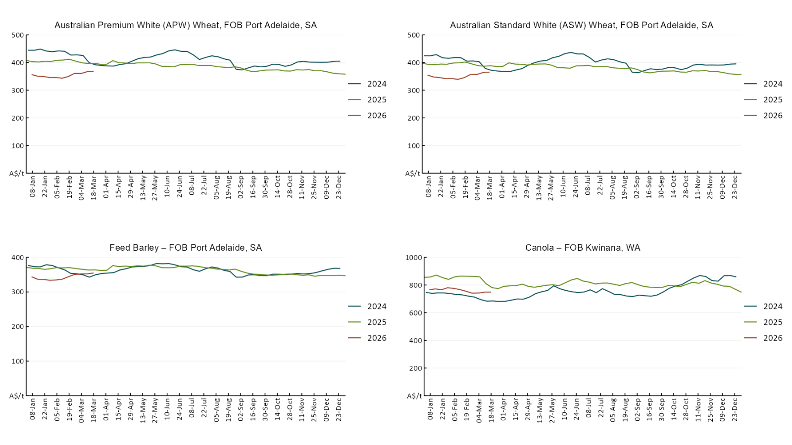

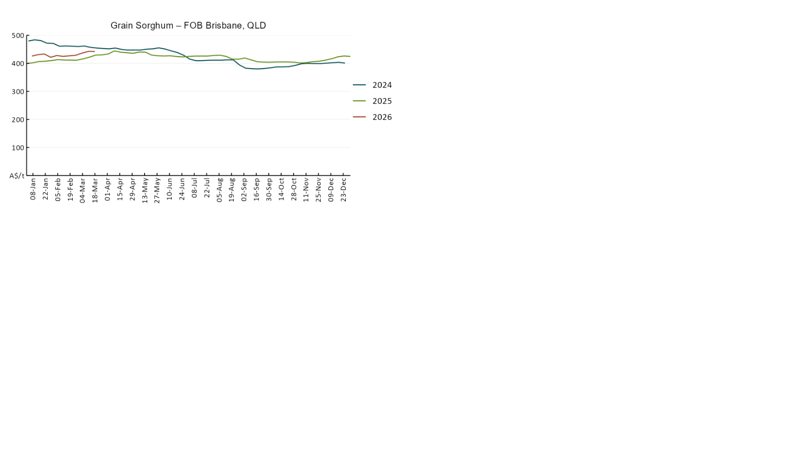

3.3 Selected domestic livestock indicator prices
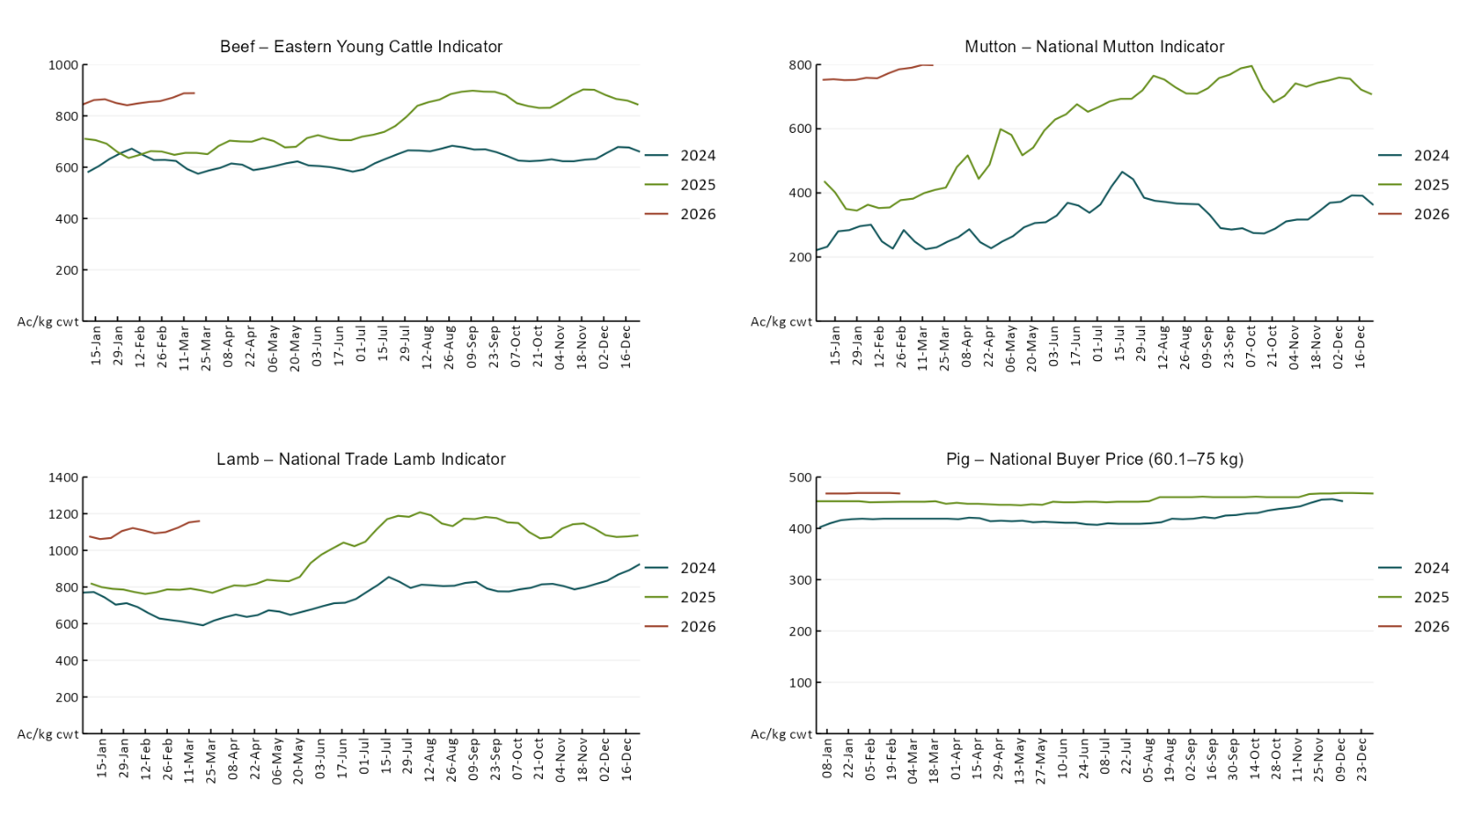
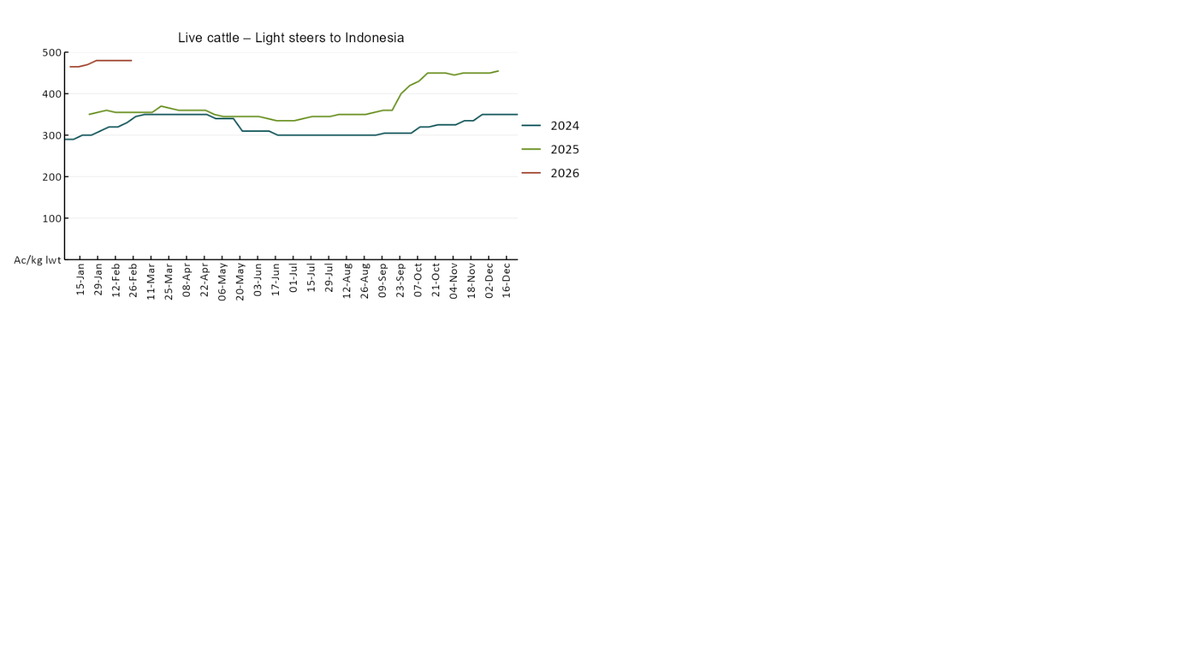

3.4 Global Dairy Trade (GDT) weighted average prices
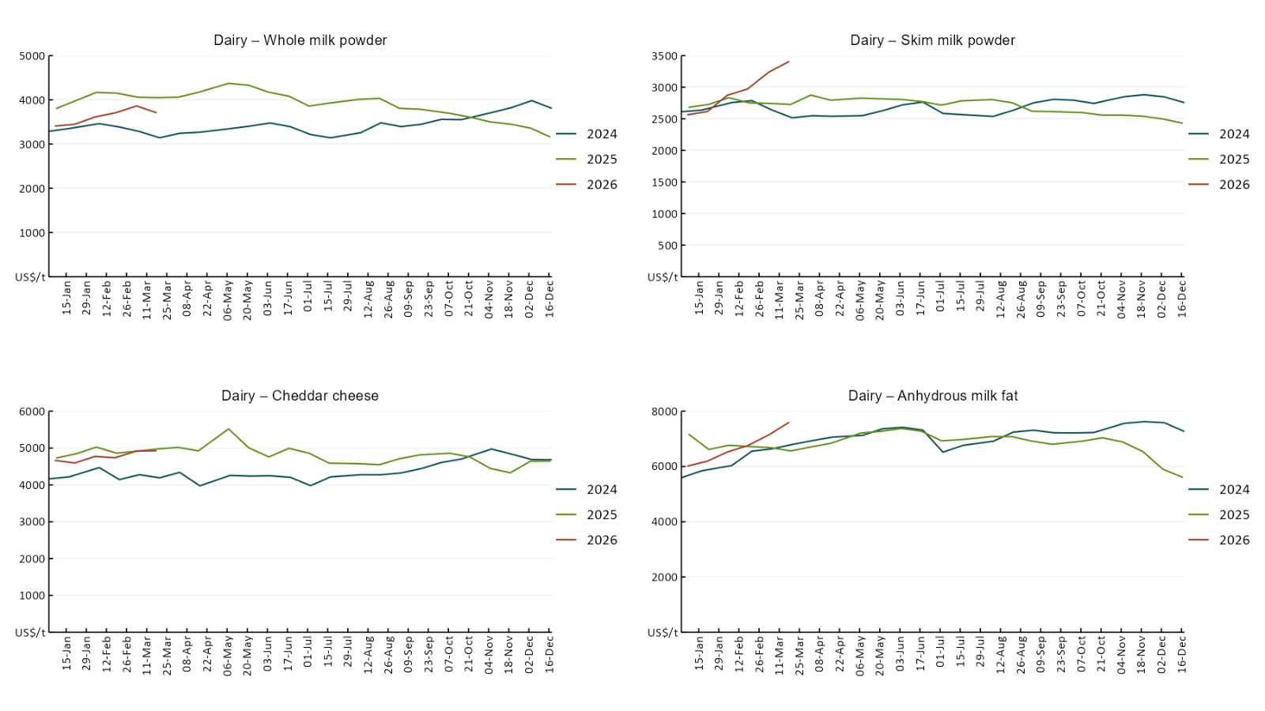

3.5 Selected fruit and vegetable prices
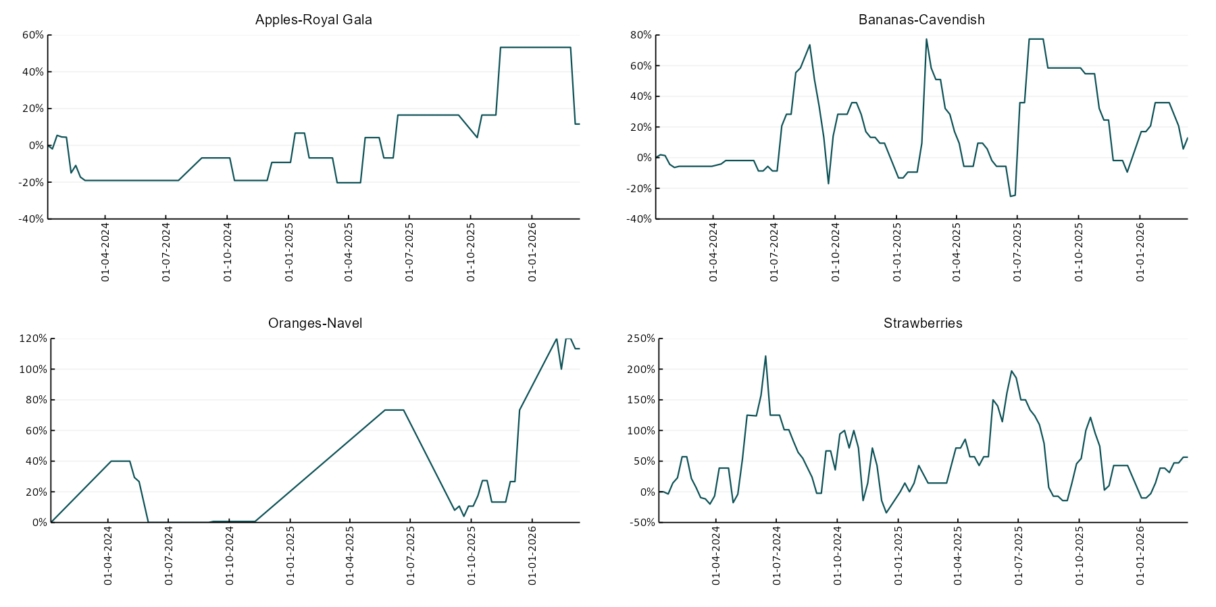
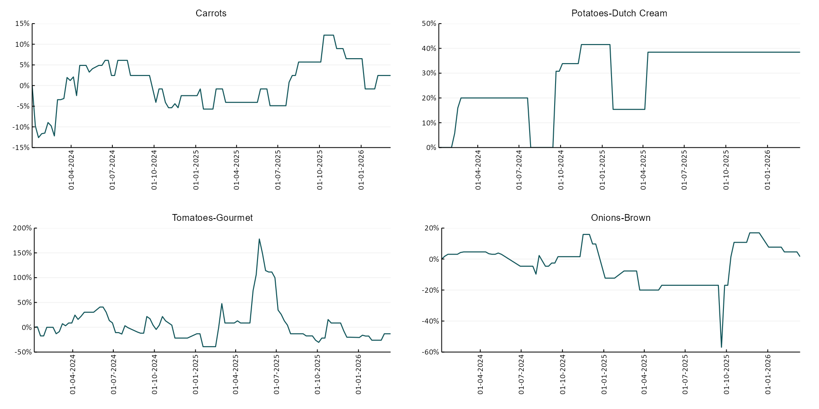

3.6 Selected domestic fodder indicator prices
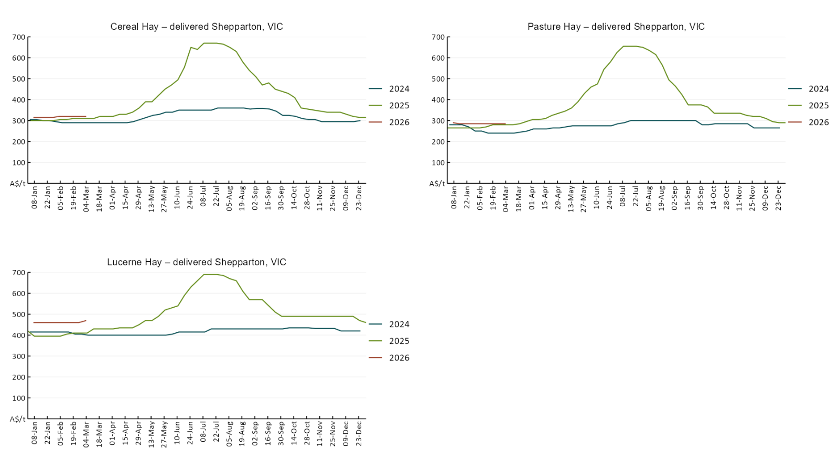

4. Data attribution

Climate
Bureau of Meteorology
- Weekly rainfall totals: www.bom.gov.au/climate/maps/rainfall/
- Monthly and last 3-month rainfall percentiles: https://www.bom.gov.au/climate/ahead/outlooks/#moreMaps
- Rainfall forecast: www.bom.gov.au/jsp/watl/rainfall/pme.jsp
- Seasonal outlook: www.bom.gov.au/climate/outlooks/#/overview/summary/
- Climate drivers: http://www.bom.gov.au/climate/enso/
- Soil moisture: https://awo.bom.gov.au/products/historical/soilMoisture-rootZone/

Other
- Pasture growth: www.longpaddock.qld.gov.au/aussiegrass/
- 3-month global outlooks: Environment and Climate Change Canada, NOAA Climate Prediction Center, EUROBRISA CPTEC/INPE, European Centre for Medium-Range Weather Forecasts, Hydrometcenter of Russia, National Climate Center Climate System Diagnosis and Prediction Room (NCC), International Research Institute for Climate and Society
- Global production: https://ipad.fas.usda.gov/ogamaps/cropmapsandcalendars.aspx
- Autumn break: Pook et al., 2009, https://rmets-onlinelibrary-wiley-com.virtual.anu.edu.au/doi/epdf/10.1002/joc.1833

Water
Prices
- Waterflow: https://www.waterflow.io/
- Ruralco: https://www.ruralcowater.com.au/
- Bureau of Meteorology:
- Allocation trade: http://www.bom.gov.au/water/dashboards/#/water-markets/mdb/at
- Storage volumes: http://www.bom.gov.au/water/dashboards/#/water-storages/summary/drainage

Trade constraints:
- Water NSW: https://www.waternsw.com.au/customer-service/ordering-trading-and-pricing/trading/murrumbidgee
- Victorian Water Register: https://www.waterregister.vic.gov.au/TradingRules2019/

Commodities
Fruit and vegetables
- Datafresh: www.freshstate.com.au

Pigs
- Australian Pork Limited: www.australianpork.com.au

Dairy
- Global Dairy Trade: www.globaldairytrade.info/en/product-results/

World wheat, canola
- International Grains Council
- https://www.igc.int/en/default.aspx
- United States Department of Agriculture

World cotton
- Cotlook: www.cotlook.com/

World sugar
- New York Stock Exchange - Intercontinental Exchange

Wool
- Australian Wool Exchange: www.awex.com.au/

Domestic wheat, barley, sorghum, canola and fodder
- Jumbuk Consulting Pty Ltd: Jumbuk AG | Agriculture Consulting

Cattle, beef, mutton, lamb, goat and live export
- Meat and Livestock Australia: https://www.mla.com.au/prices-markets/

Australian Agricultural Drought Indicators
About Australian Agricultural Drought Indicators
The Australian Agricultural Drought Indicators (AADI) links weather and agricultural data with a range of scientific and economic models to measure and forecast the effects of climate variability and drought on agricultural outcomes.
On AADI, projected broadacre farm profits are presented as percentile outcomes relative to simulated historical outcomes using the groupings:
Highest | 95-100th percentile
Very much above average | 85-95th percentile
Above average | 65-85th percentile
Average | 35-65th percentile
Below average | 15-35th percentile
Very much below average | 5-15th percentile
Lowest 5% | 0-5th percentile

There are two AADI farm profit indicators:
- The AADI farm profit climate and price indicator shows the effect of climate and prices on broadacre farm business profits of current farms compared to the last 33 years.
- The AADI farm profit climate only indicator isolates the effect of climate on profits by holding prices fixed.

© Commonwealth of Australia 2026

Ownership of intellectual property rights
Unless otherwise noted, copyright (and any other intellectual property rights, if any) in this publication is owned by the Commonwealth of Australia (referred to as the Commonwealth).

Creative Commons licence
All material in this publication is licensed under a Creative Commons Attribution 4.0 International Licence except content supplied by third parties, logos and the Commonwealth Coat of Arms.
Inquiries about the licence and any use of this document should be emailed to copyright@awe.gov.au.


Cataloguing data
This publication (and any material sourced from it) should be attributed as:
ABARES 2026, Weekly Australian Climate, Water and Agricultural Update, Australian Bureau of Agricultural and Resource Economics and Sciences, Canberra, 19 March 2026. CC BY 4.0 DOI: https://doi.org/10.25814/5f3e04e7d2503
ISSN 2652-7561
This publication is available at https://www.agriculture.gov.au/abares/products/weekly_update
Department of Agriculture, Fisheries and Forestry
GPO Box 858 Canberra ACT 2601
Telephone 1800 900 090
Web agriculture.gov.au/abares

Disclaimer
The Australian Government acting through the Department of Agriculture, Fisheries and Forestry, represented by the Australian Bureau of Agricultural and Resource Economics and Sciences, has exercised due care and skill in preparing and compiling the information and data in this publication. Notwithstanding, the Department of Agriculture, Fisheries and Forestry, ABARES, its employees and advisers disclaim all liability, including liability for negligence and for any loss, damage, injury, expense or cost incurred by any person as a result of accessing, using or relying on any of the information or data in this publication to the maximum extent permitted by law.

Statement of Professional Independence
The views and analysis presented in ABARES publications, including this one, reflect ABARES professionally independent findings, based on scientific and economic concepts, principles, information and data. These views, analysis and findings may not reflect or be consistent with the views or positions of the Australian Government, or of organisations or groups who have commissioned ABARES reports or analysis. More information on professional independence is provided on the ABARES website.

Acknowledgements
This report was prepared by Holly Beale and Matthew Miller.

