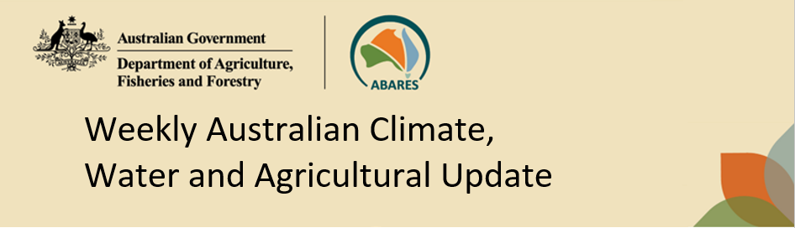
No. 11/2026 26 March 2026

Summary of key issues
- In the week ending 25 March 2026, Tropical Cyclone (TC) Narelle brought heavy rainfall to northern Australia.
  - Severe weather and flood warnings remain in place in Queensland, and parts of the Northern Territory, South Australia and New South Wales. Disruptions to supply chains are expected to persist. Most cropping regions of Queensland, South Australia, Victoria, the west of Western Australia and northern New South Wales saw little to no rainfall, while parts of New South Wales saw up to 50 millimetres.
- Over the 8 days to 2 April 2026, Tropical Cyclone (TC) Narelle is expected to bring heavy rainfall and destructive winds to the far west of Australia, while frontal and low-pressure systems are expected the bring rainfall to south-eastern Australia:
  - Falls of between 25-100 millimetres are forecast for large parts of the west of Western Australia, while the Northern Tropics continues to see rainfall of 10-50 millimetres.
  - These falls are likely to exacerbate existing flooding in the north, extend supply chain disruptions and slow recovery efforts.
- The national rainfall outlook for April to June 2026 indicates an increased probability of below median rainfall across much of southern and central Australia.
  - These expected well below average falls for much of southern and central Australia represents an increased downside production risk for the upcoming 2026–27 winter cropping season and autumn pasture growth.
- Water storage levels in the Murray-Darling Basin (MDB) decreased by 34 gigalitres (GL) between 19 March 2026 and 26 March 2026. The current volume of water held in storages is 10,541 GL, equivalent to 47% of total storage capacity. This is 14% or 1,746 GL less than the same time last year. Water storage data is sourced from the Bureau of Meteorology.
- Allocation prices in the Victorian Murray below the Barmah Choke decreased from $463/ML on 19 March 2026 to $421/ML on 26 March 2026. Trade from the Goulburn to the Murray is closed. Trade downstream through the Barmah Choke is closed. Trade from the Murrumbidgee to the Murray is open.

Climate

Rainfall this week
In the week ending 25 March 2026, Ex Tropical Cyclone (TC) Narelle brought heavy rainfall to northern Australia, while low-pressure systems brough rain to eastern and southern areas. Central and western Australia remained largely dry.
- Many northern regions continue to experience high rainfall totals, with falls of 10-300millimetres across much of the northern tropics, and isolated areas seeing falls of up to 400millimetres.
  - Severe weather and flood warnings remain in place in Queensland, and parts of the Northern Territory, South Australia and New South Wales. Disruptions to supply chains are expected to persist, including road closures and damage to railway infrastructure.
  - Several consecutive weeks of sustained rainfall in northern areas is likely to hinder the recession of floodwater and continue disruptions to agricultural operations.
- Southern and eastern coastal regions, including eastern Queensland, New South Wales, and Tasmania saw 5-50 millimetres of rainfall over the period, while much of southern Victoria and southern Western Australia recorded 5-15 millimetres.
- Much of the remainder of Western Australia, South Australia, and Queensland remained largely dry.
Across cropping regions, rainfall was mixed, with limited rainfall in the far west and some southern regions:
- Most cropping regions of Queensland, South Australia, Victoria, the west of Western Australia and northern New South Wales saw little to no rainfall.
  - These mainly dry conditions across Queensland and northern New South Wales are expected to support the harvest of late summer crops.
- Central New South Wales saw 5-50 millimetres of rainfall, while eastern Western Australia saw 5-15 millimetres.
  - These falls are expected to support autumn pasture growth and boost soil moisture levels in the led up to winter crop planting.

Rainfall for the week ending 25 March 2026
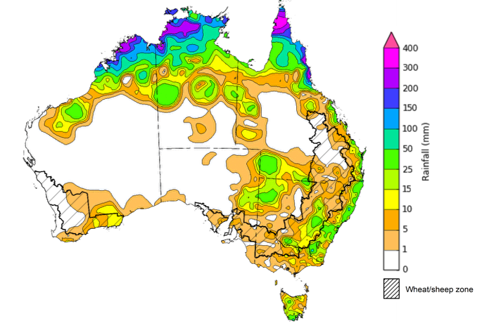
©Commonwealth of Australia 2026, Australian Bureau of Meteorology Issued: 25/3/2026
Note: The rainfall analyses and associated maps utilise data contained in the Bureau of Meteorology climate database, the Australian Data Archive for Meteorology (ADAM). The analyses are initially produced automatically from real-time data with limited quality control. They are intended to provide a general overview of rainfall across Australia as quickly as possible after the observations are received. For further information go to http://www.bom.gov.au/climate/rainfall/

Rainfall forecast for the next eight days
Over the 8 days to 2 April 2026, Tropical Cyclone (TC) Narelle is expected to bring heavy rainfall and destructive winds to the far west of Australia, while frontal and low-pressure systems are expected the bring rainfall to south-eastern Australia:
- Falls of between 25-100 millimetres are forecast for large parts of the west of Western Australia, while the Northern Tropics continues to see rainfall of 10-50 millimetres.
  - These falls are likely to exacerbate existing flooding in the north, extend supply chain disruptions and slow recovery efforts.
- In the southeast, falls of 25-100 millimetres are expected in eastern regions of Victoria and southern New South Wales, while remaining eastern areas are expected to see lower falls of between 5-15 millimetres.
- Remaining central and southern areas are likely to see little to no rainfall.
Rainfall totals across many cropping regions over the coming week are forecast to be low, with exceptions in parts of the east and west:
- Low rainfall totals (0-10 millimetres) are forecast for Queensland, northern New South Wales, South Australia, and much of Victoria and South Australia.
- Higher falls are forecast for much of Western Australia, with 25-150 millimetres forecast over the period. In southern and central New South Wales, up to 50 millimetres is expected.
  - These falls are likely to contribute to a build-up of soil moisture ahead of the planting of 2026–27 winter crops and benefit the growth of pastures.

Total forecast rainfall for the period 26 March to 2 April 2026
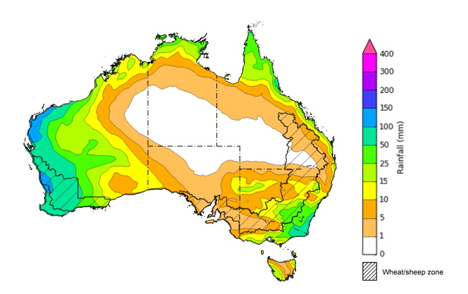
©Commonwealth of Australia 2026, Australian Bureau of Meteorology Issued 26/3/2026
Note: This rainfall forecast is produced from computer models. As the model outputs are not altered by weather forecasters, it is important to check local forecasts and warnings issued by the Bureau of Meteorology.

National Climate Outlook
The Bureau of Meteorology has indicated that the 2025–26 La Niña is close to its end. All models, including the Bureau of Meteorology's, indicate a continued warming in the tropical Pacific with a neutral ENSO state favoured through to at least late autumn. All models indicate a shift to El Niño is possible by the end of winter. However there is variation on the timing of this transition with some models suggesting development as early as May, while others delay onset until late winter. The Southern Annular Mode (SAM) is currently neutral and is forecast to remain neutral over the coming weeks. Similarly, while the Indian Ocean Dipole (IOD) has remained above the positive threshold for 6 consecutive weeks, it is unlikely to majorly influence Australian rainfall due to the presence of other weather systems.
The most recent rainfall outlook for April 2026 provided by the Bureau of Meteorology indicates that most of Australia is more likely to see below median rainfall, with parts of far northeast of Australia more likely to see median to above median falls.
The Bureau of Meteorology’s climate model indicates a 75% chance of April rainfall totals between 5-100 millimetres across parts of northern Australia. In the east, including Tasmania, the far southeast of Queensland, the east coast of New South Wales and southern Victoria, falls of 5- 50 millimetres are expected. Much of Western Australia, South Australia, and remaining areas of New South Wales, Queensland, Victoria, and the Northern Territory are likely to see little to no rainfall.
Across all cropping regions, there is a 75% chance of receiving rainfall totals of between 0- 10 millimetres of rainfall over the period. If these well below average forecast rainfall totals are realised this represents an increase chance of a false autumn break, following higher than expected March rainfall in some regions.

Rainfall totals that have a 75% chance of occurring in April 2026

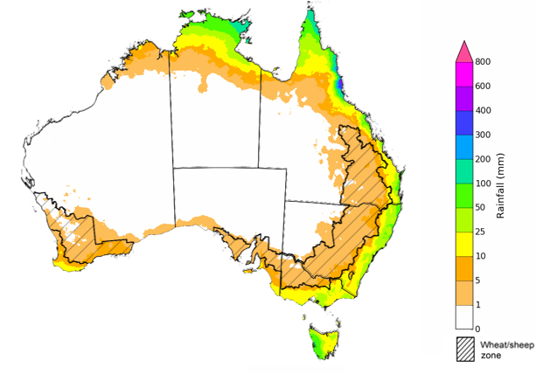
©Commonwealth of Australia 2025, Australian Bureau of Meteorology Issued: 26/3/2026
The rainfall outlook for April 2026 to June 2026 indicates a strong tendency towards below median rainfall across much of Australia. However, there is an increased probability of median to above median rainfall in parts of the northern tropics and central areas of Western Australia.
Across most cropping regions, the chance of receiving above median rainfall is 15-40%. Meanwhile, parts of northern Queensland and eastern Western Australia have no strong tendency between above or below median rainfall.

Chance of exceeding the median rainfall April 2026 to June 2026

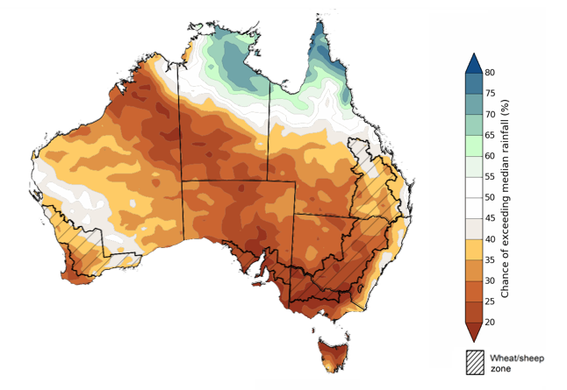
©Commonwealth of Australia 2025, Australian Bureau of Meteorology Issued: 26/3/2026

The rainfall outlook for April 2026 to June 2026 suggests a 75% chance of receiving rainfall totals of between 25-200 millimetres across parts of eastern, southern and northern Australia. Higher falls in excess of 200 millimetres are expected across scattered areas of north Queensland, southwest Western Australia, western Tasmania, as well as alpine regions of Victoria and New South Wales. Lower rainfall totals are forecast for central regions, with much of northern South Australia, central and northern Western Australia, the centre and south of the Northern Territory, western New South Wales and western Queensland likely to see 0-25 millimetres.
In cropping regions, there is a 75% chance of receiving between 10-50 millimetres across much of Queensland. Cropping regions in Western Australia, Victoria, South Australia, and New South Wales are likely to see 25-100 millimetres.
If these forecast April through June rainfall totals are realised, these expected well below average falls for much of south-eastern and eastern Australia represents an increased downside production risk for the upcoming 2026–27 winter cropping season and autumn pasture growth.

Rainfall totals that have a 75% chance of occurring April 2026 to June 2026

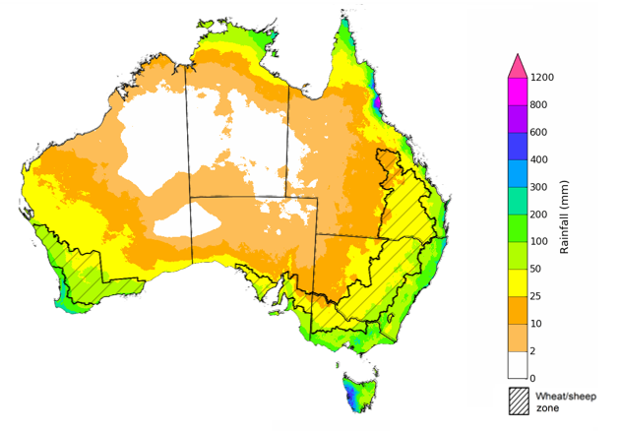
©Commonwealth of Australia 2025, Australian Bureau of Meteorology Issued: 26/3/2026

Water markets – current week
Water storage levels in the Murray-Darling Basin (MDB) decreased by 34 gigalitres (GL) between 19 March 2026 and 26 March 2026. The current volume of water held in storages is 10,541 GL, equivalent to 47% of total storage capacity. This is 14% or 1,746 GL less than the same time last year. Water storage data is sourced from the Bureau of Meteorology (BOM).

Water storages in the Murray-Darling Basin, 2013–2026
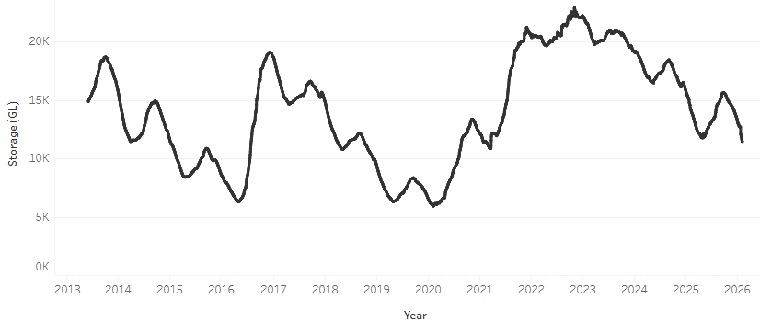
Allocation prices in the Victorian Murray below the Barmah Choke decreased from $463/ML on 19 March 2026 to $421/ML on 26 March 2026. Trade from the Goulburn to the Murray is closed. Trade downstream through the Barmah Choke is closed. Trade from the Murrumbidgee to the Murray is open.

Water market prices, Southern Murray–Darling Basin

Region | $/ML
NSW Murray Above | 311
NSW Murrumbidgee | 429
Vic Greater Goulburn | 318
Vic Murray Below | 421

Note: The water allocation prices shown are volume weighted average prices based on the last 10 trades. Price data is sourced from Waterflow and current as at 22 January 2026.
To access the full, interactive, weekly water dashboard, which contains the latest and historical water storage, water market and water allocation information, please visit https://www.agriculture.gov.au/abares/products/weekly_update/weekly-update-260319

Commodities
Indicator | Week average | Unit | Latest Price | Previous Week | Weekly change |  | Price 12 months ago | Annual change
Selected world indicator prices
AUD/USD Exchange rate | 25-Mar | A$/US$ | 0.70 | 0.71 | -1% | 0.63 |  | 11%
Wheat – US no. 2 hard red winter wheat, FOB Gulf | 25-Mar | US$/t | 273 | 278 | -2% | 256 |  | 7%
Corn – US no. 2 yellow corn, FOB Gulf | 25-Mar | US$/t | 212 | 211 | 0% | 208 |  | 2%
Canola – Rapeseed, Canada, FOB Vancouver | 25-Mar | US$/t | 551 | 553 | 0% | 452 |  | 22%
Cotton – Cotlook A Index | 25-Mar | USc/lb | 77.8 | 78.4 | -1% | 77.8 |  | 0%
Sugar – Intercontinental Exchange, nearby futures, no.11 contract | 25-Mar | USc/lb | 15.7 | 14.9 | 5% | 19.1 |  | -18%
Wool – Eastern Market Indicator | 25-Mar | Ac/kg clean | 1,751 | 1,783 | -2% | 1,241 |  | 41%
Wool – Western Market Indicator | 25-Mar | Ac/kg clean | 1,922 | 1,991 | -3% | 1,402 |  | 37%
Selected Australian grain export prices
Australian Premium White (APW) Wheat, FOB Port Adelaide, SA | 25-Mar | A$/t | 374 | 369 | 1% | 396 |  | -6%
Australian Standard White (ASW) Wheat, FOB Port Adelaide, SA | 25-Mar | A$/t | 371 | 366 | 1% | 387 |  | -4%
Feed Barley – FOB Port Adelaide, SA | 25-Mar | A$/t | 363 | 357 | 2% | 364 |  | 0%
Canola – FOB Kwinana, WA | 25-Mar | A$/t | 731 | 749 | -2% | 806 |  | -9%
Grain Sorghum – FOB Brisbane, QLD | 25-Mar | A$/t | 448 | 443 | 1% | 425 |  | 5%
Selected domestic livestock indicator prices
Beef – Eastern Young Cattle Indicator | 25-Mar | Ac/kg cwt | 868 | 882 | -2% | 653 |  | 33%
Mutton – Mutton indicator (18–24 kg fat score 2–3), VIC | 25-Mar | Ac/kg cwt | 795 | 797 | 0% | 402 |  | 98%
Lamb – National Trade Lamb Indicator | 25-Mar | Ac/kg cwt | 1,161 | 1,159 | 0% | 782 |  | 49%
Pig – Eastern Seaboard (60.1–75 kg), NSW buyer price | 25-Mar | Ac/kg cwt | 468 | 469 | 0% | 451 |  | 4%
Live cattle – Light steers to Indonesia | 25-Mar | Ac/kg lwt | 480 | 480 | 0% | 361 |  | 33%
Global Dairy Trade (GDT) weighted average prices
Dairy – Whole milk powder | 25-Mar | US$/t | 3,709 | 3,863 | -4% | 4,057 |  | -9%
Dairy – Skim milk powder | 25-Mar | US$/t | 3,409 | 3,243 | 5% | 2,737 |  | 25%
Dairy – Cheddar cheese | 25-Mar | US$/t | 4,925 | 4,920 | 0% | 4,946 |  | 0%
Dairy – Anhydrous milk fat | 25-Mar | US$/t | 7,602 | 7,147 | 6% | 6,621 |  | 15%

Selected world indicator prices
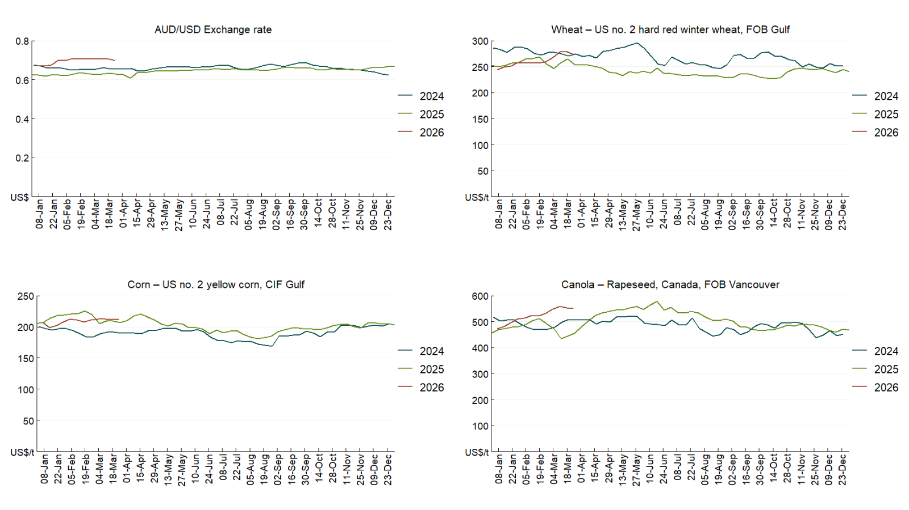

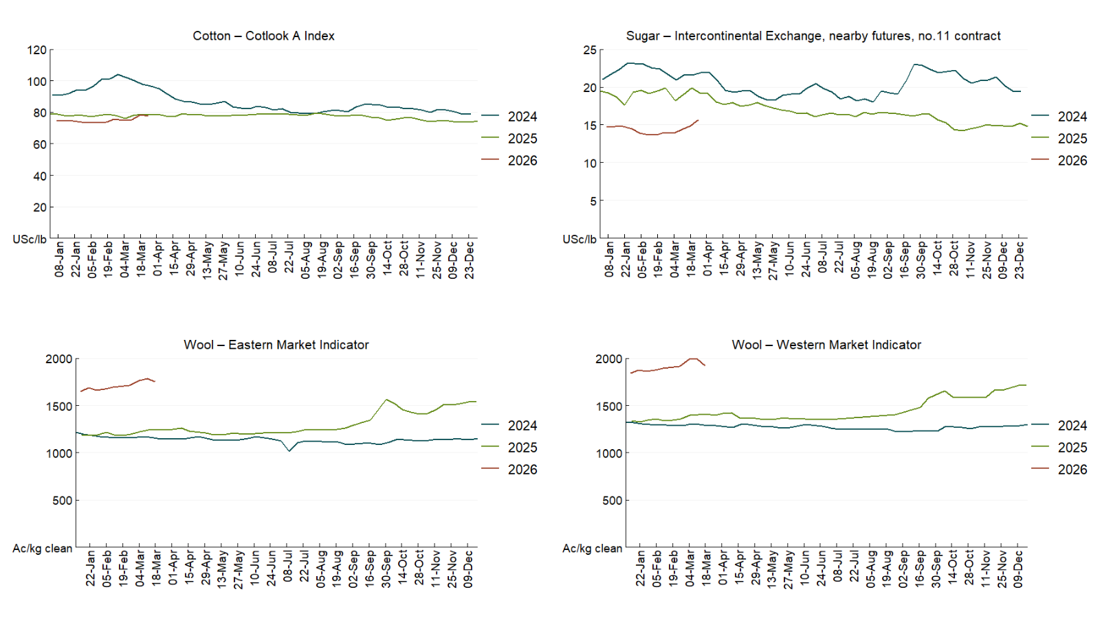

3.2 Selected domestic crop indicator prices
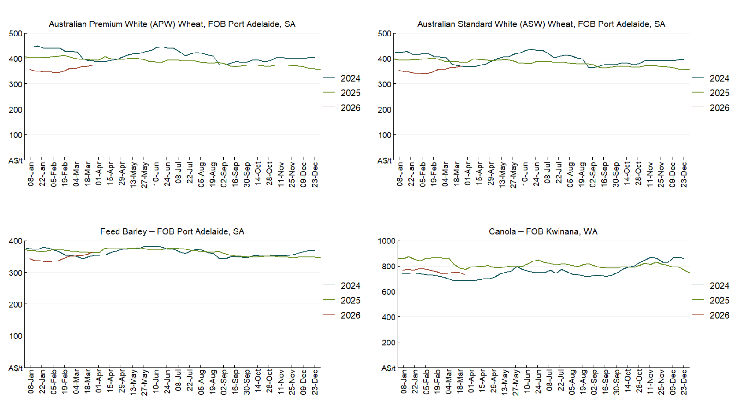

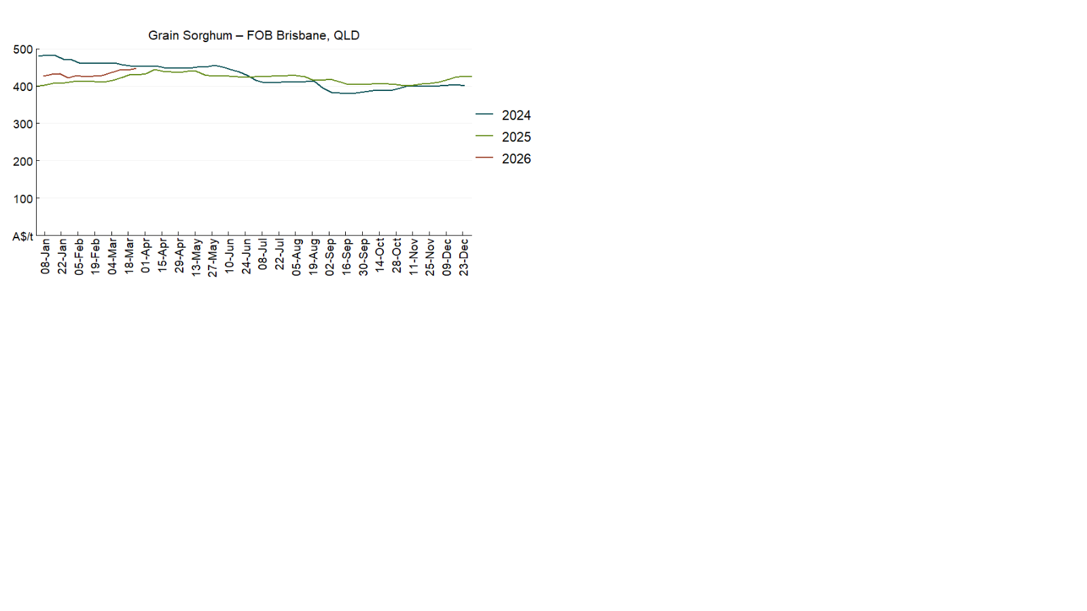

3.3 Selected domestic livestock indicator prices
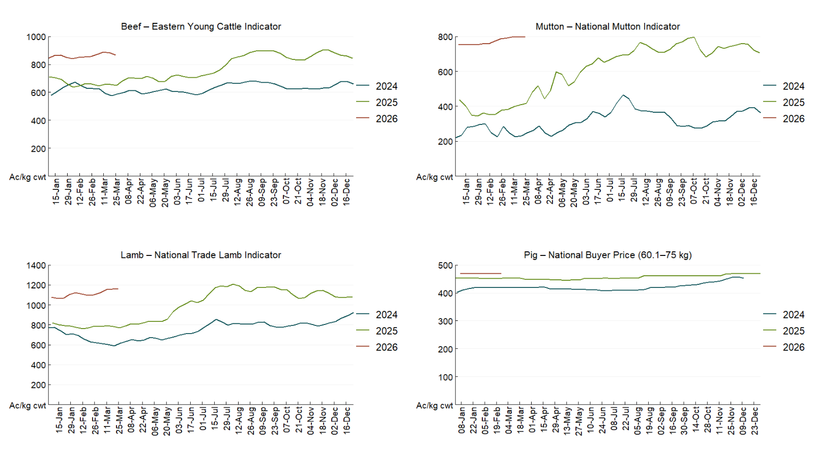

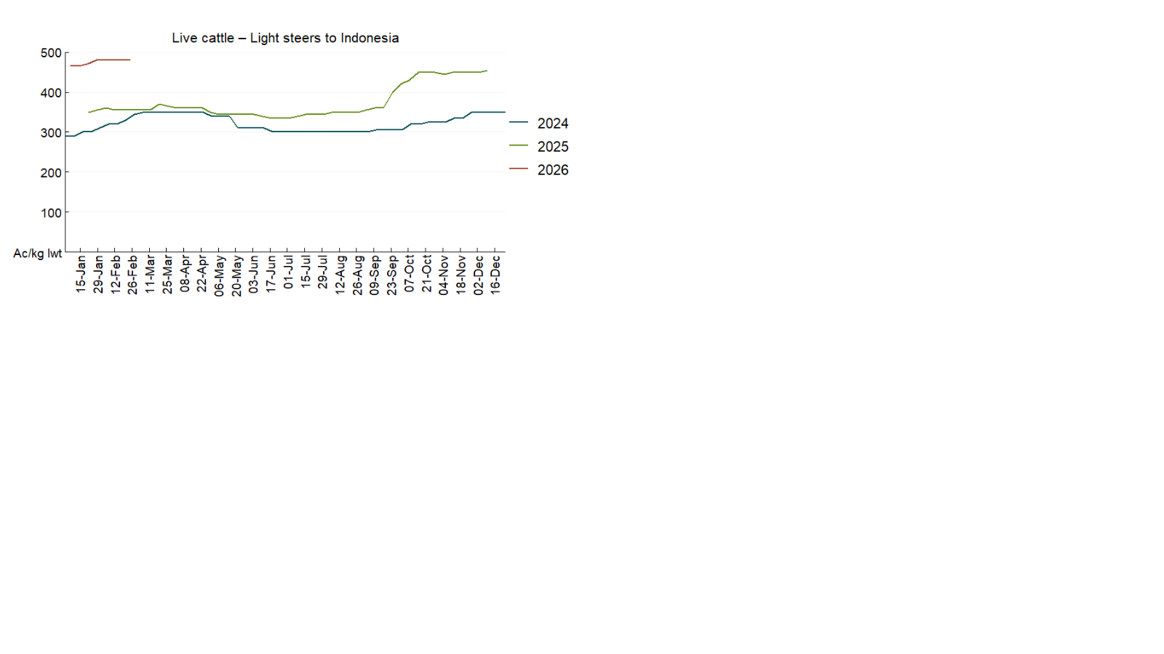

3.4 Global Dairy Trade (GDT) weighted average prices
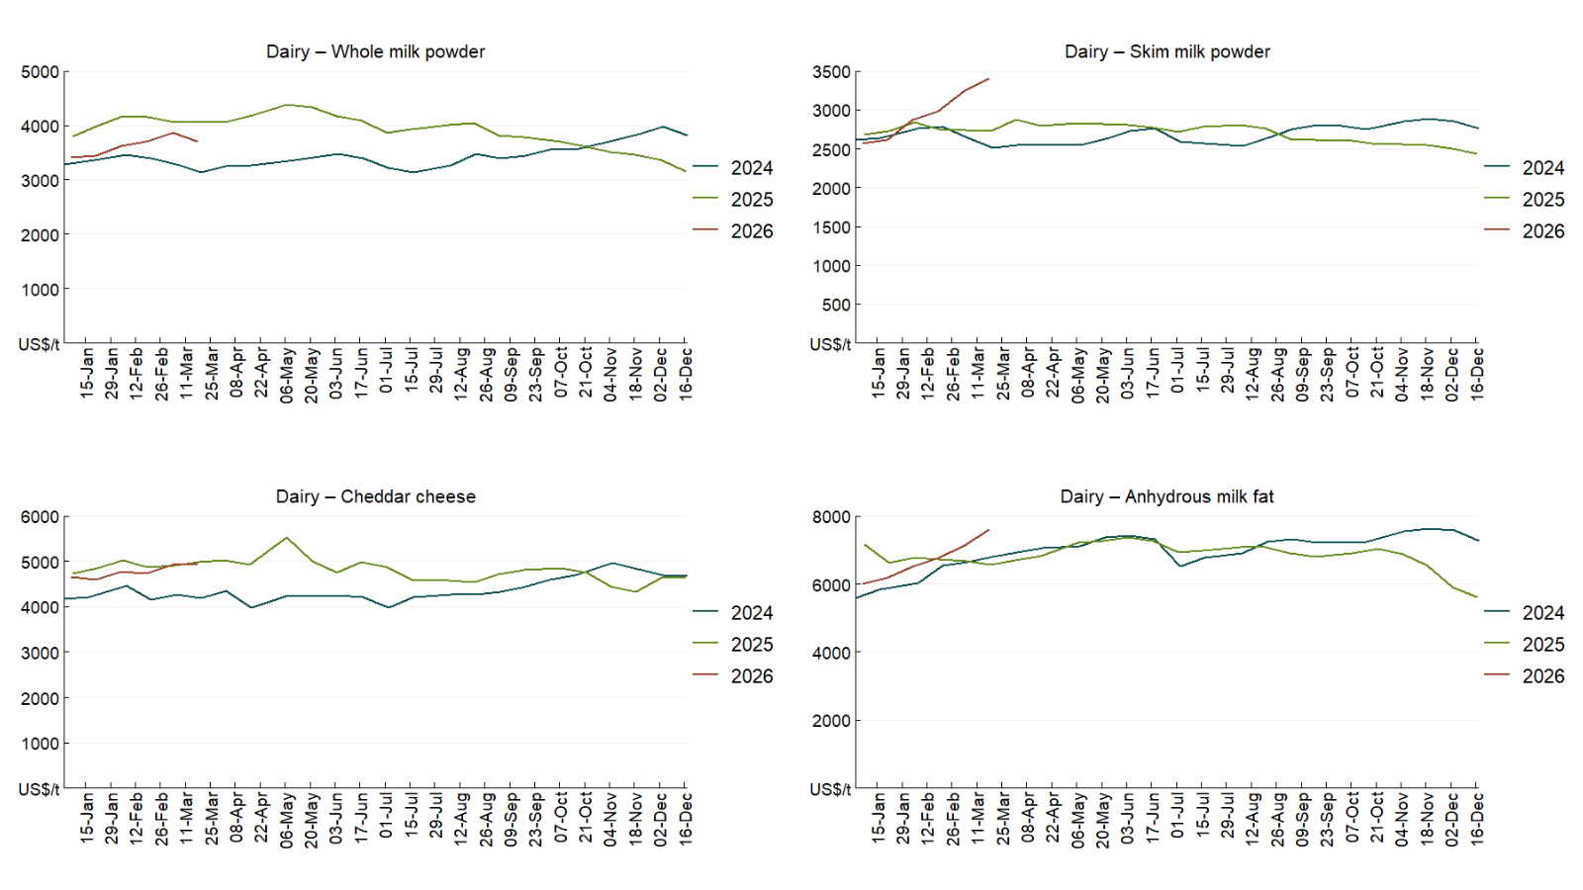

3.5 Selected fruit and vegetable prices
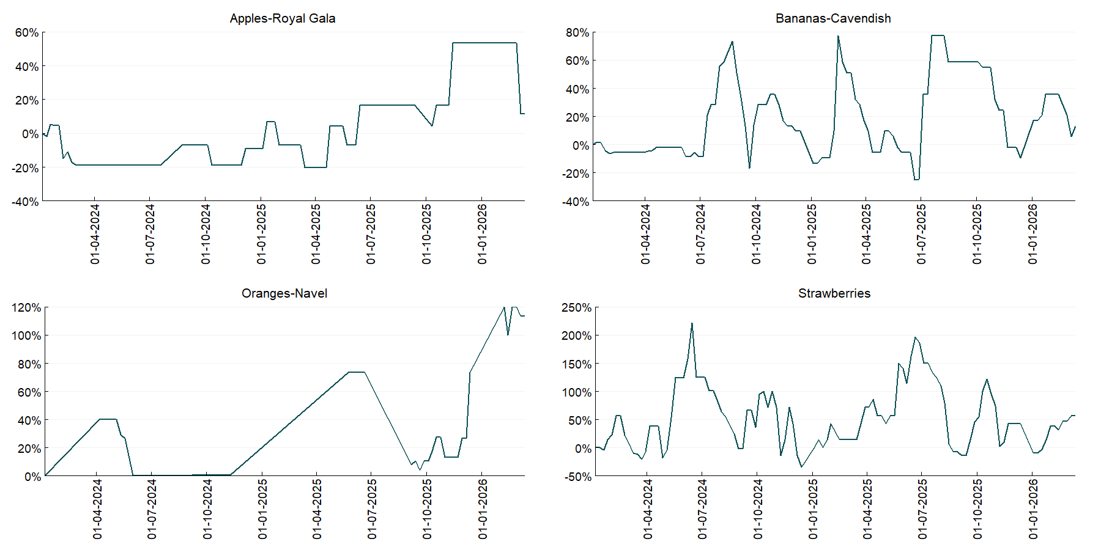

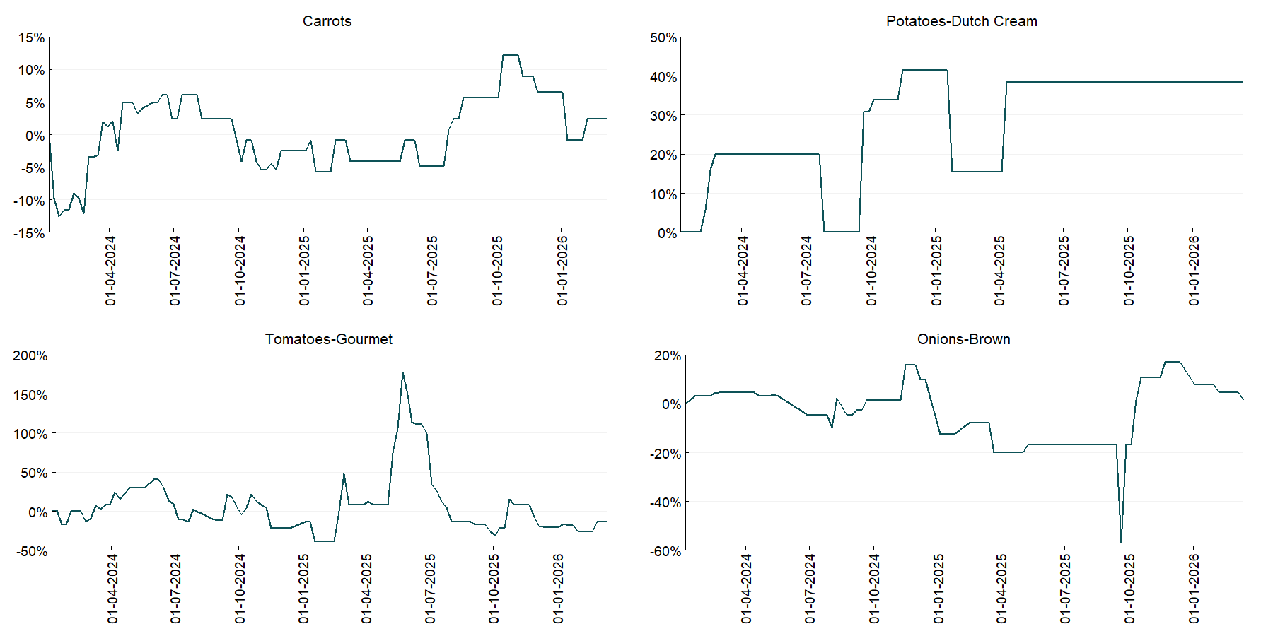

3.6 Selected domestic fodder indicator prices
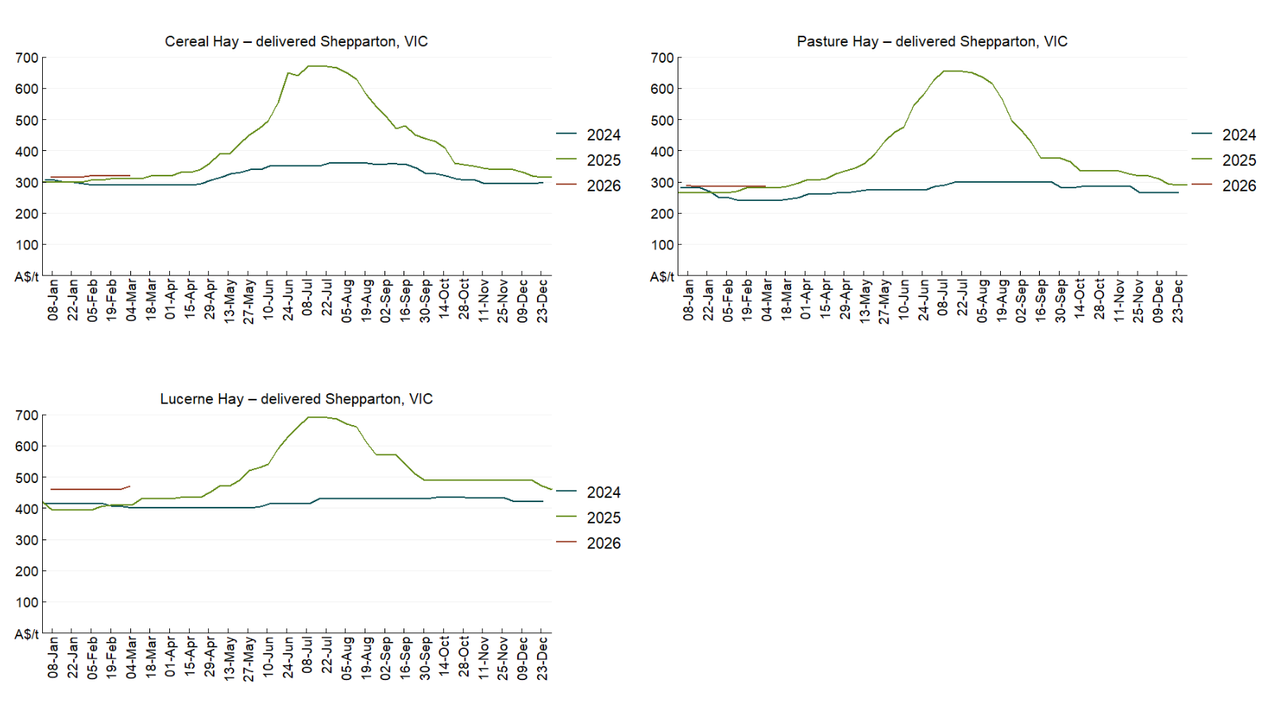

4. Data attribution

Climate
Bureau of Meteorology
- Weekly rainfall totals: www.bom.gov.au/climate/maps/rainfall/
- Monthly and last 3-month rainfall percentiles: https://www.bom.gov.au/climate/ahead/outlooks/#moreMaps
- Rainfall forecast: www.bom.gov.au/jsp/watl/rainfall/pme.jsp
- Seasonal outlook: www.bom.gov.au/climate/outlooks/#/overview/summary/
- Climate drivers: http://www.bom.gov.au/climate/enso/
- Soil moisture: https://awo.bom.gov.au/products/historical/soilMoisture-rootZone/

Other
- Pasture growth: www.longpaddock.qld.gov.au/aussiegrass/
- 3-month global outlooks: Environment and Climate Change Canada, NOAA Climate Prediction Center, EUROBRISA CPTEC/INPE, European Centre for Medium-Range Weather Forecasts, Hydrometcenter of Russia, National Climate Center Climate System Diagnosis and Prediction Room (NCC), International Research Institute for Climate and Society
- Global production: https://ipad.fas.usda.gov/ogamaps/cropmapsandcalendars.aspx
- Autumn break: Pook et al., 2009, https://rmets-onlinelibrary-wiley-com.virtual.anu.edu.au/doi/epdf/10.1002/joc.1833

Water
Prices
- Waterflow: https://www.waterflow.io/
- Ruralco: https://www.ruralcowater.com.au/
- Bureau of Meteorology:
- Allocation trade: http://www.bom.gov.au/water/dashboards/#/water-markets/mdb/at
- Storage volumes: http://www.bom.gov.au/water/dashboards/#/water-storages/summary/drainage

Trade constraints:
- Water NSW: https://www.waternsw.com.au/customer-service/ordering-trading-and-pricing/trading/murrumbidgee
- Victorian Water Register: https://www.waterregister.vic.gov.au/TradingRules2019/

Commodities
Fruit and vegetables
- Datafresh: www.freshstate.com.au

Pigs
- Australian Pork Limited: www.australianpork.com.au

Dairy
- Global Dairy Trade: www.globaldairytrade.info/en/product-results/

World wheat, canola
- International Grains Council
- https://www.igc.int/en/default.aspx
- United States Department of Agriculture

World cotton
- Cotlook: www.cotlook.com/

World sugar
- New York Stock Exchange - Intercontinental Exchange

Wool
- Australian Wool Exchange: www.awex.com.au/

Domestic wheat, barley, sorghum, canola and fodder
- Jumbuk Consulting Pty Ltd: Jumbuk AG | Agriculture Consulting

Cattle, beef, mutton, lamb, goat and live export
- Meat and Livestock Australia: https://www.mla.com.au/prices-markets/

Australian Agricultural Drought Indicators
About Australian Agricultural Drought Indicators
The Australian Agricultural Drought Indicators (AADI) links weather and agricultural data with a range of scientific and economic models to measure and forecast the effects of climate variability and drought on agricultural outcomes.
On AADI, projected broadacre farm profits are presented as percentile outcomes relative to simulated historical outcomes using the groupings:
Highest | 95-100th percentile
Very much above average | 85-95th percentile
Above average | 65-85th percentile
Average | 35-65th percentile
Below average | 15-35th percentile
Very much below average | 5-15th percentile
Lowest 5% | 0-5th percentile

There are two AADI farm profit indicators:
- The AADI farm profit climate and price indicator shows the effect of climate and prices on broadacre farm business profits of current farms compared to the last 33 years.
- The AADI farm profit climate only indicator isolates the effect of climate on profits by holding prices fixed.

© Commonwealth of Australia 2026

Ownership of intellectual property rights
Unless otherwise noted, copyright (and any other intellectual property rights, if any) in this publication is owned by the Commonwealth of Australia (referred to as the Commonwealth).

Creative Commons licence
All material in this publication is licensed under a Creative Commons Attribution 4.0 International Licence except content supplied by third parties, logos and the Commonwealth Coat of Arms.
Inquiries about the licence and any use of this document should be emailed to copyright@awe.gov.au.


Cataloguing data
This publication (and any material sourced from it) should be attributed as:
ABARES 2026, Weekly Australian Climate, Water and Agricultural Update, Australian Bureau of Agricultural and Resource Economics and Sciences, Canberra, 19 March 2026. CC BY 4.0 DOI: https://doi.org/10.25814/5f3e04e7d2503
ISSN 2652-7561
This publication is available at https://www.agriculture.gov.au/abares/products/weekly_update
Department of Agriculture, Fisheries and Forestry
GPO Box 858 Canberra ACT 2601
Telephone 1800 900 090
Web agriculture.gov.au/abares

Disclaimer
The Australian Government acting through the Department of Agriculture, Fisheries and Forestry, represented by the Australian Bureau of Agricultural and Resource Economics and Sciences, has exercised due care and skill in preparing and compiling the information and data in this publication. Notwithstanding, the Department of Agriculture, Fisheries and Forestry, ABARES, its employees and advisers disclaim all liability, including liability for negligence and for any loss, damage, injury, expense or cost incurred by any person as a result of accessing, using or relying on any of the information or data in this publication to the maximum extent permitted by law.

Statement of Professional Independence
The views and analysis presented in ABARES publications, including this one, reflect ABARES professionally independent findings, based on scientific and economic concepts, principles, information and data. These views, analysis and findings may not reflect or be consistent with the views or positions of the Australian Government, or of organisations or groups who have commissioned ABARES reports or analysis. More information on professional independence is provided on the ABARES website.

Acknowledgements
This report was prepared by Holly Beale and Matthew Miller.

