
No. 12/2026 2 April 2026

Summary of key issues
- In the week ending 1 April 2026, Ex Tropical Cyclone (TC) Narelle brought heavy rainfall to Western Australia.
  - Severe weather and flood warnings remain in place in Queensland, and parts of the Northern Territory, South Australia and New South Wales.
  - In southern cropping areas, falls are expected to support autumn pasture growth and boost soil moisture levels in the led up to winter crop planting.
- Over the 8 days to 9 April 2026, cold fronts are expected to bring rainfall to parts of the southeast and southwest:
  - Low rainfall totals (0-10 millimetres) are forecast for cropping regions in Queensland, New South Wales, South Australia, and Victoria.
  - Higher falls are forecast for much of Western Australia, with 10-50 millimetres forecast over the period.
- Rainfall was generally average to above average across Australia for March 2026, although below average to severely deficient rainfall was recorded in some isolated eastern areas, including parts of southeast Queensland and northern New South Wales, as well as Tasmania.
- Pasture growth for the three months to March 2026 has been mixed, with much of north-eastern and central Australia seeing robust pasture growth but below average growth was evident across large areas of eastern, northern and western Australia. Soil moisture models indicate broadly high soil moisture storage with exceptions in isolated eastern and western areas.
- Water storage levels in the Murray-Darling Basin (MDB) decreased by 69 gigalitres (GL) between 26 March 2026 and 1 April 2026. The current volume of water held in storages is 10,472 GL, equivalent to 47% of total storage capacity. This is 14% or 1,688 GL less than the same time last year. Water storage data is sourced from the Bureau of Meteorology.
- Allocation prices in the Victorian Murray below the Barmah Choke decreased from $421/ML on 26 March 2026 to $399/ML on 2 April 2026. Trade from the Goulburn to the Murray is closed. Trade downstream through the Barmah Choke is closed. Trade from the Murrumbidgee to the Murray is open.

Climate

Rainfall this week
In the week ending 1 April 2026, Ex Tropical Cyclone (TC) Narelle brought heavy rainfall to parts of Western Australia, while a low-pressure system brought falls to parts of the southeast. Central and eastern regions remained largely dry.
- In Western Australia, 50-400 millimetres of rainfall was recorded across much of the western coast and some inland regions. Severe weather warnings are in place in isolated areas.
- Many northern regions continue to experience rainfall, with the northern tropics observing falls of 10-50 millimetres.
  - Severe weather and flood warnings remain in place in Queensland, and well as parts of the Northern Territory, South Australia and New South Wales.
- Eastern Victoria and southern New South Wales saw 25-100 millimetres of rainfall over the period, with isolated areas up to 150 millimetres.
- Much of southern and central Queensland, South Australia, northern New South Wales, eastern Tasmania, and the remainder of the Northern Territory remained largely dry.
Across cropping regions, rainfall was mixed, with limited rainfall in the east and considerable falls in the west and parts of the southeast.
- Most cropping regions of South Australia, Victoria, northern New South Wales, and Queensland saw little to no rainfall.
  - These mainly dry conditions across Queensland and northern New South Wales are expected to support the harvest of late summer crops.
- In contrast, falls of 10-50 millimetres were recorded across much of Western Australia and southern New South Wales.
  - These falls are expected to support autumn pasture growth and boost soil moisture levels in the lead up to winter crop planting.

Rainfall for the week ending 1 April 2026
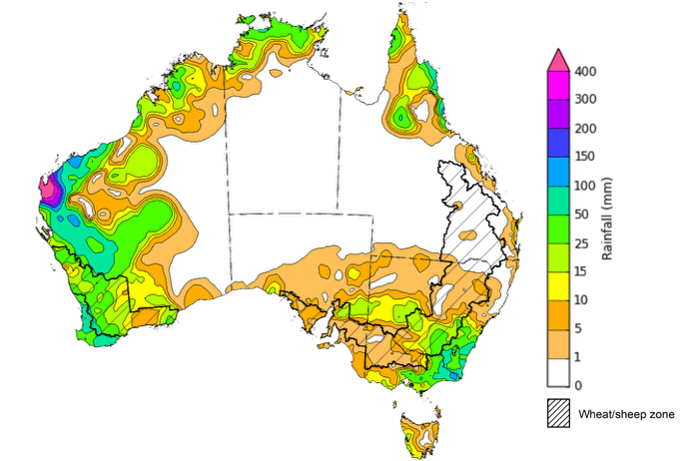
©Commonwealth of Australia 2026, Australian Bureau of Meteorology Issued: 1/4/2026
Note: The rainfall analyses and associated maps utilise data contained in the Bureau of Meteorology climate database, the Australian Data Archive for Meteorology (ADAM). The analyses are initially produced automatically from real-time data with limited quality control. They are intended to provide a general overview of rainfall across Australia as quickly as possible after the observations are received. For further information go to http://www.bom.gov.au/climate/rainfall/

Rainfall forecast for the next eight days
Over the 8 days to 9 April 2026, cold fronts are expected to bring rainfall to parts of the southeast and southwest, while low-pressure systems are expected the bring rainfall the far north.
- Falls of between 5-50 millimetres are forecast for parts of the northern tropics, including the far north of the Northern Territory and Cape York Peninsula. Similar rainfall totals are expected for much of southern Western Australia and Tasmania.
- In the east, falls of 5-25 millimetres are expected in eastern coastal regions of New South Wales and southern Victoria, while remaining eastern areas are expected to see lower falls of between 5-10 millimetres.
- Remaining central and southern areas are likely to see little to no rainfall.
Rainfall totals across many cropping regions over the coming week are forecast to be low, with exceptions in parts of the west:
- Low rainfall totals (0-10 millimetres) are forecast for Queensland, New South Wales, South Australia, and Victoria.
- Higher falls are forecast for much of Western Australia, with 10-50 millimetres forecast over the period.
  - These falls are likely to contribute to a build-up of soil moisture ahead of the planting of 2026–27 winter crops and benefit the growth of pastures.

Total forecast rainfall for the period 2 April to 9 April 2026
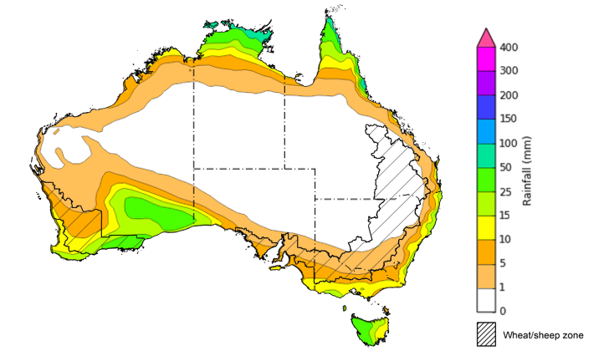
©Commonwealth of Australia 2026, Australian Bureau of Meteorology Issued 2/4/2026
Note: This rainfall forecast is produced from computer models. As the model outputs are not altered by weather forecasters, it is important to check local forecasts and warnings issued by the Bureau of Meteorology.

Monthly rainfall
- Rainfall during March 2026 was generally above average across Australia.
  - Numerous low-pressure systems and Tropical Cyclone (TC) Narelle contributed to widespread flooding across the Northern Territory, northern Queensland and Western Australia and South Australia with some areas seeing highest on record rainfall.
  - In the south, low-pressure systems and cold fronts have supported rainfall outcomes in southern New South Wales, much of Victoria and South Australia, and Western Australia, with these areas seeing average to very much above average rainfall.
  - While this heavy rainfall has led to supply chain disruptions and lead to some short-term hardship for some producers, these falls are likely to provide significant longer-term benefits to pasture production and soil moisture levels.
- Below average to severely deficient rainfall was recorded in some isolated eastern areas, including parts of southeast Queensland and northern New South Wales, as well as Tasmania.
In cropping regions, March rainfall was generally average to extremely high, with some below average falls in the east:
- March rainfall was below average to very much below average in parts of northern New South Wales and southern Queensland. Southern cropping regions, including Victoria, South Australia, and much of Western Australia, saw average to extremely high rainfall for the period.
  - This above average rainfall outcome is likely to have supported pasture growth and soil moisture storage ahead of the winter cropping season.
Rainfall deciles for March 2026
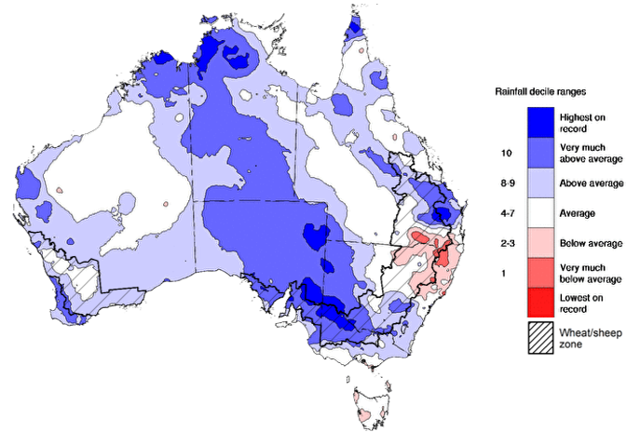

\
Note: Rainfall for March 2026 is compared with rainfall recorded for that period during the historical record (1900 to present). For further information, go to http://www.bom.gov.au/climate/austmaps/about-rain-maps.shtml
Source: Bureau of Meteorology

Monthly Soil Moisture
In March 2026, modelled upper layer soil moisture was generally average to above average in the northern, central, and southern parts of the country, with scattered areas of extremely low soil moisture in eastern and western regions.
- Parts of south-eastern Queensland, north-eastern New South Wales, and central and southern Western Australia saw very much below average to below average upper layer soil moisture.
- In contrast, much of central, southern, and northern Australia, including the northern tropics, South Australia, Victoria and remaining areas in Queensland, New South Wales, and Western Australia saw average to very much above upper layer soil moisture.
At this time of year, upper layer soil moisture is important for preparation for winter cropping in southern states, and for pasture growth across northern Australia since plant growth utilises this moisture. It is also an important indicator of the ability to access paddocks for winter crop planting activities.
Across cropping regions, modelled upper layer soil moisture in March for north-eastern cropping regions was generally average to below average, while southern cropping regions saw average to very much above average upper layer soil moisture.
Modelled upper layer soil moisture for March 2026
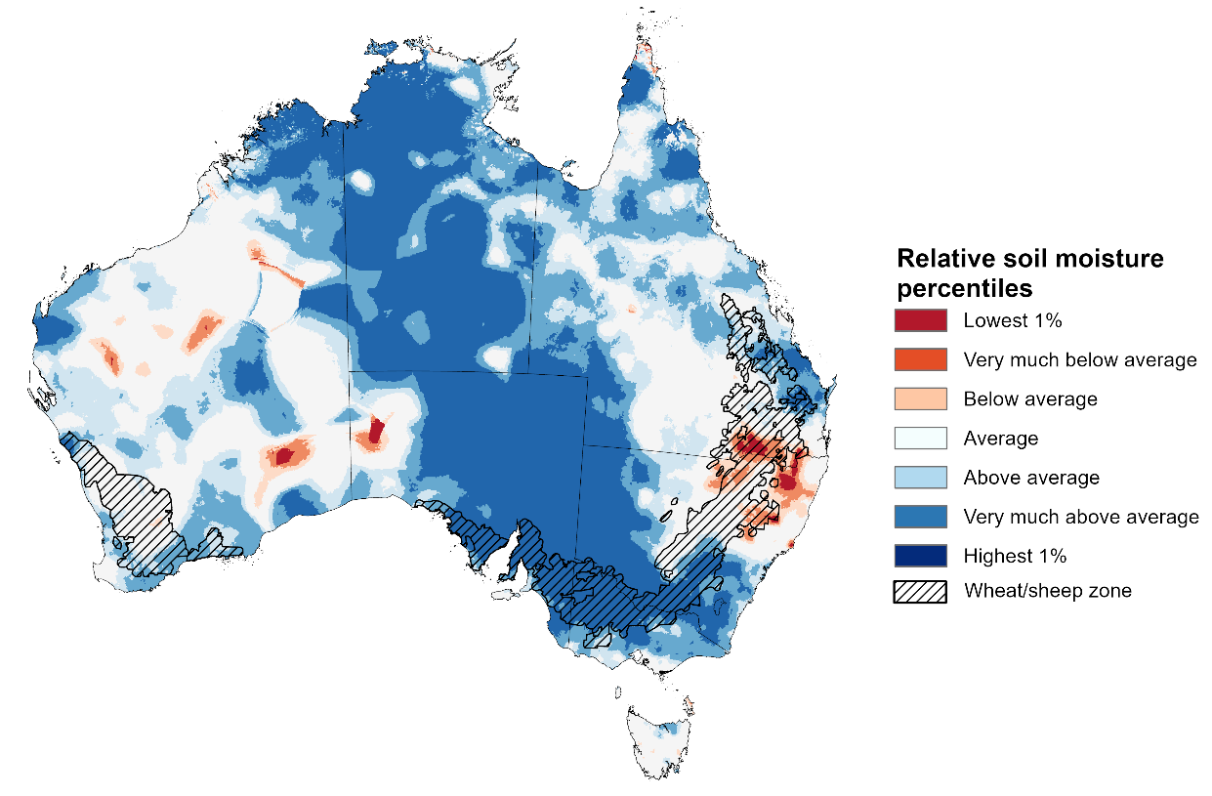

Note: This map shows the levels of modelled upper layer soil moisture (0 to 10 centimetres) during March 2026 This map shows how modelled soil conditions during March 2026 compare with March conditions modelled over the reference period (1911 to 2016). Dark blue areas on the maps were much wetter in March 2026 than during the reference period. The bulk of plant roots occur in the top 20 centimetres of the soil profile. Soil moisture in the upper layer of the soil profile is therefore useful indicator of the availability of water, particularly for germinating seed.
Source: Bureau of Meteorology (https://awo.bom.gov.au/about/overview)
Modelled lower layer soil moisture in March 2026 was average to very much above average across much of Australia, while extremely low to below average modelled lower layer soil moisture was evident across some eastern and western areas.
- Parts of south-eastern Queensland, north-eastern New South Wales, Tasmania, and central Western Australia were modelled as having very much below average to below average soil moisture. By contrast, much of the northern tropics, South Australia, western Queensland and New South Wales were modelled as having above average to very much above average soil moisture over the period.
At this time of year increased levels of lower layer soil moisture will be important to support establishment on winter crops and pasture growth during a peak growth period.
Most cropping regions in southern Queensland and northern New South Wales were modelled as having average to very much below average soil moisture, with some areas of northern Queensland seeing above average soil moisture. In contrast, southern New South Wales, Victoria, and South Australia recorded average to very much above average soil moisture for this time of year. Western Australian cropping regions were modelled as having broadly average soil moisture storage.
In areas with average to above average lower layer soil moisture, this is likely to provide a reserve of plant-available water for early winter crops. Agricultural regions across southern Australia have seen a significant improvement in soil moisture levels since the end of January 2026. This is likely to assist in arresting declining levels of pasture availability and provide a boost to soil moisture reserves ahead of planting of the 2026–27 winter crop.
Modelled lower layer soil moisture for March 2026
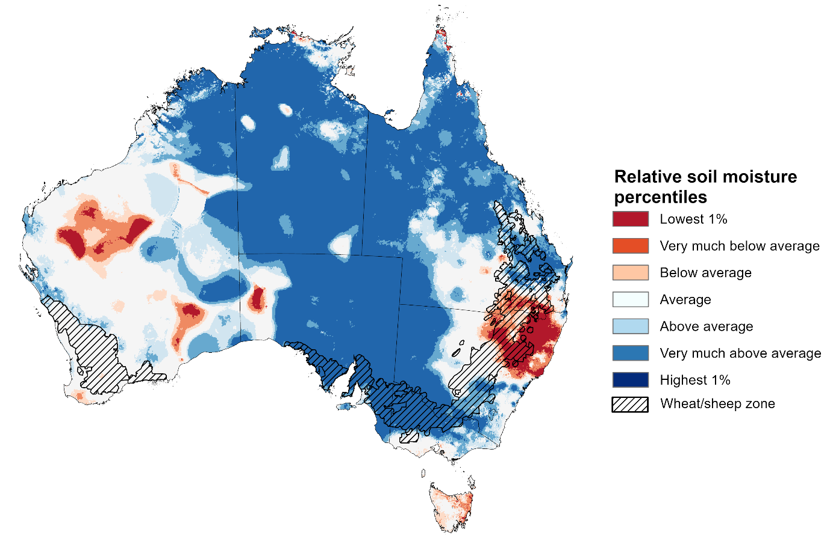

Note:. This map shows how modelled soil conditions during March 2026 compare with March conditions modelled over the reference period (1911 to 2016). Dark blue areas on the maps were much wetter in March 2026 than during the reference period. The dark red areas were much drier than during the reference period. The bulk of plant roots occur in the top 20 centimetres of the soil profile. The lower layer soil moisture is a larger, deeper store that is slower to respond to rainfall and tends to reflect accumulated rainfall events over longer time periods.
Source: Bureau of Meteorology (https://awo.bom.gov.au/about/overview)

Pasture Growth
The January to March period is an important part of the growth period for northern Australia which typically provides the bulk of feed to maintain production through the low pasture growth months of the northern dry season. Across southern Australia, January to March pasture growth is typically low reflecting lower rainfall totals, high temperature and high evapotranspiration rates at this time of year. Pasture availability during this period influences the growth and branding and marking rates of lambs and calves, livestock turnoff and the production of meat, milk, and wool.
Pasture growth for the three months to March 2026 was variable across much of country.
- Average to extremely high relative pasture growth was modelled across large areas of northern and central Australia – with exceptions in the far-north Northern Tropics – as well as isolated south-eastern regions, including northern Victoria, northern South Australia, western New South Wales and western Tasmania.
  - This pasture growth is expected to have allowed some farmers to maintain livestock numbers, provide opportunities to build standing dry matter availability and replenish fodder supplies during late spring and early summer period.
- In contrast, large areas of the eastern and western Australia, including parts of southern Queensland, north-eastern New South Wales, southern Victoria, the northern tropics, and central Western Australia saw relatively low pasture growth for this time of year.
  - This below average pasture growth has likely led to a decline in pasture availability and graziers in regions where below average pasture growth was recorded will be more reliant on supplemental feed to maintain current stocking rates and production, with others choosing to destock to take advantage of current high saleyard prices.
Relative pasture growth for 3-months ending February 2026 (1 January to 31 Narch 2026)
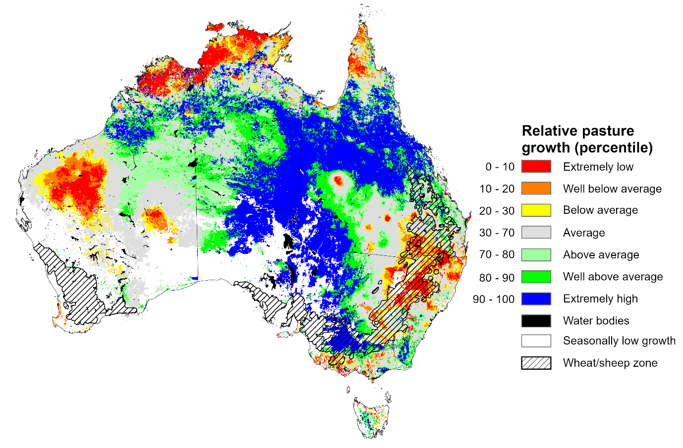
Notes: AussieGRASS pasture growth estimates are relative to the long-term record and shown in percentiles. Percentiles rank data on a scale of zero to 100. This analysis ranks pasture growth for the selected period against average pasture growth for the long-term record (1957 to 2016). Pasture growth is modelled at 5km2 grid cells.
Source: Department of Environment, Science and Innovation

Water markets – current week
Water storage levels in the Murray-Darling Basin (MDB) decreased by 69 gigalitres (GL) between 26 March 2026 and 1 April 2026. The current volume of water held in storages is 10,472 GL, equivalent to 47% of total storage capacity. This is 14% or 1,688 GL less than the same time last year. Water storage data is sourced from the Bureau of Meteorology.

Water storages in the Murray-Darling Basin, 2013–2026
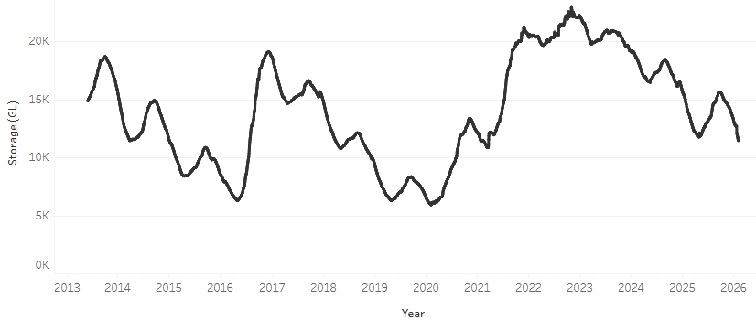
Allocation prices in the Victorian Murray below the Barmah Choke decreased from $421/ML on 26 March 2026 to $399/ML on 2 April 2026. Trade from the Goulburn to the Murray is closed. Trade downstream through the Barmah Choke is closed. Trade from the Murrumbidgee to the Murray is open.

Water market prices, Southern Murray–Darling Basin

Region | $/ML
NSW Murray Above | 290
NSW Murrumbidgee | 431
Vic Greater Goulburn | 332
Vic Murray Below | 399

Note: The water allocation prices shown are volume weighted average prices based on the last 10 trades. Price data is sourced from Waterflow and current as at 22 January 2026.
To access the full, interactive, weekly water dashboard, which contains the latest and historical water storage, water market and water allocation information, please visit https://www.agriculture.gov.au/abares/products/weekly_update/weekly-update-260402

Commodities
Indicator | Week average | Unit | Latest Price | Previous Week | Weekly change |  | Price 12 months ago | Annual change
Selected world indicator prices
AUD/USD Exchange rate | 1-Apr | A$/US$ | 0.69 | 0.70 | -1% | 0.63 |  | 9%
Wheat – US no. 2 hard red winter wheat, FOB Gulf | 1-Apr | US$/t | 281 | 278 | 1% | 249 |  | 13%
Corn – US no. 2 yellow corn, FOB Gulf | 1-Apr | US$/t | 213 | 214 | 0% | 215 |  | -1%
Canola – Rapeseed, Canada, FOB Vancouver | 1-Apr | US$/t | 550 | 551 | 0% | 517 |  | 6%
Cotton – Cotlook A Index | 1-Apr | USc/lb | 80.6 | 78.6 | 3% | 78.1 |  | 3%
Sugar – Intercontinental Exchange, nearby futures, no.11 contract | 1-Apr | USc/lb | 15.6 | 15.7 | -1% | 18.1 |  | -14%
Wool – Eastern Market Indicator | 1-Apr | Ac/kg clean | 1,786 | 1,724 | 4% | 1,238 |  | 44%
Wool – Western Market Indicator | 1-Apr | Ac/kg clean | 2,007 | 1,893 | 6% | 1,394 |  | 44%
Selected Australian grain export prices
Australian Premium White (APW) Wheat, FOB Port Adelaide, SA | 1-Apr | A$/t | 376 | 373 | 1% | 399 |  | -6%
Australian Standard White (ASW) Wheat, FOB Port Adelaide, SA | 1-Apr | A$/t | 373 | 370 | 1% | 393 |  | -5%
Feed Barley – FOB Port Adelaide, SA | 1-Apr | A$/t | 366 | 363 | 1% | 372 |  | -2%
Canola – FOB Kwinana, WA | 1-Apr | A$/t | 757 | 736 | 3% | 795 |  | -5%
Grain Sorghum – FOB Brisbane, QLD | 1-Apr | A$/t | 446 | 447 | 0% | 438 |  | 2%
Selected domestic livestock indicator prices
Beef – Eastern Young Cattle Indicator | 1-Apr | Ac/kg cwt | 847 | 867 | -2% | 700 |  | 21%
Mutton – Mutton indicator (18–24 kg fat score 2–3), VIC | 1-Apr | Ac/kg cwt | 801 | 797 | 1% | 506 |  | 58%
Lamb – National Trade Lamb Indicator | 1-Apr | Ac/kg cwt | 1,181 | 1,165 | 1% | 812 |  | 45%
Pig – Eastern Seaboard (60.1–75 kg), NSW buyer price | 18-Mar | Ac/kg cwt | 465 | 467 | 0% | 448 |  | 4%
Live cattle – Light steers to Indonesia | 25-Feb | Ac/kg lwt | 480 | 480 | 0% | 358 |  | 34%
Global Dairy Trade (GDT) weighted average prices
Dairy – Whole milk powder | 18-Mar | US$/t | 3,709 | 3,863 | -4% | 4,117 |  | -10%
Dairy – Skim milk powder | 18-Mar | US$/t | 3,409 | 3,243 | 5% | 2,836 |  | 20%
Dairy – Cheddar cheese | 18-Mar | US$/t | 4,925 | 4,920 | 0% | 4,971 |  | -1%
Dairy – Anhydrous milk fat | 18-Mar | US$/t | 7,602 | 7,147 | 6% | 6,772 |  | 12%

Selected world indicator prices
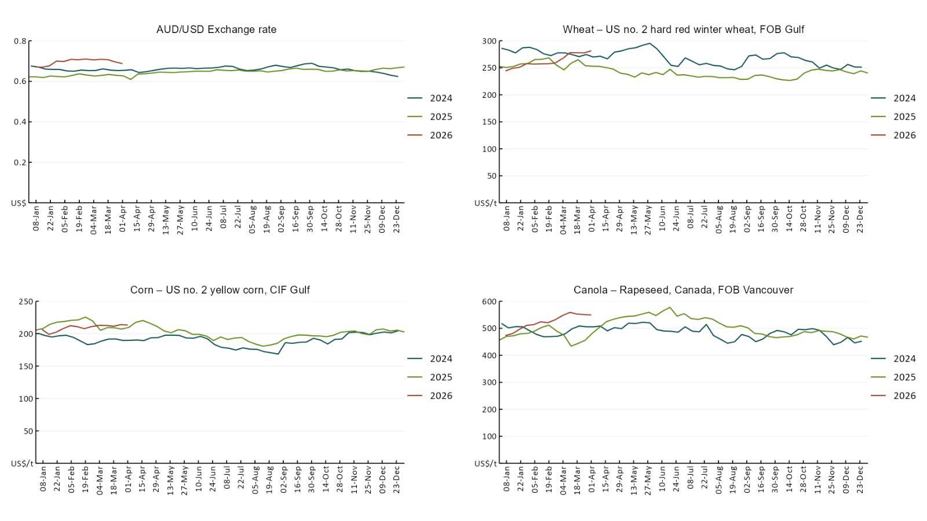

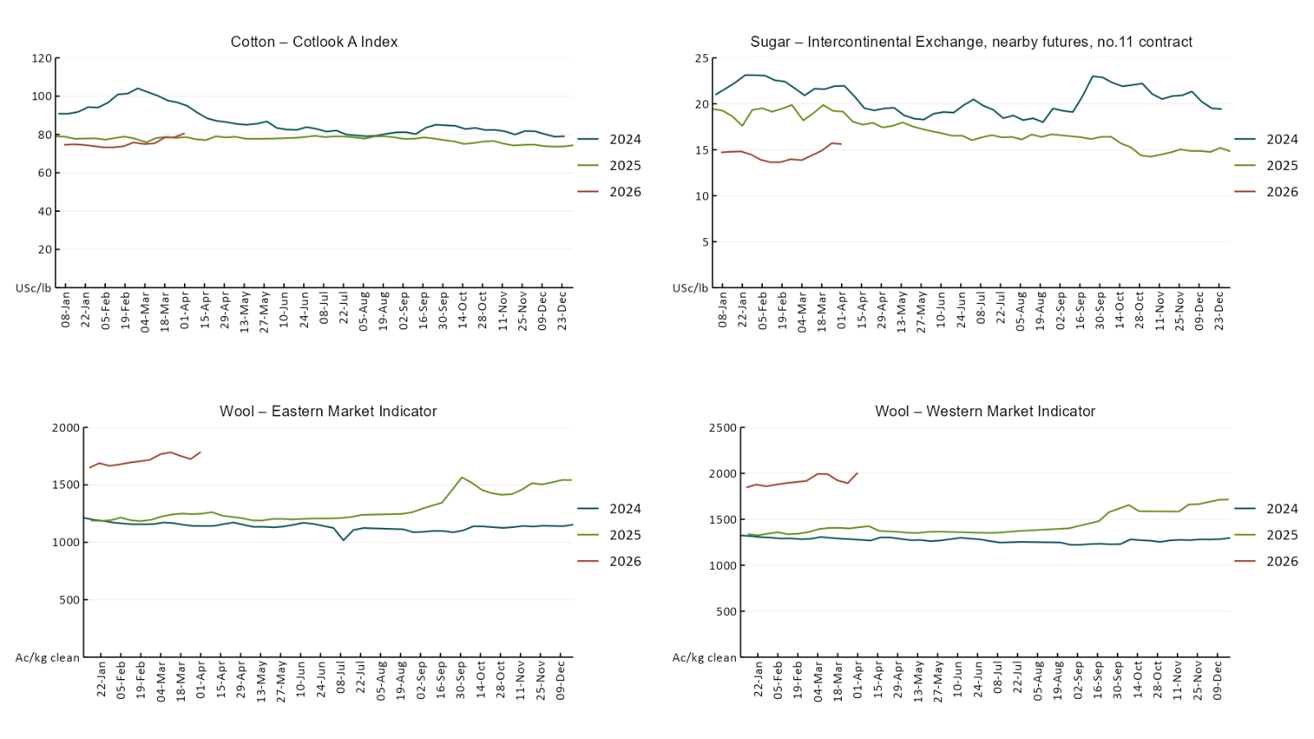

3.2 Selected domestic crop indicator prices
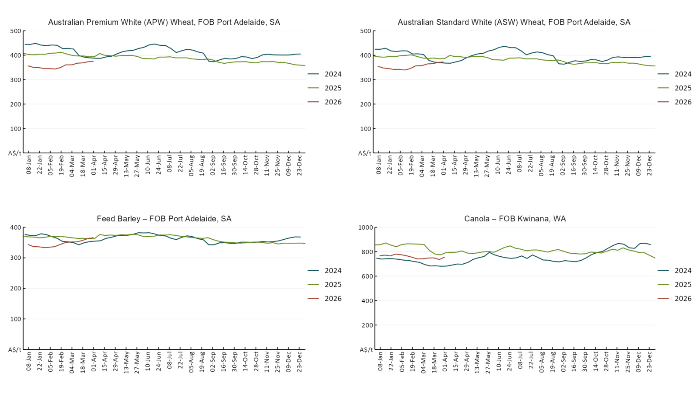

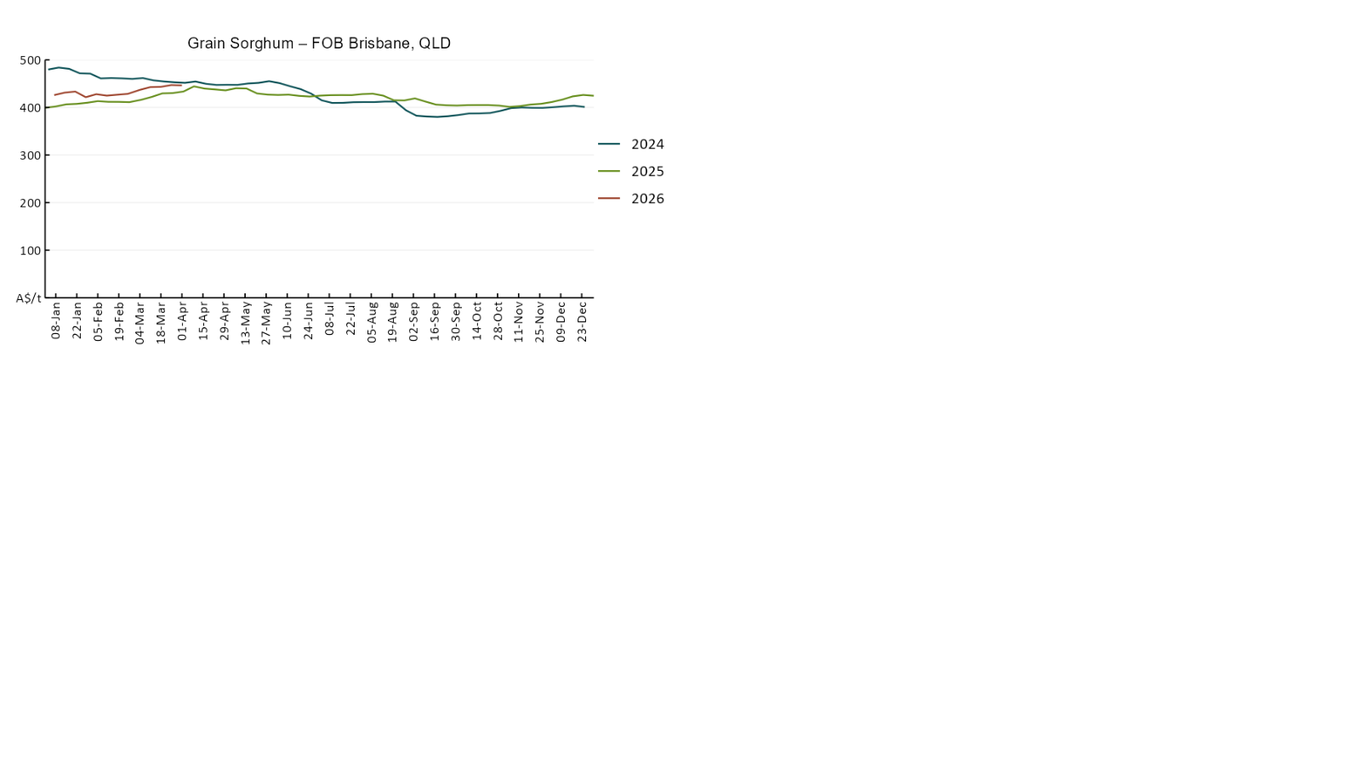

3.3 Selected domestic livestock indicator prices
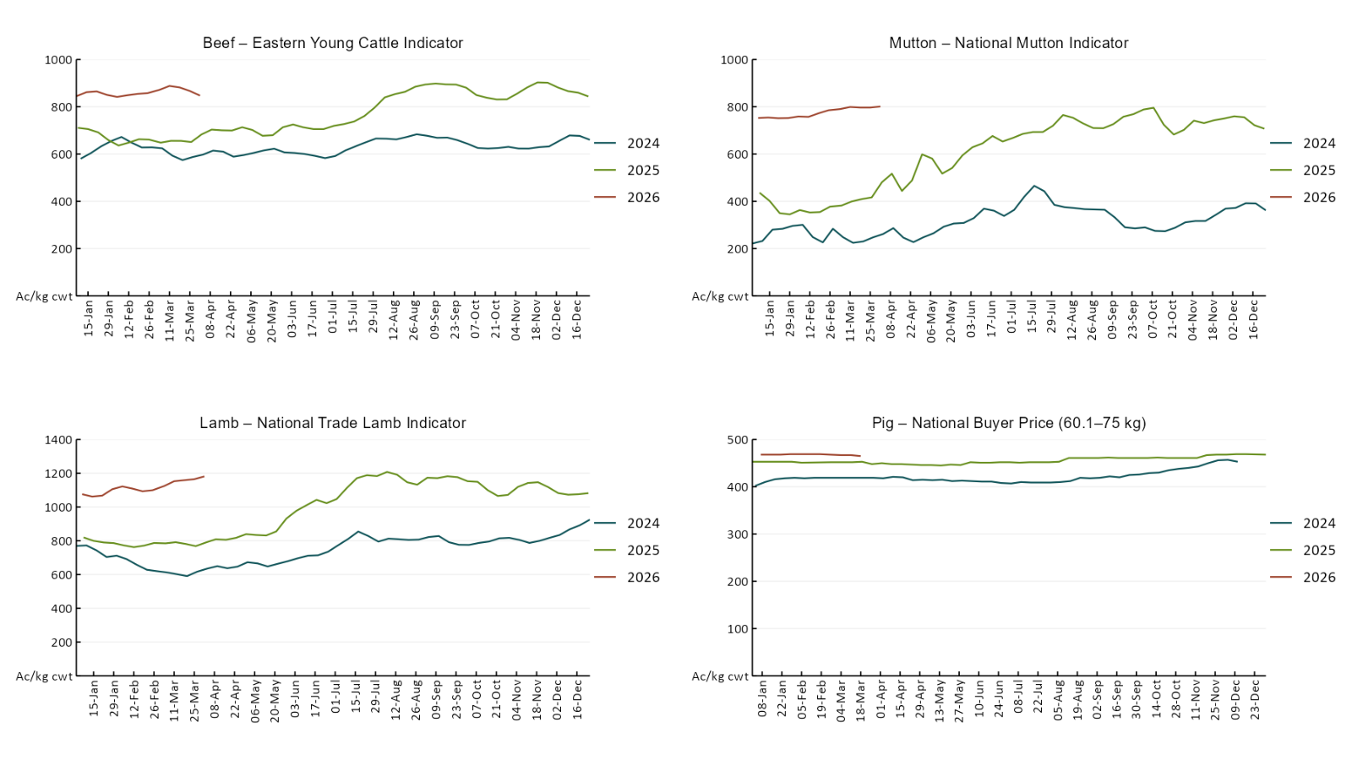

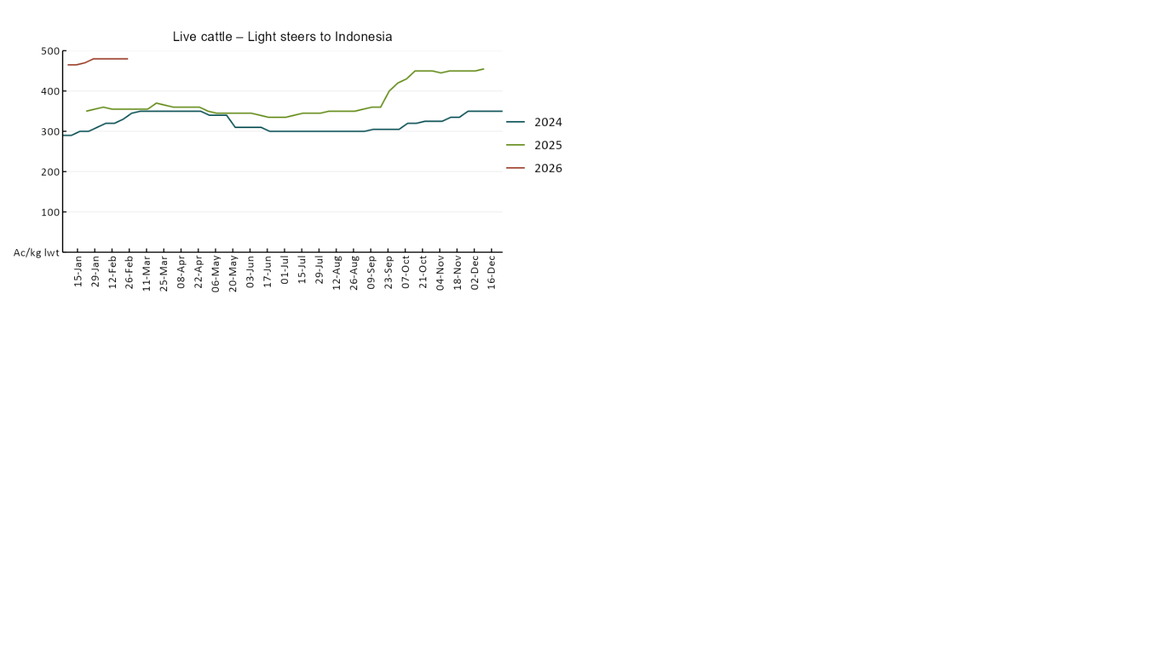

3.4 Global Dairy Trade (GDT) weighted average prices
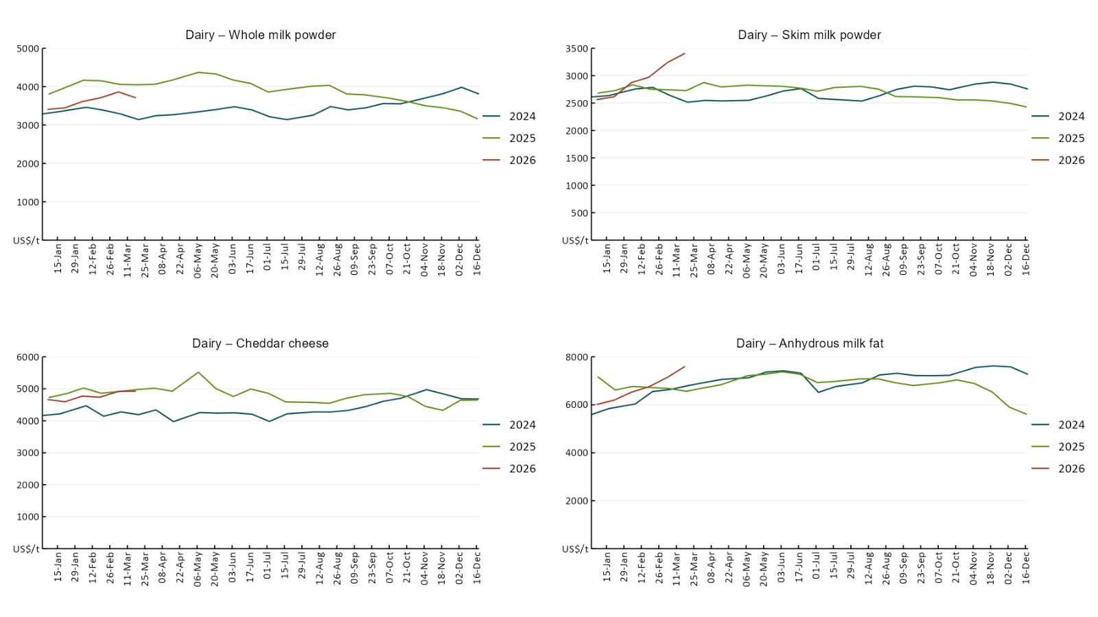

3.5 Selected fruit and vegetable prices
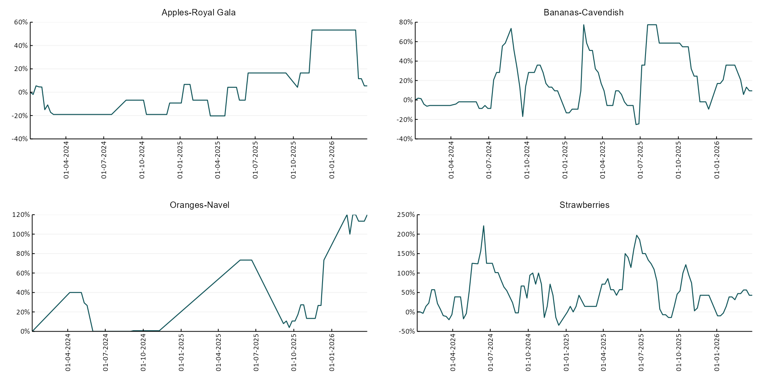

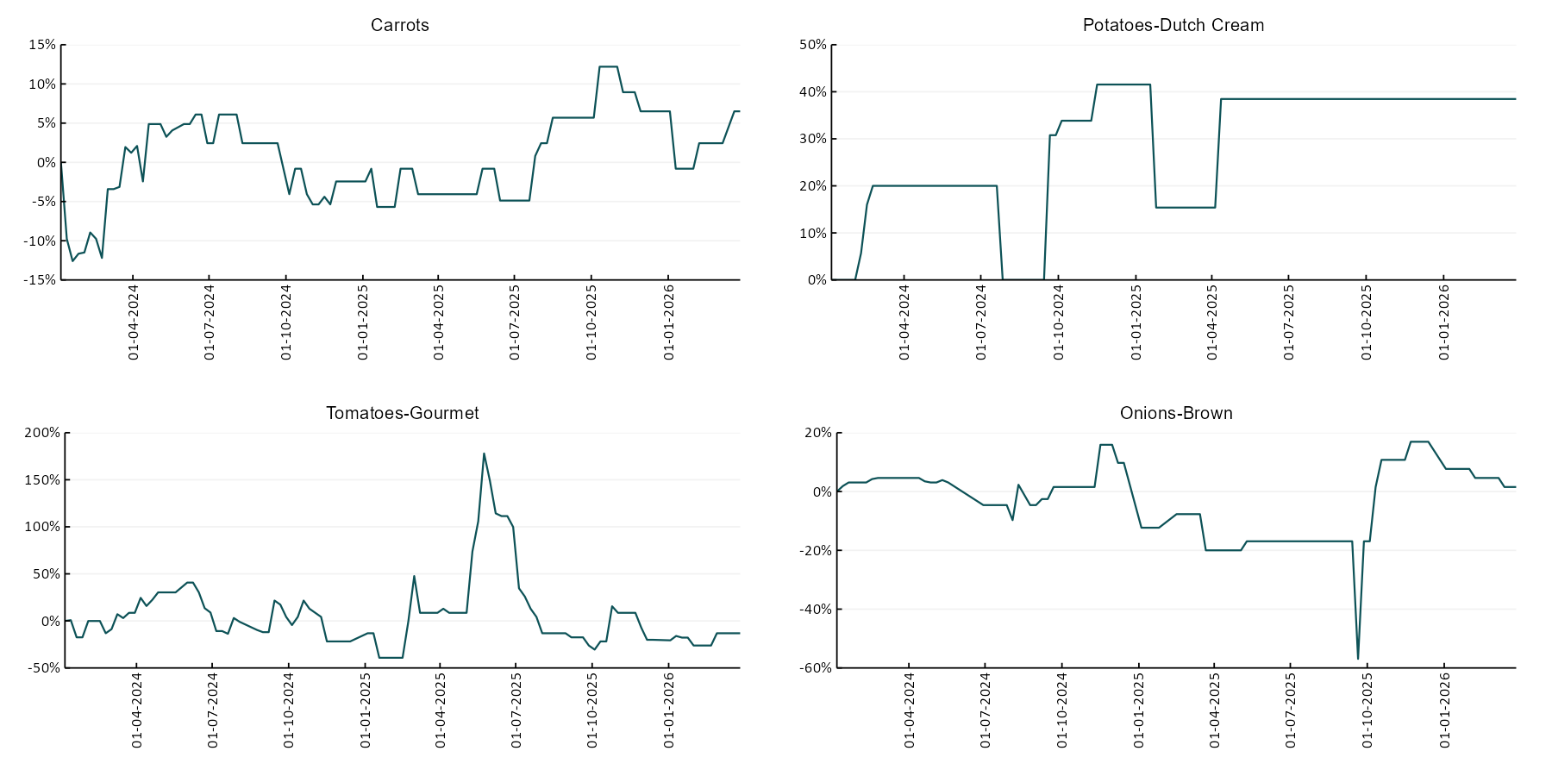

3.6 Selected domestic fodder indicator prices
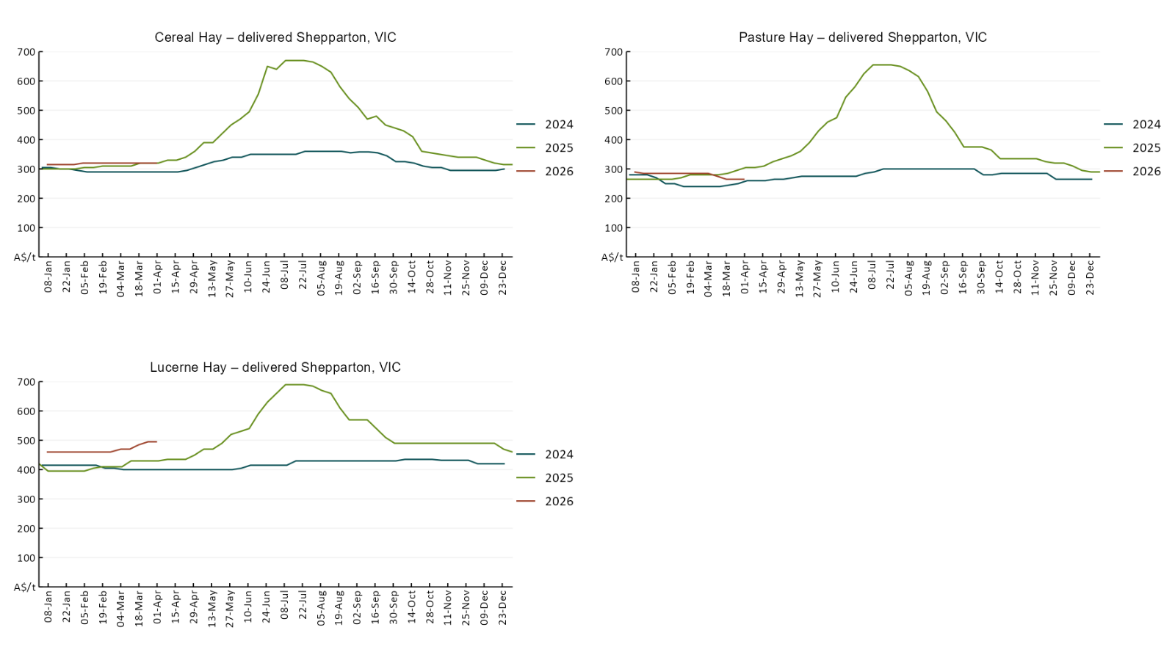

4. Data attribution

Climate
Bureau of Meteorology
- Weekly rainfall totals: www.bom.gov.au/climate/maps/rainfall/
- Monthly and last 3-month rainfall percentiles: https://www.bom.gov.au/climate/ahead/outlooks/#moreMaps
- Rainfall forecast: www.bom.gov.au/jsp/watl/rainfall/pme.jsp
- Seasonal outlook: www.bom.gov.au/climate/outlooks/#/overview/summary/
- Climate drivers: http://www.bom.gov.au/climate/enso/
- Soil moisture: https://awo.bom.gov.au/products/historical/soilMoisture-rootZone/

Other
- Pasture growth: www.longpaddock.qld.gov.au/aussiegrass/
- 3-month global outlooks: Environment and Climate Change Canada, NOAA Climate Prediction Center, EUROBRISA CPTEC/INPE, European Centre for Medium-Range Weather Forecasts, Hydrometcenter of Russia, National Climate Center Climate System Diagnosis and Prediction Room (NCC), International Research Institute for Climate and Society
- Global production: https://ipad.fas.usda.gov/ogamaps/cropmapsandcalendars.aspx
- Autumn break: Pook et al., 2009, https://rmets-onlinelibrary-wiley-com.virtual.anu.edu.au/doi/epdf/10.1002/joc.1833

Water
Prices
- Waterflow: https://www.waterflow.io/
- Ruralco: https://www.ruralcowater.com.au/
- Bureau of Meteorology:
- Allocation trade: http://www.bom.gov.au/water/dashboards/#/water-markets/mdb/at
- Storage volumes: http://www.bom.gov.au/water/dashboards/#/water-storages/summary/drainage

Trade constraints:
- Water NSW: https://www.waternsw.com.au/customer-service/ordering-trading-and-pricing/trading/murrumbidgee
- Victorian Water Register: https://www.waterregister.vic.gov.au/TradingRules2019/

Commodities
Fruit and vegetables
- Datafresh: www.freshstate.com.au

Pigs
- Australian Pork Limited: www.australianpork.com.au

Dairy
- Global Dairy Trade: www.globaldairytrade.info/en/product-results/

World wheat, canola
- International Grains Council
- https://www.igc.int/en/default.aspx
- United States Department of Agriculture

World cotton
- Cotlook: www.cotlook.com/

World sugar
- New York Stock Exchange - Intercontinental Exchange

Wool
- Australian Wool Exchange: www.awex.com.au/

Domestic wheat, barley, sorghum, canola and fodder
- Jumbuk Consulting Pty Ltd: Jumbuk AG | Agriculture Consulting

Cattle, beef, mutton, lamb, goat and live export
- Meat and Livestock Australia: https://www.mla.com.au/prices-markets/

Australian Agricultural Drought Indicators
About Australian Agricultural Drought Indicators
The Australian Agricultural Drought Indicators (AADI) links weather and agricultural data with a range of scientific and economic models to measure and forecast the effects of climate variability and drought on agricultural outcomes.
On AADI, projected broadacre farm profits are presented as percentile outcomes relative to simulated historical outcomes using the groupings:
Highest | 95-100th percentile
Very much above average | 85-95th percentile
Above average | 65-85th percentile
Average | 35-65th percentile
Below average | 15-35th percentile
Very much below average | 5-15th percentile
Lowest 5% | 0-5th percentile

There are two AADI farm profit indicators:
- The AADI farm profit climate and price indicator shows the effect of climate and prices on broadacre farm business profits of current farms compared to the last 33 years.
- The AADI farm profit climate only indicator isolates the effect of climate on profits by holding prices fixed.

© Commonwealth of Australia 2026

Ownership of intellectual property rights
Unless otherwise noted, copyright (and any other intellectual property rights, if any) in this publication is owned by the Commonwealth of Australia (referred to as the Commonwealth).

Creative Commons licence
All material in this publication is licensed under a Creative Commons Attribution 4.0 International Licence except content supplied by third parties, logos and the Commonwealth Coat of Arms.
Inquiries about the licence and any use of this document should be emailed to copyright@awe.gov.au.


Cataloguing data
This publication (and any material sourced from it) should be attributed as:
ABARES 2026, Weekly Australian Climate, Water and Agricultural Update, Australian Bureau of Agricultural and Resource Economics and Sciences, Canberra, 19 March 2026. CC BY 4.0 DOI: https://doi.org/10.25814/5f3e04e7d2503
ISSN 2652-7561
This publication is available at https://www.agriculture.gov.au/abares/products/weekly_update
Department of Agriculture, Fisheries and Forestry
GPO Box 858 Canberra ACT 2601
Telephone 1800 900 090
Web agriculture.gov.au/abares

Disclaimer
The Australian Government acting through the Department of Agriculture, Fisheries and Forestry, represented by the Australian Bureau of Agricultural and Resource Economics and Sciences, has exercised due care and skill in preparing and compiling the information and data in this publication. Notwithstanding, the Department of Agriculture, Fisheries and Forestry, ABARES, its employees and advisers disclaim all liability, including liability for negligence and for any loss, damage, injury, expense or cost incurred by any person as a result of accessing, using or relying on any of the information or data in this publication to the maximum extent permitted by law.

Statement of Professional Independence
The views and analysis presented in ABARES publications, including this one, reflect ABARES professionally independent findings, based on scientific and economic concepts, principles, information and data. These views, analysis and findings may not reflect or be consistent with the views or positions of the Australian Government, or of organisations or groups who have commissioned ABARES reports or analysis. More information on professional independence is provided on the ABARES website.

Acknowledgements
This report was prepared by Holly Beale and Matthew Miller.

