
No. 14/2026 16 April 2026

Summary of key issues
- In the week ending 15 April 2026, rainfall was broadly low across Australia, with exceptions in isolated western and eastern areas.
  - The generally dry conditions across much of northern and central Australia has seen some easing of the flood warnings in place across parts of Queensland, the Northern Territory and South Australia.
  - Most cropping regions of Queensland, northern New South Wales, and Western Australia saw little to no rainfall, with isolated southern areas receiving falls of up to 15 millimetres.
- Over the 8 days to 23 April 2026 low pressure systems and fronts are expected to bring rainfall to parts of the north and southwest, and western Tasmania:
  - Across cropping regions falls are forecast to be low, with southern Queensland, New South Wales, Victoria and South Australia seeing little to no rainfall.
  - These mainly dry forecast conditions across southern Queensland and northern New South Wales are expected to support the harvest of late summer crops.
- Global production conditions in March were generally favourable for wheat, maize, rice and soybeans. According to the most recent crop estimate numbers released by the USDA, global production has been revised upward and is higher than the numbers used to formulate ABARES 2025–26 forecasts of global grain supplies and world prices in the March 2026 Agricultural Commodities Report. As a result, global grain and oilseed production is likely to increase beyond the numbers in the March forecast.
- Water storage levels in the Murray-Darling Basin (MDB) decreased by 84 gigalitres (GL) between 09 April 2026 and 16 April 2026. The current volume of water held in storages is 10,261 GL, equivalent to 46% of total storage capacity. This is 14% or 1,697 GL less than the same time last year. Water storage data is sourced from the Bureau of Meteorology.
- Allocation prices in the Victorian Murray below the Barmah Choke decreased from $399/ML on 09 April 2026 to $381/ML on 16 April 2026. Trade from the Goulburn to the Murray is closed. Trade downstream through the Barmah Choke is closed. Trade from the Murrumbidgee to the Murray is open.

Climate

Rainfall this week
In the week ending 15 April 2026, rainfall across Australia was broadly low, with exceptions where cold fronts brought rainfall to the southeast, in isolated western and eastern areas.
- In parts of Western Australia, Victoria, southern New South Wales, South Australia and parts of northern coastal Queensland, 5-50 millimetres of rainfall were recorded.
  - Isolated parts of Victoria and southern New South Wales saw up to 100 millimetres.
  - The generally dry conditions across much of northern and central Australia have seen some easing of the flood warnings in place across parts of Queensland, the Northern Territory and South Australia.
- In Tasmania, higher falls of up to 200 millimetres were observed in western regions.
- Much of Queensland, northern New South Wales, the Northern Territory, and the remainder of Western Australia and South Australia remained largely dry.
Across cropping regions, rainfall was limited, with cropping areas largely dry in the east.
- Most cropping regions of Queensland, northern New South Wales, and Western Australia saw little to no rainfall.
  - Mainly dry conditions across Queensland and New South Wales are expected to support the harvest of late summer crops.
- In contrast, falls of 10-15 millimetres were recorded across parts of southeast South Australia, southern New South Wales, Victoria, and isolated parts of central Western Australia.
  - These falls are expected to support autumn pasture growth and boost soil moisture levels in the lead up to winter crop planting.

Rainfall for the week ending 15 April 2026
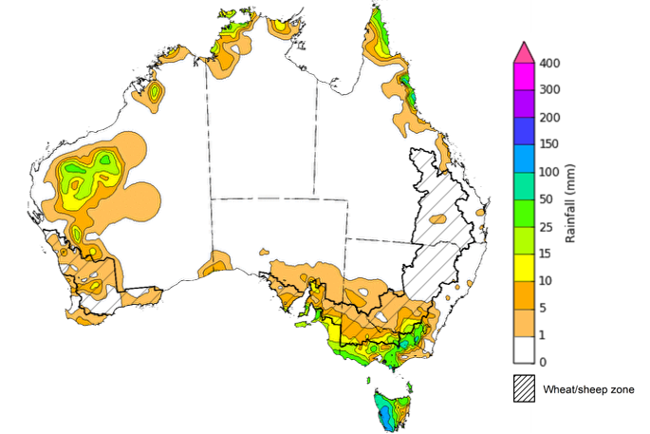
©Commonwealth of Australia 2026, Australian Bureau of Meteorology Issued: 15/4/2026
Note: The rainfall analyses and associated maps utilise data contained in the Bureau of Meteorology climate database, the Australian Data Archive for Meteorology (ADAM). The analyses are initially produced automatically from real-time data with limited quality control. They are intended to provide a general overview of rainfall across Australia as quickly as possible after the observations are received. For further information go to http://www.bom.gov.au/climate/rainfall/

Rainfall forecast for the next eight days
Over the 8 days to 23 April 2026, low-pressure systems are expected to bring rainfall to parts of the north and southwest. Most central and southern areas are forecast to remain largely dry.
- Falls of between 10-100 millimetres are forecast for much of northern Western Australia, the Northern Territory and Queensland, with isolated north-eastern coastal regions of Queensland likely to see higher falls.
- Isolated areas in southwest Western Australia and western Tasmania, are forecast to see 10-50 millimetres over this period.
- Remaining regions are likely to see little to no rainfall.
Rainfall totals across many cropping regions over the coming week are forecast to be low, with exceptions in parts of the west and far north:
- Low rainfall totals (0-10 millimetres) are forecast for southern Queensland, New South Wales, Victoria and South Australia.
  - These low totals are likely to impair a build-up of soil moisture ahead of the planting of 2026–27 winter crops, but support late harvesting activities in northern cropping regions..
- Falls of up to 25 millimetres are forecast for western regions of Western Australia and northern Queensland.

Total forecast rainfall for the period 16 April to 23 April 2026
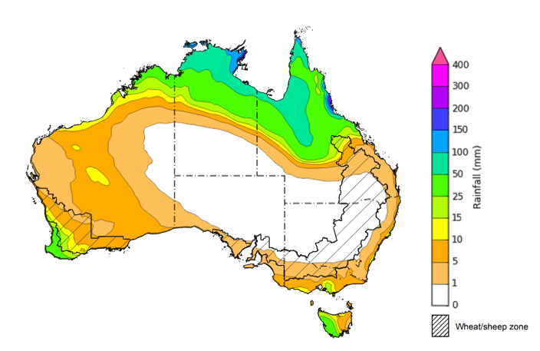
©Commonwealth of Australia 2026, Australian Bureau of Meteorology Issued 16/4/2026
Note: This rainfall forecast is produced from computer models. As the model outputs are not altered by weather forecasters, it is important to check local forecasts and warnings issued by the Bureau of Meteorology.

March precipitation percentiles and current production conditions
Crop production is affected by long-term trends in average rainfall and temperature, interannual climate variability, shocks during specific growth stages, and extreme weather events. Some crops are more tolerant than others to certain types of stresses, and at each growth stage, different types of stresses affect crop species in different ways.
Precipitation anomalies and outlooks presented below indicate the current and expected future production conditions for major grain and oilseed producing countries (responsible for over 80% of global crop production). This is an important input to assessing the global grain supply outlook.
Precipitation in March 2026 was variable across the world’s major grain and oilseed producing regions:
- In the northern hemisphere, precipitation was above average in much of central China, the southern and eastern Black Sea Region, parts of east India, southern Canada, and the northeast United States. Below average precipitation occurred across large areas of the western United States and central Europe. Precipitation was generally average across the remaining major northern hemisphere grain and oilseed producing regions.
- In the southern hemisphere, precipitation was below average across much of northern Brazil and northern Argentina, and isolated parts of Southeast Asia including Indonesia. Precipitation was above average across central and south-eastern Australia and western Argentina. Precipitation was generally average across the remaining major southern hemisphere grain and oilseed producing regions.

Global precipitation percentiles, March 2026

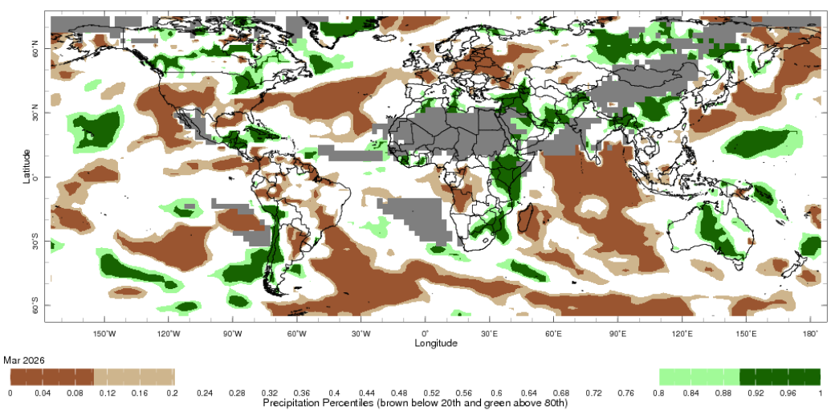

Note: The world precipitation percentiles indicate a ranking of precipitation for February, with the driest (0th percentile) being 0 on the scale and the wettest (100th percentile) being 1 on the scale. Percentiles are based on precipitation estimates from the NOAA Climate Prediction Center’s Climate Anomaly Monitoring System Outgoing Precipitation Index dataset. Precipitation estimates for February are compared with rainfall recorded for that period during the 1981 to 2010 base period.
Source: International Research Institute for Climate and Society
As of 28 March 2026, global production conditions were generally favourable for wheat, maize, rice and soybeans:
- Wheat – In the northern hemisphere, winter wheat is exiting dormancy in China, the Russian Federation, Europe, and the United States. Dry conditions in parts of the United States and Europe are expected to impact yield potential.
- Maize – In the southern hemisphere, conditions have been largely favourable for the harvest across much of Brazil, however, there are some areas of production concerns in Argentina due to recent hot and dry conditions. In Indonesia, harvesting of early sown crops is progressing. In the United States and China, sowing is underway in some regions.
- Rice – Global conditions remain broadly favourable for major rice production regions.
- Soybeans – The harvest in Brazil is continuing under favourable conditions, while favourable conditions in Argentina are supporting crop development.

Crop conditions, AMIS countries, 28 March 2026
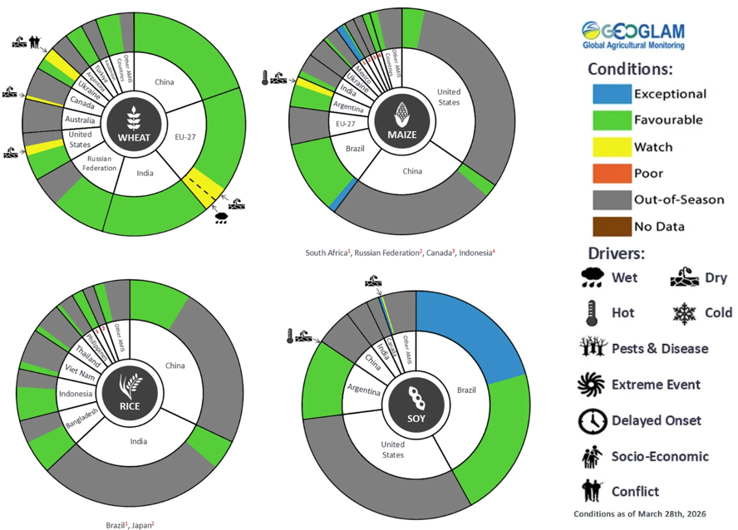
AMIS Agricultural Market Information System.
Source: AMIS

The global climate outlook for May 2026 to July 2026 indicates that mixed rainfall conditions are expected for the world’s major grain and oilseed producing regions. Outlooks and potential production impacts are presented in the following table.
Rainfall outlook and potential impact on the future state of production conditions, May 2026 - July 2026
Region | Rainfall outlook | Potential impact on production
Argentina | Above average rainfall is likely across parts of southern Argentina, with broadly average rainfall elsewhere. | Above average rainfall is likely to be sufficient to support the development of sorghum, rice, millet, and the planting of wheat.
Black Sea Region | Above average rainfall is expected across parts of northern and eastern Ukraine, as well as isolated western regions of the Russian Federation. | Above average rainfall is likely to support the heading and grain development of wheat and canola in Ukraine, Türkiye, and the Russian Federation, as well as the growth of cotton, corn, and sunflower from July.
Brazil | Rainfall outcomes across Brazil are expected to be broadly above average, with exceptions in the far south which is expected to see below average falls. | Above average rainfall across western and central western Brazil is likely to support the development of cotton and corn. Below average rainfall in the south is likely to hinder the development of wheat in June and July.
Canada | Rainfall across Canada is expected to be mixed, with broadly average conditions and areas of both below and above average precipitation in southern regions. | Average rainfall is likely to support wheat development as it leaves dormancy, and facilitate the planting of major crops including corn and soybeans over the coming months.
China | Average rainfall is expected across most of China, with scattered areas of above average and below average rainfall in inland regions. | Average rainfall across much of China is likely to support the development of winter wheat and canola and the planting and development of rice, cotton and spring wheat.
European Union | Above average rainfall is more likely for much of the central European Union, with parts of western and northern Europe to see below average falls. | Below average rainfall across parts of the European Union is likely to hinder the development of canola and winter wheat through critical stages.
South Asia (India) | Below average rainfall is expected across parts of central India, while above average rainfall is expected in isolated northwestern areas. | Anticipated rainfall is likely to support the harvesting of wheat and canola, as well as the development of major cops including corn and rice.
Southeast Asia (SEA) | Below average rainfall is likely across much of Southeast Asia. | Below average rainfall in SEA is likely to support the planting of crops, but impede flowering and development outcomes.
The United States | Below average to average rainfall is likely for much of the eastern United States, with western areas likely to see above average falls. | Below average to average rainfall conditions expected across the eastern US is likely to reduce soil moisture and impact yield potential of winter wheat exiting dormancy.

Water markets – current week
Water storage levels in the Murray-Darling Basin (MDB) decreased by 84 gigalitres (GL) between 09 April 2026 and 16 April 2026. The current volume of water held in storages is 10,261 GL, equivalent to 46% of total storage capacity. This is 14% or 1,697 GL less than the same time last year. Water storage data is sourced from the Bureau of Meteorology.

Water storages in the Murray-Darling Basin, 2013–2026
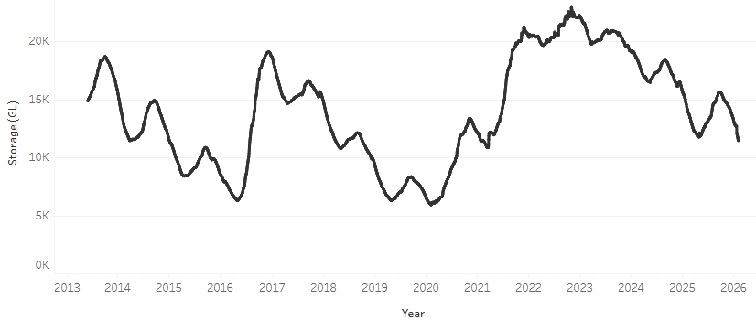
Allocation prices in the Victorian Murray below the Barmah Choke decreased from $399/ML on 09 April 2026 to $381/ML on 16 April 2026. Trade from the Goulburn to the Murray is closed. Trade downstream through the Barmah Choke is closed. Trade from the Murrumbidgee to the Murray is open.

Water market prices, Southern Murray–Darling Basin

Region | $/ML
NSW Murray Above | 310
NSW Murrumbidgee | 429
Vic Greater Goulburn | 310
Vic Murray Below | 381

Note: The water allocation prices shown are volume weighted average prices based on the last 10 trades. Price data is sourced from Waterflow and current as at 22 January 2026.
To access the full, interactive, weekly water dashboard, which contains the latest and historical water storage, water market and water allocation information, please visit https://www.agriculture.gov.au/abares/products/weekly_update/weekly-update-260416

Commodities
Indicator | Week average | Unit | Latest Price | Previous Week | Weekly change |  | Price 12 months ago | Annual change
Selected world indicator prices
AUD/USD Exchange rate | 15-Apr | A$/US$ | 0.71 | 0.70 | 1% | 0.63 |  | 12%
Wheat – US no. 2 hard red winter wheat, FOB Gulf | 15-Apr | US$/t | 275 | 269 | 2% | 249 |  | 11%
Corn – US no. 2 yellow corn, FOB Gulf | 15-Apr | US$/t | 211 | 211 | 0% | 215 |  | -2%
Canola – Rapeseed, Canada, FOB Vancouver | 15-Apr | US$/t | 541 | 544 | -1% | 517 |  | 5%
Cotton – Cotlook A Index | 15-Apr | USc/lb | 85.3 | 82.9 | 3% | 78.1 |  | 9%
Sugar – Intercontinental Exchange, nearby futures, no.11 contract | 15-Apr | USc/lb | 14.0 | 14.5 | -3% | 18.1 |  | -23%
Wool – Eastern Market Indicator | 15-Apr | Ac/kg clean | 1,835 | 1,786 | 3% | 1,238 |  | 48%
Wool – Western Market Indicator | 15-Apr | Ac/kg clean | 2,052 | 2,007 | 2% | 1,394 |  | 47%
Selected Australian grain export prices
Australian Premium White (APW) Wheat, FOB Port Adelaide, SA | 15-Apr | A$/t | 370 | 373 | -1% | 399 |  | -7%
Australian Standard White (ASW) Wheat, FOB Port Adelaide, SA | 15-Apr | A$/t | 367 | 370 | -1% | 393 |  | -6%
Feed Barley – FOB Port Adelaide, SA | 15-Apr | A$/t | 367 | 365 | 1% | 372 |  | -1%
Canola – FOB Kwinana, WA | 15-Apr | A$/t | 771 | 765 | 1% | 795 |  | -3%
Grain Sorghum – FOB Brisbane, QLD | 15-Apr | A$/t | 444 | 443 | 0% | 438 |  | 1%
Selected domestic livestock indicator prices
Beef – Eastern Young Cattle Indicator | 15-Apr | Ac/kg cwt | 812 | 810 | 0% | 700 |  | 16%
Mutton – Mutton indicator (18–24 kg fat score 2–3), VIC | 15-Apr | Ac/kg cwt | 825 | 808 | 2% | 506 |  | 63%
Lamb – National Trade Lamb Indicator | 15-Apr | Ac/kg cwt | 1,201 | 1,198 | 0% | 812 |  | 48%
Pig – Eastern Seaboard (60.1–75 kg), NSW buyer price | 1-Apr | Ac/kg cwt | 461 | 463 | 0% | 448 |  | 3%
Live cattle – Light steers to Indonesia | 8-Apr | Ac/kg lwt | 450 | 460 | -2% | 358 |  | 26%
Global Dairy Trade (GDT) weighted average prices
Dairy – Whole milk powder | 8-Apr | US$/t | 3,687 | 3,709 | -1% | 4,117 |  | -10%
Dairy – Skim milk powder | 8-Apr | US$/t | 3,381 | 3,409 | -1% | 2,836 |  | 19%
Dairy – Cheddar cheese | 8-Apr | US$/t | 4,766 | 4,925 | -3% | 4,971 |  | -4%
Dairy – Anhydrous milk fat | 8-Apr | US$/t | 7,027 | 7,602 | -8% | 6,772 |  | 4%

Selected world indicator prices
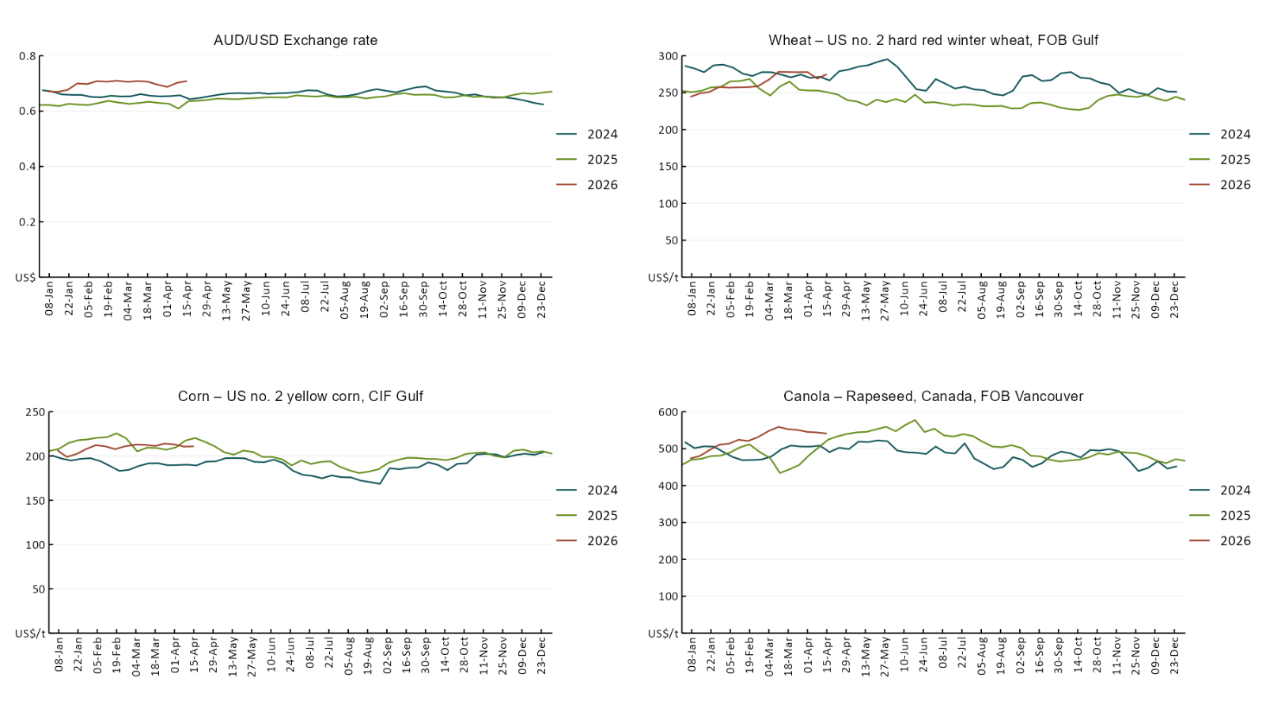

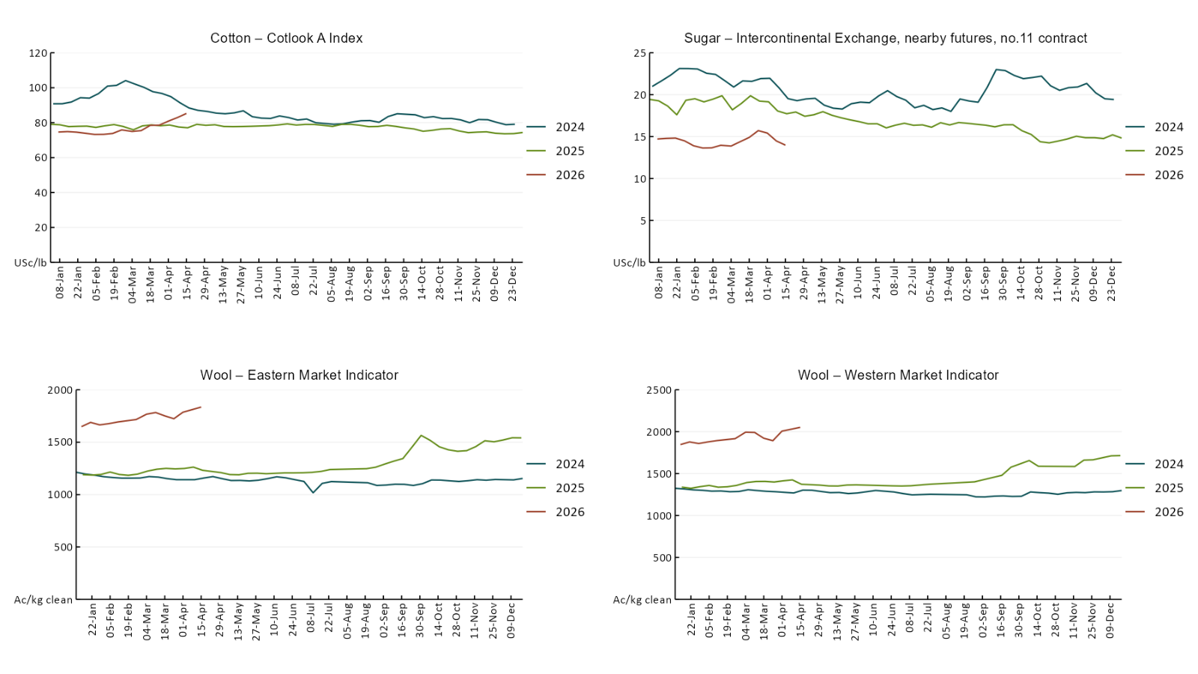

3.2 Selected domestic crop indicator prices
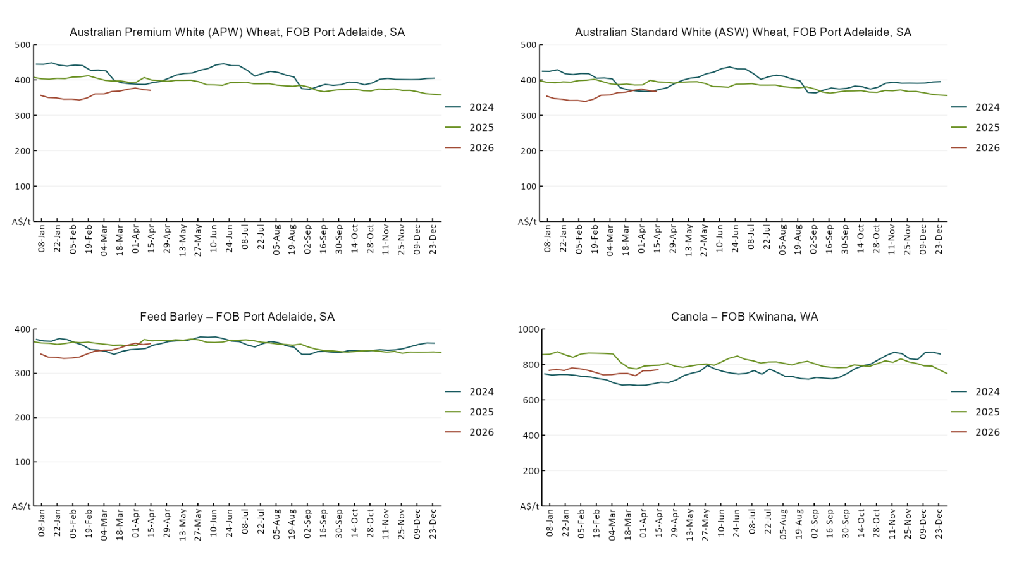

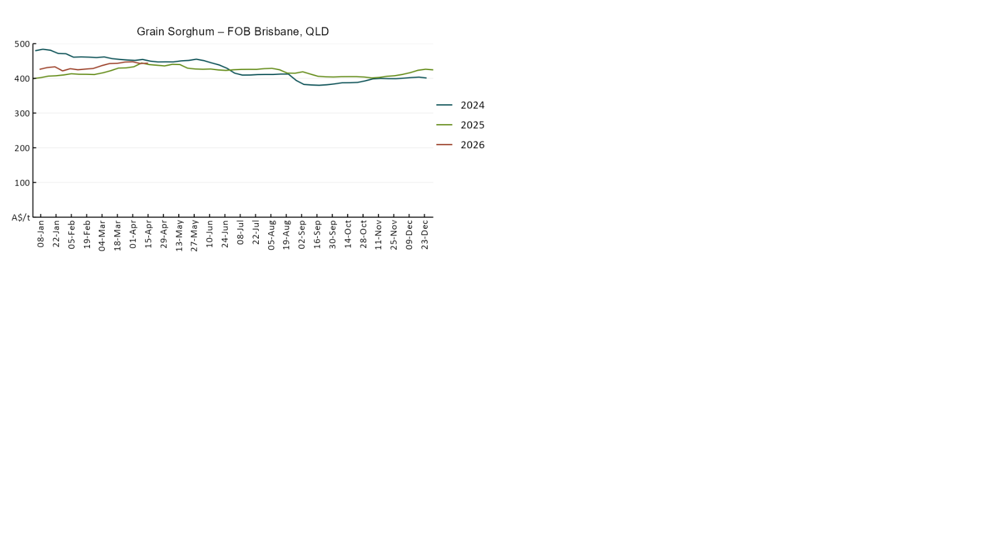

3.3 Selected domestic livestock indicator prices
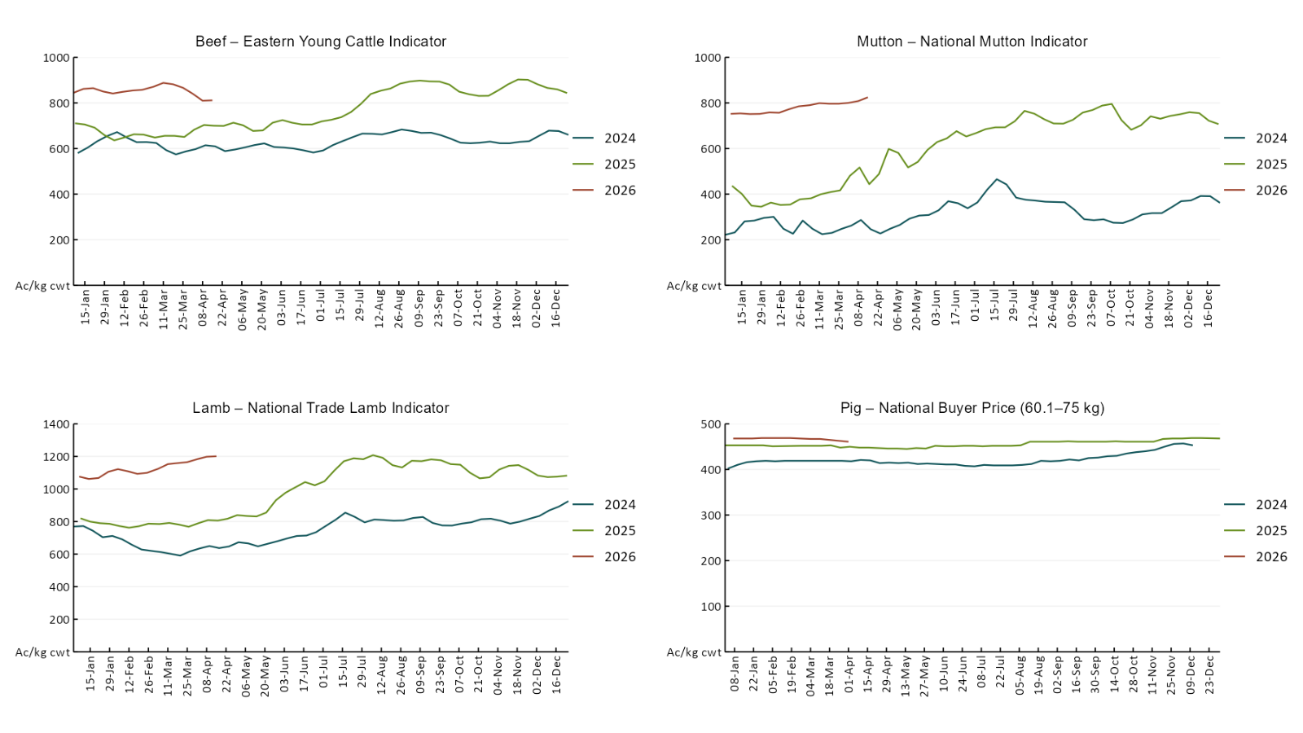

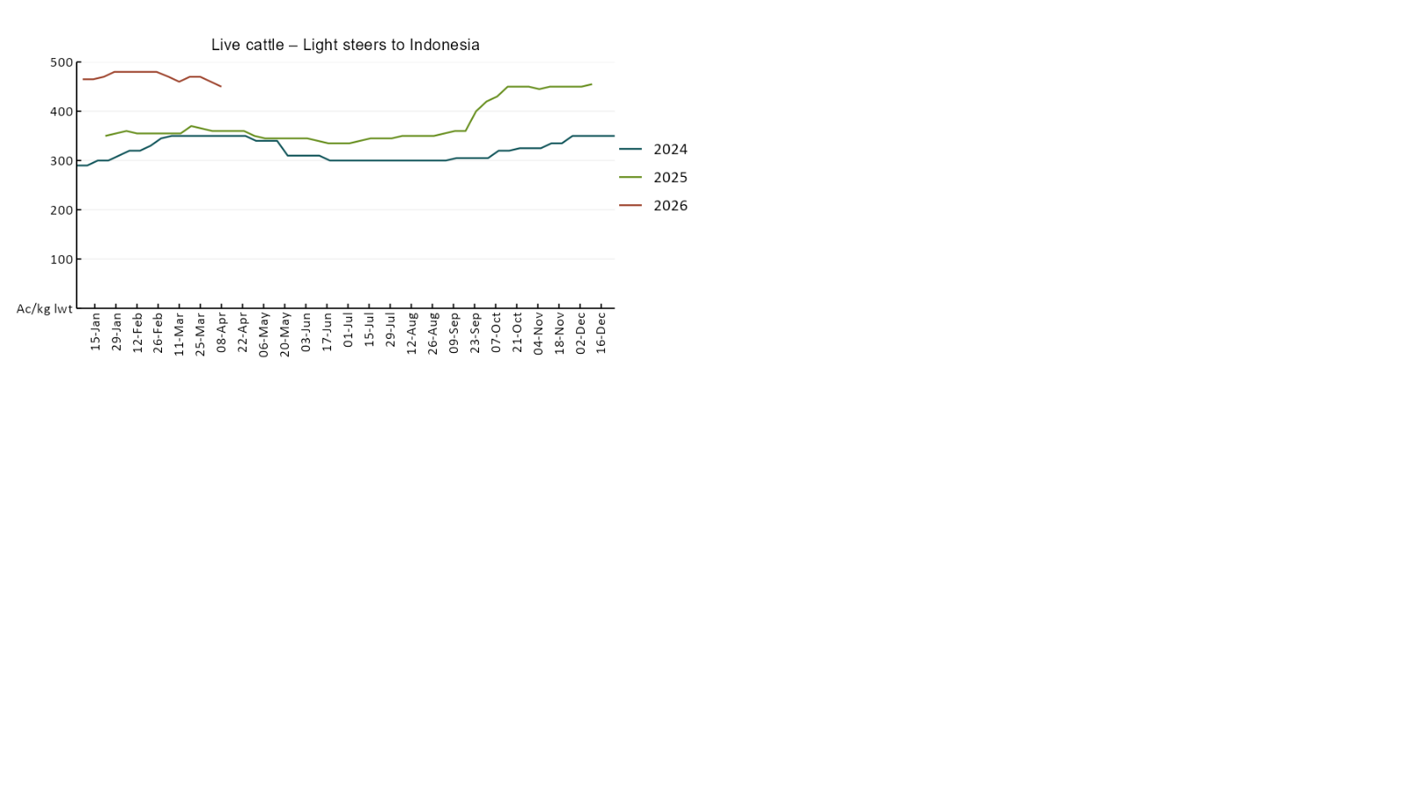

3.4 Global Dairy Trade (GDT) weighted average prices
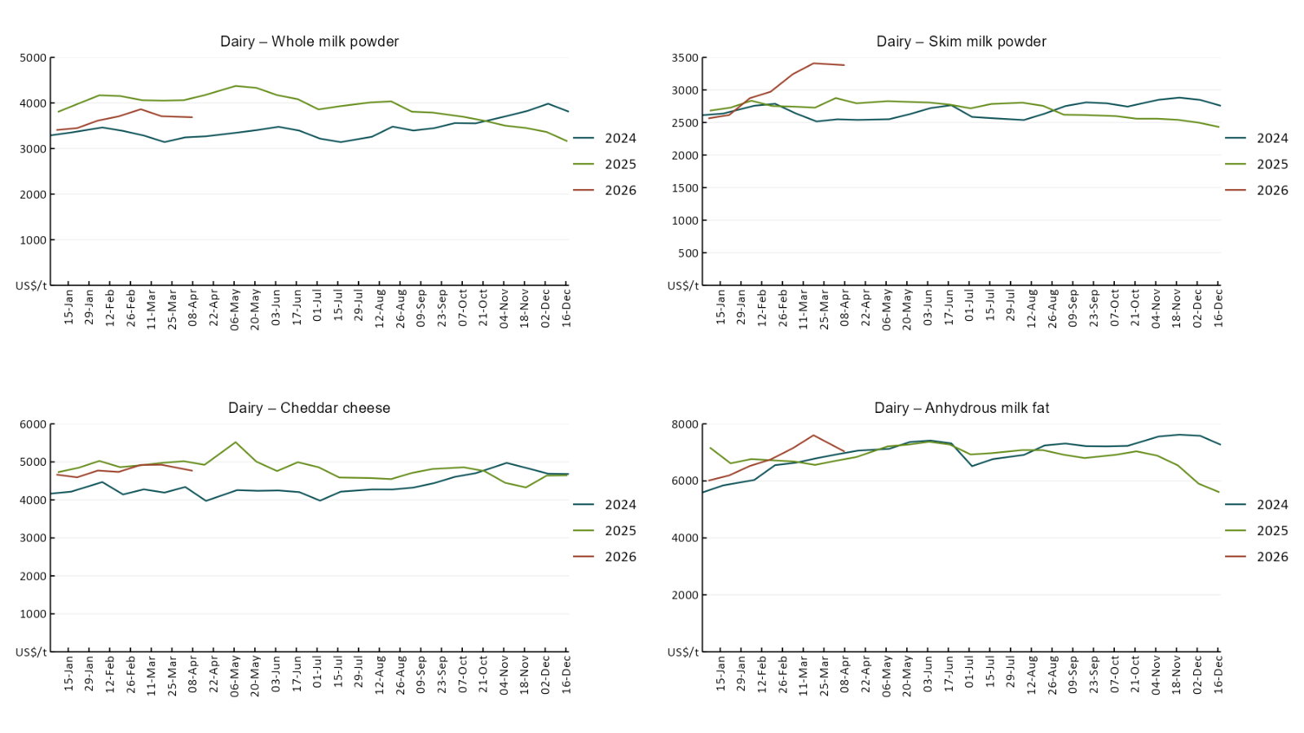

3.5 Selected fruit and vegetable prices
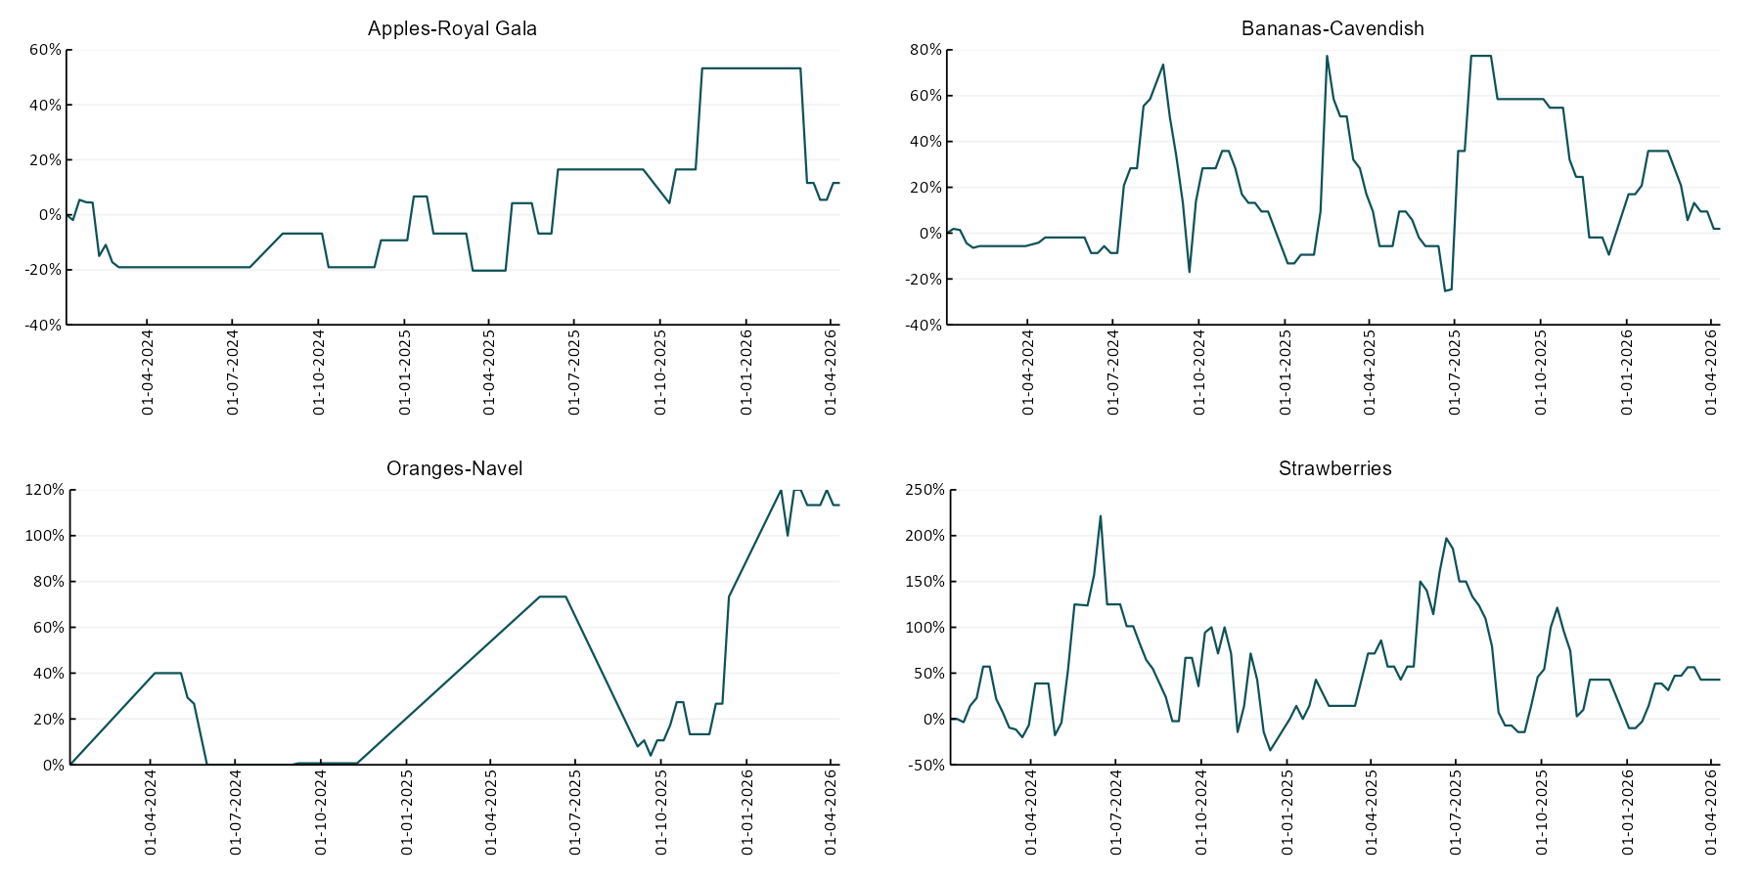

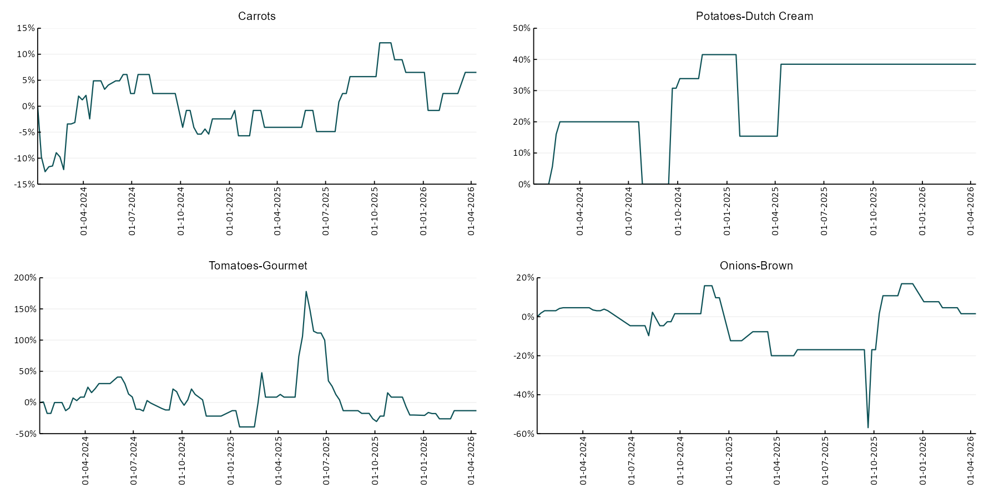

3.6 Selected domestic fodder indicator prices
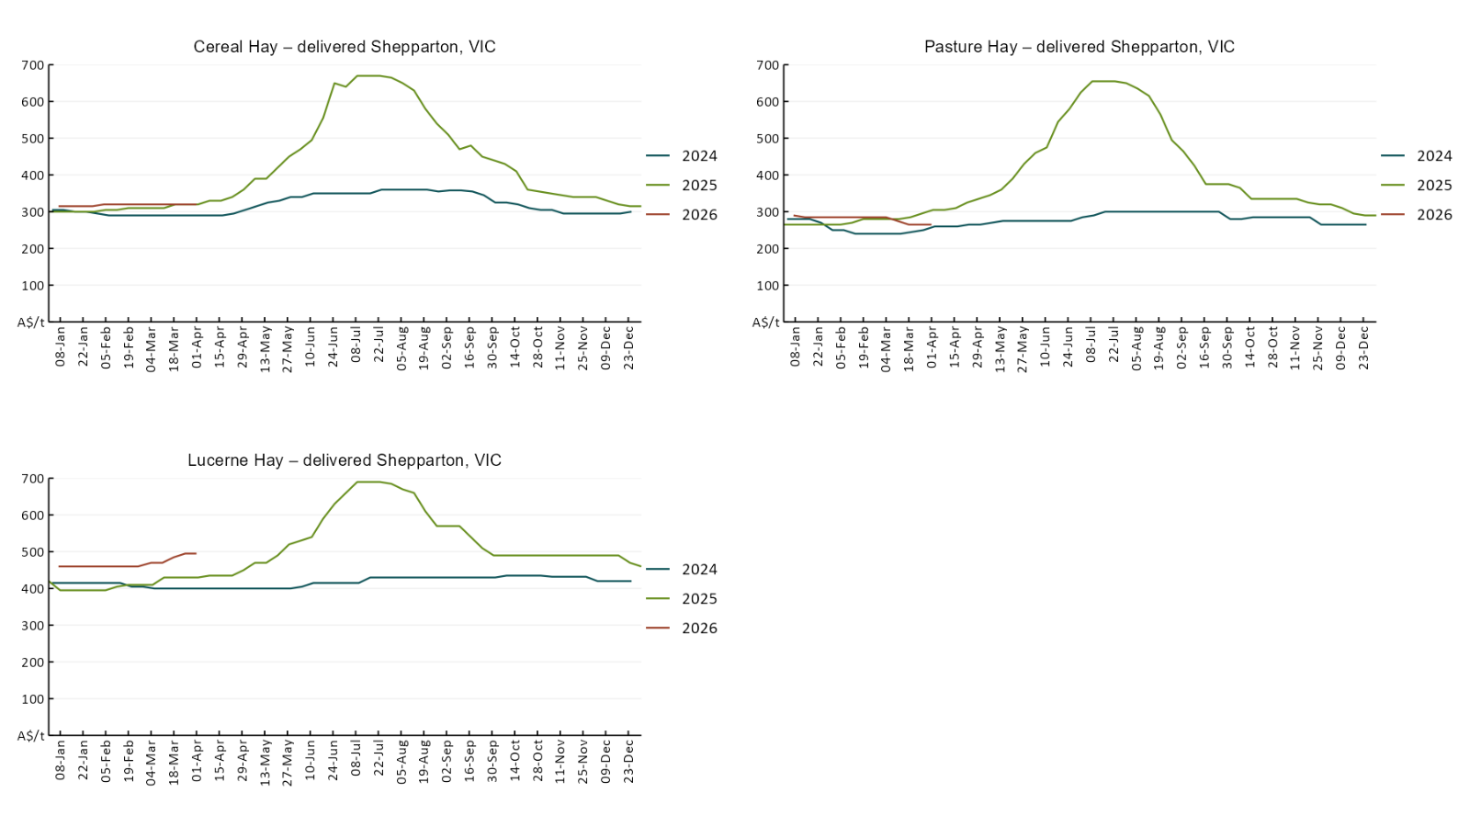

4. Data attribution

Climate
Bureau of Meteorology
- Weekly rainfall totals: www.bom.gov.au/climate/maps/rainfall/
- Monthly and last 3-month rainfall percentiles: https://www.bom.gov.au/climate/ahead/outlooks/#moreMaps
- Rainfall forecast: www.bom.gov.au/jsp/watl/rainfall/pme.jsp
- Seasonal outlook: www.bom.gov.au/climate/outlooks/#/overview/summary/
- Climate drivers: http://www.bom.gov.au/climate/enso/
- Soil moisture: https://awo.bom.gov.au/products/historical/soilMoisture-rootZone/

Other
- Pasture growth: www.longpaddock.qld.gov.au/aussiegrass/
- 3-month global outlooks: Environment and Climate Change Canada, NOAA Climate Prediction Center, EUROBRISA CPTEC/INPE, European Centre for Medium-Range Weather Forecasts, Hydrometcenter of Russia, National Climate Center Climate System Diagnosis and Prediction Room (NCC), International Research Institute for Climate and Society
- Global production: https://ipad.fas.usda.gov/ogamaps/cropmapsandcalendars.aspx
- Autumn break: Pook et al., 2009, https://rmets-onlinelibrary-wiley-com.virtual.anu.edu.au/doi/epdf/10.1002/joc.1833

Water
Prices
- Waterflow: https://www.waterflow.io/
- Ruralco: https://www.ruralcowater.com.au/
- Bureau of Meteorology:
- Allocation trade: http://www.bom.gov.au/water/dashboards/#/water-markets/mdb/at
- Storage volumes: http://www.bom.gov.au/water/dashboards/#/water-storages/summary/drainage

Trade constraints:
- Water NSW: https://www.waternsw.com.au/customer-service/ordering-trading-and-pricing/trading/murrumbidgee
- Victorian Water Register: https://www.waterregister.vic.gov.au/TradingRules2019/

Commodities
Fruit and vegetables
- Datafresh: www.freshstate.com.au

Pigs
- Australian Pork Limited: www.australianpork.com.au

Dairy
- Global Dairy Trade: www.globaldairytrade.info/en/product-results/

World wheat, canola
- International Grains Council
- https://www.igc.int/en/default.aspx
- United States Department of Agriculture

World cotton
- Cotlook: www.cotlook.com/

World sugar
- New York Stock Exchange - Intercontinental Exchange

Wool
- Australian Wool Exchange: www.awex.com.au/

Domestic wheat, barley, sorghum, canola and fodder
- Jumbuk Consulting Pty Ltd: Jumbuk AG | Agriculture Consulting

Cattle, beef, mutton, lamb, goat and live export
- Meat and Livestock Australia: https://www.mla.com.au/prices-markets/

Australian Agricultural Drought Indicators
About Australian Agricultural Drought Indicators
The Australian Agricultural Drought Indicators (AADI) links weather and agricultural data with a range of scientific and economic models to measure and forecast the effects of climate variability and drought on agricultural outcomes.
On AADI, projected broadacre farm profits are presented as percentile outcomes relative to simulated historical outcomes using the groupings:
Highest | 95-100th percentile
Very much above average | 85-95th percentile
Above average | 65-85th percentile
Average | 35-65th percentile
Below average | 15-35th percentile
Very much below average | 5-15th percentile
Lowest 5% | 0-5th percentile

There are two AADI farm profit indicators:
- The AADI farm profit climate and price indicator shows the effect of climate and prices on broadacre farm business profits of current farms compared to the last 33 years.
- The AADI farm profit climate only indicator isolates the effect of climate on profits by holding prices fixed.

© Commonwealth of Australia 2026

Ownership of intellectual property rights
Unless otherwise noted, copyright (and any other intellectual property rights, if any) in this publication is owned by the Commonwealth of Australia (referred to as the Commonwealth).

Creative Commons licence
All material in this publication is licensed under a Creative Commons Attribution 4.0 International Licence except content supplied by third parties, logos and the Commonwealth Coat of Arms.
Inquiries about the licence and any use of this document should be emailed to copyright@awe.gov.au.


Cataloguing data
This publication (and any material sourced from it) should be attributed as:
ABARES 2026, Weekly Australian Climate, Water and Agricultural Update, Australian Bureau of Agricultural and Resource Economics and Sciences, Canberra, 16 April 2026. CC BY 4.0 DOI: https://doi.org/10.25814/5f3e04e7d2503
ISSN 2652-7561
This publication is available at https://www.agriculture.gov.au/abares/products/weekly_update
Department of Agriculture, Fisheries and Forestry
GPO Box 858 Canberra ACT 2601
Telephone 1800 900 090
Web agriculture.gov.au/abares

Disclaimer
The Australian Government acting through the Department of Agriculture, Fisheries and Forestry, represented by the Australian Bureau of Agricultural and Resource Economics and Sciences, has exercised due care and skill in preparing and compiling the information and data in this publication. Notwithstanding, the Department of Agriculture, Fisheries and Forestry, ABARES, its employees and advisers disclaim all liability, including liability for negligence and for any loss, damage, injury, expense or cost incurred by any person as a result of accessing, using or relying on any of the information or data in this publication to the maximum extent permitted by law.

Statement of Professional Independence
The views and analysis presented in ABARES publications, including this one, reflect ABARES professionally independent findings, based on scientific and economic concepts, principles, information and data. These views, analysis and findings may not reflect or be consistent with the views or positions of the Australian Government, or of organisations or groups who have commissioned ABARES reports or analysis. More information on professional independence is provided on the ABARES website.

Acknowledgements
This report was prepared by Holly Beale and Amelia Brown.

