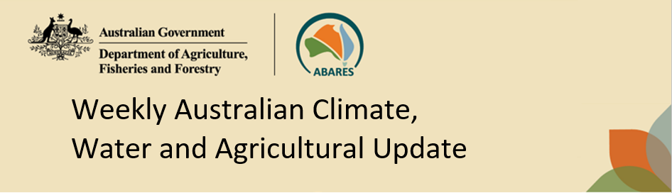
No. 15/2026 23 April 2026

Summary of key issues
- In the week ending 22 April 2026, rainfall was recorded across the north-east of the country, as well as scattered areas of the southeast and southwest.
- Most cropping regions of Queensland, New South Wales, Victoria, and South Australia saw little to no rainfall, with exceptions in northern Queensland where between 10-50 millimetres was observed.
  - Mainly dry conditions across Queensland and New South Wales are expected to support the harvest of late summer crops.
  - Across south-eastern and south-western regions, the mainly dry conditions would have provided unimpeded field access for the sowing of early canola and dual purpose crops (for forage and grain) such as oats, barley and vetch.
- Over the 8 days to 30 April 2026 low pressure systems are expected to bring rainfall to isolated parts of Australia, with conditions being broadly dry:
  - Low rainfall (0-10 millimetres) is forecast for Queensland, with 0-5 millimetres expected in New South Wales, Victoria, and South Australia. Falls of up to 25 millimetres are forecast for western regions of Western Australia.
  - If realised, falls across Western Australia are expected to support the germination and growth of early sown winter crops and provide a timely boost to soil moisture levels and encourage further plantings.
- The national rainfall outlook for May to July 2026 indicates an increased probability of below median rainfall across much of eastern and south-eastern Australia.
  - These expected below average falls represent an increased downside production risk for the upcoming 2026–27 winter cropping season and autumn pasture growth.
- Water storage levels in the Murray-Darling Basin (MDB) decreased by 105 gigalitres (GL) between 16 April 2026 and 23 April 2026. The current volume of water held in storages is 10,156 GL, equivalent to 46% of total storage capacity. This is 14% or 1,629 GL less than the same time last year. Water storage data is sourced from the Bureau of Meteorology.
- Allocation prices in the Victorian Murray below the Barmah Choke increased from $381/ML on 16 April 2026 to $400/ML on 23 April 2026. Trade from the Goulburn to the Murray is closed. Trade downstream through the Barmah Choke is open. Trade from the Murrumbidgee to the Murray is open.

Climate

Rainfall this week
In the week ending 22 April 2026, rainfall was mainly recorded across the north-east of the country, as well as scattered areas of the southeast and southwest.
- In parts of northern and central Queensland, and the north of the Northern Territory, falls of between 5-100 millimetres were recorded. Northern Western Australia saw lower falls of 10-50 millimetres in scattered areas. Isolated parts of the Northern Territory saw up to 300 millimetres.
- In Tasmania, falls of up to 50 millimetres were observed in western regions. Meanwhile, falls of between 5-50 millimetres were recorded across scattered areas of southwest Western Australia and southern Victoria.
- Much of Queensland, New South Wales, the south of the Northern Territory, South Australia and the remainder of Western Australia and Victoria remained largely dry.
Across cropping regions, rainfall was broadly low.
- Most cropping regions of Queensland, New South Wales, Victoria, and South Australia saw little to no rainfall, with exceptions in northern Queensland where between 10-50 millimetres was observed. In Western Australia, falls of 1-10 millimetres were recorded across most cropping regions.
  - Mainly dry conditions across much of Queensland and New South Wales are expected to support the harvest of late summer crops.
  - Across south-eastern and south-western regions, the mainly dry conditions would have provided unimpeded field access for the sown of early canola and dual purpose (forage and grain) crops such as oats, barley and vetch.

Rainfall for the week ending 22 April 2026
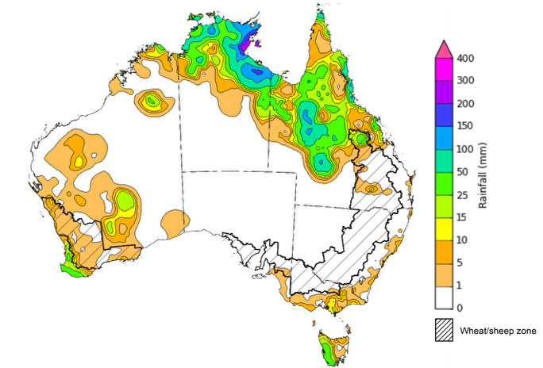
©Commonwealth of Australia 2026, Australian Bureau of Meteorology Issued: 22/4/2026
Note: The rainfall analyses and associated maps utilise data contained in the Bureau of Meteorology climate database, the Australian Data Archive for Meteorology (ADAM). The analyses are initially produced automatically from real-time data with limited quality control. They are intended to provide a general overview of rainfall across Australia as quickly as possible after the observations are received. For further information go to http://www.bom.gov.au/climate/rainfall/

Rainfall forecast for the next eight days
Over the 8 days to 30 April 2026, low-pressure systems are expected to bring rainfall to parts of the north, east and southwest. However, much of the remainder of Australia is forecast to remain largely dry.
- Falls of between 10-100 millimetres are forecast for north-eastern New South Wales and southeast Queensland, while southwest Western Australia is likely to see 10-50 millimetres. Isolated areas of Tasmania and the Northern Territory are forecast to see falls of up to 25 millimetres.
- Remaining regions are likely to see little to no rainfall.
Rainfall totals across many cropping regions over the coming week are forecast to be low, with exceptions in Western Australia.
- Low rainfall totals (0-10 millimetres) are forecast for Queensland, with 0-5 millimetres expected in New South Wales, Victoria, and South Australia
- Falls of up to 25 millimetres are forecast for western regions of Western Australia.
  - If realised, these falls are expected to support the germination and growth of early sown winter crops and provide a timely boost to soil moisture levels and encourage further plantings.

Total forecast rainfall for the period 23 April to 30 April 2026
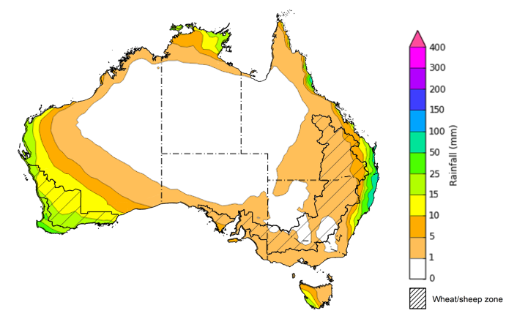
©Commonwealth of Australia 2026, Australian Bureau of Meteorology Issued 23/4/2026
Note: This rainfall forecast is produced from computer models. As the model outputs are not altered by weather forecasters, it is important to check local forecasts and warnings issued by the Bureau of Meteorology.

National Climate Outlook
The Bureau of Meteorology has indicated that the 2025–26 La Niña has concluded. All models, including the Bureau of Meteorology's, forecast the tropical Pacific to continue warming in the coming months. Neutral El Niño–Southern Oscillation conditions are expected to persist until at least late autumn, with all models indicating warming to levels consistent with El Niño by the end of winter. There is some variation across models in the rate at which El Niño thresholds may be reached, with some suggesting development as early as May, while others show a slower warming with thresholds not met until late August. The Southern Annular Mode (SAM) is currently neutral and is forecast to remain neutral over the coming weeks. Similarly, the Indian Ocean Dipole (IOD) has returned to neutral conditions but is expected to reach positive values over the winter season.
The most recent rainfall outlook for May 2026 provided by the Bureau of Meteorology indicates that most of Australia is more likely to see below median rainfall, with parts of central Western Australia more likely to see close to median falls.
The Bureau of Meteorology’s climate model indicates a 75% chance of May rainfall totals between 5- 100 millimetres across Victoria and much of south-western Western Australia. In the east, including coastal parts of Queensland, and eastern and southern New South Wales, falls of 5- 50 millimetres are expected. Similar falls are also expected for southern South Australia. Much of central and northern Western Australia, the Northern Territory, western Queensland, northern South Australia, and western parts of New South Wales are likely to see little to no rainfall.
Across south-eastern and western cropping regions, there is a 75% chance of receiving rainfall totals of between 5- 25 millimetres during May 2026. Across most cropping regions in Queensland and northern New South Wales there is a 75% chance of receiving rainfall totals of between 0- 10 millimetres.

Rainfall totals that have a 75% chance of occurring in May 2026

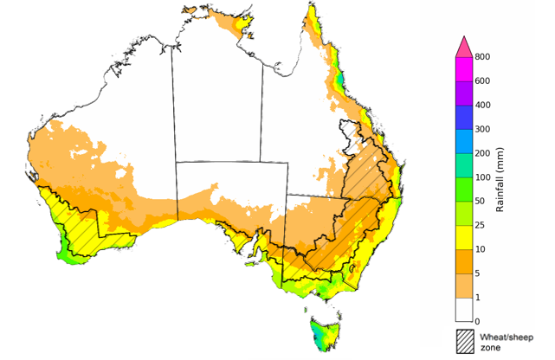
©Commonwealth of Australia 2025, Australian Bureau of Meteorology Issued: 23/4/2026
The rainfall outlook for May 2026 to July 2026 indicates a strong likelihood of below median rainfall across much of eastern Australia. However, there is an increased probability of median to above median rainfall in parts of northern and central Western Australia.
Across most cropping regions, the chance of receiving above median rainfall is 20-45%, with eastern regions on average having a lower possibility of seeing above median rainfall than southern and western regions.

Chance of exceeding the median rainfall May 2026 to July 2026

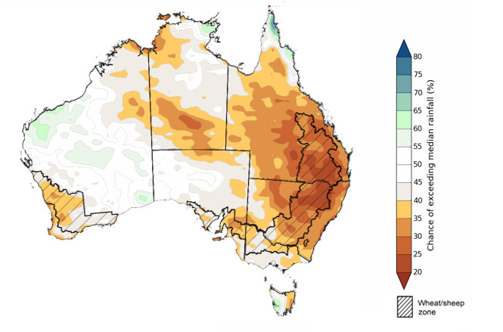
©Commonwealth of Australia 2025, Australian Bureau of Meteorology Issued: 23/4/2026

The rainfall outlook for May 2026 to July 2026 suggests a 75% chance of receiving rainfall totals of between 25-200 millimetres across parts of eastern and southern Australia. Higher falls in excess of 200 millimetres are expected across scattered areas of north-eastern Queensland, southwest Western Australia, western Tasmania, as well as alpine regions of Victoria and New South Wales. Lower rainfall totals are forecast for central and northern regions, with much of northern South Australia, central and northern Western Australia, the Northern Territory and western Queensland likely to see 0-25 millimetres.
In cropping regions, there is a 75% chance of receiving between 10-50 millimetres across much of Queensland. Cropping regions in Western Australia, Victoria, South Australia and New South Wales are likely to see 50-100 millimetres.
If forecast May through July rainfall totals are realised, the expected falls for much of south-eastern and eastern Australia are well below average and represents an increased downside production risk for the upcoming 2026–27 winter cropping season and late autumn pasture growth.

Rainfall totals that have a 75% chance of occurring May 2026 to July 2026

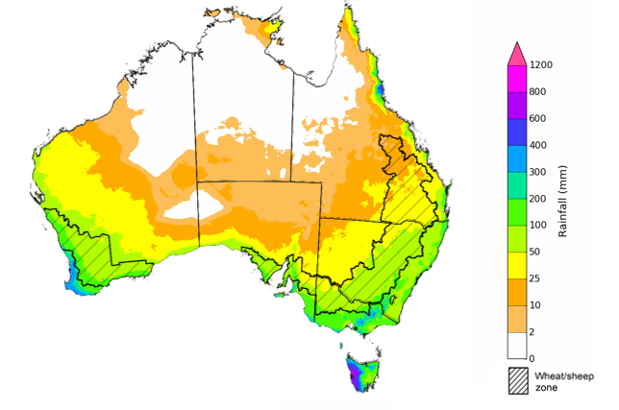
©Commonwealth of Australia 2025, Australian Bureau of Meteorology Issued: 23/4/2026

Water markets – current week
Water storage levels in the Murray-Darling Basin (MDB) decreased by 105 gigalitres (GL) between 16 April 2026 and 23 April 2026. The current volume of water held in storages is 10,156 GL, equivalent to 46% of total storage capacity. This is 14% or 1,629 GL less than the same time last year. Water storage data is sourced from the Bureau of Meteorology .

Water storages in the Murray-Darling Basin, 2013–2026
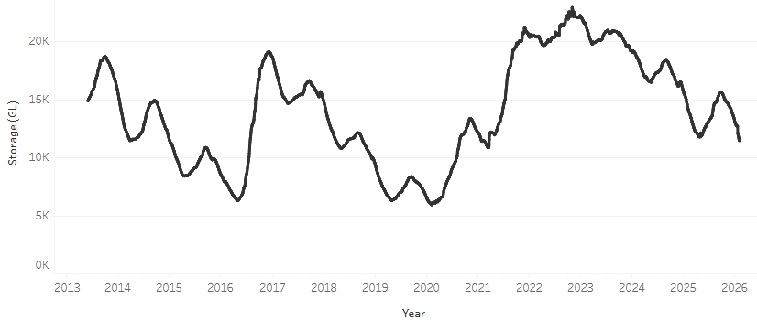
Allocation prices in the Victorian Murray below the Barmah Choke increased from $381/ML on 16 April 2026 to $400/ML on 23 April 2026. Trade from the Goulburn to the Murray is closed. Trade downstream through the Barmah Choke is open. Trade from the Murrumbidgee to the Murray is open.

Water market prices, Southern Murray–Darling Basin

Region | $/ML
NSW Murray Above | 308
NSW Murrumbidgee | 436
Vic Greater Goulburn | 363
Vic Murray Below | 400

Note: The water allocation prices shown are volume weighted average prices based on the last 10 trades. Price data is sourced from Waterflow and current as at 22 January 2026.
To access the full, interactive, weekly water dashboard, which contains the latest and historical water storage, water market and water allocation information, please visit https://www.agriculture.gov.au/abares/products/weekly_update/weekly-update-260423

Commodities
Indicator | Week average | Unit | Latest Price | Previous Week | Weekly change |  | Price 12 months ago | Annual change
Selected world indicator prices
AUD/USD Exchange rate | 22-Apr | A$/US$ | 0.72 | 0.71 | 1% | 0.63 |  | 14%
Wheat – US no. 2 hard red winter wheat, FOB Gulf | 22-Apr | US$/t | 284 | 280 | 2% | 249 |  | 14%
Corn – US no. 2 yellow corn, FOB Gulf | 22-Apr | US$/t | 216 | 212 | 2% | 215 |  | 0%
Canola – Rapeseed, Canada, FOB Vancouver | 22-Apr | US$/t | 562 | 543 | 4% | 517 |  | 9%
Cotton – Cotlook A Index | 22-Apr | USc/lb | 89.7 | 85.9 | 4% | 78.1 |  | 15%
Sugar – Intercontinental Exchange, nearby futures, no.11 contract | 22-Apr | USc/lb | 13.7 | 13.8 | -1% | 18.1 |  | -24%
Wool – Eastern Market Indicator | 22-Apr | Ac/kg clean | 1,895 | 1,825 | 4% | 1,238 |  | 53%
Wool – Western Market Indicator | 22-Apr | Ac/kg clean | 2,125 | 2,052 | 4% | 1,394 |  | 52%
Selected Australian grain export prices
Australian Premium White (APW) Wheat, FOB Port Adelaide, SA | 22-Apr | A$/t | 374 | 370 | 1% | 399 |  | -6%
Australian Standard White (ASW) Wheat, FOB Port Adelaide, SA | 22-Apr | A$/t | 371 | 367 | 1% | 393 |  | -5%
Feed Barley – FOB Port Adelaide, SA | 22-Apr | A$/t | 369 | 367 | 1% | 372 |  | -1%
Canola – FOB Kwinana, WA | 22-Apr | A$/t | 769 | 769 | 0% | 795 |  | -3%
Grain Sorghum – FOB Brisbane, QLD | 22-Apr | A$/t | 449 | 445 | 1% | 438 |  | 2%
Selected domestic livestock indicator prices
Beef – Eastern Young Cattle Indicator | 22-Apr | Ac/kg cwt | 800 | 809 | -1% | 700 |  | 14%
Mutton – Mutton indicator (18–24 kg fat score 2–3), VIC | 22-Apr | Ac/kg cwt | 823 | 827 | 0% | 506 |  | 63%
Lamb – National Trade Lamb Indicator | 22-Apr | Ac/kg cwt | 1,196 | 1,202 | 0% | 812 |  | 47%
Pig – Eastern Seaboard (60.1–75 kg), NSW buyer price | 8-Apr | Ac/kg cwt | 457 | 461 | -1% | 448 |  | 2%
Live cattle – Light steers to Indonesia | 22-Apr | Ac/kg lwt | 430 | 440 | -2% | 358 |  | 20%
Global Dairy Trade (GDT) weighted average prices
Dairy – Whole milk powder | 22-Apr | US$/t | 3,666 | 3,687 | -1% | 4,117 |  | -11%
Dairy – Skim milk powder | 22-Apr | US$/t | 3,448 | 3,381 | 2% | 2,836 |  | 22%
Dairy – Cheddar cheese | 22-Apr | US$/t | 4,798 | 4,766 | 1% | 4,971 |  | -3%
Dairy – Anhydrous milk fat | 22-Apr | US$/t | 6,537 | 7,027 | -7% | 6,772 |  | -3%

Selected world indicator prices
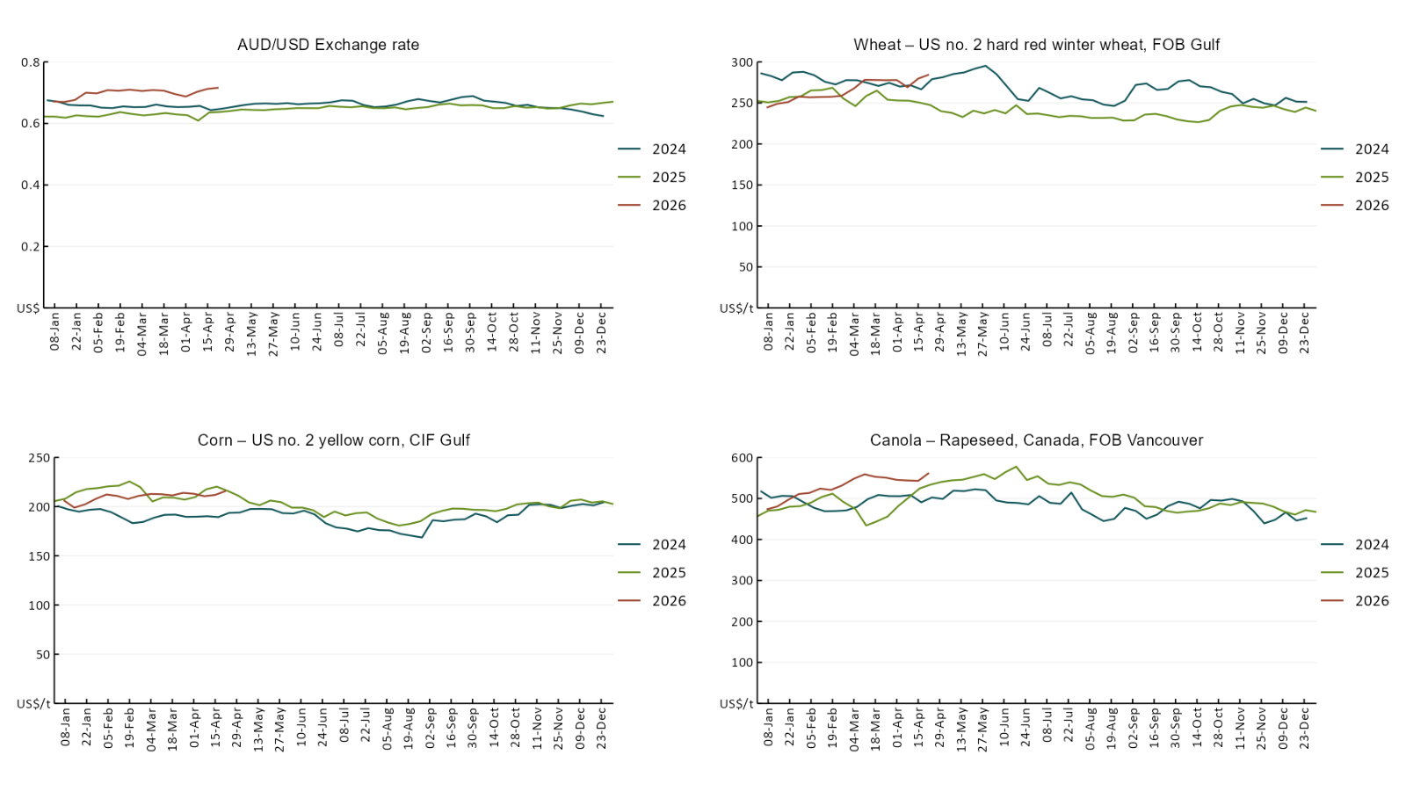

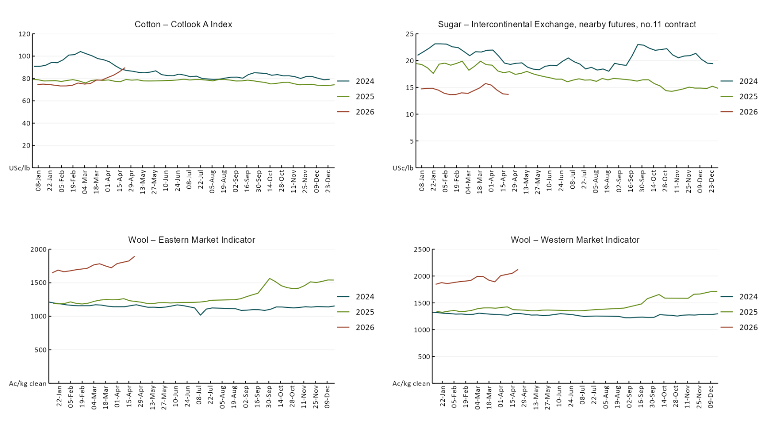

3.2 Selected domestic crop indicator prices
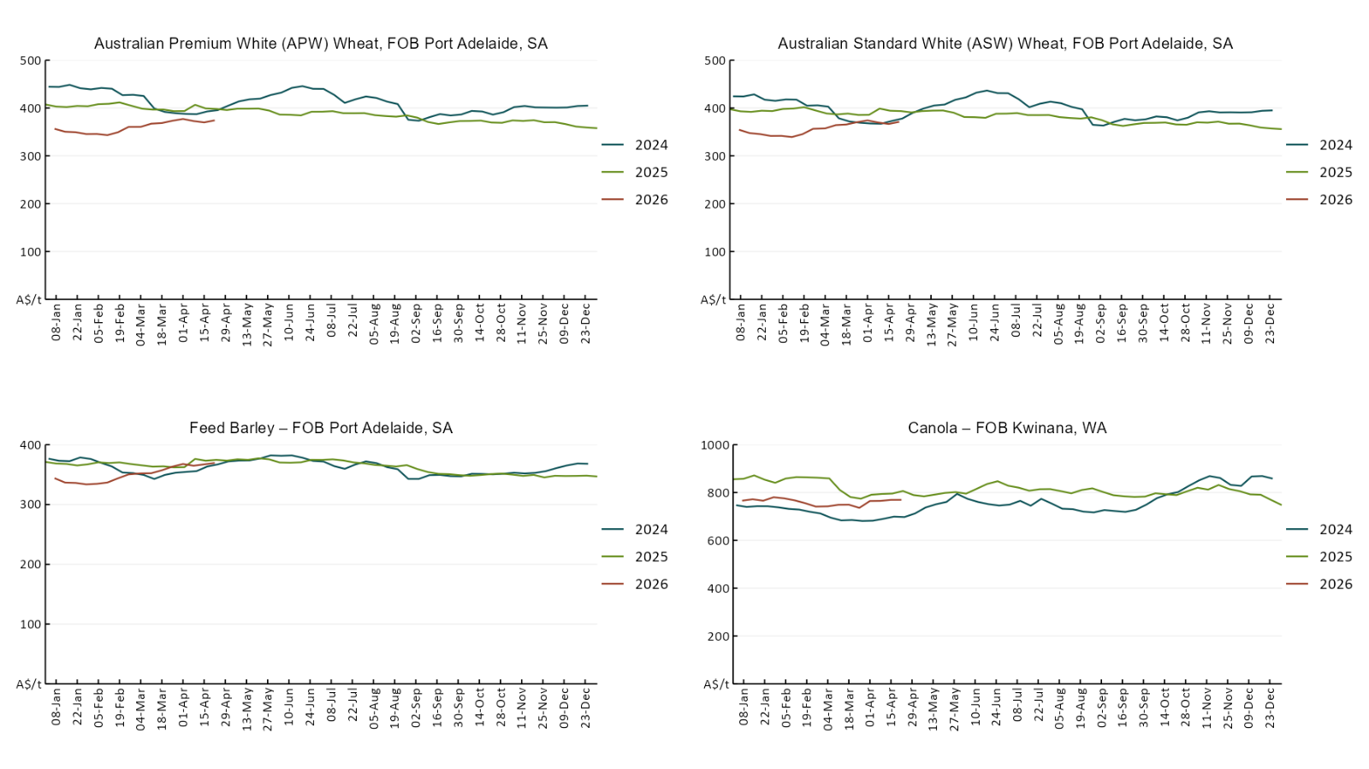

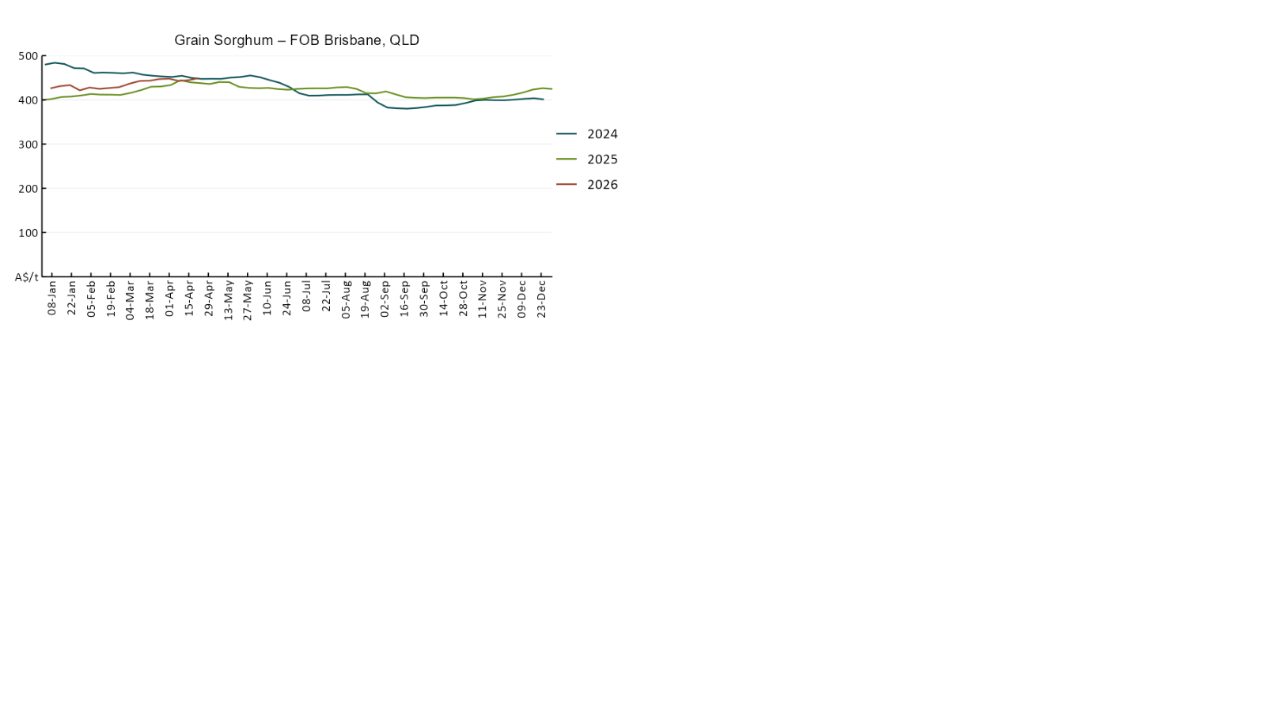

3.3 Selected domestic livestock indicator prices
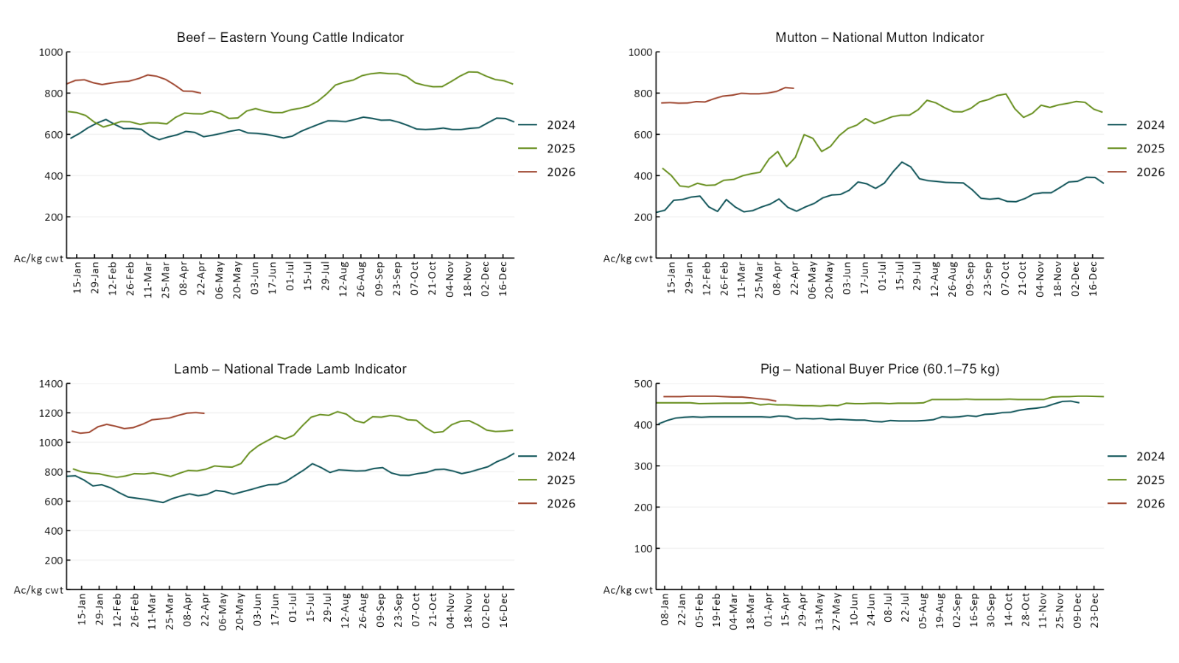

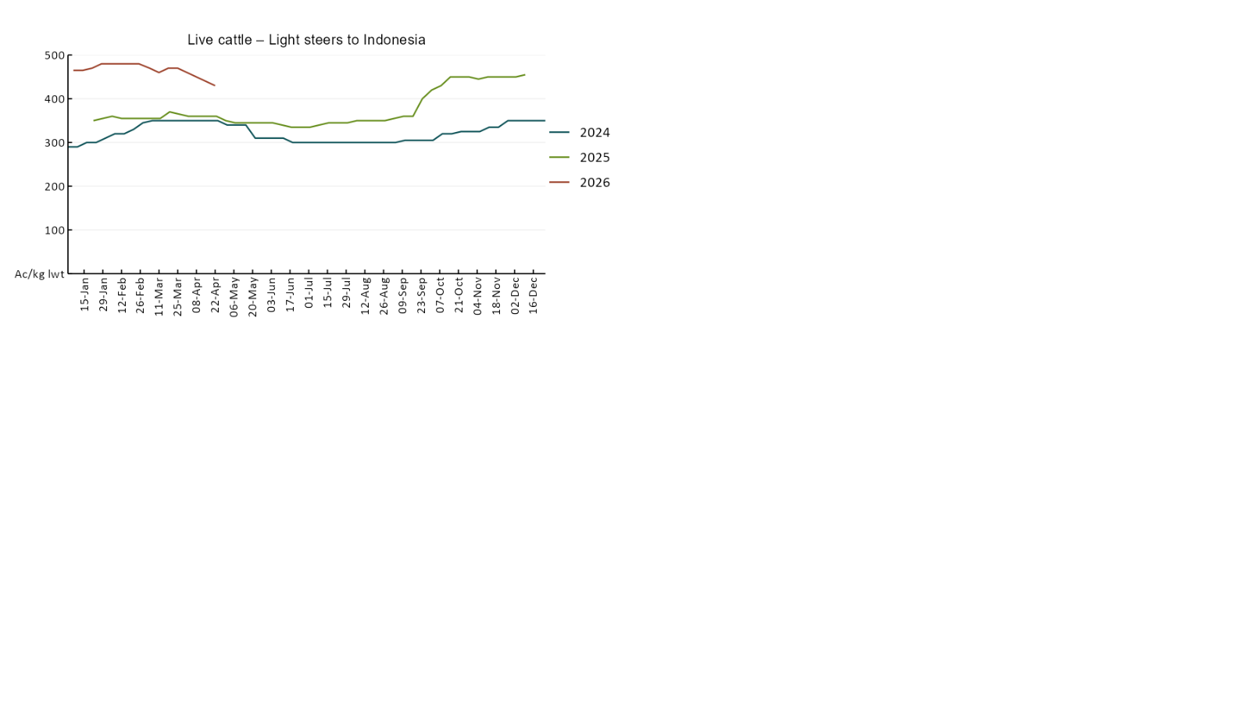

3.4 Global Dairy Trade (GDT) weighted average prices
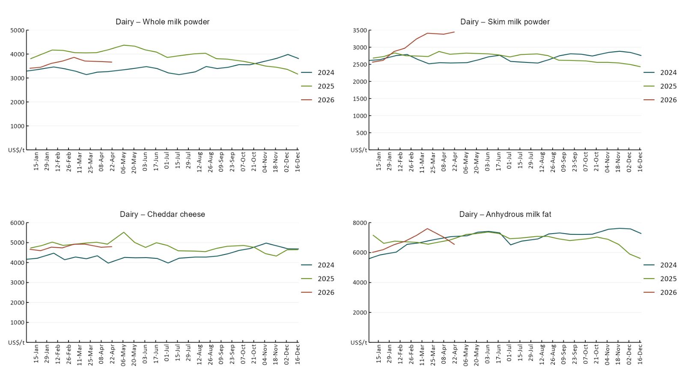

3.5 Selected fruit and vegetable prices
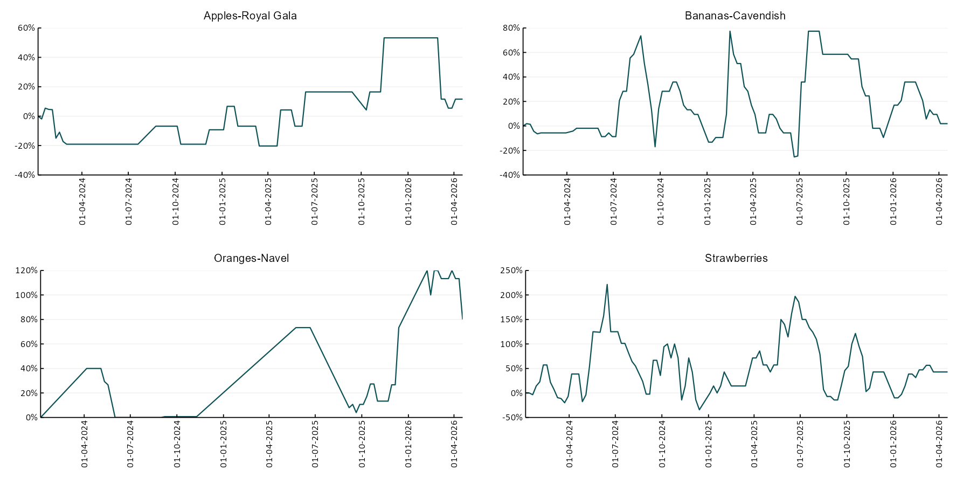

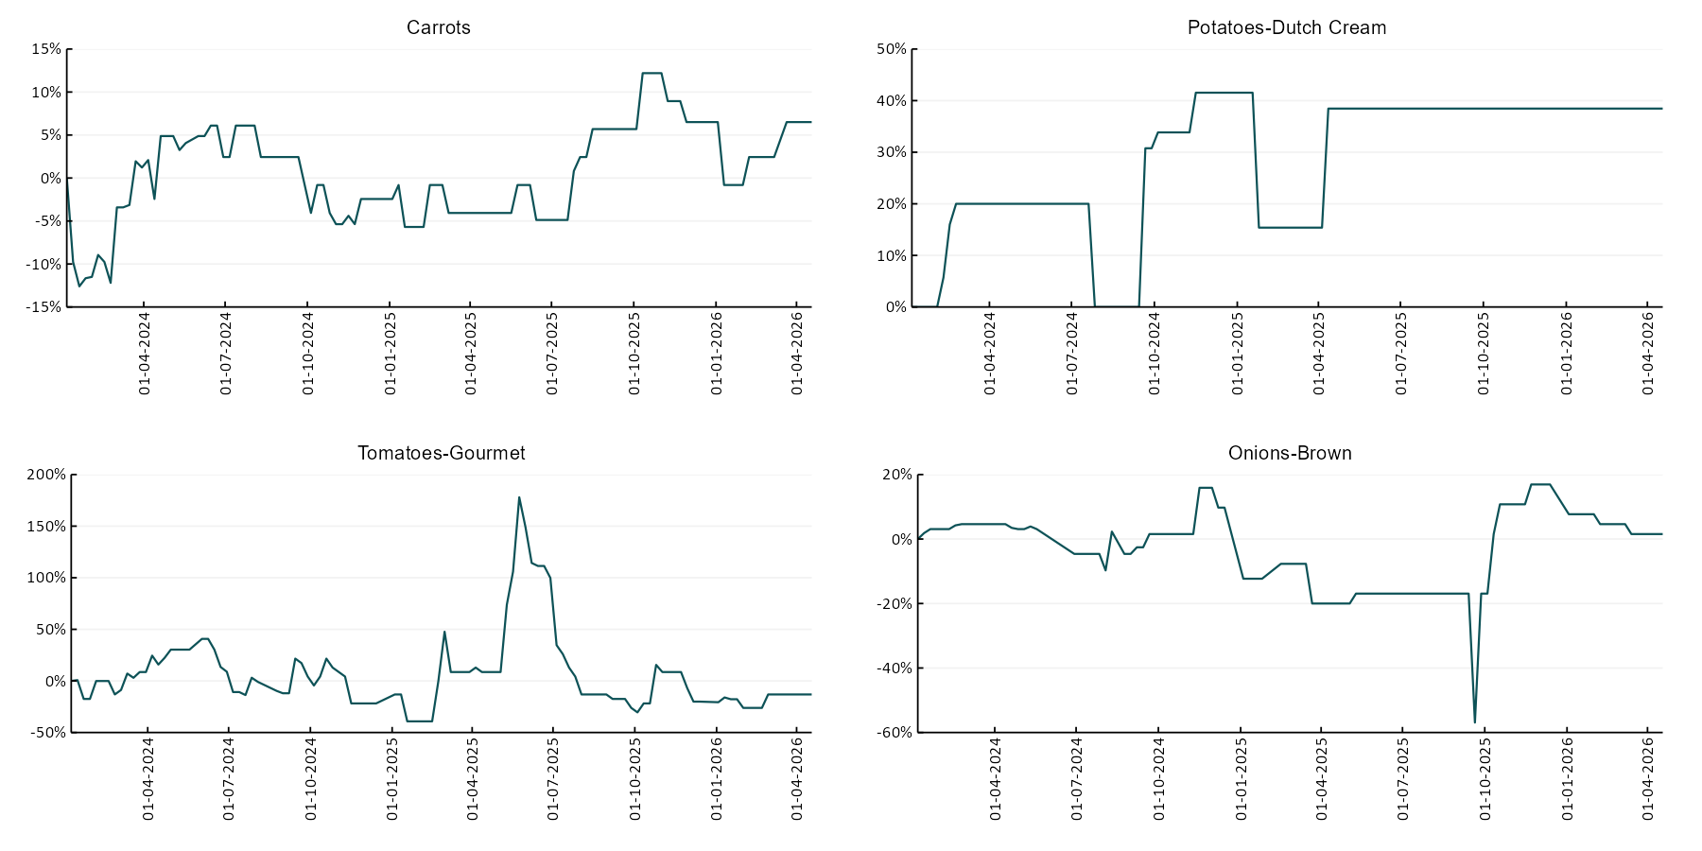

3.6 Selected domestic fodder indicator prices
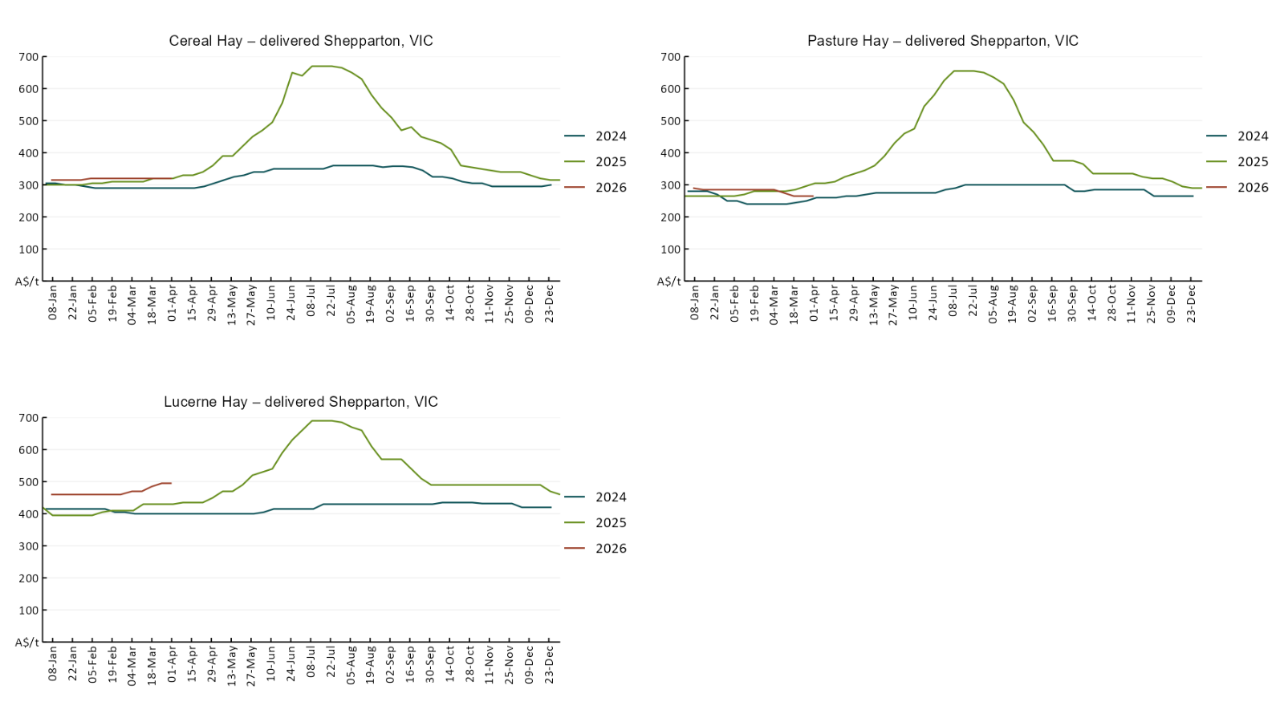

4. Data attribution

Climate
Bureau of Meteorology
- Weekly rainfall totals: www.bom.gov.au/climate/maps/rainfall/
- Monthly and last 3-month rainfall percentiles: https://www.bom.gov.au/climate/ahead/outlooks/#moreMaps
- Rainfall forecast: www.bom.gov.au/jsp/watl/rainfall/pme.jsp
- Seasonal outlook: www.bom.gov.au/climate/outlooks/#/overview/summary/
- Climate drivers: http://www.bom.gov.au/climate/enso/
- Soil moisture: https://awo.bom.gov.au/products/historical/soilMoisture-rootZone/

Other
- Pasture growth: www.longpaddock.qld.gov.au/aussiegrass/
- 3-month global outlooks: Environment and Climate Change Canada, NOAA Climate Prediction Center, EUROBRISA CPTEC/INPE, European Centre for Medium-Range Weather Forecasts, Hydrometcenter of Russia, National Climate Center Climate System Diagnosis and Prediction Room (NCC), International Research Institute for Climate and Society
- Global production: https://ipad.fas.usda.gov/ogamaps/cropmapsandcalendars.aspx
- Autumn break: Pook et al., 2009, https://rmets-onlinelibrary-wiley-com.virtual.anu.edu.au/doi/epdf/10.1002/joc.1833

Water
Prices
- Waterflow: https://www.waterflow.io/
- Ruralco: https://www.ruralcowater.com.au/
- Bureau of Meteorology:
- Allocation trade: http://www.bom.gov.au/water/dashboards/#/water-markets/mdb/at
- Storage volumes: http://www.bom.gov.au/water/dashboards/#/water-storages/summary/drainage

Trade constraints:
- Water NSW: https://www.waternsw.com.au/customer-service/ordering-trading-and-pricing/trading/murrumbidgee
- Victorian Water Register: https://www.waterregister.vic.gov.au/TradingRules2019/

Commodities
Fruit and vegetables
- Datafresh: www.freshstate.com.au

Pigs
- Australian Pork Limited: www.australianpork.com.au

Dairy
- Global Dairy Trade: www.globaldairytrade.info/en/product-results/

World wheat, canola
- International Grains Council
- https://www.igc.int/en/default.aspx
- United States Department of Agriculture

World cotton
- Cotlook: www.cotlook.com/

World sugar
- New York Stock Exchange - Intercontinental Exchange

Wool
- Australian Wool Exchange: www.awex.com.au/

Domestic wheat, barley, sorghum, canola and fodder
- Jumbuk Consulting Pty Ltd: Jumbuk AG | Agriculture Consulting

Cattle, beef, mutton, lamb, goat and live export
- Meat and Livestock Australia: https://www.mla.com.au/prices-markets/

Australian Agricultural Drought Indicators
About Australian Agricultural Drought Indicators
The Australian Agricultural Drought Indicators (AADI) links weather and agricultural data with a range of scientific and economic models to measure and forecast the effects of climate variability and drought on agricultural outcomes.
On AADI, projected broadacre farm profits are presented as percentile outcomes relative to simulated historical outcomes using the groupings:
Highest | 95-100th percentile
Very much above average | 85-95th percentile
Above average | 65-85th percentile
Average | 35-65th percentile
Below average | 15-35th percentile
Very much below average | 5-15th percentile
Lowest 5% | 0-5th percentile

There are two AADI farm profit indicators:
- The AADI farm profit climate and price indicator shows the effect of climate and prices on broadacre farm business profits of current farms compared to the last 33 years.
- The AADI farm profit climate only indicator isolates the effect of climate on profits by holding prices fixed.

© Commonwealth of Australia 2026

Ownership of intellectual property rights
Unless otherwise noted, copyright (and any other intellectual property rights, if any) in this publication is owned by the Commonwealth of Australia (referred to as the Commonwealth).

Creative Commons licence
All material in this publication is licensed under a Creative Commons Attribution 4.0 International Licence except content supplied by third parties, logos and the Commonwealth Coat of Arms.
Inquiries about the licence and any use of this document should be emailed to copyright@awe.gov.au.


Cataloguing data
This publication (and any material sourced from it) should be attributed as:
ABARES 2026, Weekly Australian Climate, Water and Agricultural Update, Australian Bureau of Agricultural and Resource Economics and Sciences, Canberra, 23 April 2026. CC BY 4.0 DOI: https://doi.org/10.25814/5f3e04e7d2503
ISSN 2652-7561
This publication is available at https://www.agriculture.gov.au/abares/products/weekly_update
Department of Agriculture, Fisheries and Forestry
GPO Box 858 Canberra ACT 2601
Telephone 1800 900 090
Web agriculture.gov.au/abares

Disclaimer
The Australian Government acting through the Department of Agriculture, Fisheries and Forestry, represented by the Australian Bureau of Agricultural and Resource Economics and Sciences, has exercised due care and skill in preparing and compiling the information and data in this publication. Notwithstanding, the Department of Agriculture, Fisheries and Forestry, ABARES, its employees and advisers disclaim all liability, including liability for negligence and for any loss, damage, injury, expense or cost incurred by any person as a result of accessing, using or relying on any of the information or data in this publication to the maximum extent permitted by law.

Statement of Professional Independence
The views and analysis presented in ABARES publications, including this one, reflect ABARES professionally independent findings, based on scientific and economic concepts, principles, information and data. These views, analysis and findings may not reflect or be consistent with the views or positions of the Australian Government, or of organisations or groups who have commissioned ABARES reports or analysis. More information on professional independence is provided on the ABARES website.

Acknowledgements
This report was prepared by Holly Beale and Amelia Brown.

