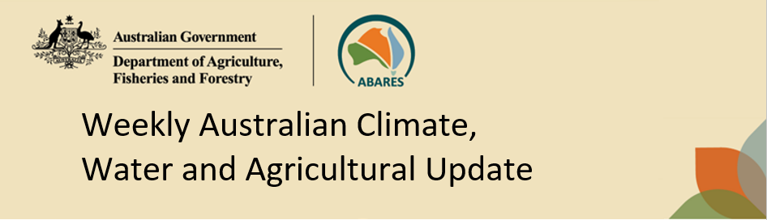
No. 16/2026 30 April 2026

Summary of key issues
- In the week ending 29 April 2026, rainfall was recorded across the southwest and parts of the east.
  - Most cropping regions of Queensland, New South Wales, Victoria, and South Australia saw little to no rainfall.
  - In regions that have seen several consecutive weeks of low rainfall, this is likely to reduce upper layer soil moisture and broaden the gap between upper and lower laver soi moisture reserves ahead of winter crop sowing.
- Over the 8 days to 7 May 2026, low pressure systems are expected to bring rainfall to parts of the east and south:
  - Low rainfall totals (1-10 millimetres) are forecast for Queensland, northern New South Wales, and much of Western Australia.
  - Falls of up to 25 millimetres are forecast for southern New South Wales, Victoria, South Australia, and eastern parts of Western Australia.
  - If realised, these falls are expected to support the germination and growth of early sown winter crops and provide a timely boost to soil moisture levels and encourage further plantings.
- Water storage levels in the Murray-Darling Basin (MDB) decreased by 115 gigalitres (GL) between 23 April 2026 and 30 April 2026. The current volume of water held in storages is 10,041 GL, equivalent to 45% of total storage capacity. This is 15% or 1,721 GL less than the same time last year. Water storage data is sourced from the Bureau of Meteorology (BOM).
- Allocation prices in the Victorian Murray below the Barmah Choke increased from $400/ML on 23 April 2026 to $438/ML on 30 April 2026. Trade from the Goulburn to the Murray is closed. Trade downstream through the Barmah Choke is closed. Trade from the Murrumbidgee to the Murray is open.

Climate

Rainfall this week
In the week ending 29 April 2026, low pressure systems brought rainfall across the southwest and parts of the east. Northern, central, and south-eastern areas remained largely dry
- Eastern regions of Queensland and northern New South Wales saw falls of 5-100 millimetres, with higher falls closer to coastal regions.
- In Western Australia, falls of up to 25 millimetres were observed in south-western regions, with scattered areas seeing up to 50 millimetres. Isolated parts of the Northern Territory saw up to 15 millimetres.
- Much of inland Queensland, New South Wales, Victoria, South Australia the south of, and the remainder of the Northern Territory and Western Australia remained largely dry.
Across cropping regions, rainfall was broadly low, with exceptions in Western Australia.
- Most cropping regions of Queensland, New South Wales, Victoria, and South Australia saw little to no rainfall.
  - In regions that have seen several consecutive weeks of low rainfall, this is likely to reduce upper layer soil moisture and broaden the gap between upper and lower laver soi moisture reserves ahead of winter crop sowing.
- In Western Australia, falls of 1-25 millimetres were recorded across most cropping regions.
  - These falls are expected to support the germination and growth of early sown winter crops and provide a timely boost to soil moisture levels and encourage further plantings.

Rainfall for the week ending 29 April 2026
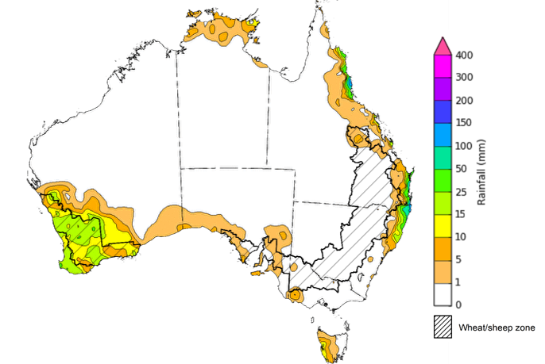
©Commonwealth of Australia 2026, Australian Bureau of Meteorology Issued: 29/4/2026
Note: The rainfall analyses and associated maps utilise data contained in the Bureau of Meteorology climate database, the Australian Data Archive for Meteorology (ADAM). The analyses are initially produced automatically from real-time data with limited quality control. They are intended to provide a general overview of rainfall across Australia as quickly as possible after the observations are received. For further information go to http://www.bom.gov.au/climate/rainfall/

Rainfall forecast for the next eight days
Over the 8 days to 7 May 2026, low-pressure systems are expected to bring rainfall to parts of the east and south. However, much of the remainder of Australia is forecast to remain largely dry.
- In the south, falls of between 10-50 millimetres are forecast for Victoria, southern parts of South Australia and New South Wales, and south-eastern regions of Western Australia
- Similarity, coastal parts of north-eastern New South Wales, the far southeast of Queensland, and isolated coastal areas of the northern tropics are forecast to see up to 50 millimetres.
- Remaining regions are likely to see little to no rainfall.
Rainfall totals across many cropping regions over the coming week are forecast to be low, with exceptions in the south and southeast.
- Low rainfall totals (1-10 millimetres) are forecast for Queensland, northern New South Wales, and much of Western Australia.
- Falls of up to 25 millimetres are forecast for southern New South Wales, Victoria, South Australia, and eastern parts of Western Australia.
  - If realised, these falls are expected to support the germination and growth of early sown winter crops and provide a timely boost to soil moisture levels and encourage further plantings.

Total forecast rainfall for the period 30 April to 7 May 2026
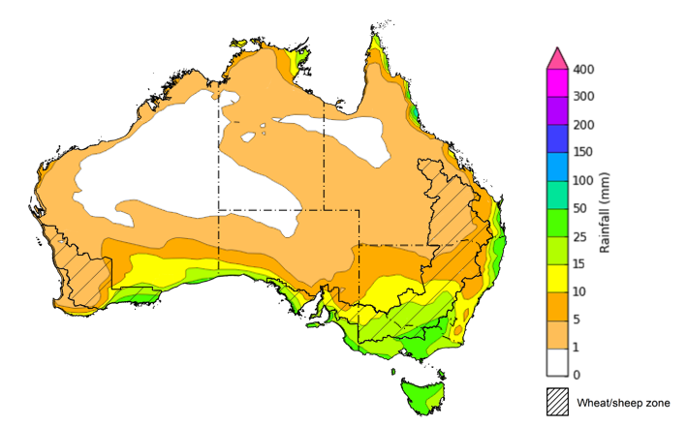
©Commonwealth of Australia 2026, Australian Bureau of Meteorology Issued 30/4/2026
Note: This rainfall forecast is produced from computer models. As the model outputs are not altered by weather forecasters, it is important to check local forecasts and warnings issued by the Bureau of Meteorology.

Water markets – current week
Water storage levels in the Murray-Darling Basin (MDB) decreased by 115 gigalitres (GL) between 23 April 2026 and 30 April 2026. The current volume of water held in storages is 10,041 GL, equivalent to 45% of total storage capacity. This is 15% or 1,721 GL less than the same time last year. Water storage data is sourced from the Bureau of Meteorology (BOM).

Water storages in the Murray-Darling Basin, 2013–2026
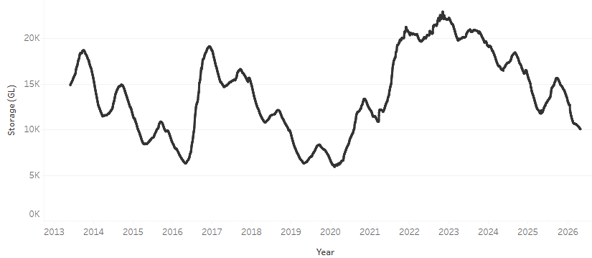
Allocation prices in the Victorian Murray below the Barmah Choke increased from $400/ML on 23 April 2026 to $438/ML on 30 April 2026. Trade from the Goulburn to the Murray is closed. Trade downstream through the Barmah Choke is closed. Trade from the Murrumbidgee to the Murray is open.

Water market prices, Southern Murray–Darling Basin

Region | $/ML
NSW Murray Above | 320
NSW Murrumbidgee | 498
Vic Greater Goulburn | 388
Vic Murray Below | 438

Note: The water allocation prices shown are volume weighted average prices based on the last 10 trades. Price data is sourced from Waterflow and current as at 22 January 2026.
To access the full, interactive, weekly water dashboard, which contains the latest and historical water storage, water market and water allocation information, please visit https://www.agriculture.gov.au/abares/products/weekly_update/weekly-update-260430

Commodities
Indicator | Week average | Unit | Latest Price | Previous Week | Weekly change |  | Price 12 months ago | Annual change
Selected world indicator prices
AUD/USD Exchange rate | 29-Apr | A$/US$ | 0.72 | 0.72 | 0% | 0.63 |  | 14%
Wheat – US no. 2 hard red winter wheat, FOB Gulf | 29-Apr | US$/t | 295 | 288 | 2% | 249 |  | 19%
Corn – US no. 2 yellow corn, FOB Gulf | 29-Apr | US$/t | 221 | 217 | 2% | 215 |  | 3%
Canola – Rapeseed, Canada, FOB Vancouver | 29-Apr | US$/t | 571 | 565 | 1% | 517 |  | 11%
Cotton – Cotlook A Index | 29-Apr | USc/lb | 89.5 | 89.4 | 0% | 78.1 |  | 15%
Sugar – Intercontinental Exchange, nearby futures, no.11 contract | 29-Apr | USc/lb | 14.1 | 13.8 | 2% | 18.1 |  | -22%
Wool – Eastern Market Indicator | 22-Apr | Ac/kg clean | 1,895 | 1,825 | 4% | 1,238 |  | 53%
Wool – Western Market Indicator | 22-Apr | Ac/kg clean | 2,125 | 2,052 | 4% | 1,394 |  | 52%
Selected Australian grain export prices
Australian Premium White (APW) Wheat, FOB Port Adelaide, SA | 29-Apr | A$/t | 377 | 375 | 1% | 399 |  | -5%
Australian Standard White (ASW) Wheat, FOB Port Adelaide, SA | 29-Apr | A$/t | 375 | 373 | 1% | 393 |  | -4%
Feed Barley – FOB Port Adelaide, SA | 29-Apr | A$/t | 376 | 372 | 1% | 372 |  | 1%
Canola – FOB Kwinana, WA | 29-Apr | A$/t | 788 | 777 | 1% | 795 |  | -1%
Grain Sorghum – FOB Brisbane, QLD | 29-Apr | A$/t | 454 | 451 | 1% | 438 |  | 4%
Selected domestic livestock indicator prices
Beef – Eastern Young Cattle Indicator | 29-Apr | Ac/kg cwt | 771 | 794 | -3% | 700 |  | 10%
Mutton – Mutton indicator (18–24 kg fat score 2–3), VIC | 29-Apr | Ac/kg cwt | 772 | 805 | -4% | 506 |  | 53%
Lamb – National Trade Lamb Indicator | 29-Apr | Ac/kg cwt | 1,166 | 1,178 | -1% | 812 |  | 43%
Pig – Eastern Seaboard (60.1–75 kg), NSW buyer price | 15-Apr | Ac/kg cwt | 455 | 457 | 0% | 448 |  | 2%
Live cattle – Light steers to Indonesia | 29-Apr | Ac/kg lwt | 420 | 430 | -2% | 358 |  | 17%
Global Dairy Trade (GDT) weighted average prices
Dairy – Whole milk powder | 22-Apr | US$/t | 3,666 | 3,687 | -1% | 4,117 |  | -11%
Dairy – Skim milk powder | 22-Apr | US$/t | 3,448 | 3,381 | 2% | 2,836 |  | 22%
Dairy – Cheddar cheese | 22-Apr | US$/t | 4,798 | 4,766 | 1% | 4,971 |  | -3%
Dairy – Anhydrous milk fat | 22-Apr | US$/t | 6,537 | 7,027 | -7% | 6,772 |  | -3%

Selected world indicator prices
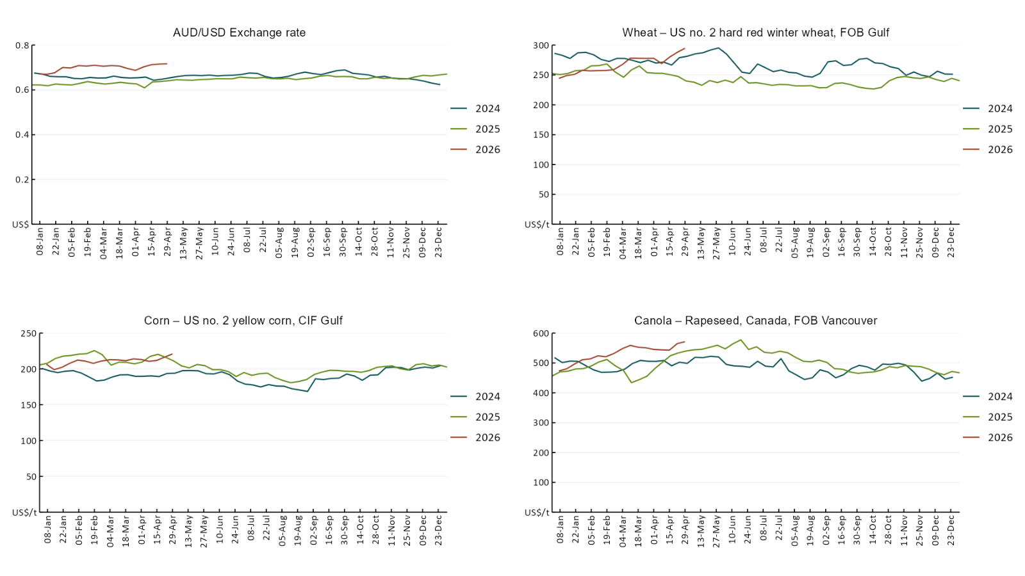

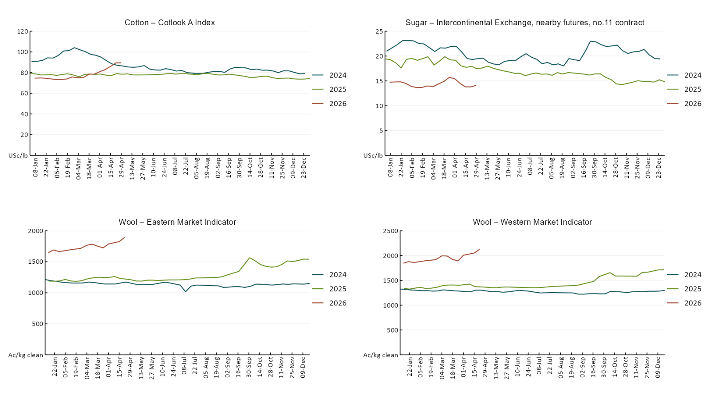

3.2 Selected domestic crop indicator prices
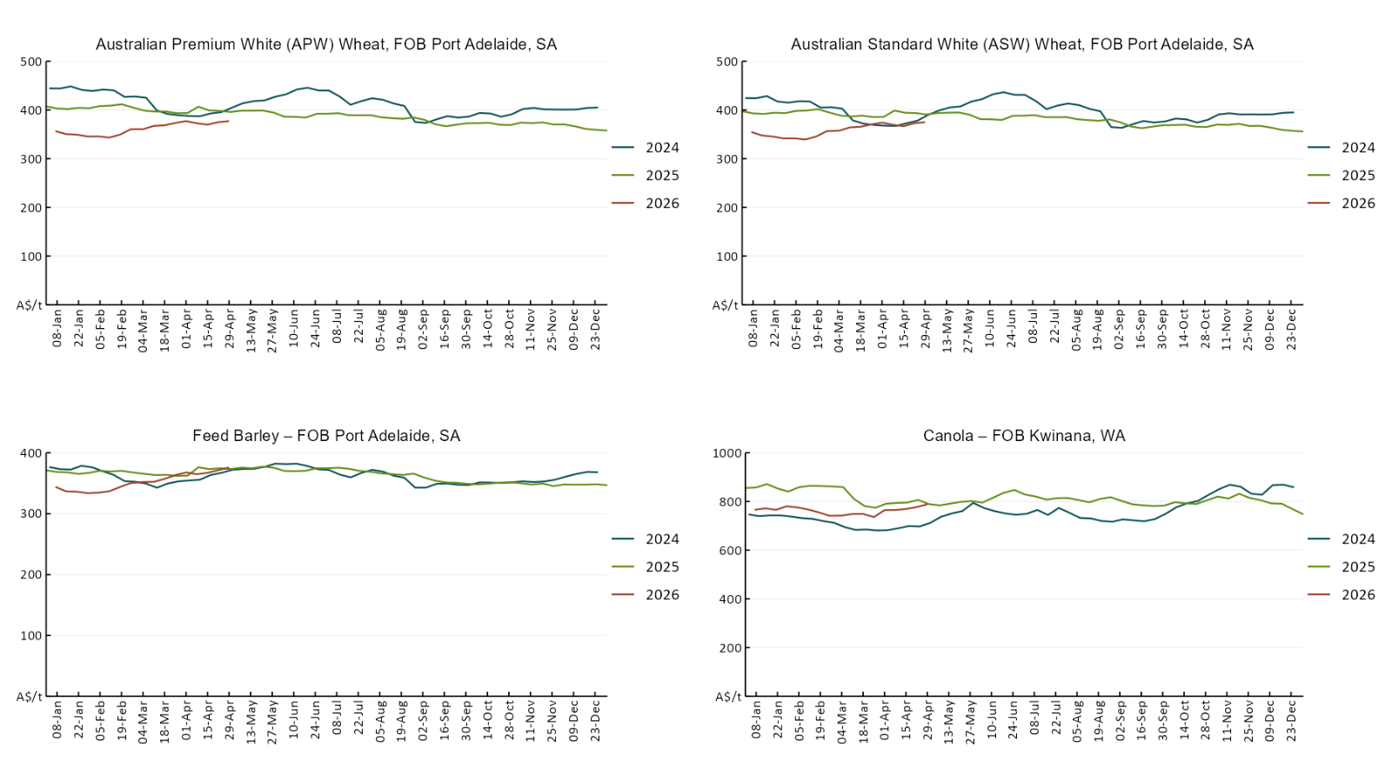

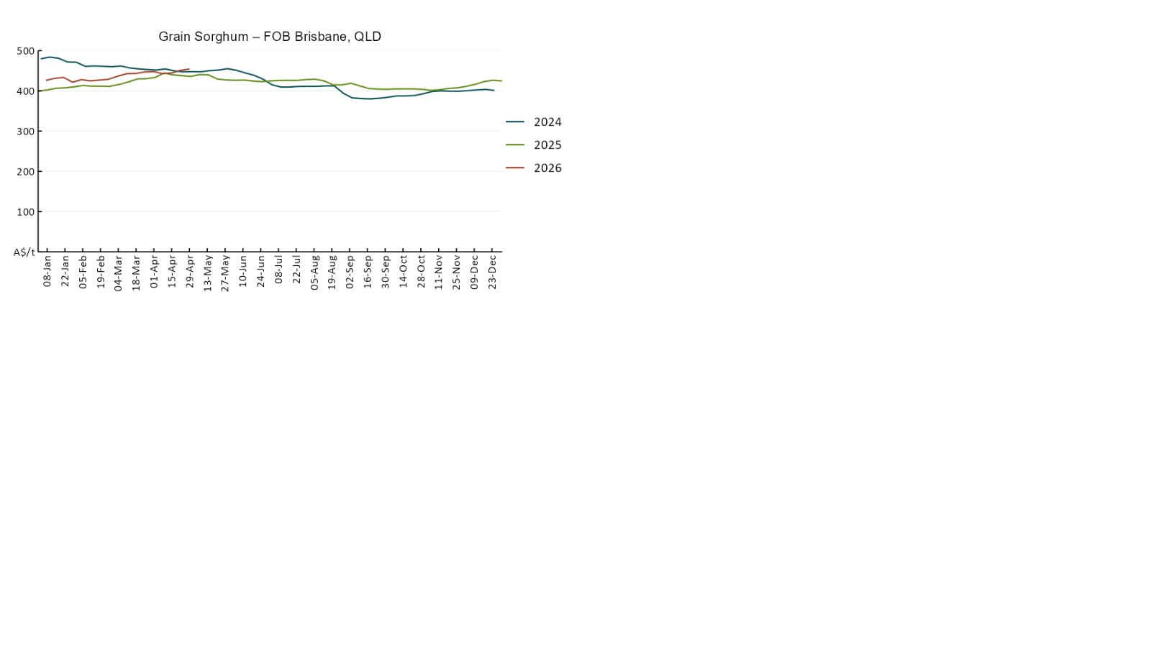

3.3 Selected domestic livestock indicator prices
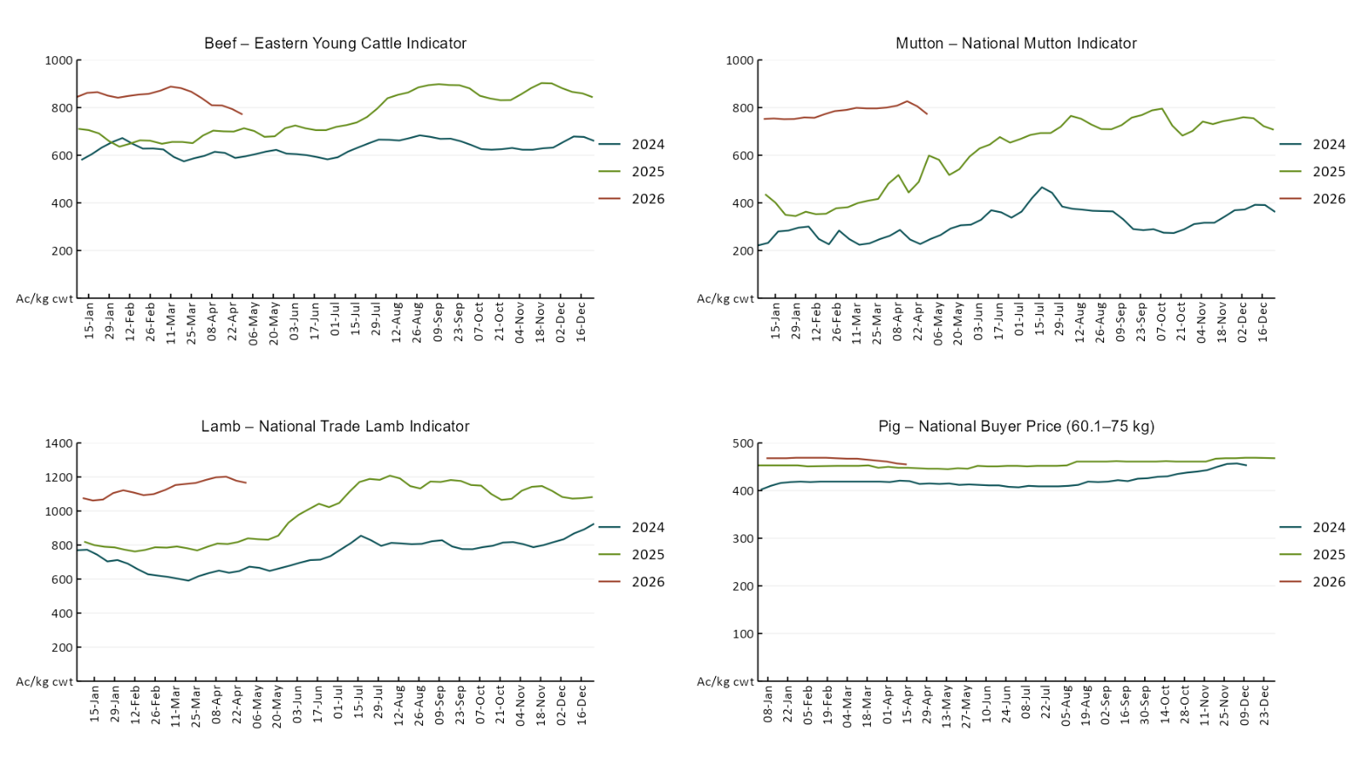

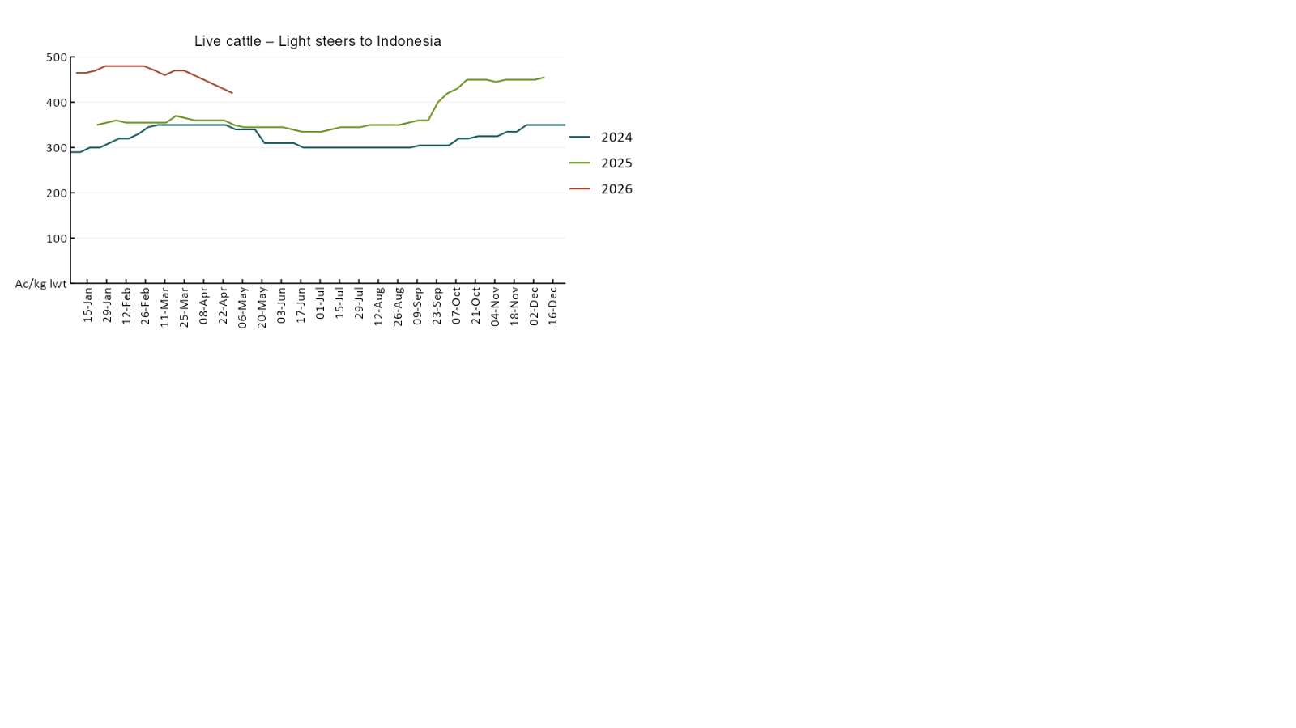

3.4 Global Dairy Trade (GDT) weighted average prices
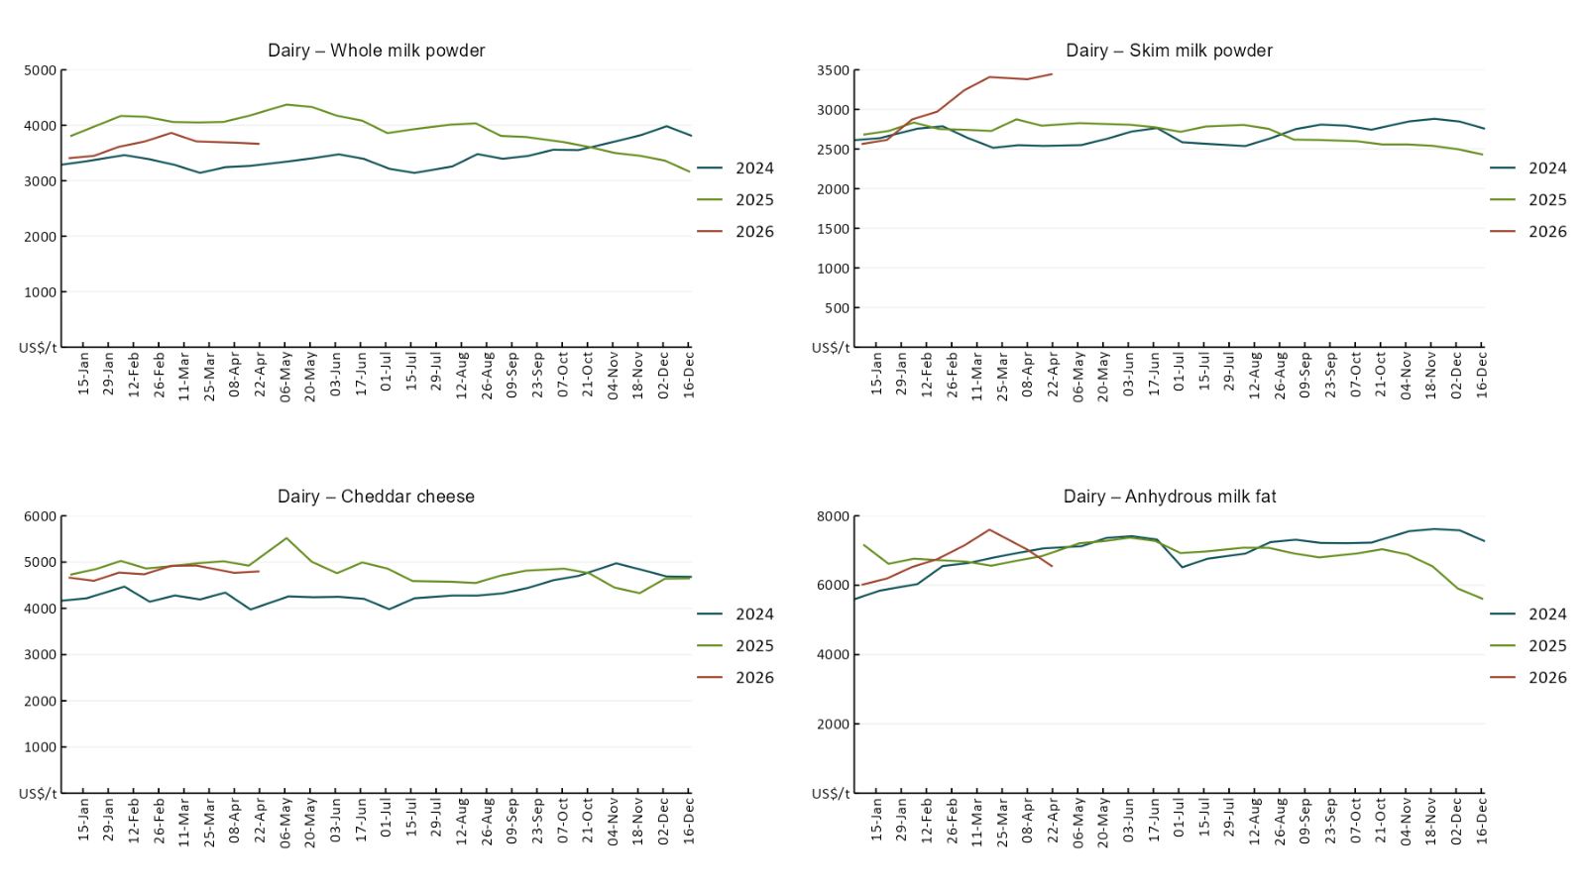

3.5 Selected fruit and vegetable prices
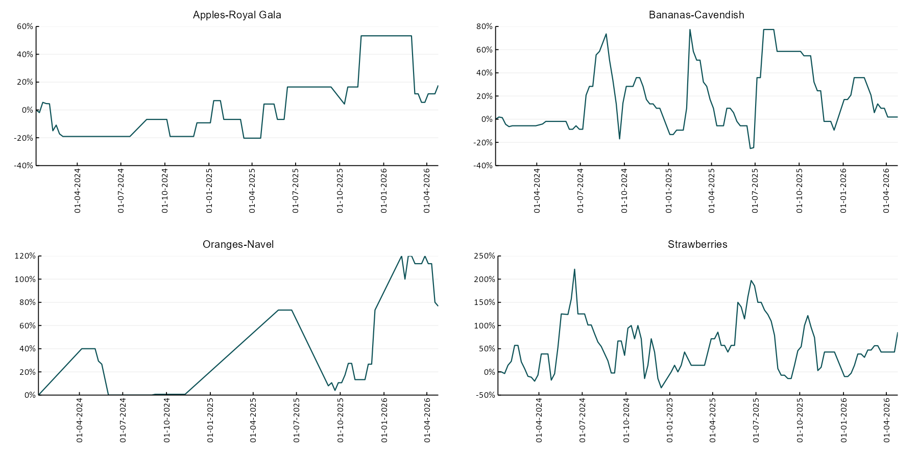

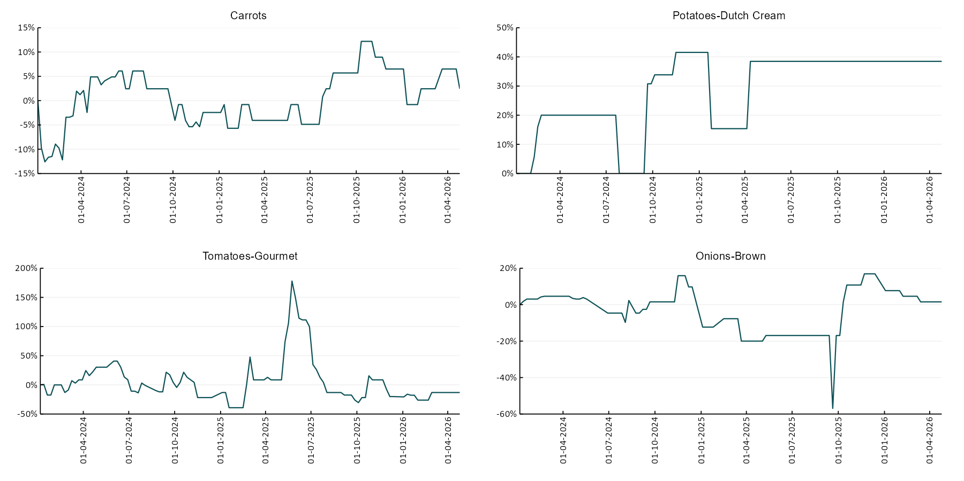

3.6 Selected domestic fodder indicator prices
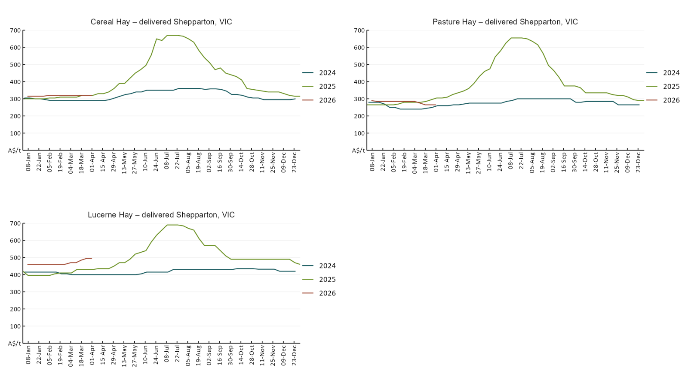

4. Data attribution

Climate
Bureau of Meteorology
- Weekly rainfall totals: www.bom.gov.au/climate/maps/rainfall/
- Monthly and last 3-month rainfall percentiles: https://www.bom.gov.au/climate/ahead/outlooks/#moreMaps
- Rainfall forecast: www.bom.gov.au/jsp/watl/rainfall/pme.jsp
- Seasonal outlook: www.bom.gov.au/climate/outlooks/#/overview/summary/
- Climate drivers: http://www.bom.gov.au/climate/enso/
- Soil moisture: https://awo.bom.gov.au/products/historical/soilMoisture-rootZone/

Other
- Pasture growth: www.longpaddock.qld.gov.au/aussiegrass/
- 3-month global outlooks: Environment and Climate Change Canada, NOAA Climate Prediction Center, EUROBRISA CPTEC/INPE, European Centre for Medium-Range Weather Forecasts, Hydrometcenter of Russia, National Climate Center Climate System Diagnosis and Prediction Room (NCC), International Research Institute for Climate and Society
- Global production: https://ipad.fas.usda.gov/ogamaps/cropmapsandcalendars.aspx
- Autumn break: Pook et al., 2009, https://rmets-onlinelibrary-wiley-com.virtual.anu.edu.au/doi/epdf/10.1002/joc.1833

Water
Prices
- Waterflow: https://www.waterflow.io/
- Ruralco: https://www.ruralcowater.com.au/
- Bureau of Meteorology:
- Allocation trade: http://www.bom.gov.au/water/dashboards/#/water-markets/mdb/at
- Storage volumes: http://www.bom.gov.au/water/dashboards/#/water-storages/summary/drainage

Trade constraints:
- Water NSW: https://www.waternsw.com.au/customer-service/ordering-trading-and-pricing/trading/murrumbidgee
- Victorian Water Register: https://www.waterregister.vic.gov.au/TradingRules2019/

Commodities
Fruit and vegetables
- Datafresh: www.freshstate.com.au

Pigs
- Australian Pork Limited: www.australianpork.com.au

Dairy
- Global Dairy Trade: www.globaldairytrade.info/en/product-results/

World wheat, canola
- International Grains Council
- https://www.igc.int/en/default.aspx
- United States Department of Agriculture

World cotton
- Cotlook: www.cotlook.com/

World sugar
- New York Stock Exchange - Intercontinental Exchange

Wool
- Australian Wool Exchange: www.awex.com.au/

Domestic wheat, barley, sorghum, canola and fodder
- Jumbuk Consulting Pty Ltd: Jumbuk AG | Agriculture Consulting

Cattle, beef, mutton, lamb, goat and live export
- Meat and Livestock Australia: https://www.mla.com.au/prices-markets/

Australian Agricultural Drought Indicators
About Australian Agricultural Drought Indicators
The Australian Agricultural Drought Indicators (AADI) links weather and agricultural data with a range of scientific and economic models to measure and forecast the effects of climate variability and drought on agricultural outcomes.
On AADI, projected broadacre farm profits are presented as percentile outcomes relative to simulated historical outcomes using the groupings:
Highest | 95-100th percentile
Very much above average | 85-95th percentile
Above average | 65-85th percentile
Average | 35-65th percentile
Below average | 15-35th percentile
Very much below average | 5-15th percentile
Lowest 5% | 0-5th percentile

There are two AADI farm profit indicators:
- The AADI farm profit climate and price indicator shows the effect of climate and prices on broadacre farm business profits of current farms compared to the last 33 years.
- The AADI farm profit climate only indicator isolates the effect of climate on profits by holding prices fixed.

© Commonwealth of Australia 2026

Ownership of intellectual property rights
Unless otherwise noted, copyright (and any other intellectual property rights, if any) in this publication is owned by the Commonwealth of Australia (referred to as the Commonwealth).

Creative Commons licence
All material in this publication is licensed under a Creative Commons Attribution 4.0 International Licence except content supplied by third parties, logos and the Commonwealth Coat of Arms.
Inquiries about the licence and any use of this document should be emailed to copyright@awe.gov.au.


Cataloguing data
This publication (and any material sourced from it) should be attributed as:
ABARES 2026, Weekly Australian Climate, Water and Agricultural Update, Australian Bureau of Agricultural and Resource Economics and Sciences, Canberra, 30 April 2026. CC BY 4.0 DOI: https://doi.org/10.25814/5f3e04e7d2503
ISSN 2652-7561
This publication is available at https://www.agriculture.gov.au/abares/products/weekly_update
Department of Agriculture, Fisheries and Forestry
GPO Box 858 Canberra ACT 2601
Telephone 1800 900 090
Web agriculture.gov.au/abares

Disclaimer
The Australian Government acting through the Department of Agriculture, Fisheries and Forestry, represented by the Australian Bureau of Agricultural and Resource Economics and Sciences, has exercised due care and skill in preparing and compiling the information and data in this publication. Notwithstanding, the Department of Agriculture, Fisheries and Forestry, ABARES, its employees and advisers disclaim all liability, including liability for negligence and for any loss, damage, injury, expense or cost incurred by any person as a result of accessing, using or relying on any of the information or data in this publication to the maximum extent permitted by law.

Statement of Professional Independence
The views and analysis presented in ABARES publications, including this one, reflect ABARES professionally independent findings, based on scientific and economic concepts, principles, information and data. These views, analysis and findings may not reflect or be consistent with the views or positions of the Australian Government, or of organisations or groups who have commissioned ABARES reports or analysis. More information on professional independence is provided on the ABARES website.

Acknowledgements
This report was prepared by Holly Beale and Matthew Miller.

