
No. 17/2026 7 May 2026

Summary of key issues
- In the week ending 6 May 2026, cold fronts brough rainfall across much of the southeast and some southern areas.
  - Most cropping regions in Victoria, New South Wales and South Australia recorded falls of 10-50 millimetres.
  - In contrast, most cropping regions of Queensland and Western Australia saw little to no rainfall.
    - A continuation of mainly dry conditions across much of Queensland is leading to further declines in soil moisture levels and is expected to result in a significant decline in the area planted to winter crops during 2026–27.
- Over the 8 days to 14 May 2026, low pressure systems and cold fronts are expected to bring rainfall to parts of the east and north:
  - Low rainfall totals (0-10 millimetres) are forecast for all cropping regions.
    - Ongoing expected dry conditions across Queensland and northern New South Wales continues to present a significant downside production risk for the 2026–27 winter cropping season.
- Rainfall during April 2026 was generally extremely low to below average in eastern and central regions, and above average across parts of the north and west. Well below average rainfall outcomes across southern Queensland and New South Wales have reduced soil moisture storage level ahead of the opening of the winter cropping season and contributed to well below average pasture production.
- Pasture growth for the three months to April 2026 has been mixed, with much of north-eastern and central Australia seeing robust pasture growth but below average growth was evident across large areas of eastern, northern and western Australia. Soil moisture models indicate broadly average soil moisture storage with exceptions in parts of eastern Australia and isolated western areas.
- Water storage levels in the Murray-Darling Basin (MDB) decreased by 57 gigalitres (GL) between 30 April 2026 and 07 May 2026. The current volume of water held in storages is 9,984 GL, equivalent to 45% of total storage capacity. This is 15% or 1,822 GL less than the same time last year. Water storage data is sourced from the Bureau of Meteorology (BOM).
- Allocation prices in the Victorian Murray below the Barmah Choke decreased from $438/ML on 30 April 2026 to $416/ML on 07 May 2026. Trade from the Goulburn to the Murray is closed. Trade downstream through the Barmah Choke is closed. Trade from the Murrumbidgee to the Murray is open.

Climate

Rainfall this week
In the week ending 6 May 2026, cold fronts brough rainfall across much of the southeast and some southern areas. Northern, central, and western areas remained largely dry, with exceptions in parts of the northern tropics.
- In the south, falls of 5-50 millimetres were recorded in most areas, including southern Western Australia, South Australia, and northern New South Wales, while parts of southern New South Wales, eastern Victoria, and Tasmania saw up to 100 millimetres. Southern Queensland saw falls of up to 50 millimetres in scattered areas.
- Scattered areas of the northern tropics saw 5-25 millimetres of rainfall, with parts of northern Western Australia and north-eastern Queensland seeing higher falls of up to 100 millimetres.
- Much of western Queensland, the Northern Territory, northern South Australia, and central Western Australia remained largely dry.
Across cropping regions, rainfall was generally low in the west and north, but stronger in the southeast.
- Most cropping regions of Queensland and Western Australia saw little to no rainfall, with exception in southwest Queensland and southeast Western Australia seeing up to 50 millimetres.
  - A continuation of mainly dry conditions across much of Queensland is leading to further declines in soil moisture levels and is expected to result in a significant decline in the area planted to winter crops during 2026–27.
- In Victoria, New South Wales, and South Australia, falls of 10-50 millimetres were observed.
  - These falls are expected to support the germination and growth of early sown winter crops and provide a timely boost to soil moisture levels and encourage further plantings.

Rainfall for the week ending 6 May 2026
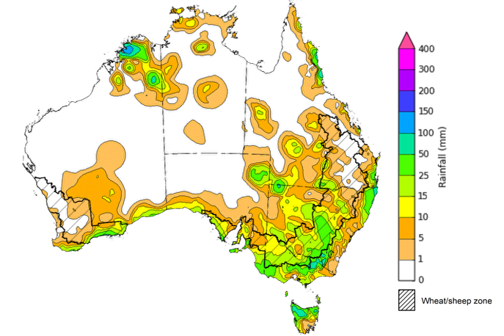
©Commonwealth of Australia 2026, Australian Bureau of Meteorology Issued: 29/4/2026
Note: The rainfall analyses and associated maps utilise data contained in the Bureau of Meteorology climate database, the Australian Data Archive for Meteorology (ADAM). The analyses are initially produced automatically from real-time data with limited quality control. They are intended to provide a general overview of rainfall across Australia as quickly as possible after the observations are received. For further information go to http://www.bom.gov.au/climate/rainfall/

Rainfall forecast for the next eight days
Over the 8 days to 14 May 2026, low-pressure systems and cold fronts are expected to bring rainfall to parts of the north and east of the country. However, much of the remainder of Australia is forecast to remain largely dry.
- In the south, falls of between 10-50 millimetres are forecast for southern Victoria, eastern New South Wales, and much of Tasmania.
- Similarity, inland regions of western Queensland, the east of the Northern Territory and northern South Australia are forecast to see 10-25 millimetres of rainfall, with up to 50 millimetres in isolated central regions.
- Remaining regions are likely to see little to no rainfall.
Rainfall totals across many cropping regions over the coming week are forecast to be low.
- Low rainfall totals (0-10 millimetres) are forecast for all cropping regions.
  - If realised, these low expected falls are likely to allow unimpeded access for the planting of winter crops following widespread rainfall across south-eastern areas last week.
  - Meanwhile, ongoing expected dry conditions across Queensland and northern New South Wales continues to present a significant downside production risk for the 2026–27 winter cropping season.

Total forecast rainfall for the period 7 May to 14 May 2026
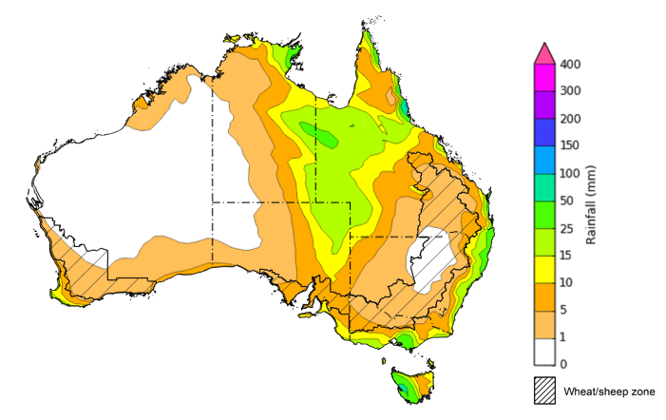
©Commonwealth of Australia 2026, Australian Bureau of Meteorology Issued 7/5/2026
Note: This rainfall forecast is produced from computer models. As the model outputs are not altered by weather forecasters, it is important to check local forecasts and warnings issued by the Bureau of Meteorology.

Monthly rainfall
Rainfall during April 2026 was generally below average in eastern and central regions, and above average across parts of the in the north and southwest.
- A series of high-pressure systems have kept eastern regions largely dry, as well as much of central Australia and the northwest.
- In the north, low-pressure systems have supported rainfall outcomes in north-western Queensland and the north of the Northern Territory – supporting pasture production and soil moisture for producers.
  - This represents a decline from the intense rainfall conditions seen in March and is likely to alleviate flood related disruptions and hardship.
In cropping regions, April rainfall was generally average in the west to severely deficient in eastern areas.
- April rainfall was below average to severely deficient in much of the east and southeast, including Queensland, New South Wales and Victoria. Western Australia and South Australia saw broadly average rainfall outcomes, with scattered areas of below and above average rainfall.
  - These well below average rainfall outcomes across southern Queensland and New South Wales have reduced soil moisture storage level ahead of the opening of the winter cropping season and contributed to well below average pasture production.
Rainfall deciles for April 2026
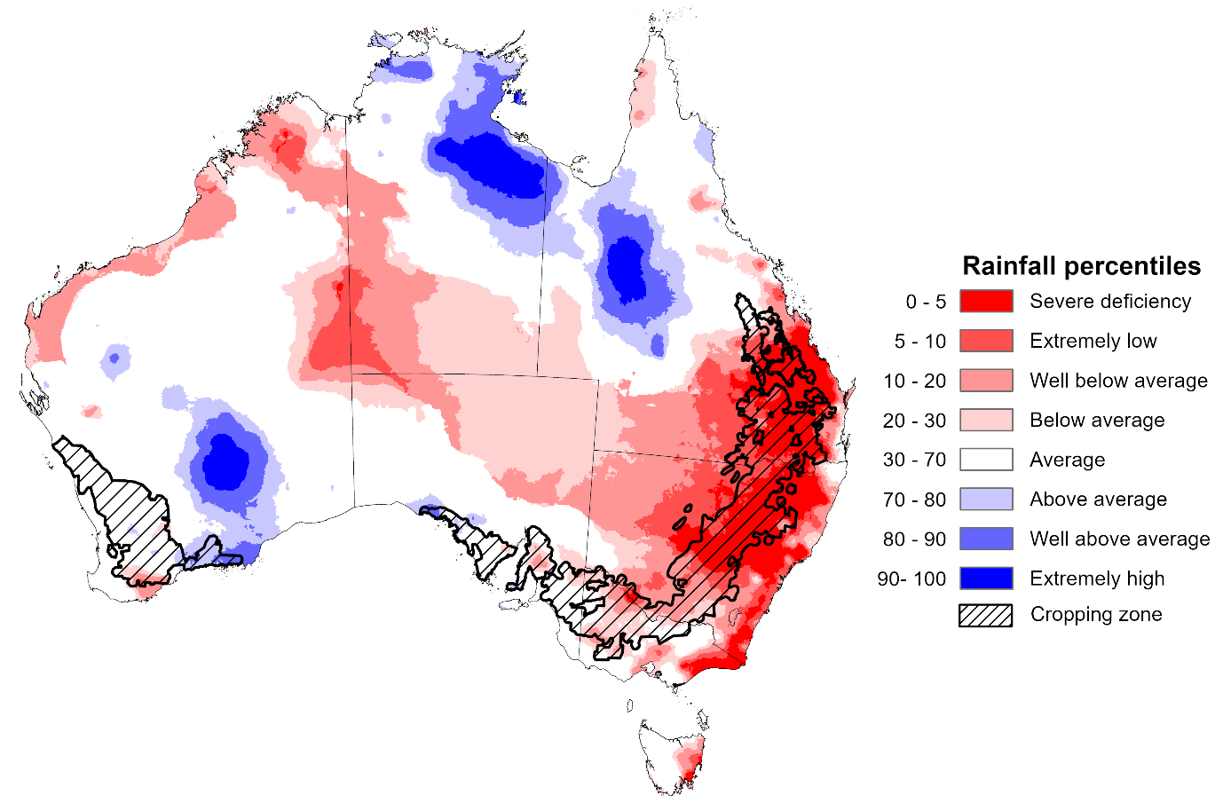
Note: Rainfall for April 2026 is compared with rainfall recorded for that period during the historical record (1900 to present). For further information, go to http://www.bom.gov.au/climate/austmaps/about-rain-maps.shtml
Source: Bureau of Meteorology

Monthly Soil Moisture
In April 2026, modelled upper layer soil moisture was generally average to above average across much of the country. In contrast large areas if eastern and central Australia have extremely low to below average soil moisture.
- Much of southern Queensland, New South Wales, eastern Victoria, and central Australia saw extremely low to below average upper layer soil moisture.
- In contrast, much of northern Queensland, the north of the Northern Territory, southern South Australia, and central and southern Western Australia saw average to very much above upper layer soil moisture.
At this time of year, upper layer soil moisture is important for preparation for winter cropping in southern states. It is also important for pasture growth across northern Australia since plant growth utilises this moisture. Further, it is an indicator of the ability to access paddocks for winter crop planting activities.
- Across cropping regions, modelled upper layer soil moisture in April for eastern cropping regions was generally extremely low to below average, while most southern and western cropping regions were modelled as having broadly average soil moisture with isolated areas of above or below average moisture.
Modelled upper layer soil moisture for April 2026
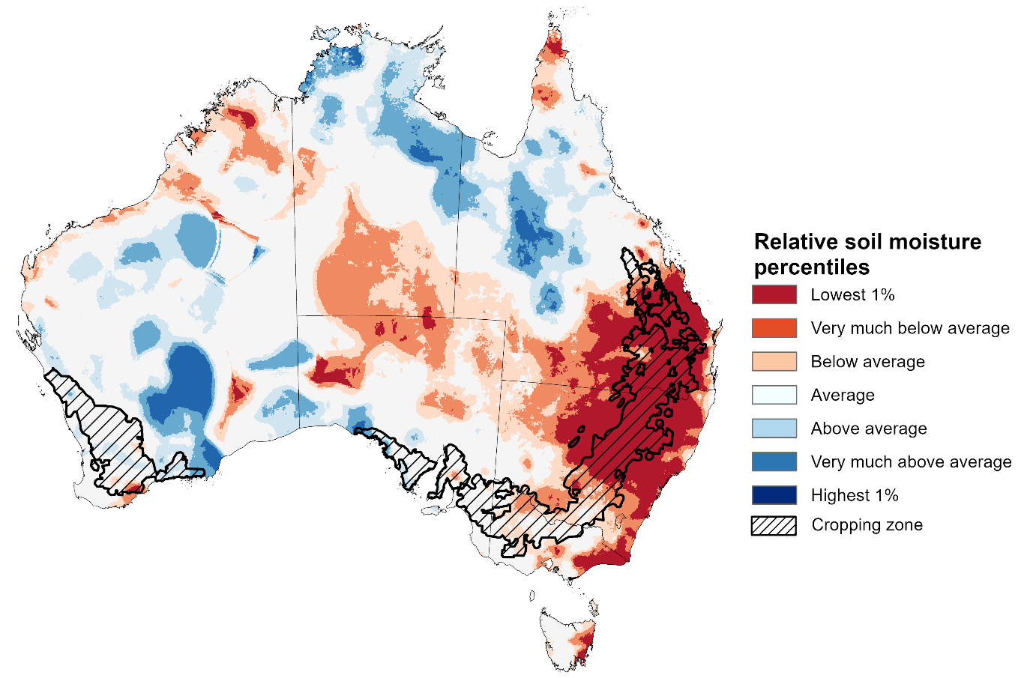
Note: This map shows the levels of modelled upper layer soil moisture (0 to 10 centimetres) during April 2026 This map shows how modelled soil conditions during April 2026 compare with April conditions modelled over the reference period (1911 to 2016). Dark blue areas on the maps were much wetter in April 2026 than during the reference period. The bulk of plant roots occur in the top 20 centimetres of the soil profile. Soil moisture in the upper layer of the soil profile is therefore useful indicator of the availability of water, particularly for germinating seed.
Source: Bureau of Meteorology (https://awo.bom.gov.au/about/overview)
Modelled lower layer soil moisture in April 2026 was average to very much above average across much of Australia, while extremely low to below average modelled lower layer soil moisture was evident across some eastern and western areas.
- Parts of south-eastern Queensland, north-eastern New South Wales, Tasmania, and central Western Australia were modelled as having extremely low to below average lower layer soil moisture. By contrast, much of the northern tropics, South Australia, western Queensland and New South Wales were modelled as having above average to very much above average soil moisture over the period.
At this time of year increased levels of lower layer soil moisture will be important to support establishment on winter crops and pasture growth during a peak growth period.
Most cropping regions in southern Queensland and northern New South Wales were modelled as having extremely low soil moisture, with some areas of northern Queensland seeing average to above average soil moisture. In contrast, southern New South Wales, Victoria, and South Australia recorded average to very much above average soil moisture for this time of year. Western Australian cropping regions were modelled as having broadly average soil moisture storage.
In areas with average to above average lower layer soil moisture, this is likely to provide a reserve of plant-available water for early winter crops. Agricultural regions across southern Australia have seen a significant improvement in soil moisture levels since the end of January 2026. However, April modelling does show a decline from March, particularly in central New South Wales – this drawdown in lower layer soil moisture levels mean the winter crop and pasture production outcomes will be highly reliant on timely and sufficient rainfall across the remainder of the growing season.
Modelled lower layer soil moisture for April 2026
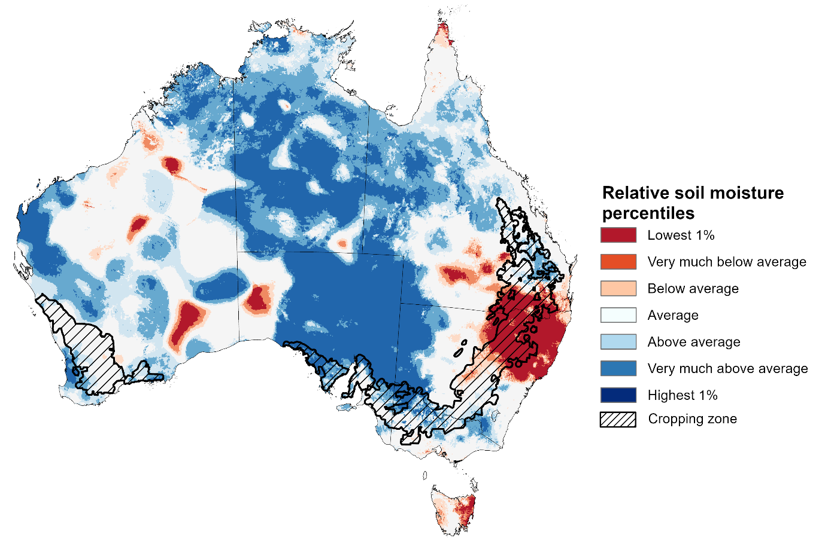
Note:. This map shows how modelled soil conditions during April 2026 compare with April conditions modelled over the reference period (1911 to 2016). Dark blue areas on the maps were much wetter in April 2026 than during the reference period. The dark red areas were much drier than during the reference period. The bulk of plant roots occur in the top 20 centimetres of the soil profile. The lower layer soil moisture is a larger, deeper store that is slower to respond to rainfall and tends to reflect accumulated rainfall events over longer time periods.
Source: Bureau of Meteorology (https://awo.bom.gov.au/about/overview)

Pasture Growth
February to April forms the final 3-months of the pasture growing season across much of northern Australia, providing a late season boost in growth and the bulk of feed to maintain production through the low pasture growth months of the northern dry season. Across southern Australia, February to April pasture growth is typically low, but beginning to rise in April following an exit from the southern dry season. Pasture availability during this period influences the growth and branding and marking rates of lambs and calves, livestock turnoff and the production of meat, milk, and wool.
Pasture growth for the three months to April 2026 was variable across much of country.
- Average to extremely high relative pasture growth was modelled across large areas of northern and central Australia, as well as western regions of Queensland and New South Wales, northern Victoria, and northern South Australia.
  - This pasture growth is expected to have allowed some farmers to maintain livestock numbers, provide opportunities to build standing dry matter availability.
- In contrast, large areas of the eastern and western Australia, as well as the far north, saw relatively low pasture growth for this time of year.
  - This below average pasture growth has likely led to a decline in pasture availability and graziers in regions where below average pasture growth was recorded will be more reliant on supplemental feed to maintain current stocking rates and production, with others choosing to destock to take advantage of relatively high saleyard prices.
Relative pasture growth for 3-months ending April 2026 (1 February to 30 April 2026)
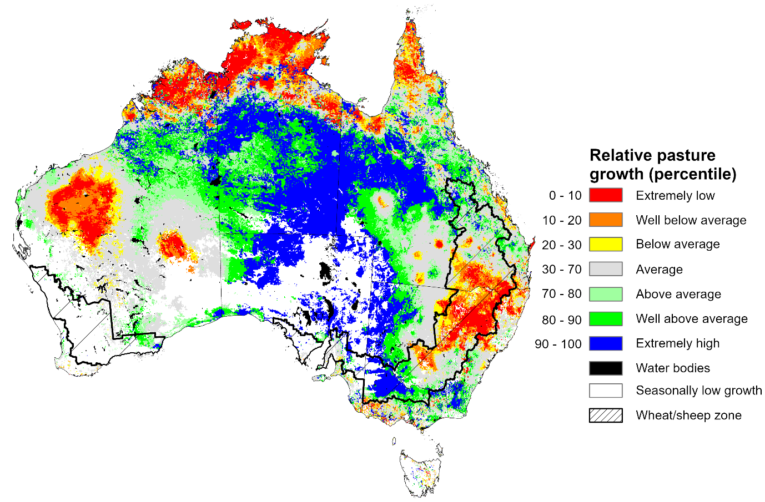

Notes: AussieGRASS pasture growth estimates are relative to the long-term record and shown in percentiles. Percentiles rank data on a scale of zero to 100. This analysis ranks pasture growth for the selected period against average pasture growth for the long-term record (1957 to 2016). Pasture growth is modelled at 5km2 grid cells.
Source: Department of Environment, Science and Innovation

Water markets – current week
Water storage levels in the Murray-Darling Basin (MDB) decreased by 57 gigalitres (GL) between 30 April 2026 and 07 May 2026. The current volume of water held in storages is 9,984 GL, equivalent to 45% of total storage capacity. This is 15% or 1,822 GL less than the same time last year. Water storage data is sourced from the Bureau of Meteorology (BOM).

Water storages in the Murray-Darling Basin, 2013–2026
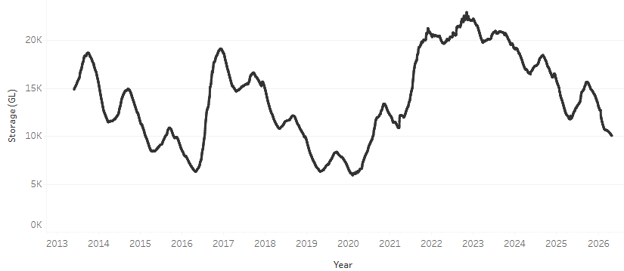
Allocation prices in the Victorian Murray below the Barmah Choke decreased from $438/ML on 30 April 2026 to $416/ML on 07 May 2026. Trade from the Goulburn to the Murray is closed. Trade downstream through the Barmah Choke is closed. Trade from the Murrumbidgee to the Murray is open.

Water market prices, Southern Murray–Darling Basin

Region | $/ML
NSW Murray Above | 337
NSW Murrumbidgee | 493
Vic Greater Goulburn | 352
Vic Murray Below | 416

Note: The water allocation prices shown are volume weighted average prices based on the last 10 trades. Price data is sourced from Waterflow and current as at 22 January 2026.
To access the full, interactive, weekly water dashboard, which contains the latest and historical water storage, water market and water allocation information, please visit https://www.agriculture.gov.au/abares/products/weekly_update/weekly-update-260430

Commodities
Indicator | Week average | Unit | Latest Price | Previous Week | Weekly change |  | Price 12 months ago | Annual change
Selected world indicator prices
AUD/USD Exchange rate | 6-May | A$/US$ | 0.72 | 0.72 | 1% | 0.64 |  | 12%
Wheat – US no. 2 hard red winter wheat, FOB Gulf | 6-May | US$/t | 299 | 301 | 0% | 237 |  | 26%
Corn – US no. 2 yellow corn, FOB Gulf | 6-May | US$/t | 220 | 221 | 0% | 204 |  | 8%
Canola – Rapeseed, Canada, FOB Vancouver | 6-May | US$/t | 583 | 580 | 1% | 550 |  | 6%
Cotton – Cotlook A Index | 6-May | USc/lb | 93.7 | 89.9 | 4% | 78.0 |  | 20%
Sugar – Intercontinental Exchange, nearby futures, no.11 contract | 6-May | USc/lb | 15.3 | 14.5 | 6% | 17.6 |  | -13%
Wool – Eastern Market Indicator | 6-May | Ac/kg clean | 1,886 | 1,897 | -1% | 1,197 |  | 58%
Wool – Western Market Indicator | 6-May | Ac/kg clean | 2,111 | 2,114 | 0% | 1,359 |  | 55%
Selected Australian grain export prices
Australian Premium White (APW) Wheat, FOB Port Adelaide, SA | 6-May | A$/t | 382 | 383 | 0% | 398 |  | -4%
Australian Standard White (ASW) Wheat, FOB Port Adelaide, SA | 6-May | A$/t | 380 | 381 | 0% | 393 |  | -3%
Feed Barley – FOB Port Adelaide, SA | 6-May | A$/t | 384 | 382 | 1% | 376 |  | 2%
Canola – FOB Kwinana, WA | 6-May | A$/t | 798 | 792 | 1% | 794 |  | 0%
Grain Sorghum – FOB Brisbane, QLD | 6-May | A$/t | 458 | 457 | 0% | 434 |  | 6%
Selected domestic livestock indicator prices
Beef – Eastern Young Cattle Indicator | 6-May | Ac/kg cwt | 795 | 773 | 3% | 693 |  | 15%
Mutton – Mutton indicator (18–24 kg fat score 2–3), VIC | 6-May | Ac/kg cwt | 770 | 772 | 0% | 558 |  | 38%
Lamb – National Trade Lamb Indicator | 6-May | Ac/kg cwt | 1,170 | 1,171 | 0% | 863 |  | 36%
Pig – Eastern Seaboard (60.1–75 kg), NSW buyer price | 15-Apr | Ac/kg cwt | 455 | 457 | 0% | 446 |  | 2%
Live cattle – Light steers to Indonesia | 29-Apr | Ac/kg lwt | 420 | 430 | -2% | 345 |  | 22%
Global Dairy Trade (GDT) weighted average prices
Dairy – Whole milk powder | 6-May | US$/t | 3,741 | 3,666 | 2% | 4,353 |  | -14%
Dairy – Skim milk powder | 6-May | US$/t | 3,547 | 3,448 | 3% | 2,823 |  | 26%
Dairy – Cheddar cheese | 6-May | US$/t | 4,611 | 4,798 | -4% | 5,263 |  | -12%
Dairy – Anhydrous milk fat | 6-May | US$/t | 6,461 | 6,537 | -1% | 7,243 |  | -11%

Selected world indicator prices
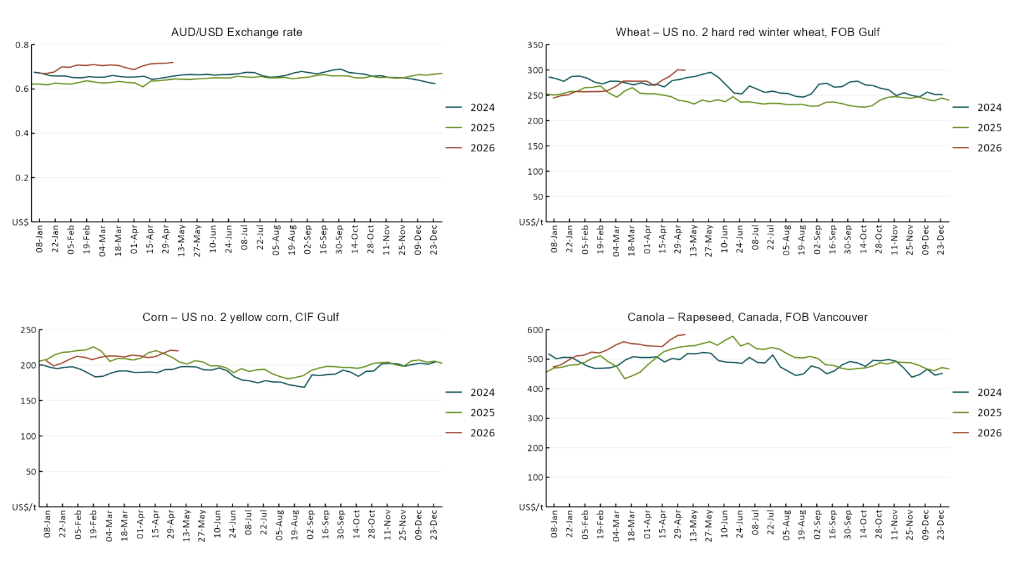

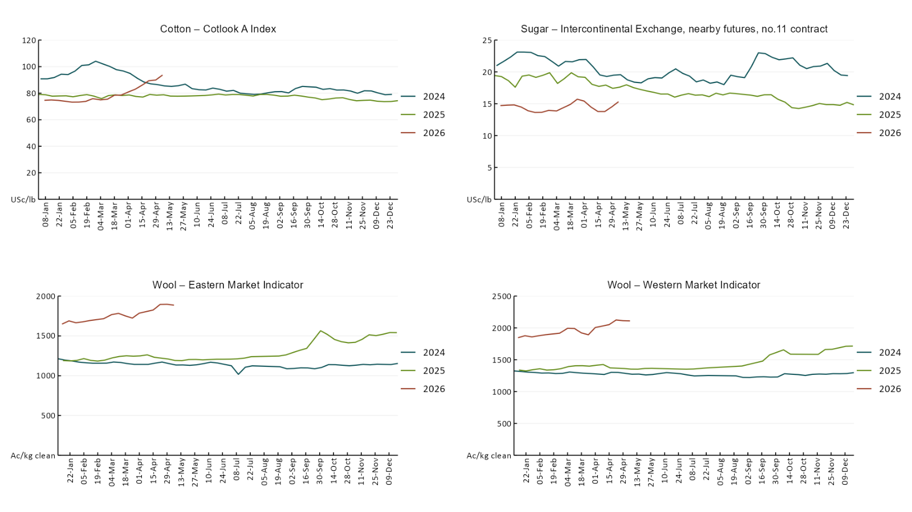

3.2 Selected domestic crop indicator prices
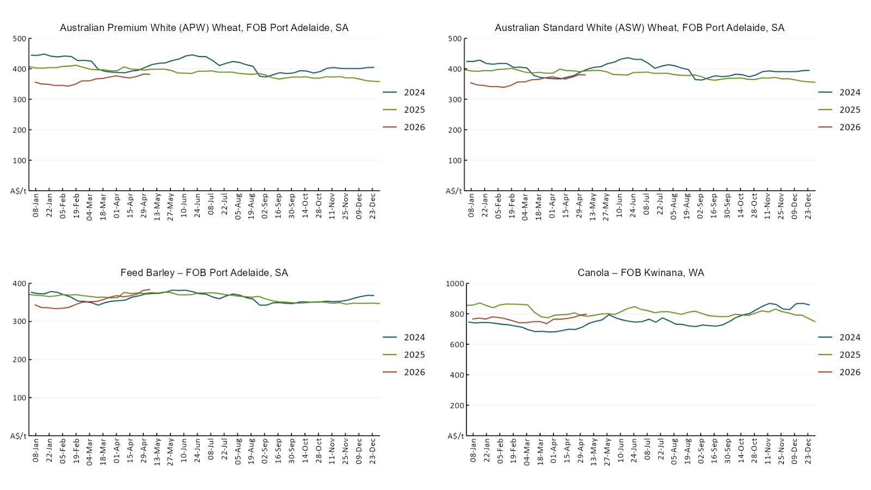

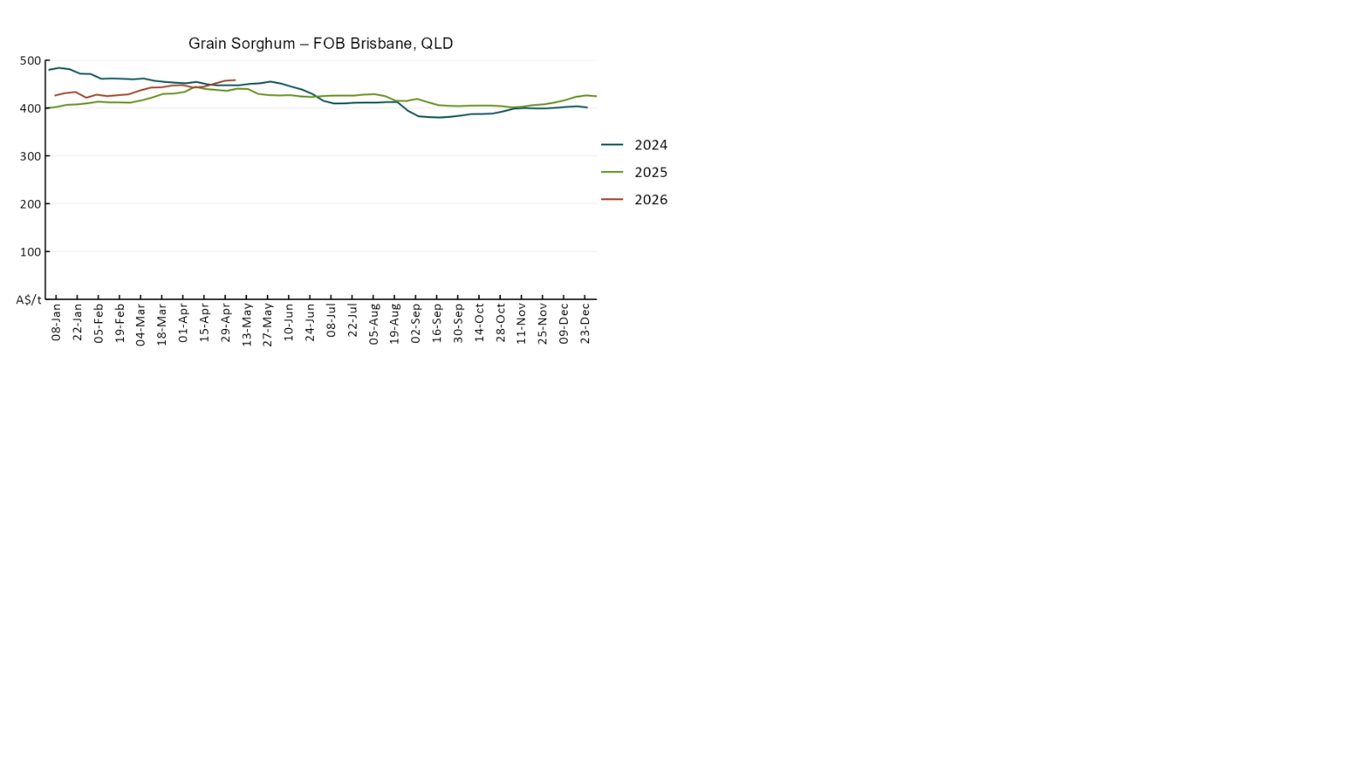

3.3 Selected domestic livestock indicator prices
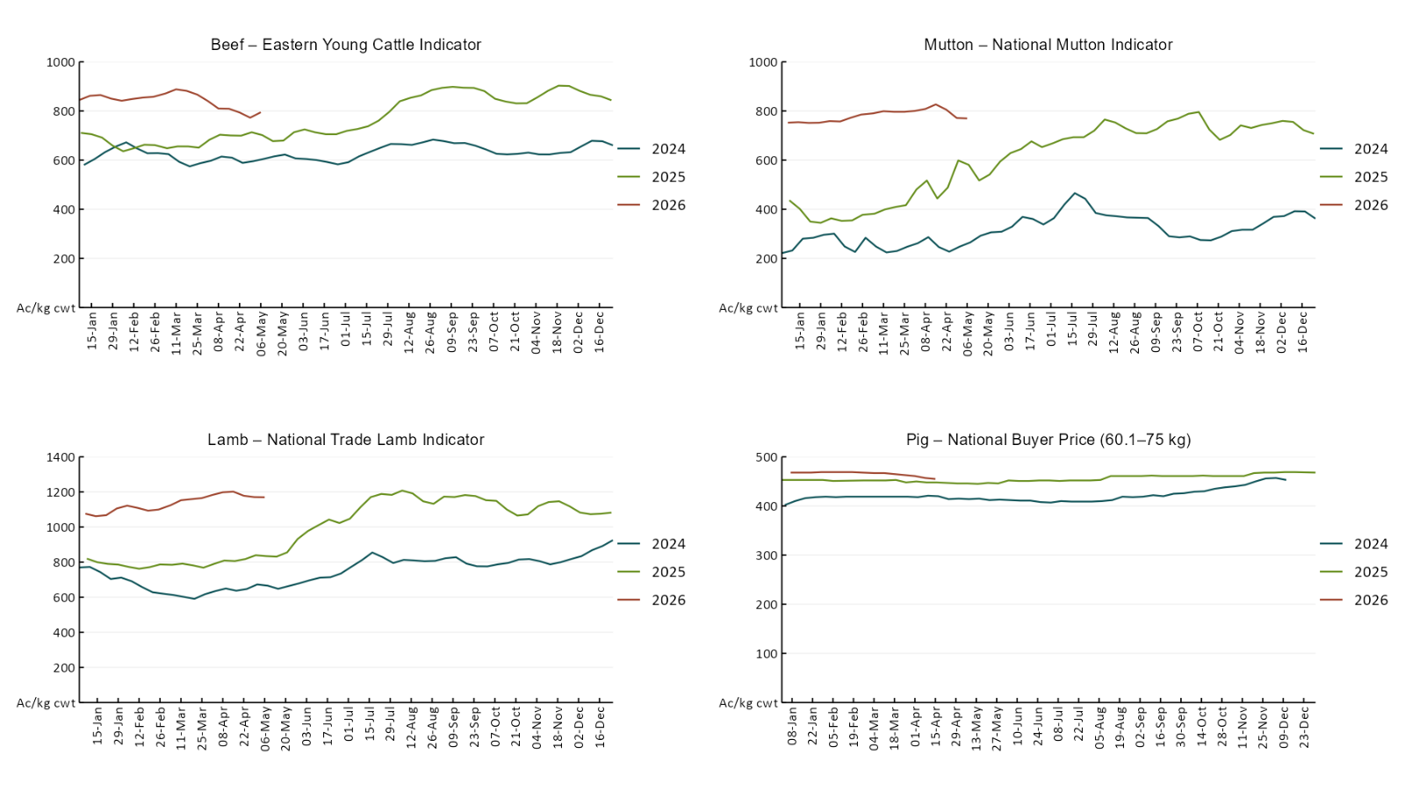

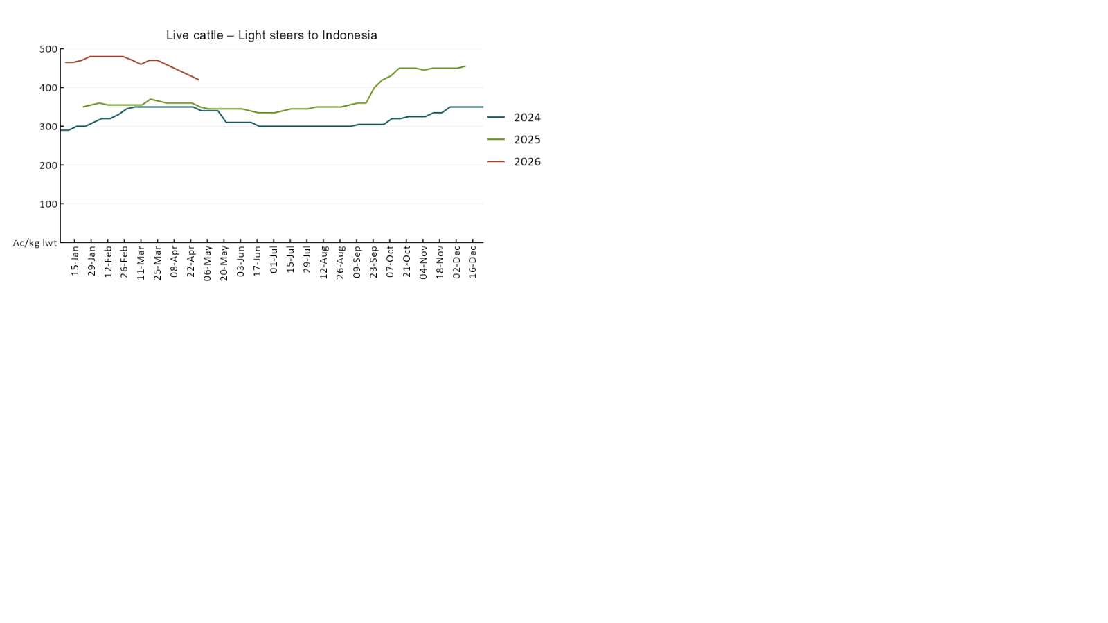

3.4 Global Dairy Trade (GDT) weighted average prices
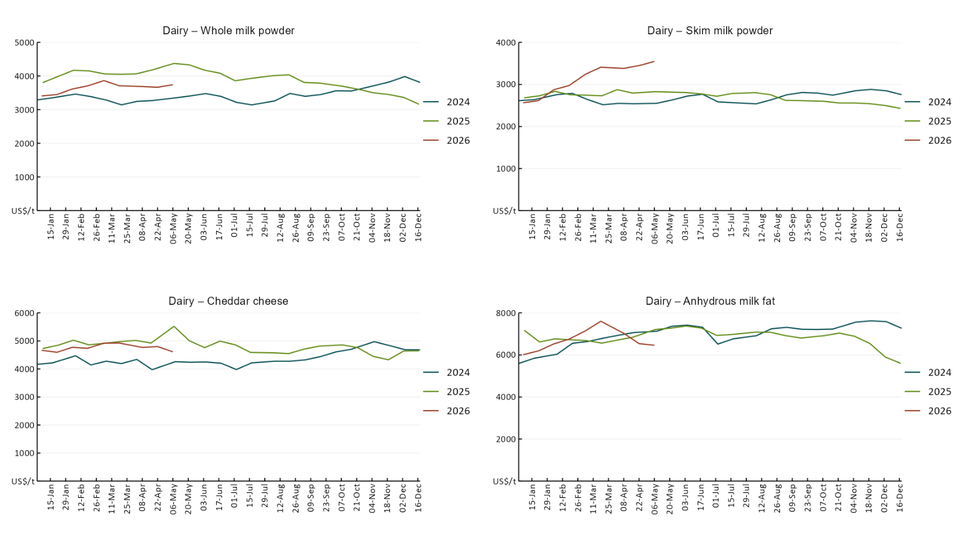

3.5 Selected fruit and vegetable prices
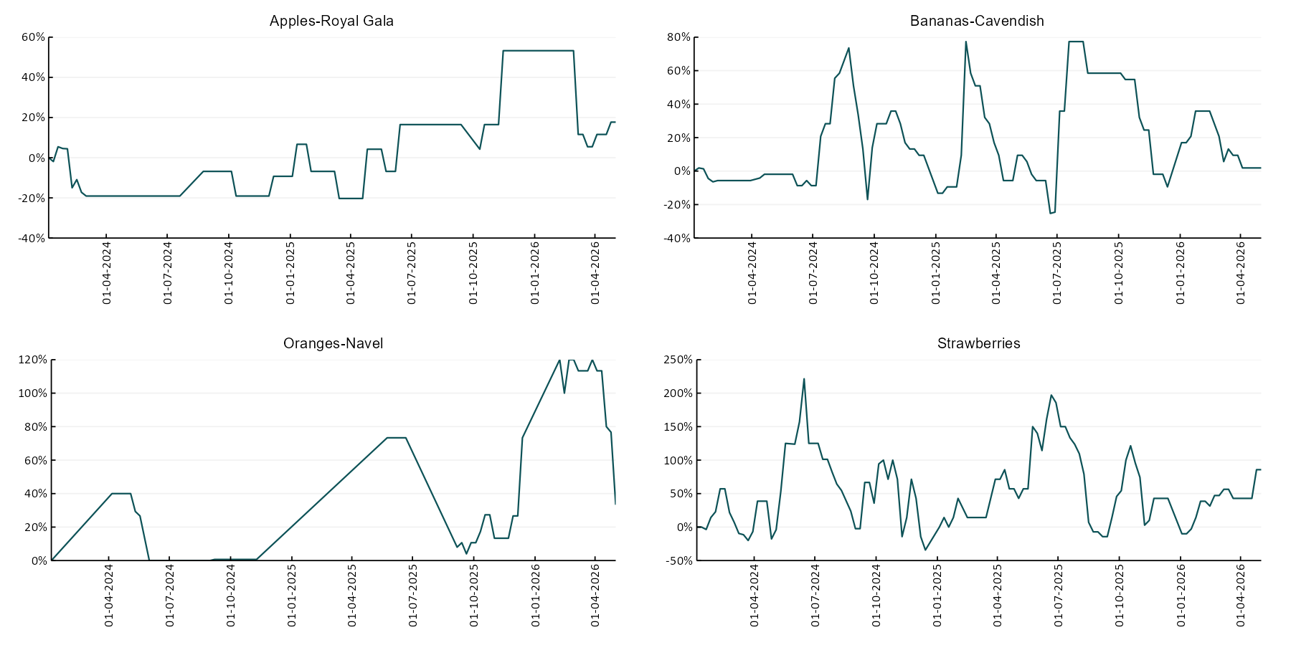

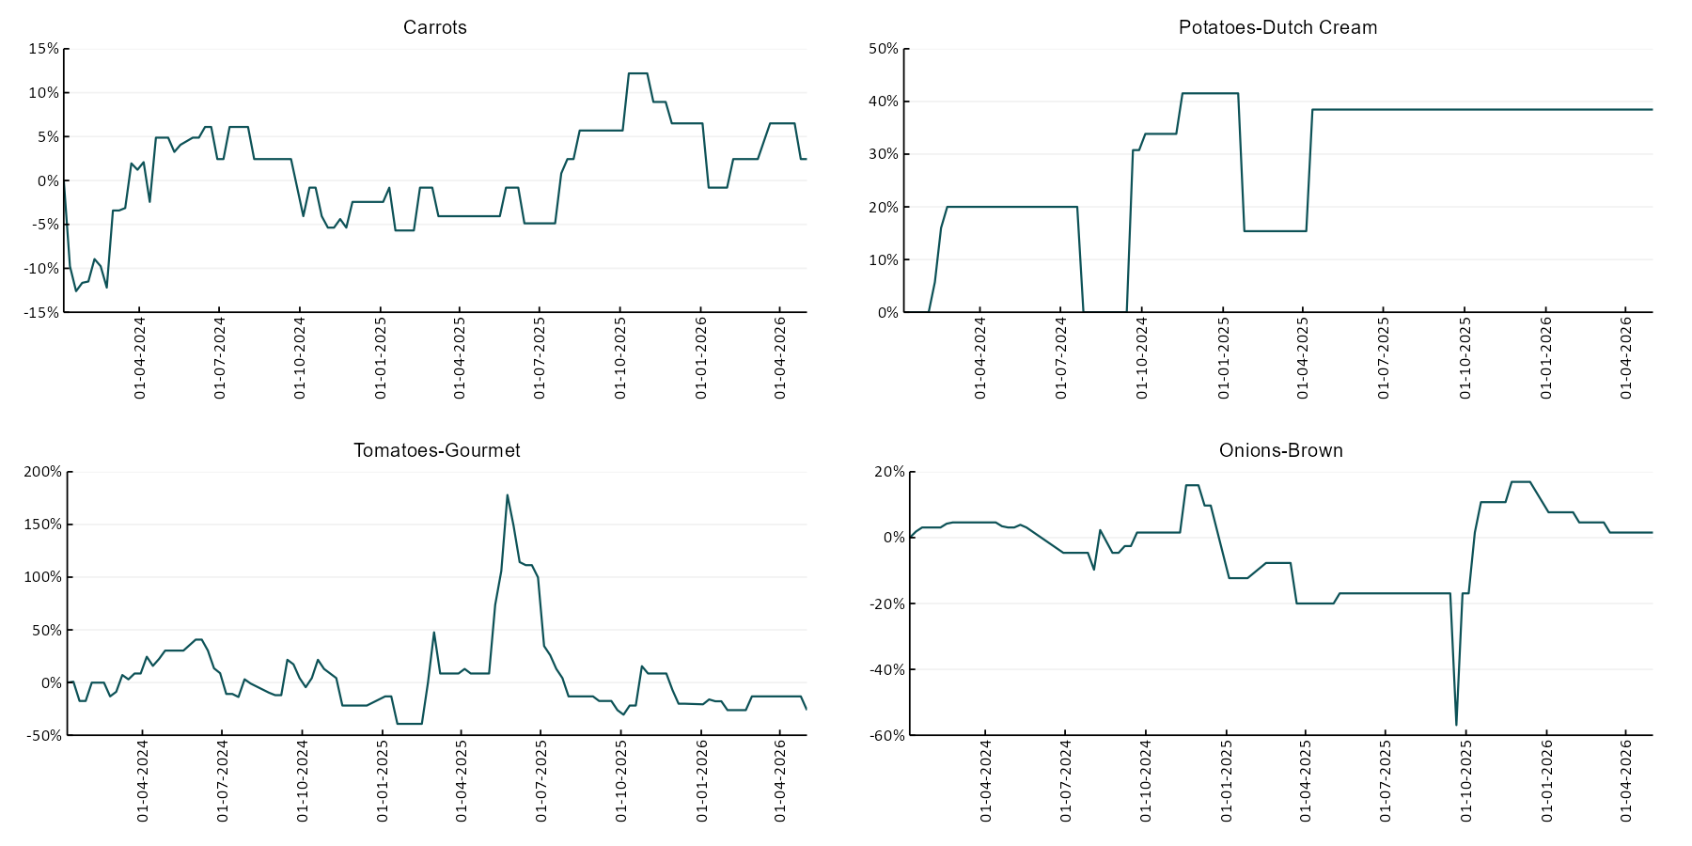

3.6 Selected domestic fodder indicator prices
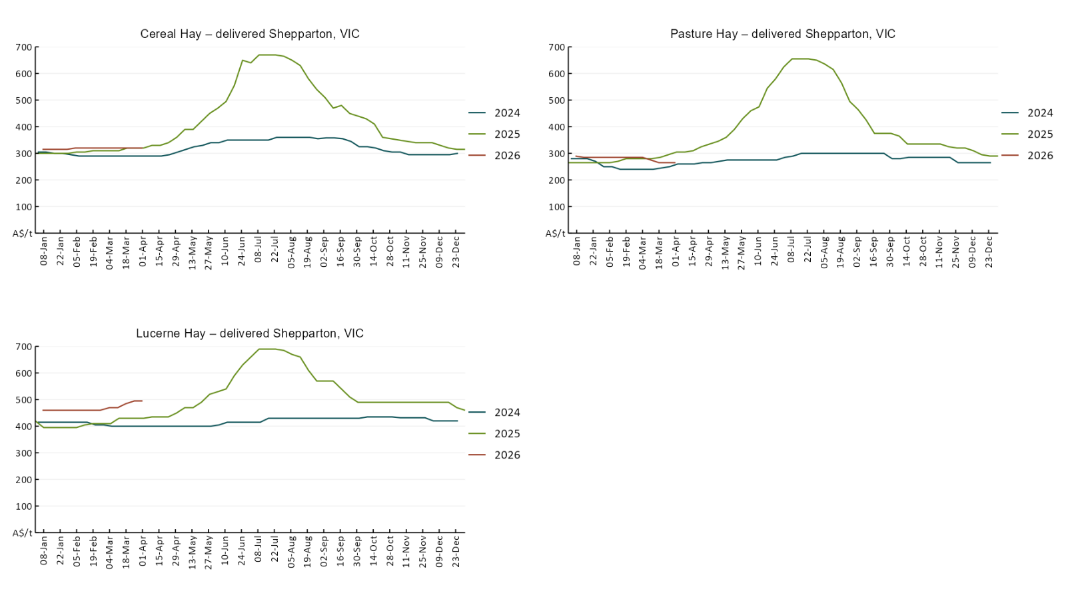

4. Data attribution

Climate
Bureau of Meteorology
- Weekly rainfall totals: www.bom.gov.au/climate/maps/rainfall/
- Monthly and last 3-month rainfall percentiles: https://www.bom.gov.au/climate/ahead/outlooks/#moreMaps
- Rainfall forecast: www.bom.gov.au/jsp/watl/rainfall/pme.jsp
- Seasonal outlook: www.bom.gov.au/climate/outlooks/#/overview/summary/
- Climate drivers: http://www.bom.gov.au/climate/enso/
- Soil moisture: https://awo.bom.gov.au/products/historical/soilMoisture-rootZone/

Other
- Pasture growth: www.longpaddock.qld.gov.au/aussiegrass/
- 3-month global outlooks: Environment and Climate Change Canada, NOAA Climate Prediction Center, EUROBRISA CPTEC/INPE, European Centre for Medium-Range Weather Forecasts, Hydrometcenter of Russia, National Climate Center Climate System Diagnosis and Prediction Room (NCC), International Research Institute for Climate and Society
- Global production: https://ipad.fas.usda.gov/ogamaps/cropmapsandcalendars.aspx
- Autumn break: Pook et al., 2009, https://rmets-onlinelibrary-wiley-com.virtual.anu.edu.au/doi/epdf/10.1002/joc.1833

Water
Prices
- Waterflow: https://www.waterflow.io/
- Ruralco: https://www.ruralcowater.com.au/
- Bureau of Meteorology:
- Allocation trade: http://www.bom.gov.au/water/dashboards/#/water-markets/mdb/at
- Storage volumes: http://www.bom.gov.au/water/dashboards/#/water-storages/summary/drainage

Trade constraints:
- Water NSW: https://www.waternsw.com.au/customer-service/ordering-trading-and-pricing/trading/murrumbidgee
- Victorian Water Register: https://www.waterregister.vic.gov.au/TradingRules2019/

Commodities
Fruit and vegetables
- Datafresh: www.freshstate.com.au

Pigs
- Australian Pork Limited: www.australianpork.com.au

Dairy
- Global Dairy Trade: www.globaldairytrade.info/en/product-results/

World wheat, canola
- International Grains Council
- https://www.igc.int/en/default.aspx
- United States Department of Agriculture

World cotton
- Cotlook: www.cotlook.com/

World sugar
- New York Stock Exchange - Intercontinental Exchange

Wool
- Australian Wool Exchange: www.awex.com.au/

Domestic wheat, barley, sorghum, canola and fodder
- Jumbuk Consulting Pty Ltd: Jumbuk AG | Agriculture Consulting

Cattle, beef, mutton, lamb, goat and live export
- Meat and Livestock Australia: https://www.mla.com.au/prices-markets/

Australian Agricultural Drought Indicators
About Australian Agricultural Drought Indicators
The Australian Agricultural Drought Indicators (AADI) links weather and agricultural data with a range of scientific and economic models to measure and forecast the effects of climate variability and drought on agricultural outcomes.
On AADI, projected broadacre farm profits are presented as percentile outcomes relative to simulated historical outcomes using the groupings:
Highest | 95-100th percentile
Very much above average | 85-95th percentile
Above average | 65-85th percentile
Average | 35-65th percentile
Below average | 15-35th percentile
Very much below average | 5-15th percentile
Lowest 5% | 0-5th percentile

There are two AADI farm profit indicators:
- The AADI farm profit climate and price indicator shows the effect of climate and prices on broadacre farm business profits of current farms compared to the last 33 years.
- The AADI farm profit climate only indicator isolates the effect of climate on profits by holding prices fixed.

© Commonwealth of Australia 2026

Ownership of intellectual property rights
Unless otherwise noted, copyright (and any other intellectual property rights, if any) in this publication is owned by the Commonwealth of Australia (referred to as the Commonwealth).

Creative Commons licence
All material in this publication is licensed under a Creative Commons Attribution 4.0 International Licence except content supplied by third parties, logos and the Commonwealth Coat of Arms.
Inquiries about the licence and any use of this document should be emailed to copyright@awe.gov.au.


Cataloguing data
This publication (and any material sourced from it) should be attributed as:
ABARES 2026, Weekly Australian Climate, Water and Agricultural Update, Australian Bureau of Agricultural and Resource Economics and Sciences, Canberra, 7 May 2026. CC BY 4.0 DOI: https://doi.org/10.25814/5f3e04e7d2503
ISSN 2652-7561
This publication is available at https://www.agriculture.gov.au/abares/products/weekly_update
Department of Agriculture, Fisheries and Forestry
GPO Box 858 Canberra ACT 2601
Telephone 1800 900 090
Web agriculture.gov.au/abares

Disclaimer
The Australian Government acting through the Department of Agriculture, Fisheries and Forestry, represented by the Australian Bureau of Agricultural and Resource Economics and Sciences, has exercised due care and skill in preparing and compiling the information and data in this publication. Notwithstanding, the Department of Agriculture, Fisheries and Forestry, ABARES, its employees and advisers disclaim all liability, including liability for negligence and for any loss, damage, injury, expense or cost incurred by any person as a result of accessing, using or relying on any of the information or data in this publication to the maximum extent permitted by law.

Statement of Professional Independence
The views and analysis presented in ABARES publications, including this one, reflect ABARES professionally independent findings, based on scientific and economic concepts, principles, information and data. These views, analysis and findings may not reflect or be consistent with the views or positions of the Australian Government, or of organisations or groups who have commissioned ABARES reports or analysis. More information on professional independence is provided on the ABARES website.

Acknowledgements
This report was prepared by Holly Beale and Matthew Miller.

