
No. 19/2026 21 May 2026

Summary of key issues
- In the week ending 20 May 2026, low pressure systems brought rainfall eastern and central areas, while western areas remained dry.
  - Cropping regions across much of South Australia, Victoria, New South Wales, and parts of southern Queensland saw falls of 10- 50 millimetres. These falls have provided a timely boost to soil moisture level across most south-eastern cropping regions.
  - Most cropping regions of Western Australia and northern Queensland saw little to no rainfall. A continuation of mainly dry conditions in these regions is expected to lead to further declines in soil moisture levels.
- Over the 8 days to 28 May 2026, cold fronts and low pressure systems are expected to bring rainfall to parts of south-eastern, south-western and north-western Australia:
  - Falls of 15-25 millimetres are forecast for Western Australia, while Victoria, New South Wales, and Queensland are forecast to see 5-15 millimetres.
  - If realised, these expected falls are likely to provide a small additional boost to soil moisture levels south-eastern cropping areas, and timely boost to soil moisture levels across much of Western Australia following a relative dry May to date.
- Global production conditions in April were generally favourable for wheat, maize, rice and soybeans. According to the most recent crop estimate numbers released by the USDA, global production has been revised upward and is higher than the numbers used to formulate ABARES 2025–26 forecasts of global grain supplies and world prices in the March 2026 Agricultural Commodities Report. As a result, global grain and oilseed production is likely to increase beyond the numbers in the March forecast.
- Water storage levels in the Murray-Darling Basin (MDB) increased by 76 gigalitres (GL) between 14 May 2026 and 21 May 2026. The current volume of water held in storages is 10,078 GL, equivalent to 45% of total storage capacity. This is 17% or 2,049 GL less than the same time last year. Water storage data is sourced from the Bureau of Meteorology (BOM).
- Allocation prices in the Victorian Murray below the Barmah Choke decreased from $390/ML on 14 May 2026 to $368/ML on 21 May 2026. Trade from the Goulburn to the Murray is closed. Trade downstream through the Barmah Choke is closed. Trade from the Murrumbidgee to the Murray is open.

Climate

Rainfall this week
In the week ending 20 May 2026, low-pressure systems brought rainfall to central and south-eastern areas. Western and north-eastern regions remained largely dry.
- In the southeast, falls of 5-100 millimetres were recorded across much of New South Wales, Tasmania and southern Queensland, while Victoria saw 5-50 millimetres. Isolated coastal areas of northern New South Wales and southern Queensland saw up to 200 millimetres.
- Similarly, central regions including eastern South Australia and the southern Northern Territory saw up to 50 millimetres of rainfall. Scattered areas of the northern tropics saw 5-25 millimetres of rainfall, with parts of northern Western Australia seeing higher falls of up to 50 millimetres.
- Much of northern Queensland, western South Australia, and remaining areas of Western Australia remained largely dry.
Across cropping regions, widespread rainfall was recorded across the southeast, but remained dry in the west and parts of the northeast:
- Cropping regions in much of South Australia, Victoria, New South Wales, and parts of southern Queensland saw falls of 10-50 millimetres, with isolates areas of central-west New Soth Wales seeing 50- 100 millimetres.
  - These falls have provided a timely boost to soil moisture level across most south-eastern cropping regions. Some rainfall across parts of southern Queensland and northern New South Wales has provide some reprieve to persistent dry conditions, but is unlikely to have been sufficient to reverse an expected significant decline in the area planted to winter crops during 2026–27 and well below average pasture availability.
- Most cropping regions of Western Australia and northern Queensland saw little to no rainfall.
  - A continuation of mainly dry conditions across these regions is expected to lead to further declines in soil moisture levels.

Rainfall for the week ending 20 May 2026
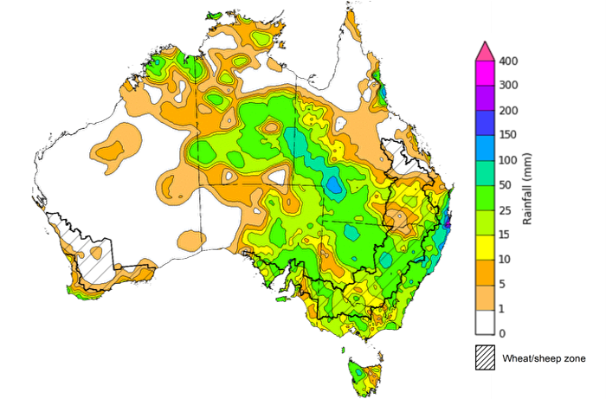
©Commonwealth of Australia 2026, Australian Bureau of Meteorology Issued: 20/5/2026
Note: The rainfall analyses and associated maps utilise data contained in the Bureau of Meteorology climate database, the Australian Data Archive for Meteorology (ADAM). The analyses are initially produced automatically from real-time data with limited quality control. They are intended to provide a general overview of rainfall across Australia as quickly as possible after the observations are received. For further information go to http://www.bom.gov.au/climate/rainfall/

Rainfall forecast for the next eight days
Over the 8 days to 28 May 2026, cold fronts and low pressure systems are expected to bring rainfall to parts of south-eastern, south-western and north-western Australia. Much of the remainder of Australia is forecast to remain largely dry.
- In the south and east, falls of between 5-50 millimetres are forecast for southwest Western Australia, Victoria, Tasmania and much of New South Wales, while southern South Australia and south-eastern Queensland is forecast to see 5-15 millimetres.
- Similarity, parts of northern Western Australia are expected to see between 5-50 millimetres.
- Remaining regions are likely to see little to no rainfall.
Rainfall totals across many cropping regions over the coming week are forecast to be moderate, with higher falls in the west:
- Falls of 5-25 millimetres are forecast for Western Australia, while Victoria, New South Wales, and Queensland are forecast to see 5-15 millimetres.
  - If realised, these expected falls are likely to provide a small additional boost to soil moisture levels south-eastern cropping areas, and timely boost to soil moisture levels across much of Western Australia following a relative dry May to date. These falls are also expected to support the germination and growth of early sown winter crops.
  - Across regions of northern New South Wales and south-eastern Queensland that have experiences ongoing rainfall deficiencies, these expected falls will provide an additional small boost to soil moisture levels but may not be sufficient to encourage the widespread planting of winter crops given we a fast approaching the end of the ideal planting window.
- Low rainfall totals (1-10 millimetres) are forecast for South Australia.

Total forecast rainfall for the period 21 May to 28 May 2026
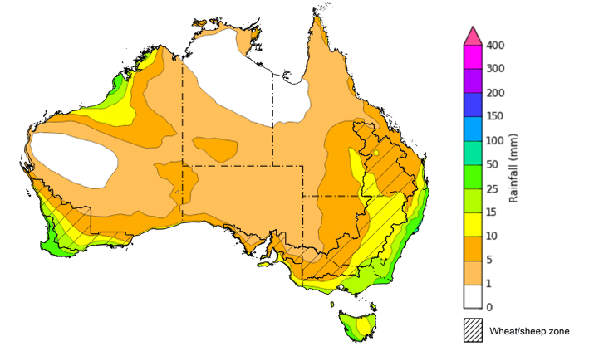
©Commonwealth of Australia 2026, Australian Bureau of Meteorology Issued 21/5/2026
Note: This rainfall forecast is produced from computer models. As the model outputs are not altered by weather forecasters, it is important to check local forecasts and warnings issued by the Bureau of Meteorology.

April precipitation percentiles and current production conditions
Crop production is affected by long-term trends in average rainfall and temperature, interannual climate variability, shocks during specific growth stages, and extreme weather events. Some crops are more tolerant than others to certain types of stresses, and at each growth stage, different types of stresses affect crop species in different ways.
Precipitation anomalies and outlooks presented below indicate the current and expected future production conditions for major grain and oilseed producing countries (responsible for over 80% of global crop production). This is an important input to assessing the global grain supply outlook.
Precipitation in April 2026 was variable across the world’s major grain and oilseed producing regions:
- In the northern hemisphere, precipitation was above average in much of central and southern China, the eastern Black Sea Region, northern India, and the northeast United States.
- Below average precipitation occurred across parts of the central United States and large areas of central and central Europe. Precipitation was generally average across the remaining major northern hemisphere grain and oilseed producing regions.
- In the southern hemisphere, precipitation was below average across much of southern Brazil, eastern Argentina, eastern Australia, and parts of Southeast Asia including Thailand, Malaysia, Indonesia and the Philippines. Precipitation was above average across western Argentina and southern Africia. Precipitation was generally average across the remaining major southern hemisphere grain and oilseed producing regions.

Global precipitation percentiles, April 2026

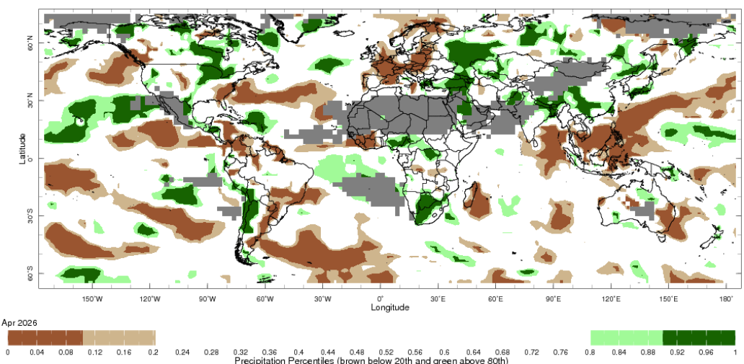

Note: The world precipitation percentiles indicate a ranking of precipitation for April, with the driest (0th percentile) being 0 on the scale and the wettest (100th percentile) being 1 on the scale. Percentiles are based on precipitation estimates from the NOAA Climate Prediction Center’s Climate Anomaly Monitoring System Outgoing Precipitation Index dataset. Precipitation estimates for April are compared with rainfall recorded for that period during the 1981 to 2010 base period.
Source: International Research Institute for Climate and Society
As of 28 April 2026, global production conditions were generally favourable for wheat, maize, rice and soybeans:
- Wheat – In the northern hemisphere, winter wheat has exited dormancy and is developing under broadly favourable conditions in China, India, the European Union, and parts of the United States. However, some regions across the European Union and the United States are undergoing dry conditions that could impact yield potential.
- Maize – In the southern hemisphere, conditions have been largely favourable for the harvest across much of Brazil and Argentina. In Indonesia, harvesting of early sown crops is progressing. In the United States and China, sowing is underway in some regions.
- Rice – Global conditions remain broadly favourable for major rice production regions, with the exception of Bangladesh where heavy rains have complicated harvests.
- Soybeans – The harvest in Brazil is concluding under favourable conditions, while the Argentina harvest is progressing despite recent flooding.

Crop conditions, AMIS countries, 28 April 2026
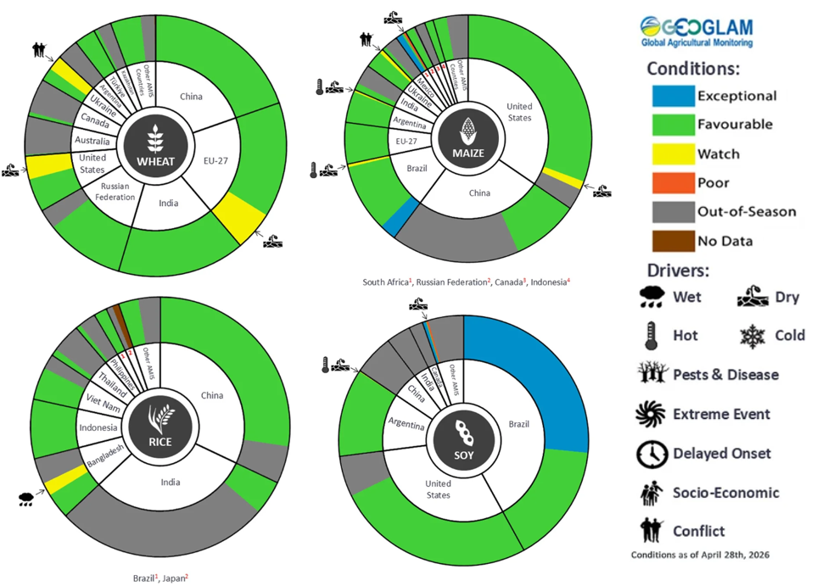
AMIS Agricultural Market Information System.
Source: AMIS

The global climate outlook for June 2026 to August 2026 indicates that mixed rainfall conditions are expected for the world’s major grain and oilseed producing regions. Outlooks and potential production impacts are presented in the following table.
Rainfall outlook and potential impact on the future state of production conditions, June 2026 - August 2026
Region | Rainfall outlook | Potential impact on production
Argentina | Above average rainfall is likely across parts of central Argentina, with broadly average to below average rainfall elsewhere. | Anticipated rainfall is likely to support the planting and vegetative development of wheat but could delay the harvesting of other major grains and oilseeds across parts of central Argentina.
Black Sea Region | Below average rainfall is expected across parts of northern and eastern Ukraine, as well as isolated western regions of the Russian Federation. | Below average rainfall is likely to adversely affect grain filling of wheat, as well as development of cotton, corn and sunflower from July.
Brazil | Rainfall outcomes across Brazil are expected to be broadly above average, with exceptions in the far east which is expected to see below average falls. | Above average rainfall across Brazil is likely to support the development of cotton and corn. Below average rainfall in the east is likely to hinder the development of wheat in July.
Canada | Rainfall across Canada is expected to be mixed, with broadly average conditions and areas of both below and above average precipitation in southern regions. | Average rainfall is likely to support wheat development as it leaves dormancy and facilitate the planting of major crops including corn and soybeans over the coming months.
China | Average rainfall is expected across most of China, with scattered areas of below average rainfall in inland and southern regions. | Average rainfall across much of China is likely to support the growth and development of major crops over the season, including spring wheat, rice, cotton, corn and soybeans.
European Union | Above average rainfall is more likely for much of the western European Union, with parts of central Europe to see below average falls. | Below average rainfall parts of central Europe is likely to pose a risk to the flowering and heading of wheat, and the growth and development of corn and soybeans in the north, and sorghum, corn and cotton in the south.
South Asia (India) | Below average rainfall is expected across parts of southern India, while above average rainfall is expected in northern areas. | Anticipated rainfall is likely to support the growth and development of many major grains and oilseeds, including corn, rice and sorghum, in the north but presents a downside production risk in the south.
Southeast Asia (SEA) | Below average rainfall is likely across much of Southeast Asia. | Below average rainfall in SEA is likely to impede growth and development outcomes for rice and corn.
The United States | Below average to average rainfall is likely for much of the eastern United States, with western areas likely to see above average falls. | Below average to average rainfall conditions expected across the eastern US is likely to reduce soil moisture and impact yield potential of major grains and oilseeds.

Water markets – current week
Water rage levels in the Murray-Darling Basin (MDB) increased by 76 gigalitres (GL) between 14 May 2026 and 21 May 2026. The current volume of water held in storages is 10,078 GL, equivalent to 45% of total storage capacity. This is 17% or 2,049 GL less than the same time last year. Water storage data is sourced from the Bureau of Meteorology (BOM).

Water storages in the Murray-Darling Basin, 2013–2026
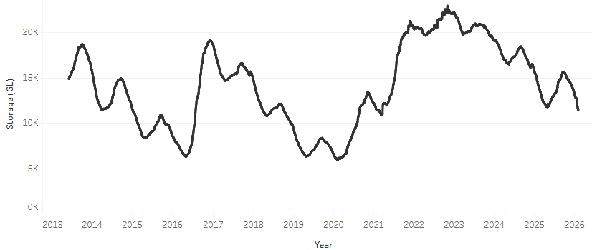
Allocation rices in the Victorian Murray below the Barmah Choke decreased from $390/ML on 14 May 2026 to $368/ML on 21 May 2026. Trade from the Goulburn to the Murray is closed. Trade downstream through the Barmah Choke is closed. Trade from the Murrumbidgee to the Murray is open.

Water market prices, Southern Murray–Darling Basin

Region | $/ML
NSW Murray Above | 299
NSW Murrumbidgee | 386
Vic Greater Goulburn | 336
Vic Murray Below | 368

Note: The water allocation prices shown are volume weighted average prices based on the last 10 trades. Price data is sourced from Waterflow and current as at 22 January 2026.
To access the full, interactive, weekly water dashboard, which contains the latest and historical water storage, water market and water allocation information, please visit https://www.agriculture.gov.au/abares/products/weekly_update/weekly-update-260521

Commodities
Indicator | Week average | Unit | Latest Price | Previous Week | Weekly change |  | Price 12 months ago | Annual change
Selected world indicator prices
AUD/USD Exchange rate | 20-May | A$/US$ | 0.71 | 0.72 | -1% | 0.64 |  | 10%
Wheat – US no. 2 hard red winter wheat, FOB Gulf | 20-May | US$/t | 310 | 310 | 0% | 237 |  | 31%
Corn – US no. 2 yellow corn, FOB Gulf | 20-May | US$/t | 217 | 217 | 0% | 204 |  | 6%
Canola – Rapeseed, Canada, FOB Vancouver | 13-May | US$/t | 569 | 577 | -1% | 550 |  | 3%
Cotton – Cotlook A Index | 20-May | USc/lb | 92.2 | 95.8 | -4% | 78.0 |  | 18%
Sugar – Intercontinental Exchange, nearby futures, no.11 contract | 20-May | USc/lb | 14.9 | 15.0 | -1% | 17.6 |  | -15%
Wool – Eastern Market Indicator | 20-May | Ac/kg clean | 1,880 | 1,876 | 0% | 1,197 |  | 57%
Wool – Western Market Indicator | 20-May | Ac/kg clean | 2,086 | 2,089 | 0% | 1,359 |  | 54%
Selected Australian grain export prices
Australian Premium White (APW) Wheat, FOB Port Adelaide, SA | 20-May | A$/t | 403 | 375 | 7% | 398 |  | 1%
Australian Standard White (ASW) Wheat, FOB Port Adelaide, SA | 20-May | A$/t | 395 | 367 | 7% | 393 |  | 0%
Feed Barley – FOB Port Adelaide, SA | 20-May | A$/t | 397 | 379 | 5% | 376 |  | 6%
Canola – FOB Kwinana, WA | 20-May | A$/t | 808 | 802 | 1% | 794 |  | 2%
Grain Sorghum – FOB Brisbane, QLD | 20-May | A$/t | 454 | 455 | 0% | 434 |  | 5%
Selected domestic livestock indicator prices
Beef – Eastern Young Cattle Indicator | 20-May | Ac/kg cwt | 845 | 822 | 3% | 693 |  | 22%
Mutton – Mutton indicator (18–24 kg fat score 2–3), VIC | 20-May | Ac/kg cwt | 800 | 781 | 2% | 558 |  | 43%
Lamb – National Trade Lamb Indicator | 20-May | Ac/kg cwt | 1,144 | 1,138 | 1% | 863 |  | 32%
Pig – Eastern Seaboard (60.1–75 kg), NSW buyer price | 6-May | Ac/kg cwt | 436 | 439 | -1% | 446 |  | -2%
Live cattle – Light steers to Indonesia | 29-Apr | Ac/kg lwt | 420 | 430 | -2% | 345 |  | 22%
Global Dairy Trade (GDT) weighted average prices
Dairy – Whole milk powder | 20-May | US$/t | 3,772 | 3,741 | 1% | 4,353 |  | -13%
Dairy – Skim milk powder | 20-May | US$/t | 3,552 | 3,547 | 0% | 2,823 |  | 26%
Dairy – Cheddar cheese | 20-May | US$/t | 4,560 | 4,611 | -1% | 5,263 |  | -13%
Dairy – Anhydrous milk fat | 20-May | US$/t | 6,344 | 6,461 | -2% | 7,243 |  | -12%

Selected world indicator prices
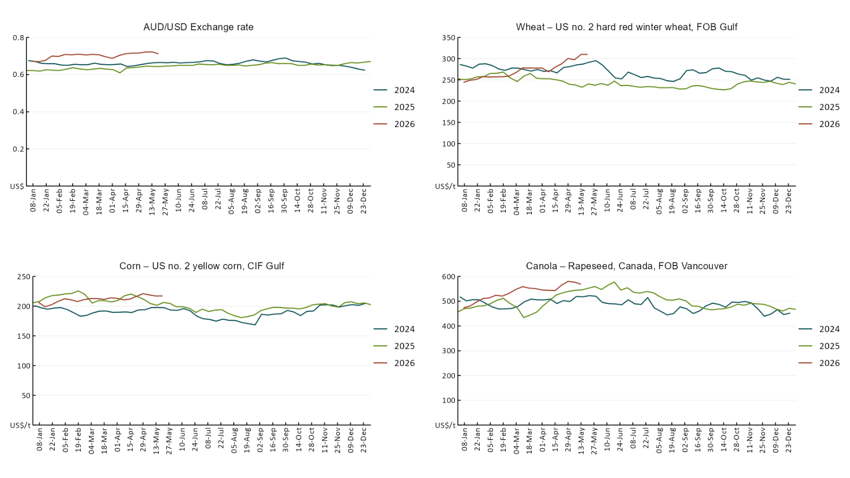

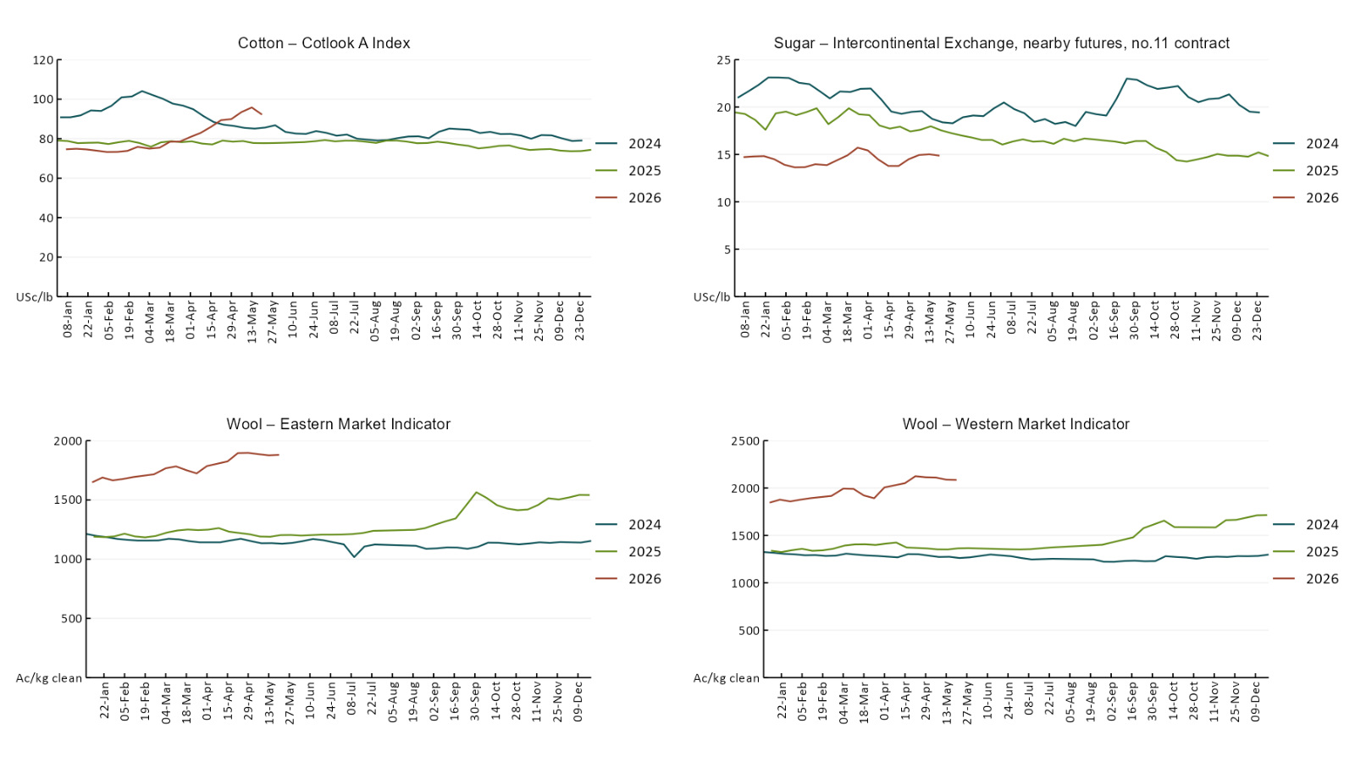

3.2 Selected domestic crop indicator prices
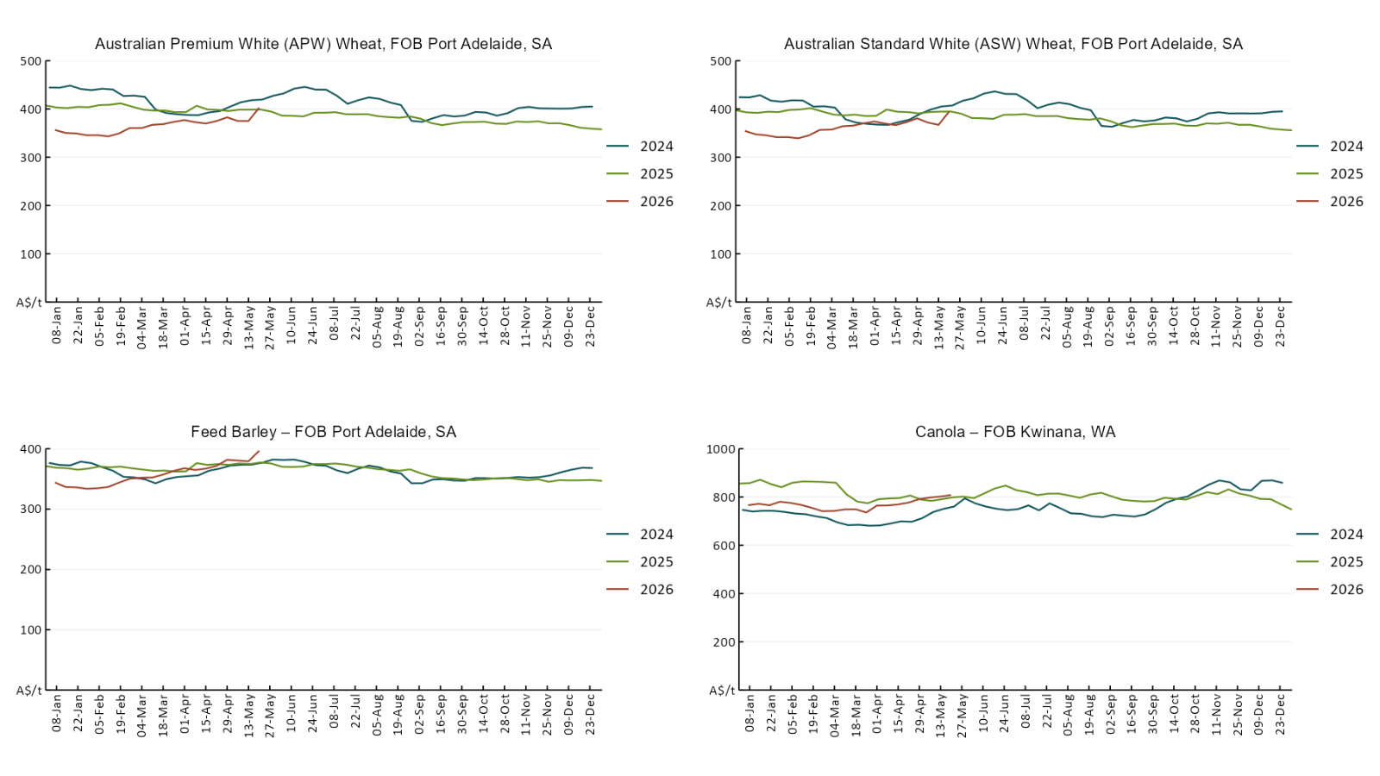

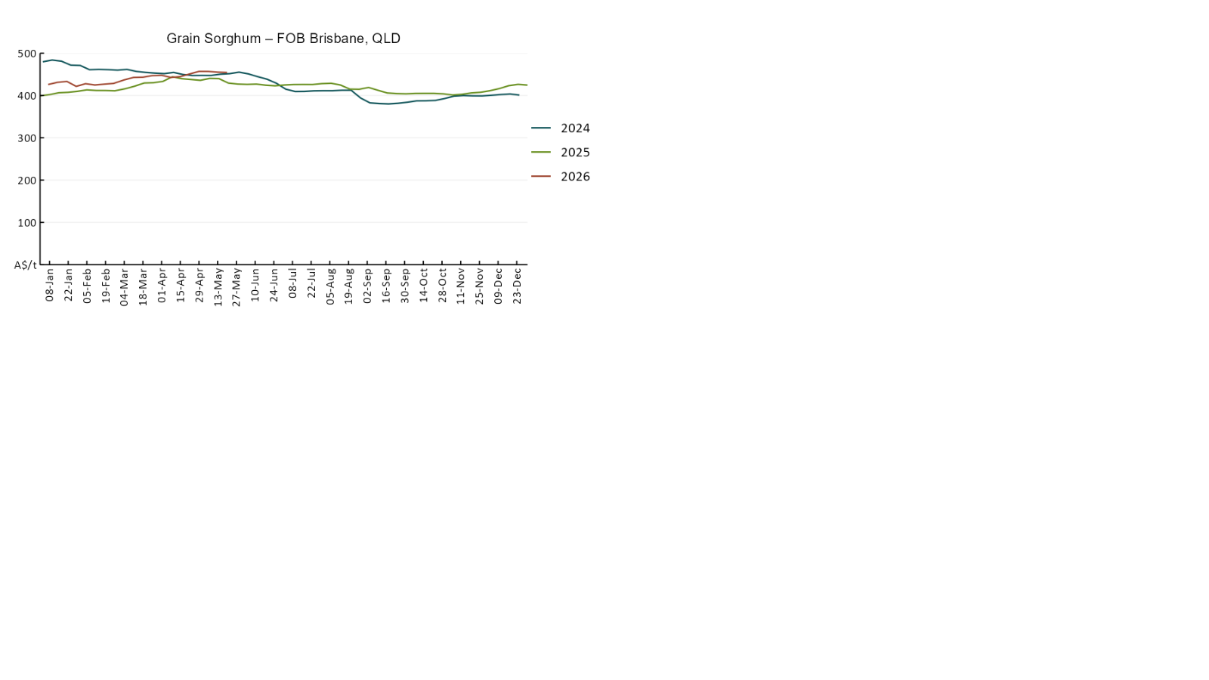

3.3 Selected domestic livestock indicator prices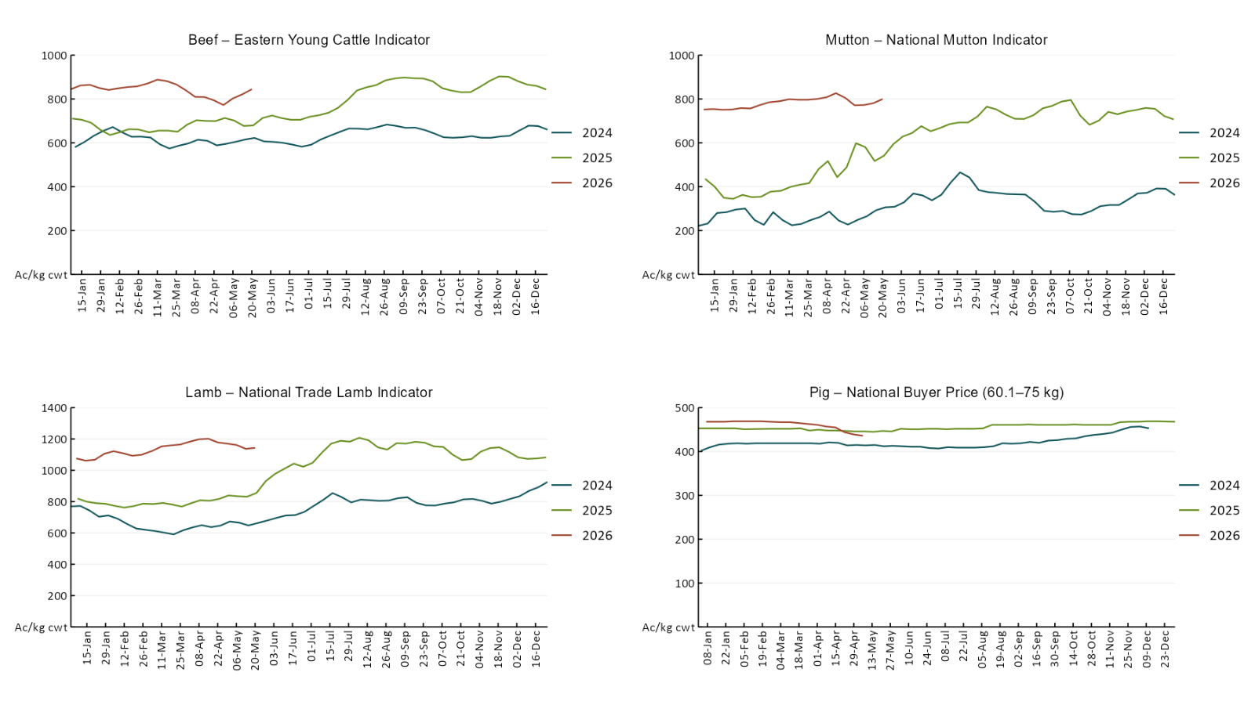

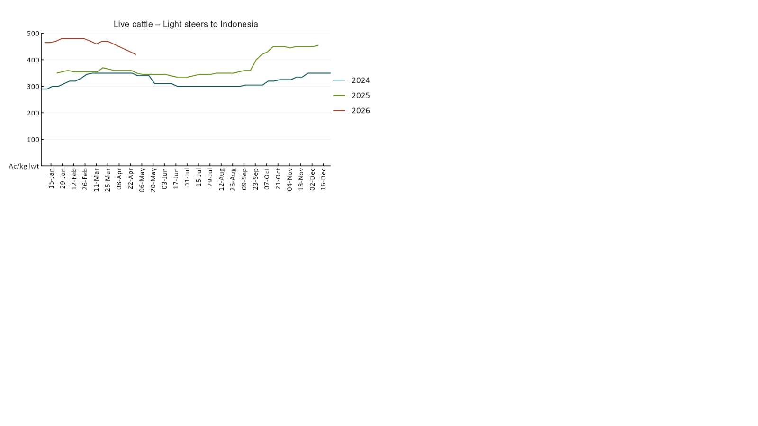

3.4 Global Dairy Trade (GDT) weighted average prices
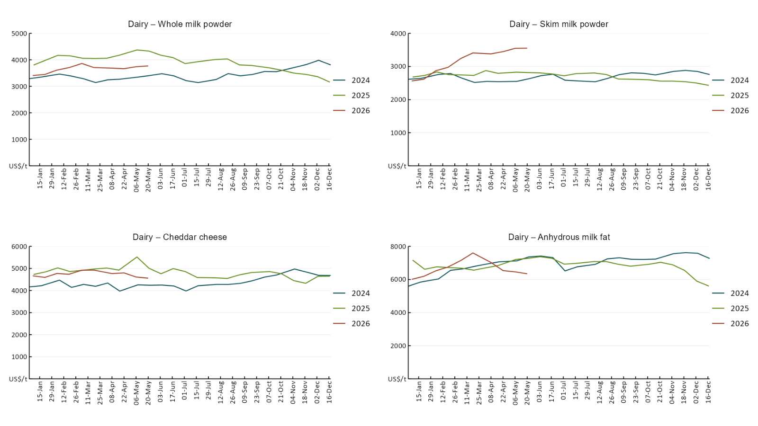

3.5 Selected fruit and vegetable prices
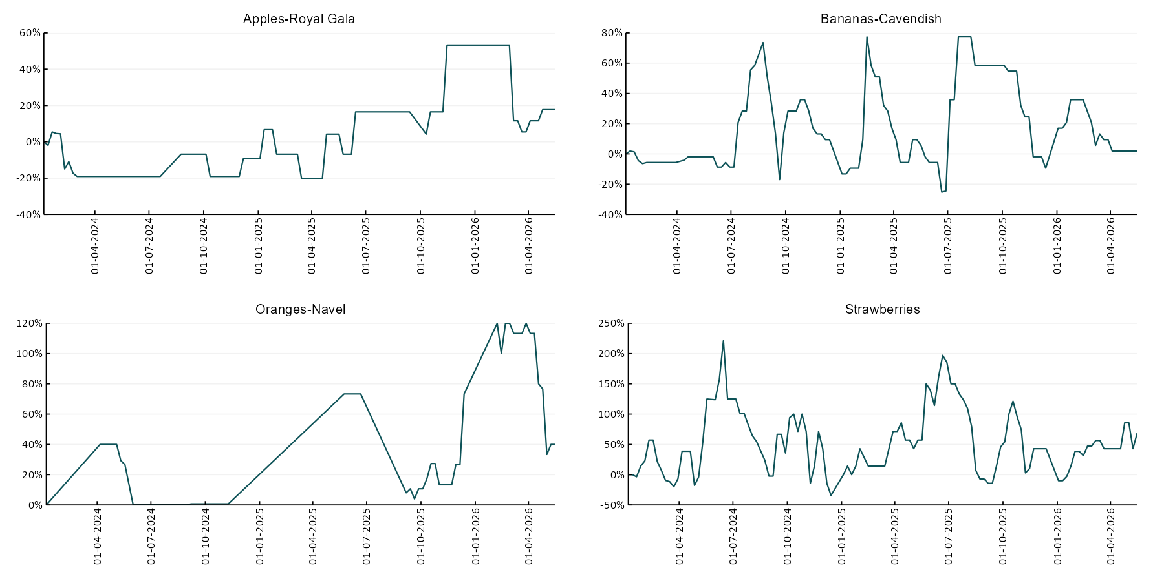

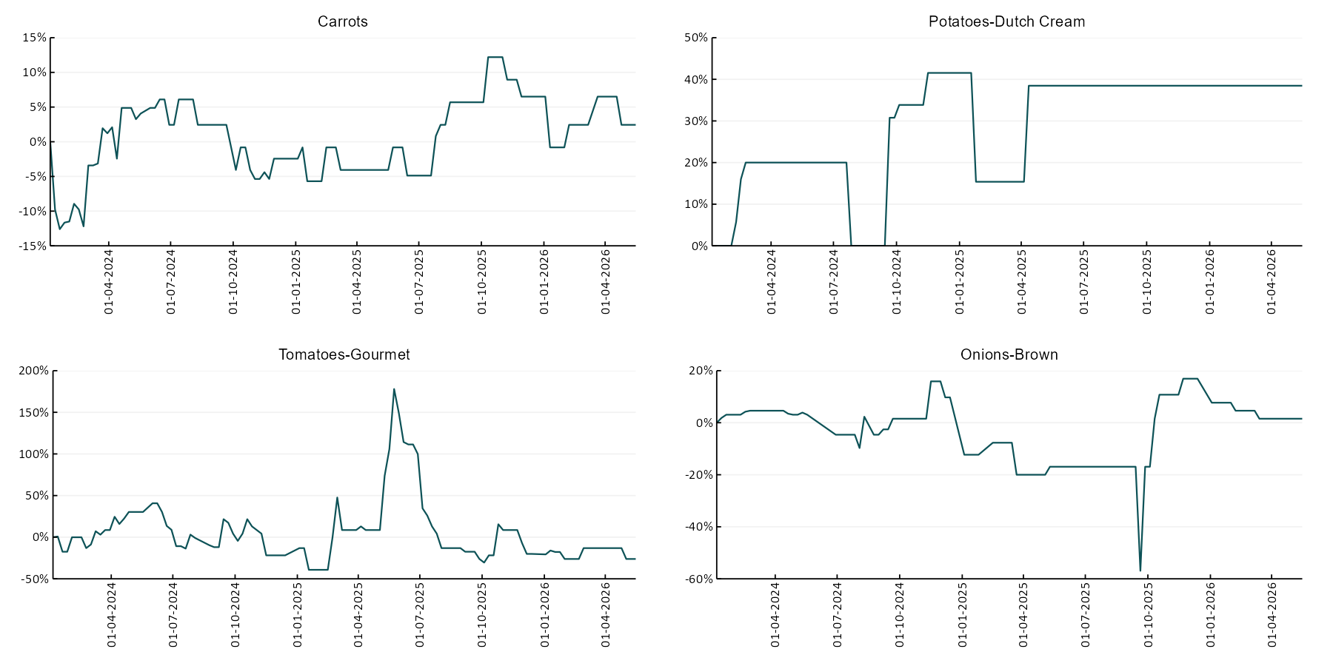

3.6 Selected domestic fodder indicator prices
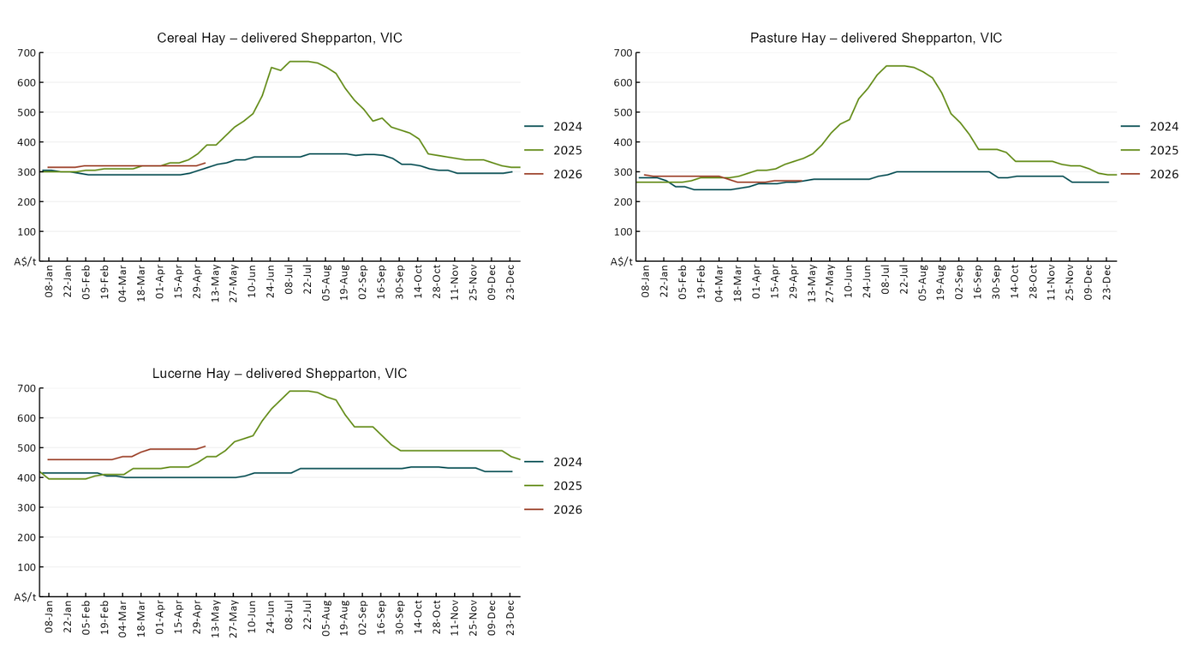

4. Data attribution

Climate
Bureau of Meteorology
- Weekly rainfall totals: www.bom.gov.au/climate/maps/rainfall/
- Monthly and last 3-month rainfall percentiles: https://www.bom.gov.au/climate/ahead/outlooks/#moreMaps
- Rainfall forecast: www.bom.gov.au/jsp/watl/rainfall/pme.jsp
- Seasonal outlook: www.bom.gov.au/climate/outlooks/#/overview/summary/
- Climate drivers: http://www.bom.gov.au/climate/enso/
- Soil moisture: https://awo.bom.gov.au/products/historical/soilMoisture-rootZone/

Other
- Pasture growth: www.longpaddock.qld.gov.au/aussiegrass/
- 3-month global outlooks: Environment and Climate Change Canada, NOAA Climate Prediction Center, EUROBRISA CPTEC/INPE, European Centre for Medium-Range Weather Forecasts, Hydrometcenter of Russia, National Climate Center Climate System Diagnosis and Prediction Room (NCC), International Research Institute for Climate and Society
- Global production: https://ipad.fas.usda.gov/ogamaps/cropmapsandcalendars.aspx
- Autumn break: Pook et al., 2009, https://rmets-onlinelibrary-wiley-com.virtual.anu.edu.au/doi/epdf/10.1002/joc.1833

Water
Prices
- Waterflow: https://www.waterflow.io/
- Ruralco: https://www.ruralcowater.com.au/
- Bureau of Meteorology:
- Allocation trade: http://www.bom.gov.au/water/dashboards/#/water-markets/mdb/at
- Storage volumes: http://www.bom.gov.au/water/dashboards/#/water-storages/summary/drainage

Trade constraints:
- Water NSW: https://www.waternsw.com.au/customer-service/ordering-trading-and-pricing/trading/murrumbidgee
- Victorian Water Register: https://www.waterregister.vic.gov.au/TradingRules2019/

Commodities
Fruit and vegetables
- Datafresh: www.freshstate.com.au

Pigs
- Australian Pork Limited: www.australianpork.com.au

Dairy
- Global Dairy Trade: www.globaldairytrade.info/en/product-results/

World wheat, canola
- International Grains Council
- https://www.igc.int/en/default.aspx
- United States Department of Agriculture

World cotton
- Cotlook: www.cotlook.com/

World sugar
- New York Stock Exchange - Intercontinental Exchange

Wool
- Australian Wool Exchange: www.awex.com.au/

Domestic wheat, barley, sorghum, canola and fodder
- Jumbuk Consulting Pty Ltd: Jumbuk AG | Agriculture Consulting

Cattle, beef, mutton, lamb, goat and live export
- Meat and Livestock Australia: https://www.mla.com.au/prices-markets/

Australian Agricultural Drought Indicators
About Australian Agricultural Drought Indicators
The Australian Agricultural Drought Indicators (AADI) links weather and agricultural data with a range of scientific and economic models to measure and forecast the effects of climate variability and drought on agricultural outcomes.
On AADI, projected broadacre farm profits are presented as percentile outcomes relative to simulated historical outcomes using the groupings:
Highest | 95-100th percentile
Very much above average | 85-95th percentile
Above average | 65-85th percentile
Average | 35-65th percentile
Below average | 15-35th percentile
Very much below average | 5-15th percentile
Lowest 5% | 0-5th percentile

There are two AADI farm profit indicators:
- The AADI farm profit climate and price indicator shows the effect of climate and prices on broadacre farm business profits of current farms compared to the last 33 years.
- The AADI farm profit climate only indicator isolates the effect of climate on profits by holding prices fixed.

© Commonwealth of Australia 2026

Ownership of intellectual property rights
Unless otherwise noted, copyright (and any other intellectual property rights, if any) in this publication is owned by the Commonwealth of Australia (referred to as the Commonwealth).

Creative Commons licence
All material in this publication is licensed under a Creative Commons Attribution 4.0 International Licence except content supplied by third parties, logos and the Commonwealth Coat of Arms.
Inquiries about the licence and any use of this document should be emailed to copyright@awe.gov.au.


Cataloguing data
This publication (and any material sourced from it) should be attributed as:
ABARES 2026, Weekly Australian Climate, Water and Agricultural Update, Australian Bureau of Agricultural and Resource Economics and Sciences, Canberra, 21 May 2026. CC BY 4.0 DOI: https://doi.org/10.25814/5f3e04e7d2503
ISSN 2652-7561
This publication is available at https://www.agriculture.gov.au/abares/products/weekly_update
Department of Agriculture, Fisheries and Forestry
GPO Box 858 Canberra ACT 2601
Telephone 1800 900 090
Web agriculture.gov.au/abares

Disclaimer
The Australian Government acting through the Department of Agriculture, Fisheries and Forestry, represented by the Australian Bureau of Agricultural and Resource Economics and Sciences, has exercised due care and skill in preparing and compiling the information and data in this publication. Notwithstanding, the Department of Agriculture, Fisheries and Forestry, ABARES, its employees and advisers disclaim all liability, including liability for negligence and for any loss, damage, injury, expense or cost incurred by any person as a result of accessing, using or relying on any of the information or data in this publication to the maximum extent permitted by law.

Statement of Professional Independence
The views and analysis presented in ABARES publications, including this one, reflect ABARES professionally independent findings, based on scientific and economic concepts, principles, information and data. These views, analysis and findings may not reflect or be consistent with the views or positions of the Australian Government, or of organisations or groups who have commissioned ABARES reports or analysis. More information on professional independence is provided on the ABARES website.

Acknowledgements
This report was prepared by Holly Beale and Matthew Miller.

