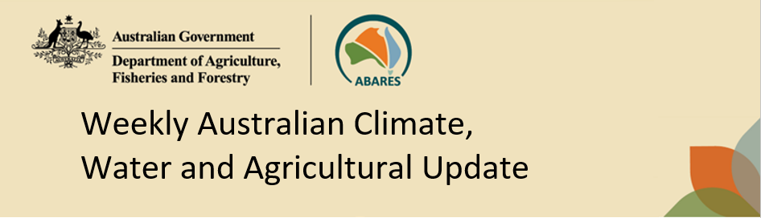
No. 20/2026 28 May 2026

Summary of key issues
- In the week ending 27 May 2026, low-pressure systems brought rainfall to southern, south-eastern, and some central areas.
  - Most cropping regions in South Australia and New South Wales saw falls of 1-50 millimetres, with isolated falls up to 100 millimetres. In Victoria and southern Western Australia falls of up to 25 millimetres were recorded.
  - These falls have provided a timely boost to soil moisture level across many southern cropping regions. Some rainfall across parts of northern New South Wales has provide some reprieve to persistent dry conditions but may not have been sufficient to reverse an expected decline in the area planted to winter crops during 2026–27.
- Over the 8 days to 4 June 2026, cold fronts and low-pressure systems are expected to bring rainfall to parts of eastern and southern Australia.
  - Across cropping regions, falls of 10-100 millimetres are forecast for much of Western Australia, northern New South Wales and Queensland. In South Australia, Victoria and southern New South Wales falls of between 10-50 millimetres are expected.
  - If realised, these expected falls are likely to provide an additional boost to soil moisture levels south-eastern cropping areas, and timely boost to soil moisture levels across much of Western Australia following a relative dry May to date. This may also encourage additional planting of crops in southern Queensland and northern New South Wales.
- The national rainfall outlook for June to August 2026 indicates an increased probability of below median rainfall across large areas of Australia.
  - While the current rainfall outlook for winter 2026 suggest below average falls, favourable soil moisture levels across most of Australia’s southern growing regions means that if forecast June through August rainfall totals are realised, these falls are likely be sufficient to support the establishment and growth of winter crops. However, these below average expected falls for north-eastern growing regions represents an ongoing downside production risk for the 2026–27 winter cropping season.
- Water storage levels in the Murray-Darling Basin (MDB) increased by 104 gigalitres (GL) between 21 May 2026 and 28 May 2026. The current volume of water held in storages is 10,183 GL, equivalent to 46% of total storage capacity. This is 18% or 2,200 GL less than the same time last year. Water storage data is sourced from the Bureau of Meteorology (BOM).
- Allocation prices in the Victorian Murray below the Barmah Choke decreased from $368/ML on 21 May 2026 to $356/ML on 28 May 2026. Trade from the Goulburn to the Murray is closed. Trade downstream through the Barmah Choke is closed. Trade from the Murrumbidgee to the Murray is open.

Climate

Rainfall this week
In the week ending 27 May 2026, low-pressure systems brought rainfall to scattered area of southern, south-eastern, and some central and north-western areas. Much of the remainder of Australia was largely dry.
- In the southeast, falls of 5-50 millimetres were recorded across large areas of New South Wales, Victoria, Tasmania, southern South Australia, and southern Western Australia. Isolated areas of New South Wales saw up to 100 millimetres. Central regions including the southern Northern Territory, eastern Western Australia and northern South Australia saw falls of up to 25 millimetres, with parts of north-western Western Australia seeing falls of up to 50 millimetres
- Much of Queensland, and remaining areas of Western Australia, South Australia and the Northern Territory remained largely dry.
Across cropping regions, scattered falls were recorded across the parts of the south and east, with mainly dry conditions persisting in the northeast and northwest:
- Most cropping regions in South Australia and New South Wales saw falls of 1-50 millimetres, with isolated falls up to 100 millimetres. In Victoria and southern Western Australia falls of between 1-25 millimetres were recorded.
  - These falls have provided a timely boost to soil moisture levels across many southern cropping regions. Some rainfall across parts of northern New South Wales has provide some reprieve to persistent dry conditions but may not have been sufficient to reverse an expected decline in the area planted to winter crops during 2026–27.
- Most cropping regions of Western Australia and Queensland saw little to no rainfall.
  - A continuation of mainly dry conditions across these regions is expected to lead to further declines in soil moisture levels.

Rainfall for the week ending 27 May 2026
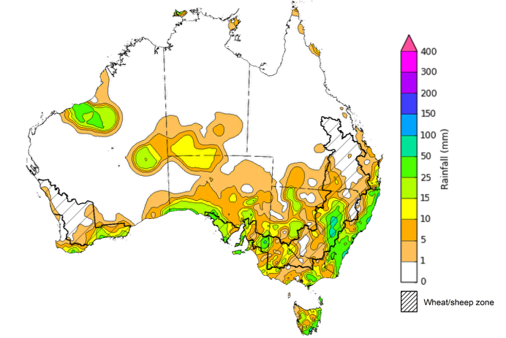
©Commonwealth of Australia 2026, Australian Bureau of Meteorology Issued: 27/5/2026
Note: The rainfall analyses and associated maps utilise data contained in the Bureau of Meteorology climate database, the Australian Data Archive for Meteorology (ADAM). The analyses are initially produced automatically from real-time data with limited quality control. They are intended to provide a general overview of rainfall across Australia as quickly as possible after the observations are received. For further information go to http://www.bom.gov.au/climate/rainfall/

Rainfall forecast for the next eight days
Over the 8 days to 4 June 2026, cold fronts and low pressure systems are expected to bring rainfall to parts of eastern and southern Australia. Much of central and northern Australia is forecast to remain largely dry.
- In south-western Western Australia, south-eastern Queensland and north-eastern New South Wales, falls of 5-150 millimetres are forecast.
- Similarity, much of south-eastern Australia, including southern South Australia, Victoria, southern New South Wales and Tasmania are expected to see between 5-100 millimetres.
- Remaining regions are likely to see little to no rainfall.
Rainfall totals across many cropping regions over the coming week are forecast to be substantial:
- Falls of 10-100 millimetres are forecast for much of Western Australia, northern New South Wales and Queensland. In South Australia, Victoria and southern New South Wales falls of between 10-50 millimetres are expected.
  - If realised, these expected falls are likely to provide an additional boost to soil moisture levels south-eastern cropping areas, and timely boost to soil moisture levels across much of Western Australia following a relative dry May to date. These falls are also expected to support the germination and growth of early sown winter crops.
  - Across regions of northern New South Wales and south-eastern Queensland that have experiences ongoing rainfall deficiencies, if realised these expected falls will provide a substantial boost to soil moisture levels and may encourage some additional planting of winter crops.

Total forecast rainfall for the period 28 May to 4 June 2026
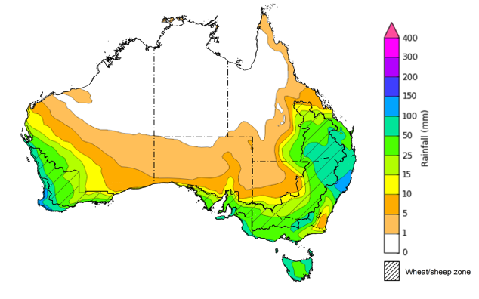
©Commonwealth of Australia 2026, Australian Bureau of Meteorology Issued 28/5/2026
Note: This rainfall forecast is produced from computer models. As the model outputs are not altered by weather forecasters, it is important to check local forecasts and warnings issued by the Bureau of Meteorology.

National Climate Outlook
The Bureau of Meteorology has indicated that El Niño conditions are currently neutral, but signs of El Niño development in 2026–27 is continuing. All models, including the Bureau's, forecast the tropical Pacific to continue warming in the coming months, with sea surface temperatures likely to reach El Niño thresholds during early winter. For El Niño to be considered established, a corresponding atmospheric response must be observed, including large-scale changes in pressure, trade winds, and cloudiness patterns. The Southern Annular Mode (SAM) is currently positive and is forecast to return to neutral over the coming weeks. Similarly, the Indian Ocean Dipole (IOD) has returned to neutral conditions following a period of elevated values. There is substantial uncertainty in the forecast state of the IOD. Most models indicate the IOD is likely to remain neutral until at least early winter, with the development of a positive IOD event possible during winter–spring.
The recent rainfall outlook for June 2026 provided by the Bureau of Meteorology indicates that most Australia is more likely to see below median rainfall, with scattered areas of northern Australia are more likely to see above median falls.
The Bureau of Meteorology’s climate model indicates a 75% chance of June rainfall totals between 5- 100 millimetres across Victoria, Tasmania, southern South Australia, and much of south-western Western Australia. In the east, including coastal parts of Queensland, and eastern and southern New South Wales, falls of 5- 25 millimetres are expected. Much of central and northern Western Australia, the Northern Territory, western Queensland, northern South Australia, and western parts of New South Wales are likely to see little to no rainfall.
Across southern cropping regions, there is a 75% chance of receiving rainfall totals of between 5- 50 millimetres during June 2026. If these forecast falls are realised across most southern regions, they are likely to provide sufficient moisture to support the establishment and growth of winter crops. Across most cropping regions in Queensland and northern New South Wales there is a 75% chance of receiving rainfall totals of between 1-10 millimetres

Rainfall totals that have a 75% chance of occurring in June 2026

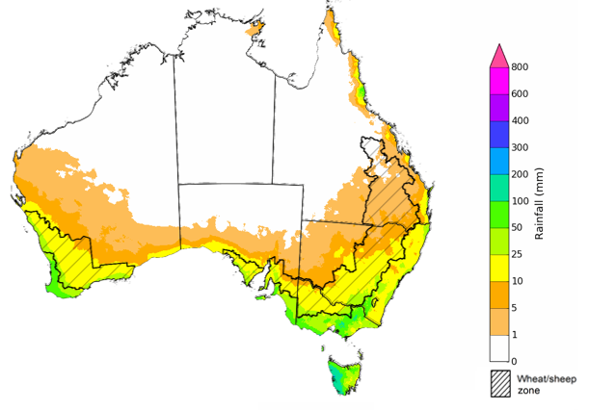
©Commonwealth of Australia 2025, Australian Bureau of Meteorology Issued: 28/5/2026
The rainfall outlook for June 2026 to August 2026 indicates a strong tendency towards below median rainfall across large areas of Australia. However, there is an increased probability of median to above median rainfall in parts of the Northern Tropics and western Tasmania.
Across most cropping regions, the chance of receiving above median rainfall is 20-40%.

Chance of exceeding the median rainfall June 2026 to August 2026

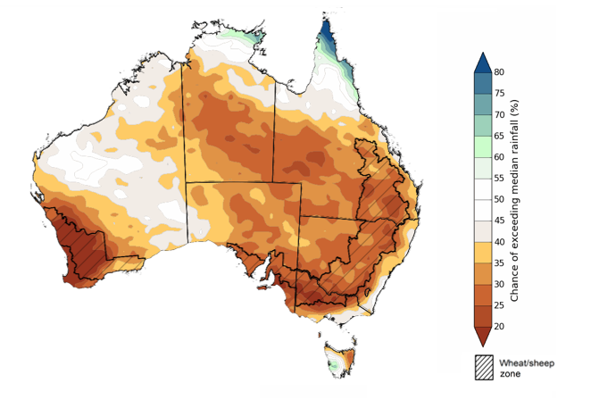
©Commonwealth of Australia 2025, Australian Bureau of Meteorology Issued: 28/5/2026

The rainfall outlook for June 2026 to August 2026 suggests a 75% chance of receiving rainfall totals of between 25-200 millimetres across parts of eastern and southern Australia. Higher falls in excess of 200 millimetres are expected across scattered areas of north-eastern Queensland, southwest Western Australia, western Tasmania, as well as alpine regions of Victoria and New South Wales. Lower rainfall totals are forecast for central and northern regions, with much of northern South Australia, central and northern Western Australia, the Northern Territory and western Queensland likely to see 0-25 millimetres.
In cropping regions, there is a 75% chance of receiving between 25-100 millimetres across much of Western Australia, South Australia, Victoria and New South Wales. Cropping regions in Queensland and are likely to see lower falls of 2-50 millimetres.
Favourable soil moisture levels across most of Australia’s southern growing regions means that if these forecast June through August rainfall totals are realised, these falls are likely be sufficient to support the establishment and growth of winter crops. However, these below average expected falls for north-eastern growing regions represents an ongoing downside production risk for the 2026–27 winter cropping season.

Rainfall totals that have a 75% chance of occurring June 2026 to August 2026

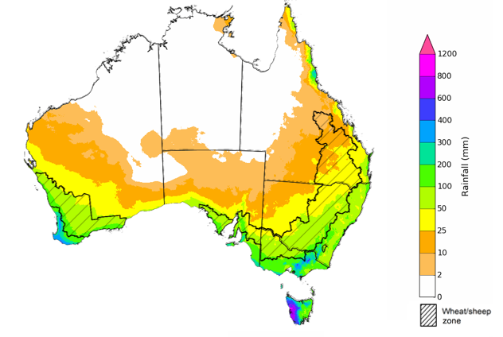
©Commonwealth of Australia 2025, Australian Bureau of Meteorology Issued: 28/5/2026

Water markets – current week
Water storage levels in the Murray-Darling Basin (MDB) increased by 104 gigalitres (GL) between 21 May 2026 and 28 May 2026. The current volume of water held in storages is 10,183 GL, equivalent to 46% of total storage capacity. This is 18% or 2,200 GL less than the same time last year. Water storage data is sourced from the Bureau of Meteorology (BOM).

Water storages in the Murray-Darling Basin, 2013–2026
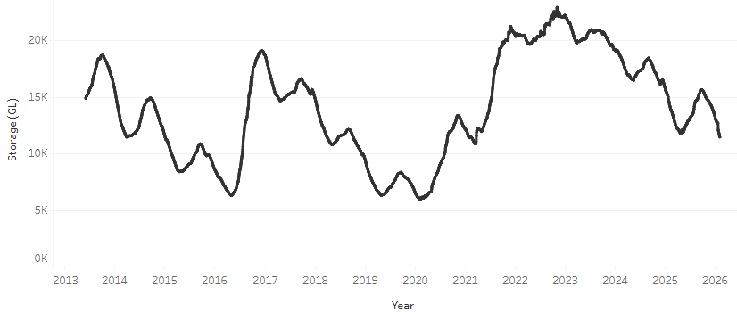
Allocation prices in the Victorian Murray below the Barmah Choke decreased from $368/ML on 21 May 2026 to $356/ML on 28 May 2026. Trade from the Goulburn to the Murray is closed. Trade downstream through the Barmah Choke is closed. Trade from the Murrumbidgee to the Murray is open.

Water market prices, Southern Murray–Darling Basin

Region | $/ML
NSW Murray Above | 299
NSW Murrumbidgee | 359
Vic Greater Goulburn | 360
Vic Murray Below | 356

Note: The water allocation prices shown are volume weighted average prices based on the last 10 trades. Price data is sourced from Waterflow and current as at 22 January 2026.
To access the full, interactive, weekly water dashboard, which contains the latest and historical water storage, water market and water allocation information, please visit https://www.agriculture.gov.au/abares/products/weekly_update/weekly-update-260528

Commodities
Indicator | Week average | Unit | Latest Price | Previous Week | Weekly change |  | Price 12 months ago | Annual change
Selected world indicator prices
AUD/USD Exchange rate | 27-May | A$/US$ | 0.72 | 0.71 | 0% | 0.64 |  | 11%
Wheat – US no. 2 hard red winter wheat, FOB Gulf | 27-May | US$/t | 303 | 308 | -2% | 237 |  | 28%
Corn – US no. 2 yellow corn, FOB Gulf | 27-May | US$/t | 210 | 216 | -3% | 204 |  | 3%
Canola – Rapeseed, Canada, FOB Vancouver | 27-May | US$/t | 564 | 570 | -1% | 550 |  | 3%
Cotton – Cotlook A Index | 27-May | USc/lb | 87.4 | 91.2 | -4% | 78.0 |  | 12%
Sugar – Intercontinental Exchange, nearby futures, no.11 contract | 27-May | USc/lb | 14.6 | 14.8 | -1% | 17.6 |  | -17%
Wool – Eastern Market Indicator | 27-May | Ac/kg clean | 1,934 | 1,880 | 3% | 1,197 |  | 62%
Wool – Western Market Indicator | 27-May | Ac/kg clean | 2,125 | 2,086 | 2% | 1,359 |  | 56%
Selected Australian grain export prices
Australian Premium White (APW) Wheat, FOB Port Adelaide, SA | 27-May | A$/t | 394 | 402 | -2% | 398 |  | -1%
Australian Standard White (ASW) Wheat, FOB Port Adelaide, SA | 27-May | A$/t | 385 | 394 | -2% | 393 |  | -2%
Feed Barley – FOB Port Adelaide, SA | 27-May | A$/t | 387 | 394 | -2% | 376 |  | 3%
Canola – FOB Kwinana, WA | 27-May | A$/t | 816 | 811 | 1% | 794 |  | 3%
Grain Sorghum – FOB Brisbane, QLD | 27-May | A$/t | 449 | 454 | -1% | 434 |  | 3%
Selected domestic livestock indicator prices
Beef – Eastern Young Cattle Indicator | 27-May | Ac/kg cwt | 899 | 855 | 5% | 693 |  | 30%
Mutton – Mutton indicator (18–24 kg fat score 2–3), VIC | 27-May | Ac/kg cwt | 818 | 805 | 2% | 558 |  | 47%
Lamb – National Trade Lamb Indicator | 27-May | Ac/kg cwt | 1,180 | 1,153 | 2% | 863 |  | 37%
Pig – Eastern Seaboard (60.1–75 kg), NSW buyer price | 6-May | Ac/kg cwt | 436 | 439 | -1% | 446 |  | -2%
Live cattle – Light steers to Indonesia | 29-Apr | Ac/kg lwt | 420 | 430 | -2% | 345 |  | 22%
Global Dairy Trade (GDT) weighted average prices
Dairy – Whole milk powder | 20-May | US$/t | 3,772 | 3,741 | 1% | 4,353 |  | -13%
Dairy – Skim milk powder | 20-May | US$/t | 3,552 | 3,547 | 0% | 2,823 |  | 26%
Dairy – Cheddar cheese | 20-May | US$/t | 4,560 | 4,611 | -1% | 5,263 |  | -13%
Dairy – Anhydrous milk fat | 20-May | US$/t | 6,344 | 6,461 | -2% | 7,243 |  | -12%

Selected world indicator prices
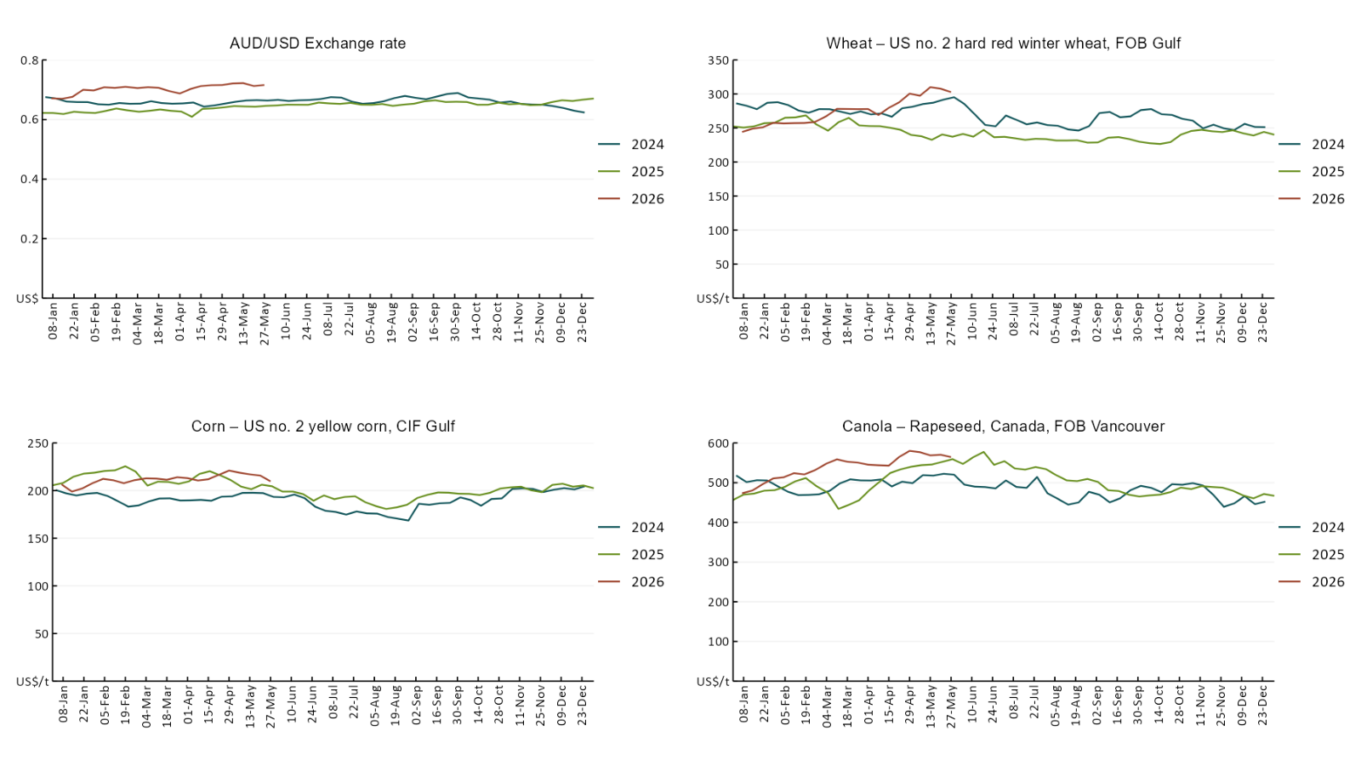

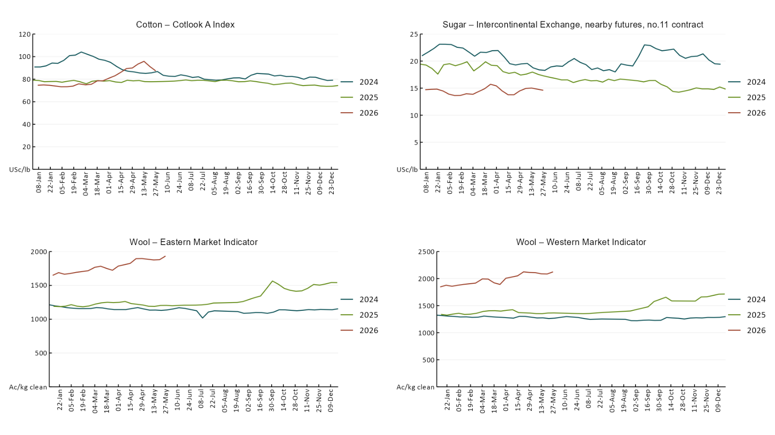

3.2 Selected domestic crop indicator prices
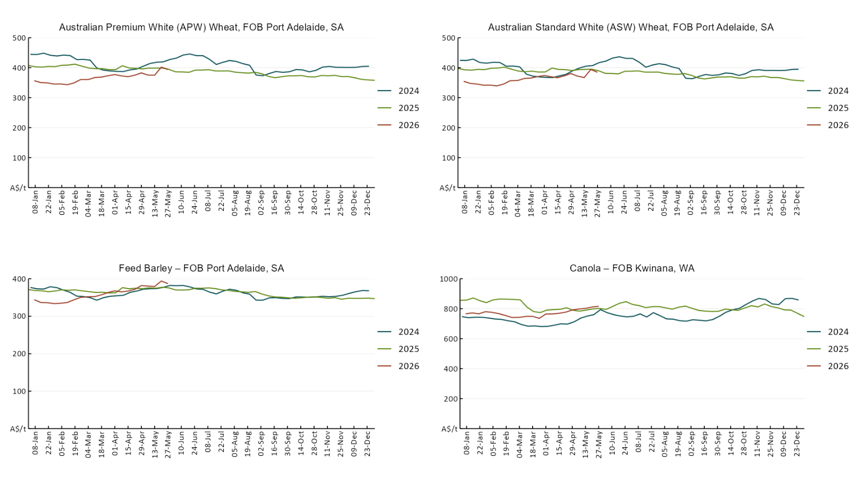

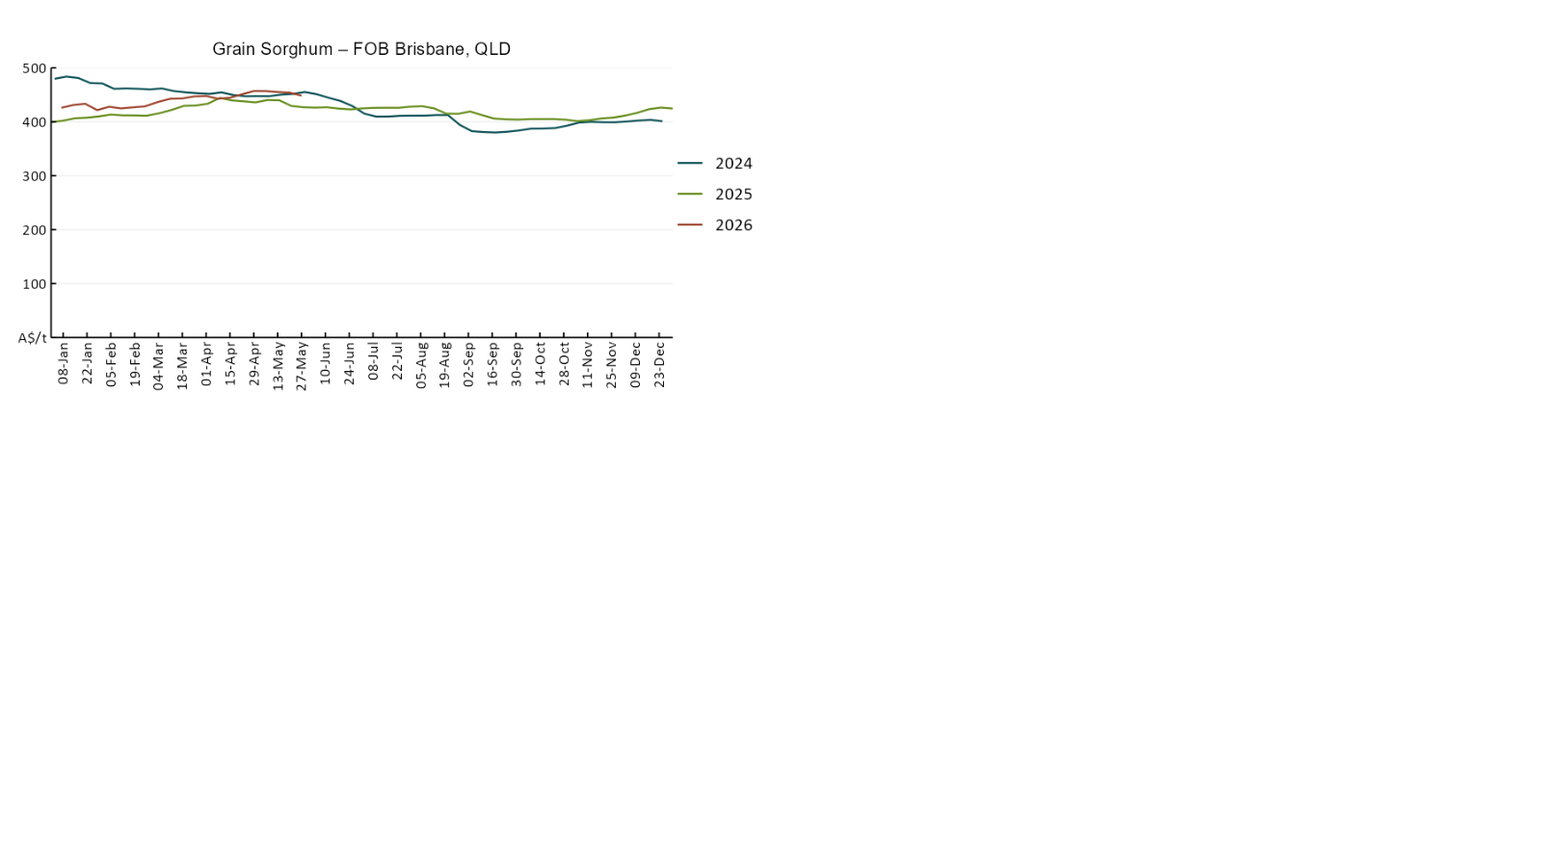

3.3 Selected domestic livestock indicator prices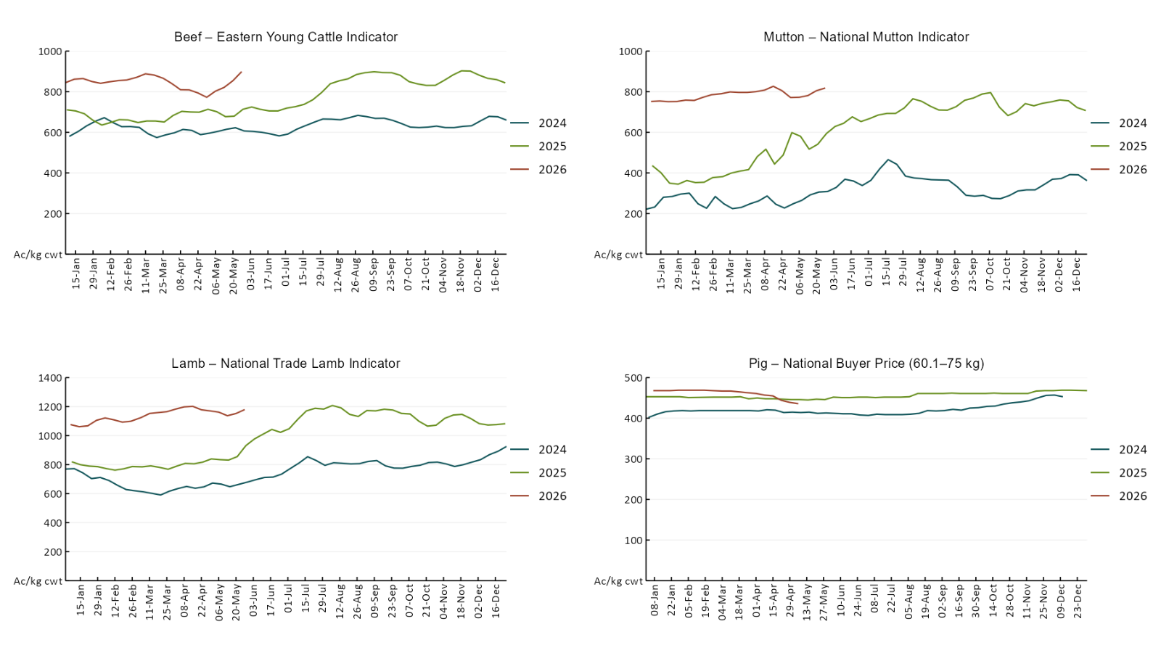

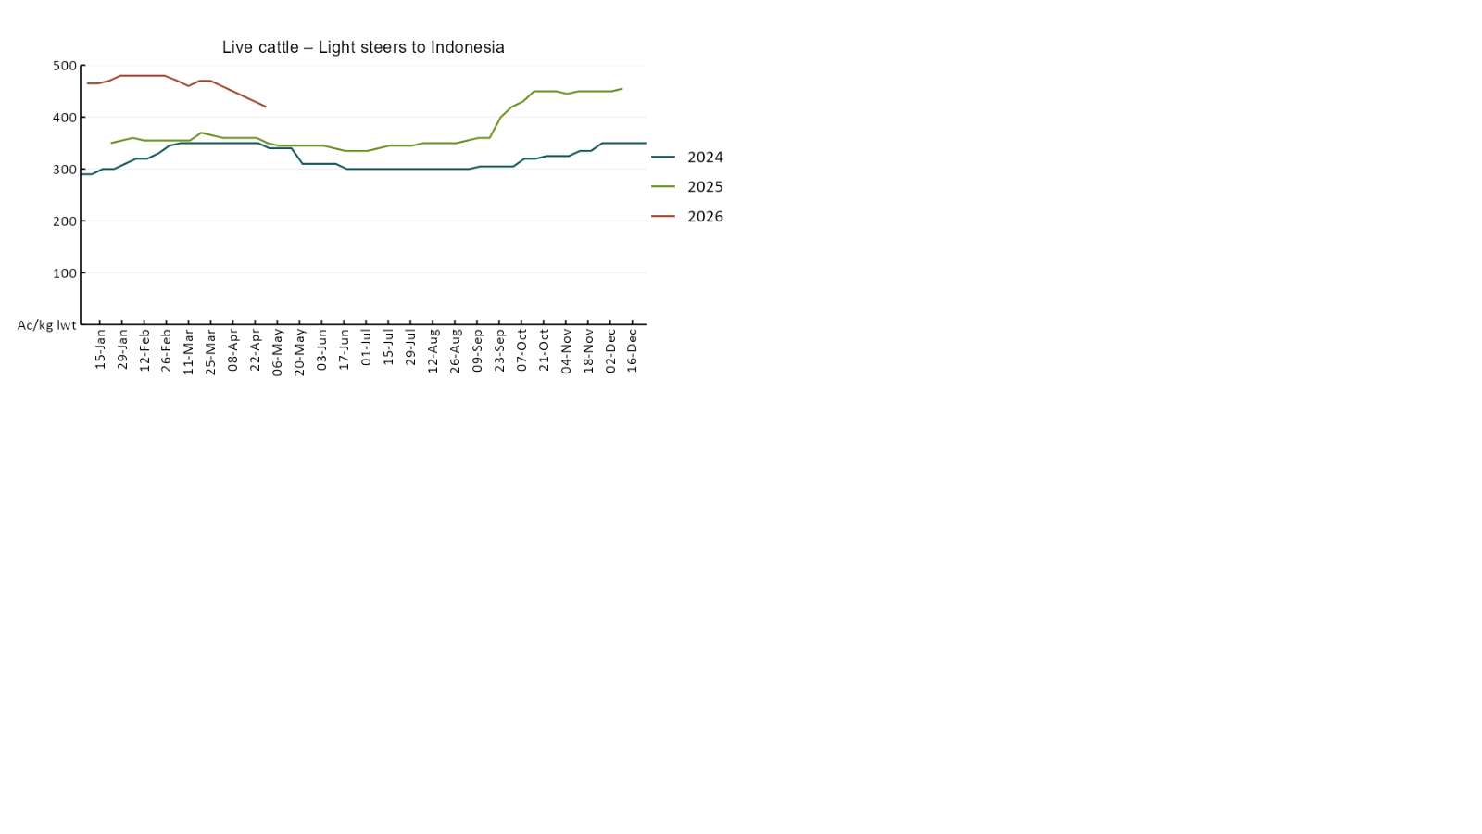

3.4 Global Dairy Trade (GDT) weighted average prices
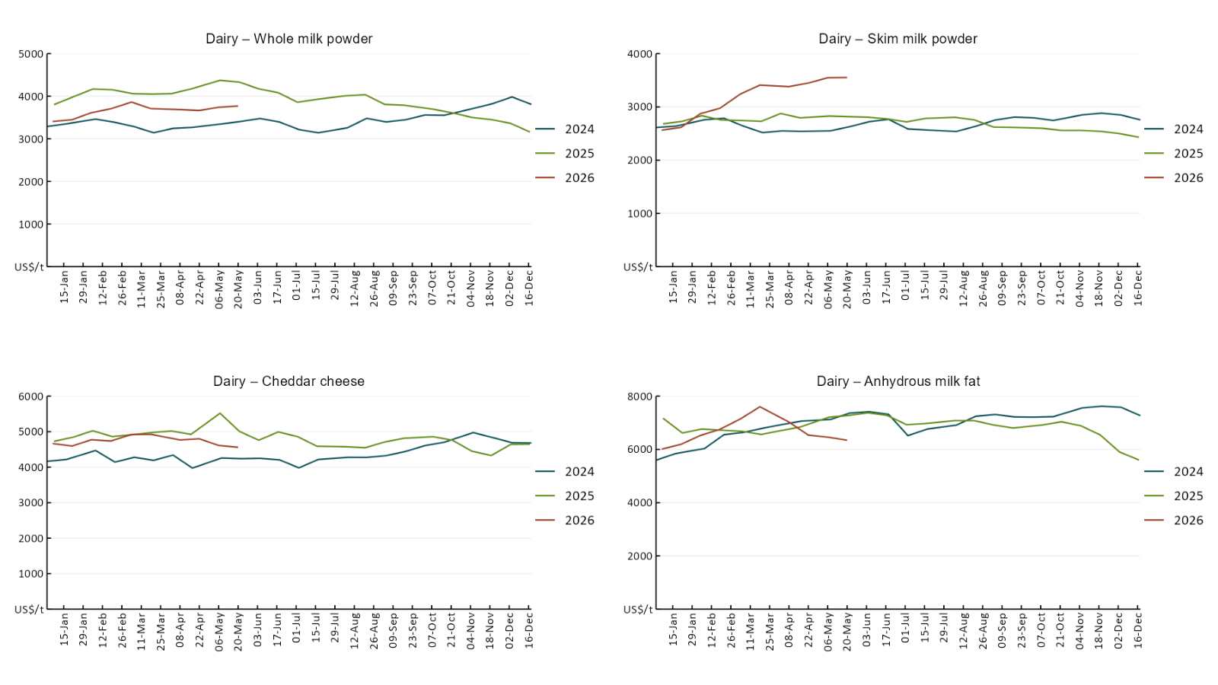

3.5 Selected fruit and vegetable prices
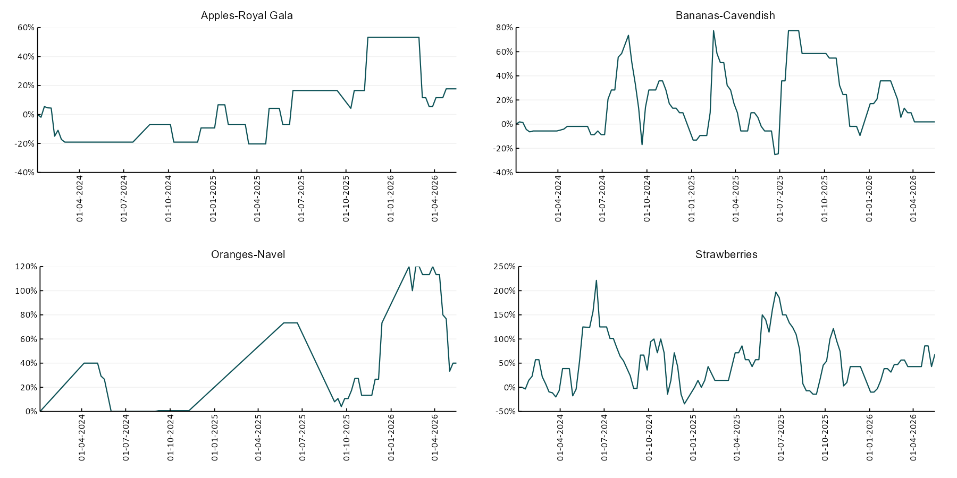

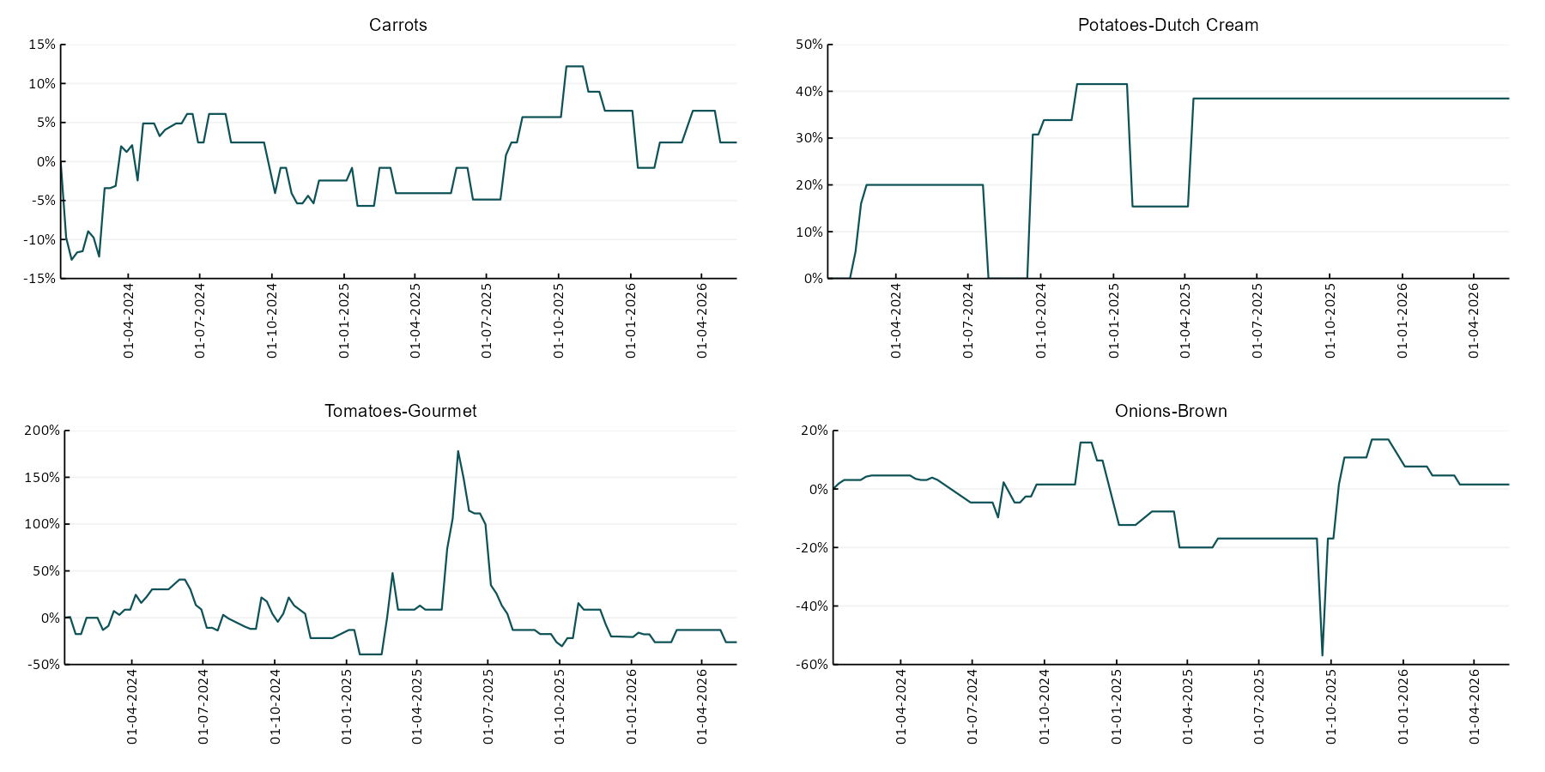

3.6 Selected domestic fodder indicator prices
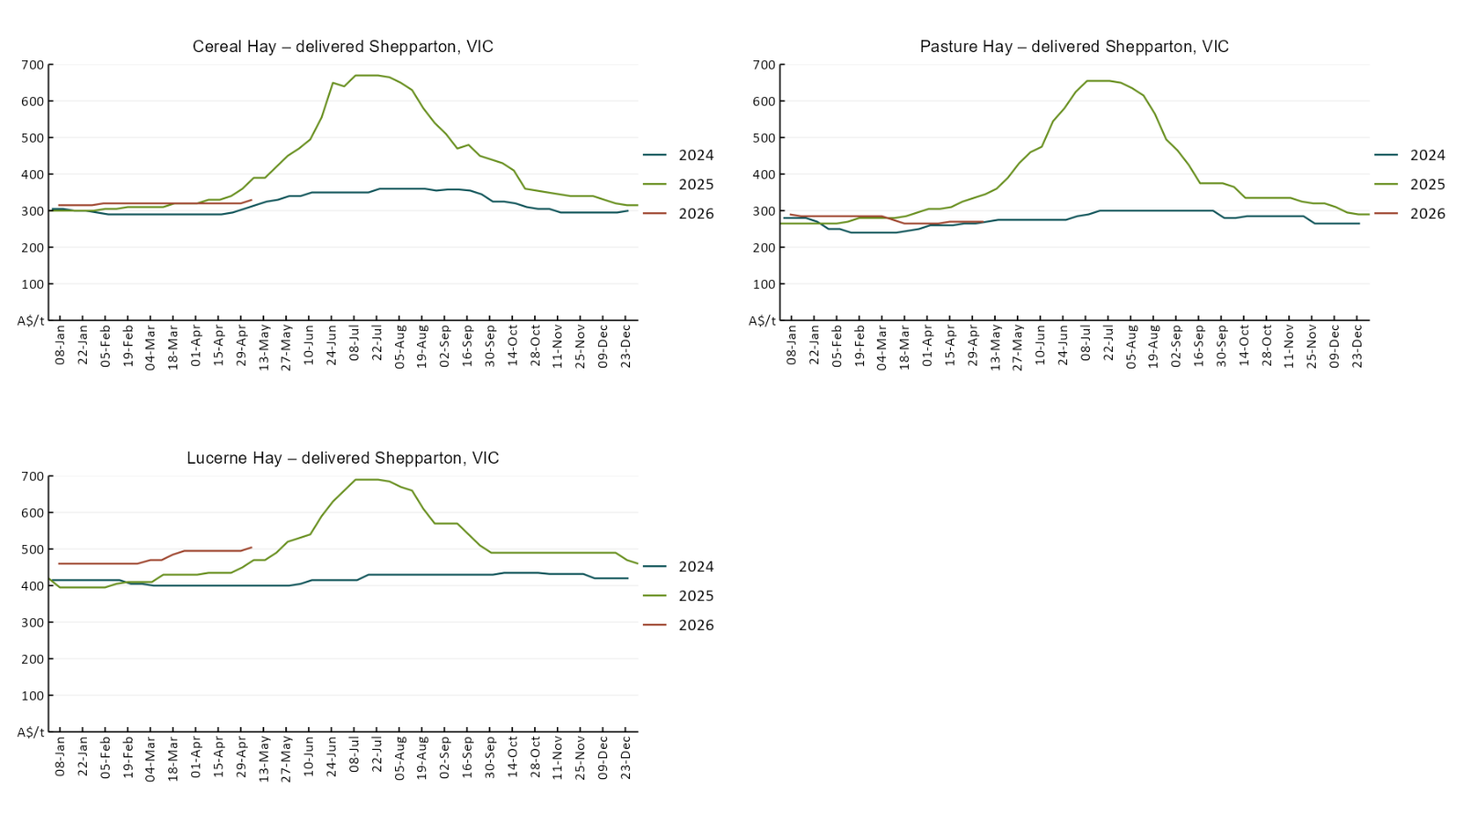

4. Data attribution

Climate
Bureau of Meteorology
- Weekly rainfall totals: www.bom.gov.au/climate/maps/rainfall/
- Monthly and last 3-month rainfall percentiles: https://www.bom.gov.au/climate/ahead/outlooks/#moreMaps
- Rainfall forecast: www.bom.gov.au/jsp/watl/rainfall/pme.jsp
- Seasonal outlook: www.bom.gov.au/climate/outlooks/#/overview/summary/
- Climate drivers: http://www.bom.gov.au/climate/enso/
- Soil moisture: https://awo.bom.gov.au/products/historical/soilMoisture-rootZone/

Other
- Pasture growth: www.longpaddock.qld.gov.au/aussiegrass/
- 3-month global outlooks: Environment and Climate Change Canada, NOAA Climate Prediction Center, EUROBRISA CPTEC/INPE, European Centre for Medium-Range Weather Forecasts, Hydrometcenter of Russia, National Climate Center Climate System Diagnosis and Prediction Room (NCC), International Research Institute for Climate and Society
- Global production: https://ipad.fas.usda.gov/ogamaps/cropmapsandcalendars.aspx
- Autumn break: Pook et al., 2009, https://rmets-onlinelibrary-wiley-com.virtual.anu.edu.au/doi/epdf/10.1002/joc.1833

Water
Prices
- Waterflow: https://www.waterflow.io/
- Ruralco: https://www.ruralcowater.com.au/
- Bureau of Meteorology:
- Allocation trade: http://www.bom.gov.au/water/dashboards/#/water-markets/mdb/at
- Storage volumes: http://www.bom.gov.au/water/dashboards/#/water-storages/summary/drainage

Trade constraints:
- Water NSW: https://www.waternsw.com.au/customer-service/ordering-trading-and-pricing/trading/murrumbidgee
- Victorian Water Register: https://www.waterregister.vic.gov.au/TradingRules2019/

Commodities
Fruit and vegetables
- Datafresh: www.freshstate.com.au

Pigs
- Australian Pork Limited: www.australianpork.com.au

Dairy
- Global Dairy Trade: www.globaldairytrade.info/en/product-results/

World wheat, canola
- International Grains Council
- https://www.igc.int/en/default.aspx
- United States Department of Agriculture

World cotton
- Cotlook: www.cotlook.com/

World sugar
- New York Stock Exchange - Intercontinental Exchange

Wool
- Australian Wool Exchange: www.awex.com.au/

Domestic wheat, barley, sorghum, canola and fodder
- Jumbuk Consulting Pty Ltd: Jumbuk AG | Agriculture Consulting

Cattle, beef, mutton, lamb, goat and live export
- Meat and Livestock Australia: https://www.mla.com.au/prices-markets/

Australian Agricultural Drought Indicators
About Australian Agricultural Drought Indicators
The Australian Agricultural Drought Indicators (AADI) links weather and agricultural data with a range of scientific and economic models to measure and forecast the effects of climate variability and drought on agricultural outcomes.
On AADI, projected broadacre farm profits are presented as percentile outcomes relative to simulated historical outcomes using the groupings:
Highest | 95-100th percentile
Very much above average | 85-95th percentile
Above average | 65-85th percentile
Average | 35-65th percentile
Below average | 15-35th percentile
Very much below average | 5-15th percentile
Lowest 5% | 0-5th percentile

There are two AADI farm profit indicators:
- The AADI farm profit climate and price indicator shows the effect of climate and prices on broadacre farm business profits of current farms compared to the last 33 years.
- The AADI farm profit climate only indicator isolates the effect of climate on profits by holding prices fixed.

© Commonwealth of Australia 2026

Ownership of intellectual property rights
Unless otherwise noted, copyright (and any other intellectual property rights, if any) in this publication is owned by the Commonwealth of Australia (referred to as the Commonwealth).

Creative Commons licence
All material in this publication is licensed under a Creative Commons Attribution 4.0 International Licence except content supplied by third parties, logos and the Commonwealth Coat of Arms.
Inquiries about the licence and any use of this document should be emailed to copyright@awe.gov.au.


Cataloguing data
This publication (and any material sourced from it) should be attributed as:
ABARES 2026, Weekly Australian Climate, Water and Agricultural Update, Australian Bureau of Agricultural and Resource Economics and Sciences, Canberra, 28 May 2026. CC BY 4.0 DOI: https://doi.org/10.25814/5f3e04e7d2503
ISSN 2652-7561
This publication is available at https://www.agriculture.gov.au/abares/products/weekly_update
Department of Agriculture, Fisheries and Forestry
GPO Box 858 Canberra ACT 2601
Telephone 1800 900 090
Web agriculture.gov.au/abares

Disclaimer
The Australian Government acting through the Department of Agriculture, Fisheries and Forestry, represented by the Australian Bureau of Agricultural and Resource Economics and Sciences, has exercised due care and skill in preparing and compiling the information and data in this publication. Notwithstanding, the Department of Agriculture, Fisheries and Forestry, ABARES, its employees and advisers disclaim all liability, including liability for negligence and for any loss, damage, injury, expense or cost incurred by any person as a result of accessing, using or relying on any of the information or data in this publication to the maximum extent permitted by law.

Statement of Professional Independence
The views and analysis presented in ABARES publications, including this one, reflect ABARES professionally independent findings, based on scientific and economic concepts, principles, information and data. These views, analysis and findings may not reflect or be consistent with the views or positions of the Australian Government, or of organisations or groups who have commissioned ABARES reports or analysis. More information on professional independence is provided on the ABARES website.

Acknowledgements
This report was prepared by Holly Beale and Matthew Miller.

