
No. 21/2026 4 June 2026

Summary of key issues
- In the week ending 3 June 2026, low-pressure systems brought rainfall to parts of eastern, south-eastern and south-western Australia.
  - Most cropping regions saw falls of 1-50 millimetres, with isolated falls up to 100 millimetres recorded across parts of southern Queensland and northern New South Wales.
  - These falls have provided a timely boost to soil moisture levels across most cropping regions and is likely to benefit the establishment of winter crops. Substantial rainfall across parts of northern New South Wales and southern Queensland has delivered a timely follow-up to rainfall received last week and may encourage some additional planting of winter crops.
- Over the 8 days to 11 June 2026, cold fronts and low-pressure systems are expected to bring rainfall to parts of eastern, western and southern Australia.
  - Across cropping regions, 5-50 millimetres are forecast for much of Western Australia and New South Wales. In Queensland and Victoria falls of between 1-25 millimetres are expected. Lighter falls of 5 and 15 millimetres are forecast across South Australia.
  - If realised, these expected falls are likely to provide an additional boost to soil moisture levels across many eastern and western cropping areas. These falls are also expected to support the germination and growth of early sown winter crops and may also encourage additional planting of crops in southern Queensland and northern New South Wales.
- Rainfall during May 2026 was generally above average in eastern and central regions, and below average across parts of the northeast and west. Average to well above average rainfall outcomes across southern Queensland and northern New South Wales have boosted soil moisture level following an extended dry period.
- Pasture growth for the three months to May 2026 was mixed, with much of south-eastern and central Australia seeing robust pasture growth but below average growth was evident across areas of eastern, northern and western Australia. Soil moisture models indicate broadly average to above average soil moisture levels with exceptions in parts of western and eastern Australia.
- Water storage levels in the Murray-Darling Basin (MDB) increased by 576 gigalitres (GL) between 28 May 2026 and 4 June 2026. The current volume of water held in storages is 10,759 GL, equivalent to 48% of total storage capacity. This is 14% or 1,758 GL less than the same time last year. Water storage data is sourced from the Bureau of Meteorology.
- Allocation prices in the Victorian Murray below the Barmah Choke decreased from $356/ML on 28 May 2026 to $334/ML on 4 June 2026. Trade from the Goulburn to the Murray is open. Trade downstream through the Barmah Choke is closed. Trade from the Murrumbidgee to the Murray is open.

Climate

Rainfall this week
In the week ending 3 June 2026, low-pressure systems brought rainfall to parts of eastern, south-eastern, and south-western Australia. Much of the remainder of Australia was largely dry.
- Large areas of south-western Western Australia, south-eastern Queensland, eastern New South Wales, Victoria, southern South Australia and Tasmania saw falls of 5-100 millimetres, with falls up to 150 millimetres recorded across parts of coastal New South Wales, alpine areas of Victoria and northern Tasmania.
- Much of remainder of Australia saw little to no rainfall.
In cropping regions, widespread falls were recorded across most regions:
- Most cropping regions in Queensland and New South Wales saw falls of 1-50 millimetres, with falls up to 100 millimetres recorded across parts of southern Queensland and northern New South Wales. Similarly, in Victoria, South Australia and Western Australia falls of between 5 - 50 millimetres were recorded.
  - These falls have provided a timely boost to soil moisture levels across most cropping regions and is likely to benefit the establishment of winter crops.
  - Substantial rainfall across parts of northern New South Wales and southern Queensland has delivered a timely follow-up to rainfall received last week and has provided a timely boost to soil moisture levels and may encourage some additional planting of winter crops.

Rainfall for the week ending 3 June 2026
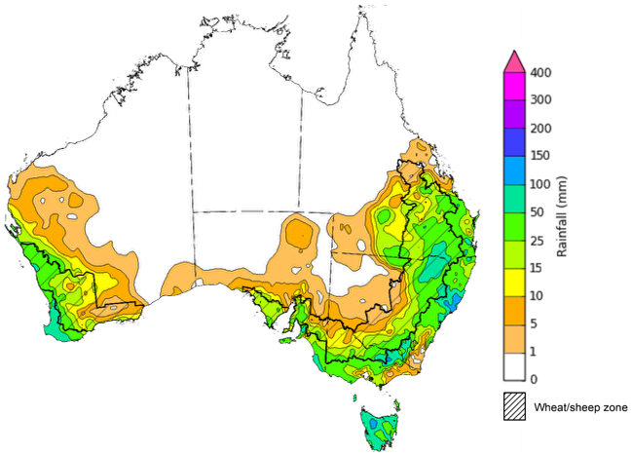
©Commonwealth of Australia 2026, Australian Bureau of Meteorology Issued: 2/6/2026
Note: The rainfall analyses and associated maps utilise data contained in the Bureau of Meteorology climate database, the Australian Data Archive for Meteorology (ADAM). The analyses are initially produced automatically from real-time data with limited quality control. They are intended to provide a general overview of rainfall across Australia as quickly as possible after the observations are received. For further information go to http://www.bom.gov.au/climate/rainfall/

Rainfall forecast for the next eight days
Over the 8 days to 11 June 2026, cold fronts and low pressure systems are expected to bring rainfall to parts of eastern, western and southern Australia. Much of central and northern Australia is forecast to remain largely dry.
- In south-western Western Australia, south-eastern Queensland, north-eastern New South Wales, eastern and central Victoria, and Tasmania falls of 10-50 millimetres are forecast.
- Lighter falls of between 1-15 millimetres are expected across remaining southern areas.
- Northern and central regions are likely to see little to no rainfall.
Across cropping regions rainfall is forecast in the east and west over the coming week:
- Falls of 5-50 millimetres are forecast for much of Western Australia and New South Wales. In Queensland and Victoria falls of between 1-25 millimetres are expected. Lighter falls of 5 and 15 millimetres are forecast across South Australia.
  - If realised, these expected falls are likely to provide an additional boost to soil moisture levels across many eastern and western cropping areas. These falls are also expected to support the germination and growth of early sown winter crops.
  - Across regions of northern New South Wales and south-eastern Queensland that received substantial falls last week, if realised these expected falls will continue to boost to soil moisture levels and could incentivise some additional planting of short season winter crops.

Total forecast rainfall for the period 4 June to 11 June 2026
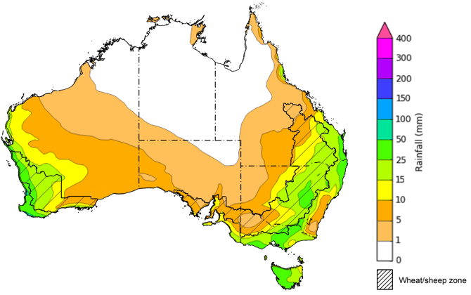
©Commonwealth of Australia 2026, Australian Bureau of Meteorology Issued 3/6/2026
Note: This rainfall forecast is produced from computer models. As the model outputs are not altered by weather forecasters, it is important to check local forecasts and warnings issued by the Bureau of Meteorology.

Monthly rainfall
Rainfall during May 2026 was generally above average in eastern and central regions, and below average across parts of the northeast and west.
- A series of low-pressure systems have brought widespread rainfall to central and eastern regions, as well as parts of the northwest and southeast – supporting pasture production and soil moisture for producers.
- In the northeast and across the west of Western Australia, high-pressure systems have limited rainfall outcomes.
In cropping regions, May rainfall was generally average to extremely high in the east and southeast, below average to severely deficient in western areas.
- Severely deficient rainfall in much of Western Australia has led to a drawdown of soil moisture storage level to support the establishment and growth of winter cop and pastures.
- Across the east and southeast, generally above average falls have provided a timely boost to soil moisture and support the establishment and growth of winter crops.
Rainfall percentiles for May 2026
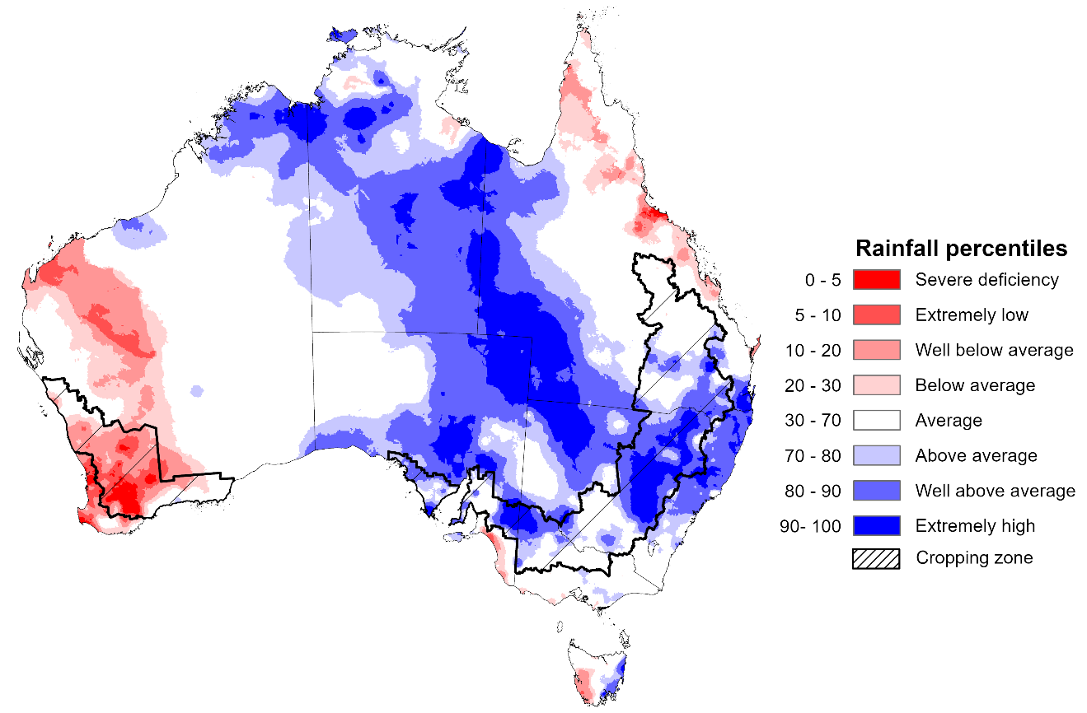
Note: Rainfall for May 2026 is compared with rainfall recorded for that period during the historical record (1900 to present). For further information, go to http://www.bom.gov.au/climate/austmaps/about-rain-maps.shtml
Source: Bureau of Meteorology

Monthly Soil Moisture
In May 2026, modelled upper layer soil moisture was generally average to above average across much of the country. In contrast large areas of western and parts of north-east and Tasmania have extremely low to below average soil moisture.
- Much of the south-western half of Western Australia, and parts of north-eastern Queensland and western Tasmania saw extremely low to below average upper layer soil moisture.
- In contrast, much of the remainder of Queensland and Tasmania, the Northern Territory, South Australia, New South Wales, Victoria and north-eastern Western Australia saw average to very much above upper layer soil moisture.
At this time of year, upper layer soil moisture is important for the establishment of winter crops in southern states. Further, it is an indicator of the ability to access paddocks for winter crop planting activities.
- Across cropping regions, modelled upper layer soil moisture in May for most eastern and south-eastern cropping regions was generally average to very much above, while most western cropping regions were modelled as having broadly extremely low to below average soil moisture with isolated areas of average moisture in the far southeast.
Modelled upper layer soil moisture for May 2026
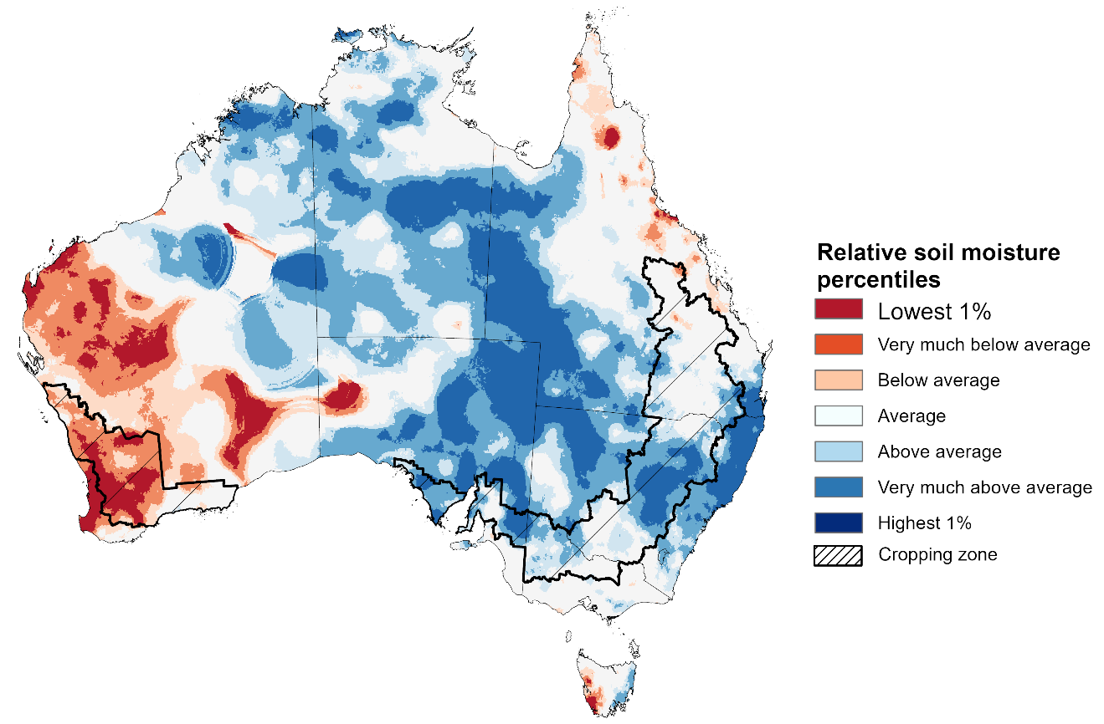
Note: This map shows the levels of modelled upper layer soil moisture (0 to 10 centimetres) during May 2026 This map shows how modelled soil conditions during May 2026 compare with May conditions modelled over the reference period (1911 to 2016). Dark blue areas on the maps were much wetter in May 2026 than during the reference period. The bulk of plant roots occur in the top 20 centimetres of the soil profile. Soil moisture in the upper layer of the soil profile is therefore useful indicator of the availability of water, particularly for germinating seed.
Source: Bureau of Meteorology (https://awo.bom.gov.au/about/overview)
Modelled lower layer soil moisture in May 2026 was average to very much above average across much of Australia, while extremely low to below average modelled lower layer soil moisture was evident across some eastern and western areas.
- Parts of south-eastern Queensland, north-eastern New South Wales, Tasmania, and central Western Australia were modelled as having extremely low to below average lower layer soil moisture. By contrast, much of the northern tropics, South Australia, western Queensland and New South Wales were modelled as having above average to very much above average soil moisture over the period.
At this time of year increased levels of lower layer soil moisture will be important to support establishment on winter crops and pasture growth during a peak growth period.
Some cropping regions in southern and central Queensland, northern New South Wales and the west and central areas of Western Australia were modelled as having extremely low to below average soil moisture. In contrast, Victoria, South Australia and remaining areas in New South Wales, Queensland and Western Australia, recorded average to very much above average soil moisture for this time of year.
In areas with average to above average lower layer soil moisture, this is likely to provide a reserve of plant-available water to support crop growth over the winter period. Agricultural regions across southern Australia have seen a significant improvement in soil moisture levels since the end of January 2026. However, May modelling does show a decline from April, particularly in Western Australia – this drawdown in lower layer soil moisture levels mean the winter crop and pasture production outcomes will be highly reliant on timely and sufficient rainfall across the remainder of the growing season.
Modelled lower layer soil moisture for May 2026
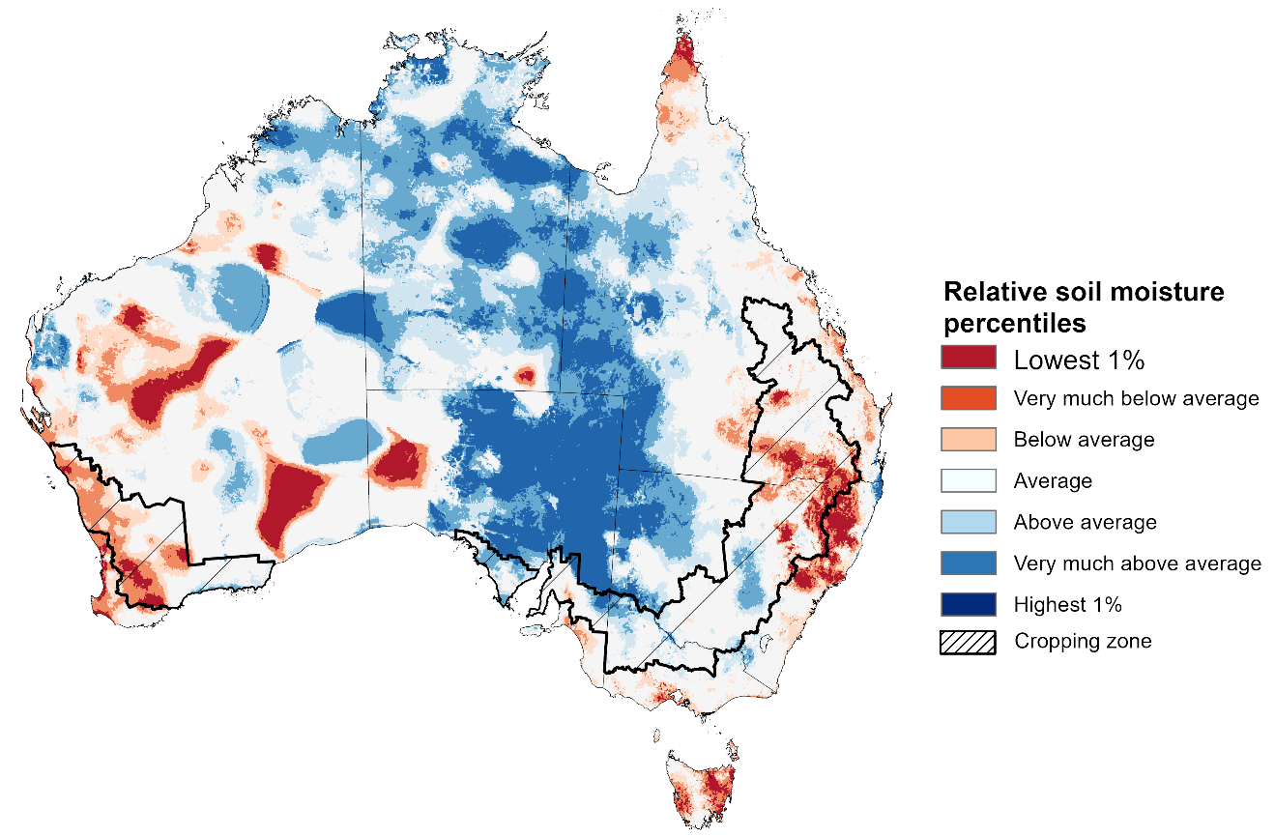
Note:. This map shows how modelled soil conditions during May 2026 compare with May conditions modelled over the reference period (1911 to 2016). Dark blue areas on the maps were much wetter in May 2026 than during the reference period. The dark red areas were much drier than during the reference period. The bulk of plant roots occur in the top 20 centimetres of the soil profile. The lower layer soil moisture is a larger, deeper store that is slower to respond to rainfall and tends to reflect accumulated rainfall events over longer time periods.
Source: Bureau of Meteorology (https://awo.bom.gov.au/about/overview)

Pasture Growth
Pasture growth during the March to May period affects the availability of fodder to support livestock production across northern Australia as it enters a seasonally low growth period. Across southern Australia, autumn pasture growth influences the standing biomass available to support livestock production over winter and the reliance on hay and grain during this period. Pasture availability during this period influences the growth and branding and marking rates of lambs and calves, livestock turnoff and the production of meat, milk, and wool.
Pasture growth for the three months to April 2026 was variable across much of country.
- Average to extremely high relative pasture growth across much of Australia.
  - This pasture growth is expected to have allowed many farmers to maintain livestock numbers, provide opportunities to build standing dry matter availability.
- In contrast, large areas of the eastern and western Australia, as well as the far north, saw relatively low pasture growth for this time of year.
  - This below average pasture growth has likely led to a decline in pasture availability. Graziers in regions where below average pasture growth was recorded will be more reliant on supplemental feed to maintain current stocking rates and production, with others choosing to destock to take advantage of relatively high saleyard prices.
Relative pasture growth for 3-months ending May 2026 (1 March to 31 May 2026)
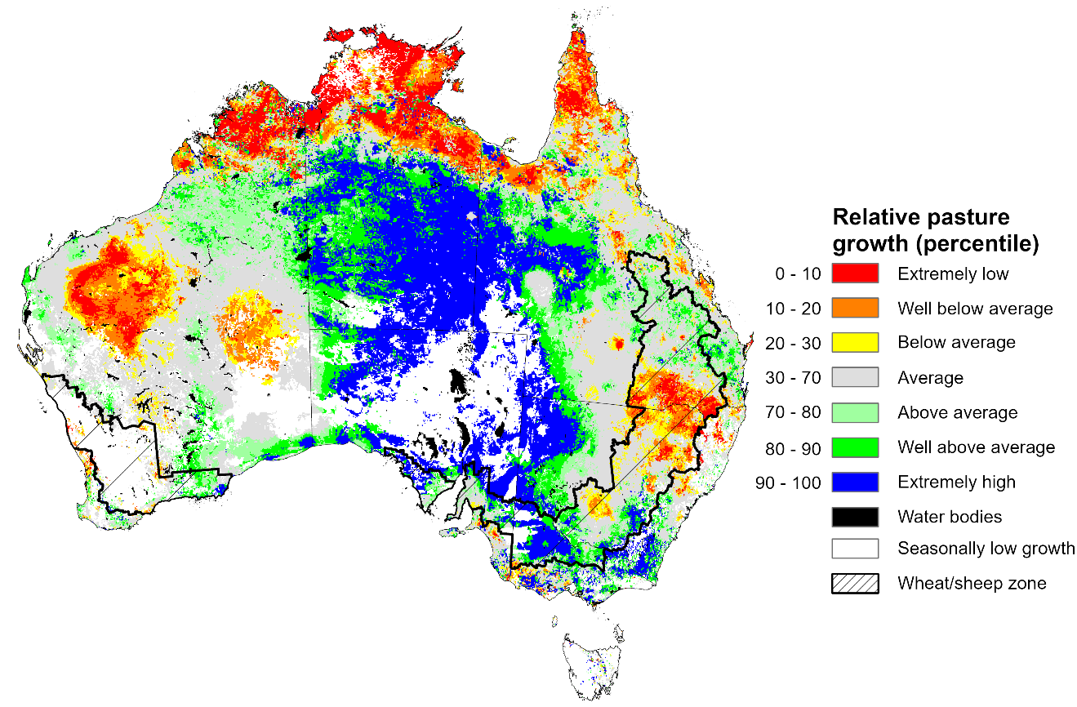
Notes: AussieGRASS pasture growth estimates are relative to the long-term record and shown in percentiles. Percentiles rank data on a scale of zero to 100. This analysis ranks pasture growth for the selected period against average pasture growth for the long-term record (1957 to 2016). Pasture growth is modelled at 5km2 grid cells.
Source: Department of Environment, Science and Innovation

Water markets – current week
Water storage levels in the Murray-Darling Basin (MDB) increased by 576 gigalitres (GL) between 28 May 2026 and 4 June 2026. The current volume of water held in storages is 10,759 GL, equivalent to 48% of total storage capacity. This is 14% or 1,758 GL less than the same time last year. Water storage data is sourced from the Bureau of Meteorology.

Water storages in the Murray-Darling Basin, 2013–2026
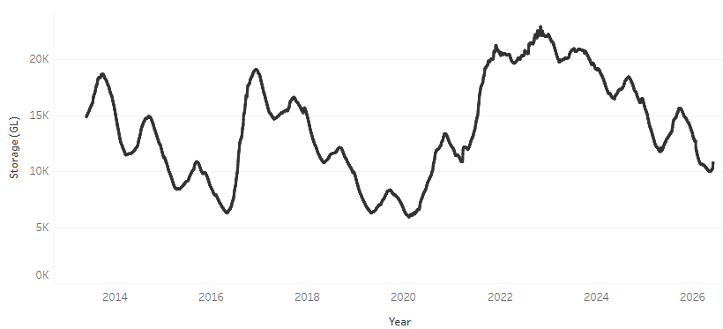
Allocation prices in the Victorian Murray below the Barmah Choke decreased from $356/ML on 28 May 2026 to $334/ML on 4 June 2026. Trade from the Goulburn to the Murray is open. Trade downstream through the Barmah Choke is closed. Trade from the Murrumbidgee to the Murray is open.

Water market prices, Southern Murray–Darling Basin

Region | $/ML
NSW Murray Above | 271
NSW Murrumbidgee | 364
Vic Greater Goulburn | 320
Vic Murray Below | 334

Note: The water allocation prices shown are volume weighted average prices based on the last 10 trades. Price data is sourced from Waterflow and current as at 22 January 2026.
To access the full, interactive, weekly water dashboard, which contains the latest and historical water storage, water market and water allocation information, please visit https://www.agriculture.gov.au/abares/products/weekly_update/weekly-update-260603

Commodities
Indicator | Week average | Unit | Latest Price | Previous Week | Weekly change |  | Price 12 months ago | Annual change
Selected world indicator prices
AUD/USD Exchange rate | 3-Jun | A$/US$ | 0.73 | 0.72 | 2% | 0.65 |  | 12%
Wheat – US no. 2 hard red winter wheat, FOB Gulf | 3-Jun | US$/t | 291 | 299 | -3% | 241 |  | 21%
Corn – US no. 2 yellow corn, FOB Gulf | 3-Jun | US$/t | 205 | 209 | -2% | 196 |  | 4%
Canola – Rapeseed, Canada, FOB Vancouver | 3-Jun | US$/t | 588 | 572 | 3% | 558 |  | 5%
Cotton – Cotlook A Index | 3-Jun | USc/lb | 86.9 | 86.9 | 0% | 78.2 |  | 11%
Sugar – Intercontinental Exchange, nearby futures, no.11 contract | 3-Jun | USc/lb | 14.9 | 14.3 | 5% | 16.7 |  | -11%
Wool – Eastern Market Indicator | 3-Jun | Ac/kg clean | 1,964 | 1,934 | 2% | 1,204 |  | 63%
Wool – Western Market Indicator | 27-May | Ac/kg clean | 2,125 | 2,086 | 2% | 1,354 |  | 57%
Selected Australian grain export prices
Australian Premium White (APW) Wheat, FOB Port Adelaide, SA | 3-Jun | A$/t | 382 | 392 | -3% | 387 |  | -1%
Australian Standard White (ASW) Wheat, FOB Port Adelaide, SA | 3-Jun | A$/t | 371 | 382 | -3% | 382 |  | -3%
Feed Barley – FOB Port Adelaide, SA | 3-Jun | A$/t | 381 | 387 | -2% | 371 |  | 2%
Canola – FOB Kwinana, WA | 3-Jun | A$/t | 808 | 820 | -1% | 824 |  | -2%
Grain Sorghum – FOB Brisbane, QLD | 3-Jun | A$/t | 435 | 446 | -3% | 425 |  | 2%
Selected domestic livestock indicator prices
Beef – Eastern Young Cattle Indicator | 3-Jun | Ac/kg cwt | 939 | 907 | 4% | 712 |  | 32%
Mutton – Mutton indicator (18–24 kg fat score 2–3), VIC | 3-Jun | Ac/kg cwt | 833 | 819 | 2% | 651 |  | 28%
Lamb – National Trade Lamb Indicator | 3-Jun | Ac/kg cwt | 1,193 | 1,182 | 1% | 1,014 |  | 18%
Pig – Eastern Seaboard (60.1–75 kg), NSW buyer price | 20-May | Ac/kg cwt | 429 | 436 | -2% | 452 |  | -5%
Live cattle – Light steers to Indonesia | 29-Apr | Ac/kg lwt | 420 | 430 | -2% | 339 |  | 24%
Global Dairy Trade (GDT) weighted average prices
Dairy – Whole milk powder | 3-Jun | US$/t | 3,706 | 3,772 | -2% | 4,129 |  | -10%
Dairy – Skim milk powder | 3-Jun | US$/t | 3,457 | 3,552 | -3% | 2,791 |  | 24%
Dairy – Cheddar cheese | 3-Jun | US$/t | 4,621 | 4,560 | 1% | 4,876 |  | -5%
Dairy – Anhydrous milk fat | 3-Jun | US$/t | 6,668 | 6,344 | 5% | 7,325 |  | -9%

Selected world indicator prices
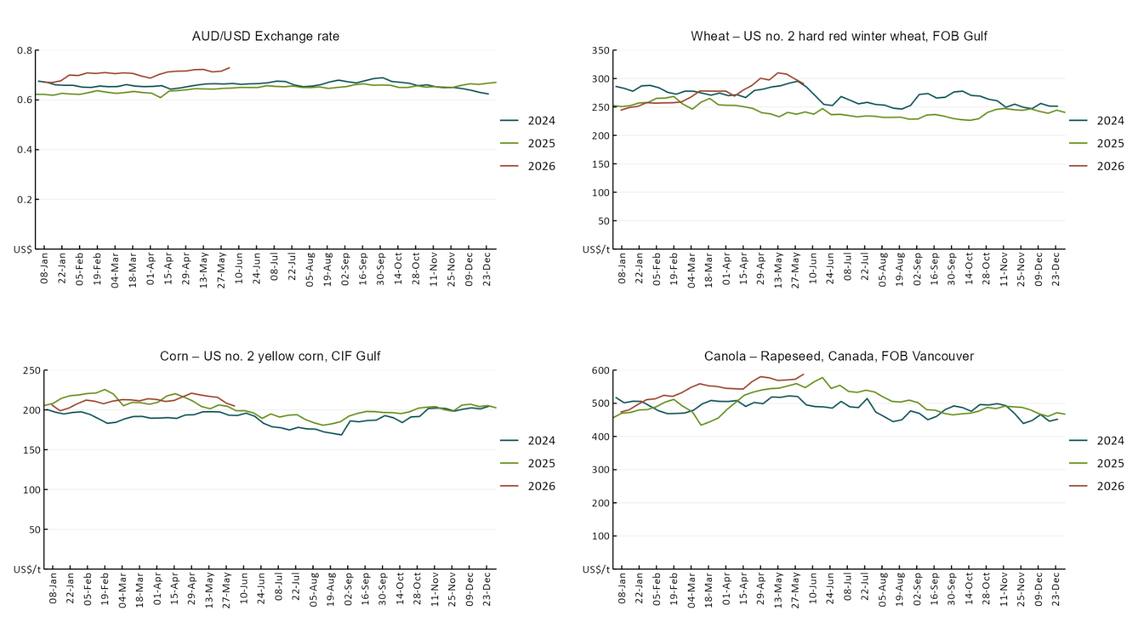
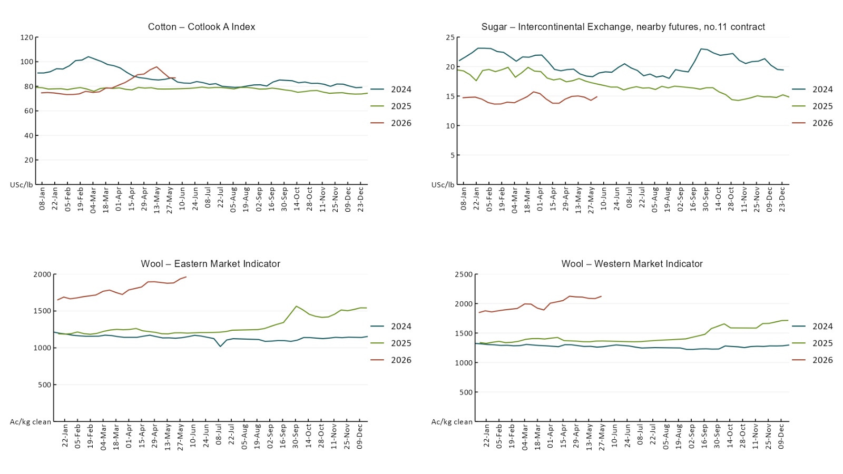

3.2 Selected domestic crop indicator prices
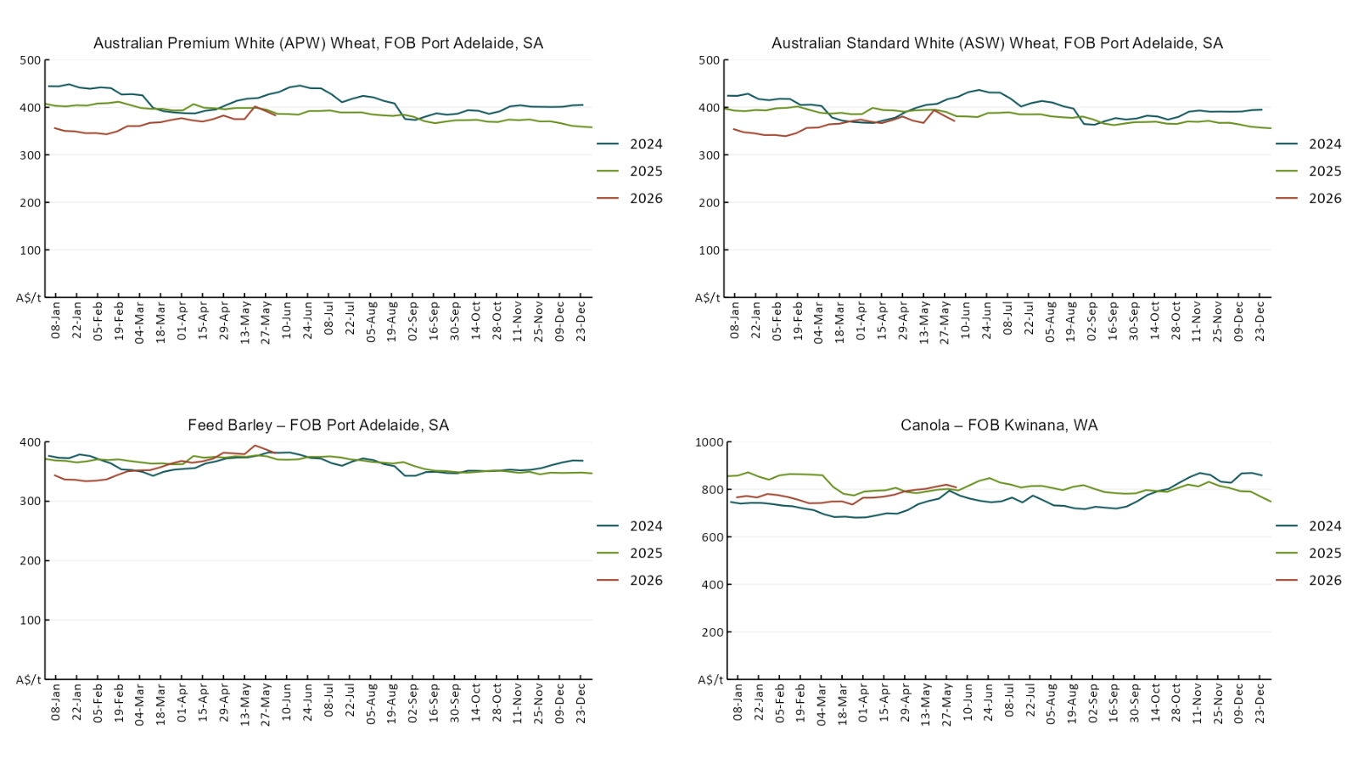

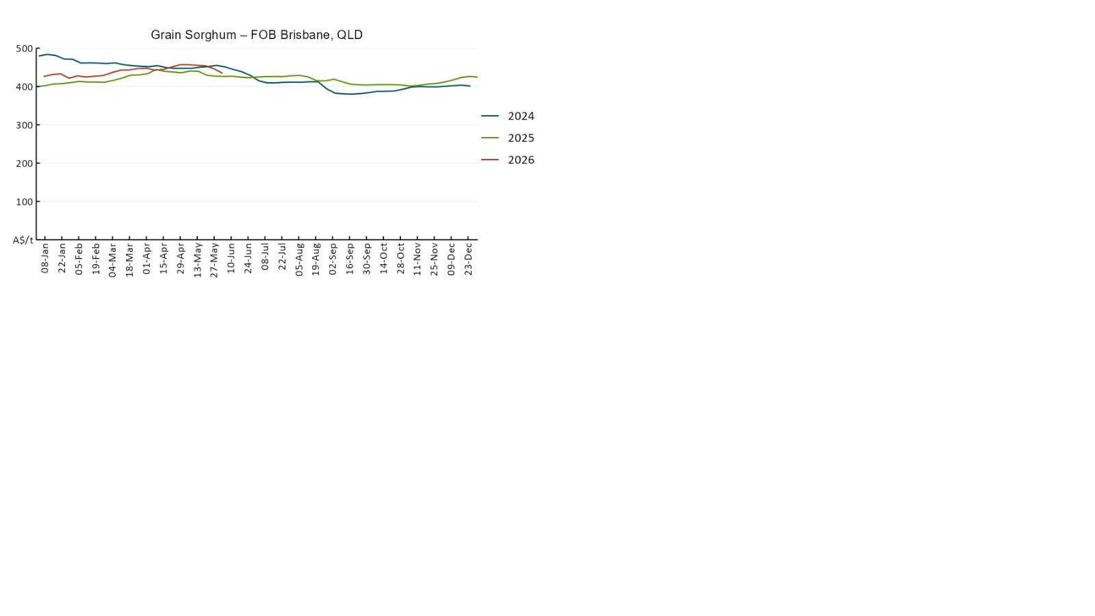

3.3 Selected domestic livestock indicator prices
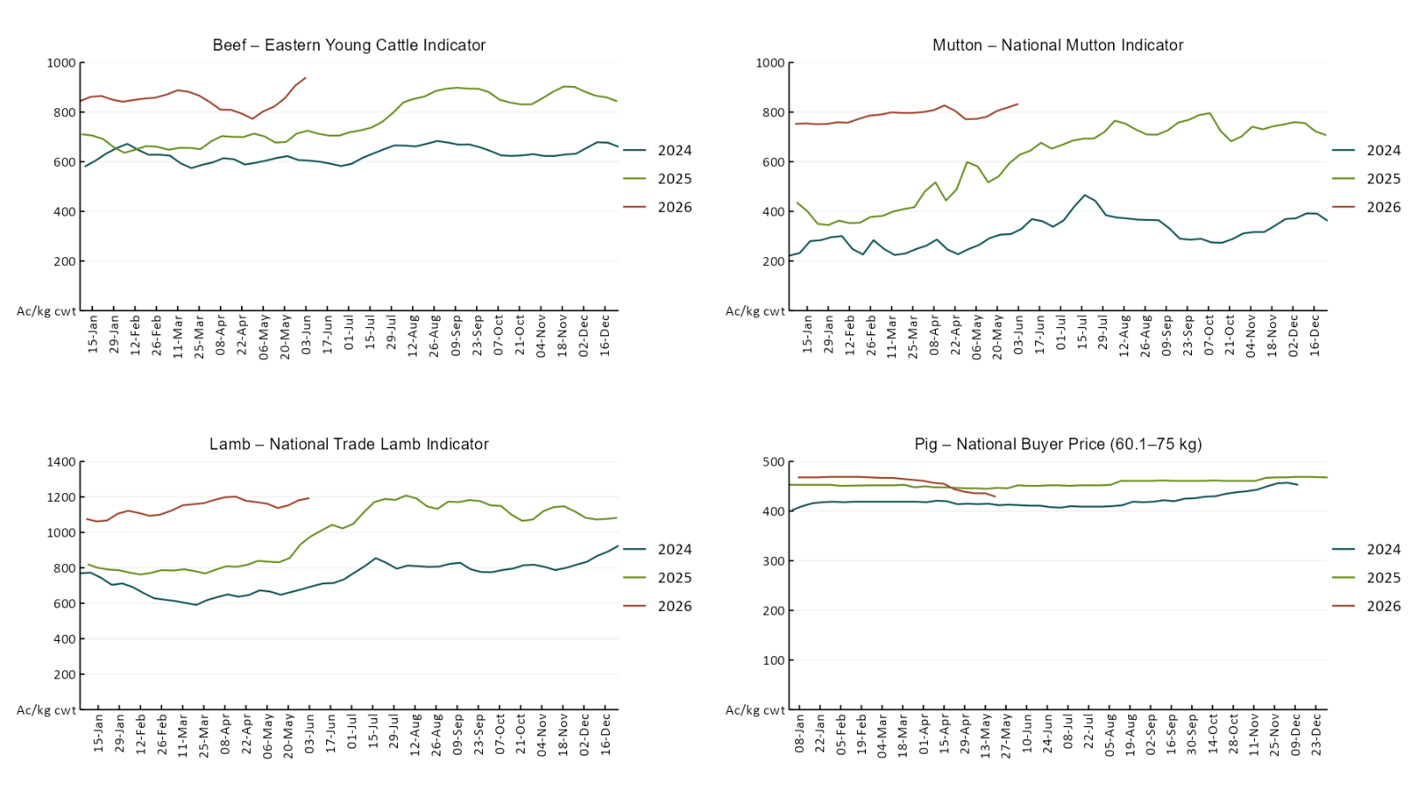
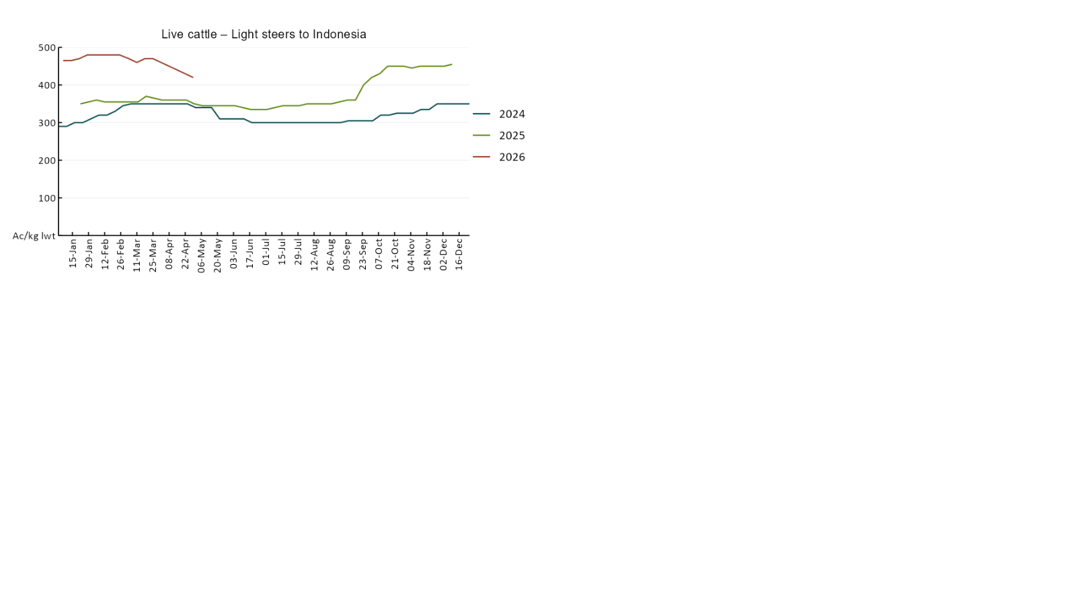

3.4 Global Dairy Trade (GDT) weighted average prices
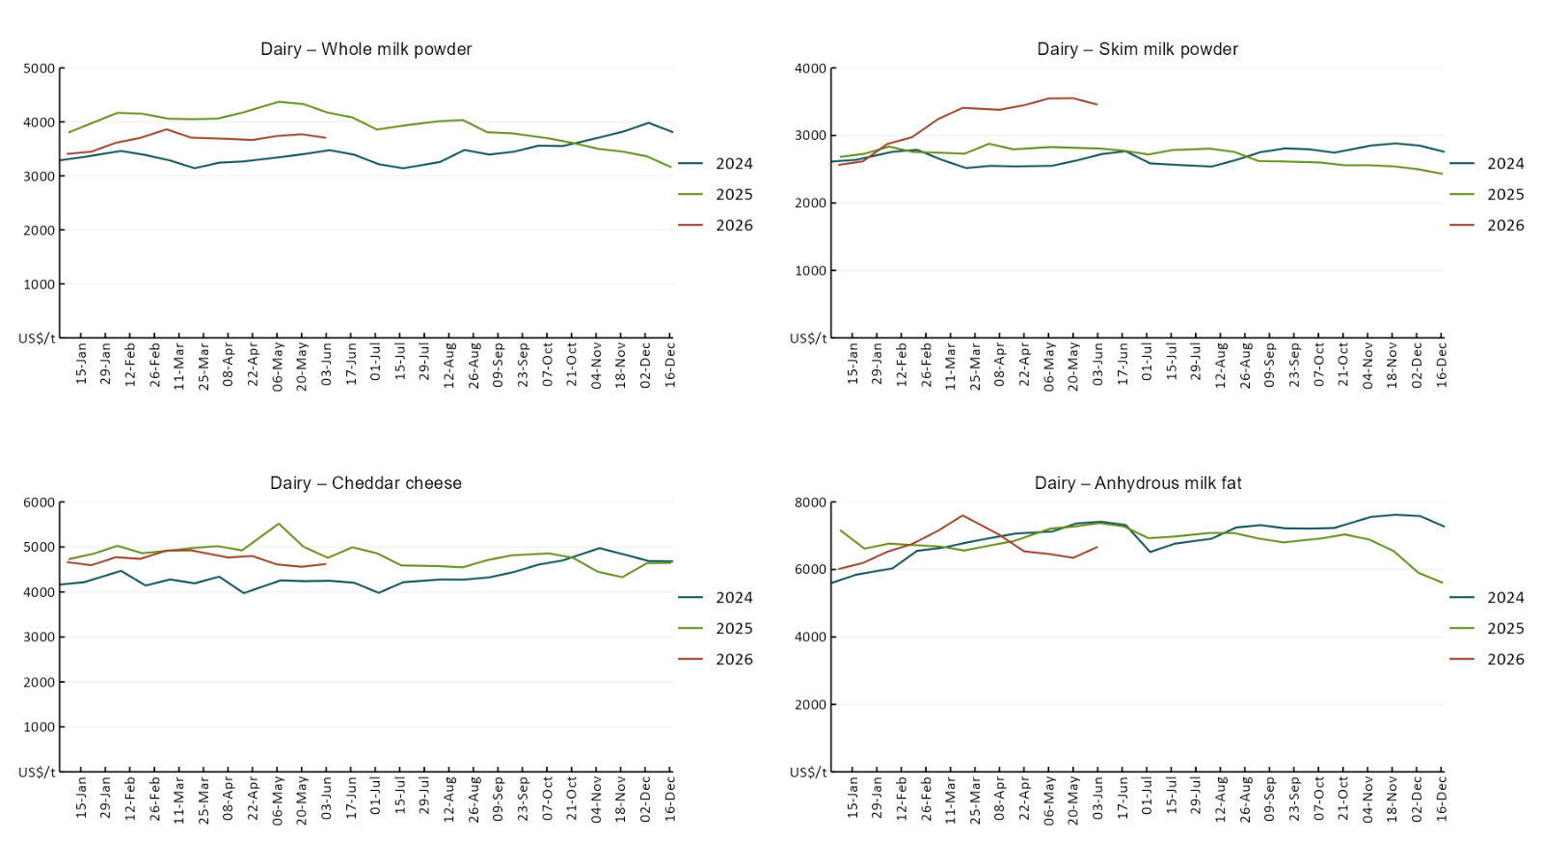

3.5 Selected fruit and vegetable prices
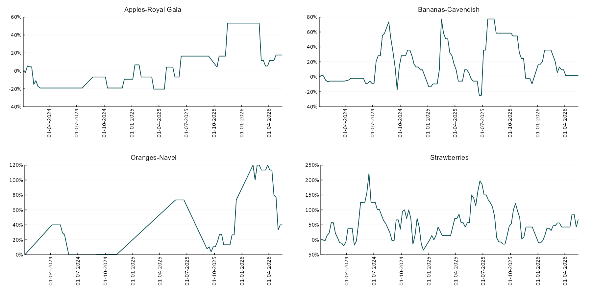
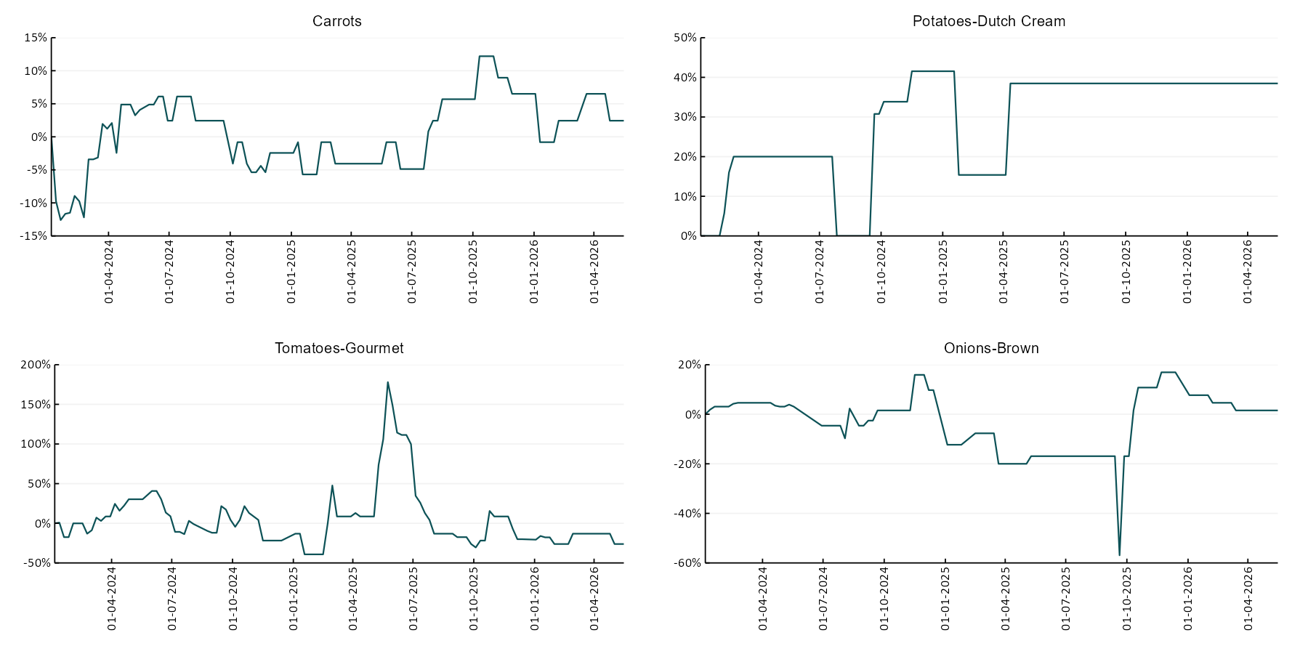

3.6 Selected domestic fodder indicator prices
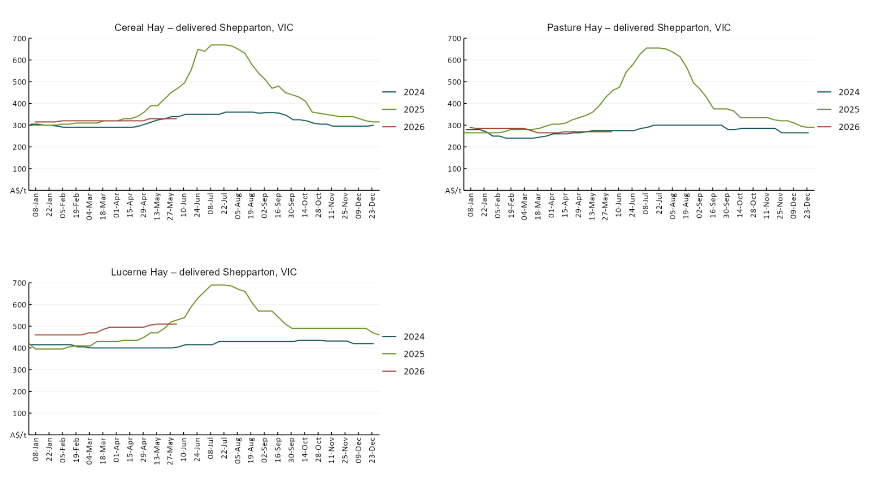

4. Data attribution

Climate
Bureau of Meteorology
- Weekly rainfall totals: www.bom.gov.au/climate/maps/rainfall/
- Monthly and last 3-month rainfall percentiles: https://www.bom.gov.au/climate/ahead/outlooks/#moreMaps
- Rainfall forecast: www.bom.gov.au/jsp/watl/rainfall/pme.jsp
- Seasonal outlook: www.bom.gov.au/climate/outlooks/#/overview/summary/
- Climate drivers: http://www.bom.gov.au/climate/enso/
- Soil moisture: https://awo.bom.gov.au/products/historical/soilMoisture-rootZone/

Other
- Pasture growth: www.longpaddock.qld.gov.au/aussiegrass/
- 3-month global outlooks: Environment and Climate Change Canada, NOAA Climate Prediction Center, EUROBRISA CPTEC/INPE, European Centre for Medium-Range Weather Forecasts, Hydrometcenter of Russia, National Climate Center Climate System Diagnosis and Prediction Room (NCC), International Research Institute for Climate and Society
- Global production: https://ipad.fas.usda.gov/ogamaps/cropmapsandcalendars.aspx
- Autumn break: Pook et al., 2009, https://rmets-onlinelibrary-wiley-com.virtual.anu.edu.au/doi/epdf/10.1002/joc.1833

Water
Prices
- Waterflow: https://www.waterflow.io/
- Ruralco: https://www.ruralcowater.com.au/
- Bureau of Meteorology:
- Allocation trade: http://www.bom.gov.au/water/dashboards/#/water-markets/mdb/at
- Storage volumes: http://www.bom.gov.au/water/dashboards/#/water-storages/summary/drainage

Trade constraints:
- Water NSW: https://www.waternsw.com.au/customer-service/ordering-trading-and-pricing/trading/murrumbidgee
- Victorian Water Register: https://www.waterregister.vic.gov.au/TradingRules2019/

Commodities
Fruit and vegetables
- Datafresh: www.freshstate.com.au

Pigs
- Australian Pork Limited: www.australianpork.com.au

Dairy
- Global Dairy Trade: www.globaldairytrade.info/en/product-results/

World wheat, canola
- International Grains Council
- https://www.igc.int/en/default.aspx
- United States Department of Agriculture

World cotton
- Cotlook: www.cotlook.com/

World sugar
- New York Stock Exchange - Intercontinental Exchange

Wool
- Australian Wool Exchange: www.awex.com.au/

Domestic wheat, barley, sorghum, canola and fodder
- Jumbuk Consulting Pty Ltd: Jumbuk AG | Agriculture Consulting

Cattle, beef, mutton, lamb, goat and live export
- Meat and Livestock Australia: https://www.mla.com.au/prices-markets/

Australian Agricultural Drought Indicators
About Australian Agricultural Drought Indicators
The Australian Agricultural Drought Indicators (AADI) links weather and agricultural data with a range of scientific and economic models to measure and forecast the effects of climate variability and drought on agricultural outcomes.
On AADI, projected broadacre farm profits are presented as percentile outcomes relative to simulated historical outcomes using the groupings:
Highest | 95-100th percentile
Very much above average | 85-95th percentile
Above average | 65-85th percentile
Average | 35-65th percentile
Below average | 15-35th percentile
Very much below average | 5-15th percentile
Lowest 5% | 0-5th percentile

There are two AADI farm profit indicators:
- The AADI farm profit climate and price indicator shows the effect of climate and prices on broadacre farm business profits of current farms compared to the last 33 years.
- The AADI farm profit climate only indicator isolates the effect of climate on profits by holding prices fixed.

© Commonwealth of Australia 2026

Ownership of intellectual property rights
Unless otherwise noted, copyright (and any other intellectual property rights, if any) in this publication is owned by the Commonwealth of Australia (referred to as the Commonwealth).

Creative Commons licence
All material in this publication is licensed under a Creative Commons Attribution 4.0 International Licence except content supplied by third parties, logos and the Commonwealth Coat of Arms.
Inquiries about the licence and any use of this document should be emailed to copyright@awe.gov.au.


Cataloguing data
This publication (and any material sourced from it) should be attributed as:
ABARES 2026, Weekly Australian Climate, Water and Agricultural Update, Australian Bureau of Agricultural and Resource Economics and Sciences, Canberra, 4 June 2026. CC BY 4.0 DOI: https://doi.org/10.25814/5f3e04e7d2503
ISSN 2652-7561
This publication is available at https://www.agriculture.gov.au/abares/products/weekly_update
Department of Agriculture, Fisheries and Forestry
GPO Box 858 Canberra ACT 2601
Telephone 1800 900 090
Web agriculture.gov.au/abares

Disclaimer
The Australian Government acting through the Department of Agriculture, Fisheries and Forestry, represented by the Australian Bureau of Agricultural and Resource Economics and Sciences, has exercised due care and skill in preparing and compiling the information and data in this publication. Notwithstanding, the Department of Agriculture, Fisheries and Forestry, ABARES, its employees and advisers disclaim all liability, including liability for negligence and for any loss, damage, injury, expense or cost incurred by any person as a result of accessing, using or relying on any of the information or data in this publication to the maximum extent permitted by law.

Statement of Professional Independence
The views and analysis presented in ABARES publications, including this one, reflect ABARES professionally independent findings, based on scientific and economic concepts, principles, information and data. These views, analysis and findings may not reflect or be consistent with the views or positions of the Australian Government, or of organisations or groups who have commissioned ABARES reports or analysis. More information on professional independence is provided on the ABARES website.

Acknowledgements
This report was prepared by Matthew Miller.

