
No. 23/2026 18 June 2026

Summary of key issues
- In the week ending 17 June 2026, low-pressure systems and a cloudband brought rainfall to parts of southern, western and eastern Australia.
  - Most cropping regions in Western Australia and western South Australia, as well as isolated areas of western Victoria, recorded 10-100 millimetres of rainfall over the period. Meanwhile, remaining cropping regions in Victoria and South Australia, as well as northern New South Wales and southern Queensland saw 5-50 millimetres.
  - The heavier falls across Western Australia and western South Australia would have provided a boost to soil moisture levels which will support the establishment and growth of winter crops.
- Over the 8 days to 25 June 2026, cold fronts and low-pressure systems are expected to bring rainfall to large areas of eastern and central Australia, while western and northern regions remain largely dry.
  - Falls of 10-50 millimetres are forecast for Victoria, with lower rainfall totals of 10-25 millimetres forecast for New South Wales and much of Queensland.
  - If realised, these expected falls are likely to provide an additional boost to soil moisture levels across many eastern cropping areas. These falls are also expected to support the establishment and growth of winter crops.
- Rainfall in May 2026 was variable across the world’s major grain- and oilseed-producing regions, leading to differing crop production outcomes. Global production conditions were generally favourable for maize, soybeans, and rice. Global wheat production conditions are more variable with unfavourable conditions across parts of the United States, Canada, the European Union and Australia weighing on potential production outcomes.
  - Global production conditions have been slightly more favourable to those used to formulate ABARES 2026–27 forecasts of global grain supplies and world prices in the June 2026 Agricultural Commodities Report. As a result, global grain and oilseed production are likely to increase beyond the estimates in the June forecast, due to small improvements in global wheat and maize production.
- Water storage levels in the Murray-Darling Basin (MDB) increased by 205 gigalitres (GL) between 11 June 2026 and 18 June 2026. The current volume of water held in storages is 10,755 GL, equivalent to 48% of total storage capacity. This is 17% or 2,168 GL less than the same time last year. Water storage data is sourced from the Bureau of Meteorology.
- Allocation prices in the Victorian Murray below the Barmah Choke increased from $372/ML on 11 June 2026 to $384/ML on 18 June 2026. Trade from the Goulburn to the Murray is closed. Trade downstream through the Barmah Choke is closed. Trade from the Murrumbidgee to the Murray is open.

Climate

Rainfall this week
In the week ending 17 June 2026, low-pressure systems and a cloudband brought rainfall to parts of southern, western and eastern Australia. Much of the remainder of Australia was largely dry.
- Large areas of southern Western Australia, southern and western South Australia, Tasmania, and southern Victoria saw falls of 10-100 millimetres, while parts of New South Wales, southern Queensland and south-eastern Northern Territory observed 5-50 millimetres.
- Much of the remainder of Australia saw little to no rainfall.
In cropping regions, considerable falls were recorded in south-western regions, while some eastern regions were comparatively dry:
- Most cropping regions in Western Australia and western South Australia, as well as isolated areas of western Victoria, recorded 10-100 millimetres of rainfall over the period. Meanwhile, remaining cropping regions in Victoria and South Australia, as well as northern New South Wales and southern Queensland saw 5-50 millimetres.
  - The heavier falls across Western Australia and western South Australia would have provided a boost to soil moisture levels which will support the establishment and growth of winter crops.
- Northern Queensland and large areas of southern New South Wales saw little to no rainfall over the period.

Rainfall for the week ending 17 June 2026
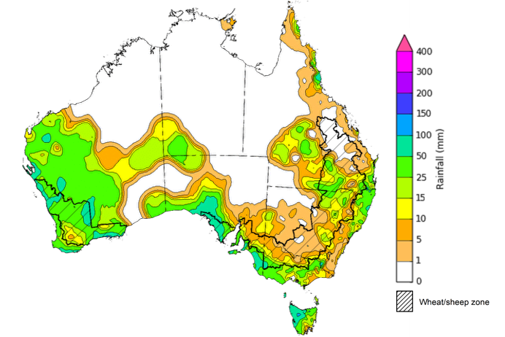
©Commonwealth of Australia 2026, Australian Bureau of Meteorology Issued: 17/6/2026
Note: The rainfall analyses and associated maps utilise data contained in the Bureau of Meteorology climate database, the Australian Data Archive for Meteorology (ADAM). The analyses are initially produced automatically from real-time data with limited quality control. They are intended to provide a general overview of rainfall across Australia as quickly as possible after the observations are received. For further information go to http://www.bom.gov.au/climate/rainfall/

Rainfall forecast for the next eight days
Over the 8 days to 25 June 2026, cold fronts and low-pressure systems are expected to bring rainfall to large areas of eastern and central Australia, while western and northern regions remain largely dry.
- In Victoria, much of New South Wales and southern Queensland falls of 10-50 millimetres are forecast, while Tasmania is likely to see higher falls of up to 100 millimetres.
- Lighter falls of between 5-25 millimetres are expected across parts of the Northern Territory and southern regions of South Australia and Western Australia
Across cropping regions, falls are expected to be broadly restricted to the east and southeast:
- Falls of 10-50 millimetres are forecast for Victoria, with lower rainfall totals of 10-25 millimetres forecast for New South Wales and much of Queensland.
  - If realised, these expected falls are likely to provide an additional boost to soil moisture levels across many eastern cropping areas. These falls are also expected to support the establishment and growth of winter crops.
- In contrast, remaining regions, including South Australia, Western Australia, and northern Queensland are expected to see little to no rainfall.

Total forecast rainfall for the period 18 June to 25 June 2026
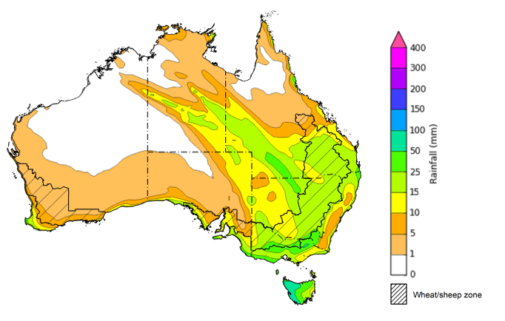
©Commonwealth of Australia 2026, Australian Bureau of Meteorology Issued 18/6/2026
Note: This rainfall forecast is produced from computer models. As the model outputs are not altered by weather forecasters, it is important to check local forecasts and warnings issued by the Bureau of Meteorology.

May precipitation percentiles and current production conditions
Crop production is affected by long-term trends in average rainfall and temperature, interannual climate variability, shocks during specific growth stages, and extreme weather events. Some crops are more tolerant than others to certain types of stresses, and at each growth stage, different types of stresses affect crop species in different ways.
Precipitation anomalies and outlooks presented below indicate the current and expected future production conditions for major grain and oilseed producing countries (responsible for over 80% of global crop production). This is an important input to assessing the global grain supply outlook.
Global precipitation was highly variable during May 2026. Drier-than average conditions spanned much of Europe, the Caribbean islands, the central and western United States, western and north-eastern Australia, parts of north-western and south-eastern Canada, and portions of north-eastern and southern parts of Asia, and much of South America. In contrast, above-average precipitation fell across central areas of Canada, the south-eastern United States, Türkiye and the Black Sea region, much of mainland Asia, and central and eastern Australia.
As of 28 May 2026, global production conditions were generally favourable for wheat, maize, rice and soybeans:
- Wheat – In the northern hemisphere, winter wheat is developing under broadly favourable conditions in China and European Union, while unfavourable conditions across parts of the United States, Canada, the European Union and Australia are likely to impact production outcomes.
- Maize – In the southern hemisphere, conditions have been largely favourable for the harvest across much of Brazil and Argentina. In the United States and China, sowing is underway in broadly favourable conditions, with some reductions in planted area in the United States and dryness impacting production across parts of central and eastern Europe.
- Rice – Global conditions remain broadly favourable for major rice production regions, with the exception of Vietnam where delayed harvest has impacted crop outcomes.
- Soybeans – The harvest in Brazil is concluding under favourable conditions, while the Argentina harvest is progressing despite recent flooding. Sowing is underway in parts of the northern hemisphere, including China, the United States, and Canada.

Crop conditions, AMIS countries, 28 May 2026
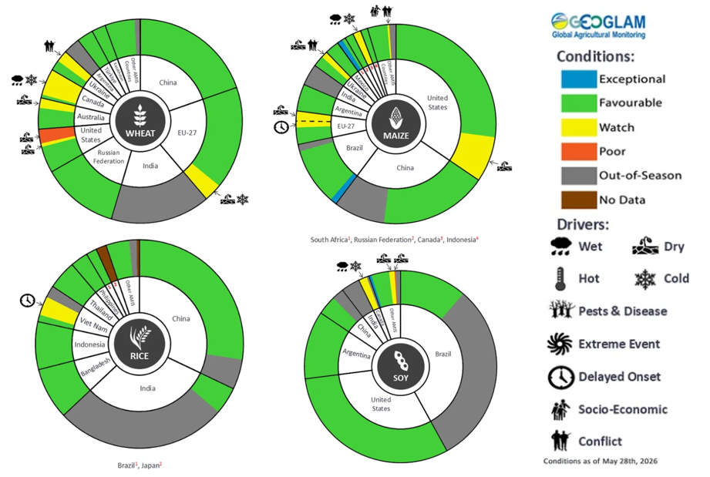
AMIS Agricultural Market Information System.
Source: AMIS

The global climate outlook for July 2026 to September 2026 indicates that mixed rainfall conditions are expected for the world’s major grain and oilseed producing regions. Outlooks and potential production impacts are presented in the following table.
Rainfall outlook and potential impact on the future state of production conditions, July 2026 - September 2026
Region | Rainfall outlook | Potential impact on production
Argentina | Above average rainfall is likely across parts of central and southern Argentina, with broadly average to below average rainfall in the north. | Anticipated rainfall is likely to support the planting and vegetative development of wheat, but could impede the planting of cotton and corn.
Black Sea Region | Below average rainfall is expected across western parts of the Russian Federation. | Below average rainfall is likely to adversely affect grain filling of wheat, as well as development of cotton, corn and sunflower from July.
Brazil | Rainfall outcomes across Brazil are expected to be broadly above average, with exceptions in the far east which is expected to see below average falls. | Above average rainfall across Brazil is likely to support the development of cotton and corn. Below average rainfall in the east is likely to hinder the development of wheat in July.
Canada | Rainfall across Canada is expected to be mixed, with broadly average conditions and areas of both below and above average precipitation in southern regions. | Average rainfall is likely to support wheat flowering, and the development of canola, corn, and soybeans in September.
China | Average rainfall is expected across most of China, with scattered areas of below average rainfall in inland and eastern regions. | Average rainfall across much of China is likely to support the growth and development of major crops over the season, including rice, cotton, corn and soybeans.
European Union | Average rainfall expected for much of the European Union, with exceptions in parts of Spain, Portugal, and Italy where below average rainfall is more likely. | Average rainfall across much of Europe is likely to benefit the development of corn, soybeans, and sunflower.
South Asia (India) | Below average rainfall is expected across parts of southern India, while above average rainfall is expected in northern areas. | Anticipated rainfall is likely to support the growth and development of many major grains and oilseeds, including corn, rice and sorghum, in the north but presents a downside production risk in the south.
Southeast Asia (SEA) | Below average rainfall is likely across much of Southeast Asia. | Below average rainfall in SEA is likely to impede growth and development outcomes for rice and corn.
The United States | Below average to average rainfall is likely for much of the eastern United States, with western and central areas likely to see above average falls. | Below average to average rainfall conditions expected across the eastern US is likely to reduce soil moisture and impact yield potential of major grains and oilseeds, but support the harvesting of crops.

Water markets – current week
Water storage levels in the Murray-Darling Basin (MDB) increased by 205 gigalitres (GL) between 11 June 2026 and 18 June 2026. The current volume of water held in storages is 10,755 GL, equivalent to 48% of total storage capacity. This is 17% or 2,168 GL less than the same time last year. Water storage data is sourced from the Bureau of Meteorology.

Water storages in the Murray-Darling Basin, 2013–2026
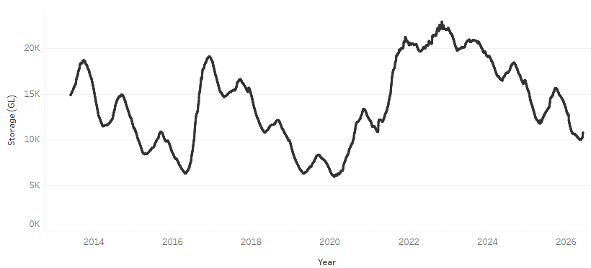
Allocation prices in the Water storages in the Murray-Darling Basin, 2013–2026 increased from $372/ML on 11 June 2026 to $384/ML on 18 June 2026. Trade from the Goulburn to the Murray is closed. Trade downstream through the Barmah Choke is closed. Trade from the Murrumbidgee to the Murray is open.

Water market prices, Southern Murray–Darling Basin
Region | $/ML
NSW Murray Above | 301
NSW Murrumbidgee | 399
Vic Greater Goulburn | 386
Vic Murray Below | 384
Note: The water allocation prices shown are volume weighted average prices based on the last 10 trades. Price data is sourced from Waterflow and current as at 18 June 2026.
To access the full, interactive, weekly water dashboard, which contains the latest and historical water storage, water market and water allocation information, please visit https://www.agriculture.gov.au/abares/products/weekly_update/weekly-update-260618

Commodities
Indicator | Week average | Unit | Latest Price | Previous Week | Weekly change |  | Price 12 months ago | Annual change
Selected world indicator prices
AUD/USD Exchange rate | 17-Jun | A$/US$ | 0.71 | 0.70 | 0% | 0.65 |  | 9%
Wheat – US no. 2 hard red winter wheat, FOB Gulf | 17-Jun | US$/t | 289 | 287 | 1% | 241 |  | 20%
Corn – US no. 2 yellow corn, FOB Gulf | 17-Jun | US$/t | 194 | 194 | 0% | 196 |  | -1%
Canola – Rapeseed, Canada, FOB Vancouver | 17-Jun | US$/t | 566 | 572 | -1% | 558 |  | 1%
Cotton – Cotlook A Index | 17-Jun | USc/lb | 85.7 | 84.7 | 1% | 78.2 |  | 10%
Sugar – Intercontinental Exchange, nearby futures, no.11 contract | 17-Jun | USc/lb | 14.3 | 14.4 | -1% | 16.7 |  | -15%
Wool – Eastern Market Indicator | 17-Jun | Ac/kg clean | 1989 | 1979 | 1% | 1204 |  | 65%
Wool – Western Market Indicator | 10-Jun | Ac/kg clean | 2170 | 2125 | 2% | 1354 |  | 60%
Selected Australian grain export prices
Australian Premium White (APW) Wheat, FOB Port Adelaide, SA | 17-Jun | A$/t | 394 | 390 | 1% | 387 |  | 2%
Australian Standard White (ASW) Wheat, FOB Port Adelaide, SA | 17-Jun | A$/t | 383 | 378 | 1% | 382 |  | 0%
Feed Barley – FOB Port Adelaide, SA | 17-Jun | A$/t | 388 | 386 | 0% | 371 |  | 5%
Canola – FOB Kwinana, WA | 17-Jun | A$/t | 820 | 820 | 0% | 824 |  | 0%
Grain Sorghum – FOB Brisbane, QLD | 17-Jun | A$/t | 437 | 437 | 0% | 425 |  | 3%
Selected domestic livestock indicator prices
Beef – Eastern Young Cattle Indicator | 17-Jun | Ac/kg cwt | 987 | 971 | 2% | 712 |  | 39%
Mutton – Mutton indicator (18–24 kg fat score 2–3), VIC | 17-Jun | Ac/kg cwt | 876 | 859 | 2% | 651 |  | 35%
Lamb – National Trade Lamb Indicator | 17-Jun | Ac/kg cwt | 1211 | 1228 | -1% | 1014 |  | 19%
Pig – Eastern Seaboard (60.1–75 kg), NSW buyer price | 3-Jun | Ac/kg cwt | 425 | 429 | -1% | 452 |  | -6%
Live cattle – Light steers to Indonesia | 29-Apr | Ac/kg lwt | 420 | 430 | -2% | 339 |  | 24%
Global Dairy Trade (GDT) weighted average prices
Dairy – Whole milk powder | 17-Jun | US$/t | 3589 | 3706 | -3% | 4129 |  | -13%
Dairy – Skim milk powder | 17-Jun | US$/t | 3368 | 3457 | -3% | 2791 |  | 21%
Dairy – Cheddar cheese | 17-Jun | US$/t | 4471 | 4621 | -3% | 4876 |  | -8%
Dairy – Anhydrous milk fat | 17-Jun | US$/t | 6601 | 6668 | -1% | 7325 |  | -10%

Selected world indicator prices
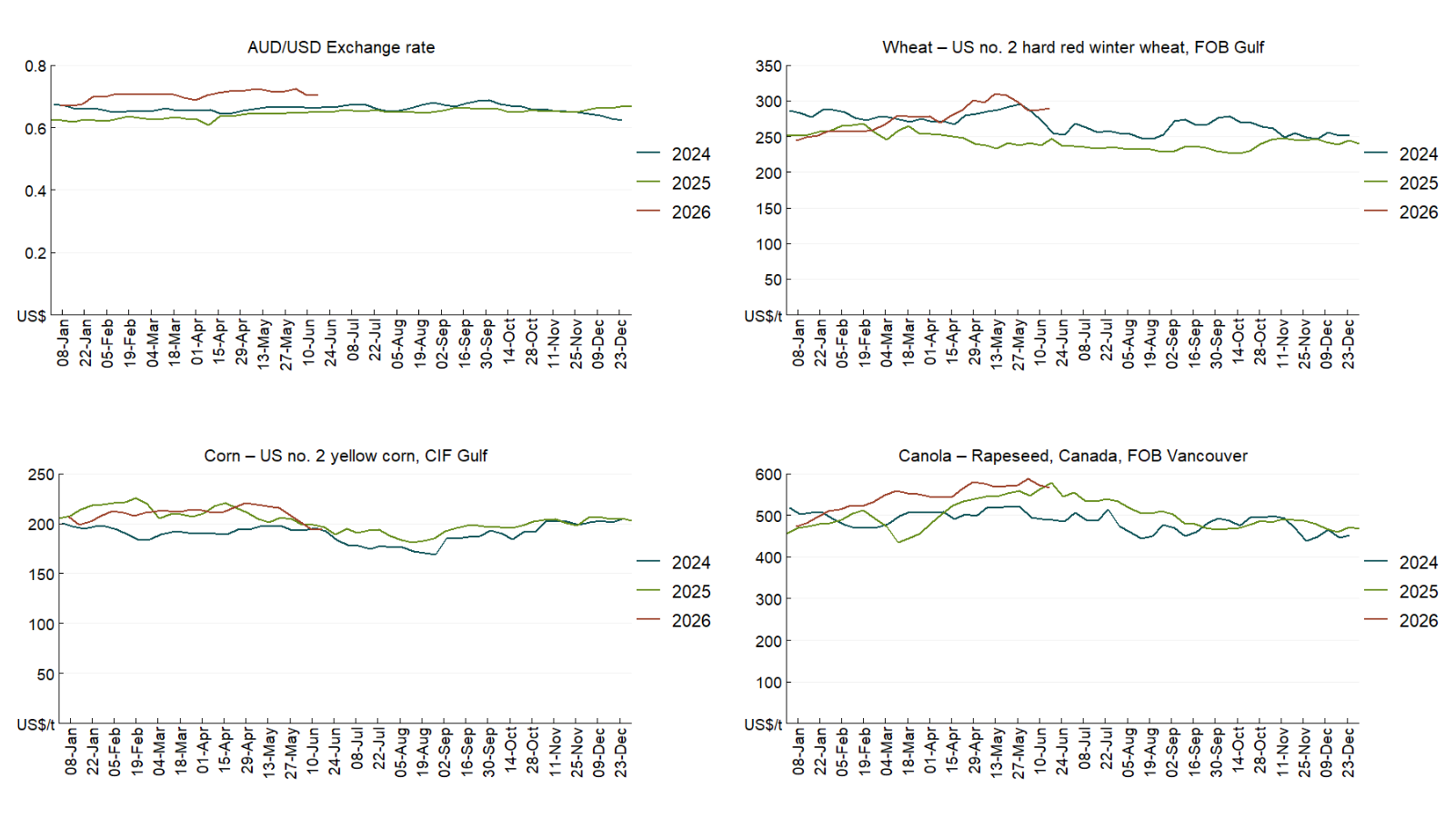

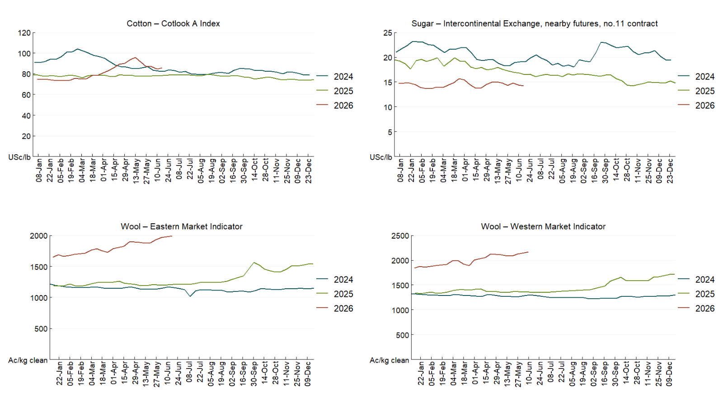

3.2 Selected domestic crop indicator prices
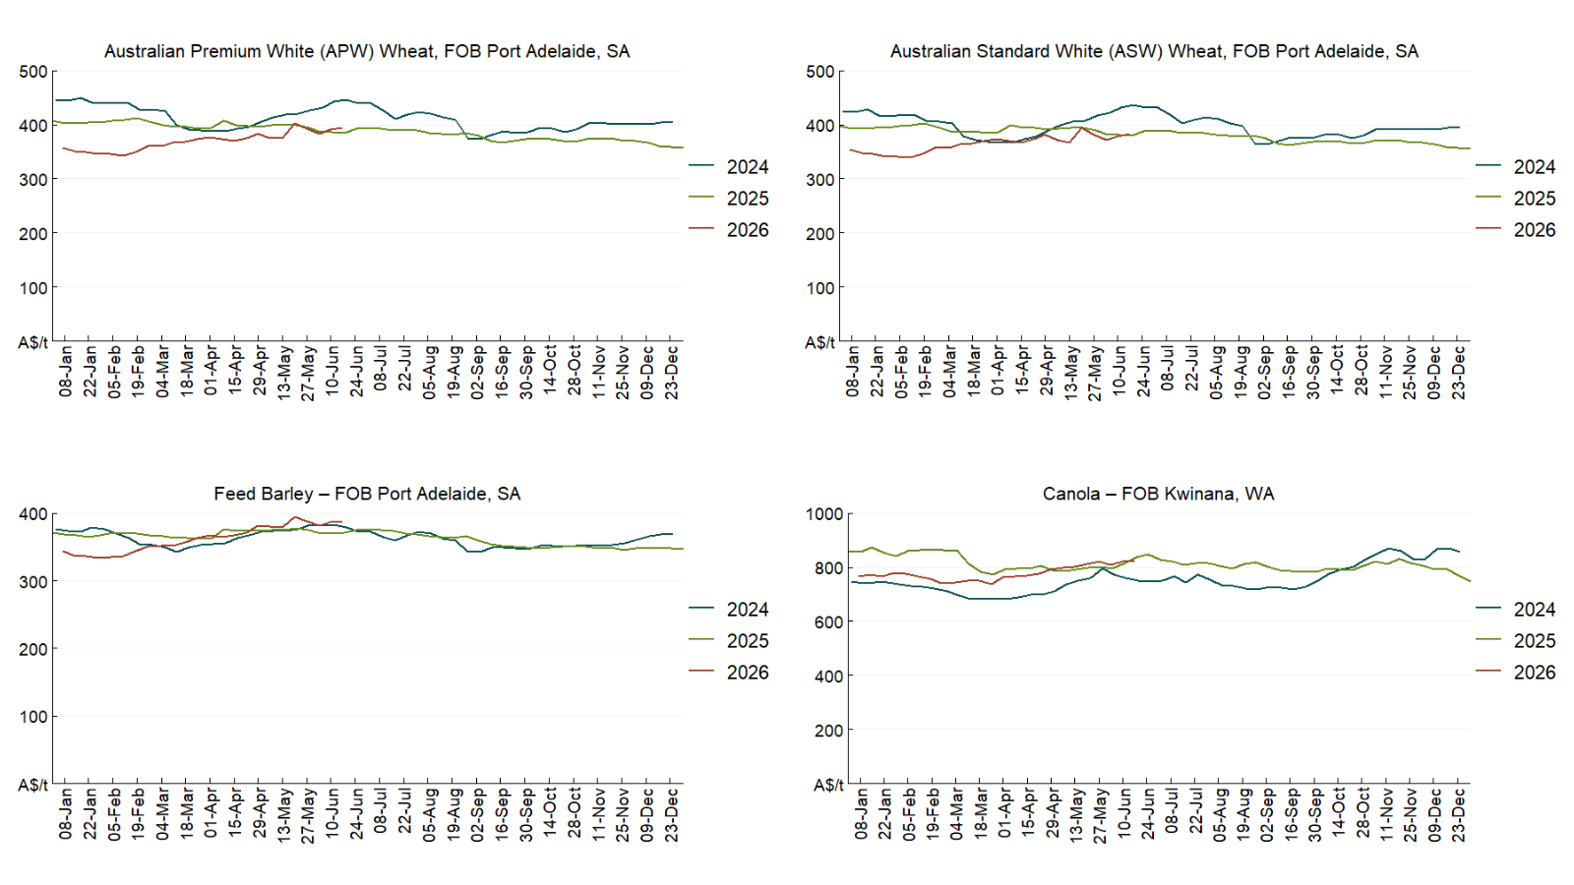

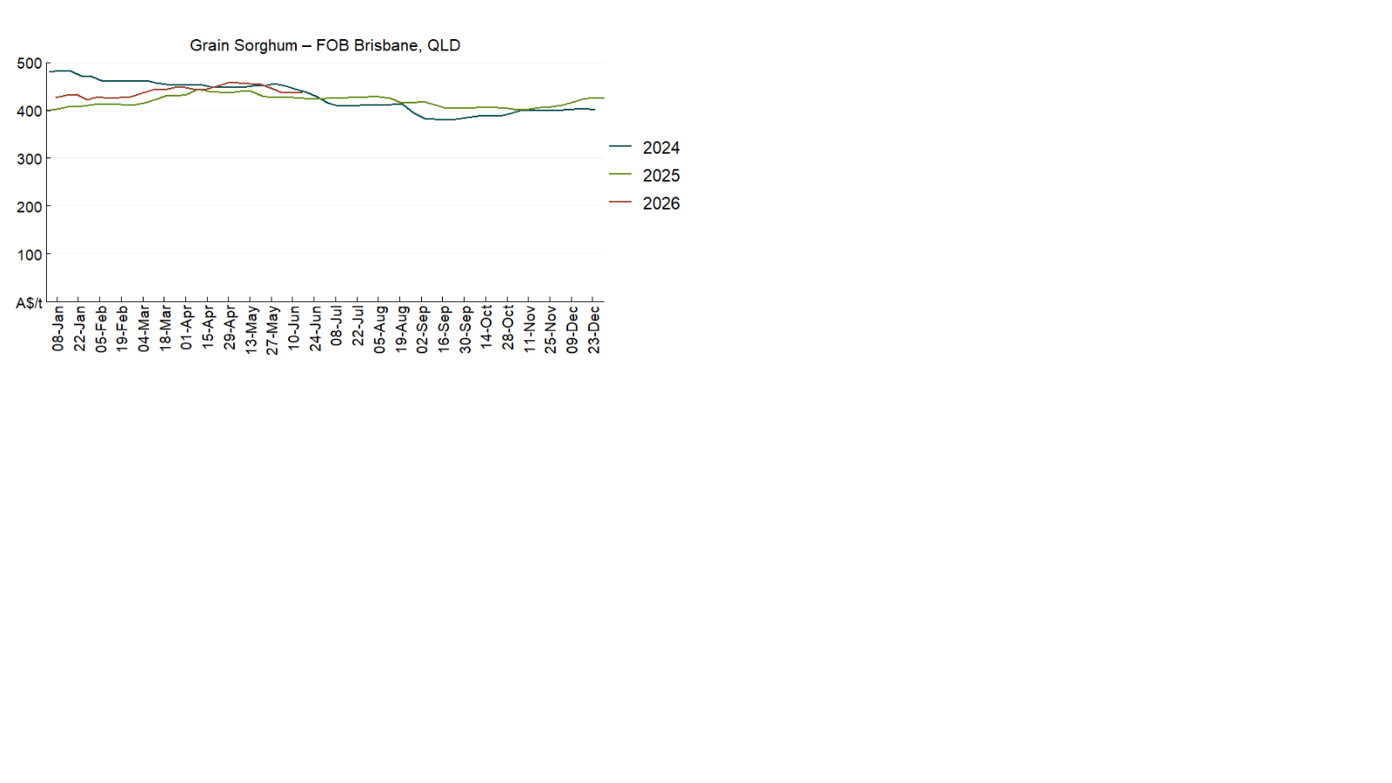

3.3 Selected domestic livestock indicator prices
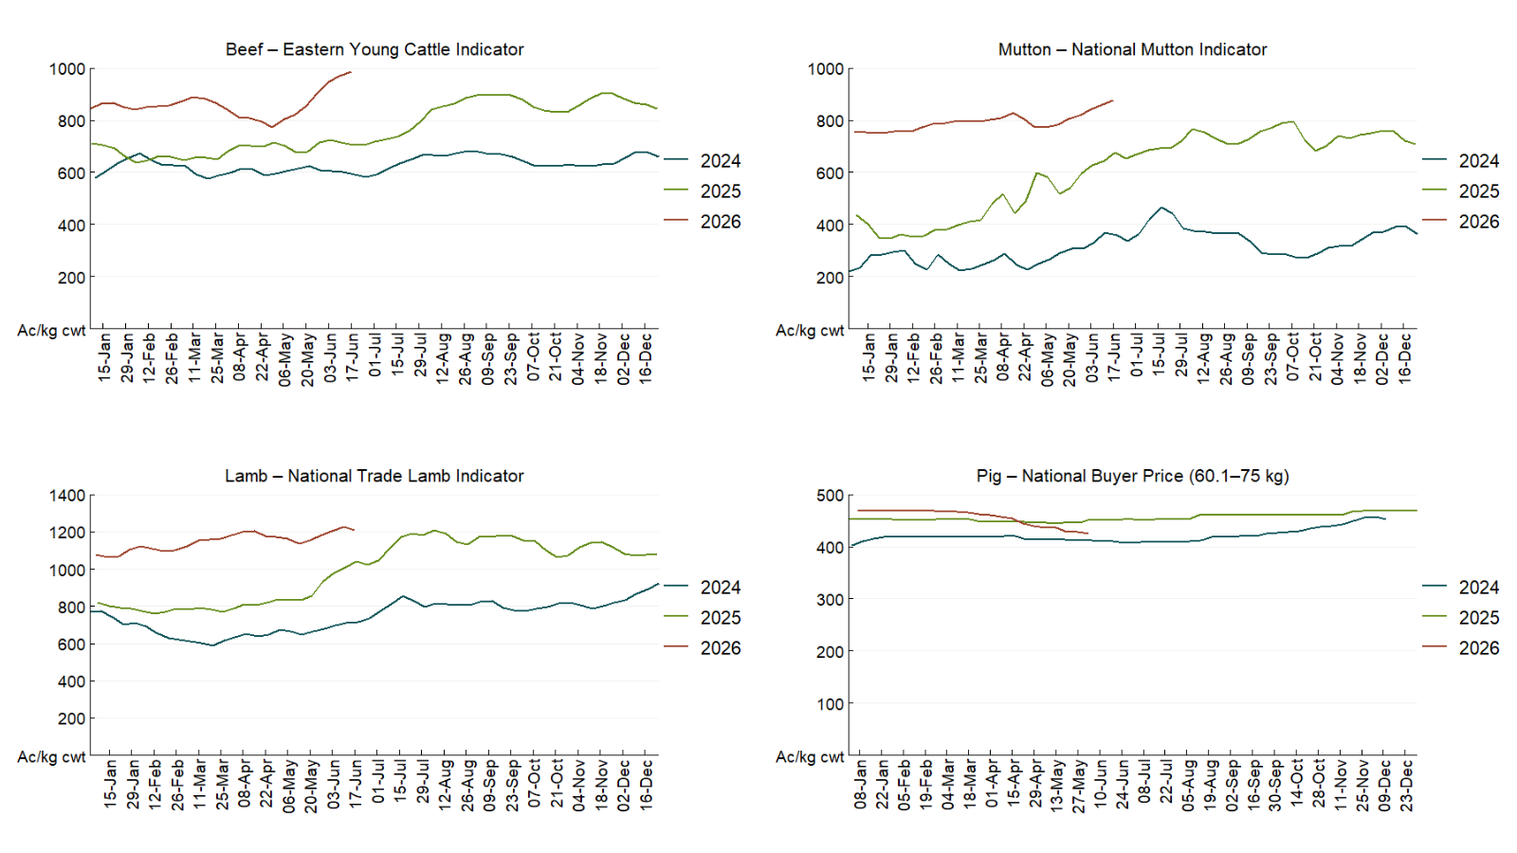

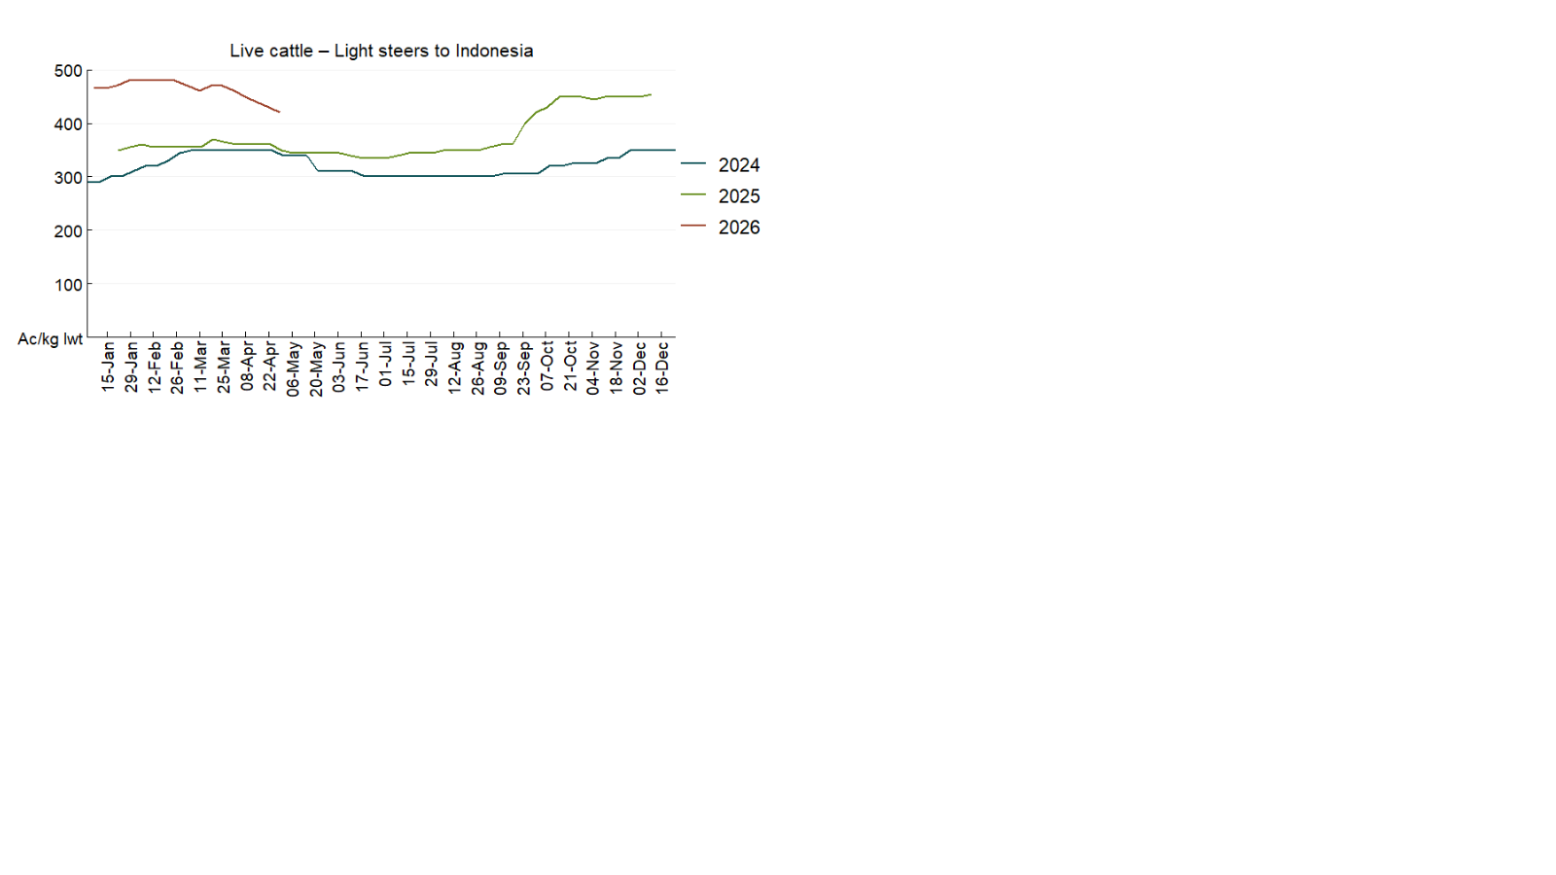

3.4 Global Dairy Trade (GDT) weighted average prices 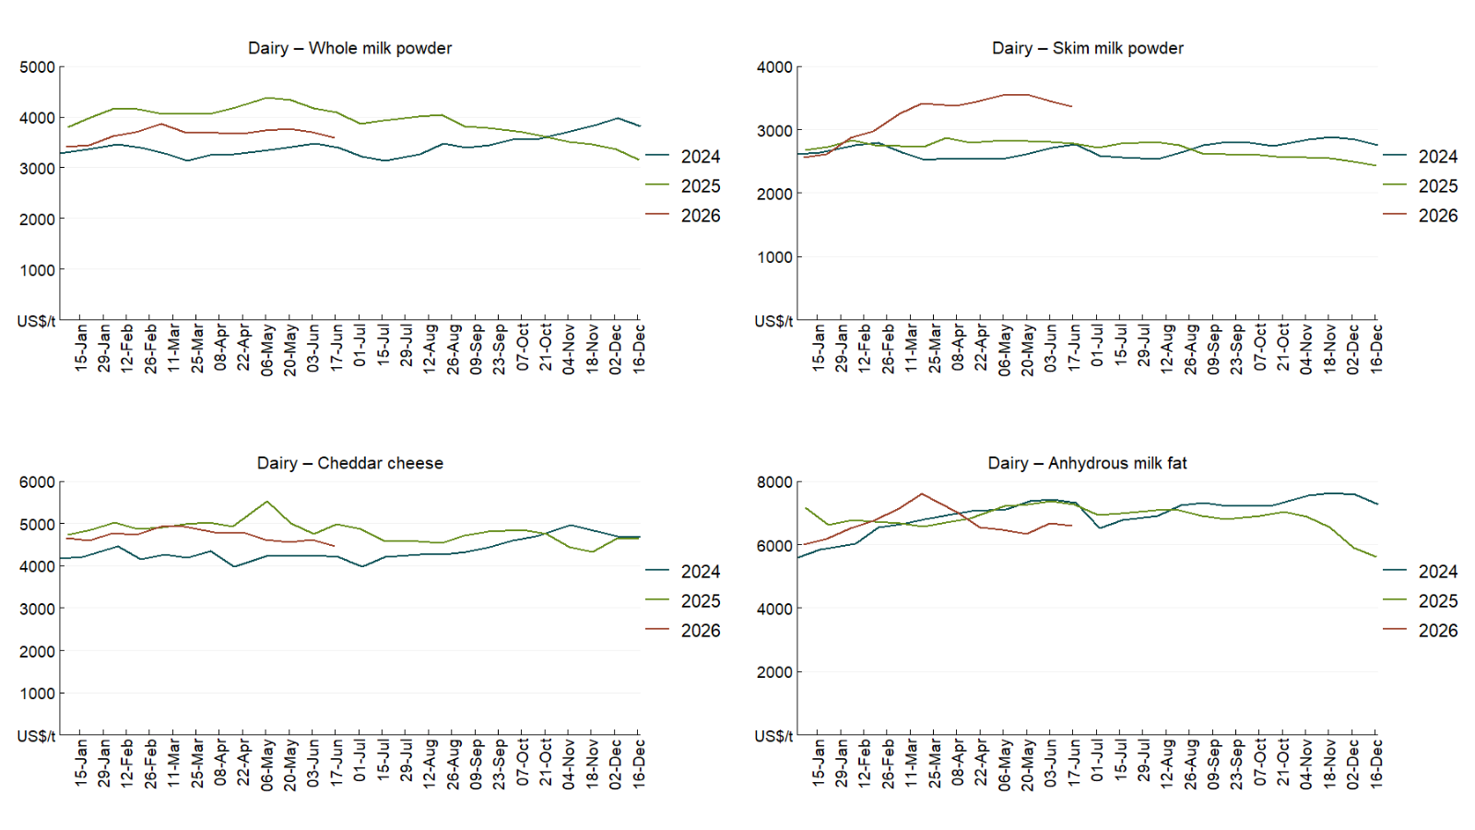

3.5 Selected fruit and vegetable prices
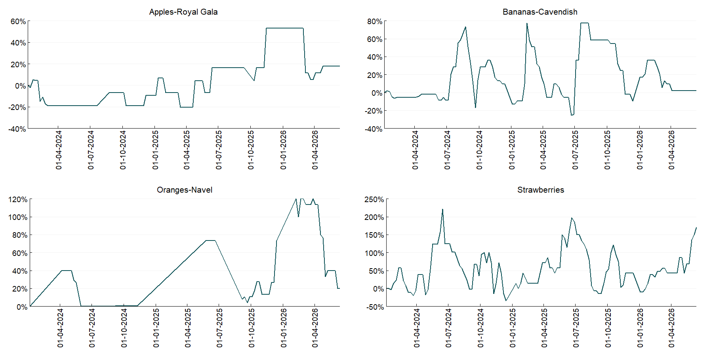

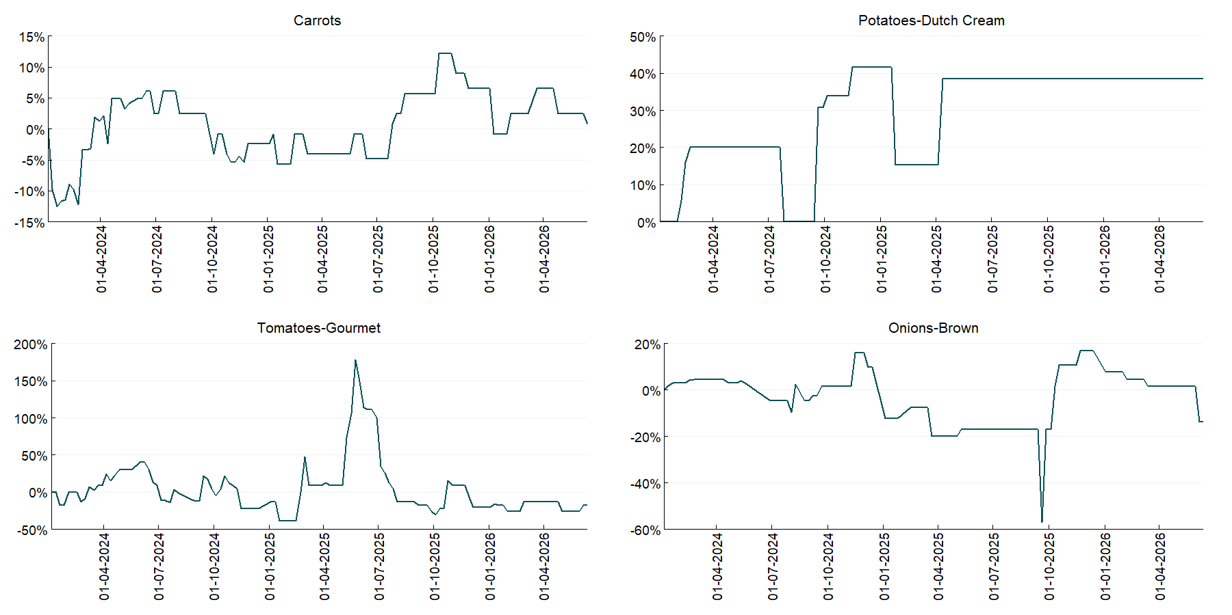

3.6 Selected domestic fodder indicator prices
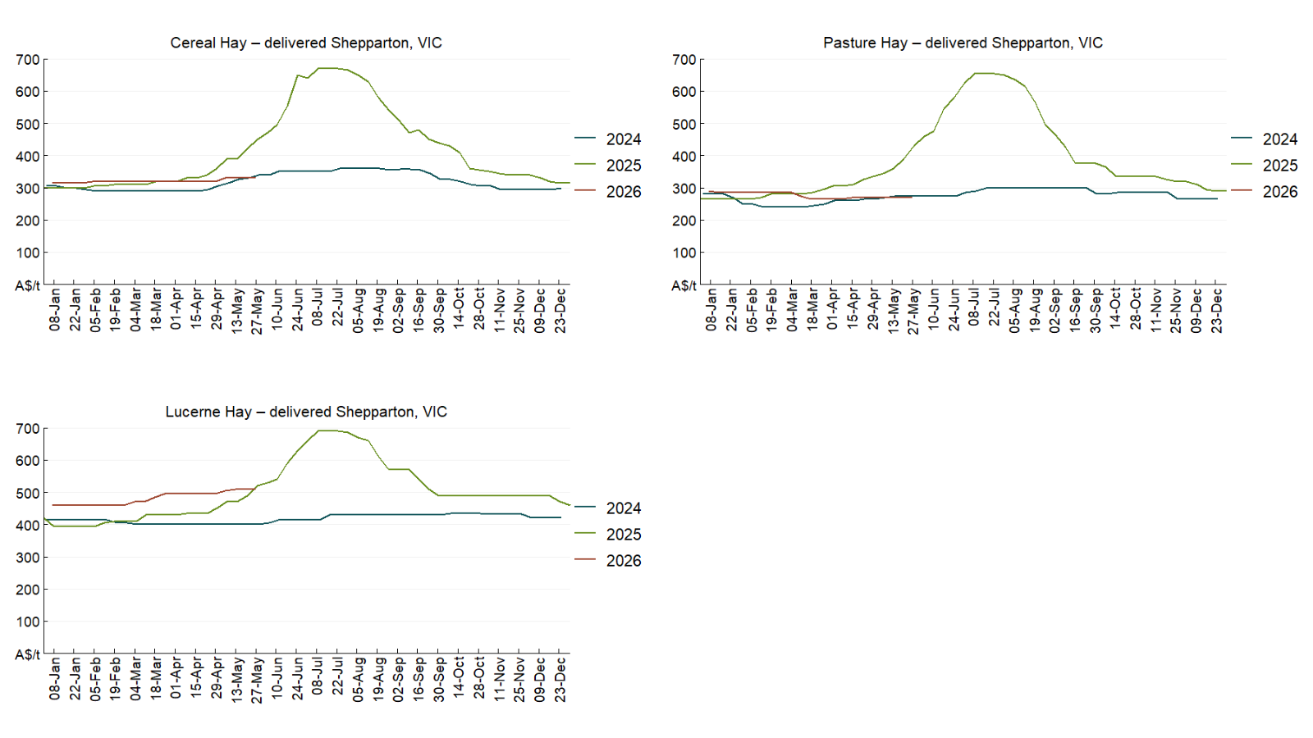

4. Data attribution

Climate
Bureau of Meteorology
- Weekly rainfall totals: www.bom.gov.au/climate/maps/rainfall/
- Monthly and last 3-month rainfall percentiles: https://www.bom.gov.au/climate/ahead/outlooks/#moreMaps
- Rainfall forecast: www.bom.gov.au/jsp/watl/rainfall/pme.jsp
- Seasonal outlook: www.bom.gov.au/climate/outlooks/#/overview/summary/
- Climate drivers: http://www.bom.gov.au/climate/enso/
- Soil moisture: https://awo.bom.gov.au/products/historical/soilMoisture-rootZone/

Other
- Pasture growth: www.longpaddock.qld.gov.au/aussiegrass/
- 3-month global outlooks: Environment and Climate Change Canada, NOAA Climate Prediction Center, EUROBRISA CPTEC/INPE, European Centre for Medium-Range Weather Forecasts, Hydrometcenter of Russia, National Climate Center Climate System Diagnosis and Prediction Room (NCC), International Research Institute for Climate and Society
- Global production: https://ipad.fas.usda.gov/ogamaps/cropmapsandcalendars.aspx
- Autumn break: Pook et al., 2009, https://rmets-onlinelibrary-wiley-com.virtual.anu.edu.au/doi/epdf/10.1002/joc.1833

Water
Prices
- Waterflow: https://www.waterflow.io/
- Ruralco: https://www.ruralcowater.com.au/
- Bureau of Meteorology:
- Allocation trade: http://www.bom.gov.au/water/dashboards/#/water-markets/mdb/at
- Storage volumes: http://www.bom.gov.au/water/dashboards/#/water-storages/summary/drainage

Trade constraints:
- Water NSW: https://www.waternsw.com.au/customer-service/ordering-trading-and-pricing/trading/murrumbidgee
- Victorian Water Register: https://www.waterregister.vic.gov.au/TradingRules2019/

Commodities
Fruit and vegetables
- Datafresh: www.freshstate.com.au

Pigs
- Australian Pork Limited: www.australianpork.com.au

Dairy
- Global Dairy Trade: www.globaldairytrade.info/en/product-results/

World wheat, canola
- International Grains Council
- https://www.igc.int/en/default.aspx
- United States Department of Agriculture

World cotton
- Cotlook: www.cotlook.com/

World sugar
- New York Stock Exchange - Intercontinental Exchange

Wool
- Australian Wool Exchange: www.awex.com.au/

Domestic wheat, barley, sorghum, canola and fodder
- Jumbuk Consulting Pty Ltd: Jumbuk AG | Agriculture Consulting

Cattle, beef, mutton, lamb, goat and live export
- Meat and Livestock Australia: https://www.mla.com.au/prices-markets/

Australian Agricultural Drought Indicators
About Australian Agricultural Drought Indicators
The Australian Agricultural Drought Indicators (AADI) links weather and agricultural data with a range of scientific and economic models to measure and forecast the effects of climate variability and drought on agricultural outcomes.
On AADI, projected broadacre farm profits are presented as percentile outcomes relative to simulated historical outcomes using the groupings:
Highest | 95-100th percentile
Very much above average | 85-95th percentile
Above average | 65-85th percentile
Average | 35-65th percentile
Below average | 15-35th percentile
Very much below average | 5-15th percentile
Lowest 5% | 0-5th percentile

There are two AADI farm profit indicators:
- The AADI farm profit climate and price indicator shows the effect of climate and prices on broadacre farm business profits of current farms compared to the last 33 years.
- The AADI farm profit climate only indicator isolates the effect of climate on profits by holding prices fixed.

© Commonwealth of Australia 2026

Ownership of intellectual property rights
Unless otherwise noted, copyright (and any other intellectual property rights, if any) in this publication is owned by the Commonwealth of Australia (referred to as the Commonwealth).

Creative Commons licence
All material in this publication is licensed under a Creative Commons Attribution 4.0 International Licence except content supplied by third parties, logos and the Commonwealth Coat of Arms.
Inquiries about the licence and any use of this document should be emailed to copyright@awe.gov.au.


Cataloguing data
This publication (and any material sourced from it) should be attributed as:
ABARES 2026, Weekly Australian Climate, Water and Agricultural Update, Australian Bureau of Agricultural and Resource Economics and Sciences, Canberra, 18 June 2026. CC BY 4.0 DOI: https://doi.org/10.25814/5f3e04e7d2503
ISSN 2652-7561
This publication is available at https://www.agriculture.gov.au/abares/products/weekly_update
Department of Agriculture, Fisheries and Forestry
GPO Box 858 Canberra ACT 2601
Telephone 1800 900 090
Web agriculture.gov.au/abares

Disclaimer
The Australian Government acting through the Department of Agriculture, Fisheries and Forestry, represented by the Australian Bureau of Agricultural and Resource Economics and Sciences, has exercised due care and skill in preparing and compiling the information and data in this publication. Notwithstanding, the Department of Agriculture, Fisheries and Forestry, ABARES, its employees and advisers disclaim all liability, including liability for negligence and for any loss, damage, injury, expense or cost incurred by any person as a result of accessing, using or relying on any of the information or data in this publication to the maximum extent permitted by law.

Statement of Professional Independence
The views and analysis presented in ABARES publications, including this one, reflect ABARES professionally independent findings, based on scientific and economic concepts, principles, information and data. These views, analysis and findings may not reflect or be consistent with the views or positions of the Australian Government, or of organisations or groups who have commissioned ABARES reports or analysis. More information on professional independence is provided on the ABARES website.

Acknowledgements
This report was prepared by Holly Beale and Matthew Miller.

