
No. 25/2026 2 July 2026

Summary of key issues
- In the week ending 1 July 2026, rainbands and low-pressure systems brought rainfall to parts of southern, western, and eastern Australia. Much of the remainder of Australia was largely dry.
  - Cropping regions in Victoria and Western Australia saw 10-100 millimetres of rainfall, with higher rainfall totals in western margins of Western Australia and the southern margins of Victoria. In New South Wales, falls of between 5-50 millimetres were recorded.
  - South Australia saw lower falls of 5-10 millimetres, with isolated areas seeing up to 25 millimetres.
- Over the 8 days to 9 July 2026, cold fronts and low-pressure systems are expected to bring rainfall to limited areas of south-eastern and south-western Australia
- Across cropping regions, falls of 5-25 millimetres are forecast for central and western South Australia, northern New South Wales, and much of Victoria.
  - If realised, these expected falls will continue to support the establishment and growth of winter crops.
- Rainfall during June 2026 was generally above average in southern and central regions, and below average across parts of the north, east and far-west. Across the south, generally average above average falls have provided a timely boost to soil moisture and support the establishment and growth of winter crops and pastures.
- Pasture growth for the three months to June 2026 was mixed but broadly high in central and southern areas, with much of south-eastern and central Australia seeing robust pasture growth, and below average growth was evident across areas of north-east and north-western Australia. Soil moisture models indicate broadly average to above average soil moisture levels with exceptions in parts of southern Western Australia, north-western and north-eastern Australia.
- Water storage levels in the Murray-Darling Basin (MDB) increased by 317 gigalitres (GL) between 25 June 2026 and 2 July 2026. The current volume of water held in storages is 11,337 GL, equivalent to 51% of total storage capacity. This is 14% or 1,840 GL less than the same time last year. Water storage data is sourced from the Bureau of Meteorology.
- Allocation prices in the Victorian Murray below the Barmah Choke increased from $390/ML on 25 June 2026 to $414/ML on 30 June 2026. Trade from the Goulburn to the Murray is open. Trade downstream through the Barmah Choke is open. Trade from the Murrumbidgee to the Murray is open.

Climate

Rainfall this week
In the week ending 1 July 2026, rainbands and low-pressure systems brought rainfall to large areas of southern, central, and eastern Australia. Much of the remainder of Australia was largely dry.
- Falls of 10-100 millimetres were recorded across southwest Western Australia, Tasmania, and much of Victoria. Similarly, much of south-eastern Australia saw falls of 5-50 millimetres, including eastern South Australia and New South Wales.
- In Queensland, falls were mixed, with south-eastern regions seeing limited falls while south-western regions saw up to 50 millimetres. Much of northern Australia saw little to no rainfall.
In cropping regions, considerable falls were recorded in south-eastern and western regions, while north-eastern regions were comparatively dry:
- Cropping regions in Victoria and Western Australia saw 5-100 millimetres of rainfall, with higher rainfall totals in western margins of Western Australia and the southern margins of Victoria. In New South Wales, falls of between 5-50 millimetres were recorded.
- South Australia saw lower falls of 5-10 millimetres, with isolated areas seeing up to 25 millimetres. Queensland saw little to no rainfall over the period.
  - The heavier falls across southwest and southeast Australia will have provided a boost to soil moisture levels which will support the establishment and growth of winter crops.

Rainfall for the week ending 1 July 2026
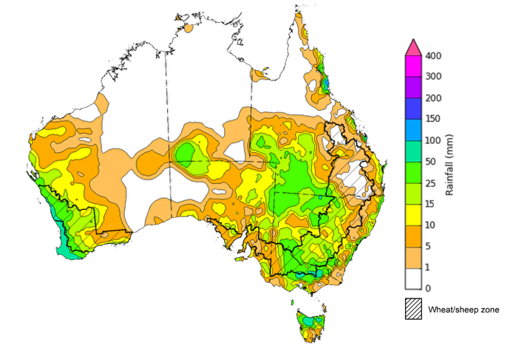
©Commonwealth of Australia 2026, Australian Bureau of Meteorology Issued: 1/7/2026
Note: The rainfall analyses and associated maps utilise data contained in the Bureau of Meteorology climate database, the Australian Data Archive for Meteorology (ADAM). The analyses are initially produced automatically from real-time data with limited quality control. They are intended to provide a general overview of rainfall across Australia as quickly as possible after the observations are received. For further information go to http://www.bom.gov.au/climate/rainfall/

Rainfall forecast for the next eight days
Over the 8 days to 9 July 2026, cold fronts and low-pressure systems are expected to bring rainfall to limited areas of southern and central Australia, while much of the rest of the country remains largely dry.
- Moderate falls of up to 50 millimetres are forecast for select southeast and southwest areas, including southern Victoria, southern and eastern New South Wales, Tasmania, and the far southwest of Western Australia. Similarly, the southern Northern Territory is expected to receive up to 50 millimetres.
- Remaining areas are expected to see little to no rainfall.
Across cropping regions, falls are expected to be limited across most cropping regions:
- Falls of 5-25 millimetres are forecast for central and western South Australia, northern New South Wales, and much of Victoria.
  - If realised, these expected falls will continue to support the establishment and growth of winter crops.
- In contrast, southern Queensland, Western Australia, and the remainder of New South Wales are expected to see lighter falls of between 1-10 millimetres.

Total forecast rainfall for the period 2 July to 9 July 2026
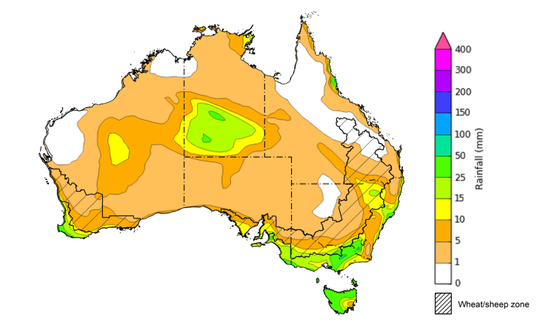
©Commonwealth of Australia 2026, Australian Bureau of Meteorology Issued 2/7/2026
Note: This rainfall forecast is produced from computer models. As the model outputs are not altered by weather forecasters, it is important to check local forecasts and warnings issued by the Bureau of Meteorology.

Monthly rainfall
Rainfall during June 2026 was generally above average in southern and central regions, and below average across parts of the north, east and south-west.
- A series of low-pressure systems have brought widespread above average rainfall to southern and central Australia – supporting pasture production and soil moisture for producers.
- In the east and across parts of northern Australia, high-pressure systems have limited rainfall outcomes.
In cropping regions, June rainfall was generally average to very much above average in the south, and below average in north-eastern areas.
- Below average rainfall in much of Queensland has led to a drawdown of soil moisture storage and continued to constrain winter crop planting and growth.
- Across the south, generally average above average falls have provided a timely boost to soil moisture and support the establishment and growth of winter crops and pastures.
Rainfall deciles for June 2026
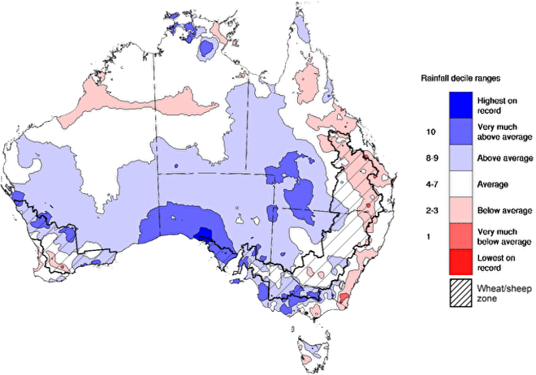
Note: Rainfall for June 2026 is compared with rainfall recorded for that period during the historical record (1900 to present). For further information, go to http://www.bom.gov.au/climate/austmaps/about-rain-maps.shtml
Source: Bureau of Meteorology

Monthly Soil Moisture
In June 2026, modelled upper layer soil moisture was generally average to above average across much of the country. Some isolated areas of extremely low soil moisture was modelled in the south and east of Australia.
- Scattered areas of northern Queensland, southern coastal New South Wales, south-eastern Western Australia, and isolated central areas of Australia saw below average to extremely low upper layer soil moisture.
- In contrast, much of the remainder of Queensland, central and western New South Wales, South Australia, remaining areas in Western Australia, and most of the northern and southern Northern Territory saw average to very much above upper layer soil moisture.
At this time of year, upper layer soil moisture is important for the establishment and vegetative growth of winter crops across Australian cropping regions.
- Across cropping regions, modelled upper layer soil moisture in June for most cropping regions was generally average to very much above average, while northern parts of Queensland saw below average to average upper layer soil moisture.
This represents a substantial improvement in growing conditions in south-western cropping regions compared to May 2026, however adequate and timely rainfall throughout the remainder of the growing season will be needed to support ongoing improvements in cropping and pasture growth outcomes.
Modelled upper layer soil moisture for June 2026
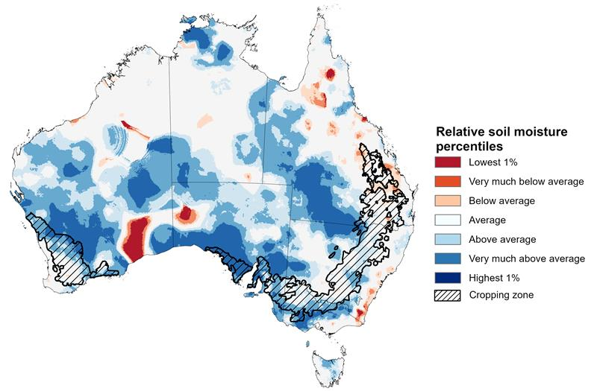

Note: This map shows the levels of modelled upper layer soil moisture (0 to 10 centimetres) during June 2026 This map shows how modelled soil conditions during June 2026 compare with June conditions modelled over the reference period (1911 to 2016). Dark blue areas on the maps were much wetter in June 2026 than during the reference period. The bulk of plant roots occur in the top 20 centimetres of the soil profile. Soil moisture in the upper layer of the soil profile is therefore useful indicator of the availability of water, particularly for germinating seed.
Source: Bureau of Meteorology (https://awo.bom.gov.au/about/overview)
Modelled lower layer soil moisture in June 2026 was average to very much above average across much of Australia, while extremely low to below average modelled lower layer soil moisture was evident across some eastern and western areas.
- Parts of northern and eastern Queensland, eastern Victoria, Tasmania, western South Australia and central Western Australia were modelled as having extremely low to below average lower layer soil moisture. By contrast, much of the Northern Territory, southern and western Queensland, New South Wales, western Victoria, and central and eastern South Australia were modelled as having above average to very much above average soil moisture over the period.
Lower layer soil moisture is a larger, deeper store that is slower to respond to seasonal conditions and tends to reflect the accumulated effects of events that have occurred over longer periods. Crop development and pasture growth in areas of above average lower layer soil moisture are typically less reliant on in-season rainfall than in areas with below average lower layer soil moisture.
Some cropping regions in northern Queensland and southern Western Australia were modelled as having extremely low to below average soil moisture. In contrast, Victoria, South Australia, southern Queensland and remaining areas in Western Australia recorded average to very much above average soil moisture for this time of year.
In areas with average to above average lower layer soil moisture, this is likely to provide a reserve of plant-available water to support crop growth over the winter period. Agricultural regions across southern Australia have seen a significant improvement in soil moisture levels since the end of January 2026. Furthermore, June 2026 modelling shows considerable improvements from May 2026 – these gains in soil moisture levels mean the winter crop and pasture growth in the coming months will be less reliant on forecast rainfall outcomes.
Modelled lower layer soil moisture for June 2026
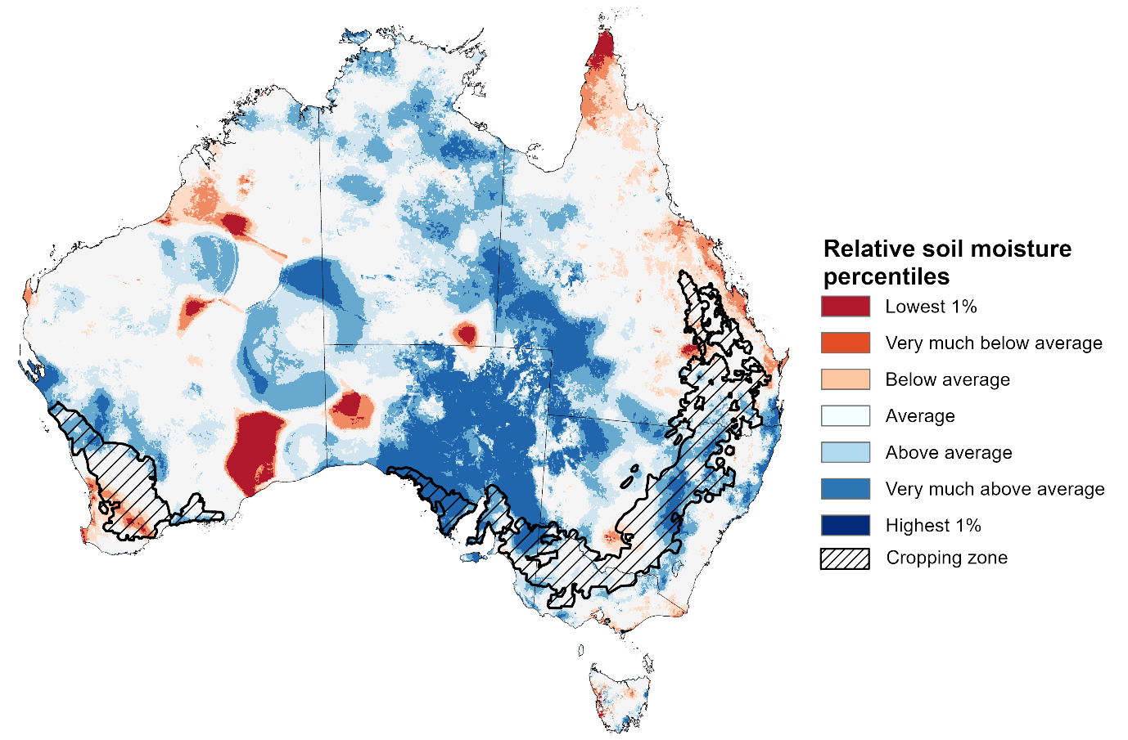
Note:. This map shows how modelled soil conditions during June 2026 compare with June conditions modelled over the reference period (1911 to 2016). Dark blue areas on the maps were much wetter in June 2026 than during the reference period. The dark red areas were much drier than during the reference period. The bulk of plant roots occur in the top 20 centimetres of the soil profile. The lower layer soil moisture is a larger, deeper store that is slower to respond to rainfall and tends to reflect accumulated rainfall events over longer time periods.
Source: Bureau of Meteorology (https://awo.bom.gov.au/about/overview)

Pasture Growth
Pasture growth during the April to June period affects the availability of fodder to support livestock production across northern Australia as it enters a seasonally low growth period. Across southern Australia, autumn pasture growth influences the standing biomass available to support livestock production over winter and the reliance on hay and grain during this period. Pasture availability during this period influences the growth and branding and marking rates of lambs and calves, livestock turnoff and the production of meat, milk, and wool.
Pasture growth for the three months to June 2026 was variable across much of country.
- Average to extremely high relative pasture growth across much of southern and central Australia.
  - This pasture growth is expected to have allowed many farmers to maintain livestock numbers, provide opportunities to build standing dry matter availability.
- In contrast, large areas of northern, western, and north-eastern Australia saw relatively low pasture growth for this time of year.
  - This below average pasture growth has likely led to a decline in pasture availability. Graziers in regions where below average pasture growth was recorded, will be more reliant on supplemental feed to maintain current stocking rates over the seasonally low pasture growth period.
Relative pasture growth for 3-months ending June 2026 (1 April to 31 June 2026)
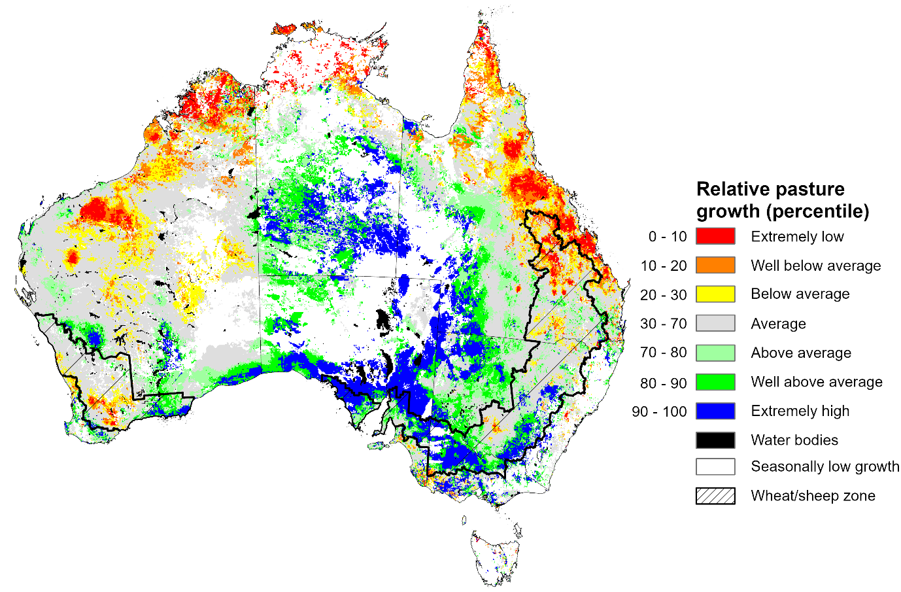

Notes: AussieGRASS pasture growth estimates are relative to the long-term record and shown in percentiles. Percentiles rank data on a scale of zero to 100. This analysis ranks pasture growth for the selected period against average pasture growth for the long-term record (1957 to 2016). Pasture growth is modelled at 5km2 grid cells.
Source: Department of Environment, Science and Innovation

Water markets – current week
Water storage levels in the Murray-Darling Basin (MDB) increased by 317 gigalitres (GL) between 25 June 2026 and 02 July 2026. The current volume of water held in storages is 11,337 GL, equivalent to 51% of total storage capacity. This is 14% or 1,840 GL less than the same time last year. Water storage data is sourced from the Bureau of Meteorology.

Water storages in the Murray-Darling Basin, 2013–2026
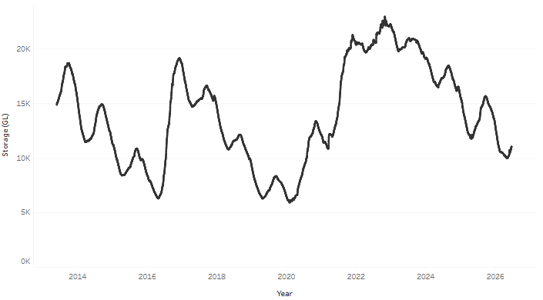
Allocation prices in the Victorian Murray below the Barmah Choke increased from $390/ML on 25 June 2026 to $414/ML on 30 June 2026. Trade from the Goulburn to the Murray is open. Trade downstream through the Barmah Choke is open. Trade from the Murrumbidgee to the Murray is open.

Surface water trade activity 2022-2026, Victorian Murray below the Barmah Choke
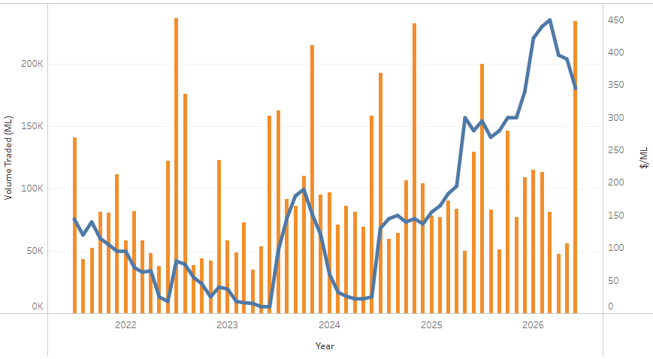

Water market prices, Southern Murray–Darling Basin
Region | $/ML
NSW Murray Above | 314
NSW Murrumbidgee | 400
Vic Greater Goulburn | 426
Vic Murray Below | 414
Note: The water allocation prices shown are volume weighted average prices based on the last 10 trades. Price data is sourced from Waterflow and current as at 25 June 2026.
To access the full, interactive, weekly water dashboard, which contains the latest and historical water storage, water market and water allocation information, please visit https://www.agriculture.gov.au/abares/products/weekly_update/weekly-update-260625

Commodities
Indicator | Week average | Unit | Latest Price | Previous Week | Weekly change |  | Price 12 months ago | Annual change
Selected world indicator prices
AUD/USD Exchange rate | 1-Jul | A$/US$ | 0.69 | 0.69 | -1% | 0.65 |  | 5%
Wheat – US no. 2 hard red winter wheat, FOB Gulf | 1-Jul | US$/t | 276 | 283 | -2% | 235 |  | 18%
Corn – US no. 2 yellow corn, FOB Gulf | 1-Jul | US$/t | 196 | 194 | 1% | 192 |  | 2%
Canola – Rapeseed, Canada, FOB Vancouver | 1-Jul | US$/t | 550 | 547 | 0% | 539 |  | 2%
Cotton – Cotlook A Index | 1-Jul | USc/lb | 85.3 | 87.1 | -2% | 78.9 |  | 8%
Sugar – Intercontinental Exchange, nearby futures, no.11 contract | 1-Jul | USc/lb | 14.9 | 14.1 | 6% | 16.4 |  | -9%
Wool – Eastern Market Indicator | 24-Jun | Ac/kg clean | 1,943 | 1,989 | -2% | 1,220 |  | 59%
Wool – Western Market Indicator | 24-Jun | Ac/kg clean | 2,129 | 2,170 | -2% | 1,360 |  | 57%
Selected Australian grain export prices
Australian Premium White (APW) Wheat, FOB Port Adelaide, SA | 1-Jul | A$/t | 392 | 398 | -1% | 391 |  | 0%
Australian Standard White (ASW) Wheat, FOB Port Adelaide, SA | 1-Jul | A$/t | 380 | 386 | -2% | 387 |  | -2%
Feed Barley – FOB Port Adelaide, SA | 1-Jul | A$/t | 385 | 384 | 0% | 373 |  | 3%
Canola – FOB Kwinana, WA | 1-Jul | A$/t | 821 | 812 | 1% | 817 |  | 0%
Grain Sorghum – FOB Brisbane, QLD | 1-Jul | A$/t | 438 | 438 | 0% | 426 |  | 3%
Selected domestic livestock indicator prices
Beef – Eastern Young Cattle Indicator | 1-Jul | Ac/kg cwt | 1,017 | 1,007 | 1% | 748 |  | 36%
Mutton – Mutton indicator (18–24 kg fat score 2–3), VIC | 1-Jul | Ac/kg cwt | 916 | 897 | 2% | 692 |  | 32%
Lamb – National Trade Lamb Indicator | 1-Jul | Ac/kg cwt | 1,231 | 1,212 | 2% | 1,141 |  | 8%
Pig – Eastern Seaboard (60.1–75 kg), NSW buyer price | 10-Jun | Ac/kg cwt | 421 | 425 | -1% | 452 |  | -7%
Live cattle – Light steers to Indonesia | 17-Jun | Ac/kg lwt | 400 | 400 | 0% | 342 |  | 17%
Global Dairy Trade (GDT) weighted average prices
Dairy – Whole milk powder | 17-Jun | US$/t | 3,589 | 3,706 | -3% | 3,894 |  | -8%
Dairy – Skim milk powder | 17-Jun | US$/t | 3,368 | 3,457 | -3% | 2,752 |  | 22%
Dairy – Cheddar cheese | 17-Jun | US$/t | 4,471 | 4,621 | -3% | 4,725 |  | -5%
Dairy – Anhydrous milk fat | 17-Jun | US$/t | 6,601 | 6,668 | -1% | 6,951 |  | -5%

Selected world indicator prices
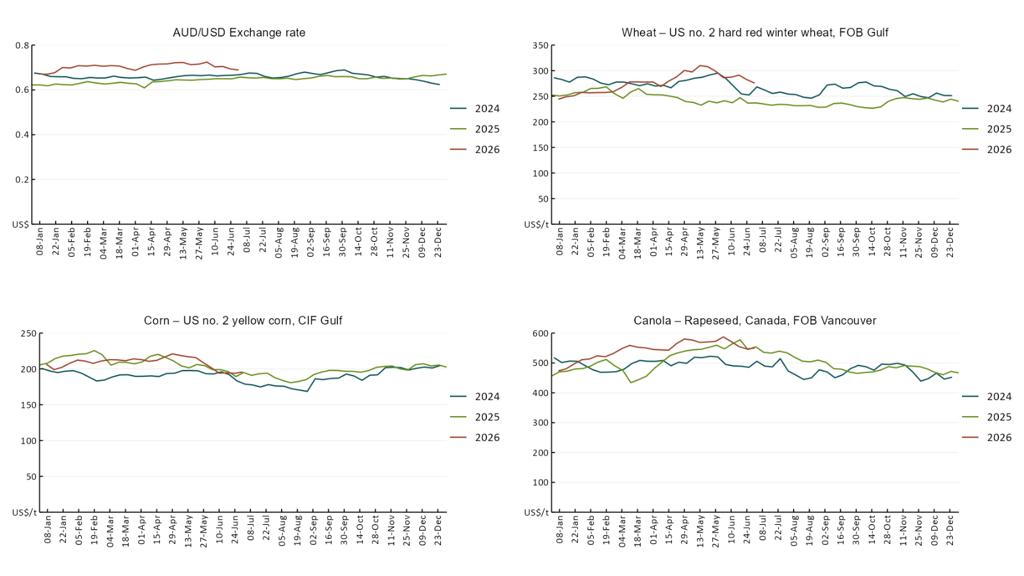

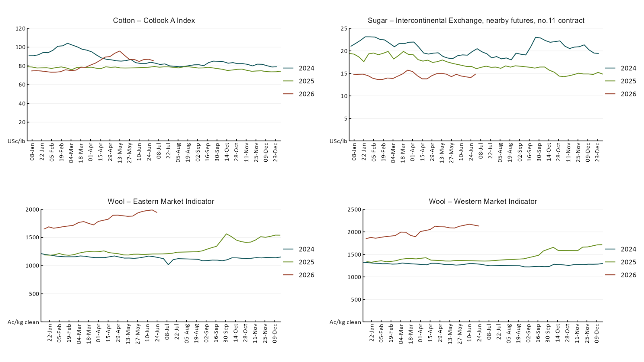

3.2 Selected domestic crop indicator prices
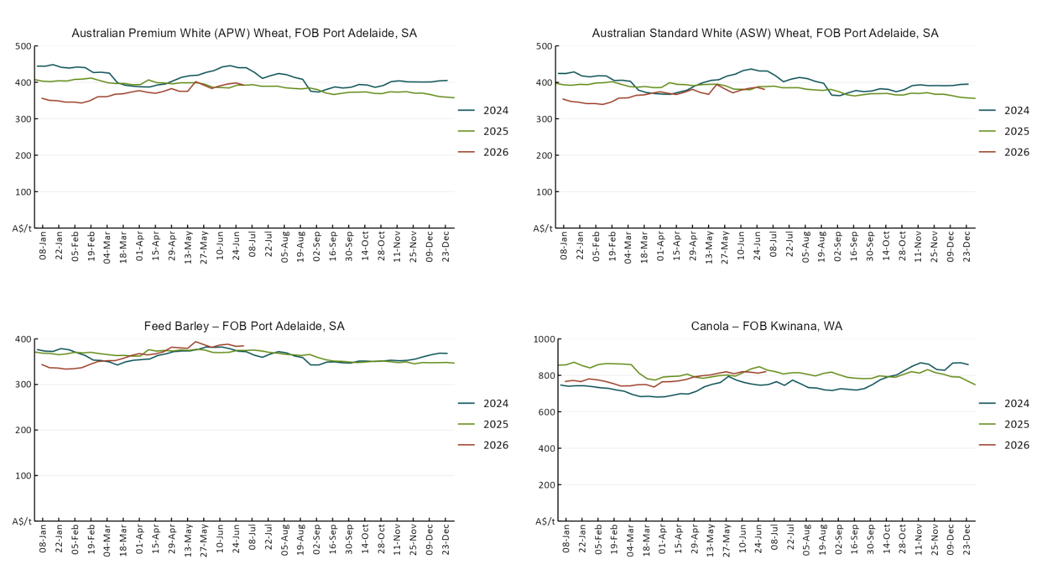

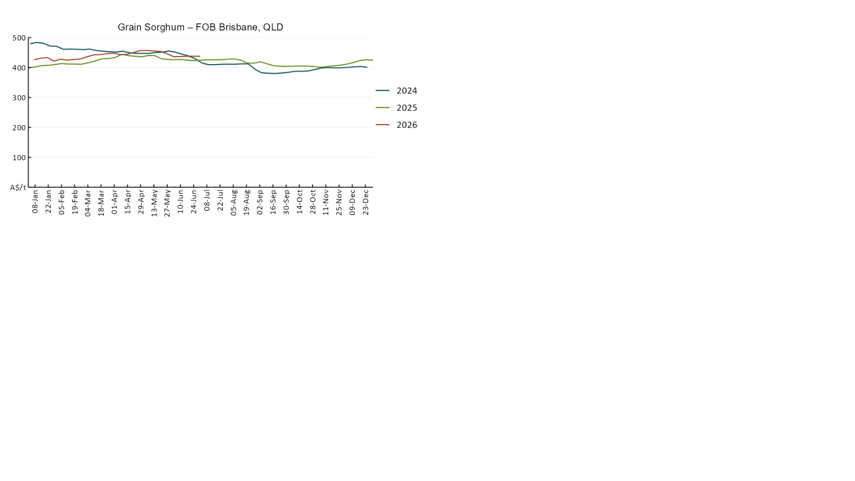

3.3 Selected domestic livestock indicator prices
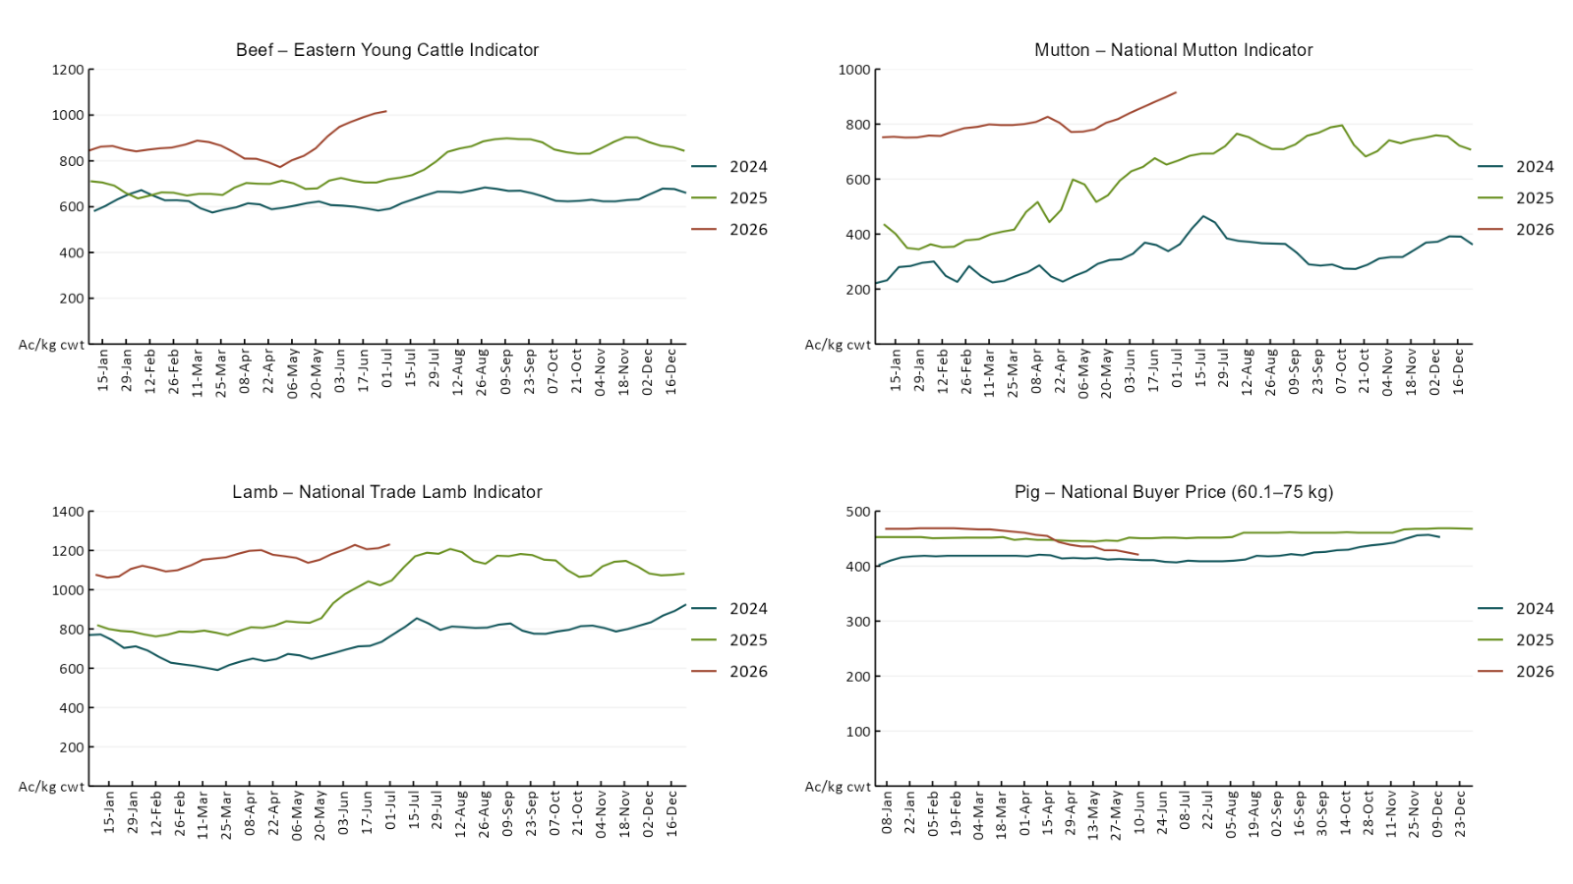

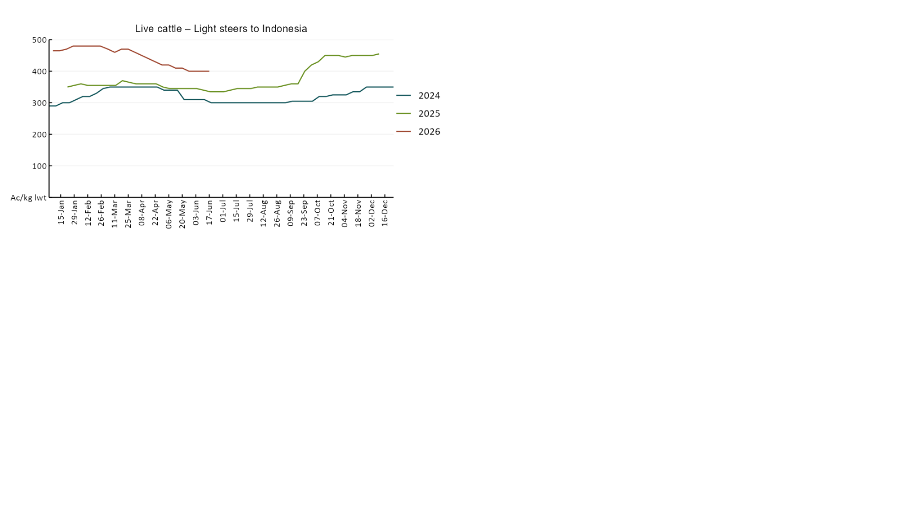

3.4 Global Dairy Trade (GDT) weighted average prices 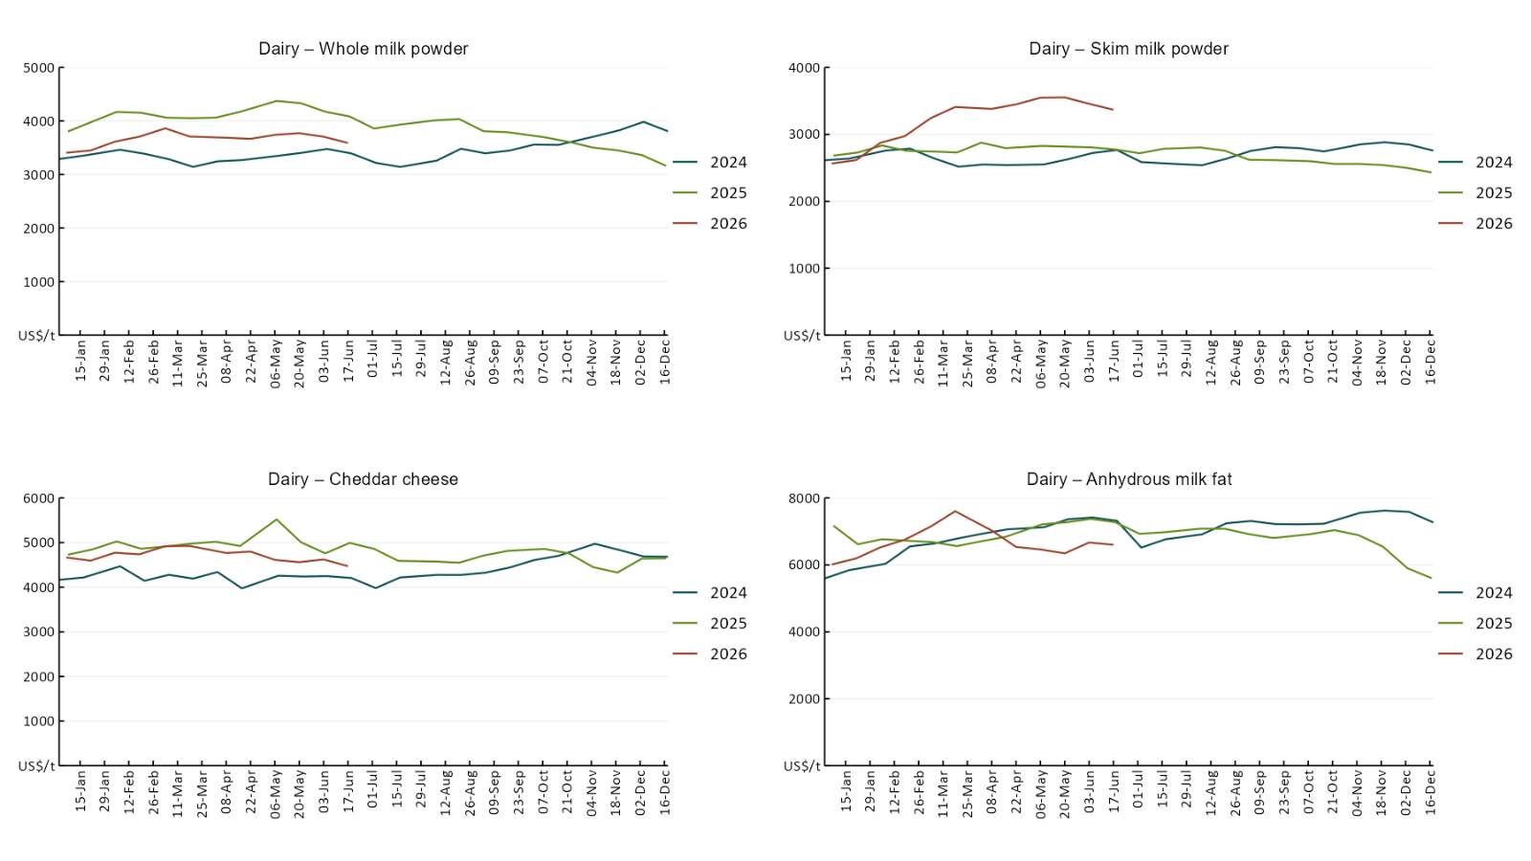

3.5 Selected fruit and vegetable prices
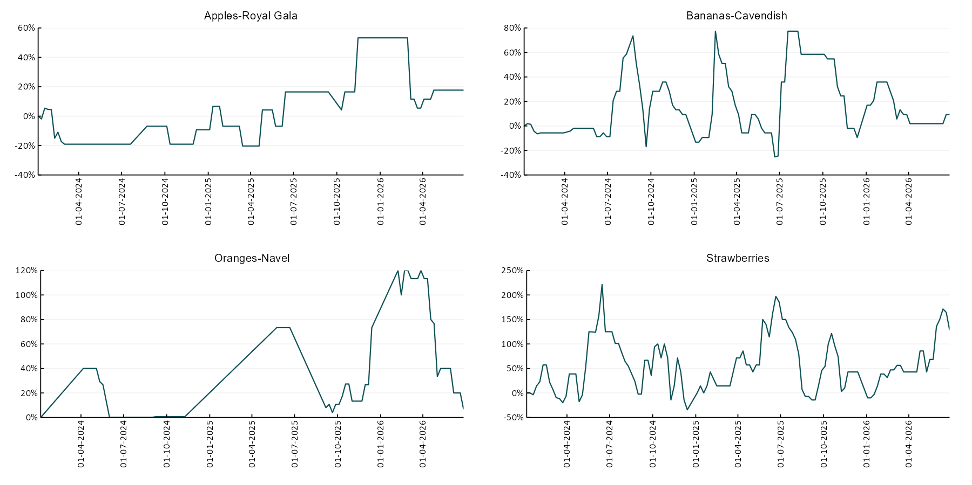

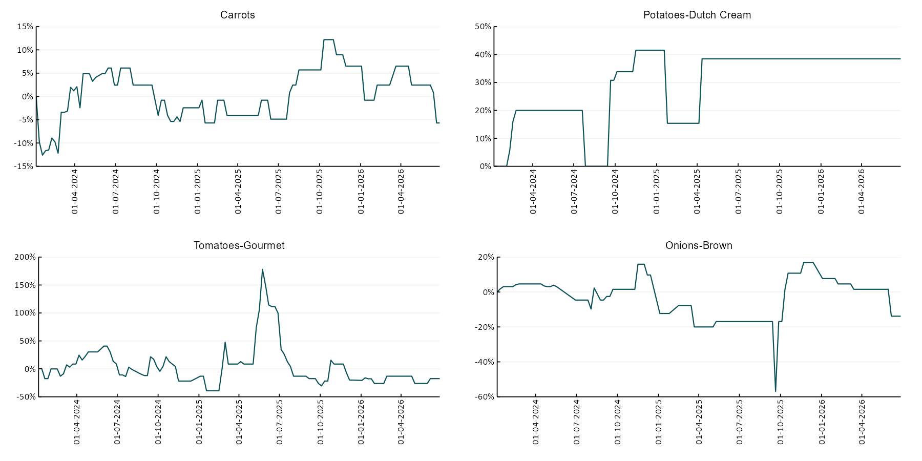

3.6 Selected domestic fodder indicator prices
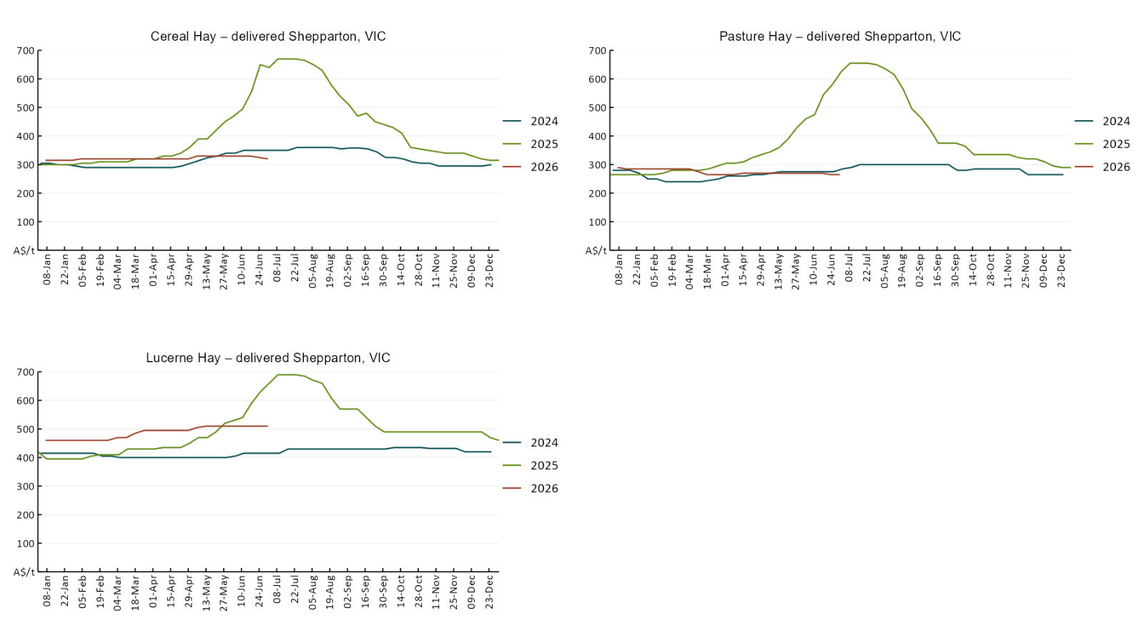

4. Data attribution

Climate
Bureau of Meteorology
- Weekly rainfall totals: www.bom.gov.au/climate/maps/rainfall/
- Monthly and last 3-month rainfall percentiles: https://www.bom.gov.au/climate/ahead/outlooks/#moreMaps
- Rainfall forecast: www.bom.gov.au/jsp/watl/rainfall/pme.jsp
- Seasonal outlook: www.bom.gov.au/climate/outlooks/#/overview/summary/
- Climate drivers: http://www.bom.gov.au/climate/enso/
- Soil moisture: https://awo.bom.gov.au/products/historical/soilMoisture-rootZone/

Other
- Pasture growth: www.longpaddock.qld.gov.au/aussiegrass/
- 3-month global outlooks: Environment and Climate Change Canada, NOAA Climate Prediction Center, EUROBRISA CPTEC/INPE, European Centre for Medium-Range Weather Forecasts, Hydrometcenter of Russia, National Climate Center Climate System Diagnosis and Prediction Room (NCC), International Research Institute for Climate and Society
- Global production: https://ipad.fas.usda.gov/ogamaps/cropmapsandcalendars.aspx
- Autumn break: Pook et al., 2009, https://rmets-onlinelibrary-wiley-com.virtual.anu.edu.au/doi/epdf/10.1002/joc.1833

Water
Prices
- Waterflow: https://www.waterflow.io/
- Ruralco: https://www.ruralcowater.com.au/
- Bureau of Meteorology:
- Allocation trade: http://www.bom.gov.au/water/dashboards/#/water-markets/mdb/at
- Storage volumes: http://www.bom.gov.au/water/dashboards/#/water-storages/summary/drainage

Trade constraints:
- Water NSW: https://www.waternsw.com.au/customer-service/ordering-trading-and-pricing/trading/murrumbidgee
- Victorian Water Register: https://www.waterregister.vic.gov.au/TradingRules2019/

Commodities
Fruit and vegetables
- Datafresh: www.freshstate.com.au

Pigs
- Australian Pork Limited: www.australianpork.com.au

Dairy
- Global Dairy Trade: www.globaldairytrade.info/en/product-results/

World wheat, canola
- International Grains Council
- https://www.igc.int/en/default.aspx
- United States Department of Agriculture

World cotton
- Cotlook: www.cotlook.com/

World sugar
- New York Stock Exchange - Intercontinental Exchange

Wool
- Australian Wool Exchange: www.awex.com.au/

Domestic wheat, barley, sorghum, canola and fodder
- Jumbuk Consulting Pty Ltd: Jumbuk AG | Agriculture Consulting

Cattle, beef, mutton, lamb, goat and live export
- Meat and Livestock Australia: https://www.mla.com.au/prices-markets/

Australian Agricultural Drought Indicators
About Australian Agricultural Drought Indicators
The Australian Agricultural Drought Indicators (AADI) links weather and agricultural data with a range of scientific and economic models to measure and forecast the effects of climate variability and drought on agricultural outcomes.
On AADI, projected broadacre farm profits are presented as percentile outcomes relative to simulated historical outcomes using the groupings:
Highest | 95-100th percentile
Very much above average | 85-95th percentile
Above average | 65-85th percentile
Average | 35-65th percentile
Below average | 15-35th percentile
Very much below average | 5-15th percentile
Lowest 5% | 0-5th percentile

There are two AADI farm profit indicators:
- The AADI farm profit climate and price indicator shows the effect of climate and prices on broadacre farm business profits of current farms compared to the last 33 years.
- The AADI farm profit climate only indicator isolates the effect of climate on profits by holding prices fixed.

© Commonwealth of Australia 2026

Ownership of intellectual property rights
Unless otherwise noted, copyright (and any other intellectual property rights, if any) in this publication is owned by the Commonwealth of Australia (referred to as the Commonwealth).

Creative Commons licence
All material in this publication is licensed under a Creative Commons Attribution 4.0 International Licence except content supplied by third parties, logos and the Commonwealth Coat of Arms.
Inquiries about the licence and any use of this document should be emailed to copyright@awe.gov.au.


Cataloguing data
This publication (and any material sourced from it) should be attributed as:
ABARES 2026, Weekly Australian Climate, Water and Agricultural Update, Australian Bureau of Agricultural and Resource Economics and Sciences, Canberra, 2 July 2026. CC BY 4.0 DOI: https://doi.org/10.25814/5f3e04e7d2503
ISSN 2652-7561
This publication is available at https://www.agriculture.gov.au/abares/products/weekly_update
Department of Agriculture, Fisheries and Forestry
GPO Box 858 Canberra ACT 2601
Telephone 1800 900 090
Web agriculture.gov.au/abares

Disclaimer
The Australian Government acting through the Department of Agriculture, Fisheries and Forestry, represented by the Australian Bureau of Agricultural and Resource Economics and Sciences, has exercised due care and skill in preparing and compiling the information and data in this publication. Notwithstanding, the Department of Agriculture, Fisheries and Forestry, ABARES, its employees and advisers disclaim all liability, including liability for negligence and for any loss, damage, injury, expense or cost incurred by any person as a result of accessing, using or relying on any of the information or data in this publication to the maximum extent permitted by law.

Statement of Professional Independence
The views and analysis presented in ABARES publications, including this one, reflect ABARES professionally independent findings, based on scientific and economic concepts, principles, information and data. These views, analysis and findings may not reflect or be consistent with the views or positions of the Australian Government, or of organisations or groups who have commissioned ABARES reports or analysis. More information on professional independence is provided on the ABARES website.

Acknowledgements
This report was prepared by Holly Beale and Matthew Miller.

