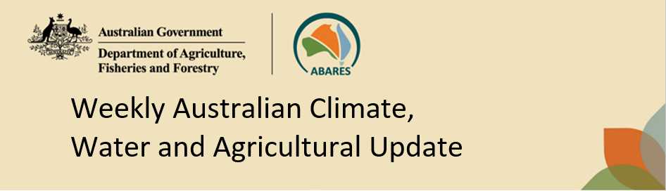
No. 26/2026 9 July 2026

Summary of key issues
- In the week ending 8 July 2026, cold fronts and low-pressure systems brought rainfall to large areas of southern and central Australia. Much of the remainder of Australia was largely dry.
  - Cropping regions in South Australia and southern New South Wales saw 5-50 millimetres of rainfall, with higher rainfall totals observed in Victoria (10-50 millimetres). In northern New South Wales, rainfall of 5-25 millimetres was recorded.
  - Cropping regions of Queensland and Western Australia saw little to no rainfall over the period.
- Over the 8 days to 16 July 2026, cold fronts and low-pressure systems are expected to bring rainfall to parts of south-eastern Australia
  - Across cropping regions, falls of 5-25 millimetres are forecast for Victoria and southern New South Wales, while other regions are expected to remain largely dry.
  - If realised, these expected falls will continue to support the establishment and growth of winter crops in the southeast.
- The national rainfall outlook for August to October 2026 indicates an increased probability of below median rainfall across parts of southern and eastern Australia.
  - The current rainfall outlook for August to October 2026 suggests below average falls across most cropping regions. However, favourable soil moisture levels across most of Australia’s southern growing regions means that if forecast August through October rainfall totals are realised, these falls are likely be sufficient to support the growth of winter crops. However, below average expected falls for north-eastern growing regions represents an ongoing downside production risk for the 2026–27 winter cropping season.
- Water storage levels in the Murray-Darling Basin (MDB) increased by 695 gigalitres (GL) between 02 July 2026 and 09 July 2026. The current volume of water held in storages is 12,032 GL, equivalent to 54% of total storage capacity. This is 10% or 1,264 GL less than the same time last year. Water storage data is sourced from the Bureau of Meteorology.
- Allocation prices in the Victorian Murray below the Barmah Choke are $426/ML on 09 July 2026. Trade from the Goulburn to the Murray is closed. Trade downstream through the Barmah Choke is closed. Trade from the Murrumbidgee to the Murray is open.

Climate

Rainfall this week
In the week ending 8 July 2026, cold fronts and low-pressure systems brought rainfall to large areas of southern and central Australia. Much of the remainder of Australia was largely dry.
- Falls of 10-100 millimetres were recorded across Tasmania, Victoria, southern New South Wales, and the southern Northern Territory. Isolated areas in the far south saw up to 150 millimetres; while remaining southern regions saw lower falls of 5-50 millimetres, including southern South Australia and isolated areas of southwest Western Australia. Northern New South Wales and southwest Queensland saw 10-50 millimetres.
- Much of northern and western Australia saw little to no rainfall.
In cropping regions, considerable falls were recorded in southeastern regions, while other areas remained comparatively dry:
- Cropping regions in South Australia and New South Wales saw 5-50 millimetres of rainfall, with higher rainfall totals observed in Victoria (10-50 millimetres).
  - The heavier falls across southeast Australia will have provided a boost to soil moisture levels which will continue to support the establishment and growth of winter crops.
- Cropping regions in Queensland and Western Australia saw little to no rainfall over the period.

Rainfall for the week ending 8 July 2026
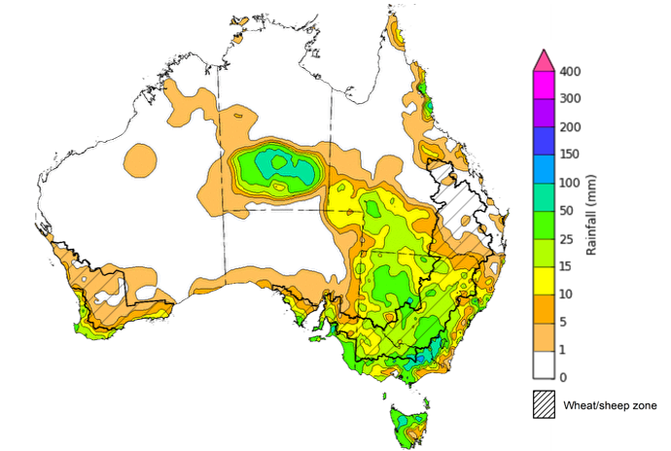
©Commonwealth of Australia 2026, Australian Bureau of Meteorology Issued: 8/7/2026
Note: The rainfall analyses and associated maps utilise data contained in the Bureau of Meteorology climate database, the Australian Data Archive for Meteorology (ADAM). The analyses are initially produced automatically from real-time data with limited quality control. They are intended to provide a general overview of rainfall across Australia as quickly as possible after the observations are received. For further information go to http://www.bom.gov.au/climate/rainfall/du

Rainfall forecast for the next eight days
Over the 8 days to 16 July 2026, cold fronts and low-pressure systems are expected to bring rainfall to limited areas of southern Australia, while much of the rest of the country is expected to remain largely dry.
- Moderate falls of up to 50 millimetres are forecast for parts of Victoria and southern New South Wales, while southern South Australia and southern Western Australia are forecast to see 5-25 millimetres. Tasmania is forecast to see up to 100 millimetres in its west.
- Remaining areas are expected to see little to no rainfall.
Across cropping regions, falls are expected to be limited, with exceptions in the southeast:
- Falls of 5-25 millimetres are forecast for Victoria and southern New South Wales. South Australia is expected to see lighter falls of 5-15 millimetres.
  - If realised, these expected falls will continue to support the establishment and growth of winter crops.
- In contrast, northern New South Wales, Queensland, and Western Australia are expected to see lighter falls of between 1-10 millimetres.

Total forecast rainfall for the period 9 July to 16 July 2026
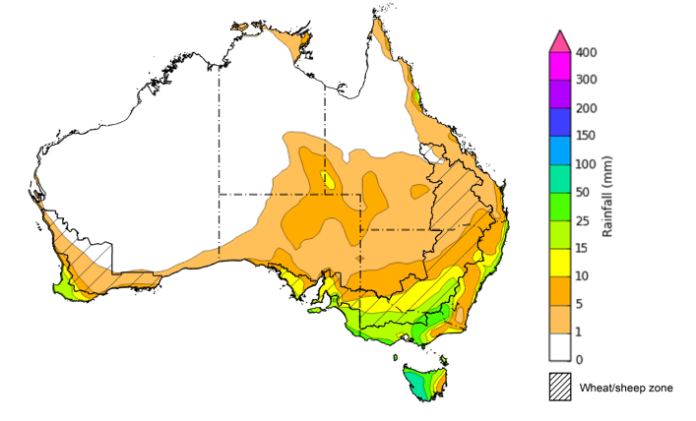
©Commonwealth of Australia 2026, Australian Bureau of Meteorology Issued 9/7/2026
Note: This rainfall forecast is produced from computer models. As the model outputs are not altered by weather forecasters, it is important to check local forecasts and warnings issued by the Bureau of Meteorology.

National Climate Outlook
The Bureau of Meteorology has indicated that El Niño is underway in the tropical Pacific. Sea surface temperatures in the central tropical Pacific are above El Niño thresholds, and atmospheric indicators are also aligning with an El Niño state. This suggests the ocean and atmosphere are acting to reinforce the El Niño state, which is likely to strengthen and sustain this event until at least the end of the year. The Southern Annular Mode (SAM) is currently positive and strengthening to near-record levels. The Indian Ocean Dipole (IOD) is currently neutral. Models suggest a positive IOD event is likely in the southern hemisphere winter-spring. However, model forecasts show a large variation in both the timing and strength of this potential event.
The recent rainfall outlook for August 2026 provided by the Bureau of Meteorology indicates that much of southwestern and southeastern Australia is likely to see below median rainfall, while scattered areas of northern Australia are more likely to see above median falls.
The Bureau of Meteorology’s climate model indicates a 75% chance of August rainfall totals between 10- 100 millimetres across Victoria, Tasmania, southern New South Wales, southern South Australia, and much of south-western Western Australia. Isolated regions, including alpine regions of Victoria, western Tasmania , are likely to see higher falls of up to 300 millimetres. In the east, including coastal parts of Queensland, and northern New South Wales, falls of 5- 25 millimetres are expected. Much of central and northern Western Australia, the Northern Territory, and the reminder of Queensland and South Australia, are likely to see little to no rainfall.
Across southern cropping regions, including Western Australia, South Australia, Victoria, and southern New South Wales, there is a 75% chance of receiving rainfall totals of between 10- 50 millimetres during August 2026. If these forecast falls are realised, they are likely to provide sufficient moisture to support the growth of winter crops. Across most cropping regions in Queensland and northern New South Wales there is a 75% chance of receiving rainfall totals of between 1-10 millimetres.

Rainfall totals that have a 75% chance of occurring in August 2026

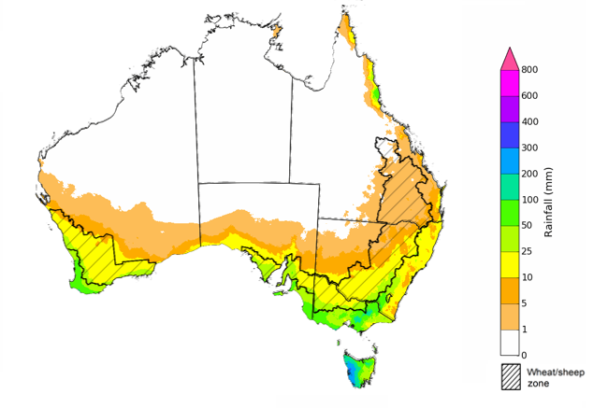
©Commonwealth of Australia 2025, Australian Bureau of Meteorology Issued: 9/7/2026
The rainfall outlook for August 2026 to October 2026 indicates a strong tendency towards below median rainfall across much of southern and eastern Australia. However, there is an increased probability of median to above median rainfall in much of western and central Australia.
Across cropping regions, the chance of receiving above median rainfall in Western Australia, is 20-50%, while in Victoria, the chance of receiving above median rainfall is slightly lower at 20-35%. In New South Wales, South Australia, and Queensland, the chance of above median rainfall is 35-50%

Chance of exceeding the median rainfall July 2026 to September 2026

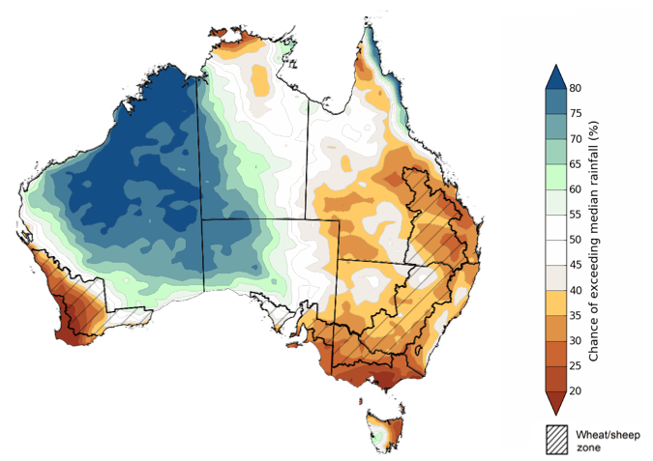
©Commonwealth of Australia 2025, Australian Bureau of Meteorology Issued: 9/7/2026

The rainfall outlook for August 2026 to October 2026 suggests a 75% chance of receiving rainfall totals of between 25-200 millimetres across parts of eastern and southern Australia. Higher falls in excess of 200 millimetres are expected across scattered areas of southwest Western Australia, western Tasmania, as well as alpine regions of Victoria and New South Wales. Lower rainfall totals are forecast for central and northern regions, with much of northern South Australia, central and northern Western Australia, the Northern Territory and Queensland likely to see 0-25 millimetres.
In cropping regions, there is a 75% chance of receiving between 50-100 millimetres across much of New South Wales, Victoria, South Australia and Western Australia. Cropping regions in Queensland are likely to see lower falls of 25-50 millimetres.
Favourable soil moisture levels across most of Australia’s southern growing regions means that if these forecast August through October rainfall totals are realised, they are likely to be sufficient to continue to support the growth and yield potential of winter crops. However, below average expected falls continue to represent an ongoing downside production risk for the 2026–27 winter cropping season.

Rainfall totals that have a 75% chance of occurring August 2026 to October 2026

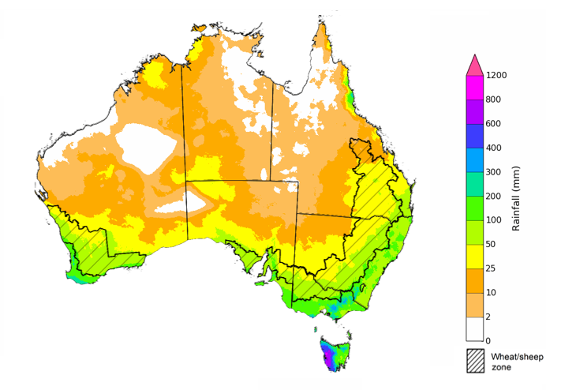
©Commonwealth of Australia 2025, Australian Bureau of Meteorology Issued: 9/7/2026

Water markets – current week
Water storage levels in the Murray-Darling Basin (MDB) increased by 695 gigalitres (GL) between 02 July 2026 and 09 July 2026. The current volume of water held in storages is 12,032 GL, equivalent to 54% of total storage capacity. This is 10% or 1,264 GL less than the same time last year. Water storage data is sourced from the Bureau of Meteorology (BOM).

Water storages in the Murray-Darling Basin, 2013–2026
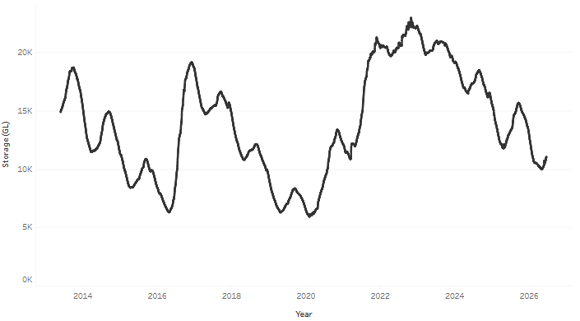
Allocation prices in the Victorian Murray below the Barmah Choke are $426/ML on 09 July 2026. Trade from the Goulburn to the Murray is closed. Trade downstream through the Barmah Choke is closed. Trade from the Murrumbidgee to the Murray is open..

Surface water trade activity 2022-2026, Victorian Murray below the Barmah Choke
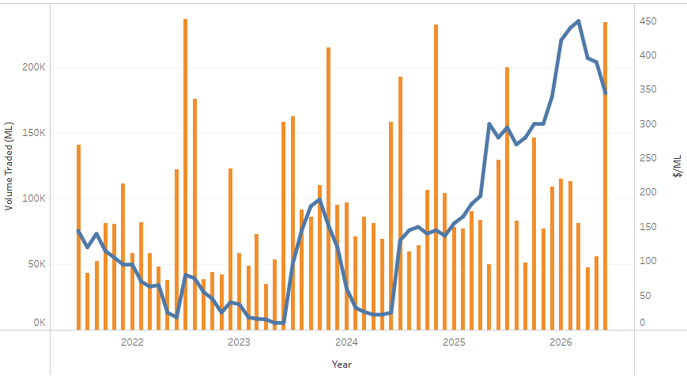

Water market prices, Southern Murray–Darling Basin
Region | $/ML
NSW Murray Above | NA
NSW Murrumbidgee | 424
Vic Greater Goulburn | 425
Vic Murray Below | 426
Note: The water allocation prices shown are volume weighted average prices based on the last 10 trades. Price data is sourced from Waterflow and current as at 25 June 2026.
To access the full, interactive, weekly water dashboard, which contains the latest and historical water storage, water market and water allocation information, please visit https://www.agriculture.gov.au/abares/products/weekly_update/weekly-update-260625

Commodities
Indicator | Week average | Unit | Latest Price | Previous Week | Weekly change |  | Price 12 months ago | Annual change
Selected world indicator prices
AUD/USD Exchange rate | 8-Jul | A$/US$ | 0.69 | 0.69 | 1% | 0.65 |  | 6%
Wheat – US no. 2 hard red winter wheat, FOB Gulf | 8-Jul | US$/t | 294 | 276 | 7% | 235 |  | 26%
Corn – US no. 2 yellow corn, FOB Gulf | 8-Jul | US$/t | 209 | 196 | 7% | 192 |  | 9%
Canola – Rapeseed, Canada, FOB Vancouver | 8-Jul | US$/t | 565 | 550 | 3% | 539 |  | 5%
Cotton – Cotlook A Index | 8-Jul | USc/lb | 87.8 | 85.3 | 3% | 78.9 |  | 11%
Sugar – Intercontinental Exchange, nearby futures, no.11 contract | 8-Jul | USc/lb | 15.2 | 14.9 | 2% | 16.4 |  | -7%
Wool – Eastern Market Indicator | 8-Jul | Ac/kg clean | 1,909 | 1,904 | 0% | 1,220 |  | 56%
Wool – Western Market Indicator | 8-Jul | Ac/kg clean | 2,094 | 2,072 | 1% | 1,360 |  | 54%
Selected Australian grain export prices
Australian Premium White (APW) Wheat, FOB Port Adelaide, SA | 8-Jul | A$/t | 392 | 392 | 0% | 391 |  | 0%
Australian Standard White (ASW) Wheat, FOB Port Adelaide, SA | 8-Jul | A$/t | 381 | 380 | 0% | 387 |  | -1%
Feed Barley – FOB Port Adelaide, SA | 8-Jul | A$/t | 382 | 385 | -1% | 373 |  | 2%
Canola – FOB Kwinana, WA | 8-Jul | A$/t | 829 | 821 | 1% | 817 |  | 1%
Grain Sorghum – FOB Brisbane, QLD | 8-Jul | A$/t | 432 | 438 | -1% | 426 |  | 1%
Selected domestic livestock indicator prices
Beef – Eastern Young Cattle Indicator | 8-Jul | Ac/kg cwt | 1,017 | 1,017 | 0% | 748 |  | 36%
Mutton – Mutton indicator (18–24 kg fat score 2–3), VIC | 8-Jul | Ac/kg cwt | 918 | 916 | 0% | 692 |  | 33%
Lamb – National Trade Lamb Indicator | 8-Jul | Ac/kg cwt | 1,242 | 1,231 | 1% | 1,141 |  | 9%
Pig – Eastern Seaboard (60.1–75 kg), NSW buyer price | 10-Jun | Ac/kg cwt | 421 | 425 | -1% | 452 |  | -7%
Live cattle – Light steers to Indonesia | 17-Jun | Ac/kg lwt | 400 | 400 | 0% | 342 |  | 17%
Global Dairy Trade (GDT) weighted average prices
Dairy – Whole milk powder | 17-Jun | US$/t | 3,589 | 3,706 | -3% | 3,894 |  | -8%
Dairy – Skim milk powder | 17-Jun | US$/t | 3,368 | 3,457 | -3% | 2,752 |  | 22%
Dairy – Cheddar cheese | 17-Jun | US$/t | 4,471 | 4,621 | -3% | 4,725 |  | -5%
Dairy – Anhydrous milk fat | 17-Jun | US$/t | 6,601 | 6,668 | -1% | 6,951 |  | -5%

Selected world indicator prices
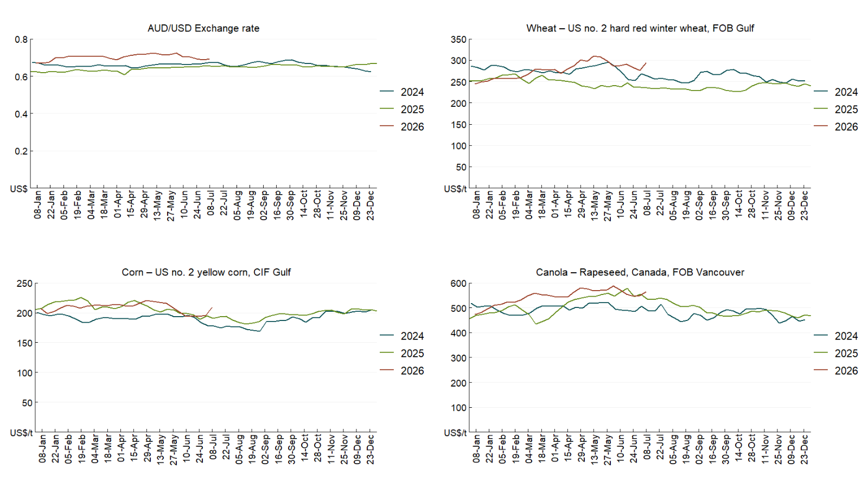

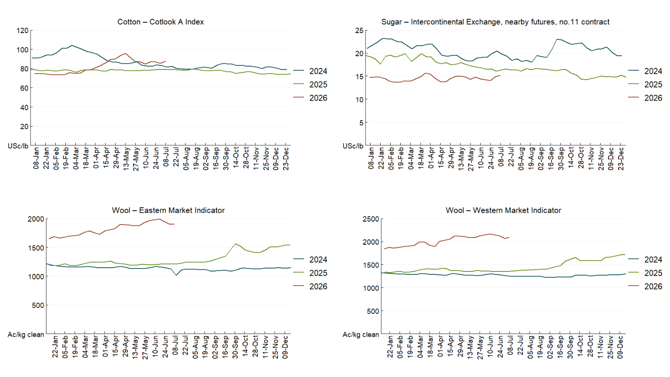

3.2 Selected domestic crop indicator prices
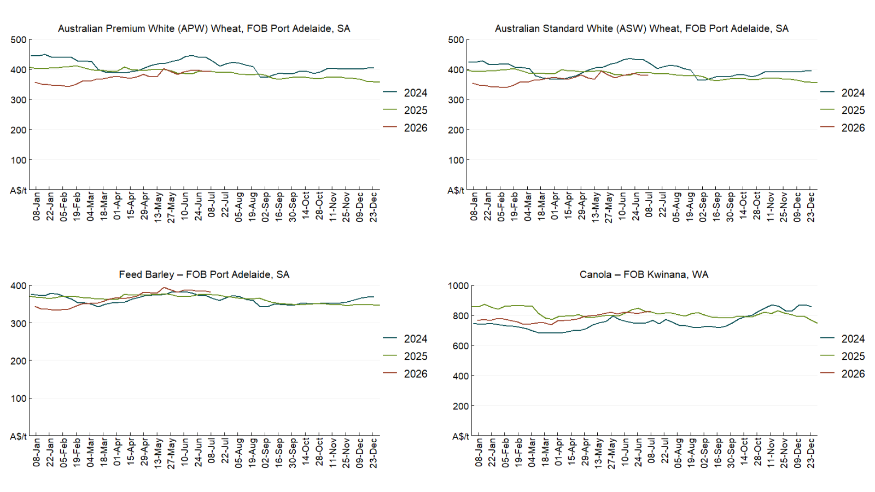

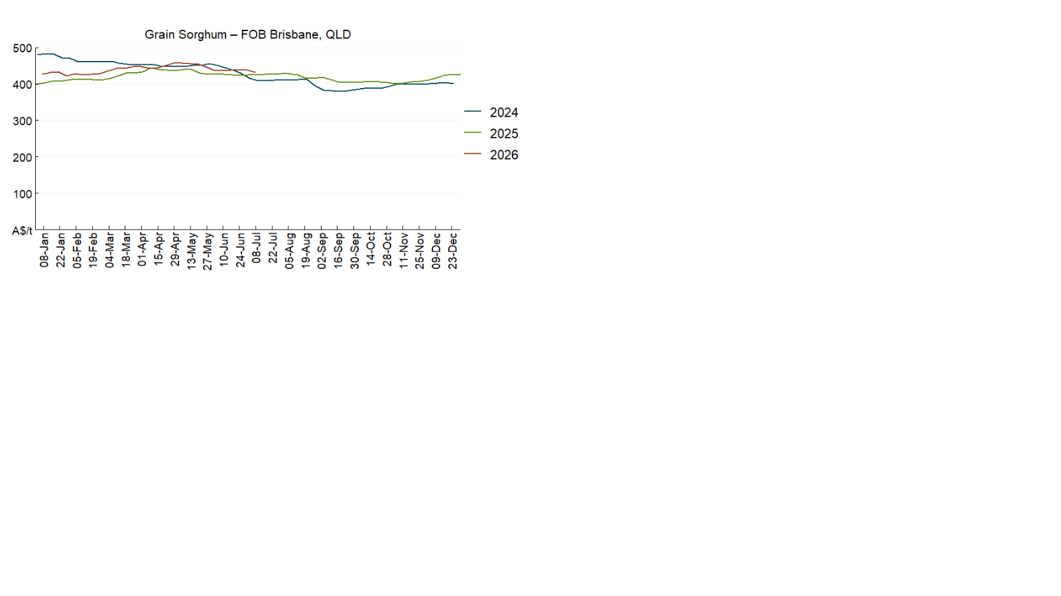

3.3 Selected domestic livestock indicator prices
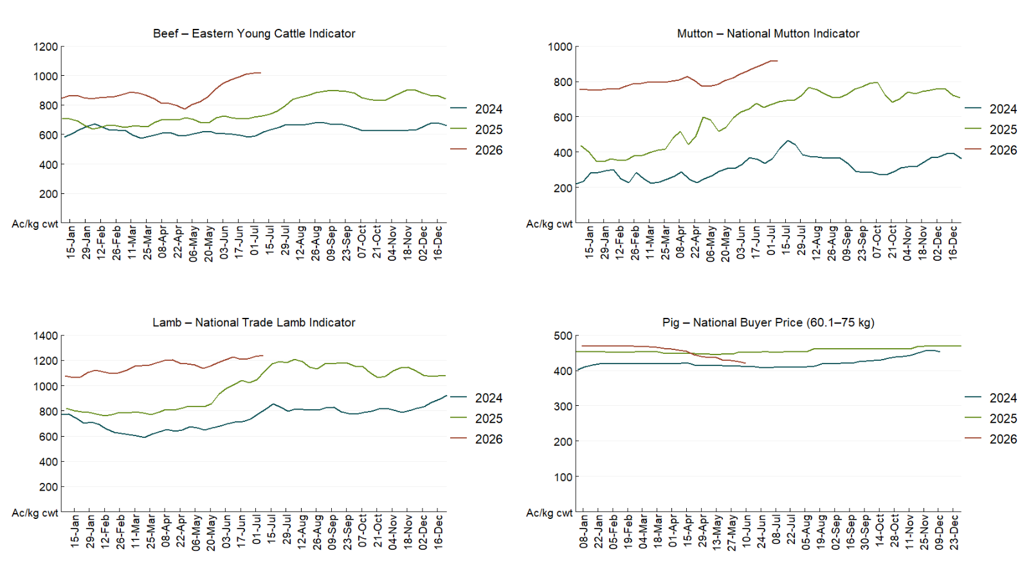

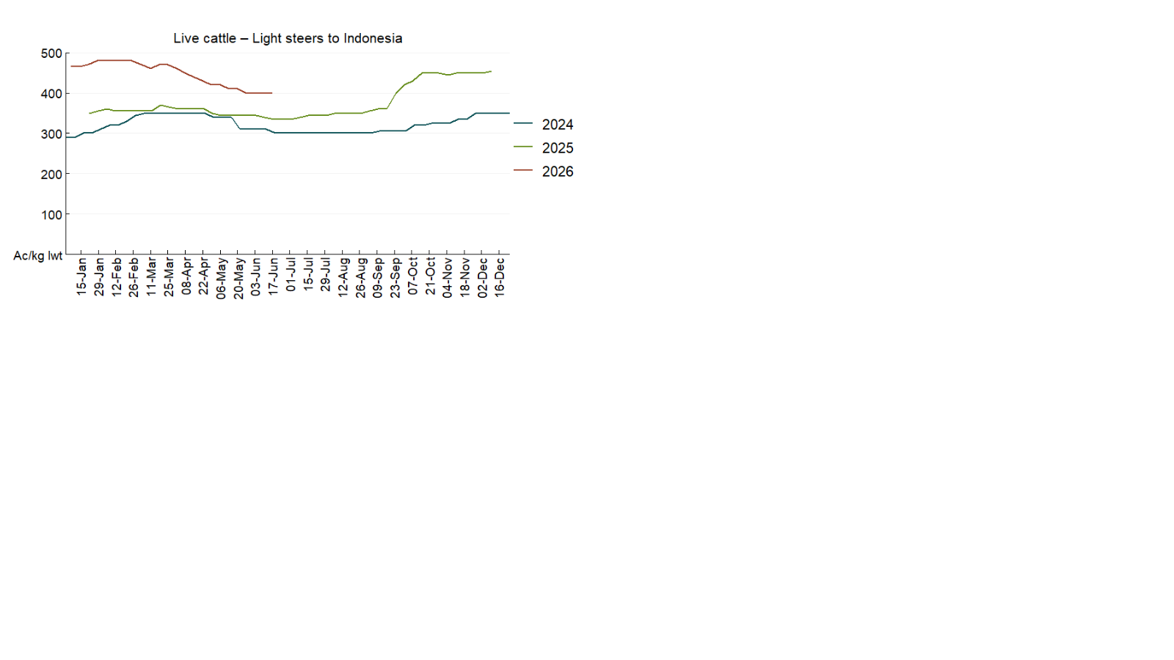

3.4 Global Dairy Trade (GDT) weighted average prices 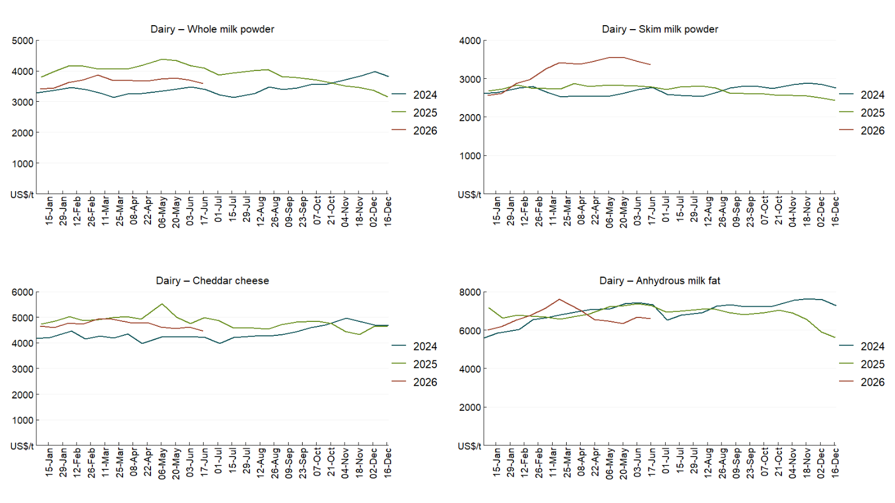

3.5 Selected fruit and vegetable prices
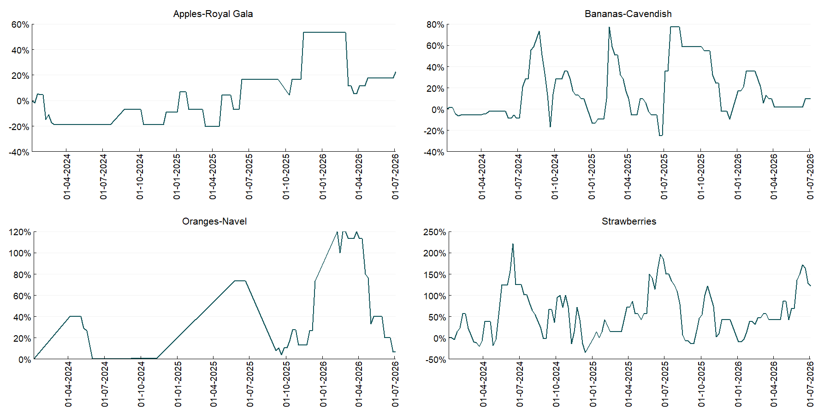

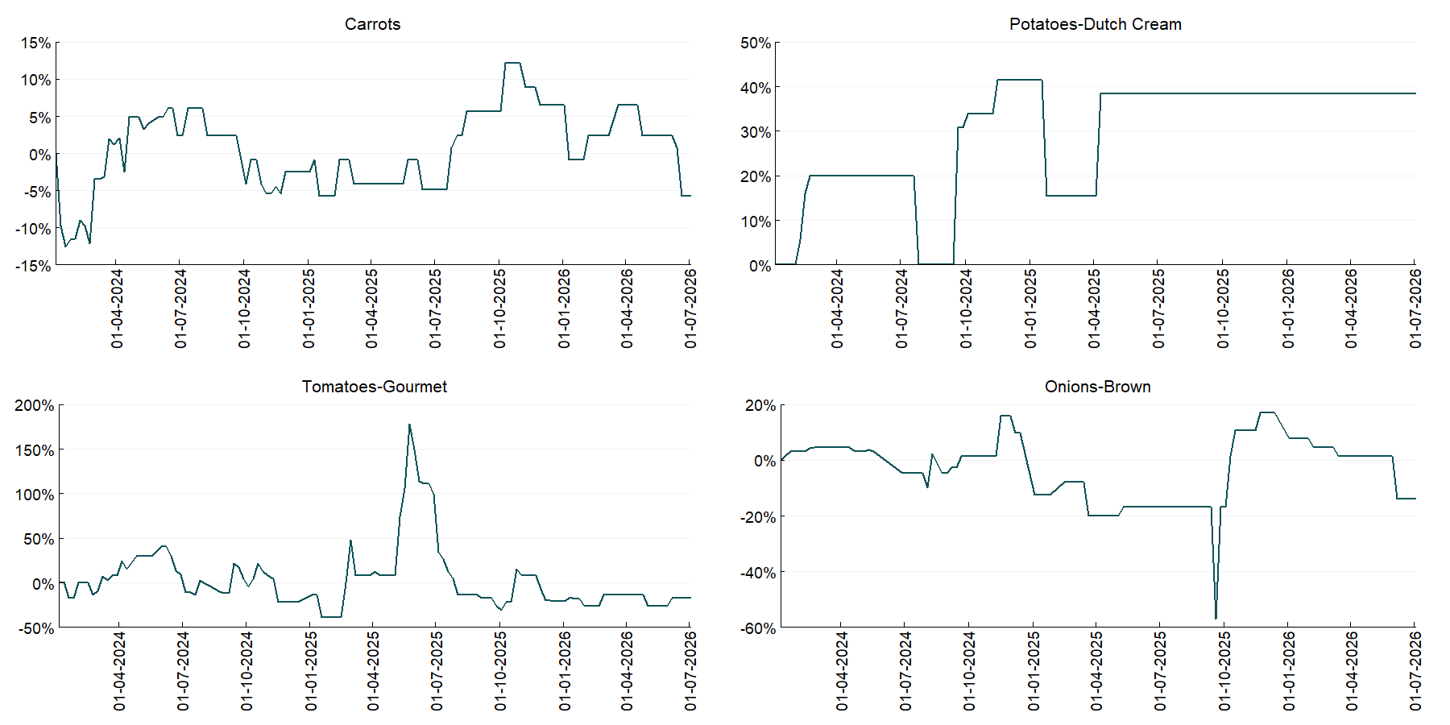

3.6 Selected domestic fodder indicator prices
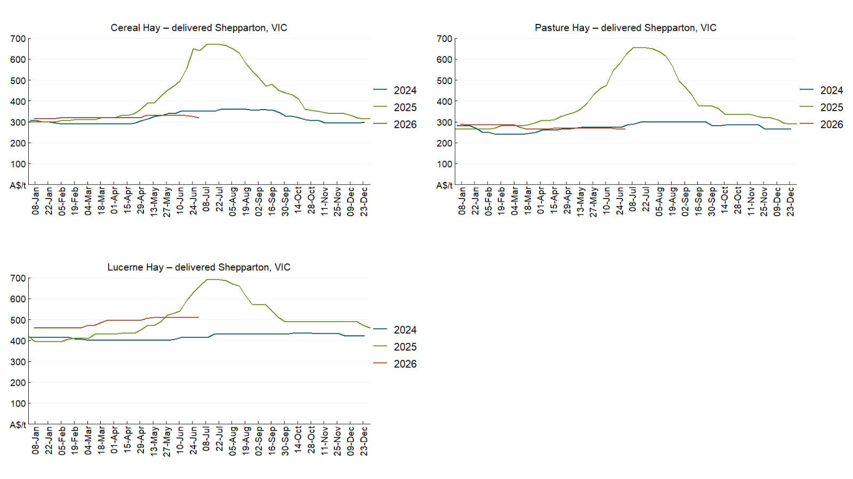

4. Data attribution

Climate
Bureau of Meteorology
- Weekly rainfall totals: www.bom.gov.au/climate/maps/rainfall/
- Monthly and last 3-month rainfall percentiles: https://www.bom.gov.au/climate/ahead/outlooks/#moreMaps
- Rainfall forecast: www.bom.gov.au/jsp/watl/rainfall/pme.jsp
- Seasonal outlook: www.bom.gov.au/climate/outlooks/#/overview/summary/
- Climate drivers: http://www.bom.gov.au/climate/enso/
- Soil moisture: https://awo.bom.gov.au/products/historical/soilMoisture-rootZone/

Other
- Pasture growth: www.longpaddock.qld.gov.au/aussiegrass/
- 3-month global outlooks: Environment and Climate Change Canada, NOAA Climate Prediction Center, EUROBRISA CPTEC/INPE, European Centre for Medium-Range Weather Forecasts, Hydrometcenter of Russia, National Climate Center Climate System Diagnosis and Prediction Room (NCC), International Research Institute for Climate and Society
- Global production: https://ipad.fas.usda.gov/ogamaps/cropmapsandcalendars.aspx
- Autumn break: Pook et al., 2009, https://rmets-onlinelibrary-wiley-com.virtual.anu.edu.au/doi/epdf/10.1002/joc.1833

Water
Prices
- Waterflow: https://www.waterflow.io/
- Ruralco: https://www.ruralcowater.com.au/
- Bureau of Meteorology:
- Allocation trade: http://www.bom.gov.au/water/dashboards/#/water-markets/mdb/at
- Storage volumes: http://www.bom.gov.au/water/dashboards/#/water-storages/summary/drainage

Trade constraints:
- Water NSW: https://www.waternsw.com.au/customer-service/ordering-trading-and-pricing/trading/murrumbidgee
- Victorian Water Register: https://www.waterregister.vic.gov.au/TradingRules2019/

Commodities
Fruit and vegetables
- Datafresh: www.freshstate.com.au

Pigs
- Australian Pork Limited: www.australianpork.com.au

Dairy
- Global Dairy Trade: www.globaldairytrade.info/en/product-results/

World wheat, canola
- International Grains Council
- https://www.igc.int/en/default.aspx
- United States Department of Agriculture

World cotton
- Cotlook: www.cotlook.com/

World sugar
- New York Stock Exchange - Intercontinental Exchange

Wool
- Australian Wool Exchange: www.awex.com.au/

Domestic wheat, barley, sorghum, canola and fodder
- Jumbuk Consulting Pty Ltd: Jumbuk AG | Agriculture Consulting

Cattle, beef, mutton, lamb, goat and live export
- Meat and Livestock Australia: https://www.mla.com.au/prices-markets/

Australian Agricultural Drought Indicators
About Australian Agricultural Drought Indicators
The Australian Agricultural Drought Indicators (AADI) links weather and agricultural data with a range of scientific and economic models to measure and forecast the effects of climate variability and drought on agricultural outcomes.
On AADI, projected broadacre farm profits are presented as percentile outcomes relative to simulated historical outcomes using the groupings:
Highest | 95-100th percentile
Very much above average | 85-95th percentile
Above average | 65-85th percentile
Average | 35-65th percentile
Below average | 15-35th percentile
Very much below average | 5-15th percentile
Lowest 5% | 0-5th percentile

There are two AADI farm profit indicators:
- The AADI farm profit climate and price indicator shows the effect of climate and prices on broadacre farm business profits of current farms compared to the last 33 years.
- The AADI farm profit climate only indicator isolates the effect of climate on profits by holding prices fixed.

© Commonwealth of Australia 2026

Ownership of intellectual property rights
Unless otherwise noted, copyright (and any other intellectual property rights, if any) in this publication is owned by the Commonwealth of Australia (referred to as the Commonwealth).

Creative Commons licence
All material in this publication is licensed under a Creative Commons Attribution 4.0 International Licence except content supplied by third parties, logos and the Commonwealth Coat of Arms.
Inquiries about the licence and any use of this document should be emailed to copyright@awe.gov.au.


Cataloguing data
This publication (and any material sourced from it) should be attributed as:
ABARES 2026, Weekly Australian Climate, Water and Agricultural Update, Australian Bureau of Agricultural and Resource Economics and Sciences, Canberra, 2 July 2026. CC BY 4.0 DOI: https://doi.org/10.25814/5f3e04e7d2503
ISSN 2652-7561
This publication is available at https://www.agriculture.gov.au/abares/products/weekly_update
Department of Agriculture, Fisheries and Forestry
GPO Box 858 Canberra ACT 2601
Telephone 1800 900 090
Web agriculture.gov.au/abares

Disclaimer
The Australian Government acting through the Department of Agriculture, Fisheries and Forestry, represented by the Australian Bureau of Agricultural and Resource Economics and Sciences, has exercised due care and skill in preparing and compiling the information and data in this publication. Notwithstanding, the Department of Agriculture, Fisheries and Forestry, ABARES, its employees and advisers disclaim all liability, including liability for negligence and for any loss, damage, injury, expense or cost incurred by any person as a result of accessing, using or relying on any of the information or data in this publication to the maximum extent permitted by law.

Statement of Professional Independence
The views and analysis presented in ABARES publications, including this one, reflect ABARES professionally independent findings, based on scientific and economic concepts, principles, information and data. These views, analysis and findings may not reflect or be consistent with the views or positions of the Australian Government, or of organisations or groups who have commissioned ABARES reports or analysis. More information on professional independence is provided on the ABARES website.

Acknowledgements
This report was prepared by Holly Beale and Amelia Brown.

