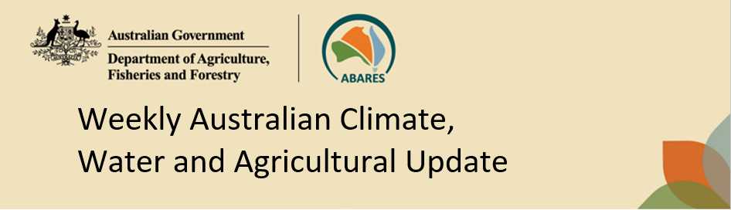
No. 29/2026 30 July 2026

Summary of key issues
- In the week ending 29 July 2026, much of Australia was largely dry, particularly across northern and central regions.
  - Light falls of between 1-10 millimetres were recorded across cropping regions in parts of southern New South Wales, Victoria, South Australia and southern Western Australia.
  - Successive weeks of dry conditions in some southern and eastern regions will see a continued drawdown of stored soil moisture to support crop and pasture growth.
- Over the 8 days to 6 August 2026, Australia is forecast to remain largely dry, with exceptions in south-western and some south-eastern regions.
- Across cropping regions, the 8-day forecasts indicates that falls are expected to be limited to the west and southeast:
  - In Western Australia falls of 10-25 millimetres are forecast for most western and central growing regions with lighter falls of up to 10 millimetres expected in the far southeast. If realised, these falls are likely to benefit crop and pasture growth, and boost soil moisture levels, following a relatively dry July.
  - Light falls of 1-5 millimetres are forecast for southern New South Wales, Victoria and South Australia. Remaining cropping regions are likely to see little to no rainfall over the coming 8-days.
- The northern rainfall onset for 2026–27 is likely to be earlier than usual for most western and central parts of northern Australia but later than normal for much of the east.
- Water storage levels in the Murray-Darling Basin (MDB) increased by 205 gigalitres (GL) between 23 July 2026 and 30 July 2026. The current volume of water held in storages is 12,963 GL, equivalent to 58% of total storage capacity. This is 8% or 1,044 GL less than the same time last year. Water storage data is sourced from the Bureau of Meteorology (BOM).
- Allocation prices in the Victorian Murray below the Barmah Choke increased from $389/ML on 23 July 2026 to $403/ML on 30 July 2026. Trade from the Goulburn to the Murray is closed. Trade downstream through the Barmah Choke is closed. Trade from the Murrumbidgee to the Murray is open.

Climate

Rainfall this week
In the week ending 29 July 2026, much of Australia was largely dry, particularly across central and northern regions. Meanwhile, low-pressure systems and cold fronts brought rainfall to parts of southern and north-eastern Australia.
- Falls of 15-150 millimetres were recorded across western Tasmania, with southern parts of Victoria and South Australia seeing 10-50 millimetres. Similarly, parts of north-eastern Queensland saw up to 50 millimetres in scattered areas.
- Lower falls of 1-15 millimetres were observed in southern Western Australia, while remaining southern regions including northern Victoria, and parts of southern New South Wales saw limited falls of up to 10 millimetres.
- Much of the remainder of Australia saw little to no rainfall.
In cropping regions, low rainfall totals were recorded across parts of southern Australia.
- Light falls of between 1-10 millimetres were recorded across cropping regions in parts of southern New South Wales, Victoria, South Australia and southern Western Australia.
  - These light falls where recorded with continue to support soil moisture level and the growth of winter crops and pastures.
- Cropping regions across the remainder of New South Wales, Queensland, and northern Western Australia, saw little to no rainfall over the period.
  - Successive weeks of dry conditions in some southern and eastern regions will see a continued drawdown of stored soil moisture to support crop and pasture growth.
  - Dry conditions in Western Australia are consistent with weather patterns associated with the recent very strongly positive Southern Annular Mode (SAM), this is expected to be alleviated in coming weeks as the SAM transitions back to a neutral state.

Rainfall for the week ending 29 July 2026
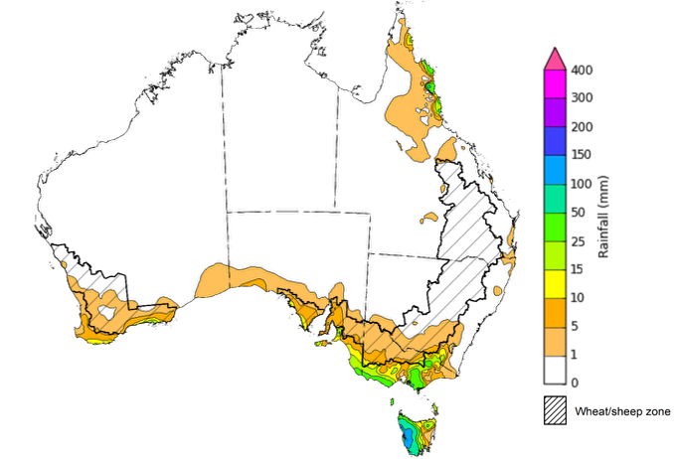
©Commonwealth of Australia 2026, Australian Bureau of Meteorology Issued: 29/7/2026
Note: The rainfall analyses and associated maps utilise data contained in the Bureau of Meteorology climate database, the Australian Data Archive for Meteorology (ADAM). The analyses are initially produced automatically from real-time data with limited quality control. They are intended to provide a general overview of rainfall across Australia as quickly as possible after the observations are received. For further information go to http://www.bom.gov.au/climate/rainfall/

Rainfall forecast for the next eight days
Over the 8 days to 6 August 2026, Australia is expected to remain largely dry, with exceptions in south-western and some south-eastern regions where cold fronts are likely to bring rainfall to certain regions.
- Falls of up to 50 millimetres are forecast for parts of Western Australia and Tasmania, with higher falls on western margins.
- Rainfall totals of between 5-15 millimetres are forecast for far southern parts of Victoria and South Australia.
- Remaining areas are expected to see little to no rainfall.
Across cropping regions, falls are expected to be limited:
- In Western Australia falls of 10-25 millimetres are forecast for most western and central growing regions with lighter falls of up to 10 millimetres expected in the far southeast.
  - If realised, these falls are likely to benefit crop and pasture growth, and boost soil moisture levels, following a relatively dry July.
- Light falls of 1-5 millimetres are forecast for southern New South Wales, Victoria, South Australia. Remaining cropping regions are likely to see little to no rainfall over the coming 8 days.

Total forecast rainfall for the period 30 July to 6 August 2026
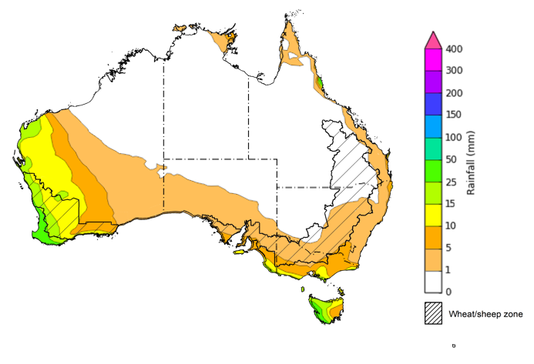
©Commonwealth of Australia 2026, Australian Bureau of Meteorology Issued 30/7/2026
Note: This rainfall forecast is produced from computer models. As the model outputs are not altered by weather forecasters, it is important to check local forecasts and warnings issued by the Bureau of Meteorology.

National Climate Outlook
The northern rainfall onset outlook provides an indication of whether the first significant rains after the dry season are likely to be earlier or later than normal. The onset occurs when the total rainfall after 1 September reaches 50 millimetres, which is considered approximately the amount of rainfall required to stimulate plant growth. The northern rainfall onset for the 2026–27 season is likely to earlier (55-80% chance of early rainfall onset) than usual for much of Western Australia and central regions including northern South Australia, much of the Northern Territory and parts of western Queensland. In contrast, across eastern and northern Queensland and the north of the Northern Territory, the chance of an early rainfall onset is 30-45%. Elsewhere, the northern rainfall onset is likely to be closer to the normal onset date.

Chance of early Northern Rainfall Onset
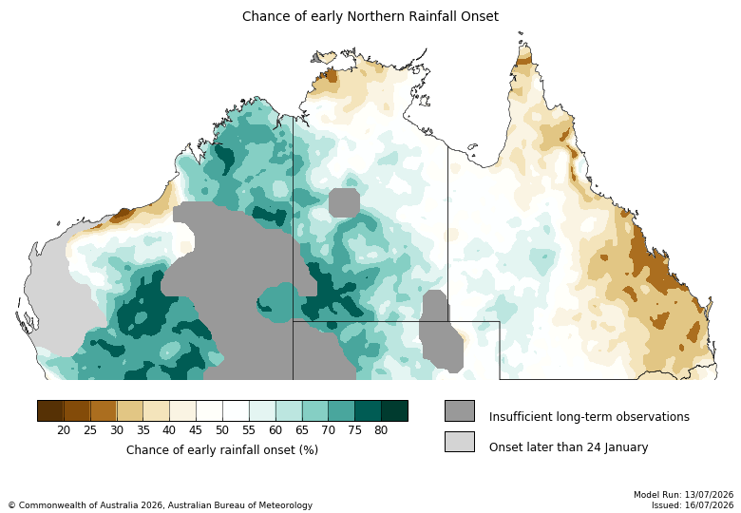

Water markets – current week
Water storage levels in the Murray-Darling Basin (MDB) increased by 205 gigalitres (GL) between 23 July 2026 and 30 July 2026. The current volume of water held in storages is 12,963 GL, equivalent to 58% of total storage capacity. This is 8% or 1,044 GL less than the same time last year. Water storage data is sourced from the Bureau of Meteorology.

Water storages in the Murray-Darling Basin, 2013–2026
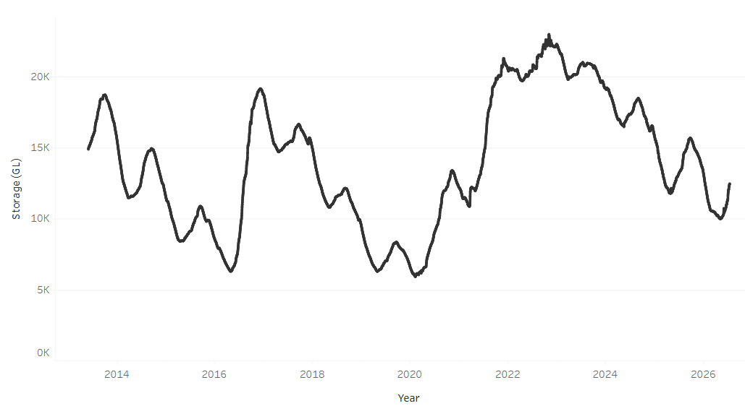
Allocation rices in the Victorian Murray below the Barmah Choke increased from $389/ML on 23 July 2026 to $403/ML on 30 July 2026. Trade from the Goulburn to the Murray is closed. Trade downstream through the Barmah Choke is closed. Trade from the Murrumbidgee to the Murray is open.

Surface water trade activity 2022-2026, Victorian Murray below the Barmah Choke
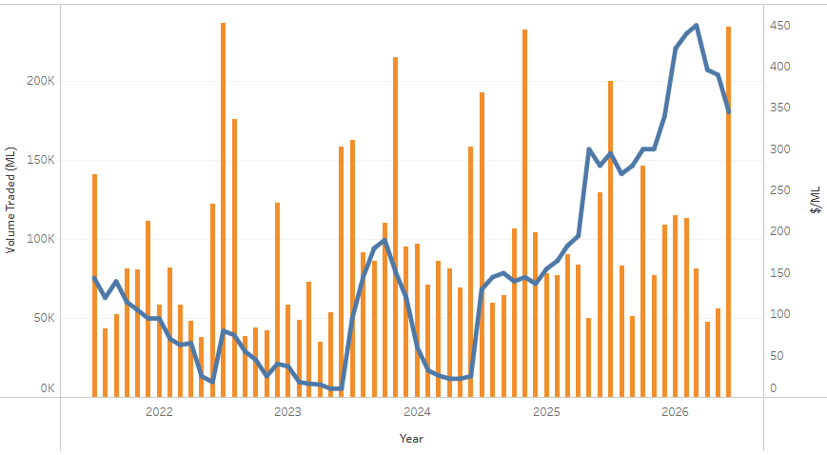

Water market prices, Southern Murray–Darling Basin
Region | $/ML
NSW Murray Above | 305
NSW Murrumbidgee | 408
Vic Greater Goulburn | 368
Vic Murray Below | 403
Note: The water allocation prices shown are volume weighted average prices based on the last 10 trades. Price data is sourced from Waterflow and current as at 23 July 2026.
To access the full, interactive, weekly water dashboard, which contains the latest and historical water storage, water market and water allocation information, please visit https://www.agriculture.gov.au/abares/products/weekly_update/weekly-update-260723

Commodities
Indicator | Week average | Unit | Latest Price | Previous Week | Weekly change |  | Price 12 months ago | Annual change
Selected world indicator prices
AUD/USD Exchange rate | 29-Jul | A$/US$ | 0.70 | 0.70 | 0% | 0.65 |  | 7%
Wheat – US no. 2 hard red winter wheat, FOB Gulf | 29-Jul | US$/t | 321 | 327 | -2% | 235 |  | 37%
Corn – US no. 2 yellow corn, FOB Gulf | 29-Jul | US$/t | 219 | 220 | 0% | 192 |  | 14%
Canola – Rapeseed, Canada, FOB Vancouver | 29-Jul | US$/t | 594 | 615 | -3% | 539 |  | 10%
Cotton – Cotlook A Index | 29-Jul | USc/lb | 89.7 | 89.2 | 1% | 78.9 |  | 14%
Sugar – Intercontinental Exchange, nearby futures, no.11 contract | 29-Jul | USc/lb | 14.6 | 14.8 | -1% | 16.4 |  | -11%
Wool – Eastern Market Indicator | 22-Jul | Ac/kg clean | 1,873 | 1,901 | -1% | 1,220 |  | 54%
Wool – Western Market Indicator | 22-Jul | Ac/kg clean | 2,062 | 2,094 | -2% | 1,360 |  | 52%
Selected Australian grain export prices
Australian Premium White (APW) Wheat, FOB Port Adelaide, SA | 29-Jul | A$/t | 404 | 401 | 1% | 391 |  | 3%
Australian Standard White (ASW) Wheat, FOB Port Adelaide, SA | 29-Jul | A$/t | 397 | 394 | 1% | 387 |  | 3%
Feed Barley – FOB Port Adelaide, SA | 29-Jul | A$/t | 375 | 376 | 0% | 373 |  | 1%
Canola – FOB Kwinana, WA | 29-Jul | A$/t | 829 | 839 | -1% | 817 |  | 2%
Grain Sorghum – FOB Brisbane, QLD | 29-Jul | A$/t | 433 | 432 | 0% | 426 |  | 2%
Selected domestic livestock indicator prices
Beef – Eastern Young Cattle Indicator | 29-Jul | Ac/kg cwt | 990 | 1,004 | -1% | 748 |  | 32%
Mutton – Mutton indicator (18–24 kg fat score 2–3), VIC | 29-Jul | Ac/kg cwt | 879 | 908 | -3% | 692 |  | 27%
Lamb – National Trade Lamb Indicator | 29-Jul | Ac/kg cwt | 1,192 | 1,203 | -1% | 1,141 |  | 4%
Pig – Eastern Seaboard (60.1–75 kg), NSW buyer price | 15-Jul | Ac/kg cwt | 401 | 404 | -1% | 452 |  | -11%
Live cattle – Light steers to Indonesia | 29-Jul | Ac/kg lwt | 430 | 440 | -2% | 342 |  | 26%
Global Dairy Trade (GDT) weighted average prices
Dairy – Whole milk powder | 22-Jul | US$/t | 3,486 | 3,425 | 2% | 3,894 |  | -10%
Dairy – Skim milk powder | 22-Jul | US$/t | 3,234 | 3,135 | 3% | 2,752 |  | 18%
Dairy – Cheddar cheese | 22-Jul | US$/t | 3,586 | 3,900 | -8% | 4,725 |  | -24%
Dairy – Anhydrous milk fat | 22-Jul | US$/t | 6,405 | 6,341 | 1% | 6,951 |  | -8%

Selected world indicator prices
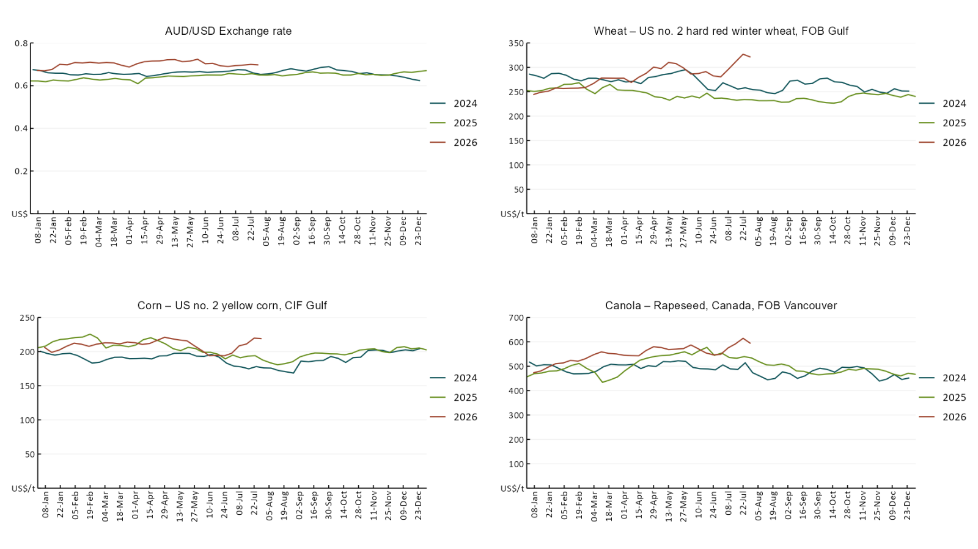

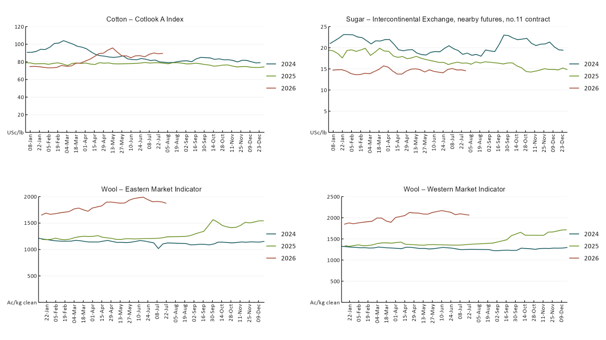

3.2 Selected domestic crop indicator prices
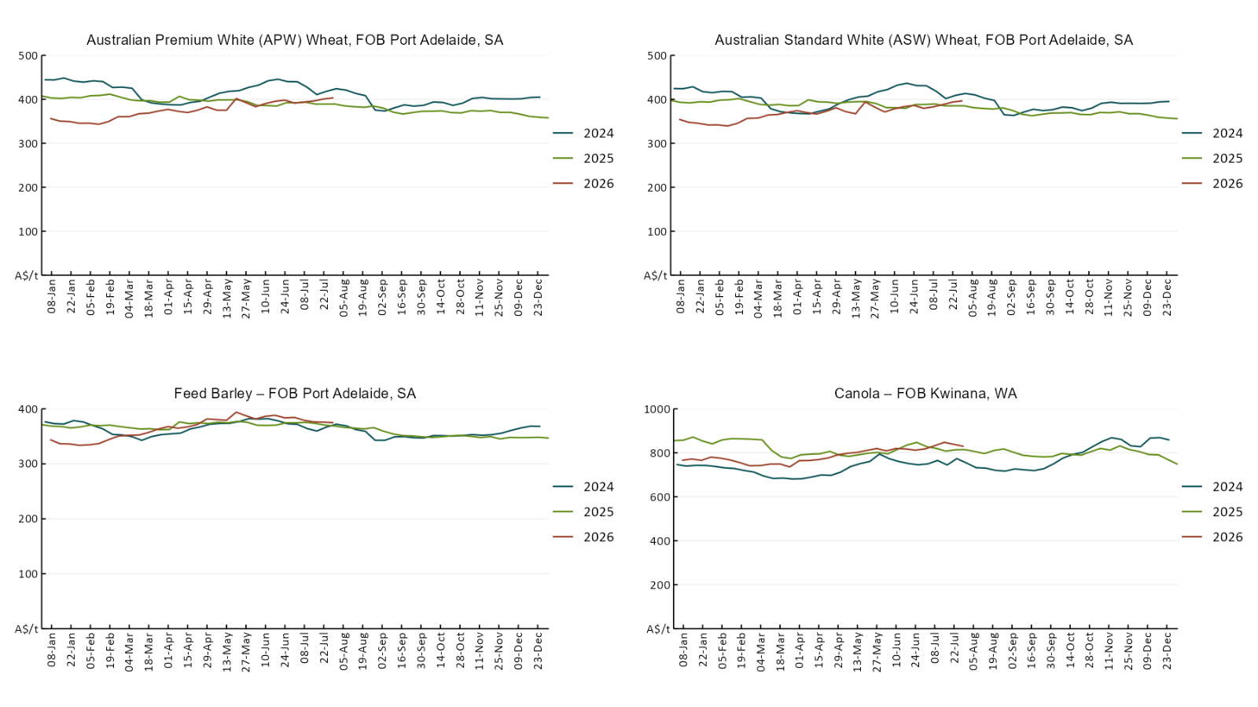

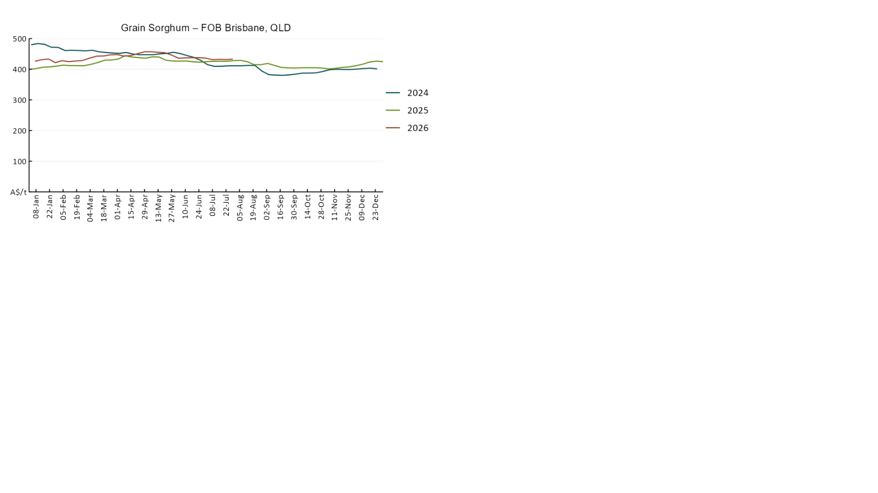

3.3 Selected domestic livestock indicator prices
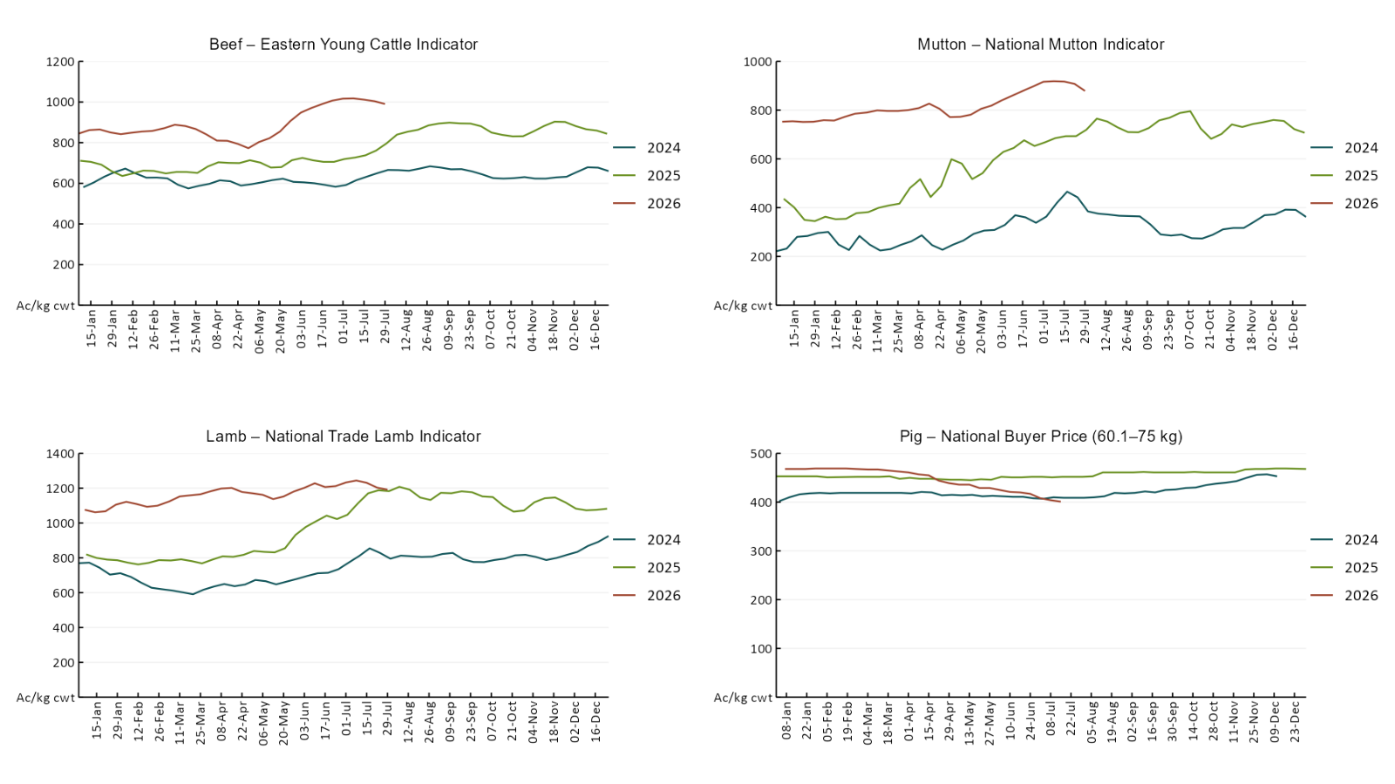

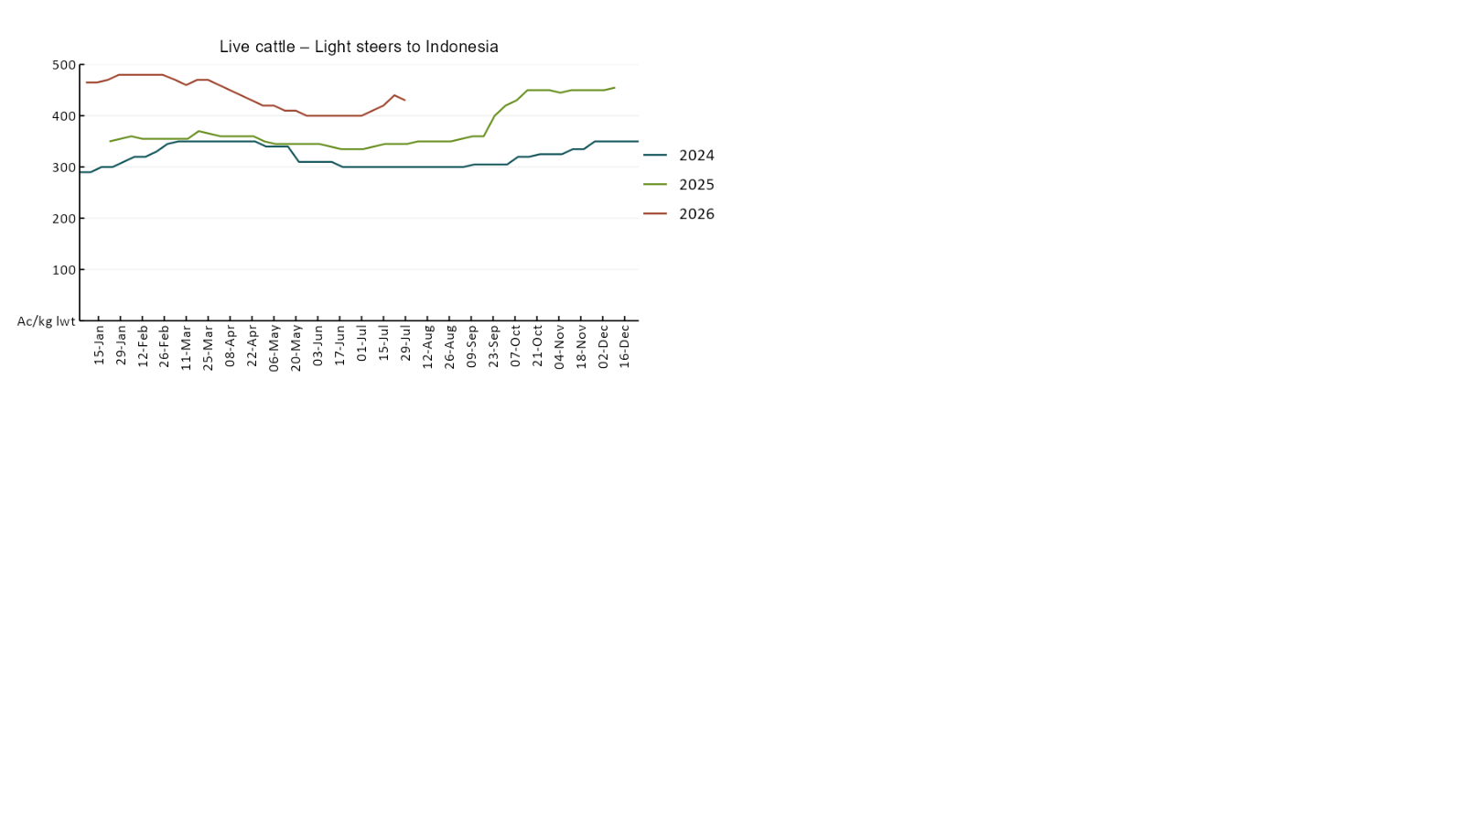

3.4 Global Dairy Trade (GDT) weighted average prices 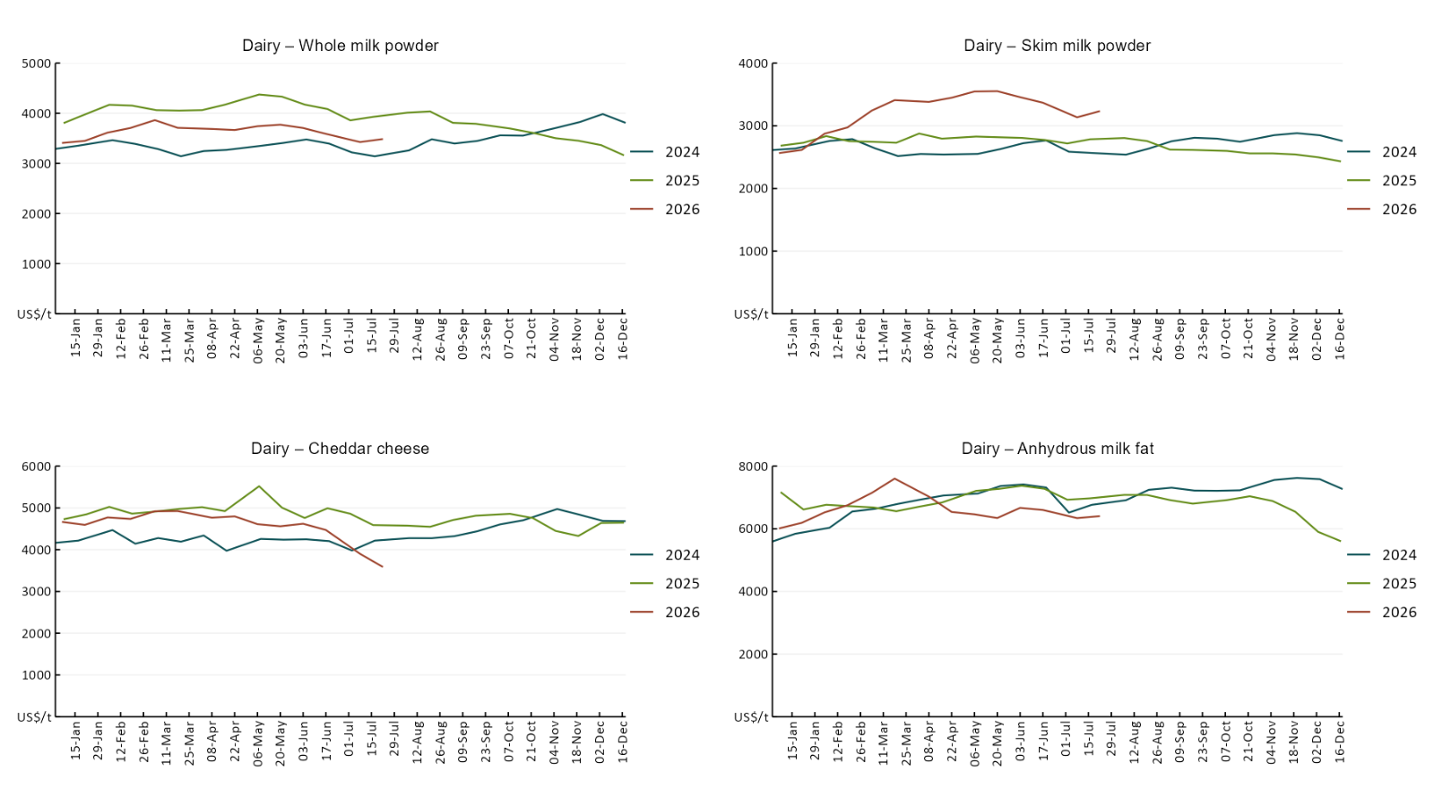

3.5 Selected fruit and vegetable prices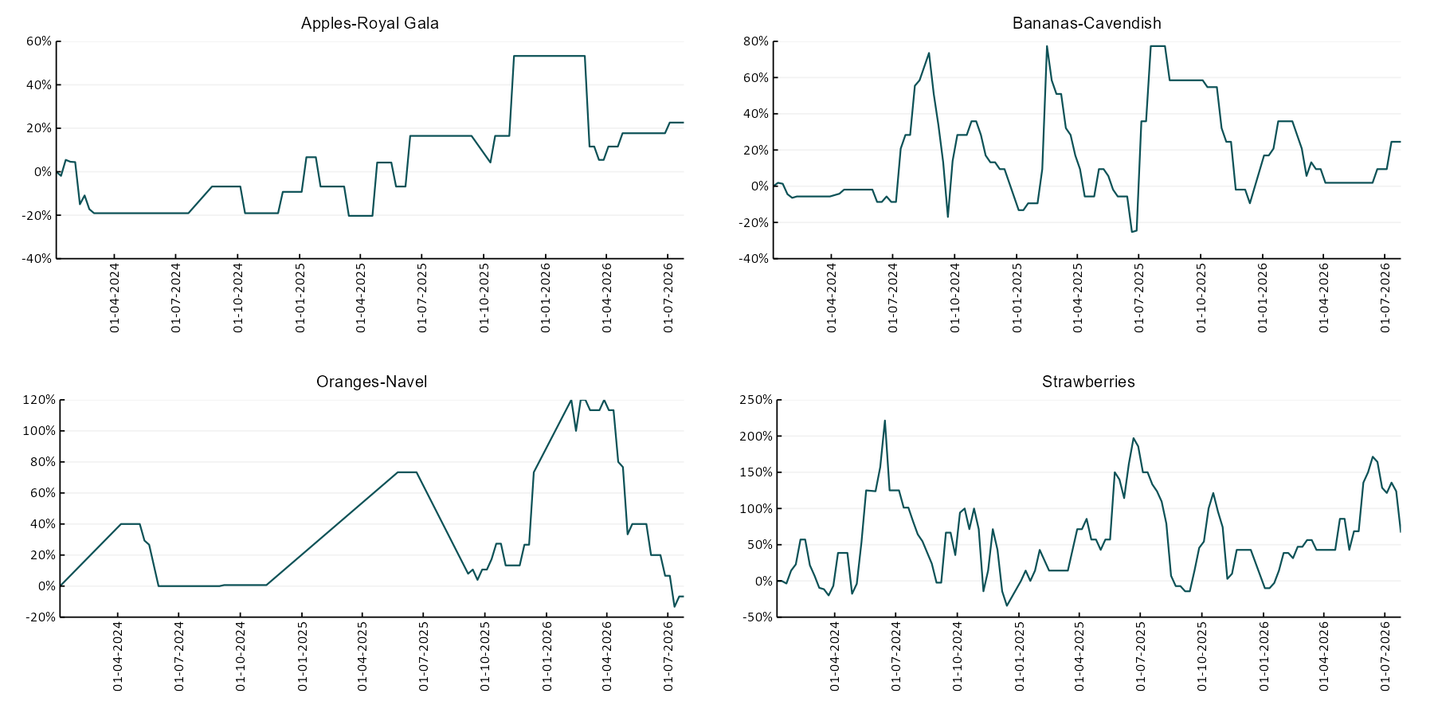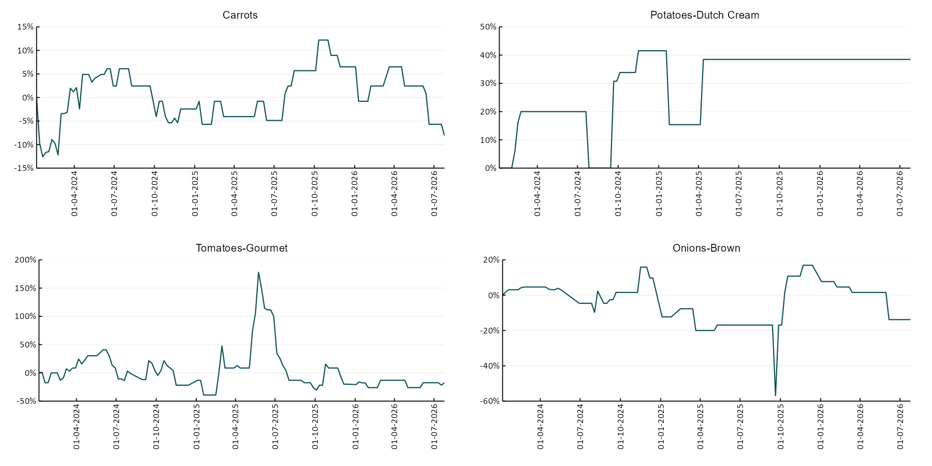

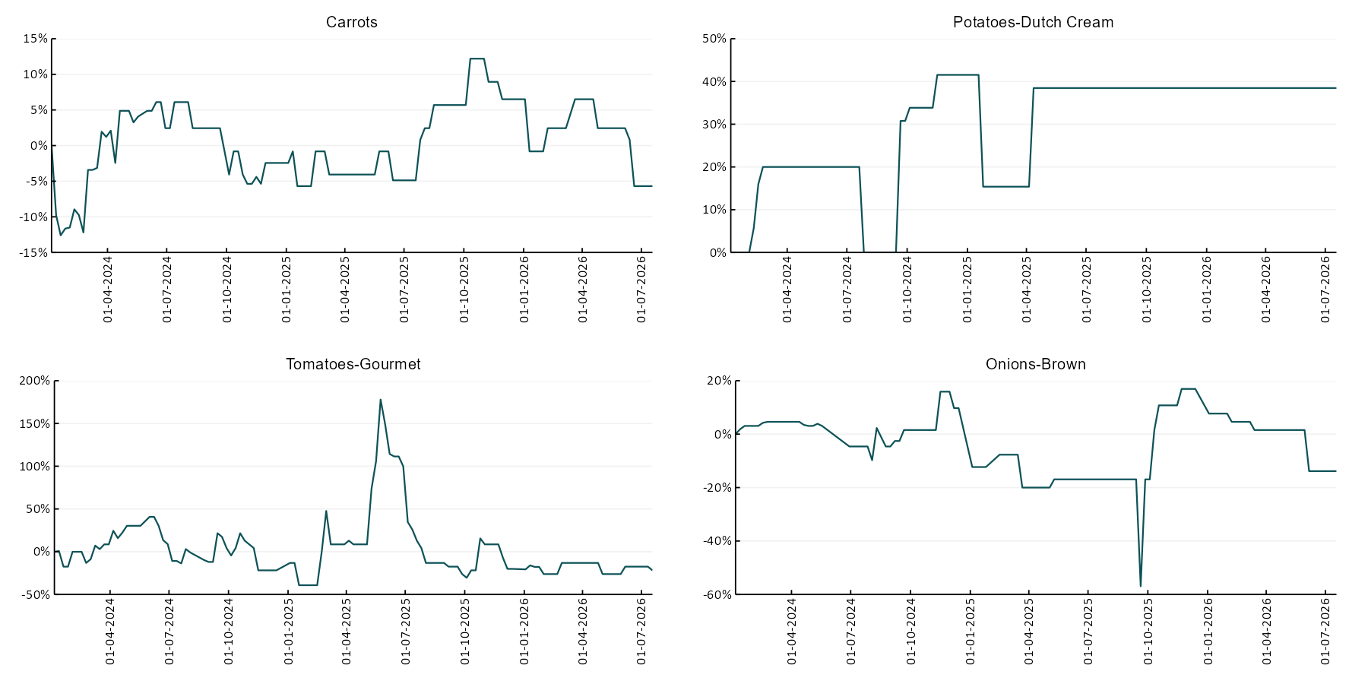

3.6 Selected domestic fodder indicator prices
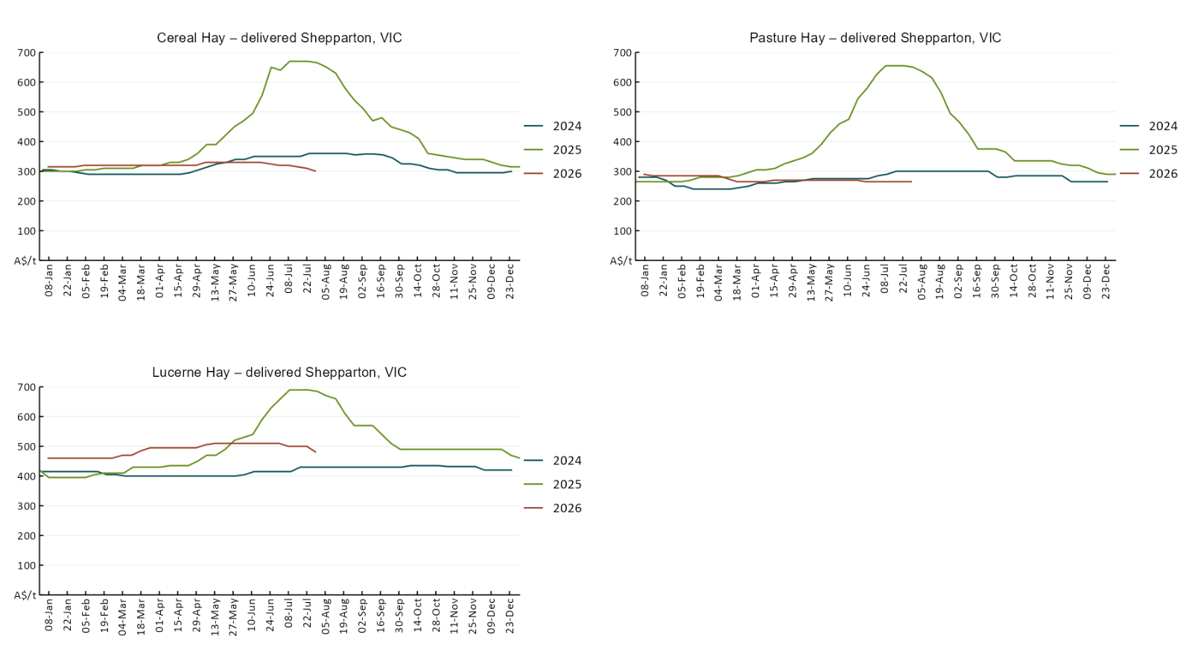

4. Data attribution

Climate
Bureau of Meteorology
- Weekly rainfall totals: www.bom.gov.au/climate/maps/rainfall/
- Monthly and last 3-month rainfall percentiles: https://www.bom.gov.au/climate/ahead/outlooks/#moreMaps
- Rainfall forecast: www.bom.gov.au/jsp/watl/rainfall/pme.jsp
- Seasonal outlook: www.bom.gov.au/climate/outlooks/#/overview/summary/
- Climate drivers: http://www.bom.gov.au/climate/enso/
- Soil moisture: https://awo.bom.gov.au/products/historical/soilMoisture-rootZone/

Other
- Pasture growth: www.longpaddock.qld.gov.au/aussiegrass/
- 3-month global outlooks: Environment and Climate Change Canada, NOAA Climate Prediction Center, EUROBRISA CPTEC/INPE, European Centre for Medium-Range Weather Forecasts, Hydrometcenter of Russia, National Climate Center Climate System Diagnosis and Prediction Room (NCC), International Research Institute for Climate and Society
- Global production: https://ipad.fas.usda.gov/ogamaps/cropmapsandcalendars.aspx
- Autumn break: Pook et al., 2009, https://rmets-onlinelibrary-wiley-com.virtual.anu.edu.au/doi/epdf/10.1002/joc.1833

Water
Prices
- Waterflow: https://www.waterflow.io/
- Ruralco: https://www.ruralcowater.com.au/
- Bureau of Meteorology:
- Allocation trade: http://www.bom.gov.au/water/dashboards/#/water-markets/mdb/at
- Storage volumes: http://www.bom.gov.au/water/dashboards/#/water-storages/summary/drainage

Trade constraints:
- Water NSW: https://www.waternsw.com.au/customer-service/ordering-trading-and-pricing/trading/murrumbidgee
- Victorian Water Register: https://www.waterregister.vic.gov.au/TradingRules2019/

Commodities
Fruit and vegetables
- Datafresh: www.freshstate.com.au

Pigs
- Australian Pork Limited: www.australianpork.com.au

Dairy
- Global Dairy Trade: www.globaldairytrade.info/en/product-results/

World wheat, canola
- International Grains Council
- https://www.igc.int/en/default.aspx
- United States Department of Agriculture

World cotton
- Cotlook: www.cotlook.com/

World sugar
- New York Stock Exchange - Intercontinental Exchange

Wool
- Australian Wool Exchange: www.awex.com.au/

Domestic wheat, barley, sorghum, canola and fodder
- Jumbuk Consulting Pty Ltd: Jumbuk AG | Agriculture Consulting

Cattle, beef, mutton, lamb, goat and live export
- Meat and Livestock Australia: https://www.mla.com.au/prices-markets/

Australian Agricultural Drought Indicators
About Australian Agricultural Drought Indicators
The Australian Agricultural Drought Indicators (AADI) links weather and agricultural data with a range of scientific and economic models to measure and forecast the effects of climate variability and drought on agricultural outcomes.
On AADI, projected broadacre farm profits are presented as percentile outcomes relative to simulated historical outcomes using the groupings:
Highest | 95-100th percentile
Very much above average | 85-95th percentile
Above average | 65-85th percentile
Average | 35-65th percentile
Below average | 15-35th percentile
Very much below average | 5-15th percentile
Lowest 5% | 0-5th percentile

There are two AADI farm profit indicators:
- The AADI farm profit climate and price indicator shows the effect of climate and prices on broadacre farm business profits of current farms compared to the last 33 years.
- The AADI farm profit climate only indicator isolates the effect of climate on profits by holding prices fixed.

© Commonwealth of Australia 2026

Ownership of intellectual property rights
Unless otherwise noted, copyright (and any other intellectual property rights, if any) in this publication is owned by the Commonwealth of Australia (referred to as the Commonwealth).

Creative Commons licence
All material in this publication is licensed under a Creative Commons Attribution 4.0 International Licence except content supplied by third parties, logos and the Commonwealth Coat of Arms.
Inquiries about the licence and any use of this document should be emailed to copyright@awe.gov.au.


Cataloguing data
This publication (and any material sourced from it) should be attributed as:
ABARES 2026, Weekly Australian Climate, Water and Agricultural Update, Australian Bureau of Agricultural and Resource Economics and Sciences, Canberra, 16 July 2026. CC BY 4.0 DOI: https://doi.org/10.25814/5f3e04e7d2503
ISSN 2652-7561
This publication is available at https://www.agriculture.gov.au/abares/products/weekly_update
Department of Agriculture, Fisheries and Forestry
GPO Box 858 Canberra ACT 2601
Telephone 1800 900 090
Web agriculture.gov.au/abares

Disclaimer
The Australian Government acting through the Department of Agriculture, Fisheries and Forestry, represented by the Australian Bureau of Agricultural and Resource Economics and Sciences, has exercised due care and skill in preparing and compiling the information and data in this publication. Notwithstanding, the Department of Agriculture, Fisheries and Forestry, ABARES, its employees and advisers disclaim all liability, including liability for negligence and for any loss, damage, injury, expense or cost incurred by any person as a result of accessing, using or relying on any of the information or data in this publication to the maximum extent permitted by law.

Statement of Professional Independence
The views and analysis presented in ABARES publications, including this one, reflect ABARES professionally independent findings, based on scientific and economic concepts, principles, information and data. These views, analysis and findings may not reflect or be consistent with the views or positions of the Australian Government, or of organisations or groups who have commissioned ABARES reports or analysis. More information on professional independence is provided on the ABARES website.

Acknowledgements
This report was prepared by Holly Beale and Matt Miller.

