
No. 30/2026 6 August 2026

Summary of key issues
- In the week ending 5 August 2026, much of Australia was largely dry, particularly across northern and central regions.
  - Across cropping regions falls of between 1-10 millimetres were recorded in Western Australia, and parts of southern Victoria and eastern South Australia.
  - Cropping regions across New South Wales and Queensland, and the remainder of South Australia and Victoria were largely dry.
- Over the 8 days to 13 August 2026, widespread rainfall is expected across large areas of southern Australia, while much of northern Australia is expected to remain largely dry.
- Across cropping regions, the 8-day forecasts indicates that falls are expected to widespread, except for the northeast.
  - In southern New South Wales, Victoria, South Australia and parts of Western Australia falls of 25-50 millimetres are forecast. Some parts of southern New South Wales and eastern Victoria are expected to see up to 100 millimetres. Meanwhile cropping region in northern New South Wales and the remainder of Western Australia are likely to recorded 5-25 millimetres. If realised, these falls are likely to benefit crop and pasture growth, and boost soil moisture levels particularly in Western Australia following a relatively dry July.
  - In contrast, conditions are expected to remain dry across cropping regions in Queensland.
- Rainfall during July 2026 was generally above average in central regions, but below average across parts of the east and west. Across the southeast, generally average falls have continued to support soil moisture levels, above average pasture growth and winter cropping outcomes.
- Pasture growth for the three months to July 2026 was mixed but broadly above average in central and southern areas, with much of south-eastern and central Australia seeing robust pasture growth, and below average growth was evident across areas of north-eastern and north-western Australia. Soil moisture models indicate broadly average to above average moisture in much of Australia.
- Water storage levels in the Murray-Darling Basin (MDB) increased by 108 gigalitres (GL) between 30 July 2026 and 6 August 2026. The current volume of water held in storages is 13,071 GL, equivalent to 59% of total storage capacity. This is 10% or 1,437 GL less than the same time last year. Water storage data is sourced from the Bureau of Meteorology.
- Allocation rices in the Victorian Murray below the Barmah Choke increased from $403/ML on 30 July 2026 to $409/ML on 6 August 2026. Trade from the Goulburn to the Murray is closed. Trade downstream through the Barmah Choke is closed. Trade from the Murrumbidgee to the Murray is open.

Climate

Rainfall this week
In the week ending 5 August 2026, much of Australia remained largely dry, particularly across central and northern regions. Meanwhile, low-pressure systems and cold fronts brought some rainfall to parts of southern, eastern and western Australia.
- Falls of 5-50 millimetres were recorded across western and southern Western Australia, as well as southern Victoria. Similarly, much of Tasmania saw falls of between 5-50 millimetres with up to 100 millimetres recorded in the west.
- Lower falls of 1-15 millimetres were observed in southern South Australia and scattered eastern areas of Queensland and New South Wales.
- Much of the remainder of Australia saw little to no rainfall.
In cropping regions, low rainfall totals were recorded across parts of southern Australia.
- Falls of between 1-10 millimetres were recorded across cropping regions in Western Australia, and parts of southern Victoria and eastern South Australia.
  - These light falls where recorded with continue to support soil moisture level and the growth of winter crops and pastures.
- Cropping regions across the remainder of South Australia and Victoria, as well as much of New South Wales and Queensland were largely dry.
  - Successive weeks of dry conditions in some southern and eastern regions will see a continued drawdown of stored soil moisture to support crop and pasture growth.

Rainfall for the week ending 5 August 2026
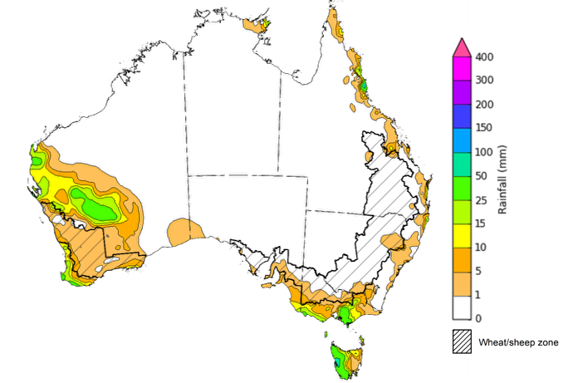
©Commonwealth of Australia 2026, Australian Bureau of Meteorology Issued: 5/8/2026
Note: The rainfall analyses and associated maps utilise data contained in the Bureau of Meteorology climate database, the Australian Data Archive for Meteorology (ADAM). The analyses are initially produced automatically from real-time data with limited quality control. They are intended to provide a general overview of rainfall across Australia as quickly as possible after the observations are received. For further information go to http://www.bom.gov.au/climate/rainfall/

Rainfall forecast for the next eight days
Over the 8 days to 13 August 2026, widespread rainfall is expected across large areas of southern Australia, while much of northern Australia is expected to remain largely dry.
- Falls of between 5-50 millimetres are forecast for much of New South Wales, Victoria, South Australia, Tasmania and southern Western Australia, with higher falls in the far southeast and southwest.
- Rainfall totals of between 1-10 millimetres are forecast for parts of southern Queensland and north-eastern New South Wales.
- Remaining areas are expected to see little to no rainfall.
Across cropping regions, falls are expected to widespread, except for the northeast:
- In southern New South Wales, Victoria, South Australia and parts of Western Australia falls of 25-50 millimetres are forecast. Some parts of southern New South Wales and eastern Victoria are likely to see up to 100 millimetres. Meanwhile cropping region in northern New South Wales and the remainder of Western Australia are likely to recorded 5-25 millimetres.
  - If realised, these falls are likely to benefit crop and pasture growth, and boost soil moisture levels particularly in Western Australia following a relatively dry July.
- In contrast, conditions are expected to remain dry across cropping regions in Queensland.

Total forecast rainfall for the period 6 August to 13 August 2026
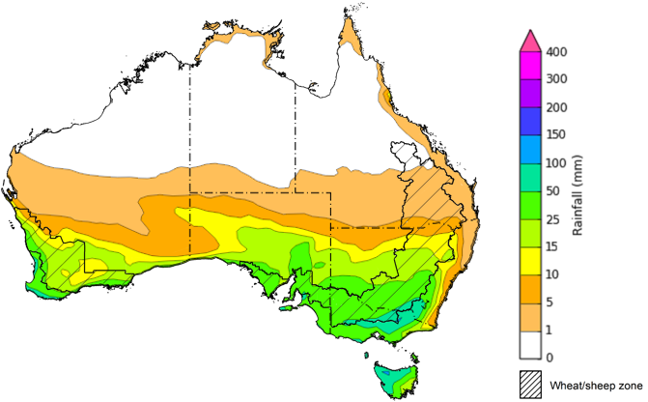

©Commonwealth of Australia 2026, Australian Bureau of Meteorology Issued 6/8/2026
Note: This rainfall forecast is produced from computer models. As the model outputs are not altered by weather forecasters, it is important to check local forecasts and warnings issued by the Bureau of Meteorology.

Monthly rainfall
Rainfall during July 2026 was generally above average in central regions, but below average across much of the west, and parts of the east and south.
- Persistently dry conditions leading to well below average July rainfall in Western Australia have been driven by positive Southern Annual Mode (SAM) climate conditions, reducing the frequency of cold fronts.
In cropping regions, July rainfall was well below average in the west and northeast, with south-eastern regions seeing broadly average rainfall outcomes.
- Extremely low rainfall in much of Queensland and Western Australia and part of northern New South Wales has led to a drawdown of soil moisture storage to support winter crop and pasture growth.
  - In the west, this recent dryness means that most growing regions will be highly reliant in positive rainfall outcome during the remainder of winter and early spring to maintain current positive production prospects
- Across the southeast, generally average falls have continued to support soil moisture levels, above average pasture growth and winter cropping outcomes.
Rainfall deciles for July 2026
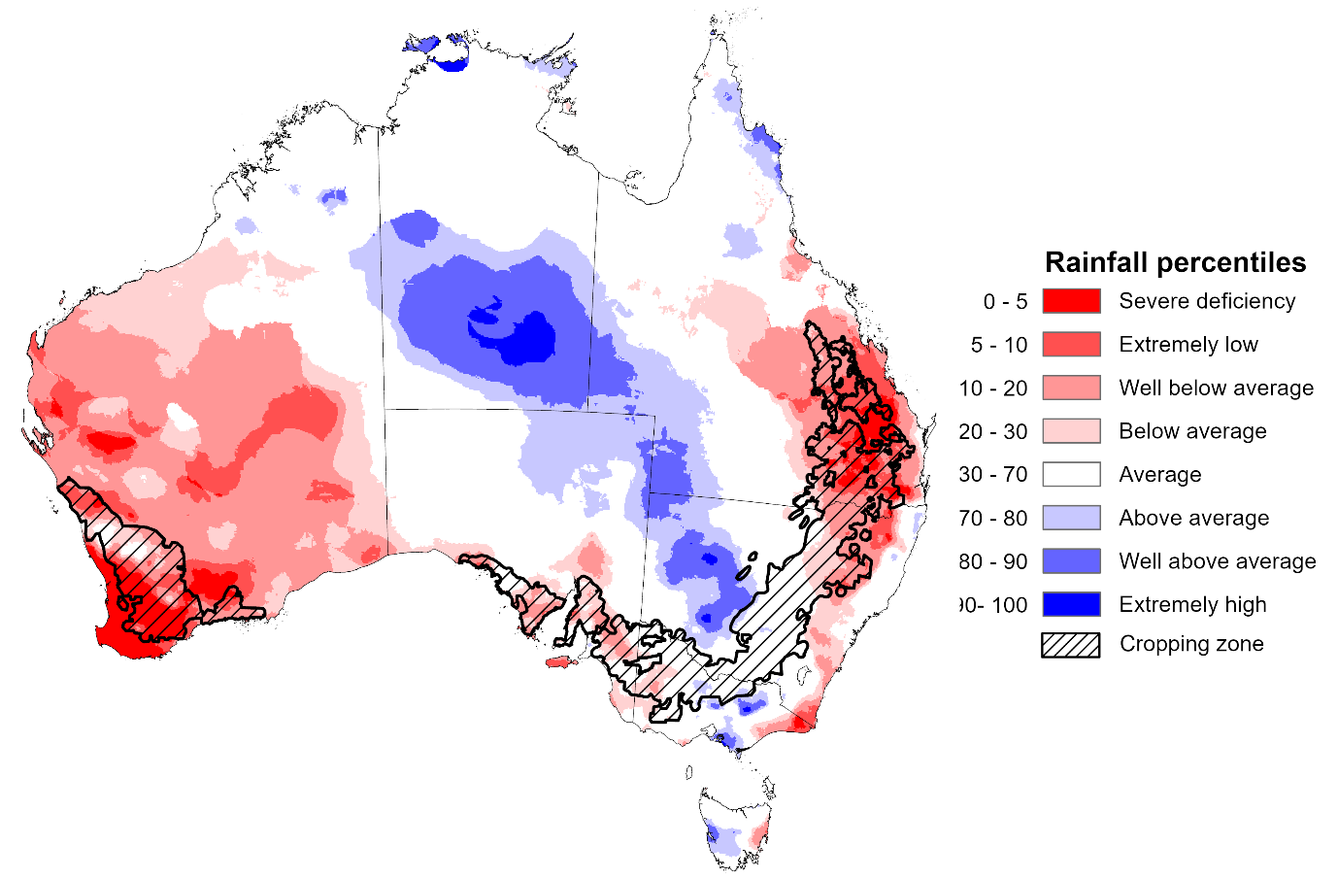
Note: Rainfall for July 2026 is compared with rainfall recorded for that period during the historical record (1900 to present). For further information, go to http://www.bom.gov.au/climate/austmaps/about-rain-maps.shtml
Source: Bureau of Meteorology

Monthly Soil Moisture
In July 2026, modelled upper layer soil moisture was generally average to above average across northern and central areas. In contrast, south-western and some eastern areas saw below average soil moisture.
- Much of southern Western Australia, south-eastern Queensland, parts of eastern New South Wales, and scattered parts of South Australia and Victoria saw below average to extremely low upper layer soil moisture.
- In contrast, much of the Northern Territory, northern and western Queensland, northern Western Australia, much of Victoria, South Australia and New South Wales saw average to very much above upper layer soil moisture.
At this time of year, upper layer soil moisture is important for the vegetative growth and yield potential of winter crops across Australian cropping regions.
- Across cropping regions, modelled upper layer soil moisture in July was modelled to be below average to extremely low for most western and north-eastern cropping regions, with generally average upper layer soil moisture across south-eastern regions.
This represents a considerable decline from June 2026 as a result of persistent dryness for much of the west and northeast. Adequate and timely rainfall throughout the remainder of the growing season will be needed to support ongoing improvements in cropping and pasture growth outcomes.
Modelled upper layer soil moisture for July 2026
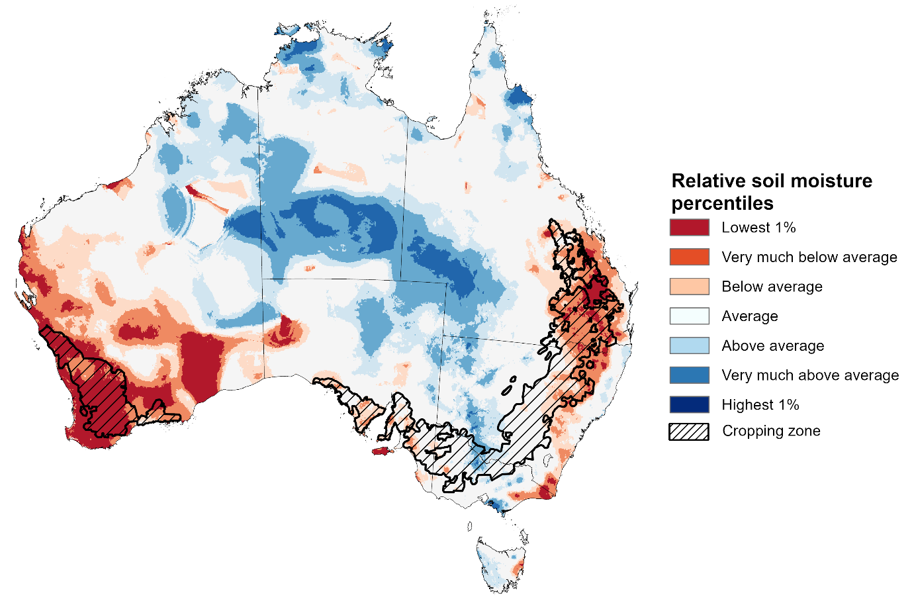
Note: This map shows the levels of modelled upper layer soil moisture (0 to 10 centimetres) during July 2026 This map shows how modelled soil conditions during July 2026 compare with July conditions modelled over the reference period (1911 to 2016). Dark blue areas on the maps were much wetter in July 2026 than during the reference period. The bulk of plant roots occur in the top 20 centimetres of the soil profile. Soil moisture in the upper layer of the soil profile is therefore useful indicator of the availability of water, particularly for germinating seed.
Source: Bureau of Meteorology (https://awo.bom.gov.au/about/overview)
Modelled lower layer soil moisture in July 2026 was average to very much above average across much of Australia, while extremely low to below average modelled lower layer soil moisture was evident across some eastern and western areas.
- Parts of northern and eastern Queensland, eastern Victoria, eastern New South Wales, western South Australia and southern Western Australia were modelled as having extremely low to below average lower layer soil moisture. By contrast, much of the Northern Territory, western Queensland and New South Wales, Victoria, and central and eastern South Australia were modelled as having above average to very much above average soil moisture over the period.
Lower layer soil moisture is a larger, deeper store that is slower to respond to seasonal conditions and tends to reflect the accumulated effects of events that have occurred over longer periods. Crop development and pasture growth in areas of above average lower layer soil moisture are typically less reliant on in-season rainfall than in areas with below average lower layer soil moisture.
- Cropping regions in Queensland and southern Western Australia were modelled as having extremely low to below average soil moisture. In contrast, Victoria, South Australia, New South Wales, scattered areas in Queensland and remaining areas in Western Australia recorded average to very much above average soil moisture for this time of year.
In areas with average to above average lower layer soil moisture, this is likely to provide a reserve of plant-available water to support crop growth over the spring period. Agricultural regions across southern Australia have seen a significant improvement in soil moisture levels since the end of January 2026. Furthermore, July 2026 modelling shows considerable improvements from June 2026 in some south-eastern area– these gains in soil moisture levels mean the winter crop and pasture growth in the coming months will be less reliant on forecast rainfall outcomes. However, conditions have declined in cropping areas in Queensland and parts of southern Western Australia.
Modelled lower layer soil moisture for July 2026
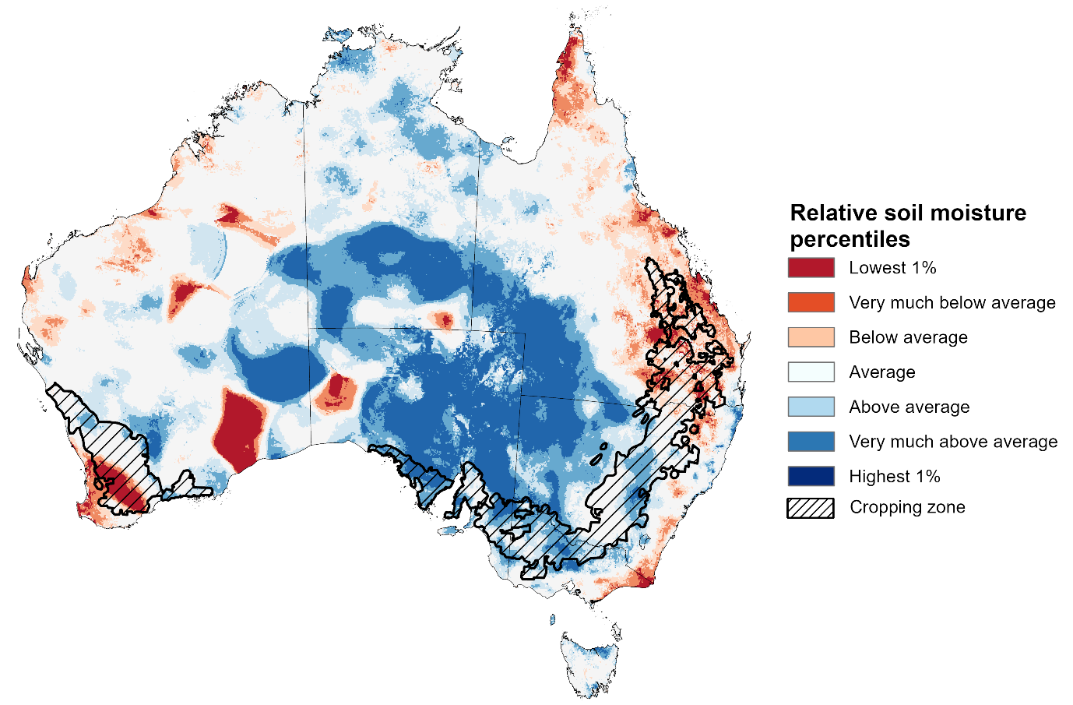
Note:. This map shows how modelled soil conditions during July 2026 compare with July conditions modelled over the reference period (1911 to 2016). Dark blue areas on the maps were much wetter in July 2026 than during the reference period. The dark red areas were much drier than during the reference period. The bulk of plant roots occur in the top 20 centimetres of the soil profile. The lower layer soil moisture is a larger, deeper store that is slower to respond to rainfall and tends to reflect accumulated rainfall events over longer time periods.
Source: Bureau of Meteorology (https://awo.bom.gov.au/about/overview)

Pasture Growth
During the northern Australia dry season (May to September), pasture growth typically declines significantly due to the reduction in water availability, with livestock relying on pasture grown throughout the previous wet season. During winter, pasture growth typically increases in southeast Australia, reflecting higher rainfall totals, and reduced temperatures and evapotranspiration rates at this time of year. Pasture availability during this period influences the growth and branding and marking rates of lambs and calves, livestock turnoff and the production of meat, milk, and wool.
Pasture growth for the three months to July 2026 was variable across much of country.
- Average to extremely high relative pasture growth was modelled across much of southern and central Australia.
  - This pasture growth is expected to have allowed many farmers to maintain livestock numbers, provide opportunities to build standing dry matter availability.
- In contrast, large areas of western and north-eastern Australia saw relatively low pasture growth for this time of year.
  - This below average pasture growth has likely led to a decline in pasture availability. Graziers in regions where below average pasture growth was recorded will be more reliant on supplemental feed to maintain current stocking rates and production.
Relative pasture growth for 3-months ending July 2026 (1 May to 31 July 2026)
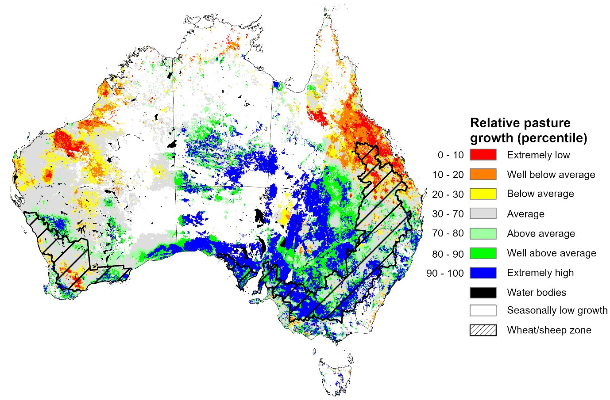
Notes: AussieGRASS pasture growth estimates are relative to the long-term record and shown in percentiles. Percentiles rank data on a scale of zero to 100. This analysis ranks pasture growth for the selected period against average pasture growth for the long-term record (1957 to 2016). Pasture growth is modelled at 5km2 grid cells.
Source: Department of Environment, Science and Innovation

Water markets – current week
Water storage levels in the Murray-Darling Basin (MDB) increased by 108 gigalitres (GL) between 30 July 2026 and 6 August 2026. The current volume of water held in storages is 13,071 GL, equivalent to 59% of total storage capacity. This is 10% or 1,437 GL less than the same time last year. Water storage data is sourced from the Bureau of Meteorology.

Water storages in the Murray-Darling Basin, 2013–2026
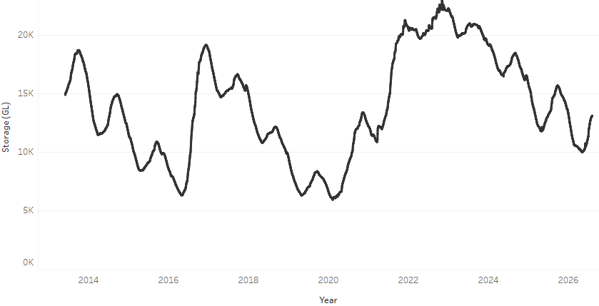
Allocation rices in the Victorian Murray below the Barmah Choke increased from $403/ML on 30 July 2026 to $409/ML on 6 August 2026. Trade from the Goulburn to the Murray is closed. Trade downstream through the Barmah Choke is closed. Trade from the Murrumbidgee to the Murray is open.

Surface water trade activity 2022-2026, Victorian Murray below the Barmah Choke 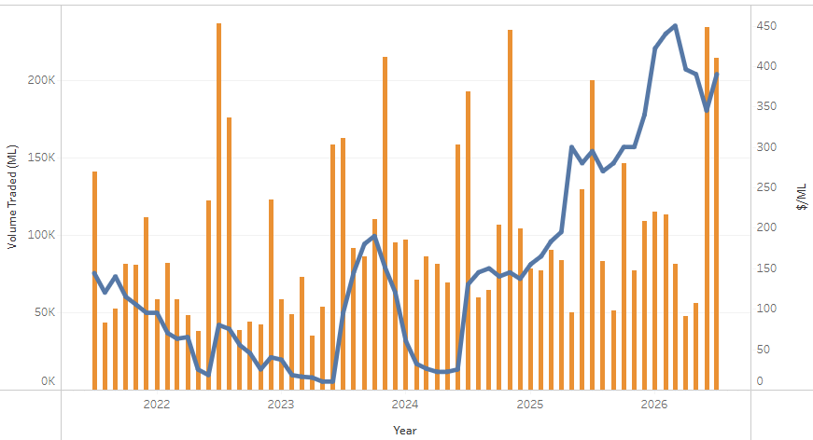

Water market prices, Southern Murray–Darling Basin
Region | $/ML
NSW Murray Above | 341
NSW Murrumbidgee | 369
Vic Greater Goulburn | 395
Vic Murray Below | 409
Note: The water allocation prices shown are volume weighted average prices based on the last 10 trades. Price data is sourced from Waterflow and current as at 6 August 2026.
To access the full, interactive, weekly water dashboard, which contains the latest and historical water storage, water market and water allocation information, please visit https://www.agriculture.gov.au/abares/products/weekly_update/weekly-update-260806

Commodities
Indicator | Week average | Unit | Latest Price | Previous Week | Weekly change |  | Price 12 months ago | Annual change
Selected world indicator prices
AUD/USD Exchange rate | 5-Aug | A$/US$ | 0.70 | 0.70 | 1% | 0.65 |  | 8%
Wheat – US no. 2 hard red winter wheat, FOB Gulf | 5-Aug | US$/t | 317 | 320 | -1% | 231 |  | 37%
Corn – US no. 2 yellow corn, FOB Gulf | 5-Aug | US$/t | 216 | 218 | -1% | 183 |  | 18%
Canola – Rapeseed, Canada, FOB Vancouver | 5-Aug | US$/t | 573 | 584 | -2% | 510 |  | 13%
Cotton – Cotlook A Index | 5-Aug | USc/lb | 93.2 | 89.5 | 4% | 78.6 |  | 19%
Sugar – Intercontinental Exchange, nearby futures, no.11 contract | 5-Aug | USc/lb | 15.0 | 14.5 | 3% | 16.5 |  | -9%
Wool – Eastern Market Indicator | 22-Jul | Ac/kg clean | 1,873 | 1,901 | -1% | 1,220 |  | 54%
Wool – Western Market Indicator | 22-Jul | Ac/kg clean | 2,062 | 2,094 | -2% | 1,360 |  | 52%
Selected Australian grain export prices
Australian Premium White (APW) Wheat, FOB Port Adelaide, SA | 5-Aug | A$/t | 394 | 399 | -1% | 384 |  | 3%
Australian Standard White (ASW) Wheat, FOB Port Adelaide, SA | 5-Aug | A$/t | 387 | 392 | -1% | 380 |  | 2%
Feed Barley – FOB Port Adelaide, SA | 5-Aug | A$/t | 371 | 374 | -1% | 365 |  | 2%
Canola – FOB Kwinana, WA | 5-Aug | A$/t | 773 | 810 | -5% | 808 |  | -4%
Grain Sorghum – FOB Brisbane, QLD | 5-Aug | A$/t | 431 | 432 | 0% | 421 |  | 2%
Selected domestic livestock indicator prices
Beef – Eastern Young Cattle Indicator | 5-Aug | Ac/kg cwt | 946 | 983 | -4% | 860 |  | 10%
Mutton – Mutton indicator (18–24 kg fat score 2–3), VIC | 5-Aug | Ac/kg cwt | 845 | 870 | -3% | 740 |  | 14%
Lamb – National Trade Lamb Indicator | 5-Aug | Ac/kg cwt | 1,176 | 1,188 | -1% | 1,170 |  | 1%
Pig – Eastern Seaboard (60.1–75 kg), NSW buyer price | 22-Jul | Ac/kg cwt | 396 | 401 | -1% | 459 |  | -14%
Live cattle – Light steers to Indonesia | 5-Aug | Ac/kg lwt | 440 | 430 | 2% | 350 |  | 26%
Global Dairy Trade (GDT) weighted average prices
Dairy – Whole milk powder | 5-Aug | US$/t | 3,483 | 3,486 | 0% | 4,024 |  | -13%
Dairy – Skim milk powder | 5-Aug | US$/t | 3,261 | 3,234 | 1% | 2,781 |  | 17%
Dairy – Cheddar cheese | 5-Aug | US$/t | 3,723 | 3,586 | 4% | 4,562 |  | -18%
Dairy – Anhydrous milk fat | 5-Aug | US$/t | 6,367 | 6,405 | -1% | 7,080 |  | -10%

Selected world indicator prices
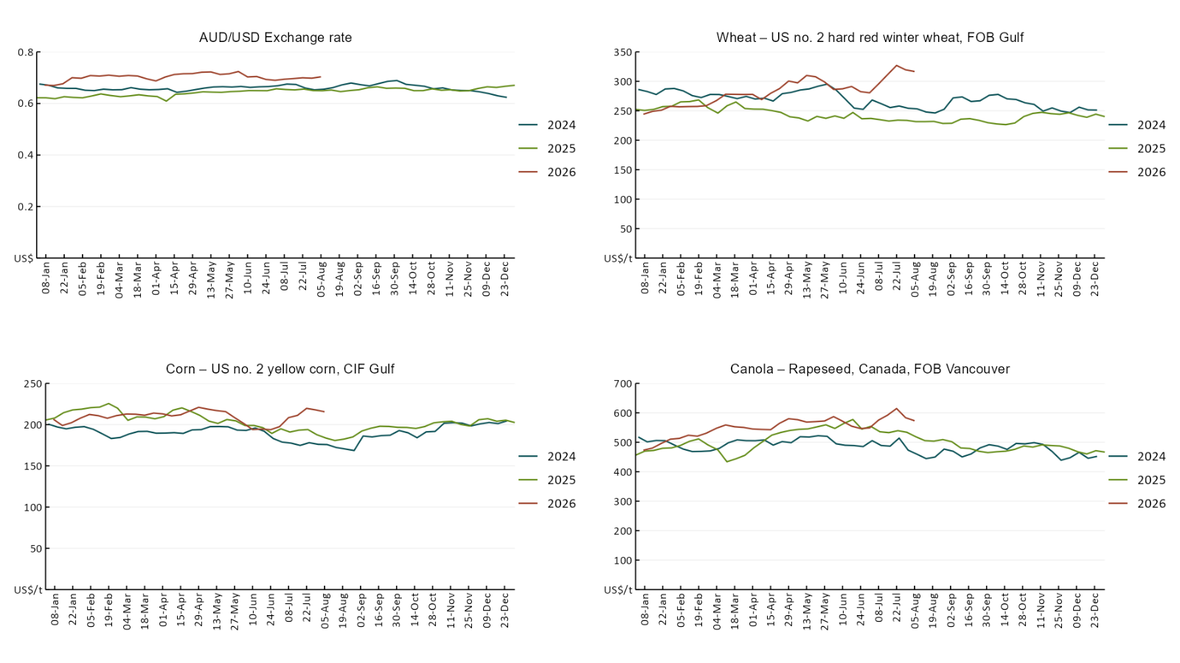

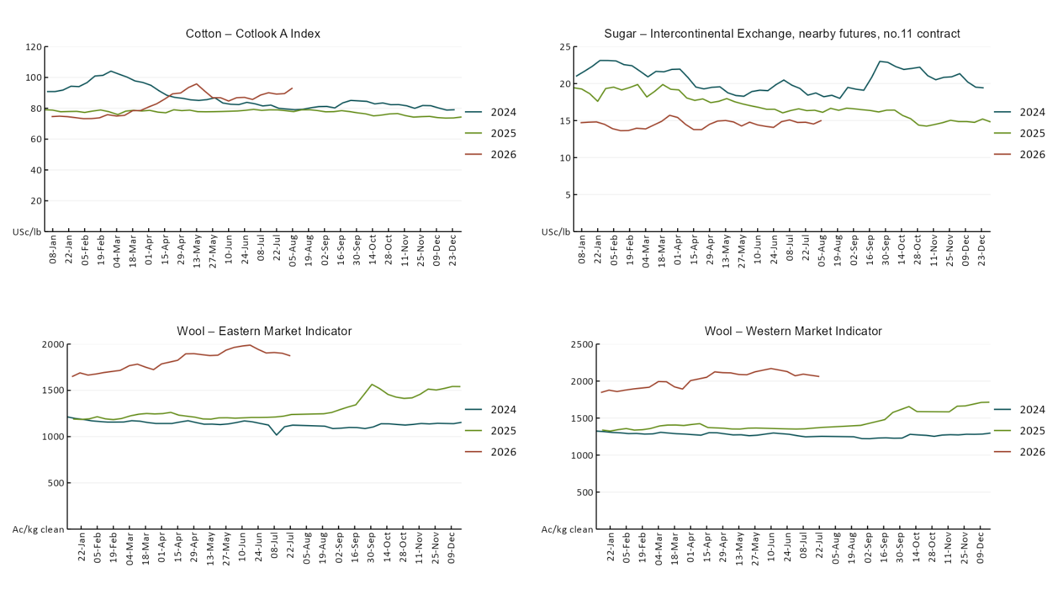

3.2 Selected domestic crop indicator prices
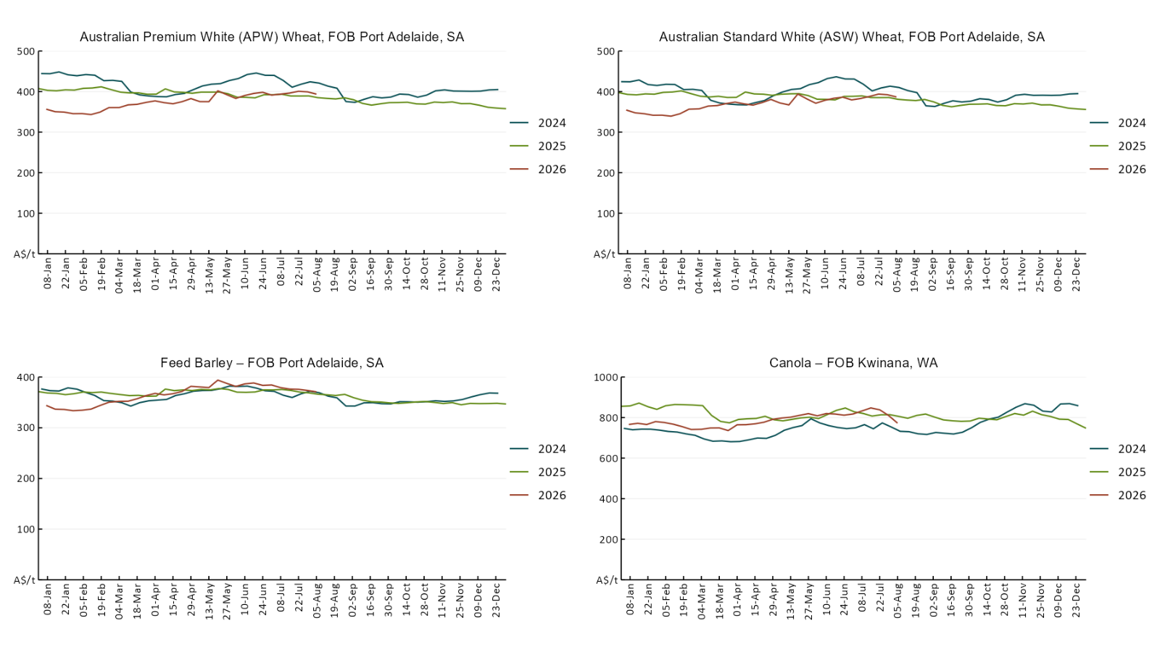

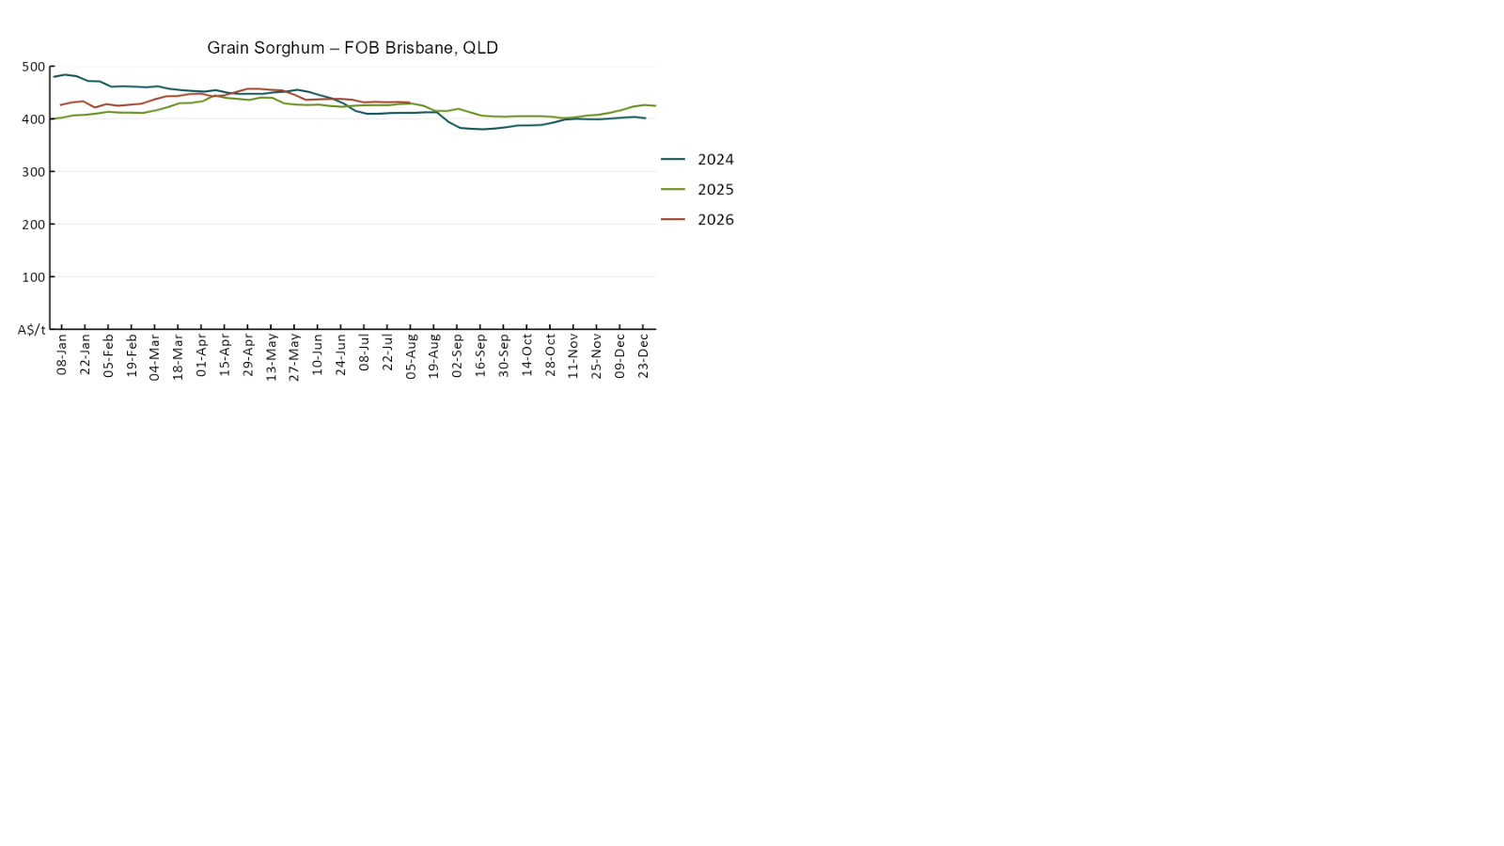

3.3 Selected domestic livestock indicator prices
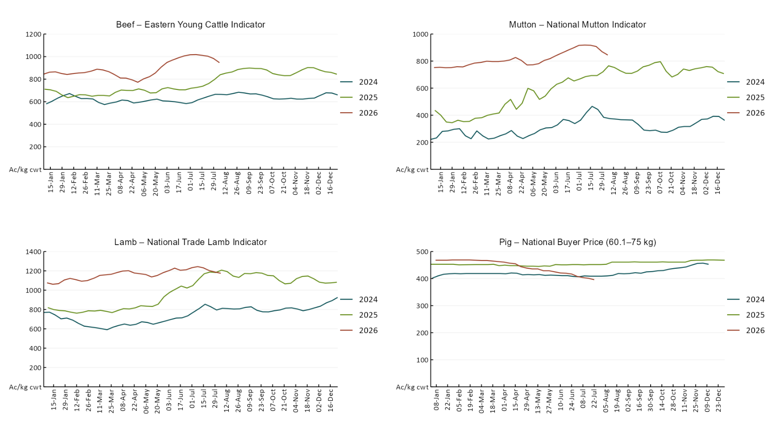

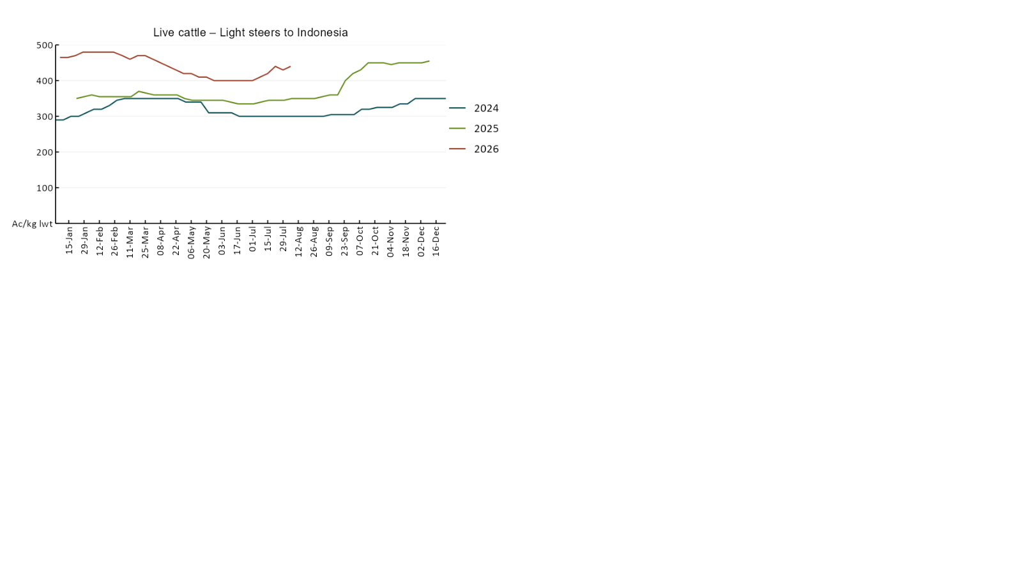

3.4 Global Dairy Trade (GDT) weighted average prices
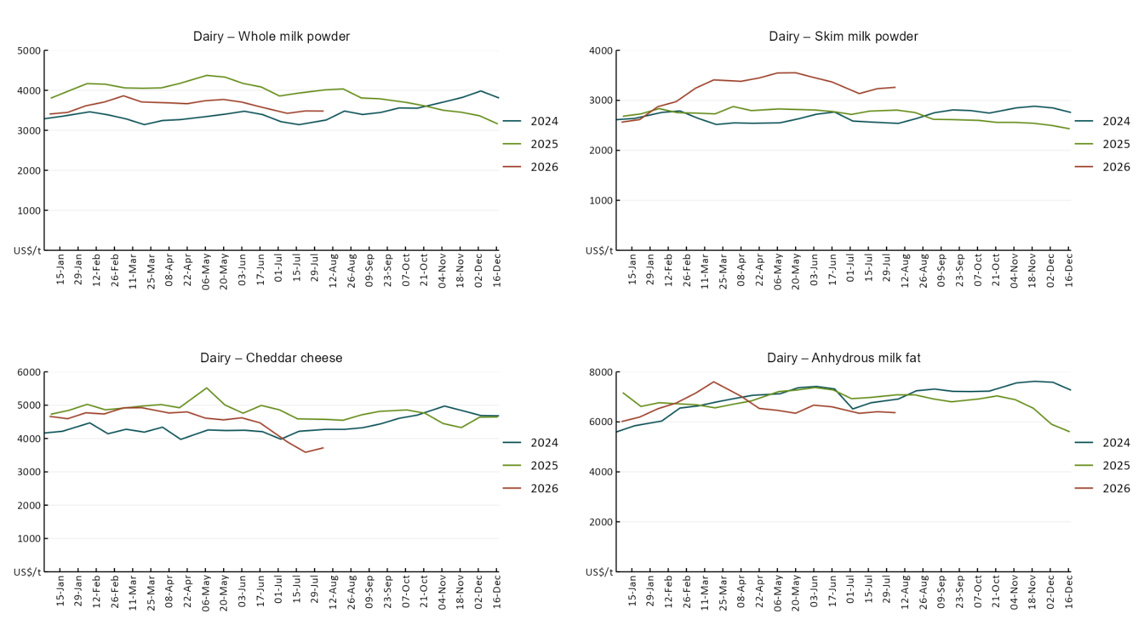

3.5 Selected fruit and vegetable prices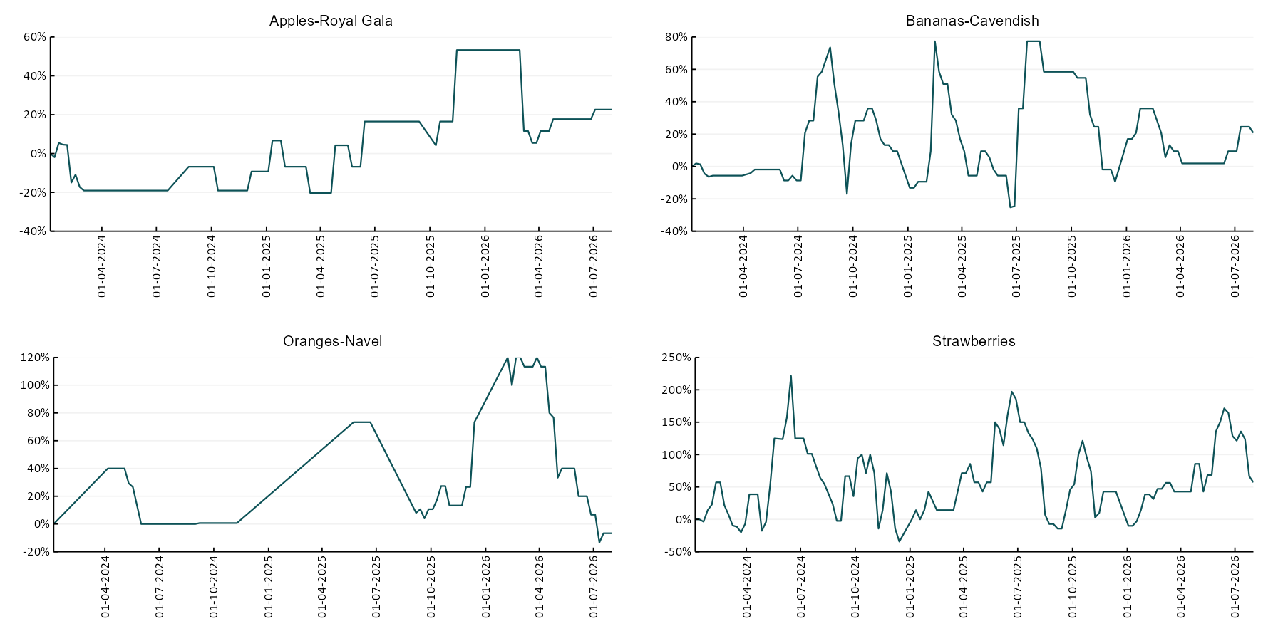
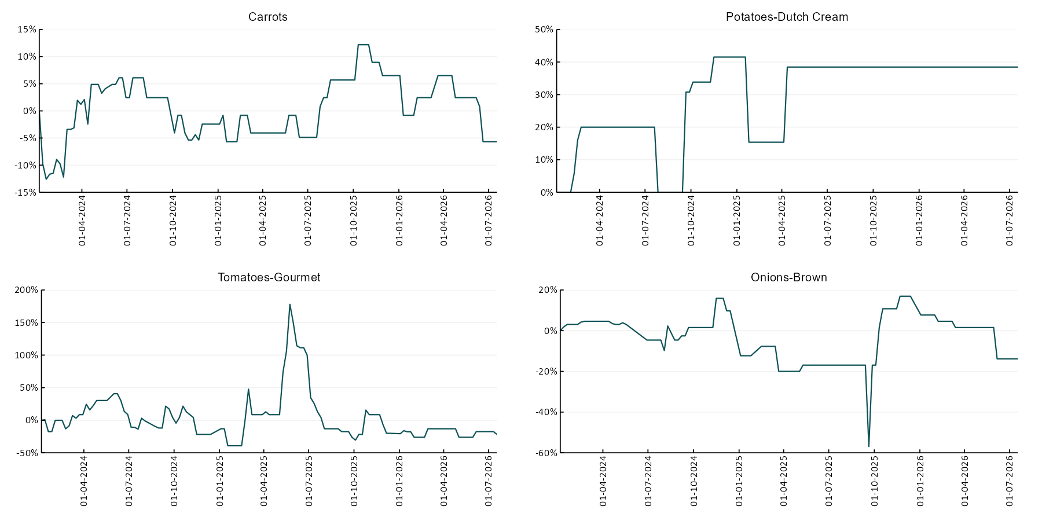

3.6 Selected domestic fodder indicator prices
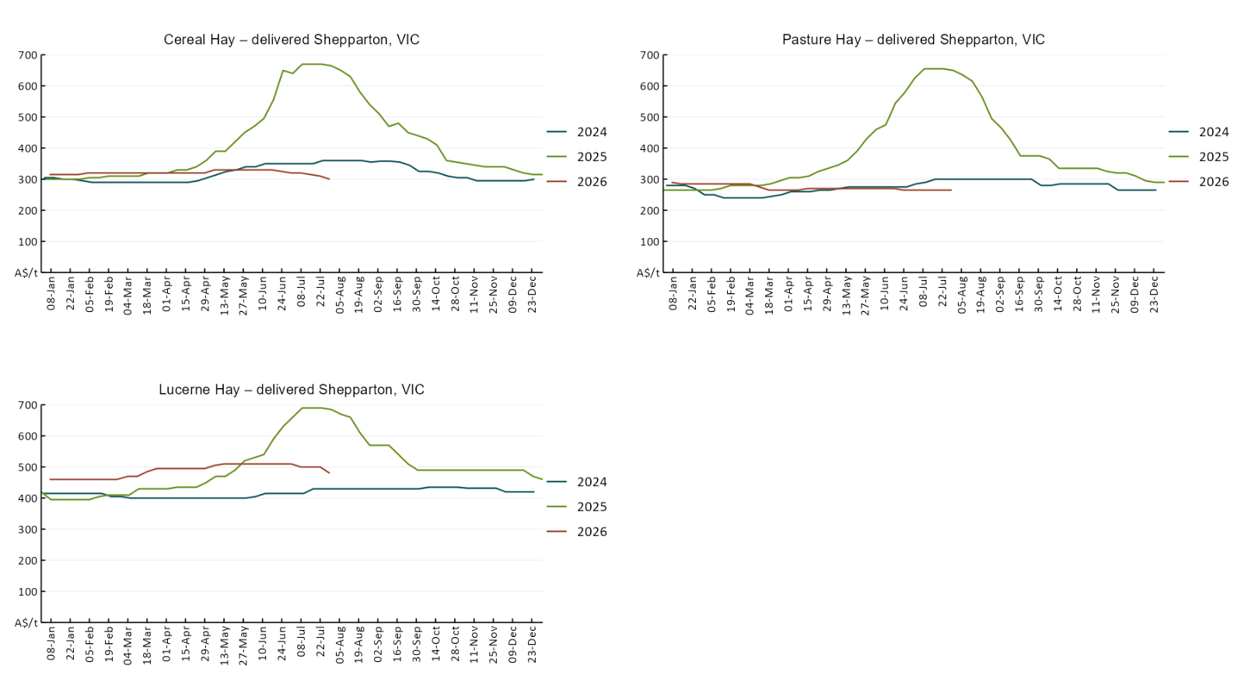

4. Data attribution

Climate
Bureau of Meteorology
- Weekly rainfall totals: www.bom.gov.au/climate/maps/rainfall/
- Monthly and last 3-month rainfall percentiles: https://www.bom.gov.au/climate/ahead/outlooks/#moreMaps
- Rainfall forecast: www.bom.gov.au/jsp/watl/rainfall/pme.jsp
- Seasonal outlook: www.bom.gov.au/climate/outlooks/#/overview/summary/
- Climate drivers: http://www.bom.gov.au/climate/enso/
- Soil moisture: https://awo.bom.gov.au/products/historical/soilMoisture-rootZone/

Other
- Pasture growth: www.longpaddock.qld.gov.au/aussiegrass/
- 3-month global outlooks: Environment and Climate Change Canada, NOAA Climate Prediction Center, EUROBRISA CPTEC/INPE, European Centre for Medium-Range Weather Forecasts, Hydrometcenter of Russia, National Climate Center Climate System Diagnosis and Prediction Room (NCC), International Research Institute for Climate and Society
- Global production: https://ipad.fas.usda.gov/ogamaps/cropmapsandcalendars.aspx
- Autumn break: Pook et al., 2009, https://rmets-onlinelibrary-wiley-com.virtual.anu.edu.au/doi/epdf/10.1002/joc.1833

Water
Prices
- Waterflow: https://www.waterflow.io/
- Ruralco: https://www.ruralcowater.com.au/
- Bureau of Meteorology:
- Allocation trade: http://www.bom.gov.au/water/dashboards/#/water-markets/mdb/at
- Storage volumes: http://www.bom.gov.au/water/dashboards/#/water-storages/summary/drainage

Trade constraints:
- Water NSW: https://www.waternsw.com.au/customer-service/ordering-trading-and-pricing/trading/murrumbidgee
- Victorian Water Register: https://www.waterregister.vic.gov.au/TradingRules2019/

Commodities
Fruit and vegetables
- Datafresh: www.freshstate.com.au

Pigs
- Australian Pork Limited: www.australianpork.com.au

Dairy
- Global Dairy Trade: www.globaldairytrade.info/en/product-results/

World wheat, canola
- International Grains Council
- https://www.igc.int/en/default.aspx
- United States Department of Agriculture

World cotton
- Cotlook: www.cotlook.com/

World sugar
- New York Stock Exchange - Intercontinental Exchange

Wool
- Australian Wool Exchange: www.awex.com.au/

Domestic wheat, barley, sorghum, canola and fodder
- Jumbuk Consulting Pty Ltd: Jumbuk AG | Agriculture Consulting

Cattle, beef, mutton, lamb, goat and live export
- Meat and Livestock Australia: https://www.mla.com.au/prices-markets/

Australian Agricultural Drought Indicators
About Australian Agricultural Drought Indicators
The Australian Agricultural Drought Indicators (AADI) links weather and agricultural data with a range of scientific and economic models to measure and forecast the effects of climate variability and drought on agricultural outcomes.
On AADI, projected broadacre farm profits are presented as percentile outcomes relative to simulated historical outcomes using the groupings:
Highest | 95-100th percentile
Very much above average | 85-95th percentile
Above average | 65-85th percentile
Average | 35-65th percentile
Below average | 15-35th percentile
Very much below average | 5-15th percentile
Lowest 5% | 0-5th percentile

There are two AADI farm profit indicators:
- The AADI farm profit climate and price indicator shows the effect of climate and prices on broadacre farm business profits of current farms compared to the last 33 years.
- The AADI farm profit climate only indicator isolates the effect of climate on profits by holding prices fixed.

© Commonwealth of Australia 2026

Ownership of intellectual property rights
Unless otherwise noted, copyright (and any other intellectual property rights, if any) in this publication is owned by the Commonwealth of Australia (referred to as the Commonwealth).

Creative Commons licence
All material in this publication is licensed under a Creative Commons Attribution 4.0 International Licence except content supplied by third parties, logos and the Commonwealth Coat of Arms.
Inquiries about the licence and any use of this document should be emailed to copyright@awe.gov.au.


Cataloguing data
This publication (and any material sourced from it) should be attributed as:
ABARES 2026, Weekly Australian Climate, Water and Agricultural Update, Australian Bureau of Agricultural and Resource Economics and Sciences, Canberra, 6 August 2026. CC BY 4.0 DOI: https://doi.org/10.25814/5f3e04e7d2503
ISSN 2652-7561
This publication is available at https://www.agriculture.gov.au/abares/products/weekly_update
Department of Agriculture, Fisheries and Forestry
GPO Box 858 Canberra ACT 2601
Telephone 1800 900 090
Web agriculture.gov.au/abares

Disclaimer
The Australian Government acting through the Department of Agriculture, Fisheries and Forestry, represented by the Australian Bureau of Agricultural and Resource Economics and Sciences, has exercised due care and skill in preparing and compiling the information and data in this publication. Notwithstanding, the Department of Agriculture, Fisheries and Forestry, ABARES, its employees and advisers disclaim all liability, including liability for negligence and for any loss, damage, injury, expense or cost incurred by any person as a result of accessing, using or relying on any of the information or data in this publication to the maximum extent permitted by law.

Statement of Professional Independence
The views and analysis presented in ABARES publications, including this one, reflect ABARES professionally independent findings, based on scientific and economic concepts, principles, information and data. These views, analysis and findings may not reflect or be consistent with the views or positions of the Australian Government, or of organisations or groups who have commissioned ABARES reports or analysis. More information on professional independence is provided on the ABARES website.

Acknowledgements
This report was prepared by Holly Beale and Matt Miller.

