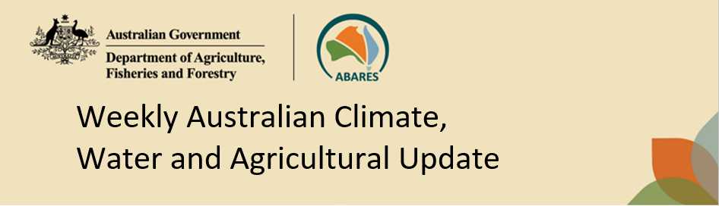
No. 31/2026 13 August 2026

Summary of key issues
- In the week ending 12 August 2026, cold fronts brought rainfall to much of the south, while the northern half of Australia remained largely dry.
  - Meanwhile, heavier falls of between 10-50 millimetres were recorded across most cropping regions in Western Australia, South Australia, Victoria, and southern and central New South Wales. These falls are expected to benefit crop and pasture growth, and boost soil moisture levels particularly in Western Australia following a relatively dry July.
  - Cropping regions across Queensland were largely dry.
- Over the 8 days to 20 August 2026, rainfall is expected across parts of southern and eastern Australia.
  - Cropping regions in South Australia and Victoria are forecast to see 10-25 millimetres, while remaining southern cropping regions including Western Australia and southern New South Wales are expected to see 1-15 millimetres.
  - In contrast, conditions are expected to remain dry across cropping regions in northern New South Wales and Queensland.
- The national rainfall outlook for September to November 2026 indicates an increased probability of below median rainfall across parts of south-eastern Australia.
  - The current rainfall outlook for September to November 2026 suggests below average falls across most cropping regions in south-eastern Australia, and mixed expected falls in Western Australia. However, favourable soil moisture levels across most of Australia’s southern growing regions means that if forecast spring rainfall totals of between 25-100 millimetres are realised, these falls are likely be sufficient to support the growth of winter crops. However, due to limited stored soil moisture across large areas of northern New South Wales and Queensland, below average expected spring rainfall totals continue to represent an ongoing downside production risk for the 2026–27 winter and summer cropping seasons in these areas.
- Water storage levels in the Murray-Darling Basin (MDB) increased by 381 gigalitres (GL) between 6 August 2026 and 13 August 2026. The current volume of water held in storages is 13,452 GL, equivalent to 60% of total storage capacity. This is 8% or 1,209 GL less than the same time last year. Water storage data is sourced from the Bureau of Meteorology (BOM).
- Allocation prices in the Victorian Murray below the Barmah Choke decreased from $409/ML on 6 August 2026 to $375/ML on 13 August 2026. Trade from the Goulburn to the Murray is closed. Trade downstream through the Barmah Choke is closed. Trade from the Murrumbidgee to the Murray is closed.

Climate

Rainfall this week
In the week ending 12 August 2026, cold fronts brought rainfall to much of the south, while the northern half of Australia remained largely dry.
- Falls of 10-50 millimetres were recorded across large areas of southern Western Australia and western Tasmania. Heavier falls of up to 150 millimetres occurred across much of South Australia, Victoria, and southern and central New South Wales.
- Lower falls of 1-10 millimetres were observed in southern Queensland and northern New South Wales.
- Much of the remainder of Australia saw little to no rainfall.
In cropping regions, substantial rainfall totals were recorded across parts of southern Australia.
- Light falls of between 1-15 millimetres were recorded across northern New South Wales and southern Queensland cropping regions.
- Meanwhile, heavier falls of between 10-50 millimetres were recorded across most cropping regions in Western Australia, South Australia, Victoria, and southern and central New South Wales. Isolated regions in Victoria and South Australia saw greater falls of up to 100 millimetres.
  - These falls are expected to benefit crop and pasture growth, and boost soil moisture levels particularly in Western Australia following a relatively dry July.
- Northern cropping regions in Queensland were largely dry.

Rainfall for the week ending 12 August 2026
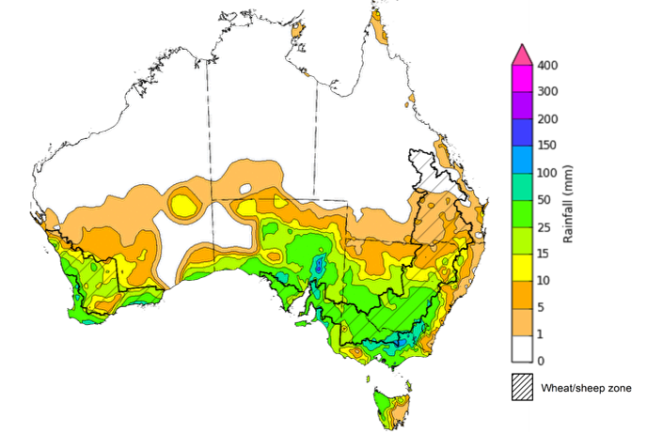
©Commonwealth of Australia 2026, Australian Bureau of Meteorology Issued: 12/8/2026
Note: The rainfall analyses and associated maps utilise data contained in the Bureau of Meteorology climate database, the Australian Data Archive for Meteorology (ADAM). The analyses are initially produced automatically from real-time data with limited quality control. They are intended to provide a general overview of rainfall across Australia as quickly as possible after the observations are received. For further information go to http://www.bom.gov.au/climate/rainfall/

Rainfall forecast for the next eight days
Over the 8 days to 20 August 2026, rainfall is expected across parts of southern and eastern Australia, while much of northern and western Australia is expected to remain largely dry.
- Falls of between 5-50 millimetres are forecast for the eastern seaboard including the far southeast coast of Queensland and coastal New South Wales, as well as western Tasmania.
- Lower falls are expected in southern and central regions. Falls of between 5-25 millimetres are expected across parts of south-western Queensland and Western Australia, much of South Australia, and western New South Wales and Victoria, while central areas including the southern Northern Territory and eastern Western Australia are forecast to see up to 15 millimetres.
- Remaining areas are expected to see little to no rainfall.
Across cropping regions, falls are expected across parts of the southeast, with limited rainfall elsewhere:
- Cropping regions in South Australia and Victoria are forecast to receive 10-25 millimetres, while remaining southern cropping regions including Western Australia and southern New South Wales are expected to see 1-15 millimetres.
  - If realised, these falls are likely to continues to support above average winter crop yield expectation across may south-eastern cropping areas.
- In contrast, conditions are expected to remain dry across cropping regions in northern New South Wales and Queensland.

Total forecast rainfall for the period 13 August to 20 August 2026
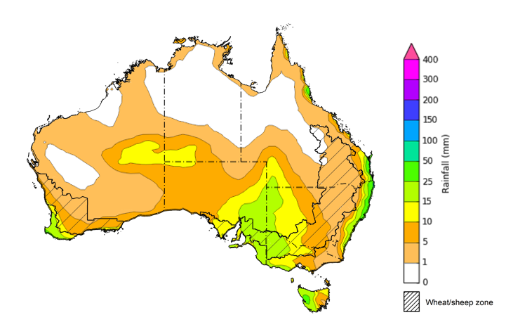

©Commonwealth of Australia 2026, Australian Bureau of Meteorology Issued 13/8/2026
Note: This rainfall forecast is produced from computer models. As the model outputs are not altered by weather forecasters, it is important to check local forecasts and warnings issued by the Bureau of Meteorology.

National Climate Outlook
The Bureau of Meteorology has indicated that El Niño is underway in the tropical Pacific. Sea surface temperatures in the central tropical Pacific are above El Niño thresholds and atmospheric indicators are also aligning with an El Niño state. This suggests ocean-atmosphere coupling is acting to reinforce the El Niño state, which is likely to strengthen and sustain this event until at least the end of the year. The Southern Annular Mode (SAM) has returned to neutral. The Indian Ocean Dipole (IOD) is currently neutral but in its third week of positive values. Models suggest a positive IOD event is likely in the spring, however, this remains uncertain.
The most recent rainfall outlook for September 2026 provided by the Bureau of Meteorology indicates that much of central, south-western, and eastern Australia is likely to see below median rainfall, while scattered areas of northern and north-western Australia are more likely to see above median falls.
The Bureau of Meteorology’s climate model indicates a 75% chance of September rainfall totals between 5- 100 millimetres across south-western Western Australia and Victoria. Isolated regions, including alpine regions of Victoria and western Tasmania, are likely to see higher falls of up to 300 millimetres. Across parts of southern South Australia and eastern New South Wales falls of 5- 25 millimetres are expected. Much of central and northern Australia are likely to see little to no rainfall.
Across southern cropping regions, including Western Australia, South Australia, Victoria, and parts southern New South Wales, there is a 75% chance of receiving rainfall totals of between 5- 25 millimetres during September 2026. If these forecast falls are realised, they are likely to provide sufficient moisture to support the growth of winter crops through the winter cropping period, with exceptions in regions that have seen low soil moisture following extended dry periods. Across most cropping regions in Queensland and northern New South Wales there is a 75% chance of receiving rainfall totals of between 1-10 millimetres. This expected lack of rainfall in northern areas is likely to have a negative effect on the winter crop development and provide limited opportunities for the early planting of summer crops.

Rainfall totals that have a 75% chance of occurring in September 2026

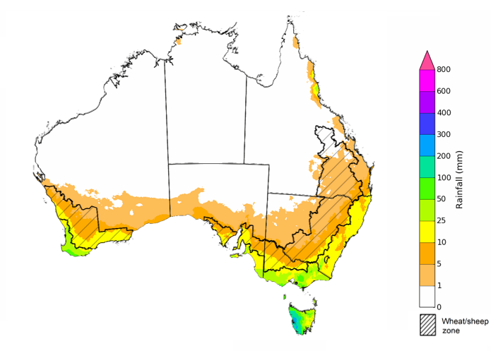
©Commonwealth of Australia 2025, Australian Bureau of Meteorology Issued: 13/8/2026
The rainfall outlook for September 2026 to November 2026 indicates a strong tendency towards below median rainfall across much of south-eastern Australia. However, there is an increased probability of median to above median rainfall in much of western and central Australia.
Across Western Australia cropping regions, the chance of receiving above median rainfall is 30-80%, with higher chances in northern regions. Cropping regions in Victoria, southern New South Wales and South Australia are estimated have a 20-40% chance of above median rainfall, with northern New South Wales and Queensland cropping regions having a 25-50% chance of above median rainfall.

Chance of exceeding the median rainfall September 2026 to November 2026

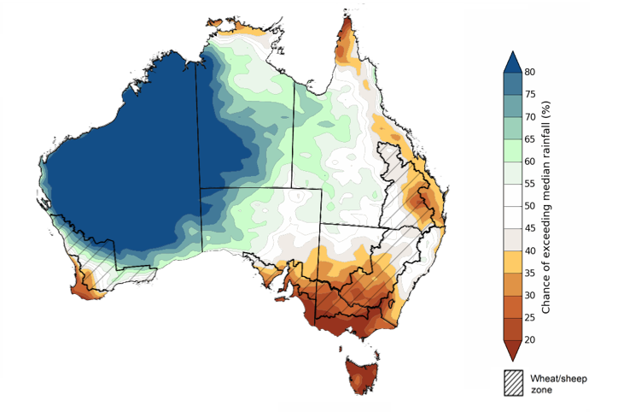
©Commonwealth of Australia 2025, Australian Bureau of Meteorology Issued: 13/8/2026

The rainfall outlook for September 2026 to November 2026 suggests a 75% chance of receiving rainfall totals of between 25-200 millimetres across much of Australia, including eastern, southern, and north-western areas. Higher falls in excess of 200 millimetres are expected across western Tasmania, scattered areas of eastern New South Wales, as well as alpine regions of Victoria. Lower rainfall totals are forecast for central and western regions, with much of the west of Western Australia, north-eastern and central Australia, and northern Western Australia likely to see 0-50 millimetres.
In cropping regions, there is a 75% chance of receiving between 25-100 millimetres across much of New South Wales, Victoria, South Australia and Western Australia. Most cropping regions in Queensland are likely to see 50-100 millimetres.
While these forecast 75% chance rainfall totals are only around half of the 1981-2018 median across most area, favourable soil moisture levels across most of Australia’s southern growing regions means that if these forecast September through November rainfall totals are realised, they are likely to be sufficient to continue to support the growth and yield potential of winter crops. However, due to limited stored soil moisture across large areas of northern New South Wales and Queensland, below average expected spring rainfall totals northern New South Wales and Queensland continue to represent an ongoing downside production risk for the 2026–27 winter and summer cropping seasons in these areas.

Rainfall totals that have a 75% chance of occurring September 2026 to November 2026

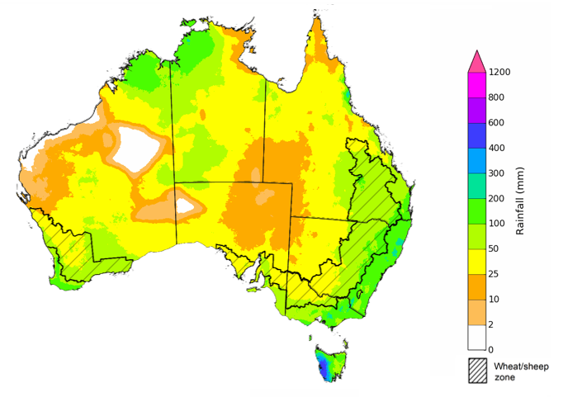
©Commonwealth of Australia 2025, Australian Bureau of Meteorology Issued: 13/8/2026

Water markets – current week
Water storage levels in the Murray-Darling Basin (MDB) increased by 381 gigalitres (GL) between 6 August 2026 and 13 August 2026. The current volume of water held in storages is 13,452 GL, equivalent to 60% of total storage capacity. This is 8% or 1,209 GL less than the same time last year. Water storage data is sourced from the Bureau of Meteorology.

Water storages in the Murray-Darling Basin, 2013–2026
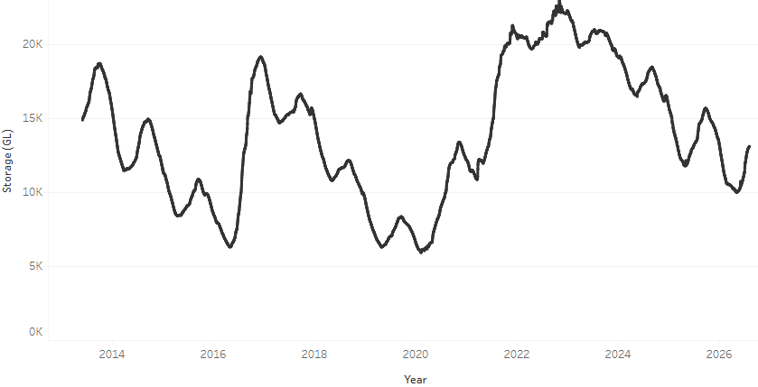
Allocation prices in the Victorian Murray below the Barmah Choke decreased from $409/ML on 6 August 2026 to $375/ML on 13 August 2026. Trade from the Goulburn to the Murray is closed. Trade downstream through the Barmah Choke is closed. Trade from the Murrumbidgee to the Murray is closed.

Surface water trade activity 2022-2026, Victorian Murray below the Barmah Choke 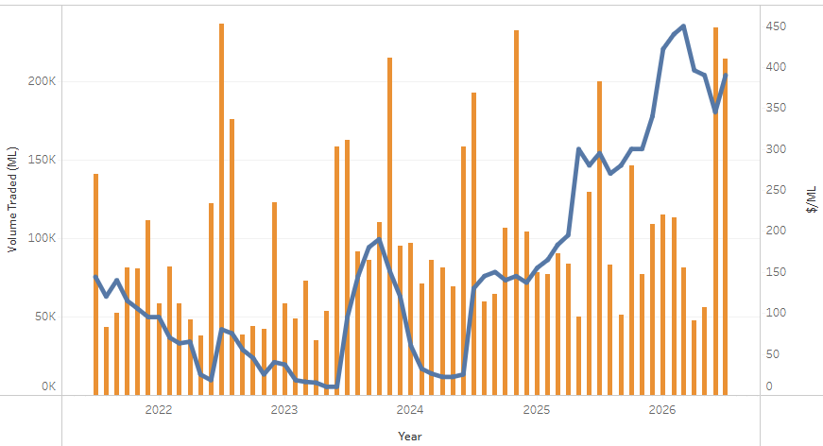

Water market prices, Southern Murray–Darling Basin
Region | $/ML
NSW Murray Above | 325
NSW Murrumbidgee | 318
Vic Greater Goulburn | 317
Vic Murray Below | 375
Note: The water allocation prices shown are volume weighted average prices based on the last 10 trades. Price data is sourced from Waterflow and current as at 6 August 2026.
To access the full, interactive, weekly water dashboard, which contains the latest and historical water storage, water market and water allocation information, please visit https://www.agriculture.gov.au/abares/products/weekly_update/weekly-update-260813

Commodities
Indicator | Week average | Unit | Latest Price | Previous Week | Weekly change |  | Price 12 months ago | Annual change
Selected world indicator prices
AUD/USD Exchange rate | 12-Aug | A$/US$ | 0.71 | 0.70 | 0% | 0.65 |  | 9%
Wheat – US no. 2 hard red winter wheat, FOB Gulf | 12-Aug | US$/t | 321 | 317 | 1% | 231 |  | 39%
Corn – US no. 2 yellow corn, FOB Gulf | 12-Aug | US$/t | 213 | 214 | 0% | 183 |  | 17%
Canola – Rapeseed, Canada, FOB Vancouver | 12-Aug | US$/t | 604 | 580 | 4% | 510 |  | 19%
Cotton – Cotlook A Index | 12-Aug | USc/lb | 94.8 | 93.3 | 2% | 78.6 |  | 21%
Sugar – Intercontinental Exchange, nearby futures, no.11 contract | 12-Aug | USc/lb | 16.6 | 15.4 | 7% | 16.5 |  | 1%
Wool – Eastern Market Indicator | 22-Jul | Ac/kg clean | 1,873 | 1,901 | -1% | 1,254 |  | 49%
Wool – Western Market Indicator | 22-Jul | Ac/kg clean | 2,062 | 2,094 | -2% | 1,399 |  | 47%
Selected Australian grain export prices
Australian Premium White (APW) Wheat, FOB Port Adelaide, SA | 12-Aug | A$/t | 397 | 395 | 1% | 384 |  | 3%
Australian Standard White (ASW) Wheat, FOB Port Adelaide, SA | 12-Aug | A$/t | 390 | 388 | 1% | 380 |  | 3%
Feed Barley – FOB Port Adelaide, SA | 12-Aug | A$/t | 375 | 372 | 1% | 365 |  | 3%
Canola – FOB Kwinana, WA | 12-Aug | A$/t | 777 | 774 | 0% | 808 |  | -4%
Grain Sorghum – FOB Brisbane, QLD | 12-Aug | A$/t | 432 | 431 | 0% | 421 |  | 3%
Selected domestic livestock indicator prices
Beef – Eastern Young Cattle Indicator | 12-Aug | Ac/kg cwt | 909 | 936 | -3% | 860 |  | 6%
Mutton – Mutton indicator (18–24 kg fat score 2–3), VIC | 12-Aug | Ac/kg cwt | 818 | 841 | -3% | 740 |  | 11%
Lamb – National Trade Lamb Indicator | 12-Aug | Ac/kg cwt | 1,169 | 1,171 | 0% | 1,170 |  | 0%
Pig – Eastern Seaboard (60.1–75 kg), NSW buyer price | 29-Jul | Ac/kg cwt | 389 | 396 | -2% | 459 |  | -15%
Live cattle – Light steers to Indonesia | 5-Aug | Ac/kg lwt | 440 | 430 | 2% | 350 |  | 26%
Global Dairy Trade (GDT) weighted average prices
Dairy – Whole milk powder | 5-Aug | US$/t | 3,483 | 3,486 | 0% | 4,024 |  | -13%
Dairy – Skim milk powder | 5-Aug | US$/t | 3,261 | 3,234 | 1% | 2,781 |  | 17%
Dairy – Cheddar cheese | 5-Aug | US$/t | 3,723 | 3,586 | 4% | 4,562 |  | -18%
Dairy – Anhydrous milk fat | 5-Aug | US$/t | 6,367 | 6,405 | -1% | 7,080 |  | -10%

Selected world indicator prices
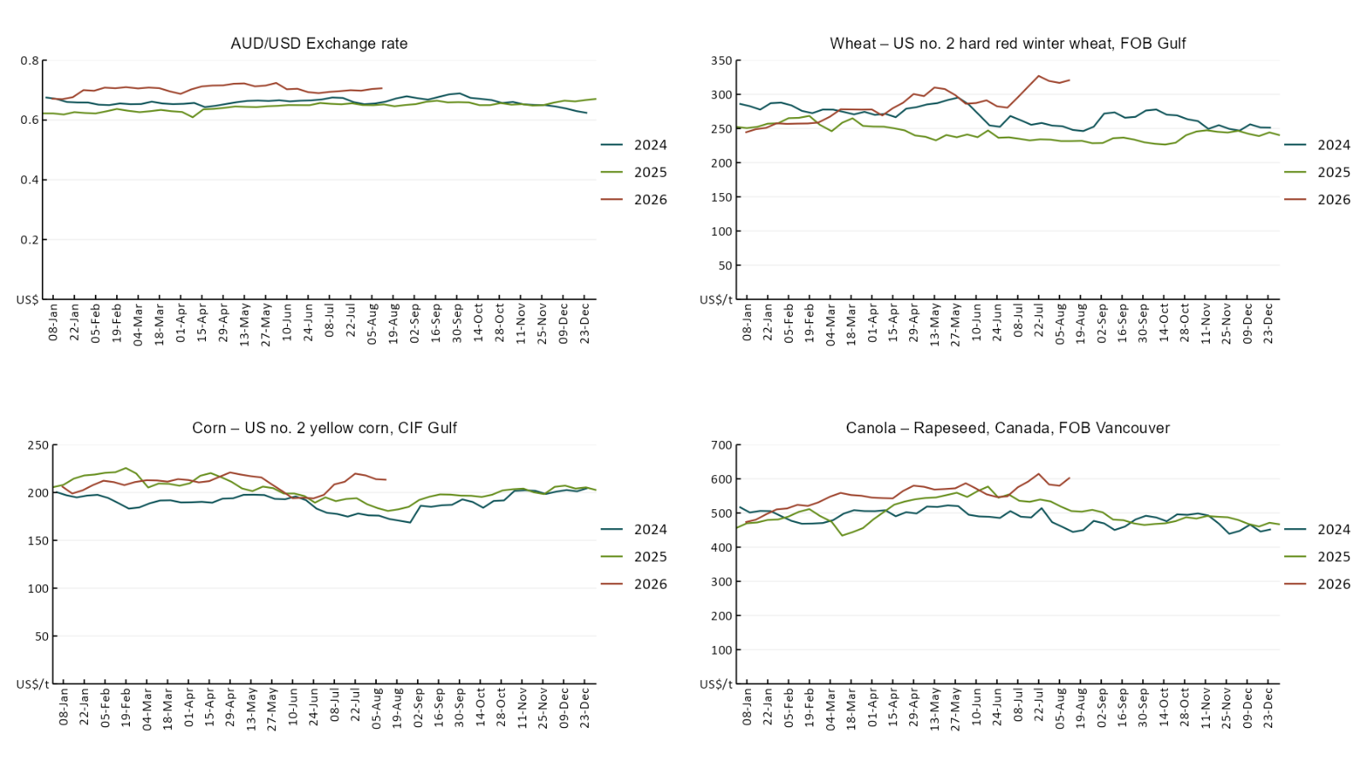

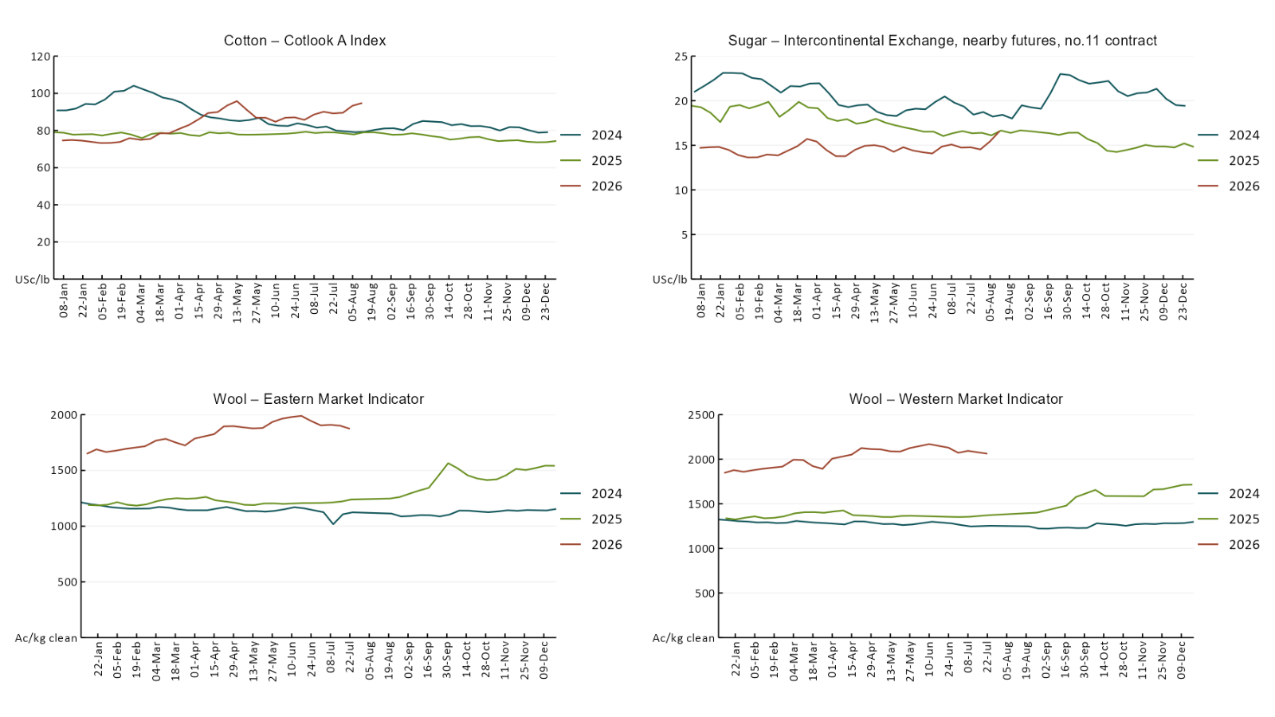

3.2 Selected domestic crop indicator prices
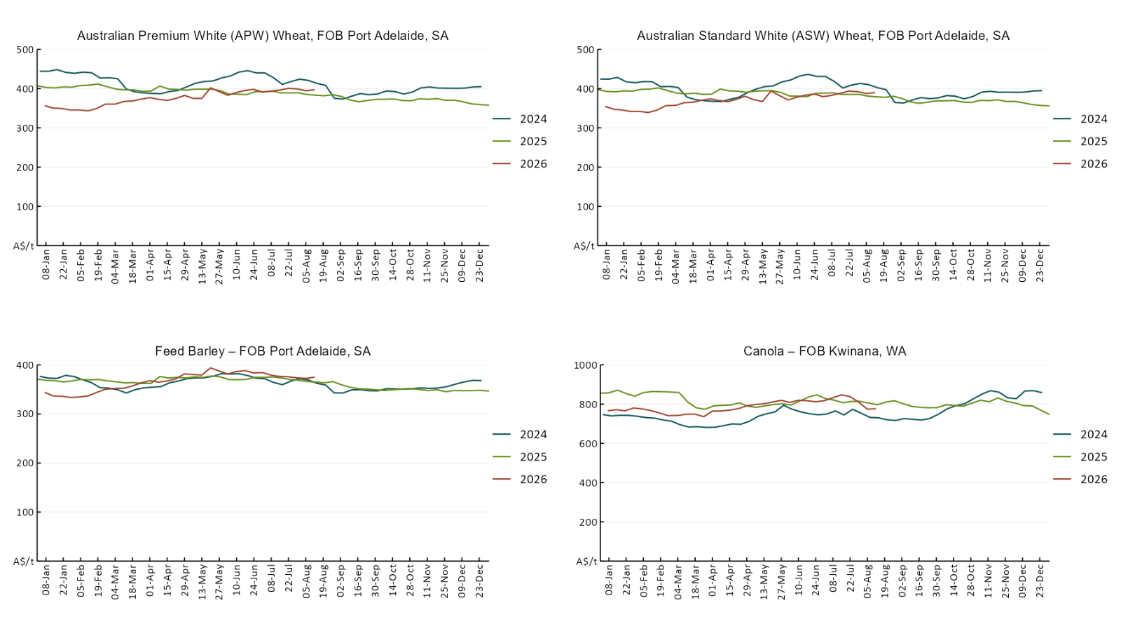

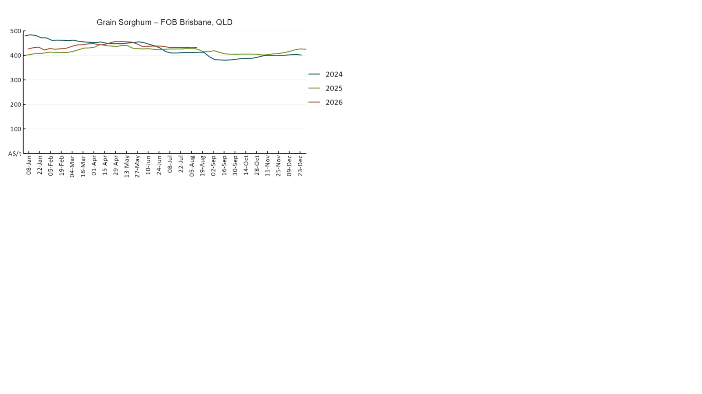

3.3 Selected domestic livestock indicator prices
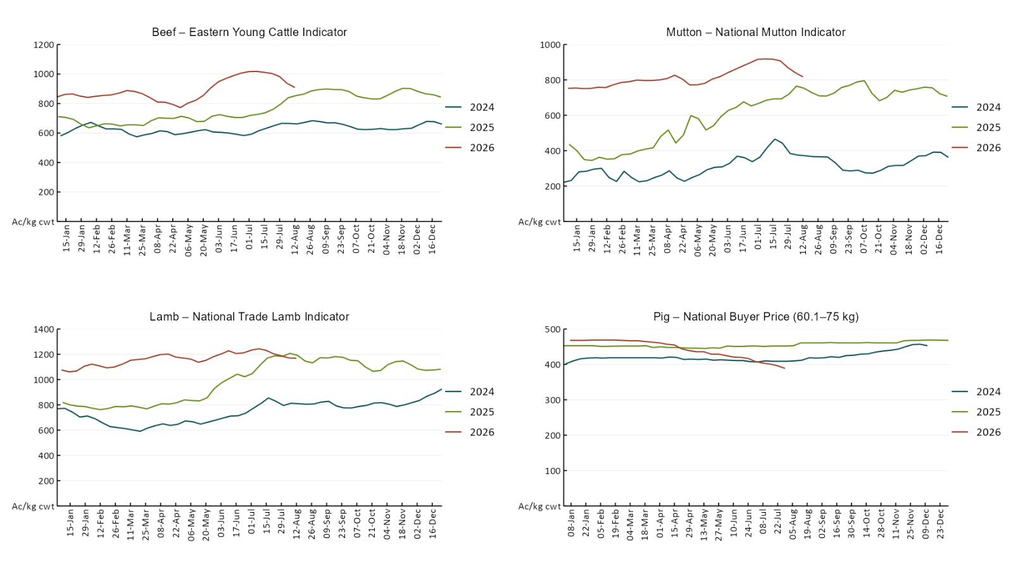

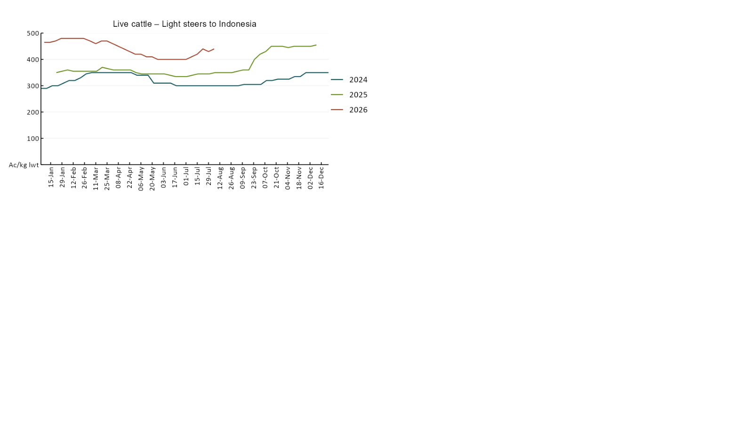

3.4 Global Dairy Trade (GDT) weighted average prices
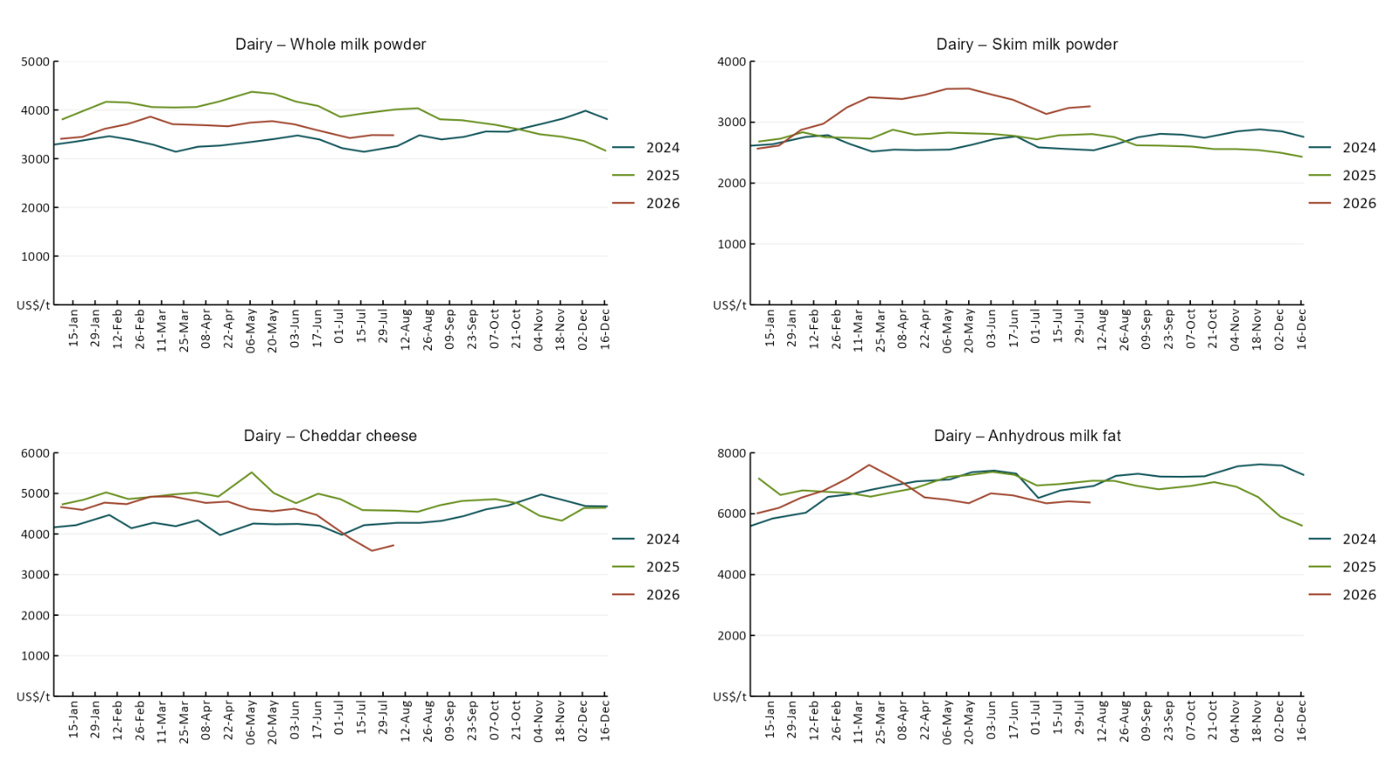

3.5 Selected fruit and vegetable prices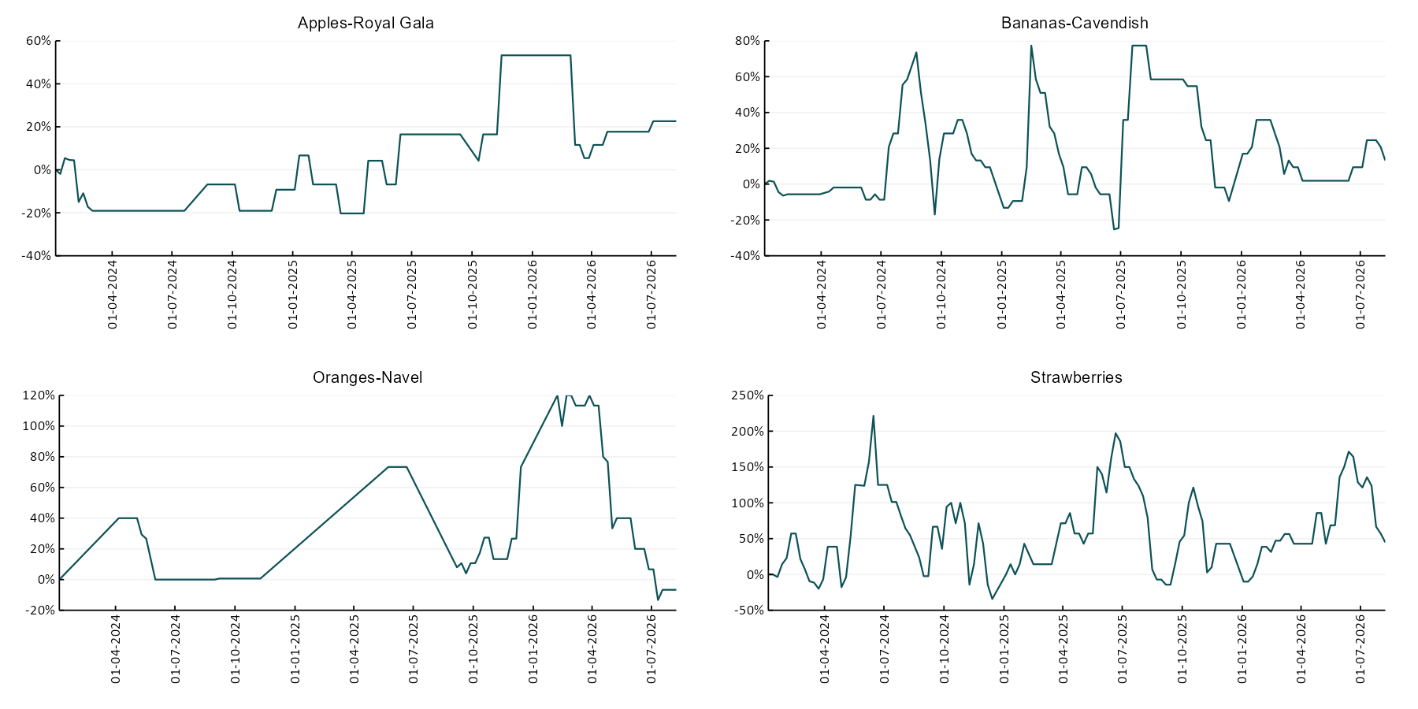
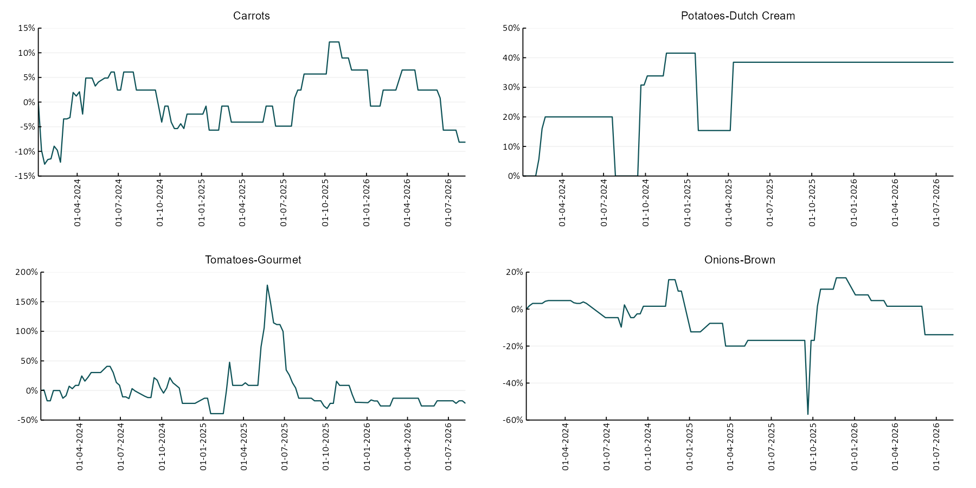

3.6 Selected domestic fodder indicator prices
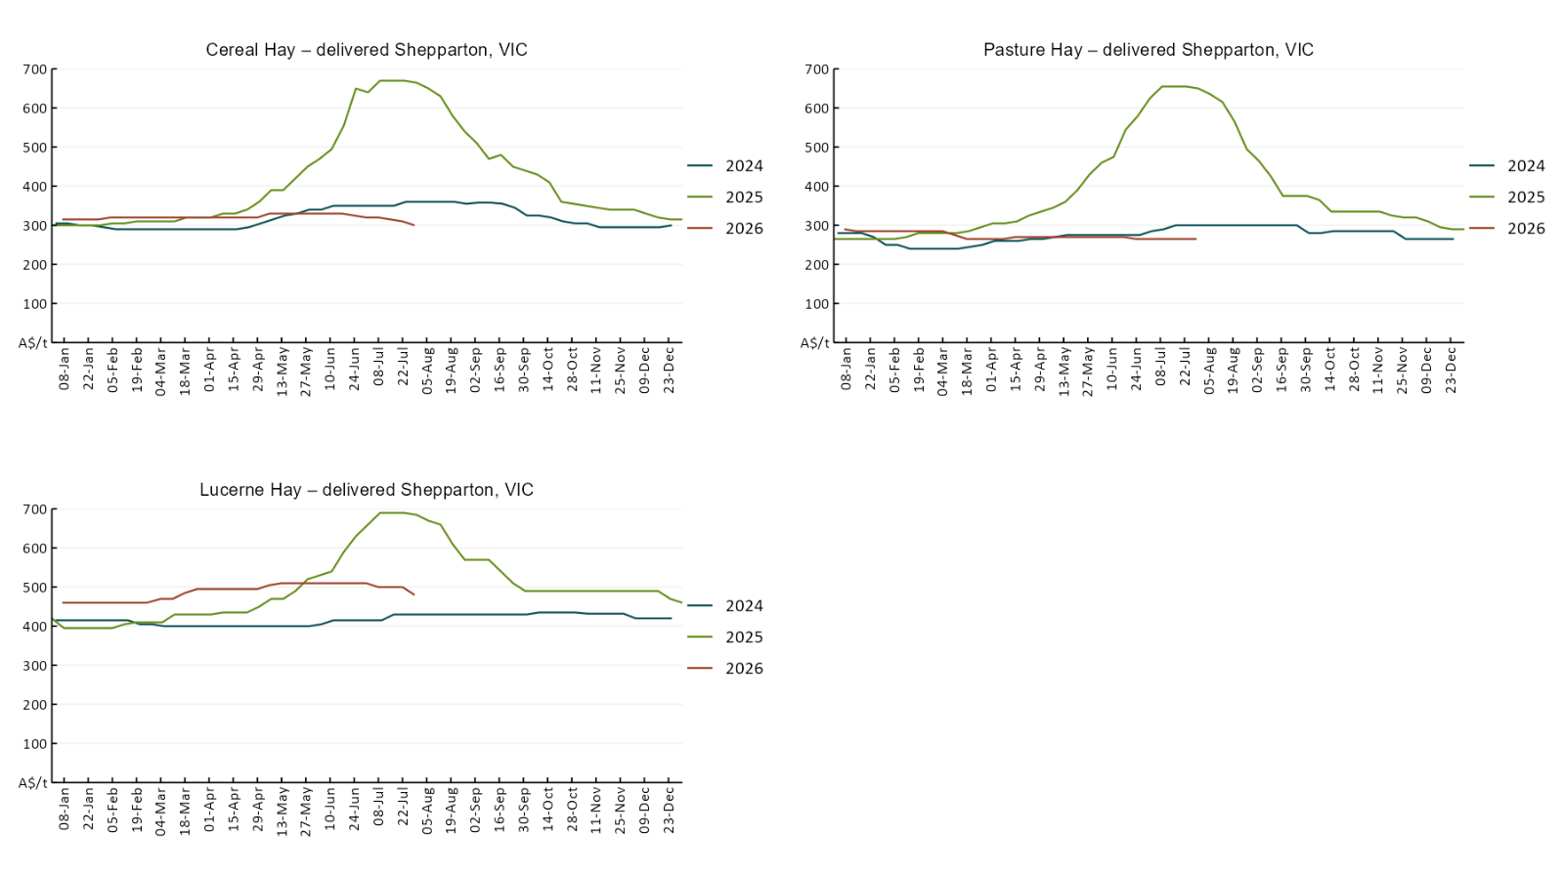

4. Data attribution

Climate
Bureau of Meteorology
- Weekly rainfall totals: www.bom.gov.au/climate/maps/rainfall/
- Monthly and last 3-month rainfall percentiles: https://www.bom.gov.au/climate/ahead/outlooks/#moreMaps
- Rainfall forecast: www.bom.gov.au/jsp/watl/rainfall/pme.jsp
- Seasonal outlook: www.bom.gov.au/climate/outlooks/#/overview/summary/
- Climate drivers: http://www.bom.gov.au/climate/enso/
- Soil moisture: https://awo.bom.gov.au/products/historical/soilMoisture-rootZone/

Other
- Pasture growth: www.longpaddock.qld.gov.au/aussiegrass/
- 3-month global outlooks: Environment and Climate Change Canada, NOAA Climate Prediction Center, EUROBRISA CPTEC/INPE, European Centre for Medium-Range Weather Forecasts, Hydrometcenter of Russia, National Climate Center Climate System Diagnosis and Prediction Room (NCC), International Research Institute for Climate and Society
- Global production: https://ipad.fas.usda.gov/ogamaps/cropmapsandcalendars.aspx
- Autumn break: Pook et al., 2009, https://rmets-onlinelibrary-wiley-com.virtual.anu.edu.au/doi/epdf/10.1002/joc.1833

Water
Prices
- Waterflow: https://www.waterflow.io/
- Ruralco: https://www.ruralcowater.com.au/
- Bureau of Meteorology:
- Allocation trade: http://www.bom.gov.au/water/dashboards/#/water-markets/mdb/at
- Storage volumes: http://www.bom.gov.au/water/dashboards/#/water-storages/summary/drainage

Trade constraints:
- Water NSW: https://www.waternsw.com.au/customer-service/ordering-trading-and-pricing/trading/murrumbidgee
- Victorian Water Register: https://www.waterregister.vic.gov.au/TradingRules2019/

Commodities
Fruit and vegetables
- Datafresh: www.freshstate.com.au

Pigs
- Australian Pork Limited: www.australianpork.com.au

Dairy
- Global Dairy Trade: www.globaldairytrade.info/en/product-results/

World wheat, canola
- International Grains Council
- https://www.igc.int/en/default.aspx
- United States Department of Agriculture

World cotton
- Cotlook: www.cotlook.com/

World sugar
- New York Stock Exchange - Intercontinental Exchange

Wool
- Australian Wool Exchange: www.awex.com.au/

Domestic wheat, barley, sorghum, canola and fodder
- Jumbuk Consulting Pty Ltd: Jumbuk AG | Agriculture Consulting

Cattle, beef, mutton, lamb, goat and live export
- Meat and Livestock Australia: https://www.mla.com.au/prices-markets/

Australian Agricultural Drought Indicators
About Australian Agricultural Drought Indicators
The Australian Agricultural Drought Indicators (AADI) links weather and agricultural data with a range of scientific and economic models to measure and forecast the effects of climate variability and drought on agricultural outcomes.
On AADI, projected broadacre farm profits are presented as percentile outcomes relative to simulated historical outcomes using the groupings:
Highest | 95-100th percentile
Very much above average | 85-95th percentile
Above average | 65-85th percentile
Average | 35-65th percentile
Below average | 15-35th percentile
Very much below average | 5-15th percentile
Lowest 5% | 0-5th percentile

There are two AADI farm profit indicators:
- The AADI farm profit climate and price indicator shows the effect of climate and prices on broadacre farm business profits of current farms compared to the last 33 years.
- The AADI farm profit climate only indicator isolates the effect of climate on profits by holding prices fixed.

© Commonwealth of Australia 2026

Ownership of intellectual property rights
Unless otherwise noted, copyright (and any other intellectual property rights, if any) in this publication is owned by the Commonwealth of Australia (referred to as the Commonwealth).

Creative Commons licence
All material in this publication is licensed under a Creative Commons Attribution 4.0 International Licence except content supplied by third parties, logos and the Commonwealth Coat of Arms.
Inquiries about the licence and any use of this document should be emailed to copyright@awe.gov.au.


Cataloguing data
This publication (and any material sourced from it) should be attributed as:
ABARES 2026, Weekly Australian Climate, Water and Agricultural Update, Australian Bureau of Agricultural and Resource Economics and Sciences, Canberra, 13 August 2026. CC BY 4.0 DOI: https://doi.org/10.25814/5f3e04e7d2503
ISSN 2652-7561
This publication is available at https://www.agriculture.gov.au/abares/products/weekly_update
Department of Agriculture, Fisheries and Forestry
GPO Box 858 Canberra ACT 2601
Telephone 1800 900 090
Web agriculture.gov.au/abares

Disclaimer
The Australian Government acting through the Department of Agriculture, Fisheries and Forestry, represented by the Australian Bureau of Agricultural and Resource Economics and Sciences, has exercised due care and skill in preparing and compiling the information and data in this publication. Notwithstanding, the Department of Agriculture, Fisheries and Forestry, ABARES, its employees and advisers disclaim all liability, including liability for negligence and for any loss, damage, injury, expense or cost incurred by any person as a result of accessing, using or relying on any of the information or data in this publication to the maximum extent permitted by law.

Statement of Professional Independence
The views and analysis presented in ABARES publications, including this one, reflect ABARES professionally independent findings, based on scientific and economic concepts, principles, information and data. These views, analysis and findings may not reflect or be consistent with the views or positions of the Australian Government, or of organisations or groups who have commissioned ABARES reports or analysis. More information on professional independence is provided on the ABARES website.

Acknowledgements
This report was prepared by Holly Beale and Matt Miller.

