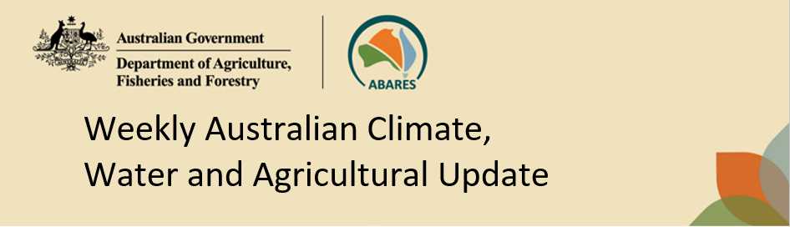
No. 32/2026 20 August 2026

Summary of key issues
- In the week ending 19 August 2026, cold fronts and low-pressure systems brought rainfall to parts of the south, east and centre, while western and northern Australia remained largely dry.
  - Across cropping regions moderate falls of between 1-15 millimetres were recorded across Western Australia and South Australia. In Victoria, between 1-25 millimetres was observed.
  - These falls are expected to continue to support above average crop and pasture growth, particularly in South Australia and Victoria.
- Over the 8 days to 27 August 2026, rainfall is expected across parts of central, western and south-eastern Australia.
  - Cropping regions in New South Wales are forecast to receive 15-100 millimetres of rainfall, while Victoria is likely to see 10-50 millimetres. In South Australia and southern parts of Queensland, lighter falls of 10-25 millimetres are expected.
  - In contrast, conditions are expected to remain dry across cropping regions in Western Australia and northern Queensland.
- Rainfall in July 2026 was variable across the world’s major grain- and oilseed-producing regions, leading to differing crop production outcomes. Global production conditions were generally favourable for wheat, maize, soybeans, and rice. However, unfavourable conditions across parts of the United States, India, the European Union and Southeast Asia are a risk to potential global production outcomes for wheat, maize and rice.
  - Global production conditions have been slightly more favourable to those used to formulate ABARES 2026–27 forecasts of global grain supplies and world prices in the June 2026 Agricultural Commodities Report. As a result, global grain and oilseed production are likely to increase beyond the estimates in the June forecast, due to small improvements in global soybeans and maize production.
- Water storage levels in the Murray-Darling Basin (MDB) increased by 416 gigalitres (GL) between 13 August 2026 and 20 August 2026. The current volume of water held in storages is 13,868 GL, equivalent to 62% of total storage capacity. This is 6% or 871 GL less than the same time last year. Water storage data is sourced from the Bureau of Meteorology (BOM).
- Allocation prices in the Victorian Murray below the Barmah Choke decreased from $375/ML on 13 August 2026 to $319/ML on 20 August 2026. Trade from the Goulburn to the Murray is closed. Trade downstream through the Barmah Choke is closed. Trade from the Murrumbidgee to the Murray is closed.

Climate

Rainfall this week
In the week ending 19 August 2026, cold fronts and low-pressure systems brought rainfall to parts of the south, east and centre of the country, while much of Australia remained largely dry.
- Falls of 10-50 millimetres were recorded across scattered areas of eastern Queensland, northern New South Wales and western Tasmania. Lighter falls of up to 5-25 millimetres occurred across western New South Wales, western Victoria and South Australia, the far southwest of Western Australia and southern Northern Territory.
- Much of the remainder of Australia saw little to no rainfall.
In cropping regions, moderate rainfall totals were recorded across parts of south-eastern Australia.
- Moderate falls of between 1-15 millimetres were recorded across Western Australia and South Australia. In Victoria, between 1-25 millimetres was observed.
  - These falls are expected to continue to support above average crop and pasture growth, particularly in South Australia and Victoria.
- Meanwhile, limited falls of between 0-5 millimetres were recorded across cropping regions in New South Wales and Queensland.

Rainfall for the week ending 19 August 2026
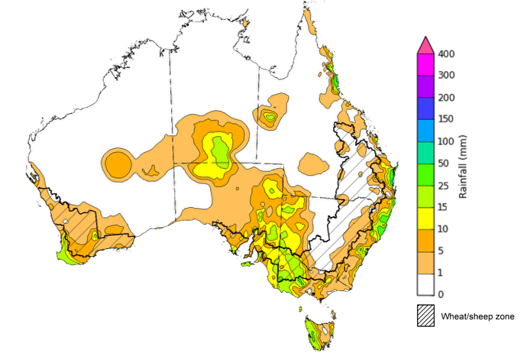
©Commonwealth of Australia 2026, Australian Bureau of Meteorology Issued: 19/8/2026
Note: The rainfall analyses and associated maps utilise data contained in the Bureau of Meteorology climate database, the Australian Data Archive for Meteorology (ADAM). The analyses are initially produced automatically from real-time data with limited quality control. They are intended to provide a general overview of rainfall across Australia as quickly as possible after the observations are received. For further information go to http://www.bom.gov.au/climate/rainfall/

Rainfall forecast for the next eight days
Over the 8 days to 27 August 2026, rainfall is expected across parts of central, western and south-eastern Australia, while much of northern Australia is expected to remain largely dry.
- Falls of between 10-100 millimetres are forecast for south-eastern regions including Tasmania, Victoria, and southern New South Wales.
- Lower falls are expected in eastern and central regions. Falls of between 10-50 millimetres are expected across parts of northern New South Wales, southern Queensland, South Australia, the southern Northern Territory, and central and the far southwest of Western Australia.
- Remaining areas are expected to see little to no rainfall.
Across cropping regions, falls are expected across parts of the southeast, with limited rainfall elsewhere:
- Cropping regions in New South Wales are forecast to receive 15-100 millimetres of rainfall, while Victoria is likely to see 10-50 millimetres. In South Australia and southern parts of Queensland, lighter falls of 10-25 millimetres are expected.
  - If realised, these falls are likely to continues to support above average winter crop yield expectation across many south-eastern cropping areas.
- In contrast, conditions are expected to remain dry across cropping regions in Western Australia and northern Queensland

Total forecast rainfall for the period 20 August to 27 August 2026
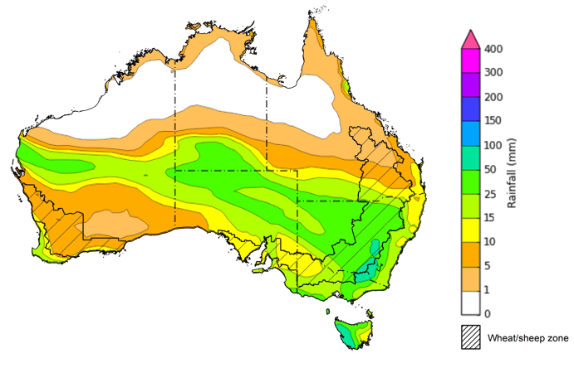

©Commonwealth of Australia 2026, Australian Bureau of Meteorology Issued 20/8/2026
Note: This rainfall forecast is produced from computer models. As the model outputs are not altered by weather forecasters, it is important to check local forecasts and warnings issued by the Bureau of Meteorology.

July precipitation percentiles and current production conditions
Crop production is affected by long-term trends in average rainfall and temperature, interannual climate variability, shocks during specific growth stages, and extreme weather events. Some crops are more tolerant than others to certain types of stresses, and at each growth stage, different types of stresses affect crop species in different ways.
Precipitation anomalies and outlooks presented below indicate the current and expected future production conditions for major grain and oilseed producing countries (responsible for over 80% of global crop production). This is an important input to assessing the global grain supply outlook.
Precipitation in July 2026 was variable across the world’s major grain and oilseed producing regions:
- In the northern hemisphere, precipitation was above average in scattered western and eastern regions of China, parts of the northern Black Sea region, eastern India, and western parts of the United States. Precipitation was generally below average in western and central Europe, central China, and parts of the central and eastern United States. Precipitation was generally average across the remaining major northern hemisphere grain and oilseed producing regions.
- In the southern hemisphere, precipitation was below average across much of eastern Brazil, western Australia, as well as parts of Southeast Asia including Indonesia and the Philippines. Precipitation was above average across Argentina and central Brazil. Precipitation was generally average across the remaining major southern hemisphere grain and oilseed producing regions.

Global precipitation percentiles, July 2026

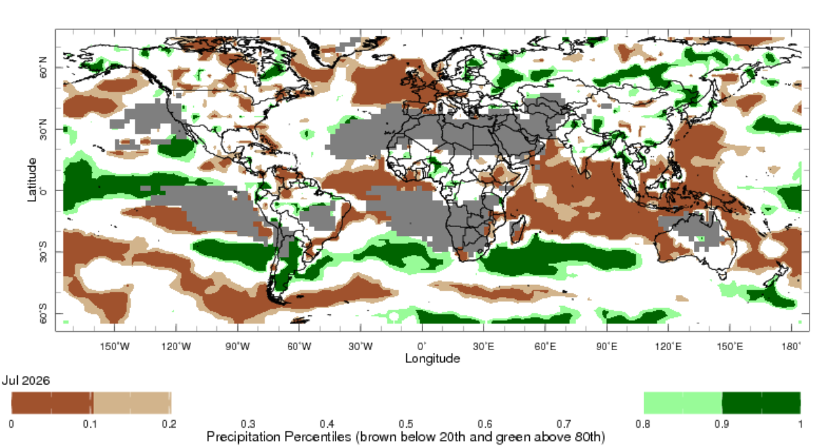
Note: The world precipitation percentiles indicate a ranking of precipitation for July, with the driest (0th percentile) being 0 on the scale and the wettest (100th percentile) being 1 on the scale. Percentiles are based on precipitation estimates from the NOAA Climate Prediction Center’s Climate Anomaly Monitoring System Outgoing Precipitation Index dataset. Precipitation estimates for April are compared with rainfall recorded

As of 28 July 2026, global production conditions were generally favourable for wheat, maize, rice and soybeans, however, there are some areas of production concern across all four commodities:
- Wheat – In the northern hemisphere, wheat is developing under broadly favourable conditions in China and the Black Sea Region, while yields in the European Union and United States see challenges from hot and dry climate conditions. In the southern hemisphere, wheat is developing under generally favourable conditions.
- Maize – In the southern hemisphere, conditions have been largely favourable for the harvest across much of Brazil and Argentina. However, dry and heatwave conditions in northern hemisphere growing regions, including the European Union and India, are likely to weigh on crop outcomes.
- Rice – Global conditions remain broadly favourable for most major rice production regions, with exceptions in Thailand, parts of India, and Vietnam.
- Soybeans – Harvest has concluded in the southern hemisphere. Meanwhile, in the northern hemisphere crop establishment in the United States, Canada, China, and Ukraine has been broadly favourable, however, in India sowing is just beginning under mixed conditions due to the slow progress of the Southwest Monsoon and dry soils.

Crop conditions, AMIS countries, 28 July 2026
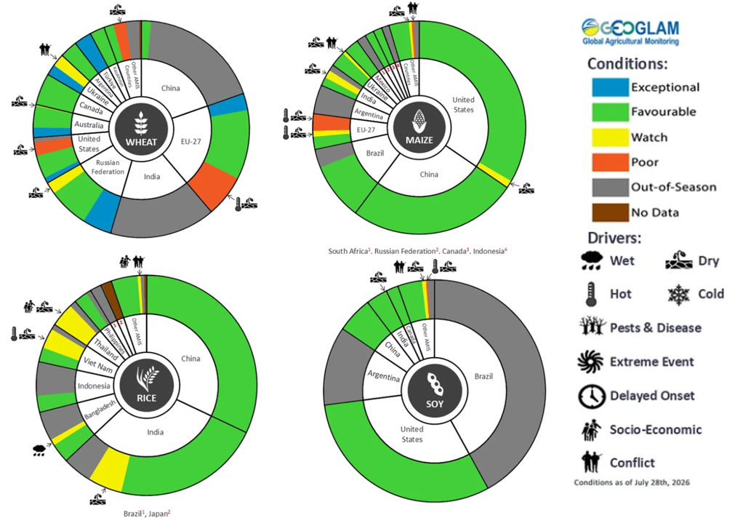
AMIS Agricultural Market Information System.
Source: AMIS

The global climate outlook for September 2026 to November 2026 indicates that mixed rainfall conditions are expected for the world’s major grain and oilseed producing regions. Outlooks and potential production impacts are presented in the following table.
Rainfall outlook and potential impact on the future state of production conditions, September 2026 - November 2026
Region | Rainfall outlook | Potential impact on production
Argentina | Above average rainfall is likely across parts of central and southern Argentina, with broadly average to below average rainfall in the north. | Anticipated rainfall is likely to support the heading and vegetative development of wheat and corn, but could impede the planting of cotton and corn.
Black Sea Region | Above average rainfall is expected across northern parts of Türkiye, while average to below average rainfall is expected in remaining areas. | Above average rainfall is likely to support vegetative development and maturation of cotton, rice, and corn, as well as snowpack ahead of winter wheat dormancy.
Brazil | Rainfall outcomes across Brazil are expected to be below average in many northern and central areas, while southern areas see broadly average to above average conditions. | Average to above average rainfall across southern Brazil is likely to benefit the maturation of wheat and rice.
Canada | Rainfall across Canada is expected to be mixed, with broadly average conditions and areas of both below and above average precipitation in southern regions. | Average rainfall is likely to support corn, soybean, and sunflower flowering, and the development of grain and oilseeds over October.
China | Average rainfall is expected across most of China, with scattered areas of above average rainfall in western regions and below average rainfall in central and eastern regions. | Generally average rainfall across much of China is likely to support the growth and development of major crops over the season, including rice, cotton, corn and soybeans.
European Union | Average rainfall expected for much of the European Union, with exceptions in parts of central and western Europe where below average rainfall is more likely. | Close to average rainfall across much of Europe is likely to benefit harvesting of major crops including corn and soybeans, but below average rainfall in parts of central and western Europe could reduce yield potential.
South Asia (India) | Below average rainfall is expected across much of India. | Anticipated rainfall is likely to present a downside production risk the flowering of cotton in September.
Southeast Asia (SEA) | Below average rainfall is likely across much of Southeast Asia. | Below average rainfall in SEA is likely to impede growth and development outcomes for rice and corn, but could support harvesting in October.
The United States | Above average rainfall is likely for much of the southern and central United States, with northern areas likely to see close to average falls. | Average to above average rainfall conditions expected across the United States is likely to support soil moisture levels and the development of major crops.

Water markets – current week
Water storage levels in the Murray-Darling Basin (MDB) increased by 416 gigalitres (GL) between 13 August 2026 and 20 August 2026. The current volume of water held in storages is 13,868 GL, equivalent to 62% of total storage capacity. This is 6% or 871 GL less than the same time last year. Water storage data is sourced from the Bureau of Meteorology.

Weekly water storage levels in the Murray-Darling Basin, 2013–2026
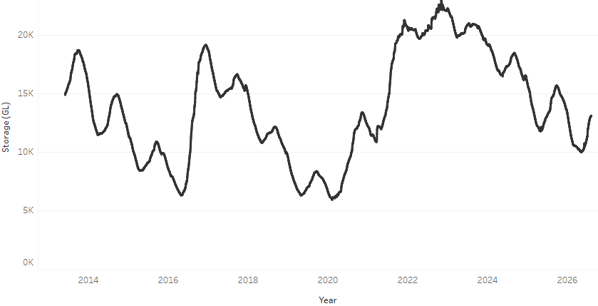
Allocation prices in the Victorian Murray below the Barmah Choke decreased from $375/ML on 13 August 2026 to $319/ML on 20 August 2026. Trade from the Goulburn to the Murray is closed. Trade downstream through the Barmah Choke is closed. Trade from the Murrumbidgee to the Murray is closed.

Monthly surface water trade activity 2022-2026, Victorian Murray below the Barmah Choke 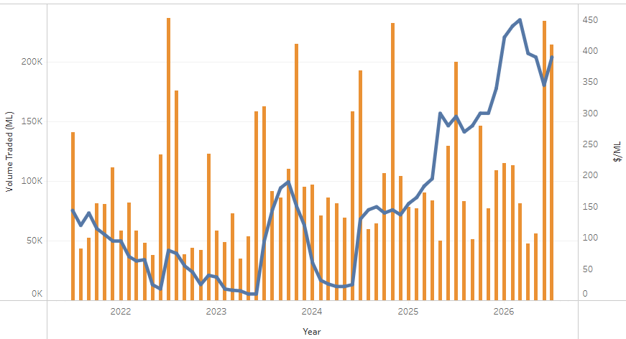
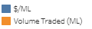

Weekly water market prices, Southern Murray–Darling Basin
Region | $/ML
NSW Murray Above | 276
NSW Murrumbidgee | 287
Vic Greater Goulburn | 298
Vic Murray Below | 319
Note: The water allocation prices shown are volume weighted average prices based on the last 10 trades. Price data is sourced from Waterflow and current as at 6 August 2026.
To access the full, interactive, weekly water dashboard, which contains the latest and historical water storage, water market and water allocation information, please visit https://www.agriculture.gov.au/abares/products/weekly_update/weekly-update-260820

Commodities
Indicator | Week average | Unit | Latest Price | Previous Week | Weekly change |  | Price 12 months ago | Annual change
Selected world indicator prices
AUD/USD Exchange rate | 19-Aug | A$/US$ | 0.71 | 0.71 | 0% | 0.65 |  | 9%
Wheat – US no. 2 hard red winter wheat, FOB Gulf | 19-Aug | US$/t | 332 | 323 | 3% | 231 |  | 44%
Corn – US no. 2 yellow corn, FOB Gulf | 19-Aug | US$/t | 223 | 215 | 4% | 183 |  | 22%
Canola – Rapeseed, Canada, FOB Vancouver | 19-Aug | US$/t | 630 | 607 | 4% | 510 |  | 24%
Cotton – Cotlook A Index | 19-Aug | USc/lb | 95.7 | 94.7 | 1% | 78.6 |  | 22%
Sugar – Intercontinental Exchange, nearby futures, no.11 contract | 19-Aug | USc/lb | 17.2 | 16.6 | 3% | 16.5 |  | 4%
Wool – Eastern Market Indicator | 19-Aug | Ac/kg clean | 1,812 | 1,873 | -3% | 1,254 |  | 44%
Wool – Western Market Indicator | 19-Aug | Ac/kg clean | 1,998 | 2,062 | -3% | 1,399 |  | 43%
Selected Australian grain export prices
Australian Premium White (APW) Wheat, FOB Port Adelaide, SA | 19-Aug | A$/t | 402 | 398 | 1% | 384 |  | 5%
Australian Standard White (ASW) Wheat, FOB Port Adelaide, SA | 19-Aug | A$/t | 396 | 391 | 1% | 380 |  | 4%
Feed Barley – FOB Port Adelaide, SA | 19-Aug | A$/t | 370 | 375 | -1% | 365 |  | 1%
Canola – FOB Kwinana, WA | 19-Aug | A$/t | 778 | 777 | 0% | 808 |  | -4%
Grain Sorghum – FOB Brisbane, QLD | 19-Aug | A$/t | 432 | 432 | 0% | 421 |  | 3%
Selected domestic livestock indicator prices
Beef – Eastern Young Cattle Indicator | 19-Aug | Ac/kg cwt | 924 | 911 | 1% | 860 |  | 7%
Mutton – Mutton indicator (18–24 kg fat score 2–3), VIC | 19-Aug | Ac/kg cwt | 835 | 820 | 2% | 740 |  | 13%
Lamb – National Trade Lamb Indicator | 19-Aug | Ac/kg cwt | 1,193 | 1,177 | 1% | 1,170 |  | 2%
Pig – Eastern Seaboard (60.1–75 kg), NSW buyer price | 5-Aug | Ac/kg cwt | 388 | 389 | 0% | 459 |  | -15%
Live cattle – Light steers to Indonesia | 5-Aug | Ac/kg lwt | 440 | 430 | 2% | 350 |  | 26%
Global Dairy Trade (GDT) weighted average prices
Dairy – Whole milk powder | 19-Aug | US$/t | 3,591 | 3,483 | 3% | 4,024 |  | -11%
Dairy – Skim milk powder | 19-Aug | US$/t | 3,502 | 3,261 | 7% | 2,781 |  | 26%
Dairy – Cheddar cheese | 19-Aug | US$/t | 3,744 | 3,723 | 1% | 4,562 |  | -18%
Dairy – Anhydrous milk fat | 19-Aug | US$/t | 5,993 | 6,367 | -6% | 7,080 |  | -15%

Selected world indicator prices
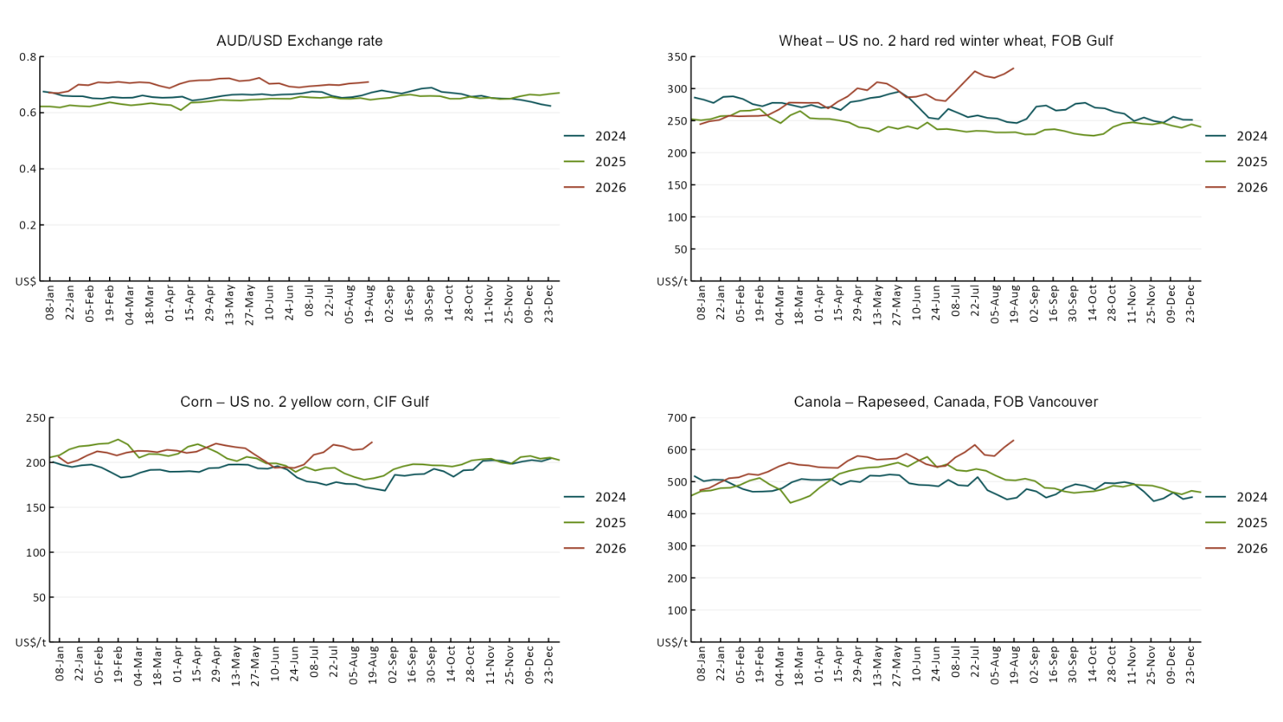

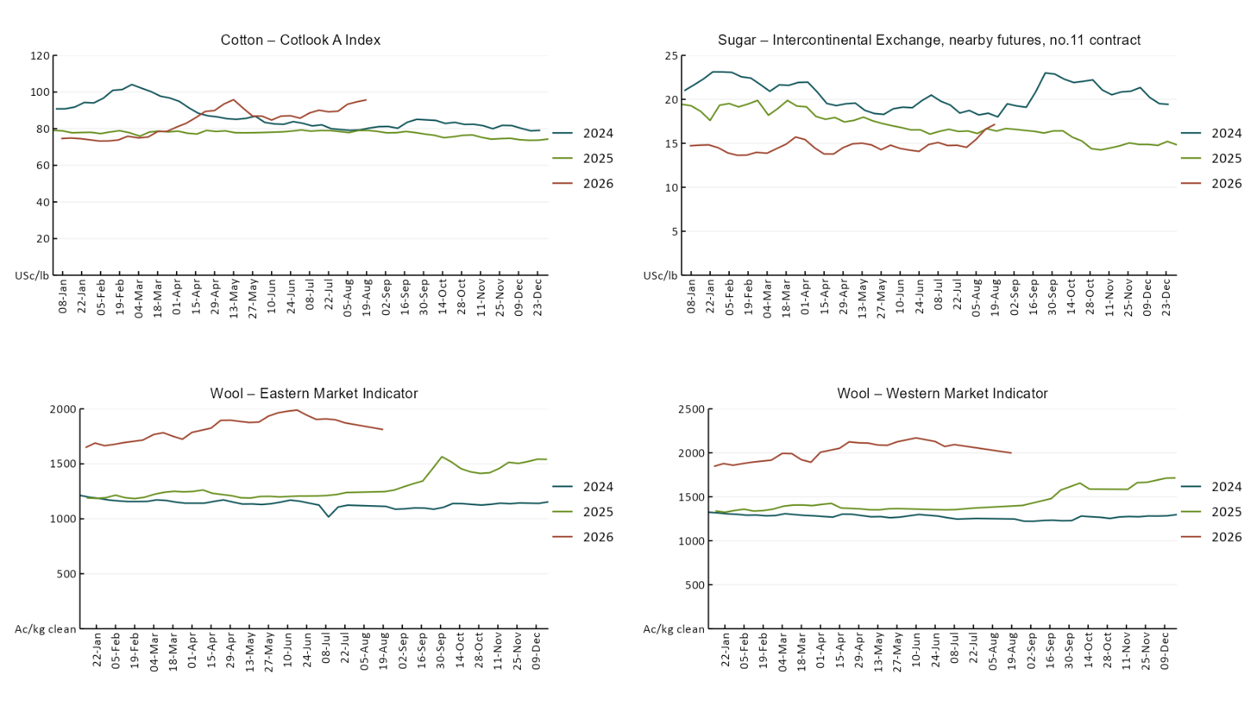

3.2 Selected domestic crop indicator prices
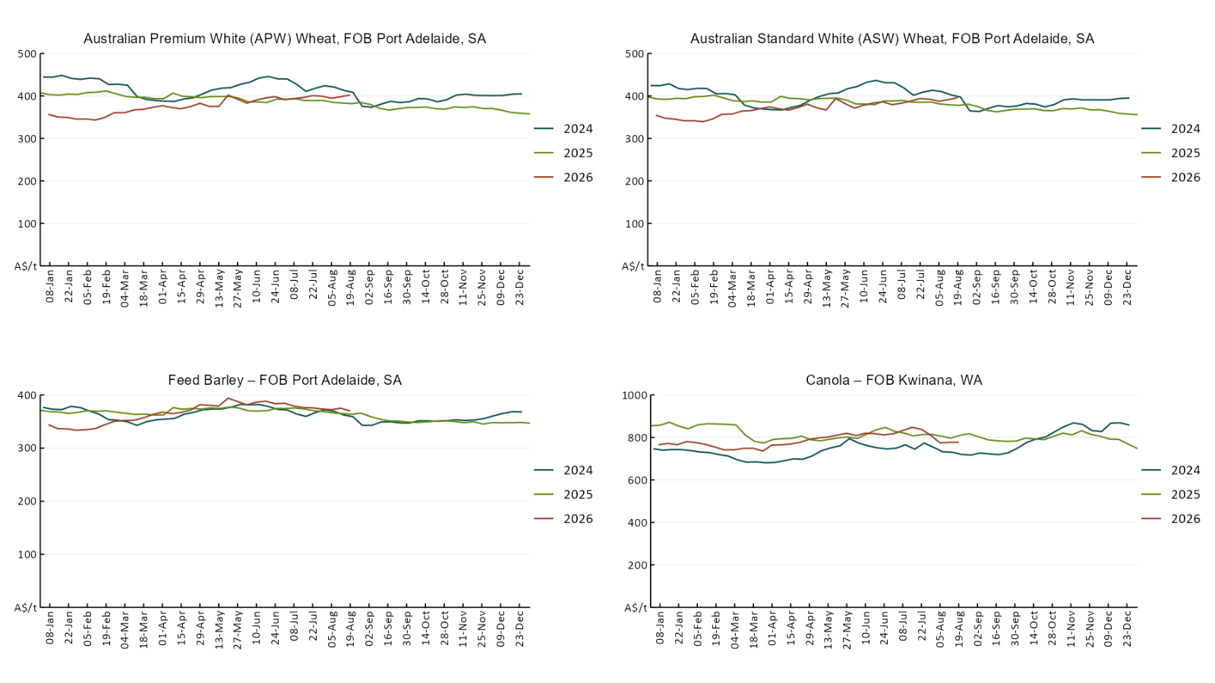

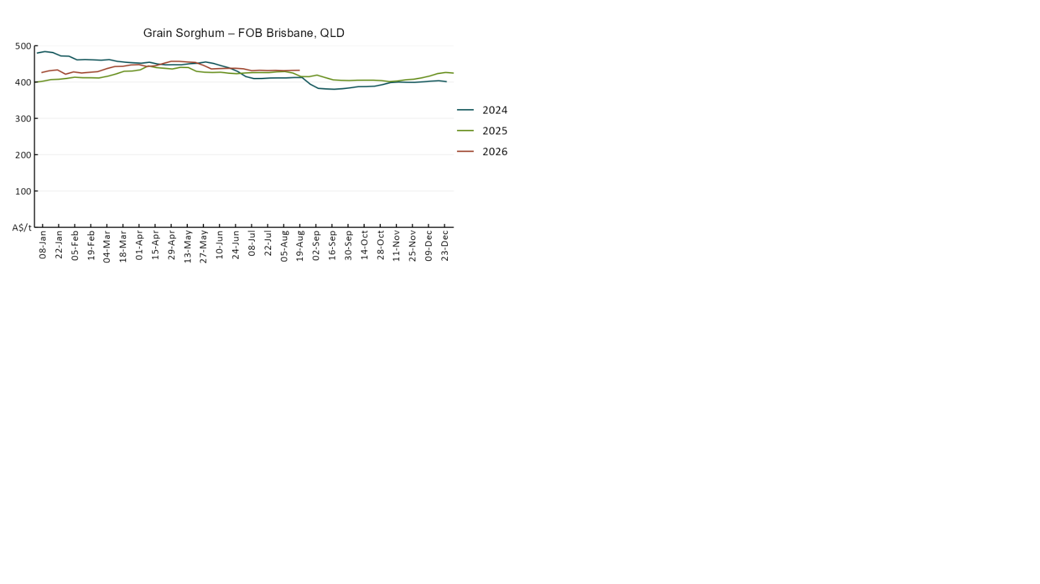

3.3 Selected domestic livestock indicator prices
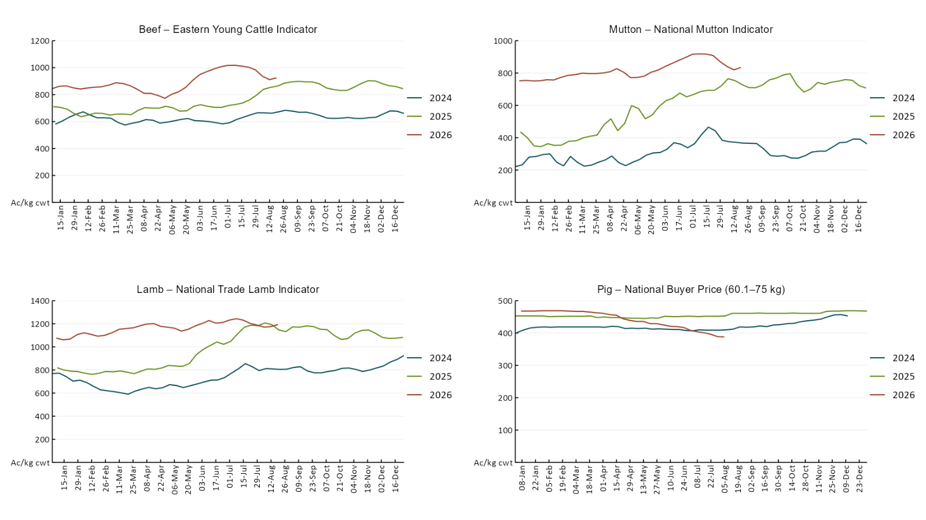

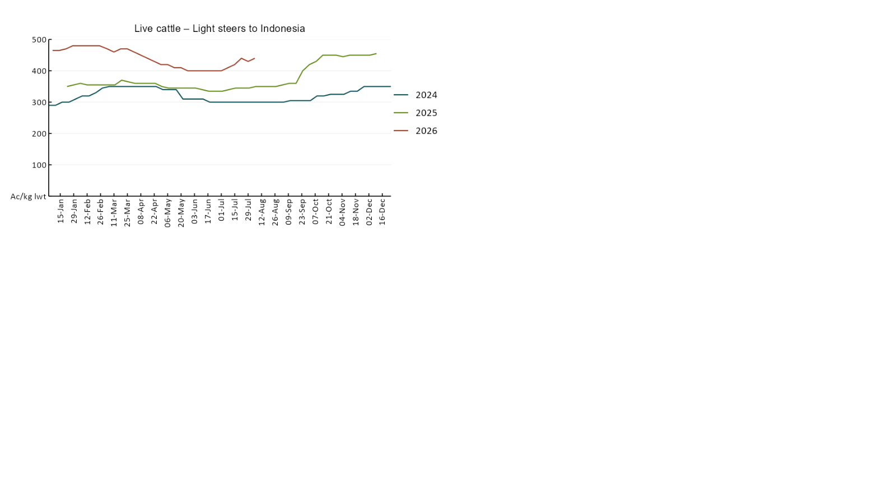

3.4 Global Dairy Trade (GDT) weighted average prices
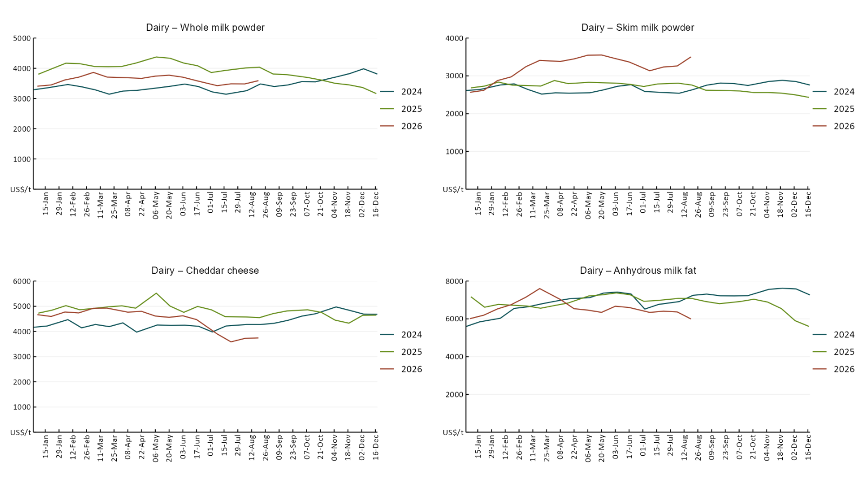

3.5 Selected fruit and vegetable prices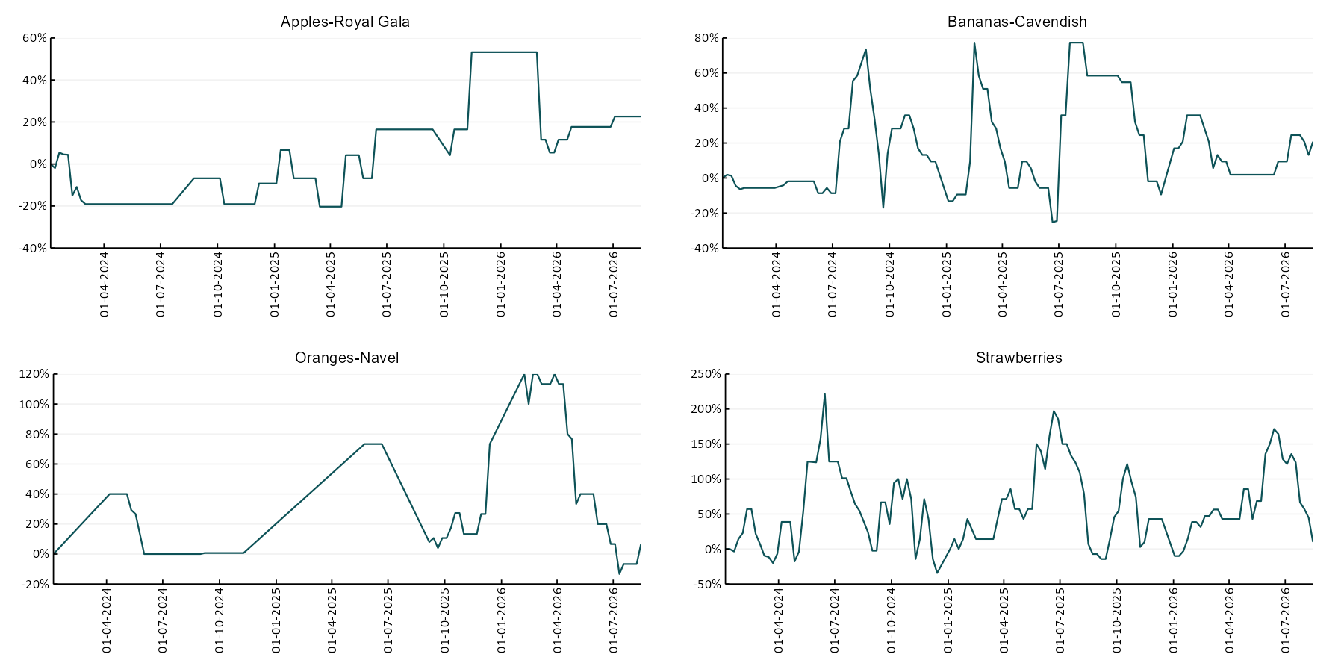
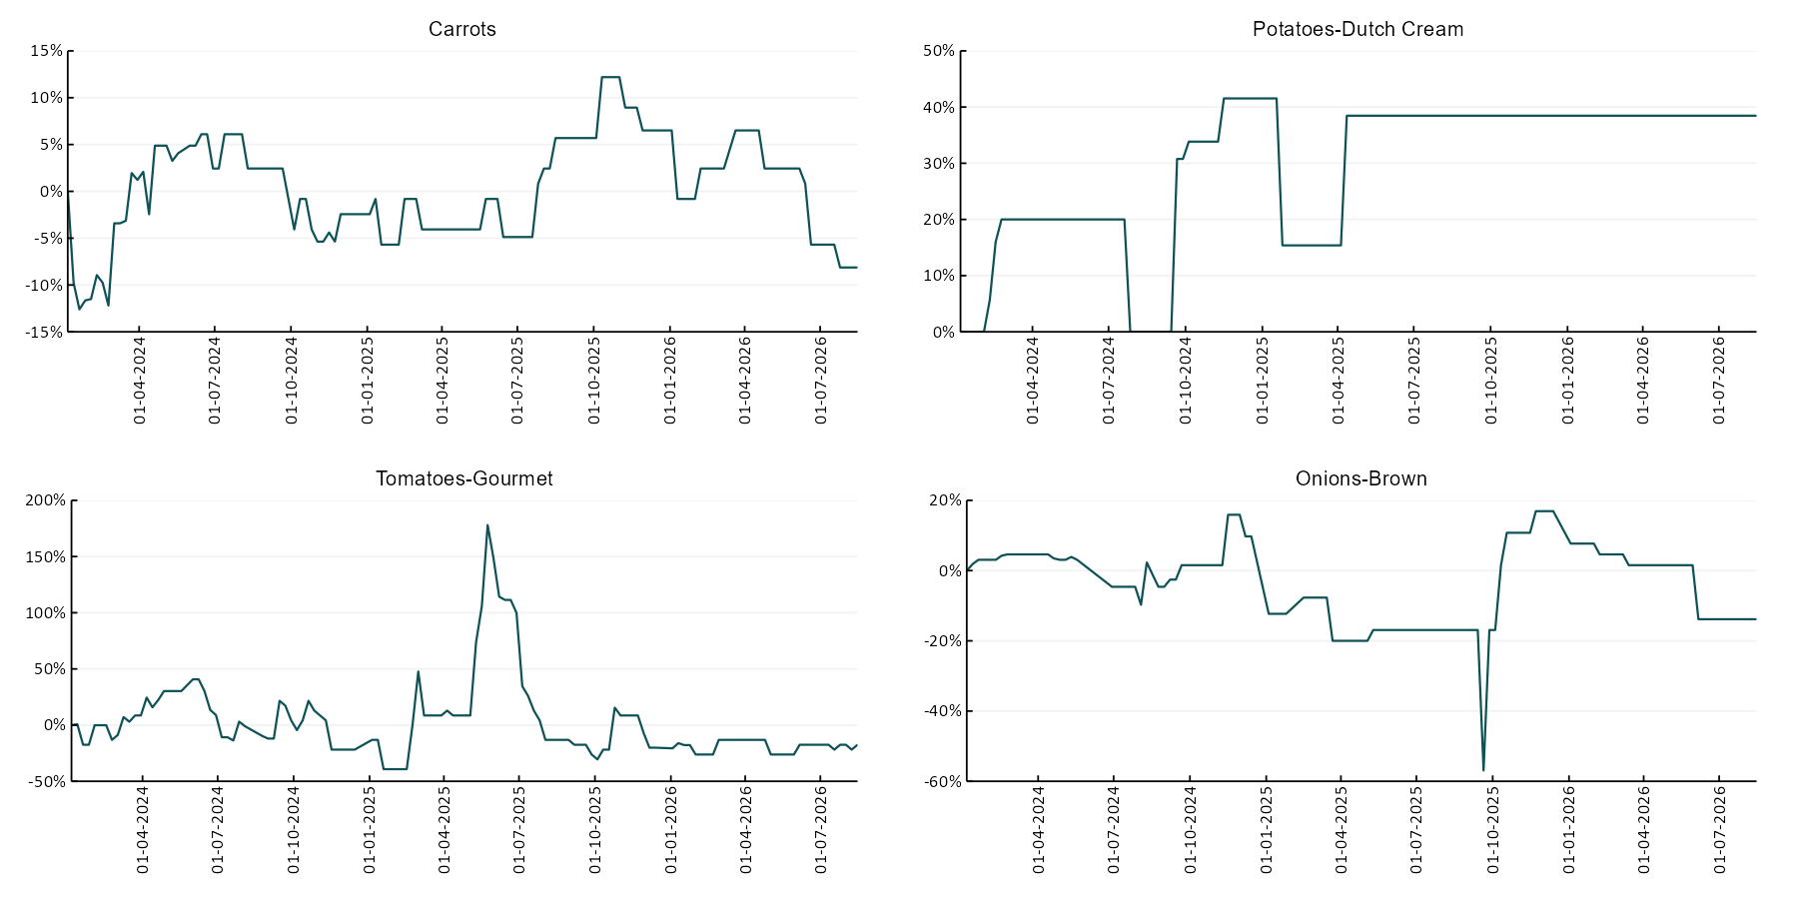

3.6 Selected domestic fodder indicator prices
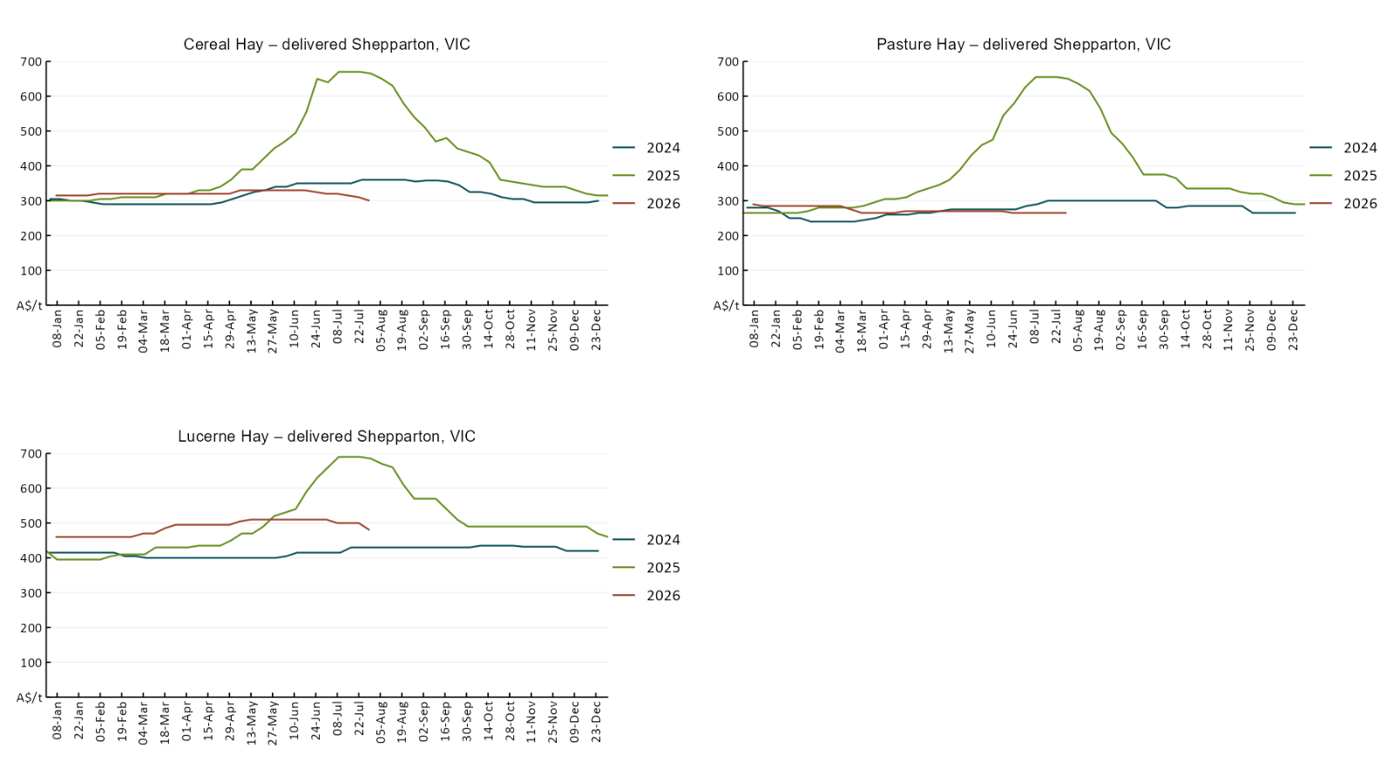

4. Data attribution

Climate
Bureau of Meteorology
- Weekly rainfall totals: www.bom.gov.au/climate/maps/rainfall/
- Monthly and last 3-month rainfall percentiles: https://www.bom.gov.au/climate/ahead/outlooks/#moreMaps
- Rainfall forecast: www.bom.gov.au/jsp/watl/rainfall/pme.jsp
- Seasonal outlook: www.bom.gov.au/climate/outlooks/#/overview/summary/
- Climate drivers: http://www.bom.gov.au/climate/enso/
- Soil moisture: https://awo.bom.gov.au/products/historical/soilMoisture-rootZone/

Other
- Pasture growth: www.longpaddock.qld.gov.au/aussiegrass/
- 3-month global outlooks: Environment and Climate Change Canada, NOAA Climate Prediction Center, EUROBRISA CPTEC/INPE, European Centre for Medium-Range Weather Forecasts, Hydrometcenter of Russia, National Climate Center Climate System Diagnosis and Prediction Room (NCC), International Research Institute for Climate and Society
- Global production: https://ipad.fas.usda.gov/ogamaps/cropmapsandcalendars.aspx
- Autumn break: Pook et al., 2009, https://rmets-onlinelibrary-wiley-com.virtual.anu.edu.au/doi/epdf/10.1002/joc.1833

Water
Prices
- Waterflow: https://www.waterflow.io/
- Ruralco: https://www.ruralcowater.com.au/
- Bureau of Meteorology:
- Allocation trade: http://www.bom.gov.au/water/dashboards/#/water-markets/mdb/at
- Storage volumes: http://www.bom.gov.au/water/dashboards/#/water-storages/summary/drainage

Trade constraints:
- Water NSW: https://www.waternsw.com.au/customer-service/ordering-trading-and-pricing/trading/murrumbidgee
- Victorian Water Register: https://www.waterregister.vic.gov.au/TradingRules2019/

Commodities
Fruit and vegetables
- Datafresh: www.freshstate.com.au

Pigs
- Australian Pork Limited: www.australianpork.com.au

Dairy
- Global Dairy Trade: www.globaldairytrade.info/en/product-results/

World wheat, canola
- International Grains Council
- https://www.igc.int/en/default.aspx
- United States Department of Agriculture

World cotton
- Cotlook: www.cotlook.com/

World sugar
- New York Stock Exchange - Intercontinental Exchange

Wool
- Australian Wool Exchange: www.awex.com.au/

Domestic wheat, barley, sorghum, canola and fodder
- Jumbuk Consulting Pty Ltd: Jumbuk AG | Agriculture Consulting

Cattle, beef, mutton, lamb, goat and live export
- Meat and Livestock Australia: https://www.mla.com.au/prices-markets/

Australian Agricultural Drought Indicators
About Australian Agricultural Drought Indicators
The Australian Agricultural Drought Indicators (AADI) links weather and agricultural data with a range of scientific and economic models to measure and forecast the effects of climate variability and drought on agricultural outcomes.
On AADI, projected broadacre farm profits are presented as percentile outcomes relative to simulated historical outcomes using the groupings:
Highest | 95-100th percentile
Very much above average | 85-95th percentile
Above average | 65-85th percentile
Average | 35-65th percentile
Below average | 15-35th percentile
Very much below average | 5-15th percentile
Lowest 5% | 0-5th percentile

There are two AADI farm profit indicators:
- The AADI farm profit climate and price indicator shows the effect of climate and prices on broadacre farm business profits of current farms compared to the last 33 years.
- The AADI farm profit climate only indicator isolates the effect of climate on profits by holding prices fixed.

© Commonwealth of Australia 2026

Ownership of intellectual property rights
Unless otherwise noted, copyright (and any other intellectual property rights, if any) in this publication is owned by the Commonwealth of Australia (referred to as the Commonwealth).

Creative Commons licence
All material in this publication is licensed under a Creative Commons Attribution 4.0 International Licence except content supplied by third parties, logos and the Commonwealth Coat of Arms.
Inquiries about the licence and any use of this document should be emailed to copyright@awe.gov.au.


Cataloguing data
This publication (and any material sourced from it) should be attributed as:
ABARES 2026, Weekly Australian Climate, Water and Agricultural Update, Australian Bureau of Agricultural and Resource Economics and Sciences, Canberra, 20 August 2026. CC BY 4.0 DOI: https://doi.org/10.25814/5f3e04e7d2503
ISSN 2652-7561
This publication is available at https://www.agriculture.gov.au/abares/products/weekly_update
Department of Agriculture, Fisheries and Forestry
GPO Box 858 Canberra ACT 2601
Telephone 1800 900 090
Web agriculture.gov.au/abares

Disclaimer
The Australian Government acting through the Department of Agriculture, Fisheries and Forestry, represented by the Australian Bureau of Agricultural and Resource Economics and Sciences, has exercised due care and skill in preparing and compiling the information and data in this publication. Notwithstanding, the Department of Agriculture, Fisheries and Forestry, ABARES, its employees and advisers disclaim all liability, including liability for negligence and for any loss, damage, injury, expense or cost incurred by any person as a result of accessing, using or relying on any of the information or data in this publication to the maximum extent permitted by law.

Statement of Professional Independence
The views and analysis presented in ABARES publications, including this one, reflect ABARES professionally independent findings, based on scientific and economic concepts, principles, information and data. These views, analysis and findings may not reflect or be consistent with the views or positions of the Australian Government, or of organisations or groups who have commissioned ABARES reports or analysis. More information on professional independence is provided on the ABARES website.

Acknowledgements
This report was prepared by Holly Beale and Matt Miller.

