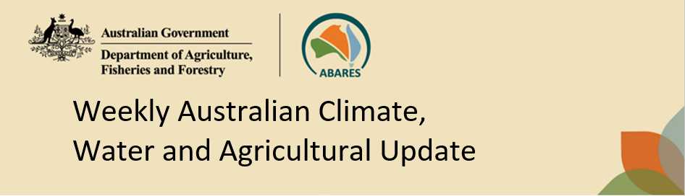
No. 36/2026 17 September 2026

Summary of key issues
- In the week ending 16 September 2026, cold fronts brought limited rainfall to parts of southern and central Australia.
- Across cropping regions rainfall was generally restricted to the west and parts of the southeast. In Western Australia, most areas recorded falls of between 1-10 millimetres with falls of up to 25 millimetres observed in some central and northern areas. In western Victoria and parts of southern New South Wales falls of 1-15 millimetres were recorded. In South Australia falls of between 1- 10 millimetres were observed in the west and some eastern areas.
  - These falls are expected to continue to support winter crop and pasture growth.
- Over the 8 days to 24 September 2026, rainfall is expected in south-western Australia and Tasmania, as well as the eastern seaboard, while much of the remainder of Australia is expected to remain largely dry.
  - Cropping regions in Western Australia are forecast to receive 1-25 millimetres, with higher rainfall totals in southern areas. Remaining cropping regions are forecast to see little to no rainfall.
- Rainfall in August 2026 was variable across the world’s major grain and oilseed producing regions, leading to differing crop production outcomes. Global production conditions were highly variable for wheat, maize, soybeans, and rice. Unfavourable conditions across parts of the United States, India, Europe and Southeast Asia are a risk to potential global production outcomes for major grains and oilseeds.
  - Global production conditions have been slightly less favourable to those used to formulate ABARES 2026–27 forecasts of global grain supplies and world prices in the September 2026 Agricultural Commodities Report. As a result, global grain and oilseed production are likely to decrease below the estimates in the September forecast, due to declines in global soybeans and maize production more than offsetting a small, expected increase in global wheat production.
- Water storage levels in the Murray-Darling Basin (MDB) increased by 214 gigalitres (GL) between 10 September 2026 and 17 September 2026. The current volume of water held in storages is 15,058 GL, equivalent to 68% of total storage capacity. This is -3% or -526 GL less than the same time last year. Water storage data is sourced from the Bureau of Meteorology (BOM).
- Allocation prices in the Victorian Murray below the Barmah Choke decreased from $342/ML on 10 September 2026 to $337/ML on 17 September 2026. Trade from the Goulburn to the Murray is closed. Trade downstream through the Barmah Choke is closed. Trade from the Murrumbidgee to the Murray is open.

Climate

Rainfall this week
In the week ending 16 September 2026, cold fronts brought limited rainfall to parts of southern and central Australia, while much of Australia remained largely dry.
- Isolated areas of eastern Queensland and Tasmania saw up to 50 millimetres.
- Falls of 5-25 millimetres were recorded across scattered areas of southern and central Western Australia, while parts of South Australia, southern New South Wales, Victoria and parts of the south of the Northern Territory recorded fall of between 5-15 millimetres.
- In contrast, much of the remainder of Australia saw little to no rainfall.
In cropping regions, some rainfall was recorded across parts of southern Australia.
- In Western Australia, most areas recorded falls of between 1-10 millimetres with falls of up to 25 millimetres observed in some central and northern areas. In western Victoria and parts of southern New South Wales falls of 1-15 millimetres were recorded. In South Australia falls of between 1- 10 millimetres were observed in the west and some eastern areas.
  - These falls are expected to continue to support winter crop and pasture growth.
- Meanwhile, little to no rainfall was recorded across cropping regions in Queensland, and central and northern New South Wales.

Rainfall for the week ending 16 September 2026
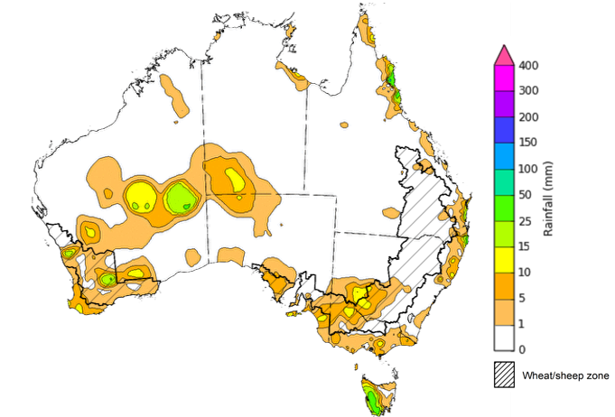
©Commonwealth of Australia 2026, Australian Bureau of Meteorology Issued: 16/09/2026
Note: The rainfall analyses and associated maps utilise data contained in the Bureau of Meteorology climate database, the Australian Data Archive for Meteorology (ADAM). The analyses are initially produced automatically from real-time data with limited quality control. They are intended to provide a general overview of rainfall across Australia as quickly as possible after the observations are received. For further information go to http://www.bom.gov.au/climate/rainfall/

Rainfall forecast for the next eight days
Over the 8 days to 24 September 2026, rainfall is expected across parts of south-western Australia and Tasmania, as well as the eastern seaboard, while much of the remainder of Australia is expected to remain largely dry.
- Falls of between 25-100 millimetres are forecast for western Tasmania and isolated areas of northern coastal Queensland and north-eastern New South Wales. In Western Australia, falls of between 5-25 millimetres are expected in southern regions.
- Much of the remainder of Australia of is expected to see little to no rainfall.
Little to no rainfall is expected across south-eastern and eastern cropping regions, low falls are expected across parts of the west:
- Cropping regions in Western Australia are forecast to receive 1-25 millimetres, with higher rainfall totals in southern areas.
  - If realised, these falls are likely to continue to maintain positive winter crop yield expectations and above average pasture growth across much of the southwest.
- In contrast, conditions are expected to be mostly dry across most cropping regions in South Australia, Victoria, New South Wales and Queensland.

Total forecast rainfall for the period 17 September to 24 September 2026
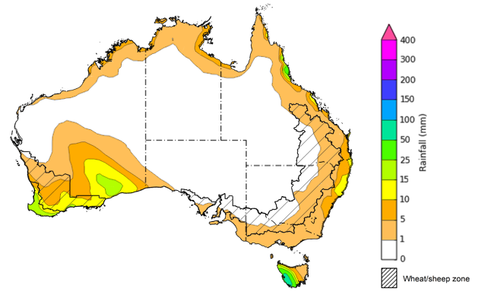

©Commonwealth of Australia 2026, Australian Bureau of Meteorology Issued: 17/09/2026
Note: This rainfall forecast is produced from computer models. As the model outputs are not altered by weather forecasters, it is important to check local forecasts and warnings issued by the Bureau of Meteorology.

August precipitation percentiles and current production conditions
Crop production is affected by long-term trends in average rainfall and temperature, interannual climate variability, shocks during specific growth stages, and extreme weather events. Some crops are more tolerant than others to certain types of stresses, and at each growth stage, different types of stresses affect crop species in different ways.
Precipitation anomalies and outlooks presented below indicate the current and expected future production conditions for major grain and oilseed producing countries (responsible for over 80% of global crop production). This is an important input to assessing the global grain supply outlook.
Precipitation in August 2026 was variable across the world’s major grain and oilseed producing regions:
- In the northern hemisphere, precipitation was above average in scattered western and northern regions of China, eastern India, and northern parts of the United States. Precipitation was generally below average in western and central Europe, the Black Sea region, central India, and parts of the southern United States and Mexico. Precipitation was generally average across the remaining major northern hemisphere grain and oilseed producing regions.
- In the southern hemisphere, precipitation was below average across parts of the north and far south of Brazil, the far southwest of Australia, as well as parts of Southeast Asia including Indonesia and the Philippines. Precipitation was above average across Argentina and south-eastern Australia. Precipitation was generally average across the remaining major southern hemisphere grain and oilseed producing regions.

Global precipitation percentiles, August 2026

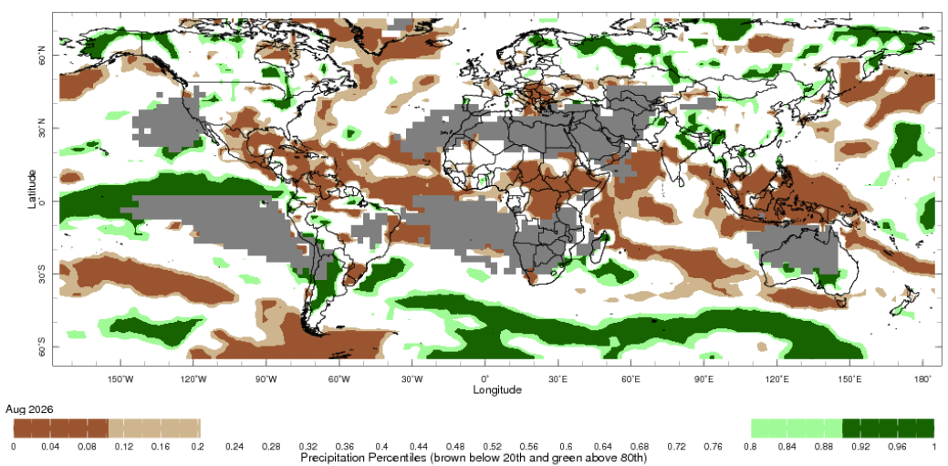
Note: The world precipitation percentiles indicate a ranking of precipitation for August, with the driest (0th percentile) being 0 on the scale and the wettest (100th percentile) being 1 on the scale. Percentiles are based on precipitation estimates from the NOAA Climate Prediction Center’s Climate Anomaly Monitoring System Outgoing Precipitation Index dataset. Precipitation estimates for April are compared with rainfall recorded

As of 28 August 2026, global production conditions were highly variable for all four major grain and oilseed crops (wheat, maize, rice and soybeans):
- Wheat – In the northern hemisphere, spring wheat harvest is occurring under broadly favourable conditions in much of China, the United States, and the Black Sea region. However, hot and dry conditions in central and western Europe is expected to result in below average production outcomes. In the southern hemisphere, wheat is developing under generally favourable conditions.
- Maize – In the southern hemisphere, conditions have been largely favourable with above average yields across much of Brazil. However, in the northern hemisphere unfavourable growing conditions across Europe, and parts of China, India, Southeast Asia, Ukraine and the United States, are likely to result in below average crop production outcomes.
- Rice – Global conditions remain broadly favourable for most major rice production regions, with exceptions in Thailand, the Philippines, parts of India and Vietnam.
- Soybeans – Harvest has concluded in the southern hemisphere. In the northern hemisphere, crop development in the United States, Canada, and China has been broadly favourable, however, in Ukraine conditions have declined with hot and dry conditions.

Crop conditions, AMIS countries, 28 August 2026
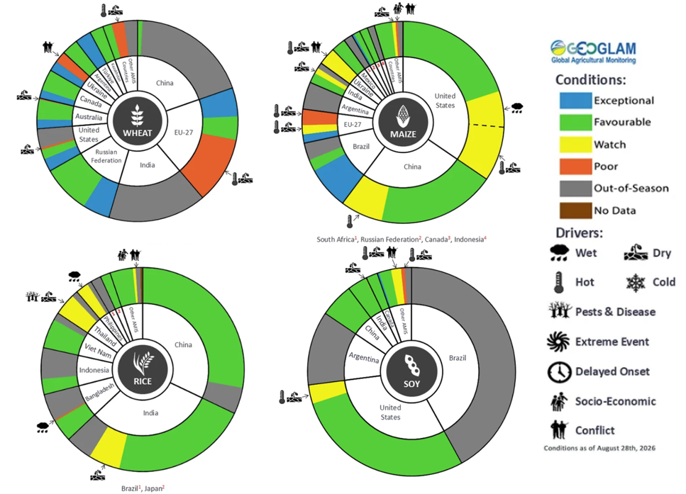
AMIS Agricultural Market Information System.
Source: AMIS

The global climate outlook for October 2026 to December 2026 indicates that mixed rainfall conditions are expected for the world’s major grain and oilseed producing regions. Outlooks and potential production impacts are presented in the following table.
Rainfall outlook and potential impact on the future state of production conditions, October 2026 - December 2026
Region | Rainfall outlook | Potential impact on production
Argentina | Above average rainfall is likely across parts of central and southern Argentina, with broadly average to below average rainfall in the far north. | Generally, above average forecast rainfall is likely to support the heading and vegetative development of wheat, cotton, and corn, but could impede the planting of sorghum.
Black Sea Region | Above average rainfall is expected across northern parts of Türkiye, while average to below average rainfall is expected in remaining areas. | Average rainfall is likely to support vegetative development and maturation of winter wheat and canola, as well as snowpack ahead of winter wheat dormancy. In Türkiye, above average rainfall is likely to benefit soil moisture levels and the planting of major grains.
Brazil | Rainfall outcomes across Brazil are expected to be below average in many northern and central areas, while southern areas see broadly average to above average conditions. | Average to above average rainfall across southern Brazil is likely to benefit the maturation of rice, cotton, and sorghum, as well as support the critical flowering stage for corn and soybeans. However below average expected rainfall across central Brazil may adversely affect the planting and growth of soybeans.
Canada | Rainfall across Canada is expected to be below average in southern regions, with scattered areas seeing average to above average rainfall. | Below average rainfall is likely to support wheat, corn, and soybean harvesting over October and November.
China | Above average rainfall is expected across most of eastern and northern China, with scattered areas below average rainfall in central and southern regions. | Generally average to above average rainfall across much of China is likely to support the growth and development of major crops over the season, including rice, cotton, corn and soybeans.
European Union | Average rainfall expected for much of the European Union, with exceptions in parts of western Europe where below average rainfall is more likely. | Close to average rainfall across much of Europe is likely to benefit harvesting and planting of major crops, as well as snowpack ahead of dormancy. Below average rainfall in parts of western Europe could reduce yield potential.
South Asia (India) | Below average rainfall is expected across much of India. | Anticipated below average rainfall is likely to present a downside production risk to the boll formation of cotton and the maturation of grains and oilseeds.
Southeast Asia (SEA) | Below average rainfall is likely across much of Southeast Asia. | Below average rainfall in Southeast Asia. is likely to impede growth and development outcomes for crops but could support the harvest of rice and corn.
The United States | Above average rainfall is likely for much of the southern and central United States, with northern areas likely to see close to average falls. | Average to above average rainfall conditions expected across the United States are likely to support soil moisture levels and the development of major crops.

Water markets – current week
Water storage levels in the Murray-Darling Basin (MDB) increased by 214 gigalitres (GL) between 10 September 2026 and 17 September 2026. The current volume of water held in storages is 15,058 GL, equivalent to 68% of total storage capacity. This is -3% or -526 GL less than the same time last year. Water storage data is sourced from the Bureau of Meteorology (BOM).

Weekly water storage levels in the Murray-Darling Basin, 2013–2026

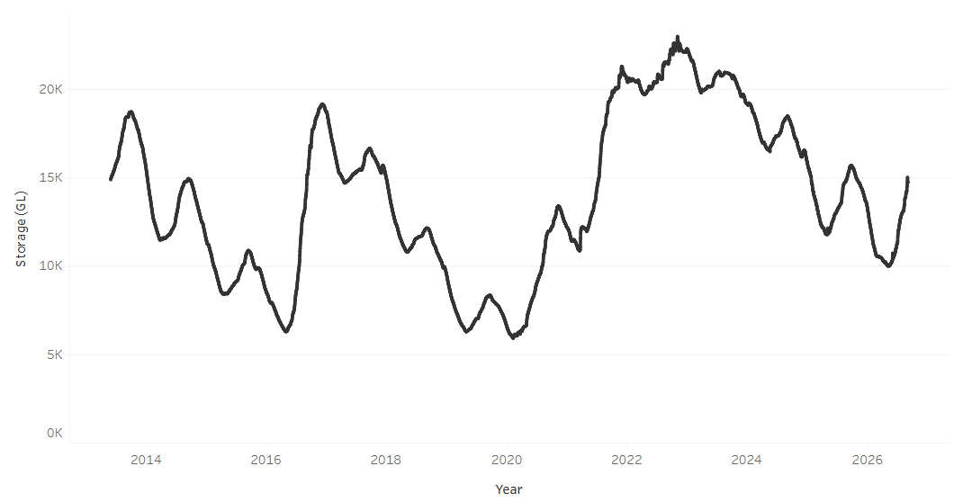
Allocation prices in the Victorian Murray below the Barmah Choke decreased from $342/ML on 10 September 2026 to $337/ML on 17 September 2026. Trade from the Goulburn to the Murray is closed. Trade downstream through the Barmah Choke is closed. Trade from the Murrumbidgee to the Murray is open.

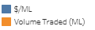
Monthly surface water trade activity 2022-2026, Victorian Murray below the Barmah Choke 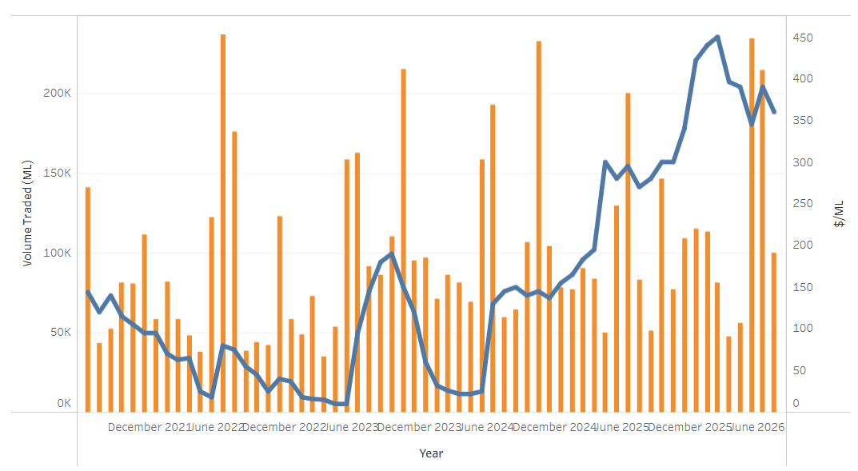

Weekly water market prices, Southern Murray–Darling Basin
Region | $/ML
NSW Murray Above | 202
NSW Murrumbidgee | 279
Vic Greater Goulburn | 321
Vic Murray Below | 337
Note: The water allocation prices shown are volume weighted average prices based on the last 10 trades. Price data is sourced from Waterflow and current as at 6 August 2026.
To access the full, interactive, weekly water dashboard, which contains the latest and historical water storage, water market and water allocation information, please visit https://www.agriculture.gov.au/abares/products/weekly_update/weekly-update-260917

Commodities
Indicator | Week average | Unit | Latest Price | Previous Week | Weekly change |  | Price 12 months ago | Annual change
Selected world indicator prices
AUD/USD Exchange rate | 16-Sep | A$/US$ | 0.71 | 0.72 | -1% | 0.66 |  | 8%
Wheat – US no. 2 hard red winter wheat, FOB Gulf | 16-Sep | US$/t | 349 | 351 | -1% | 234 |  | 49%
Corn – US no. 2 yellow corn, FOB Gulf | 16-Sep | US$/t | 238 | 235 | 1% | 196 |  | 21%
Canola – Rapeseed, Canada, FOB Vancouver | 16-Sep | US$/t | 631 | 631 | 0% | 483 |  | 31%
Cotton – Cotlook A Index | 16-Sep | USc/lb | 94.6 | 96.9 | -2% | 78.0 |  | 21%
Sugar – Intercontinental Exchange, nearby futures, no.11 contract | 16-Sep | USc/lb | 19.0 | 19.3 | -2% | 16.4 |  | 16%
Wool – Eastern Market Indicator | 16-Sep | Ac/kg clean | 1,857 | 1,878 | -1% | 1,352 |  | 37%
Wool – Western Market Indicator | 16-Sep | Ac/kg clean | 2,039 | 2,084 | -2% | 1,529 |  | 33%
Selected Australian grain export prices
Australian Premium White (APW) Wheat, FOB Port Adelaide, SA | 16-Sep | A$/t | 426 | 426 | 0% | 372 |  | 14%
Australian Standard White (ASW) Wheat, FOB Port Adelaide, SA | 16-Sep | A$/t | 417 | 417 | 0% | 367 |  | 13%
Feed Barley – FOB Port Adelaide, SA | 16-Sep | A$/t | 370 | 367 | 1% | 354 |  | 4%
Canola – FOB Kwinana, WA | 16-Sep | A$/t | 801 | 803 | 0% | 789 |  | 1%
Grain Sorghum – FOB Brisbane, QLD | 16-Sep | A$/t | 441 | 429 | 3% | 411 |  | 7%
Selected domestic livestock indicator prices
Beef – Eastern Young Cattle Indicator | 16-Sep | Ac/kg cwt | 984 | 1,000 | -2% | 895 |  | 10%
Mutton – Mutton indicator (18–24 kg fat score 2–3), VIC | 16-Sep | Ac/kg cwt | 872 | 879 | -1% | 741 |  | 18%
Lamb – National Trade Lamb Indicator | 16-Sep | Ac/kg cwt | 1,171 | 1,191 | -2% | 1,176 |  | 0%
Pig – Eastern Seaboard (60.1–75 kg), NSW buyer price | 26-Aug | Ac/kg cwt | 373 | 374 | 0% | 461 |  | -19%
Live cattle – Light steers to Indonesia | 5-Aug | Ac/kg lwt | 440 | 430 | 2% | 369 |  | 19%
Global Dairy Trade (GDT) weighted average prices
Dairy – Whole milk powder | 16-Sep | US$/t | 3,565 | 3,585 | -1% | 3,800 |  | -6%
Dairy – Skim milk powder | 16-Sep | US$/t | 3,689 | 3,695 | 0% | 2,618 |  | 41%
Dairy – Cheddar cheese | 16-Sep | US$/t | 4,075 | 3,503 | 16% | 4,762 |  | -14%
Dairy – Anhydrous milk fat | 16-Sep | US$/t | 5,739 | 5,917 | -3% | 6,860 |  | -16%

Selected world indicator prices
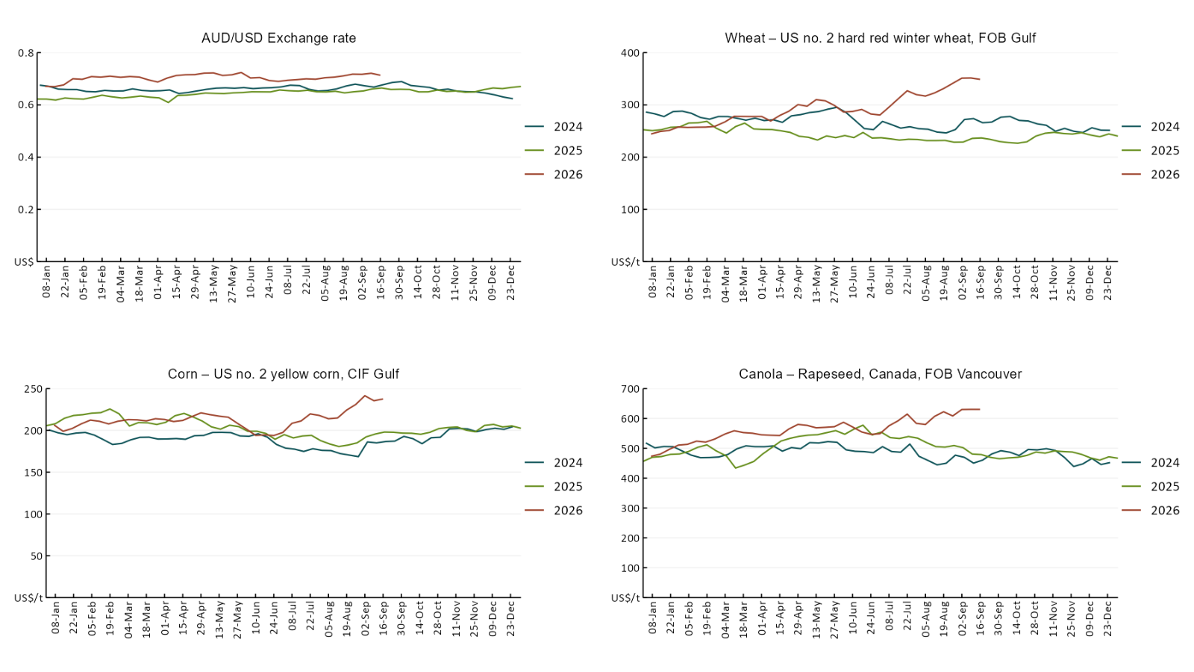

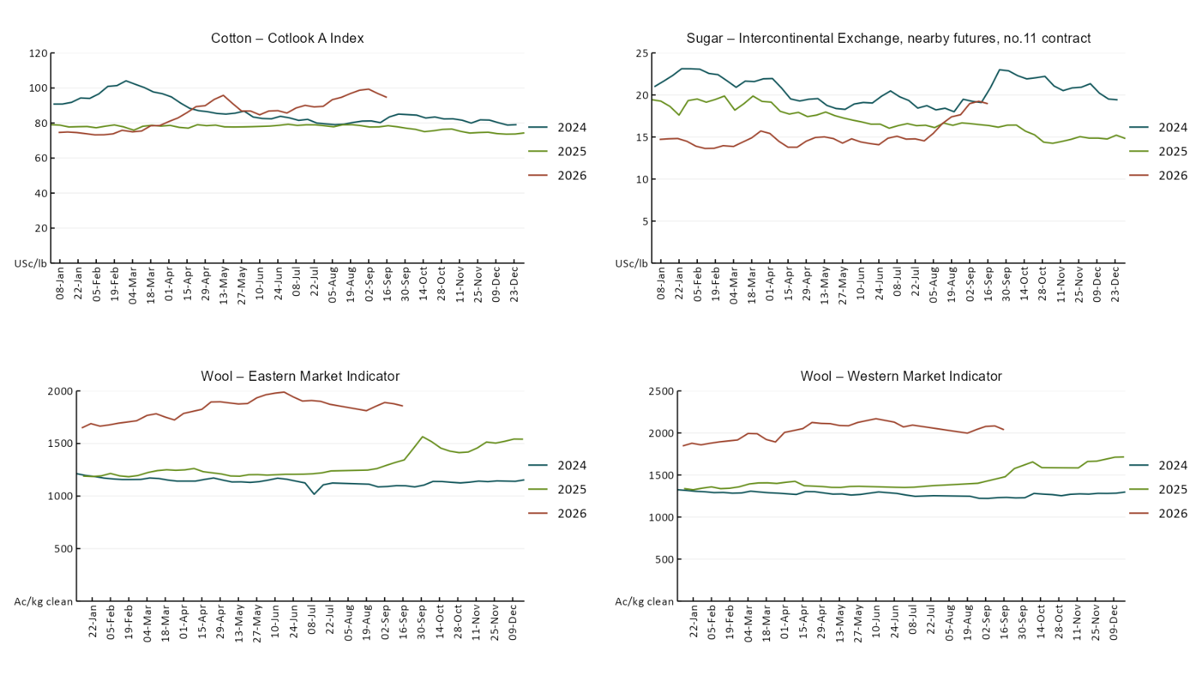

3.2 Selected domestic crop indicator prices
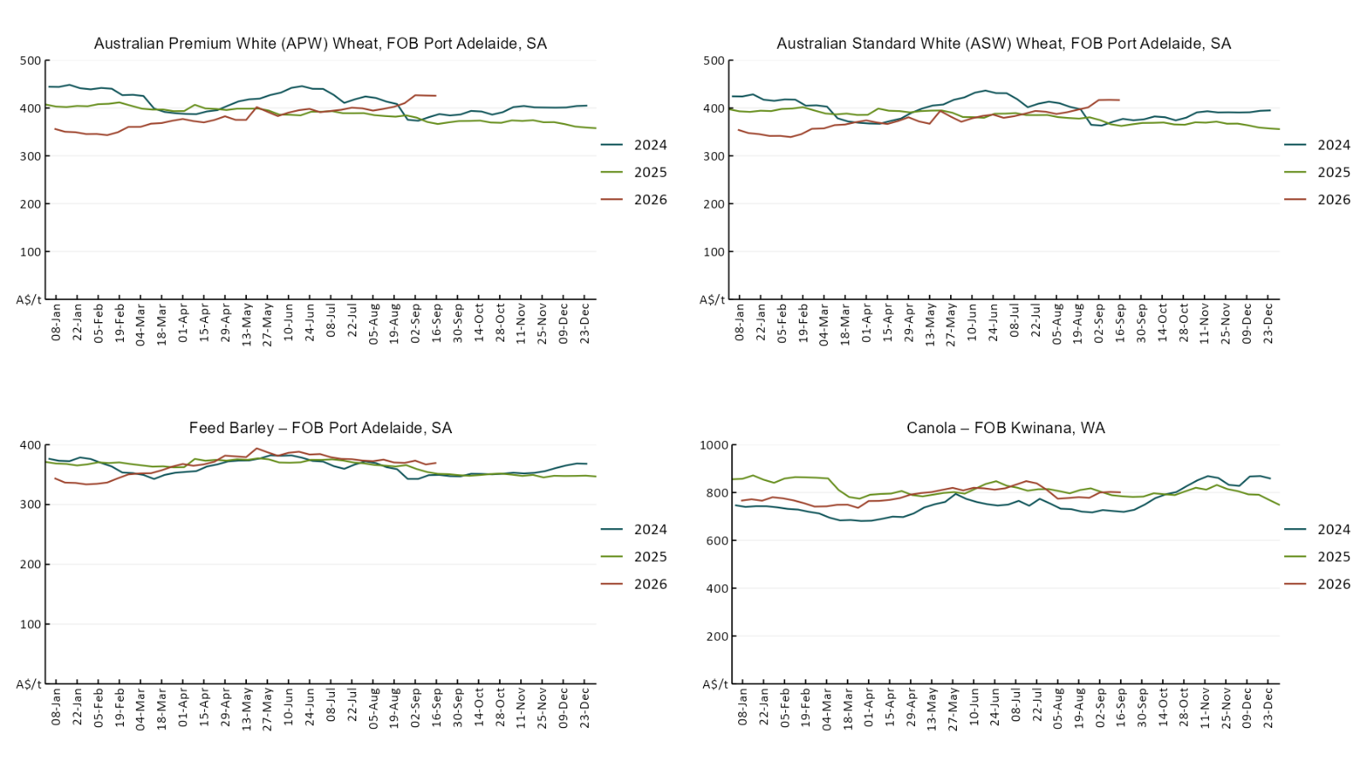

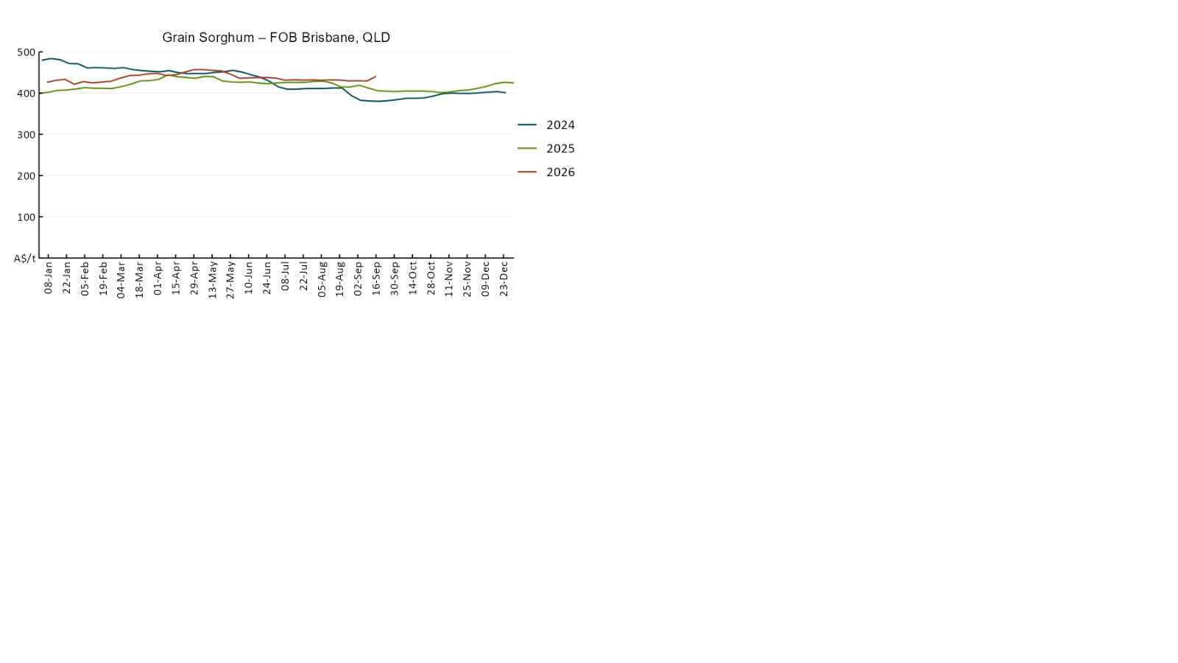

3.3 Selected domestic livestock indicator prices
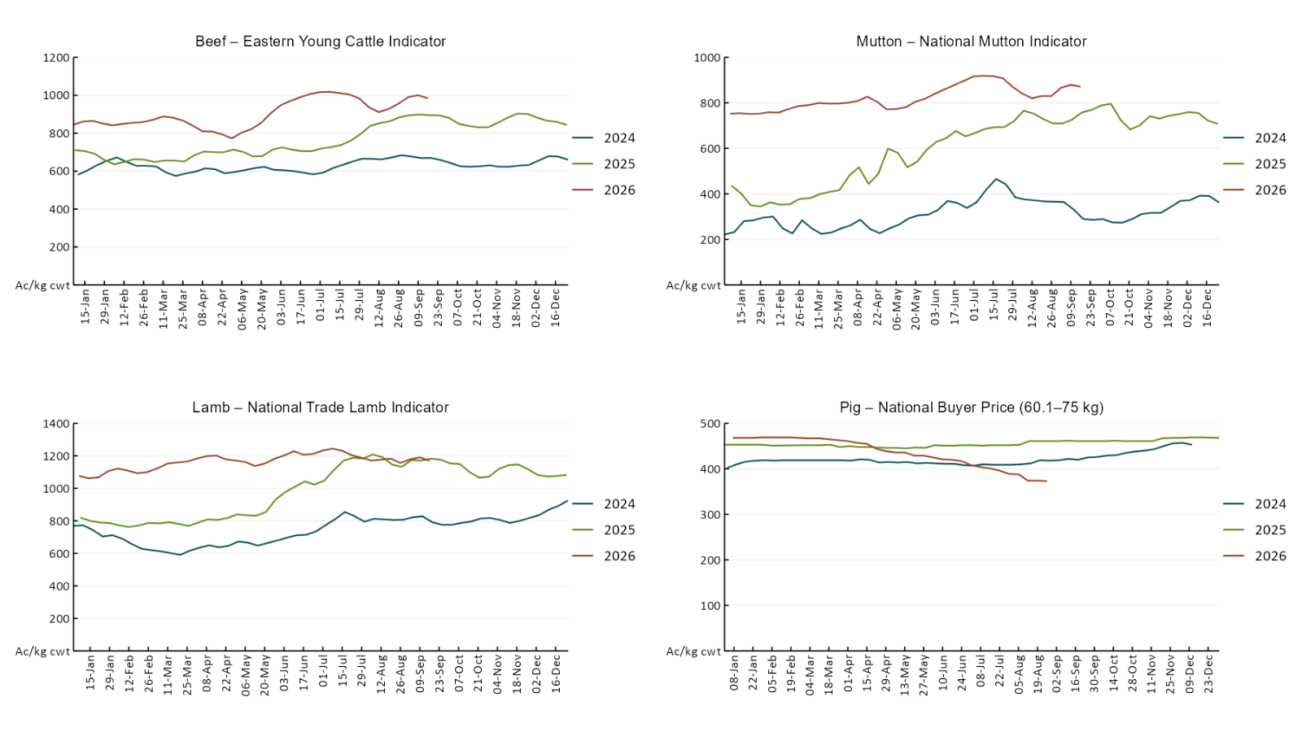

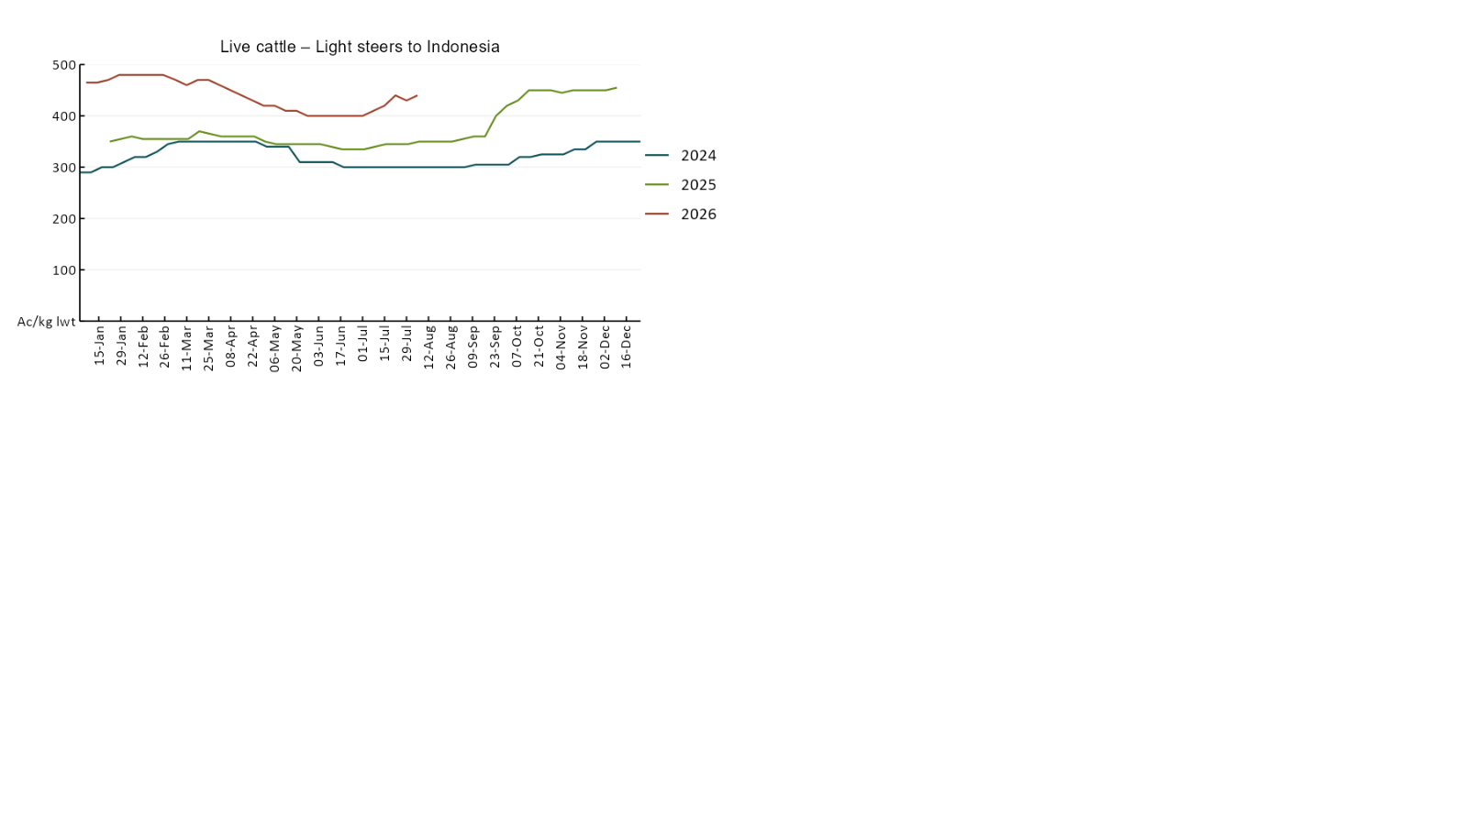

3.4 Global Dairy Trade (GDT) weighted average prices
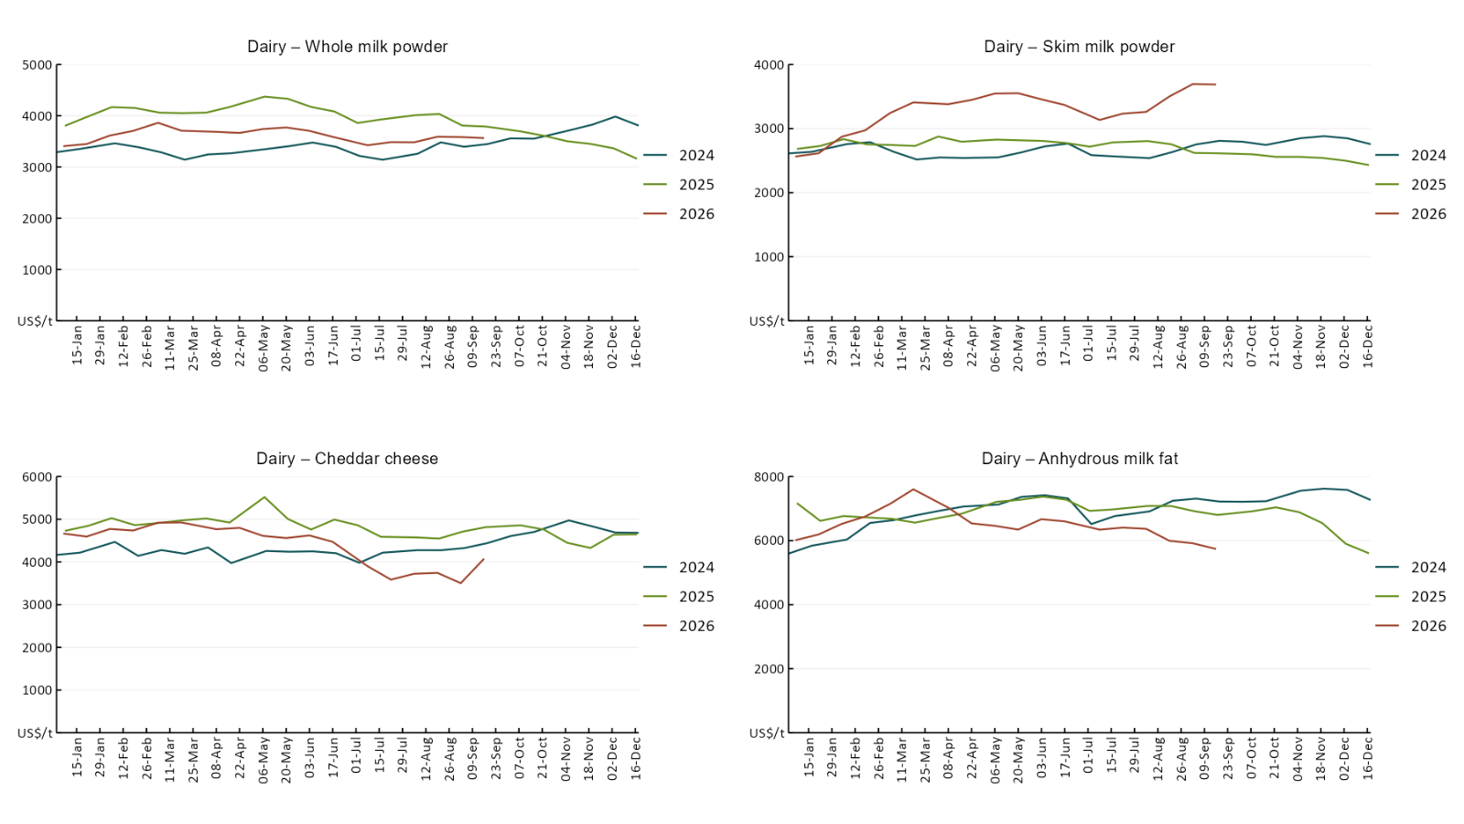

3.5 Selected fruit and vegetable prices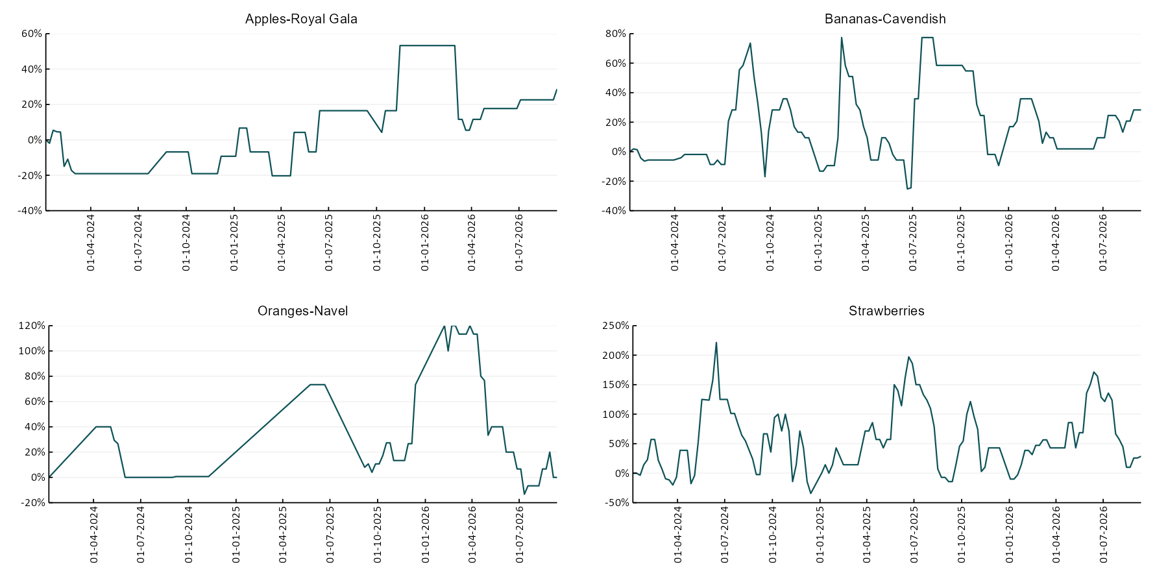
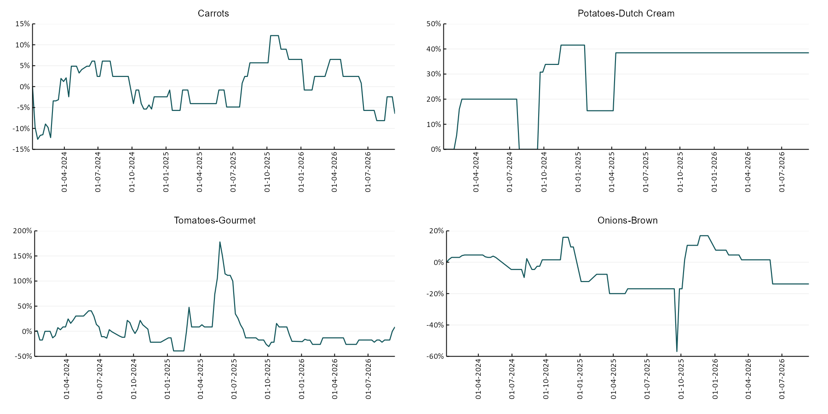

3.6 Selected domestic fodder indicator prices
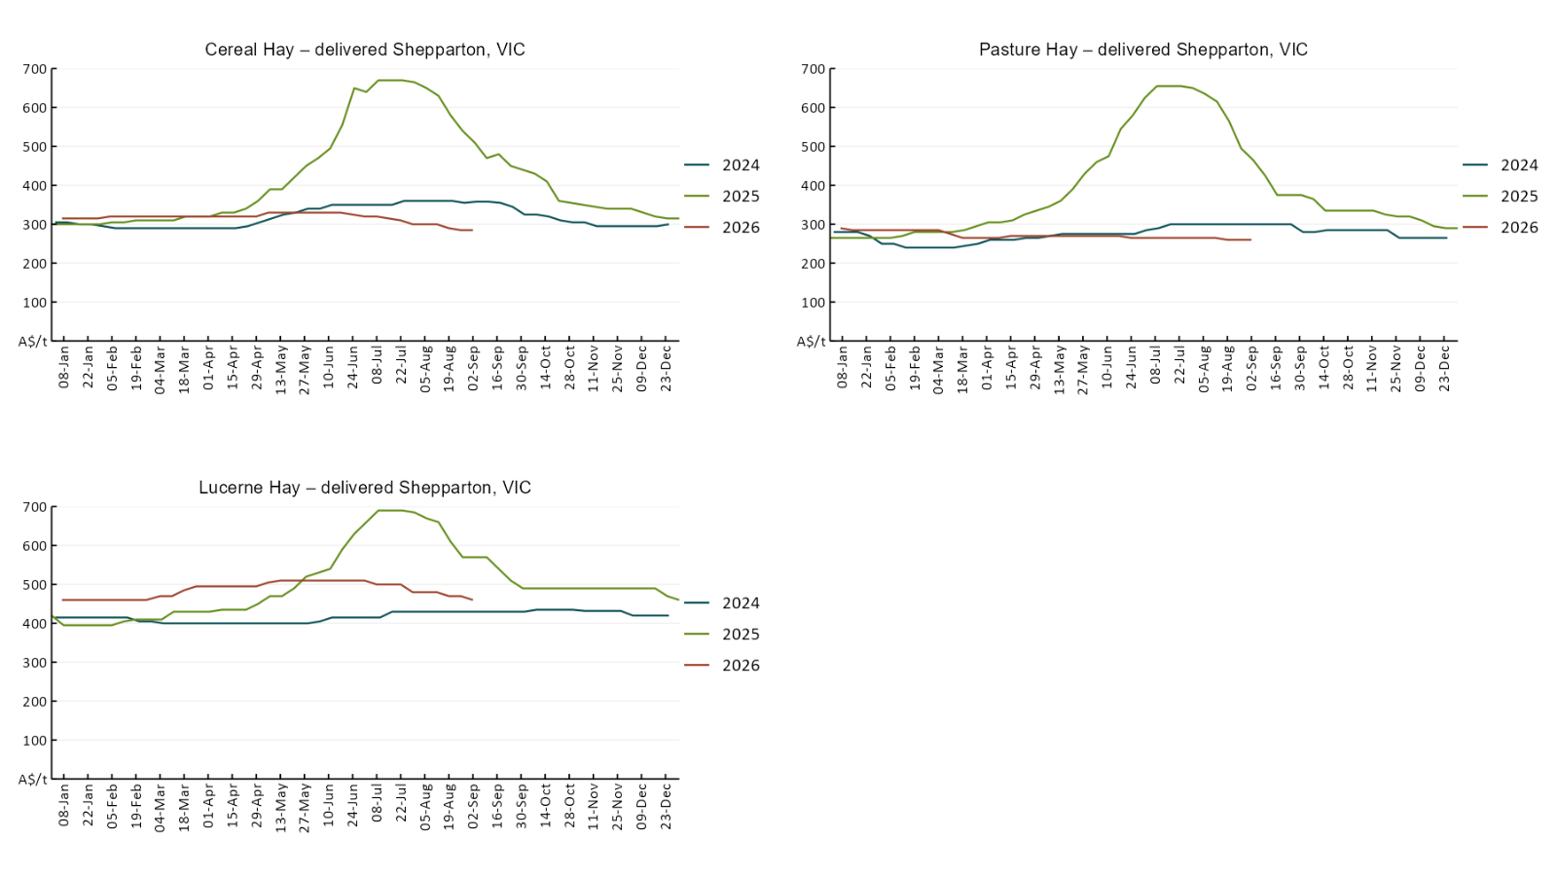

4. Data attribution

Climate
Bureau of Meteorology
- Weekly rainfall totals: www.bom.gov.au/climate/maps/rainfall/
- Monthly and last 3-month rainfall percentiles: https://www.bom.gov.au/climate/ahead/outlooks/#moreMaps
- Rainfall forecast: www.bom.gov.au/jsp/watl/rainfall/pme.jsp
- Seasonal outlook: www.bom.gov.au/climate/outlooks/#/overview/summary/
- Climate drivers: http://www.bom.gov.au/climate/enso/
- Soil moisture: https://awo.bom.gov.au/products/historical/soilMoisture-rootZone/

Other
- Pasture growth: www.longpaddock.qld.gov.au/aussiegrass/
- 3-month global outlooks: Environment and Climate Change Canada, NOAA Climate Prediction Center, EUROBRISA CPTEC/INPE, European Centre for Medium-Range Weather Forecasts, Hydrometcenter of Russia, National Climate Center Climate System Diagnosis and Prediction Room (NCC), International Research Institute for Climate and Society
- Global production: https://ipad.fas.usda.gov/ogamaps/cropmapsandcalendars.aspx
- Autumn break: Pook et al., 2009, https://rmets-onlinelibrary-wiley-com.virtual.anu.edu.au/doi/epdf/10.1002/joc.1833

Water
Prices
- Waterflow: https://www.waterflow.io/
- Ruralco: https://www.ruralcowater.com.au/
- Bureau of Meteorology:
- Allocation trade: http://www.bom.gov.au/water/dashboards/#/water-markets/mdb/at
- Storage volumes: http://www.bom.gov.au/water/dashboards/#/water-storages/summary/drainage

Trade constraints:
- Water NSW: https://www.waternsw.com.au/customer-service/ordering-trading-and-pricing/trading/murrumbidgee
- Victorian Water Register: https://www.waterregister.vic.gov.au/TradingRules2019/

Commodities
Fruit and vegetables
- Datafresh: www.freshstate.com.au

Pigs
- Australian Pork Limited: www.australianpork.com.au

Dairy
- Global Dairy Trade: www.globaldairytrade.info/en/product-results/

World wheat, canola
- International Grains Council
- https://www.igc.int/en/default.aspx
- United States Department of Agriculture

World cotton
- Cotlook: www.cotlook.com/

World sugar
- New York Stock Exchange - Intercontinental Exchange

Wool
- Australian Wool Exchange: www.awex.com.au/

Domestic wheat, barley, sorghum, canola and fodder
- Jumbuk Consulting Pty Ltd: Jumbuk AG | Agriculture Consulting

Cattle, beef, mutton, lamb, goat and live export
- Meat and Livestock Australia: https://www.mla.com.au/prices-markets/

Australian Agricultural Drought Indicators
About Australian Agricultural Drought Indicators
The Australian Agricultural Drought Indicators (AADI) links weather and agricultural data with a range of scientific and economic models to measure and forecast the effects of climate variability and drought on agricultural outcomes.
On AADI, projected broadacre farm profits are presented as percentile outcomes relative to simulated historical outcomes using the groupings:
Highest | 95-100th percentile
Very much above average | 85-95th percentile
Above average | 65-85th percentile
Average | 35-65th percentile
Below average | 15-35th percentile
Very much below average | 5-15th percentile
Lowest 5% | 0-5th percentile

There are two AADI farm profit indicators:
- The AADI farm profit climate and price indicator shows the effect of climate and prices on broadacre farm business profits of current farms compared to the last 33 years.
- The AADI farm profit climate only indicator isolates the effect of climate on profits by holding prices fixed.

© Commonwealth of Australia 2026

Ownership of intellectual property rights
Unless otherwise noted, copyright (and any other intellectual property rights, if any) in this publication is owned by the Commonwealth of Australia (referred to as the Commonwealth).

Creative Commons licence
All material in this publication is licensed under a Creative Commons Attribution 4.0 International Licence except content supplied by third parties, logos and the Commonwealth Coat of Arms.
Inquiries about the licence and any use of this document should be emailed to copyright@awe.gov.au.


Cataloguing data
This publication (and any material sourced from it) should be attributed as:
ABARES 2026, Weekly Australian Climate, Water and Agricultural Update, Australian Bureau of Agricultural and Resource Economics and Sciences, Canberra, 17 September 2026. CC BY 4.0 DOI: https://doi.org/10.25814/5f3e04e7d2503
ISSN 2652-7561
This publication is available at https://www.agriculture.gov.au/abares/products/weekly_update
Department of Agriculture, Fisheries and Forestry
GPO Box 858 Canberra ACT 2601
Telephone 1800 900 090
Web agriculture.gov.au/abares

Disclaimer
The Australian Government acting through the Department of Agriculture, Fisheries and Forestry, represented by the Australian Bureau of Agricultural and Resource Economics and Sciences, has exercised due care and skill in preparing and compiling the information and data in this publication. Notwithstanding, the Department of Agriculture, Fisheries and Forestry, ABARES, its employees and advisers disclaim all liability, including liability for negligence and for any loss, damage, injury, expense or cost incurred by any person as a result of accessing, using or relying on any of the information or data in this publication to the maximum extent permitted by law.

Statement of Professional Independence
The views and analysis presented in ABARES publications, including this one, reflect ABARES professionally independent findings, based on scientific and economic concepts, principles, information and data. These views, analysis and findings may not reflect or be consistent with the views or positions of the Australian Government, or of organisations or groups who have commissioned ABARES reports or analysis. More information on professional independence is provided on the ABARES website.

Acknowledgements
This report was prepared by Holly Beale and Matthew Miller.

