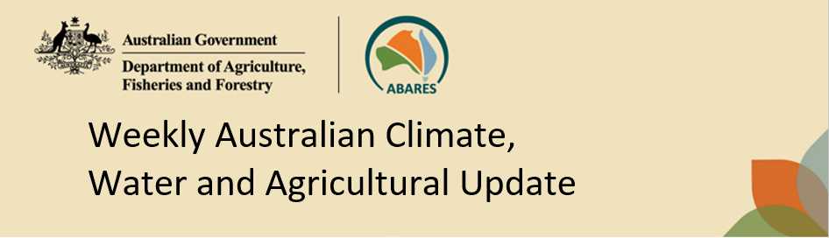
No. 37/2026 24 September 2026

Summary of key issues
- In the week ending 23 September 2026, little to no rainfall was recorded across much of Australia. Scattered rainfall was recorded across parts of the east, south and west of Australia.
- Across cropping regions, rainfall was largely confined to Western Australia, with most south-eastern and eastern cropping regions remaining mostly dry.
  - In Western Australia, rainfall of 1–5 millimetres was recorded across most southern and eastern cropping regions, while little to no rainfall was recorded across other cropping regions.
- Over the 8 days to 1 October 2026, rainfall is expected across large parts of southern Australia. Rainfall is also forecast for coastal Queensland and eastern New South Wales, while much of central Australia is expected to remain largely dry.
  - Most cropping regions in Western Australia, South Australia, Victoria and eastern New South Wales are forecast to receive 5–25 millimetres, with higher totals of up to 50 millimetres possible in southern Western Australian cropping regions. If realised, these falls are likely to provide useful late-season moisture for winter crops and support pasture growth across southern cropping regions, where soil moisture conditions are adequate.
  - Cropping regions in Queensland and western New South Wales are forecast to receive little to no rainfall.
- The Bureau of Meteorology indicates that El Niño continues to strengthen in the tropical Pacific. Despite the strengthen El Niño, the October to December 2026 outlook indicates below average rainfall is likely be restricted to parts of south-eastern Australia and far northern Queensland, while above average rainfall is more likely across much of western and central Australia, including parts of inland and southern Queensland and northern New South Wales.
  - If forecast October to December rainfall totals are realised, they are likely to support at least average pasture growth and maintain winter crop yield potential in areas with average or better soil moisture. In Queensland and north-eastern New South Wales, forecast rainfall may assist summer crop planting opportunities but is likely to arrive too late to materially improve below average winter crop production outcomes.
- Water storage levels in the Murray-Darling Basin increased by 20 gigalitres between 17 September 2026 and 24 September 2026. The current volume of water held in storages is 15,079 gigalitres, equivalent to 68% of total storage capacity. This is 4% or 581 gigalitres less than the same time last year.
- Allocation prices in the Victorian Murray below the Barmah Choke increased from $337 per megalitre on 17 September 2026 to $350 per megalitre on 24 September 2026. Trade from the Goulburn to the Murray is closed, trade downstream through the Barmah Choke is closed, and trade from the Murrumbidgee to the Murray is open.

Climate

Rainfall this week
In the week ending 23 September 2026, little to no rainfall was recorded across much of Australia. Light and scattered rainfall was recorded across parts of eastern Queensland, western Tasmania, south-western Western Australia and isolated coastal areas of south-eastern Australia.
- Falls of 1-10 millimetres were recorded across parts of southern and western Australia, with isolated totals of 15-25 millimetres in south-western Western Australia, parts of western Tasmania and scattered coastal areas.
- Higher totals of 25-50 millimetres were recorded in western Tasmania and isolated areas of eastern Queensland.
In cropping regions, rainfall was largely confined to Western Australia, with most south-eastern and eastern cropping regions remaining mostly dry.
- In Western Australia, rainfall of 1-5 millimetres was recorded across most southern and eastern cropping regions.
- However, little to no rainfall was recorded across most cropping regions in New South Wales, Victoria, Queensland, South Australia and northern Western Australia.

Rainfall for the week ending 23 September 2026
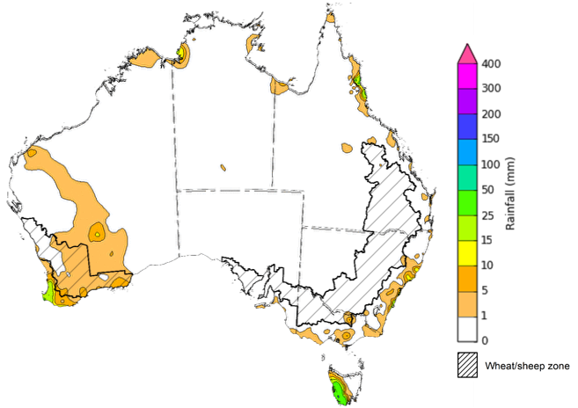
©Commonwealth of Australia 2026, Australian Bureau of Meteorology Issued: 23/09/2026
Note: The rainfall analyses and associated maps utilise data contained in the Bureau of Meteorology climate database, the Australian Data Archive for Meteorology (ADAM). The analyses are initially produced automatically from real-time data with limited quality control. They are intended to provide a general overview of rainfall across Australia as quickly as possible after the observations are received. For further information go to http://www.bom.gov.au/climate/rainfall/

Rainfall forecast for the next eight days
Over the 8 days to 1 October 2026, rainfall is expected across large parts of southern Australia. Rainfall is also forecast for coastal Queensland and eastern New South Wales, while much of central Australia is expected to remain largely dry.
- Falls of between 5–50 millimetres are forecast across much of southern Australia, including southern Western Australia, southern and western South Australia, Victoria, Tasmania, and eastern New South Wales and coastal Queensland. Higher falls of 50–100 millimetres are forecast for parts of the far south of Western Australia and isolated areas of north-eastern Queensland.
- Much of central Australia, including inland parts of the Northern Territory, South Australia, Queensland and New South Wales, is expected to see little to no rainfall.
Rainfall is expected across most cropping regions, particularly in Western Australia, southern South Australia, Victoria, and eastern New South Wales.
- Most cropping regions in Western Australia, South Australia, Victoria and eastern New South Wales are forecast to receive 5–25 millimetres, with higher totals up to 50 millimetres possible in southern Western Australian region.
  - If realised, these falls are likely to provide useful late-season moisture for winter crops and support pasture growth across southern cropping regions, where soil moisture conditions are adequate.
- Cropping regions in Queensland and western New South Wales are forecast to receive little to no rainfall

Total forecast rainfall for the period 24 September to 1 October 2026
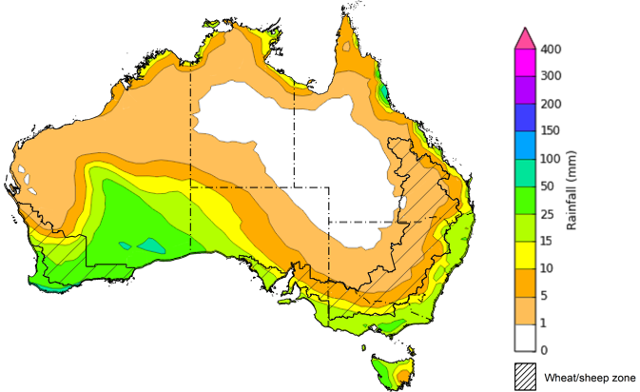

©Commonwealth of Australia 2026, Australian Bureau of Meteorology Issued: 24/09/2026
Note: This rainfall forecast is produced from computer models. As the model outputs are not altered by weather forecasters, it is important to check local forecasts and warnings issued by the Bureau of Meteorology.

National Climate Outlook
The Bureau of Meteorology indicates that El Niño continues to strengthen in the tropical Pacific. El Niño typically increases the chance of drier conditions across parts of eastern Australia during spring, although rainfall outcomes vary depending on the strength and interaction of other climate influences. The Indian Ocean Dipole (IOD) is currently neutral, while the Southern Annular Mode (SAM) is also neutral. As a result, neither the IOD nor SAM is currently providing a strong additional influence on Australian rainfall patterns. Sea surface temperatures are forecast to remain warmer than average across much of the globe during October to December, including notably warm waters near south-eastern Australia, increasing the risk of marine heatwave conditions.
The rainfall outlook for October 2026 indicates that below median rainfall is more likely across parts of south-eastern and south-western Australia, and far northern Queensland. Above median rainfall is more likely across much of western Australia and parts of the west of the Northern Territory and South Australia.
The Bureau of Meteorology’s climate model indicates a 75% chance of October rainfall totals between 5–50 millimetres across large areas of southern and eastern Australia, with higher totals possible across western Tasmania and alpine regions of Victoria. Much of central and northern Australia is likely to receive little to no rainfall.
Across most winter and summer cropping regions, there is a 75% chance of receiving rainfall totals of between 5–25 millimetres during October 2026. If realised, these relatively low expected rainfall totals are unlikely to materially improve winter crop production prospects or early summer crop planting conditions in drier parts of Queensland and northern New South Wales. In southern Australia, where soil moisture conditions are generally more favourable, forecast rainfall is likely to provide sufficient moisture to support winter crop development and pasture growth where crops and pastures remain responsive.

Rainfall totals that have a 75% chance of occurring in October 2026

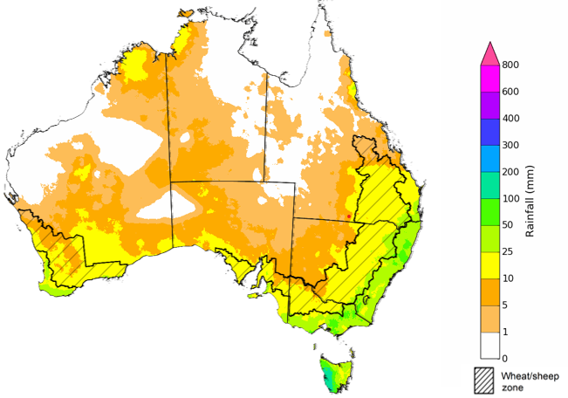
©Commonwealth of Australia 2026, Australian Bureau of Meteorology Issued: 17/9/2026
The rainfall outlook for October 2026 to December 2026 indicates that below average rainfall is likely across parts of south-eastern Australia and far northern Queensland. Above average rainfall is more likely across much of western and central Australia, including parts of inland and southern Queensland and northern New South Wales. Temperatures are very likely to be above average across most of the country for this time of year.
During the October 2026 to December 2026 period, the chance of receiving above median rainfall is highest across Western Australian and western South Australian cropping regions. Most cropping regions in South Australia, southern Queensland and northern New South Wales have a slightly elevated chances of above median rainfall. Meanwhile, cropping regions in Victoria, southern New South Wales and northern Queensland have a close to equal chance of above median or below median rainfall.

Chance of exceeding the median rainfall October 2026 to December 2026

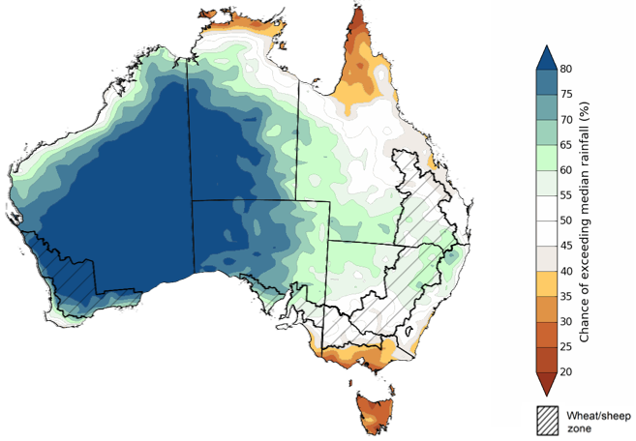
©Commonwealth of Australia 2026, Australian Bureau of Meteorology Issued: 17/9/2026

The rainfall outlook for October 2026 to December 2026 suggests a 75% chance of receiving rainfall totals of between 50–300 millimetres across much of eastern and northern Australia. Higher falls above 300 millimetres are possible across western Tasmania, alpine regions of Victoria, parts of the tropical north and isolated areas of eastern Australia. Lower rainfall totals are forecast for central and north-western regions, including parts of Western Australia, South Australia, south-western Queensland and western parts of New South Wales and Victoria.
In cropping regions, there is a 75% chance of receiving between 100–200 millimetres across much of Queensland and eastern New South Wales. Southern cropping regions, including Western Australia, South Australia, Victoria and southern New South Wales, are more likely to receive lower totals of 25–100 millimetres.
If these forecast October to December rainfall totals are realised, they are likely to support at least average pasture growth and maintain winter crop yield potential in areas with average or better soil moisture. In Queensland and north-eastern New South Wales, forecast rainfall may assist summer crop planting opportunities but are likely to arrive too late to materially improve below average winter crop production outcomes.

Rainfall totals that have a 75% chance of occurring October 2026 to December 2026

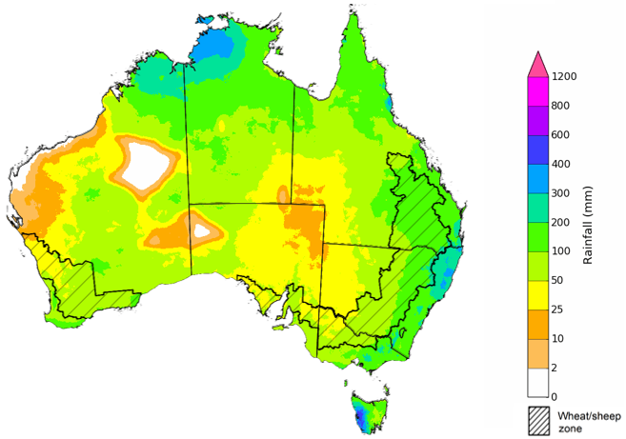
©Commonwealth of Australia 2026, Australian Bureau of Meteorology Issued: 17/9/2026

Water markets – current week
Water storage levels in the Murray-Darling Basin (MDB) increased by 20 gigalitres (GL) between 17 September 2026 and 24 September 2026. The current volume of water held in storages is 15,079 GL, equivalent to 68% of total storage capacity. This is 4% or 581 GL less than the same time last year. Water storage data is sourced from the Bureau of Meteorology.

Weekly water storage levels in the Murray-Darling Basin, 2013–2026
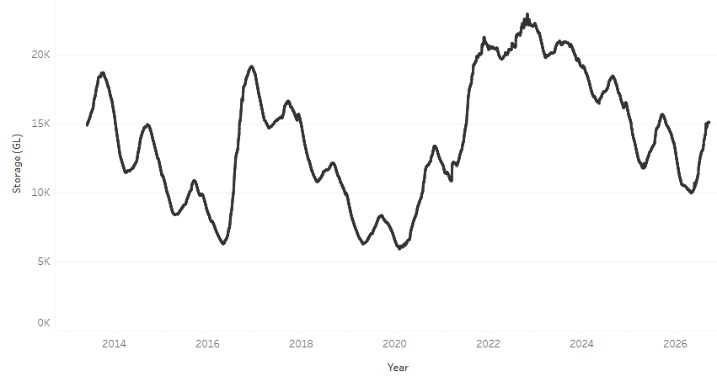
Allocation prices in the Victorian Murray below the Barmah Choke decreased from $337/ML on 17 September 2026 to $350/ML on 24 September 2026. Trade from the Goulburn to the Murray is closed. Trade downstream through the Barmah Choke is closed. Trade from the Murrumbidgee to the Murray is open.

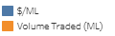
Monthly surface water trade activity 2022-2026, Victorian Murray below the Barmah Choke 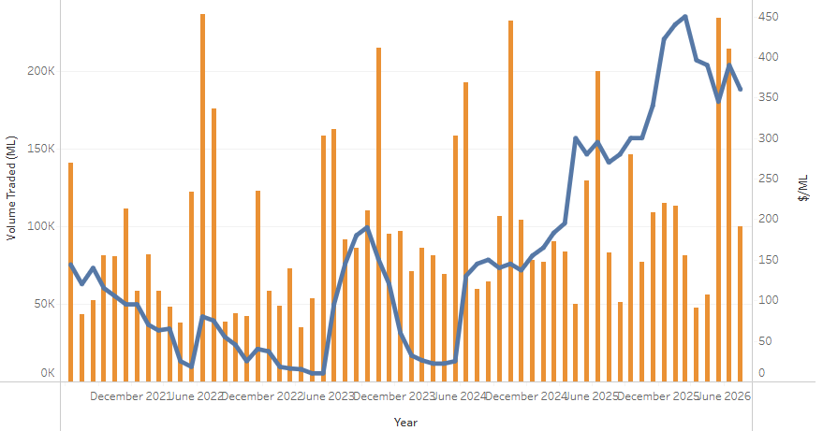

Weekly water market prices, Southern Murray–Darling Basin
Region | $/ML
NSW Murray Above | 216
NSW Murrumbidgee | 290
Vic Greater Goulburn | 349
Vic Murray Below | 350
Note: The water allocation prices shown are volume weighted average prices based on the last 10 trades. Price data is sourced from Waterflow and current as at 6 August 2026.
To access the full, interactive, weekly water dashboard, which contains the latest and historical water storage, water market and water allocation information, please visit https://www.agriculture.gov.au/abares/products/weekly_update/weekly-update-260924

Commodities
Indicator | Week average | Unit | Latest Price | Previous Week | Weekly change |  | Price 12 months ago | Annual change
Selected world indicator prices
AUD/USD Exchange rate | 23-Sep | A$/US$ | 0.71 | 0.71 | 0% | 0.66 |  | 8%
Wheat – US no. 2 hard red winter wheat, FOB Gulf | 23-Sep | US$/t | 346 | 348 | -1% | 234 |  | 48%
Corn – US no. 2 yellow corn, FOB Gulf | 23-Sep | US$/t | 240 | 238 | 1% | 196 |  | 22%
Canola – Rapeseed, Canada, FOB Vancouver | 23-Sep | US$/t | 627 | 629 | 0% | 483 |  | 30%
Cotton – Cotlook A Index | 23-Sep | USc/lb | 94.7 | 94.0 | 1% | 78.0 |  | 21%
Sugar – Intercontinental Exchange, nearby futures, no.11 contract | 23-Sep | USc/lb | 18.5 | 18.5 | 0% | 16.4 |  | 13%
Wool – Eastern Market Indicator | 23-Sep | Ac/kg clean | 1,845 | 1,857 | -1% | 1,352 |  | 36%
Wool – Western Market Indicator | 23-Sep | Ac/kg clean | 2,033 | 2,039 | 0% | 1,529 |  | 33%
Selected Australian grain export prices
Australian Premium White (APW) Wheat, FOB Port Adelaide, SA | 23-Sep | A$/t | 431 | 427 | 1% | 372 |  | 16%
Australian Standard White (ASW) Wheat, FOB Port Adelaide, SA | 23-Sep | A$/t | 422 | 418 | 1% | 367 |  | 15%
Feed Barley – FOB Port Adelaide, SA | 23-Sep | A$/t | 369 | 370 | 0% | 354 |  | 4%
Canola – FOB Kwinana, WA | 23-Sep | A$/t | 806 | 801 | 1% | 789 |  | 2%
Grain Sorghum – FOB Brisbane, QLD | 23-Sep | A$/t | 440 | 443 | -1% | 411 |  | 7%
Selected domestic livestock indicator prices
Beef – Eastern Young Cattle Indicator | 23-Sep | Ac/kg cwt | 942 | 976 | -3% | 895 |  | 5%
Mutton – Mutton indicator (18–24 kg fat score 2–3), VIC | 23-Sep | Ac/kg cwt | 832 | 863 | -4% | 741 |  | 12%
Lamb – National Trade Lamb Indicator | 23-Sep | Ac/kg cwt | 1,116 | 1,157 | -3% | 1,176 |  | -5%
Pig – Eastern Seaboard (60.1–75 kg), NSW buyer price | 9-Sep | Ac/kg cwt | 367 | 369 | -1% | 461 |  | -20%
Live cattle – Light steers to Indonesia | 9-Sep | Ac/kg lwt | 450 | 440 | 2% | 369 |  | 22%
Global Dairy Trade (GDT) weighted average prices
Dairy – Whole milk powder | 16-Sep | US$/t | 3,565 | 3,585 | -1% | 3,800 |  | -6%
Dairy – Skim milk powder | 16-Sep | US$/t | 3,689 | 3,695 | 0% | 2,618 |  | 41%
Dairy – Cheddar cheese | 16-Sep | US$/t | 4,075 | 3,503 | 16% | 4,762 |  | -14%
Dairy – Anhydrous milk fat | 16-Sep | US$/t | 5,739 | 5,917 | -3% | 6,860 |  | -16%

Selected world indicator prices
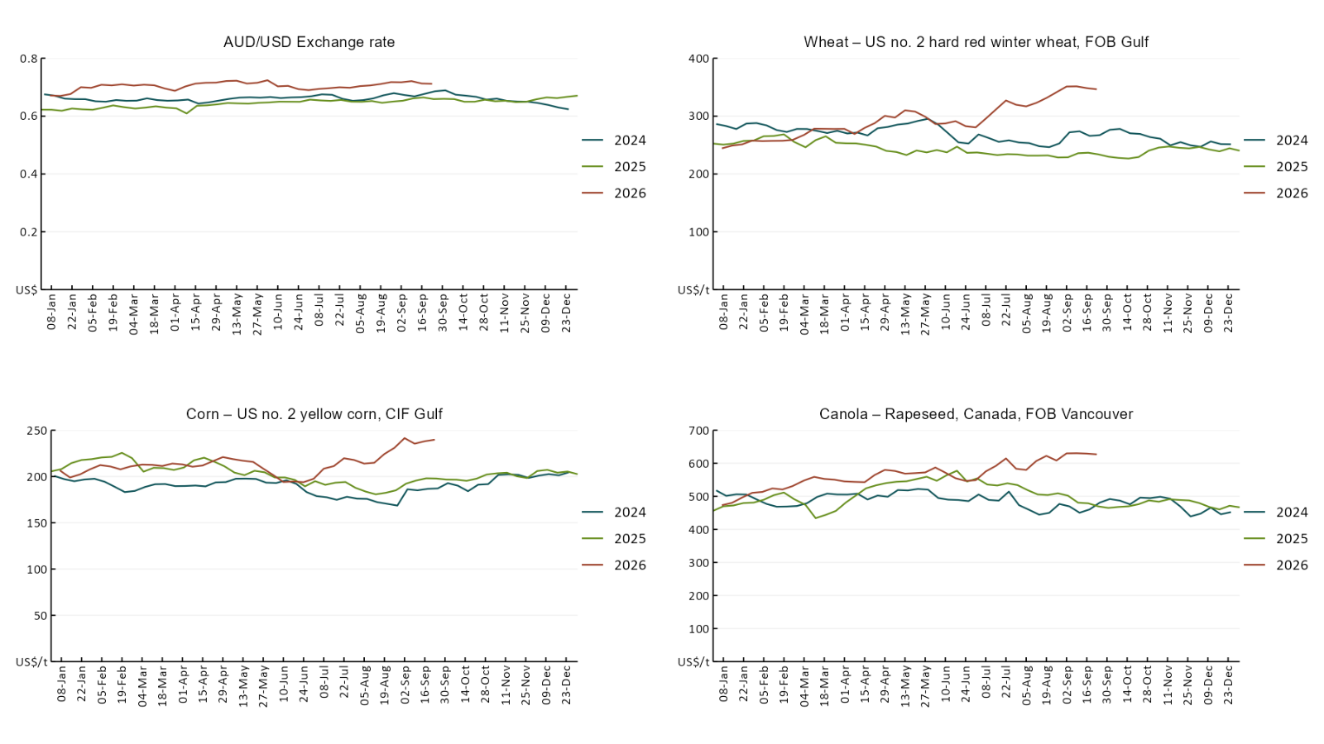

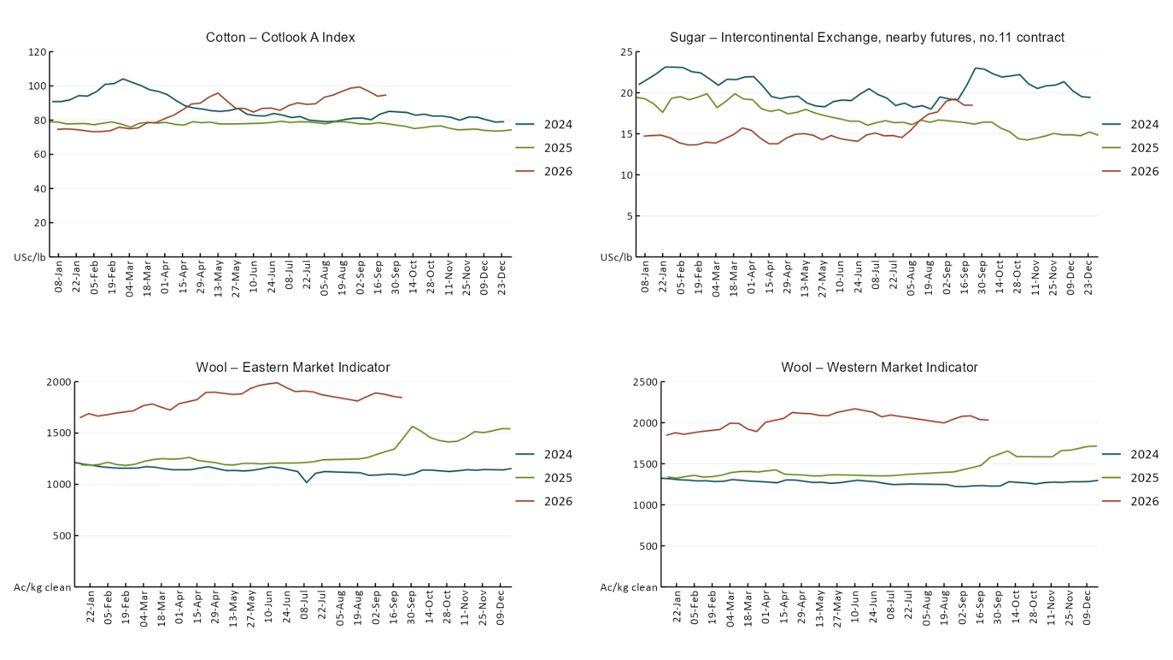

3.2 Selected domestic crop indicator prices
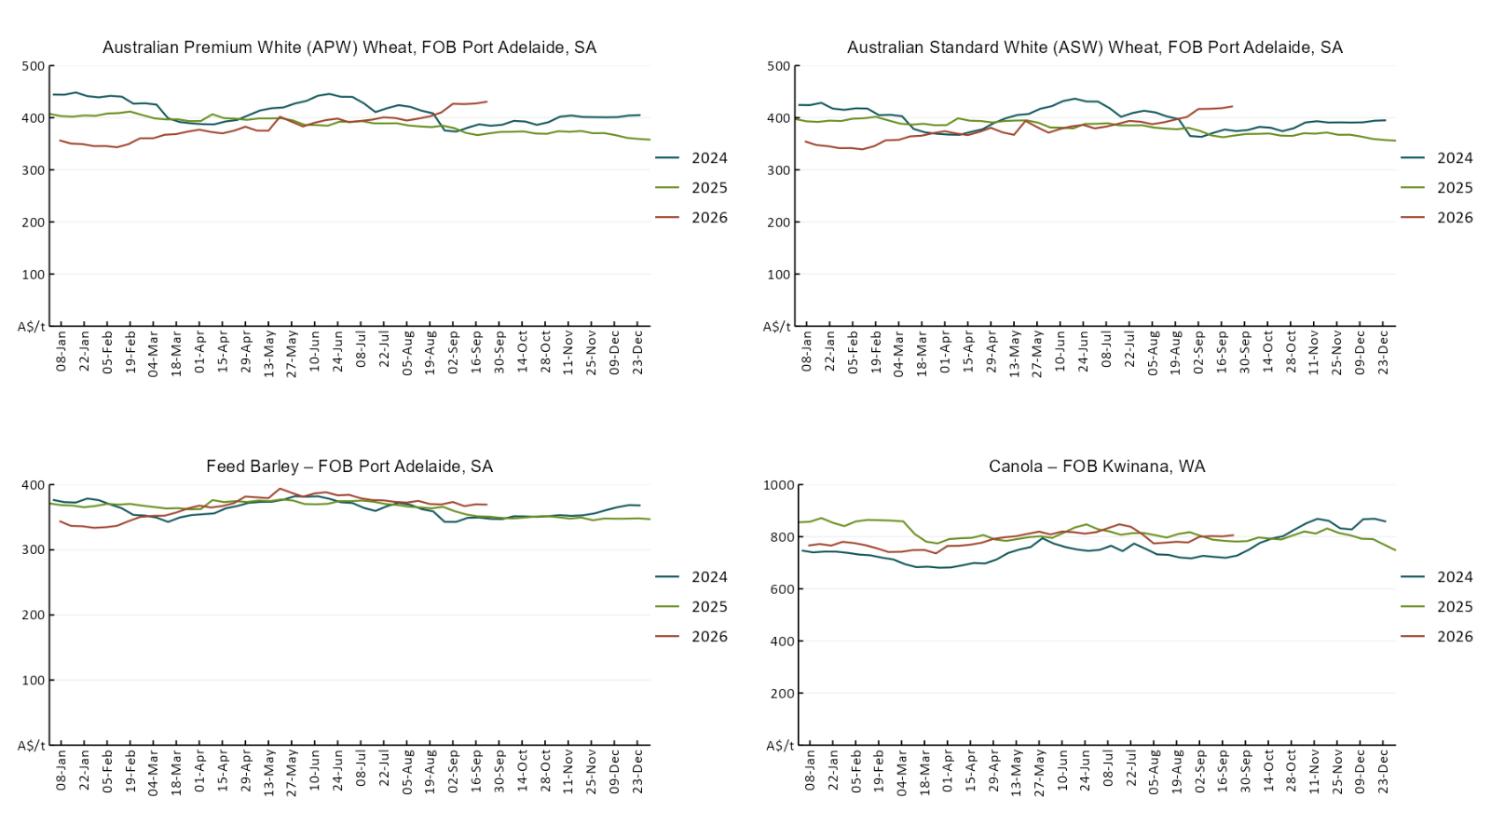

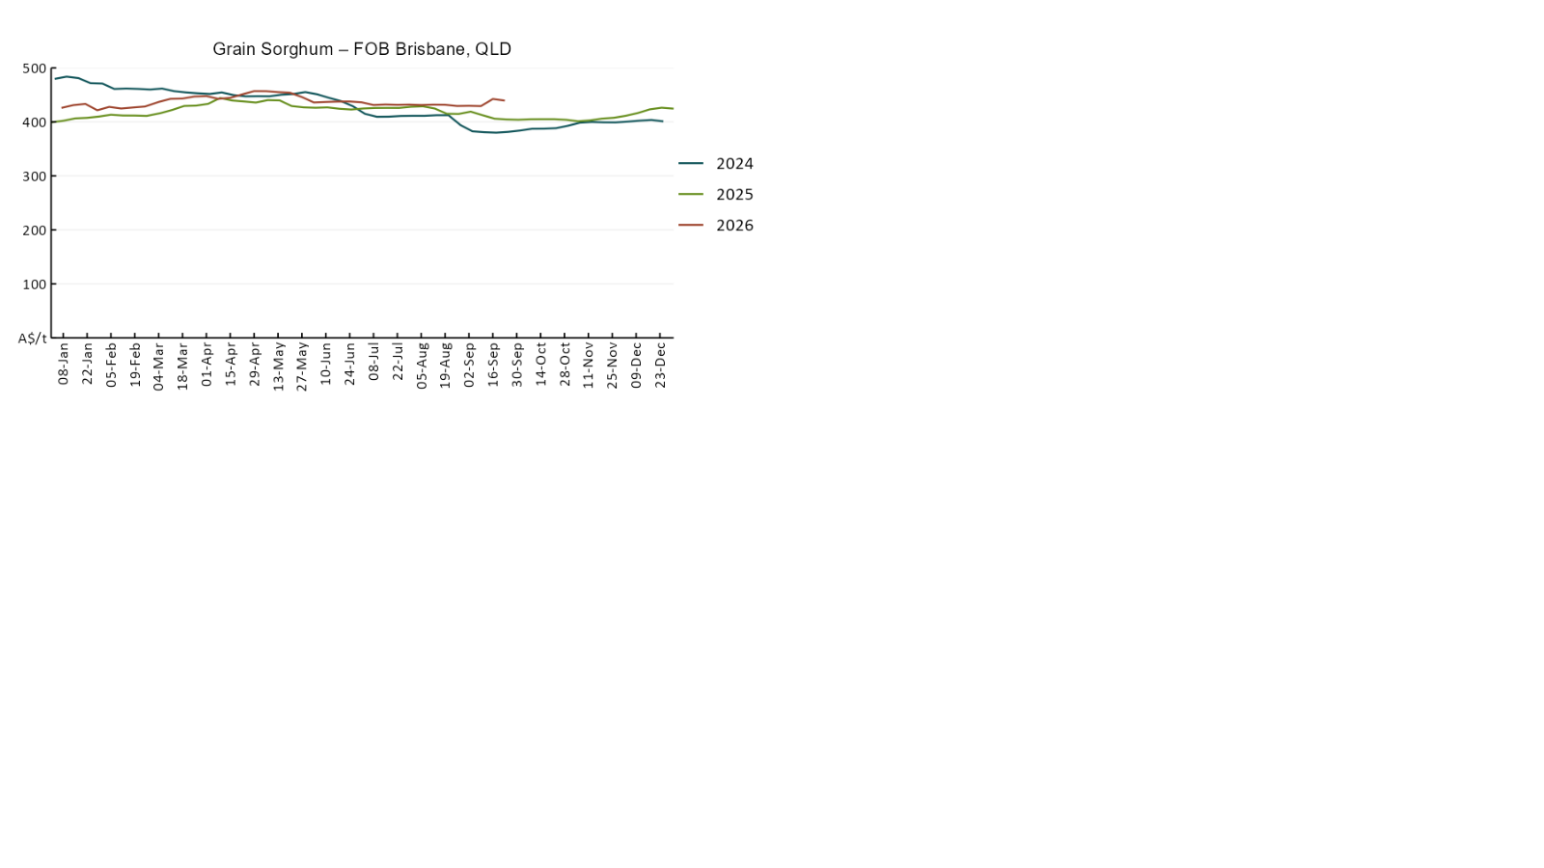

3.3 Selected domestic livestock indicator prices
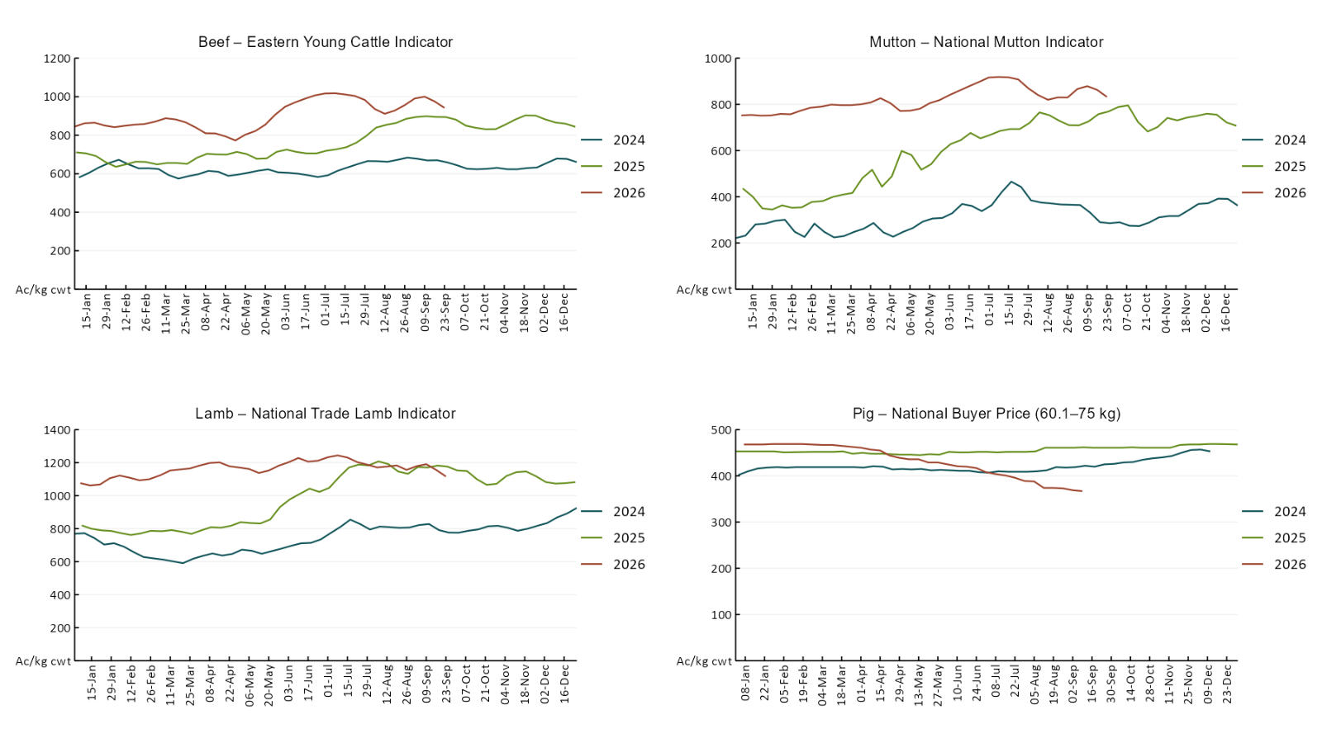

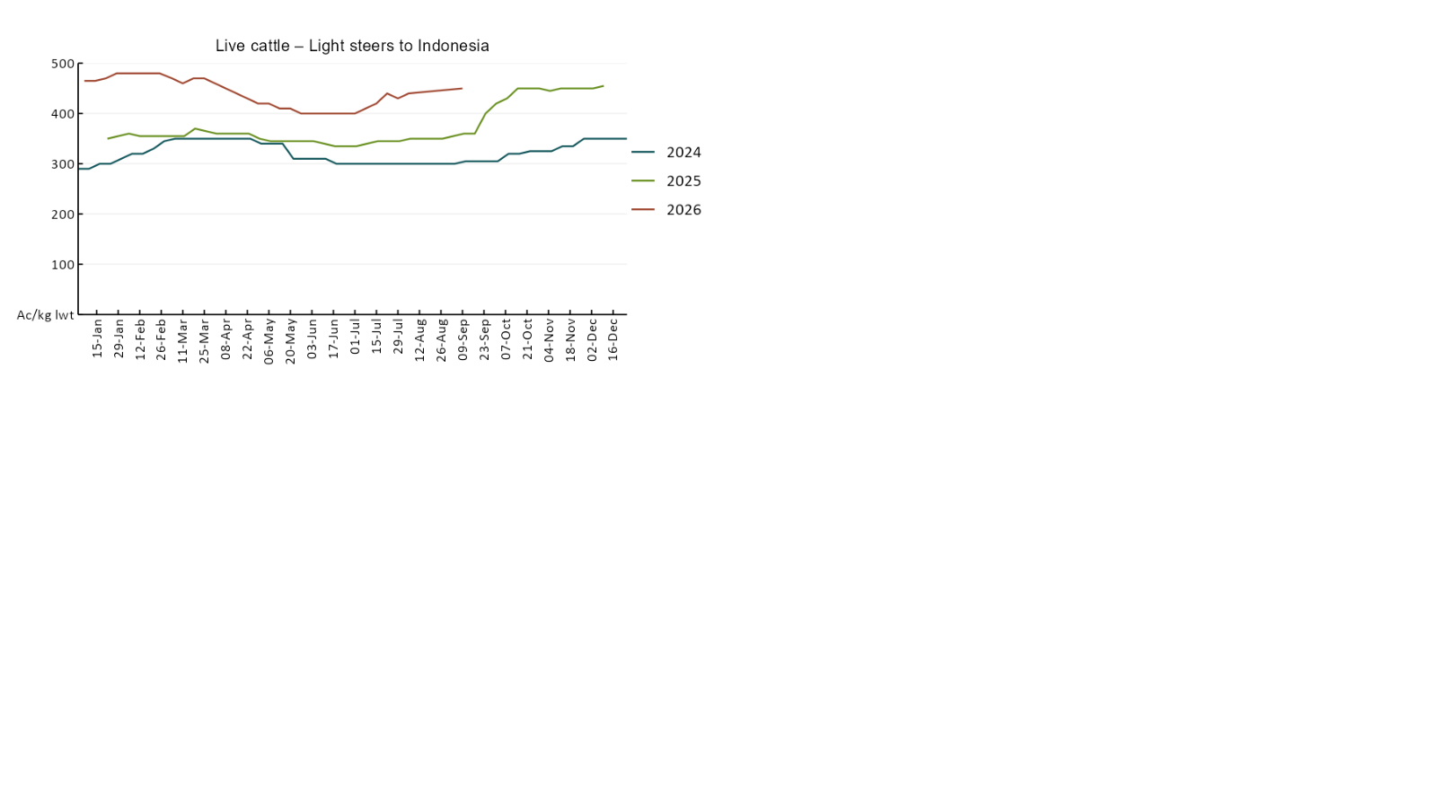

3.4 Global Dairy Trade (GDT) weighted average prices
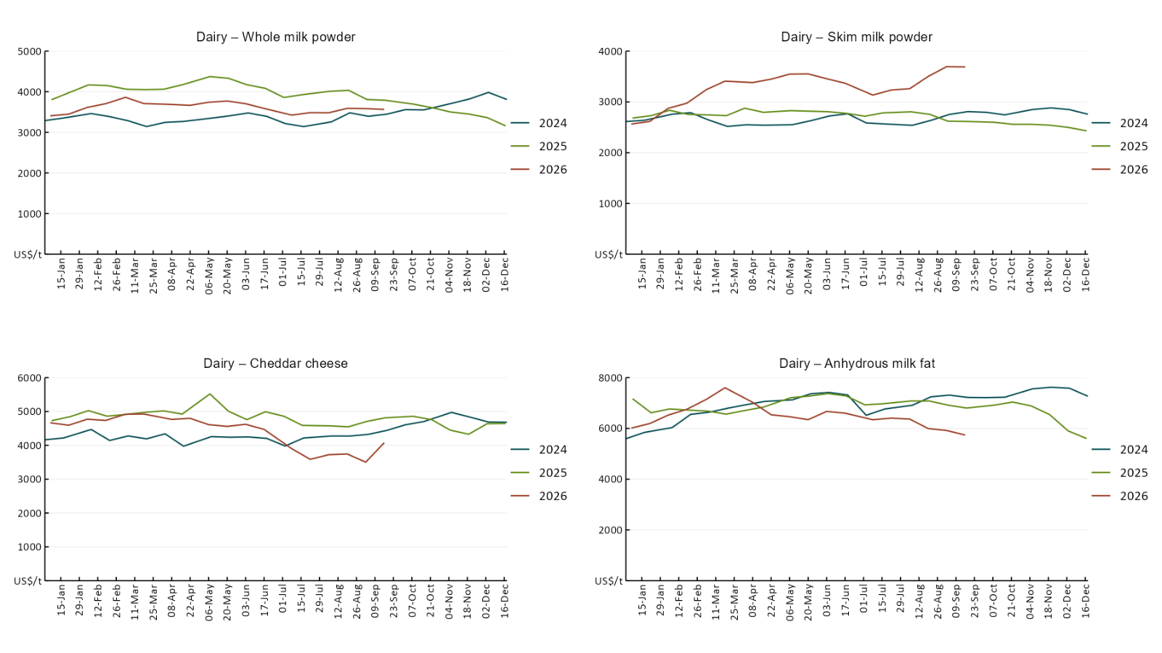

3.5 Selected fruit and vegetable prices
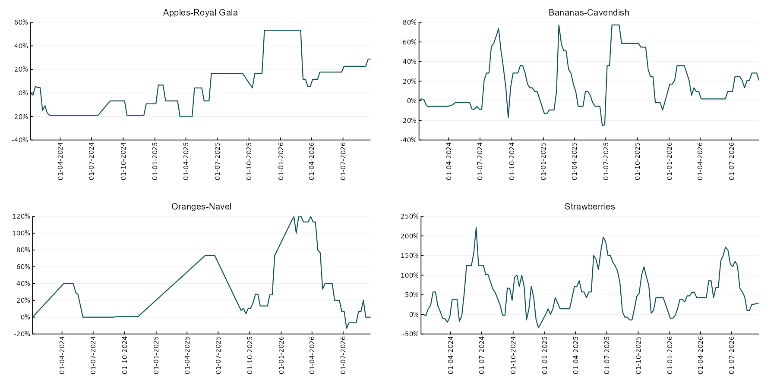

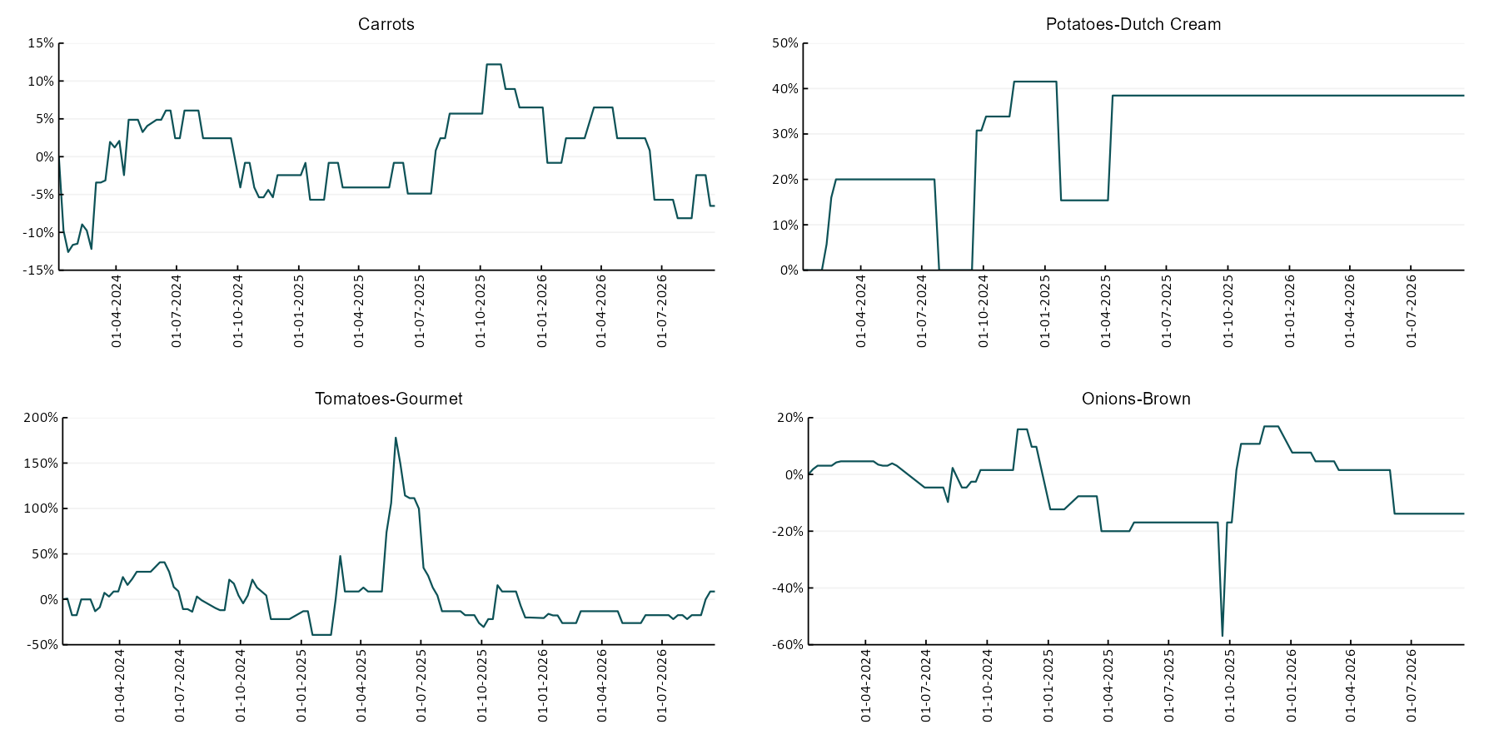

3.6 Selected domestic fodder indicator prices
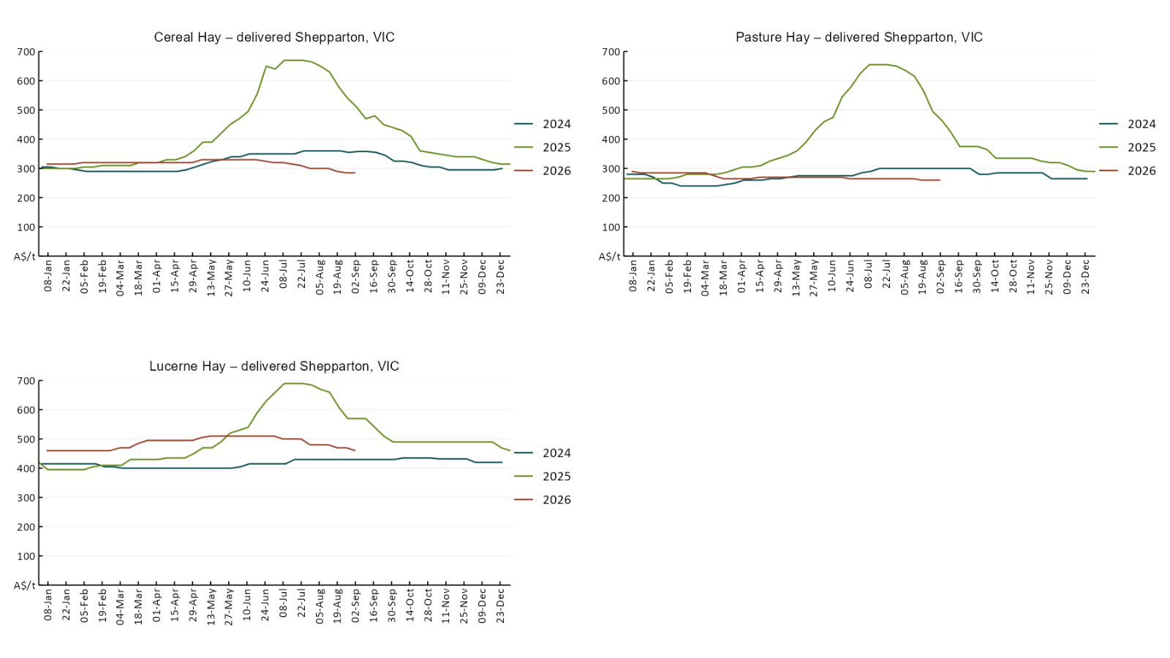

4. Data attribution

Climate
Bureau of Meteorology
- Weekly rainfall totals: www.bom.gov.au/climate/maps/rainfall/
- Monthly and last 3-month rainfall percentiles: https://www.bom.gov.au/climate/ahead/outlooks/#moreMaps
- Rainfall forecast: www.bom.gov.au/jsp/watl/rainfall/pme.jsp
- Seasonal outlook: www.bom.gov.au/climate/outlooks/#/overview/summary/
- Climate drivers: http://www.bom.gov.au/climate/enso/
- Soil moisture: https://awo.bom.gov.au/products/historical/soilMoisture-rootZone/

Other
- Pasture growth: www.longpaddock.qld.gov.au/aussiegrass/
- 3-month global outlooks: Environment and Climate Change Canada, NOAA Climate Prediction Center, EUROBRISA CPTEC/INPE, European Centre for Medium-Range Weather Forecasts, Hydrometcenter of Russia, National Climate Center Climate System Diagnosis and Prediction Room (NCC), International Research Institute for Climate and Society
- Global production: https://ipad.fas.usda.gov/ogamaps/cropmapsandcalendars.aspx
- Autumn break: Pook et al., 2009, https://rmets-onlinelibrary-wiley-com.virtual.anu.edu.au/doi/epdf/10.1002/joc.1833

Water
Prices
- Waterflow: https://www.waterflow.io/
- Ruralco: https://www.ruralcowater.com.au/
- Bureau of Meteorology:
- Allocation trade: http://www.bom.gov.au/water/dashboards/#/water-markets/mdb/at
- Storage volumes: http://www.bom.gov.au/water/dashboards/#/water-storages/summary/drainage

Trade constraints:
- Water NSW: https://www.waternsw.com.au/customer-service/ordering-trading-and-pricing/trading/murrumbidgee
- Victorian Water Register: https://www.waterregister.vic.gov.au/TradingRules2019/

Commodities
Fruit and vegetables
- Datafresh: www.freshstate.com.au

Pigs
- Australian Pork Limited: www.australianpork.com.au

Dairy
- Global Dairy Trade: www.globaldairytrade.info/en/product-results/

World wheat, canola
- International Grains Council
- https://www.igc.int/en/default.aspx
- United States Department of Agriculture

World cotton
- Cotlook: www.cotlook.com/

World sugar
- New York Stock Exchange - Intercontinental Exchange

Wool
- Australian Wool Exchange: www.awex.com.au/

Domestic wheat, barley, sorghum, canola and fodder
- Jumbuk Consulting Pty Ltd: Jumbuk AG | Agriculture Consulting

Cattle, beef, mutton, lamb, goat and live export
- Meat and Livestock Australia: https://www.mla.com.au/prices-markets/

Australian Agricultural Drought Indicators
About Australian Agricultural Drought Indicators
The Australian Agricultural Drought Indicators (AADI) links weather and agricultural data with a range of scientific and economic models to measure and forecast the effects of climate variability and drought on agricultural outcomes.
On AADI, projected broadacre farm profits are presented as percentile outcomes relative to simulated historical outcomes using the groupings:
Highest | 95-100th percentile
Very much above average | 85-95th percentile
Above average | 65-85th percentile
Average | 35-65th percentile
Below average | 15-35th percentile
Very much below average | 5-15th percentile
Lowest 5% | 0-5th percentile

There are two AADI farm profit indicators:
- The AADI farm profit climate and price indicator shows the effect of climate and prices on broadacre farm business profits of current farms compared to the last 33 years.
- The AADI farm profit climate only indicator isolates the effect of climate on profits by holding prices fixed.

© Commonwealth of Australia 2026

Ownership of intellectual property rights
Unless otherwise noted, copyright (and any other intellectual property rights, if any) in this publication is owned by the Commonwealth of Australia (referred to as the Commonwealth).

Creative Commons licence
All material in this publication is licensed under a Creative Commons Attribution 4.0 International Licence except content supplied by third parties, logos and the Commonwealth Coat of Arms.
Inquiries about the licence and any use of this document should be emailed to copyright@awe.gov.au.


Cataloguing data
This publication (and any material sourced from it) should be attributed as:
ABARES 2026, Weekly Australian Climate, Water and Agricultural Update, Australian Bureau of Agricultural and Resource Economics and Sciences, Canberra, 24 September 2026. CC BY 4.0 DOI: https://doi.org/10.25814/5f3e04e7d2503
ISSN 2652-7561
This publication is available at https://www.agriculture.gov.au/abares/products/weekly_update
Department of Agriculture, Fisheries and Forestry
GPO Box 858 Canberra ACT 2601
Telephone 1800 900 090
Web agriculture.gov.au/abares

Disclaimer
The Australian Government acting through the Department of Agriculture, Fisheries and Forestry, represented by the Australian Bureau of Agricultural and Resource Economics and Sciences, has exercised due care and skill in preparing and compiling the information and data in this publication. Notwithstanding, the Department of Agriculture, Fisheries and Forestry, ABARES, its employees and advisers disclaim all liability, including liability for negligence and for any loss, damage, injury, expense or cost incurred by any person as a result of accessing, using or relying on any of the information or data in this publication to the maximum extent permitted by law.

Statement of Professional Independence
The views and analysis presented in ABARES publications, including this one, reflect ABARES professionally independent findings, based on scientific and economic concepts, principles, information and data. These views, analysis and findings may not reflect or be consistent with the views or positions of the Australian Government, or of organisations or groups who have commissioned ABARES reports or analysis. More information on professional independence is provided on the ABARES website.

Acknowledgements
This report was prepared by Matthew Miller.

