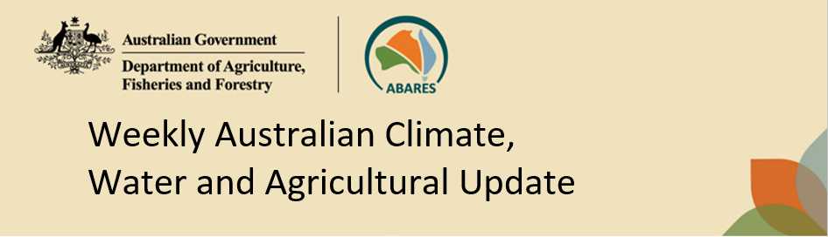
No. 38/2026 1 October 2026

Summary of key issues
- In the week ending 30 September 2026, rainfall was concentrated across western and scattered areas of the northern and eastern seaboards, while much of the remainder of Australia remained largely dry.
- Across cropping regions rainfall was again generally restricted to the west. In Western Australia, most areas recorded falls of between 5-25 millimetres, with falls of 25-50 millimetres and isolated totals above 50 millimetres recorded across in parts of the south.
  - These falls are expected to support winter crop development and pasture growth, particularly where higher totals were recorded.
- Over the 8 days to 8 October 2026, rainfall is forecast across large areas of southern, central and eastern Australia, with the highest totals expected in Victoria and parts of south-eastern New South Wales.
  - Cropping regions in Victoria, South Australia and central and southern New South Wales are forecast to receive 10-50 millimetres, with higher rainfall totals in southern areas. If realised, these falls are likely to provide a timely boost to soil moisture levels, support winter crop grain fill and maintain favourable pasture growth.
  - Remaining cropping regions, including Western Australia, northern New South Wales and Queensland, are generally forecast to receive only 1–10 millimetres.
- Rainfall during September 2026 was above average across much of Western Australia and parts of northern Australia, but below average across large areas of eastern and southern Australia as well as the parts of the far southwest.
  - The particularly low rainfall across the southeast has likely led to a drawdown of stored soil moisture levels to maintain forecast above average winter crop yields and above average pasture growth rates. Meanwhile, above average falls across parts of southern Western Australia would have provided a timely boost to soil moisture levels, support winter crop grain fill and maintain favourable pasture growth.
- Water storage levels in the Murray-Darling Basin (MDB) decreased by 88 gigalitres (GL) between 24 September 2026 and 1 October 2026. The current volume of water held in storages is 14,991 GL, equivalent to 67% of total storage capacity. This is 4% or 589 GL less than the same time last year. Water storage data is sourced from the Bureau of Meteorology.
- Allocation prices in the Victorian Murray below the Barmah Choke increased from $350/ML on 24 September 2026 to $358/ML on 1 October 2026.

Climate

Rainfall this week
In the week ending 30 September 2026, rainfall was concentrated across western and scattered areas of the northern and eastern seaboards, while much of the remainder of Australia remained largely dry.
- The highest weekly totals were recorded in south-western Western Australia, where widespread falls of 5–50 millimetres and local totals of 50–150 millimetres were observed.
- Falls of 5–50 millimetres were also recorded across narrow bands of coastal northern and eastern Australia, and western Tasmania.
- In contrast, much of the remainder of Australia recorded little to no rainfall.
Across cropping regions, rainfall outcomes were mixed, with the most substantial falls confined to Western Australia.
- Western Australian cropping regions generally received 5–25 millimetres, with falls of 25– 50 millimetres and isolated totals above 50 millimetres recorded across parts of the south.
  - These falls are expected to support winter crop development and pasture growth, particularly where higher totals were recorded.
- Cropping regions in South Australia, Victoria, New South Wales and Queensland recorded little to no rainfall.

Rainfall for the week ending 30 September 2026
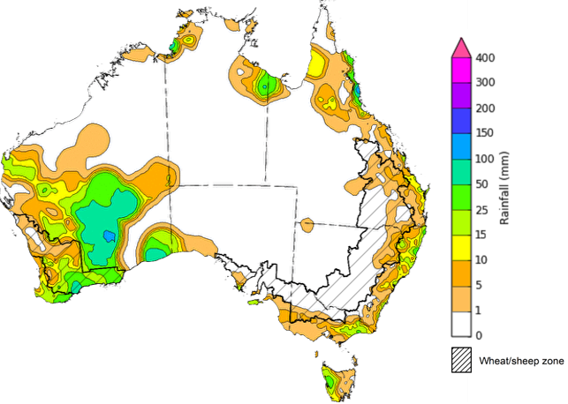
©Commonwealth of Australia 2026, Australian Bureau of Meteorology Issued: 30/09/2026
Note: The rainfall analyses and associated maps utilise data contained in the Bureau of Meteorology climate database, the Australian Data Archive for Meteorology (ADAM). The analyses are initially produced automatically from real-time data with limited quality control. They are intended to provide a general overview of rainfall across Australia as quickly as possible after the observations are received. For further information go to http://www.bom.gov.au/climate/rainfall/

Rainfall forecast for the next eight days
Over the 8 days from 1 to 8 October 2026, rainfall is forecast across large areas of southern, central and eastern Australia, with the highest totals expected in Victoria and parts of south-eastern New South Wales. Much of northern Australia is forecast to receive low rainfall or remain dry.
- Falls of 15-50 millimetres are forecast across much of Victoria and parts of south-eastern New South Wales, increasing to 50-100 millimetres in southern and eastern Victoria. Similar totals are forecast for isolated areas in the far southeast of New South Wales.
- Rainfall of 10-50 millimetres is forecast across parts of southern and north-western South Australia, north-eastern New South Wales, south-eastern Queensland, Tasmania, parts of the southern, central and northern Western Australia and the south and north of the Northern Territory.
Across cropping regions rainfall over the 8 days to 8 October 2026 is forecast to be highest in Victoria, South Australia and southern New South Wales, with lower totals expected across Western Australia and Queensland.
- Across the Victorian cropping regions, widespread falls of 15-50 millimetres are forecast. Southern and central New South Wales, and South Australian cropping regions are forecast to receive 10-50 millimetres.
  - If realised, these falls are likely to provide a timely boost to soil moisture levels, support winter crop grain fill and maintain favourable pasture growth.
- Cropping regions across northern New South Wales, Queensland and Western Australia are forecast to receive generally 1-10 millimetres.

Total forecast rainfall for the period 1 October to 8 October 2026
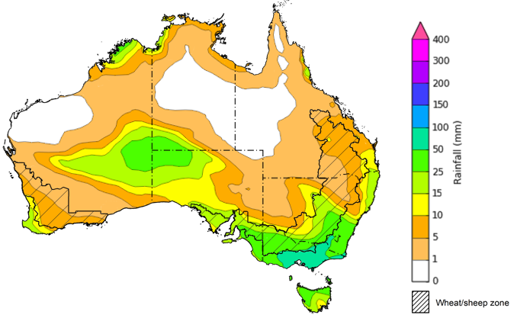
©Commonwealth of Australia 2026, Australian Bureau of Meteorology Issued: 1/10/2026
Note: This rainfall forecast is produced from computer models. As the model outputs are not altered by weather forecasters, it is important to check local forecasts and warnings issued by the Bureau of Meteorology.

Monthly rainfall
Rainfall during September 2026 was above average across much of Western Australia and parts of northern Australia, but below average across large areas of eastern and southern Australia as well as parts of the far southwest.
- Rainfall was very much above average to highest on record across parts of inland Western Australia, and above average across broader areas of western and northern Australia. In contrast, rainfall was very much below average to lowest on record across much of eastern and central New South Wales, south-eastern Queensland, southern Victoria and parts of southern South Australia and Tasmania.
Across cropping regions, September rainfall was generally very much below average, with the most pronounced deficiencies across eastern and south-eastern Australia, as well some north-western areas.
- Most cropping regions in New South Wales, Queensland, Victoria and South Australia generally recorded below average to very much below average rainfall. Across Western Australian cropping regions, rainfall was mostly below average to very much below average, although some south-eastern areas recorded average to very much above average rainfall.
  - These rainfall deficiencies have likely resulted in a drawdown of stored soil moisture levels to maintain forecast above average winter crop yields and above average pasture growth rates across much of the south-east. Meanwhile above average falls across parts of southern Western Australia would have provided a timely boost to soil moisture levels, support winter crop grain fill and maintain favourable pasture growth.
  - However, in areas where stored soil moisture was already limited, these conditions have likely led to substantial moisture stress at a critical period for winter crop development and may have further reduced winter crop yield particularly across northern New South Wales, Queensland and parts of Western Australia.
Rainfall deciles for September 2026
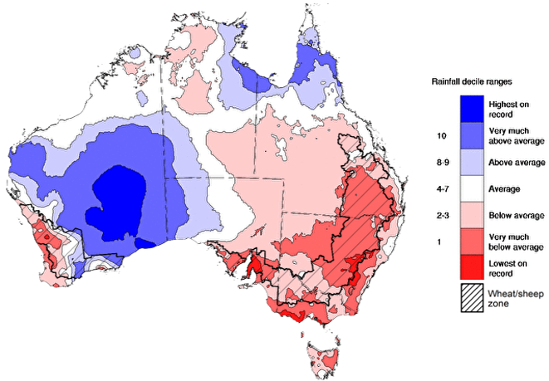
Note: Rainfall for September 2026 is compared with rainfall recorded for that period during the historical record (1900 to present). For further information, go to http://www.bom.gov.au/climate/austmaps/about-rain-maps.shtml
Source: Bureau of Meteorology

Water markets – current week
Water storage levels in the Murray-Darling Basin (MDB) decreased by 88 gigalitres (GL) between 24 September 2026 and 1 October 2026. The current volume of water held in storages is 14,991 GL, equivalent to 67% of total storage capacity. This is 4% or 589 GL less than the same time last year. Water storage data is sourced from the Bureau of Meteorology.

Weekly water storage levels in the Murray-Darling Basin, 2013–2026
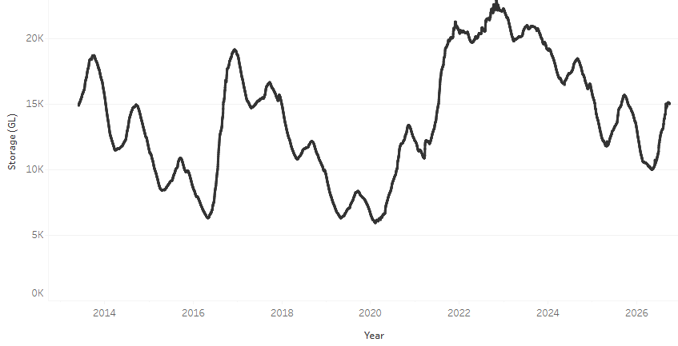
Allocation prices in the Victorian Murray below the Barmah Choke increased from $350/ML on 24 September 2026 to $358/ML on 1 October 2026. Trade from the Goulburn to the Murray is closed. Trade downstream through the Barmah Choke is closed. Trade from the Murrumbidgee to the Murray is open.

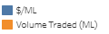
Monthly surface water trade activity 2022-2026, Victorian Murray below the Barmah Choke

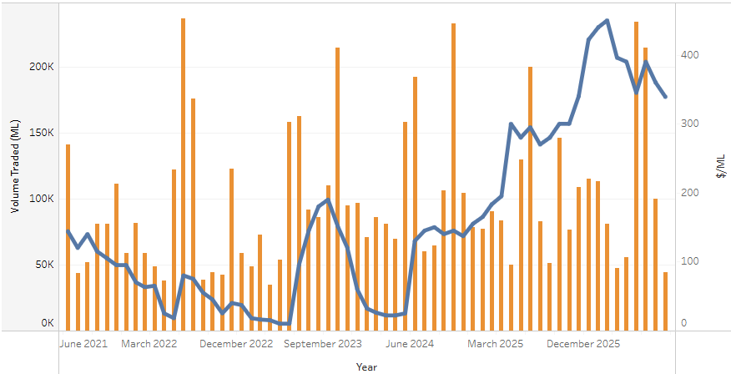

Weekly water market prices, Southern Murray–Darling Basin
Region | $/ML
NSW Murray Above | 205
NSW Murrumbidgee | 285
Vic Greater Goulburn | 336
Vic Murray Below | 358
Note: The water allocation prices shown are volume weighted average prices based on the last 10 trades. Price data is sourced from Waterflow and current as at 1 October 2026.
To access the full, interactive, weekly water dashboard, which contains the latest and historical water storage, water market and water allocation information, please visit https://www.agriculture.gov.au/abares/products/weekly_update/weekly-update-261001

Commodities
Indicator | Week average | Unit | Latest Price | Previous Week | Weekly change |  | Price 12 months ago | Annual change
Selected world indicator prices
AUD/USD Exchange rate | 30-Sep | A$/US$ | 0.70 | 0.71 | -1% | 0.66 |  | 6%
Wheat – US no. 2 hard red winter wheat, FOB Gulf | 30-Sep | US$/t | 334 | 343 | -3% | 234 |  | 43%
Corn – US no. 2 yellow corn, FOB Gulf | 30-Sep | US$/t | 226 | 237 | -4% | 196 |  | 16%
Canola – Rapeseed, Canada, FOB Vancouver | 30-Sep | US$/t | 612 | 625 | -2% | 483 |  | 27%
Cotton – Cotlook A Index | 30-Sep | USc/lb | 93.3 | 94.2 | -1% | 78.0 |  | 20%
Sugar – Intercontinental Exchange, nearby futures, no.11 contract | 30-Sep | USc/lb | 18.7 | 18.6 | 1% | 16.4 |  | 14%
Wool – Eastern Market Indicator | 30-Sep | Ac/kg clean | 1,819 | 1,845 | -1% | 1,352 |  | 35%
Wool – Western Market Indicator | 30-Sep | Ac/kg clean | 1,989 | 2,033 | -2% | 1,529 |  | 30%
Selected Australian grain export prices
Australian Premium White (APW) Wheat, FOB Port Adelaide, SA | 30-Sep | A$/t | 430 | 431 | 0% | 372 |  | 16%
Australian Standard White (ASW) Wheat, FOB Port Adelaide, SA | 30-Sep | A$/t | 421 | 422 | 0% | 367 |  | 15%
Feed Barley – FOB Port Adelaide, SA | 30-Sep | A$/t | 370 | 369 | 0% | 354 |  | 4%
Canola – FOB Kwinana, WA | 30-Sep | A$/t | 799 | 806 | -1% | 789 |  | 1%
Grain Sorghum – FOB Brisbane, QLD | 30-Sep | A$/t | 441 | 440 | 0% | 411 |  | 7%
Selected domestic livestock indicator prices
Beef – Eastern Young Cattle Indicator | 30-Sep | Ac/kg cwt | 914 | 935 | -2% | 895 |  | 2%
Mutton – Mutton indicator (18–24 kg fat score 2–3), VIC | 30-Sep | Ac/kg cwt | 810 | 827 | -2% | 741 |  | 9%
Lamb – National Trade Lamb Indicator | 30-Sep | Ac/kg cwt | 1,088 | 1,110 | -2% | 1,176 |  | -8%
Pig – Eastern Seaboard (60.1–75 kg), NSW buyer price | 16-Sep | Ac/kg cwt | 367 | 367 | 0% | 461 |  | -20%
Live cattle – Light steers to Indonesia | 9-Sep | Ac/kg lwt | 450 | 440 | 2% | 369 |  | 22%
Global Dairy Trade (GDT) weighted average prices
Dairy – Whole milk powder | 16-Sep | US$/t | 3,565 | 3,585 | -1% | 3,800 |  | -6%
Dairy – Skim milk powder | 16-Sep | US$/t | 3,689 | 3,695 | 0% | 2,618 |  | 41%
Dairy – Cheddar cheese | 16-Sep | US$/t | 4,075 | 3,503 | 16% | 4,762 |  | -14%
Dairy – Anhydrous milk fat | 16-Sep | US$/t | 5,739 | 5,917 | -3% | 6,860 |  | -16%

Selected world indicator prices
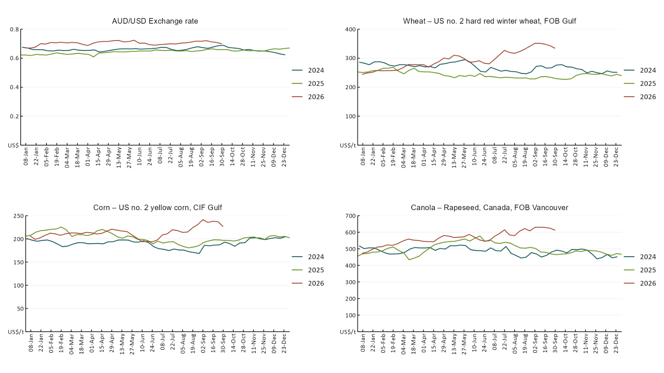

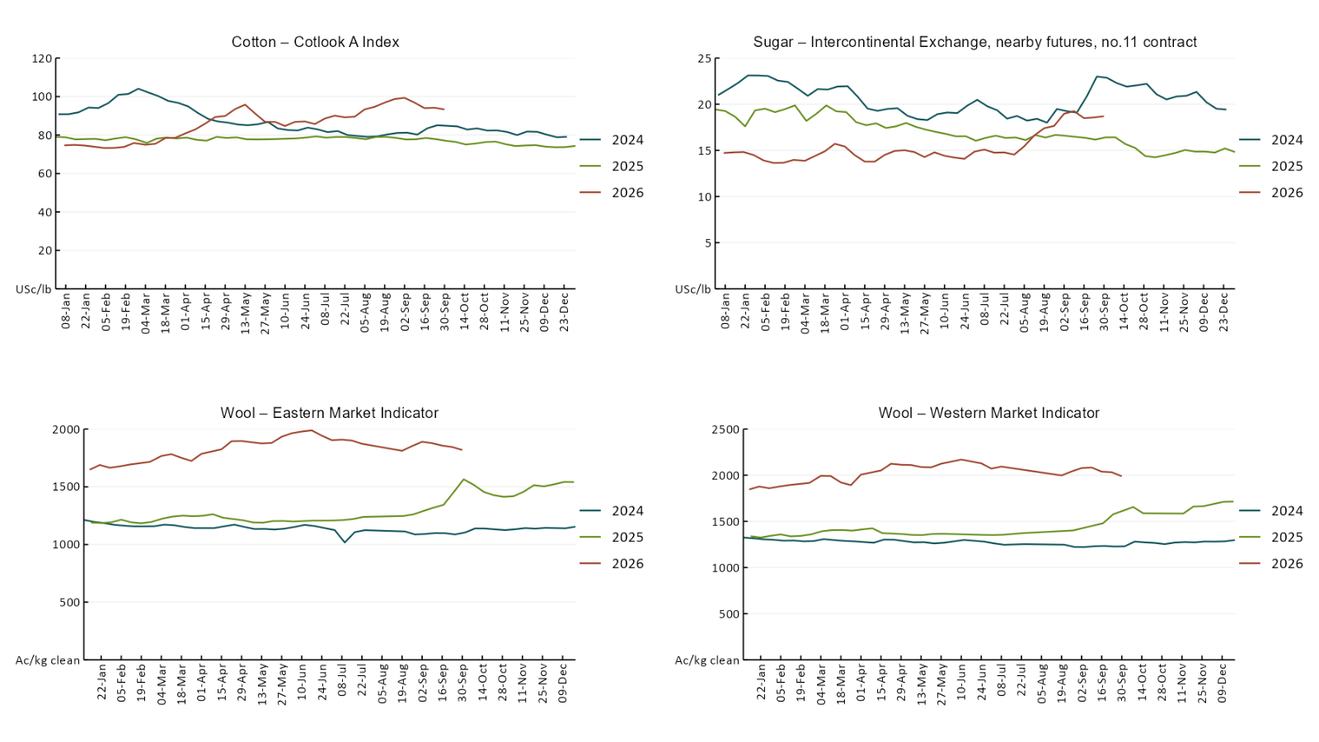

3.2 Selected domestic crop indicator prices
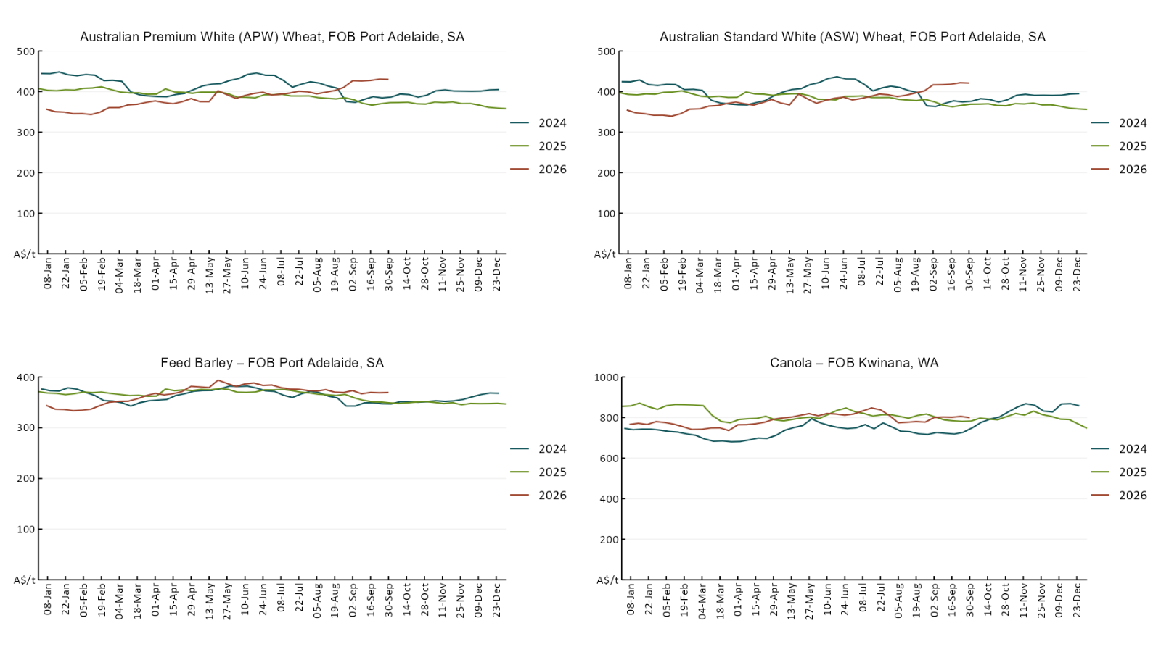

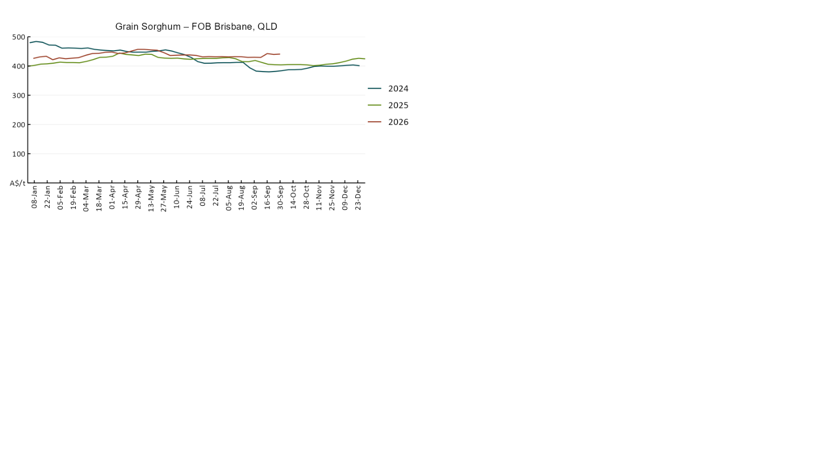

3.3 Selected domestic livestock indicator prices
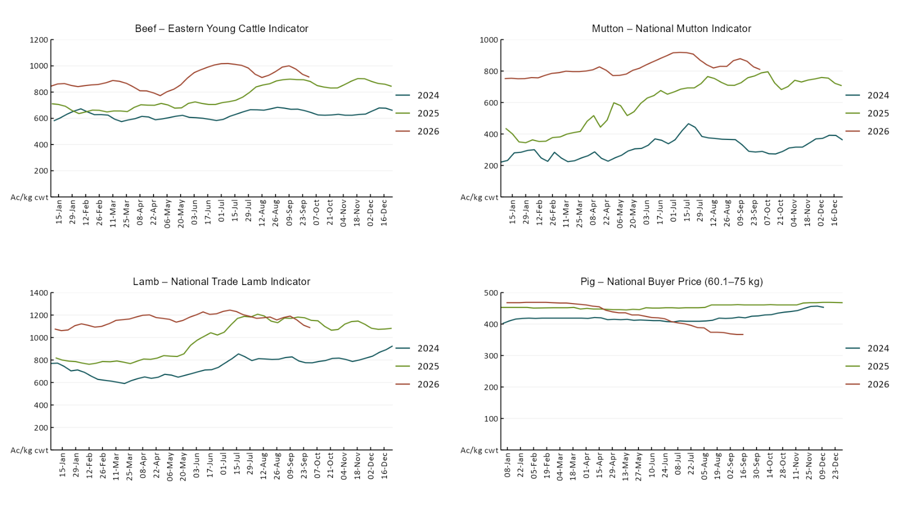

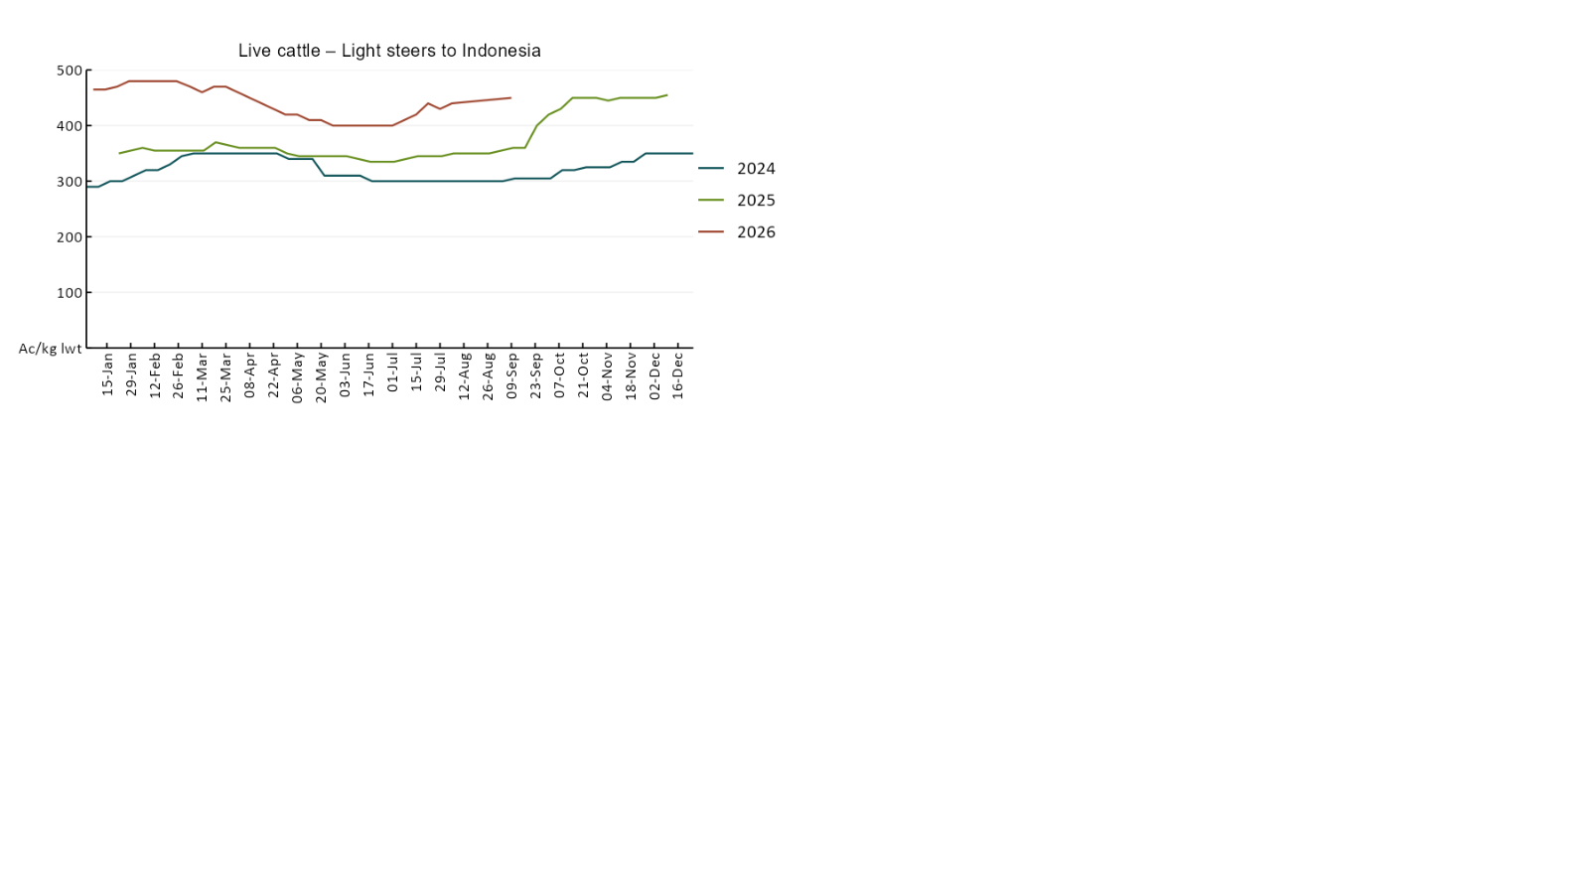

3.4 Global Dairy Trade (GDT) weighted average prices
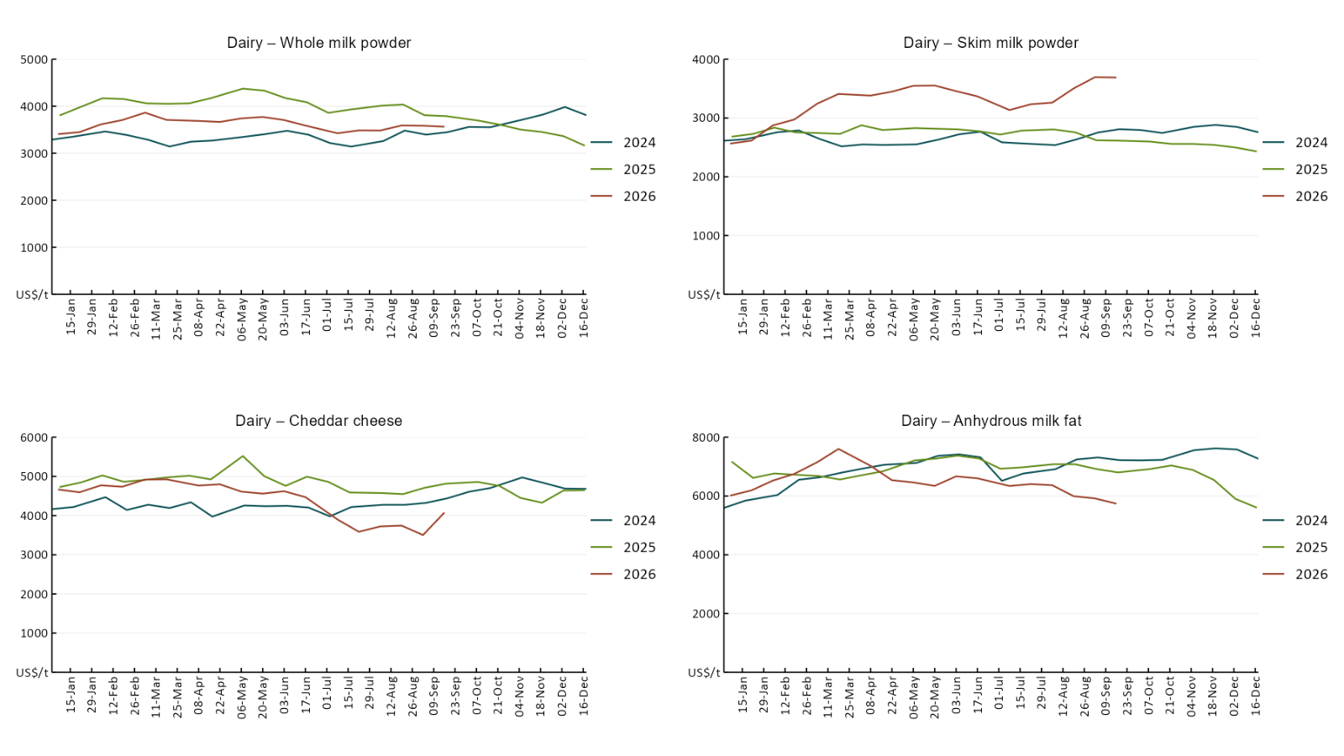

3.5 Selected fruit and vegetable prices
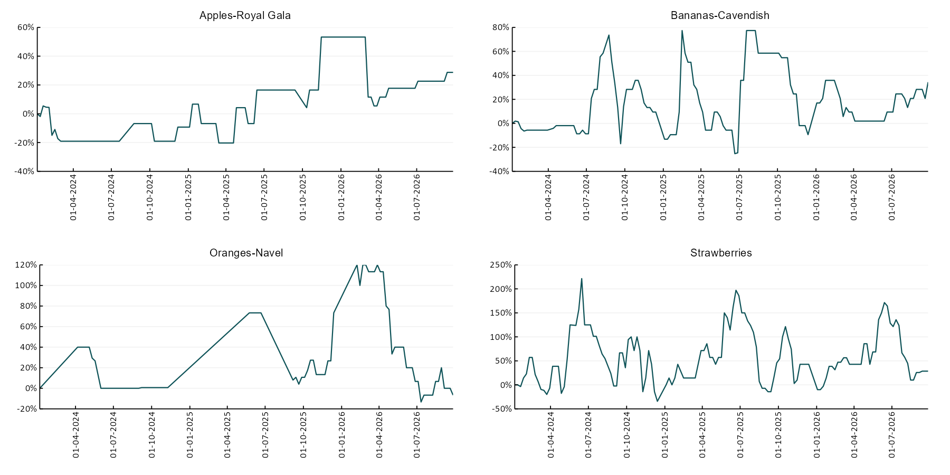

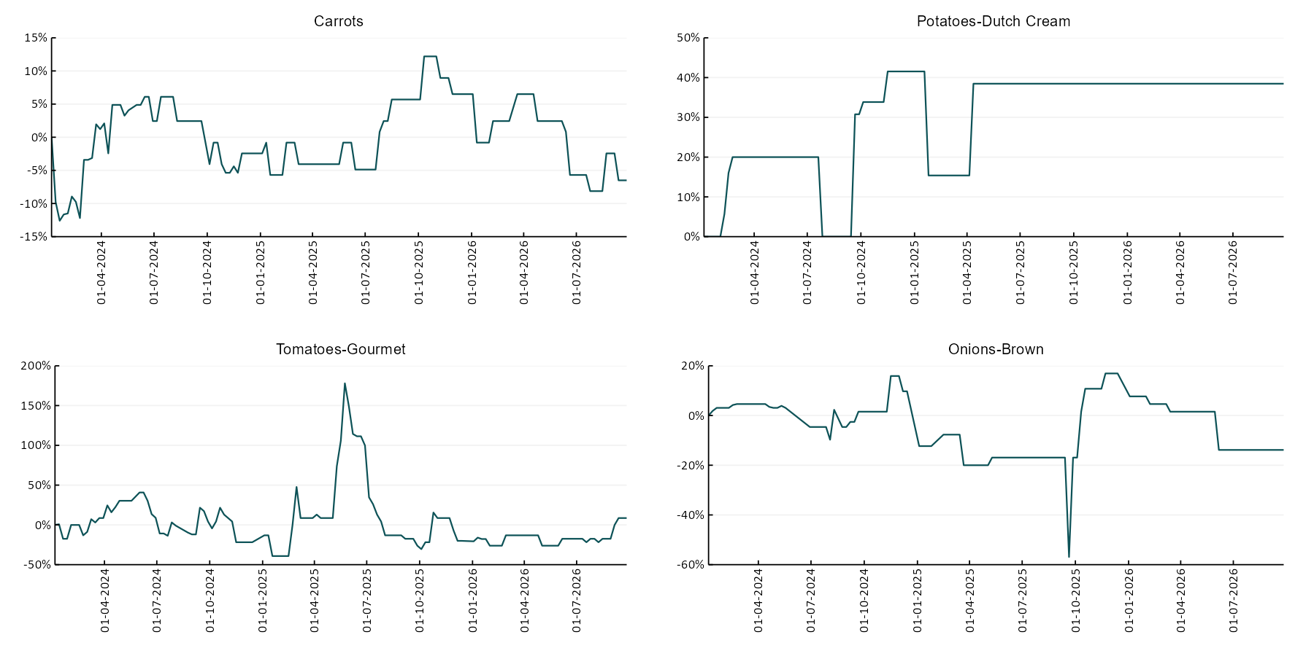

3.6 Selected domestic fodder indicator prices
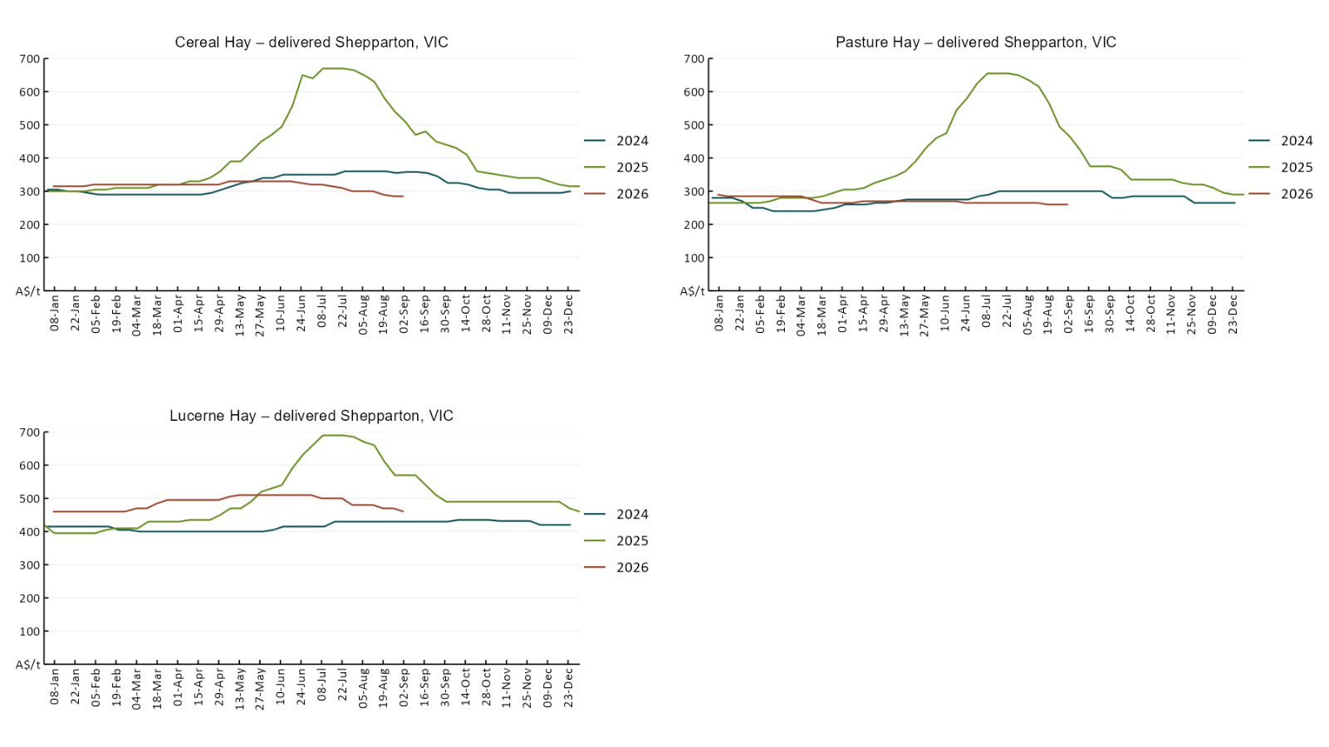

4. Data attribution

Climate
Bureau of Meteorology
- Weekly rainfall totals: www.bom.gov.au/climate/maps/rainfall/
- Monthly and last 3-month rainfall percentiles: https://www.bom.gov.au/climate/ahead/outlooks/#moreMaps
- Rainfall forecast: www.bom.gov.au/jsp/watl/rainfall/pme.jsp
- Seasonal outlook: www.bom.gov.au/climate/outlooks/#/overview/summary/
- Climate drivers: http://www.bom.gov.au/climate/enso/
- Soil moisture: https://awo.bom.gov.au/products/historical/soilMoisture-rootZone/

Other
- Pasture growth: www.longpaddock.qld.gov.au/aussiegrass/
- 3-month global outlooks: Environment and Climate Change Canada, NOAA Climate Prediction Center, EUROBRISA CPTEC/INPE, European Centre for Medium-Range Weather Forecasts, Hydrometcenter of Russia, National Climate Center Climate System Diagnosis and Prediction Room (NCC), International Research Institute for Climate and Society
- Global production: https://ipad.fas.usda.gov/ogamaps/cropmapsandcalendars.aspx
- Autumn break: Pook et al., 2009, https://rmets-onlinelibrary-wiley-com.virtual.anu.edu.au/doi/epdf/10.1002/joc.1833

Water
Prices
- Waterflow: https://www.waterflow.io/
- Ruralco: https://www.ruralcowater.com.au/
- Bureau of Meteorology:
- Allocation trade: http://www.bom.gov.au/water/dashboards/#/water-markets/mdb/at
- Storage volumes: http://www.bom.gov.au/water/dashboards/#/water-storages/summary/drainage

Trade constraints:
- Water NSW: https://www.waternsw.com.au/customer-service/ordering-trading-and-pricing/trading/murrumbidgee
- Victorian Water Register: https://www.waterregister.vic.gov.au/TradingRules2019/

Commodities
Fruit and vegetables
- Datafresh: www.freshstate.com.au

Pigs
- Australian Pork Limited: www.australianpork.com.au

Dairy
- Global Dairy Trade: www.globaldairytrade.info/en/product-results/

World wheat, canola
- International Grains Council: https://www.igc.int/en/default.aspx
- United States Department of Agriculture

World cotton
- Cotlook: www.cotlook.com/

World sugar
- New York Stock Exchange - Intercontinental Exchange

Wool
- Australian Wool Exchange: www.awex.com.au/

Domestic wheat, barley, sorghum, canola and fodder
- Jumbuk Consulting Pty Ltd: Jumbuk AG | Agriculture Consulting

Cattle, beef, mutton, lamb, goat and live export
- Meat and Livestock Australia: https://www.mla.com.au/prices-markets/

Australian Agricultural Drought Indicators
About Australian Agricultural Drought Indicators
The Australian Agricultural Drought Indicators (AADI) links weather and agricultural data with a range of scientific and economic models to measure and forecast the effects of climate variability and drought on agricultural outcomes.
On AADI, projected broadacre farm profits are presented as percentile outcomes relative to simulated historical outcomes using the groupings:
Highest | 95-100th percentile
Very much above average | 85-95th percentile
Above average | 65-85th percentile
Average | 35-65th percentile
Below average | 15-35th percentile
Very much below average | 5-15th percentile
Lowest 5% | 0-5th percentile

There are two AADI farm profit indicators:
- The AADI farm profit climate and price indicator shows the effect of climate and prices on broadacre farm business profits of current farms compared to the last 33 years.
- The AADI farm profit climate only indicator isolates the effect of climate on profits by holding prices fixed.

© Commonwealth of Australia 2026

Ownership of intellectual property rights
Unless otherwise noted, copyright (and any other intellectual property rights, if any) in this publication is owned by the Commonwealth of Australia (referred to as the Commonwealth).

Creative Commons licence
All material in this publication is licensed under a Creative Commons Attribution 4.0 International Licence except content supplied by third parties, logos and the Commonwealth Coat of Arms.
Inquiries about the licence and any use of this document should be emailed to copyright@aff.gov.au.


Cataloguing data
This publication (and any material sourced from it) should be attributed as:
ABARES 2026, Weekly Australian Climate, Water and Agricultural Update, Australian Bureau of Agricultural and Resource Economics and Sciences, Canberra, 1 October 2026. CC BY 4.0 DOI: https://doi.org/10.25814/5f3e04e7d2503
ISSN 2652-7561
This publication is available at https://www.agriculture.gov.au/abares/products/weekly_update
Department of Agriculture, Fisheries and Forestry
GPO Box 858 Canberra ACT 2601
Telephone 1800 900 090
Web agriculture.gov.au/abares

Disclaimer
The Australian Government acting through the Department of Agriculture, Fisheries and Forestry, represented by the Australian Bureau of Agricultural and Resource Economics and Sciences, has exercised due care and skill in preparing and compiling the information and data in this publication. Notwithstanding, the Department of Agriculture, Fisheries and Forestry, ABARES, its employees and advisers disclaim all liability, including liability for negligence and for any loss, damage, injury, expense or cost incurred by any person as a result of accessing, using or relying on any of the information or data in this publication to the maximum extent permitted by law.

Statement of Professional Independence
The views and analysis presented in ABARES publications, including this one, reflect ABARES professionally independent findings, based on scientific and economic concepts, principles, information and data. These views, analysis and findings may not reflect or be consistent with the views or positions of the Australian Government, or of organisations or groups who have commissioned ABARES reports or analysis. More information on professional independence is provided on the ABARES website.

Acknowledgements
This report was prepared by Matthew Miller.

