
No. 39/2026 8 October 2026

Summary of key issues
- In the week ending 7 October 2026, cold fronts and low-pressure systems brought rainfall to large areas of south-eastern and central Australia.
  - Cropping regions in Victoria generally received 25-100 millimetres, while parts of eastern South Australia and southern New South Wales saw lower falls of 5-50 millimetres.
  - These falls are expected to support winter crop development and pasture growth, particularly where higher totals were recorded.
- Over the 8 days to 15 October 2026, rainfall is forecast for the eastern two thirds of Australia, while western areas are forecast to remain largely dry.
  - Across south-eastern cropping regions, including South Australia, Victoria, and New South Wales, widespread falls of 10-25 millimetres are forecast. Higher falls of 15-50 millimetres are forecast for northern New South Wales and Queensland.
  - If realised, these falls are likely to provide a timely boost to soil moisture levels, support winter crop grain fill and maintain favourable pasture growth.
- The Bureau of Meteorology indicates that El Niño continues to strengthen in the tropical Pacific. Despite the strengthened El Niño, the November 2026 to January 2027 outlook indicates below average rainfall is likely be restricted to parts of south-eastern Australia and the northern tropics, while above average rainfall is more likely across much of western and central Australia, including parts of inland and southern Queensland and northern New South Wales.
  - If forecast November to January rainfall totals are realised, they are likely to support at least average pasture growth across much of eastern and northern Australia. In Queensland and north-eastern New South Wales these falls are also likely to benefit the growth of early planted summer crops and provide opportunities for later planting of summer crops.
- Pasture growth for the three months to September 2026 was mixed but broadly above average in central and southern areas, while eastern areas saw below average pasture growth.
- Water storage levels in the Murray-Darling Basin (MDB) increased by 75 gigalitres (GL) between 1 October 2026 and 8 October 2026. The current volume of water held in storages is 15,065 GL, equivalent to 68% of total storage capacity. This is 2% or 373 GL less than the same time last year. Water storage data is sourced from the Bureau of Meteorology.
- Allocation prices in the Victorian Murray below the Barmah Choke decreased from $358/ML on 1 October 2026 to $322/ML on 8 October 2026.

Climate

Rainfall this week
In the week ending 7 October 2026, cold fronts and low-pressure systems brought rainfall to large areas of south-eastern and central Australia, while much of the remainder of Australia remained largely dry.
- Falls of 15-150 millimetres were recorded across Victoria, while south-eastern New South Wales and eastern Western Australia saw falls of up to 100 millimetres.
- Falls of 5–50 millimetres were also recorded across parts of south-eastern South Australia.
- In contrast, much of northern Australia recorded little to no rainfall.
Across cropping regions, rainfall outcomes were mixed, with the most substantial falls recorded in south-eastern regions.
- Cropping regions in Victoria generally received 25-100 millimetres, while parts of eastern South Australia and southern New South Wales saw lower falls of 5-50 millimetres.
  - These falls are expected to support winter crop development and pasture growth, particularly where higher totals were recorded.
- Cropping regions in Western Australia, western South Australia, northern New South Wales and Queensland recorded highly variable falls, with scattered areas recording falls of up to 15 millimetres, with little to no rainfall elsewhere.

Rainfall for the week ending 7 October 2026
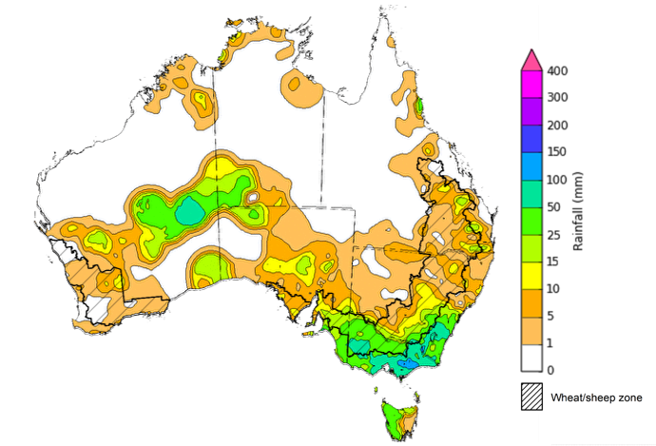
©Commonwealth of Australia 2026, Australian Bureau of Meteorology Issued: 07/10/2026
Note: The rainfall analyses and associated maps utilise data contained in the Bureau of Meteorology climate database, the Australian Data Archive for Meteorology (ADAM). The analyses are initially produced automatically from real-time data with limited quality control. They are intended to provide a general overview of rainfall across Australia as quickly as possible after the observations are received. For further information go to http://www.bom.gov.au/climate/rainfall/

Rainfall forecast for the next eight days
Over the 8 days from 8 to 15 October 2026, rainfall is forecast across much of the eastern two thirds of Australia. Much of Western Australia is forecast to receive low rainfall or remain dry.
- Falls of 10-50 millimetres are forecast across much of the Northern Territory, Queensland, Tasmania, New South Wales, South Australia and Victoria.
- Rainfall of 5-15 millimetres is forecast across parts of southwest and east of Western Australia.
Across cropping regions rainfall over the 8 days to 15 October 2026 is forecast to be high in the southeast and east, with lower totals expected across Western Australia.
- Across south-eastern cropping regions, including South Australia, Victoria, and New South Wales, widespread falls of 10-25 millimetres are forecast. Higher falls of 15-50 millimetres are forecast for northern New South Wales and Queensland.
  - If realised, these falls are likely to provide a timely boost to soil moisture levels, support grain filling in winter crop and boost pasture growth.
- Cropping regions across Western Australia are forecast to receive generally 5-15 millimetres.

Total forecast rainfall for the period 8 October to 15 October 2026
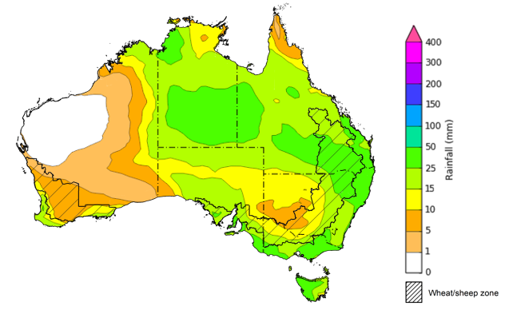
©Commonwealth of Australia 2026, Australian Bureau of Meteorology Issued: 8/10/2026
Note: This rainfall forecast is produced from computer models. As the model outputs are not altered by weather forecasters, it is important to check local forecasts and warnings issued by the Bureau of Meteorology.

Monthly Soil Moisture
In September 2026, modelled upper layer soil moisture was generally average to above average across much of north and west of Australia, with much of south-eastern Australia seeing below average modelled soil moisture.
- Much of Western Australia, western South Australia, parts of the south and north of the Northern Territory, and parts of northern Queensland saw above average to very much above average upper layer soil moisture.
- In contrast, much of Tasmania, as well as parts of south-western Western Australia, southern Queensland, New South Wales, Victoria, and southern South Australia saw below average to extremely low upper layer soil moisture.
At this time of year, upper layer soil moisture is less critical for well-established winter crops. However, upper layer soil moisture will be critical for supporting the germination and establishment of summer crops in the coming months in northern and eastern regions.
- Across cropping regions, modelled upper layer soil moisture in September was modelled to be below average to very much below average for most cropping regions, including Queensland and New South Wales, as well as Victoria, South Australia, and the west of Western Australia. Exceptions were modelled in isolated parts of Western Australia, with generally average to above average upper layer soil moisture.
This represents a considerable decline from August 2026 as a result low realised rainfall outcomes in parts of southern and eastern Australia during September. Adequate rainfall during the remainder of the summer cropping period will be needed to support production outcomes in areas of Queensland and northern New South Wales where soil moisture storage is limited.
Modelled upper layer soil moisture for September 2026
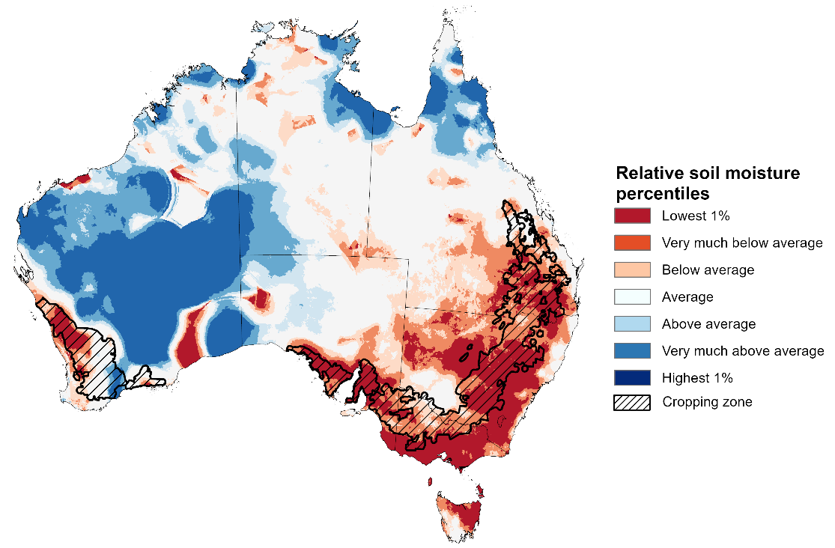

Note: This map shows the levels of modelled upper layer soil moisture (0 to 10 centimetres) during September 2026 This map shows how modelled soil conditions during September 2026 compare with September conditions modelled over the reference period (1911 to 2016). Dark blue areas on the maps were much wetter in September 2026 than during the reference period. The bulk of plant roots occur in the top 20 centimetres of the soil profile. Soil moisture in the upper layer of the soil profile is therefore useful indicator of the availability of water, particularly for germinating seed.
Source: Bureau of Meteorology (https://awo.bom.gov.au/about/overview)
Modelled lower layer soil moisture in September 2026 was average to very much above average across much of central Australia, while extremely low to below average modelled lower layer soil moisture was evident across large areas of eastern and western Australia.
- Parts of eastern Queensland, eastern Victoria, eastern New South Wales, western South Australia, and south-western Western Australia were modelled as having extremely low to below average lower layer soil moisture. By contrast, much of the southern Northern Territory, western Queensland, South Australia, western New South Wales, central Western Australia, and northern Victoria were modelled as having above average to very much above average soil moisture over the period.
Lower layer soil moisture is a larger, deeper store that is slower to respond to seasonal conditions and tends to reflect the accumulated effects of events that have occurred over longer periods. Crop development and pasture growth in areas of above average lower layer soil moisture are typically less reliant on in-season rainfall than in areas with below average lower layer soil moisture.
- Cropping regions in Queensland and the far west of Western Australia were modelled as having extremely low to below average soil moisture. In contrast, much of Victoria, South Australia, New South Wales, and remaining areas in Western Australia recorded average to above average soil moisture for this time of year.
In areas with average to above average lower layer soil moisture, this is likely to provide a reserve of plant-available water to support crop growth over the spring period. September 2026 modelling shows a decline in soil moisture storage compared to August 2026, which indicates a drawdown of soil moisture reserves to support forecast above average winter crop yield and positive pasture growth outcome across much of the southeast. However, outlooks in northern cropping regions remain subdued.
Modelled lower layer soil moisture for September 2026
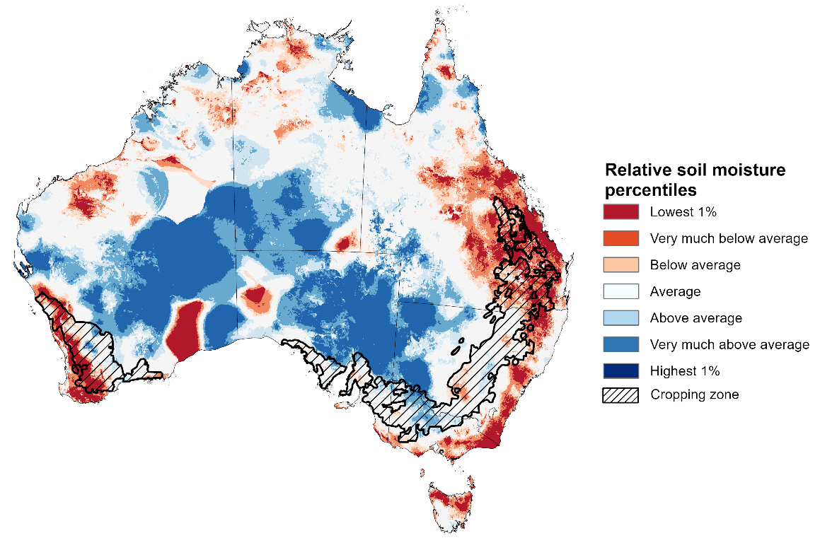
Note: This map shows how modelled soil conditions during September 2026 compare with September conditions modelled over the reference period (1911 to 2016). Dark blue areas on the maps were much wetter in September 2026 than during the reference period. The dark red areas were much drier than during the reference period. The bulk of plant roots occur in the top 20 centimetres of the soil profile. The lower layer soil moisture is a larger, deeper store that is slower to respond to rainfall and tends to reflect accumulated rainfall events over longer time periods.
Source: Bureau of Meteorology (https://awo.bom.gov.au/about/overview)

Pasture Growth
During the northern Australia dry season (May to September), pasture growth typically declines significantly due to the reduction in water availability, with livestock relying on pasture grown throughout the previous wet season. Across southern Australia, July to September pasture growth influences the number of livestock than can be supported without supplementary feeding over winter and the level of reliance on hay and grain during this period. Pasture availability during this period influences the growth and branding and marking rates of lambs and calves, livestock turnoff and the production of meat, milk, and wool.
Pasture growth for the three months to September 2026 was variable across much of country.
- Average to extremely high relative pasture growth was modelled across much of southern and central Australia.
  - This pasture growth is expected to have allowed many farmers to maintain livestock numbers and provided opportunities to build standing dry matter availability.
- In contrast, large areas of north-eastern Australia, and isolated south-western and south-eastern regions, saw relatively low pasture growth for this time of year.
  - This below average pasture growth particularly across eastern Queensland has led to a decline in pasture availability. Graziers in regions where below average pasture growth was recorded will be more reliant on supplemental feed to maintain current stocking rates and production, with others choosing to destock to take advantage of relatively high saleyard prices.
Relative pasture growth for 3-months ending September 2026 (1 July to 30 September 2026)
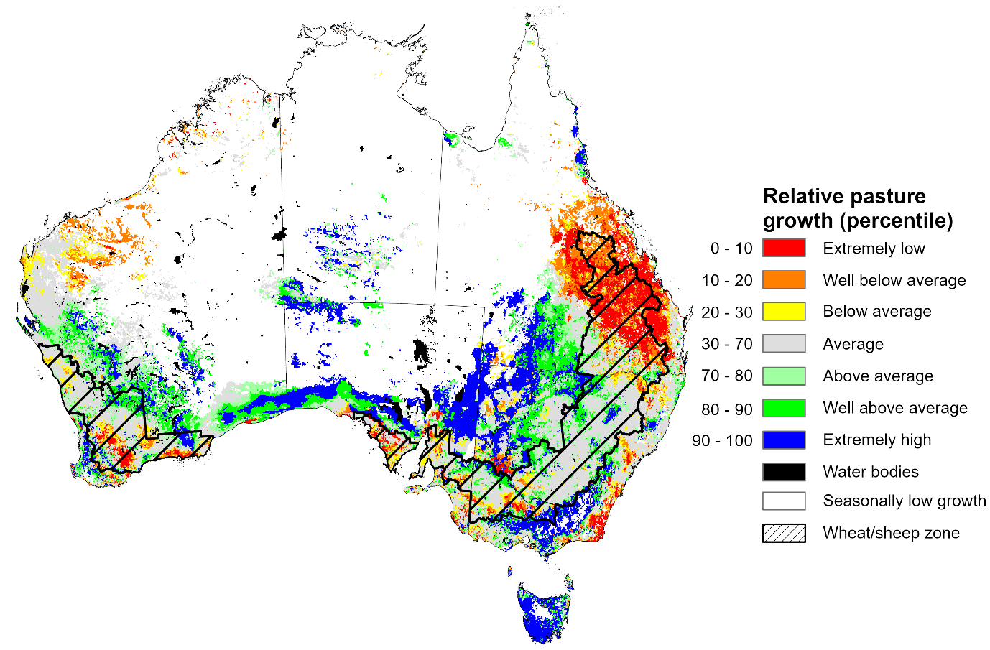

Notes: AussieGRASS pasture growth estimates are relative to the long-term record and shown in percentiles. Percentiles rank data on a scale of zero to 100. This analysis ranks pasture growth for the selected period against average pasture growth for the long-term record (1957 to 2016). Pasture growth is modelled at 5km2 grid cells.
Source: Department of Environment, Science and Innovation

National Climate Outlook
The Bureau of Meteorology indicates that El Niño is continuing to strengthen to near record highs in the tropical Pacific. El Niño typically increases the chance of drier conditions across parts of eastern Australia during spring, although rainfall outcomes vary depending on the strength and interaction of other climate influences. The Indian Ocean Dipole (IOD) is currently neutral, while the Southern Annular Mode (SAM) is trending negative and forecast to return to neutral over the coming week. As a result, the IOD is currently providing no strong additional influence on Australian rainfall patterns, while effects from the SAM are likely to be limited. Sea surface temperatures are forecast to remain warmer than average across much of the globe during November to January, including notably warm waters near south-eastern Australia, increasing the risk of marine heatwave conditions.
The rainfall outlook for November 2026 indicates that below median rainfall is more likely across parts of south-eastern and north-eastern Australia. Above median rainfall is more likely across much of Western Australia and parts of the west of the Northern Territory and South Australia.
The Bureau of Meteorology’s climate model indicates a 75% chance of November rainfall totals between 25-100 millimetres across large areas of northern and eastern Australia, with higher totals possible across the far north of the Northern Territory. Much of southern, central, and north-eastern Australia is likely to receive 5-50 millimetres of rainfall.
Across cropping regions in Queensland and northern New South Wales, there is a 75% chance of receiving rainfall totals of between 25-50 millimetres during November 2026. In southern New South Wales, Victoria, South Australia and Western Australia, falls of between 10-25 millimetres are likely. If realised, these expected rainfall totals are likely to support winter crop production prospects and pasture growth across southern growing regions where crops and pastures remain responsive, and may provide some opportunities for summer crop planting across parts of Queensland and northern New South Wales.

Rainfall totals that have a 75% chance of occurring in November 2026

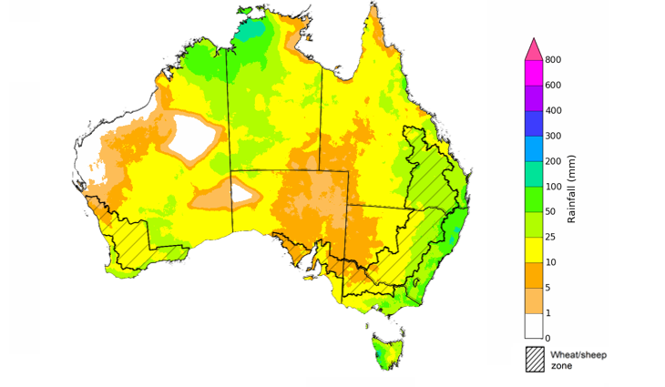
©Commonwealth of Australia 2026, Australian Bureau of Meteorology Issued: 8/10/2026
The rainfall outlook for November 2026 to January 2027 indicates that below average rainfall is likely across parts of south-eastern Australia and parts of the tropical north of Australia. Above average rainfall is more likely across much of south-western and central Australia, as well as scattered eastern regions including southern Queensland and northern New South Wales.
During the November 2026 to January 2027 period, the chance of receiving above median rainfall is highest across cropping regions in Western Australia, western areas in South Australia, Queensland, and northern New South Wales. Southern New South Wales and Victorian cropping regions are forecast to see below average to average falls. Meanwhile, cropping regions in eastern South Australia have a close to equal chance of above median or below median rainfall.

Chance of exceeding the median rainfall November 2026 to January 2027

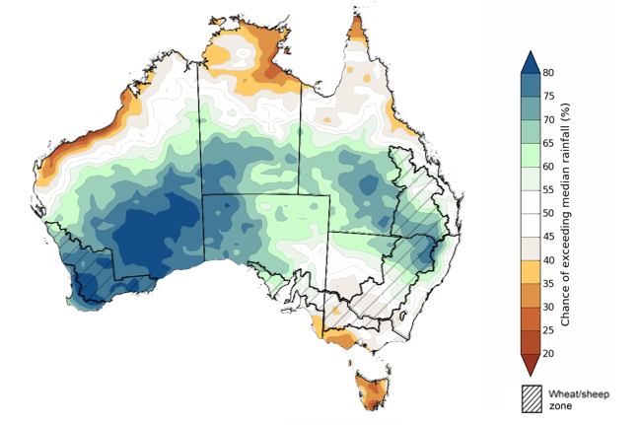
©Commonwealth of Australia 2026, Australian Bureau of Meteorology Issued: 1/10/2026

The rainfall outlook for November 2026 to January 2027 suggests a 75% chance of receiving rainfall totals of between 100–400 millimetres across large areas of eastern and northern Australia. Higher falls above 400 millimetres are possible across parts of the northern tropics. Lower rainfall totals are forecast for central and western regions, including parts of Western Australia, eastern South Australia, south-western Queensland and western parts of New South Wales and Victoria.
In cropping regions, there is a 75% chance of receiving between 100–200 millimetres across much of Queensland and eastern New South Wales. Southern cropping regions, including Western Australia, South Australia, Victoria and south-western New South Wales, are more likely to receive lower totals of 25–100 millimetres.
If these forecast November to January rainfall totals are realised, they are likely to support at least average pasture growth across much of eastern and northern Australia. In Queensland and north-eastern New South Wales, forecast rainfall may assist summer crop planting opportunities but are likely to arrive too late to materially improve below average winter crop production outcomes.

Rainfall totals that have a 75% chance of occurring November 2026 to January 2027

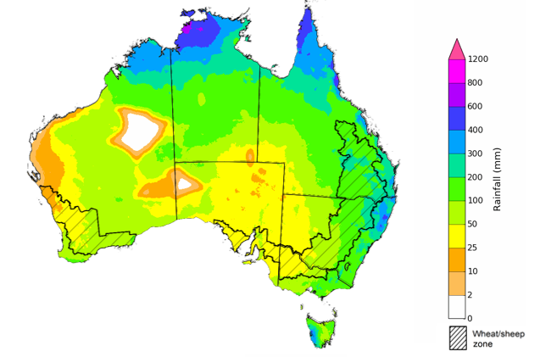
©Commonwealth of Australia 2026, Australian Bureau of Meteorology Issued: 1/10/2026

Water

Water markets – current week
Water storage levels in the Murray-Darling Basin (MDB) increased by 75 gigalitres (GL) between 1 October 2026 and 8 October 2026. The current volume of water held in storages is 15,065 GL, equivalent to 68% of total storage capacity. This is 2% or 373 GL less than the same time last year. Water storage data is sourced from the Bureau of Meteorology.

Weekly water storage levels in the Murray-Darling Basin, 2013–2026
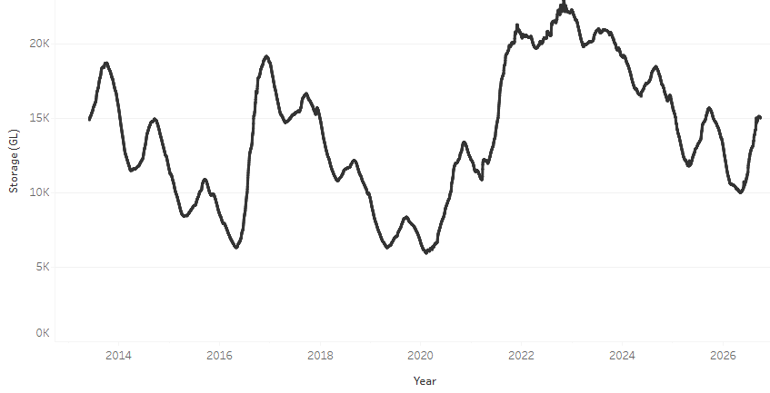
Allocation prices in the Victorian Murray below the Barmah Choke decreased from $358/ML on 1 October 2026 to $322/ML on 8 October 2026. Trade from the Goulburn to the Murray is closed. Trade downstream through the Barmah Choke is closed. Trade from the Murrumbidgee to the Murray is open.

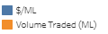
Monthly surface water trade activity 2022-2026, Victorian Murray below the Barmah Choke

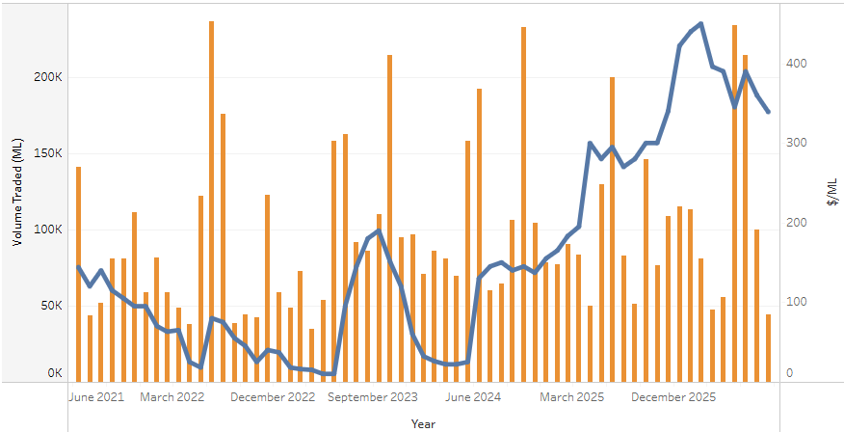

Weekly water market prices, Southern Murray–Darling Basin
Region | $/ML
NSW Murray Above | 193
NSW Murrumbidgee | 259
Vic Greater Goulburn | 299
Vic Murray Below | 322
Note: The water allocation prices shown are volume weighted average prices based on the last 10 trades. Price data is sourced from Waterflow and current as at 8 October 2026.
To access the full, interactive, weekly water dashboard, which contains the latest and historical water storage, water market and water allocation information, please visit https://www.agriculture.gov.au/abares/products/weekly_update/weekly-update-261008

Commodities
Indicator | Week average | Unit | Latest Price | Previous Week | Weekly change |  | Price 12 months ago | Annual change
Selected world indicator prices
AUD/USD Exchange rate | 7-Oct | A$/US$ | 0.70 | 0.70 | 0% | 0.65 |  | 6%
Wheat – US no. 2 hard red winter wheat, FOB Gulf | 7-Oct | US$/t | 336 | 332 | 1% | 231 |  | 46%
Corn – US no. 2 yellow corn, FOB Gulf | 7-Oct | US$/t | 224 | 225 | 0% | 198 |  | 13%
Canola – Rapeseed, Canada, FOB Vancouver | 7-Oct | US$/t | 614 | 611 | 1% | 473 |  | 30%
Cotton – Cotlook A Index | 7-Oct | USc/lb | 90.8 | 90.7 | 0% | 76.1 |  | 19%
Sugar – Intercontinental Exchange, nearby futures, no.11 contract | 7-Oct | USc/lb | 20.8 | 19.0 | 9% | 15.6 |  | 33%
Wool – Eastern Market Indicator | 30-Sep | Ac/kg clean | 1,819 | 1,845 | -1% | 1,476 |  | 23%
Wool – Western Market Indicator | 30-Sep | Ac/kg clean | 1,989 | 2,033 | -2% | 1,622 |  | 23%
Selected Australian grain export prices
Australian Premium White (APW) Wheat, FOB Port Adelaide, SA | 7-Oct | A$/t | 431 | 430 | 0% | 372 |  | 16%
Australian Standard White (ASW) Wheat, FOB Port Adelaide, SA | 7-Oct | A$/t | 422 | 421 | 0% | 368 |  | 15%
Feed Barley – FOB Port Adelaide, SA | 7-Oct | A$/t | 374 | 371 | 1% | 350 |  | 7%
Canola – FOB Kwinana, WA | 7-Oct | A$/t | 806 | 802 | 1% | 794 |  | 2%
Grain Sorghum – FOB Brisbane, QLD | 7-Oct | A$/t | 450 | 440 | 2% | 405 |  | 11%
Selected domestic livestock indicator prices
Beef – Eastern Young Cattle Indicator | 7-Oct | Ac/kg cwt | 917 | 916 | 0% | 846 |  | 8%
Mutton – Mutton indicator (18–24 kg fat score 2–3), VIC | 7-Oct | Ac/kg cwt | 820 | 811 | 1% | 739 |  | 11%
Lamb – National Trade Lamb Indicator | 7-Oct | Ac/kg cwt | 1,116 | 1,090 | 2% | 1,108 |  | 1%
Pig – Eastern Seaboard (60.1–75 kg), NSW buyer price | 7-Oct | Ac/kg cwt | 367 | 367 | 0% | 461 |  | -20%
Live cattle – Light steers to Indonesia | 9-Sep | Ac/kg lwt | 450 | 440 | 2% | 440 |  | 2%
Global Dairy Trade (GDT) weighted average prices
Dairy – Whole milk powder | 7-Oct | US$/t | 3,605 | 3,565 | 1% | 3,653 |  | -1%
Dairy – Skim milk powder | 7-Oct | US$/t | 3,847 | 3,689 | 4% | 2,579 |  | 49%
Dairy – Cheddar cheese | 7-Oct | US$/t | 3,925 | 4,075 | -4% | 4,808 |  | -18%
Dairy – Anhydrous milk fat | 7-Oct | US$/t | 5,683 | 5,739 | -1% | 6,977 |  | -19%

Selected world indicator prices
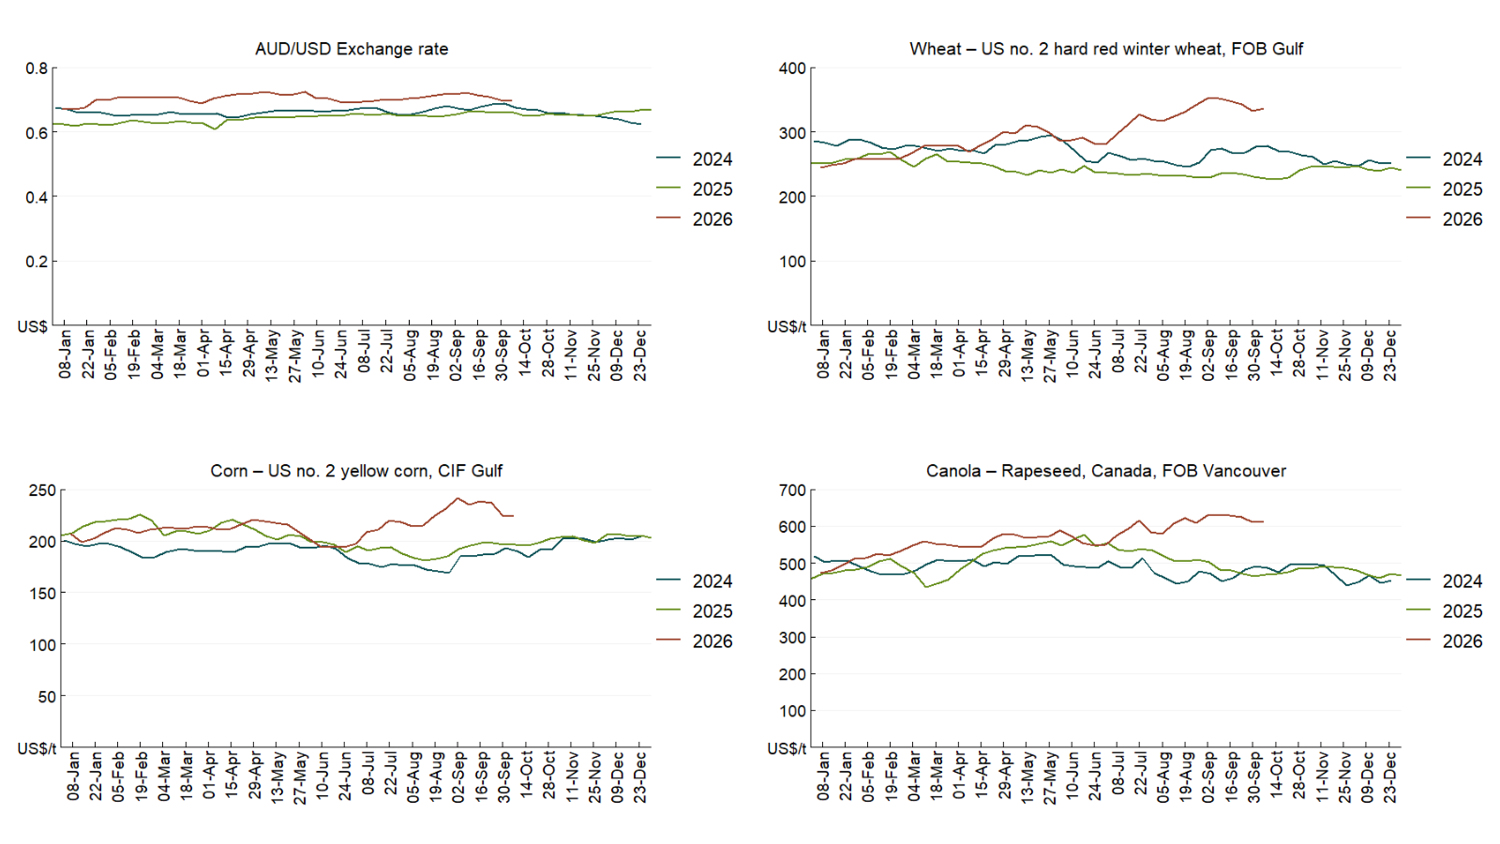

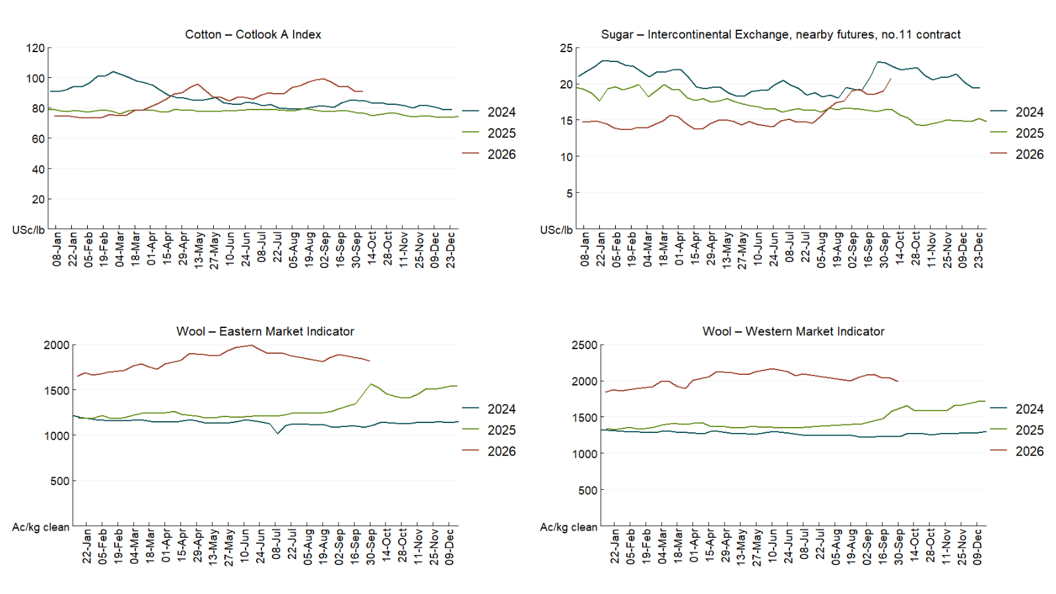

3.2 Selected domestic crop indicator prices
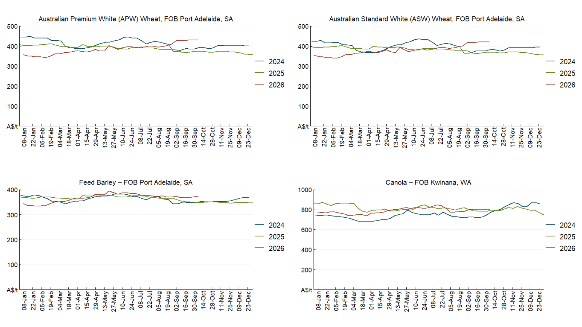

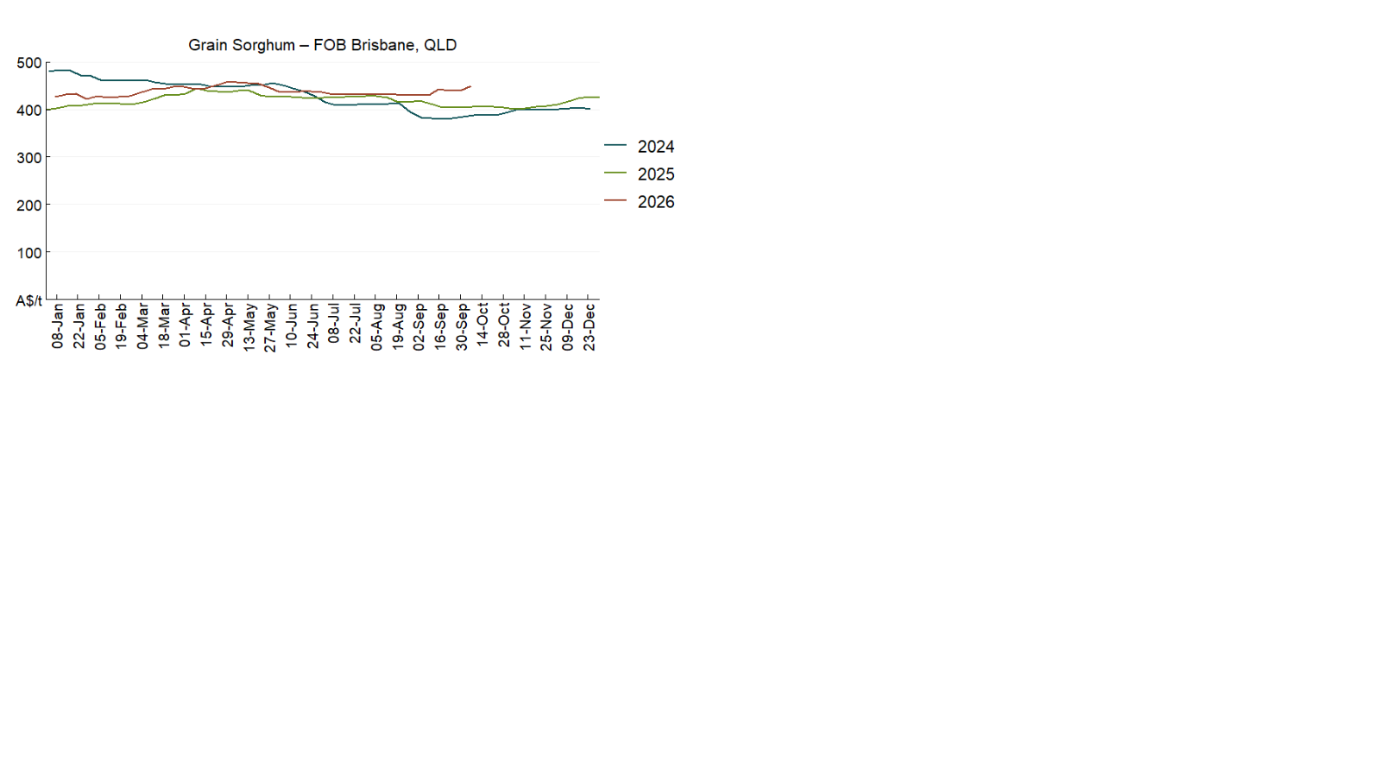

3.3 Selected domestic livestock indicator prices
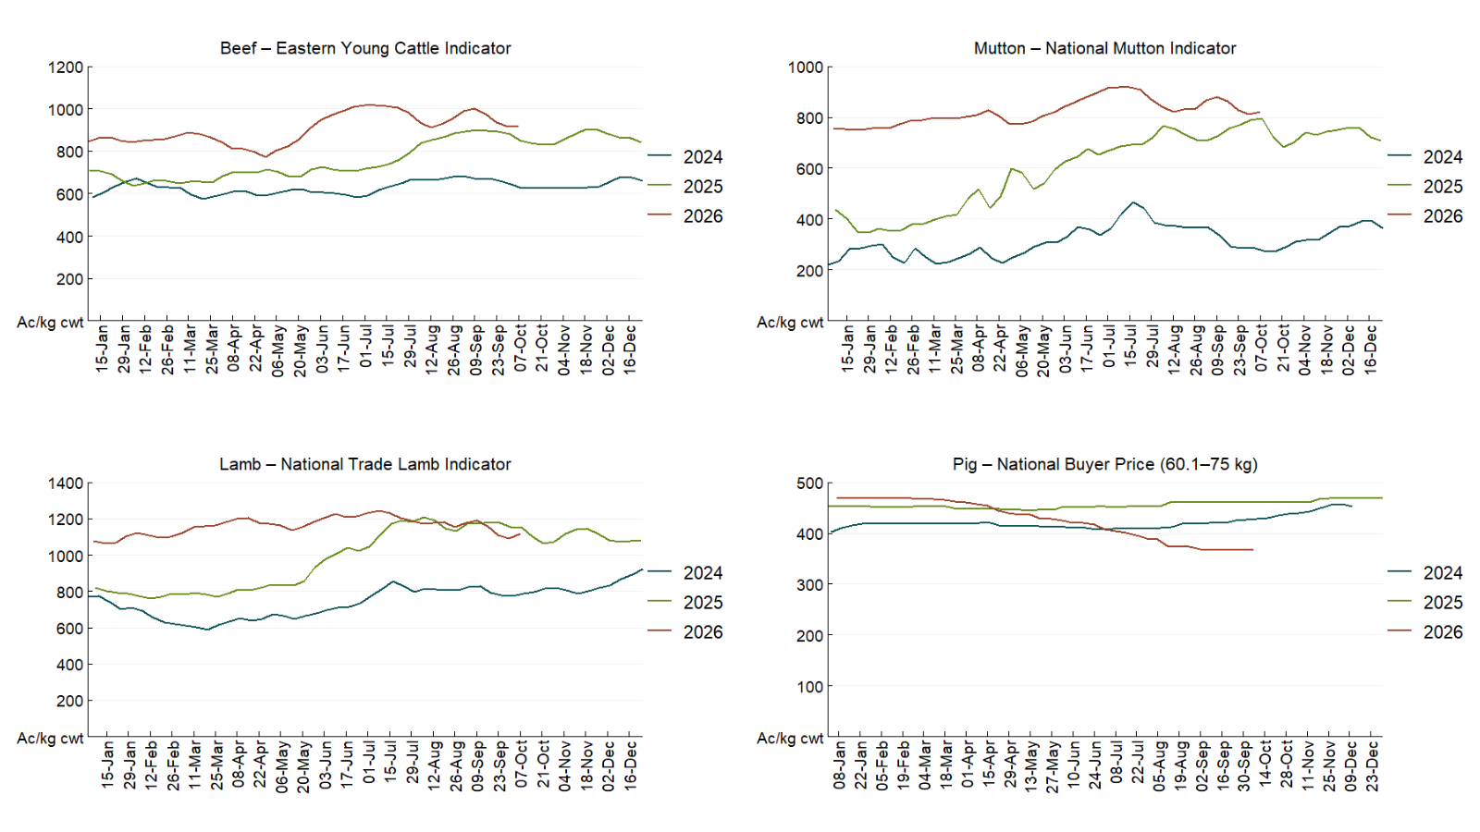

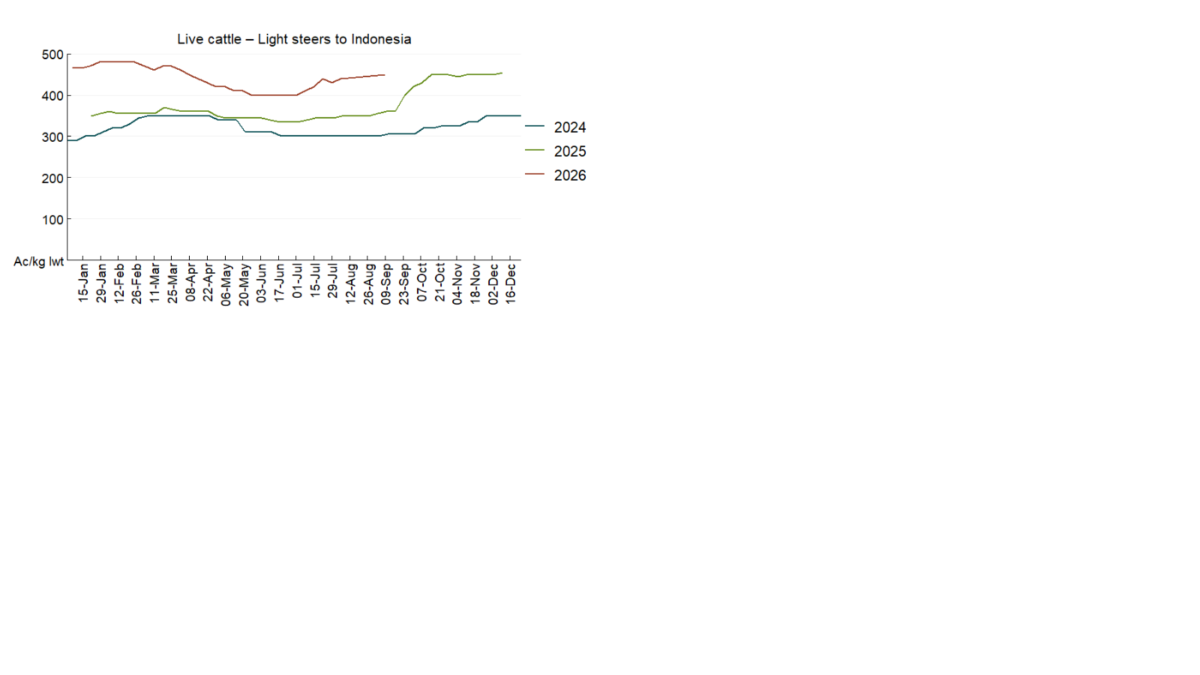

3.4 Global Dairy Trade (GDT) weighted average prices
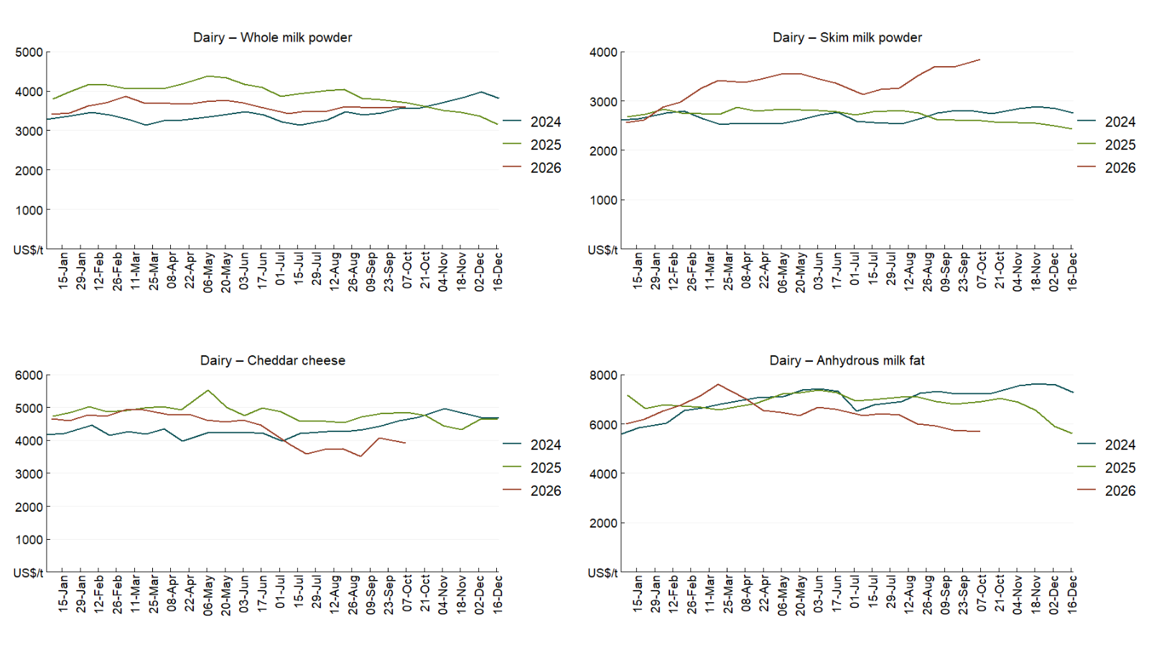

3.5 Selected fruit and vegetable prices
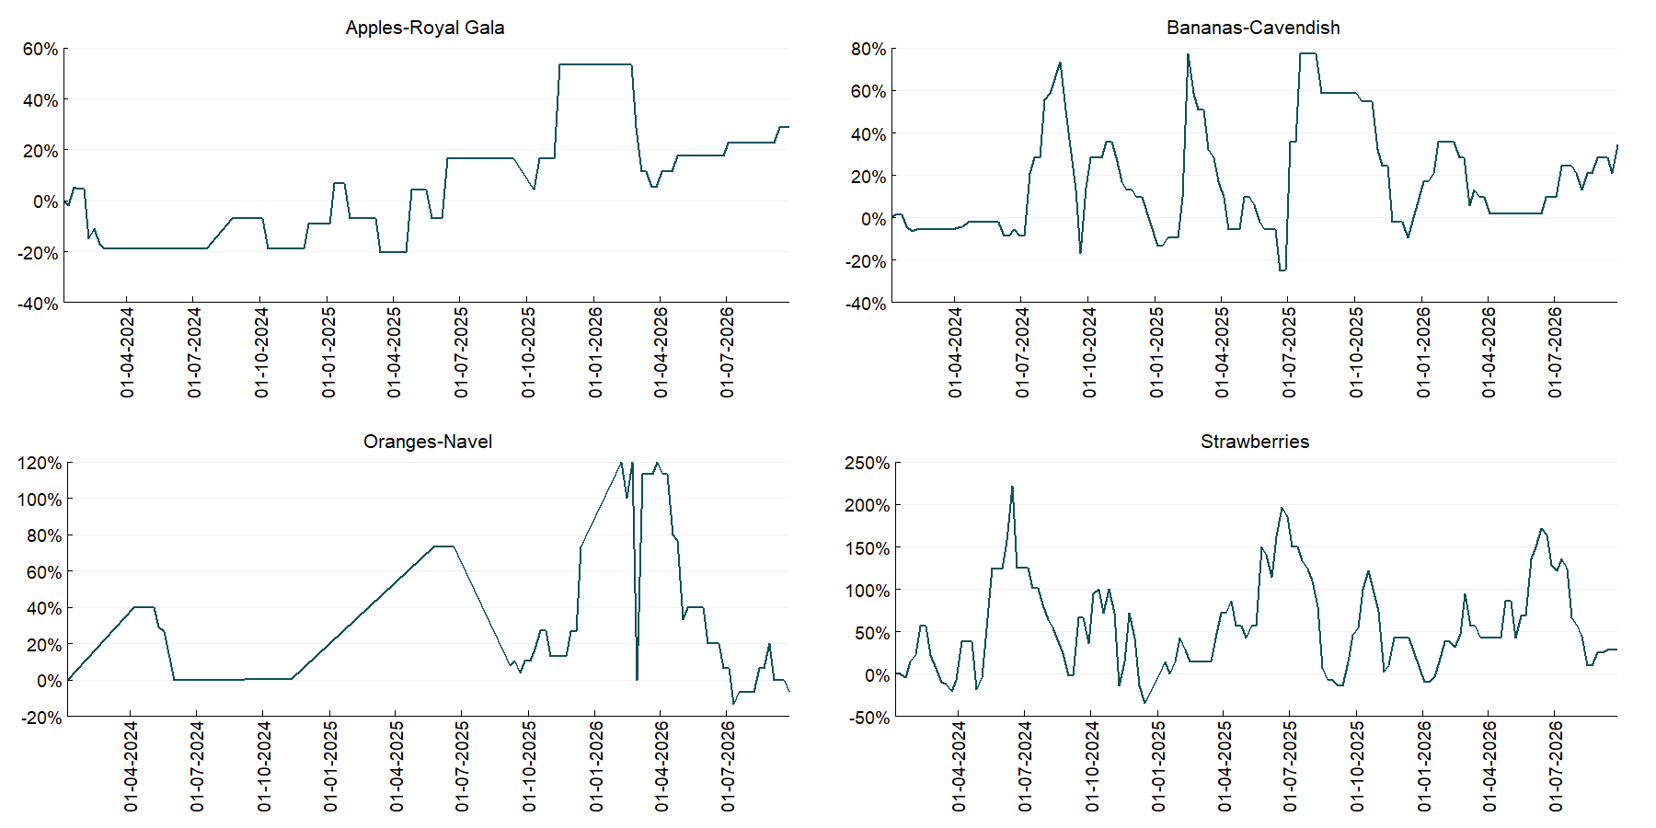

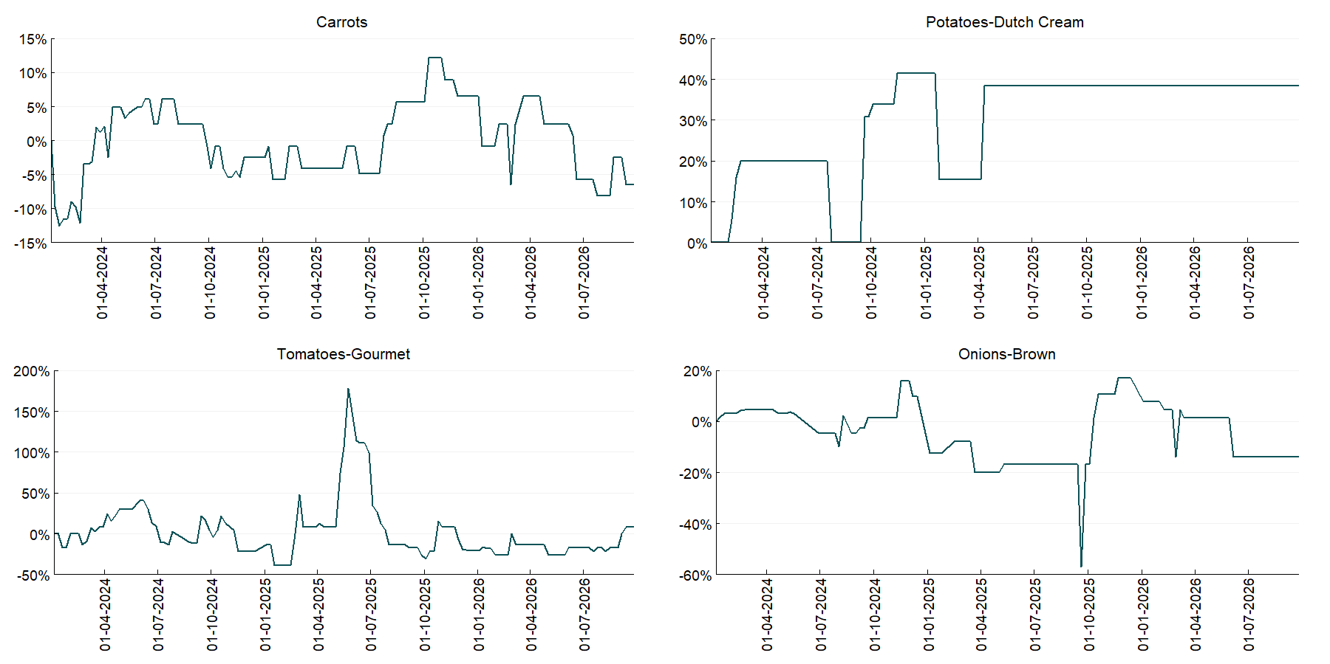

3.6 Selected domestic fodder indicator prices
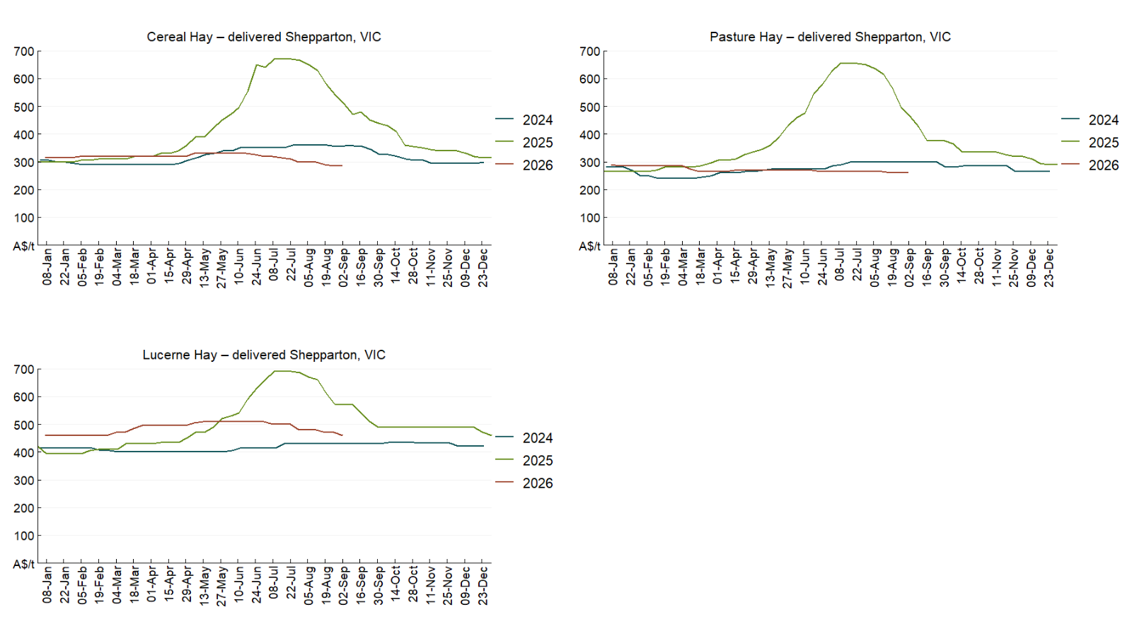

4. Data attribution

Climate
Bureau of Meteorology
- Weekly rainfall totals: www.bom.gov.au/climate/maps/rainfall/
- Monthly and last 3-month rainfall percentiles: https://www.bom.gov.au/climate/ahead/outlooks/#moreMaps
- Rainfall forecast: www.bom.gov.au/jsp/watl/rainfall/pme.jsp
- Seasonal outlook: www.bom.gov.au/climate/outlooks/#/overview/summary/
- Climate drivers: http://www.bom.gov.au/climate/enso/
- Soil moisture: https://awo.bom.gov.au/products/historical/soilMoisture-rootZone/

Other
- Pasture growth: www.longpaddock.qld.gov.au/aussiegrass/
- 3-month global outlooks: Environment and Climate Change Canada, NOAA Climate Prediction Center, EUROBRISA CPTEC/INPE, European Centre for Medium-Range Weather Forecasts, Hydrometcenter of Russia, National Climate Center Climate System Diagnosis and Prediction Room (NCC), International Research Institute for Climate and Society
- Global production: https://ipad.fas.usda.gov/ogamaps/cropmapsandcalendars.aspx
- Autumn break: Pook et al., 2009, https://rmets-onlinelibrary-wiley-com.virtual.anu.edu.au/doi/epdf/10.1002/joc.1833

Water
Prices
- Waterflow: https://www.waterflow.io/
- Ruralco: https://www.ruralcowater.com.au/
- Bureau of Meteorology:
- Allocation trade: http://www.bom.gov.au/water/dashboards/#/water-markets/mdb/at
- Storage volumes: http://www.bom.gov.au/water/dashboards/#/water-storages/summary/drainage

Trade constraints:
- Water NSW: https://www.waternsw.com.au/customer-service/ordering-trading-and-pricing/trading/murrumbidgee
- Victorian Water Register: https://www.waterregister.vic.gov.au/TradingRules2019/

Commodities
Fruit and vegetables
- Datafresh: www.freshstate.com.au

Pigs
- Australian Pork Limited: www.australianpork.com.au

Dairy
- Global Dairy Trade: www.globaldairytrade.info/en/product-results/

World wheat, canola
- International Grains Council: https://www.igc.int/en/default.aspx
- United States Department of Agriculture

World cotton
- Cotlook: www.cotlook.com/

World sugar
- New York Stock Exchange - Intercontinental Exchange

Wool
- Australian Wool Exchange: www.awex.com.au/

Domestic wheat, barley, sorghum, canola and fodder
- Jumbuk Consulting Pty Ltd: Jumbuk AG | Agriculture Consulting

Cattle, beef, mutton, lamb, goat and live export
- Meat and Livestock Australia: https://www.mla.com.au/prices-markets/

Australian Agricultural Drought Indicators
About Australian Agricultural Drought Indicators
The Australian Agricultural Drought Indicators (AADI) links weather and agricultural data with a range of scientific and economic models to measure and forecast the effects of climate variability and drought on agricultural outcomes.
On AADI, projected broadacre farm profits are presented as percentile outcomes relative to simulated historical outcomes using the groupings:
Highest | 95-100th percentile
Very much above average | 85-95th percentile
Above average | 65-85th percentile
Average | 35-65th percentile
Below average | 15-35th percentile
Very much below average | 5-15th percentile
Lowest 5% | 0-5th percentile

There are two AADI farm profit indicators:
- The AADI farm profit climate and price indicator shows the effect of climate and prices on broadacre farm business profits of current farms compared to the last 33 years.
- The AADI farm profit climate only indicator isolates the effect of climate on profits by holding prices fixed.

© Commonwealth of Australia 2026

Ownership of intellectual property rights
Unless otherwise noted, copyright (and any other intellectual property rights, if any) in this publication is owned by the Commonwealth of Australia (referred to as the Commonwealth).

Creative Commons licence
All material in this publication is licensed under a Creative Commons Attribution 4.0 International Licence except content supplied by third parties, logos and the Commonwealth Coat of Arms.
Inquiries about the licence and any use of this document should be emailed to copyright@aff.gov.au.


Cataloguing data
This publication (and any material sourced from it) should be attributed as:
ABARES 2026, Weekly Australian Climate, Water and Agricultural Update, Australian Bureau of Agricultural and Resource Economics and Sciences, Canberra, 8 October 2026. CC BY 4.0 DOI: https://doi.org/10.25814/5f3e04e7d2503
ISSN 2652-7561
This publication is available at https://www.agriculture.gov.au/abares/products/weekly_update
Department of Agriculture, Fisheries and Forestry
GPO Box 858 Canberra ACT 2601
Telephone 1800 900 090
Web agriculture.gov.au/abares

Disclaimer
The Australian Government acting through the Department of Agriculture, Fisheries and Forestry, represented by the Australian Bureau of Agricultural and Resource Economics and Sciences, has exercised due care and skill in preparing and compiling the information and data in this publication. Notwithstanding, the Department of Agriculture, Fisheries and Forestry, ABARES, its employees and advisers disclaim all liability, including liability for negligence and for any loss, damage, injury, expense or cost incurred by any person as a result of accessing, using or relying on any of the information or data in this publication to the maximum extent permitted by law.

Statement of Professional Independence
The views and analysis presented in ABARES publications, including this one, reflect ABARES professionally independent findings, based on scientific and economic concepts, principles, information and data. These views, analysis and findings may not reflect or be consistent with the views or positions of the Australian Government, or of organisations or groups who have commissioned ABARES reports or analysis. More information on professional independence is provided on the ABARES website.

Acknowledgements
This report was prepared by Holly Beale and Matthew Miller.

