
No. 40/2026 15 October 2026

Summary of key issues
- In the week ending 14 October 2026, cold fronts and low-pressure systems brought rainfall to large areas of eastern and central Australia.
  - Cropping regions in Queensland and northern New South Wales generally received 5 - 50 millimetres, while parts of central New South Wales and South Australia saw lower falls of 5-25 millimetres.
- Over the eight days from 15 to 22 October 2026, rainfall is forecast across much of the eastern two-thirds of Australia. Much of northwest Western Australia is forecast to receive low rainfall or remain dry.
  - Across eastern cropping regions, considerable falls are expected. Queensland is forecast to receive 25–150 millimetres, with 15-100 millimetres forecast for northern New South Wales.
  - If realised, these falls are likely to provide a timely boost to soil moisture levels ahead of summer cropping.
- Rainfall in September 2026 was broadly positive across the world’s major grain and oilseed producing regions, with some variability in crop production outcomes. Global production conditions were broadly positive for wheat, maize, soybeans, and rice. Unfavourable conditions across parts of the United States, India, Europe and Southeast Asia are a risk to potential global production outcomes for major grains and oilseeds.
  - Global production conditions have been slightly less favourable to those used to formulate ABARES 2026–27 forecasts of global grain supplies and world prices in the September 2026 Agricultural Commodities Report. As a result, global grain and oilseed production are likely to decrease below the estimates in the September forecast, due to declines in global maize and rice production more than offsetting a small, expected increase in global wheat and soybeans production.
- Water storage levels in the Murray-Darling Basin (MDB) decreased by 33 gigalitres (GL) between 8 October 2026 and 15 October 2026. The current volume of water held in storages is 15,028 GL, equivalent to 68% of total storage capacity. This is 1% or 215 GL less than the same time last year. Water storage data is sourced from the Bureau of Meteorology.
- Allocation prices in the Victorian Murray below the Barmah Choke increased from $322/ML on 8 October 2026 to $349/ML on 15 October 2026. Trade from the Goulburn to the Murray is closed. Trade downstream through the Barmah Choke is closed. Trade from the Murrumbidgee to the Murray is open.

Climate

Rainfall this week
In the week ending 14 October 2026, cold fronts and low-pressure systems brought rainfall to large areas of eastern and central Australia, while much of the remainder of Australia remained largely dry.
- Falls of between 50-100 millimetres were recorded across parts of the southern Northern Territory, northern South Australia, western Tasmania, and isolated parts of coastal New South Wales. Falls of 5-50 millimetres were observed across much of eastern and northern New South Wales, south-eastern and central Queensland, and parts of the far southwest of Western Australia, much of South Australia and remaining areas in southern Northern Territory.
- Parts of southern Victoria saw lower falls of 5-15 millimetres.
- In contrast, much of the remainder of western and far northern Australia recorded little to no rainfall.
Across cropping regions, rainfall outcomes were mixed, with the most substantial falls recorded in eastern regions.
- Cropping regions in Queensland and northern New South Wales generally received 5- 50 millimetres, while parts of central New South Wales and South Australia saw lower falls of 5-25 millimetres.
  - These falls are expected to support summer crop development and pasture growth, particularly in south-eastern Queensland and northern New South Wales.
- Limited rainfall was recorded across remaining cropping regions

Rainfall for the week ending 14 October 2026
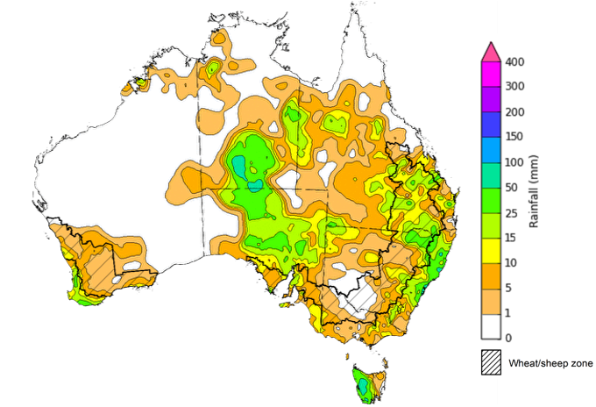
©Commonwealth of Australia 2026, Australian Bureau of Meteorology Issued: 14/10/2026
Note: The rainfall analyses and associated maps utilise data contained in the Bureau of Meteorology climate database, the Australian Data Archive for Meteorology (ADAM). The analyses are initially produced automatically from real-time data with limited quality control. They are intended to provide a general overview of rainfall across Australia as quickly as possible after the observations are received. For further information go to http://www.bom.gov.au/climate/rainfall/

Rainfall forecast for the next eight days
Over the eight days from 15 to 22 October 2026, rainfall is forecast across much of the eastern two- thirds of Australia. Much of the north-west of Western Australia is forecast to receive low rainfall or remain dry.
- Considerable falls of 50-150 millimetres are forecast across much of eastern Queensland, while more moderate falls of 10-100 millimetres are expected across northern New South Wales, the Northern Territory, far northern and far southern Western Australia, and north-western South Australia.
- In Victoria, the remainder of South Australia, southern New South Wales and Tasmania, between 5-25 millimetres of rainfall is likely.
- Little to no rainfall is forecast for central Western Australia.
Across cropping regions, rainfall over the eight days to 22 October 2026 is forecast to be high in the northeast, with lower totals expected across southern regions.
- Across north-eastern cropping regions, falls are expected to be considerable. In Queensland, between 25-150 millimetres of rainfall is forecast, while lower falls of 15-100 millimetres are forecast for northern New South Wales.
  - If realised, these falls are likely to provide a timely boost to soil moisture levels to support summer cropping activities.
- Southern cropping regions, including southern New South Wales and Victoria, are forecast to receive 10–25 millimetres. In South Australia and much of Western Australia, falls of up to 15 millimetres are expected.

Total forecast rainfall for the period 15 October to 22 October 2026
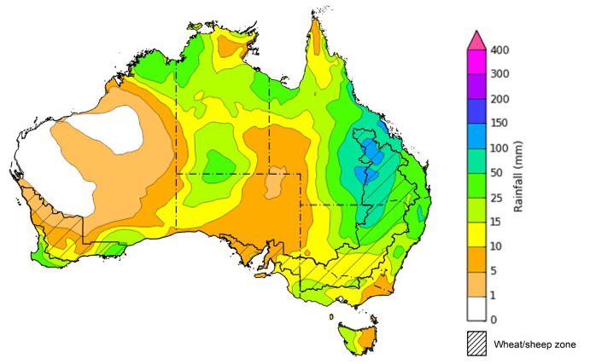
©Commonwealth of Australia 2026, Australian Bureau of Meteorology Issued: 15/10/2026
Note: This rainfall forecast is produced from computer models. As the model outputs are not altered by weather forecasters, it is important to check local forecasts and warnings issued by the Bureau of Meteorology.

1.3. September precipitation percentiles and current production conditions
Crop production is affected by long-term trends in average rainfall and temperature, interannual climate variability, shocks during specific growth stages, and extreme weather events. Some crops are more tolerant than others to certain types of stresses, and at each growth stage, different types of stresses affect crop species in different ways.
Precipitation anomalies and outlooks presented below indicate the current and expected future production conditions for major grain and oilseed producing countries (responsible for over 80% of global crop production). This is an important input to assessing the global grain supply outlook.
Precipitation in September 2026 was variable across the world’s major grain and oilseed producing regions:
- In the northern hemisphere, precipitation was above average in scattered central and western regions of the United States, southern Canada, Türkiye, eastern India, and western parts of China. Precipitation was generally below average in western and central Europe, southern and eastern China, and parts of the southern United States and Mexico. Precipitation was generally average across the remaining major northern hemisphere grain and oilseed producing regions.
- In the southern hemisphere, precipitation was below average across parts of the north and far south of Brazil, south-eastern Australia, as well as parts of Southeast Asia including Indonesia and the Philippines. Precipitation was above average across Argentina and parts of southwest Australia. Precipitation was generally average across the remaining major southern hemisphere grain and oilseed producing regions.

Global precipitation percentiles, September 2026

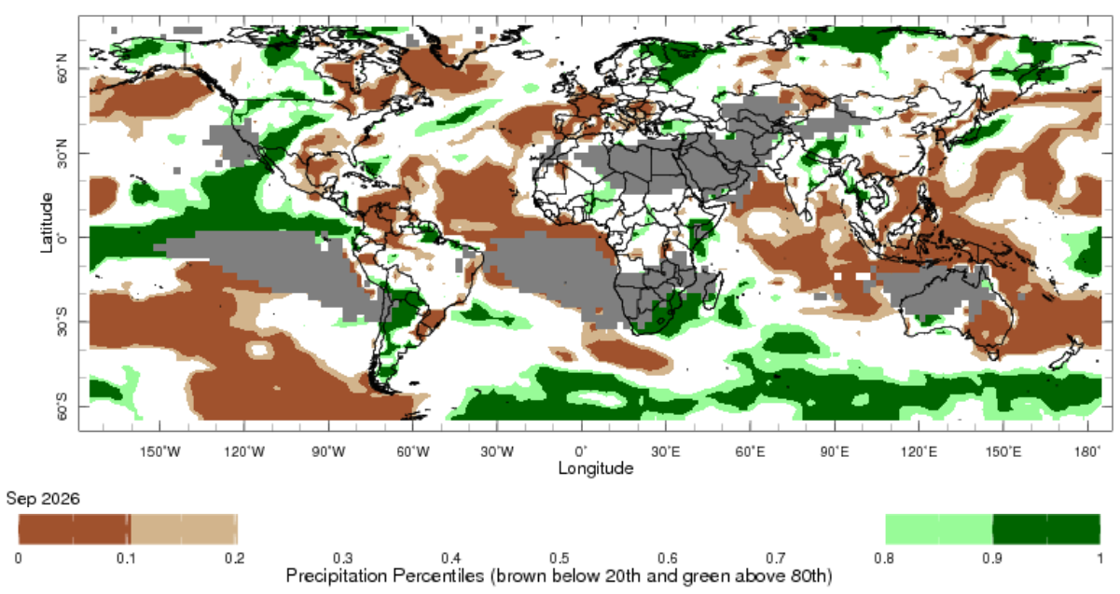
Note: The world precipitation percentiles indicate a ranking of precipitation for September, with the driest (0th percentile) being 0 on the scale and the wettest (100th percentile) being 1 on the scale. Percentiles are based on precipitation estimates from the NOAA Climate Prediction Center’s Climate Anomaly Monitoring System Outgoing Precipitation Index dataset. September precipitation estimates are compared with rainfall recorded over the historical reference period.

As of 28 September 2026, global production conditions were broadly positive with some variability for all four major grain and oilseed crops (wheat, maize, rice and soybeans):
- Wheat – In the northern hemisphere, spring wheat harvest is occurring under broadly favourable conditions apart from some productions concerns in the Black Sea region. In the southern hemisphere, wheat is developing under generally favourable conditions, with exceptions in parts of Australia.
- Maize – In the southern hemisphere, harvesting of the early season crop is nearly complete in Brazil, with sowing of the later season crop underway. In Indonesia, harvesting is concluding with moderate yields. However, in the northern hemisphere unfavourable growing conditions across Europe, and parts of India, Ukraine and the United States, are likely to result in below average crop production outcomes.
- Rice – Global conditions remain broadly favourable for most major rice production regions, with exceptions in Thailand, the Philippines, and Vietnam.
- Soybeans – Harvest has concluded in the southern hemisphere under favourable conditions. In the northern hemisphere, crop development in the United States, Canada and China has been broadly favourable. However, conditions in Ukraine have deteriorated because of hot and dry weather.

Crop conditions, AMIS countries, 28 September 2026
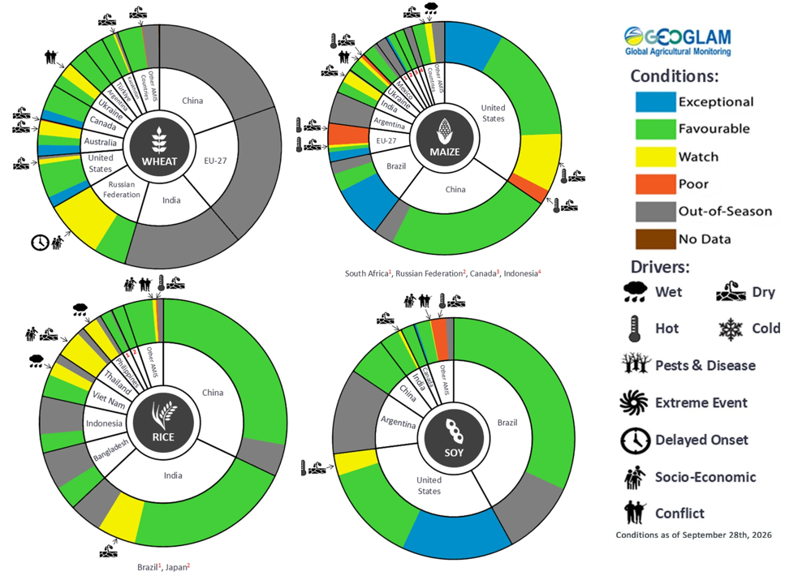
AMIS Agricultural Market Information System.
Source: AMIS

The global climate outlook for November 2026 to January 2027 indicates that mixed rainfall conditions are expected for the world’s major grain and oilseed producing regions. Outlooks and potential production impacts are presented in the following table.
Rainfall outlook and potential impact on the future state of production conditions, November 2026 to January 2027
Region | Rainfall outlook | Potential impact on production
Argentina | Above average rainfall is likely across parts of central and southern Argentina, with broadly average to below average rainfall in the far north. | Generally, above average forecast rainfall is likely to support the silking of corn and the flowering of cotton, soybeans, and other oilseeds.
Black Sea region | Above average rainfall is expected across eastern parts of the Black Sea region, with remaining areas more likely to receive average rainfall. | Average to above average rainfall is likely to support vegetative development and maturation of winter wheat and canola, as well as snowpack ahead of winter wheat dormancy.
Brazil | Rainfall outcomes across Brazil are expected to be below average in many northern and central areas, while far southern areas see broadly average to above average conditions. | Average to above-average rainfall across southern Brazil is likely to benefit the maturation of rice, cotton and sorghum, as well as support the critical flowering stage for maize and soybeans. However, below-average forecast rainfall across central Brazil may adversely affect soybean planting and growth.
Canada | Rainfall across Canada is expected to be below average in southern regions, with scattered areas seeing average to above average rainfall. | Below average rainfall could impair snowpack ahead of the winter dormancy period and increase the risk of crop damage.
China | Above average rainfall is expected across most of China, with central regions seeing average falls. | Generally average to above average rainfall across much of China is likely to support overwintering and reduce the risk of frost damage with insufficient snowpack.
European Union | Average rainfall is expected for much of the European Union, with exceptions in parts of western and central Europe where below average rainfall is more likely. | Close to average rainfall across much of Europe is likely to benefit harvesting and planting of major crops, as well as snowpack ahead of dormancy. Below average rainfall in parts of western Europe could reduce yield potential.
South Asia (India) | Above average rainfall is forecast for central regions of India, with isolated southern and eastern regions more likely to see below average rainfall. | Anticipated above average to average rainfall is likely to provide an upside to production outcomes over the vegetative growth period.
Southeast Asia (SEA) | Below average rainfall is likely across much of Southeast Asia. | Below average rainfall in Southeast Asia is likely to impede growth and development outcomes for crops.
The United States | Above average rainfall is likely for much of the southern and central United States, with northern areas likely to see close to average falls. | Average to above average rainfall conditions expected across the United States are likely to support soil moisture levels and the development of major crops ahead of winter dormancy.

Water

Water markets – current week
Water storage levels in the Murray-Darling Basin (MDB) decreased by 33 gigalitres (GL) between 8 October 2026 and 15 October 2026. The current volume of water held in storages is 15,028 GL, equivalent to 68% of total storage capacity. This is 1% or 215 GL less than the same time last year. Water storage data is sourced from the Bureau of Meteorology.

Weekly water storage levels in the Murray-Darling Basin, 2013–2026
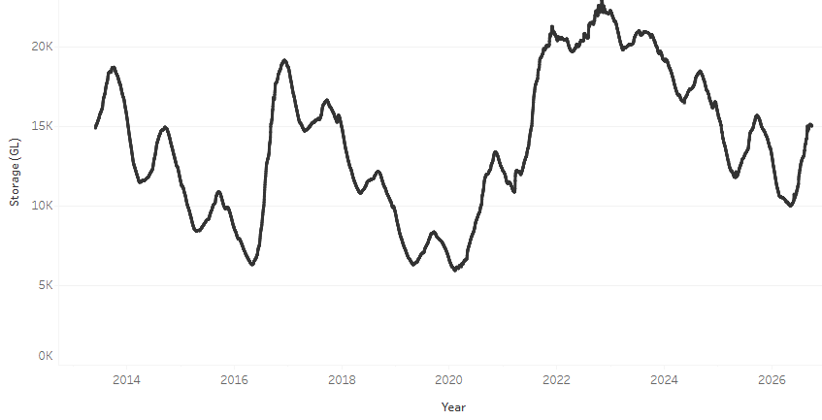
Allocation prices in the Victorian Murray below the Barmah Choke increased from $322/ML on 8 October 2026 to $349/ML on 15 October 2026. Trade from the Goulburn to the Murray is closed. Trade downstream through the Barmah Choke is closed. Trade from the Murrumbidgee to the Murray is open.

Monthly surface water trade activity 2022–2026, Victorian Murray below the Barmah Choke

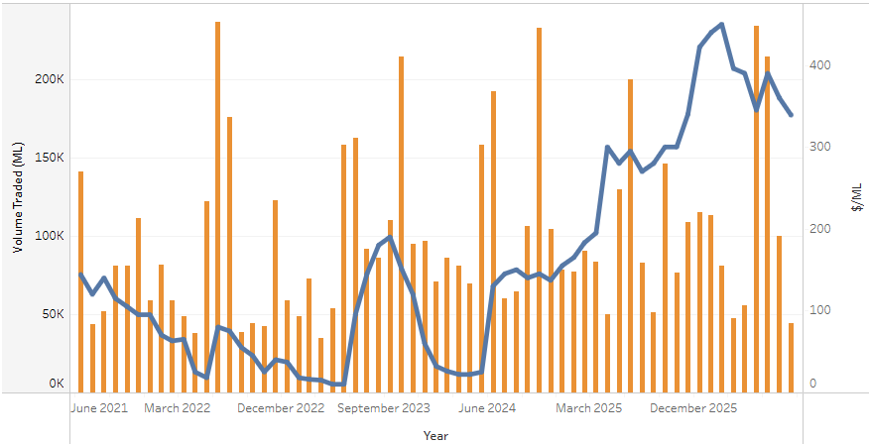

Weekly water market prices, Southern Murray–Darling Basin
Region | $/ML
NSW Murray Above | 185
NSW Murrumbidgee | 252
Vic Greater Goulburn | 298
Vic Murray Below | 349
Note: The water allocation prices shown are volume weighted average prices based on the last 10 trades. Price data is sourced from Waterflow and current as at 8 October 2026.
To access the full, interactive, weekly water dashboard, which contains the latest and historical water storage, water market and water allocation information, please visit https://www.agriculture.gov.au/abares/products/weekly_update/weekly-update-261015

Commodities
Indicator | Week average | Unit | Latest Price | Previous Week | Weekly change |  | Price 12 months ago | Annual change
Selected world indicator prices
AUD/USD Exchange rate | 14-Oct | A$/US$ | 0.70 | 0.70 | 0% | 0.65 |  | 7%
Wheat – US no. 2 hard red winter wheat, FOB Gulf | 14-Oct | US$/t | 321 | 332 | -3% | 231 |  | 39%
Corn – US no. 2 yellow corn, FOB Gulf | 14-Oct | US$/t | 218 | 223 | -2% | 198 |  | 10%
Canola – Rapeseed, Canada, FOB Vancouver | 14-Oct | US$/t | 610 | 610 | 0% | 473 |  | 29%
Cotton – Cotlook A Index | 14-Oct | USc/lb | 91.2 | 90.8 | 1% | 76.1 |  | 20%
Sugar – Intercontinental Exchange, nearby futures, no.11 contract | 14-Oct | USc/lb | 20.9 | 20.6 | 1% | 15.6 |  | 33%
Wool – Eastern Market Indicator | 14-Oct | Ac/kg clean | 1,803 | 1,820 | -1% | 1,476 |  | 22%
Wool – Western Market Indicator | 14-Oct | Ac/kg clean | 1,986 | 1,988 | 0% | 1,622 |  | 22%
Selected Australian grain export prices
Australian Premium White (APW) Wheat, FOB Port Adelaide, SA | 14-Oct | A$/t | 432 | 432 | 0% | 372 |  | 16%
Australian Standard White (ASW) Wheat, FOB Port Adelaide, SA | 14-Oct | A$/t | 423 | 423 | 0% | 368 |  | 15%
Feed Barley – FOB Port Adelaide, SA | 14-Oct | A$/t | 372 | 374 | 0% | 350 |  | 6%
Canola – FOB Kwinana, WA | 14-Oct | A$/t | 805 | 807 | 0% | 794 |  | 1%
Grain Sorghum – FOB Brisbane, QLD | 14-Oct | A$/t | 461 | 456 | 1% | 405 |  | 14%
Selected domestic livestock indicator prices
Beef – Eastern Young Cattle Indicator | 14-Oct | Ac/kg cwt | 939 | 918 | 2% | 846 |  | 11%
Mutton – Mutton indicator (18–24 kg fat score 2–3), VIC | 14-Oct | Ac/kg cwt | 832 | 823 | 1% | 739 |  | 13%
Lamb – National Trade Lamb Indicator | 14-Oct | Ac/kg cwt | 1,150 | 1,127 | 2% | 1,108 |  | 4%
Pig – Eastern Seaboard (60.1–75 kg), NSW buyer price | 14-Oct | Ac/kg cwt | 367 | 367 | 0% | 461 |  | -20%
Live cattle – Light steers to Indonesia | 14-Oct | Ac/kg lwt | 450 | 440 | 2% | 440 |  | 2%
Global Dairy Trade (GDT) weighted average prices
Dairy – Whole milk powder | 14-Oct | US$/t | 3,605 | 3,565 | 1% | 3,653 |  | -1%
Dairy – Skim milk powder | 14-Oct | US$/t | 3,847 | 3,689 | 4% | 2,579 |  | 49%
Dairy – Cheddar cheese | 14-Oct | US$/t | 3,925 | 4,075 | -4% | 4,808 |  | -18%
Dairy – Anhydrous milk fat | 14-Oct | US$/t | 5,683 | 5,739 | -1% | 6,977 |  | -19%

Selected world indicator prices
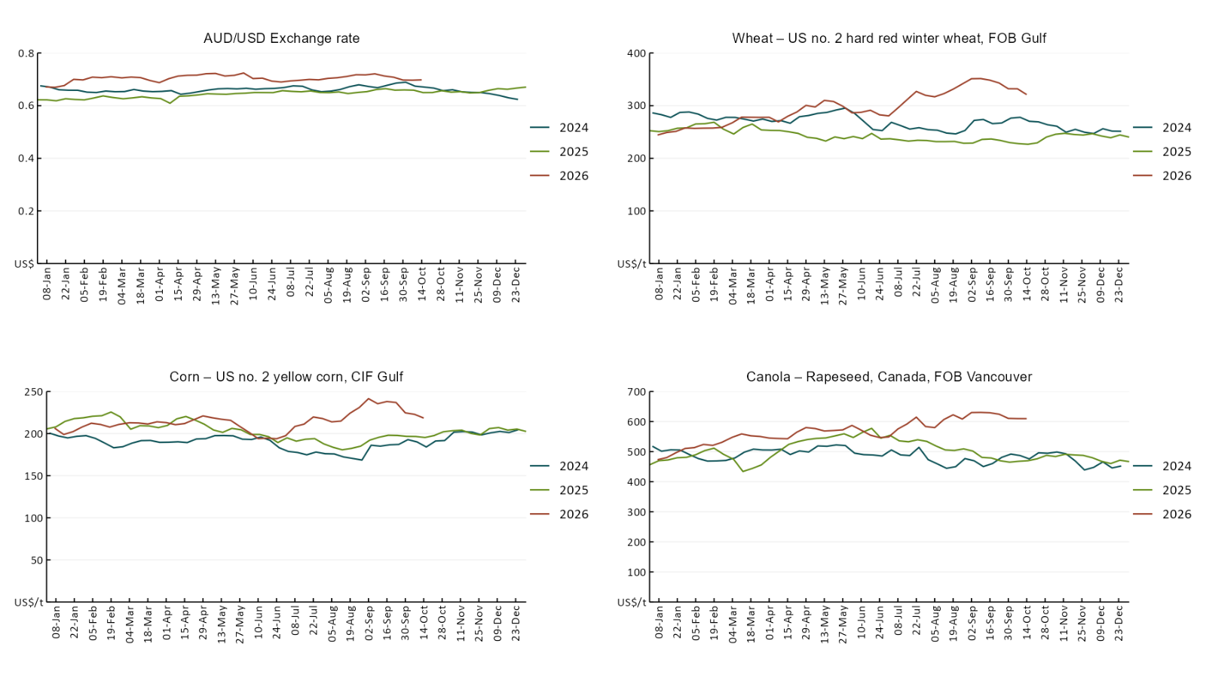

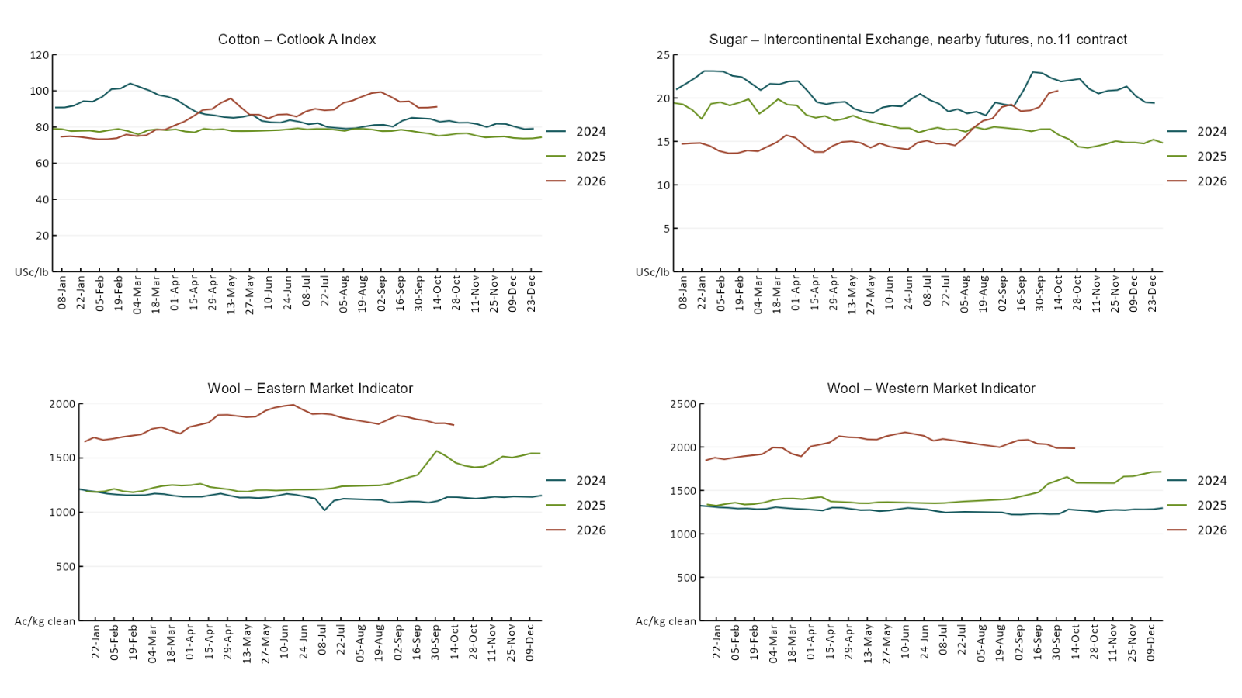

3.2 Selected domestic crop indicator prices
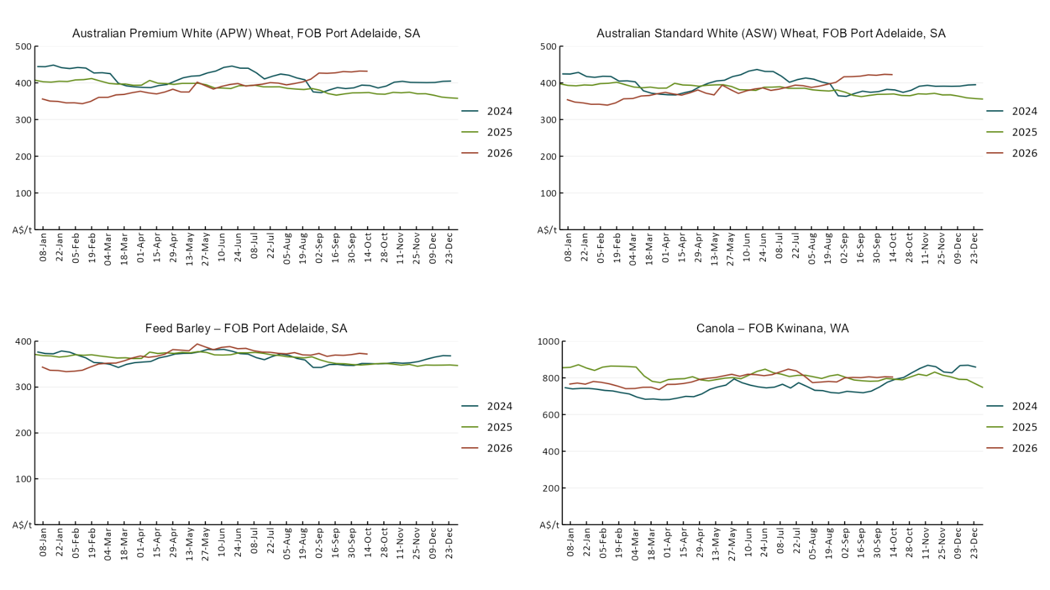

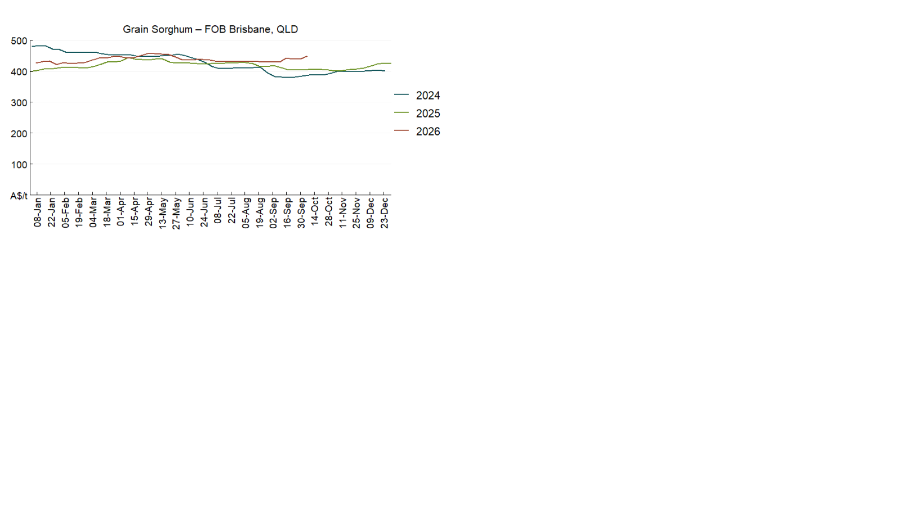

3.3 Selected domestic livestock indicator prices
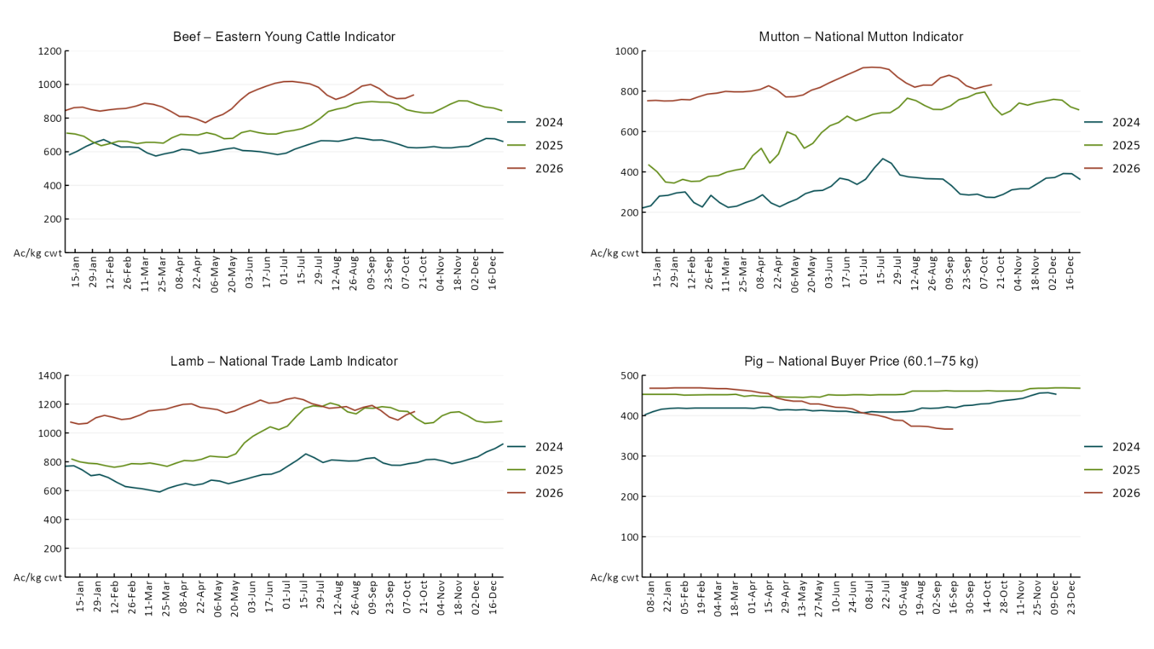

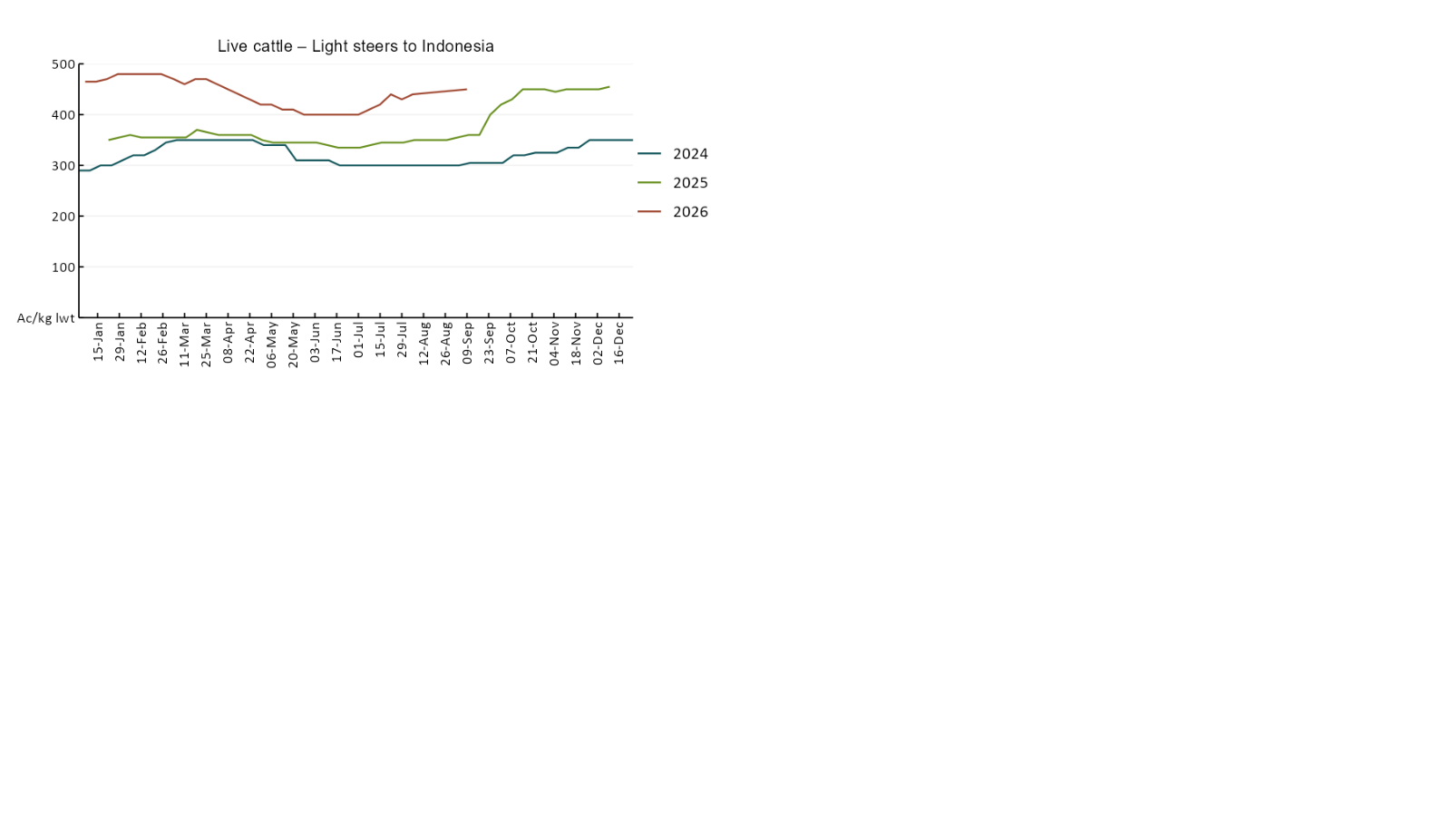

3.4 Global Dairy Trade (GDT) weighted average prices
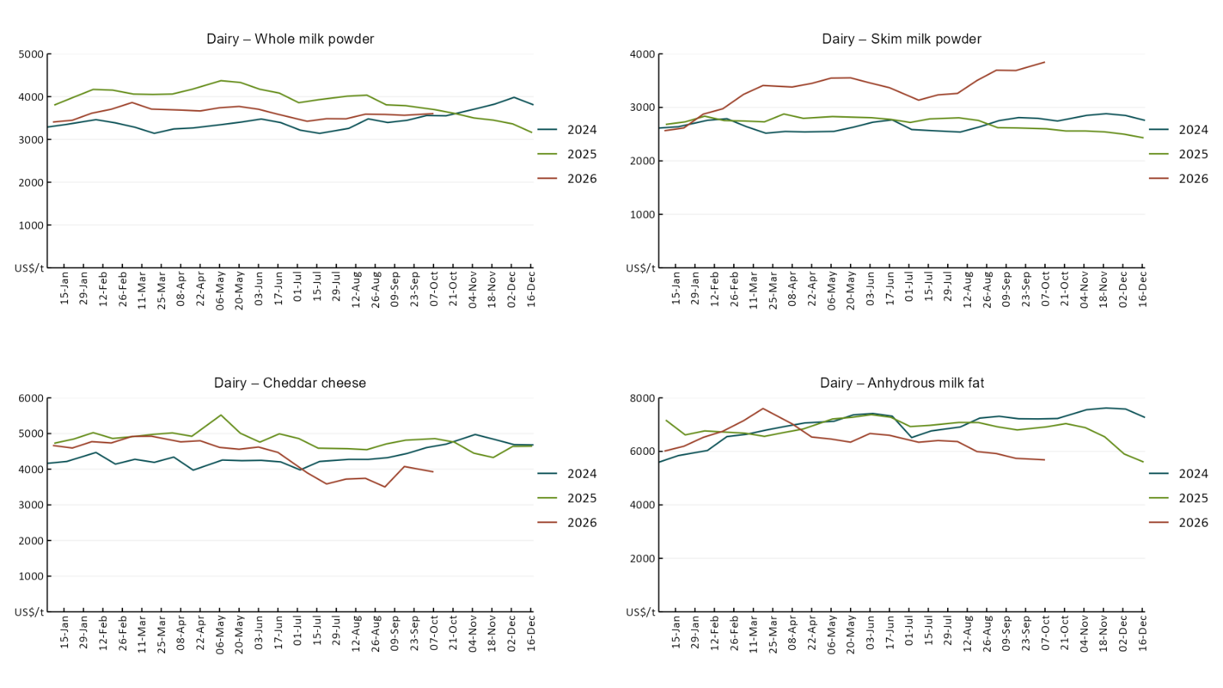

3.5 Selected fruit and vegetable prices
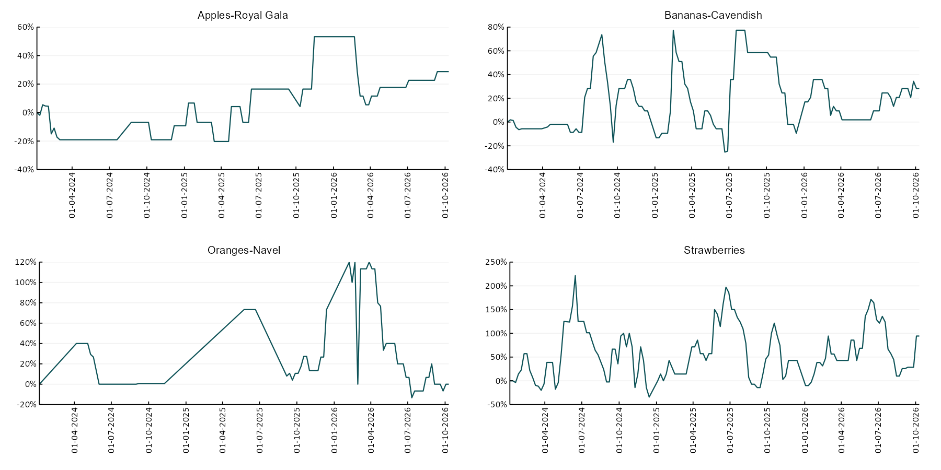

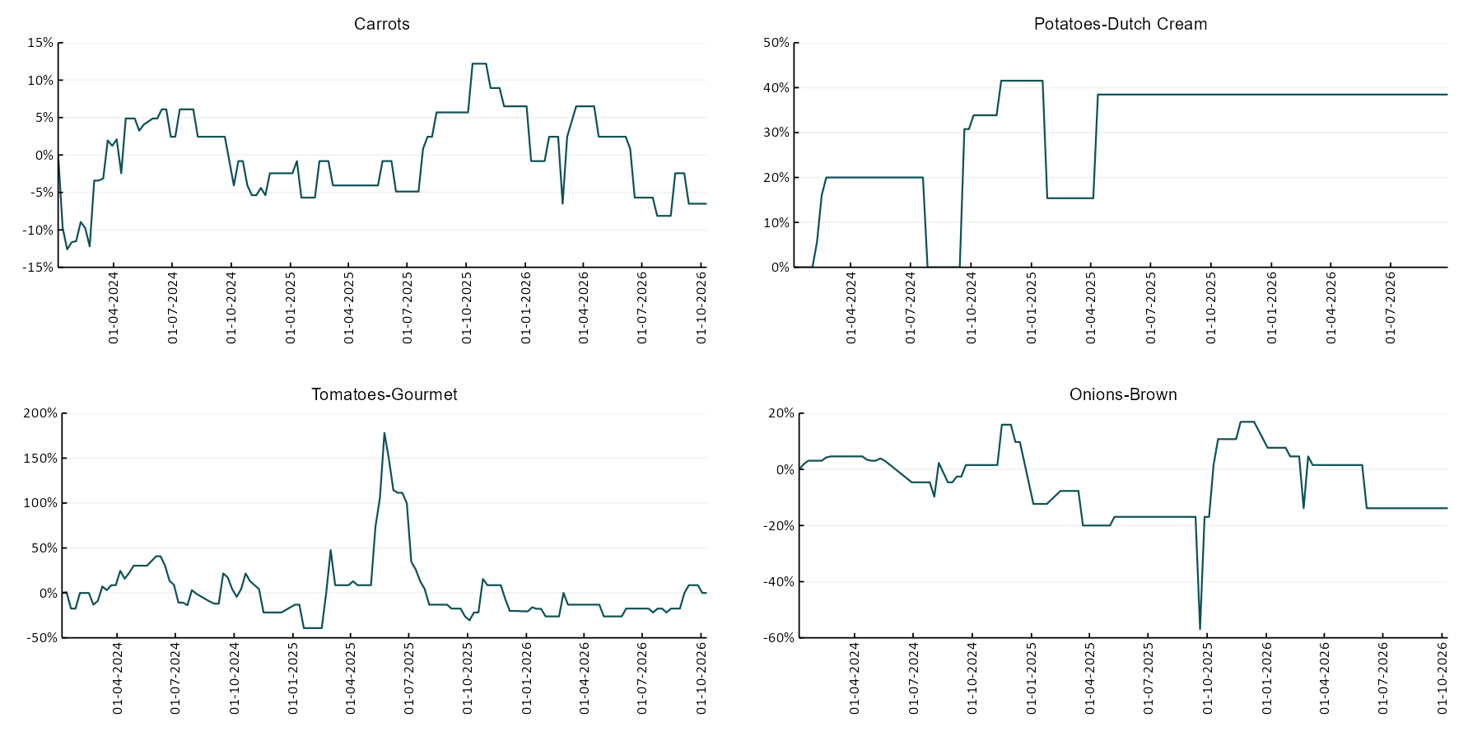

3.6 Selected domestic fodder indicator prices
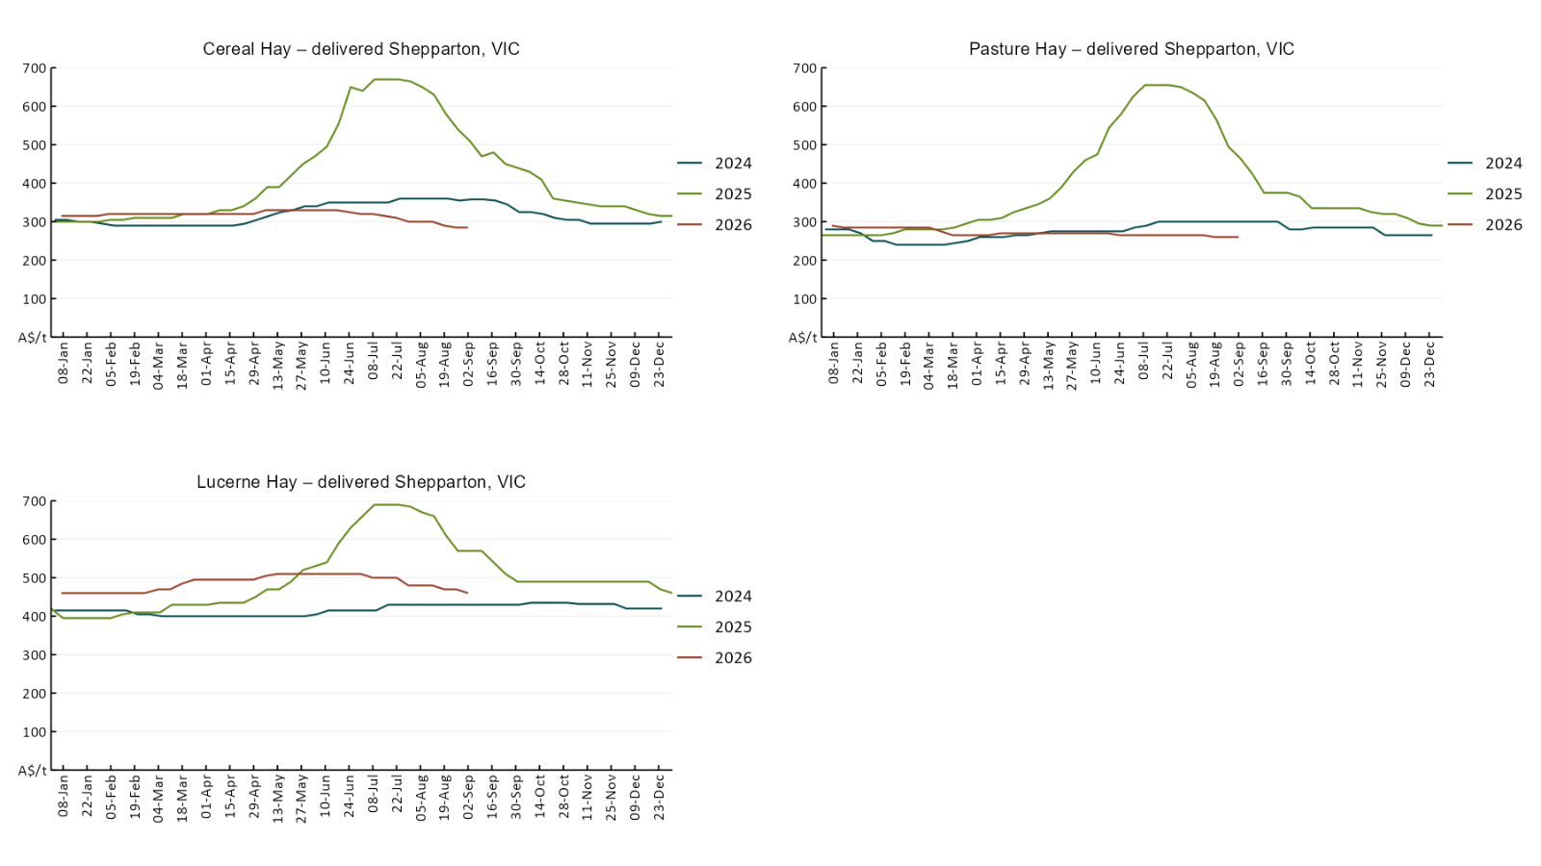

4. Data attribution

Climate
Bureau of Meteorology
- Weekly rainfall totals: www.bom.gov.au/climate/maps/rainfall/
- Monthly and last 3-month rainfall percentiles: https://www.bom.gov.au/climate/ahead/outlooks/#moreMaps
- Rainfall forecast: www.bom.gov.au/jsp/watl/rainfall/pme.jsp
- Seasonal outlook: www.bom.gov.au/climate/outlooks/#/overview/summary/
- Climate drivers: http://www.bom.gov.au/climate/enso/
- Soil moisture: https://awo.bom.gov.au/products/historical/soilMoisture-rootZone/

Other
- Pasture growth: www.longpaddock.qld.gov.au/aussiegrass/
- 3-month global outlooks: Environment and Climate Change Canada, NOAA Climate Prediction Center, EUROBRISA CPTEC/INPE, European Centre for Medium-Range Weather Forecasts, Hydrometcenter of Russia, National Climate Center Climate System Diagnosis and Prediction Room (NCC), International Research Institute for Climate and Society
- Global production: https://ipad.fas.usda.gov/ogamaps/cropmapsandcalendars.aspx
- Autumn break: Pook et al., 2009, https://rmets-onlinelibrary-wiley-com.virtual.anu.edu.au/doi/epdf/10.1002/joc.1833

Water
Prices
- Waterflow: https://www.waterflow.io/
- Ruralco: https://www.ruralcowater.com.au/
- Bureau of Meteorology:
- Allocation trade: http://www.bom.gov.au/water/dashboards/#/water-markets/mdb/at
- Storage volumes: http://www.bom.gov.au/water/dashboards/#/water-storages/summary/drainage

Trade constraints:
- Water NSW: https://www.waternsw.com.au/customer-service/ordering-trading-and-pricing/trading/murrumbidgee
- Victorian Water Register: https://www.waterregister.vic.gov.au/TradingRules2019/

Commodities
Fruit and vegetables
- Datafresh: www.freshstate.com.au

Pigs
- Australian Pork Limited: www.australianpork.com.au

Dairy
- Global Dairy Trade: www.globaldairytrade.info/en/product-results/

World wheat, canola
- International Grains Council: https://www.igc.int/en/default.aspx
- United States Department of Agriculture

World cotton
- Cotlook: www.cotlook.com/

World sugar
- New York Stock Exchange - Intercontinental Exchange

Wool
- Australian Wool Exchange: www.awex.com.au/

Domestic wheat, barley, sorghum, canola and fodder
- Jumbuk Consulting Pty Ltd: Jumbuk AG | Agriculture Consulting

Cattle, beef, mutton, lamb, goat and live export
- Meat and Livestock Australia: https://www.mla.com.au/prices-markets/

Australian Agricultural Drought Indicators
About Australian Agricultural Drought Indicators
- The Australian Agricultural Drought Indicators (AADI) project links weather and agricultural data with a range of scientific and economic models to measure and forecast the effects of climate variability and drought on agricultural outcomes.
On AADI, projected broadacre farm profits are presented as percentile outcomes relative to simulated historical outcomes using the groupings:
Highest | 95-100th percentile
Very much above average | 85-95th percentile
Above average | 65-85th percentile
Average | 35-65th percentile
Below average | 15-35th percentile
Very much below average | 5-15th percentile
Lowest 5% | 0-5th percentile

There are two AADI farm profit indicators:
- The AADI farm profit climate and price indicator shows the effect of climate and prices on broadacre farm business profits of current farms compared to the last 33 years.
- The AADI farm profit climate only indicator isolates the effect of climate on profits by holding prices fixed.

© Commonwealth of Australia 2026

Ownership of intellectual property rights
Unless otherwise noted, copyright (and any other intellectual property rights, if any) in this publication is owned by the Commonwealth of Australia (referred to as the Commonwealth).

Creative Commons licence
All material in this publication is licensed under a Creative Commons Attribution 4.0 International Licence except content supplied by third parties, logos and the Commonwealth Coat of Arms.
Inquiries about the licence and any use of this document should be emailed to copyright@aff.gov.au.


Cataloguing data
This publication (and any material sourced from it) should be attributed as:
ABARES 2026, Weekly Australian Climate, Water and Agricultural Update, Australian Bureau of Agricultural and Resource Economics and Sciences, Canberra, 15 October 2026. CC BY 4.0 DOI: https://doi.org/10.25814/5f3e04e7d2503
ISSN 2652-7561
This publication is available at https://www.agriculture.gov.au/abares/products/weekly_update
Department of Agriculture, Fisheries and Forestry
GPO Box 858 Canberra ACT 2601
Telephone 1800 900 090
Web agriculture.gov.au/abares

Disclaimer
The Australian Government acting through the Department of Agriculture, Fisheries and Forestry, represented by the Australian Bureau of Agricultural and Resource Economics and Sciences, has exercised due care and skill in preparing and compiling the information and data in this publication. Notwithstanding, the Department of Agriculture, Fisheries and Forestry, ABARES, its employees and advisers disclaim all liability, including liability for negligence and for any loss, damage, injury, expense or cost incurred by any person as a result of accessing, using or relying on any of the information or data in this publication to the maximum extent permitted by law.

Statement of Professional Independence
The views and analysis presented in ABARES publications, including this one, reflect ABARES professionally independent findings, based on scientific and economic concepts, principles, information and data. These views, analysis and findings may not reflect or be consistent with the views or positions of the Australian Government, or of organisations or groups who have commissioned ABARES reports or analysis. More information on professional independence is provided on the ABARES website.

Acknowledgements
This report was prepared by Holly Beale and Matthew Miller.

