
No. 41/2026 22 October 2026

Summary of key issues
- In the week ending 21 October 2026, cold fronts and low-pressure systems brought rainfall to large areas of north-eastern Australia, with lighter isolated showers distributed across the country.
  - Cropping regions in Queensland and northern New South Wales saw between 10- 100 millimetres of rainfall over the period.
  - These falls are expected to support summer crop development and pasture growth but are likely to delay winter crop harvest activities.
- Over the eight days from 22 to 29 October 2026, rainfall is forecast across much of the eastern two- thirds of Australia. Much of the north-west of Western Australia is forecast to receive low rainfall or remain dry. Across north-eastern cropping regions, falls are expected to be considerable. In Queensland and northern New South Wales, between 25-150 millimetres of rainfall is forecast. Lower falls of 15-50 millimetres are forecast for Victoria, South Australia, and central and southern New South Wales
  - If realised, these falls are likely to provide a timely boost to soil moisture levels to support pasture growth, winter crop grain filling in the southeast and summer cropping activities in the northeast. However following rainfall across many north-eastern regions last week, these expected falls are likely to further delay winter crop harvest activities in these areas and increase the risk of grain quality downgrades due to excess moisture at harvest.
- Despite the strengthening El Niño, the Bureau of Meteorology’s November 2026 to January 2027 outlook indicates below average rainfall is likely be restricted to parts of the far south-east and the northern tropics. Above average rainfall is more likely across much of western and central Australia, as well as parts of inland and southern Queensland and northern New South Wales.
  - If forecast above average November to January rainfall totals are realised, they are likely to support at least average pasture growth across much of eastern and northern Australia. In Queensland and north-eastern New South Wales these falls are also likely to benefit the growth of early planted summer crops and provide opportunities for later plantings.
- According to the Australian Agricultural Drought Indicators September 2026 estimates, taking into account climate and price impacts, broadacre farm profits for 2026–27 at a national level are forecast to be above average (72nd percentile) compared to the past 33 years.
- Water storage levels in the Murray-Darling Basin (MDB) decreased by 97 gigalitres (GL) between 15 October 2026 and 22 October 2026. The current volume of water held in storages is 14,931 GL, equivalent to 67% of total storage capacity. This is 77 GL less than the same time last year. Water storage data is sourced from the Bureau of Meteorology.
- Allocation prices in the Victorian Murray below the Barmah Choke decreased from $349/ML on 15 October 2026 to $324/ML on 22 October 2026. Trade from the Goulburn to the Murray is closed. Trade downstream through the Barmah Choke is closed. Trade from the Murrumbidgee to the Murray is closed.

Climate

Rainfall this week
In the week ending 21 October 2026, cold fronts and low-pressure systems brought rainfall to large areas of north-eastern Australia, with lighter isolated showers distributed across the country.
- Falls of between 5-200 millimetres were recorded across much of Queensland, with exceptions in the far north and south-west. In north-eastern New South Wales, up to 100 millimetres was recorded.
- Falls of 5-25 millimetres were recorded across scattered areas of southern New South Wales, South Australia, the Northern Territory, and Western Australia. Isolated areas saw up to 50 millimetres.
- In contrast, much of Tasmania and Victoria recorded little to no rainfall.
Across cropping regions, southern areas recorded little to no rainfall, with significant falls recorded in north-eastern regions.
- Cropping regions in Queensland and northern New South Wales saw between 10-100 millimetres of rainfall over the period.
  - These falls are expected to support summer crop development and pasture growth but are likely to delay winter crop harvest activities.
- In Western Australia, South Australia, western Victoria, and central New South Wales, falls of between 1-10 millimetres were recorded.
- Limited rainfall was recorded across remaining cropping regions

Rainfall for the week ending 21 October 2026
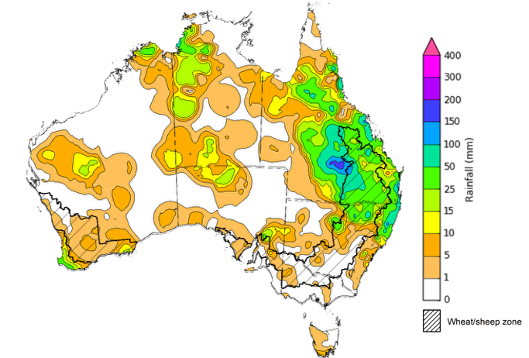
©Commonwealth of Australia 2026, Australian Bureau of Meteorology Issued: 21/10/2026
Note: The rainfall analyses and associated maps utilise data contained in the Bureau of Meteorology climate database, the Australian Data Archive for Meteorology (ADAM). The analyses are initially produced automatically from real-time data with limited quality control. They are intended to provide a general overview of rainfall across Australia as quickly as possible after the observations are received. For further information go to http://www.bom.gov.au/climate/rainfall/

Rainfall forecast for the next eight days
Over the eight days from 22 to 29 October 2026, rainfall is forecast across much of the eastern two- thirds of Australia. Much of the north-west of Western Australia is forecast to receive low rainfall or remain dry.
- Considerable falls of 50-150 millimetres are forecast across much of eastern Queensland, north-eastern New South Wales, parts of western Tasmania and the far north of the Northern Territory.
- More moderate falls of 10-50 millimetres are expected across Victoria, South Australia, eastern Western Australia, and the remainder of Northern Territory, Tasmania, New South Wales and Queensland.
- Little to no rainfall is forecast for north-western Western Australia.
Across cropping regions, rainfall over the eight days to 29 October 2026 is forecast to be high in the east and southeast, with lower totals expected across south-western regions.
- Across north-eastern cropping regions, falls are expected to be considerable. In Queensland and northern New South Wales between 25-150 millimetres is forecast. Lower falls of between 10- 50 millimetres are forecast for Victoria, South Australia, and central and southern New South Wales.
  - If realised, these falls are likely to provide a timely boost to soil moisture levels to support pasture growth, winter crop grain filling in the southeast and summer cropping activities in the northeast. However following rainfall across many north-eastern regions last week, these expected falls are likely to further delay winter crop harvest activities in these areas and increase the risk of grain quality downgrades due to excess moisture at harvest.
- Western Australia cropping regions are forecast to receive 5-10 millimetres.

Total forecast rainfall for the period 22 October to 29 October 2026
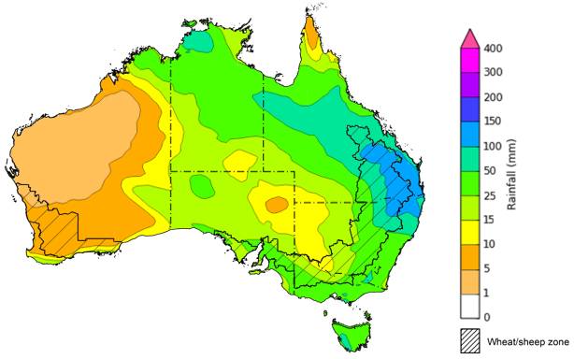
©Commonwealth of Australia 2026, Australian Bureau of Meteorology Issued: 22/10/2026
Note: This rainfall forecast is produced from computer models. As the model outputs are not altered by weather forecasters, it is important to check local forecasts and warnings issued by the Bureau of Meteorology.

National Climate Outlook
The Bureau of Meteorology indicates that El Niño is continuing to strengthen to near record highs in the tropical Pacific. El Niño typically increases the chance of drier conditions across parts of eastern Australia during spring, although rainfall outcomes vary depending on the strength and interaction of other climate influences. The Indian Ocean Dipole (IOD) is currently neutral, while the Southern Annular Mode (SAM) is trending negative and forecast to return to neutral over the coming week. As a result, the IOD is currently providing no strong additional influence on Australian rainfall patterns, while effects from the SAM are likely to be limited. Sea surface temperatures are forecast to remain warmer than average across much of the globe during November to January, including notably warm waters near south-eastern Australia, increasing the risk of marine heatwave conditions.
The rainfall outlook for November 2026 indicates that below median rainfall is more likely across parts of the far southeast and northeast of Australia. Above median rainfall is more likely across much of Western Australia, the Northern Territory, Queensland, South Australia and northern New South Wales.
The Bureau of Meteorology’s climate model indicates a 75% chance of November rainfall totals between 25-100 millimetres across large areas of northern and eastern Australia, with higher totals possible across the far north of the Northern Territory. Much of southern, central, and north-eastern Australia is likely to receive 5-50 millimetres of rainfall.
Across cropping regions in Queensland and northern New South Wales, there is a 75% chance of receiving rainfall totals of between 25-100 millimetres during November 2026. In southern New South Wales, falls of between 10-50 millimetres are likely, with lower falls of 5-25 millimetres in Victoria, South Australia and Western Australia. If realised, these expected rainfall totals are likely to support winter crop production prospects and pasture growth across south-eastern growing regions where crops and pastures remain responsive, and provide additional soil moisture to support summer growth planting across Queensland and northern New South Wales.

Rainfall totals that have a 75% chance of occurring in November 2026

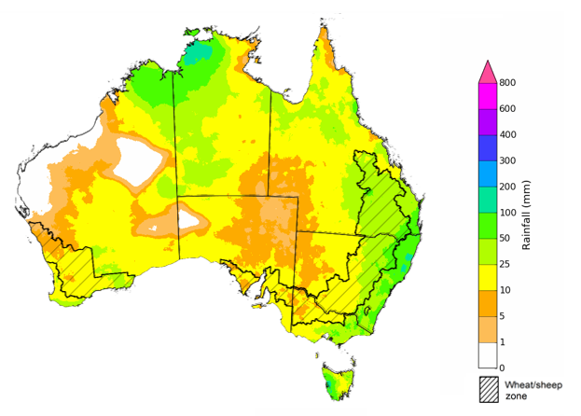
©Commonwealth of Australia 2026, Australian Bureau of Meteorology Issued: 22/10/2026
The rainfall outlook for November 2026 to January 2027 indicates that below average rainfall is likely across parts of the far southeast of Australia and large areas the tropical north. Above average rainfall is more likely across much of south-western and central Australia, as well as eastern regions including southern Queensland and northern New South Wales.
During the November 2026 to January 2027 period, the chance of receiving above median rainfall is highest across cropping regions in Western Australia, western areas in South Australia, southern Queensland, and northern New South Wales. Meanwhile, cropping regions in eastern South Australia, Victoria, and southern New South Wales have a close to equal chance of above median or below median rainfall.

Chance of exceeding the median rainfall November 2026 to January 2027

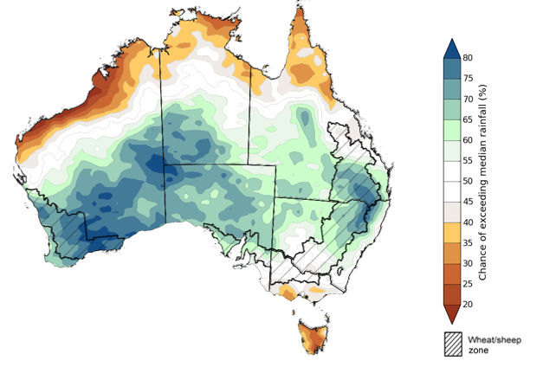
©Commonwealth of Australia 2026, Australian Bureau of Meteorology Issued: 22/10/2026

The rainfall outlook for November 2026 to January 2027 suggests a 75% chance of receiving rainfall totals of between 100–400 millimetres across large areas of eastern and northern Australia. Higher falls above 400 millimetres are possible across parts of the northern tropics and scattered eastern coastal regions. Lower rainfall totals are forecast for central and western regions, including much of Western Australia, South Australia, south-western Queensland and western parts of New South Wales and Victoria.
In cropping regions, there is a 75% chance of receiving between 100–300 millimetres across much of Queensland and eastern New South Wales. Southern cropping regions, including Western Australia, South Australia, Victoria and south-western New South Wales, are more likely to receive lower totals of 25–100 millimetres.
If these forecast November to January rainfall totals are realised, they are likely to support at least average pasture growth across much of eastern and northern Australia. In Queensland and north-eastern New South Wales, forecast rainfall with aid late summer crop planting opportunities and support the growth and yield potential of early planted summer crops.

Rainfall totals that have a 75% chance of occurring November 2026 to January 2027

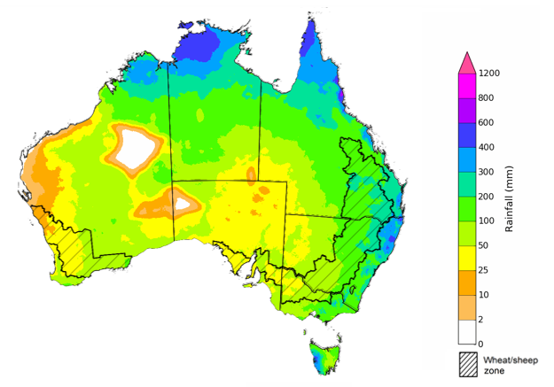
©Commonwealth of Australia 2026, Australian Bureau of Meteorology Issued: 22/10/2026

Climate and price impacts on broadacre farm profits
The Australian Agricultural Drought Indicators (AADI) project combines climate and economic modelling to produce monthly forecasts of broadacre farm profits. The AADI profit (climate and prices) indicator brings together forecast seasonal conditions (using Bureau of Meteorology climate data) and commodity prices (drawn from the quarterly ABARES Agricultural Commodities). This indicator provides a representation of forecast farm profits, presented as percentiles relative to the last 33 years (which provide a long-term historical benchmark). For more information, see Australian Agricultural Drought Indicators.
Considering recent and forecast climatic conditions as at the end of September 2026, Australian broadacre farm business profits are forecast to be average or better across much of Australia in 2026–27, tracking at the 73rd percentile of the last 33 years. Broadacre farm business profits are expected to be more favourable for much of Queensland, Victoria, South Australia, the Northern Territory, western New South Wales, and parts of central and northern Western Australia. In contrast, across parts of north-western and south-western Western Australia and isolated areas of south-eastern Queensland and north-eastern New South Wales, broadacre farm business profits are forecast to be below average.
Broadacre farm business profit indicator (climate and price), 2026–27
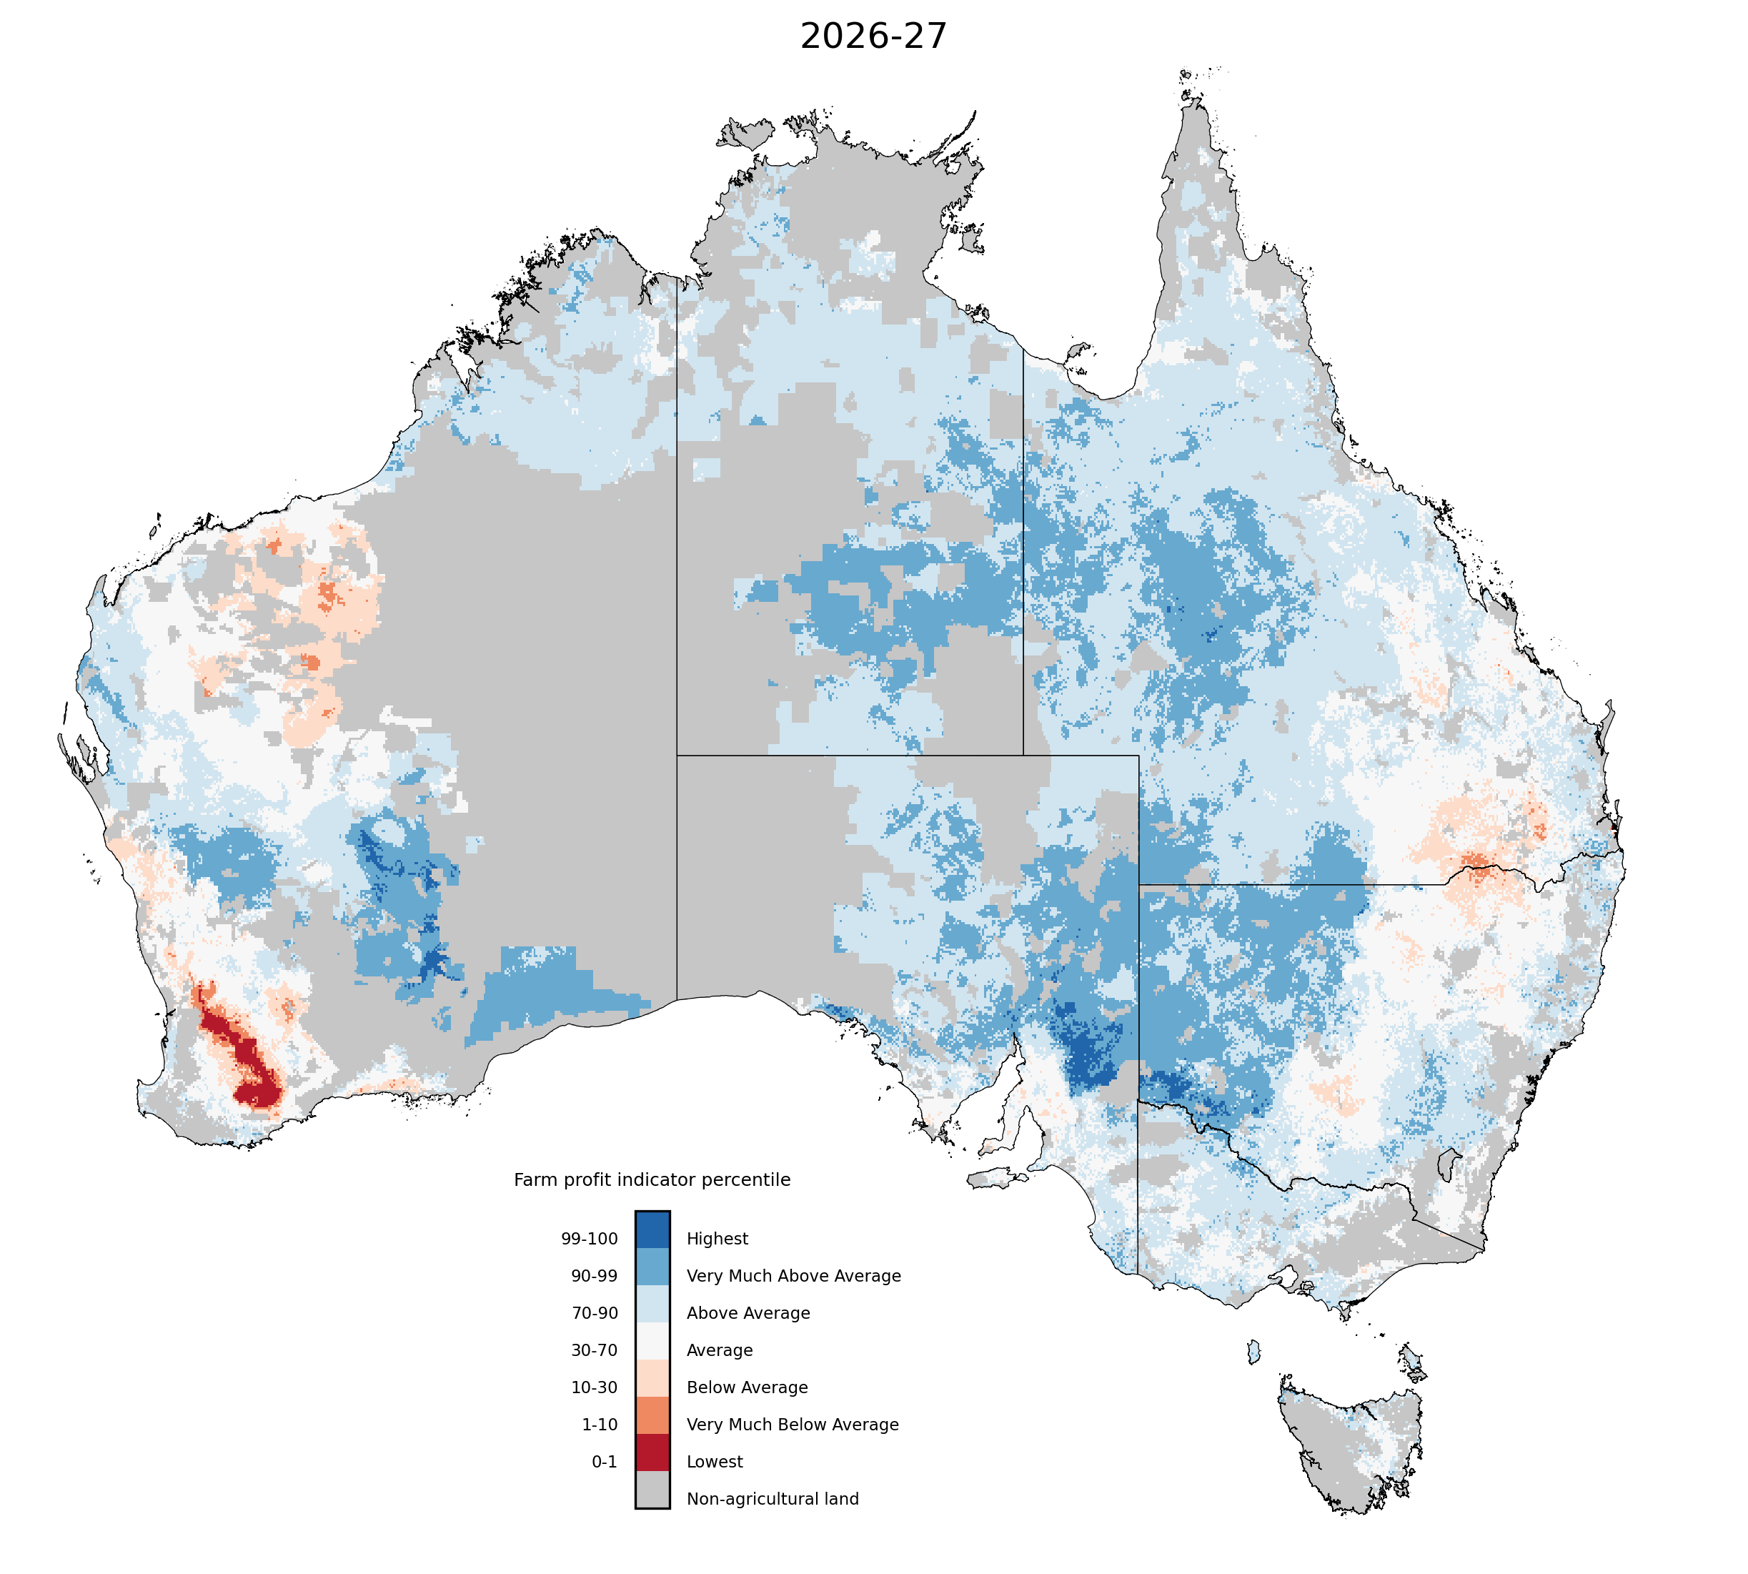

Note: The percentile ranges cover the forecast profitability of broadacre farms in 2026–27 based on forecast climate conditions and prices and current farm characteristics. They are calculated compared to simulated farm performance over the past 33 years, based on historical climate conditions and prices.

Source: ABARES farmpredict; AADI

The interplay between climate and price drivers has created distinct regional outcomes:
- The strongest forecast broadacre farm business profits are concentrated in the Northern Territory, Queensland, central Western Australia, northern South Australia and western New South Wales. Here, favourable climatic conditions are aligning with strong livestock prices to lead to above average to very much above average forecast farm business profits in many areas.
- In southern cropping regions, specifically parts of Western Australia, southern Queensland, and northern and southern New South Wales, less favourable climatic conditions have constrained production outcomes. This is compounded by higher input prices but partially offset by supportive commodity prices for broadacre crops and livestock.
Conditions as of the end of September 2026 are expected to be broadly above average, with significant regional variability:
- Profit (climate and price impacts) is forecast to be lowest in Western Australia (average at 33rd percentile) and second lowest in Queensland (average at 66th percentile). The 5 lowest performing Australian Agricultural and Grazing Industries Survey (AAGIS) regions across the Wheat-sheep and High rainfall zones in 2026–27 are forecast to be:
  - WA: Central and South Wheat Belt (below average at the 28th percentile)
  - QLD: Eastern Darling Downs (average at the 34th percentile)
  - NSW: North-West Slopes and Plains (average at the 38th percentile)
  - WA: North and East Wheat Belt (average at the 45th percentile)
  - QLD: Darling Downs and Central Highlands (average at the 49th percentile)
- Profit (climate and price) is forecast to be highest in Northern Territory (above average at 85th percentile) and second highest in Victoria (above average at 83rd percentile). The 5 lowest performing (AAGIS) regions across the Wheat-sheep and High rainfall zones in 2026–27are forecast to be:
  - VIC: Mallee (above average at the 87th percentile)
  - VIC: Central North (above average at the 85th percentile)
  - QLD: Central North (above average at the 83rd percentile)
  - SA: Eyre Peninsula (above average at the 81st percentile)
  - QLD: North Coastal - Mackay to Cairns (above average at the 80th percentile)

Water

Water markets – current week
Water storage levels in the Murray-Darling Basin (MDB) decreased by 97 gigalitres (GL) between 15 October 2026 and 22 October 2026. The current volume of water held in storages is 14,931 GL, equivalent to 67% of total storage capacity. This is 77 GL less than the same time last year. Water storage data is sourced from the Bureau of Meteorology.

Weekly water storage levels in the Murray-Darling Basin, 2013–2026
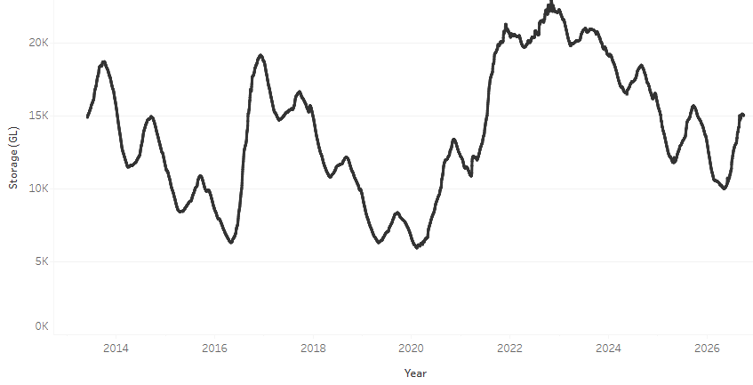
Allocation prices in the Victorian Murray below the Barmah Choke decreased from $349/ML on 15 October 2026 to $324/ML on 22 October 2026. Trade from the Goulburn to the Murray is closed. Trade downstream through the Barmah Choke is closed. Trade from the Murrumbidgee to the Murray is closed

Monthly surface water trade activity 2022–2026, Victorian Murray below the Barmah Choke

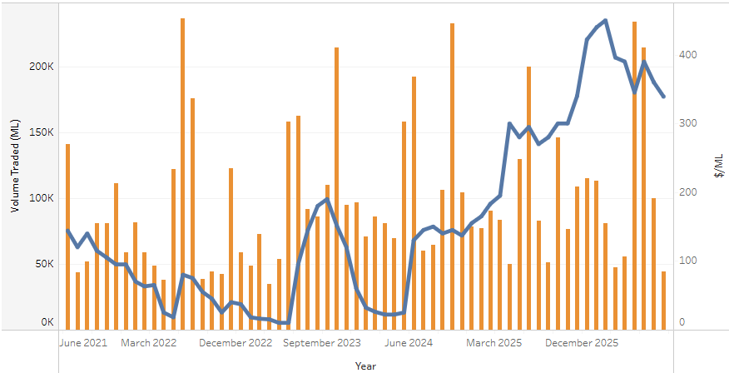

Weekly water market prices, Southern Murray–Darling Basin
Region | $/ML
NSW Murray Above | 225
NSW Murrumbidgee | 273
Vic Greater Goulburn | 292
Vic Murray Below | 325
Note: The water allocation prices shown are volume weighted average prices based on the last 10 trades. Price data is sourced from Waterflow and current as at 8 October 2026.
To access the full, interactive, weekly water dashboard, which contains the latest and historical water storage, water market and water allocation information, please visit https://www.agriculture.gov.au/abares/products/weekly_update/weekly-update-261022

Commodities
Indicator | Week average | Unit | Latest Price | Previous Week | Weekly change |  | Price 12 months ago | Annual change
Selected world indicator prices
AUD/USD Exchange rate | 21-Oct | A$/US$ | 0.70 | 0.70 | 0% | 0.65 |  | 7%
Wheat – US no. 2 hard red winter wheat, FOB Gulf | 21-Oct | US$/t | 314 | 320 | -2% | 231 |  | 36%
Corn – US no. 2 yellow corn, FOB Gulf | 21-Oct | US$/t | 214 | 218 | -2% | 198 |  | 8%
Canola – Rapeseed, Canada, FOB Vancouver | 21-Oct | US$/t | 597 | 607 | -2% | 473 |  | 26%
Cotton – Cotlook A Index | 21-Oct | USc/lb | 91.3 | 91.2 | 0% | 76.1 |  | 20%
Sugar – Intercontinental Exchange, nearby futures, no.11 contract | 21-Oct | USc/lb | 20.5 | 21.0 | -2% | 15.6 |  | 31%
Wool – Eastern Market Indicator | 21-Oct | Ac/kg clean | 1,785 | 1,803 | -1% | 1,476 |  | 21%
Wool – Western Market Indicator | 21-Oct | Ac/kg clean | 1,954 | 1,986 | -2% | 1,622 |  | 20%
Selected Australian grain export prices
Australian Premium White (APW) Wheat, FOB Port Adelaide, SA | 21-Oct | A$/t | 430 | 430 | 0% | 372 |  | 16%
Australian Standard White (ASW) Wheat, FOB Port Adelaide, SA | 21-Oct | A$/t | 420 | 421 | 0% | 368 |  | 14%
Feed Barley – FOB Port Adelaide, SA | 21-Oct | A$/t | 366 | 370 | -1% | 350 |  | 5%
Canola – FOB Kwinana, WA | 21-Oct | A$/t | 796 | 806 | -1% | 794 |  | 0%
Grain Sorghum – FOB Brisbane, QLD | 21-Oct | A$/t | 454 | 460 | -1% | 405 |  | 12%
Selected domestic livestock indicator prices
Beef – Eastern Young Cattle Indicator | 21-Oct | Ac/kg cwt | 968 | 948 | 2% | 846 |  | 14%
Mutton – Mutton indicator (18–24 kg fat score 2–3), VIC | 21-Oct | Ac/kg cwt | 840 | 833 | 1% | 739 |  | 14%
Lamb – National Trade Lamb Indicator | 21-Oct | Ac/kg cwt | 1,162 | 1,151 | 1% | 1,108 |  | 5%
Pig – Eastern Seaboard (60.1–75 kg), NSW buyer price | 7-Oct | Ac/kg cwt | 365 | 367 | -1% | 461 |  | -21%
Live cattle – Light steers to Indonesia | 9-Sep | Ac/kg lwt | 450 | 440 | 2% | 440 |  | 2%
Global Dairy Trade (GDT) weighted average prices
Dairy – Whole milk powder | 21-Oct | US$/t | 3,760 | 3,605 | 4% | 3,653 |  | 3%
Dairy – Skim milk powder | 21-Oct | US$/t | 3,975 | 3,847 | 3% | 2,579 |  | 54%
Dairy – Cheddar cheese | 21-Oct | US$/t | 3,645 | 3,925 | -7% | 4,808 |  | -24%
Dairy – Anhydrous milk fat | 21-Oct | US$/t | 5,488 | 5,683 | -3% | 6,977 |  | -21%

Selected world indicator prices
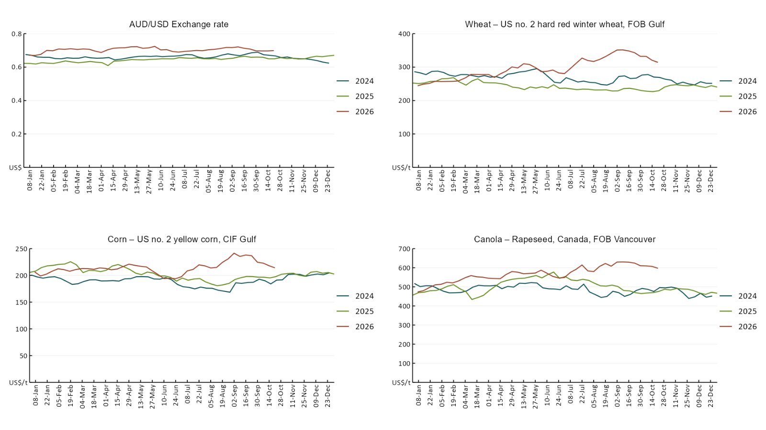

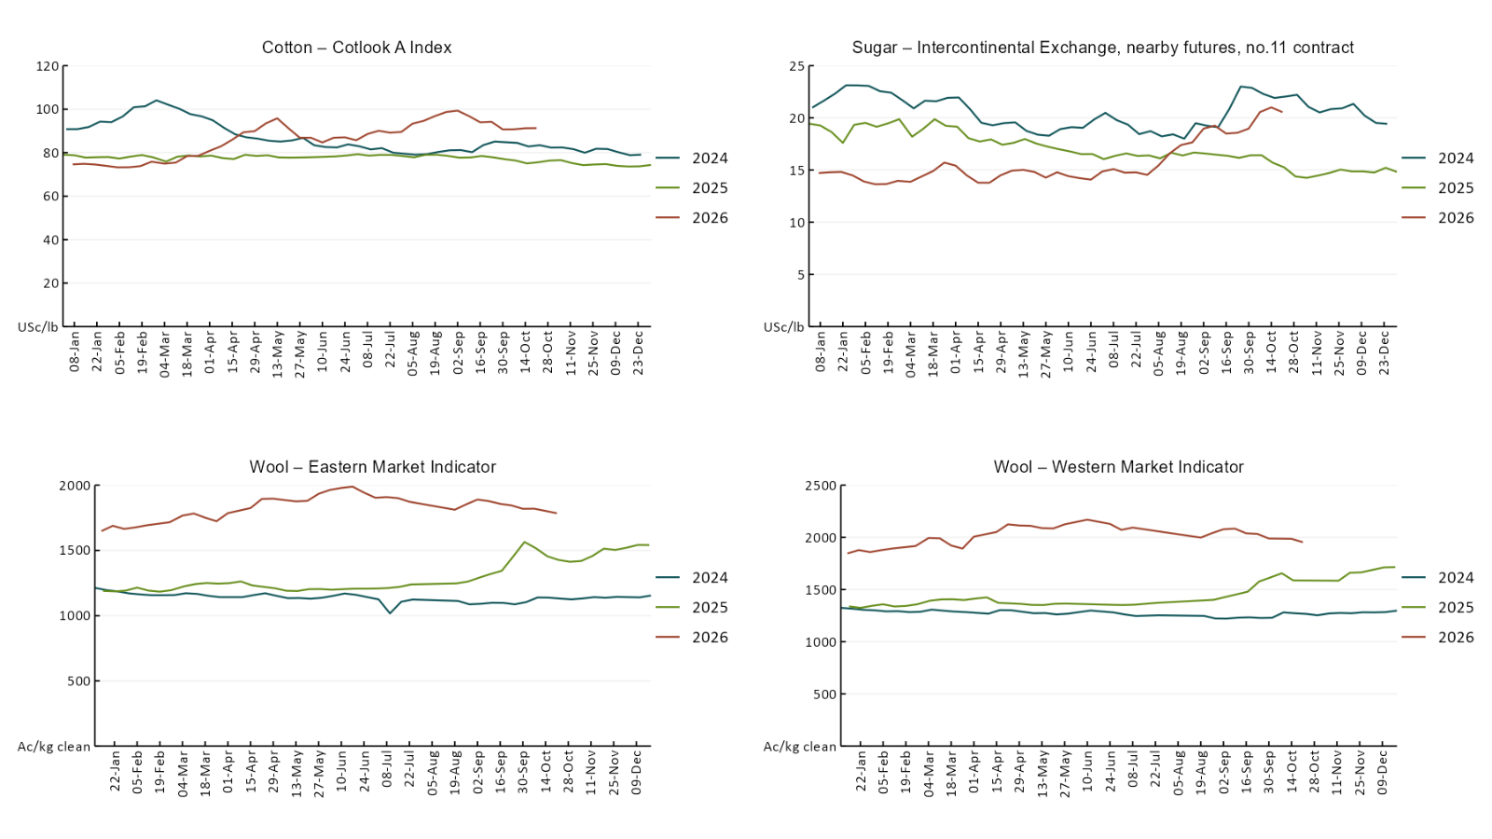

3.2 Selected domestic crop indicator prices
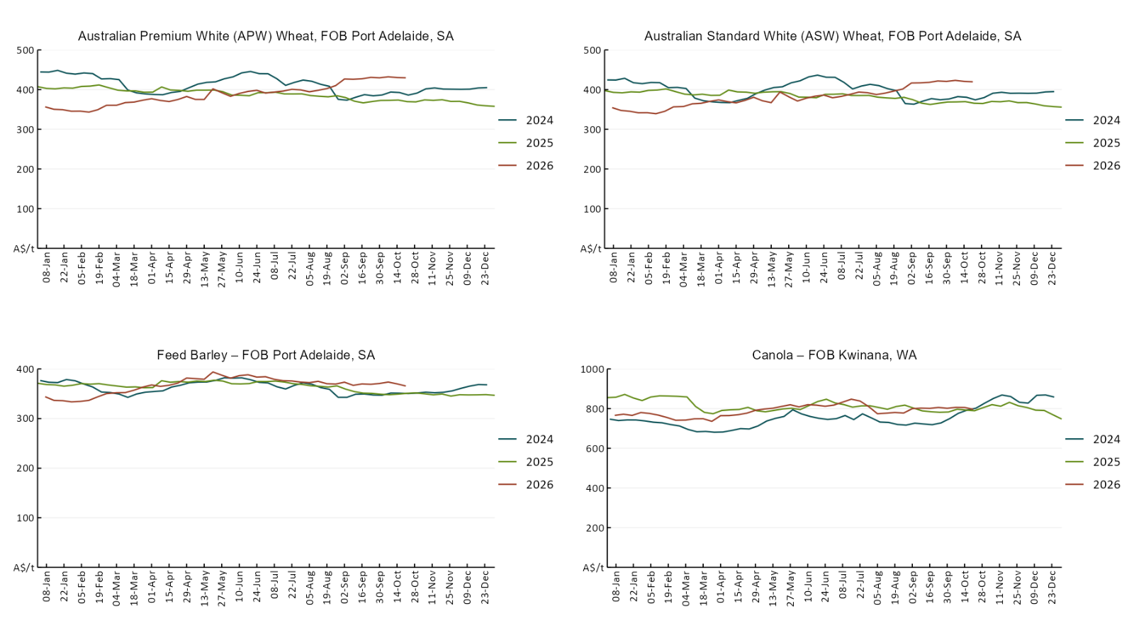

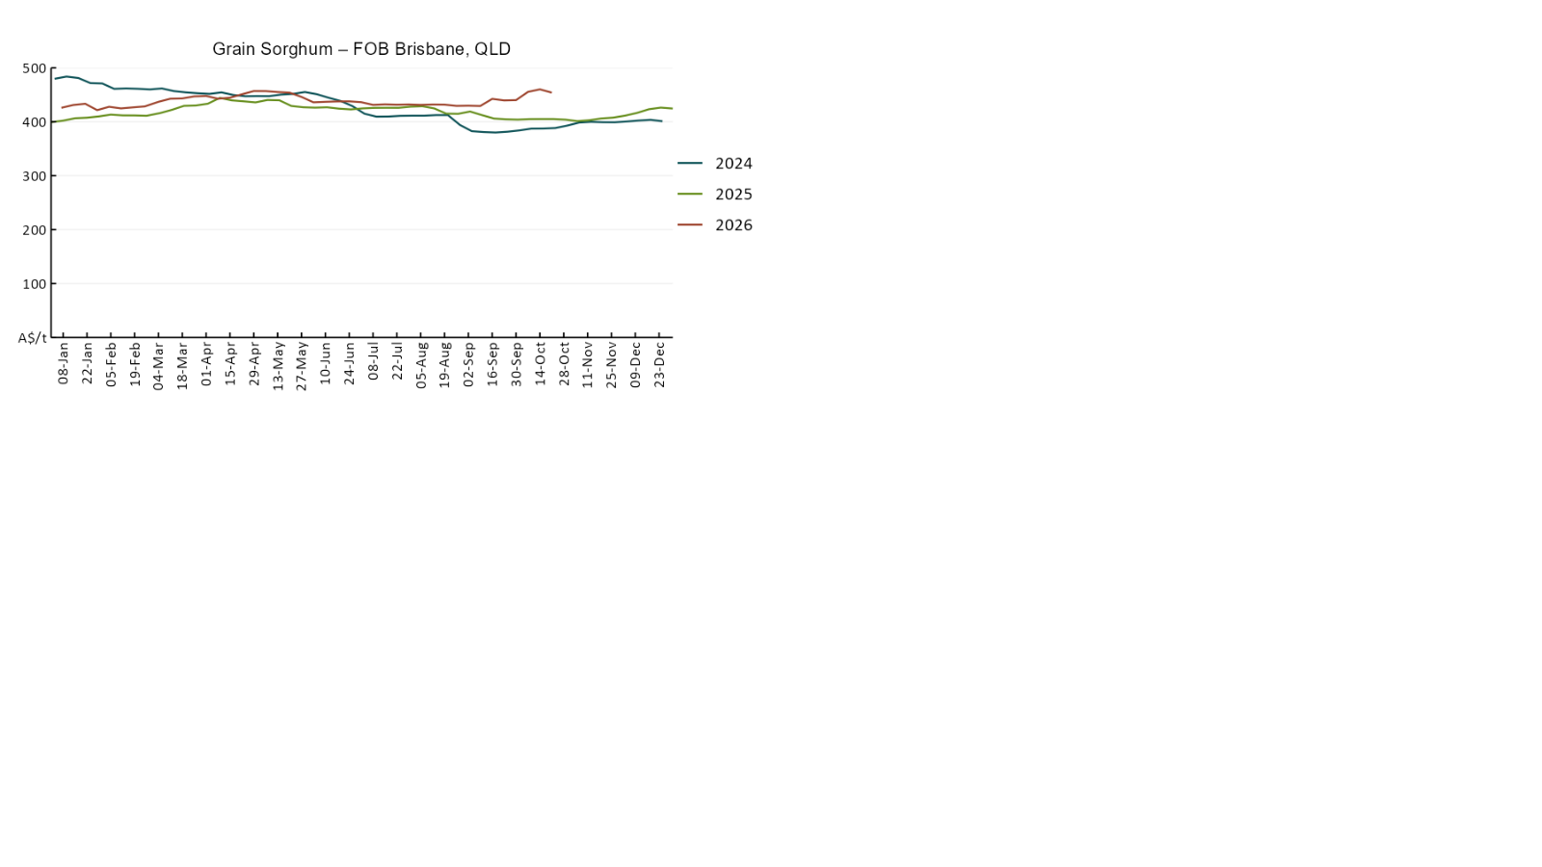

3.3 Selected domestic livestock indicator prices
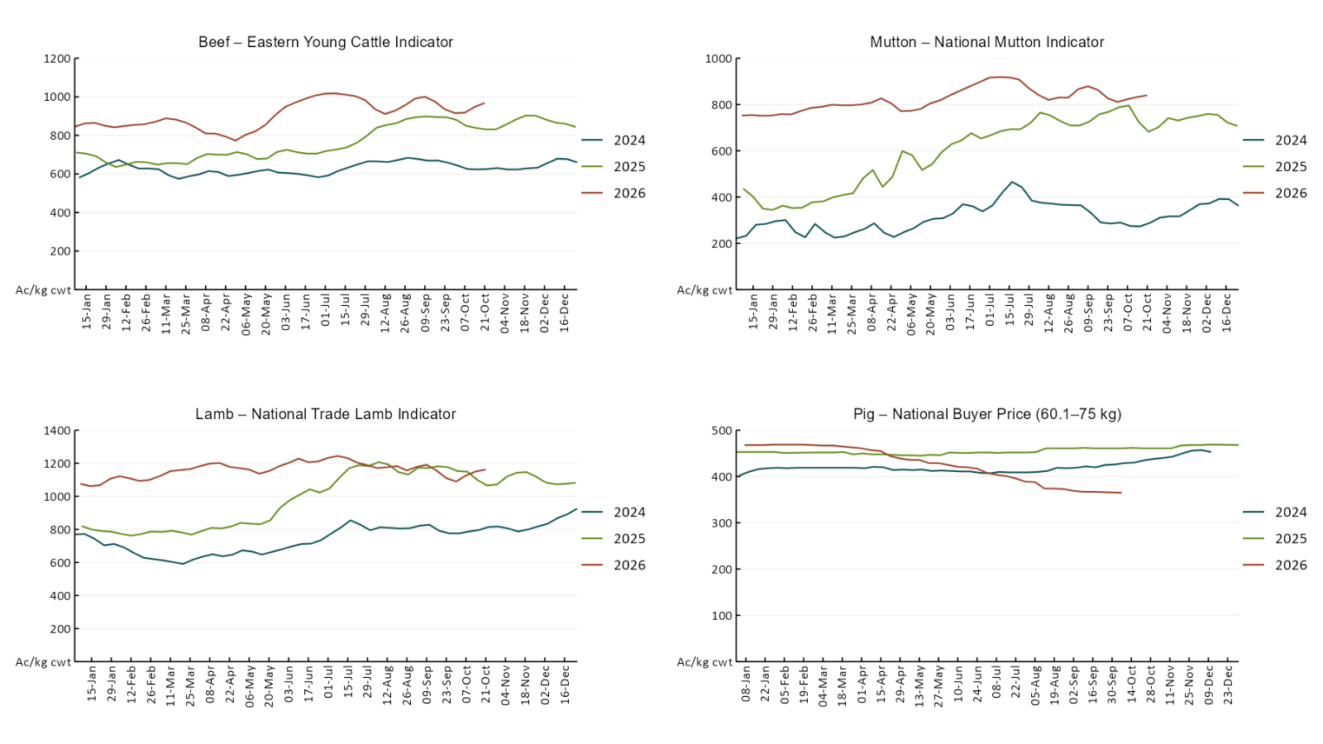

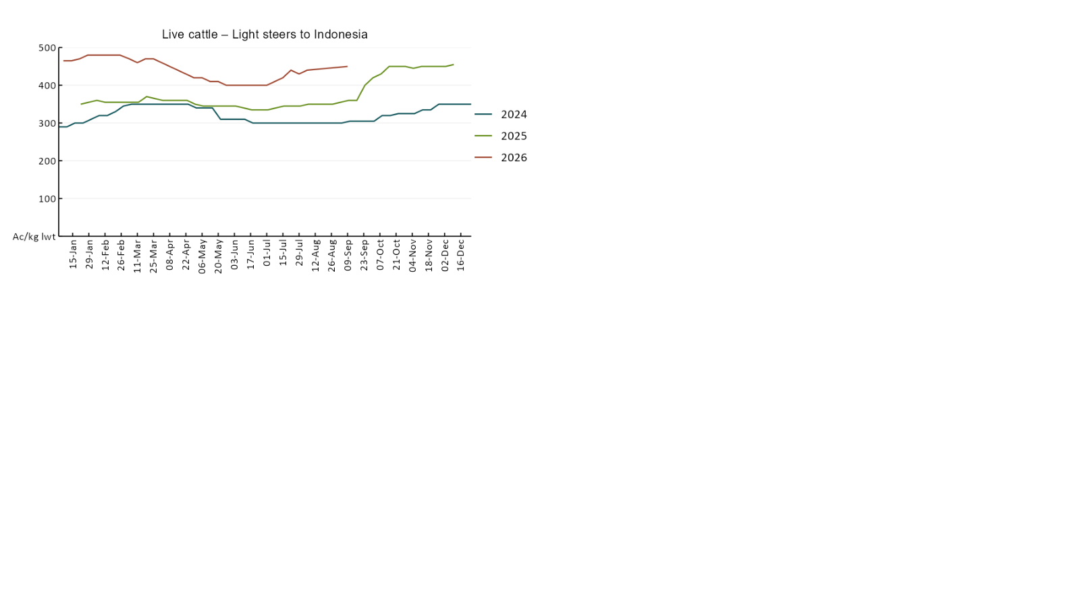

3.4 Global Dairy Trade (GDT) weighted average prices
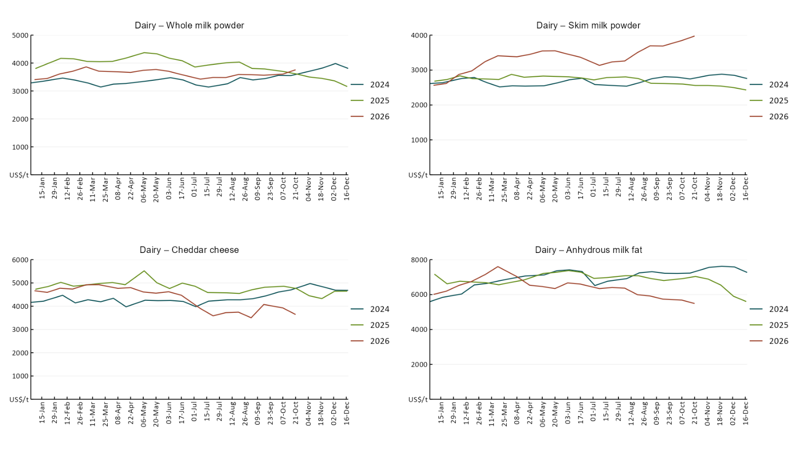

3.5 Selected fruit and vegetable prices
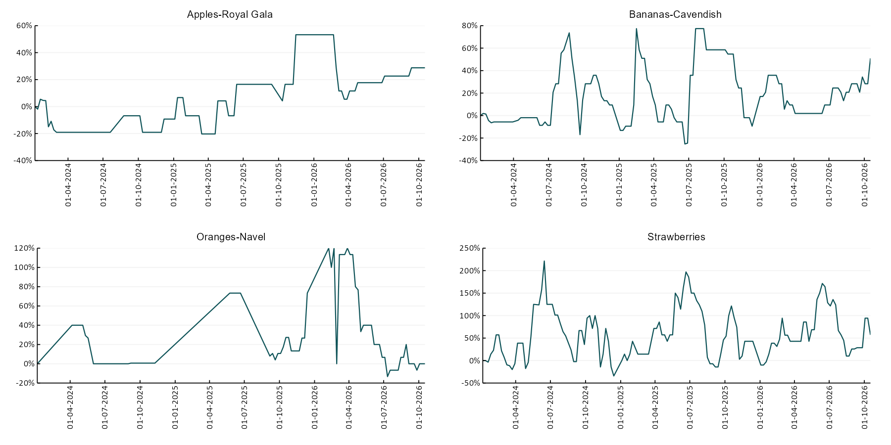

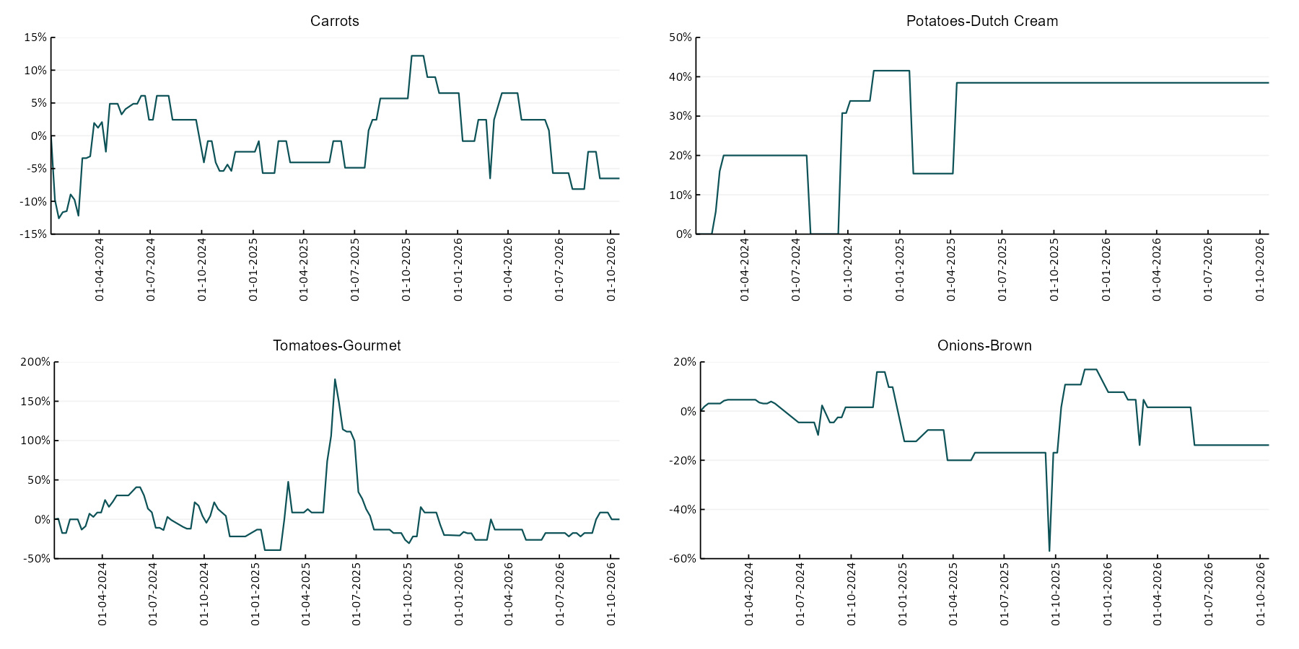

3.6 Selected domestic fodder indicator prices
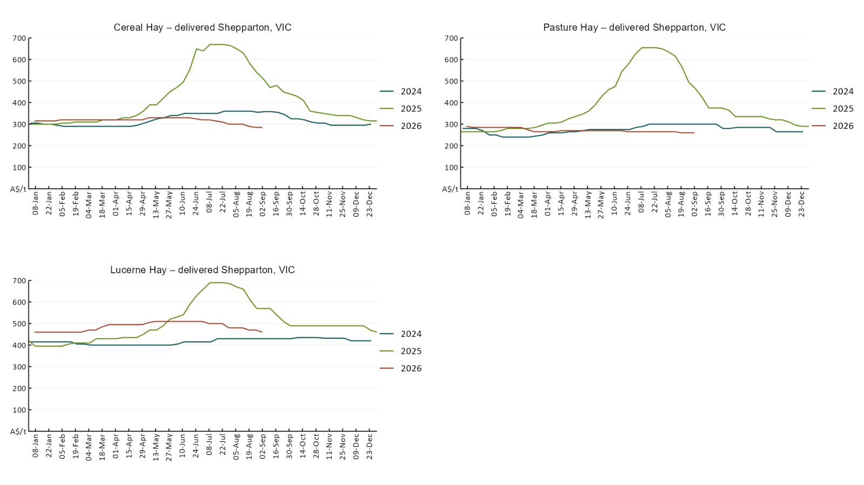

4. Data attribution

Climate
Bureau of Meteorology
- Weekly rainfall totals: www.bom.gov.au/climate/maps/rainfall/
- Monthly and last 3-month rainfall percentiles: https://www.bom.gov.au/climate/ahead/outlooks/#moreMaps
- Rainfall forecast: www.bom.gov.au/jsp/watl/rainfall/pme.jsp
- Seasonal outlook: www.bom.gov.au/climate/outlooks/#/overview/summary/
- Climate drivers: http://www.bom.gov.au/climate/enso/
- Soil moisture: https://awo.bom.gov.au/products/historical/soilMoisture-rootZone/

Other
- Pasture growth: www.longpaddock.qld.gov.au/aussiegrass/
- 3-month global outlooks: Environment and Climate Change Canada, NOAA Climate Prediction Center, EUROBRISA CPTEC/INPE, European Centre for Medium-Range Weather Forecasts, Hydrometcenter of Russia, National Climate Center Climate System Diagnosis and Prediction Room (NCC), International Research Institute for Climate and Society
- Global production: https://ipad.fas.usda.gov/ogamaps/cropmapsandcalendars.aspx
- Autumn break: Pook et al., 2009, https://rmets-onlinelibrary-wiley-com.virtual.anu.edu.au/doi/epdf/10.1002/joc.1833

Water
Prices
- Waterflow: https://www.waterflow.io/
- Ruralco: https://www.ruralcowater.com.au/
- Bureau of Meteorology:
- Allocation trade: http://www.bom.gov.au/water/dashboards/#/water-markets/mdb/at
- Storage volumes: http://www.bom.gov.au/water/dashboards/#/water-storages/summary/drainage

Trade constraints:
- Water NSW: https://www.waternsw.com.au/customer-service/ordering-trading-and-pricing/trading/murrumbidgee
- Victorian Water Register: https://www.waterregister.vic.gov.au/TradingRules2019/

Commodities
Fruit and vegetables
- Datafresh: www.freshstate.com.au

Pigs
- Australian Pork Limited: www.australianpork.com.au

Dairy
- Global Dairy Trade: www.globaldairytrade.info/en/product-results/

World wheat, canola
- International Grains Council: https://www.igc.int/en/default.aspx
- United States Department of Agriculture

World cotton
- Cotlook: www.cotlook.com/

World sugar
- New York Stock Exchange - Intercontinental Exchange

Wool
- Australian Wool Exchange: www.awex.com.au/

Domestic wheat, barley, sorghum, canola and fodder
- Jumbuk Consulting Pty Ltd: Jumbuk AG | Agriculture Consulting

Cattle, beef, mutton, lamb, goat and live export
- Meat and Livestock Australia: https://www.mla.com.au/prices-markets/

Australian Agricultural Drought Indicators
About Australian Agricultural Drought Indicators
- The Australian Agricultural Drought Indicators (AADI) project links weather and agricultural data with a range of scientific and economic models to measure and forecast the effects of climate variability and drought on agricultural outcomes.
On AADI, projected broadacre farm profits are presented as percentile outcomes relative to simulated historical outcomes using the groupings:
Highest | 95-100th percentile
Very much above average | 85-95th percentile
Above average | 65-85th percentile
Average | 35-65th percentile
Below average | 15-35th percentile
Very much below average | 5-15th percentile
Lowest 5% | 0-5th percentile

There are two AADI farm profit indicators:
- The AADI farm profit climate and price indicator shows the effect of climate and prices on broadacre farm business profits of current farms compared to the last 33 years.
- The AADI farm profit climate only indicator isolates the effect of climate on profits by holding prices fixed.

© Commonwealth of Australia 2026

Ownership of intellectual property rights
Unless otherwise noted, copyright (and any other intellectual property rights, if any) in this publication is owned by the Commonwealth of Australia (referred to as the Commonwealth).

Creative Commons licence
All material in this publication is licensed under a Creative Commons Attribution 4.0 International Licence except content supplied by third parties, logos and the Commonwealth Coat of Arms.
Inquiries about the licence and any use of this document should be emailed to copyright@aff.gov.au.


Cataloguing data
This publication (and any material sourced from it) should be attributed as:
ABARES 2026, Weekly Australian Climate, Water and Agricultural Update, Australian Bureau of Agricultural and Resource Economics and Sciences, Canberra, 22 October 2026. CC BY 4.0 DOI: https://doi.org/10.25814/5f3e04e7d2503
ISSN 2652-7561
This publication is available at https://www.agriculture.gov.au/abares/products/weekly_update
Department of Agriculture, Fisheries and Forestry
GPO Box 858 Canberra ACT 2601
Telephone 1800 900 090
Web agriculture.gov.au/abares

Disclaimer
The Australian Government acting through the Department of Agriculture, Fisheries and Forestry, represented by the Australian Bureau of Agricultural and Resource Economics and Sciences, has exercised due care and skill in preparing and compiling the information and data in this publication. Notwithstanding, the Department of Agriculture, Fisheries and Forestry, ABARES, its employees and advisers disclaim all liability, including liability for negligence and for any loss, damage, injury, expense or cost incurred by any person as a result of accessing, using or relying on any of the information or data in this publication to the maximum extent permitted by law.

Statement of Professional Independence
The views and analysis presented in ABARES publications, including this one, reflect ABARES professionally independent findings, based on scientific and economic concepts, principles, information and data. These views, analysis and findings may not reflect or be consistent with the views or positions of the Australian Government, or of organisations or groups who have commissioned ABARES reports or analysis. More information on professional independence is provided on the ABARES website.

Acknowledgements
This report was prepared by Holly Beale and Matthew Miller.

